Software Quality Engineering
Lecture No. 25
Part- 3:
Quality Assurance Techniques
Summary of the previous lecture
In last lecture, our discussion on fault Tolerance and failure containment continued. We talked about:
- Hazard Elimination and Hazard Reduction.
- Hazard Control and Damage Control.
- Software Safety Program (SSP)
- TFM: Two-Frame-Model
- Frame Inconsistencies
- Prescriptive Specifications (PS)
Outlines
We will Compare QA Alternatives, More specifically, we will talk about\
- General Areas
- Questions for Comparison
- Applicability, Effectiveness, and Cost
- Summary and Recommendations.
Objectives
- To understand and distinguish between QA alternatives.
- To be able to apply the knowledge learnt on real life QA in software.
QA Alternatives
• Defect and QA:
Defect: error/fault/failure.
Defect prevention/removal/containment.
Map to major QA activities
• Defect prevention
Error source removal & error blocking
• Defect removal: Inspection/testing/etc.
• Defect containment: Fault tolerance and failure containment (safety assurance).
• Comparison: This Lecture
Comparison
• Cost-benefit under given environments:
- . Environments: applicable or not?
- . Cost to perform.
- . Benefit: quality, directly or indirectly.
• Testing as the comparison baseline:
- . Most commonly performed QA activity.
- . Empirical and internal data for testing.
- . QA alternatives compared to testing:
defect prevention (DP),
Inspection and formal verification (FV),
fault tolerance (FT),
failure containment (FC).
- . FT & FC: separate items in comparison.
Comparison: Applicability
• Applicability questions:
- . High-level questions: development vs. field usage (and support/maintenance)
- . Low level questions: development phases/activities.
• Applicability to maintenance:
- . Not applicable: Defect prevention. (although lessons applied to future)
- . Applicable to a limited degree: Inspection, testing, formal verification, as related to reported field failures.
- . Applicable: fault tolerance and failure containment, but designed/implemented during development.
• Our focus: applicability to development
Comparison: Applicability
• Objects QA activities applied on:
. Mostly on specific objects, e.g., testing executable code
. Exception: defect prevention on (implementation related) dev. activities
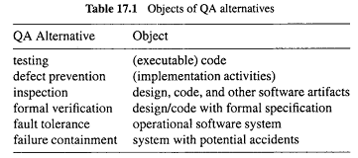
Comparison: Applicability
• Applicability to development phases:
- . In waterfall or V-model: implementation (req/design/coding) & testing/later.
- . Inspection in all phases.
- . Other QA in specific sets of phases.
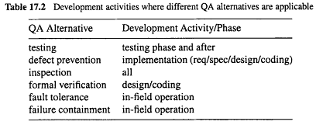
Comparison: Applicability
• Applicability to product domain/segment:
- . All QA alternatives can be applied to all domains/segments.
- . Other factors: cost-benefit ratio.
- . Higher cost needs to be justified by higher payoff/returns.
- . Further comparison in connect to cost and effectiveness comparisons.
Comparison: Applicability
• Also relate to general context of QA
. QA distribution
. Related activities in other phases, e.g., design/implementation for FT/SSE.
• Other process variations: similar to smaller cycles of waterfall
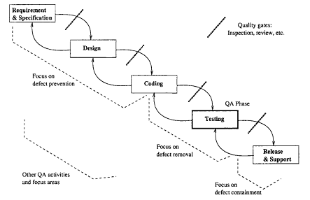
Comparison: Applicability/Expertise
• Pre-condition to performing specific QA activities:
- . specific expertise required
- . also related to cost
• Expertise areas:
- . Specifics about the QA alternative.
- . Background/domain-specific knowledge.
- . FV: formal training.
- . FT: dynamic system behavior.
- . FC: embedded system safety.
- . Other QA: general CS/SE knowledge.
Comparison: Applicability/Expertise
• General expertise levels: mostly in ranges, depending on specific techniques used.
• Specific background knowledge
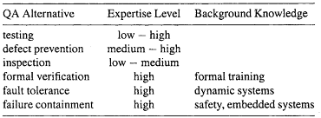
Required expertise and background knowledge for people to perform different QA Alternatives
Comparison: Benefit or Effectiveness
• General benefit questions:
- . Better quality: views and perspectives?
- . Defect-centered view in this book: ⇒ fewer defects
- . Defect-related questions below.
- . Other benefit: experience, culture change, process improvement, etc.
• Defect related question:
- . Defect specifics: errors/faults/failures
- . Problem or defect types
- . Defect levels or pervasiveness
- . Information for defect↓ and quality↑
Comparison: Effectiveness
• Defect specifics or perspectives:
. Dealing with errors/faults/failures?
. Direct action vs follow-up action: may deal with different defect perspectives.
. Example: failures detected in testing but (failure-causing) faults fixed in follow-up.
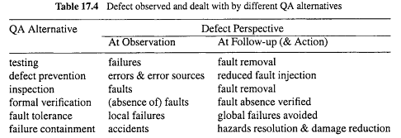
Comparison: Effectiveness
Problem or defect types:
- errors/faults/failures of different types or characteristics
- Comparison: Effectiveness
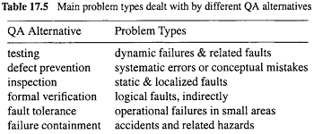
• Defect types: Inspection vs. testing:
- . Static analysis vs. dynamic execution ⇒ static vs dynamic problems and conceptual/logical problems vs. timing problems.
- . Localized defects easily detected by inspection vs. interface/interaction problems detected by testing.
• Defect types: Other QA:
- . defect prevention: negating causes or pre-conditions to pervasive problems.
- . fault tolerance: rare conditions
- . safety assurance: accidents
- . FV: logical problems, but indirectly.
Comparison: Effectiveness
• Defect types: Inspection vs. testing:
    - . Static analysis vs. dynamic execution ⇒ static vs dynamic problems and conceptual/logical problems vs. timing problems.
    - . Localized defects easily detected by inspection vs. interface/interaction problems detected by testing.
• Defect types: Other QA:
    - . defect prevention: negating causes or pre-conditions to pervasive problems.
    - . fault tolerance: rare conditions
    - . safety assurance: accidents
    - . FV: logical problems, but indirectly.
Comparison: Effectiveness
- Information for defect↓ and quality↑
- Result interpretation:
- specific pieces of info.
- interpret the info./result
- link to quality, impact, meaning, etc.?
- Using information/measurement:
- to provide feedback
- to guide followup activities
- to help decision making/improvement
- goal: defect↓ and quality↑ (usually via analysis/modeling)
- Part IV. Quantifiable Improvement: measure-analyze-feedback-improve steps.
Comparison: Effectiveness
- Ease of result interpretation
- Specific info/measurement
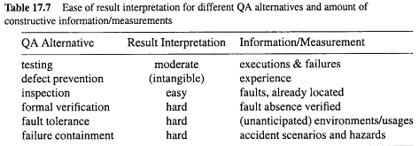
Comparison: Cost
• Cost measurement/characterization:
- Direct cost: $$$
- Indirect cost: time, effort, etc.
- Things affecting cost: simplicity, expertise (already addressed), tools, etc.
- Cost to perform specific QA activities.
• Factors beyond cost to perform QA:
- Cost of failures and related damage.
- Other cost, particularly for defect containment (FT and FC)
- Operational cost, e.g., FT mechanisms slow down normal operations
- Implementation cost of FT mechanisms.
Comparison: Cost
• Overall cost comparison:
. rough values and ranges
. multiple factors but focus on performing the specific QA activities
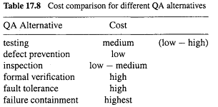
Comparison: Summary
• Testing:
. Important link in dev. process
. Activities spilt over to other phases
- OP development, test preparation, etc.
- (partial) code exist before testing
Dynamic/run-time/interaction problems
- . Medium/low defect situations
- . Techniques and tools
- . Coverage vs. reliability focus
- . Cost: moderate
• Defect prevention: . Most effective if causes known. . Good at pervasive problems. . Low cost, due to downstream damage↓. . Issue: “if causes”, and up-front cost
Comparison: Summary
• Defect prevention:
- . Most effective if causes known.
- . Good at general/universal problems.
- . Low cost, due to downstream damage↓.
- . Issue: “if causes”, and up-front cost

Comparison: Summary
• Inspection:
- . Good throughout dev. process
- . Works on many software artifacts
- . Conceptual/static faults
- . High fault density situations:
- non-blocking
- experience ⇒ efficiency↑
- . Human intensive, varied cost
Comparison: Summary
Formal verification:
- . Positive confirmation/correctness.
- . On design/code with formal spec.
- . Low/no defect situations
- . Practicality: high cost → benefit?
- . Human intensive, rigorous training (therefore, high up-front cost)
Comparison: Summary
• Fault tolerance:
- . Dynamic problems (must be rare)
- . High cost & reliability (low defect)
- . Technique problems (independent NVP?) . Process/technology intensive
• Failure containment:
- . Similar to FT above, but even more so.
- . Rare conditions related to accidents
- . Extremely high cost ⇒ apply only when safety matters
- . Many specialized techniques
- . Process/technology intensive
Comparison: Grand Summary
Pairwise comparison, if needed.
Different strength/weakness ⇒ hybrid/integrated strategies
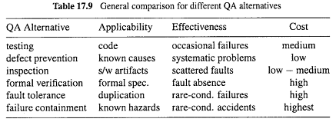
Pairwise Comparison
• Inspection vs. preventive actions:
- . Inspection coupled with causal analysis.
- . Together drive preventive actions.
- . Key difference: error vs fault focus
• Inspection vs. formal verification
- . FV ≈ formalized inspection
- . Focus: people vs. mathematical/logical
- . Applicability to design/code only?
- . Existence of formal specifications?
- . Tradeoff: formality vs. cost
- . Training and acceptability issues
Pairwise Comparison
• Inspection vs. testing:
- . Existence of the implemented product
- . Levels of quality/defects
- . Static vs. dynamic defects
- . Localized vs. interconnected defects
- . Combined approaches:
  - phases and transitions
  - inspection of testing entities/processes
• Inspection vs. fault tolerance
- . Complementary instead of competing (e.g., inspect individual versions)
- . Static vs. dynamic
- . Inspection of FT techniques/mechanisms

Recommendation: Integration
• Different QA alternatives often complementary instead of competing to one another:
- . Dealing with different problems.
- . Work in different phases/environments.
- . Combined effect ⇒ use multiple QA alternatives together.
- . Shared resource and expertise.
Recommendation: Integration
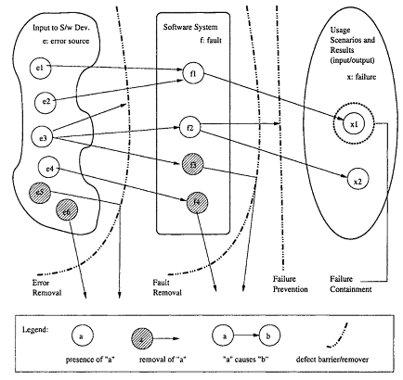
Integration: Concerted QA effort
- . As a series of defense (Fig 3.1, p.30).
- . Satisfy specific product/segment needs.
- . Fit into process and overall environment.
- . Adaptation/customization often needed.
- . Match to organizational culture.
Summary of Today’s Lecture
- In today’s lecture, we talked about comparing QA alternatives. We highlighted its General Areas and we did comparison using different tables. Lastly, we have seen the summary and recommendations.
Overview of the next lecture
- We will proceed to the Part- 4 of the course, i.e., Quantifiable Quality Improvement:
- We will talk about Feedback Loop and Activities for Quantifiable Quality Improvement.
The End

