Software Quality Engineering
Lecture No. 23
Part- 3:
Quality Assurance Techniques
Summary of the previous lecture
We continued our discussion on Formal Verification of a software. The General idea and approaches for formal verification were discussed. We also highlight Axiomatic verification and other approaches for software verification
Outlines
- In today’s lecture, we will talk about Fault Tolerance and Safety Assurance.
- The basic concepts and safety assurance techniques will be discussed.
- We will also talk about Fault Tolerance recovery blocks and Event Tree Analysis (ETA)
Objectives
- To be able to understand the concepts of Safety for Software development.
- To understand and distinguish between Fault Tolerance Analysis (FTA) and Event Tree Analysis (ETA)
QA Alternatives
Defect and QA:
- . Defect: error/fault/failure.
- . Defect prevention/removal/containment.
- . Map to major QA activities
Defect prevention:
- Error source removal & error blocking
- Defect removal: Inspection (Lecture No. 21)
- Special case (this lecture): Formal verification (Lecture 22)
- Defect containment: Fault tolerance and failure containment (safety assurance) This Lecture.
QA and Fault Tolerance (FT)
• Fault tolerance as part of QA:
- . Duplication: over time or components
- . High cost, high reliability
- . Run-time/dynamic focus
- . FT design and implementation
- . Complementary to other QA activities
• General idea
- . Local faults not lead to system failures
- . Duplication/redundancy used
- . redo ⇒ recovery block (RB)
- . parallel redundancy
- ⇒ N version programming (NVP)
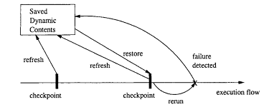
FT: Recovery Blocks (RB)
General idea:
. Periodic check-pointing
. Problem detection/acceptance test
. Rollback (recovery)
FT: Recovery Blocks (RB)
• Periodic check-pointing
- . too often: expensive check-pointing
- . too rare: expensive recovery
- . smart/incremental check-pointing
• Problem detection/acceptance test
- . exceptions due to in/external causes
- . periodic vs event-triggered
• Recovery (rollback) from problems:
- . external disturbance: environment?
- . internal faults: tolerate/correct?

Fault Tolerance: N- Version Programming
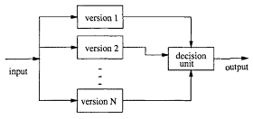
• FT with NVP:
- . NVP: N-Version Programming
- . Multiple independent versions
- . Dynamic voting/decision ⇒ FT.
Fault Tolerance: N- Version Programming
Multiple independent versions
- . Multiple: parallel vs backup?
- . How to ensure independence?
- Support environment:
- . concurrent execution
- . switching
- . voting/decision algorithms
Correction/recovery?
- . p-out-of-n reliability
- . in conjunction with RB
- . dynamic vs. off-line correction
FT/NVP: Ensure Independence
Ways to ensure independence:
- . People diversity: type, background, training, teams, etc. . Process variations
- . Technology: methods/tools/PL/etc.
- . End result/product:
- design diversity: high potential
- implementation diversity: limited
Ways to ensure design diversity:
- . People/teams
- . Algorithm/language/data structure
- . Software development methods
- . Tools and environments
- . Testing methods and tools
- . Formal/near-formal specifications
FT/NVP: Development Process
• Programming team independence
- Assumption: P-team independence
⇒ version independence
- Maximize P-team isolation/independence .
Mandatory rules (DOs & DON’Ts)
Controlled communication (see below)
• Use of coordination team
- . 1 C-team – n P-teams
- . Communication via C-team
not P-team to P-team
protocols and overhead cost
- . Special training for C-team
FT/NVP: Development Phases
• Pre-process training/organization
• Requirement/specification phases: .
NVP process planning
- . Goals, constraints, and possibilities
- . Diversity as part of requirement
relation to and trade-off with others
achievable goals under constraints
- . Diversity specification
- . Fault detection/recovery algorithm?
• Design and coding phases: enforce NVP-process/rules/protocols
FT/NVP: Development Phases
• Testing phases:
- Cross-checking by different versions.
- Focus on fault detection/removal
- Focus on individual versions
• Evaluation/acceptance phases:
- . How N-versions work together?
- . Evidence of diversity/independence?
- . NVP system reliability/dependability?
- . Modeling/simulation/experiments
• Operational phase:
- . Monitoring and quality assurance
- . NVP-process for modification also
FT and Safety
• Extending FT idea for safety:
- . FT: tolerate fault
- . Extend: tolerate failure
- . Safety: accident free
- . Weaken error-fault-failure-accident link
• FT in SSE (software safety engineering):
- . Too expensive for regular systems
- . As hazard reduction technique in SSE
- . Other related SSE techniques:
- general redundancy
- substitution/choice of modules
- barriers and locks
- analysis of FT
What Is Safety?
• Safety: The property of being accident-free for (embedded) software systems.
- . Accident: failures with severe consequences
- . Hazard: condition for accident
- . Special case of reliability
- . Specialized techniques
• Software safety engineering (SSE): .
Hazard identification/analysis techniques
- . Hazard resolution alternatives
- . Safety and risk assessment
- . Qualitative focus
- . Safety and process improvement
Safety Analysis & Improvement
• Hazard analysis:
- . Hazard: condition for accident
- . Fault trees: (static) logical conditions
- . Event trees: dynamic sequences
- . Combined and other analyses
- . Generally qualitative
- . Related: accident analysis and risk assessment
• Hazard resolution
- . Hazard elimination
- . Hazard reduction
- . Hazard control
- . Related: damage reduction
Hazard Analysis: Fault Tolerance Analysis
• Fault tree idea:
- . Top event (accident)
- . Intermediate events/conditions
- . Basic or primary events/conditions
- . Logical connections
- . Form a tree structure
• Elements of a fault tree:
- . Nodes: conditions and sub-conditions – terminal vs. no terminal
- . Logical relations among sub-conditions – AND, OR, NOT
- . Other types/extensions possible
Hazard Analysis: FTA Example
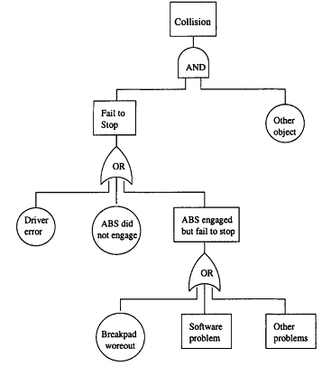

Example FTA for an automobile accident
Hazard Analysis: FTA
• FTA construction:
- . Starts with top event/accident
- . Decomposition of events or conditions
- . Stop when further development not required or not possible (atomic)
- . Focus on controllable events/elements
• Using FTA:
- . Hazard identification – logical composition – (vs. temporal composition in Event Tree Analysis (ETA).
- . Hazard resolution (more later) component replacement etc.
- focused safety verification
- negate logical relation

Hazard Analysis: Event Tree Analysis (ETA)
• ETA: Why?
- . FTA: focus on static analysis
- (static) logical conditions
- . Dynamic aspect of accidents
- . Timing and temporal relations
- . Real-time control systems
• Search space/strategy concerns:
- . Contrast ETA with FTA:
FTA: backward search
ETA: forward search
- . May yield different path/info.
- . ETA provide additional info.
Hazard Analysis: ETA Example
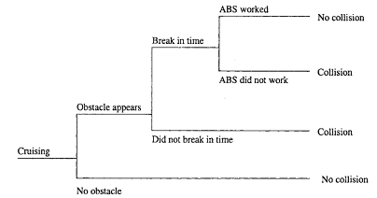
Hazard Analysis: ETA
• Event trees:
- . Temporal/cause-effect diagram
- . (Primary) event and consequences
- . Stages and (simple) propagation
not exact time interval
logical stages and decisions
• Event tree analysis (ETA):
- Recreate accident sequence/scenario
- Critical path analysis
- Used in hazard resolution (more later)
esp. in hazard reduction/control
e.g. creating barriers
isolation and containment
Summary of Today’s Lecture
In today’s lecture, we talked about Fault Tolerance and Safety Assurance. We have seen some basic concepts and safety assurance techniques. We also talked about Fault Tolerance recovery blocks. Our discussion ended on Fault Tolerance Analysis (FTA) and Event Tree Analysis (ETA)
Overview of the next lecture
- We will talk about Hazard Elimination and Hazard Reduction.
- We will also talk about Hazard Control and Damage Control.
The End

