Lecture No. 18
Part- 2 (b):
Other Models & Techniques of Testing
Summary of the previous lecture
Use Case Test Generation
- Step 1: Draw a Use Case Diagram
- Step 2: Write the Detailed Use Case Text
- Step 3: Identify Use Case Scenarios
- Step 4: Generating the Test Cases
- Step 5: Generating Test Data
Which testing technique to be applied / used
Equalince Partitioning & Boundry Value Analysis
Outlines
- Testing Vs Debugging
- System Testing Process
- Test Execution and Fault Reports
- Bug Life cycle
Objectives
- To understand and distinguish between Testing Vs Debugging
- To understand the bug life cycle and learn the stages to resolve errors.
Introduction
Software Testing
- Computer programs are designed and developed by human beings and hence are prone to errors.
- Unchecked, they can lead to a lot of problems, including social implications.
- Testing the software becomes an essential part of the software development lifecycle.
- Carrying out the testing activities for projects has to be practiced with proper planning and must be implemented correctly.
Basic Questions on Testing
Why to test?
- testing becomes absolutely essential to make sure the software works properly and does the work that it is meant to perform.
What to test?
- Any working product which forms part of the software application has to be tested. Both data and programs must be tested.
How often to test?
- When a program (source code) is modified or newly developed, it has to be tested.
Who tests?
- Programmer, Tester and Customer
Software Development Lifecycle (SDLC)
Inception
Requirements
Design
Coding
Testing
Release
Maintenance
Inception
- Request for Proposal
- Proposal
- Negotiation
- Letter Of Intent (LOI) – some companies may do this along with a feasibility study to ensure that everything is correct, before signing contract
- Contract
Requirements
User Requirements Specification (URS)
- This document will describe in detail about what is expected out of the software product from the user's perspective.
- The wordings of this document will be in the same tone that of a user
Software Requirements Specification (SRS)
- A team of business analysts, who are having a very good domain or functional expertise, will go to the clients place and get to know the activities that are to be automated and prepare a document based on URS and it is called as SRS
Design
High Level Design (HLD)
- List of modules and a brief description of each module.
- Brief functionality of each module.
- Interface relationship among modules
- Dependencies between modules (if exists, B exists etc.)
- Database tables identified along with key element.
- Overall architecture diagrams along with technology details.
Low Level Design (LLD)
- Details functional logic of the module, in pseudo code.
- Database tables, with all elements, including their type and size
- All interface details with complete API references (both requests and responses)
- All dependency issues Error message Listings
- Complete input and outputs for a module.
Coding
Converting the pseudo code into a programming language in the specified platform
Guidelines to be followed for the naming convention of procedures, variables, commenting methods etc
By compiling and correcting the errors, all syntax error and removed.
Testing Levels
Unit Testing
- Programs will be tested at unit level
- The same developer will do the test
Integration Testing
- When all the individual program units are tested in the unit testing phase and all units are clear of any known bugs, the interfaces between those modules will be tested
- Ensure that data flows from one piece to another piece
System Testing
- After all the interfaces are tested between multiple modules, the whole set of software is tested to establish that all modules work together correctly as an application.
- Put all pieces together and test
Acceptance Testing
- The client will test it, in their place, in a near-real-time or simulated environment.
Release to Production and Warranty Period
- When the clients to the acceptance testing and finds no problems, then they will accept the software and now they have to start using the software in their real office.
- Bug Fixes during the warranty period – we cannot charge the customer for this
- Go Live Process means the product is used in live servers
Maintenance Phase
- Bug fixing
- Upgrade
- Enhancement
- After some time, the software may become obsolete and will reach a point that it cannot be used. At that time, it will be replaced by another software which is superior to that. This is the end of the software
- We do not use FoxPro or Windows 3.1 now as they are gone!
Development Models
Water Fall Model – do one phase at a time for all requirements given by customer
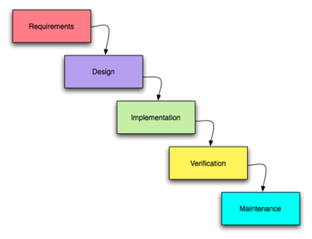
Development Models
Incremental Model – take smaller set of requirements and build slowly
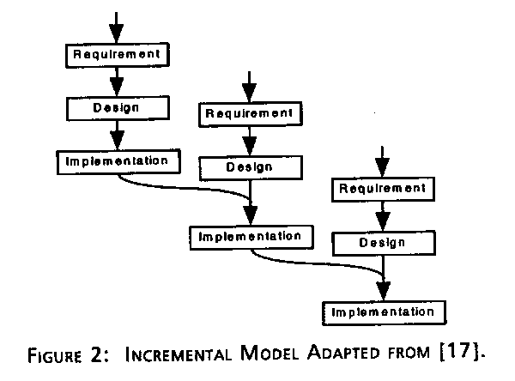
Development Models
Extreme Programming Model – take only one piece and develop!
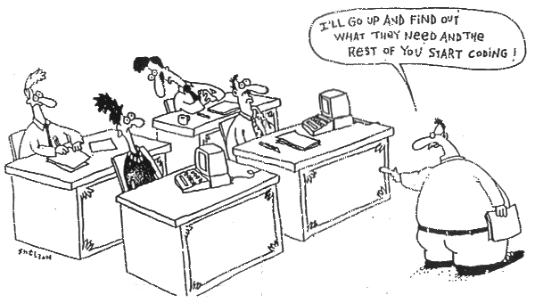
Testing Vs Debugging
- Testing is focused on identifying the problems in the product
- Done by Tester
- Need not know the source code
- Debugging is to make sure that the bugs are removed or fixed
- Done by Developer
- Need to know the source Code
System Testing Process
Plan
- Create master test plan (MTP) – done by test manager or test lead
- Create Detailed Test Plan (what to test) – by testers – this will contain test scenarios also known as test conditions
- Create Detailed Test Cases (DTC) – how to test – by testers
Execute
Regress and Analyze
Detailed Test Plan
What is to be tested ?
- Configuration – check all parts for existence
- Security – how the safety measures work
- Functionality – the requirements
- Performance – with more users and more data
Environment – keep product same but other settings different
Detailed Test Cases
The test cases will have a generic format as
below.
- Test Case Id
- Test Case Description
- Test Prerequisite
- Test Inputs
- Test Steps
- Expected Results
Detailed Test Case (DTC)
- Simple Functionality – field level
- Communicative Functionality – data on one screen goes to another
- End-to-End Test Cases – full sequence as though the end users carry out
Test Execution and Fault Reports
- Test Case Assignment – done by test lead
- Test Environment Set-up – install OS, database, applications
- Test Data Preparation – what kind of data to be used
- Actual Test Execution – do it!
Test Environment Set-up
- There must be no development tools installed in a test bed.
- Ensure the right OS and service pack/patch installed.
- Ensure the disks have enough space for the application
- Carry out a virus check if needed.
- Ensure the integrity of the web server.
- Ensure the integrity of the database serves.
Test Data Preparation
- This data can be identified either at the time of writing the test case itself or just before executing the test cases.
- Data that are very much static can be identified while writing the test case itself.
- Data which are dynamic and configurable need more analysis before preparation.
- Preparation of test data depends upon the functionality that is being tested.
Actual Test Execution
Install Tests
Auto install in default mode
- Does the installer check for the prequsites?
- Does the installer check for the system user privileges?
- Does the installer check for disk and memory space?
- Does the installer check for the license agreement ?
- Does the installer check for the right product key?
- Does the installer installs in the default path?
- Do we have different install types like custom, full, compact, fully?
Install Tests continued..
- Cancel the installation half way thru.
- Uninstall the software.
- Cancel half way thru un-install.
- Reinstall on the same machine. Repair an existing install on the same machine.
- Does installer create folders, icons, short cuts, files, database, registry entries?
- Does uninstall remove any other files that do not belong to this product?
Actual Test Execution
Navigation Tests
- Once install complete, start the application
- Move to every possible screen using menus, tool bar icons, short cut keys, or links.
- Check for respective screen titles and screen fields for the existence.
- Move back and forth from various screens to other forms in adhoc
- Exit the application and restart the application many times
Core Functional Test
Build Verification Tests (BVT)
- A set of test scenarios/cases must be identified as critical priority, such that, if these tests do not work, the product does not get acceptance from the test team.
Build Acceptance Tests (BAT)
- This starts once the BVT is done. This involves feeding the values to the program as per the test input and then performing the other actions (like clicking specific buttons of function keys etc) in the sequence as given in the test steps.
Test Problem Report or Fault Report or Bug Report
TPR Id | A unique identifier across the company
TPR Description | A brief description of the problem
Date | The date on which the TPR is raised
Author | The tester who raised the TPR
Test Case Id | The test case that caused this TPR to be raised
Software Version/Build | The version number of the software that was tested and found faulty
Problem Severity | Show stopper/High/Medium/Low. This will be agreed by the lead tester and the development project manager.
Priority | High/Medium/Low. How soon to fix?
Problem Detailed Description | A description of what was tested and what happened  This will be filled by the tester.
Problem Resolution | After fixing the problem, the developer fills this section, with details about the fix. Developer gives this
Assigned to | To whom the TPR is assigned to be fixed
Expected Closure | When the problem to be closed Data
Actual closure data  TPR status | When the problem is actually rectified and closed  This is a changing field to reflect the status of the TPR.

Bug Life Cycle
Do it until solved
- New
- Open
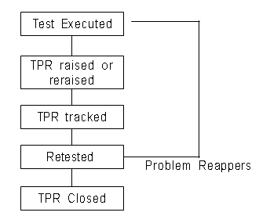
- In-Fix
- Fix-Complete
- In-Retest
- Retest-Complete
- Closed
- Retest-Complete
- Open

Bug Tracking Tools
- Softsmith’s QAMonitor and SPCG
- Bugzilla
- HP Quality Center
- JIRA
Summary of Today’s Lecture
- We talked about software testing and debugging and have explored different details which are applied on different phases of software testing
The End

