Software Quality Engineering
Lecture No. 17
Part- 2 (b):
Other Models & Techniques of Testing
Summary of the previous lecture
- Testing Techniques: Adaptation, Specialization, and Integration.
- Adaptation to Test Sub-phases
- Specialized Testing Techniques
- Integration and Web Testing Case Study

Outlines
- Use case based test case generation
- Equivalence Partitioning
- Boundary Value Analysis
- Some examples of will be explored.
Objectives
- To understand and distinguish between use case test generation, Equivalence Partitioning and Boundary Value Analysis
- To be able to test a use case and apply boundary value analysis in real life.
Transforming Use cases into Test cases
- Step 1: Draw a Use Case Diagram
- Step 2: Write the Detailed Use Case Text
- Step 3: Identify Use Case Scenarios
- Step 4: Generating the Test Cases
- Step 5: Generating Test Data
Step 1
Enroll
Change
Drop
Student
Step 2
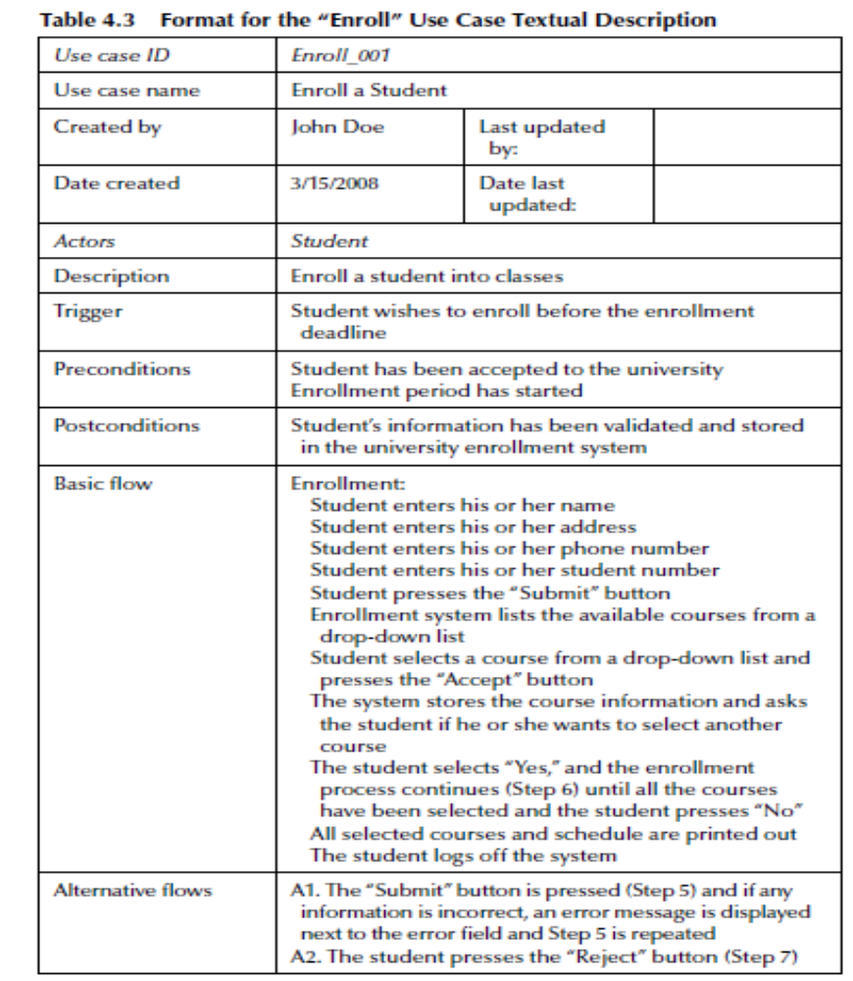
Step 2
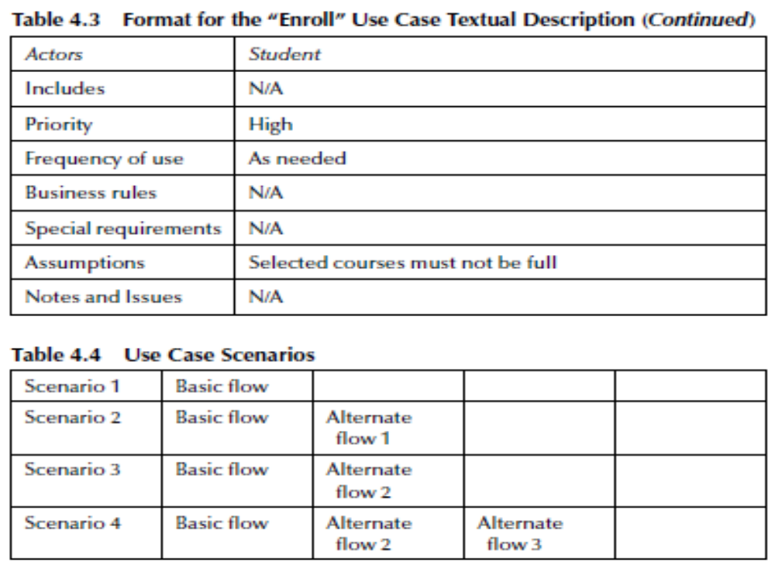
Step 3: Identify Use Case Scenarios
- A use case scenario is an instance of a use case, or a complete “path” through the use case.
- End users of a system can go down many paths as they execute the functionality specified in the use case.
- The basic (or normal) path is illustrated by the dotted lines.
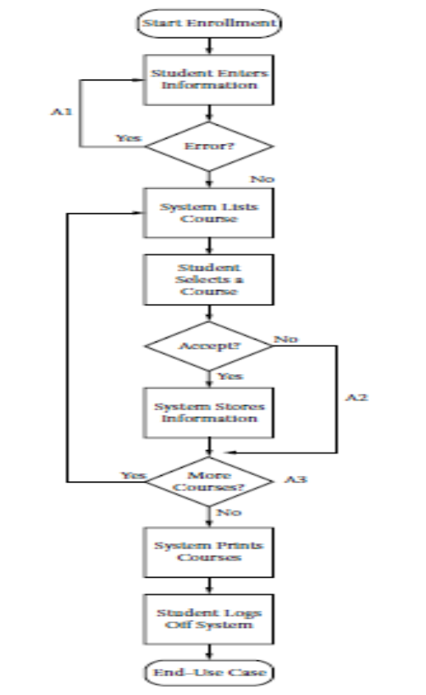
Step 4: Generate Test Case
- A test case is a set of test inputs, execution conditions, and expected results developed for a particular objective.
- Once the set of scenarios has been identified, the next step is to identify the test cases.
- This is accomplished by analyzing the scenarios and reviewing the use case textual descriptions.
- There should be at least one test case for each scenario.
- For each invalid test case, there should be only one invalid input.
Step 4: Generate Test Case
- To document the test cases, a matrix format can be used.
- The first column of the first row contains the test case ID, and the second column has a brief description of the test case and the scenario being tested.
- All the other columns except the last one contain data elements that will be used to implement the tests.
- The last column contains a description of the test case’s expected output. The “V” depicts a valid test input, and an “I” depicts an invalid test input.
Step 4: Generate Test Case
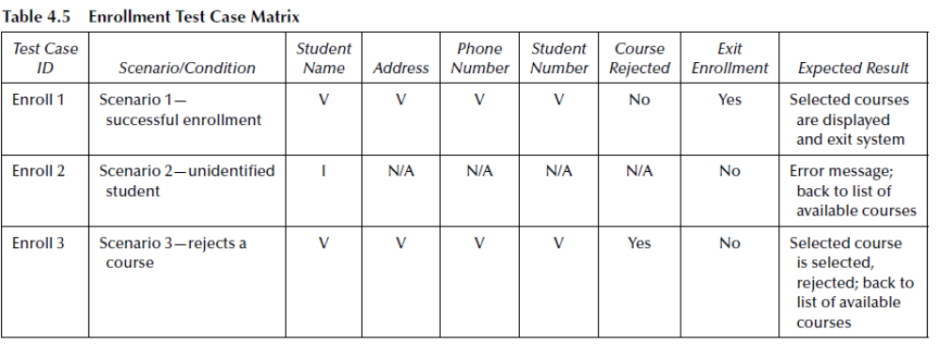
Step 5: Generating Test Data
- Once all of the test cases have been identified, they should be reviewed and validated to ensure accuracy and to identify redundant or missing test cases.
- Then, once they are approved, the final step is to substitute actual data values for the I’s and V’s.
- A test case matrix with values substituted for the I’s and V’s in the previous matrix.
- A number of techniques can be used for identifying data values.
- Two valuable techniques are Equivalence Class Partitioning and Boundary Value Analysis.
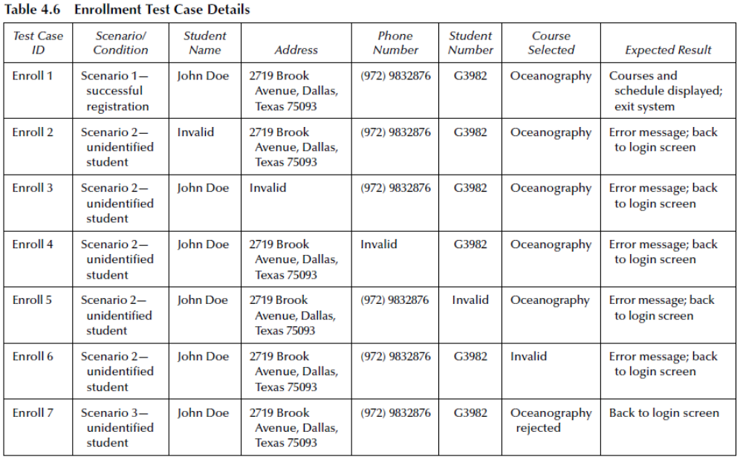

Equivalence Partitioning #1
- It is very difficult, expensive and time consuming if not at times impossible to test every single input value combination for a system.
- We can break our set of test cases into sub-sets. We then choose representative values for each subset and ensure that we test these.
- Each subset of tests is thought of as a partition between neighbouring subsets or domains.
Equivalence Partitioning #2
Equivalence Partitioning:
- Makes use of the principle that software acts in a general way (generalises) in the way it deals with subsets of data,
- Selects Groups of inputs that will be expected to be handled in the same way.
- Within a group of data, a representative input can be selected for testing.
- For many professional testers this is fairly intuitive.
- The approach formalises the technique allowing an intuitive approach to become repeatable.
Equivalence Partitioning #3
EP Example:
Consider a requirement for a software system:
- “The customer is eligible for a life assurance discount if they are at least 18 and no older than 56 years of age.”
Equivalence Partitioning #4
“The customer is eligible for a life assurance discount if they are at least 18 and no older than 56 years of age.”
18
56
Invalid Partition
Less than or equal to 18
Invalid Partition
Greater than 56
Valid Partition
Range 19 to 56
Equivalence Partitioning #5
What if our developer incorrectly interpreted the requirement as:
- “The customer is eligible for a life assurance discount if they are over 18 and less than 56 years of age.”
- People aged exactly 18 or exactly 56 would now not get a discount.
18
56
Invalid Partition
=< 18
Invalid Partition
<56
Valid Partition
18< Range <56
Errors are more common at boundary values, either just below, just above or specifically on the boundary value.

Boundary Analysis #1
“The customer is eligible for a life assurance discount if they are at least 18 and no older than 56 years of age.”
17, 18, 19
55, 56, 57
Invalid Partition
Less than 18
Invalid Partition
Greater than 56
Valid Partition
Range 17 to 56
Boundaries
Test values would be: 17, 18, 19, 55, 56 and 57.
This assumes that we are dealing with integers and so least significant digit is 1 either side of boundary.
Boundary Analysis #2
For each boundary we test +/- 1 in the least significant digit of either side of the boundary.
Boundary Limit
Boundary Limit + 1
Boundary Limit -1
Test values would be: 17, 18, 19, 55, 56 and 57.
This assumes that we are dealing with integers and so least significant digit is 1 either side of boundary.
Boundary Analysis #3
- While the textbooks may limit testing to the boundaries, we are interested in how software normally behaves and how it reacts to handling error conditions. Therefore it is normal to treat NOT ONLY the boundaries but also:
- A typical mid range value e.g. 37
- Zero (since divide by 0 errors can occur).
- Negative values
- Numbers out of range by a long way e.g. +/-1000
- Illegal data entries like “nineteen” as letters, Fred, banana.
- Illegal characters such as # $ & ‘ @ : ;
Taking EP and BVA Further
Consider the following requirement:
“The customers must be at least 18. Customers are eligible for a life assurance discount of 40% if they are at least 18 and no older than 25 years of age. Customers are entitled to a 30% discount if they are older than 25 years of age, but under 40. Customers are entitled to a 10% discount if they are 40 or over, but no older than 56. Over 56 customers are not entitled to a discount.”
- What are the equivalence partitions?
- What are the boundary values to be tested?
- What other values might you test?
Taking EP and BVA Further - Answer
“The customers must be at least 18. Customers are eligible for a life assurance discount of 40% if they are at least 18 and no older than 25 years of age. Age is only recorded in integer years. Customers are entitled to a 30% discount if they are older than 25 years of age, but under 40. Customers are entitled to a 10% discount if they are 40 or over, but no older than 56. Over 56 customers are not entitled to a discount.”
17, 18, 19
24, 25, 26
40% discount
38, 39, 40
10% discount
55, 56, 57
10% discount
0% discount
invalid
Might also test: 0, -5, 200, Fred, 0.00000001, some typical mid range values: 21, 32, 47. Note boundary values tested +/- least significant recorded digit.

Invalid Partitions
Let’s consider some example
Question 1
One of the fields on a form contains a text box which accepts numeric values in the range of 18 to 26. Identify the invalid Equivalence class.
a) 17
b) 19
c) 25
d) 21
Solution 1
The text box accepts numeric values in the range 18 to 25 (18 and 25 are also part of the class). So this class becomes our valid class. But the question is to identify invalid equivalence class. The classes will be as follows:
Class I: values < 18 => invalid class
Class II: 18 to 25 => valid class
Class III: values > 25 => invalid class
17 fall under invalid class. 19, 25 and 21 fall under valid class.
So answer is ‘a’ (17)
Question 2
In an Examination a candidate has to score minimum of 25 marks in order to pass the exam. The maximum that he can score is 50 marks. Identify the Valid Equivalence values if the student passes the exam.
a) 22,24,27
b) 21,39,40
c) 29,30,31
d) 0,15,22
Solution 2
The classes will be as follows:
Class I: values < 25 => invalid class
Class II: 25 to 50 => valid class
Class III: values > 50 => invalid class
We have to indentify Valid Equivalence values. Valid Equivalence values will be there in Valid Equivalence class.
  - All the values should be in Class II.
  - So answer is ‘c’ ( 29,30,31)
Summary of Today’s Lecture
We applied testing on use cases, Equivalence Partitioning and tested the boundary values for some cases.
Overview of Next lecture
Software testing depends on good requirements, so it is important to understand some of the key elements of quality requirements.
We will talk about Requirement Quality Factors such as Understandable, Necessary, Modifiable, etc.
The End

