Software Quality Engineering
Lecture No. 16
Part- 2 (b):
Other Models & Techniques of Testing
Summary of the previous lecture
- Overview of Different Software Testing Techniques
- Identified the need of specific testing technique for specific environment (software or a program)
- Unit & Component Testing
- Key characteristics
- Applications and adaption

Outlines
- Integration Testing
- Regression Testing
- Beta Testing
- Testing Sub-Phases Comparison
- Existing Web Testing
Objectives
- To understand and distinguish between the characteristics and applications of different software testing (integration, regression, beta etc.)
- To understand and compare the need of specialized testing (sub-phases).
Integration Testing
Key characteristics:
- .Object: interface and interaction among multiple components or subsystems.
- . Component as a black-box (assumed).
- . System as a white-box (focus).
- . Exit: coverage (sometimes reliability).
Commonly used testing techniques:
- . FSM-based coverage testing.
- . Other techniques may also be used.
- . Sometimes treated as ⊂ system testing ⇒ see system testing techniques in next slide.
System Testing
Key characteristics:
- . Object: whole system and the overall operations, typically from a customer’s perspective.
- . No implementation detail ⇒ BBT.
- . Customer perspective ⇒ UBST.
- . Exit: reliability (sometimes coverage).
Commonly used testing techniques:
- . UBST with Musa or Markov OPs.
- . High-level functional checklists.
- . High-level FSM, possibly CFT & DFT.
- . Special case: as part of a “super”-system in embedded environment ⇒ test interaction with environment.
Acceptance Testing
Key characteristics:
- . Object: whole system.
  - but defect fixing no longer allowed.
- . Customer acceptance in the market.
- . Exit: reliability.
Commonly used testing techniques:
- . Repeated random sampling without defect fixing.
- .UBST with Musa OPs.
- . External testing services/organizations may be used for system “certification”.
Beta Testing
Key characteristics:
- . Object: whole system
- . Normal usage by customers.
- . Exit: reliability.
Commonly used testing techniques:
- . Normal usage.
- . Ad hoc testing by customers. (trying out different functions/features)
- . Diagnosis testing by testers/developers to fix problems observed by customers.
Testing Sub-Phases: Comparison
Key characteristics for comparison:
- . Object and perspectives.
- . Exit criteria.
- . Who is performing the test.
- . Major types of specific techniques.
“Who” question not covered earlier:
- . Dual role of programmers as testers in unit testing and component testing I.
- . Customers as testers in beta testing. .
- Professional testers in other sub-phases.
- . Possible 3rd party (IV&V) to test reusable components & system acceptance.
Testing Sub-Phases: Summary
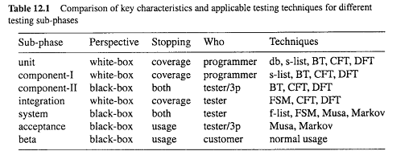
Specialized Testing
Specialized testing tasks:
- . Some do not fit into specific sub-phases.
- . Different goals (other than reliability).
- . Non-standard application environment.
Our coverage:
- . Defect diagnosis testing.
- . Defect-based testing.
- . Regression testing.
- . Testing beyond programs.
- . Testing for other goals/objectives.
Defect Diagnosis Testing
Context of defect diagnosis testing:
- . In follow-up to discovered problems by customers or during testing.
- . Pre-test: understand/recreate problems.
- . Test result: faults located.
- . Follow-up with fault removal and re-run/re-test to confirm defect fixing.
Defect diagnosis testing:
- . Typically involve multiple related runs.
- . Problem recreation as the starting point. .
- . Domain knowledge important.
- . More recorded defect information ⇒ less reliance on defect diagnosis.
- . Defect-based techniques (below) useful.
Defect-Based Testing
General idea and generic techniques:
- . Focus: discovered or potential defects (and related areas).
- . Ad hoc testing based on defect guesses.
- . Risk identification ⇒ risk-based testing.
- . Defect injection and mutation testing.
Defect injection and testing:
- . Inject known defect (seed known fault).
- . Test for both seeded and ingenuous faults.
- . Missed faults ⇒ testing technique↑.
- . Also used in reliability modeling.
Regression Testing
Context of regression testing:
- . In software maintenance and support: – ensure change /⇒ negative impact.
. In legacy software systems:
- ensure quality of remaining functions,
- during development/product update,
- new part ≈ new development,
- focus: integration sub-phase & after.
- . Re-test to verify defect fixing as well as no unintended consequences.
Regression testing techniques:
- . Specialized analysis of change (new part)
- . Focused testing on new part.
- . Integration of old and new
Other Specialized Testing
Testing beyond programs:
- . Embedded and heterogeneous systems:
- test interactions with surroundings.
- . Web testing.
Testing to achieve other goals:
- . Performance testing;
- . Stress testing;
- . Usability testing, etc.
Dynamic analysis and related techniques:
- . Simulation to reduce overall cost.
- . Prototyping, particularly in early phases.
- . Timing and sequencing analysis.
- . Event-tree analysis (ETA),
Existing Web Testing
Web functionality testing: .
Focus on the web components
- . HTML syntax checking via various tools.
- . Link checking.
- . Form testing.
- . Verification of end-to-end transactions.
- . Java and other program testing.
• Beyond web functionality testing:
- . Load testing.
- . Usability testing.
- . Browse rendering.
Hierarchical Web Testing
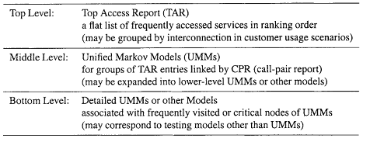
Implementation of the hierarchical web testing strategy:

Summary of Today’s Lecture
- We overviewed unit, component, system and regression testing.
- We compared different sub-phases of testing
- Lastly, we explored the need of Hierarchical Web Testing
Overview of Next lecture
- Use case based test case generation
- Equivalence Partitioning
- Boundary Value Analysis
- Some examples of will be explored
The End

