Software Quality Engineering
Lecture No. 15
Part- 2 (b):
Other Models & Techniques of Testing
Summary of the previous lecture
- Data Dependency and Sequencing
- Data Dependency Analysis
- Data Dependency Graph (DDG)
- we need DDG; Its characteristics and construction with example was discussed
- CFT Vs DDT
Outlines
- Testing Techniques: Adaptation, Specialization, and Integration.
- Adaptation to Test Sub-phases
- Specialized Testing Techniques
Objectives
- To understand and distinguish between different Application and adaptation issues of testing
- To understand the needs of Testing Sub-Phases.
Applications of Testing Techniques
• Major testing techniques covered so far:
- Ad hoc (non-systematic) testing.
- Checklist-based testing.
- Partition-based coverage testing.
- Musa’s OP for UBST.
- Boundary testing (BT).
- Control flow testing (CFT).
- Data flow testing (DFT)
• Application and adaptation issues:
- For different purposes/goals.
- In different environments/sub-phases.
- Existing techniques: select/adapt.
- May need new or specialized techniques.
V-Model
- Solid box: original sub-phase
- Dashed box: added sub-phase or specialized testing

Testing Sub-Phases: V-Model
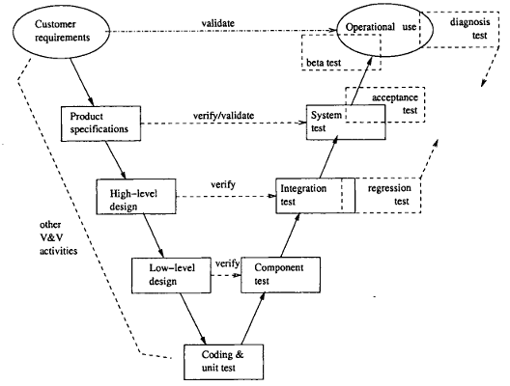
Testing sub-phases associated with the V-Model
Testing Sub-Phases: V-Model
- Original sub-phases in V-model:
- Operational use (not testing, strictly).
- System test for product specification.
- Integration test for high-level design.
- Component test for low-level design.
- Unit test for program code.
Additional sub-phases/specialized testing:
- Diagnosis test through all sub-phases.
- Beta test for limited product release.
- Acceptance test for product release.
- Regression test for legacy products.
Unit Testing
Key characteristics:
- Object: unit (implemented code)
- function/procedure/subroutine in C, FORTRAN, etc.
- method in OO languages
- Implementation detail ⇒ WBT. (BBT could be used, but less often.)
- Exit: coverage (reliability undefined).

Commonly used testing techniques:
- Ad hoc testing.
- Informal debugging.
- Input domain partition testing and BT.
- CFT and DFT.
Component Testing
Key characteristics:
- Object: component (⊃ unit), 2 types.
1. collection of units in C/FORTRAN/etc.
- implementation detail ⇒ WBT. .
2. class in OO languages
reusable component ⇒ BBT.
- Exit: coverage (sometimes reliability).
Commonly used testing techniques:
- for traditional systems (component I) ≈ unit testing, but at larger scale
- for OO systems (component II) ≈ system testing, but at smaller scale
- see system testing techniques later in the slides
Integration Testing
Key characteristics:
- .Object: interface and interaction among multiple components or subsystems.
- . Component as a black-box (assumed).
- . System as a white-box (focus).
- . Exit: coverage (sometimes reliability).
Commonly used testing techniques:
- . FSM-based coverage testing.
- . Other techniques may also be used.
- . Sometimes treated as ⊂ system testing ⇒ see system testing techniques in next slide.
System Testing
Key characteristics:
- . Object: whole system and the overall operations, typically from a customer’s perspective.
- . No implementation detail ⇒ BBT.
- . Customer perspective ⇒ UBST.
- . Exit: reliability (sometimes coverage).
Commonly used testing techniques:
- . UBST with Musa or Markov OPs.
- . High-level functional checklists.
- . High-level FSM, possibly CFT & DFT.
- . Special case: as part of a “super”-system in embedded environment ⇒ test interaction with environment.
Acceptance Testing
Key characteristics:
- . Object: whole system.
  - but defect fixing no longer allowed.
- . Customer acceptance in the market.
- . Exit: reliability.
Commonly used testing techniques:
- . Repeated random sampling without defect fixing.
- .UBST with Musa OPs.
- . External testing services/organizations may be used for system “certification”.
Beta Testing
Key characteristics:
- . Object: whole system
- . Normal usage by customers.
- . Exit: reliability.
Commonly used testing techniques:
- . Normal usage.
- . Ad hoc testing by customers. (trying out different functions/features)
- . Diagnosis testing by testers/developers to fix problems observed by customers.
Testing Sub-Phases: Comparison
Key characteristics for comparison:
- . Object and perspectives.
- . Exit criteria.
- . Who is performing the test.
- . Major types of specific techniques.
“Who” question not covered earlier:
- . Dual role of programmers as testers in unit testing and component testing I.
- . Customers as testers in beta testing. .
- Professional testers in other sub-phases.
- . Possible 3rd party (IV&V) to test reusable components & system acceptance.
Testing Sub-Phases: Summary
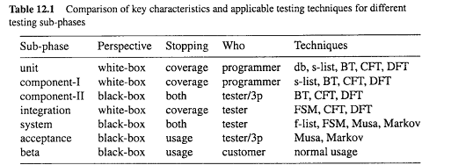
Specialized Testing
Specialized testing tasks:
- . Some do not fit into specific sub-phases.
- . Different goals (other than reliability).
- . Non-standard application environment.
Our coverage:
- . Defect diagnosis testing.
- . Defect-based testing.
- . Regression testing.
- . Testing beyond programs.
- . Testing for other goals/objectives.
Defect Diagnosis Testing
Context of defect diagnosis testing:
- . In follow-up to discovered problems by customers or during testing.
- . Pre-test: understand/recreate problems.
- . Test result: faults located.
- Follow-up with fault removal and re-run/re-test to confirm defect fixing.
Defect diagnosis testing:
- . Typically involve multiple related runs.
- . Problem recreation as the starting point. .
- . Domain knowledge important.
- . More recorded defect information ⇒ less reliance on defect diagnosis.
- . Defect-based techniques (below) useful.
Defect-Based Testing
General idea and generic techniques:
- . Focus: discovered or potential defects (and related areas).
- . Ad hoc testing based on defect guesses.
- . Risk identification ⇒ risk-based testing.
- . Defect injection and mutation testing.
Defect injection and testing:
- . Inject known defect (seed known fault).
- . Test for both seeded and ingenuous faults.
- . Missed faults ⇒ testing technique↑.
- . Also used in reliability modeling.
Regression Testing
Context of regression testing:
- . In software maintenance and support: – ensure change /⇒ negative impact.
- . In legacy software systems:
- ensure quality of remaining functions,
- during development/product update,
- new part ≈ new development,
- focus: integration sub-phase & after.
- . Re-test to verify defect fixing as well as no unintended consequences.
Regression testing techniques:
- . Specialized analysis of change (new part)
- . Focused testing on new part.
- . Integration of old and new
Other Specialized Testing
- Testing beyond programs:
- . Embedded and heterogeneous systems:
- test interactions with surroundings.
- . Web testing.
Testing to achieve other goals:
- . Performance testing;
- . Stress testing;
- . Usability testing, etc.
Dynamic analysis and related techniques:
- . Simulation to reduce overall cost.
- . Prototyping, particularly in early phases.
- . Timing and sequencing analysis.
- . Event-tree analysis (ETA),
Test Integration
General idea:
- . Many activities and tasks.
- . Different techniques.
- . Individual advantages and limitations.
- . Much commonality exists.
- . Possibility of integration?
Test integration: Advantages
- . combined strength ⇒ benefit↑.
- . common elements ⇒ cost↓.
- . flexibility↑.
Existing Web Testing
Web functionality testing: .
- Focus on the web components
- . HTML syntax checking via various tools.
- . Link checking.
- . Form testing.
- . Verification of end-to-end transactions.
- Java and other program testing.
Beyond web functionality testing:
- . Load testing.
- . Usability testing.
- . Browse rendering.
Hierarchical Web Testing
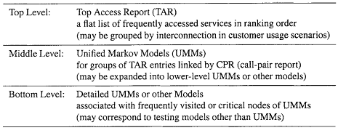
Implementation of the hierarchical web testing strategy:

Summary of Today’s Lecture
- We explored what type of testing is suitable in which type of environment.
- Not all types of testing are suitable universally
Overview of Next lecture
- System Testing, Acceptance Testing, Beta Testing
- Integration and Web Testing Case Study
- Defect Diagnose Testing
- Regression Testing
END

