Software Quality Engineering
Lecture No. 9
Part- 2 (a):
Software Testing
Summary of the previous lecture
- We discussed basics of software testing. We highlighted why testing is important and how it plays role in SQE
- W examined different types of testing such as black box and white box testing.
Outlines
- Software Testing Activities
- Software Testing Scope
- Software Testing Principles
- Software Testing Process
- Software Testing Myths
- Software Testing Limits
- Different Types of Software Testing
Objectives
- To further understand the basics of Testing
- To be able to distinguish between unit, integration and system testing
What is Software Testing?
Several definitions:
“Testing is the process of establishing confidence that a program or system does what it is supposed to.” by Hetzel 1973
“Testing is the process of executing a program or system with the intent of finding errors.”
by Myers 1979
“Testing is any activity aimed at evaluating an attribute or capability of a program or system and determining that it meets its required results.”
by Hetzel 1983
What is Software Testing?
- One of very important software development phases
- A software process based on well-defined software quality control and testing standards, testing methods, strategy, test criteria, and tools.
- Engineers perform all types of software testing activities to perform a software
test process.
- The last quality checking point for software on its production line.

Testing Objectives
The Major Objectives of Software Testing:
- Uncover as many as errors (or bugs) as possible in a given timeline.
- Demonstrate a given software product matching its requirement specifications.
- Validate the quality of a software testing using the minimum cost and efforts.
- Generate high quality test cases, perform effective tests, and issue correct and helpful problem reports.
Major goals:
uncover the errors (defects) in the software, including errors in:
- requirements from requirement analysis
- design documented in design specifications
- coding (implementation)
- system resources and system environment
- hardware problems and their interfaces to software
Who does Software Testing
Test manager
- manage and control a software test project
- supervise test engineers
- define and specify a test plan
- Software Test Engineers and Testers
- define test cases, write test specifications, run tests
- Independent Test Group
- Development Engineers
- Only perform unit tests and integration tests
- Quality Assurance Group and Engineers
- Perform system testing
- Define software testing standards and quality control process
Software Testing Scope
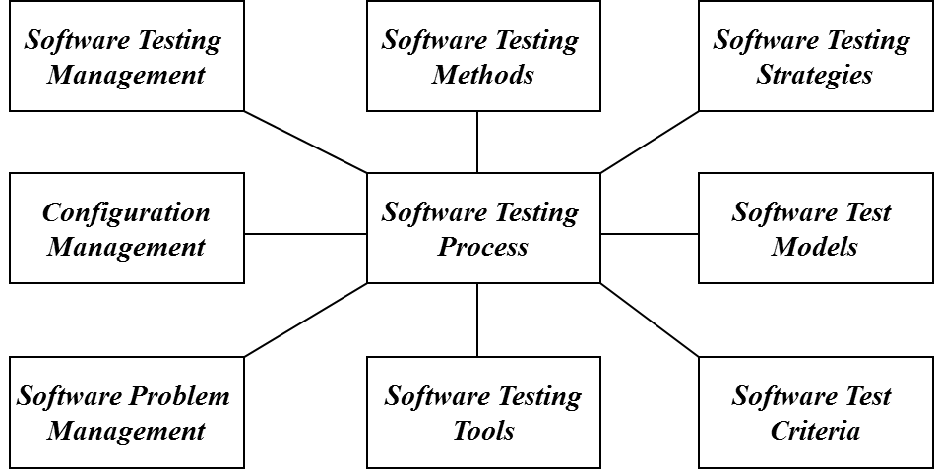
Software Testing Activities
- Test Planning
Define a software test plan by specifying:
- a test schedule for a test process and its activities, as well as assignments
- test requirements and items
- test strategy and supporting tools
- Test Design and Specification
- Conduct software design based well-defined test generation methods.
- Specify test cases to achieve a targeted test coverage.
- Test Set up:
- Testing Tools and Environment Set-up
- Test Suite Set-up
- Test Operation and Execution
- Run test cases manually or automatically
Software Testing Activities
- Test Result Analysis and Reporting
Report software testing results and conduct test result analysis
- Problem Reporting
Report program errors using a systematic solution.
- Test Management and Measurement
Manage software testing activities, control testing schedule, measure testing complexity and cost
- Test Automation
- Define and develop software test tools
- Adopt and use software test tools
- Write software test scripts and facility
- Test Configuration Management
- Manage and maintain different versions of software test suites, test environment and tools, and documents for various product versions.
Verification and Validation
Software testing is one element of a broader topic that is often referred to as
===> Verification and Validation (V&V)
Verification --> refers to the set of activities that ensure that software correctly implements a specific function.
Validation -> refers to a different set of activities that ensure that the software that has been built is traceable to customer requirements.
Boehm [BOE81]:
  - Verification: “Are we building the product right?”
  - Validation: “Are we building the right product?”
The definition of V&V encompasses many of SQA activities, including
  - formal technical reviews, quality and configuration audits
  - performance monitoring, different types of software testing
  - feasibility study and simulation
Software Quality Factors
Functionality (exterior quality)
- Correctness, reliability, usability, and integrity
Engineering (interior quality)
- Efficiency, testability, documentation, structure
Adaptability (future qualities)
- Flexibility, reusability, maintainability
Software Testing Principles
- Principle #1: Complete testing is impossible.
- Principle #2: Software testing is not simple.
  - Reasons:
    - Quality testing requires testers to understand a system/product completely
    - Quality testing needs adequate test set, and efficient testing methods
    - A very tight schedule and lack of test tools.
- Principle #3: Testing is risk-based.
- Principle #4: Testing must be planned.
- Principle #5: Testing requires independence.
- Principle #6: Quality software testing depends on:
    - Good understanding of software products and related domain application
    - Cost-effective testing methodology, coverage, test methods, and tools.
    - Good engineers with creativity, and solid software testing experience
Software Testing Myths
- We can test a program completely. In other words, we test a program exhaustively.
- We can find all program errors as long as test engineers do a good job.
- We can test a program by trying all possible inputs and states of a program.
- A good test suite must include a great number of test cases.
- Good test cases always are complicated ones.
- Software test automation can replace test engineers to perform good software testing.
- Software testing is simple and easy. Anyone can do it. No training is needed.
Software Testing Limits
Due to the testing time limit, it is impossible to achieve total confidence.
- We can never be sure the specifications are 100% correct.
- We can never be certain that a testing system (or tool) is correct.
- No testing tools can copy with every software program.
- Tester engineers never be sure that they completely understand a software product.
- We never have enough resources to perform software testing.
- We can never be certain that we achieve 100% adequate software testing.
Software Testing Process
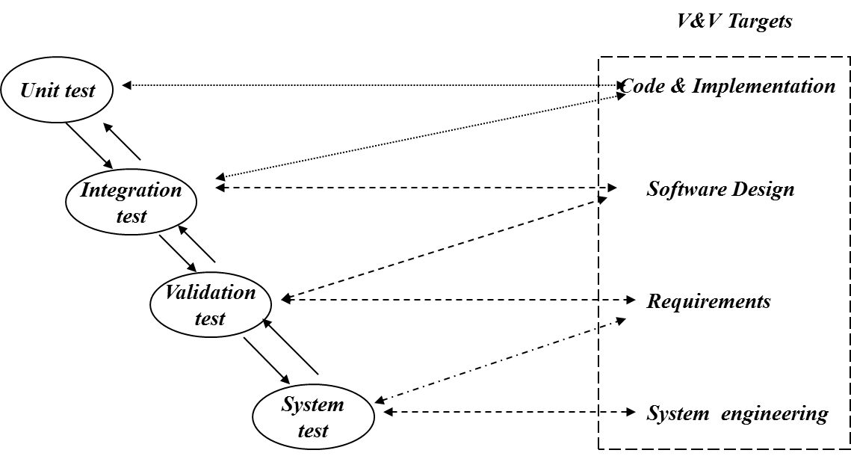
Unit Test (Component Level Test)
Unit testing: Individual components are tested independently to ensure their quality. The focus is to uncover errors in design
and implementation, including:
- data structure in a component
- program logic and program structure in a component
- component interface
- functions and operations of a component
Unit testers: developers of the components.
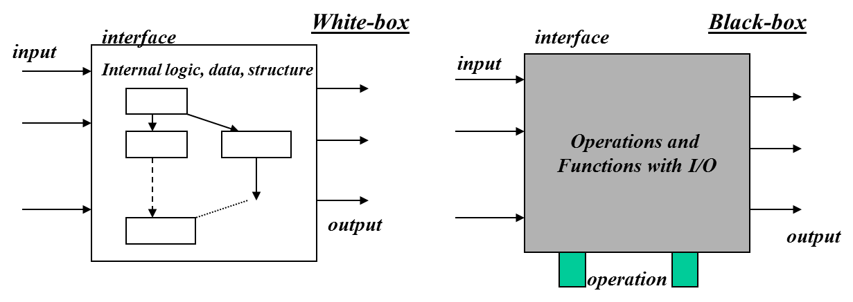
Integration Testing
Integration test: A group of dependent components are tested together to ensure their the quality of their integration unit.
The focus is to uncover errors in:
- Design and construction of software architecture
- Integrated functions or operations at sub-system level
- Interfaces and interactions between them
- Resource integration and/or environment integration
Integration testers: either developers and/or test engineers.
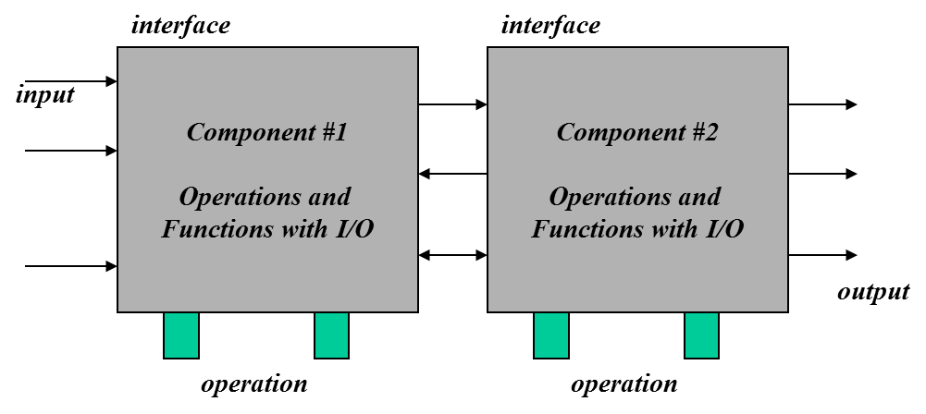
Function Validation Testing
Validation test: The integrated software is tested based on requirements to ensure that we have a right product.
The focus is to uncover errors in:
- System input/output
- System functions and information data
- System interfaces with external parts
- User interfaces
- System behavior and performance
Validation testers: test engineers in ITG or SQA people.
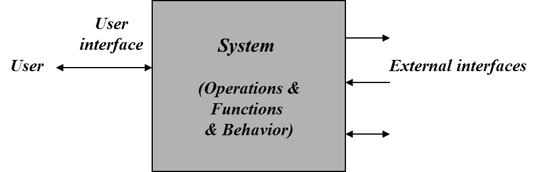
System Testing
System test: The system software is tested as a whole. It verifies all
elements mesh properly to make sure that all system functions and performance are achieved in the target environment.

The focus areas are:
- System functions and performance
- System reliability and recoverability (recovery test)
- System installation (installation test)
- System behavior in the special conditions
- (stress and load test)
- System user operations (acceptance test/alpha test)
- Hardware and software integration and collaboration
- Integration of external software and the system
System testers: test engineers in ITG or SQA people.
When a system is to be marketed as a software product, a testing process called
- beta testing is often used.

Test Issues in Real World
Software testing is very expensive.
How to achieve test automation?????
When should we stop software testing?
Test criteria, test coverage, adequate testing.
Other software testing:
- GUI Testing
- Object-Oriented Software Testing
- Component Testing and Component-based Software Testing
- Domain-specific Feature Testing
- Testing Web-based Systems

Summary of Today’s Lecture
- In today’s lecture, we explored what quality is and why it is important in the life cycle of a software.
- We explored different types of testing such as white box, black box, unit, integration and system testing.
Overview of Next lecture
- Our discussion on testing will continue. We will see more details about software testing and how it achieves software quality.
The End

