Software Quality Engineering
Lecture No. 8
Summary of the previous lecture
- More on:
- Quality concepts
- Quality control
- Cost of Quality
- Statistical Quality Assurance
- The SQA Plan
Part- 2 (a):
Software Testing
Outlines
- What is testing
- Why testing is needed
- History of testing
- White box testing
- Black box testing
Objectives
- To understand the basics of Testing
- To be able to distinguish between black box testing and white box testing
Software Testing
- “Testing is the process of executing a program with the intention of finding errors.”
- “Testing can show the presence of bugs but never their absence.”
Objective Testing
- Uncover as many as error(or bug) as possible in a given produce.
- Demonstrate a given software product matching its requirement specification.
- Validate the quality of a software testing using the minimum cost and effort.
- Generate high quality test case, perform effective test and issue correct and helpful problem report.
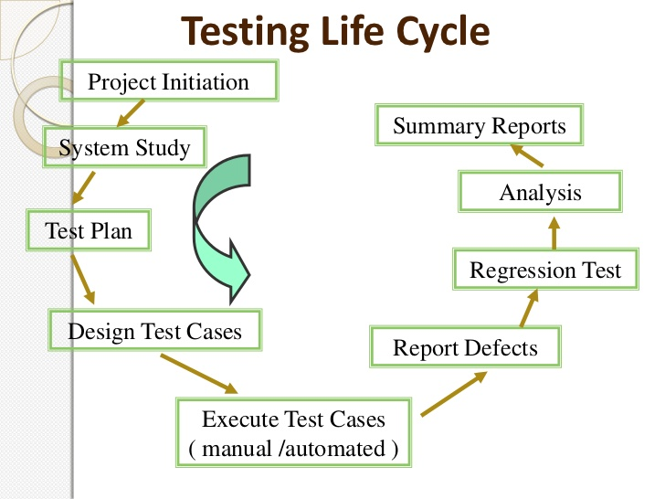

DEVELOPMENT PROCESS EVOLUTION
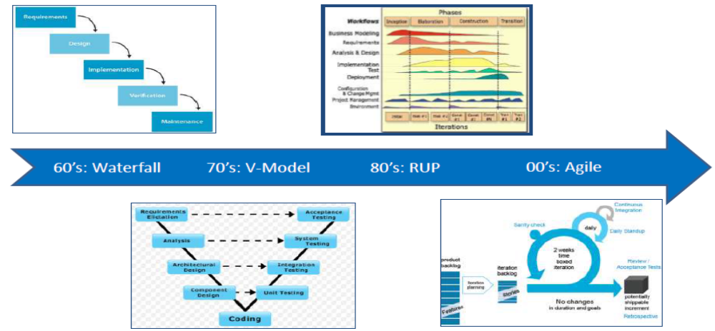
How Testing Has Changed
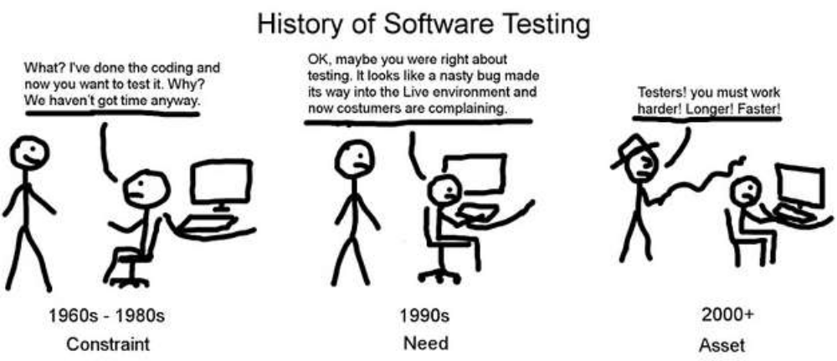
What? I have done the coding and now you want to test it? Why? We have not got time anyway
OK. May be you were right about testing. It looks like a nasty bug made its way into Live environment and now customers are complaining
Testers! You must work harder! Longer! Fasters!
History of Software Testing
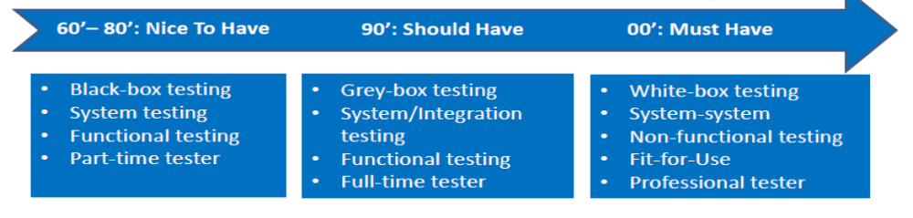
Phases in Testing
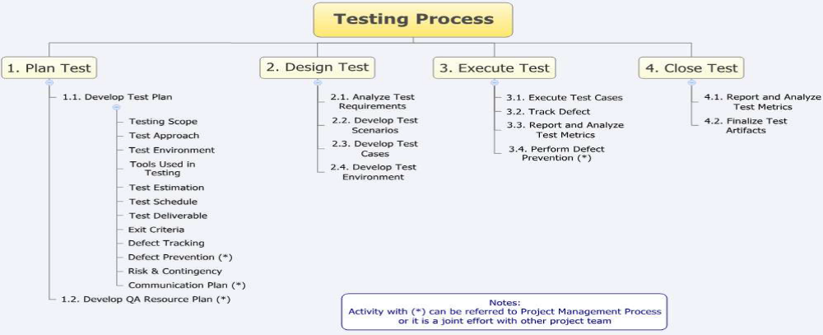
Testing Methology
- BLACK BOX TESTING
- WHITE BOX TESTING
Black Box Testing
- No knowledge of internal program design or code required
- Testing are based on requirement and functionality
Software is considered as a Black Box
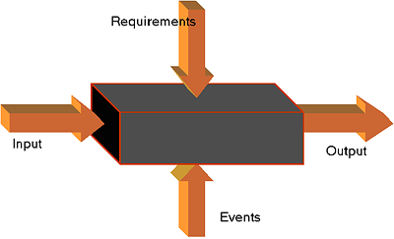
WHITE BOX TESTING
- Knowledge of the internal program design and code required.
- Test are based on coverage of code statement,branches,path,condition.
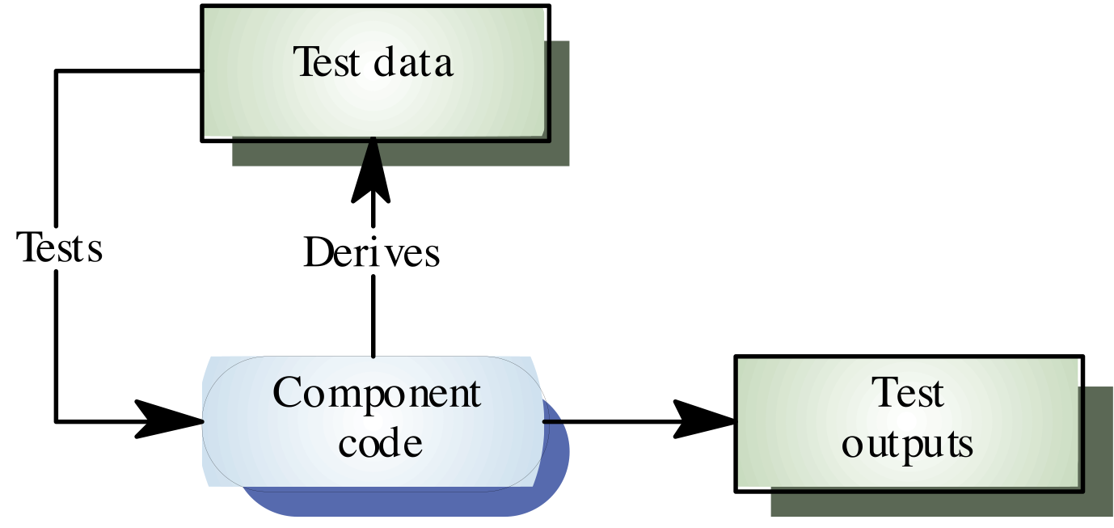
LEVEL OF TESTING
- Unit testing
- Integration testing
- System testing
UNIT TESTING
- Test each module individually.
- Follows a white box testing.
INTEGRATION TESTING
- Once all modules have been tested, integration testing is perform.
- It is systematic testing
- Produce test to identify errors associated with interfacing.
- TYPES:-
  - Big bang integration testing
  - Top down integration testing
  - Bottom up integration testing
  - Mixed integration testing
System Testing
- This system as a whole is tested to uncover requirement errors.
- Verifies that all system element work properly and that overall system function and performance has been achieved.
TYPES:-
- Alfa testing
- Beta testing
- Acceptance testing
- Performance testing
Summary of Today’s Lecture
- In today’s lecture, we explored what quality is and why it is important in the life cycle of a software.
- We explored different types of testing such as white box, black box, unit, integration and system testing.
Overview of Next lecture
- Our discussion on Testing will continue and we will explore some challenges associated with testing in real life
- We will explore further unit, integration and system testing in details
The End

