Lecture No. 6
Part- 1
Overview and Basics
Summary of the previous lecture
- QA to SQE
- Key SQE Activities
- SQE in Software Process
- SQE and QIP (quality improvement paradigm)
Outlines
- SQE: Software Quality Engineering
- Key SQE Activities
- SQE in Software Process
Objectives
- To understand SQE in software process
- To understand and distinguish between SQE activities
QA to SQE
QA activities need additional support:
- Planning and goal setting
- Management:
- when to stop?
- adjustment and improvement, etc.
- all based on assessments/predictions
Assessment of quality/reliability/etc.:
- Data collection needed
- Analysis and modeling
- Providing feedback for management
QA + above ⇒ software quality engineering (SQE)
SQE Process
Quality Engineering Process
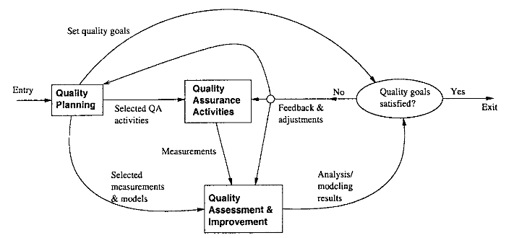

SQE Process
SQE process to link major SQE activities:
Pre-QA planning;
QA: covered previously (Lecture 4 and 5);
Post-QA analysis and feedback
(maybe parallel instead of “post-”)
SQE and QIP
QIP (quality improvement paradigm):
- Step 1: understand baseline
- Step 2: change then assess impact
- Step 3: package for improvement
SQE and QIP
QIP support:
- overall support: experience factory
- measurement/analysis: GQM (goal-question-metric paradigm)
SQE as expanding QA to include QIP ideas
Pre-QA Planning
Pre-QA planning:
- Quality goal
- Overall QA strategy:
- QA activities to perform?
- measurement/feedback planning
Setting quality goal(s):
- Identify quality views/attributes
- Select direct quality measurements
- Assess quality expectations vs. cost
Setting Quality Goals
Identify quality views/attributes
- customer/user expectations,
- market condition,
- product type, etc.
Select direct quality measurements
- direct: reliability
- defect-based measurement
- other measurements
Assess quality expectations vs. cost
- cost-of-quality/defect studies
- economic models: COCOMO etc
Forming QA Strategy
- QA activity planning
- evaluate individual QA alternatives
- strength/weakness/cost/applicability/etc.
- match against goals
- integration/cost considerations
Measurement/feedback planning:
- define measurements (defect & others)
- planning to collect data
- preliminary choices of models/analyses
- feedback & follow-up mechanisms, etc.
Measurement Analysis and Feedback
Measurement:
- defect measurement as part of defect handling process
- other data and historical baselines
Analyses: quality/other models
- input: above data
- output/goal: feedback and follow-up
- focus on defect/risk/reliability analyses
Feedback and follow-up:
- frequent feedback: assessments/predictions
- possible improvement areas
- project management and improvement
SQE in Software Processes
SQE activities ⊂ development activities:
- quality planning ⊂ product planning
- QA activities ⊂ development activities
- analysis/feedback ⊂ project management
Fitting SQE in software processes:
- different start/end time
- different sets of activities, sub-activities, and focuses
- In waterfall process: more staged (planning, execution, analysis/feedback)
- In other processes: more iterative or other variations
Quality engineering in the waterfall process
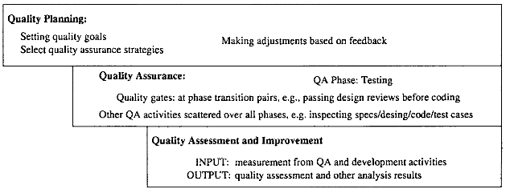
Quality engineering in the waterfall process
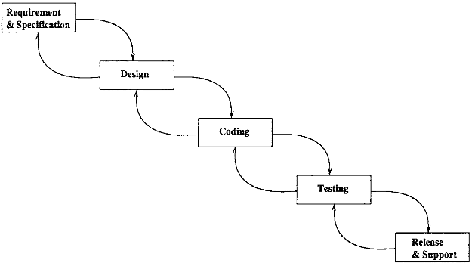
SQE Effort Profile
QE activity/effort distribution/dynamics:
- different focus in different phases
- different levels (qualitatively)
- different build-up/wind-down patterns
- impact of product release deadline (deadline-driven activities)
- planning: front heavy
- QA: activity mix (early vs. late; peak variability? deadline?)
- analysis/feedback: tail heavy (often deadline-driven or decision-driven)
SQE Effort in Waterfall Process
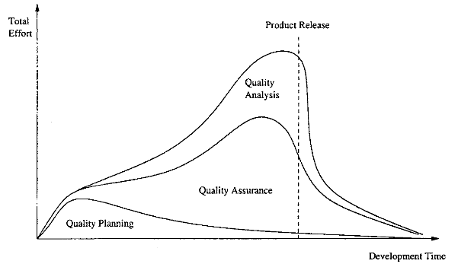
Quality engineering effort profile: The share of different activities as part of the total effort
SQE Effort in Waterfall Process
- Effort profile
- planning/QA/analysis of total effort
- general shape/pattern only (actually data would not be as smooth)
- in other processes: – similar but more evenly distributed
Summary of Today’s Lecture
- In today’s lecture, we explored Key SQE Activities
- We also discussed SQE in Software Process such as waterfall
Overview of Next lecture
- We will move to the last lecture of Part-I
- We will explore some more expects that leads to or are helpful in SQE
The End

