Lecture No. 5
Part- 1
Overview and Basics
Summary of the previous lecture
- QA Classification
- Overview
- Defect prevention
- Testing
- Fault
- Safety
Outlines
- QA Context
- Quality in software processes
- V & V View
- DC View
- QA: Defect View vs V&V View
Objectives
- To understand and distinguish between V&V-view and DC-view of SQE
Quality Assurance in Context
QA and the overall development context
- defect handling/resolution
- activities in process
- alternative perspectives: verification/validation (V&V) view
Defect handling/resolution
- status and tracking
- causal (root-cause) analysis
- Resolution: defect removal/etc.
- improvement: break causal chain
Defect Measurement and Analysis
Defect measurement: .
- parallel to defect handling
- where injected/found?
- type/severity/impact?
- more detailed classification possible?
- consistent interpretation
- timely defect reporting
Defect analyses/quality models
- as follow-up to defect handling
- data and historical baselines
- goal: assessment/prediction/improvement
- causal/risk/reliability/etc. analyses
QA in Software Processes
Mega-process:
- initiation, development, maintenance, termination.
Development process components:
- requirement, specification, design, coding, testing, release.
QA in software Process
Process variations:
- waterfall development process
- iterative development process
- spiral development process
- lightweight/agile development processes and XP (extreme programming)
- maintenance process too
- mixed/synthesized/customized processes
- QA important in all processes
QA in Waterfall Process
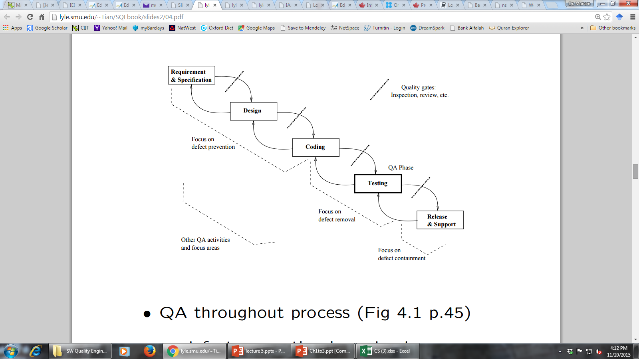

- Defect prevention in early phases . focused defect removal in testing phase . defect containment in late phases . phase transitions: inspection/review/etc
QA in software Processes
Process variations (¬ waterfall) and QA:
- iterative: QA in iterations/increments
- spiral: QA and risk management
- XP: test-driven development
- mixed/synthesized: case specific
- more evenly distributed QA activities
QA in maintenance processes:
- focus on defect handling;
- some defect containment activities for critical or highly-dependable systems;
- data for future QA activities •
- QA scattered throughout all processes
V & V
Core QA activities grouped into V&V
Validation: w.r.t. requirement (what?)
- appropriate/fit-for-use/“right thing”?
- scenario and usage inspection/testing;
- system/integration/acceptance testing;
- beta testing and operational support.
Verification: w.r.t. specification/design (how?)
- correct/“doing things right”?
- design as specification for components;
- structural and functional testing;
- inspections and formal verification.
V&V in Software Process
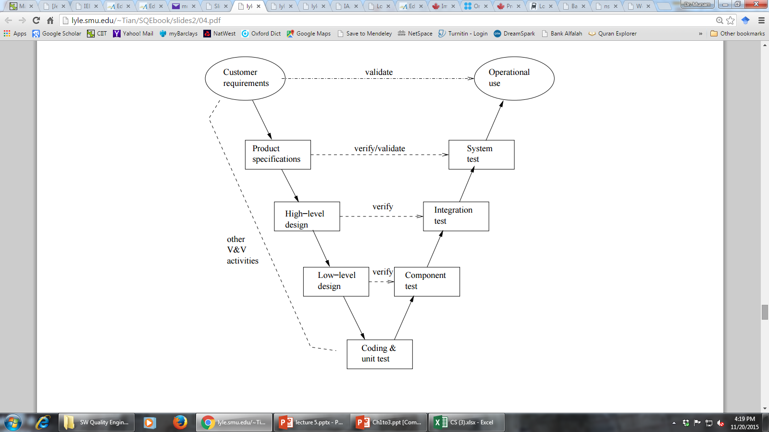
V & V
V-model
V&V in Software Process
- V-model as bent-over waterfall .
- left-arm: implementation (& V&V)
- right-arm: testing (& V&V)
- user@top vs. developer@bottom
V&V vs DC View
Two views of QA:
- V&V view
- DC (defect-centered)
- Interconnected: mapping possible?
V&V vs DC View
- Mapping between V&V and DC view:
- V&V after commitment (defect injected already) ⇒ defect removal & containment focus
- Verification: more internal focus
- Validation: more external focus
- In V-model: closer to user (near top) or developer (near bottom)?
DC-V&V Mapping
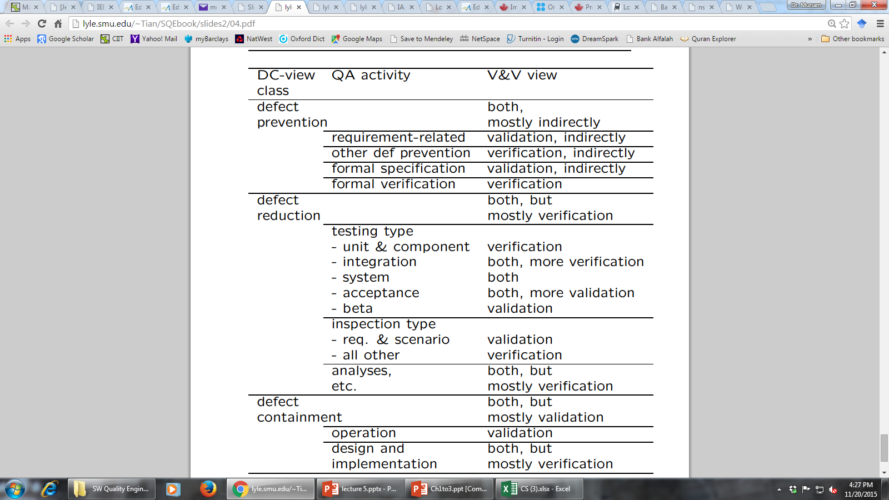

Summary of Today’s Lecture
- QA in Software Processes
- We explored some V & V model
- We compared and contrasted V & V and DC views
Overview of Next lecture
- QA to SQE
- Key SQE Activities
- SQE in Software Process
- SQE and QIP (quality improvement paradigm)
The End

