LECTURE 4
Part-1
Overview and Basics
Summary of the previous lecture
- ISO-9126 Quality Framework
- Other Quality Frameworks
- Correctness, Defects and Quality
- Failure, Fault, error, bug, defect
- Quality, as a Historical Perspective
Summary of the previous lecture
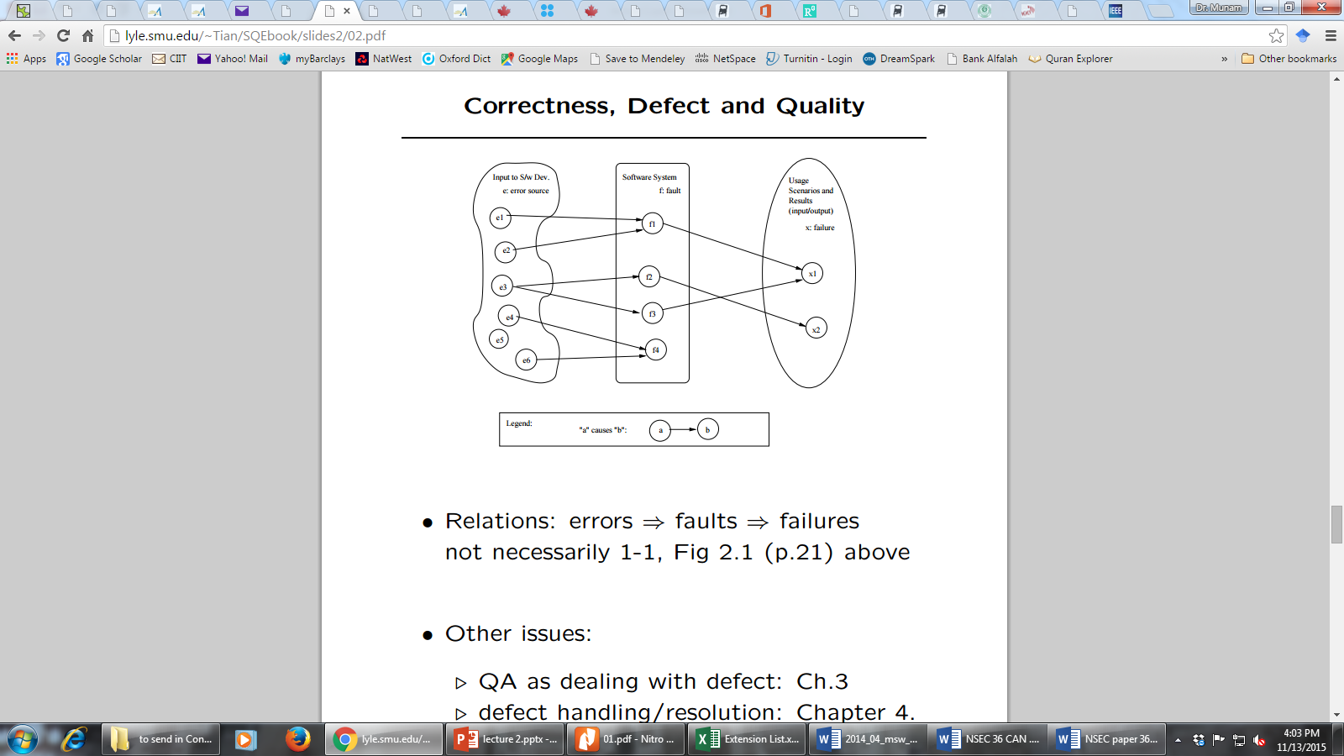
Outlines
QA Classification
Overview
- Defect prevention
- Testing
- Fault
- Safety
Objectives
To describe how to prevent and stop defects
To briefly overview some concepts related to SQE
Quality Assurance
Quality Assurance mainly deals in
    - Dealing with Defect
    - Defect Prevention
    - Defect Detection and Removal
- QA focus on correctness aspect of Q
- QA as dealing with defects
  - – post-release: impact on consumers
  - – pre-release: what producer can do .
- what: testing & many others
- when: earlier ones desirable (lower cost) but may not be feasible
- how ⇒ classification below
How to deal with defects
Quality Assurance mainly deals in
    - Prevention
    - Removal (but detect them first)
    - Containment (control)
QA Classification
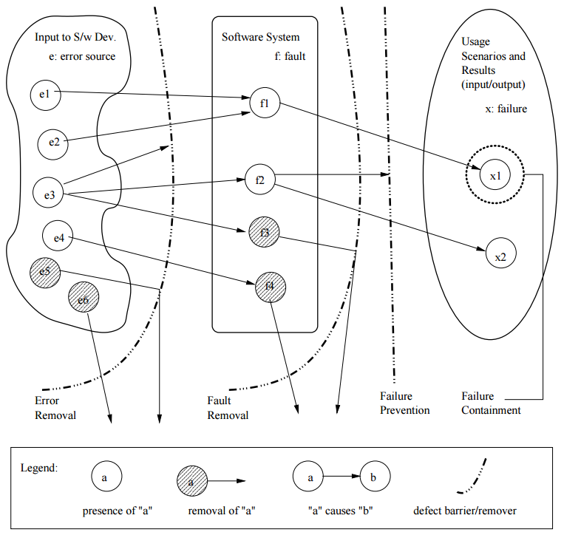
Dealing with errors, faults, or failures
Removing or blocking defect sources
Preventing undesirable consequences
Error/Fault/Failure & QA
Preventing fault injection
- error blocking (errors 6⇒ faults)
- error source removal
Removal of faults (pre: detection)
- inspection: faults discovered/removed
- testing: failures trace back to faults
Failure prevention and containment:
- local failure 6⇒ global failure – via dynamic measures to tolerate faults
- failure impact↓ ⇒ safety assurance
Overview of some topics related to SQE
We will briefly overview the following
- Detect Prevention Overview
- Testing Overview
- Fault Tolerance Overview
- Safety Assurance Overview
- Formal Method Overview
- Inspection Overview
Defect Prevention Overview
Error blocking
- error: missing/incorrect actions .
- direct intervention to block errors ⇒ fault injections prevented
- rely on technology/tools/etc.
Error source removal .
- root cause analysis ⇒ identify error sources
- removal through education/training/etc.
- Systematic defect prevention via process improvement.
Formal Method Overview
Motivation .
- fault present: – revealed through testing/inspection/etc.
- fault absent: formally verify. (formal methods ⇒ fault absent)
Basic ideas .
- behavior formally specified:
- pre/post conditions, or
- as mathematical functions. .
- verify “correctness”: – intermediate states/steps, – axioms and compositional rules. .
- Approaches: axiomatic/functional/etc.
Inspection Overview
Artifacts (code/design/test-cases/etc.) from req./design/coding/testing/etc. phases. •
Informal reviews:
- self-conducted reviews.
- independent reviews.
- orthogonality of views desirable. •
- Formal inspections: .
- Fagan inspection and variations. .
- process and structure. .
- individual vs. group inspections. .
- what/how to check: techniques
Testing Overview
Product/Process characteristics:
- object: product type, language, etc.
- scale/order: unit, component, system, who: self, independent, 3rd party
What to check:
- verification vs. validation
- external specifications (black-box) .
- internal implementation (white/clear-box)
Criteria: when to stop?
- coverage of specs/structures. .
- reliability ⇒ usage-based testing
Fault Tolerance Overview
Motivation .
- fault present but removal infeasible/impractical
- fault tolerance ⇒ contain defects
FT techniques: break fault-failure link
- recovery: rollback and redo
- NVP: N-version programming – fault blocked/out-voted
Safety Assurance Overview
Extending FT idea for safety:
- fault tolerance to failure “tolerance”
Safety related concepts:
- safety: accident free .
- accident: failure w/ severe consequences
- hazard: precondition to accident
Safety assurance:.
- hazard analysis
- hazard elimination/reduction/control
- damage control
Summary of Today’s Lecture
We explored some standards of Quality Engineering
Furthermore, we briefly overviewed following
- Detect Prevention Overview
- Testing Overview
- Fault Tolerance Overview
- Safety Assurance Overview
- Formal Method Overview
- Inspection Overview
Overview of Next lecture
- Defect Handling
- QA in Software Processes
- V&V Perspective
- QA: Defect View vs. V&V View
The End

