Lecture 3
CSE302

Part-1
Overview and Basics
Summary of the previous lecture
- Meeting People’s Quality Expectations
- General Expectations
- Meeting Quality Expectations
- Internal Expectations / Consumer Expectations
- External Expectations / Producer Expectations
- Software Quality Engineering (SQE) activities
- Testing => Quality Assurance Alternatives => SQE
- Software Quality Framework
Outlines
- ISO-9126 Quality Framework
- Other Quality Frameworks
- Correctness, Defects and Quality
- Quality, as a Historical Perspective
- How to prevent defect
Objectives
- To describe the standards for quality engineering
- To understand and distinguish between correctness defect and quality and detection, prevention and removal
ISO-9126 Quality Framework
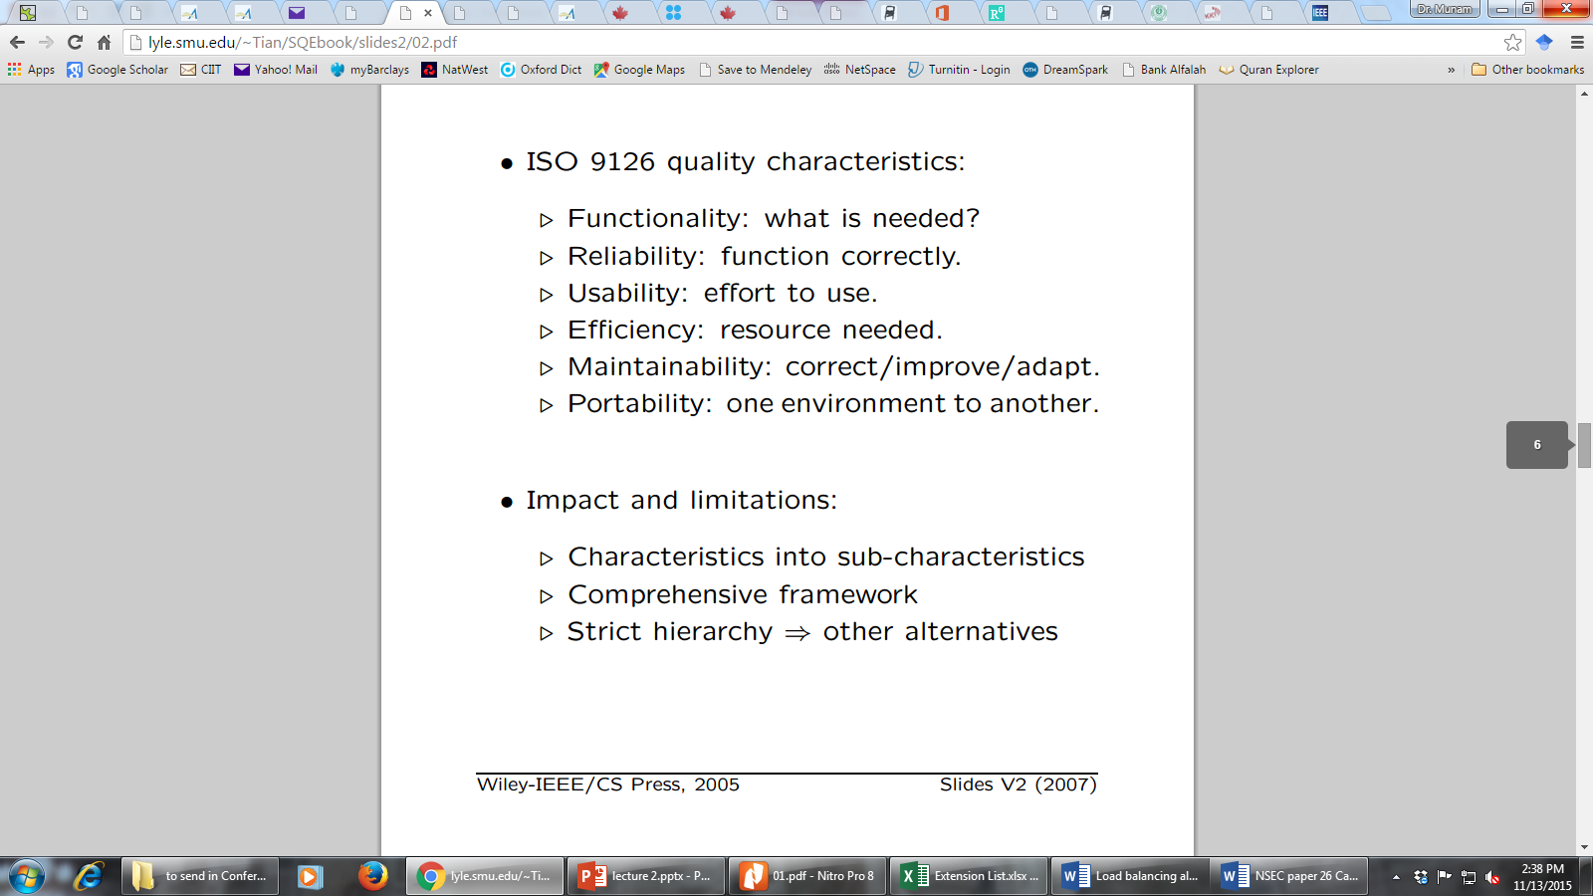
Other Quality Frameworks
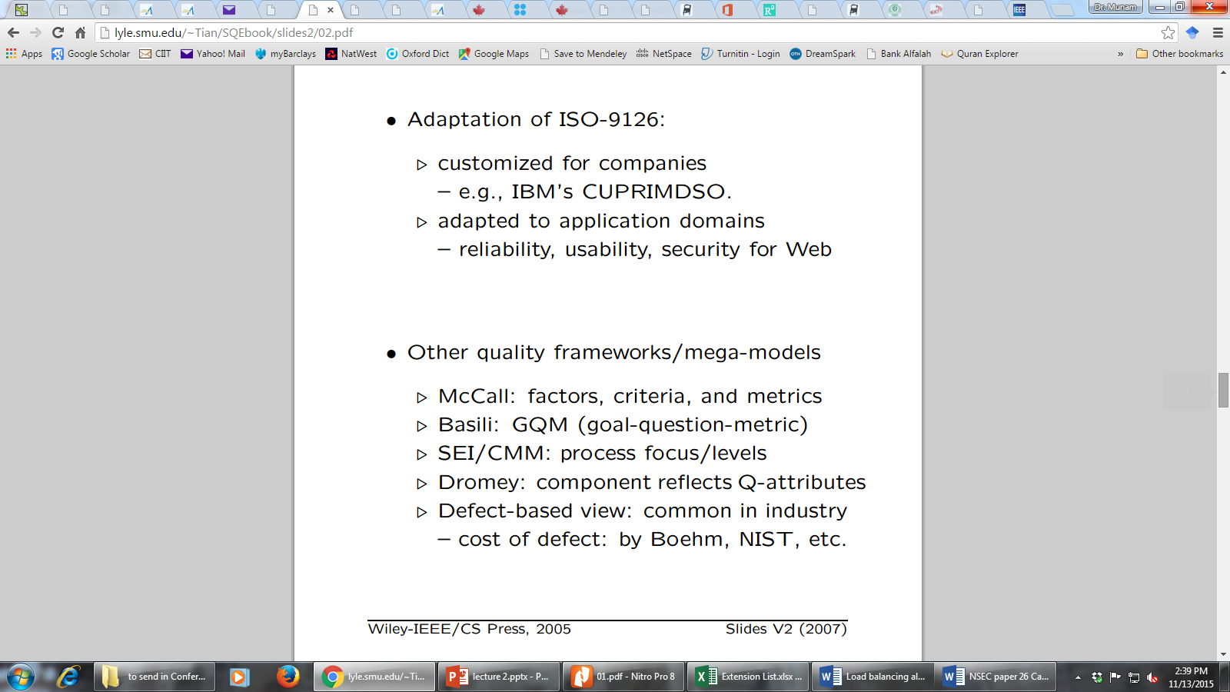

Correctness, Defect and Quality
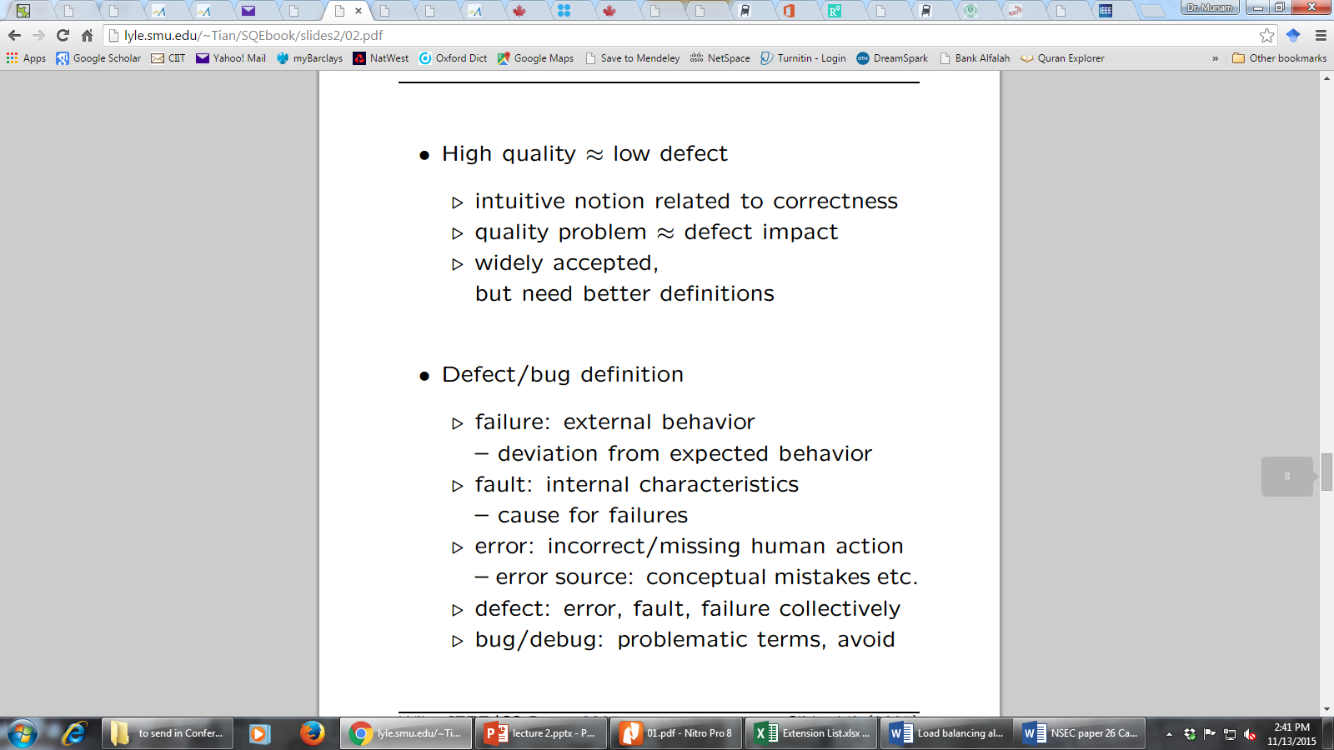
Correctness, Defect and Quality
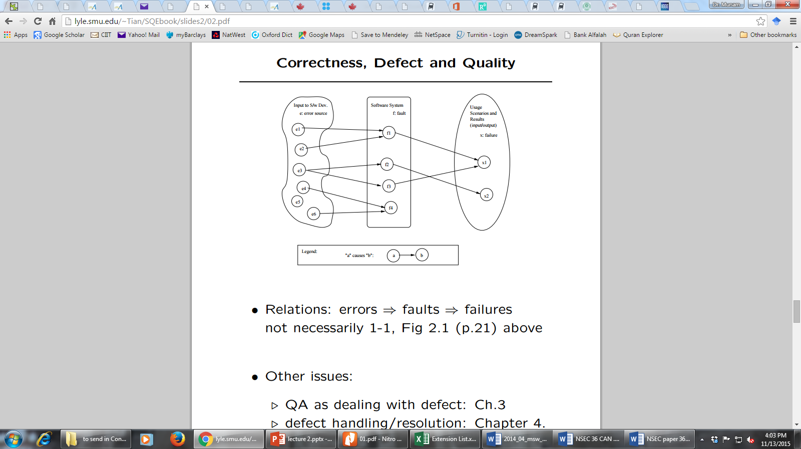

Defining Quality in SQE
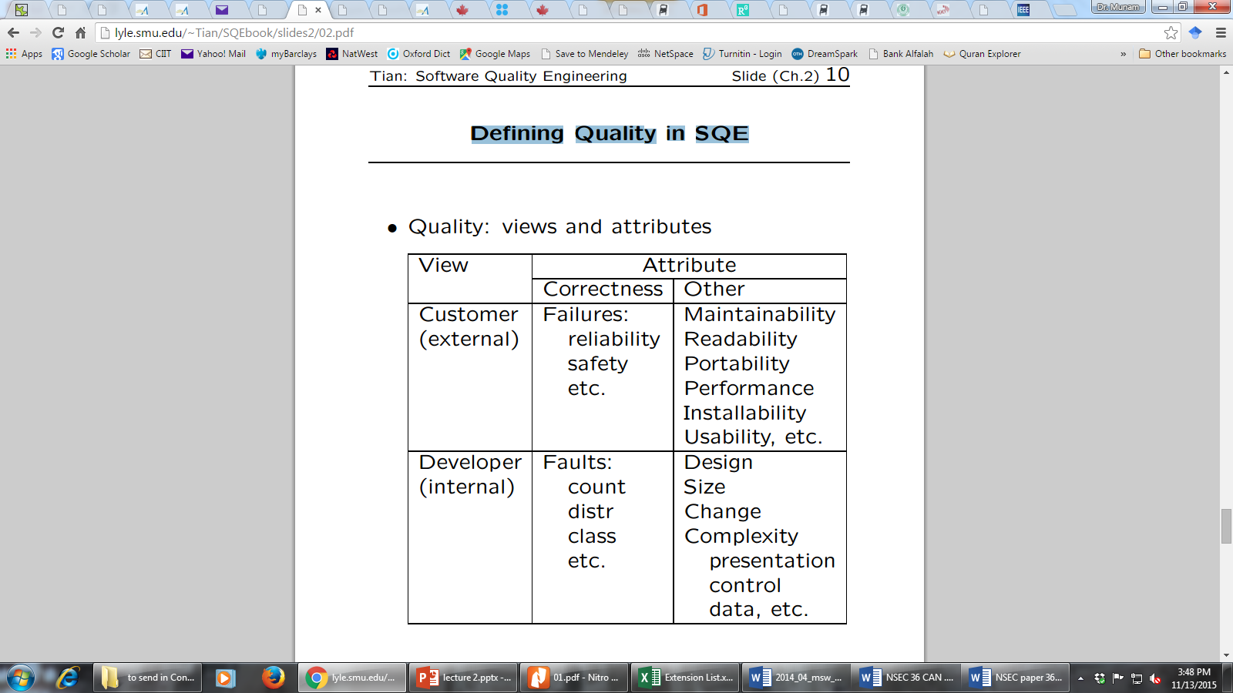
Quality: Historical Perspective
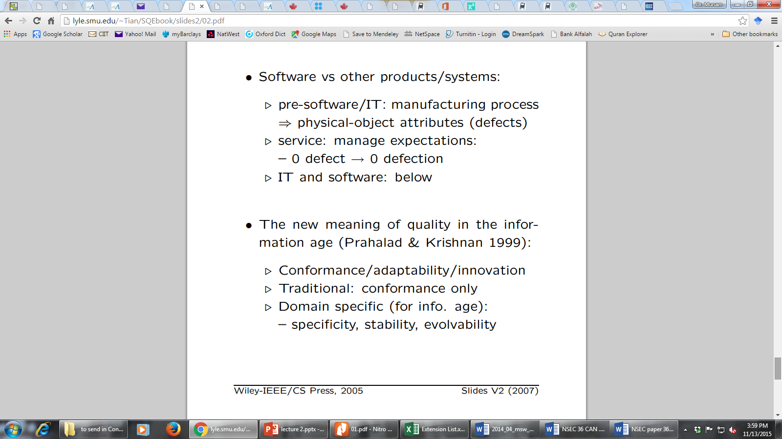

Quality: Historical Perspective (conti..)
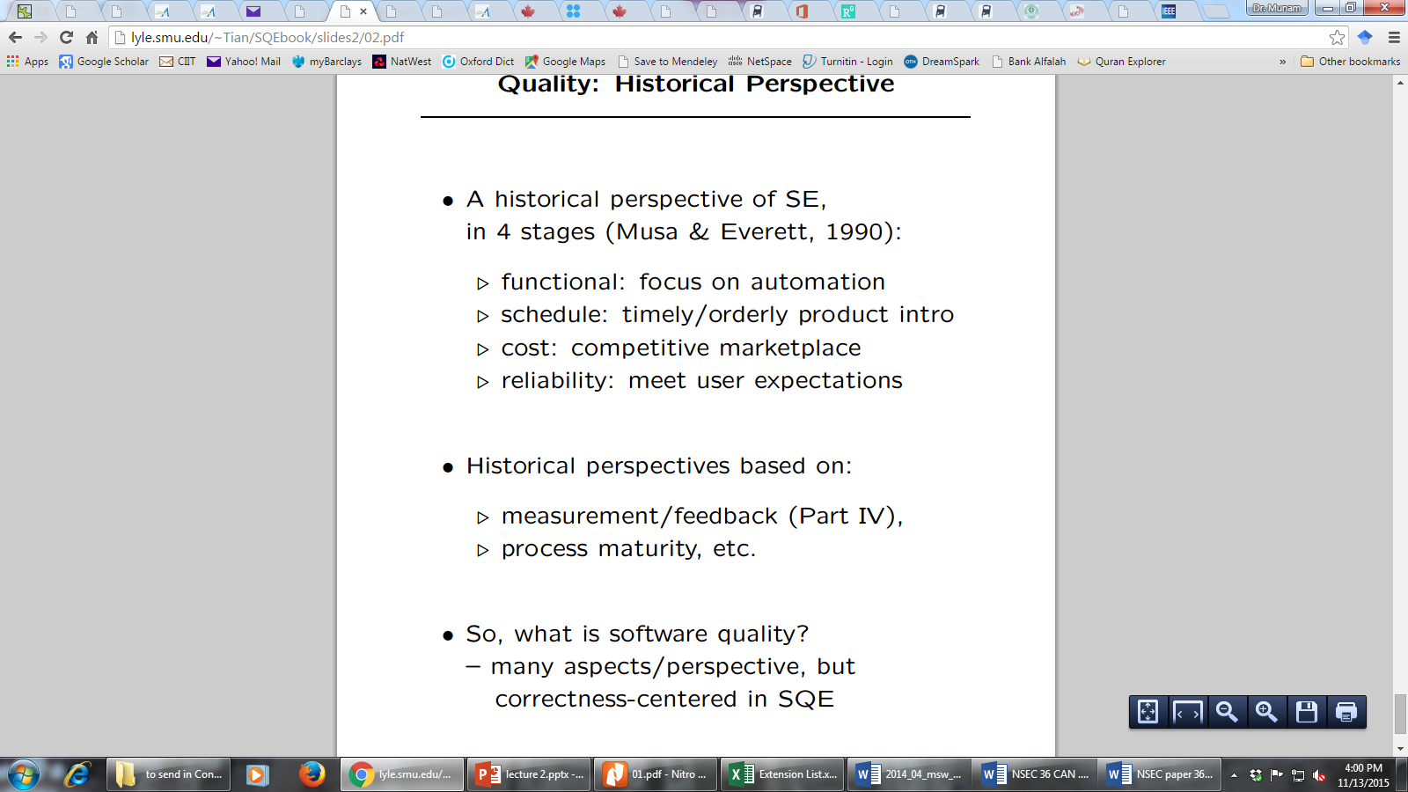
Quality Assurance
Quality Assurance mainly deals in
    - Dealing with Defect
    - Defect Prevention
    - Defect Detection and Removal
- QA focus on correctness aspect of Q
- QA as dealing with defects
  - – post-release: impact on consumers
  - – pre-release: what producer can do .
- what: testing & many others
- when: earlier ones desirable (lower cost) but may not be feasible
- how ⇒ classification below
How to deal with defects
Quality Assurance mainly deals in
    - Prevention
    - Removal (but detect them first)
    - Containment (control)
QA Classification
- dealing with errors, faults, or failures
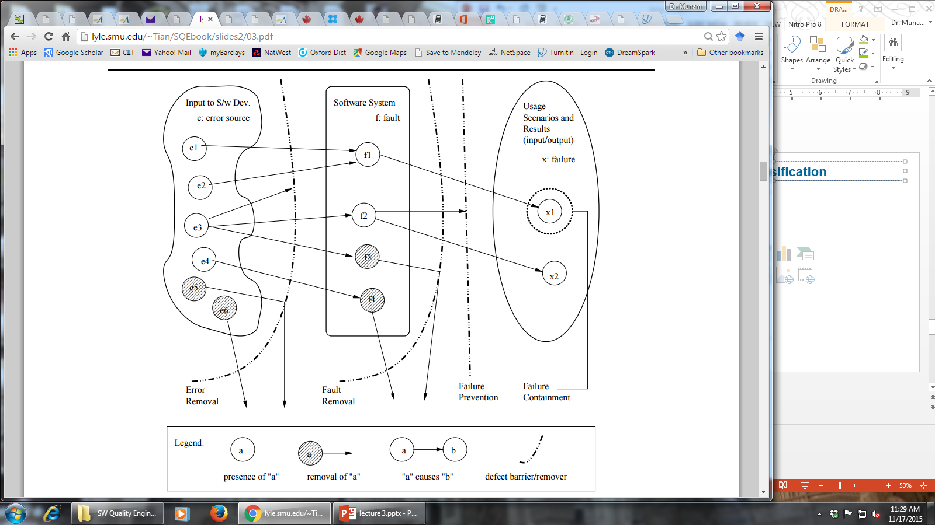
- removing or blocking defect sources
- preventing undesirable consequences
Error/Fault/Failure & QA
Preventing fault injection
- error blocking (errors 6⇒ faults)
- error source removal
Removal of faults (pre: detection)
- inspection: faults discovered/removed
- testing: failures trace back to faults
Failure prevention and containment:
- local failure 6⇒ global failure – via dynamic measures to tolerate faults
- failure impact↓ ⇒ safety assurance
Overview of some topics related to SQE
We will briefly overview the following
- Detect Prevention Overview
- Testing Overview
- Fault Tolerance Overview
- Safety Assurance Overview
- Formal Method Overview
- Inspection Overview
Defect Prevention Overview
Error blocking
- error: missing/incorrect actions .
- direct intervention to block errors ⇒ fault injections prevented
- rely on technology/tools/etc.
Error source removal .
- root cause analysis ⇒ identify error sources
- removal through education/training/etc.
- Systematic defect prevention via process improvement.
Formal Method Overview
Motivation .
- fault present: – revealed through testing/inspection/etc.
- fault absent: formally verify. (formal methods ⇒ fault absent)
Basic ideas .
- behavior formally specified:
– pre/post conditions, or
– as mathematical functions. .
- Verify “correctness”: – intermediate states/steps, – axioms and compositional rules.
- Approaches: axiomatic/functional/etc.
Inspection Overview
Artifacts (code/design/test-cases/etc.) from req./design/coding/testing/etc. phases. •
Informal reviews: .
- self-conducted reviews.
- independent reviews.
- orthogonality of views desirable.
Formal inspections:
- Fagan inspection and variations. .
- process and structure. .
- individual vs. group inspections. .
- what/how to check: techniques
Testing Overview
Product/Process characteristics: .
- object: product type, language, etc. .
- scale/order: unit, component, system, . . . .
- who: self, independent, 3rd party •
What to check: .
- Verification vs. validation.
- External specifications (black-box) .
- internal implementation (white/clear-box)
Criteria: when to stop? .
- Coverage of specs/structures. .
- reliability ⇒ usage-based testing
Fault Tolerance Overview
Motivation.
- Fault present but removal infeasible/impractical .
- fault tolerance ⇒ contain defects •
FT techniques: break fault-failure link
- Recovery: rollback and redo .
- NVP: N-version programming – fault blocked/out-voted
Safety Assurance Overview
Extending FT idea for safety:
- fault tolerance to failure “tolerance”.
Safety related concepts: .
- safety: accident free .
- accident: failure w/ severe consequences .
- hazard: precondition to accident
Safety assurance: .
- hazard analysis .
- hazard elimination/reduction/control .
- damage control
Summary of Today’s Lecture
- We explored some standards of Quality Engineering
- Furthermore, we briefly overviewed following
- Detect Prevention Overview
- Testing Overview
- Fault Tolerance Overview
- Safety Assurance Overview
- Formal Method Overview
- Inspection Overview
Overview of Next lecture
- Defect Handling
- QA in Software Processes
- V&V Perspective
- QA: Defect View vs V&V View
The End

