Software Quality Engineering
LECTURE 2
CSE302
Part - 1: Overview and Basics.
The main concepts that are discussed in this part are:
Overview. What is Quality? Quality Assurance, QA in Context, Quality Engineering and the Quality Challenge.

This part will be covered in
Lecture 1 to Lecture 7
Part-1
Overview and Basics
Summary of the previous lecture
What is a software?
Characteristics of a Software
What is Engineering?
What is difference between engineering, manufacturing and construction
What is Quality?
Outlines of today’s lecture
Meeting People’s Quality Expectations
General Expectations
Quality Expectations
Meeting Quality Expectations
Software Quality Engineering (SQE) activities
Objectives
To describe the basics of what is expected as quality
To understand and distinguish between people expectations and software quality expectations.
Meeting People’s Quality Expectations
As we previously discussed, if people’s expectations are met in any product, then the product is supposed to have quality in it.
Must perform expected behavior.
General Expectations
General expectation: “good” software quality
Objects of our study: software
- software products, systems, and services
- stand-alone to embedded
- software-intensive systems
- wide variety, but focus on software
• Quality (and how “good”) formally defined in Ch.2
Quality Expectations
People: Consumers vs producers.
- quality expectations by consumers
- to be satisfied by producers through software quality engineering (SQE)
Deliver software system that:
- does what it is supposed to do –
- needs to be “validated” .
- does the things correctly
- needs to be “verified” .
- show/demonstrate/prove it (“does”) – modeling/analysis needed
Meeting Quality Expectations
Difficulties in achieving good quality:
- size: MLOC products common
- Complexity
- environmental stress/constraints
- flexibility/adaptability expected
Other difficulties/factors:
- product type
- cost and market conditions
Major SQE Activities
Major SQE Activities:
- Testing: MLOC products common
- Other quality assurance alternatives to testing
- How do you know: analysis & modeling
Scope and content hierarchy:
Software Quality Engineering
Quality Assurance
Testing

- Perspectives and Expectations
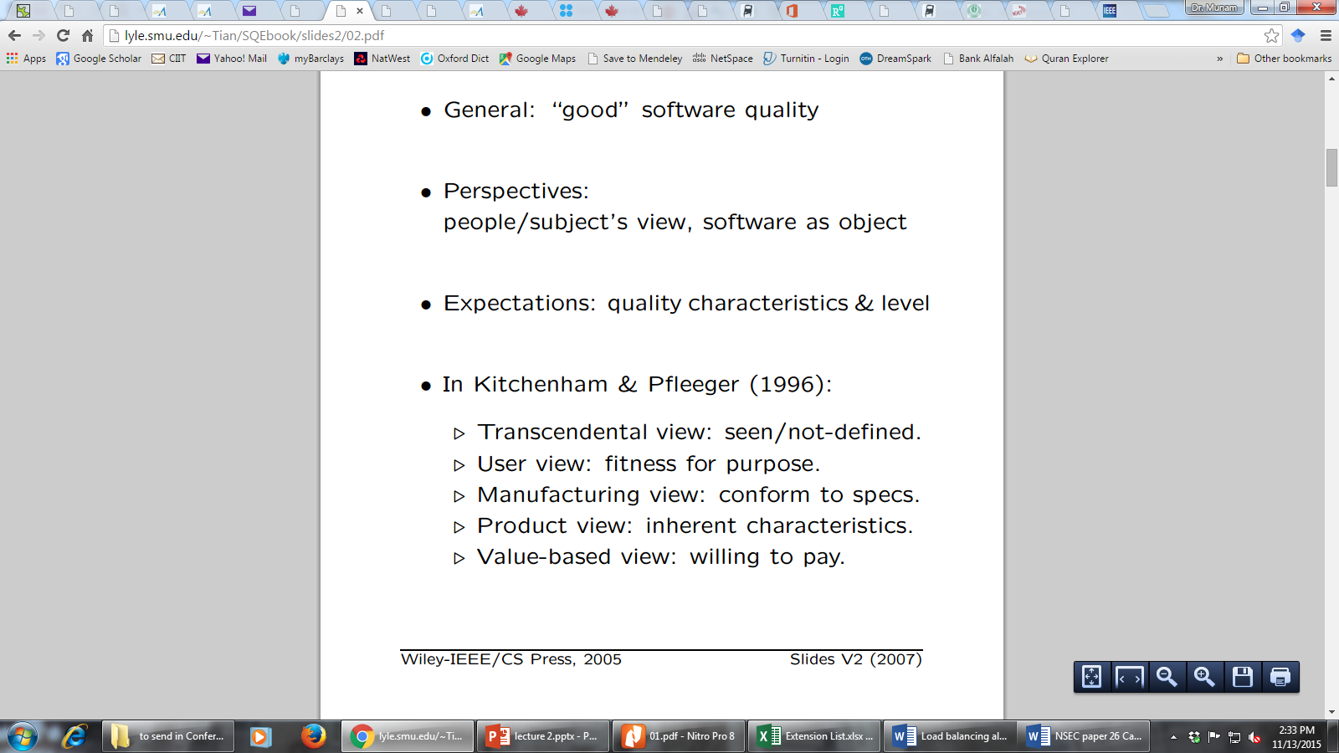
- Quality Perspective
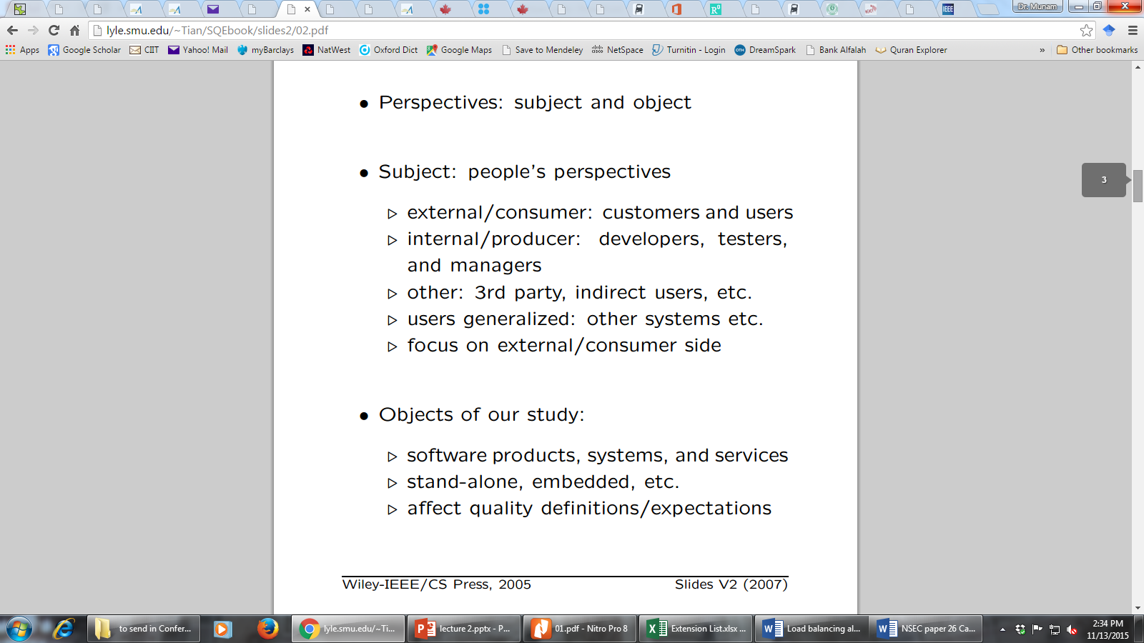

- Quality Expectations
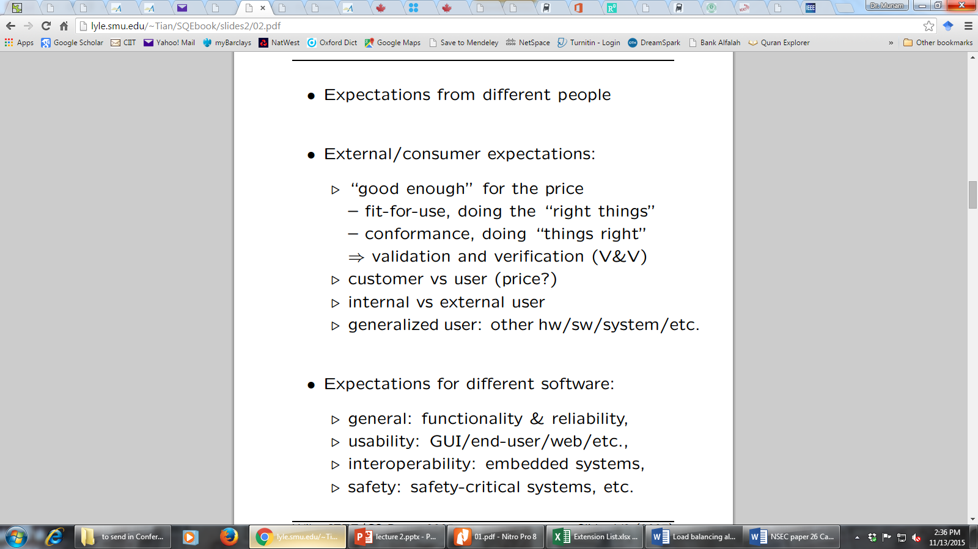

- Quality Expectations (conti..)

ISO-9126 Quality Framework
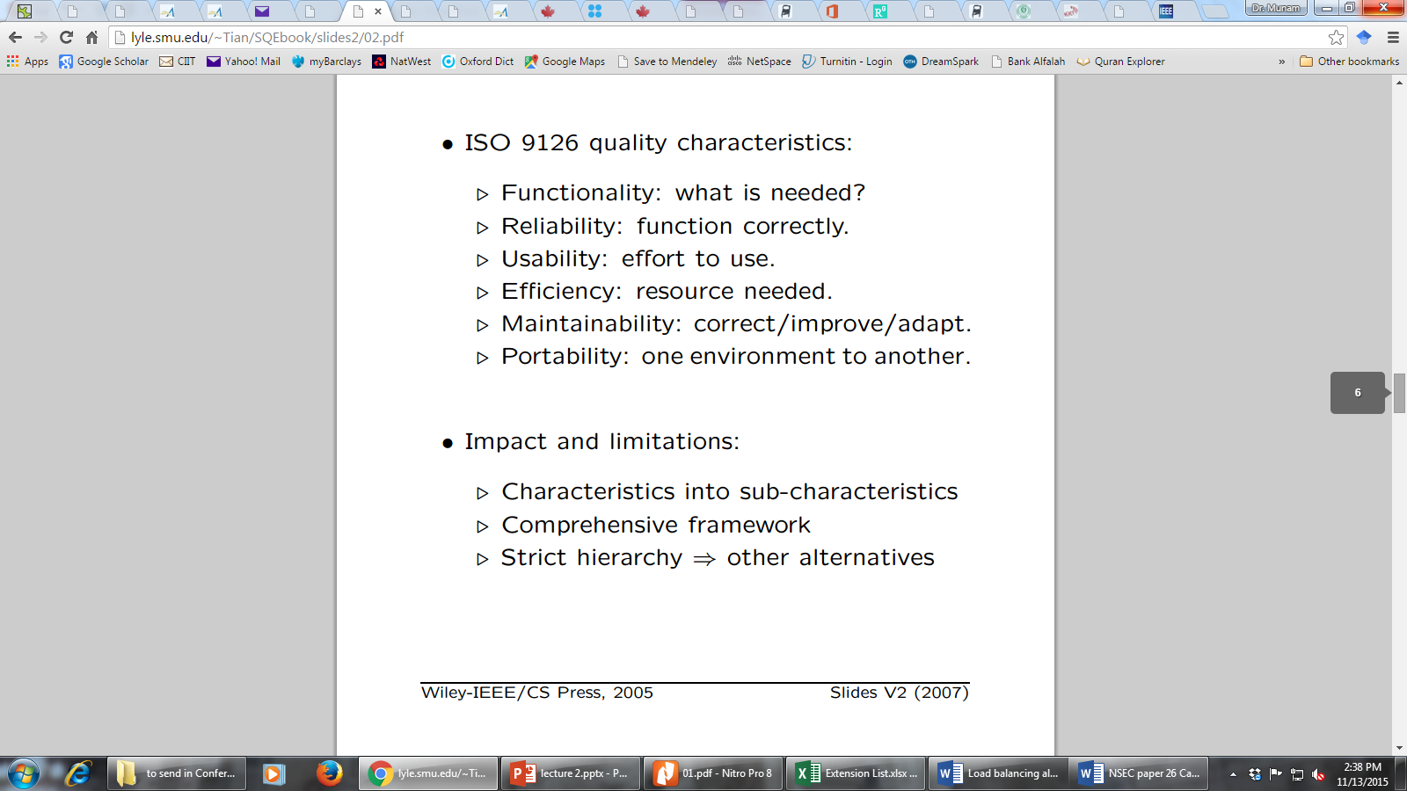
Other Quality Frameworks
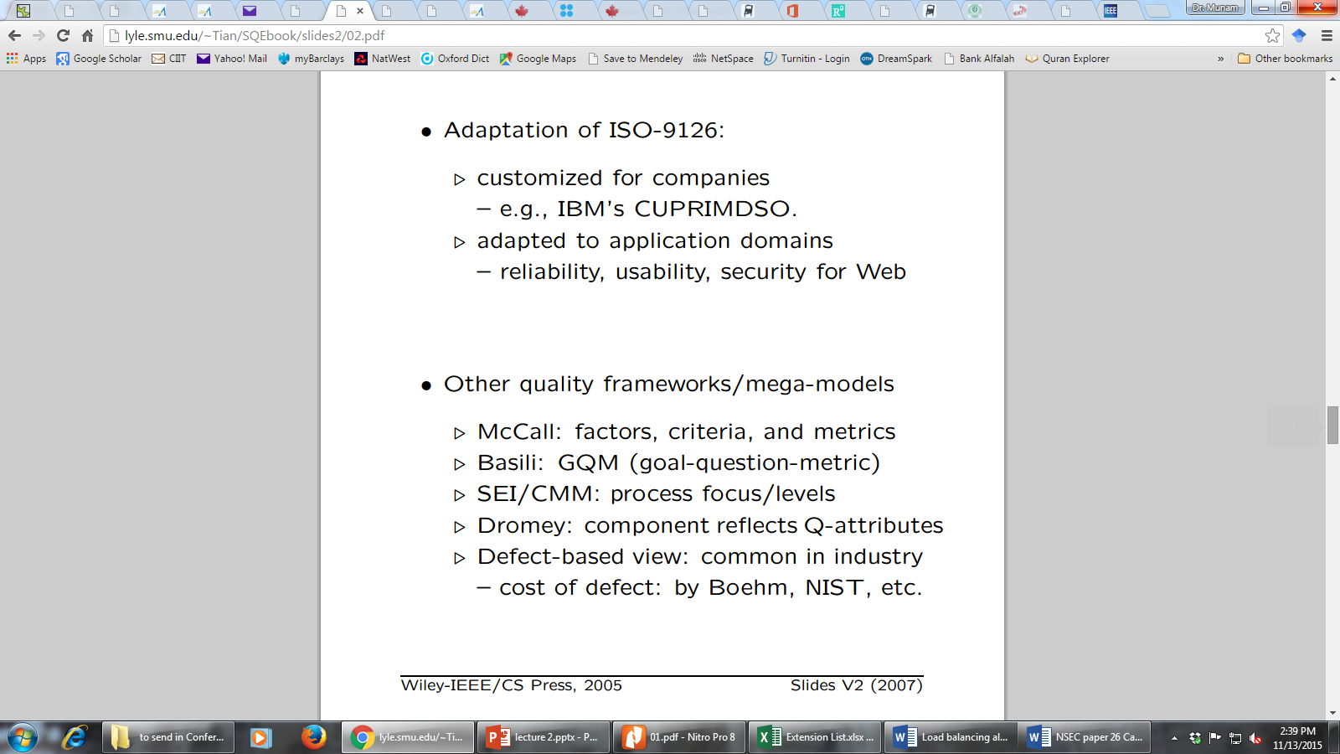
Correctness, Defect and Quality
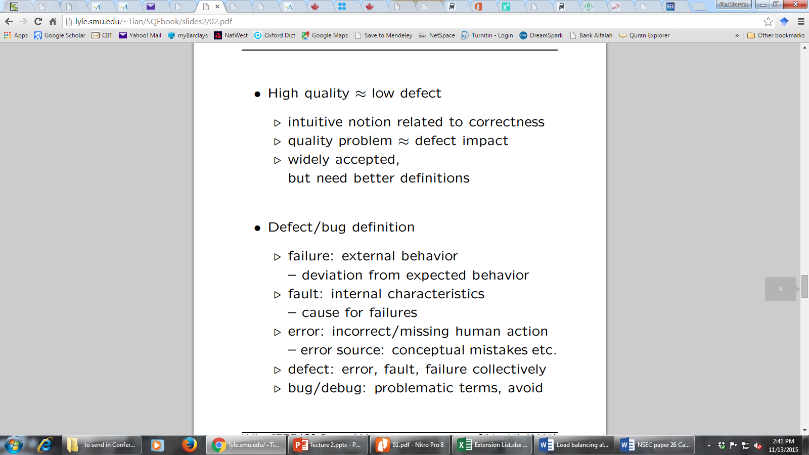
Correctness, Defect and Quality
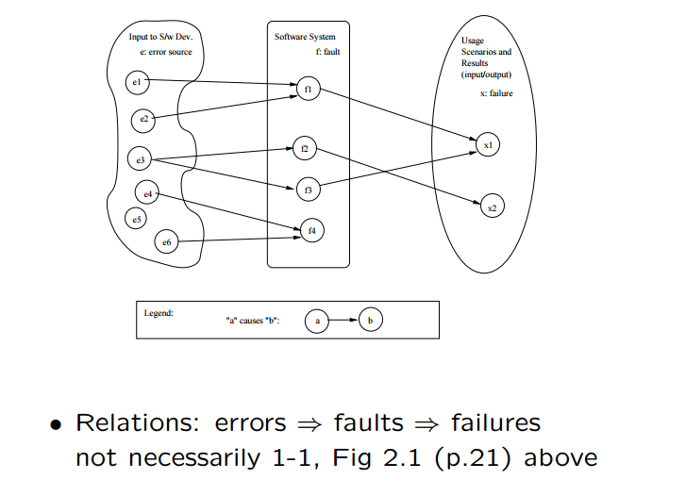
Defining Quality in SQE
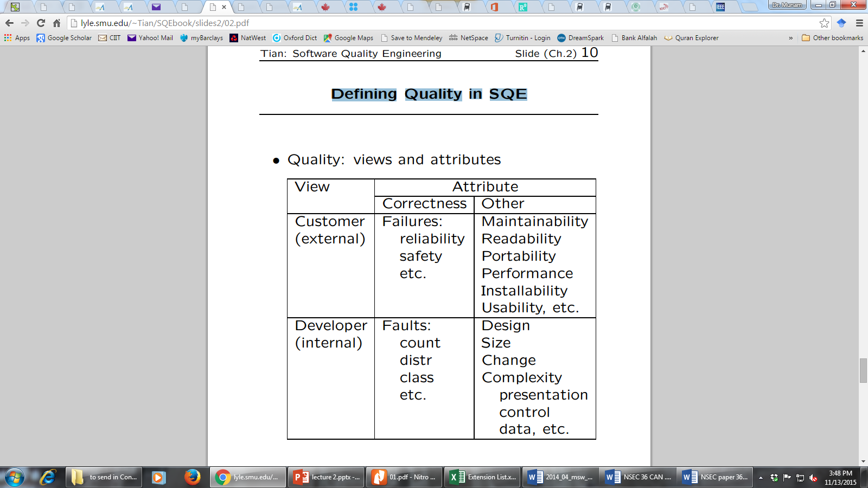
Quality: Historical Perspective
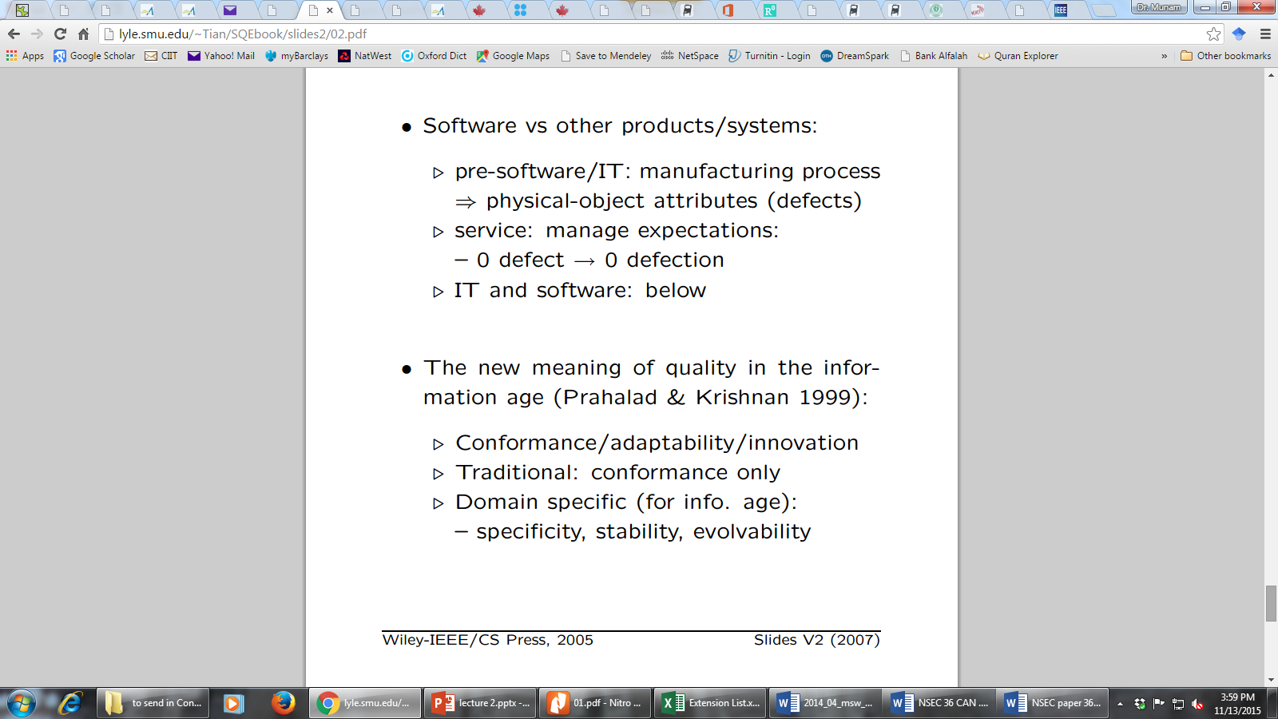
Quality: Historical Perspective (conti..)
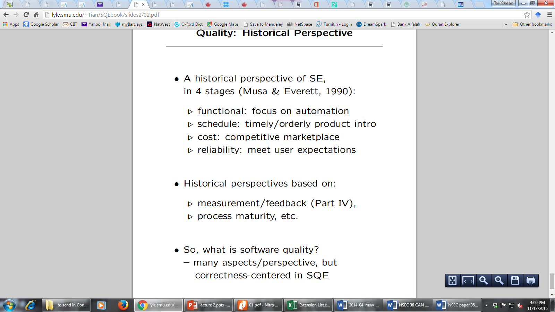
Summary of Today’s Lecture
- We explored the concept of quality from different aspects.
- We have also seen what is a defect or failure to the quality.
- Lastly, we talked about the history of the Quality
Overview of Next lecture
- QA as Dealing with Defect
- Defect Prevention
- Defect Detection and Removal
- Defect Containment
The End

