Software Quality Engineering
Lecture No. 13
Summary of the previous lecture
- Usage Based Statistical Testing
- Checklist-Based Testing
- Partitions and Partition Testing
- OP case study
Part- 2 (b):
Other Models & Techniques of Testing
Outlines
- Control Flow Testing (CFT)
- Data Dependency Analysis
- Control Flow Graph (CFG)
- Steps
- Construction
- Issues
- Methods
Objectives
- To understand and distinguish
Interactions in program execution
.Interaction along the execution paths:
- path: involving multiple elements/stages
- later execution affected by earlier stages
- tested via control flow testing (CFT)
- control flow graph (CFG) ⊂ FSM
Computational results affected too:
- data dependency through execution
- analysis: data dependency graph (DDG)
- tested via data flow testing (DFT)
CFGs and FSMs
CFG (control flow graph):
- Basis for control flow testing (CFT).
- CFG as specialized FSMs:
- type II: processing & I/O in nodes,
- links: “is-followed-by” relation, some annotated with conditions.
• CFG elements as FSM elements:
- nodes = states = unit of processing.
- links = transitions = “is-followed-by”.
- link types: unconditional and conditional,
- latter marked by branching condition
CFG Example
Example: CFG for a proper structured program (seq. concatenation. + nesting, no GOTOs)
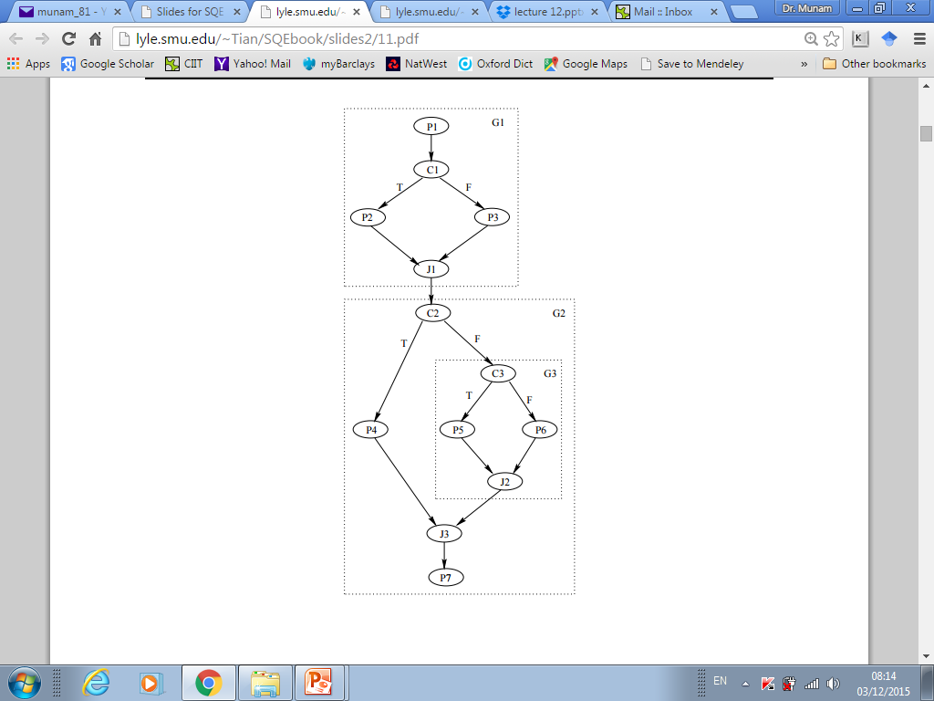

CFG: Nodes and Links
Inlink and outlink defined w.r.t a node.
• Entry/exit/processing nodes:
- Entry (source/initial) nodes.
- Exit (sink/final) nodes.
- Processing nodes.
• Branching & junction nodes & links:
- Branching/decision/condition nodes:
- multiple outlinks,
- each marked by a specific condition,
- only 1 outlink taken in execution.
. Junction nodes:
- opposite to branching nodes,
- but no need to mark these inlinks,
– only 1 inlink taken in execution.
- 2-way and N-way branching/junction
CFG for CFT
CFGs for our CFT:
- Separate processing/branching/junction
nodes for clarity
- Sequential nodes: mostly processing
⇒ collapsing into one node (larger unit)
- No parallelism allow
(single point of control in all executions).
- Mostly single-entry/single-exit CFGs
- Focus: structured programs, ¬ GOTO.
- GOTOs ⇒ ad hoc testing.
Notational conventions:
- “Pi” for processing node “i”
- “Ji” for junction node “i”
- “Ci” for condition/branching node “i”
CFT Technique
Test preparation:
- Build and verify the model (CFG)
- Test cases: CFG ⇒ path to follow
- Outcome checking: what to expect and how to check it
Other steps: Standard
- Test planning & procedure preparation.
- Execution: normal/failure case handling.
- Analysis and Follow-up
Some specific attention in standard steps: Confirmation of outcome and route in analysis and follow-up.
CFT: Constructing CFG
Sources for CFG:
- .White box: design/code
– traditional white-box technique
- Black box: specification
– structure and relations in specs
Program-derived (white-box) CFGs:
Processing: assignment and calls
Branch statements:
– binary: if-then-else, if-then
– multi-way: switch-case, cascading if’s.
. Loop statements (later)
. composition: concatenating/nesting.
. structured programming: no GOTOs
– hierarchical decomposition possible.
. explicit/implicit entry/exit
CFT: Constructing WB/CFG
- Analyse program code on left
- derive CFG on right
- focus on decision and branches
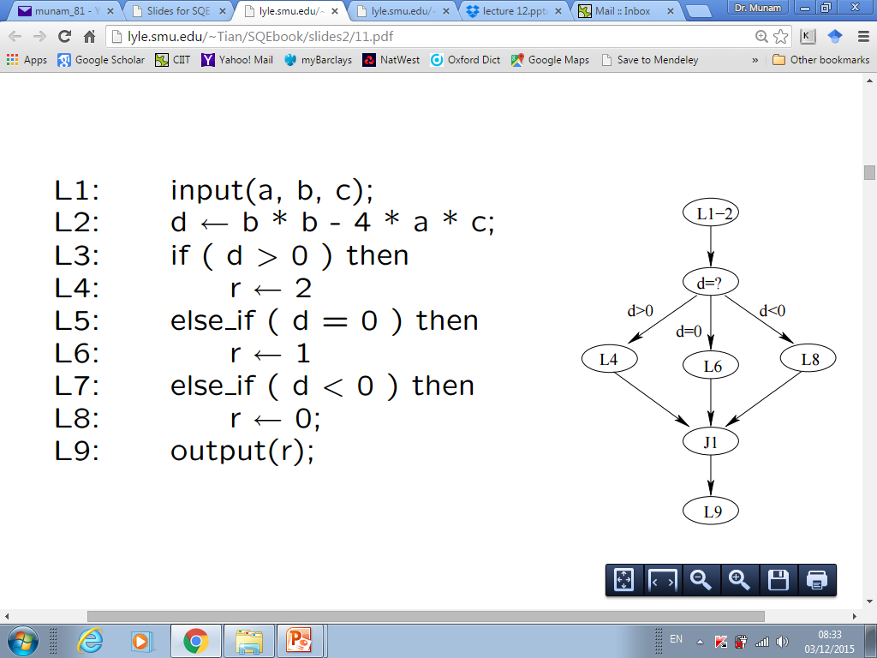
CFT: Constructing CFG
Specification-derived (black-box) CFGs:
- Node: “do” (enter, calculate, etc.)
- Branch: “goto/if/when/while/...”
- Loop: “repeat” (for all, until, etc.)
- Entry: usually implicit
- Exit: explicit and implicit
- External reference as process unit
- General sequence: “do”...(then)...“do”.
• Comparison to white-box CFGs:
Implementation independent.
- Generally assume structured programs.
- Other info sources: user-related items
- usage-scenarios/traces/user-manuals,
- high-level req. and market analyses.
CFT: Path Definition
Test cases: CFG ⇒ path to follow
- Connecting CFG elements together in paths.
- Define and select paths to cover
- Sensitize (decide input for) the paths
Path related concepts/definitions:
- Path: entry to exit via n intermediate links and nodes.
- Path segment or sub-path: proper subset of a path.
- Loop: path or sub-path with 1+ nodes visited 1+ times.
- Testing based on sub-path combinations. . Loop testing: specialized techniques.
CFT: Path Selection
Path selection (divide & conquer)
- Path segment definition
- Sequential concatenation
- Nesting of segments
- Unstructured construction: difficult
- Eliminate unachievable/dead paths
  - (contradictions and correlations)
- “Divide”: hierarchical decomposition for structured programs.
- “Conquer”: Bottom-up path definition one segment at a time via basic cases for nesting and sequential concatenation.
CFT: Other Steps
• CFT: Sensitization: Path sensitization/realization
• CFT: Algebraic Sensitization
Complexity due to dynamic values . Symbolic execution
• CFT: Logic Sensitization:
• Segment and combination . Divide into segments (entry-exit).
• Segment and combination . Divide into segments
• Execution and follow-up: . Path/statement- oriented execution – debugger and other tools helpful . Follow-up: coverage and analysis
Loops: What and Why
• Loop: What is it?
- Repetitive or iterative process.
- Graph: a path with one or more nodes visited more than once.
- Appear in many testing models.
- Recursion.
• Why is it important?
- Intrinsic complexity:
– coverage: how much?
– effectiveness concerns (above)
- Practical evidence: loop defects
- Usage in other testing.
Loop Examples
• Common loop examples:
- left: “while” loops
- right: “for” loops
- other (structured) loops can be converted to these loops
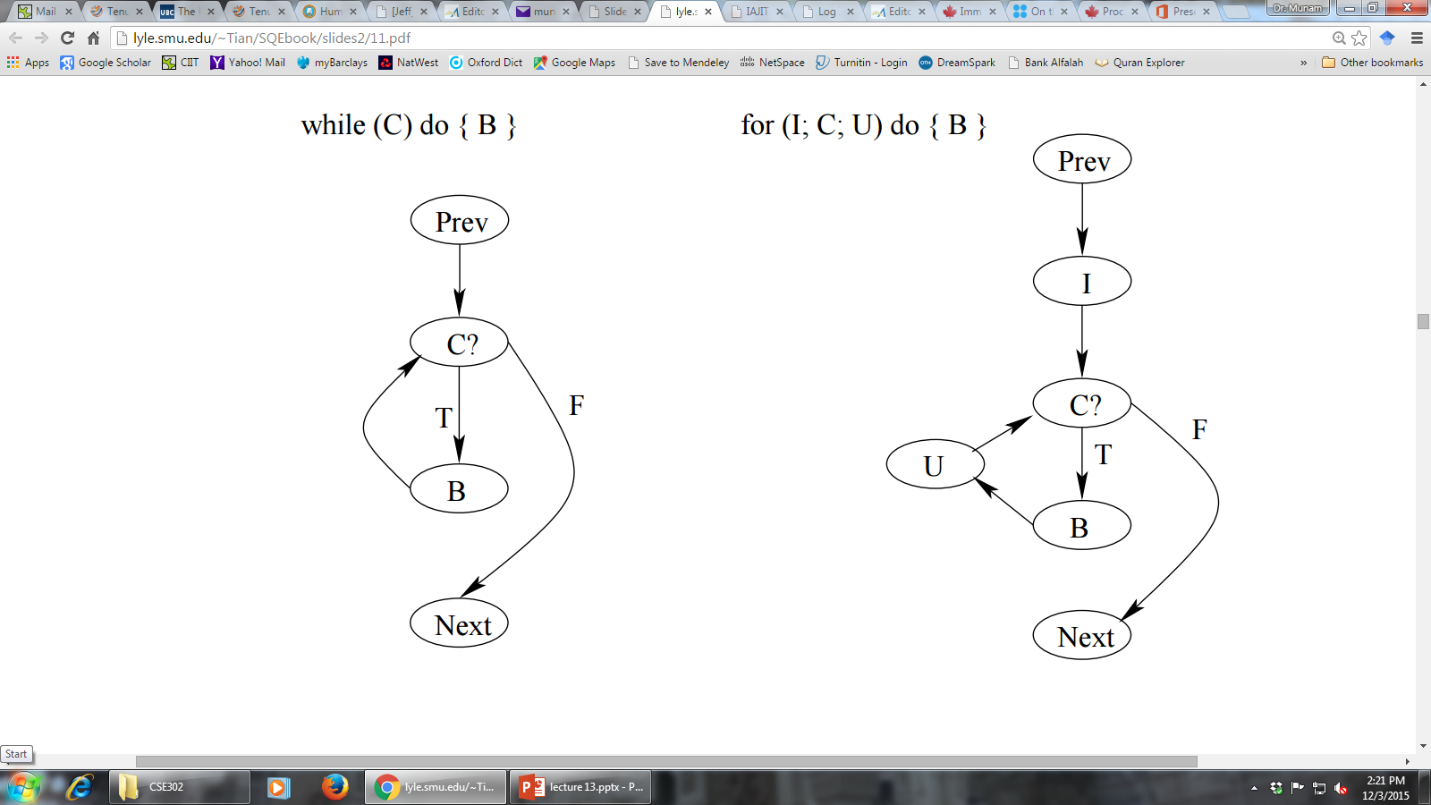
Loop Specification
Deterministic vs. nondeterministic
– determining #iterations ahead of time?
• Individual loops:
- Loop control: node, predicate, and control variable.
- Loop entry/exit.
- Processing and looping: pre-test, post-test, mixed-test.
• Combining loops: structured (nesting & concat.) vs. non-structured (goto).
Loop Testing

Critical Values for Loop Testing
• General boundary problems:
. Under/over defined problems and closure problems.
. Boundary shift, ±1 problem.
• Lower bound problems:
. Initialization problem.
. Loop execution problem.
. Other boundary problems.
• Lower bound test values:
. Bypass, once, twice.
. Min, min + 1, min − 1.
CFT Usage
As white box testing (more often):
- Small programs during unit testing.
- Coarse-grain system level model.
As black box testing (less often):
- Model built on specification
– higher level constraints as specs.
- Overall coverage of functionality.
- Can be used for UBST.
• Application environment:
- Control flow errors (& decision errors).
- In combination with other techniques.
CFT: Other Issues
• Limit control flow complexity
- Proper granularity
- Hierarchical modeling ideas:
– external units/internal blocks
- Combination with other strategies:
– CFT for frequently-used/critical parts
- Language/programming methodology
- Complexity measurement as guidelines
• Need automated support:
- Models from specifications/programs
- Sensitization support — debugging
- Path verification — tracing
Summary of Today’s Lecture
- We discussed Control Flow Testing (CFT) and Control Flow Graph (CFG).
- We explored details of CFG such as:
- Steps
- Construction
- Issues
- Methods
- Overview of Next lecture
- Interaction Testing
- General Types of Interaction in Execution
The End

