Software Quality Engineering
CSE302
Lecture No. 1

Software Quality Engineering
CSE302
Dr. Munam Ali Shah
PhD: University of Bedfordshire
MS: University of Surrey
M.Sc: University of Peshawar
Serving COMSATS since July 2004
Contact Information
Dr. Munam Ali Shah
Office: Room 137, Department of Computer Science, Academic Block II, COMSATS, Islamabad.

About the course
- To provide a survey and exposure of both principles and practice of Software Quality Engineering.
- To assure how to incorporate quality in the life cycle of a software.
- The course will also help you understand and learn quality parameters, standards and specification while engineering software.
Books and Resources
Software Quality Engineering, 6th Edition by Jeff Tian
Software Engineering, A practitioner’s approach, 8th Edition by Roger S. Pressman
How this course will be run
The course is comprised of 32 lectures and is divided in following parts:
Part - 1: Overview and Basics.
Part - 2: Software Testing: models & techniques, management, automation, and integration,
Part-3: Other Quality Assurance Techniques:
defect prevention, process improvement, inspection, formal verification, fault tolerance, accident prevention, and safety assurance.
Part – 4: Quantifiable Quality Improvement: analysis and feedback, measurements and models, defect analysis, risk identification, and software reliability engineering.
Part - 1: Overview and Basics.
The main concepts that are discussed in this part are:
Overview. What is Quality? Quality Assurance, QA in Context, Quality Engineering and the Quality Challenge.
This part will be covered in
Lecture 1 to Lecture 7
Part - 2: Software Testing
This part is will cover most of the important contents of the course. It has been further divided in following sub-parts:
  - Software Testing
  - Models and Techniques
  - Management
  - Automation
  - Integration
Part – 2 (a): Software Testing
Here we will discuss :
Different Software Testing Techniques. Specification Based Testing Techniques, Black-box and Grey-Box Testing, Other Comprehensive Software Testing techniques for SDLC.
Coverage and Usage Testing Based on Checklists and Partitions
The topics will be covered in
Lecture 8 - Lecture 12
Part – 2 (b): Models and Techniques
Topics covered in this part are:
Use of different models for Software Quality Assurance, Quality Planning and Quality Control
The topics will be covered in
Lecture 13 - Lecture 14
Part – 2 (c): Software Quality Management
Topics covered in this part are:
Phases of Quality Assurance, Test Execution, Result checking and Test Measurement
The topics will be covered in
Lecture 15 - Lecture 16
Part – 2 (d): Test Automation
This part will cover the following topics:
Specific needs and potential for automation; Selection of existing testing tools, if available; Possibility and cost of constructing specific test automation tools; Availability of user training for these tools and time/effort needed.
The topics will be covered in
Lecture 17 - Lecture 18
Part – 2 (e): Test Integration
This part will discuss the following topics:
Testing Sub-Phases and Applicable Testing Techniques, Specialized Test Tasks and Techniques, Test Integration
The topics will be covered in
Lecture 19 - Lecture 20
Part - 3: Quality Assurance Techniques
The main concepts that are discussed in this part are:
Defect prevention, process improvement, inspection, formal verification, fault tolerance, accident prevention, and safety assurance. Defect Prevention and Process Improvement. Software Inspection. Formal Verification. Fault Tolerance and Failure Containment. Comparing QA Techniques and Activities.
This part will be covered in
Lecture 21 – Lecture 25
The last two lectures, i.e., Lecture 31 and 32 are reserved for the revision of the course.
Part - 4: Quantifiable Quality Improvement
This is the last part of the course. The main concepts that are discussed in this part are:
Feedback Loop and Activities for Quantifiable Quality Improvement. Quality Models and Measurements. Defect Classification and Analysis. Risk Identification for Quantifiable Quality Improvement. Software Reliability Engineering
This part will be covered in
Lecture 26 – Lecture 29
The last two lectures, i.e., Lecture 31 and 32 are reserved for the revision of the course.
Are you ready !!!!
Lets Begin
Lecture 1:
Software Quality Engineering
Outlines
What is software?
What is Quality?
What is engineering?
Objectives
To describe the basics of a Software Quality Engineering
To understand and distinguish between Software engineering and Software Quality Engineering.

The Software Engineering
“Software is instructions (computer programs) that when executed provide desired function and performance.
Or
Data structures that enable the programs to adequately manipulate information”
(Roger S. Pressman)

The Software Engineering
Characteristics of software:
1. Software is developed or engineered; it is not manufactured in the classical sense.
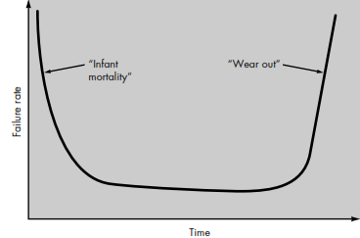
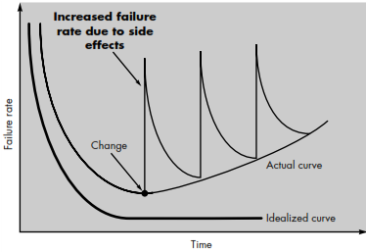
  - Software doesn't "wear out.

Hardware failure Software failure
Although the industry is moving toward component-based assembly, most software continues to be custom built.
Difference b/w Engineering and Manufacturing
Engineering refers to planning or designing whereas manufacturing refers to using of machines and raw materials to physically make the thing.
Manufacturing does not refer to making of civil architectures. It’s called construction.
For example Company A makes the blueprint of a building. It’s in engineering business. Company B makes cement and bricks to make the building. It’s in manufacturing. Company C takes raw material from B and blue print from A and makes the building, it’s in construction.


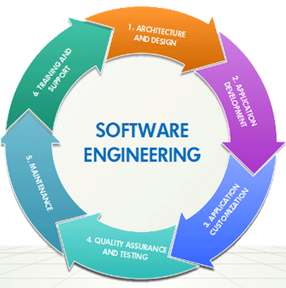

What is Quality
In general, people’s quality expectations for software systems they use and rely upon are two-fold:
1. The software systems must do what they are supposed to do. In other words, they must do the right things.
2. They must perform these specific tasks correctly or satisfactorily. In other words, they must do the things right.
Now you can define Software Quality Engineering.
Summary of Today’s Lecture
We overviewed the course outlines
We discusses and revised important concepts of Software Engineering
We overviewed what is Software Quality Engineering
Overview of Next lecture
We will continue our discussion on overview and basics of Software Quality Engineering
Precisely, we will talk about the quality assurance
The End

