Intelligent agents are supposed to maximize their performance measure. , achieving this is sometimes simplified if the agent can adopt a goal and aim at satisfying it. Let us first look at why and how an agent might do this.
Imagine an agent in the city of Arad, Romania, enjoying a touring holiday. Tile agent's performance measure contains many factors: it wants to improve its suntan, improve its Romanian, take in the sights, enjoy the nightlife (such as it is), avoid hangovers, and so on. The decision problem is a complex one involving many tradeoffs and careful reading of guidebooks.

Now, suppose the agent has a nonrefundable ticket to fly out of Bucharest the following day. In that case, it makes sense for the agent to adopt the goal of getting to Bucharest.

Courses of action that don't reach Bucharest on time can be rejected without further consideration and the agent's decision problem is greatly simplified. Goals help organize behavior by limiting the objectives that the agent is trying to achieve. Goal formulation, based on the current situation and the agent's performance measure, is the first step in problem solving.

We will consider a goal to be a set of world states-exactly those states in which the goal is satisfied. The agent's task is to find out which sequence of actions will get it to a goal state. Before it can do this, it needs to decide what sorts of actions and states to consider. If it were to try to consider actions at the level of "move the left foot forward an inch" or "turn the steering wheel one degree left," the agent would probably never find its way out of the parking lot, let alone to Bucharest, because at that level of detail there is too much uncertainty in the world and there would be too many steps in a solution. Problem formulation is the process of deciding what actions and states to consider, given a goal. We will discuss this process in more detail later. For now, let us assume that the agent will consider actions at the level of driving from one major town to another. The states it will consider therefore correspond to being in a particular town.'

Our agent has now adopted the goal of driving to Bucharest, and is considering where to go from Arad. There are three roads out of Arad, one toward Sibiu, one to Timisoara, and one to Zerind. None of these achieves the goal, so unless the agent is very familiar with the geography of Romania, it will not know which road to f01low. in other words, the agent will
not know which of its possible actions is best, because it does not know enough about the state that results from taking each action. If the agent has no additional knowledge, then it is stuck. The best it can do is choose one of the actions at random.

But suppose the agent has a map of Romania, either on paper or in its memory. The point of a map is to provide the agent with information about the states it might get itself into, and the actions it can take. The agent can use this information to consider subsequent stages of a hypothetical journey via each of the three towns, trying to find a journey that eventually gets to Bucharest. Once it has found a path on the map from Arad to Bucharest, it can achieve its goal by carrying out the driving actions that correspond to the legs of the journey. In general, an agent with several immediate options of unknown value can decide what to do by jrst examining diflerent possible sequences of actions that lead to states of known value, and then choosing the best sequence.

This process of looking for such a sequence is called search. A search algorithm takes a problem as input and returns a solution in the form of an action sequence. Once a solution is found, the actions it recommends can be carried out. This is called the execution phase. Thus, we have a simple "formulate" design for the agent,

After formulating a goal and a problem to solve, the agent calls a search procedure to solve the next thing to do-typically, the first action of the sequence-and then removing that step from the sequence. Once the solution has been executed, the agent will formulate new goal. We first describe the process of problem formulation, and then devote the bulk of various algorithms for the SEARCH function. We will not discuss the workings of the UPDATE-STATE and FORMULATE-GOAL.

Well-defined problems and solutions
A problem can be defined formally by four components:

The initial state that the agent starts in. For example, the initial state for our agent in
Romania might be described as In(Arad).
A description of the possible actions available to the agent. The most common for mulation successor function. Given a particular state x, SUCCESSOR-FN(x) returns a set of (action, successor) ordered pairs, where each action is one of the legal actions in state x and each successor is a state that can be reached from x by applying the action. For example, from the state In(Arad), the successor function for the Romania problem would return

{(G o(Sibzu),I n(Sibiu)), (Go(T imisoara), In( Tzmisoara)), (Go(Zerznd),I n(Zerind)))

Together, the initial state and successor function implicitly define the state space of the problem-the set of all states reachable from the initial state. The state space forms a graph in which the nodes are states and the arcs between nodes are actions. (The map of Romania shown in Figure 3.2 can be interpreted as a state space graph if we view each road as standing for two driving actions, one in each direction.) A path in the state space is a sequence of states connected by a sequence of actions.

The goal test, which determines whether a given state is a goal state. Sometimes there is an explicit set of possible goal states, and the test simply checks whether the given state is one of them. The agent's goal in Romania is the singleton set {In(Bucharest)).

Sometimes the goal is specified by an abstract property rather than an explicitly enumerated set of states. For example, in chess, the goal is to reach a state called "checkmate," where the opponent's king is under attack and can't escape.

A path cost function that assigns a numeric cost to each path. The problem-solving agent chooses a cost function that reflects its own performance measure. For the agent trying to get to Bucharest, time is of the essence, so the cost of a path might be its length in kilometers. In this chapter, we assume that the cost of a path can be described as the sum of the costs of the individual actions along the path. The step cost of taking action a to go from state x to state y is denoted by c(x, a, y). The step costs for Romania are as route distances. We will assume that step costs are nonnegative

The preceding elements define a problem and can be gathered together into a single data structure that is given as input to a problem-solving algorithm. A solution to a problem is a path from the initial state to a goal state. Solution quality is measured by the path cost function, and an optimal solution has the lowest path cost among all solutions.

Formulating problems
In the preceding section we proposed a formulation of the problem of getting to Bucharest in terms of the initial state, successor function, goal test, and path cost. This formulation seems

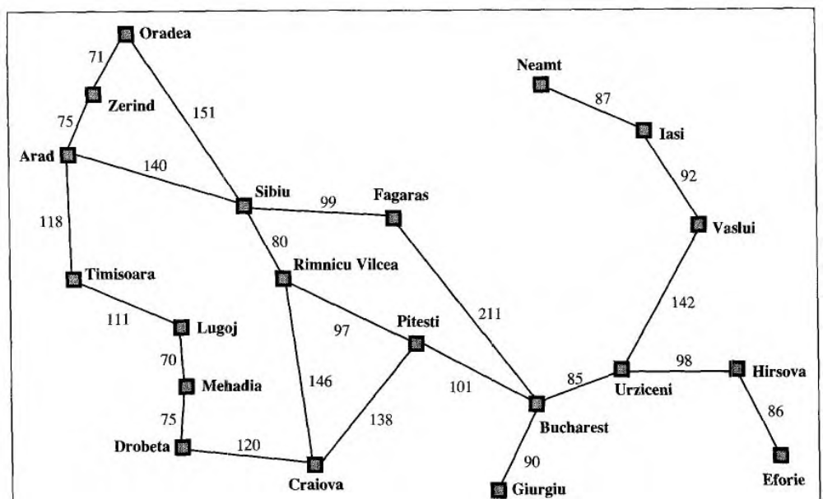

reasonable, yet it omits a great many aspects of the real world. Compare the sirnple state description we have chosen, In(Arad), to an actual cross-country trip, where the state of the world includes so many things: the traveling companions, what is on the radio, the scenery out of the window, whether there are any law enforcement officers nearby, how far lit is to the next rest stop, the condition of the road, the weather, and so on. All these considerations are left out of our state descriptions because they are irrelevant to the problem of finding a route. The process of removing detail from a representation is called abstraction.

In addition to abstracting the state description, we must abstract the actions themselves.
A driving action has many effects. Besides changing the location of the vehicle and its occupants, it takes up time, consumes fuel, generates pollution, and changes the agent (as they say, travel is broadening). In our formulation, we take into account only the change in location.
Also, there are many actions that we will omit altogether: turning on the radio, lookling out of the window, slowing down for law enforcement officers, and so on. And of course, we don't specify actions at the level of "turn steering wheel to the left by three degrees."
Can we be more precise about defining the appropriate level of abstraction? Think of the abstract states and actions we have chosen as corresponding to large sets of detailed world states and detailed action sequences. Now consider a solution to the abstract pro1) lem: for example, the path from Arad to Sibiu to Rimnicu Vilcea to Pitesti to Bucharest. This abstractsolution corresponds to a large number of more detailed paths. For example, we could drive with the radio on between Sibiu and Rimnicu Vilcea, and then switch it off for the rest of the trip. The abstraction is valid if we can expand any abstract solution into a soluti~onin the more detailed world; a sufficient condition is that for every detailed state that is "in Arad," there is a detailed path to some state that is "in Sibiu," and so on. The abstraction is useful if carrying out each of the actions in the solution is easier than the original problem; in this case they are easy enough that they can be carried out without further search or planning by an average driving agent. The choice of a good abstraction thus involves removing as much detail as possible while retaining validity and ensuring that the abstract actions are easy to carry out. Were it not for the ability to construct useful abstractions, intelligent agents would be completely swamped by the real world.

