Enterprise Systems Development
Hand Book

COMSATS Institute of Information Technology
(Virtual Campus)
Islamabad, Pakistan

Lecture No. 1
Enterprise Systems Development
Introduction to Enterprise Systems
1.1 Introduction
Enterprise Systems Development is an interesting subject. In order to understand this subject the course will tell what enterprise systems are, and how they are developed. It will make students understand the principles, techniques and tools that are required to develop enterprise systems. Before we move on to Enterprise Systems Development we need to understand definition of some basic concepts.
- Information Technology
IT (information technology) is a term that encompasses all forms of technology used to create, store, exchange, and use information in its various forms (business data, voice conversations, still images, motion pictures, multimedia presentations, and other forms, including those not yet conceived). It's a convenient term for including both telephony and computer technology in the same word. It is the technology that is driving what has often been called "the information revolution."
- Business Process
A business process is a specific ordering of work activities across time and place, with a beginning, an end, and clearly identified inputs and outputs. Davenport, 1993
It’s a manner in which work is organized, coordinated, and focused to produce a valuable product or service. Concrete work flows of material, information, and knowledge sets of activities.
It often can be visualized with a flowchart as a sequence of activities with interleaving decision points or with a Process Matrix as a sequence of activities with relevance rules based on the data in the process.
- Business Process Examples
Manufacturing and Production: Assembling product, checking quality, producing bills of materials.
Sales and Marketing: Identifying customers, creating customer awareness, selling.
Finance and Accounting: Paying creditors, creating financial statements, managing cash accounts.
Human Resources: Hiring employees, evaluating performance, enrolling employees in benefits plans.
- Cross-Functional Business Processes
Cross-functional business processes are processes that span across several different departments of one business. For example, in an online retailer business, someone would need to take the order. Then the order would get sent to whoever processes the order and takes the money (e.g. enter the customer's credit card). Then it might go to the person who handles inventory. And so on. The example of Cross-Functional Business Processes is “Order Fulfillment Process”.
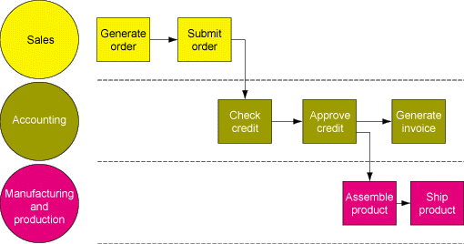
The Order Fulfillment Process
- Information Systems
An information system (IS) is the study of complementary networks of hardware and software that people and organizations use to collect, filter, and process, create, and distribute data. The study bridges business and computer science using the theoretical foundations of information and computation to study various business models and related algorithmic processes within a computer science discipline.
An information system is a unique configuration of IT resources and organizational processes whereby the IT resources (and the information they provide) are applied to support specific organizational processes.
Any specific Information System aims to support operations, management and decision making. In a broad sense, the term is used to refer not only to the information and communication technology (ICT) that an organization uses, but also to the way in which people interact with this technology in support of business processes.

- Types of information systems
The 'classic' view of Information systems found in the textbooks[36] in the 1980s was of a pyramid of systems that reflected the hierarchy of the organization, usually transaction processing systems at the bottom of the pyramid, followed by management information systems, decision support systems, and ending with executive information systems at the top. Although the pyramid model remains useful, since it was first formulated a number of new technologies have been developed and new categories of information systems have emerged, some of which no longer fit easily into the original pyramid model.
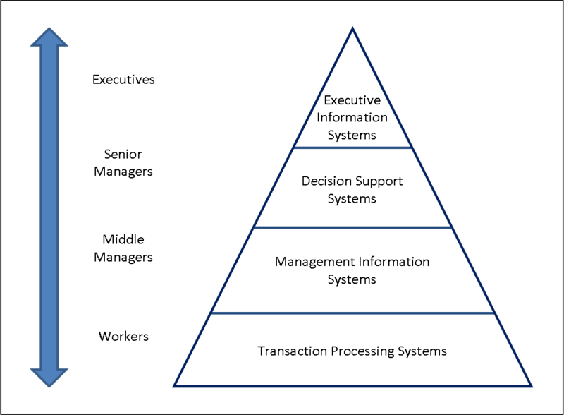
Four-Level-Pyramid-model
Some examples of such systems are:
- Data Warehouses
- Enterprise Resource Planning
- Enterprise Systems
- Expert Systems
- Geographic Information System
- Global Information System
- Office Automation.
- Organization
Organization involves coordination and control mechanisms for people, process and structure.
- Organization and Environment
Organization and Environment includes stakeholders, competitors, and other influences on the system.

Organization & Environment

Information Systems in Organizations
- Major Types of Systems in Organizations
There are various types of systems used in organizations. Some most important of those are:
- Executive Support Systems (ESS)
Executive Support System (ESS) is a reporting tool (software) that allows you to turn your organization's data into useful summarized reports. These reports are generally used by executive level managers for quick access to reports coming from all company levels and departments such as billing, cost accounting, staffing, scheduling, and more.
- Decision Support Systems (DSS)
A decision support system (DSS) is a computer-based information system that supports business or organizational decision-making activities. DSSs serve the management, operations, and planning levels of an organization and help to make decisions, which may be rapidly changing and not easily specified in advance. Decision support systems can be either fully computerized, human or a combination of both.
- Management Information Systems (MIS)
A management information system (MIS) provides information that organizations require to manage themselves efficiently and effectively.[1] Management information systems are typically computer systems used for managing five primary components: Hardware, Software, Data (information for decision making), Procedures (design, development and documentation) and People (individuals, groups, or organizations).
- Office Systems
Over the years, Office systems have grown substantially closer with shared features such as a common spell checker, OLE data integration and Microsoft Visual Basic for Applications scripting language.
- Transaction Processing Systems (TPS)
A transaction process system (TPS) is an information processing system for business transactions involving the collection, modification and retrieval of all transaction data. Characteristics of a TPS include performance, reliability and consistency. TPS is also known as transaction processing or real-time processing.

- Traditional View of the Systems

Within the business there are functions, each having its uses of information systems. Outside the organization’s boundaries there are customers and vendors. Functions tend to work in isolation.
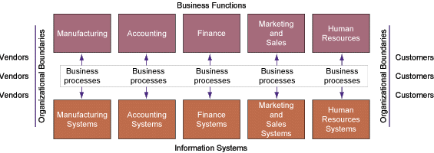
Traditional View of the Systems

- Integration
Integration generally means combining parts so that they work together or form a whole. In information technology, there are several common usages:
1) Integration during product development is a process in which separately produced components or subsystems are combined and problems in their interactions are addressed.
2) Integration is an activity by companies that specialize in bringing different manufacturers' products together into a smoothly working system.
Integration is used for overcoming isolation of information systems.
- Enterprise Systems
Enterprise systems (ES) are large-scale application software packages that support business processes, information flows, reporting, and data analytics in complex organizations. Whilst ES are generally packaged enterprise application software (PEAS) systems they can also be bespoke, custom developed systems created to support a specific organization’s needs.
Types of enterprise systems include enterprise resource planning (ERP) systems, enterprise planning systems, and customer relationship management software.

- Example : Enterprise Resource Planning (ERP) Systems
Enterprise Resource Planning Systems are the first generation of enterprise systems meant to integrate data and support all the major functions of organizations. ERP systems integrate various functional aspects of the organization as well as systems within the organization of its partners and suppliers.
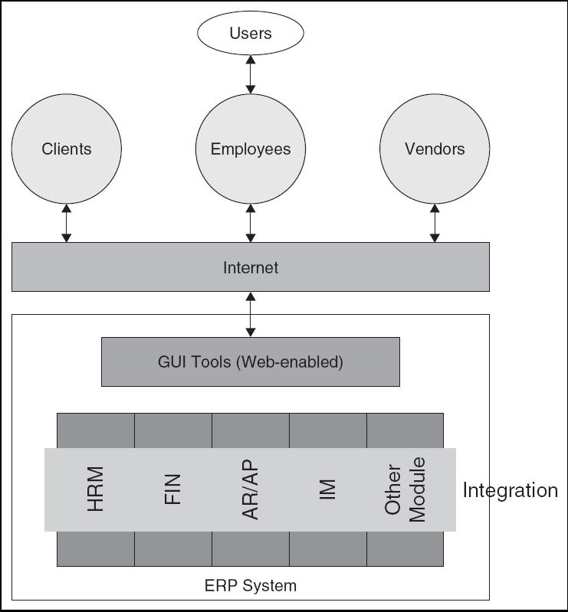The goal of an ERP system is to make the information flow dynamic and immediate, therefore, increasing its usefulness and value.

Integrated Systems – ERP
Another goal of ERP is to integrate departments and functions across an organization into a single infrastructure that serves the needs of each department. ERP systems replace an assortment of systems that typically existed in organizations. (Accounting, HR, Materials Planning, Transaction Processing, etc.). ERP solves the critical problem of integrating information from different sources and makes it available in real-time.
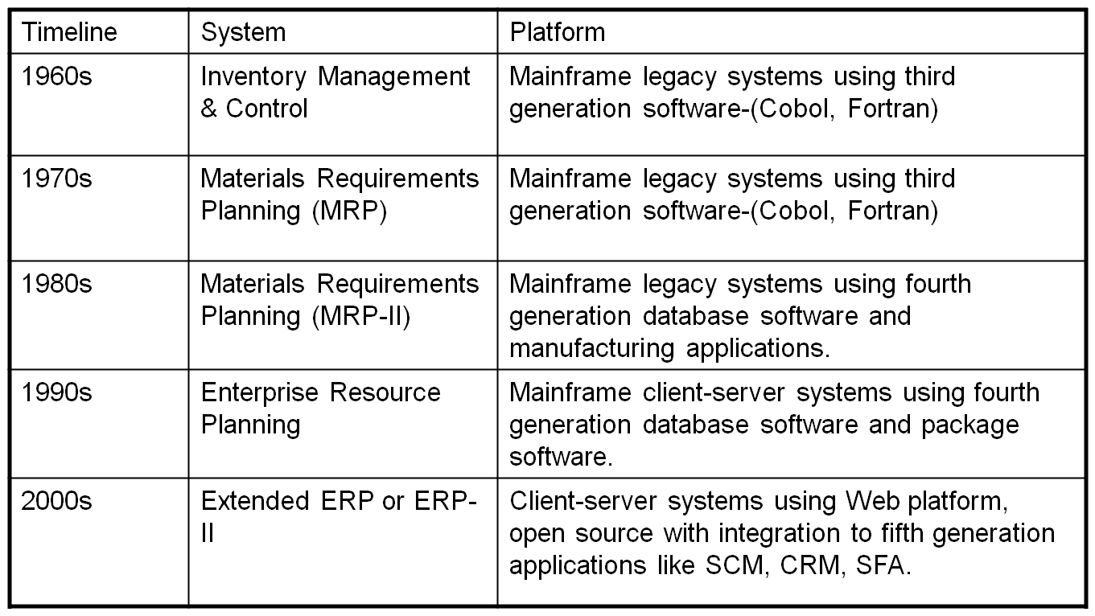
Evolution of ERP
- Business Processes and Enterprise Resource Planning
A crucial role of ERP in business is to better position the organization to change its business processes. ERP software has hundreds of business processes built into the logic of the system which may or may not agree with current processes of an organization. When implementing an ERP system, organizations have two choices:
  - Change business processes to match the software functionality.
  - Modify the ERP software to match the business processes.
- Enterprise Resource Planning Systems Components
An Enterprise Resource Planning System consists of the following components:
Hardware: Servers and peripherals
Software: Operating systems and database
Information: Organizational data from internal and external sources
Process: Business processes, procedures, and policies
People: End users and IT staff

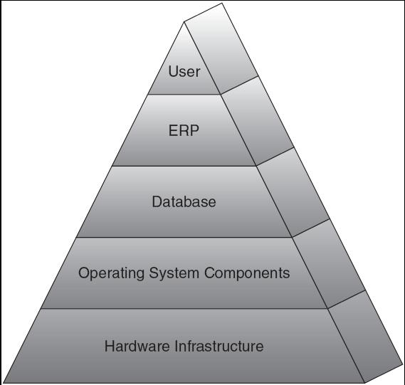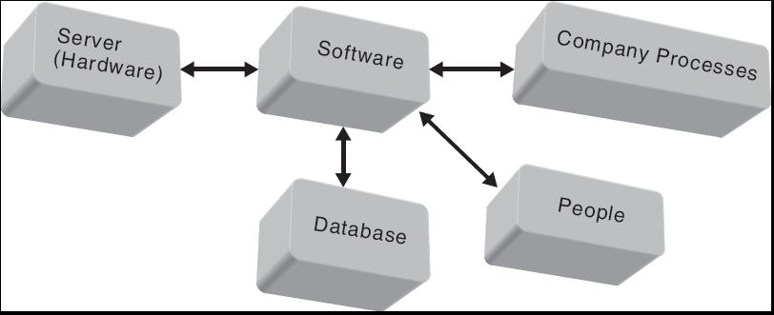

ERP Components ERP Components Integration
- Enterprise Resource Planning Architecture
The architecture of an ERP system influences the cost, maintenance, and the use of the system. A flexible architecture is best as it allows for scalability as needs change and grow. A system’s architecture is a blueprint of the actual ERP system and helps the implementation team build the ERP system. If purchased, ERP architecture is often driven by the vendor but other IT architectures are driven by organizational strategy and business processes.
- 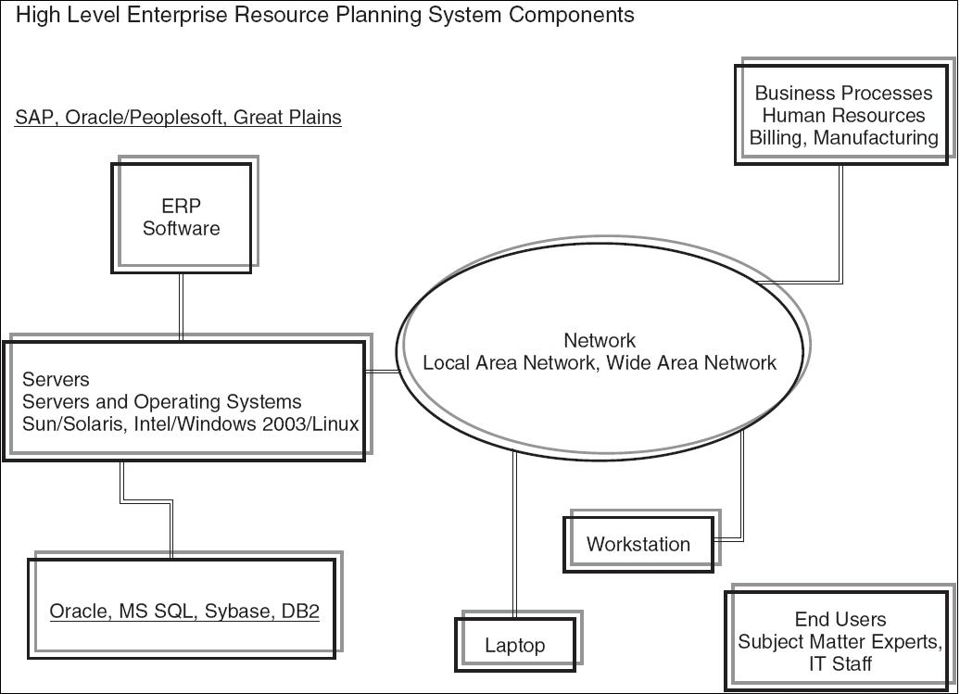Example of Architecture of ERP at Large University

- Logical Architecture of an ERP System
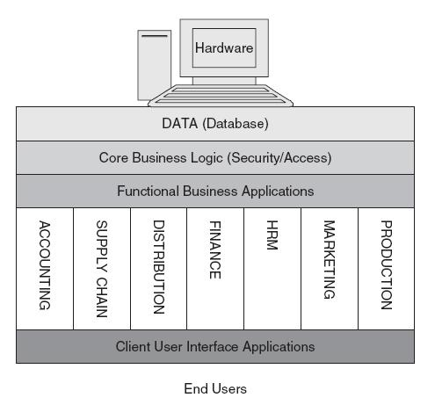

- 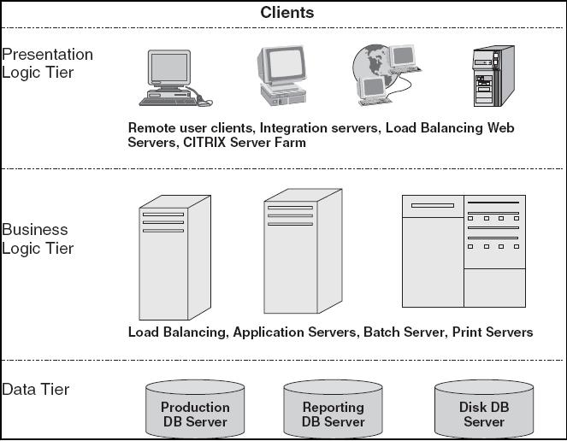Tiered Architecture Example of ERP System

- Characteristics of Enterprise Systems
They are some of the most complex systems in use today. They are typically
  - N-tier systems made up of clients, an application layer, and a data layer
  - Many are now employing a service-oriented architecture
  - SaaS, PaaS, SOA, Web services
- Why Enterprise Systems
IT departments in every organization continue to be challenged on too many fronts: Cost pressures, Data growth, and Security and privacy breaches. In this environment, transforming the management of critical information and processes is vital to generating new business value, delivering new client services and capturing new markets. To deliver this transformation, forward-thinking businesses rely on Enterprise Systems.
- Benefits of Enterprise Systems
- Firm structure and organization: One organization
- Management: Firm-wide knowledge-based management processes
- Technology: Unified platform
- Business: More efficient operations and customer-driven business processes
- Challenges of Enterprise Systems
- Difficult to build: Require fundamental changes in the way the business operates
- Technology: Require complex pieces of software and large investments of time, money, and expertise
- Centralized organizational coordination and decision making: Not the best way for the firms to operate
1.2 Systems Development
After having an introduction of Enterprise Systems, we now move towards introduction of Systems Development.
- We start with commonly held myths in software development
- Difference between small programs and large systems
- Software Myths
Software Myths are beliefs about software and the process used to build it. Myths have number of attributes that have made them insidious (i.e. dangerous).Misleading Attitudes caused serious problem for managers and technical people. There are three perspectives of Software Myths:
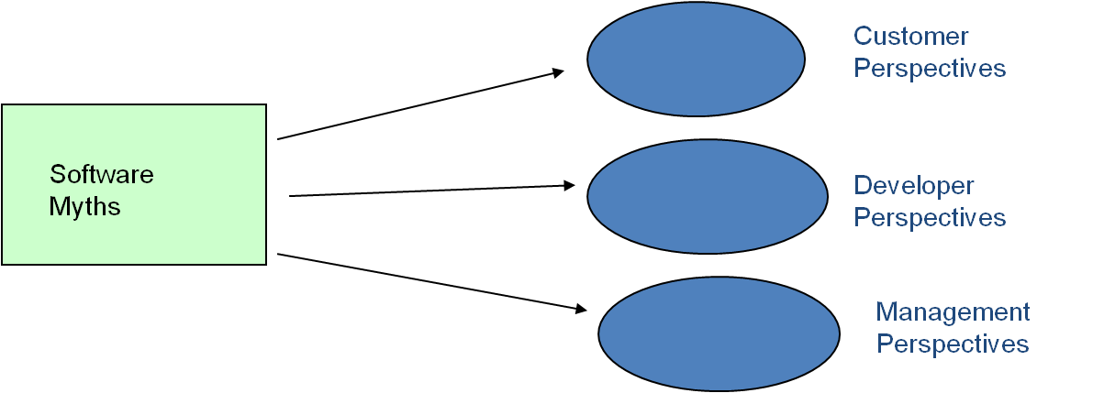
Software Myths Perspectives
- Customer Perspectives
Customer may be a person from inside or outside the company that has requested software under contract.
Myth: A general statement of objectives is sufficient to begin writing programs we can fill in the details later.
Reality: A poor up-front definition is the major cause of failed software efforts. A formal and detailed description of the information domain, function, behavior, performance and validation criteria is essential. These characteristics can be determined only after thorough communication between customer and developer.
Myth: Project requirements continually change, but change can be easily accommodated because software is flexible.
Reality: Customer can review requirements and recommend modifications with relatively little impact on cost. When changes are requested during software design, the cost impact grows rapidly.
- Management Perspectives
Managers in most disciplines are often under pressure to maintain budgets, keep schedules on time, and improve quality.
Myth1: We already have a book that's full of standards and procedures for building software; won't that provide my people with everything they need to know?
Reality: Are software practitioners aware of existence standards? Does it reflect modern software engineering practice? Is it complete?
Myth2: If we get behind schedule, we can add more programmers and catch up
Reality: Software development is not a mechanistic process like manufacturing. Adding people to a late software project makes it later.
People can be added but only in a planned and well-coordinated manner
Myth3: If I decide to outsource the software project to a third party, I can just relax and let that firm build it.
Reality: If an organization does not understand how to manage and control software projects internally, it will invariably struggle when it outsource software projects.
- Developer Perspectives
Myth1: Once we write the program and get it to work, our job is done.
Reality: Someone once said that "the sooner you begin 'writing code', the longer it'll take you to get done." Industry data indicate that between 60 and 80 percent of all effort expended on software will be expended after it is delivered to the customer for the first time.
Myth2: Until I get the program "running" I have no way of assessing its quality.
Reality: One of the most effective software quality assurance mechanisms can be applied from the inception of a project that is formal technical review.
Myth3: The only deliverable work product for a successful project is the working program.
Reality: A working program is only one part of a software configuration that includes many elements. Documentation provides a foundation for successful engineering and, more important, guidance for software support.
Myth4: Software engineering will make us creates voluminous and unnecessary documentation and will invariably slow us down.
Reality: Software engineering is not about creating documents. It is about creating quality. Better quality leads to reduced rework. And reduced rework results in faster delivery times.
- Confusion with Programs and Products
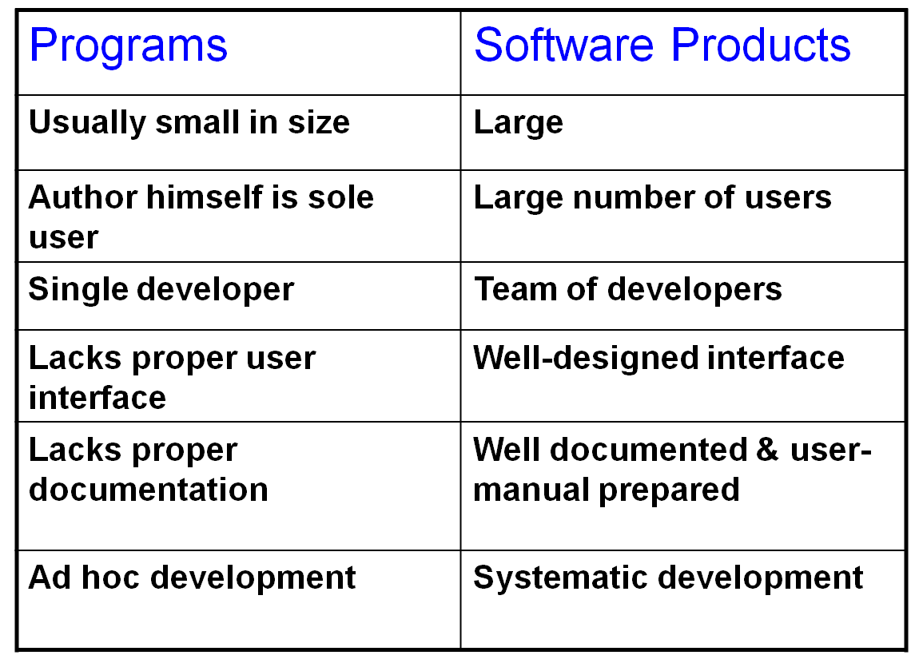
Programs and Products
- Software Programming ≠ Software Engineering
Software Programming: The process of translating a problem from its physical environment into a language that a computer can understand and obey. (Webster’s New World Dictionary of Computer Terms).
  - Single developer
  - “Toy” applications
  - Short lifespan
  - Single or few stakeholders
    - Architect = Developer = Manager = Tester = Customer = User
  - One-of-a-kind systems
  - Built from scratch
  - Minimal maintenance
Software Engineering:
  - Teams of developers with multiple roles
  - Complex systems
  - Indefinite lifespan
  - Numerous stakeholders
    - Architect ≠ Developer ≠ Manager ≠ Tester ≠ Customer ≠ User
  - System families
  - Reuse to amortize costs
  - Maintenance accounts for over 60% of overall development costs
Summary
- Information Technology
- Business Process
- Information Systems
- Organization
- Integration
- Enterprise Systems
- Software Myths

Lecture No. 2
Software Systems and Their Development Life Cycle
2.1 Software Systems
Software Systems are developed by software engineers. Software is a collection of computer programs and related data that provides the instructions for telling a computer what to do and how to do it.
Software systems are developed by using sound engineering principles in order to obtain economically software that is reliable and work efficiently on real machine.
Software systems may be developed for a particular customer (Custom - developed for a single customer according to their specification) or may be developed for a general market (Generic - developed to be sold to a range of different customers e.g. PC software such as Excel or Word).
- Software Systems Vs Other Engineering Artifacts
Now let’s talk something about how a software system is different from any other systems. For example, how software is different from a car, a TV or the similar systems or what is the difference between software engineering and other engineering like mechanical or electrical engineering. Let’s look at some of the non-software systems like TV, Car or an Electric Bulb. The car may be malfunctioned due to some problem in engine while driving. Similarly an electric bulb may be fused while glowing and a TV could be dysfunctional while working.
So the major thing that distinguishes a software system from other systems is that: “Software does not wear out”. This Means:
As we have seen in above example that our non-software systems could be malfunctioned or crash while working. That mean they are affected by the phenomenon of wear and tear. They have a particular life and after that they could have some problem and may not behave and perform as expected. But this is not the case with software. Software systems does not affect by the phenomenon of wear and tear. If software has any defect then that defect will be there from the very first day and that defect normally called bug. That means if software is not working then it should not work from the very first day. But this could not be the case that at a particular point in time software is functioning well and after some time the same software is not performing the same task as required. So software does not have the element of wear and tear. Let’s elaborate this point further. We have just talked about software defects which we call bugs. If a part of a car became wear out you just need to get a new one from market and replace the damages one with the new one and the car will start working properly as it was working previously. Similarly if an electric bulb got fused then you just need to get a new one and put into the socket in place of the fused one and your room will again be illuminated, but the case of software is somewhat different. If software has a bug then the same process of replacing faulty part with the new one may not work. You cannot remove the bug by just replacing the faulty part of software with the new one. Or it will not be as simple that, you go to the concerned company, get a new CD of that software and it will start working properly. If the software has a bug and that bug was present in the older CD then that will remain in the new one. This is a fundamental difference between software and other systems.
Some other differences of software systems and other engineering disciplines are:
- Once a hardware product has been manufactured, it is difficult or impossible to modify. In contrast, software products are routinely modified and upgraded.
- In hardware, hiring more people allows you to accomplish more work, but the same does not necessarily hold true in software engineering.
- Unlike hardware, software costs are concentrated in design rather than production.
- Engineering methods put a lot of emphasis on planning before you build. Design, plan and then construct.
- In other engineering disciplines construction is much bigger in both cost and time than design and planning i.e. 80-90%
- While the construction in software engineering is just 10-30%, making software construction is so cheap as to be free.
- In software engineering almost all effort is of design.
- Software Engineering Difficulties
Software engineers deal with unique set of problems. These problems include:
- Young field with tremendous expectations
- Building of vastly complex, but intangible systems
- Software is not useful on its own e.g., unlike a car, thus
- It must conform to changes in other engineering areas
These problems are categorized in to two sections. The first category contains the problems that can be eliminated are known as Brooks’ “accidental difficulties”. The second category contains the problems that can be lessened, but not eliminated; these are known as Brooks’ “essential difficulties”.
- Accidental Difficulties
- Accidental complexity is complexity that arises in computer programs or their development process.
- Accidental complexity is caused by the approach chosen to solve the problem.
- Sometimes accidental complexity can be due to mistakes such as ineffective planning, or low priority placed on a project.
- Essential Difficulties
Essential complexity refers to a situation where all reasonable solutions to a problem must be complicated. Only partial solutions exist for them, if any. these difficulties are further categorized into four subcategories.
- Complexity: No two software parts are alike, if they are; they are abstracted away into one. Complexity grows non-linearly with size (scaling-up), e.g., it is impossible to enumerate all states of program, except perhaps “toy” programs. from complexity comes the difficulty of communication, enumerating, less understanding of all the possible states of the program
- Conformity: Natural Science – God VS Software – People
Much of the complexity that he (developer) must master is based on individual judgments. These (standards) differ from interface to interface and from time to time, not because of necessity but only because they were designed by different people, rather than by God.
- Changeability: The software entity is constantly subject to pressures for change. Of course, so are buildings, cars, and computers. But manufactured things are infrequently changed. Software of a system embodies its function, and the function is the part that most feels the pressure of change. In part it is because software can be changed more easily, it is pure thought stuff.
Buildings do in fact get change but the high cost of change understood by all serve to dampen the whims of the changes. The software product is embodied in a cultural matrix of applications, users, laws, and machine vehicles. These change continually, and their changes inevitably force change upon the software product.
- Invisibility: Software is invisible and un-visualizable. A geometric reality is captured in a geometric abstraction. The reality of software is not inherently embedded in space. As soon as we attempt to diagram software structure, we find it to constitute not one, but several, general directed graphs superimposed one upon another. These lacks not only obstruct the process of design within one mind, it severely hinders communication among minds.
2.2 What is Software Engineering?
Let us define it first and then we will move on with development of enterprise software systems.
The term Software Engineering was/is sometimes confusing, firstly because Software engineer (some time) work as system programmer, people assumes that the engineering component of the term comes from this source. So, we have hardware engineering and software engineering. Second cause of confusion lies in the fact that there is no generally agreed definition of software engineering, although many are similar.
Software Engineering as a term was first coined in 1968 at a NATO conference in West Germany held to discuss the software crises. Other definitions such as Fairley’s 1985 explicitly include the concerns of management in the software development process: ‘Software engineering is the technological and managerial discipline concerned with systematic production and maintenance of software products that are developed and modified on time and within cost estimates.’
- Software Engineering Definitions
"The establishment and use of sound engineering principles (methods) in order to obtain economically software that is reliable and works on real machines", [Bauer 1972].
"Cost-effective Software engineering is that form of engineering that applies the principles of computer science and mathematics to achieving solutions to software problems”, [CMU/SEI-90-TR-003].
"The application of a systematic, disciplined, quantifiable approach to the development, operation, and maintenance of software; that is, the application of engineering to software", [IEEE Standard Computer Dictionary, 610.12, ISBN 1-55937-079-3, 1990].
“Software engineering is concerned with the theories, methods and tools for developing, managing and evolving software products”, [I. Sommerville, 6ed.]
“A discipline whose aim is the production of quality software, delivered on time, within budget, and satisfying users' needs”, (Stephen R. Schach, Software Engineering, 2ed.)
“The practical application of scientific knowledge in the design and construction of computer programs and the associated documentation required to develop, operate and maintain them”, [B.W. Boehm]
“Multi-person construction of multi-version software”, (Parnas, 1987).
So, Software Engineering is:
Scope: The study of software process, development principles, techniques, and notations.
Goals: Production of quality software, delivered on time, within budget, satisfying customers’ requirements and users’ needs.
2.3 Software Systems Life Cycle
Software Systems, like other engineering artifacts, have a lifecycle. For examples, your cell phone has a lifecycle, we human being also has a life cycle.

System Development Life Cycle (SDLC)
2.4 Software Development Process Models
Problem solving loop with basic four activities, these activities are: problem analysis, problem definition, technical development and solution integration. Regardless of the process model chosen, all the four activities coexist simultaneously at some level of detail. A process model is chosen based upon the: nature of the project, application, methods and tools to be used, and controls and deliverables that are required. There are many process models used for software development. Let’s explore them one by one.

- The waterfall model
The Waterfall Model was first Process Model to be introduced. It is also referred to as a linear-sequential life cycle model. It is very simple to understand and use. In a waterfall model, each phase must be completed fully before the next phase can begin. At the end of each phase, a review takes place to determine if the project is on the right path and whether or not to continue or discard the project. In waterfall model phases do not overlap.

Work Tasks &Work Products of Waterfall Model
Advantages of waterfall model:
- Simple and easy to understand and use.
- Easy to manage due to the rigidity of the model – each phase has specific deliverables and a review process.
- Phases are processed and completed one at a time.
- Works well for smaller projects where requirements are very well understood.
Disadvantages of waterfall model:
- Once an application is in the testing stage, it is very difficult to go back and change something that was not well-thought out in the concept stage.
- No working software is produced until late during the life cycle.
- High amounts of risk and uncertainty.
- Not a good model for complex and object-oriented projects.
- Poor model for long and ongoing projects.
- Not suitable for the projects where requirements are at a moderate to high risk of changing.
When to use the waterfall model:
- Requirements are very well known, clear and fixed.
- Product definition is stable.
- Technology is understood.
- There are no ambiguous requirements
- Ample resources with required expertise are available freely
- The project is short.
- Prototyping Model
The basic idea here is that instead of freezing the requirements before a design or coding can proceed, a throwaway prototype is built to understand the requirements. This prototype is developed based on the currently known requirements. By using this prototype, the client can get an “actual feel” of the system, since the interactions with prototype can enable the client to better understand the requirements of the desired system.
Prototyping is an attractive idea for complicated and large systems for which there is no manual process or existing system to help determining the requirements. The prototypes are usually not complete systems and many of the details are not built in the prototype. The goal is to provide a system with overall functionality.

Prototyping Model
Advantages of Prototype model:
- Users are actively involved in the development.
- Since in this methodology a working model of the system is provided, the users get a better understanding of the system being developed.
- Errors can be detected much earlier.
- Quicker user feedback is available leading to better solutions.
- Missing functionality can be identified easily.
- Confusing or difficult functions can be identified Requirements validation, Quick implementation of, incomplete, but functional, application.
Disadvantages of Prototype model:
- Leads to implementing and then repairing way of building systems.
- Practically, this methodology may increase the complexity of the system as scope of the system may expand beyond original plans.
- Incomplete application may cause application not to be used as the full system was designed Incomplete or inadequate problem analysis.
When to use Prototype model:
- Prototype model should be used when the desired system needs to have a lot of interaction with the end users.
- Typically, online systems, web interfaces have a very high amount of interaction with end users, are best suited for Prototype model. It might take a while for a system to be built that allows ease of use and needs minimal training for the end user.
- Prototyping ensures that the end users constantly work with the system and provide a feedback which is incorporated in the prototype to result in a useable system. They are excellent for designing good human computer interface systems.

- Rapid Application Development (RAD) Model
RAD model is Rapid Application Development model. It is a type of incremental model. In RAD model the components or functions are developed in parallel as if they were mini projects. The developments are time boxed, delivered and then assembled into a working prototype. This can quickly give the customer something to see and use and to provide feedback regarding the delivery and their requirements.
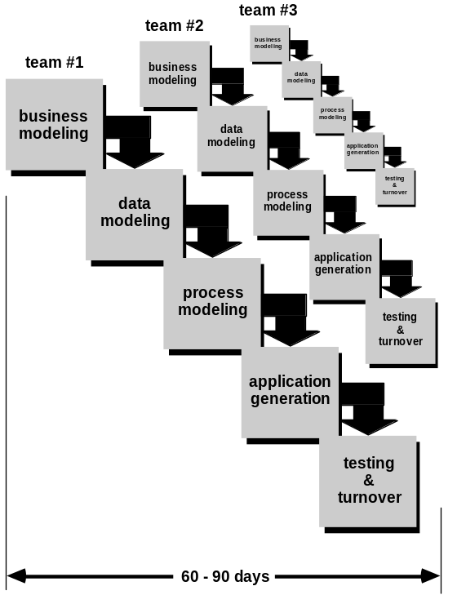
RAD Model
The phases in the rapid application development (RAD) model are:
Business Modeling: The information flow is identified between various business functions.
Data Modeling: Information gathered from business modeling is used to define data objects that are needed for the business.
Process Modeling: Data objects defined in data modeling are converted to achieve the business information flow to achieve some specific business objective. Description are identified and created for CRUD of data objects.
Application Generation: Automated tools are used to convert process models into code and the actual system.
Testing and Turnover: Test new components and all the interfaces.
Advantages of the RAD model:
- Reduced development time.
- Increases reusability of components
- Quick initial reviews occur
- Encourages customer feedback
- Integration from very beginning solves a lot of integration issues.
Disadvantages of RAD model:
- Depends on strong team and individual performances for identifying business requirements.
- Only system that can be modularized can be built using RAD
- Requires highly skilled developers/designers.
- High dependency on modeling skills
- Inapplicable to cheaper projects as cost of modeling and automated code generation is very high.
When to use RAD model:
- RAD should be used when there is a need to create a system that can be modularized in 2-3 months of time.
- It should be used if there’s high availability of designers for modeling and the budget is high enough to afford their cost along with the cost of automated code generating tools.
- RAD SDLC model should be chosen only if resources with high business knowledge are available and there is a need to produce the system in a short span of time (2-3 months).
- The Incremental Model
In incremental model the whole requirement is divided into various builds. Multiple development cycles take place here, making the life cycle a “multi-waterfall” cycle. Cycles are divided up into smaller, more easily managed modules. Each module passes through the requirements, design, implementation and testing phases. A working version of software is produced during the first module, so you have working software early on during the software life cycle. Each subsequent release of the module adds function to the previous release. The process continues till the complete system is achieved. For Example:

In the diagram above when we work incrementally we are adding piece by piece but expect that each piece is fully finished. Thus keep on adding the pieces until it’s complete.

The Incremental Model
Advantages of Incremental model:
- Generates working software quickly and early during the software life cycle.
- More flexible – less costly to change scope and requirements.
- Easier to test and debug during a smaller iteration.
- Customer can respond to each built.
- Lowers initial delivery cost.
- Easier to manage risk because risky pieces are identified and handled during it’d iteration.
Disadvantages of Incremental model:
- Needs good planning and design.
- Needs a clear and complete definition of the whole system before it can be broken down and built incrementally.
- Total cost is higher than waterfall.
When to use the Incremental model:
- Requirements of the complete system are clearly defined and understood.
- Major requirements must be defined; however, some details can evolve with time.
- There is a need to get a product to the market early.
- A new technology is being used
- Resources with needed skill set are not available
- There are some high risk features and goals.
- Spiral Model
The spiral model is similar to the incremental model, with more emphasis placed on risk analysis. The spiral model has four phases: Planning, Risk Analysis, Engineering and Evaluation. A software project repeatedly passes through these phases in iterations (called Spirals in this model). The baseline spiral, starting in the planning phase, requirements is gathered and risk is assessed. Each subsequent spiral builds on the baseline spiral. Requirements are gathered during the planning phase. In the risk analysis phase, a process is undertaken to identify risk and alternate solutions. A prototype is produced at the end of the risk analysis phase.
Software is produced in the engineering phase, along with testing at the end of the phase. The evaluation phase allows the customer to evaluate the output of the project to date before the project continues to the next spiral.
Advantages of Spiral model:
- High amount of risk analysis hence, avoidance of Risk is enhanced.
- Good for large and mission-critical projects.
- Strong approval and documentation control.
- Additional Functionality can be added at a later date.
- Software is produced early in the software life cycle.
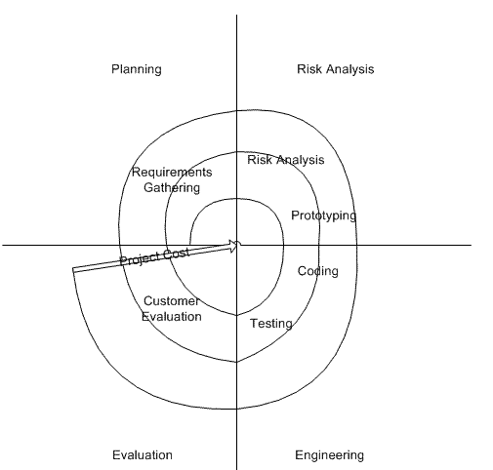
Spiral Model
Disadvantages of Spiral model:
- Can be a costly model to use.
- Risk analysis requires highly specific expertise.
- Project’s success is highly dependent on the risk analysis phase.
- Doesn’t work well for smaller projects.
When to use Spiral model:
- When costs and risk evaluation is important
- For medium to high-risk projects
- Long-term project commitment unwise because of potential changes to economic priorities
- Users are unsure of their needs
- Requirements are complex
- New product line
- Significant changes are expected (research and exploration)

Summary
- Software Systems
- Difficulties of Software Engineering
- Concept of Life Cycle
- Waterfall Model
- Prototype Model
- RAD Model
- Incremental Model
- Spiral Model
- Agile Methods

Lecture No. 3
Agile Development
3.1 Agile Development
In 2001, Kent Beck and 16 other software developers, referred to as “Agile Alliance”, signed the “manifesto for Agile software development”. It stated: Through this work we have come to Value:
- Individuals and interaction over processes and tool
- Working software over comprehensive documentation
- Customer collaboration over contract negotiation
- Responding to change over following plan
That is, while there is value in the items on the right, we value the items on the left more.
Agile development model is also a type of Incremental model. Software is developed in incremental, rapid cycles. This results in small incremental releases with each release building on previous functionality. Each release is thoroughly tested to ensure software quality is maintained. It is used for time critical applications. Extreme Programming (XP) is currently one of the most well known agile development life cycle model.
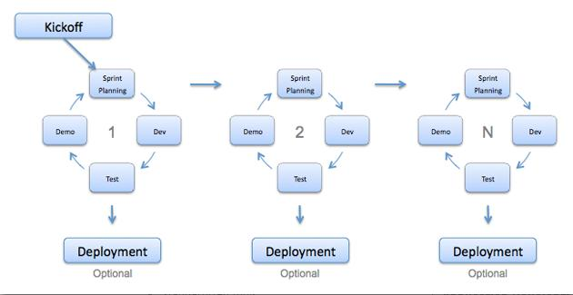
Agile Development Model
Advantages of Agile model:
- Customer satisfaction by rapid, continuous delivery of useful software.
- People and interactions are emphasized rather than process and tools. Customers, developers and testers constantly interact with each other.
- Working software is delivered frequently (weeks rather than months).
- Face-to-face conversation is the best form of communication.
- Close daily cooperation between business people and developers.
- Continuous attention to technical excellence and good design.
- Regular adaptation to changing circumstances.
- Even late changes in requirements are welcomed
Disadvantages of Agile model:
- In case of some software deliverables, especially the large ones, it is difficult to assess the effort required at the beginning of the software development life cycle.
- There is lack of emphasis on necessary designing and documentation.
- The project can easily get taken off track if the customer representative is not clear what final outcome that they want.
- Only senior programmers are capable of taking the kind of decisions required during the development process. Hence it has no place for newbie programmers, unless combined with experienced resources.
When to use Agile model:
- When new changes are needed to be implemented. The freedom agile gives to change is very important. New changes can be implemented at very little cost because of the frequency of new increments that are produced.
- To implement a new feature the developers need to lose only the work of a few days, or even only hours, to roll back and implement it.
- Unlike the waterfall model in agile model very limited planning is required to get started with the project. Agile assumes that the end users’ needs are ever changing in a dynamic business and IT world. Changes can be discussed and features can be newly effected or removed based on feedback. This effectively gives the customer the finished system they want or need.
- Both system developers and stakeholders alike, find they also get more freedom of time and options than if the software was developed in a more rigid sequential way. Having options gives them the ability to leave important decisions until more or better data or even entire hosting programs are available; meaning the project can continue to move forward without fear of reaching a sudden standstill.
- Agile Methods
Agile software development is a group of software development methodologies that are based on similar principles. Agile methodologies generally promote a project management process that encourages
- frequent inspection and adaptation
- a leadership philosophy that encourages team work
- a set of engineering best practices that allow for rapid delivery of high-quality software, and a business approach that aligns development with customer needs and company goals
- What are Agile Methods?
- Agile software development is a conceptual framework for undertaking software engineering projects.
- Most agile methods attempt to minimize risk by developing software in short time boxes, called iterations, which may typically last one to four weeks.
- Each of the iteration is like a miniature software project of its own, and includes all of the tasks necessary to release the mini-increment of new functionality.
- Time Boxing
- Timeboxing is a time management technique common in planning projects (typically for software development), where the schedule is divided into a number of separate time periods (timeboxes, normally two to six weeks long), with each part having its own deliverables, deadline and budget. Timeboxing is a core aspect of rapid application development (RAD) software development processes, such as dynamic systems development method (DSDM) and agile software development techniques.
- Timeboxes are used as a form of risk management for tasks that easily run over their deadlines. The end date is set in stone and may not be changed. If the team exceeds the date, the work is considered a failure and is cancelled or rescheduled. Some timebox methods allow the team to adjust the scope of the task in order to meet the deadline.
- Agile Methods v/s Traditional Methods
To address the challenges posed by the traditional methods, a set of lightweight methods called "Agile" were developed more than a decade ago. They include XP, Scrum, feature-driven development, and more. Agile methods, using various tactics, try to overcome the limitations of the dynamic nature of systems development projects.
Agile methods address the inherent problems of traditional systems development using two scientific concepts: One method is using "empirical process control." One can also say that this is based on "soft-systems thinking." The other method is seeing the systems development as "complex adaptive systems" and designing team structures and methods around that.
Here is how Agile addresses the shortcomings of the traditional software development life cycle:
- Agile methods adopt the empirical process control model as against the defined process control model. Empirical process control is meant for processes that aren't well defined and are unpredictable and unrepeatable. It implements control through frequent inspection and adaptation. Since software development processes are highly complex and variable in nature, empirical process control methods seem to be a best fit to deliver results.
- According to complexity theory, a complex adaptive system (CAS) self-organizes and adapts to changes in the environment without any central rules governing its behavior. An Agile development system can be likened to a CAS, responding to complex and unpredictable changes in the requirements.
- The development model changes from a linear life cycle model to an evolutionary delivery model. This is characterized by short iterative cycles, with periodic reflections and adaptations and continuous integration of code into the overall system under development.
- Since the cycles are short and iterative, they provide the necessary flexibility and speed to adapt to changes in requirements through constant feedback from the stakeholders.
- Agile methods also need constant collaboration with customers, using their input and feedback at various checkpoints during each iterative cycle.
3.2 Different Agile Methods
There are various agile methods used these days. These methods include:
- Extreme Programming (XP)
- Scrum
- Agile Modeling
- Adaptive Software Development (ASD)
- Crystal Clear and Other Crystal Methodologies
- Dynamic Systems Development Method (DSDM)
- Feature Driven Development
- Lean software development
- Agile Unified Process (AUP)
3.2.1 Extreme Programming
Extreme Programming (XP) is a software development methodology which is intended to improve software quality and responsiveness to changing customer requirements. As a type of agile software development, it advocates frequent "releases" in short development cycles, which is intended to improve productivity and introduce checkpoints where new customer requirements can be adopted.
Extreme Programming emphasizes teamwork. Managers, customers, and developers are all equal partners in a collaborative team. Extreme Programming implements a simple, yet effective environment enabling teams to become highly productive. The team self-organizes around the problem to solve it as efficiently as possible.
Extreme Programming improves a software project in five essential ways; communication, simplicity, feedback, respect, and courage. Extreme Programmers constantly communicate with their customers and fellow programmers. They keep their design simple and clean. They get feedback by testing their software starting on day one. They deliver the system to the customers as early as possible and implement changes as suggested. Every small success deepens their respect for the unique contributions of each and every team member. With this foundation Extreme Programmers are able to courageously respond to changing requirements and technology.
The most surprising aspect of Extreme Programming is its simple rules. Extreme Programming is a lot like a jig saw puzzle. There are many small pieces. Individually the pieces make no sense, but when combined together a complete picture can be seen. The rules may seem awkward and perhaps even naive at first, but are based on sound values and principles.
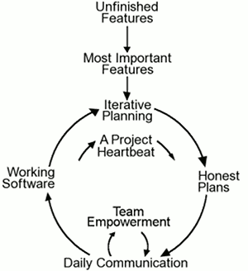
Flow Chart of Extreme Programming
Our rules set expectations between team members but are not the end goal themselves. You will come to realize these rules define an environment that promotes team collaboration and empowerment that is your goal. Once achieved productive teamwork will continue even as rules are changed to fit your company's specific needs.
This flow chart shows how Extreme Programming's rules work together. Customers enjoy being partners in the software process, developers actively contribute regardless of experience level, and managers concentrate on communication and relationships. Unproductive activities have been trimmed to reduce costs and frustration of everyone involved.
- Philosophy of Extreme Programming: Take known good practices and push them to extremes. For Example:
- “If code reviews are good, we’ll review code all the time”
- “If testing is good, we’ll test all the time”
- “If design is good, we’ll make it part of everybody’s daily business”
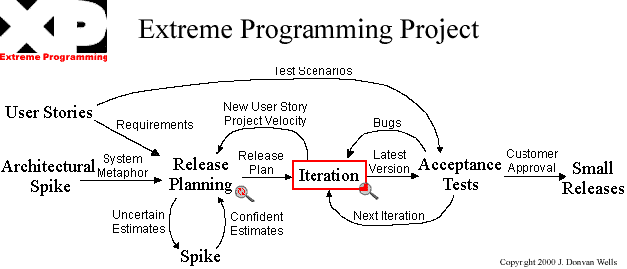
Extreme Programming Project
- Essence of XP
- Four variables in software development
- Cost, Time, Quality, Scope
- Four Values
- Communication, Simplicity, Feedback, and Courage
- Five Principles
- Provide feedback, assume simplicity, make incremental changes, embrace change, quality work
- 12 Practices
- The planning game (customer defines value)
- Small releases
- Metaphor (common vision, common names)
- Simple design
- Writing tests first
- Refactoring
- Pair programming
- Collective ownership
- Continuous integration (small increments)
- Sustainable pace (40 hours/week)
- On-site customer
- Coding standards
- Extreme Programming Practices
- Planning game - programmers estimate effort of implementing customer stories and customer decides about scope and timing of releases
- Short releases - new release every 2-3 months
- Simple design - emphasis on simplest design
- Testing - development test driven…*
- Refactoring - restructuring and changes to simplify
- Pair Programming - 2 people at 1 computer
- Collective ownership - anyone can change any part of the code at any time.
- Continuous integration - new builds as soon as code ready
- 40 hour week - maximum 40-hour week. No overtime
- On-site customer - customer present and available full-time for team
- Coding standards - rules exist and are followed
- Open workspace - large room small cubicles
- Just rules - team has own rules but can be changed any at time
* Unit Tests before Code: In computer programming, unit testing is a software verification and validation method in which a programmer tests if individual units of source code are fit for use. A unit is the smallest testable part of an application. In procedural programming a unit may be an individual function or procedure.
Ideally, each test case is independent from the others: substitutes like method stubs, mock objects, fakes and test harnesses can be used to assist testing a module in isolation. Unit tests are typically written and run by software developers to ensure that code meets its design and behaves as intended. Its implementation can vary from being very manual (pencil and paper) to being formalized as part of build automation.
- The Rules of Extreme Programming
Planning:
- User stories are written.
- Release planning creates the schedule.
- Make frequent small releases
- The Project Velocity is measured.
- The project is divided into iterations.
- Iteration planning starts each iteration.
- Move people around.
- A stand-up meeting starts each day.
- Fix XP when it breaks.
Managing:
- Give the team a dedicated open work space.
- Set a sustainable pace.
- A stand up meeting starts each day.
- The Project Velocity is measured.
- Move people around.
- Fix XP when it breaks.
Designing:
- Simplicity.
- Choose a system metaphor. (system of names for your objects that everyone can relate to)
- Use CRC cards for design sessions.
- Create spike solutions to reduce risk.
- Re-factor whenever and wherever possible.
Coding:
- The customer is always available.
- Code must be written to agreed standards.
- Code the unit test first.
- All production code is pair programmed.
- Only one pair integrates code at a time.
- Integrate often.
- No overtime.
Testing:
- All code must have unit tests.
- All code must pass all unit tests before it can be released.
- When a bug is found tests are created.
- Acceptance tests are run often and the score is published.
*System metaphor: Choose a system metaphor to keep the team on the same page by naming classes and methods consistently. Choose a system of names for your objects that everyone can relate to without specific, hard to earn knowledge about the system.
CRC: Class Responsibility collaborators??
*Re-factor: When we remove redundancy, eliminate unused functionality, and renew obsolete designs we are refactoring. Refactoring throughout the entire project life cycle saves time and increases quality. Re-factor mercilessly to keep the design simple as you go and to avoid needless clutter and complexity.
*A Class Responsibility Collaborator (CRC) model: (Beck & Cunningham 1989; Wilkinson 1995; Ambler 1995) is a collection of standard index cards that have been divided into three sections. A class represents a collection of similar objects, a responsibility is something that a class knows or does, and a collaborator is another class that a class interacts with to fulfill its responsibilities.
*Unit Test First: When you create your tests first, before the code, you will find it much easier and faster to create your code. The combined time it takes to create a unit test and create some code to make it pass is about the same as just coding it up straight away. But, if you already have the unit tests you don't need to create them after the code saving you some time now and lots later.
- Use collective code ownership.
- Leave optimization till last.
- XP > Practices > “Circles of Life”
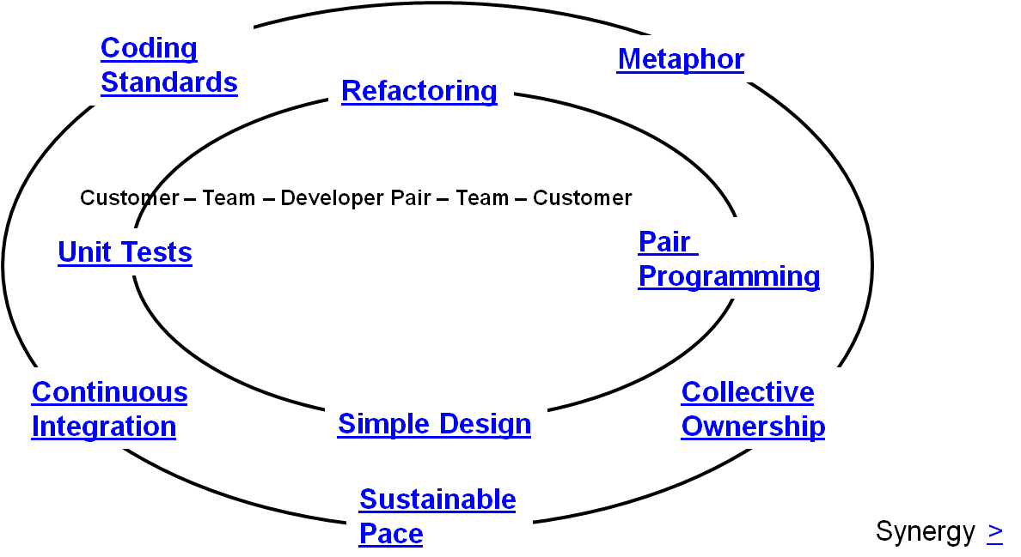
* Different Roles within the Extreme Programming methodology work with some of the practices more than others. This “Circle of Life” diagram (adapted from Ron Jefferies papers on XP) shows how the customer is more involved with the “outer ring” practices, the team is involved in all practices, and developers or pairs of developers are involved in some of the “inner ring” practices.
*Synergy >> meaning working together
- When is Extreme Too Extreme?
- Extreme programming's practices are interdependent
  - A vulnerability if one of them is modified
- Requirements expressed as a set of test cases must be passed by the software
  - System passes the tests but is not what the customer is paying for
- Refactoring issue
  - Difficult to rework a system without degrading its architecture
3.2.2 Scrum
In Rugby, a scrum is a way to restart the game after an interruption, e.g. after a minor foul.
“During a Scrum, the pack must work as a unit, not as 8 individuals. Everybody has a role to play. The important goal to bear in mind is that when you work well together as a unit, the whole is much greater than the sum of the parts.” The On-Line Rugby Coaching Manual
- What is Scrum?
Scrum is an Agile framework for completing complex projects. Scrum originally was formalized for software development projects, but it works well for any complex, innovative scope of work. The possibilities are endless. The Scrum framework is deceptively simple.
- Scrum is not an acronym
- Scrum is a team-based approach, to iteratively, incrementally develop systems and products.
- when requirements are rapidly changing
- Assumes complicated, unpredictable environment
- It produces a potentially shippable set of functionality at the end of every iteration

- How does Scrum work?
- Small teams (< 10 people)
- A series of Sprints (1-4 weeks)
- Visible, usable increments
- Time-boxed
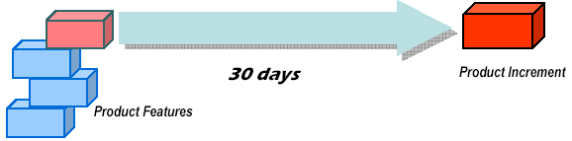
Scrum Working
* One person must be the final arbiter for prioritizing backlog. Clearly, Marketing must be involved. Each Sprint team must buy into the assignment for the team.
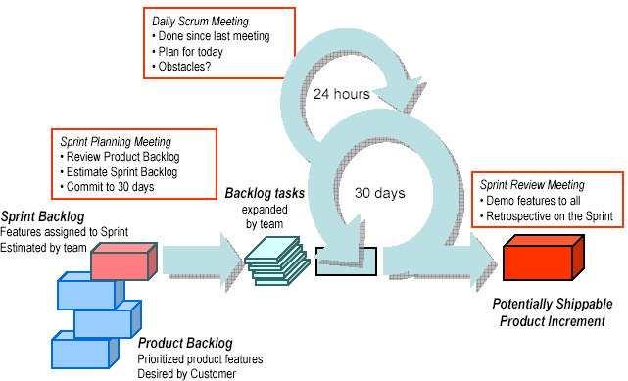
How Scrum work
- Sprint Rules
- Total focus—no unwanted diversion
- NO interruptions/changes from the outside
- New work may be uncovered by the team
- Very XP-ish

- What Happens During a Sprint?
- Frequent, short Scrum Meetings
- Each team produces a visible, usable increment
- Each increment builds on prior increments
- Clearly defined deliverables and responsibilities
- Each team member buys into the assignment
- What’s a Scrum Meeting?
- Short (15 - 30 min) frequent meetings, facilitated by the Scrum Master
- All team members attend—even tele-workers
- One activity – Scrum Master asks each attendee 3 questions
- What Are The 3 Questions?
- What have you completed (relative to the Backlog) since the last Scrum meeting?
- What got in your way of completing this work?
- What will you do between now and the next Scrum meeting?
- At the End of a Sprint?
- Status meeting with all stakeholders.
- Increments are delivered.
- Surprises are reported.
- ANYTHING can be changed, work can be added, eliminated, re-prioritized.
- New estimates and team assignments are made for the next Sprint.
- The project can be cancelled.
* “Experience from earlier increments allows better estimates and planning as project progresses. It's always easier to estimate shorter development periods”
3.2.3 Rational Unified Process
Well defined and well documented process is important in project success. Its goal is to ensure the production of high-quality software that meets the needs of its end-users, within a predictable schedule and budget. Aimed at guiding software development organizations in their endeavors.
It defines roles. It describes the work that each role performs in activities. These activities operate on concrete artifacts: models, code, documents, and reports. Guidelines to perform certain activity with a given tool. All of these process definition elements are organized into disciplines. RUP defines nine disciplines, More than forty roles, hundred artifacts, More than a thousand guidance pages. Process "plug-ins" adds even more functionality. RUP is heavy weight?
Like any software product and is integrated with rational suits of software development. Rational developers team continuously work to update (twice/year) the RUP, so it is never obsolete. All team members uses same version of process. Delivered online, using web technology. In electronic form so can be tailored.
Rational Unified Process is a:
- S/W Engineering Process
- Process Framework
- Process Product
- Workers, Activities, Artifacts, Workflows
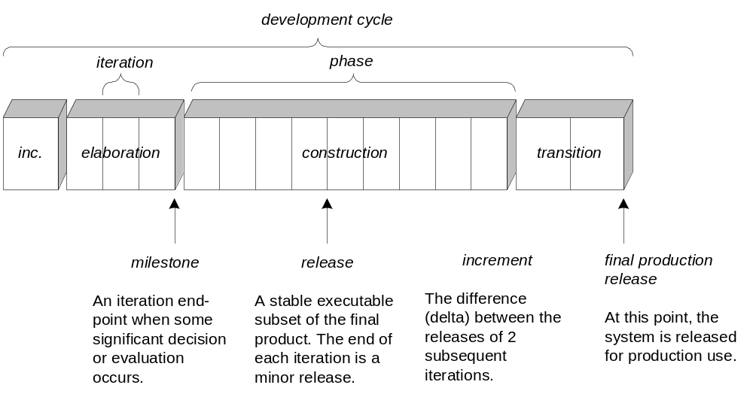

RUP Phases

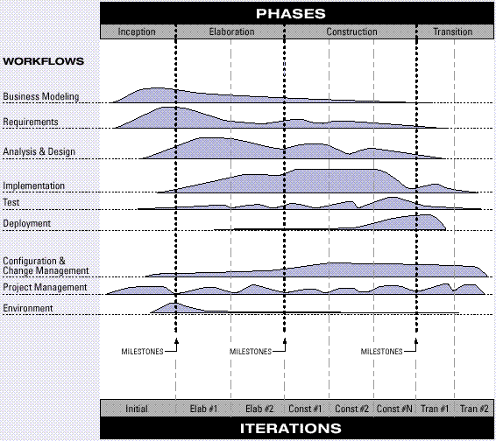
The Architecture of RUP
- You Didn’t Understand the RUP When…
- You think that
- Inception = requirements
- Elaboration = design
- Construction = implementation
- You think that the purpose of elaboration is to fully and carefully define models, which are translated into code during construction
- You think that only prototypes are created in elaboration
- You try to define most of the requirements before starting design or implementation.
- You try to define most of the design before starting implementation
- A “long time” is spent doing requirements or design work before programming starts
- You try to plan a project in detail from start to finish, allocating the work to each iteration; you try to speculatively predict all the iterations
- An organization wants believable plans and estimates for projects before they have entered the elaboration phase
- RUP Support
- Templates
- http://sce.uhcl.edu/helm/rationalunifiedprocess/process/templates.htm
- http://pic.dhe.ibm.com/infocenter/reqpro/v7r1m0/index.jsp?topic=/com.ibm.reqpro.help/administering/projects/creating_modifying/r_rup_proj_template.html
- Tools
- http://www.rational.com.ar/tools/herramientas.html
- S/W Development Best Practices
- Develop software iteratively
- Manage requirements
- Use component based architecture
- Visually model software
- Continuously verify software quality?
- Control changes to software
* It lets you take into account changing requirements. Elements are integrated progressively. It lets you mitigate risks earlier. It provides management with a way to do tactical changes with product.
*Testing process itself can be improved. Workload of a team, stakeholders in project
*What is requirement management? Eliciting, organizing, documenting and establishing and maintaining agreement with customer. RUP provides different workflows for requirement management.
*Reusable components. Tested from developing S/W to composing S/W. RUP facilitates this by iterative development, packages, subsystems in analysis and design.
*Modeling visually helps to match with real world. RUP uses OO design model that reflects the real world and is easy to understand and modify.
- Process Models
- Waterfall
- Prototyping
- RAD
- Incremental
- Spiral
- Agile
- XP
- SCRUM
- RUP
Summary
- Agile Methods
- Extreme Programming
- SCRUM
- RUP
- S/W Development Best Practices

Lecture No. 4
An introduction to Requirements Engineering

4.1 Requirements Engineering
Requirements engineering is the process of establishing the services that the customer requires from a system and the constraints under which it operates and is developed.
The requirements themselves are the descriptions of the system services and constraints that are generated during the requirements engineering process.
- Requirements-Hardest Task
- “The hardest single part of building a software system is deciding precisely what to build.
- No other part of the conceptual work is as difficult as establishing the detailed technical requirements, including all the interfaces to people, to machines, and to other software systems.
- No other part of the work so cripples the resulting system if done wrong. No other part is more difficult to rectify later.” F B Brooks
- What is a Requirement?
- It may range from a high-level abstract statement of a service or of a system constraint to a detailed mathematical functional specification.
- This is inevitable as requirements may serve a dual function
  - May be the basis for a bid for a contract - therefore must be open to interpretation;
  - May be the basis for the contract itself - therefore must be defined in detail;
  - Both these statements may be called requirements.

- Types of Requirements
- User Requirements: Statements in natural language plus diagrams of the services the system provides and its operational constraints. Written for customers.
- System Requirements: A structured document setting out detailed descriptions of the system’s functions, services and operational constraints. Defines what should be implemented so may be part of a contract between client and contractor.
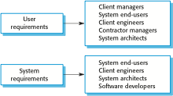
Readers of Different Types of Requirements Specification
- Functional and Non-Functional Requirements
- Functional requirements: Statements of services the system should provide how the system should react to particular inputs and how the system should behave in particular situations.
- May state what the system should not do.
- Non-functional requirements: Constraints on the services or functions offered by the system such as timing constraints, constraints on the development process, standards, etc.
- Often apply to the system as a whole rather than individual features or services.
- Domain requirements: Constraints on the system from the domain of operation

- Functional Requirements
- Describe functionality or system services.
- Depend on the type of software, expected users and the type of system where the software is used.
- Functional user requirements may be high-level statements of what the system should do.
- Functional system requirements should describe the system services in detail.
- Functional Requirements for HMIS
- A user shall be able to search the appointments lists for all clinics.
- The system shall generate each day, for each clinic, a list of patients who are expected to attend appointments that day.
- Each staff member using the system shall be uniquely identified by his or her 8-digit employee number.
- Requirements imprecision
- Problems arise when requirements are not precisely stated.
- Ambiguous requirements may be interpreted in different ways by developers and users.
- Consider the term ‘search’ in requirement 1
  - User intention – search for a patient name across all appointments in all clinics;
  - Developer interpretation – search for a patient name in an individual clinic. User chooses clinic then search.
- Requirements completeness and consistency
- In principle, requirements should be both complete and consistent.
- Complete
  - They should include descriptions of all facilities required.
- Consistent
  - There should be no conflicts or contradictions in the descriptions of the system facilities.
- In practice, it is impossible to produce a complete and consistent requirements document.
- Non-functional requirements
- These define system properties and constraints e.g. reliability, response time and storage requirements. Constraints are I/O device capability, system representations, etc.
- Process requirements may also be specified mandating a particular IDE, programming language or development method.
- Non-functional requirements may be more critical than functional requirements. If these are not met, the system may be useless.
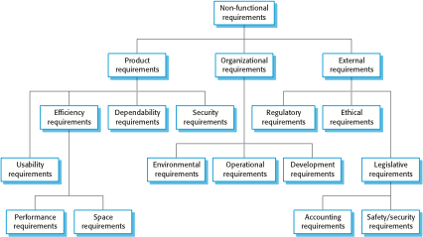
Types of Nonfunctional Requirements

- Non-functional requirements implementation
- Non-functional requirements may affect the overall architecture of a system rather than the individual components.
  - For example, to ensure that performance requirements are met, you may have to organize the system to minimize communications between components.
- A single non-functional requirement, such as a security requirement, may generate a number of related functional requirements that define system services that are required.
  - It may also generate requirements that restrict existing requirements.
- Non-functional classifications
- Product requirements
  - Requirements which specify that the delivered product must behave in a particular way e.g. execution speed, reliability, etc.
- Organisational requirements
  - Requirements which are a consequence of organisational policies and procedures e.g. process standards used, implementation requirements, etc.
- External requirements
  - Requirements which arise from factors which are external to the system and its development process e.g. interoperability requirements, legislative requirements, etc.
- Examples of nonfunctional requirements in HMIS
- Product requirement
The System shall be available to all clinics during normal working hours (Mon–Fri, 0830–17.30). Downtime within normal working hours shall not exceed five seconds in any one day.
- Organizational requirement
Users of the system shall authenticate themselves using their health authority identity card.
- External requirement
The system shall implement patient privacy provisions as set out in HStan-03-2006-priv.
- Goals and requirements
- Non-functional requirements may be very difficult to state precisely and imprecise requirements may be difficult to verify.
- Goal
  - A general intention of the user such as ease of use.
- Verifiable non-functional requirement
  - A statement using some measure that can be objectively tested.
- Goals are helpful to developers as they convey the intentions of the system users.
- Usability requirements
- The system should be easy to use by medical staff and should be organized in such a way that user errors are minimized. (Goal)
- Medical staff shall be able to use all the system functions after four hours of training. After this training, the average number of errors made by experienced users shall not exceed two per hour of system use. (Testable non-functional requirement)

- Metrics for specifying nonfunctional requirements
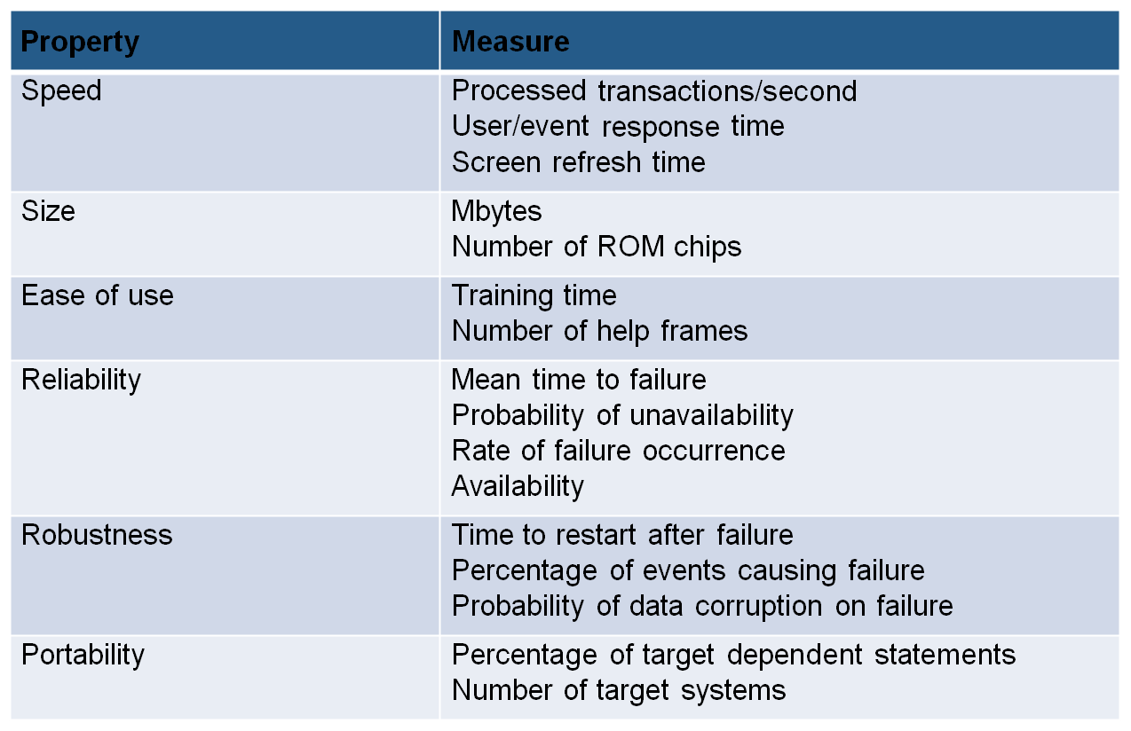
- Domain requirements
- The system’s operational domain imposes requirements on the system.
  - For example, a train control system has to take into account the braking characteristics in different weather conditions.
- Domain requirements be new functional requirements, constraints on existing requirements or define specific computations.
- If domain requirements are not satisfied, the system may be unworkable.
- Domain requirements problems
- Understandability
  - Requirements are expressed in the language of the application domain;
  - This is often not understood by software engineers developing the system.
- Implicitness
  - Domain specialists understand the area so well that they do not think of making the domain requirements explicit.
- FAQS about requirements
- What are requirements?
  - A statement of a system service or constraint
- What is requirement engineering?
  - The processes involved in developing system requirements
- How much does requirements engineering cost?
  - About 15% of system development costs
- What is a requirements engineering process?
  - The structured set of activities involved in developing system requirements
- What happens when the requirements are wrong?
  - Systems are late, unreliable and don’t meet customers’ needs
- Is there an ideal requirements engineering process?
  - No - processes must be tailored to organisational needs
- What is a requirements document?
  - The formal statement of the system requirements
- What are system stakeholders?
  - Anyone affected in some way by the system
- What is the relationship between requirements and design?
  - Requirements and design are interleaved. They should, ideally, be separate processes but in practice this is impossible
- What is requirements management?
  - The processes involved in managing changes to requirements
- Systems engineering
There is a close relationship between software and more general system requirements. Computer-based systems fall into two broad categories:
  - User-configured systems where a purchaser puts together a system from existing software products
  - Custom systems where a customer produces a set of requirements for hardware/software system and a contractor develops and delivers that system
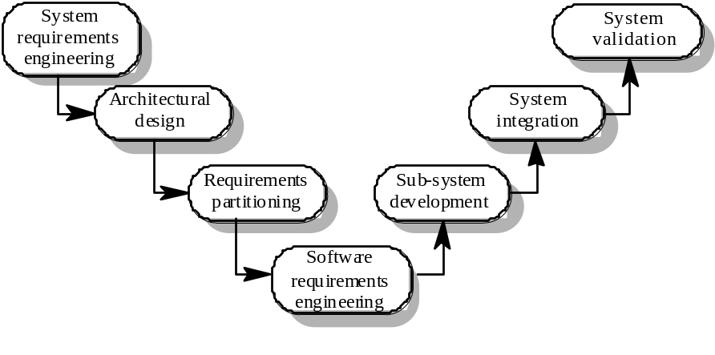

The systems engineering process
- System engineering activities
- System requirements engineering
  - The requirements for the system as a whole are established and written to be understandable to all stakeholders
- Architectural design
  - The system is decomposed into sub-systems
- Requirements partitioning
  - Requirements are allocated to these sub-systems
- Software requirements engineering
  - More detailed system requirements are derived for the system software
- Sub-system development
  - The hardware and software sub-systems are designed and implemented in parallel.
  - System integration
  - The hardware and software sub-systems are put together to make up the system.
- System validation
  - The system is validated against its requirements.
- Requirements document
The requirements document is a formal document used to communicate the requirements to customers, engineers and managers. The requirements document describes:
  - The services and functions which the system should provide
  - The constraints under which the system must operate
  - Overall properties of the system i.e. constraints on the system’s emergent properties
  - Definitions of other systems which the system must integrate with.
  - Information about the application domain of the system e.g. how to carry out particular types of computation
  - Constraints on the processes used to develop the system
  - Description of the hardware on which the system is to run
In addition, the requirements document should always include an introductory chapter which provides an overview of the system, business needs supported by the system and a glossary which explains the terminology used.
- Users of requirements documents
- System customers
  - specify the requirements and read them to check they meet their needs
- Project managers
  - Use the requirements document to plan a bid for system and to plan the system development process
- System engineers
  - Use the requirements to understand the system being developed
- System test engineers
  - Use the requirements to develop validation tests for the system
- System maintenance engineers
  - Use the requirements to help understand the system
- Requirements document structure
IEEE/ANSI 830-1993 standard proposes a structure for software requirements documents.
1. Introduction
1.1 Purpose of requirements document
1.2 Scope of the product
1.3 Definitions, acronyms and abbreviations
1.4 References
1.5 Overview of the remainder of the document
2. General description
2.1 Product perspective
2.2 Product functions
2.3 User characteristics
2.4 General constraints
2.5 Assumptions and dependencies
3. Specific requirements
Covering functional, non-functional and interface requirements.
4. Appendices
Index
- Adapting the standard
The IEEE standard is a generic standard which is intended apply to a wide range of requirements documents. In general, not all parts of the standard are required for all requirements documents each organisation should adapt the standard depending on the type of systems it develops consider a company (XYZ) that develops scientific instruments.
- Organisation XYZ standard
- Preface
  - This should define the expected readership of the document and describe its version history including a rationale for the creation of a new version and a summary of the changes made in each version.
- Introduction
  - This should define the product in which the software is embedded, its expected usage and present and overview of the functionality of the control software.
- Glossary
  - This should define all technical terms and abbreviations used in the document.
- General user requirements
  - This should define the system requirements from the perspective of the user of the system. These should be presented using a mixture of natural language and diagrams.
- System architecture
  - This chapter should present a high-level overview of the anticipated system architecture showing the distribution of functions across system modules. Architectural components which are to be reused should be highlighted.
- Hardware specification
  - This is an optional chapter specifying the hardware that the software is expected to control. It may be omitted if the standard instrument platform is used.
- Detailed software specification
  - This is a detailed description of the functionality expected of the software of the system. It may include details of specific algorithms which should be used for computation. If a prototyping approach is to be used for development on the standard instrument platform, this chapter may be omitted.
- Reliability and performance requirements
  - This chapter should describe the reliability and performance requirements which are expected of the system.
- The following appendices may be included where appropriate:
  - Hardware interface specification
  - Software components which must be reused in the system implementation
  - Data structure specification
  - Data-flow models of the software system
  - Detailed object models of the software system
- Index
- Writing requirements
Requirements are usually written as paragraphs of natural language text supplemented by diagrams and equations.
- Problems with requirements
  - use of complex conditional clauses which are confusing
  - sloppy and inconsistent terminology
  - writers assume readers have domain knowledge
- Writing essentials
  - Requirements are read more often than they are written. You should invest time to write readable and understandable requirements
  - Do not assume that all readers of the requirements have the same background and use the same terminology as you
  - Allow time for review, revision and re-drafting of the requirements document
- Writing guidelines
  - Define standard templates for describing requirements
  - Use language simply consistently and concisely
  - Use diagrams appropriately
  - Supplement natural language with other description of requirements
  - Specify requirements quantitatively
Summary
- Requirements Engineering
- Functional requirements
- Non Functional requirements
- System Engineering
- Requirements Documents

Lecture No. 5
Requirements Engineering Processes

5.1 Requirements Engineering Processes
- Processes:
A process is an organized set of activities which transforms inputs to outputs Process descriptions encapsulate knowledge and allow it to be reused. Examples of process descriptions include:
- Instruction manual for a dishwasher
- Cookery book
- Procedures manual for a bank
- Quality manual for software development
- Design processes
Processes which involve creativity, interactions between a wide range of different people, engineering judgement and background knowledge and experience. Examples of design processes include:
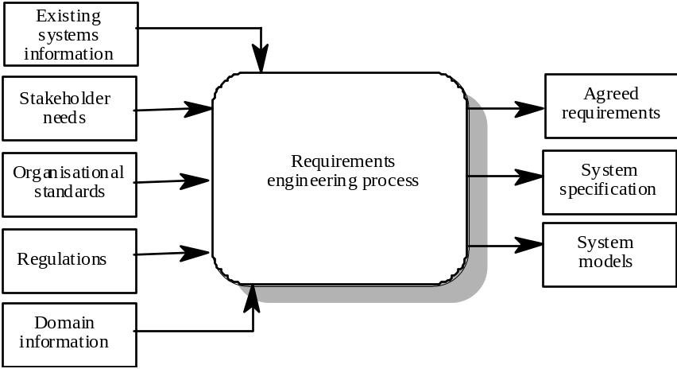

RE Process - Inputs and Outputs

- Writing a book
- Organising a conference
- Designing a processor chip
- Requirements engineering
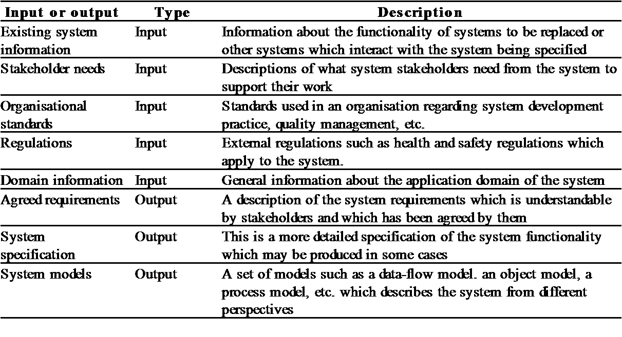Input/output Description
- RE process variability
RE processes vary radically from one organisation to another. Factors contributing to this variability include:
- Technical maturity
- Disciplinary involvement
- Organisational culture
- Application domain
There are therefore no ‘ideal’ requirements engineering process.

- Process models
A process model is a simplified description of a process presented from a particular perspective. Types of process model include:
- Coarse-grain activity models
- Fine-grain activity models
- Role-action models
- Entity-relation models
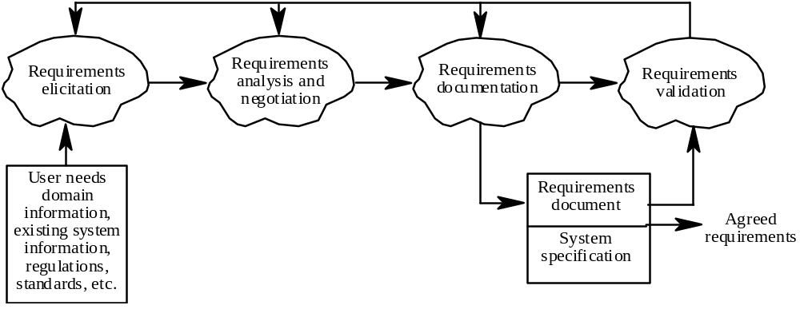

Coarse-grain activity model of RE
- RE process activities
There are various activities involved in requirements engineering process. These activities are:
  - Requirements elicitation: Requirements discovered through consultation with stakeholders.
  - Requirements analysis and negotiation: Requirements are analysed and conflicts resolved through negotiation.
  - Requirements documentation: A requirements document is produced.
  - Requirements validation: The requirements document is checked for consistency and completeness.

- Waterfall model of the software process
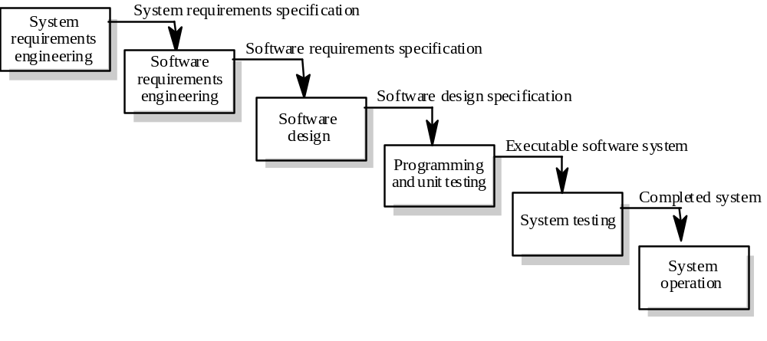

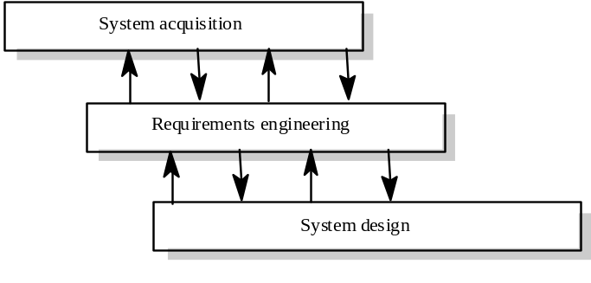
- Context of the RE process

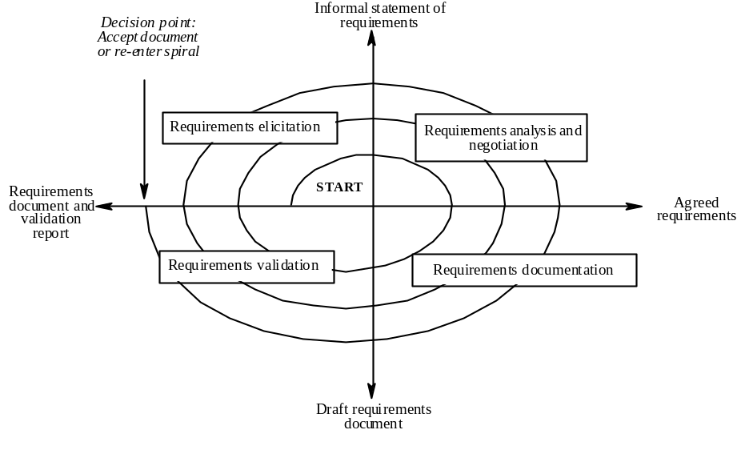
- Spiral model of the RE process

- Actors in the RE process
- Actors in a process are the people involved in the execution of that process
- Actors are normally identified by their roles rather than individually
- Requirements engineering involves actors who are primarily interested in the problem to be solved (end-users, etc) as well actors interested in the solution (system designers, etc.)
- Role-action diagrams document which actors are involved in different activities
- RAD for software prototyping
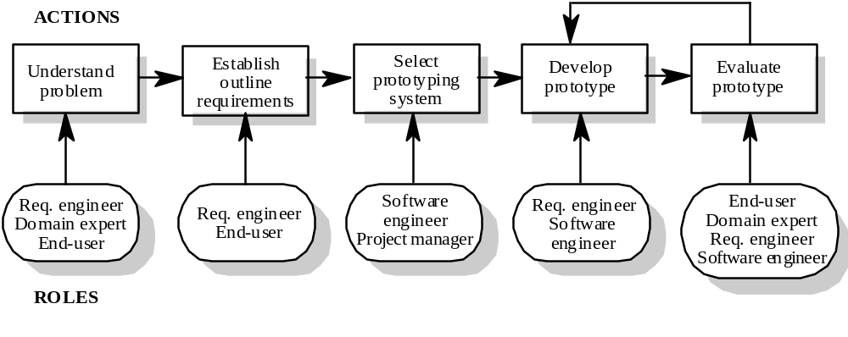

- Role descriptions
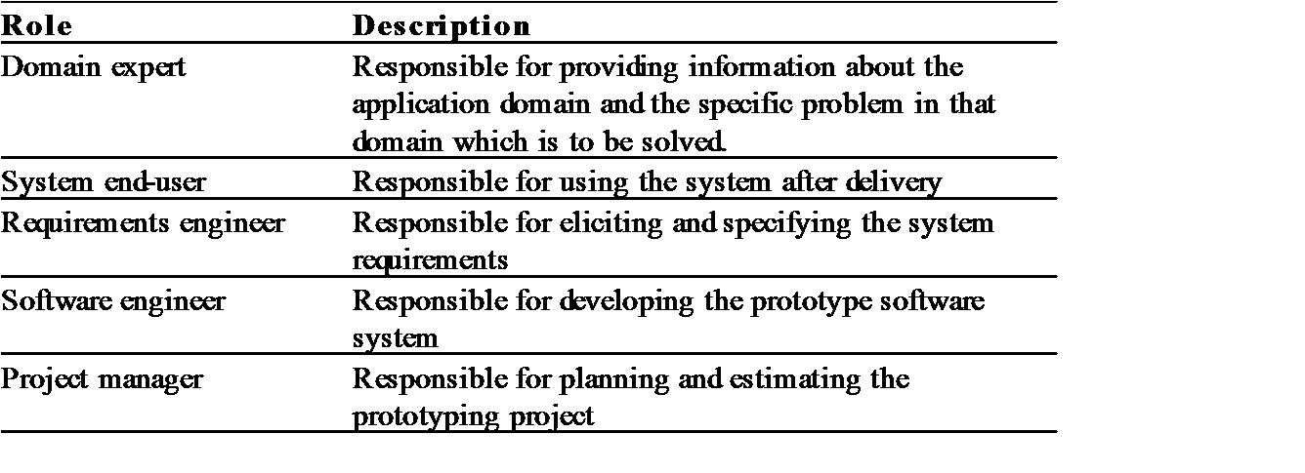

- Human and social factors
Requirements engineering processes are dominated by human, social and organisational factors because they always involve a range of stakeholders from different backgrounds and with different individual and organizational goals.
System stakeholders may come from a range of technical and non-technical background and from different disciplines.
- Types of stakeholder
- Software engineers responsible for system development
- System end-users who will use the system after it has been delivered
- Managers of system end-users who are responsible for their work
- External regulators who check that the system meets its legal requirements
- Domain experts who give essential background information about the system application domain
- Factors influencing requirements
- Personality and status of stakeholders
- The personal goals of individuals within an organisation
- The degree of political influence of stakeholders within an organization
- Process support
- CASE tools provide automated support for software engineering processes
- The most mature CASE tools support well-understood activities such as programming and testing and the use of structured methods.
- Support for requirements engineering is still limited because of the informality and the variability of the process.
5.2 CASE tools for RE
Modeling and validation tools support the development of system models which can be used to specify the system and the checking of these models for completeness and consistency.
Management tools help manage a database of requirements and support the management of changes to these requirements. These requirements engineering/requirements management tools include:
- Telelogic DOORS
- Rational Suite AnalystStudio (Rational Requisite Pro Component)
- RDT 3.0
- Starbase Caliber-RM
- Omni Vista OnYourMark Pro
- Requirements browser
- Requirements query system
- Traceability support system
- Report generator
- Requirements converter and word processor linker
- 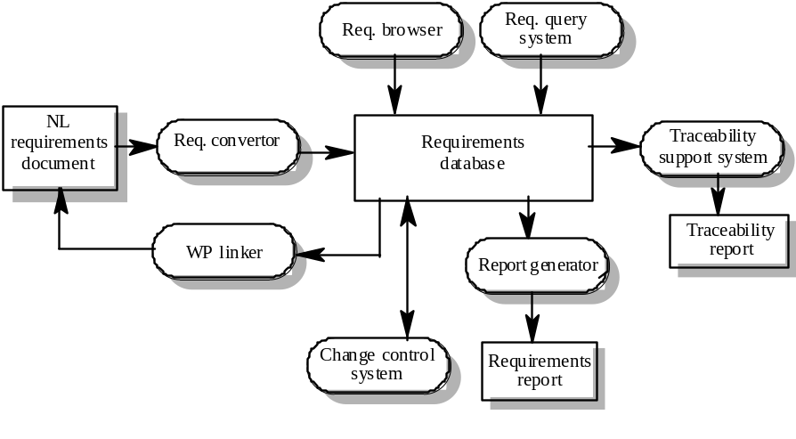Change control system

A requirements management system
- Process improvement
Process improvement is concerned with modifying processes in order to meet some improvement objectives. These improvement objectives are:
- Quality improvement
- Schedule reduction
- Resource reduction
- Planning process improvement
While planning process improvement, get yourself ready to answer the following questions.
- What are the problems with current processes?
- What are the improvement goals?
- How can process improvement be introduced to achieve these goals?
- How should process improvements be controlled and managed?
- RE process problems
- Lack of stakeholder involvement
- Business needs not considered
- Lack of requirements management
- Lack of defined responsibilities
- Stakeholder communication problems
- Over-long schedules and poor quality requirements documents
5.3 Process Maturity
Process maturity can be thought of as the extent that an organisation has defined its processes, actively controls these processes and provides systematic human and computer-based support for them.
The SEI’s Capability Maturity Model is a framework for assessing software process maturity in development organisations
- 5.3.1 Capability Maturity Model
The Capability Maturity Model (CMM) is a development model created after study of data collected from organizations that contracted with the U.S. Department of Defense, who funded the research. This model became the foundation from which Carnegie Mellon created the Software Engineering Institute (SEI). The term "maturity" relates to the degree of formality and optimization of processes, from ad hoc practices, to formally defined steps, to managed result metrics, to active optimization of the processes.
The model's aim is to improve existing software-development processes, but it can also be applied to other processes. The CMM defines each process area in terms of “specific goals” and the “specific practices” required to achieve these goals.
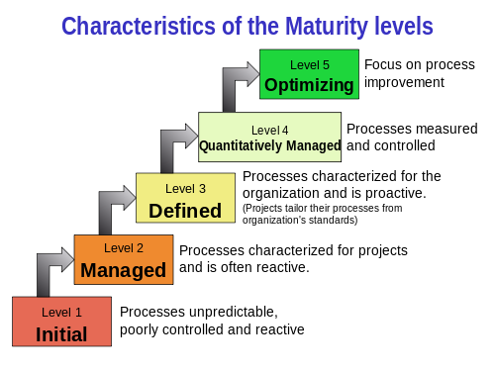
Capability Maturity Model

- Maturity levels
There are five Maturity levels of Capability Maturity Model, lets study them in detail.

- Initial level: Organisations have an undisciplined process and it is left to individuals how to manage the process and which development techniques to use.
- Repeatable level: Organisations have basic cost and schedule management procedures in place. They are likely to be able to make consistent budget and schedule predictions for projects in the same application area.
- Defined level: The software process for both management and engineering activities is documented, standardized and integrated into a standard software process for the organisation.
- Managed level: Detailed measurements of both process and product quality are collected and used to control the process.
- Optimizing level: The organisation has a continuous process improvement strategy, based on objective measurements, in place.
- 5.3.2 RE process maturity model
- 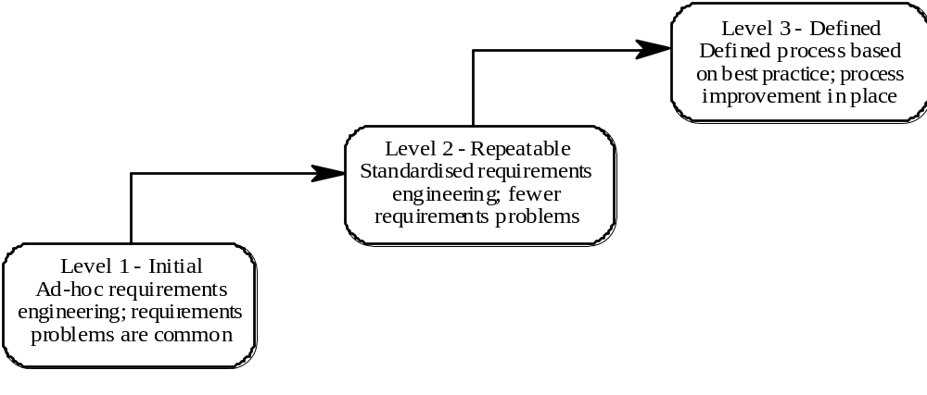Initial level: No defined RE process. Suffer from requirements problems such as requirements volatility, unsatisfied stakeholders and high rework costs. Dependent on individual skills and experience.

RE Process Maturity Model
- Repeatable level: Defined standards for requirements documents and policies and procedures for requirements management.
- Defined level: Defined RE process based on good practices and techniques. Active process improvement process in place.
- Good practice for RE process improvement
- RE processes can be improved by the systematic introduction of good requirements engineering practice.
- Each improvement cycle identifies good practice guidelines and works to introduce them in an organisation.
Examples of good practice guidelines:
- Define a standard document structure
- Uniquely identify each requirement
- Define policies for requirements management
- Use checklists for requirements analysis
- Use scenarios to elicit requirements
- Specify requirements quantitatively
- Use prototyping to animate requirements
- Reuse requirements
- Key points to Remember
- The requirements engineering process is a structured set of activities which lead to the production of a requirements document.
- Inputs to the requirements engineering process are information about existing systems, stakeholder needs, organisational standards, regulations and domain information.
- Requirements engineering processes vary radically from one organisation to another. Most processes include requirements elicitation, requirements analysis and negotiation and requirements validation.
- Requirements engineering process models are simplified process descriptions which are presented from a particular perspective.
- Human, social and organisational factors are important influences on requirements engineering processes.
- Requirements engineering process improvement is difficult and is best tackled in an incremental way.
- Requirements engineering processes can be classified according to their degree of maturity.
Summary
- Requirements Engineering Process
- Process Models
- Types of stakeholder
- CASE tools for RE
- Maturity levels

Lecture No. 6
Requirements Elicitation and Analysis

6.1 Requirements Elicitation and Analysis
In requirements engineering, requirements elicitation is the practice of collecting the requirements of a system from users, customers and other stakeholders. The practice is also sometimes referred to as requirements gathering.
The term elicitation is used in books and research to raise the fact that good requirements cannot just be collected from the customer, as would be indicated by the name requirements gathering. Requirements elicitation is non-trivial because you can never be sure you get all requirements from the user and customer by just asking them what the system should do. Requirements elicitation practices include interviews, questionnaires, user observation, workshops, brainstorming, use cases, role playing and prototyping.
- Components of Requirements Elicitation
Before requirements can be analyzed, modeled, or specified they must be gathered through an elicitation process. Requirements elicitation is a part of the requirements engineering process, usually followed by analysis and specification of the requirements.
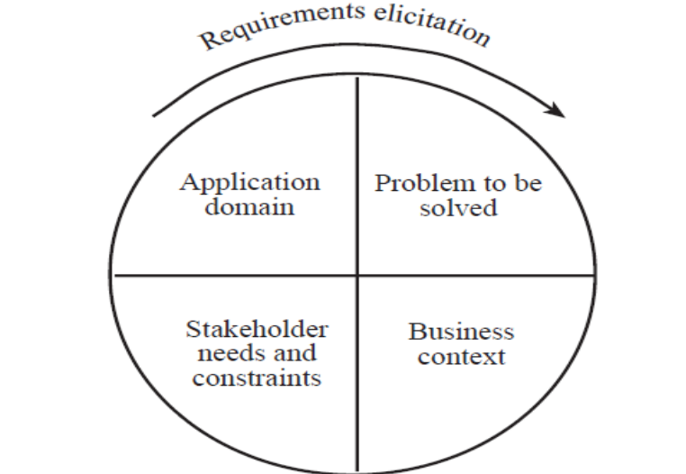
Commonly used elicitation processes are the stakeholder meetings or interviews. For example, an important first meeting could be between software engineers and customers where they discuss their perspective of the requirements.
- Elicitation Activities
- Application domain understanding: Application domain knowledge is knowledge of the general area where the system is applied.
- Problem understanding: The details of the specific customer problem where the system will be applied must be understood.
- Business understanding: You must understand how systems interact and contribute to overall business goals.
- Understanding the needs and constraints of system stakeholders: You must understand, in detail, the specific needs of people who require system support in their work.
- Elicitation, Analysis and Negotiation
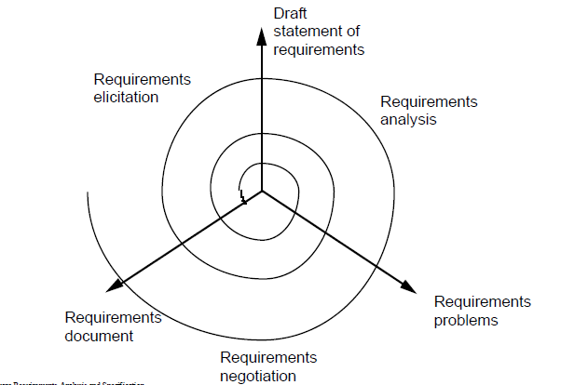

- Elicitation Stages
- Objective Setting: The organisational objectives should be established including general goals of the business, an outline description of the problem to be solved, why the system is necessary and the constraints on the system.
- Background Knowledge Acquisition: Background information about the system includes information about the organisation where the system is to be installed, the application domain of the system and information about existing systems
- Knowledge Organisation: The large amount of knowledge which has been collected in the previous stage must be organised and collated.
- Stakeholder Requirements Collection: System stakeholders are consulted to discover their requirements.
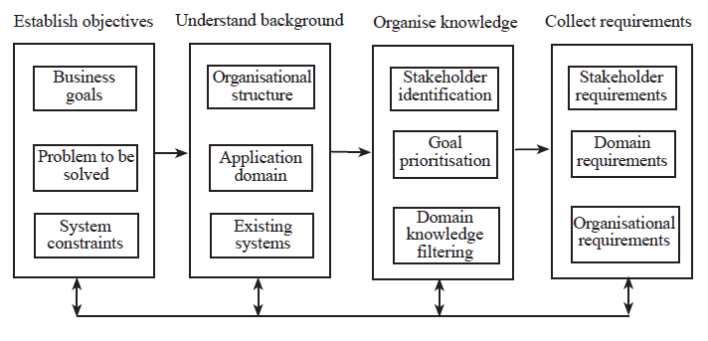
The Requirements Elicitation Process
- Analysis Checks
- Necessity checking: The need for the requirement is analysed. In some cases, requirements may be proposed which don’t contribute to the business goals of the organisation or to the specific problem to be addressed by the system.
- Consistency and completeness checking: The requirements are cross-checked for consistency and completeness. Consistency means that no requirements should be contradictory; completeness means that no services or constraints which are needed have been missed out.
- Feasibility checking: The requirements are checked to ensure that they are feasible in the context of the budget and schedule available for the system development.
- Requirements Negotiation
- Requirements discussion: Requirements which have been highlighted as problematical are discussed and the stakeholders involved present their views about the requirements.
- Requirements prioritization: Disputed requirements are prioritized to identify critical requirements and to help the decision making process.
- Requirements agreement: Solutions to the requirements problems are identified and a compromise set of requirements are agreed. Generally, this will involve making changes to some of the requirements.
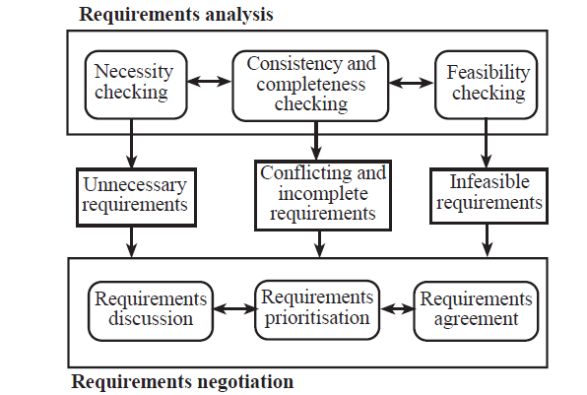
- Guidelines for Requirements Elicitation
In 1997, Sommerville and Sawyer suggested a set of guidelines for requirements elicitation, to address concerns such as those identified by Christel and Kang:
- Assess the business and technical feasibility for the proposed system
- Identify the people who will help specify requirements and understand their organizational bias
- Define the technical environment (e.g., computing architecture, operating system, telecommunications needs) into which the system or product will be placed
- Identify "domain constraints" (i.e., characteristics of the business environment specific to the application domain) that limit the functionality or performance of the system or product to be built
- Define one or more requirements elicitation methods (e.g., interviews, focus groups, team meetings)
- Solicit participation from many people so that requirements are defined from different points of view; be sure to identify the rationale for each requirement that is recorded
- Identify ambiguous requirements as candidates for prototyping
- Create usage scenarios or use cases to help customers/users better identify key requirements
6.2 Requirements Elicitation Techniques
Specific techniques are there, which may be used to collect knowledge about system requirements. The knowledge regarding elicitation techniques must be structured.
- Partitioning - aggregating related knowledge
- Abstraction - recognizing generalities
- Projection - organizing according to perspective
Elicitation problems can be in the form of:
- Not enough time for elicitation
- Inadequate preparation by engineers
- Stakeholders are unconvinced of the need for a new system
- Specific elicitation techniques
Commonly used elicitation processes are the stakeholder meetings or interviews. For example, an important first meeting could be between software engineers and customers where they discuss their perspective of the requirements. Other important elicitation techniques includes: Scenarios, Soft systems methods, Observations and social analysis, Requirements reuse.
- 1. Interviews
The requirements engineer or analyst discusses the system with different stakeholders and builds up an understanding of their requirements.
Types of interview: There are two main types of interviews. These are:
Closed interviews: The requirements engineer looks for answers to a pre-defined set of questions
Open interviews: There is no predefined agenda and the requirements engineer discusses, in an open -ended way, what stakeholders want from the system.
- Interviewing essentials
- Interviewers must be open-minded and should not approach the interview with pre-conceived notions about what is required
- Stakeholders must be given a starting point for discussion. This can be a question, a requirements proposal or an existing system
- Interviewers must be aware of organizational politics - many real requirements may not be discussed because of their political implications
- 2. Scenarios
Scenarios are stories which explain how a system might be used. They should include:
- a description of the system state before entering the scenario
- the normal flow of events in the scenario
- exceptions to the normal flow of events
- information about concurrent activities
- a description of the system state at the end of the scenario
Scenarios are examples of interaction sessions which describe how a user interacts with system Discovering scenarios exposes possible system interactions and reveals system facilities which may be required.
- Library scenario - document ordering
- Log on to EDDIS system
- Issue order document command
- Enter reference number of the required document
- Select a delivery option
- Log out from EDDIS
- This sequence of events can be illustrated in a diagram
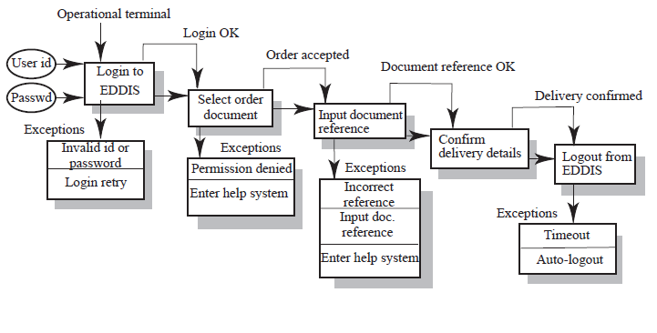
Library Scenario
- Scenarios and OOD
Scenarios are an inherent part of some object-oriented development methods. The term use-case (i.e. a specific case of system usage) is sometimes used to refer to a scenario. There are different views on the relationship between use cases and scenarios:
- A use-case is a scenario
- A scenario is a collection of use-cases. Therefore, each exceptional interaction is represented as a separate use-case.

- 3. Soft Systems methods
These produce informal models of a socio-technical system. They consider the system, the people and the organization. Not techniques for detailed requirements elicitation. Rather, they are ways of understanding a problem and its organizational context. Software Systems Methodology (SSM) is probably the best known of these methods. The essence of SSM is its recognition that systems are embedded in a wider human and organizational context.
- Stages of Soft Systems methods
The major stages of software systems methods for requirement elicitation are:
- Problem situation assessment
- Problem situation description
- Abstract system definition from selected viewpoints
- Conceptual system modelling
- Model/real-world comparison
- Change identification
- Recommendations for action
- 4. Observation and social analysis
People often find it hard to describe what they do because it is so natural to them. Sometimes, the best way to understand it is to observe them at work. Ethnography is a technique from the social sciences which has proved to be valuable in understanding actual work processes.
Actual work processes often differ from formal, prescribed processes. An ethnographer spends some time observing people at work and building up a picture of how work is done.
- Ethnography guidelines
- Assume that people are good at doing their job and look for non-standard ways of working
- Spend time getting to know the people and establish a trust relationship
- Keep detailed notes of all work practices. Analyse them and draw conclusions from them
- Combine observation with open-ended interviewing
- Organise regular de-briefing session where the
- ethnographer talks with people outside the process
- Combine ethnography with other elicitation techniques
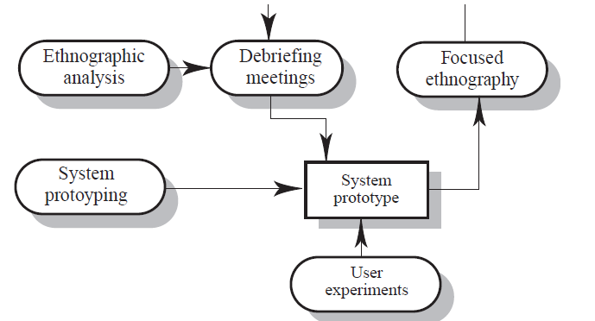
Ethnography in Elicitation
- Ethnographic perspectives
- The work setting viewpoint: This describes the context and the physical location of the work and how people use objects to carry out tasks. Therefore, in a study of a help desk (say), this would describe the objects which the helper had to hand and how these were organised.
- Social and organisational perspectives: This tries to bring out the day -to-day experience of work as seen by different people who are involved. Each individual typically sees the work in a different ways and this viewpoint tries to organise and integrate all of these perceptions.
- The workflow viewpoint: This viewpoint presents the work from a series of work activities with information flowing from one activity to another.
- 5. Requirements reuse
Reuse involves taking the requirements which have been developed for one system and using them in a different system. Requirements reuse saves time and effort as reused requirements have already been analysed and validated in other systems. Currently, requirements reuse is an informal process but more systematic reuse could lead to larger cost savings
- Reuse possibilities
The requirements reuse possibilities are in the following situations:
- Where the requirement is concerned with providing application domain information.
- Where the requirement is concerned with the style of information presentation. Reuse leads to a consistency of style across applications.
- Where the requirement reflects company policies such as security policies.
- Prototyping
A prototype is an initial version of a system which may be used for experimentation. Prototypes are valuable for requirements elicitation because users can experiment with the system and point out its strengths and weaknesses. They have something concrete to criticise. Rapid development of prototypes is essential so that they are available early in the elicitation process.
- Prototyping benefits
- The prototype allows users to experiment and discover what they really need to support their work
- Establishes feasibility and usefulness before high development costs are incurred
- Essential for developing the ‘look and feel’ of a user interface
- Can be used for system testing and the development of documentation
- Forces a detailed study of the requirements which reveals inconsistencies and omissions
- Types of prototyping
- Throw-away prototyping: Intended to help elicit and develop the system requirements. The requirements which should be prototyped are those which cause most difficulties to customers and which are the hardest to understand. Requirements which are well-understood need not be implemented by the prototype.
- Evolutionary prototyping: Intended to deliver a workable system quickly to the customer. Therefore, the requirements which should be supported by the initial versions of this prototype are those which are well-understood and which can deliver useful end -user functionality. It is only after extensive use that poorly understood requirements should be implemented.
- Prototyping costs and problems
- Training costs - prototype development may require the use of special purpose tools
- Development costs - depend on the type of prototype being developed
- Extended development schedules - developing a prototype may extend the schedule although the prototyping time may be recovered because rework is avoided
- Incompleteness - it may not be possible to prototype critical system requirements
- Approaches to prototyping
- Paper prototyping: A paper mock -up of the system is developed and experiments
- ‘Wizard of Oz’ prototyping: A person simulates the responses of the system inputs
- Executable prototyping: A fourth generation language or other rapid development is used to develop an executable prototype
- Executable prototype development
- Fourth generation languages based around database systems
- Visual programming languages such as Visual Basic or Object Works
- Internet-based prototyping solutions based on World Wide Web browsers and languages such as Java

- Requirements analysis
The goal of analysis is to discover problems, incompleteness and inconsistencies in the elicited requirements. These are then fed back to the stakeholders to resolve them through the negotiation process. Analysis is interleaved with elicitation as problems are discovered when the requirements are elicited. A problem checklist may be used to support analysis. Each requirement may be assessed against the checklist.
- Analysis checklists
- Premature design: Does the requirement include premature design or implementation information?
- Combined requirements: Does the description of a requirement describe a single requirement or could it be broken down into several different requirements?
- Unnecessary requirements: Is the requirement ‘gold plating’? That is, is the requirement a cosmetic addition to the system which is not really necessary?
- Use of non-standard hardware: Does the requirement mean that non-standard hardware or software must be used? To make this decision, you need to know the computer platform requirements.
- Conformance with business goals: Is the requirement consistent with the business goals defined in the introduction to the requirements document? Requirements ambiguity
- Requirements ambiguity: Is the requirement ambiguous i.e. could it be read in different ways by different people? What are the possible interpretations of the requirement?
- Requirements realism: Is the requirement realistic given the technology which will be used to implement the system?
- Requirements testability: Is the requirement testable, that is, is it stated in such a way that test engineers can derive a test which can show if the system meets that requirement?
- Requirements interactions
A very important objective of requirements analysis is to discover the interactions between requirements and to highlight requirements conflicts and overlaps. A requirements interaction matrix shows how requirements interact with each other. Requirements are listed along the rows and columns of the matrix.
- For requirements which conflict, fill in a 1
- For requirements which overlap, fill in a 1000
- For requirements which are independent, fill in a 0
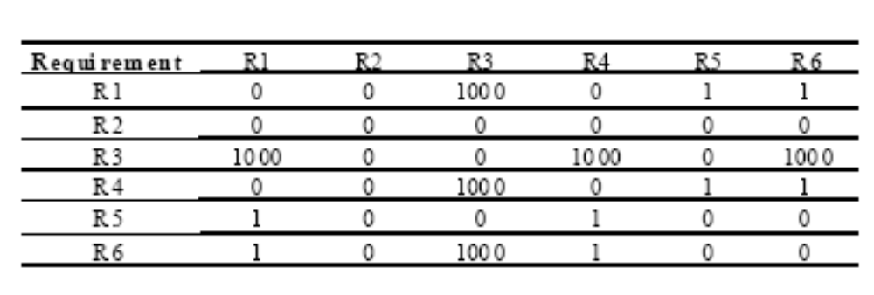
Interaction matrices

- Requirements negotiation
Disagreements about requirements are inevitable when a system has many stakeholders. Conflicts are not ‘failures’ but reflect different stakeholder needs and priorities.
Requirements negotiation is the process of discussing requirements conflicts and reaching a compromise that all stakeholders can agree to. In planning a requirements engineering process, it is important to leave enough time for negotiation. Finding an acceptable compromise can be time-consuming.
- Negotiation meetings
An information stage where the nature of the problems associated with a requirement is explained. A discussion stage where the stakeholders involved discuss how these problems might be resolved.
- All stakeholders with an interest in the requirement should be given the opportunity to comment. Priorities may be assigned to requirements at this stage.
A resolution stage is where actions concerning the requirement are agreed.
- These actions might be to delete the requirement, to suggest specific modifications to the requirement or to elicit further information about the requirement.
- Requirements Elicitation Key Points
- Requirements elicitation involves understanding the application domain, the specific problem to be solved, the organisational needs and constraints and the specific facilities needed by system stakeholders.
- The processes of requirements elicitation, analysis and negotiation are iterative, interleaved processes which must usually be repeated several times.
- There are various techniques of requirements elicitation which may be used including interviewing, scenarios, soft systems methods, and prototyping and participant observation.
- Prototypes are effective for requirements elicitation because stakeholders have something which they can experiment with to find their real requirements.
- Checklists are particularly useful as a way of organising the requirements validation process. They remind analysts what to look for when reading through the proposed requirements.
- Requirements negotiation is always necessary to resolve requirements conflicts and remove requirements overlaps. Negotiation involves information interchange, discussion and resolution of disagreements.
Summary
- Requirements Elicitation
- Elicitation Activities
- Elicitation Stages
- Analysis Checks
- Elicitation Techniques
- Requirements Analysis

Lecture No. 7
Requirements Documentation/Specification

7.1 Software Requirements Specification
The System Requirements Definition Document is a statement in a natural language of what user services the system is expected to provide. Sometimes known as the user requirements document (or concept of operations) records the system requirements. there are various definition/explanations of requirements specification.
- (1) Requirements Specification
Requirements specification defines the high-level system requirements from the domain perspective. Requirements specification must list the system requirements along with background information about overall objectives for the system, its target environment and a statement of the constraints, assumptions and non-functional requirements. May include conceptual models designed to illustrate the system context, usage scenarios, the principal domain entities, and data, information and work-flows.
- (2) Requirements Specification
According to another definition, Requirements specification (intermediate level) is a structured document which sets out the system services in more detail. It should be written such that understandable by technical staff from both clients and developers.
- Characteristics of Requirements
The main characteristics for requirements are that requirements should be:
- Correct
- Consistent
- Unambiguous
- Complete
- Feasible
- Relevant
- Testable
- Traceable
- Examples of Poorly Written Requirements
Here are some of the examples of poorly written requirements.
- ATM machine will confiscate the card if user enters wrong PIN multiple times.
- The product should have a good human interface.
- The output of the program shall usually be given within 10 secs.
- The System shall allow student to add six courses in one semester if he/she has good GPA.
- Sample Table of Contents
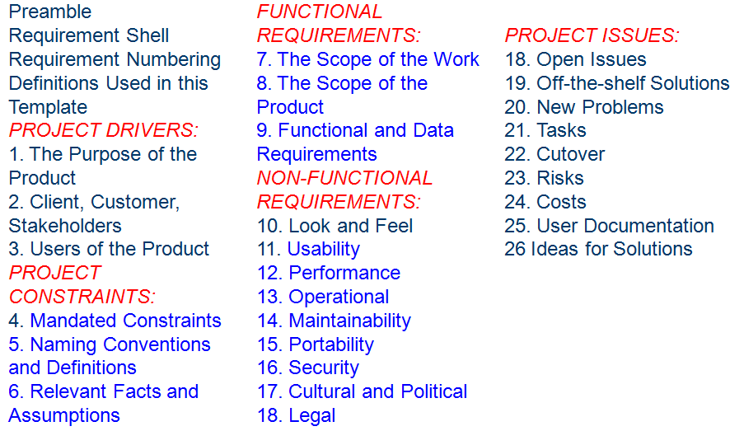
- (3) Software Requirements Specification (SRS)
Software Requirements Specification (SRS) is also called Design Specification. It is an abstract description of the S/W, which is basis for its design and implementation. There should be a clear and direct relationship between this document and the requirement specification, but the reader of this is S/W designers.
Such a specification is included mostly as part of system contract and is the basis for designing system acceptance tests. Inputs, Process, Output, pre-conditions, post-conditions are the minimum required.
7.2 Why We Use Software Requirements Specifications Document
A key benefit of developing a software requirement specification is streamlining the development process. The developer working from the software requirement specification has; ideally, all of their questions answered about the application and can start to develop. Since this is a functional specification that was client approved, they are building nothing less than what the customer wants. There should be nothing left to guess or interpret when the functional specification is completed. This is the brilliance of the software requirement specification. Below are some good guidelines for what the benefits of a good Software Requirement Specification (SRS):
- Congruency between the Customers (Stakeholders) and the Suppliers on What the Software Product Is To Do: The complete description of the functions to be performed by the software specified in the Software Requirement Specification will help the potential users to determine if the software in question adheres to their needs.
- Reduce The Development Effort: The preparation of the Software Requirement Specification forces the various concerned groups in the customer’s organization to consider rigorously all of the requirements before design begins and reduces later redesign, recoding, and retesting. Careful review of the requirements in the Software Requirement Specification can reveal omissions, misunderstandings, and inconsistencies early in the development cycle when these problems are easier to correct.
- Provide A Basis For Estimating Costs And Schedules: The description of the product to be developed as given in the Software Requirement Specification is a realistic basis for estimating project costs and can be used to obtain approval for bids or price estimates.
- Provide A Baseline For Validation And Verification: Organizations can develop their validation and Verification plans much more productively from a good Software Requirement Specification. As a part of the development contract, the SRS provides a baseline against which compliance can be measured.
- Facilitate Transfer: The Software Requirement Specification makes it easier to transfer the software product to new users or new machines. Customers thus find it easier to transfer the software to other parts of their organization, and suppliers find it easier to transfer it to new customers.
Serve As A Basis For Enhancement: Because the Software Requirement Specification discusses the product but not the project that developed it, the SRS serves as a basis for later enhancement of the finished product. The SRS may need to be altered, but it does provide a foundation for continued production evaluation.
7.3 Structured Language Specification
- Natural Language is required because of understandability. Many notations have been developed which rely on natural language in a controlled way using standard form and also use graphical highlighting.
- The form structure will vary depending on the requirement structuring technique (functional, data, object e.t.c).
- Functional oriented Specifications are most common.
- May use control constructs, (derived from program languages)
- Form based approach fits well with formal mathematical specification. A formal specification can be defined and paraphrased in a set of forms or a formal specification can be defined from the structured forms and used to refine the requirement specification.
- Other approaches (e.g. formal mathematical) tackle some problems of specifications ambiguity but at the cost of perhaps, readability.

ATM example of structured requirement specification (functional approach)
A form based approach could obviously be automated.
- Pre and post conditions are used to specify the actions of the function.
- It is not an operational specification of what the function must do.
- The names used (in the form) must be defined elsewhere or if possible in data dictionary.
- Document Structure and Standards
Several recommended guides and standards exist to help define the structure of requirements documentation. These include IEEE P1233/D3 guide, IEEE Std. 1233 guide, IEEE Std. 830-1998, ISO/IEC 12119-1994. IEEE Std 1362-1998 concept of operations (ConOPs).
- Importance of SRS
- It serves as a basis of communication among all parties
- Formally or informally, it represents an agreement among the various parties
- It serves as the software manager's reference standard.
- It serves as input to the design and implementation groups.
- It serves as input to the software testing and QA (quality assurance) groups.
- It controls the evolution of the system throughout the development phase of the project; as new features are added or modified in the Vision document, they are elaborated within the package.
- Characteristics of a good SRS
- An SRS should be
- Correct
- Unambiguous
- Complete
- Consistent
- Ranked for importance and/or stability
- Verifiable
- Modifiable
- Traceable

- Examples of Bad SRS Documents
- Unstructured Specifications: Narrative essay --- one of the worst types of specification document:
- Difficult to change
- Difficult to be precise
- Difficult to be unambiguous
- Scope for contradictions etc.
- Noise: Presence of text containing information irrelevant to the problem.
- Silence: Aspects important to proper solution of the problem are omitted.
- Over specification: Addressing “how to” aspects
- For example, “Library member names should be stored in a sorted descending order”
- Over specification restricts the solution space for the designer.
- Contradictions: Contradictions might arise if the same thing described at several places in different ways.
- Ambiguity: Literary expressions Unquantifiable aspects, e.g. “good user interface”
- Forward References: References to aspects of problem defined only later on in the text.
- Wishful Thinking: Descriptions of aspects for which realistic solutions will be hard to find.
- Requirements Modeling
- Functional Requirements
- Use Case Modeling
- Domain Modeling
- Activity Diagrams
- Non- Functional Requirements
- Quality Attribute Scenarios
- Activity Diagrams
To model the dynamic aspects of a system, it is essentially a flowchart, showing flow of control from activity to activity. The purpose of activity diagram is to model business workflows and model operations. Activity diagrams commonly contain: Activity states and action states, Transitions and Objects.
- Action States and Activity States
- Action states are atomic and cannot be decomposed
- Work of the action state is not interrupted
- Activity states can be further decomposed
- Their activity being represented by other activity diagrams
- They may be interrupted
- Transitions
- When the action or activity of a state completes, flow of control passes immediately to the next action or activity state
- A flow of control has to start and end someplace
- initial state -- a solid ball
- stop state -- a solid ball inside a circle
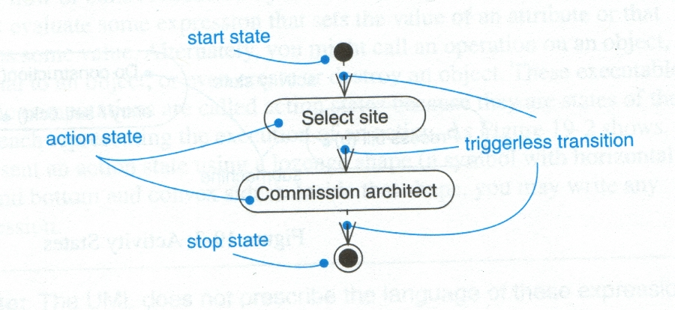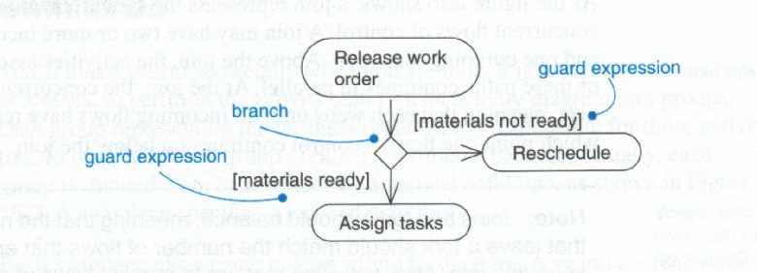
Transition Branching
- Branching
- A branch specifies alternate paths taken based on some Boolean expression
- A branch may have one incoming transition and two or more outgoing ones
- Forking and Joining
- Use a synchronization bar to specify the forking and joining of parallel flows of control
- A synchronization bar is rendered as a thick horizontal or vertical line
- Fork: A fork may have one incoming transitions and two or more outgoing transitions. Each transition represents an independent flow of control conceptually, the activities of each of outgoing transitions are concurrent
- either truly concurrent (multiple nodes)
- or sequential yet interleaved (one node)
- Join: A join may have two or more incoming transitions and one outgoing transition.
- above the join, the activities associated with each of these paths continues in parallel
- at the join, the concurrent flows synchronize (each waits until all incoming flows have reached the join, at which point one flow of control continues on below the join)
- Swimlanes
- A swimlane specifies a locus of activities. To partition the activity states on an activity diagram into groups. Each group representing the business organization responsible for those activities, each group is called a swimlane.
- Each swimlane is divided from its neighbor by a vertical solid line.
- Each swimlane has a name unique within its diagram
- Each swimlane may represent some real-world entity
- Each swimlane may be implemented by one or more classes
- Every activity belongs to exactly one swimlane, but transitions may cross lanes
Summary
- Requirements Characteristics
- Requirements specification
- SRS
- Importance of SRS
- RUP SRS Template
- Requirements Modeling

Lecture No. 8
Use Case Modelling

8.1 What is a Use Case?
Use Cases are narrative descriptions of domain processes in a structured prose format. They are stories or scenarios of how people use the system.
Use cases capture user requirements for a system by describing how a system will be used and to what ends in a way that the end user can understand. Use cases are the method favored by the component and object community to specify requirements and indeed to drive the whole software development process. A use case is a collection of possible sequences of interactions between the system under discussion and its external Actors related to a particular goal. The use case is complete when the goal has been satisfied. A use case is usually written in simple language and without technical jargon so that it can be understood by all participants in the analysis process. A complete set of use cases specifies all the different ways to use the system and therefore defines all behavior required of the system bounding the scope of the system. It is in this way that the use case helps to reduce scope creep.
Each use case is a complete course of events in the system from a user perspective. Each use case is independent of the others. Use cases usually stick to fairly major tasks; they do not need to be written for every action the user can take. Design information is included in the use case in order to make it easier to discuss with the customer but this information is not part of the requirements. The goal is to extract the real underlying requirements. It is important to keep in mind that a Use Case is a depiction of a User’s vision so the analyst should be as flexible as possible.
- Advantages of Use Cases
Use cases provide many benefits beyond defining user requirements. Use cases can be used to:
- Illuminate and document current or goal-stated methods, systems and stakeholders
- Identify business-domain classes and their associates
- Drive detailed application analysis and design
- Develop scripts for testing
- Suggest prototyping activity
- Clarify architecture requirements
- Highlight risks and needs for risk management
- Disadvantages of Use Cases
Disadvantages Limitations of use cases include:
- Use cases are not well suited to capturing non-interaction based requirements of a system (such as algorithm or mathematical requirements) or non-functional requirements (such as platform, performance, timing, or safety-critical aspects). These are better specified declaratively elsewhere.
- Use case templates do not automatically ensure clarity. Clarity depends on the skill of the writer(s).
- Use cases are complex to write and to understand, for both end users and developers.
- As there are no fully standard definitions of use cases, each project must form its own interpretation.
- Some use case relationships, such as extends, are ambiguous in interpretation and can be difficult for stakeholders to understand.
- In Agile, simpler user stories are preferred to use cases.
- Use cases are a starting point for test design, but since each test needs its own success criteria, use cases may need to be modified to provide separate post conditions for each path.
- A Short Example to Start With (Dice game)
Software simulates a player rolling two dice. If the total is seven, they win; otherwise, they lose.
Use case: Play a game
Actors: Player
Description: Player requests to roll the dice. System presents results: If the dice face value totals seven, player wins; otherwise, player loses.
- Case Study – The NextGen POS System
- Computerized application used to record sales and handle payments
- Used in retail store
- It includes hardware and software
- It also interfaces to other applications, such as a third-party tax calculator and inventory control
- Multiple and varied clients-side terminals and interfaces
- Commercial POS
- Use Case, Actor, and Scenario
- Actors: A use case defines the interactions between external actors and the system under consideration to accomplish a goal. Actors must be able to make decisions, but need not be human: "An actor might be a person, a company or organization, a computer program, or a computer system, hardware, software, or both." Actors are always stakeholders, but many stakeholders are not actors, since they "never interact directly with the system, even though they have the right to care how the system behaves." For example, "the owners of the system, the company's board of directors, and regulatory bodies such as the Internal Revenue Service and the Department of Insurance" could all be stakeholders but are unlikely to be actors.
Similarly, a person using a system may be represented as different actors because he is playing different roles. For example, user "Joe" could be playing the role of a Customer when using an Automated Teller Machine to withdraw cash from his own account, or playing the role of a Bank Teller when using the system to restock the cash drawer on behalf of the bank. Actors are often working on behalf of someone else.
- Scenario: It is a specific sequence of actions and interactions between actors and the system. It is also called use case instance. It is one particular story of using a system.
- E.g. scenario of successfully purchasing items with cash or scenario of failing to purchase items because of credit payment denial
- Use case then is a collection of success and failure scenarios
- Use cases are requirements, primarily functional
- A UC is a dialogue between an Actor and a system that accomplishes a task. The dialogue is presented as a sequence of steps. A complete sequence of steps is a use case scenario.
- A scenario (UC instance) forms a complete path thru the UC.
- UC can contain multiple scenarios (i.e., >1 path thru UC)
- Can range from simple (brief summary) to elaborate (detailed steps using adopted document template)
- UCs are NOT object-oriented artifacts! They feed into other OO models
- Kinds of Actors in Use Cases
Basically there three broad types of actors involved in a use case.
  - Primary actor
    - has user goals fulfilled through using services of the SuD
    - Why identify? To find user goals, which drive the use cases?
  - Supporting actor
    - provides a service (for example, information) to the SuD
    - Why identify? To clarify external interfaces and protocols.
  - Offstage actor
    - has an interest in the behavior of the use case
    - Why identify? To ensure that all necessary interests are identified and satisfied.
- Guidelines for Use Cases
  - How to find use cases
    - Choose the system boundary
    - Find primary actors
    - Identify goals for each primary actor
    - Define Use cases that satisfy user goals
- 1. System Boundary
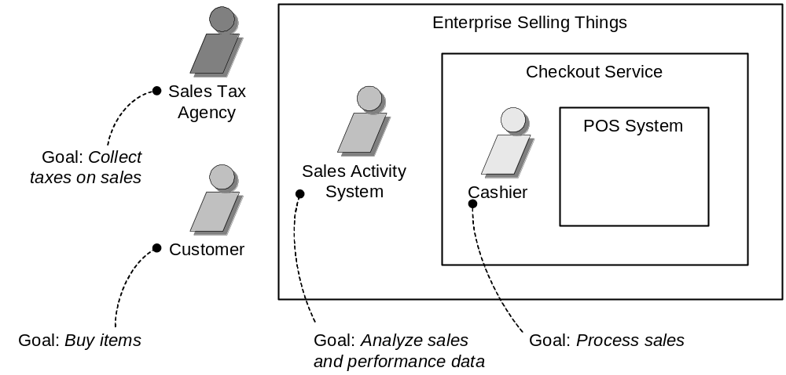

- 2 and 3. Primary actors and Goals
Brainstorm the primary actors first. Questions to help identify Actors and Goals are:
- Who starts and stops the system?
- Who does user and security management?
- Who does system administration?
- Is “Time” an actor because the system does something in response to a time event?
- Are there any external software systems that call upon the services of the system?
Organize the actors and goals in an Actor Goal List.
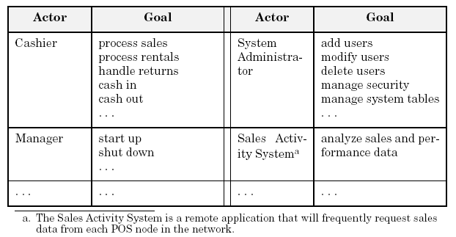
- 4. Define Use cases for user goals
8.2 Writing Use Cases
Use cases are text documents, not diagrams and use case modeling is primarily an act of writing text, not drawing diagrams.
- Use Case Style
- Black Box Use cases: Focus on what not how
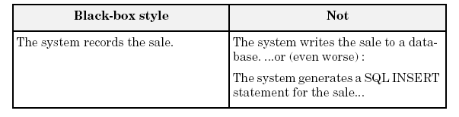
- Use Case Formats
- Brief
- Process Sale: A customer arrives at a checkout with items to purchase. The cashier uses the POS system to record each purchased item. The system presents a running total and line-item details. The customer enters payment information, which the system validates and records. The system updates inventory. The customer receives a receipt from the system and then leaves with the items.
- Causal
- Main Success Scenario: A customer arrives at a checkout with items to return. The cashier uses the POS system to record each returned item.
- Alternate Scenarios: If the credit authorization is reject, inform the customer and ask for an alternate payment method.
If the item identifier is not found in the system, notify the Cashier and suggest manual entry of the identifier code (perhaps it is corrupted). If the system detects failure to communicate with the external tax calculator system
- Fully dressed
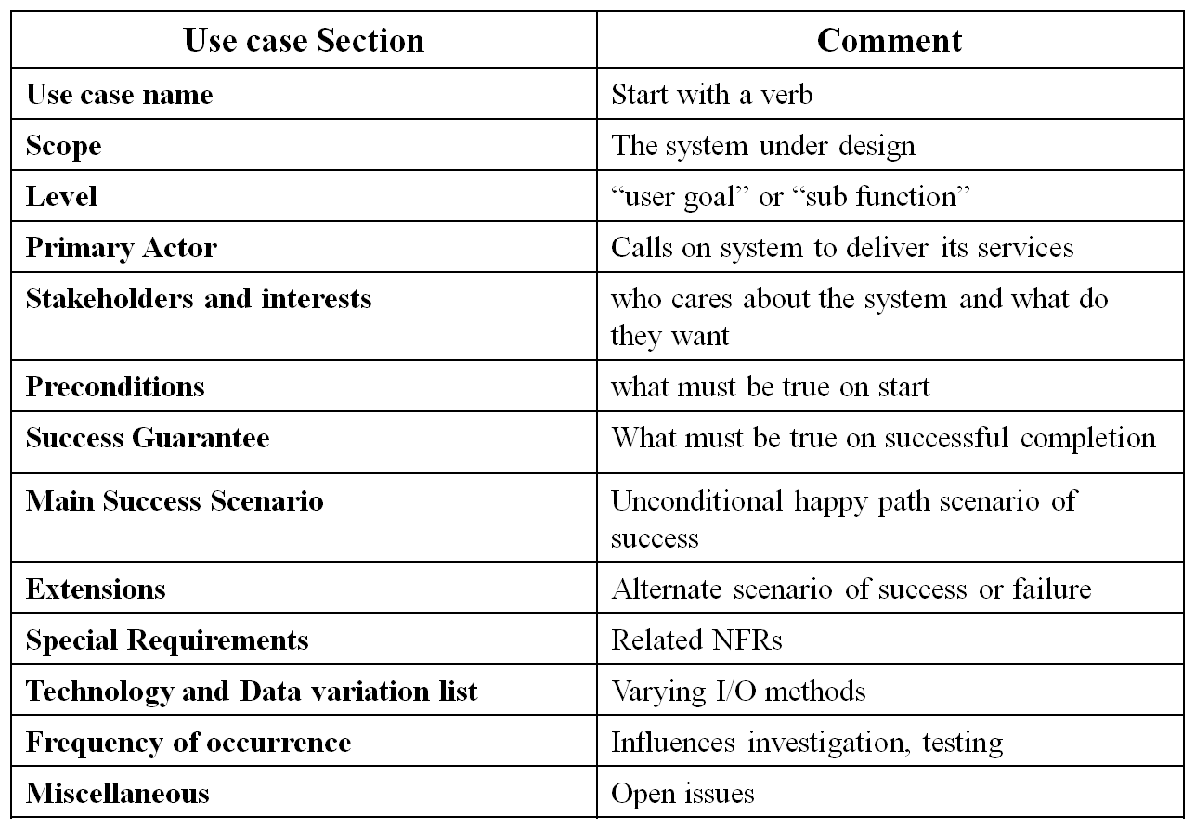
- Process Sale Use Case
- UC: Process Sale
- User selects new sale option
- System requests item identifier
- User enters item identifier
- System records sale of item, and
- System displays item description, price, and current total. Steps 2-5 repeated until user finished
- User selects sale finished option
- System displays total and taxes due
- User selects payment option
- System requests payment information
- User enters payment information
- System handles payment
- System logs completed sale and sends sale information to Accounting System and Inventory System
- System generates receipt
- Alternate Flow or Extensions
- 3a. Invalid identifier:
1. System signals error and rejects entry.
- 3-6a: Customer asks Cashier to remove an item from the purchase:
1. Cashier enters item identifier for removal from sale.
2. System displays updated running total.
- 3-6b. Customer tells Cashier to cancel sale:
1. Cashier cancels sale on System.
- 4a. The system generated item price is not wanted (e.g., Customer complained about something and is offered a lower price):
1. Cashier enters override price. .
2. System presents new price.
- Common UC Issues
- What Tests Can Help Find Useful Use Cases?
- The Boss Test
- The EBP Test: A task performed by 1 user in 1 place at 1 time in response to a business event that adds measurable value to the business and leaves data in a consistent state.
- The Size Test
- Writing Style
- Essential (keep the UI out)
- Concrete (UI decisions embedded in the UC text)
- Write ‘black box’ UCs
- Defer implementation details
- Avoid reference to specific technologies
- Library Use Case Diagram
- A computerized library system for a university keeps track of all books and periodicals in the library and their check-out status.
- Checkout and return are automated through a bar code reader (an external device).
- The library system also interfaces with an external relational database which stores information about the library users (students, faculty, and staff), including whether they have any library items checked out.
- Library users can access the catalog and recall books and periodicals.
- Library employees have the same access as well as additional capabilities (e.g., listing the status of an item).
Note: the library catalog is part of the library computer system so it is not shown as an actor.

- Use Case for Employee Login
- Employee initiates use case by entering user name
- System prompts for password
- If password is valid, employee is logged on and now has access to employee commands
- Starting and Ending Conditions?
- Exceptions? e.g., cannot find the employee login

- Use Case for Check Book Availability
- User/Employee initiates use case by selecting the check book availability option
- System prompts for choice of search by title, author, or call number
- User makes selection and enters title, author or call number
- System performs search through the library catalog database
- If a match is found, system displays item status (not checked out, checked out and due date, overdue)

- Terminology:
- Concrete use case
- is initiated by an actor
- is an EBP use case
- e.g., Process Sale

- Abstract use case
- is never instantiated by itself
- is a sub-function use case (part of another use case)
- e.g., Handle Credit Payment
- Base use case
- that includes another use case, or that is extended or specialized by another use case
- e.g., Process Sale with respect to the included Handle Credit Payment
- Addition use case
- that is an inclusion, extension, or specialization
- Handle Credit Payment in the include relationship to Process Sale
Addition use cases are usually abstract while base use cases are usually concrete.
- Generalization Association in Use Cases
- Problem
  - You have common behavior among use cases and want to factor this out.
- Solution
  - The generalization association among use cases factors out common behavior. The child use cases inherit the behavior and meaning of the parent use case and add or override some behavior.
- Example
  - Consider the use case “Validate User”, responsible for verifying the identity of the user. The customer might require two realizations: “Check Password” and “Check Fingerprint”

Summary
- Use Case
- Case Study
- Writing Use Cases
- UC Formats
- Common UC Issues

Lecture No. 9
Domain Model
9.1 Domain Models?

It shows an abstraction of the conceptual classes, because there are many other things one could communicate about registers, sales, and so forth.

Domain models are fundamental OO analysis model.

Shows important concepts in the domain of interest

Visual dictionary of concepts & their relationships

Inspiration for SW objects in class diagram

Depicts objects, their attributes, associations between objects

Does NOT show object’s operations
- Guideline:

Avoid a waterfall-mindset big-modeling effort to make a thorough or "correct" domain model. It won't ever be either, and such over-modeling efforts lead to analysis paralysis, with little or no return on the investment.

Partial Domain Model – A Visual Dictionary
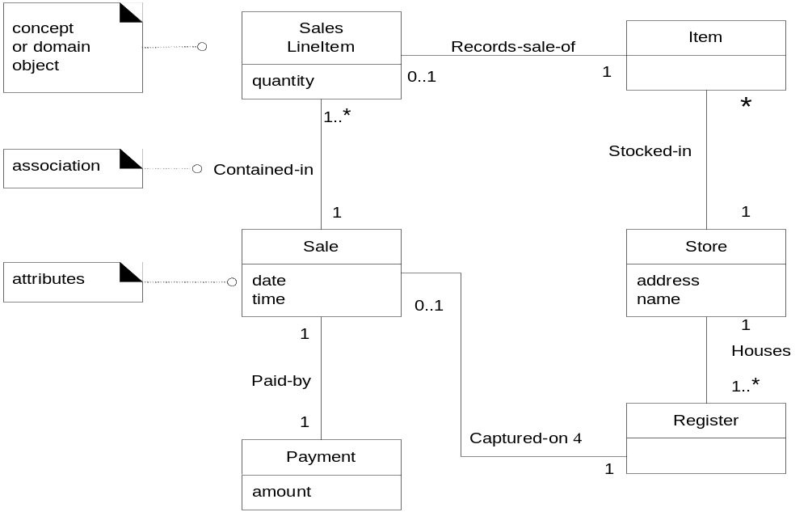

- Conceptual Classes

The domain model illustrates conceptual classes or vocabulary in the domain.

Informally, a conceptual class is an idea, thing, or object.

Conceptual class may be considered in terms of its

Symbol – words or images representing a conceptual class

Intension – the definition of a conceptual class

Extension – the set of examples to which the conceptual class applies

Example

Symbol – Sale

Intension – represents the event of a purchase transaction, and has a date and time

Extension – all the examples/instances of sales
- Domain models Don’t Confuse with Data Models

Don’t confuse with data model

Object might have attributes that aren’t persisted

Object might have no attributes

Such objects wouldn’t be in a data model

Domain model simpler than full-blown design class model

Easier for users to understand

Use it to educate users about basic OO modeling

Reduces tendency for modeler to drill too deep too quickly
- Motivation: Domain Models

OO modeling lowers the representational gap between our mental and software models.

Use software class names in the domain layer inspired from names in the domain model, with objects having domain-familiar information and responsibilities.
- How to Create Domain Models

How to create a domain model?

Bounded by the current iteration requirements under design:

Find the conceptual classes

Draw them as classes in a UML class diagram.

Add associations and attributes

Guideline: How to Find Conceptual Classes?

Reuse or modify existing models

Use a category list

Identify noun phrases
- Finding Conceptual Classes with Noun Phrase Identification

Linguistic analysis:

Identify the nouns and noun phrases in textual descriptions of a domain, and consider them as candidate conceptual classes or attributes

Have to differentiate between attribute and class

A weakness of this approach is the imprecision of natural language

It is recommended in combination with the Conceptual Class Category List technique.

The fully dressed use cases are an excellent description to draw from for
- Example

Main Success Scenario (or Basic Flow):

Customer arrives at a POS checkout with goods and/or services to purchase.

Cashier starts a new sale.

Cashier enters item identifier.

System records sale line item and presents item description, price, and running total. Price calculated from a set of price rules.

Cashier repeats steps 2-3 until indicates done.

System presents total with taxes calculated.

Cashier tells Customer the total, and asks for payment.

Customer pays and System handles payment.

System logs the completed sale and sends sale and payment information to the external Accounting (for accounting and commissions) and Inventory systems (to update inventory).

System presents receipt.

Customer leaves with receipt and goods (if any).

- Guidelines

Agile Modeling and Maintain the Model in a Tool

Report Object in the domain

Include it in domain model or not?

e.g., Receipt is only a report of Sale and Payment

Think like a Mapmaker

Use the existing names in the territory. For example, if developing a model for a library, name the customer a "Borrower" or "Patron" the terms used by the library staff.

Exclude irrelevant or out-of-scope features.

How to Model the Unreal World?

e.g., Software for Telecommunication

It requires a high degree of abstraction

Listening carefully to the core vocabulary and concepts that domain experts use

A Common Mistake with Attributes vs. Classes

If we do not think of some conceptual class X as a number or text in the real world, X is probably a conceptual class, not an attribute.

Objects vs. attributes

Attributes are ‘simple’ data types

e.g., number, text

Concepts that are described by simple attributes are objects

A Store has an address, phone number, etc.

As another example, consider the domain of airline reservations. Should destination be an attribute of Flight, or a separate conceptual class Airport?
- Guidelines: Description classes

When to model with Description classes

A description class Contain info that describes something else, very common in OO models

A Product Description that records the price, picture, and text description of an Item.

If description is not separate from the underlying object, then deletion of the object results in loss of all info about that object

Also error prone due to data duplication

When Are Description Classes Useful?

Add a description class (for example, Product Description) when:

There needs to be a description about an item or service, independent of the current existence of any examples of those items or services.

Deleting instances of things they describe (for example, Item) results in a loss of information that needs to be maintained, but was incorrectly associated with the deleted thing.

It reduces redundant or duplicated information.
- Guidelines: Associations

Associations

A meaningful relationship between objects

When knowledge of relationship needs to be preserved

For example, do we need to remember what Sales Line Item instances are associated with a Sale instance? Definitely, otherwise it would not be possible to reconstruct a sale, print a receipt, or calculate a sale total.

A Cashier may look up Product Descriptions, but there is no need to remember the fact of a particular Cashier looking up particular Product Descriptions.
- Consider including the following associations in a domain model:

Associations for which knowledge of the relationship needs to be preserved for some duration ("need-to-remember" associations)

Associations derived from the Common Associations List.

Why Should We Avoid Adding Many Associations?

Many lines on the diagram will obscure it with "visual noise”

Focus on "need-to-remember" associations.

Associations are NOT

A model of data flows

DB foreign keys

Instance variables

SW object connections

It is a statement that a relationship is meaningful in a purely conceptual perspective in the real domain.

Many, but not all, associations will be implemented eventually
- 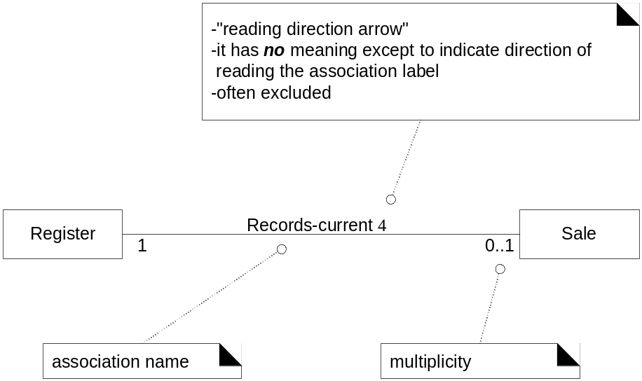Applying UML: Association Notation

An optional "reading direction arrow" indicates the direction to read the association name; it does not indicate direction of visibility or navigation.

Name an association based on a Class Name-Verb Phrase-Class Name format.

Simple association names such as "Has" or "Uses" are usually poor, as they seldom enhance our understanding of the domain.

Sale Paid-by Cash Payment

Bad example (doesn't enhance meaning): Sale Uses Cash Payment

Applying UML: Roles

Each end of an association is called a role. Roles may optionally have:

Multiplicity expression

Name

Navigability

Multiple Associations between Two Classes
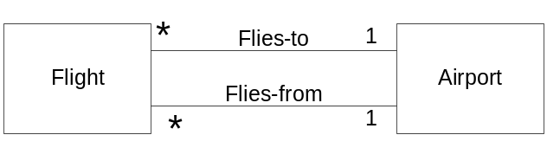

It can have more than 1 association between classes. A class can also have an association with itself.

Example: Associations in the Domain Models

Transactions related to another transaction Sale Paid-by Cash Payment.

Line items of a transaction sale contain sales line item.

Product for a transaction (or line item), sales line item records-sale-of item

NextGen POS partial domain model

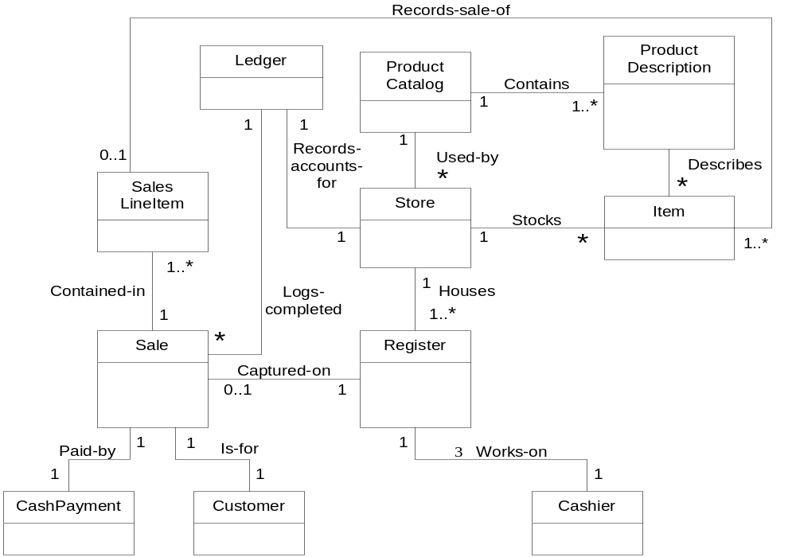

Attributes

A logical data value of an object that needs to be remembered

Some attributes are derived from other attributes

The usual ‘primitive’ data types

Numbers, characters, Booleans

Common compound data types

Date, time (or date Time), address, SSN, phone Number, bar codes, etc.

May become full class objects in design

Include attributes that the requirements (for example, use cases) suggest or imply a need to remember information.

Sale needs a date Time attribute.

Store needs a name and address.

Cashier needs an ID.

Applying UML: Derived Attribute
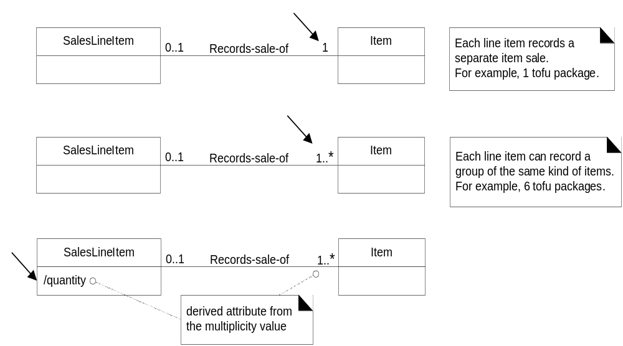The total attribute in the Sale can be calculated or derived from the information in the Sales Line Items.

Summary
- Domain Model
- Conceptual Classes
- Guidelines
- Attributes
- Data Types
- Modeling Quantities

Lecture No. 10
Requirements Document for the Banking System

10.1 Requirements Document

The requirements document is a formal document used to communicate the requirements to customers, engineers and managers. It is also known as software requirements specifications or SRS. The services and functions which the system should provide the constraints under which the system must operate Overall properties of the system i.e., constraints on the system’s emergent properties
- SRS for the Banking System
- Preface: This should define the expected readership of the document and describe its version history including a rationale for creation of a new version and a summary of the changes made in each version.
- Introduction: This should define the product in which the software is embedded, its expected usage and present an overview of the functionality of the control software.
- Glossary: This should define all technical terms and abbreviations used in the document
- Specific requirements: This should define specific requirements for the system using natural language with the help of diagrams, where appropriate.
- Appendices:
Use-case model, Object model, Data-flow model

10.2 Software Requirements Specifications for the Banking System
- 1. Preface
- This document, Software Requirements Specification (SRS), is created to document the software requirements for the Banking System, as described in section 2, Introduction, of this document.
- This document was created on the request of the ‘XYZ Bank Inc.’ – the ‘Client’. The creator of this document is ‘A Software House Inc.’ – ‘Vendor’. The ‘Client’ has asked the ‘Vendor’ to develop an SRS for the Banking System. The ‘Vendor’ will also be responsible for the development of the software based on this SRS
- This is the first version of the SRS.
- 2. Introduction
- This section documents an overview of the functionality expected from the software for the Banking System
- We’ll review the functionality of the software to be developed
- A bank has several automated teller machines (ATMs), which are geographically distributed and connected via a wide area network to a central server. Each ATM machine has a card reader, a cash dispenser, a keyboard/display, and a receipt printer. By using the ATM machine, a customer can withdraw cash from either checking or savings account, query the balance of an account, or transfer funds from one account to another. A transaction is initiated when a customer inserts an ATM card into the card reader. Encoded on the magnetic strip on the back of the ATM card are the card numbers, the start date, and the expiration date. Assuming the card is recognized, the system validates the ATM card to determine that the expiration date has not passed, that the user-entered PIN (personal identification number) matches the PIN maintained by the system, and that the card is not lost or stolen. The customer is allowed three attempts to enter the correct PIN; the card is confiscated if the third attempt fails. Cards that have been reported lost or stolen are also confiscated.
- If the PIN is validated satisfactorily, the customer is prompted for a withdrawal, query, or transfer transaction. Before withdrawal transaction can be approved, the system determines that sufficient funds exist in the requested account, that the maximum daily limit will not be exceeded, and that there are sufficient funds available at the local cash dispenser. If the transaction is approved, the requested amount of cash is dispensed, a receipt is printed containing information about the transaction, and the card is ejected. Before a transfer transaction can be approved, the system determines that the customer has at least two accounts and that there are sufficient funds in the account to be debited. For approved query and transfer requests, a receipt is printed and card ejected. A customer may cancel a transaction at any time; the transaction is terminated and the card is ejected. Customer records, account records, and debit card records are all maintained at the server.
- An ATM operator may start up and close down the ATM to replenish the ATM cash dispenser and for routine maintenance. It is assumed that functionality to open and close accounts and to create, update, and delete customer and debit card records is provided by an existing system and is not part of this problem.
- 3. Glossary
- ATM: Automated Teller Machine
- PIN: Personal Identification Number
- 4. Specific Requirements
- The XYZ Bank Inc. can have many automated teller machines (ATMs), and the new software system shall provide functionality on all ATMs.
- The system shall enable the customers of XYZ Bank Inc., who have valid ATM cards, to perform three types of transactions; 1) withdrawal of funds, 2) Query of account balance, and 3) transfer of funds from one bank account to another account in the same bank.
- An ATM card usage shall be considered valid if it meets the following conditions:
- The card was issued by an authorized bank.
- The card is used after the start date, i.e., the date when the card was issued.
- The card is used before the expiration date, i.e., the date when the card expires.
- The card has not been reported lost/stolen by the customer
- The customer provides correct personal identification number (PIN), which matches the PIN maintained by the system
- The system shall confiscate the ATM card if it detects that a lost or stolen card has been inserted by a customer. The system shall also display an apology to the customer.
- The system shall allow the customer to enter the correct PIN in no more three attempts. The failure to provide correct PIN in three attempts shall result in the confiscation of the ATM card.
- The system shall ask for the transaction type after satisfactory validation of the customer PIN. The customer shall be given three options: withdrawal transaction, or query transaction, or transfer transaction.
- If a customer selects withdrawal transaction, the system shall prompt the customer to enter account number and amount to be dispensed.
- For a withdrawal transaction, the system shall determine that sufficient funds exist in the requested account, that the maximum daily limit has not be exceeded, and that there are sufficient funds available at the local cash dispenser.
- If a withdrawal transaction is approved, the requested amount of cash shall be dispensed, a receipt shall be printed containing information about the transaction, and the card shall be ejected. The information printed on the receipt includes transaction number, transaction type, amount withdrawn, and account balance.
- If a customer selects query transaction, the system shall prompt the customer to enter account number.
- If a query transaction is approved, the system shall print a receipt and eject the card. The information contained on the receipt includes transaction number, transaction type, and account balance.
- If a customer selects transfer transaction, the system shall prompt the customer to enter from account number, to account number, and amount to be transferred.
- The system shall check if there are enough funds available in the from account, which are being requested for transfer to the to account.
- If the transfer transaction is approved, a receipt shall be printed and card shall be ejected. The information printed on the receipt includes transaction number, transaction type; amount transferred, and account balance.
- The system shall cancel any transaction if it has not been completed if the customer presses the Cancel button
- The customer records, account records, and debit card records will all be maintained at the server and shall not be the responsibility of the system.
- The system shall enable an ATM operator to shutdown or start up an ATM for routine maintenance.
- The system shall enable an ATM operator to add cash to the cash dispenser.
- The system shall not be responsible for opening or closing of accounts, and to create, update, and delete customer and debit card records. These tasks are performed elsewhere by a bank.
- The system shall be linked with the bank server through communication systems, which are beyond the scope of the current system. It is assumed that this facility is always available.
- The system shall not be responsible for the maintenance of the hardware devices of the ATM or network facilities.
- 5. Appendices
- . 5.1 Use-case model
- 5.2 Object model
- 5.3 Functional model
  - 5.3.1 Data-flow model
  - 5.3.2 SADT model
- 5.4 Dynamic model
  - 5.4.1 State charts
  - 5.4.2 Interaction diagrams
Summary
- Requirements Document
- SRS for the Banking System
- Preface
- Introduction
- Glossary
- Specific Requirements
- Use Case Model
- Object Model
- Statecharts
- Collaboration Diagrams
- Sequence Diagram
Lecture No. 11
Software Architecture

11.1 Software Architecture
The software architecture of a program or computing system is the structure or structures of the system, which comprise software elements, the externally visible properties of those elements, and the relationships among them.
"Externally visible" properties are those assumptions other elements can make of an element, such as its provided services, performance characteristics, fault handling, shared resource usage, and so on. Let's look at some of the implications of this definition in more detail.
- First, architecture defines software elements. The architecture embodies information about how the elements relate to each other. This means that it specifically omits certain information about elements that does not pertain to their interaction.
- Second, the definition makes clear that systems can and do comprise more than one structure: So no one structure can irrefutably claim to be the architecture. For example, all nontrivial projects are partitioned into implementation units; these units are given specific responsibilities and are frequently the basis of work assignments for programming teams.
- Third, the definition implies that every computing system with software has software architecture because every system can be shown to comprise elements and the relations among them. In the most trivial case, a system is itself a single element uninteresting and probably non useful but an architecture nevertheless.
- Fourth, the behavior of each element is part of the architecture insofar as that behavior can be observed or discerned from the point of view of another element. Such behavior is what allows elements to interact with each other, which is clearly part of the architecture.
- Finally, the definition is indifferent as to whether the architecture for a system is a good one or a bad one, meaning that it will allow or prevent the system from meeting its behavioural, performance, and life-cycle requirements.
- What is Software Architecture
Software architecture serves as the blueprint for both the system and the project developing it, defining the work assignments that must be carried out by design and implementation teams. The architecture is the primary carrier of system qualities such as performance, modifiability, and security, none of which can be achieved without a unifying architectural vision. Architecture is an artifact for early analysis to make sure that a design approach will yield an acceptable system. By building effective architecture, you can identify design risks and mitigate them early in the development process.
Applying the term “architecture” to software systems is a metaphor that refers to the classical field of the architecture of buildings. The term “software architecture” is used to denote three concepts. These are:
- High level structure of a software system
- Discipline of creating such a high level structure
- Documentation of this high level structure
- Software architecture characteristics
Software architecture exhibits the following characteristics.
- Multitude of stakeholders: Software systems have to cater to a variety of stakeholders such as business managers, owners, users and operators. These stakeholders all have their own concerns with respect to the system. Balancing these concerns and demonstrating how they are addressed is part of designing the system.
- Separation of concerns: The established way for architects to reduce complexity is by separating the concerns that drive the design. Architecture documentation shows that all stakeholder concerns are addressed by modeling and describing the architecture from separate points of view associated with the various stakeholder concerns. These separate descriptions are called architectural views.
- Quality Driven: The architecture of a software system is more closely related to its quality attributes such as fault-tolerance, backward compatibility, extensibility, reliability, maintainability, availability, security, usability, and other such –ileitis. Stakeholder concerns often translate into requirements on these quality attributes, which are variously called non-functional requirements, extra-functional requirements.
- Recurring styles: Like building architecture, the software architecture discipline has developed standard ways to address recurring concerns. These “standard ways” are called by various names at various levels of abstraction. Common terms for recurring solutions are architectural style, strategy or tactic, reference architecture and architectural pattern.
- Conceptual integrity: A term introduced by Fred Brooks in The Mythical Man-Month to denote the idea that the architecture of a software system represents an overall vision of what it should do and how it should do it. This vision should be separated from its implementation. The architect assumes the role of “keeper of the vision”, making sure that additions to the system are in line with the architecture, hence preserving conceptual integrity.
- The Importance of Software Architecture:
- Software architecture is important from a technical perspective because of three reasons described below. These reasons are:
- Communication among stakeholders: Software architecture represents a common abstraction of a system that most if not all of the system's stakeholders can use as a basis for mutual understanding, negotiation, consensus, and communication.
- Early design decisions: Software architecture manifests the earliest design decisions about a system, and these early bindings carry weight far out of proportion to their individual gravity with respect to the system's remaining development, its deployment, and its maintenance life. It is also the earliest point at which design decisions governing the system to be built can be analyzed.
- Transferable abstraction of a system: Software architecture constitutes a relatively small, intellectually graspable model for how a system is structured and how its elements work together, and this model is transferable across systems. In particular, it can be applied to other systems exhibiting similar quality attribute and functional requirements and can promote large-scale re-use.

- Software Architecture Defines
- The Software Elements
  - Abstraction of the system
    - Omits some information
- And relationships between elements
  - Relationships typically are interfaces
  - Architecture talks about the public interfaces
- Other Definitions of Software Architecture
- Perry and Wolf
  - Software Architecture = { Elements, Form, Rationale }
  - what how why
- Shaw and Garlan
  - Software architecture [is a level of design that] involves
    - the description of elements from which systems are built,
    - interactions among those elements,
    - patterns that guide their composition, and
    - constraints on these patterns.
- Kruchten
  - Software architecture deals with the design and implementation of the high-level structure of software.
  - Architecture deals with abstraction, decomposition, composition, style, and aesthetics.
- Organizational structure of a system or component (IEEE Standard Glossary of Software Engineering Terminology 1990)
- IEEE 1471-2000
  - Software architecture is the fundamental organization of a system, embodied in its components, their relationships to each other and the environment, and the principles governing its design and evolution.

11.2 Architecture and Functionality
- Functionality is largely orthogonal to quality attribute requirements. Functionality is the ability of a system to do the work it was intended to do Systems are decomposed into elements to achieve a variety of purposes other than function.
- Architectural choices promote certain qualities as well as implement the desired functionality.
- The degree to which a system meets its quality attribute requirements is dependent on architectural decisions.
- A change in structure improving one quality often affects the other qualities.
- Architecture is critical to the realization of quality attributes.
- These product qualities should be designed into the architecture.
- Architecture can only permit, not guarantee, any quality attribute.
- Role of the Software Architect

- Systems Structure(s)
- Systems have more than one structure: Module structure, Interaction structure, Deployment structure.
- Every system has an architecture
- Behavior is part of the architecture (Behavior allows component interaction to be specified).
- Structures and Views
- Modules: Functional decomposition & uses information, Class structure (generalization) & Layers
- Component-and-Connector: Runtime components, Concurrency and shared data models
- Allocation: Deployment, Implementation, work assignments
- Views: A view is a representation of a structure, that is, a representation of a set of system elements and the relations associated with them.
- SEI Architectural View types
A view type defines the element types and relationship types used to describe the software architecture from a particular perspective.
- Module View types describe how the system is to be structured as a set of units of implementation.
- Component and Connector (C&C) View types describe how the system is to be structured as a set of interacting runtime elements.
- Allocation View types describe how the system relates to non-software structures in its environment.
- Architectural Views – RUP
- The Logical View supports the functional requirements. It decomposes the system into objects or object classes.
- The Process View addresses concurrency and distribution, system integrity, and fault-tolerance. It contains the description of the tasks – processes and threads – involved.
- The Development View focuses on the organization of the software modules in the software development environment.
- The Physical View takes into account the system availability, reliability, performance and scalability. It maps the various elements identified in the logical, process and development views, onto the processing nodes.
- The Use Case View contains a small set of scenarios to show that the elements of the four views work together seamlessly (unifying view, “+1”).
- IEEE 1471 Recommendation
- IEEE Recommended Practice for the Architectural Description of Software-Intensive Systems.
- Based on two key ideas: A conceptual framework for architectural description. 2- What information must be found in each 1471-compliant architectural description
- The conceptual framework ties together such concepts as system, architectural description, and view.
- Views have a central role in documenting software architecture.
- A view is a representation of a whole system from the perspective of a related set of concerns. A view conforms to a viewpoint.
- The architectural description of a system includes one or more views.
- A viewpoint is a pattern or template from which to develop individual views by establishing the purposes and audience for a view and the techniques for its creation and analysis. Viewpoints are defined with specific stakeholder concerns in mind.
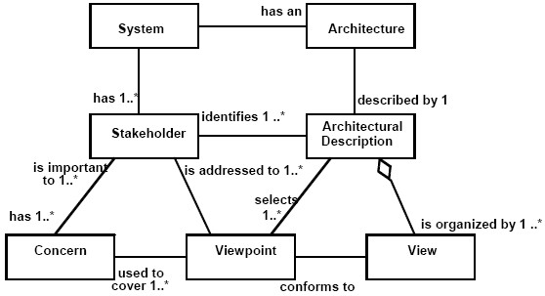
Excerpt from 1471 conceptual framework
- Some Useful Concepts
- Three stages that capture characteristics of an architecture, on the way from box-and-arrow to full software architectures:
  - Architectural Patterns
  - Reference Models
  - Reference Architectures

- Architectural Patterns
- A description of element & relation types together with a set of constraints on how they may be used.
- These constraints on architecture define a set or family of architectures. For example, the client-server pattern has 2 element types; their relationship is a protocol that the server uses to communicate with each of its clients, the clients don’t communicate directly.
- Value of Patterns
- They exhibit known quality attributes, and are a reuse of experience.
- Some patterns solve performance problems; others apply to high-security systems, or high-availability goals.
- Often the architect’s first major design decision. Also referred to as architectural styles.
- Reference Models
- A division of functionality together with data flow between the pieces.
- A standard decomposition of a known problem into parts that cooperatively solve the problem.
- They arise from experience, and are thus a characteristic of mature domains. For example, the standard parts of a compiler or database management system & how they work together.
- Reference Architectures
- A reference model mapped onto software elements and the data flows between them. The elements must cooperatively implement the functionality defined in the reference model.
- The mapping may be 1-1, but an element may implement a part of a function or several functions.
Summary
- Software Architecture
- Software Architecture in Context
- Architecture and Functionality
- Systems Structure(s)
- Structures and Views
- SEI Architectural Viewtypes
- Architectural Views – RUP
- Architectural Patterns
- Reference Models
- Architecture Documentation

Lecture No. 12
Architecture Documentation an Introduction

12.1 Architecture Documentation
As we have seen over and over, the software architecture for a system plays a central role in system development and in the organization that produces it. The architecture serves as the blueprint for both the system and the project developing it. It defines the work assignments that must be carried out by design and implementation teams and it is the primary carrier of system qualities such as performance, modifiability, and security none of which can be achieved without a unifying architectural vision. Architecture is an artifact for early analysis to make sure that the design approach will yield an acceptable system. Moreover, architecture holds the key to post-deployment system understanding, maintenance, and mining efforts. In short, architecture is the conceptual glue that holds every phase of the project together for all of its many stakeholders.
Documenting the architecture is the crowning step to crafting it. Even a perfect architecture is useless if no one understands it or (perhaps worse) if key stakeholders misunderstand it. If you go to the trouble of creating a strong architecture, you must describe it in sufficient detail, without ambiguity, and organized in such a way that others can quickly find needed information. Otherwise, your effort will have been wasted because the architecture will be unusable.
- Why Documenting Software Architecture
Software architecture documentation serves as a means of education and primary Vehicle for communication among stakeholders. It also serves as basis for system analysis:
- Quality attributes
- Behaviour
- Evolution and extension

- Architecture Documentation

- Why Multiple?
- Each exposes different quality attributes to different degrees
- Each has different goals and uses
- How to choose which ones? (Depends on what do you care about?) (What is important for readers to understand?).
- Documentation Beyond Views
- Introduction to the entire documentation package (“reader’s guide”)
- Describe how views relate to one another
- Overall constraints and rationale
- Management and control information
- View Components
- Primary (graphical) presentation
- Element catalog
- Specification of element interfaces & behavior
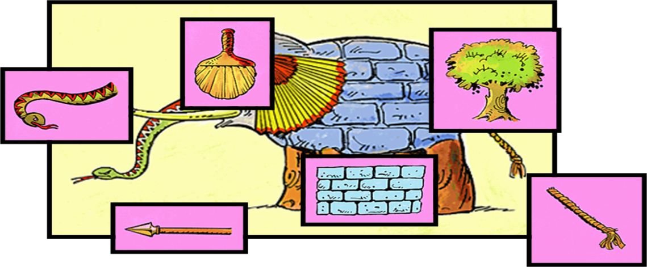
Conceptually Speaking Views provide slices of system understanding and going beyond views produces the integrated picture of the whole system.
- 7 Rules for Sound Documentation
- Write for the Reader
- One fact = one location
- Avoid Ambiguity; Explain semantics
- Use a standard organization
- Record Rationale
- Keep documentation current
- Review for fitness of purpose
12. 2 Software Architecture Quality Attributes
- Interesting Fact
“Systems are frequently redesigned not because they are functionally deficient – the replacement are often functionally identical – but because they are difficult to maintain, port, or scale, or are too slow or have been compromised by network hackers.”
- Where Does Architecture Fit?
Architecture is critical to the realization of many qualities of interest. The architecture alone does not achieve the desired qualities. Attention must still be paid to the details throughout detailed design and implementation. For Example:
- Modifiability of the systems is determined by the module structure (Architectural) and by the coding techniques (not Architectural)
- Usability of systems depends on screen layout and wigit styles (not Architectural) and whether there are undo/cancel (Arch)
- Classes of Quality Attributes
- Qualities of the system (e.g., availability)
- Business Qualities (e.g., time to market)
- Qualities about the architecture itself (meta-qualities) (e.g., conceptual integrity)
- Scenarios
Scenarios are brief narratives of expected or anticipated use of a system from both development and end-user viewpoint. Quality attributes such as modifiability etc are abstract and vague.
- No universal measures for these attributes. Context dependent measures are possible
- Scenarios are used to represent operational context for a system
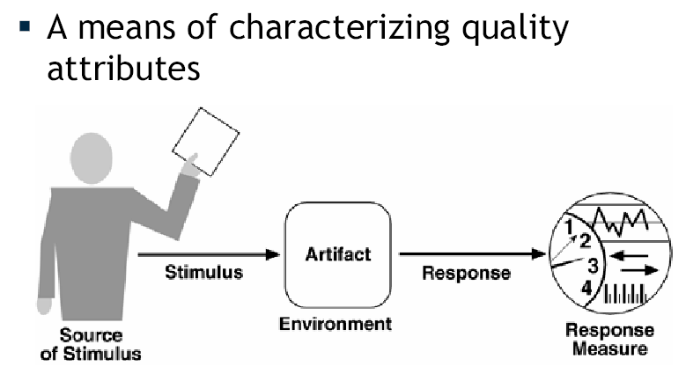
Quality Attribute Scenarios
- Types of Scenarios
- General Scenario: General scenario are system dependent
- Concrete Scenario: Concrete scenario are specific to the system under development
- Availability
- Fault = Something went wrong or was unexpected
- Failure = System is unavailable
Note: Can talk about degraded modes of operation degrees of availability. In considering availability must consider mean time to failure plus recovery time.
- General Scenarios for Availability
- Source – Internal or External?
- Stimulus – omission, crash, timing, response
- Artifact – what should be available?
- Environment – State/Mode of system
- Response – What is the desired response? (logging, restart)
- Response Measure – Time intervals or repair time
- Modifiability
- Chief concerns
  - What can change?
  - Who makes the change? What is the change mechanism and binding time?
    - Ex: Change the code vs change configuration file
- General Scenarios for Modifiability
- Source – User, developer, sys admin…
- Stimulus – Wishes to add/delete/mod functionality/quality attribute/capacity
- Artifact – UI, Platform, environment…
- Environment – run, compile, build, design
- Response – Locates section of architecture makes modification…
- Response Measure – Cost, effort, time, ripple
- Performance
- Timing: Events, interrupts, messages, request.
- Measuring time between arrival and response
- Complicated by: Large # of possible sequences and combos
- General Scenarios for Performance
- Source – where does event come from?
- Stimulus – characterize arrival (sporadic, simultaneous, periodic)
- Artifact – System
- Environment – System mode
- Response – process event; change mode
- Response Measure – Latency, deadline, throughput, miss rate, data loss
- Security
- Ability of the system to prevent unauthorized use while allowing authorized use
- Properties
- Confidentiality of data from unauthorized access
- Integrity (delivered as intended)
- Assurance of identity
- Availability for authorized use
- Auditing
- Security General Scenarios
- Source – human or another system; anticipated/actual sources important
- Stimulus – The attack
- Artifact – Services of system or data
- Environment – Mode, firewall status
- Response – Granting/withdrawing access
- Response Measure – Difficulty of attacks, recovery from attacks
- Testability
- How can we find faults in the system?
- Is a test harness available?
- Can pieces of the system be tested independently and at different levels of integration?
- General Scenarios for Testability
- Source – Who performs test
- Stimulus – What triggers testing?
- Artifact – design, code, part/whole system
- Environment – Time at which test occurs
- Response – provides access to state, provides results, etc.
- Response Measure – Coverage, effectiveness (prob of finding error), effort/time to test
- Usability
- How easy is it for the user to accomplish a desired task?
  - Learning system features
  - Using system effectively
  - Minimizing impact of errors
  - Adapting to user needs
  - Increasing confidence & satisfaction
- General Scenarios for Usability
  - Source – User
  - Stimulus – What the user wants to do
  - Artifact – System
  - Environment – Runtime or configuration time
  - Response – What the system does
  - Response Measure – time, tries, number of errors or solutions, learning curve
12.3 Tactics
- Tactics & Strategies
- Tactic – Fundamental design decisions that impart desired quality attributes to a design
- Architectural Strategy – A collection of tactics

- Availability Tactics
- Goal: Stop a Fault from becoming a Failure
- Fault Detection
  - How to tell when a fault has occurred?
- Fault Recovery
  - How to deal with a fault when it occurs?
  - Preparation and Repair
  - Recovery and reintroduction
- Fault Prevention
  - How to stop faults from occurring?
- Availability: Fault Detection
  - Ping/Echo
  - Heartbeat/Watchdog
  - Exceptions
- Availability: Fault Recovery
- Prevention and Repair
- Voting
- Active Redundancy (Two parallel systems)
- Passive Redundancy (Master & backup components)
- Spare
- Reintroduction
- Checkpoint/Rollback
- Availability: Fault Prevention
- Removal from service to prevent failures
- Transactions
- Monitor processes for faults and create replacement processes
- Modifiability Tactics
- Localize modifications
  - Minimize the # modules that must change
- Prevent ripple effects
  - Limit necessary modifications to localized modules (those directly affected)
- Control deployment time & cost
  - Defer binding time
- Modifiability: Localize Modifications
- Maintain semantic coherence
  - Coupling and cohesion
- Anticipate expected changes
- Generalize
- Modifiability: Prevent Ripple
- Hide information
- Maintain existing interfaces
- Restrict communication paths
- Use an intermediary
- Modifiability: Defer Binding Time
- Runtime registration
- Configuration files
- Polymorphism
- Component replacement
- Define protocols
- Performance Tactics
- Goal: Generate a response from the system within some time after receiving stimulus
- Two contributors
- Resource Time
- Blocked Time
  - Contention
  - Availability of resources
  - Dependency on others
- Performance: Resource Demand
- Reduce resources per event
- Increase computational efficiency
- Reduce computational overhead
- Reduce the number of events
- Manage event rate
- Control sampling frequency
- Bound queue sizes
- Performance: Resource Management and Arbitration
- Management
  - Introduce concurrency
  - Maintain multiple copies of data or computation
  - Increase available resources
- Arbitration
  - Implement scheduling
- Security Tactics
- Resisting attacks
- Detecting attacks
- Recovering from attacks
- Security: Resisting Attacks
- Authenticate users
- Authorize users
- Maintain data confidentiality (encryption)
- Manage integrity (checksums)
- Limit exposure – spread services among hosts
- Limit access – firewall
- Security: Detection and Recovery
- Intrusion detection systems
- Recovery
  - State restoration (availability)
  - Attacker identification (audit trails)
- Usability
- Runtime, for the User
  - Separate user interface
  - Support user initiative
    - Cancel, undo, aggregate
  - Support system initiative
    - User model, System model, Task model
- Design Time
  - Separate UI from rest of design
Summary
- Architecture Documentation
- View Components
- Styles and/or Patterns
- Classes of Quality Attributes
- Scenarios

Lecture No. 13
View Based Documentation of Software Architectures

13.1 Uses of Documentation
Documentation acts as means of education, introducing people to the system. As a primary vehicle for communication amongst stakeholders and as a basis for system analysis
- View types

Architects need to look at software in three ways

How it is structured as a set of implementation units

How it is structured as a set of elements that have runtime behavior and interaction

How it relates to non-software structures and its environment

The module view type

Document a system’s principals units of implementations

The component and connector view type

Document the system’s units of execution

The allocation view type

Document the relationship between a system’s software and its development and execution environment
- Styles

In each view type there are a set of commonly occurring forms and variations – styles

Layered style, client-server
- Seven rules for sound Documentation

Write documentation from the Reader’s Point of view

Avoid unnecessary repetition

Avoid ambiguity

Use a standard of Organization

Record Rationale

Keep documentation current but not too current

Review Documentation for fitness of purpose
- View types and Styles
- Module View type

Module View type is a code unit that implements a set of responsibilities. It can be a class, a collection of classes, a layer or any decomposition of the code unit. It has some properties: responsibility, visibility, and author.
- Module View type styles

Decomposition style

Uses style

Generalization style

Layered style

13.2 Component and Connector View Type:
The component-and-connector view type enables the representation of software architecture from the point of view of its components, the principal unit of runtime interaction or data storage, and its connectors, the interaction mechanism among components and the “data flow” among them.
The component-and-connector view is considered one of the most important ones for the developer as well as for the architect and of vital significance for the analysis and quality requirements scope, such as availability, performance, scalability among others.
- Elements of Component and Connector View Type:
- Components:
Components are runtime processors and data stores. Components are usually implemented with a combination of custom, reusable, and purchased modules (cots). The goal is to reduce the number of custom modules that must be developed to implement a component.
Some examples of purchased and reusable modules are sorters, XSLT transformers, XML parsers, and database management systems.
- Connectors:
Connectors are mechanisms that allow for the exchange of data between components. Connectors are usually implemented using purchased modules (cots), technologies, and protocols. The format of the data that is exchanged may be custom or standard. The content of the data that is exchanged is often custom. The goal is to use purchased middleware and increase the use of standard formats.
Two systems that must interact are really just large components with one or more connections. These connections are interfaces between the systems.
- Example:
Suppose that the practical requirements for the automated portion of an enterprise application are given by the following essential events:
Event: Client A Submits Transaction
Message Stimulus: | Receive transaction http web form from Client A.
Update Response: | Add transaction to database.
Message Response: | Send acknowledgement http web page to Client A.
Event: Client B Requests Activity Report
Message Stimulus: |  | Receive http request from Client B.
Message Response: |  | Send transaction summary http web page to Client B.
Message Response: |  | FTP transaction detail file to Client C.
The Figure shows a basic architecture for an application that meets these requirements. Because the events are asynchronous, a shared data style is used:
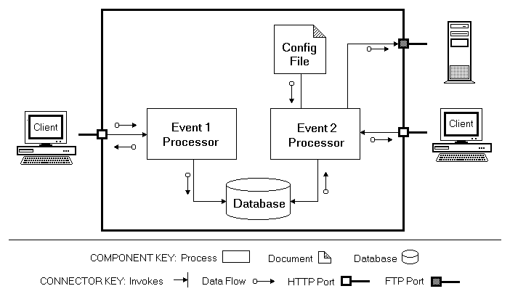

Event Driven Application Architecture
- Component and connector View type

Express runtime behavior

Described in terms of connectors and components

Objects, processes, collection of objects are components

Pipes, repositories, sockets are connectors

Middleware is a connector

- C&C View type Styles

Pipe-and-filter

Shared-data

Publish-subscribe

Client-server

Peer-to-peer

Communicating processes

- Allocation View type

Maps software units to elements of the environment (hardware, development team)

Deployment style

Implementation style

Work assignment style
- Style Guide

Overview

Elements, relations and properties

What it’s for and not for

Notations

Relation to other views

Examples
- View types

The module view type

Document a system’s principals units of implementations

The component and connector view type

Document the system’s units of execution

The allocation view type

Document the relationship between a system’s software and its development and execution environment
- Module View types

A code unit that implements a set of responsibilities

Can be a class, a collection of classes, a layer or any decomposition of the code unit

Have some properties: responsibility, visibility, and author.
- Overview

What is a module? – Software units with well defined interfaces providing a set of services

Module vs. component

Both are about decomposition

Module has a design time connotation and component a runtime connotation

4 common styles

The decomposition style – containment relationship among modules

The uses style – functional dependency relationships among modules

Generalization style – specialization relationships among modules

Layered style – allowed-to-use relation in a restricted fashion among modules
- What is it for?

Construction –

Blueprint for the source code

Modules and physical structures (source code files) will have close mapping

Analysis

Requirements traceability

Impact analysis

Communication – useful for explaining the systems functionality

- What is it not for?

Cannot make inferences about runtime behavior

Hence not used for analysis of performance, reliability and other runtime qualities; we use c-and-c and allocation views are used
- Relation to other view types

Module views commonly mapped to c-and-c view types

Sometimes one-to-one or one-to-many but could also be fragments to fragment

- Module View types styles

Decomposition Style

Uses

Generalization

Layered

- Decomposition - overview

Focus on the is-part-of relationship between elements and their properties

How system responsibilities are partitioned across how these modules are decomposed into sub modules

All architectures begin with module decomposition style – divide and conquer

Useful for communicating the broad picture to new comers

Since functionality is allocated, modifiability is immediately addressed

- Criteria for decomposition

Achievement of certain quality attributes

Modifiability

Performance

Build-versus-buy decisions

Product line implementations
- Decomposition style

What is it for?

Learning

New comers

Work assignment

What is it not for?

Notations

Named boxes within boxes

Textual notation

Examples of decomposition style
- From Clements etal
- 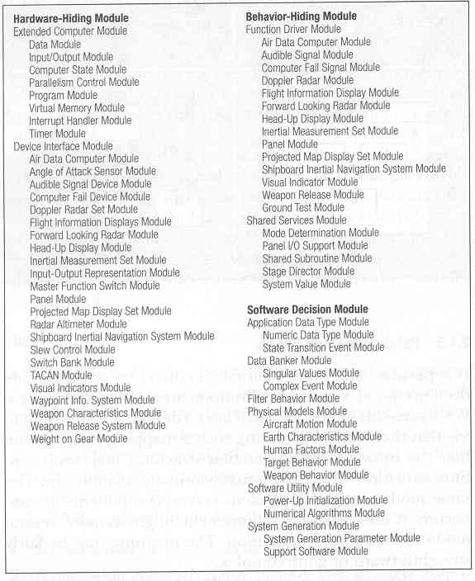
- Relation to other styles

Module decomposition view can be mapped into component-and-connector view; either one-to-one or one-to-many or fragment to fragment

Closely related to work assignment style of allocation view types
- Module View types styles

Decomposition Style

Uses style

Generalization

Layered
- Uses - overview

What other modules should exist in order to do their part of the work properly

Can be documented as a two column table

Or any graphical notation

P1 uses P2, if P1’s correctness depend on the correctness of P2

Kinds of usage

CALLS but not USES

Exception handling – just pass on the name of caller

CALLS and USES

No CALL yet USES

Expect P2 to leave a variable in a certain state
- Where is it useful?

Incremental development

Implement part of the total functionality

Sub-setting, debugging, testing, impact analysis
- Decomposition Styles

Decomposition Style

Uses

Generalization

Layered

- Overview

Is-a relation is specialized to generalization

Parent is a more general version of the child

In decomposition the parent consists of the child

Useful for extension and evolution of architectures and individual elements

Inheritance of interface and implementation
- Gen: where is it useful?

Object-oriented designs

Extension and evolution

Local change or variation

Reuse

- Decomposition - Styles

Decomposition Style

Uses style

Generalization

Layered

- Layered - overview

Each layer represents a virtual machine

Completely partitions the software

Strict ordering

Layer bridging
- Layers - What is it for?

Modifiability

Portability

Principle of information hiding (VM)

Run time overhead is more?

How to reduce it?
- Relation to other styles

Layers are not modules

A layer may be module

But modules can be decomposed to other modules; layers are not decomposed to other smaller layers

Segmenting a layer gives rise to modules; modules can span layers

Summary
- View types
- C&C Viewtype
- Allocation Viewtype
- Module Viewtype
- View Based Documentation

Lecture No. 14-15
Component and Connector View Type

14.1 Overview
It defines models consisting of elements, having some runtime presence, processes, objects, clients, servers and data stores. Pathways of interaction, communication links, protocols, information flows, access to shares storage.
- Runtime entities and their interactions

May contain many instances of the same component type

Similar to object (collaboration) diagrams as against class diagrams (which define types of elements)
- Summary of C&C View type
- 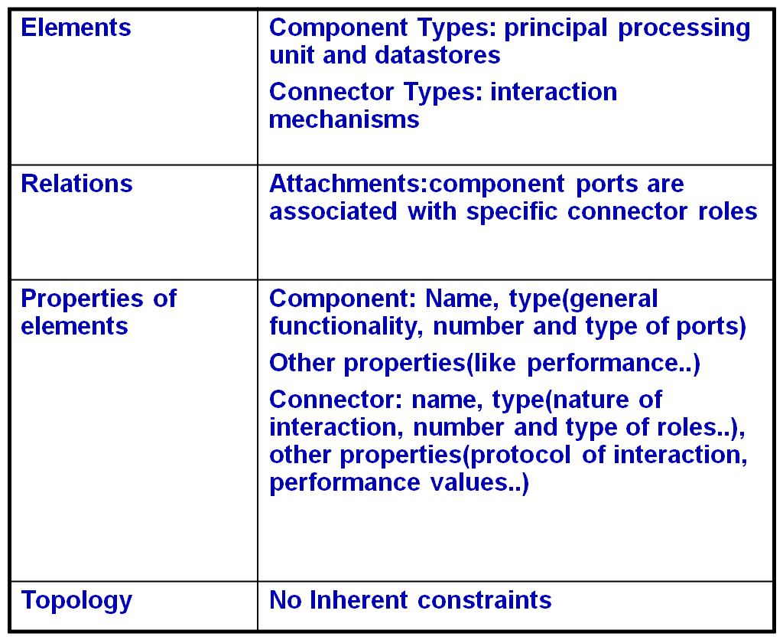
- What is C&C for?
- To reason about runtime system quality attributes – performance, reliability, availability
- What are the systems principal executing components and how do they interact
- What are the major shared data resources
- Which parts of the system are replicated and how many times
- How does data progress through a system as it executes
- What protocols of interaction are used by communicating entities
- What parts of the system run in parallel
- How can the system’s structure change as it executes
- What is C&C not for?
- Can not represent design elements which do not have a runtime presence
- Example – interface of an element - usability
- C&C View type Styles

Pipe-and-filter

Shared-data

Publish-subscribe

Client-server

Peer-to-peer

Communicating processes
- Pipes and Filters

A filter transforms data that it receives from one or more pipes and transmits through one or more pipes a pipe is a connector that conveys streams of data from output port of one filter to input port of another. Pipes buffer data. The overall function is a composition of filter functions
- What for?

Very useful in data transformation

Signal processing

Compilers

To reason about system performance, stream latency, pipe buffer requirements, schedule ability
- Relationship with other styles

It is different from data flow projections/views. In pipes-and-filters lines have specific meaning – transmit streams of data. In dataflow relationships implies data communication – could be implemented as a procedure call, publish-subscribe, via a pipe.
- Shared data style

Useful in exchange of persistent data, which has multiple assessors

How does the consumer know data is available?

Store informs the consumer – blackboard

Consumer is responsible - repository
- What for?

Used when there are multiple assessors and persistence

Decouple producer from consumer

Data store performance, security, privacy, compatibility with other stores…
- Similarity to others

Client-server style

Publish-subscribe is similar without persistence
- Publish-subscribe styles

Components interact via announced events. Components subscribe to a set of events. P-S runtime ensures that each published event is delivered to all subscribers. The connector is an event bus. Used in message production/consumption
- Where to use?

To send events and messages to recipients

Set of recipients are unknown – can be added dynamically
- Client-Server

Components interact by requesting services of other components. The communication is initiated by a client.
- What for?

Assignment of functionality is clear

Can be independently assigned to tiers

Can be used to argue about performance

Example - WWW
- Peer-to-peer
Components interact with each other exchanging services. No asymmetry as in client-server.
Connectors are bidirectional.
14.2 Allocation View type
- Allocation View type styles

Deployment style

Implementation style

Work assignment style
- Deployment style

Elements of the C&C styles are allocated to execution platforms
- Common Architectural Styles (Adapted from Shaw and Garlan)

Dataflow systems

Batch sequential

Process control

Pipes and filters

Call-and-return systems

Main program and subroutine

Object-oriented systems

Hierarchical layers

Independent components

Communicating processes

Event systems

Virtual machines

Interpreters

Rule-based systems

Repositories

Databases

Hypertext systems

Blackboards

Summary
- C&C Viewtype
- Components
- Connectors
- Pipes and Filters
- Shared data style
- Publish-subscribe styles
- Client-Server
- Peer to Peer
- Allocation Viewtype

Lecture No. 16
Architecting Process

16.1 Architecting Process
- SA Process Outline: The architect must typically
- Work with the requirements team
- Work with various application stakeholders
- Lead the technical design team
- Work with the project management
- Architecting Process
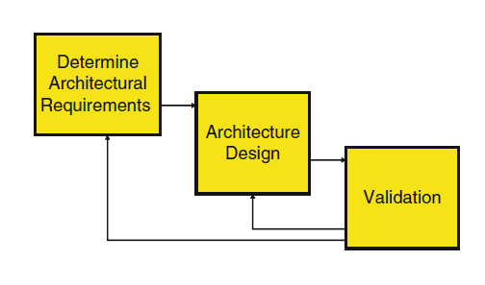

Determine Architectural Requirements
- Also called architecturally significant requirements or architecture use cases, are quality and nonfunctional requirements
- Identifying ASR
- Determine Architectural Requirements

Prioritize ASR
- Initially, it’s usually sufficient to allocate each requirement to one of three categories, namely:

High: the application must support this requirement. These requirements drive the architecture design

2. Medium: this requirement will need to be supported at some stage, but not necessarily in the first/next release

3. Low: this is part of the requirements wish list.
- Prioritization gets trickier in the face of conflicting requirements
- Good architects know how to say “no”.
- Architecting Process

2. Architecture Design
- Wonderful requirement documents and attentive networking with stakeholders mean nothing if a poor design is produced.
- Design is typically the most difficult task an architect undertakes.
- Good architects draw on several years of software engineering and design experience. There’s no substitute for this experience
- The design stage itself has two steps, which are iterative in nature. The first involves

First involves choosing an overall strategy for the architecture based around proven architecture patterns.

The second involves specifying the individual components that make up the application, showing how they fit into the overall framework and allocating them responsibilities
- Choosing the Architecture Framework
- N Tier Client Server
- Messaging
- Publish-Subscribe
- Broker
- Process Coordinator
- Allocate Components
- Identifying the major application components, and how they plug into the framework.
- Identifying the interface or services that each component supports.
- Identifying the responsibilities of the component, stating what it can be relied upon to do when it receives a request.
- Identifying dependencies between components.
- Identifying partitions in the architecture that are candidates for distribution over servers in a network.

Allocate Components

Component design has much in common with widely used object-oriented design techniques. In fact, class and package diagrams are often used to depict components in an architecture
- Some guidelines for component design are:

Minimize dependencies between components

Design components that encapsulate a highly “cohesive” set of responsibilities

Isolate dependencies on middleware and any COTS infrastructure technologies

Use decomposition to structure components hierarchically

Minimize calls between components
16.2 N Tier Client Server
Three-tier or multi-tier architectures are often used when describing how clients connect to servers.
- Separation of concerns: Presentation, business and data handling logic are clearly partitioned in different tiers.
- Synchronous communications: Communications between tiers is synchronous request–reply.
- Flexible deployment: There are no restrictions on how a multi-tier application is deployed.

All tiers could run on the same machine, or at the other extreme, each tier may be deployed on its own machine.

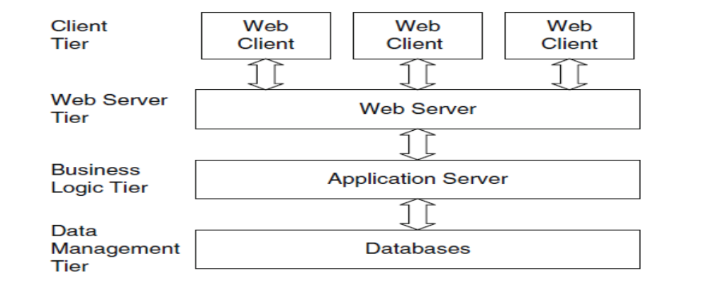
- 1-Tier Architecture:
Software packages like MS Access, MS Excel and QuickBooks access files directly. This means that the file you want to work with must be accessible from a local or shared drive. This is the simplest of all the architectures, but also the least secure. Since users have direct access to the files, they could accidentally move, modify, or even worse, delete the file by accident or on purpose. There is also usually an issue when multiple users access the same file at the same time: In many cases only one can edit the file while others only have read-only access. Figure 1 shows 1-tier architecture.
So 1-tier architecture is simple and cheap, but usually unsecured and data can easily be lost if you are not careful.
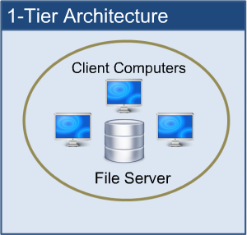

- 2-Tier Architecture:
This architecture is also called Client-Server architecture because of the two components: The client that runs the application and the server that handles the database back-end. When the client starts it establishes a connection to the server and communicates as needed with the server while running the client. The client computer usually can’t see the database directly and can only access the data by starting the client. This means that the data on the server is much more secure. Now users are unable to change or delete data unless they have specific user rights to do so.
The client-server solution also allows multiple users to access the database at the same time as long as they are accessing data in different parts of the database. One other huge benefit is that the server is processing data that allows the client to work on the presentation and business logic only. This mean that the client and the server is sharing the workload and by scaling the server to be more powerful than the client, you are usually able to load many clients to the server allowing more users to work on the system at the same time. Figure 2 shows 2-tier-architecture.
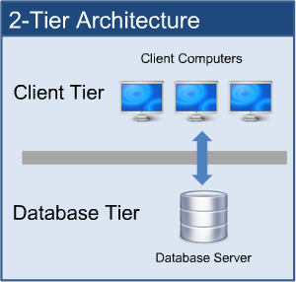
- 3-Tier Architecture:
This involves one more layer called the business logic tier, service tier or middle tier (layer). In the client-server solution the client was handling the business logic and that makes the client “thick”. A thick client means that it requires heavy traffic with the server, thus making it difficult to use over slower network connections like Internet and Wireless (LTE, 3G, or Wi-Fi).
By introducing the middle layer, the client is only handling presentation logic. This means that only little communication is needed between the client and the middle tier making the client “thin” or “thinner”. An example of a thin client is an Internet browser that allows you to see and provide information fast and almost with no delay.
As more users access the system a three-tier solution is more scalable than the other solutions because you can add as many middle tiers (running on each own server) as needed to ensure good performance (N-tier or multiple-tier). Security is also the best in the three-tier architecture because the middle layer protects the database tier. There is one major drawback to the N-tier architecture and that is that the additional tiers increase the complexity and cost of the installation.
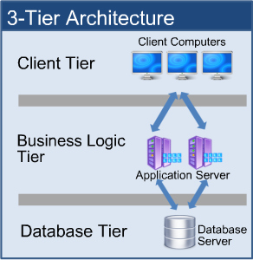
The differences among these three tiers are summarized below.
Table: Differences among 3-Tiers Architectures
 | 1-Tier | 2-Tier | Multi-Tier
Benefits | Very simple  Inexpensive  No server needed | Good security  More scalable  Faster execution | Exceptional security Fastest execution  “Thin” client  Very scalable
Issues | Poor security  Multi user issues | More costly  More complex  “Thick” client | Very costly  Very complex
Users | Usually 1 (or a few) | 2-100 | 50-2000 (+)

- Case Study: Order Processing Application
- New orders are received (from where is irrelevant) and loaded into a database.
- Each order must be validated against an existing customer details system to check the customer information and that valid payment options exist.
- Once validated, the order data is simply stored in the order processing database, and an email is generated to the customer to inform them that their order is being processed
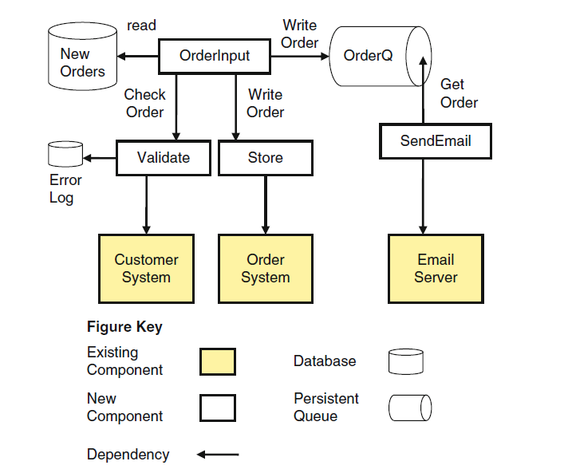
- Case Study: Architectural Framework
- The general architecture framework is based on straightforward messaging.
- The customer order details are read from the database, validated, and if valid, they are stored in the order application message and written to a queue.
- Information about each valid order is removed from the queue, formatted as an email and sent to the
- Customer using the mail server.
- Hence, using a message queue this architecture decouples the order processing from the email formatting and delivery.
- Four components are introduced to solve this problem. These are described below, along with their responsibilities:
- Order Input: This is responsible for accessing the new orders database, encapsulating the order processing logic, and writing to the queue.
- Validate: This encapsulates the responsibility of interacting with the customer system to carry out validation, and writing to the error logs if an order is invalid.
- Store: This has the responsibility of interacting with the order system to store the order data.
- Send Email: This removes a message from the queue, formats an email message and sends it via an email server. It encapsulates all knowledge of the email format and email server access.

16.3 A general model of software architecture design
- Generic Model for Software Architecture Design
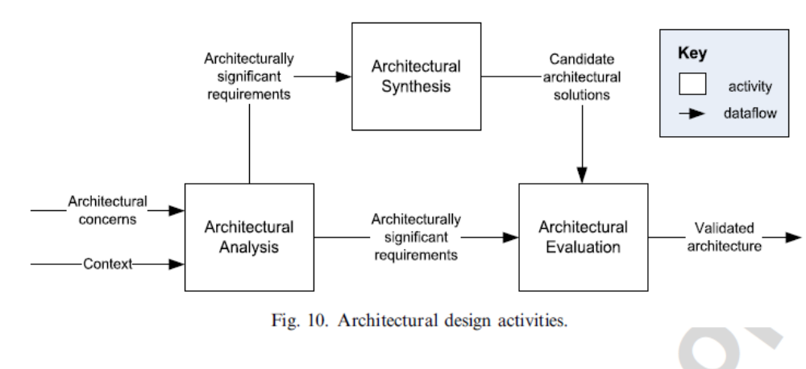
- Tiered Architectures
- System: A group of interrelated elements forming a collective entity
- Architecture: A style and method of design and construction
- An architectural history of computing
- 1 tier architecture
- Monolithic Information Systems
- Presentation, application logic, and resource management were merged into a single tier
- 2 tier architecture
- Separation of presentation tier from other 2 tiers (app + resource)
- became popular as 'client/server' systems
- 3 tier architecture
- can be achieved by separating RM (resource management) from application logic tier
- Tiers of an architecture
- Presentation Tier

Any IS needs to communicate with external entities, human users or other computers

Allows these entities to interact with the system

Implemented as a GUI interface

Referred to as the client of the IS – which is not correct

Example:
- Systems accessed by web browsers using plain HTML documents
- The client is a web browser that only displays information prepared by the Web server
- The presentation layer in this case is the Web server

How the data should appear to the user and how the user should interact with the interface
- Application Logic Tier

IS do more than information delivery, they perform data processing (Business Logic & calculation) behind the results being delivered

Example:
- A program that implements a withdrawal operation from a bank
- This program takes the request, checks whether there is enough funds, verifies whether withdrawal limits are exceeded, creates a log entry for the operation, performs the operations against the current balance and gives approval for handing out the money.
- Here the algorithms are implemented

This tier is often referred to as
- Services
- Business logic
- Business rules
- Server
- Resource Management Layer
- IS needs data to work with
- Data can reside in databases or other information repositories
- Deals with and implements different data sources of Information Systems
- Also referred to as the data layer, which indicates that it is implemented using a Database Management System
- From the banking example:
- The RM layer could be the account database of the bank
- Can also be a gateway to recursively using other ISs
- Advantages of 1 – Tier Architectures
- easy to optimise performance
- no context switching
- no compatibility issues
- no client development, maintenance and deployment cost
- Disadvantages of 1 – Tier Architectures
- Monolithic pieces of code (high maintenance)
- hard to modify – lack of documentation and qualified programmers
- lack of qualified programmers for these systems

- Advantages of 2 – Tier Architectures
- Portability
- No need for context switches or calls between component for key operations
- Disadvantages of 2 – Tier Architectures
- limited scalability
- legacy problems (blown up clients)
- Advantages of 3 – Tier Architectures
- Scalability by running each layer on a different server
- Scalability by distributing AL (application logic layer) across many nodes
- Additional tier for integration logic
- Flexibility
- Disadvantages of 3 – Tier Architectures
- Performance loss if distributed over the internet
- Problem when integrating different 3 – tier systems
- Middleware

Middleware refers to the software which is common to multiple applications and builds on the network transport services to enable ready development of new applications and network services.

Middleware typically includes a set of components such as resources and services that can be utilized by applications either individually or in various subsets.

Examples of services: Security, Directory and naming, end-to-end quality of service, support for mobile code.

Examples:
- OMG’s CORBA
- J2EE - Java 2 Enterprise Edition
- Microsoft’s .Net
- Middleware features

Allows communication
- through a standard language
- across different platforms
- between legacy and modern applications

Takes care of
- transactions between servers
- data conversion
- authentication
- communications between computers

Provides runtime environment for components in the middle-tier
- Component lifecyle and management
- Transaction, event and security services
- Provides connections to databases, mainframes and legacy systems

Separates client-tier from the data source
- Clean separation of user-interfaces and presentation logic from the data source

Summary
- Architecting Process
- Architecture Design
- N Tier Client Server
- Case Study
- software architecture design
- Tiered Architectures
- Middleware

Lecture No. 17
Software Architecture Evaluation

17.1 Why Analyzing Software Architecture?
Marry your architecture in haste and you can repent in leisure. (Barry Boehm)
Being the foundation for any software system, Architecture can allow or preclude almost all system’s quality attributes. Software quality cannot be appended late in a project. Proposed design may or may not be suitable w.r.t. some qualities of importance. It should be assessed before long term investment.
- Cost Vs Benefits
- Costs
- Staff time
- Consumption of experienced designers
- Benefits
- At AT&T over last eight years average cost savings due to full architecture review is 10%
- A large company avoided a multimillion-dollar purchase when architecture of global information system they were procuring was found to be incapable of providing the desired system attributes necessary to support a product line
- An architecture review of retail merchandise revealed early that there would be peak order performance problems that no amount of hardware could fix; a major business failure was avoided.
- In the architecture review of revision control system, a number of severe limitations in achieving system portability and modifiability were uncovered.
- Architectural reviews help uncover conflicts and tradeoffs and also improvement in architecture.
- Early detection of problems, Validation of requirements

- Quality Attributes
- Evaluation and Quality attributes
- Categories: System Quality attributes discernable at runtime and System Quality attributes Not discernable at runtime
- System Quality attributes discernable at runtime
- Performance
- Security
- Reliability
- Usability
- System Quality attributes not discernable at runtime
- Modifiability
- Portability
- Reusability
- Analysis/Review techniques
- Questioning techniques
- Scenario based techniques
- Questionnaire based techniques
- Checklist based techniques

Relationship between Scenarios, questionnaires and checklists
- Measuring techniques
- Metrics, Simulation and Prototypes
- These techniques provide quantitative results and provide answers to the questions a review team already have about particular qualities.

An existing prototype or simulation may be an answer to an issue raised by a questioning technique
- Classification of Techniques
- Generality

General purpose (Questionnaire, Metrics) or domain specific (Scenarios, checklists etc)
- Level of detail

Coarse (Questionnaire), medium (Scenarios) and fine (Metrics)
- Phases

Early, middle and post deployment
- What is reviewed

Artifact (All) or Process (Questionnaire and checklist)

- Scenarios

Scenarios are brief narratives of expected or anticipated use of a system from both development and end-user viewpoint.

Quality attributes such as modifiability etc are abstract and vague
- No universal measures for these attributes. Context dependent measures are possible
- Scenarios are used to represent operational context for a system

The process of choosing scenarios for analysis forces designers to consider the future uses of and changes to the system
- How will this architecture accommodate the following change?

Benefits of using Scenarios in analysis
- Better understanding of requirements
- Stakeholder buy-in
- Better documentation
- Requirements tractability at architectural level

Specifically quality attributes
- Scenario Based Analysis Techniques

They are many Scenario Based Analysis Techniques; the most important of them are listed below:
- Software Architecture analysis method (SAAM)
- SAAM for complex scenarios (SAAMCS)
- SAAM for evolution and reusability (SAAMER)
- Aspectual SAAM (ASAAM)
- Architecture level Modifiability Analysis (ALMA)
- ATAM,CBAM,ARID,PASA,CBAR
17.2 Software Architecture Analysis Method (SAAM)

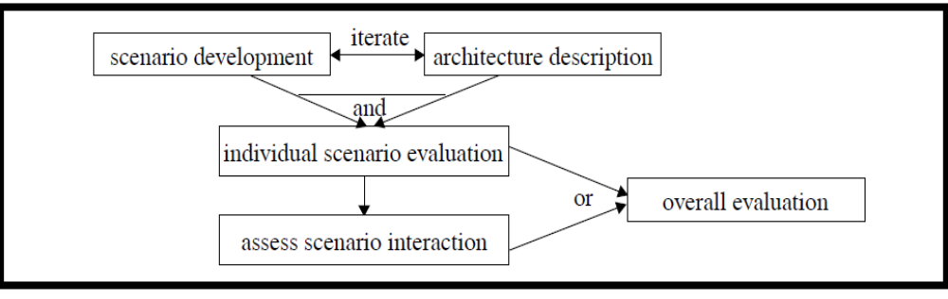
- Scenarios and their Evaluation

Develop task scenarios that illustrate the kinds of activities the system must support and the kinds of changes which it is anticipated will be made to the system over time.

Scenario evaluations: Direct/Indirect scenarios
- For each indirect scenario, list the changes to the architecture that are necessary for it to support the scenario and estimate the cost of performing the change.
- A modification to the architecture means that either a new component or connection is introduced or an existing component or connection requires a change in its specification.
- For each indirect scenario the impact, or set of changes, that scenario has on the architecture should be described
- Scenario Interaction
- Different indirect scenarios may necessitate changes to the same components or connections
- Scenarios interact in that component on connector
- Scenario interaction measures the extent to which the architecture supports an appropriate separation of concerns
- SAAM favors the architecture with the fewest scenario conflicts
- Overall Evaluation

Finally, weight each scenario and the scenario interactions in terms of their relative importance.

Determine an overall ranking. This is a subjective process involving all of the stake-holders in the system.

The weighting chosen will reflect the relative importance of the quality factors that the scenarios manifest
- Validation of SAAM
- Global information system

A company was contemplating the purchase of a system as the infrastructure to support applications development for multimedia communication with unlimited conferencing.

The purchasing company wanted some assurance that the architecture of the system they purchased was going to provide for the generic satellite-based multi-user applications they anticipated developing in the near and long term.

As a result of the analysis, the company decided to not purchase the system, avoiding an investment of tens of millions of dollars.
- Air traffic control

This was an investigation of a complex, real-time system against a set of proposed changes to that system.

The purpose of the evaluation was to determine whether future development on this system was justified.

The change scenarios were intended to represent appropriate manifestations of the abstract qualities of performance and availability.

The result of this evaluation was a decision to proceed with the proposed changes
- WRCS

This case study was an analysis of a commercial version control/configuration management tool

This analysis covers all activities of SAAM and shows all artifacts of a SAAM evaluation that can be produced.

The result of the analysis was that significant problems were discovered with the product’s architecture, with respect to the scenarios considered

WRCS provides the functionality to allow developers of projects the ability to create archives, compare files, check files in and out, create releases, back up to old versions of files, and so on.

“Project'' in this context means any group of related files that, when linked together appropriately, form a finished product.

WRCS keeps track of changes made to these files as they evolve over time

It provides capabilities for multiple users to work on the same project within their own private work areas.

Applying SAAM Steps

Develop Scenarios/Describe Candidate Architecture
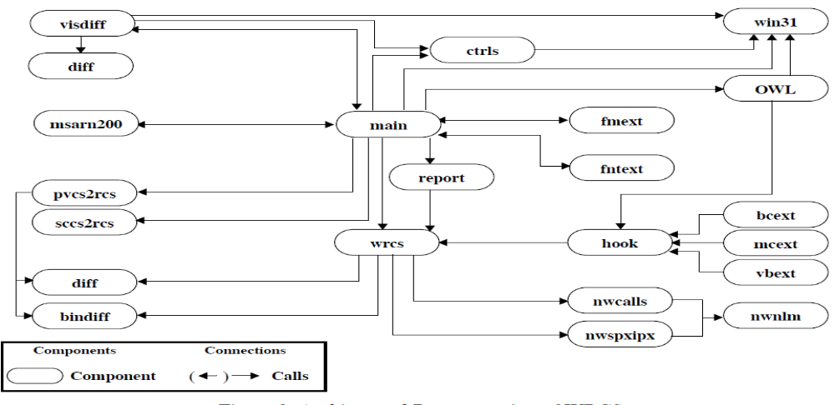
- User:

1. Compare binary file representations. Compare binary files generated by other products. For example, Frame Maker files are stored in a binary representation. But when we are comparing two versions of a Frame Maker file we want to see our editing changes in a human-readable form, and not the changes to the binary codes stored in the files.

2. Configure the product's toolbar. Change the icons and actions associated with a button in the toolbar.
- Maintainer:

3. Port to another operating system.

4. Make minor modifications to the user interface. Add a menu item; change the look and feel of a dialog box.
- Administrator:

5. Change access permissions for a project.

6. Integrate with a new development environment. Attach for example to Symantec C++.
- Overall Evaluation

Prioritize the scenarios which have been identified as potentially problematic

The WRCS analysis identified a number of severe limitations in achieving the extra-functional qualities of portability and modifiability.

A major redesign of the system was recommended.

Having gone through an analysis procedure such as SAAM before implementation would have substantially contributed to avoiding the problems which the WRCS developers now face,
- Results and Lessons

SAAM is for people

SAAM and traditional architectural metrics

Determining the proper level of architectural description

Determining the proper set of scenarios
17.3 Architecture Trade-off Analysis Method (ATAM):
In software engineering, architecture tradeoff analysis method (ATAM) is a risk-mitigation process used early in the software development life cycle. ATAM was developed by the Software Engineering Institute at the Carnegie Mellon University. Its purpose is to help choose a suitable architecture for a software system by discovering trade-offs and sensitivity points. ATAM is most beneficial when done early in the software development life-cycle, when the cost of changing architectures is minimal.
The ATAM is based upon a set of attribute-specific measures of the system; Analytic (performance & availability), Qualitative (modifiability, safety, security). The ATAM workshops typically take three days and the involvement of 10-20 people like; evaluators, architects and other system stakeholders.
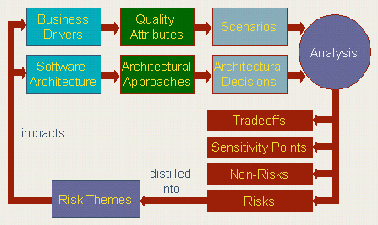
- Steps of ATAM:
ATAM formally consists of nine steps, outlined below:
- Present ATAM – Present the concept of ATAM to the stakeholders, and answer any questions about the process.
- Present Business Drivers – Everyone in the process presents and evaluates the business drivers for the system in question.
- Present The Architecture – The architect presents the high level architecture to the team, with an 'appropriate level of detail'
- Identify Architectural Approaches – Different architectural approaches to the system are presented by the team, and discussed.
- Generate Quality Attribute Utility Tree – Define the core business and technical requirements of the system, and map them to an appropriate architectural property. Present a scenario for this given requirement.
- Analyze Architectural Approaches – Analyze each scenario, rating them by priority. The architecture is then evaluated against each scenario.
- Brainstorm And Prioritize Scenarios – Among the larger stakeholder group, present the current scenarios, and expand.
- Analyze Architectural Approaches – Perform step 6 again with the added knowledge of the larger stakeholder community.
- Present Results – Provide all documentation to the stakeholders.
- Advantages of ATAM:
The following are some of the benefits of the ATAM process.

Promotes the gathering of precise quality requirements

Creates an early start at architecture documentation

Creates a documented basis for architectural decisions

Promotes identification of risks early in the life-cycle

Encourages increased communication among stakeholders

Results in the Prioritization of Conflicting Goals

Forces a Clear Explication of the Architecture

Uncovers Opportunities for Cross-Project Reuse

Results in Improved Architecture Practices
Summary
- Analyzing SA
- Quality Attributes
- Scenarios
- SAAM
- ATAM

Lecture No. 18
Software Quality

18.1 Why Are Software Difficult?
Software engineering is difficult because it a young field with tremendous expectations. It involves building of vastly complex, but intangible systems. Software is not useful on its own e.g., unlike a car. It must conform to changes in other engineering areas.
According to Fred Brooks software projects are difficult because of software engineering have to cope with accidental complexity and essential complexity.
Accidental complexity is complexity that arises in computer programs or their development process. Accidental complexity is caused by the approach chosen to solve the problem. Sometimes accidental complexity can be due to mistakes such as ineffective planning, or low priority placed on a project
Essential complexity refers to a situation where all reasonable solutions to a problem must be complicated. Only partial solutions exist for them, if any. There are four types of essential difficulties. These are known as Complexity, Conformity, Changeability and Intangibility.
Additional reasons software projects are difficult are:
Intellect-intensive - team-oriented nature of the work
Externally imposed constraints - engineering, platform, domain, process, scientific, technology, domain knowledge
- Software Errors, Faults, & Software Failures
Software errors are introduced when there is a failure to completely and accurately translate one representation to another, or to fully match the solution to the problem.
Bug / defect / fault are consequence of a human error and results in non-conformance to requirements, obvious as failure in running software.

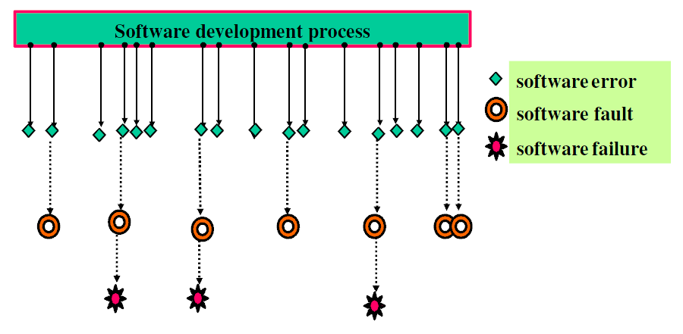

- Approaches to quality

Quality of the product versus quality of the process

Check whether (product or process) conforms to certain norms

Improve quality by improving the product or process
- Major Software Failures of 2011

Deficiencies in software quality often results
- in costly emergency fixes
- damage to a brand’s reputation, software company defaulters – large repayments

Software defects are extremely costly in term of
- money
- reputation
- loss of life
- Major Failures

Cash machine bug benefits customers by giving them extra money

An Australian bank began giving out large sums of money from 40 Cash Machines cross one city. Officials at the company said they were operating in stand-by mode, so could not identify the account balances of customers.

22 people wrongly arrested in Australia due to failures in new NZ $54.5 million courts computer system

A new NZ $54.5 million ($42.7 million or £26.8 million) computer system linking New South Wales courts and allowing documents to be lodged electronically led to damages claims for unlawful arrest and malicious prosecution, after 3600 defects in the electric transfers of data from the courts to

The police’s database led to the wrongful arrest of 22 individuals.
- Computer system bugs cause Asian banking facilities’ downtime

Computer system problems at one of Japan’s largest banks resulted in a nationwide ATM network of more than 5,600 machines going offline for 24 hours, internet banking services being shut down for three days, delays in salary payments worth $1.5 billion (£939 million) into the accounts of 620,000 people and a backlog of more than 1 million unprocessed. Payments worth around $ 9 billion (£5.64 billion)
- Some Failure Statistics
- IT projects have a terrible track record
  - A 1995 Standish Group study (CHAOS) found that only 16.2% of IT projects were successful and over 31% were canceled before completion, costing over $81 B in the U.S. alone
  - 2009 – only 32 % project become successful
    - 24 % Failed – never completed
    - 44 % Challenged – cost & time over run
- The need for IT projects keeps increasing
  - In 2000, there were 300,000 new IT projects
  - In 2001, over 500,000 new IT projects were started
- Causes of Software Errors
- Faulty requirements definition
- Client developer communication failures
- Intentional deviations from software requirements
- Logical design errors
- Coding errors
- Noncompliance with documentation and coding instructions
- Shortcomings of the testing process
- User interface and procedure errors
- Documentation errors
- etc
- Development process relation to defects

- Importance of software quality
Software is a major component of computer systems
(About 80% of the cost – used for)
  - Communication (e.g. phone system, email system), health monitoring,
  - Entertainment, transportation (e.g. automobile, aeronautics),
  - Economic exchanges (e.g. ecommerce), etc.
Software defects are extremely costly in term of money
  - reputation , loss of life
How to avoid Failure?
  - Through an effective quality management strategy
  - Identifying resolving potential glitches before they appear.

  - The term ‘defect’ generally refer to the some problem with software either with
  - Its external or internal characteristics
  - Failure: The inability of a system or component to perform its required
  - Functions within specified performance requirements
  - Fault: An incorrect step, process, or data definition in a computer program
  - Error: A human action that produces an incorrect result
  - Error, fault and failure collectively refer to as defects

Errors faults failures
Errors may cause faults to be injected into the software, and faults may cause failures when the software is executed. A single error may cause many faults, such as in the case that a wrong algorithm is applied in multiple modules and causes multiple faults, and a single fault may cause many failures in repeated executions.
Faults which do not cause a failure under the given scenarios are typically called dormant or latent faults, which may still cause problems under a different set of scenarios or circumstances.
Software can be seen as a series of imperfect translation processes. Each of these translations produces a work product or deliverable.
Software errors are introduced when there is a failure to completely and accurately translate one representation to another, or to fully match the solution to the problem.

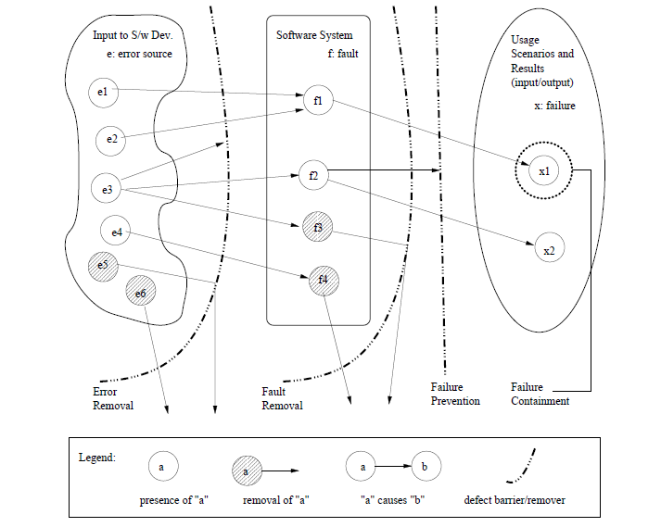

Importance of Software Quality

- Definition of Software Quality

Quality is conformance to requirements and prevention of defects.

The degree to which a system, component, or process meets specified requirements

-The degree to which a system, component, or process meets customer or user needs or expectations.
- Different Views of Software Quality

Perceived in different domains differently

Five major views according to (Kitchenham and Pfleeger1996, Pfleeger et al., 2002, software quality: The elusive target) are:
- User View

The basic building block on which fitness for use is built is the Quality Characteristic.

Any feature (property, attribute, etc.) of the products, materials, or processes

Which is needed to achieve fitness for use is a Quality Characteristic.
- Manufacturing View

The degree to which a system, component, or process meets

Specified requirements, customer/user needs or expectations

Conformance to process standards
- Product View

In the product view, the focus is on inherent characteristics in the product itself in the hope that controlling these internal quality indicators will result in improved external product behavior (quality in use)
- Value Based View

In the value-based view, quality is the customers’ willingness to pay for software.
- Achieving Quality

Achieving a high level of product or service quality is the objective of most organizations. It is no longer acceptable to deliver poor quality products, and fix deficiencies after they have been shipped to the customer. However, software quality is a complex notion that cannot be defined in a simple way, unlike for other manufactured products such as cars, televisions, or computers Quality product is expected to comply with customer requirements;
unfortunately such requirements are often incomplete for software. We do not know how to precisely specify and check certain quality requirements (e.g., usability, maintainability, reusability etc.)

Software Quality Attributes

The expected quality features and characteristics of a software product are commonly referred to as Quality Attributes.

Quality attributes are used early in the development process to identify user quality requirements. Each system has specific and unique quality needs, which are a function of the purpose of the application.

Quality is not just meeting requirements - it has many dimensions
- Software Quality Attributes
External (rely on execution) Internal (don’t rely on s/w execution)
Correctness Maintainability
Reliability Flexibility
Usability Portability
Efficiency Reusability
Integrity Readability
Adaptability Testability
Robustness Understandability

Software Quality and Quality Software

Software Quality

Software quality measures how well software is designed (quality of design), and how well the software conforms to that design (quality of conformance).

Quality of conformance is concerned with implementation,

Quality of design measures how valid the design and requirements are in creating a worthwhile product (Pressman)

Quality Software

Software that exhibit all the functional capabilities and non-functional attributes that ensure that it can be put to all its intended uses with the least effort, inconvenience and resource cost to the user.

Software should function correctly with respect to a specification that has been predefined by the client who has commissioned the development of the software.

Software must possess attributes other than correctness with respect to a specification before it can be classified as quality software.

Software Quality
In large organizations or projects, how to ensure that the required level of product quality is achieved.
- Who’s Responsibility?
- the responsibility of the so-called quality managers, quality team / group
- quality group: director, manager, coordinator, members of different
- department i.e. HR, PM, Finance
- How Quality process will be carried out?
- If it is carried out through established Engineering?
- Apply Engineering?
Engineering is concerned with applying science/ scientific principles and techniques to develop products for use by society
- Objective: within the constraints of Project Scope, Time, and Resources & Budget:
  - Civil? - Science? Steel Structures
  - Software? - Science? Data Structure, Algorithm, Analysis, Brainstorming techniques, OOAD, White Box Testing
  - Quality? - Science? Inspection, Assessments Techniques, Measurement Tools, Feedback & Improvements
- Difference in (QA) & (QC)?
- Quality Assurance (QA)
- Things done before developing software & related produces
- Recruit Good People
- Develop Good Processes
- Provide Good Tools
- Train People to use Processes & Tools
- Provide Adequate Supervision
- Appreciate Good work
- - Plan for QC
- Quality Control (QC)
- Things done after developing software & related products
- In spite our best efforts, some mistakes will occur
- Detect mistakes & ensures that quality standards / procedures are followed
- Quality Practices in the Software Lifecycle
Recalling the Quality Views
Quality is several attributes (portability, reliability, efficiency, usability,
Testability, understand ability, modifiability) ...……………. Glass
- Quality is conformance to requirements ………………… Crosby
- Quality is fitness for use …………………………………... Deming
- Quality is value to some person ………………..…...……. Weinberg
- Quality is whatever the customer decides………….……. Ginac
Quality is an attitude or state of mind ……………...…….. Juran
Other Views …….. Garvin
Manufacturing View….Conformance to specification
Value-based View..How much customer is willing to pay
- Software Quality Engineering Approach
Three Elements of SQE
-Pre-QA activities, in-QA activities, and post-QA activities:
- Pre-QA activities: Quality planning.
Software Quality Engineering Process is driven by the Software Quality Plan
These are the activities that should be carried out before carrying out the regular QA activities. Two major types
(a) Set specific quality goals.
(b) Form an overall QA strategy, which includes two sub-activities:
i. Select appropriate QA activities to perform.
ii. Choose appropriate quality measurements and models to provide feedback, quality assessment and improvement.
2. In-QA activities: Executing planned QA activities and handling discovered defects.
3. Post-QA activities: Quality measurement, assessment and improvement
Primary purpose: is to provide quality assessment and feedback so that various management decisions can be made and possible quality improvement initiatives can be carried out.
- Software Quality Engineering
Long-Term Feedback of SQE comes from two processes
- Comes from quality planning
e.g. if current goals are unachievable them we have to made adjustments
2. Feedback to quality assessment and improvement activities:
E.g. modeling results may be highly unstable, which may well be an indication of the model inappropriateness. In this case, new or modified models need to be used
Quality improvement process QIP (another model similar to SQE)
- Van Solingen and Berghout, (1999)
- Quality improvement was achieved through measurement, analysis, feedback, and organizational support.
- QIP includes three interconnected steps:
1) Understanding (the baseline, all future processes are measured with this baseline)
2) Assessing (assessing impact and change)
3) Packaging (packing the baseline data and update the process)
Summary
- ATAM
- Software Quality
- Achieving Quality
- Software Quality Attributes
- Apply Engineering
- SQE
Lecture No. 19
Software Quality Framework

19.1 Evaluation of Software Quality Framework?
- Quality requirements that the software product must meet
- Quality factors – Management-oriented attributes of software that contribute to its quality
- Quality sub-factors – Decompositions of a quality factor to its technical components
- Metrics – quantitative measures of the degree to which given attributes (factors) are present
- “Factors” McCall’s & “Characteristics” ISO 9126
- Example
- Quality requirement – “The product will be easy to use”
- Quality factor(s) – Usability (An attribute that bear on the effort needed for use and on the assessment of such use by users)
- Quality sub-factors – Understandability, ease of learning, operability, communicativeness
Sub factors
- Understandability – The amount of effort required to understand software
- Ease of learning – The degree to which user effort required to learn how to use the software is minimized
- Operability – The degree to which the effort required to perform an operation is minimized
- Communicativeness – The degree to which software is designed in accordance with the psychological characteristics of users
Metrics
- Understanding
  - Learning time: Time for new user to gain basic understanding of features of the software
- Ease of learning
  - Learning time: Time for new user to learn how to perform basic functions of the software
- Operability
  - Operation time: Time required for a user to perform operation(s) of the software
- Communicativeness
  - Human factors: Number of negative comments from new users regarding ergonomics, human factors, etc.
- Criteria for the evaluation of Software Quality

- Product operation factors
- Correctness: extent to which a program fulfills its specification.
- Reliability: ability not to fail.
- Efficiency: use of resources execution and storage.
- Integrity: protection of the program from unauthorized access.
- Usability: ease of use of the software.

- Product revision factors
- Maintainability: effort required to locate and fix a fault in a program.
- Flexibility: ease of making changes required by changes in operating environment.
- Testability: ease of testing the program to ensure that it is error-free and meets its specification.
- Product transition factors
- Portability: Effort required transferring a program from one environment to another system.
- Reusability: ease of re-using software in a different context.
- Interoperability: effort required to couple a system to another system.
- McCall’s Software Quality Model
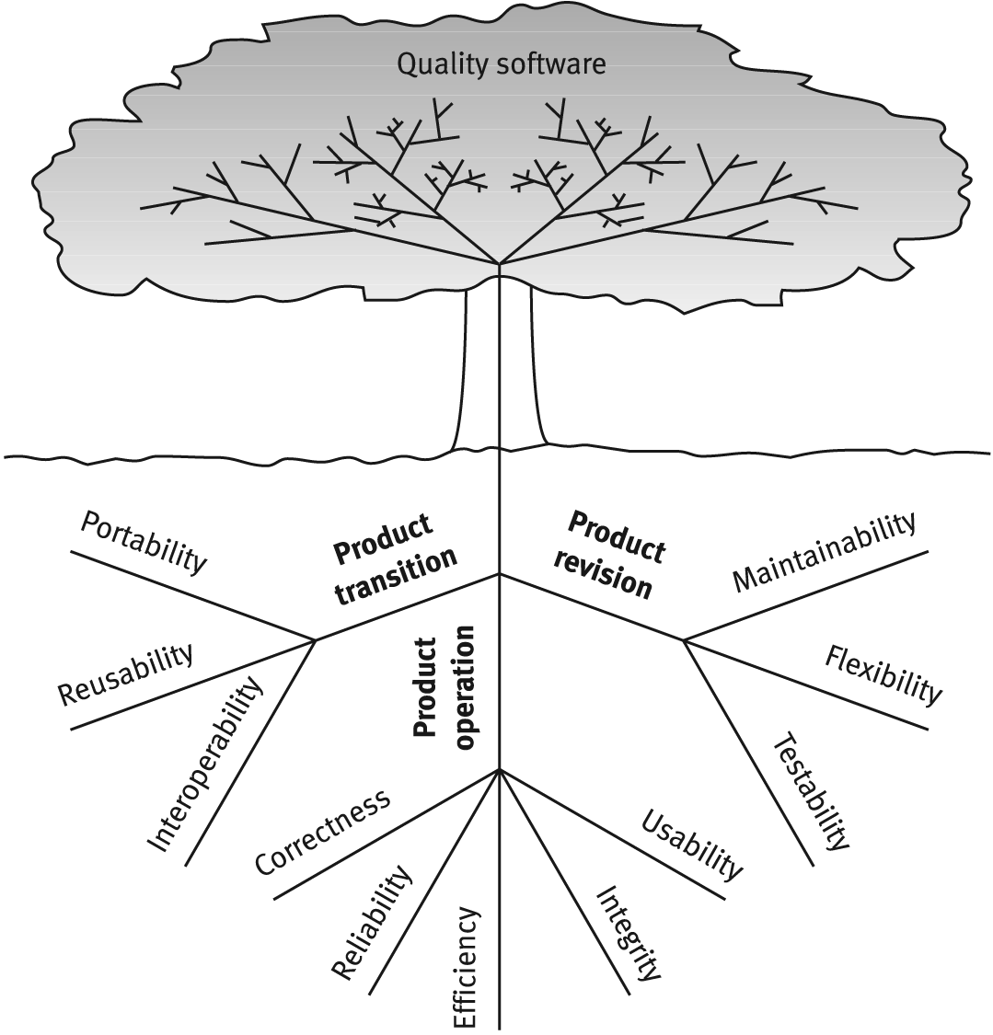

- Criteria for evaluation of software quality at NASA
At NASA, the criteria for evaluation of software quality are taken from McCall's software quality factors model. Selection of criteria is application dependent. At NASA, Selection of criteria is mission dependent, and environment dependent.
Examples:
- Flight software that flies on a single mission satellite will not be concerned with portability but may be very concerned with reliability.
- A software system that remains on the ground may be concerned with portability and not very concerned by reliability.
- Other Software Quality Factors Models
- IBM monitors CUPRIMDSO–Capability (Functionality), Usability, Performance, Reliability, Install ability, Maintainability, Documentation, Service, & Overall.
- HP monitors FURPS–Functionality, Usability, Reliability, and Performance & Service.
- McCall’s Quality Criteria - Sub factors
- A quality criterion is an attribute of quality factor that is related to software development.
- McCall and his colleagues have introduced 23 criteria: Modularity, Error Tolerance, Storage efficiency, Simplicity, Machine independence, Data communality, Training, Conciseness.
- Access audit: Ease with which software and data can be checked for compliance with standards or other requirements.
- Access control: Provisions for control and protection of the software and data.
- Accuracy: Precision of computations and output.
- Communication commonality: Degree to which standard protocols and interfaces are used.
- Completeness: Degree to which a full implementation of the required functionalities has been achieved.
- Communicativeness: Ease with which inputs and outputs can be assimilated
- Conciseness: Compactness of the source code, in terms of lines of code.
- Consistency: Use of uniform design and implementation techniques and notation throughout a project.
- Data commonality: Use of standard data representations.
- Error tolerance: Degree to which continuity of operation is ensured under adverse conditions.
- Execution efficiency: Run time efficiency of the software.
- Expandability: Degree to which storage requirements or software functions can be expanded.
- Generality: Breadth of the potential application of software components.
- Hardware independence: Degree to which the software is dependent on the underlying hardware.
- Instrumentation: Degree to which the software provides for measurement of its use or identification of errors.
- Modularity: Provision of highly independent modules.
- Operability: Ease of operation of the software.
- Self-documentation: Provision of in-line documentation that explains implementation of components.
- Simplicity: Ease with which the software can be understood.
- Software system independence: Degree to which the software is independent of its software environment—nonstandard language constructs, operating system, libraries, database management system, etc.
- Software efficiency: Run time storage requirements of the software.
- Traceability: Ability to link software components to requirements.
- Training: Ease with which new users can use the system.

- Quality factors and quality criteria
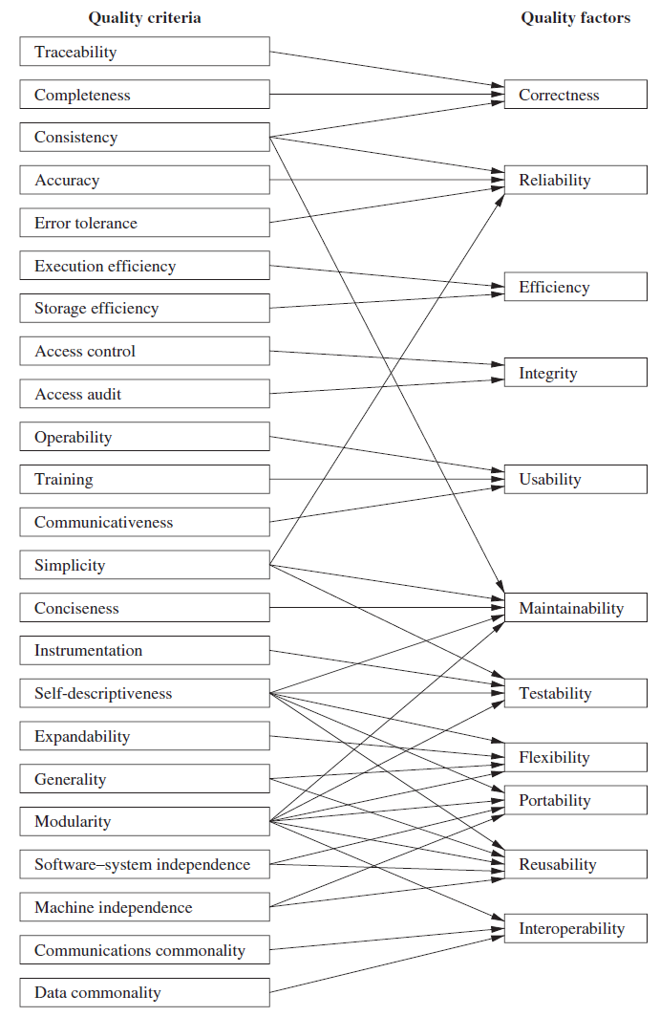
9.2 Other Quality factors models
- ISO 9126 Model

- ISO 9126 Quality Characteristics “Quality Factors”
- Functionality: A set of attributes that bear on the existence of a set of functions and their specified properties. The functions are those that satisfy stated or implied needs.
- Reliability: A set of attributes that bear on the capability of software to maintain its performance level under stated conditions for a stated period of time.
- Usability: A set of attributes that bear on the effort needed for use and on the individual assessment of such use by a stated or implied set of users.
- Efficiency: A set of attributes that bear on the relationship between the software’s performance and the amount of resource used under stated conditions.
- Maintainability: A set of attributes that bear on the effort needed to make specified modifications
- Portability: A set of attributes that bear on the ability of software to be transferred from one environment to another
- ISO 9126 Quality Sub-characteristics (“Quality Sub-factors” by McCalls)
- Functionality
- Suitability: The capability of the software to provide an adequate set of functions for specified tasks and user objectives.
- Accuracy: The capability of the software to provide the right or agreed-upon results or effects.
- Interoperability: The capability of the software to interact with one or more specified systems.
- Security: The capability of the software to prevent unintended access and resist deliberate attacks intended to gain unauthorized access to confidential information.
- Reliability
- Maturity: The capability of the software to avoid failure as a result of faults in the software.
- Fault Tolerance: The capability of the software to maintain a specified level of performance in case of software faults or of infringement of its specified interface.
- Recoverability: The capability of the software to reestablish its level of performance and recover the data directly affected in the case of a failure.
- Usability
- Understandability: The capability of the software product to enable the user to understand whether the software is suitable, and how it can be used for particular tasks and conditions of use.
- Learnability: The capability of the software product to enable the user to learn its applications.
- Operability: The capability of the software product to enable the user to operate and control it.
- Attractiveness: The capability of the software product to be liked by the user.
- Efficiency
- Time Behavior: The capability of the software to provide appropriate response and processing times and throughput rates when performing its function under stated conditions.
- Resource Behavior: The capability of the software to use appropriate resources in an appropriate time when the software performs its function under stated condition.
- Maintainability
- Analyzability: The capability of the software product to be diagnosed for deficiencies or causes of failures in the software or for the parts to be modified to be identified.
- Changeability: The capability of the software product to enable a specified modification to be implemented.
- Stability: The capability of the software to minimize unexpected effects from modifications of the software.
- Testability: The capability of the software product to enable modified software to be validated.
- Portability
- Adaptability: The capability of the software to be modified for different specified environments without applying actions or means other than those provided for this purpose for the software considered.
- Install ability: The capability of the software to be installed in a specified environment.
- Coexistence: The capability of the software to coexist with other independent software in a common environment sharing common resources.
- Replace ability: The capability of the software to be used in place of other specified software in the environment of that software.

- Relation between ISO 9126 characteristics and sub characteristics
- Strict Hierarchy
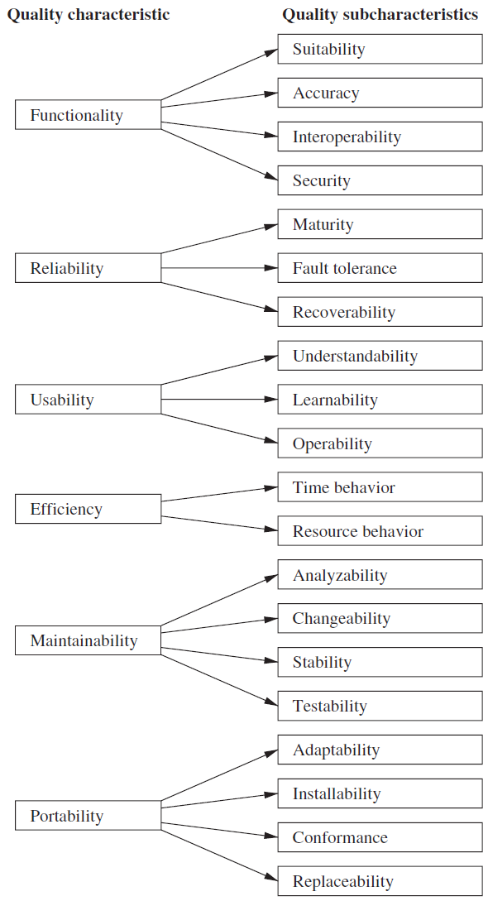

- Quality factors and quality criteria
- Flexible Hierarchy
9.3 Software Quality Attributes
- Eight Dimensions Software Quality Attributes (Garvins David)
- Performance Quality: Does software delivers all contents, functions, & features that are specified
- Feature Quality: Does software provides features that surprise & delight first-time end users?
- Reliability: If deliver without failure? If available when needed?
- Conformance: Does conform to design & coding conventions? e.g. accepted design rules for menu selection
- Durability: Can software be maintained (changed) & corrected (debugged) without side effects?
- Serviceability: Can debugged in acceptability short time period? If support staff acquire all info to make change
- Aesthetics: Artistic, Aesthetics entity has certain elegance, cannot quantify
- Perceptions: if a vender has an excellent reputation, you may perceive quality even it doesn’t really exists, vice versa, or some past experience is more bitter
- Quality Attributes: Practical Usage
- Quality attributes are identified early to express quality requirements and to drive the development and evaluation of quality products.
- Quality attributes for a given system may be:
- Conflicting; for instance, achieving security may be at the expense of efficiency or interoperability. So trade-off must be made when addressing such kinds of quality attributes
- Supportive; for instance usability can improve maintainability.
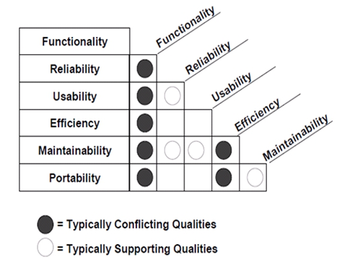
- Other Characteristics
- Quality Standards by ISO
- Several well-established and proven quality standards and procedures are available.
- Two basic premises underlie existing quality standards:
- Process vs. Product: The quality of a product is largely based on the quality of the process that leads to that product.
- . Conformance vs. Improvement: techniques can be developed to improve the quality of product or process, or alternatively to ensure they conform to specified quality requirements.
- ISO 9000 Quality Standard
What is assessment? Comparison of your organization with some standards where you stand Where improvement? STEPS: obtain data, find strengths & weakness, identify area to improve, use guidelines and implement standards i.e. ISO. ISO 9000 is a set of international standards that can be used in the development of a quality management system in all industries.
- ISO 9001 is a generic model of a quality process that describes
- Which standards and procedures should exist within an organization?
- As it is not industry-specific, this description is high-level. Within any specific organization, a set of appropriate quality processes should be defined and documented in an organizational quality manual.
- Certification bodies exist that check regularly conformance with ISO 9001 of the quality process as expressed in the quality plan.
- ISO 9004 – more comprehensive
- Some of the requirements in ISO 9000-3 include:
- Develop and document software test plans.
- Develop methods to test whether the software meets the customer's requirements.
- Perform software validation and acceptance tests.
- Maintain records of the test results.
- Control how software bugs are investigated and resolved.
- Prove that the product is ready before it is released.
- Develop procedures to control the software's release process.
- Identify and define what quality information should be collected.
- Use statistical techniques to analyze the software development process.
- Use statistical techniques to evaluate product quality.
Summary
- Software Quality
- McCall’s Quality Model
- ISO 9126 Model
- Software Quality Attributes
- ISO 9000 Quality Standard
- CUPRIMDSO & FURPS

Lecture No. 20
Common Process Problems

20.1 Common Process Problems
Settling for Less: Do these statements sound familiar? If they do, your organization may be settling for less than it is capable of and may be a good candidate for process improvement.
- “I'd rather have it wrong than have it late. We can always fix it later.”
- “The bottom line is schedule. My promotions and raises are based on meeting schedule first and foremost.”
- Symptoms of Process Failure
- Commitments consistently missed
  - Late delivery
  - Last minute crunches
  - Spiraling costs
- No management visibility into progress
  - You’re always being surprised.
- Quality problems
  - Too much rework
  - Functions do not work correctly.
  - Customer complaints after delivery
- Poor morale
  - People frustrated
  - Is anyone in charge?
- Software-Intensive Systems
Software is becoming a larger part of many products and services. Systems and software disciplines traditionally have not been well integrated. The importance of software in systems has increased dramatically.

- Process Improvement Basics
The Process Management Premise
The quality of a system is highly influenced by the quality of the process used to acquire, develop, and maintain it. This premise implies a focus on processes as well as on products.
- This is a long-established premise in manufacturing (and is based on TQM principles as taught by Shewhart, Juran, Deming, and Humphrey).
- Belief in this premise is visible worldwide in quality movements in manufacturing and service industries (e.g., ISO standards).
The Role of Process
Everyone realizes the importance of having a motivated, quality work force and the latest technology, but even the finest people can’t perform at their best when the process is not understood or operating at its best.
PEOPLE
PROCESS
TECHNOLOGY
- Common Misconceptions
- I don’t need process, I have
• Really good people
• Advanced technology
• An experienced manager
- Process
• interferes with creativity
• equals bureaucracy + regimentation
• isn’t needed when building prototypes
• is only useful on large projects
• hinders agility in fast-moving markets
• costs too much

20.2 Capability Maturity Model Integration (CMMI)
Capability Maturity Modeling, CMM, and CMMI are registered in the U.S. Patent and Trademark Office by Carnegie Mellon University.
- What Is a CMM?
A Capability Maturity Model (CMM) is a reference model of mature practices in a specified discipline, used to improve and appraise a group’s capability to perform that discipline.
- CMMs differ by
• Discipline (e.g., software engineering, systems engineering)
• Structure (e.g., staged, continuous)
• Definition of maturity (i.e., process improvement path)
- Multiple Process Models
- Software CMM
- Systems Security Engr CMM
- Systems Engr CMM
- People CMM
- IPD CMM
- Software Acq CMM
- EEIIAA 773311
- ISO 15504
- Success of the Software CMM® caused development of other CMMs, but they:
- Had different structures, formats, terms, ways of measuring maturity
- Caused confusion, especially when more than one was used together
- Were difficult to integrate into a combined improvement program
- Were difficult to use in supplier selection and sub-contracting
- Understanding CMMI Representations
There are two types of representations in the CMMI models:
- Staged
- Continuous
A representation allows an organization to pursue different improvement paths. The organization and presentation of the data are different in each representation. However, the content is the same.
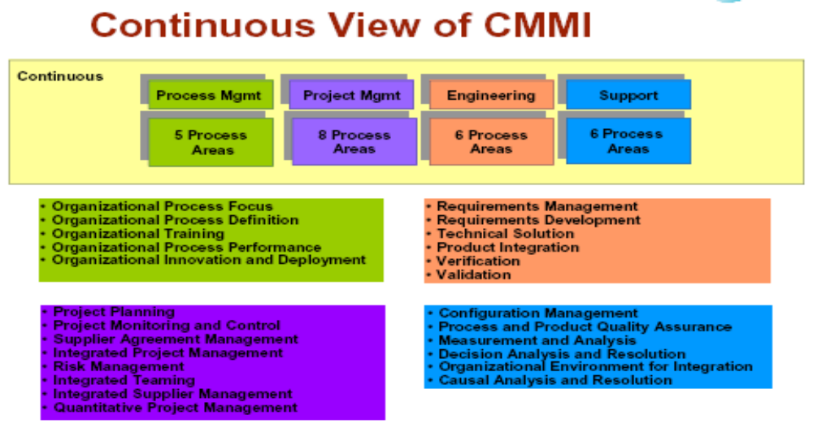

- Capability Maturity Model (CMM):
A Capability Maturity Model (CMM) is a reference model of mature practices in a specified discipline, used to improve and appraise a group’s capability to perform that discipline. CMM broadly refers to a process improvement approach that is based on a process model. CMM was the first such model, developed by the Software Engineering Institute (SEI) in the mid-1980s, as well as the family of process models that followed. A process model is a structured collection of practices that describe the characteristics of effective processes; the practices included are those proven by experience to be effective.
CMM can be used to assess an organization against a scale of five process maturity levels. Each level ranks the organization according to its standardization of processes in the subject area being assessed. The subject areas can be as diverse as software engineering, systems engineering, project management, risk management, system acquisition, information technology (IT) services and personnel management.
- Maturity Model:
The Capability Maturity Model (CMM) is a way to develop and refine an organization's processes. The first CMM was for the purpose of developing and refining software development processes. A maturity model is a structured collection of elements that describe characteristics of effective processes. A maturity model provides:
- A place to start
- The benefit of a community’s prior experiences
- A common language and a shared vision
- A framework for prioritizing actions
- A way to define what improvement means for your organization
A maturity model can be used as a benchmark for assessing different organizations for equivalent comparison. It describes the maturity of the company based upon the project the company is dealing with and the clients.
- The Five Levels of Software Process Maturity:
A capability level is a well-defined evolutionary plateau describing the organization’s capability relative to a particular process area. There are five levels defined along the continuum of the model and, according to the SEI: "Predictability, effectiveness, and control of an organization's software processes are believed to improve as the organization moves up these five levels.
Each level is a layer in the foundation for continuous process improvement. Thus, capability levels are cumulative (i.e., a higher capability level includes the attributes of the lower levels). The five levels of Software Process Maturity are depicted in figure.
- Level 1 – Initial:
It is characteristic of processes at this level that they are (typically) un-documented and in a state of dynamic change, tending to be driven in an ad hoc, uncontrolled and reactive manner by users or events. This provides a chaotic or unstable environment for the processes.

- Level 2 – Repeatable:
It is characteristic of processes at this level that some processes are repeatable, possibly with consistent results. Process discipline is unlikely to be rigorous, but where it exists it may help to ensure that existing processes are maintained during times of stress.

Figure: The Five Levels of Software Process Maturity
- Level 3 – Defined:
It is characteristic of processes at this level that there are sets of defined and documented standard processes established and subject to some degree of improvement over time. These standard processes are in place (i.e., they are the AS-IS processes) and used to establish consistency of process performance across the organization.
- Level 4 – Managed:
It is characteristic of processes at this level that, using process metrics, management can effectively control the AS-IS process (e.g., for software development). In particular, management can identify ways to adjust and adapt the process to particular projects without measurable losses of quality or deviations from specifications. Process Capability is established from this level.
- Level 5 – Optimizing:
It is a characteristic of processes at this level that the focus is on continually improving process performance through both incremental and innovative technological changes/improvements.
Summary
- Common Process Problems
- Process Improvement
- CMMI
- Capability Levels
- Initial
- Repeatable
- defined
- Managed
- Optimized

Lecture No. 21
Component-Based Software Engineering

21.1 Component-based development
Component-based software engineering (CBSE) is an approach to software development that relies on the reuse of entities called ‘software components’. It emerged from the failure of object-oriented development to support effective reuse. Single object classes are too detailed and specific. Components are more abstract than object classes and can be considered to be stand-alone service providers. They can exist as stand-alone entities.
- CBSE Essentials
- Independent components specified by their interfaces.
- Component standards to facilitate component integration.
- Middleware that provides support for component inter-operability.
- A development process that is geared to reuse.
- CBSE and design principles

Apart from the benefits of reuse, CBSE is based on sound software engineering design principles:
- Components are independent so do not interfere with each other;
- Component implementations are hidden;
- Communication is through well-defined interfaces;
- Component platforms are shared and reduce development costs.
- Component standards

Standards need to be established so that components can communicate with each other and inter-operate. Unfortunately, several competing component standards were established:
- Sun’s Enterprise Java Beans
- Microsoft’s COM and .NET
- CORBA’s CCM

In practice, these multiple standards have hindered the uptake of CBSE. It is impossible for components developed using different approaches to work together.
- CBSE problems
- Component trustworthiness - how can a component with no available source code be trusted?
- Component certification - who will certify the quality of components?
- Emergent property prediction - how can the emergent properties of component compositions be predicted?
- Requirements trade-offs - how do we do trade-off analysis between the features of one component and another?
- Components

Components provide a service without regard to where the component is executing or its programming language
- A component is an independent executable entity that can be made up of one or more executable objects
- The component interface is published and all interactions are through the published interface;
- Component definitions
- Councill and Heinmann

“A software component is a software element that conforms to a component model and can be independently deployed and composed without modification according to a composition standard”.
- Szyperski

“A software component is a unit of composition with contractually specified interfaces and explicit context dependencies only. A software component can be deployed independently and is subject to composition by third-parties”.

- Component as a service provider

The component is an independent, executable entity. It does not have to be compiled before it is used with other components. The services offered by a component are made available through an interface and all component interactions take place through that interface. The component interface is expressed in terms of parameterized operations and its internal state is never exposed.

- Component interfaces

Provides interface
- Defines the services that are provided by the component to other components.
- This interface, essentially, is the component API. It defines the methods that can be called by a user of the component.

Requires interface
- Defines the services that specifies what services must be made available for the component to execute as specified.
- This does not compromise the independence or deployability of a component because the ‘requires’ interface does not define how these services should be provided.
- Component models

A component model is a definition of standards for component implementation, documentation and deployment. Examples of component models are:
- EJB model (Enterprise Java Beans)
- COM+ model (.NET model)
- Corba Component Model
- The component model specifies how interfaces should be defined and the elements that should be included in an interface definition.

- Elements of a component model

Interfaces

Components are defined by specifying their interfaces. The component model specifies how the interfaces should be defined and the elements, such as operation names, parameters and exceptions, which should be included in the interface definition.

Usage

In order for components to be distributed and accessed remotely, they need to have a unique name or handle associated with them. This has to be globally unique.

Deployment

The component model includes a specification of how components should be packaged for deployment as independent, executable entities.
- Middleware support

Component models are the basis for middleware that provides support for executing components.

Component model implementations provide:
- Platform services that allow components written according to the model to communicate;
- Support services that are application-independent services used by different components.

To use services provided by a model, components are deployed in a container. This is a set of interfaces used to access the service implementations.
- CBSE processes

CBSE processes are software processes that support component-based software engineering.
- They take into account the possibilities of reuse and the different process activities involved in developing and using reusable components.

Development for reuse
- This process is concerned with developing components or services that will be reused in other applications. It usually involves generalizing existing components.

Development with reuse
- This process is the process of developing new applications using existing components and services.
- Supporting processes

Component acquisition is the process of acquiring components for reuse or development into a reusable component.
- It may involve accessing locally- developed components or services or finding these components from an external source.

Component management is concerned with managing a company’s reusable components, ensuring that they are properly catalogued, stored and made available for reuse.

Component certification is the process of checking a component and certifying that it meets its specification.

- CBSE for reuse

CBSE for reuse focuses on component development. Components developed for a specific application usually have to be generalised to make them reusable. A component is most likely to be reusable if it associated with a stable domain abstraction (business object). For example, in a hospital stable domain abstractions are associated with the fundamental purpose - nurses, patients, treatments, etc.
- Component development for reuse

Components for reuse may be specially constructed by generalising existing components.

Component reusability
- Should reflect stable domain abstractions;
- Should hide state representation;
- Should be as independent as possible;
- Should publish exceptions through the component interface.

There is a trade-off between reusability and usability
- The more general the interface, the greater the reusability but it is then more complex and hence less usable.
- Changes for reusability

Remove application-specific methods.

Change names to make them general.

Add methods to broaden coverage.

Make exception handling consistent.

Add a configuration interface for component adaptation.

Integrate required components to reduce dependencies.
- Exception handling

Components should not handle exceptions themselves, because each application will have its own requirements for exception handling.
- Rather, the component should define what exceptions can arise and should publish these as part of the interface.

In practice, however, there are two problems with this:
- Publishing all exceptions leads to bloated interfaces that are harder to understand. This may put off potential users of the component.
- The operation of the component may depend on local exception handling, and changing this may have serious implications for the functionality of the component.

- Legacy system components
- Existing legacy systems that fulfill a useful business function can be re-packaged as components for reuse.
- This involves writing a wrapper component that implements provides and requires interfaces then accesses the legacy system.
- Although costly, this can be much less expensive than rewriting the legacy system.
- Reusable components
- The development cost of reusable components may be higher than the cost of specific equivalents. This extra reusability enhancement cost should be an organization rather than a project cost.
- Generic components may be less space-efficient and may have longer execution times than their specific equivalents.
- Component management

Component management involves deciding how to classify the component so that it can be discovered, making the component available either in a repository or as a service, maintaining information about the use of the component and keeping track of different component versions.

A company with a reuse program may carry out some form of component certification before the component is made available for reuse.
- Certification means that someone apart from the developer checks the quality of the component.

- CBSE with reuse

CBSE with reuse process has to find and integrate reusable components.

When reusing components, it is essential to make trade-offs between ideal requirements and the services actually provided by available components.

This involves:
- Developing outline requirements;
- Searching for components then modifying requirements according to available functionality.
- Searching again to find if there are better components that meet the revised requirements
- Composing components to create the system

- Component identification issues

Trust: You need to be able to trust the supplier of a component. At best, an un-trusted component may not operate as advertised; at worst, it can breach your security.

Requirements: Different groups of components will satisfy different requirements.

Validation:
- The component specification may not be detailed enough to allow comprehensive tests to be developed.
- Components may have unwanted functionality. How can you test this will not interfere with your application?
- Component validation

Component validation involves developing a set of test cases for a component (or, possibly, extending test cases supplied with that component) and developing a test harness to run component tests.
- The major problem with component validation is that the component specification may not be sufficiently detailed to allow you to develop a complete set of component tests.

As well as testing that a component for reuse does what you require, you may also have to check that the component does not include any malicious code or functionality that you don’t need.
- Ariane launcher failure – validation failure?

In 1996, the 1st test flight of the Ariane 5 rocket ended in disaster when the launcher went out of control 37 seconds after takeoff.

The problem was due to a reused component from a previous version of the launcher (the Inertial Navigation System) that failed because assumptions made when that component was developed did not hold for Ariane 5.

The functionality that failed in this component was not required in Ariane 5.
- Component composition

The process of assembling components to create a system

Composition involves integrating components with each other and with the component infrastructure.

Normally you have to write ‘glue code’ to integrate components.
- Types of composition

Sequential composition: where the composed components are executed in sequence. This involves composing the provides interfaces of each component.

Hierarchical composition: where one component calls on the services of another. The provides interface of one component is composed with the requires interface of another.

Additive composition: where the interfaces of two components are put together to create a new component. Provides and requires interfaces of integrated component are a combination of interfaces of constituent components.
- Interface incompatibility

Parameter incompatibility: where operations have the same name but are of different types.

Operation incompatibility: where the names of operations in the composed interfaces are different.

Operation incompleteness: where the provides interface of one component is a subset of the requires interface of another.
- Adaptor components

Address the problem of component incompatibility by reconciling the interfaces of the components that are composed.

Different types of adaptor are required depending on the type of composition.

An address Finder and a mapper component may be composed through an adaptor that strips the postal code from an address and passes this to the mapper component.
- Composition through an adaptor

The component postCodeStripper is the adaptor that facilitates the sequential composition of addressFinder and mapper components.
- The Object Constraint Language

The Object Constraint Language (OCL) has been designed to define constraints that are associated with UML models.

It is based around the notion of pre and post condition specification – common to many formal methods.

Summary
- Process Improvement
- CMMI
- CBSE
- CBSE problems
- Component models
- Middleware support
- CBSE processes
- CBSE for reuse

Lecture No. 22

Interfaces Components

22.1 Abstract Classes

When we define a class to be “final”, it cannot be extended. In certain situation, we want to properties of classes to be always extended and used. Such classes are called Abstract Classes. An Abstract class is a conceptual class. An Abstract class cannot be instantiated – objects cannot be created. Abstract classes provide a common root for a group of classes, nicely tied together in a package.
abstract class ClassName
{
...
…
abstract Type MethodName1();
…
…
Type Method2()
{
// method body
}
}
When a class contains one or more abstract methods, it should be declared as abstract class. The abstract methods of an abstract class must be defined in its subclass. We cannot declare abstract constructors or abstract static methods.
- Abstract Class Syntax
abstract class ClassName
{
...
…
abstract Type MethodName1();
…
…
Type Method2()
{
// method body
}
}

When a class contains one or more abstract methods, it should be declared as abstract class.

The abstract methods of an abstract class must be defined in its subclass.

We cannot declare abstract constructors or abstract static methods.
- Abstract Classes Properties
- A class with one or more abstract methods is automatically abstract and it cannot be instantiated.
- A class declared abstract, even with no abstract methods cannot be instantiated.
- A subclass of an abstract class can be instantiated if it overrides all abstract methods by implementation them.
- A subclass that does not implement all of the super class abstract methods is itself abstract; and it cannot be instantiated.
- Abstract Classes

If you do not want (properties of) your class to be extended or inherited by other classes, define it as a final class.
- Java supports this is through the keyword “final”.
- This is applied to classes.

You can also apply the final to only methods if you do not want anyone to override them.

If you want your class (properties/methods) to be extended by all those who want to use, then define it as an abstract class or define one or more of its methods as abstract methods.
- Java supports this is through the keyword “abstract”.
- This is applied to methods only.
- Subclasses should implement abstract methods; otherwise, they cannot be instantiated.
- Interfaces
- Interface is a conceptual entity similar to an Abstract class.
- Can contain only constants (final variables) and abstract method (no implementation) - Different from Abstract classes.
- Use when a number of classes share a common interface.
- Each class should implement the interface.
- Interfaces: An informal way of realizing multiple inheritance
- An interface is basically a kind of class. It contains methods and variables, but they have to be only abstract classes and final fields/variables.
- Therefore, it is the responsibility of the class that implements an interface to supply the code for methods.
- A class can implement any number of interfaces, but cannot extend more than one class at a time.
- Therefore, interfaces are considered as an informal way of realizing multiple inheritances in Java.
- Interfaces and Software Engineering

Interfaces, like abstract classes and methods, provide templates of behaviour that other classes are expected to implement.

It separates out a design hierarchy from implementation hierarchy. This allows software designers to enforce/pass common/standard syntax for programmers implementing different classes.

Pass method descriptions, not implementation

Java allows for inheritance from only a single super class. Interfaces allow for class mixing.

Classes implement interfaces.
22.2 Components
- IC analogy

Software components should be like integrated circuits (ICs)

Or plumbing components?

Why? What are our desires for software components?

Bertrand Meyer, in Object Oriented Software Construction:

Modular (IC chips, disk drivers, are self-contained: packaged code)

Compatible (chips or boards that plug in easily, simple interfaces)

Reusable (same processor IC can serve various purposes)

Extendible (IC technology can be improved: inheritance)

Reliable (an IC works most of the time!)
a) Correct (it does what it's supposed to, according to specification)
b) Robust (it functions in abnormal conditions)

Efficient (ICs are getting faster and faster!)

Inexpensive (ICs prices are falling

Portable (ease of transferring to different platforms)

Timely (released when or before users want it)

What do you think: will any software paradigm answer all our wishes?

- Definition of Software Components
“A software component is a unit of composition with contractually specified interfaces and explicit context dependencies only. A software component can be deployed independently and is subject to composition by third parties.”

Unit of composition – combine components to build systems

Binary units – black boxes, not source code

Contractually specified interfaces – mechanism for interface definition, such as Interface Definition Language

Independent production – separation of concerns

Deployed and composed by third parties – reusable units assembled like parts supplied by manufacturers

Why a component based approach?

Consider two ends of a spectrum:

Comm. off the shelf < --- > Custom-made

What advantages of COTS software could components offer to custom-made?

Advantages:

Cost efficiency & flexibility

Reuse, productivity

Scalability

Application of engineering techniques

Costs of components

It takes significant effort to create a software component that is effectively reusable. How so?

The component needs:

To be fully documented;

More thorough testing;

Robust input validity checking;

To pass back useful error messages as appropriate;

To be built with an awareness that it will be put to unforeseen uses

A mechanism for compensating developers who invest the (substantial) effort implied above.

Distributed Component Technologies

The goal:

Integration of services for applications on various platforms

Interoperability: let disparate systems communicate and share data seamlessly

Approaches:

- Microsoft: DDE, COM, OLE, OCX, DCOM and ActiveX

- Sun: JavaBeans, Enterprise JavaBeans, J2EE

- CORBA (Common Object Request Broker Architecture)

- SOAP (using XML)

Example from Microsoft environment (80’s)

Excel-generated pie chart embedded in a Word document displayed in a PowerPoint presentation

Different applications need to share data or procedures
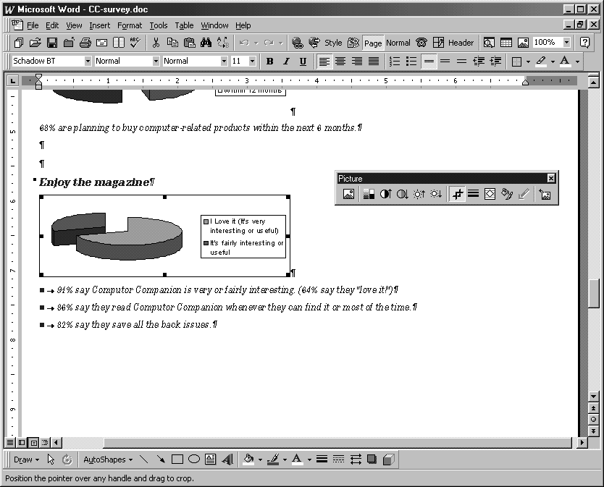

DDE (Dynamic Data Exchange)

A little history: starting with evolution of Microsoft approach:

Windows gave PCs a more accessible computing environment

Problem: lack of consistency between different programs

What if spreadsheet and word processor need to share data?

Early solution was integrating suites into large programs:

e.g., Microsoft Works – Pros and cons of suite approach?

Microsoft comes out with Dynamic Data Exchange (DDE), circa 1989

Lets different Windows programs share data through links

Suppose some spreadsheet data were linked into word processor

When you changed data in spreadsheet, the new data would appear in word processor

Limitation: you couldn’t update the data in the word processor; you had to invoke the spreadsheet to update the date there

Worse, links were fragile and would break if you moved data files around in file system

OLE (circa 1991)

Object Linking and Embedding

Linking is essentially DDE, using reference semantics

Embedding lets users copy a snapshot of data into word processor and save it there

Linking is cheaper when data files are large

Embedding supports compound documents (“document-centric” computing)

A way for Windows to create documents containing objects from other programs

E.g. place a chart from Excel and a slide from PowerPoint into
a Word document

Components containers can be re-used by many applications

But components do not make data independent of application programs, and OLE is a platform-specific solution.

OLE Technology (circa 1993)

A set of APIs to create and display a (compound) document

Now possible to share code as well as data

Component Object Model (COM)

COM protocols let components connect to origination program:

E.g. word processor can tell spreadsheet, “the user just clicked on the spreadsheet, so start yourself up, look for data here, and let me know when you’re done.”

COM now includes OLE as part of a larger concept

OLE becomes a set of standard COM interfaces

Embedded documents retain all their original properties

If the user decides to edit the embedded data, Windows activates the originating application and loads the embedded document

OLE Extensions (OCX)

With Windows 95 came a new standard:

OCX (OLE Custom eXtension component)

A piece of code, smaller than application program, but with its own user interface

Let users bundle OCX controls to form customized applications

E.g., combine spell checker and synonym provider component to make a new program

Is this beginning to sound like object-oriented programming?

ActiveX (circa 1996)

Microsoft retools OLE and COM as ActiveX

ActiveX applies to a whole set of COM-based technologies

ActiveX control is Microsoft's answer to the Java technology from

An ActiveX control is roughly equivalent to a applet, but is known as an ActiveX control

Writing a program to run in the ActiveX environment creates a self-sufficient program that can run anywhere in ActiveX network

This component is known as an ActiveX control, and is often used to attach a program to a web page

ActiveX - implementation

An ActiveX control can be created using one of several languages or development tools, including C++ and Visual Basic, or with scripting tools such as VBScript.

Network OLE for rudimentary support of distributed applications

ActiveX controls originally were Windows only

Other vendors later provided Mac and Unix/Linux support for ActiveX

Security issues: ActiveX controls have full file access (no sandbox)

Can be signed for authentication

Are signed controls secure enough?

Communication Protocol Models

Remote Procedure Call (RPC)

Since 1980s, pioneered by Sun

Tears of testing with various communication models

Distributed extension of MS COM (DCOM)

Lets COM talk to other platforms

Complex configuration and complicated security model

Remote Method Invocation (RMI)

Communication between methods of Java classes

Drawbacks of RPC/RMI approach?

Platform-specific, procedural and low-level

The JavaBeans API

“A Java Bean is a reusable software component that can be manipulated visually in a builder tool.”

JavaBeans API makes it possible to write component software in Java

Components are self-contained, reusable software units that can be visually composed into composite components, applets, applications, and servlets using visual application builder tools.

JavaBean components are known as Beans.

Components and Software Architecture

Classes vs. components:

Class hierarchies + object collaboration = detailed design

Components + collaboration = architecture

Class vs. JavaBean:

Class == a brick, a piece of wood, a nail

Javabean = a wall element, a roof, a room

Client application == a building

Architecture does not concentrate on nails and bricks!

JavaBeans made out of Java classes

Beans are classes that can be manipulated in a visual builder tool and composed into apps. Any Java class that adheres to certain conventions regarding property and event interface definitions can be a JavaBean. Beans publish their attributes and behaviours through special method signature patterns that are recognized by beans-aware application construction tools.

Builder Tools and Properties

Discover Bean’s Properties

Determine properties’ read/write attributes

Determine property types

Locate property editors

Display property sheet

Alter properties

Beans communicate via events

Message sent from one object to another.

Sender fires event, recipient (listener) handles the event

There may be many listeners.

Enterprise Java Beans (EJB)

A server-side component

Contains the business logic of an application

Application clients execute the business logic by invoking the enterprise bean's methods

Why EJBs are attractive: Frees application developer from dealing with system level aspects of an application. Allows bean developer to focus solely on the logic of the application

Middleware approach

Middleware: General-purpose software that manages communication between distributed components (modules, classes, JavaBeans). Thus it sits in the middle, between distributed components, the glue between components

Reuse benefits: The developer doesn’t have to write code to communicate across processes or processors. Middleware “broker” handles bindings between components, so that components can be reused in other contexts without changing its code.
22.2 Common Object Request Broker Architecture (CORBA):
The Common Object Request Broker Architecture (CORBA) is a standard defined by the Object Management Group (OMG) that enables software components written in multiple computer languages and running on multiple computers to work together (i.e., it supports multiple platforms).
CORBA enables separate pieces of software written in different languages and running on different computers to work with each other like a single application or set of services. More specifically, CORBA is a mechanism in software for normalizing the method-call semantics between application objects residing either in the same address space (application) or remote address space (same host, or remote host on a network).
CORBA uses an interface definition language (IDL) to specify the interfaces that objects will present to the outside world. CORBA then specifies a “mapping” from IDL to a specific implementation language such as C++ or Java.
The CORBA specification dictates that there shall be an object request broker (ORB) through which the application interacts with other objects. In practice, the application simply initializes the ORB, and accesses an internal Object Adapter which maintains such issues as reference counting, object (& reference) instantiation policies, object lifetime policies, etc. The Object Adapter is used to register instances of the generated code classes. Generated Code Classes are the result of compiling the user IDL code which translates the high-level interface definition into an OS- and language-specific class base for use by the user application. This step is necessary in order to enforce the CORBA semantics and provide a clean user processes for interfacing with the CORBA infrastructure.
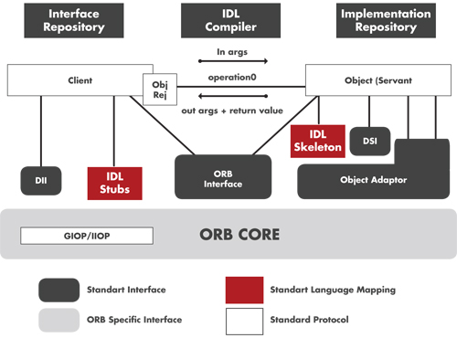
Common Object Request Broker Architecture (CORBA)

Purpose of CORBA:
CORBA is used mainly for the following two purposes:

1- Vendor independent Interoperability (high level definition):
Middleware that’s everywhere is the main purpose of CORBA, which try to provide perfect interoperability among any OS, hardware, and system. We might see the immediate benefit by integrating legacy systems on mainframe computers and/or traditional client-server models with relatively new component based systems on web technologies. Not only the interoperability among the variety of system (architecture) styles but also interoperability among different vendors produces significant benefit for users. “Open system” was the first step for vendor independent interoperability but still had a limitation in architecture point of views. CORBA could be rephrased to “the road to the perfect open system”.

2- Implement ORB functions (narrow definition in OMA):
The purpose of CORBA in OMA is to implement ORB functions. OMA has CORBA-related objects: CORBA services [OMG 1998b], CORBA facilities, and CORBA domains.
- CORBA services provide low-level, base-type services such as transactions, security, life-cycle, and naming.
- CORBA facilities provide a higher-level set of services such as printing management.
- CORBA domains represent vertical domain-related standards such as manufacturing, telecommunication, healthcare, financial and so on.
- Application objects, other than these CORBA related objects, are not standardized as part of OMG activities.
CORBA
Domain
CORBA
Domain

CORBA
Domain

Application Objects

CORBA facilities

ORB (Object Request Broker)

CORBA Services

Mapping among CORBA-related objects (OMA)

Communication protocol models
- Common Object Request Broker Architecture (CORBA)
- CORBA2 adopted in 1994
- A specification of services helpful to build distributed applications
- Remote Method Invocation (RMI)
- Used for communication between components across a network (for example, in Java)
- Simple Object Access Protocol (SOAP)
- A protocol specification for invoking methods on different servers, services, components and objects

Web services with SOAP
- Emerging standards support web services, all in XML:
- UDDI (Universal Description, Discovery and Integration)
- describes a way to publish & discover information (directory)
- WSDL (Web Service Definition Language)
- - describes services as a set of endpoints operating on messages
- SOAP (Simple Object Access Protocol)
- - defines the overall message structure of web service request

SOAP uses Internet Protocols

What is SOAP?
SOAP is an open wire protocol specification that defines a uniform way to access services, objects and servers in various platforms.
- Works with existing Internet infrastructure
- Talks to web server via XML text rather than several ports
- HTTP as the underlying communication protocol
- Encapsulate messages between objects in HTTP
- XML as the data serialization format.
- Client and server exchange data in SOAP-XML messages

SOAP specification

SOAP messages describe information in XML: Consists of a SOAP envelope and encoding rules. Envelope defines name spaces used in the definition of the enclosed data structures. Encoding rules describe how to serialize data and a convention for making remote procedure calls (RPC).

Tools using SOAP for Web Services
- Microsoft SOAP Toolkit 2.0: Provides necessary components for both client-side and server-side, and other operations for Web Services. Available on web site: http://msdn.microsoft.com/downloads/default.asp?
- URL=/code/sample.asp?url=/msdn-files/027/001/580/msdncompositedoc.xml
- IBM Apache SOAP: Based on the IBM SOAP4J implementation. Available on web site: http://xml.apache.org/soap/

Summary
- Interfaces
- Components
- Abstract Classes
- DDE
- OLE
- ActiveX
- JavaBeans
- EJB
- CORBA
- SOAP

Lecture No. 23
J2EE Architecture

23.1 HTTP Interface to Web

Java servlet on Web server interacts with client’s browser using HTTP messages and then initiates programs on the application server.

- Web Application Server

A Web application server is a set of tools and modules for building and executing transaction processing systems for the Web
- Including the application server tier of the system

Name is confusing because application server is the name usually given to the middle tier in an transaction processing system

Most Web application servers support the J2EE (Java 2 Enterprise Edition) standards

Or Microsoft .NET

We discuss J2EE

J2EE One language, many platforms

A standard implemented by many vendors

.NET One platform, many languages

A set of products of Microsoft

- J2EE

J2EE defines a set of services and classes particularly oriented toward transaction-oriented Web services

Java servlets

Enterprise Java beans

- J2EE Architecture

J2EE multi-tiered applications are generally considered to be three-tiered applications because they are distributed over three different locations

Client machines

The j2ee server machine

The database or legacy machines at the back end
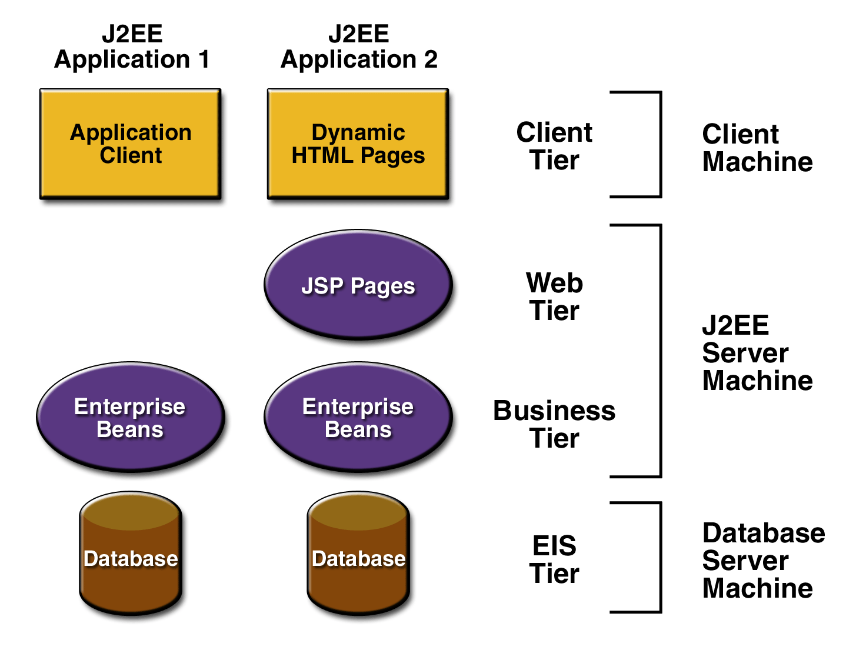
- J2EE Architecture

Three-tiered applications that run in this way extend the standard two-tiered client and server model by placing a multithreaded application server between the client application and back-end storage.
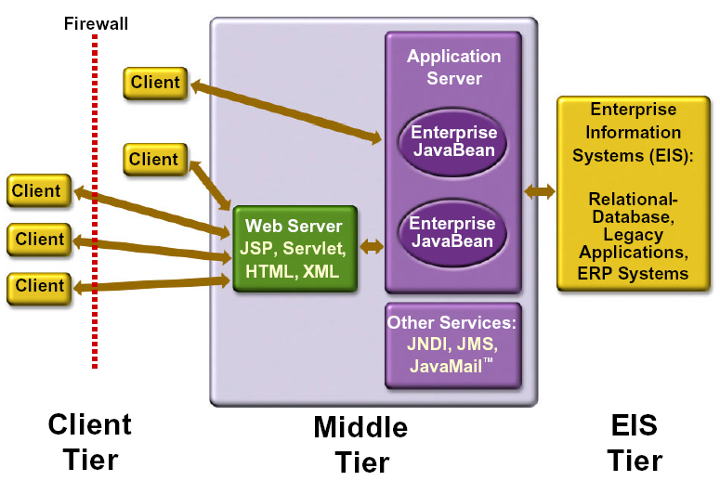

- J2EE Containers

The application server maintains control and provides services through an interface or framework known as a container.

There are five defined container types in the J2EE specification

Three of these are server-side containers:
- The server itself, which provides the J2EE runtime environment and the other two containers
- An EJB container to manage EJB components
- A Web container to manage servlets and JSP pages

The other two container types are client-side:
- An application container for stand-alone GUIs, console
- An applet container, meaning a browser, usually with the Java Plug-in
- J2EE Components

As said earlier, J2EE applications are made up of components A J2EE component is a self-contained functional software unit that is assembled into a J2EE application with its related classes and files and that communicates with other components.
- Components
- Client components run on the client machine, which correlate to the client containers
- Web components -servlets and JSP pages
- EJB Components
- Enterprise Java Beans

Java classes that implement the business methods of an enterprise

Execute within an infrastructure of services provided by the Web application server
- Supports transactions, persistence, concurrency, authorization, etc
- Implements declarative transaction semantics
- The bean programmer can just declare that a particular method is to be a transaction and does not have to specify the begin and commit commands
- Bean programmer can focus on business methods of the enterprise rather on details of system implementation
- Entity Bean

Represents a persistent business object whose state is stored in the database
- An entity bean corresponds to a database table
- A bean instance corresponds to a row in that table.

Example of an Entity Bean
- An entity bean called Account, which corresponds to a database table Account
- Each instance of that bean corresponds to a row in that table
- Account has fields that include AccountId and Balance
- AccountId is the primary key
- Every entity bean has a FindByPrimaryKey method that can be used to find the bean based on its primary key
- Account has other methods that might include Deposit and Withdraw

- Persistence of Entity Beans

Any changes to the bean are persistent in that those changes are propagated to the corresponding database items

This persistence can be managed either manually by the bean itself using standard JDBC statements or automatically by the system (as described later)

The system can also automatically manage the authorization and transactional properties of the bean (as described later)

- Session Bean

A session bean represents a client performing interactions within a session using the business methods of the enterprise
- A session is a sequence of interactions by a user to accomplish some objective. For example, a session might include selecting items from a catalog and then purchasing them.

The session bean retains its state during all the interactions of the session

Stateless session beans also exist

Example of a Session Bean

ShoppingCart provides the services of adding items to a “shopping cart” and then purchasing the selected items

Methods include AddItemToShoppingCart and Checkout

ShoppingCart maintains state during all the interactions of a session

It remembers what items are in the shopping cart
- Session Beans and Entity Beans

Session beans can call methods in entity beans

The Checkout method of the ShoppingCart session bean calls appropriate methods in the Customer, Order, and Shipping entity beans to record the order in the database
- Session Bean Transactions

Session beans can be transactional

The transaction can be managed manually by the bean itself using standard JDBC or JTA (Java Transaction API) calls or automatically by the system (as described below)

- Message-Driven Beans

All of the communication so far is synchronous

A session bean calls an entity bean and waits for a reply

Sometimes the sender of a message does not need to wait for a reply

Communication can be asynchronous

Thus increasing throughput

Message-driven beans are provided for this purpose

A message-driven bean is like a session bean in that it implements the business methods of the enterprise

It is called when an asynchronous message is placed on the message queue to which it is associated

Its onMessage method is called by the system to process the message

Example of a Message-Driven Bean

When shopping cart Checkout method completes, it sends an asynchronous message to the shipping department to ship the purchased goods

The shipping department maintains a message queue, ShippingMessageQ, and a message driven bean, ShippingMessageQListener, associated with that queue

When a message is placed on the queue, the system selects an instance of the bean to process it and calls that bean’s onMessage method
- Structure of an Enterprise Bean

The bean class

Contains the implementations of the business methods of the enterprise

A remote interface (also optionally a local interface)

Used by clients to access the bean class remotely, using RMI (or locally with the local interface)

Acts as a proxy for the bean class

Includes declarations of all the business methods

A home interface (also optionally a local home interface)

Contains methods that control bean’s life cycle

Create, remove

Also finder methods (e.g. FindByPrimaryKey) methods

A deployment descriptor:

Containing declarative metadata for the bean

Describing persistence, transactional, and authorization properties

Example of Deployment Descriptor

The deployment descriptor for a banking application might say that

The Withdraw method of an Account entity bean

Is to be executed as a transaction

Can be executed either by the account owner or by a teller

The Balance field of the Account Bean

Has its persistence managed by the system

Any changes are automatically propagated to the DB

Deployment descriptors are written in XML
- Portion of a Deployment Descriptor Describing Authorization

<method-permission>

<role-name> teller </role-name>

<method>

<ejb-name> Account </ejb-name>

<method-name> Withdraw </method-name>

</method>

</method-permission>

- EJB Container

Enterprise beans together with their deployment descriptors are encapsulated within an EJB container supplied by the Web application server

The EJB container provides system-level support for the beans based on information in their deployment descriptors

The EJB container provides this support by intervening before and after each bean method is called and performing whatever actions are necessary

When a method is called, the call goes to the similarly named interface method

The interface method performs whatever actions are necessary before and after calling the bean method

For example, if the deployment descriptor says the method is to run as a transaction

The interface method starts the transaction before calling the method

Commits the transaction when the method completes

The EJB container supplies the code for the interface methods.

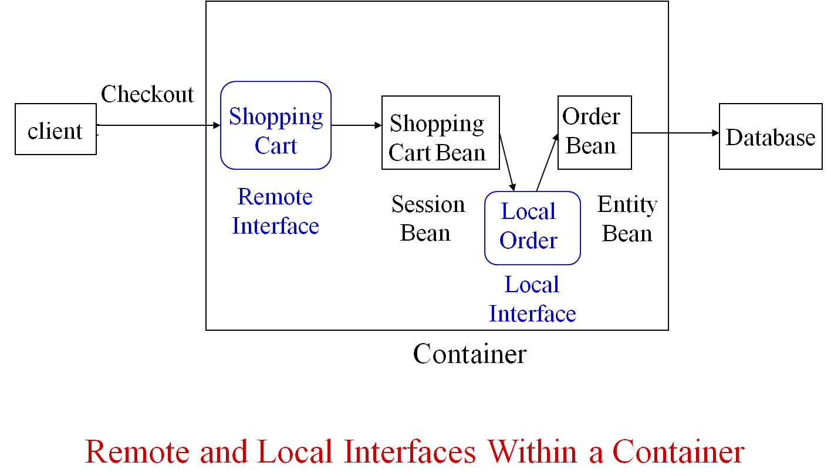

- Persistence of Entity Beans

Persistence of entity beans can be managed

Manually by the bean itself (bean-managed persistence) using standard JDBC statements

Automatically by the container (container-managed persistence, cmp)

Example of Deployment Descriptor for Container Managed Persistence

<persistence-type> container </persistence-type>

<cmp-field>

<field-name> balance </field-name>

</cmp-field>

- Get and Set Methods

The entity bean must contain declarations for get and set methods. For example

public abstract float getBalance( )

public abstract void setBalance (float balance)

The container generates code for these methods

A client of the bean, for example a session bean, can use

A finder method, for example, findbyprimarykey(), to find an entity bean and then

A get or set method to read or update specific fields of that bean.

- EJB QL Language

The container will generate the code for the FindByPrimaryKey() method

The container will also generate code for other finder methods described in the deployment descriptor

These methods are described in the deployment descriptor using the EJB QL (EJB Query Language)

EJB QL is used to find one or more entity beans based on criteria other than their primary key

Example of EJB QL

<query>

<query-method>

<method-name>FindByName </method-name>

<method-params>

<method-param>string</method-param>

</method-params>

</query-method>

<ejb-ql>

SELECT OBJECT (A) FROM Account A WHERE A.Name = ?1

</ejb-ql>

</query>

- Create and Remove Methods

A client of an entity bean can use the create and remove methods in its home interface to create and remove instances of that entity (rows in the database table).
- Container-Managed Relationships

In addition to fields that represent data, entity beans can have fields that represent relationships

One-to-one, One-to-many, Many-to-many

As with other database applications, these relationships can be used to find entity beans based on their relationships to other beans.

Example: there might be a many-to-many relationship, Signers, relating Account bean and BankCustomer bean

Signers specifies which customers can sign checks on which accounts

Relationships can be declared in the deployment descriptor to be container-managed

For a many-to-many relationship such as Signers, the container will automatically create a new table to manage the relationship

For a one-to-one relationship, the container will automatically generate a foreign key

- Portion of Deployment Descriptor

<ejb-relation>

<ejb-relation-name>Signers</ejb-relation-name>

<ejb-relationship-role>

<ejb-relationship-role-name>account-has-signers

</ejb-relationship-role-name>

<multiplicity>many</multiplicity>

<relationship-role-source>

<ejb-name>Account</ejb-name>

</relationship-role-source>

<cmr-field>

<cmr-field-name>Signers</cmr-field-name>

<cmr-field-type>java.util.collection</cmr-field-type>

</cmr-field>

</ejb-relationship-role>

………… description of the other bean in the relation

</ejb-relation>

- Get and Set Methods

The entity bean must contain declarations for get and set methods for these relationship fields (as for other fields)

For example

public abstract collection getSigners( )

public abstract void setSigners (collection BankCustomers)

The EJB container will generate code for these methods

- Transactions

Transactions can be managed

Manually by the bean itself (bean-managed transactions) using standard JDBC or JTA calls

Bean programmer must provide statements to start and commit transactions

Automatically by the container (container-managed transactions)

Deployment descriptor contains declarative description of transaction attributes of each method

In container-managed transactions, the deployment descriptor must specify the transaction attributes of each method

Attributes supported are

Required

RequiresNew

Mandatory

NotSupported

Supports

Never

Details given here

http://docs.oracle.com/javaee/6/tutorial/doc/bncij.html
- Example of Deployment Descriptor

<container-transaction>

<method>

<ejb-name> ShoppingCart </ejbname>

<method-name> Checkout </method-name>

</method>

<trans-attribute> Required </trans-attribute>

</container-transaction>
- Two-Phase Commit

The container also contains a transaction manager, which will manage a two-phase commit procedure, for both container-managed and bean-managed transactions.
- Concurrency of Entity Beans

A number of concurrently executing clients might request access to the same entity bean and hence the same row of a database table

If that bean has been declared transactional, the concurrency is controlled by the container

If not, each client gets its own copy of the entity bean and the concurrency is controlled by the DBMS

For session beans and message-driven beans with bean-managed concurrency the bean programmer can specify the isolation level within the code for the bean

The default J2EE implementation of container-managed concurrency is that each client gets its own copy of the entity bean and the underlying DBMS manages the concurrency
- Reusability of Enterprise Beans

Part of the vision underlying enterprise beans is that they would be reusable components

Sam’s Software Company sells a set of beans for shopping cart applications, including a ShoppingCartBean session bean

Joe’s Hardware Store buys the beans

Instead of using the standard ShoppingCartBean, Joe’s system uses a child of that bean, JoesShoppingCartBean that had been changed slightly to reflect Joe’s business rules

Joe also changes the deployment descriptor a bit

The implementation of Joe’s system is considerably simplified

Joe’s programmers need be concerned mainly with Joe’s business rules not with implementation details

Joe’s shopping cart application will run on any system using any Web application server that supports J2EE

Provided it does not use any proprietary extensions to J2EE

Summary
- J2EE Architecture
- Web Server
- Web Application Server
- Enterprise Java Beans
- Entity Bean
- Session Bean
- Message-Driven Beans
- Enterprise Bean
- EJB Container

Lecture No. 24
Service Orientation
24.1: Services, service description, service communication

- Italian restaurant analogy

Restaurant provides food: a service

After the order is taken, food is produced, served, service may consist of other services

The menu indicates the service provided: a service description

The order is written down, or yelled at, the cook: services communicate through messages

- Main ingredients

Services

Service descriptions

Messages

Implementation: through web services

Other example

Citizen looking for a house:

Check personal data ⇒ System X

Check tax history ⇒ System Y

Check credit history ⇒ System Z

Search rental agencies ⇒ System A,B

- What’s a service

Platform-independent computational entity that can be used in a platform-independent way

Callable entities or application functionalities accessed via exchange of messages

Component capable of performing a task

Often just used in connection with something else: SOA, Web services …

Shift from producing software to using software

You need not host the software

Or keep track of versions, releases

Need not make sure it evolves

Etc

Software is “somewhere”, deployed on as-needed basis

SaaS: Software as a Service

- Key aspects

Services can be discovered

Services can be composed to form larger services

Services adhere to a service contract

Services are loosely coupled

Services are stateless

Services are autonomous

Services hide their logic

Services are reusable

Services use open standards

Services facilitate interoperability
- Service discovery
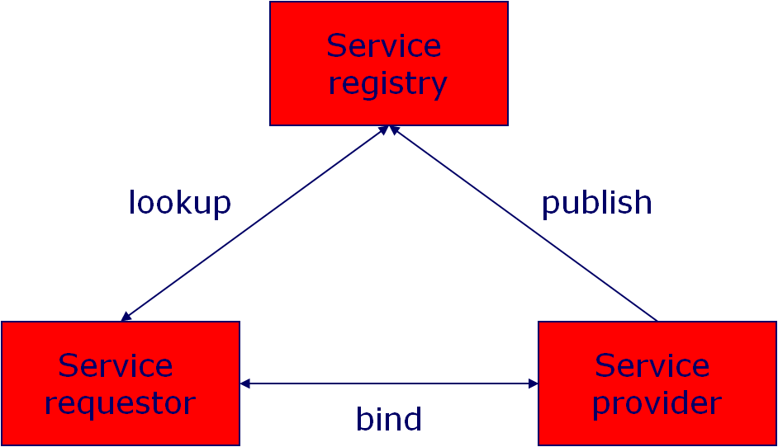
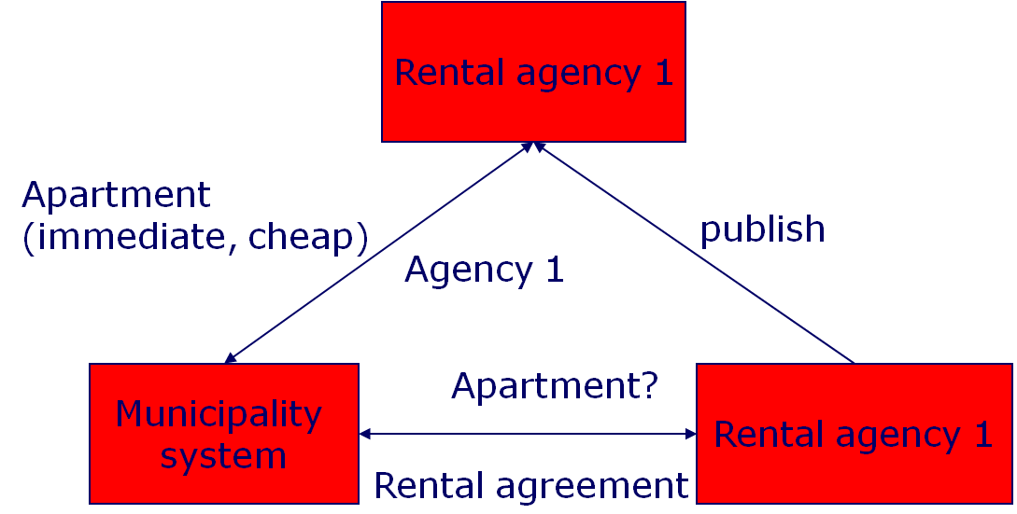

Discovery is dynamic, each invocation may select a different one

Primary criterion in selection: contract

Selection may be based on workload, complexity of the question, etc ⇒ optimize compute resources

If answer fails, or takes too long  select another service  more fault-tolerance

Is discovery really new?

Many design patterns loosen coupling between classes

Factory pattern: creates object without specifying the exact class of the object.
- Services can be composed

Service can be a building block for larger services

Not different from CBSE and other approaches
- Services adhere to a contract

Request to registry should contain everything needed, not just functionality

For “normal” components, much is implicit:

Platform characteristics

Quality information

Tacit design decisions

Trust promises?

Quality of Services (QoC), levels thereof

Service Level Agreement (SLA)

Service discovery
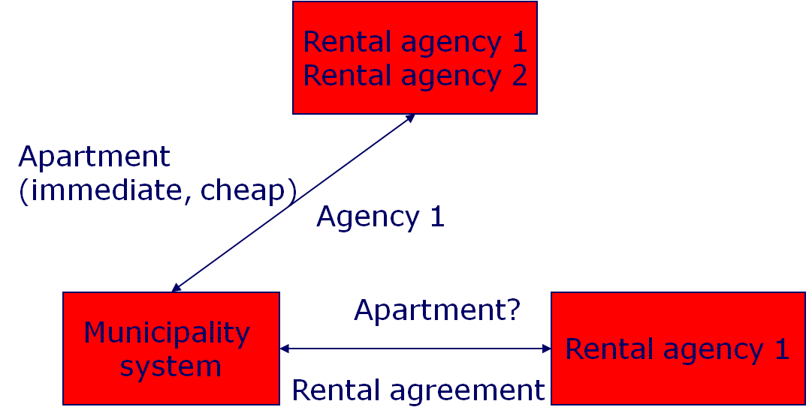
- Services are loosely coupled

Rental agencies come and go

No assumptions possible

Stronger than CBSE loose coupling
- Services are stateless

Rental agency cannot retain information: it doesn’t know if and when it will be invoked again, and by whom
- Services are autonomous, hide their logic

Rental agency has its own rules on how to structure its process

Its logic does not depend on the municipality service it is invoked by

This works two ways: outside doesn’t know the inside, and vice versa
- Services are reusable

Service models a business process:

Not very fine grained

Collecting debt status from one Credit Company is not a service, checking credit status is

Deciding on proper granularity raises lots of debate
- Service use open standards

Proprietary standards ⇒ vendor lockin

There are lots of open standards:

How services are described

How services communicate

How services exchange data

Etc
- Services facilitate interoperability

Because of open standards, explicit contracts and loose coupling

Classical CBSE solutions pose problems:

Proprietary formats

Platform differences

Etc

Interoperability within an organization (EAI) and between (B2B)

24.2: Service-Oriented Architecture

Architecture:

The fundamental organization of a system in its components, their relationships to each other and to the environment and the principles guiding its design and evolution

SOA: Any system made out of services?
- What is SOA?
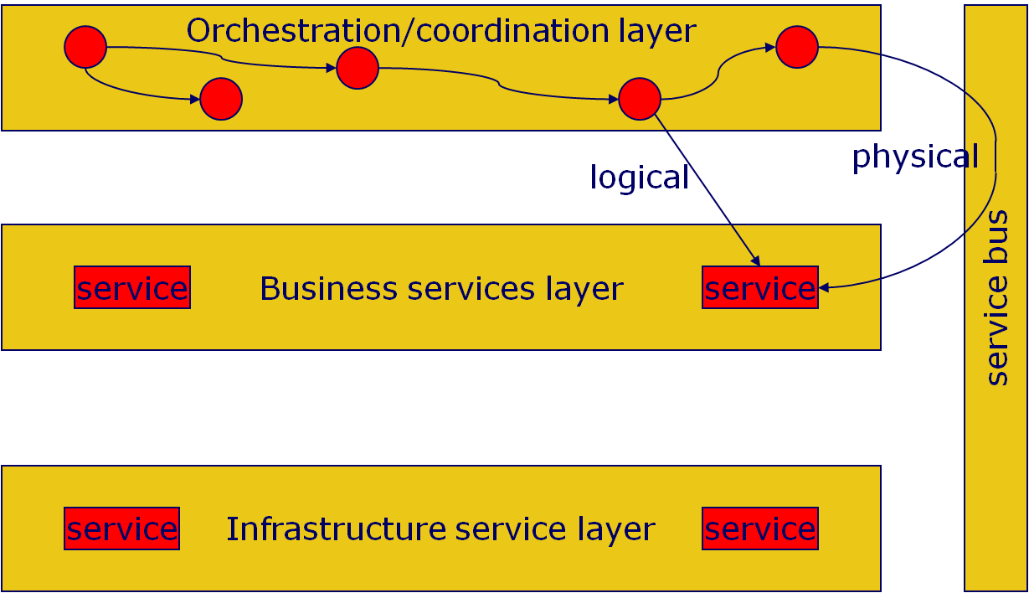
- Service bus

Event-based messaging engine

Origin: EAI, solve integration problems

Often takes care of:

Mediation: protocol translation, data transformation, etc

Quality of Service issues: security, reliable delivery of messages, etc

Management issues: logging, audit info, etc.

Service discovery

Can be central (broker, hub), or decentral (smart endpoints)
- Service coordination

Orchestration: central control

Choreography: decentral control

24.3: Web services

Implementation means to realize services

Based on open standards:

XML

SOAP: Simple Object Access Protocol

WSDL: Web Services Description Language

UDDI: Universal Description, Discovery and Integration

BPEL4WS: Business Process Execution Language for Web Services

Main standardization bodies: OASIS, W3C

- Coordination of Web services
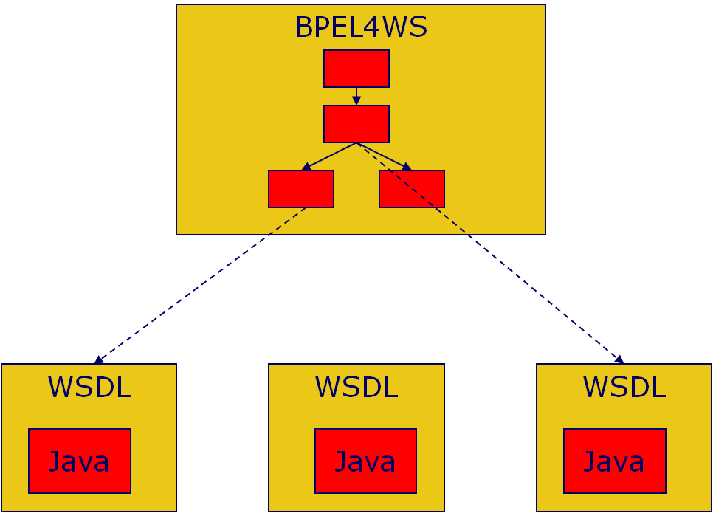
- Web services stack
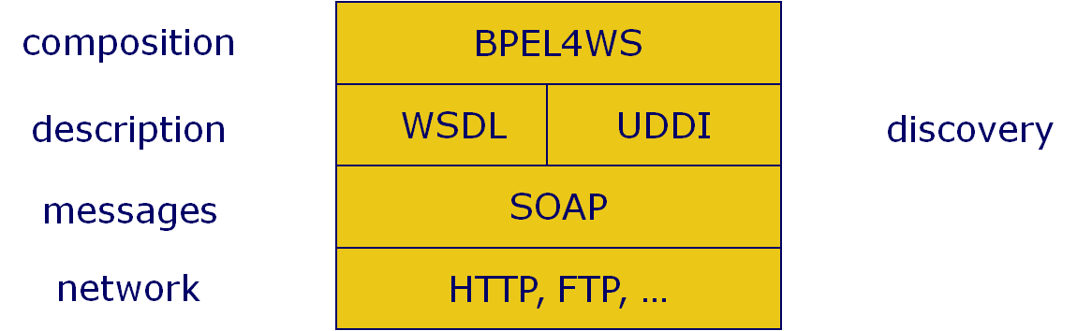
- XML

Looks like HTML

Language/vocabulary defined in schema: collection of trees

Only syntax

Semantic Web, Web 2.0: semantics as well: OWL and descendants
- SOAP

Message inside an envelope

Envelop has optional header (~address), and mandatory body: actual container of data

SOAP message is unidirectional: it’s NOT a conversation
- SOAP Message Structure

Request and Response messages

Request invokes a method on a remote object

Response returns result of running the method

SOAP specification defines an “envelop”

“Envelop” wraps the message itself

Message is a different vocabulary

Namespace prefix is used to distinguish the two parts

- SOAP Request Message
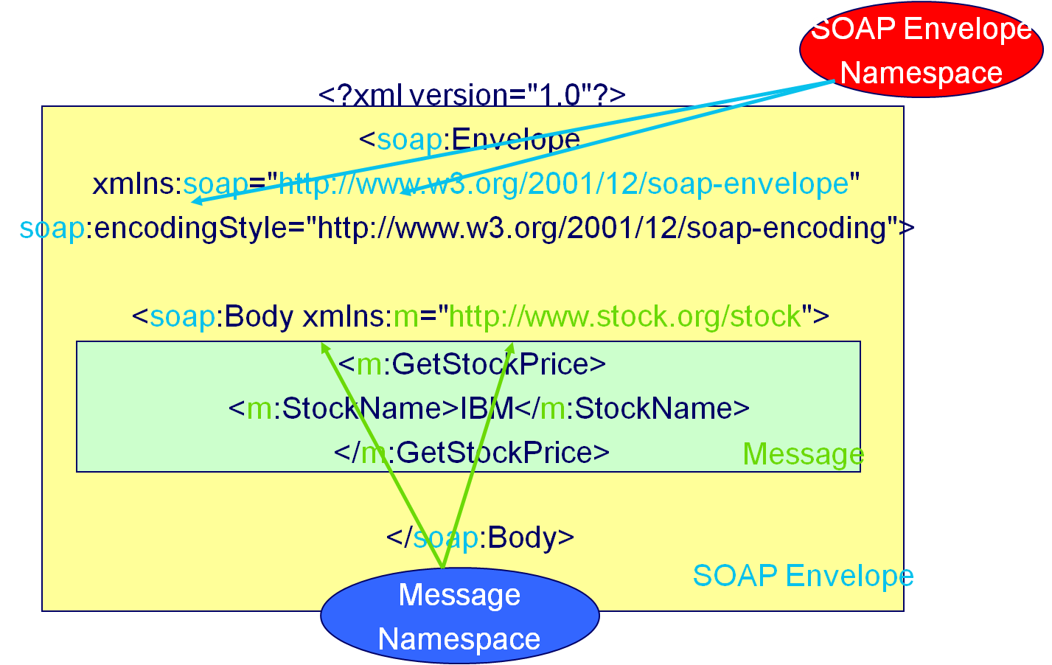
- SOAP Response Message
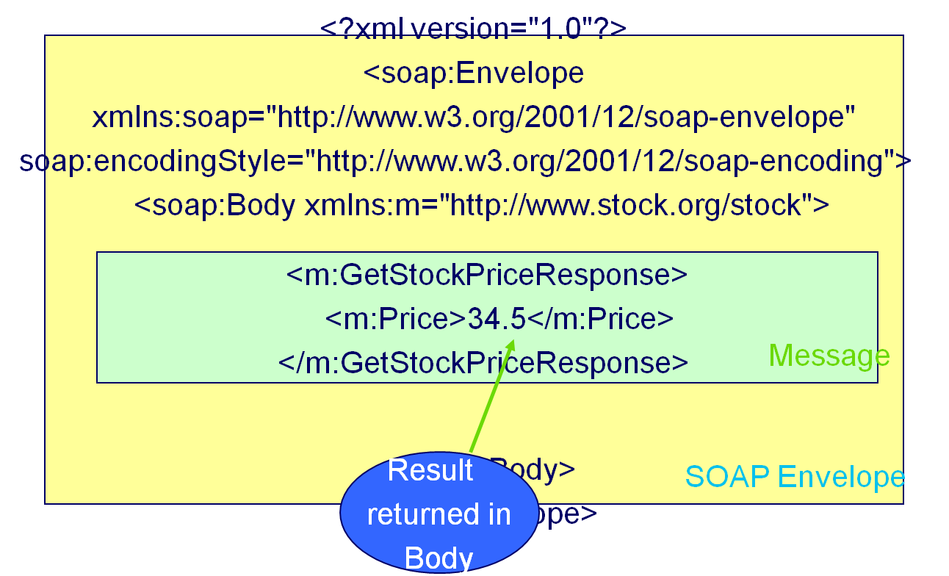
- Why SOAP?

Other distributed technologies failed on the Internet

Unix RPC – requires binary-compatible Unix implementations at each endpoint

CORBA – requires compatible ORBs

RMI – requires Java at each endpoint

DCOM – requires Windows at each endpoint

SOAP is the platform-neutral choice

Simply an XML wire format

Places no restrictions on the endpoint implementation technology choices
- WSDL

Four parts:

Web service interfaces

Message definitions

Bindings: transport, format details

Services: endpoints for accessing service. Endpoint = (binding, network address)
- UDDI

Three (main) parts:

Info about organization that publishes the services

Descriptive info about each service

Technical info to link services to implementation

Original dream: one global registry

Reality: many registries, with different levels of visibility

Mapping problems
- BPEL4WS

Three main parts:

Partnerlinks: dependencies between services: who sends what to whom

Global variables

Workflow model: “program”

BPEL4WS is an orchestration language; executable

WS-CDL (Web Services Choreography Description Language) is a choreography language; not executable

24.4: SOSE: Service-Oriented Software Engineering

- SOSE life cycle
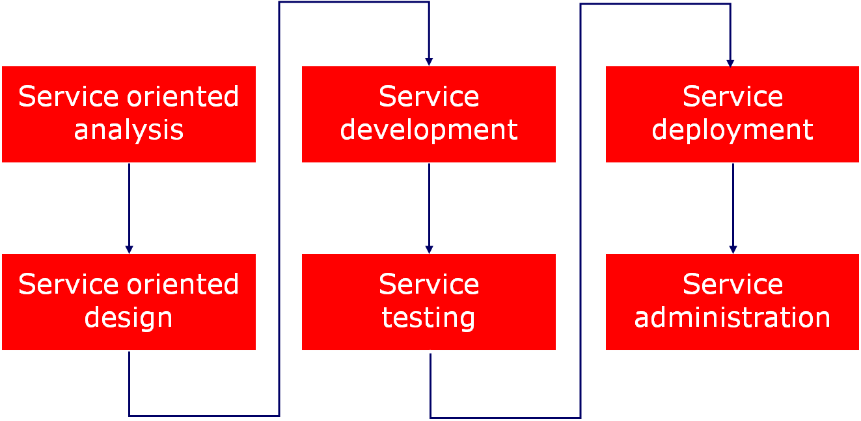
- Terminology

service oriented environment (or service oriented ecosystem)

business process + supporting services

application (infrastructure) service

business service

Task-centric business service

Entity-centric business service

hybrid service

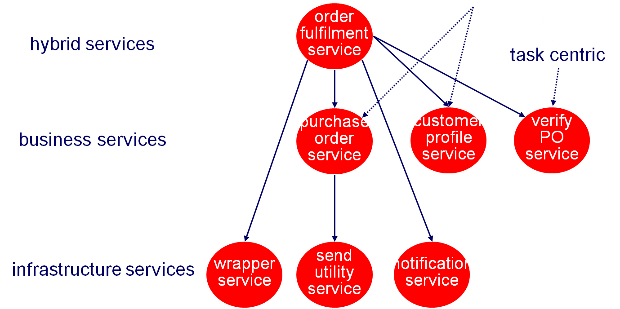
- Strategies for life cycle organization

Top-down strategy

Bottom-up strategy

Agile strategy
- Top-down strategy
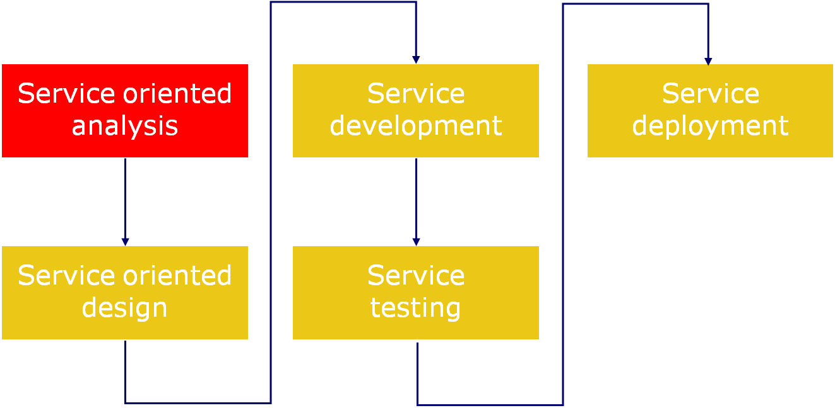

- Top-down SO analysis
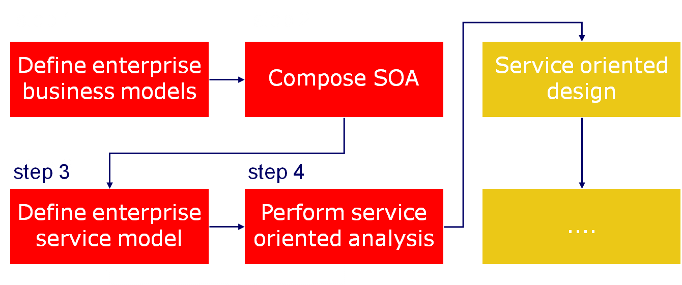
- Bottom-up strategy
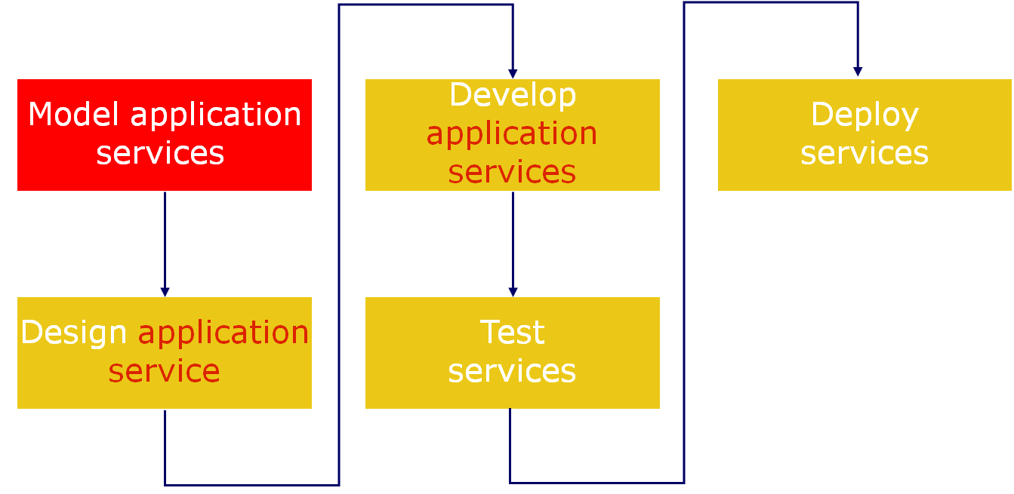
Application service = infrastructure service

- Agile strategy
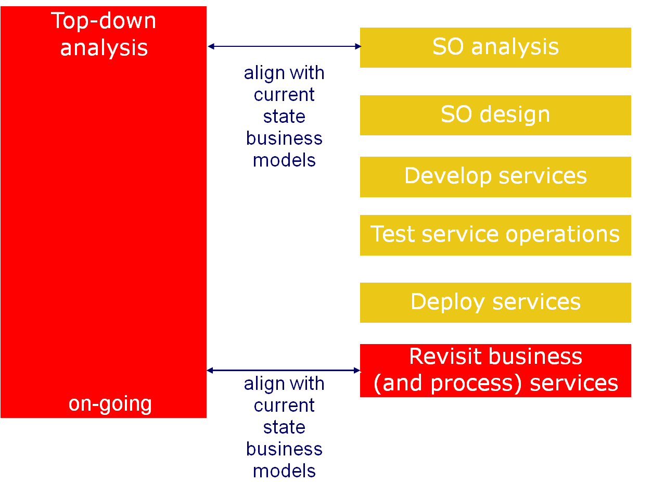
- Service oriented analysis

The process of determining how business automation requirements can be represented through service orientation
- Goals of SO analysis

Appropriateness for intended use

Identify preliminary issues that may challenge required service autonomy

Define known preliminary composition models
- 3 Analysis sub-steps
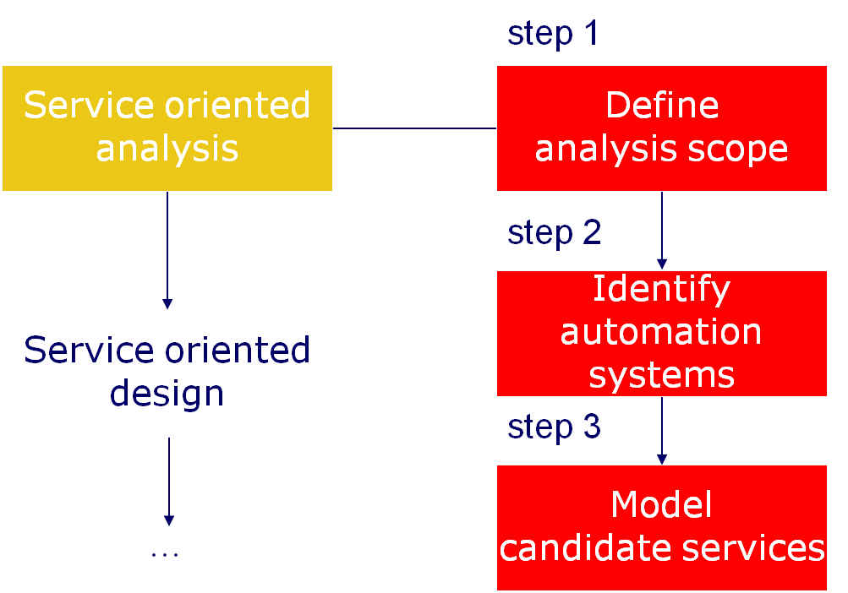

Step 1: Define analysis scope

Mature and understood business requirements

S = ∑i Si, where smaller services may still be quite complex

Can lead to

process-agnostic services/service operations (generic service portfolio)

services delivering business-specific tasks

Models: UML use case or activity diagrams

Order Fulfillment Process
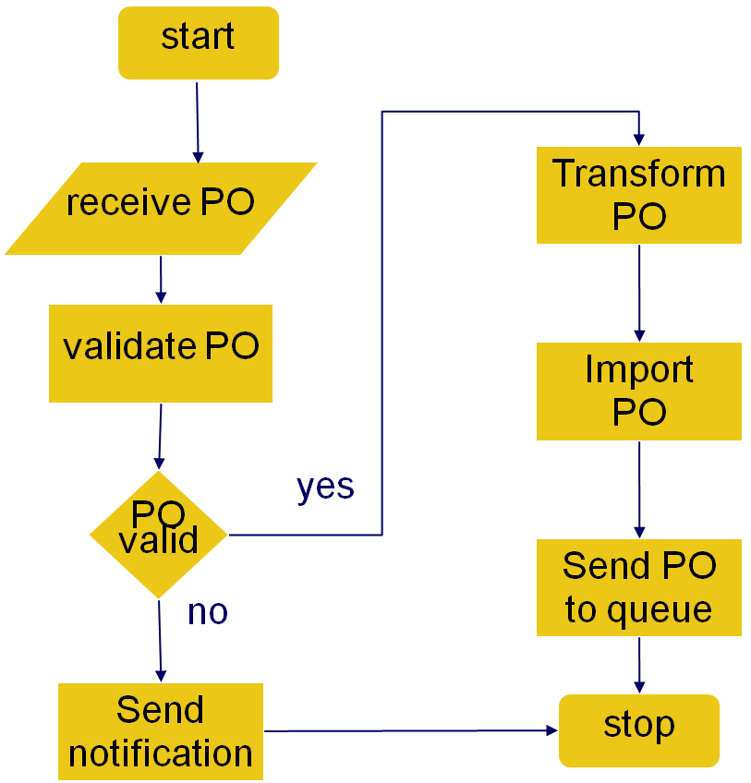

Step 2: Identify automation systems

What is already implemented?

encapsulate

replace

Models: UML deployment diagram, mapping tables

Order Fulfillment Process
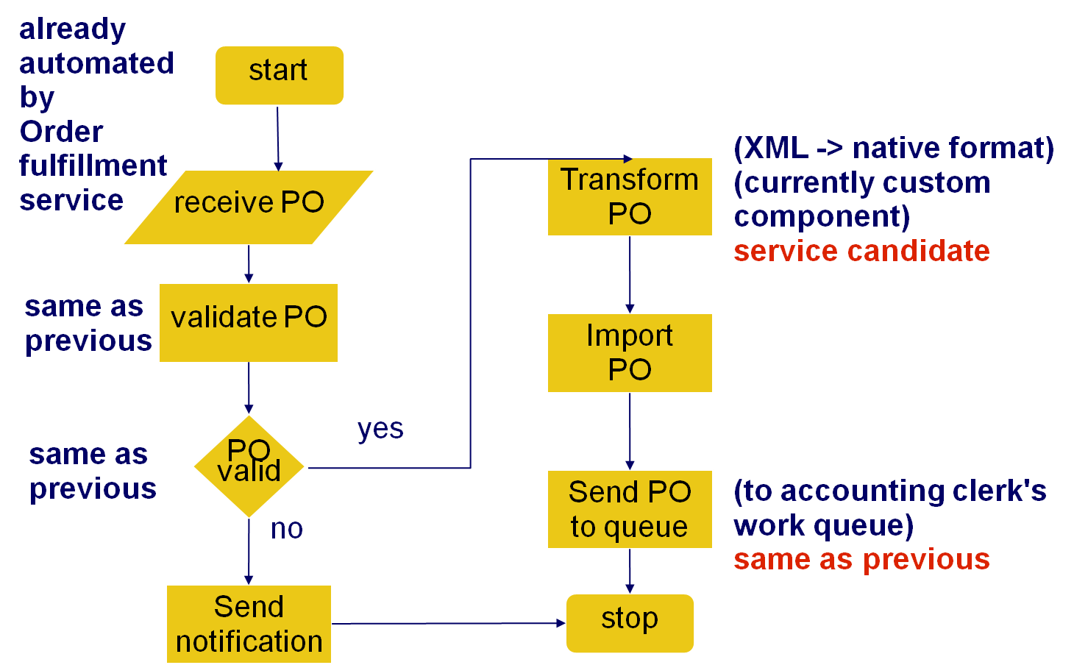

Step 3: Model candidate services

How to compose services?

Service (candidates) conceptual model

operations + service contexts

SO principles

Focus on task- and entity-centred services

Models: BPM, UML use case or class diag.

Example service operation candidates
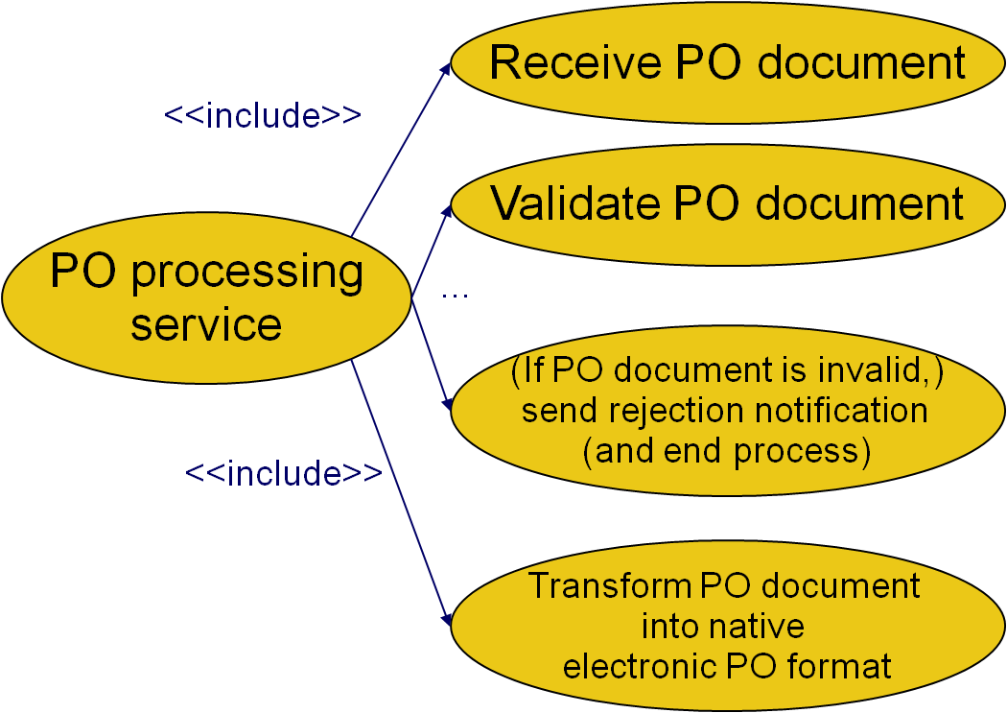

Example business process logic

Not service operation candidates

If PO document is valid, proceed with the transform PO document step

If the PO document is invalid, end process
- Task- versus entity-centred services

Task-centred

(+) direct mapping of business requirements

(-) dependent on specific process

Entity-centred

(+) agility

(-) upfront analysis

(-) dependent on controllers
- Modeling

Identify agnostic service candidates

Filter out process-specific logic

Apply so principles

Identify candidate service compositions

Identify application service operation/service candidates

Apply so principles

Revise operation candidates grouping
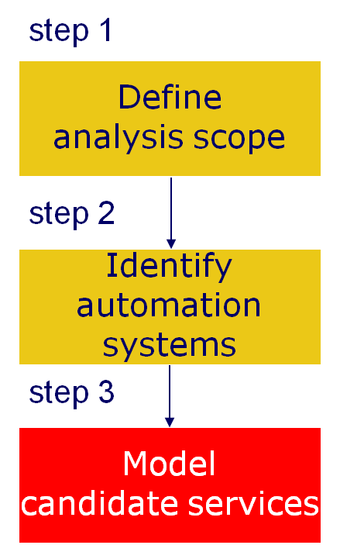
- Entity Models
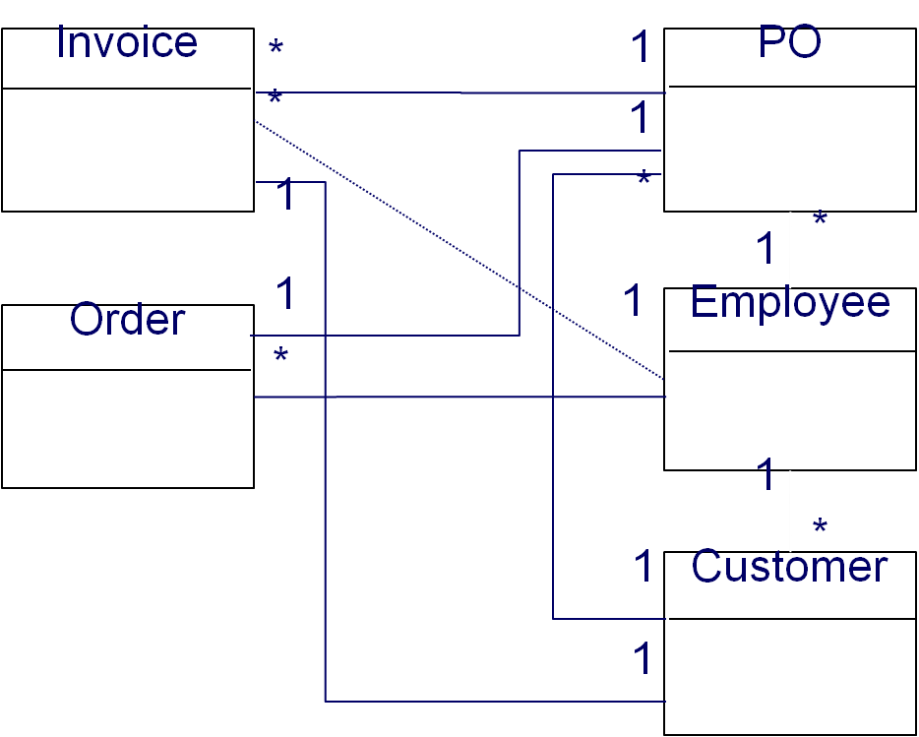
- Service modeling guidelines

Task-centric business service candidates

Reusability of encapsulated logic across processes
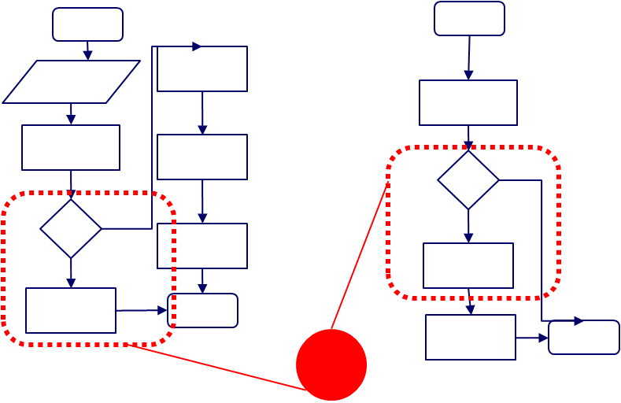
- Service modeling guidelines

Task-centric business service candidates

Reusability of encapsulated logic within a process
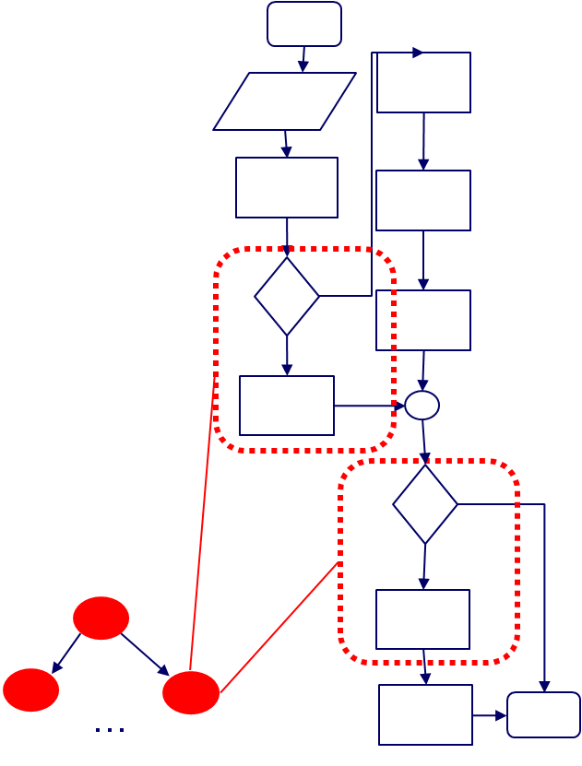
- Service modeling guidelines

Identify logical units of work with explicit boundaries

SO principle about autonomous services (hiding logic)
- Service-oriented design: design sub-steps
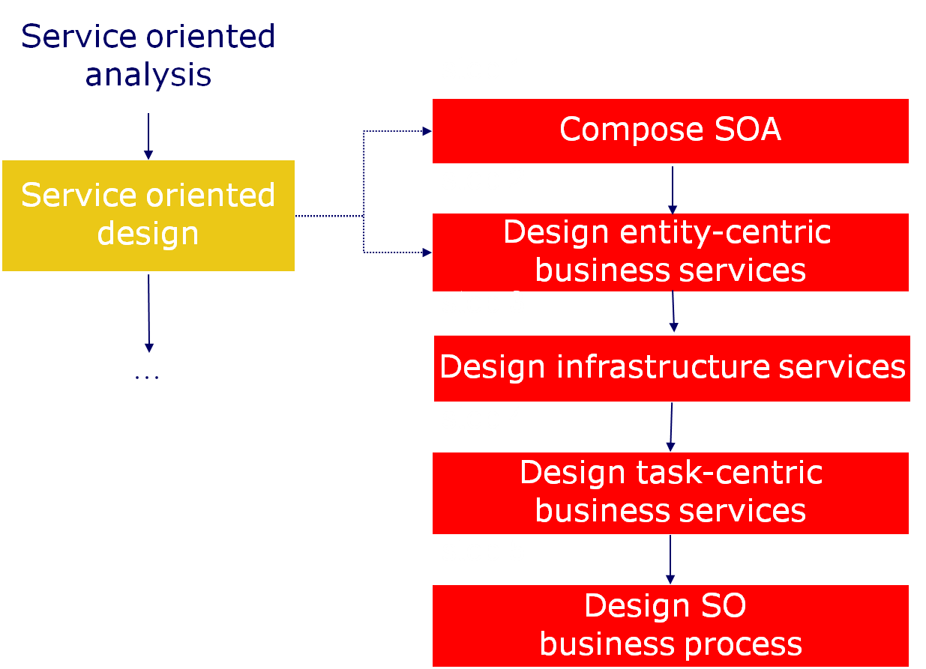
- Entity-centric business services

Goal: entity-centric business service layer + parent orchestration layer
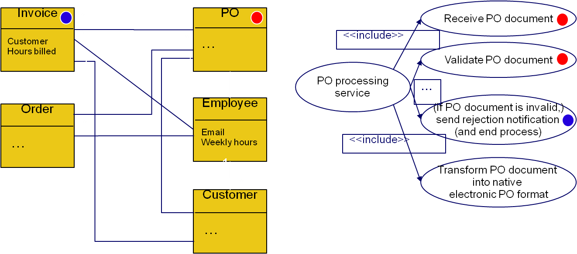

- Infrastructure services
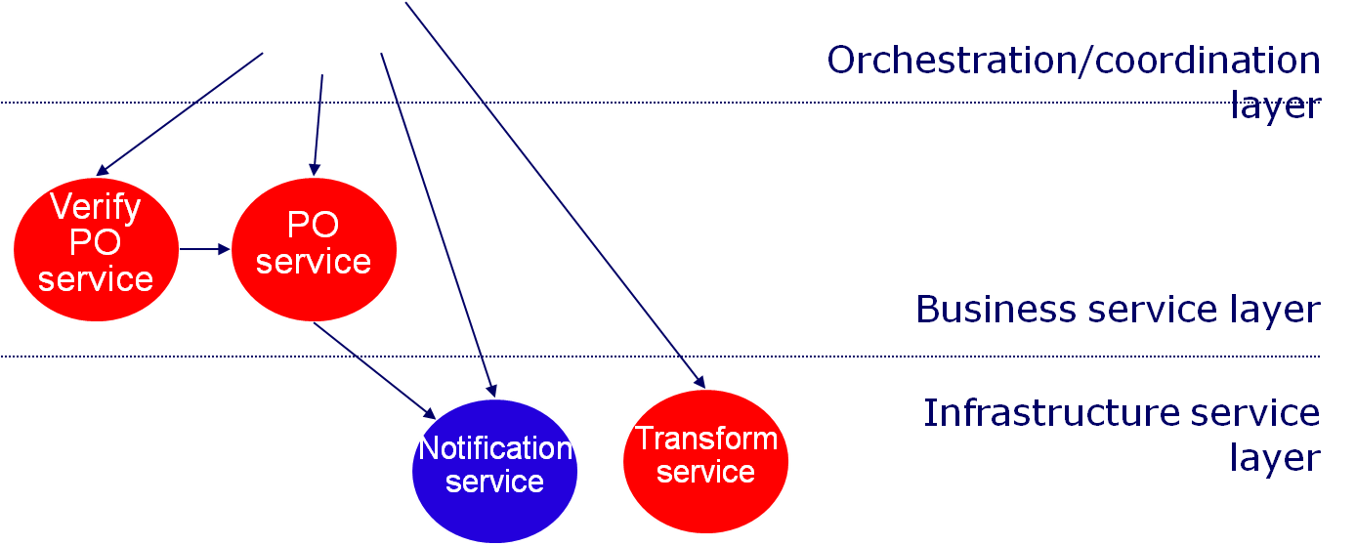

- Task-centric business services

UML sequence diagram

Express and refine order of invocations implicit in the UML use case diagram
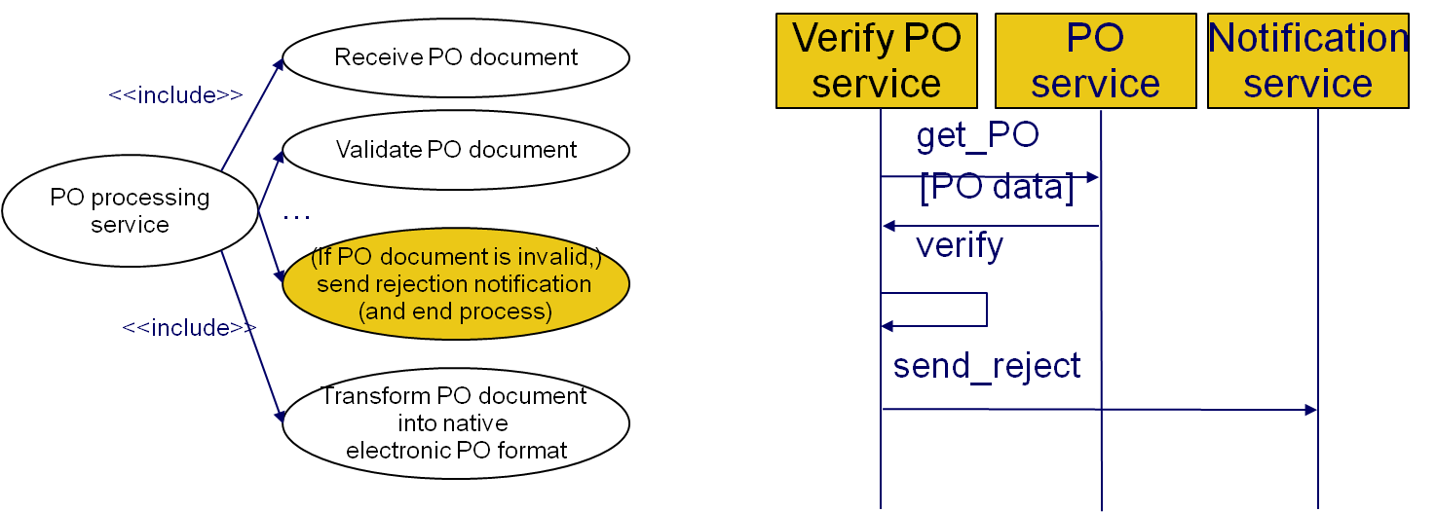

Summary
- Service Orientation
- Service discovery
- Service-Oriented Architecture
- SOAP
- Service oriented analysis

Lecture No. 25
Database Design

25.1 Database Management System (DBMS)

Database Management System (DBMS) contains information about a particular enterprise. The collection of interrelated data, set of programs to access the data and an environment that is both convenient and efficient to use
- Database Applications:
- Banking: all transactions
- Airlines: reservations, schedules
- Universities: registration, grades
- Sales: customers, products, purchases
- Online retailers: order tracking, customized recommendations
- Manufacturing: production, inventory, orders, supply chain
- Human resources: employee records, salaries, tax deductions
- Databases touch all aspects of our lives
- Purpose of Database Systems

In the early days, database applications were built directly on top of file systems Drawbacks of using file systems to store data:
- Data redundancy and inconsistency
- Multiple file formats, duplication of information in different files
- Difficulty in accessing data
- Need to write a new program to carry out each new task
- Data isolation — multiple files and formats
- Integrity problems
- Integrity constraints (e.g. account balance > 0) become “buried” in program code rather than being stated explicitly
- Hard to add new constraints or change existing ones
- Atomicity of updates
- Failures may leave database in an inconsistent state with partial updates carried out
- Example: Transfer of funds from one account to another should either complete or not happen at all
- Concurrent access by multiple users
- Concurrent accessed needed for performance
- Uncontrolled concurrent accesses can lead to inconsistencies
- Example: Two people reading a balance and updating it at the same time
- Security problems
- Hard to provide user access to some, but not all, data
- Database systems offer solutions to all the above problems
- Levels of Abstraction
- Physical level: describes how a record (e.g., customer) is stored.
- Logical level: describes data stored in database, and the relationships among the data.

type customer = record

customer_id : string;
customer_name : string;
customer_street : string;
customer_city : string;

end;
- View level: application programs hide details of data types. Views can also hide information (such as an employee’s salary) for security purposes.
- Instances and Schemas
- Similar to types and variables in programming languages
- Schema – the logical structure of the database
- Example: The database consists of information about a set of customers and accounts and the relationship between them)
- Analogous to type information of a variable in a program
- Physical schema: database design at the physical level
- Logical schema: database design at the logical level
- Instance – the actual content of the database at a particular point in time
- Analogous to the value of a variable
- Physical Data Independence – the ability to modify the physical schema without changing the logical schema
- Applications depend on the logical schema
- In general, the interfaces between the various levels and components should be well defined so that changes in some parts do not seriously influence others.

- Data Models
- A collection of tools for describing
- Data
- Data relationships
- Data semantics
- Data constraints
- Relational model
- Entity-Relationship data model (mainly for database design)
- Object-based data models (Object-oriented and Object-relational)
- Semi structured data model (XML)
- Other older models:
- Network model
- Hierarchical model
- Data Manipulation Language (DML)
- Language for accessing and manipulating the data organized by the appropriate data model
- DML also known as query language
- Two classes of languages
- Procedural – user specifies what data is required and how to get those data
- Declarative (nonprocedural) – user specifies what data is required without specifying how to get those data
- SQL is the most widely used query language
- Data Definition Language (DDL)
- Specification notation for defining the database schema
- DDL compiler generates a set of tables stored in a data dictionary
- Data dictionary contains metadata (i.e., data about data)
- Database schema
- Data storage and definition language
- Specifies the storage structure and access methods used
- Integrity constraints
- Domain constraints
- Referential integrity (e.g. branch_name must correspond to a valid branch in the branch table)
- Authorization
- Database Design

The process of designing the general structure of the database:
- Logical Design – Deciding on the database schema. Database design requires that we find a “good” collection of relation schemas.
- Business decision – What attributes should we record in the database?
- Computer Science decision – What relation schemas should we have and how should the attributes be distributed among the various relation schemas?
- Physical Design – Deciding on the physical layout of the database
- The Entity-Relationship Model
- Models an enterprise as a collection of entities and relationships
- Entity: a “thing” or “object” in the enterprise that is distinguishable from other objects
- Described by a set of attributes
- Relationship: an association among several entities
- Represented diagrammatically by an entity-relationship diagram:
- Other Data Models
- Object-oriented data model
- Object-relational data model

- Database Application Architectures
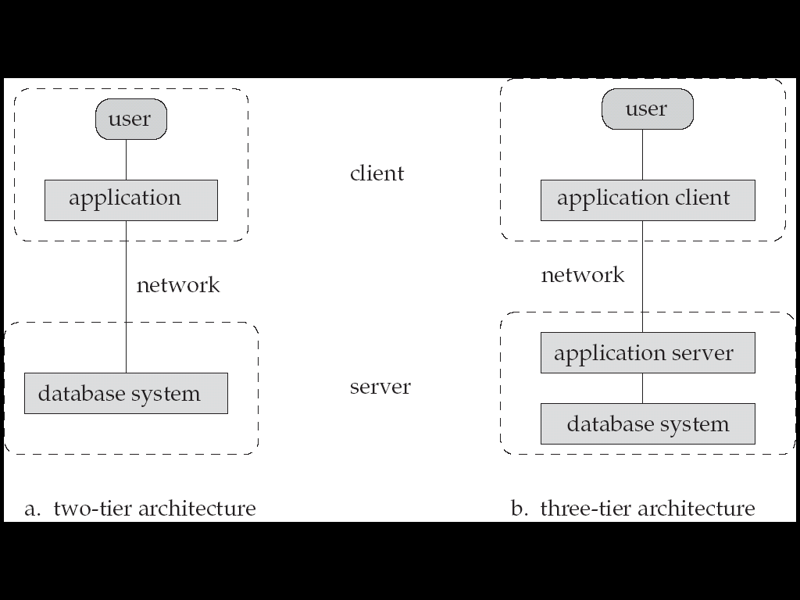
- Database Management System Internals
- Storage Management
- Storage manager is a program module that provides the interface between the low-level data stored in the database and the application programs and queries submitted to the system. The storage manager is responsible for the tasks like interaction with the file manager, efficient storing, retrieving and updating of data.
- Issues: Storage access, File organization, Indexing and hashing
- Query Processing

1. Parsing and translation

2. Optimization

3. Evaluation
- Alternative ways of evaluating a given query
- Equivalent expressions
- Different algorithms for each operation

Cost difference between a good and a bad way of evaluating a query can be enormous. Need to estimate the cost of operations. It depends critically on statistical information about relations which the database must maintain. Need to estimate statistics for intermediate results to compute cost of complex expressions

- Transaction Management
- A transaction is a collection of operations that performs a single logical function in a database application
- Transaction-management component ensures that the database remains in a consistent (correct) state despite system failures (e.g., power failures and operating system crashes) and transaction failures.
- Concurrency-control manager controls the interaction among the concurrent transactions, to ensure the consistency of the database.
- Overall System Structure
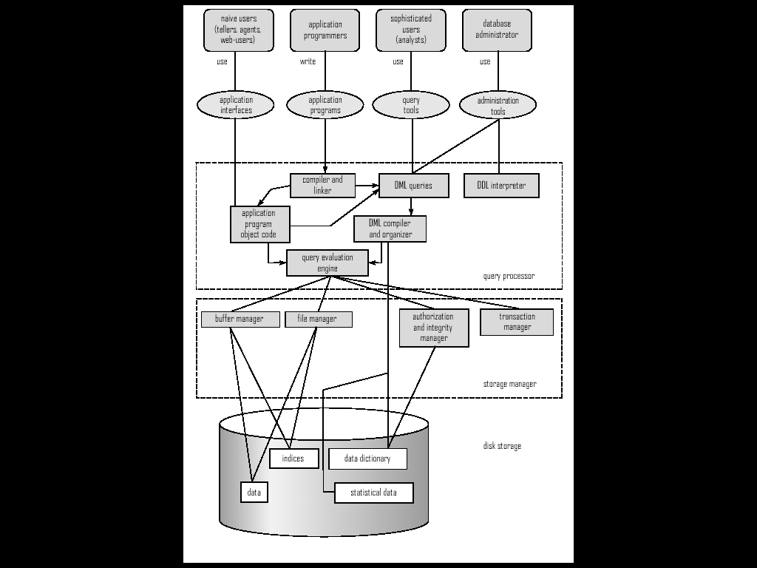
- History of Database Systems
- 1950s and early 1960s:
- Data processing using magnetic tapes for storage
- Tapes provide only sequential access
- Punched cards for input
- Late 1960s and 1970s:
- Hard disks allow direct access to data
- Network and hierarchical data models in widespread use
- Ted Codd defines the relational data model
- Would win the ACM Turing Award for this work
- IBM Research begins System R prototype
- UC Berkeley begins Ingres prototype
- High-performance (for the era) transaction processing
- 1980s:
- Research relational prototypes evolve into commercial systems
- SQL becomes industry standard
- Parallel and distributed database systems
- Object-oriented database systems
- 1990s:
- Large decision support and data-mining applications
- Large multi-terabyte data warehouses
- Emergence of Web commerce
- 2000s:
- XML and XQuery standards
- Automated database administration
- Increasing use of highly parallel database systems
- Web-scale distributed data storage systems

25. 2 Relational Model
- Attribute Types
- Each attribute of a relation has a name
- The set of allowed values for each attribute is called the domain of the attribute
- Attribute values are (normally) required to be atomic; that is, indivisible
- E.g. the value of an attribute can be an account number,
but cannot be a set of account numbers
- Domain is said to be atomic if all its members are atomic
- The special value null is a member of every domain
- The null value causes complications in the definition of many operations
- Relation Schema
- Formally, given domains D₁, D₂, …. D_{n} a relation r is a subset of
D₁ x D₂ x … x D_{n}
Thus, a relation is a set of n-tuples (a₁, a₂, …, a_{n}) where each a_{i} ∈ D_{i}
- Schema of a relation consists of
- attribute definitions
- name
- type/domain
- integrity constraints
- Relation Instance
- The current values (relation instance) of a relation are specified by a table
- An element t of r is a tuple, represented by a row in a table
- Order of tuples is irrelevant (tuples may be stored in an arbitrary order)
- Database
- A database consists of multiple relations
- Information about an enterprise is broken up into parts, with each relation storing one part of the information
- E.g.

account : information about accounts
depositor : which customer owns which account
customer : information about customers
- Why Split Information Across Relations?
- Storing all information as a single relation such as
bank (account_number, balance, customer_name, ..)
results in
- repetition of information
- e.g.,if two customers own an account (What gets repeated?)
- the need for null values
- e.g., to represent a customer without an account
- Normalization theory deals with how to design relational schemas
- Keys
- Let K ⊆ R
- K is a superkey of R if values for K are sufficient to identify a unique tuple of each possible relation r(R)
- by “possible r ” we mean a relation r that could exist in the enterprise we are modeling.
- Example: {customer_name, customer_street} and
{customer_name}
are both superkeys of Customer, if no two customers can possibly have the same name
- In real life, an attribute such as customer_id would be used instead of customer_name to uniquely identify customers, but we omit it to keep our examples small, and instead assume customer names are unique.
- K is a candidate key if K is minimal
Example: {customer_name} is a candidate key for Customer, since it is a superkey and no subset of it is a superkey.
- Primary key: a candidate key chosen as the principal means of identifying tuples within a relation
- Should choose an attribute whose value never, or very rarely, changes. E.g. email address is unique, but may change
- Foreign Keys
- A relation schema may have an attribute that corresponds to the primary key of another relation. The attribute is called a foreign key.
- E.g. customer_name and account_number attributes of depositor are foreign keys to customer and account respectively.
- Only values occurring in the primary key attribute of the referenced relation may occur in the foreign key attribute of the referencing relation.
- Schema Diagram
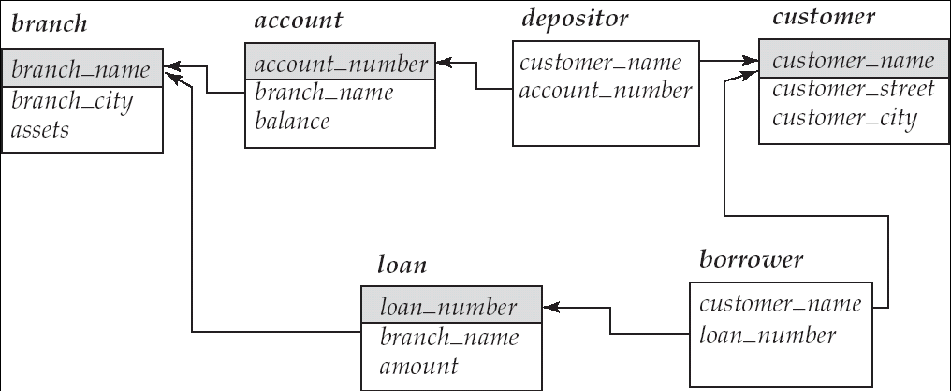
- Query Languages

Query languages are language in which user requests information from the database. Categories of languages are:
- Procedural
- Non-procedural, or declarative
- “Pure” languages:
- Relational algebra
- Tuple relational calculus
- Domain relational calculus
- Pure languages form underlying basis of query languages that people use.

Summary
- Database Design
- DBMS
- Data Models
- DML
- DDL
- SQL
- Relational Model

Lecture No. 26
Entity-Relationship Model

26.1 Modeling

A database can be modeled as: a collection of entities, and relationship among entities. An entity is an object that exists and is distinguishable from other objects. For example, specific person, company, event, plant.
- Entities have attributes
- Example: people have names and addresses
- An entity set is a set of entities of the same type that share the same properties.
- Example: set of all persons, companies, trees, holidays
- Relationship Sets
- A relationship is an association among several entities

Example:
Hayes depositor A-102
customer entity relationship set account entity
- A relationship set is a mathematical relation among n ≥ 2 entities, each taken from entity sets

{(e₁, e₂, … e_{n}) | e₁ E₁, e₂ E₂, …, e_{n} E_{n}}
where (e₁, e₂, …, e_{n}) is a relationship
- Example:

(Hayes, A-102) Depositor
- Degree of a Relationship Set
- Refers to number of entity sets that participate in a relationship set.
- Relationship sets that involve two entity sets are binary (or degree two). Generally, most relationship sets in a database system are binary.
- Relationship sets may involve more than two entity sets.
- Relationships between more than two entity sets are rare. Most relationships are binary.

- Attributes

An entity is represented by a set of attributes that is descriptive properties possessed by all members of an entity set.

Domain – the set of permitted values for each attribute
- Attribute types:
- Simple and composite attributes
- Single-valued and multi-valued attributes
- Example: multivalued attribute: phone_numbers
- Derived attributes
- Can be computed from other attributes
- Example: age, given date_of_birth

- Mapping Cardinality Constraints

Express the number of entities to which another entity can be associated via a relationship set. Most useful in describing binary relationship sets. For a binary relationship set the mapping cardinality must be one of the following types:
- One to one
- One to many
- Many to one
- Many to many
- Keys

A super key of an entity set is a set of one or more attributes whose values uniquely determine each entity.

A candidate key of an entity set is a minimal super key
- Customer_id is candidate key of customer
- account_number is candidate key of account

Although several candidate keys may exist, one of the candidate keys is selected to be the primary key.
- Keys for Relationship Sets

The combination of primary keys of the participating entity sets forms a super key of a relationship set.
- (customer_id, account_number) is the super key of depositor
- NOTE: this means a pair of entity sets can have at most one relationship in a particular relationship set.
- Example: if we wish to track all access_dates to each account by each customer, we cannot assume a relationship for each access. We can use a multivalued attribute though

Must consider the mapping cardinality of the relationship set when deciding what the candidate keys are. Need to consider semantics of relationship set in selecting the primary key in case of more than one candidate key
- E-R Diagrams
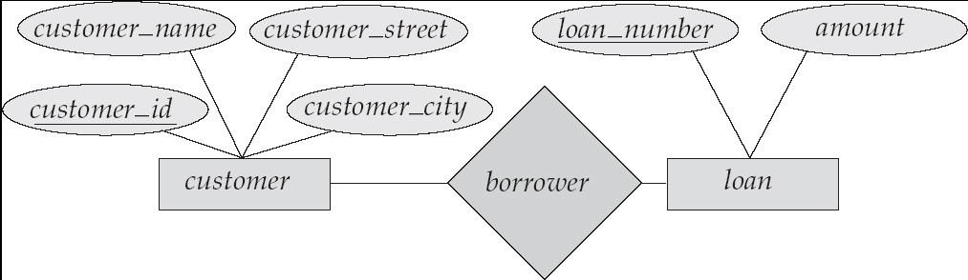
- Rectangles represent entity sets.
- Diamonds represent relationship sets.
- Lines link attributes to entity sets and entity sets to relationship sets.
- Ellipses represent attributes
- Double ellipses represent multivalve attributes.
- Dashed ellipses denote derived attributes.
- Underline indicates primary key attributes (will study later)
- Cardinality Constraints

We express cardinality constraints by drawing either a directed line (→), signifying “one,” or an undirected line (—), signifying “many,” between the relationship set and the entity set.
- One-to-one relationship:
- A customer is associated with at most one loan via the relationship borrower
- A loan is associated with at most one customer via borrower

- Participation of an Entity Set in a Relationship Set
We allow at most one arrow out of a ternary (or greater degree) relationship to indicate a cardinality constraint. E.g. an arrow from works_on to job indicates each employee works on at most one job at any branch. If there is more than one arrow, there are two ways of defining the meaning. E.g a ternary relationship R between A, B and C with arrows to B and C could mean
- 1. Each A entity is associated with a unique entity from B and C or
- 2. Each pair of entities from (A, B) is associated with a unique C entity, and each pair (A, C) is associated with a unique B
Each alternative has been used in different formalisms. To avoid confusion we outlaw more than one arrow
- Design Issues
- Use of entity sets vs. attributes
Choice mainly depends on the structure of the enterprise being modeled, and on the semantics associated with the attribute in question.
- Use of entity sets vs. relationship sets
possible guideline is to designate a relationship set to describe an action that occurs between entities
- Binary versus n-ary relationship sets
Although it is possible to replace any nonbinary (n-ary, for n > 2) relationship set by a number of distinct binary relationship sets, a n-ary relationship set shows more clearly that several entities participate in a single relationship.
- Placement of relationship attributes
- Binary Vs. Non-Binary Relationships
- Some relationships that appear to be non-binary may be better represented using binary relationships
- E.g. A ternary relationship parents, relating a child to his/her father and mother, is best replaced by two binary relationships, father and mother
- Using two binary relationships allows partial information (e.g. only mother being know)
- But there are some relationships that are naturally non-binary
- Example: works_on
- Converting Non-Binary Relationships to Binary Form
- In general, any non-binary relationship can be represented using binary relationships by creating an artificial entity set.
- Replace R between entity sets A, B and C by an entity set E, and three relationship sets:

1. R_{A}, relating E and A 2.R_{B}, relating E and B

3. R_{C}, relating E and C
- Create a special identifying attribute for E
- Add any attributes of R to E
- For each relationship (a_{i} , b_{i} , c_{i}) in R, create

1. a new entity e_{i} in the entity set E 2. add (e_{i} , a_{i} ) to R_{A}

3. add (e_{i} , b_{i} ) to R_{B} 4. add (e_{i} , c_{i} ) to R_{C}
- Also need to translate constraints
- Translating all constraints may not be possible
- There may be instances in the translated schema that
cannot correspond to any instance of R
- Exercise: add constraints to the relationships R_{A}, R_{B} and R_{C} to ensure that a newly created entity corresponds to exactly one entity in each of entity sets A, B and C
- Weak Entity Sets
- An entity set that does not have a primary key is referred to as a weak entity set.
- The existence of a weak entity set depends on the existence of a identifying entity set
- it must relate to the identifying entity set via a total, one-to-many relationship set from the identifying to the weak entity set
- Identifying relationship depicted using a double diamond
- The discriminator (or partial key) of a weak entity set is the set of attributes that distinguishes among all the entities of a weak entity set.
- The primary key of a weak entity set is formed by the primary key of the strong entity set on which the weak entity set is existence dependent, plus the weak entity set’s discriminator.
- We depict a weak entity set by double rectangles.
- We underline the discriminator of a weak entity set with a dashed line.
- payment_number – discriminator of the payment entity set
- Primary key for payment – (loan_number, payment_number)
- Note: the primary key of the strong entity set is not explicitly stored with the weak entity set, since it is implicit in the identifying relationship.
- If loan_number were explicitly stored, payment could be made a strong entity, but then the relationship between payment and loan would be duplicated by an implicit relationship defined by the attribute loan_number common to payment and loan
- In a university, a course is a strong entity and a course_offering can be modeled as a weak entity
- The discriminator of course_offering would be semester (including year) and section_number (if there is more than one section)
- If we model course_offering as a strong entity we would model course_number as an attribute.

Then the relationship with course would be implicit in the course_number attribute
- Extended E-R Features: Specialization
- Top-down design process; we designate subgroupings within an entity set that are distinctive from other entities in the set.
- These subgroupings become lower-level entity sets that have attributes or participate in relationships that do not apply to the higher-level entity set.
- Depicted by a triangle component labeled ISA (E.g. customer “is a” person).
- Attribute inheritance – a lower-level entity set inherits all the attributes and relationship participation of the higher-level entity set to which it is linked.
- Extended ER Features: Generalization
- A bottom-up design process – combine a number of entities sets that share the same features into a higher-level entity set.
- Specialization and generalization are simple inversions of each other; they are represented in an E-R diagram in the same way.
- The terms specialization and generalization are used interchangeably.
- Can have multiple specializations of an entity set based on different features.
- E.g. permanent_employee vs. temporary_employee, in addition to officer vs. secretary vs. teller
- Each particular employee would be
- a member of one of permanent_employee or temporary_employee,
- and also a member of one of officer, secretary, or teller
- The ISA relationship also referred to as superclass - subclass relationship
- Design Constraints on a Specialization/Generalization
- Constraint on which entities can be members of a given lower-level entity set.
- Condition-defined
- Example: all customers over 65 years are members of senior-citizen entity set; senior-citizen ISA person.
- User-defined
- Constraint on whether or not entities may belong to more than one lower-level entity set within a single generalization.
- Disjoint
- an entity can belong to only one lower-level entity set
- Noted in E-R diagram by writing disjoint next to the ISA triangle
- Overlapping
- An entity can belong to more than one lower-level entity set
- Completeness constraint -- specifies whether or not an entity in the higher-level entity set must belong to at least one of the lower-level entity sets within a generalization.
- total : an entity must belong to one of the lower-level entity sets
- partial: an entity need not belong to one of the lower-level entity sets
- Aggregation
- Relationship sets works_on and manages represent overlapping information
- Every manages relationship corresponds to a works_on relationship
- However, some works_on relationships may not correspond to any manages relationships
- So we can’t discard the works_on relationship
- Eliminate this redundancy via aggregation
- Treat relationship as an abstract entity
- Allows relationships between relationships
- Abstraction of relationship into new entity
- Without introducing redundancy, the following diagram represents:
- An employee works on a particular job at a particular branch
- An employee, branch, job combination may have an associated manager
- E-R Design Decisions

The use of an attribute or entity set to represent an object.
- Whether a real-world concept is best expressed by an entity set or a relationship set.
- The use of a ternary relationship versus a pair of binary relationships
- The use of a strong or weak entity set.
- The use of specialization/generalization – contributes to modularity in the design.
- The use of aggregation – can treat the aggregate entity set as a single unit without concern for the details of its internal structure.
- Reduction to Relation Schemas
- Primary keys allow entity sets and relationship sets to be expressed uniformly as relation schemas that represent the contents of the database.
- A database which conforms to an E-R diagram can be represented by a collection of schemas.
- For each entity set and relationship set there is a unique schema that is assigned the name of the corresponding entity set or relationship set.
- Each schema has a number of columns (generally corresponding to attributes), which have unique names.
- Representing Entity Sets as Schemas
- A strong entity set reduces to a schema with the same attributes.
- A weak entity set becomes a table that includes a column for the primary key of the identifying strong entity set

payment = ( loan_number, payment_number, payment_date, payment_amount )
- Representing Relationship Sets as Schemas
- A many-to-many relationship set is represented as a schema with attributes for the primary keys of the two participating entity sets, and any descriptive attributes of the relationship set.
- Example: schema for relationship set borrower

borrower = (customer_id, loan_number )
- Redundancy of Schemas
- For one-to-one relationship sets, either side can be chosen to act as the “many” side
- That is, extra attribute can be added to either of the tables corresponding to the two entity sets
- If participation is partial on the “many” side, replacing a schema by an extra attribute in the schema corresponding to the “many” side could result in null values
- The schema corresponding to a relationship set linking a weak entity set to its identifying strong entity set is redundant.
- Example: The payment schema already contains the attributes that would appear in the loan_payment schema (i.e., loan_number and payment_number).

- Representing Specialization via Schemas
- Method 1:
- Form a schema for the higher-level entity
- Form a schema for each lower-level entity set, include primary key of higher-level entity set and local attributes
schema attributes
person name, street, city
customer name, credit_rating
employee name, salary
- Drawback: getting information about, an employee requires accessing two relations, the one corresponding to the low-level schema and the one corresponding to the high-level schema
- Method 2:
- Form a schema for each entity set with all local and inherited attributes

schema attributes
person name, street, city
customer name, street, city, credit_rating
employee name, street, city, salary
If specialization is total, the schema for the generalized entity set (person) not required to store information
- Can be defined as a “view” relation containing union of specialization relations
- But explicit schema may still be needed for foreign key constraints
- Drawback: street and city may be stored redundantly for people who are both customers and employees
- UML
- UML: Unified Modeling Language
- UML has many components to graphically model different aspects of an entire software system
- UML Class Diagrams correspond to E-R Diagram, but several differences.
- UML Class Diagrams
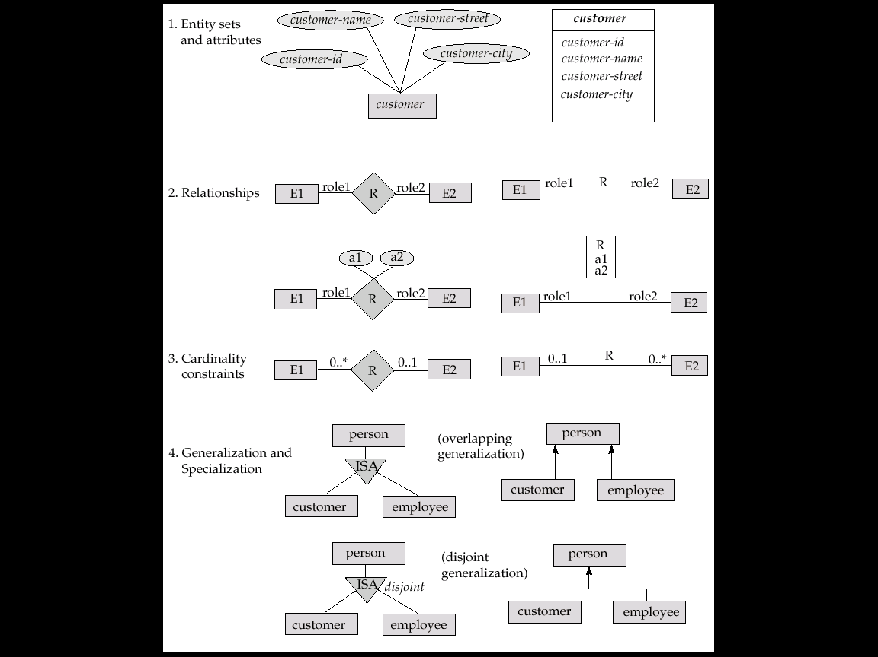
- Entity sets are shown as boxes, and attributes are shown within the box, rather than as separate ellipses in E-R diagrams.
- Binary relationship sets are represented in UML by just drawing a line connecting the entity sets. The relationship set name is written adjacent to the line.
- The role played by an entity set in a relationship set may also be specified by writing the role name on the line, adjacent to the entity set.
- The relationship set name may alternatively be written in a box, along with attributes of the relationship set, and the box is connected, using a dotted line, to the line depicting the relationship set.
- Non-binary relationships drawn using diamonds, just as in ER diagrams
- Summary of UML Class Diagram Notation
- Cardinality constraints are specified in the form l..h, where l denotes the minimum and h the maximum number of relationships an entity can participate in.
- Beware: the positioning of the constraints is exactly the reverse of the positioning of constraints in E-R diagrams.
- The constraint 0..* on the E2 side and 0..1 on the E1 side means that each E2 entity can participate in at most one relationship, whereas each E1 entity can participate in many relationships; in other words, the relationship is many to one from E2 to E1.
- Single values, such as 1 or * may be written on edges; the single value 1 on an edge is treated as equivalent to 1...1, while * is equivalent to 0...*.
Summary
- Entity-Relationship Models
- Modeling
- E-R Diagrams
- Cardinality Constraints
- UML

Lecture No. 27
Transactions

27.1 Transaction Concept

A transaction is a unit of program execution that accesses and possibly updates various data items.
- E.g. transaction to transfer $50 from account A to account B:

1. read(A)

2. A := A – 50

3. write(A)

4. read(B)

5. B := B + 50

6. write(B)
- Two main issues to deal with:
- Failures of various kinds, such as hardware failures and system crashes
- Concurrent execution of multiple transactions
- Example of Fund Transfer
- Transaction to transfer $50 from account A to account B:

1. read(A)

2. A := A – 50

3. write(A)

4. read(B)

5. B := B + 50

6. write(B)
- Atomicity requirement
- If the transaction fails after step 3 and before step 6, money will be “lost” leading to an inconsistent database state
- Failure could be due to software or hardware
- The system should ensure that updates of a partially executed transaction are not reflected in the database
- Durability requirement — once the user has been notified that the transaction has completed (i.e., the transfer of the $50 has taken place), the updates to the database by the transaction must persist even if there are software or hardware failures.
- Transaction to transfer $50 from account A to account B:

1. read(A)

2. A := A – 50

3. write(A)

4. read(B)

5. B := B + 50

6. write(B)
- Consistency requirement in above example:
- The sum of A and B is unchanged by the execution of the transaction
- In general, consistency requirements include
- Explicitly specified integrity constraints such as primary keys and foreign keys
- Implicit integrity constraints
- e.g. sum of balances of all accounts, minus sum of loan amounts must equal value of cash-in-hand
- A transaction must see a consistent database.
- During transaction execution the database may be temporarily inconsistent.
- When the transaction completes successfully the database must be consistent
- Erroneous transaction logic can lead to inconsistency
- Isolation requirement — if between steps 3 and 6, another transaction T2 is allowed to access the partially updated database, it will see an inconsistent database (the sum A + B will be less than it should be).
T1 T2

1. read(A)

2. A := A – 50

3. write(A)
read(A), read(B), print(A+B)

4. read(B)

5. B := B + 50

6. write(B
- Isolation can be ensured trivially by running transactions serially
- that is, one after the other.
- However, executing multiple transactions concurrently has significant benefits, as we will see later.
- ACID Properties
- Atomicity: Either all operations of the transaction are properly reflected in the database or none are.
- Consistency: Execution of a transaction in isolation preserves the consistency of the database.
- Isolation: Although multiple transactions may execute concurrently, each transaction must be unaware of other concurrently executing transactions. Intermediate transaction results must be hidden from other concurrently executed transactions.
- That is, for every pair of transactions T_{i} and T_{j}, it appears to T_{i} that either T_{j}, finished execution before T_{i} started, or T_{j} started execution after T_{i} finished.
- Durability: After a transaction completes successfully, the changes it has made to the database persist, even if there are system failures.
- Transaction State
- Active – the initial state; the transaction stays in this state while it is executing
- Partially committed – after the final statement has been executed
- Failed -- after the discovery that normal execution can no longer proceed
- Aborted – after the transaction has been rolled back and the database restored to its state prior to the start of the transaction. Two options after it have been aborted:
- Restart the transaction
- Can be done only if no internal logical error
- Kill the transaction
- Committed – after successful completion.
- Implementation of Atomicity and Durability
- The recovery-management component of a database system implements the support for atomicity and durability.
- E.g. the shadow-database scheme:
- All updates are made on a shadow copy of the database
- db_pointer is made to point to the updated shadow copy after
- The transaction reaches partial commit and
- All updated pages have been flushed to disk.
- db_pointer always points to the current consistent copy of the database.
- In case transaction fails, old consistent copy pointed to by db_pointer can be used, and the shadow copy can be deleted.
- The shadow-database scheme:
- Assumes that only one transaction is active at a time
- Assumes disks do not fail
- Useful for text editors, but
- extremely inefficient for large databases (why?)
- Variant called shadow paging reduces copying of data, but is still not practical for large databases
- Does not handle concurrent transactions
- Concurrent Executions
- Multiple transactions are allowed to run concurrently in the system. Advantages are:
- Increased processor and disk utilization, leading to better transaction throughput
- E.g. one transaction can be using the CPU while another is reading from or writing to the disk
- Reduced average response time for transactions: short transactions need not wait behind long ones.
- Concurrency control schemes – mechanisms to achieve isolation
- That is, to control the interaction among the concurrent transactions in order to prevent them from destroying the consistency of the database
- Schedules

A sequence of instructions that specify the chronological order in which instructions of concurrent transactions are executed
- A schedule for a set of transactions must consist of all instructions of those transactions
- Must preserve the order in which the instructions appear in each individual transaction.
- A transaction that successfully completes its execution will have a commit instructions as the last statement
- By default transaction assumed to execute commit instruction as its last step
- A transaction that fails to successfully complete its execution will have an abort instruction as the last statement

- Serializability
- Basic Assumption – Each transaction preserves database consistency.
- Thus serial execution of a set of transactions preserves database consistency.
- A (possibly concurrent) schedule is serializable if it is equivalent to a serial schedule. Different forms of schedule equivalence give rise to the notions of:

1. Conflict serializability

2. View serializability
- Simplified view of transactions
- We ignore operations other than read and write instructions
- We assume that transactions may perform arbitrary computations on data in local buffers in between reads and writes.
- Our simplified schedules consist of only read and write instructions.
- Conflicting Instructions
- Instructions l_{i} and l_{j} of transactions T_{i} and T_{j} respectively, conflict if and only if there exists some item Q accessed by both l_{i} and l_{j}, and at least one of these instructions wrote Q.

1. l_{i} = read(Q), l_{j} = read(Q). l_{i} and l_{j} don’t conflict.
2. l_{i} = read(Q), l_{j} = write(Q). They conflict.
3. l_{i} = write(Q), l_{j} = read(Q). They conflict
4. l_{i} = write(Q), l_{j} = write(Q). They conflict
- Intuitively, a conflict between l_{i} and l_{j} forces a (logical) temporal order between them.
- If l_{i} and l_{j} are consecutive in a schedule and they do not conflict, their results would remain the same even if they had been interchanged in the schedule.

- Conflict Serializability
- If a schedule S can be transformed into a schedule S´ by a series of swaps of non-conflicting instructions, we say that S and S´ are conflict equivalent.
- We say that a schedule S is conflict serializable if it is conflict equivalent to a serial schedule
- View Serializability
- Let S and S´ be two schedules with the same set of transactions. S and S´ are view equivalent if the following three conditions are met, for each data item Q,
- If in schedule S, transaction T_{i} reads the initial value of Q, then in schedule S’ also transaction T_{i} must read the initial value of Q.
- If in schedule S transaction T_{i} executes read(Q), and that value was produced by transaction T_{j} (if any), then in schedule S’ also transaction T_{i} must read the value of Q that was produced by the same write(Q) operation of transaction T_{j} .
- The transaction (if any) that performs the final write(Q) operation in schedule S must also perform the final write(Q) operation in schedule S’.

As can be seen, view equivalence is also based purely on reads and writes alone.
- A schedule S is view serializable if it is view equivalent to a serial schedule.
- Every conflict serializable schedule is also view serializable.
- Below is a schedule which is view-serializable but not conflict serializable.
- Every view serializable schedule that is not conflict serializable has blind writes.
- Cascading Rollbacks
- A single transaction failure leads to a series of transaction rollbacks. Consider the following schedule where none of the transactions has yet committed (so the schedule is recoverable).
Concurrency Control
- A database must provide a mechanism that will ensure that all possible schedules are
- Either conflict or view serializable, and
- Are recoverable and preferably cascadeless
- A policy in which only one transaction can execute at a time generates serial schedules, but provides a poor degree of concurrency
- Are serial schedules recoverable/cascadeless?
- Testing a schedule for serializability after it has executed is a little too late!
- Goal – to develop concurrency control protocols that will assure serializability.

- Concurrency Control vs. Serializability Tests

Concurrency-control protocols allow concurrent schedules, but ensure that the schedules are conflict/view serializable, and are recoverable and cascadeless. Concurrency control protocols generally do not examine the precedence graph as it is being created

Instead a protocol imposes a discipline that avoids nonseralizable schedules. Different concurrency control protocols provide different tradeoffs between the amount of concurrency they allow and the amount of overhead that they incur. Tests for serializability help us understand why a concurrency control protocol is correct.

- Weak Levels of Consistency

Some applications are willing to live with weak levels of consistency, allowing schedules that are not serializable
- E.g. a read-only transaction that wants to get an approximate total balance of all accounts
- E.g. database statistics computed for query optimization can be approximate (why?)
- Such transactions need not be serializable with respect to other transactions

Tradeoff accuracy for performance
- Levels of Consistency in SQL-92
- Serializable — default
- Repeatable read — only committed records to be read, repeated reads of same record must return same value. However, a transaction may not be serializable – it may find some records inserted by a transaction but not find others.
- Read committed — only committed records can be read, but successive reads of record may return different (but committed) values.
- Read uncommitted — even uncommitted records may be read.
- Transaction Definition in SQL
- Data manipulation language must include a construct for specifying the set of actions that comprise a transaction.
- In SQL, a transaction begins implicitly.
- A transaction in SQL ends by:
- Commit work commits current transaction and begins a new one.
- Rollback work causes current transaction to abort.
- In almost all database systems, by default, every SQL statement also commits implicitly if it executes successfully
- Implicit commit can be turned off by a database directive
- E.g. in JDBC, connection.setAutoCommit(false);
- Transaction Processing Monitors
- TP monitors initially developed as multithreaded servers to support large numbers of terminals from a single process.
- Provide infrastructure for building and administering complex transaction processing systems with a large number of clients and multiple servers.
- Provide services such as:
- Presentation facilities to simplify creating user interfaces
- Persistent queuing of client requests and server responses
- Routing of client messages to servers
- Coordination of two-phase commit when transactions access multiple servers.
- Some commercial TP monitors: CICS from IBM, Pathway from Tandem, Top End from NCR, and Encina from Transarc

- TP Monitor Architectures
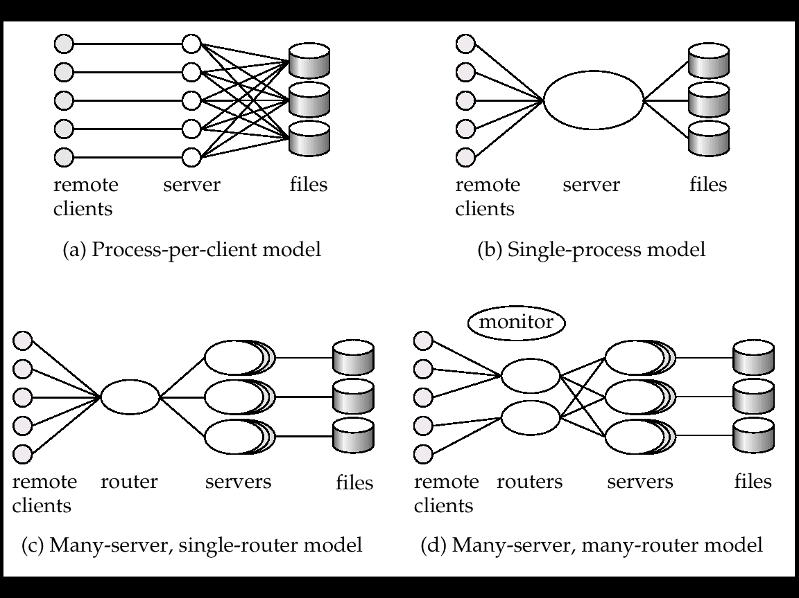
- Process per client model - instead of individual login session per terminal, server process communicates with the terminal, handles authentication, and executes actions.
- Memory requirements are high
- Multitasking- high CPU overhead for context switching between processes
- Single process model - all remote terminals connect to a single server process.
- Used in client-server environments
- Server process is multi-threaded; low cost for thread switching
- No protection between applications
- Not suited for parallel or distributed databases
- Many-server single-router model - multiple application server processes access a common database; clients communicate with the application through a single communication process that routes requests.
- Independent server processes for multiple applications
- Multithread server process
- Run on parallel or distributed database
- Many server many-router models - multiple processes communicate with clients.
- Client communication processes interact with router processes that route their requests to the appropriate server.
- Controller process starts up and supervises other processes.
- Detailed Structure of a TP Monitor
- Queue manager handles incoming messages
- Some queue managers provide persistent or durable message queueing contents of queue are safe even if systems fail.
- Durable queueing of outgoing messages is important
- Application server writes message to durable queue as part of a transaction
- Once the transaction commits, the TP monitor guarantees message is eventually delivered, regardless of crashes.
- ACID properties are thus provided even for messages sent outside the database
- Many TP monitors provide locking, logging and recovery services, to enable application servers to implement ACID properties by themselves.
- Application Coordination Using TP Monitors
- A TP monitor treats each subsystem as a resource manager that provides transactional access to some set of resources.
- The interface between the TP monitor and the resource manager is defined by a set of transaction primitives
- The resource manager interface is defined by the X/Open Distributed Transaction Processing standard.
- TP monitor systems provide a transactional remote procedure call (transactional RPC) interface to their service
- Transactional RPC provides calls to enclose a series of RPC calls within a transaction.
- Updates performed by an RPC are carried out within the scope of the transaction, and can be rolled back if there is any failure.

Summary
- E-R Design Decisions
- Redundancy of Schemas
- UML
- UML Class Diagrams
- Transactions
- Transactions Processing
- Scheduling

Lecture No. 28

User Interface Design

Usability of Interactive Systems

28.1 Introduction
The Interdisciplinary Design Science of Human-Computer Interaction (HCI) combines knowledge and methods associated with professionals including:

Psychologists (incl. Experimental, Educational, Social and Industrial Psychologists)

Computer Scientists

Instructional and Graphic Designers

Technical Writers

Human Factors and Ergonomics Experts

Anthropologists and Sociologists

What are the Ramifications?

Success Stories: Microsoft, Linux, Amazon.com, Google

Competition: Firefox vs. Internet Explorer

Copyright Infringement Suits - Apple vs. Microsoft (Windows) and Napster vs. The music industry

Mergers: AOL and Time Warner

Corporate Takeovers: IBM's seizure of Lotus

Privacy and Security issues: identification theft, medical information, viruses, spam, pornography, national security

Individual User Level

Routine processes: tax return preparation

Decision support: a doctor’s diagnosis and treatment

Education and training: encyclopedias, drill-and-practice exercises, simulations

Leisure: music and sports information

User generated content: social networking web sites, photo and video share sites, user communities

Internet-enabled devices and communication

Communities

Business use: financial planning, publishing applications

Industries and professions: web resources for journals, and career opportunities

Family use: entertainment, games and communication

Globalization: language and culture
- Usability requirements
Synonyms for “user-friendly” in Microsoft Word 2002 are easy to use; accessible; comprehensible; intelligible; idiot proof; available; and ready.
But a “friend” also seeks to help and be valuable. A friend is not only understandable, but understands. A friend is reliable and doesn’t hurt. A friend is pleasant to be with.
These measures are still subjective and vague, so a systematic process is necessary to develop usable systems for specific users in a specific context.
The U.S. Human Engineering Design Criteria for Military Systems (1999) states these purposes:

Achieve required performance by operator, control, and maintenance personnel

Minimize skill and personnel requirements and training time

Achieve required reliability of personnel-equipment/software combinations

Foster design standardization within and among systems
Should improving the user’s quality of life and the community also be objectives? Usability requires project management and careful attention to requirements analysis and testing for clearly defined objectives
- Goals for requirements analysis

Ascertain the user’s needs

Determine what tasks and subtasks must be carried out

Include tasks which are only performed occasionally. Common tasks are easy to identify.

Functionality must match need or else users will reject or underutilize the product

Ensure reliability

Actions must function as specified

Database data displayed must reflect the actual database

Appease the user's sense of mistrust

The system should be available as often as possible

The system must not introduce errors

Ensure the user's privacy and data security by protecting against unwarranted access, destruction of data, and malicious tampering

Promote standardization, integration, consistency, and portability

Standardization: use pre-existing industry standards where they exist to aid learning and avoid errors (e.g. the W3C and ISO standards)

Integration: the product should be able to run across different software tools and packages (e.g. Unix)

Consistency:

Compatibility across different product versions

Compatibility with related paper and other non-computer based systems

Use common action sequences, terms, units, colors, etc. within the program

Portability: allow for the user to convert data across multiple software and hardware environments

Complete projects on time and within budget
Late or over budget products can create serious pressure within a company and potentially mean dissatisfied customers and loss of business to competitors

Usability measures

Define the target user community and class of tasks associated with the interface

Communities evolve and change (e.g. the interface to information services for the U.S. Library of Congress)

5 human factors central to community evaluation:

Time to learn
How long does it take for typical members of the community to learn relevant task?

Speed of performance
How long does it take to perform relevant benchmarks?

Rate of errors by users
How many and what kinds of errors are made during benchmark tasks?

Retention over time
Frequency of use and ease of learning help make for better user retention

Subjective satisfaction
Allow for user feedback via interviews, free-form comments and satisfaction scales

Trade-offs in design options frequently occur.

Changes to the interface in a new version may create consistency problems with the previous version, but the changes may improve the interface in other ways or introduce new needed functionality.

Design alternatives can be evaluated by designers and users via mockups or high-fidelity prototypes.

The basic tradeoff is getting feedback early and perhaps less expensively in the development process versus having a more authentic interface evaluated.

Usability motivations

Many interfaces are poorly designed and this is true across domains:

Life-critical systems

Air traffic control, nuclear reactors, power utilities, police & fire dispatch systems, medical equipment

High costs, reliability and effectiveness are expected

Length training periods are acceptable despite the financial cost to provide error-free performance and avoid the low frequency but high cost errors

Subject satisfaction is less an issue due to well motivated users

Industrial and commercial uses

Banking, insurance, order entry, inventory management, reservation, billing, and point-of-sales systems

Ease of learning is important to reduce training costs

Speed and error rates are relative to cost

Speed of performance is important because of the number of transactions

Subjective satisfaction is fairly important to limit operator burnout

Office, home, and entertainment applications

Word processing, electronic mail, computer conferencing, and video game systems, educational packages, search engines, mobile device, etc.

Ease of learning, low error rates, and subjective satisfaction are paramount due to use is often discretionary and competition fierce

Infrequent use of some applications means interfaces must be intuitive and easy to use online help is important

Choosing functionality is difficult because the population has a wide range of both novice and expert users

Competition cause the need for low cost

New games and gaming devices!

For example, Nintendo Wii

Exploratory, creative, and cooperative systems

Web browsing, search engines, artist toolkits, architectural design, software development, music composition, and scientific modeling systems

Collaborative work

Benchmarks are hard to describe for exploratory tasks and device users

With these applications, the computer should be transparent so that the user can be absorbed in their task domain

Social-technical systems

Complex systems that involve many people over long time periods

Voting, health support, identity verification, crime reporting

Trust, privacy, responsibility, and security are issues

Verifiable sources and status feedback are important

Ease of learning for novices and feedback to build trust

Administrators need tools to detect unusual patterns of usage

Universal Usability

Physical abilities and physical workplaces

Basic data about human dimensions comes from research in anthropometry

There is no average user, either compromises must be made or multiple versions of a system must be created

Physical measurement of human dimensions are not enough, take into account dynamic measures such as reach, strength or speed

Screen-brightness preferences vary substantially, designers customarily provide a knob to enable user control

Account for variances of the user population's sense perception

Vision: depth, contrast, color blindness, and motion sensitivity

Touch: keyboard and touchscreen sensitivity

Hearing: audio clues must be distinct

Workplace design can both help and hinder work performance

The standard ANSI/HFES 100-2007 Human Factors Engineering of Computer Workstations (2007) lists these concerns:

Work-surface and display-support height

Clearance under work surface for legs

Work-surface width and depth

Adjustability of heights and angles for chairs and work surfaces

Posture - seating depth and angle; back-rest height and lumbar support

Availability of armrests, footrests, and palmrests

Cognitive and perceptual abilities

The human ability to interpret sensory input rapidly and to initiate complex actions makes modern computer systems possible

The journal Ergonomics Abstracts offers this classification of human cognitive processes:

Long-term and semantic memory

Short-term and working memory

Problem solving and reasoning

Decision making and risk assessment

Language communication and comprehension

Search, imagery, and sensory memory

Learning, skill development, knowledge acquisition, and concept attainment

They also suggest this set of factors affecting perceptual and motor performance:

Arousal and vigilance

Fatigue and sleep deprivation

Perceptual (mental) load

Knowledge of results and feedback

Monotony and boredom

Sensory deprivation

Nutrition and diet

Fear, anxiety, mood, and emotion

Drugs, smoking, and alcohol

Physiological rhythms

But note, in any application, background experience and knowledge in the task domain and the interface domain play key roles in learning and performance

Personality differences

There is no set taxonomy for identifying user personality types

Designers must be aware that populations are subdivided and that these subdivisions have various responses to different stimuli

Myers-Briggs Type Indicator (MBTI)

Extroversion versus introversion

Sensing versus intuition

Perceptive versus judging

Feeling versus thinking

Cultural and international diversity

Characters, numerals, special characters, and diacriticals

Left-to-right versus right-to-left versus vertical input and reading

Date and time formats

Numeric and currency formats

Weights and measures

Telephone numbers and addresses

Names and titles (Mr., Ms., Mme.)

Social-security, national identification, and passport numbers

Capitalization and punctuation

Sorting sequences

Icons, buttons, colors

Pluralization, grammar, spelling

Etiquette, policies, tone, formality, metaphors

Users with physical challenges

Designers must plan early to accommodate users with disabilities

Early planning is more cost efficient than adding on later

Businesses must comply with the "Americans With Disabilities" Act for some applications

Older Adult Users

Including the elderly is fairly easy

Designers should allow for variability within their applications via settings for sound, color, brightness, font sizes, etc. with less distracting animation

Goals for our profession

Potential research topics

Reducing anxiety and fear of computer usage

Graceful evolution

Specification and implementation of interaction

Direct manipulation

Social media participation

Input devices

Online assistance

Information exploration

Providing tools, techniques, and knowledge for system implementers

Rapid prototyping is easy when using contemporary tools

Use general or self-determined guideline documents written for specific audiences

To refine systems, use feedback from individual or groups of users

Raising the computer consciousness of the general public

Many novice users are fearful due to experience with poor product design

Good designs help novices through these fears by being clear, competent, and nonthreatening

User Interface Design
Guidelines, Principles and Theories

Guidelines

Shared language

Best practices

Critics

Too specific, incomplete, hard to apply, and sometimes wrong

Proponents

Encapsulate experience

Navigating the interface

Sample of the National Cancer Institute’s guidelines:

Standardize task sequences

Ensure that embedded links are descriptive

Use unique and descriptive headings

Use check boxes for binary choices

Develop pages that will print properly

Use thumbnail images to preview larger images

Accessibility guidelines

Provide a text equivalent for every nontext element

For any time-based multimedia presentation synchronize equivalent alternatives

Information conveyed with color should also be conveyed without it

Title each frame to facilitate identification and navigation

Organizing the display

Smith and Mosier (1986) offer five high-level goals

Consistency of data display

Efficient information assimilation by the user

Minimal memory load on the user

Compatibility of data display with data entry

Flexibility for user control of data display

Getting the user’s attention

Intensity

Marking

Size

Choice of fonts

Inverse video

Blinking

Color

Audio

Principles

More fundamental, widely applicable, and enduring than guidelines

Need more clarification

Fundamental principles

Determine user’s skill levels

Identify the tasks

Five primary interaction styles

Eight golden rules of interface design

Prevent errors

Automation and human control

Determine user’s skill levels

“Know thy user”

Age, gender, physical and cognitive abilities, education, cultural or ethnic background, training, motivation, goals and personality

Design goals based on skill level

Novice or first-time users

Knowledgeable intermittent users

Expert frequent users

Multi-layer designs

Identify the tasks

Task Analysis usually involve long hours observing and interviewing users

Decomposition of high level tasks

Relative task frequencies

Choose an interaction style

Direct Manipulation

Menu selection

Form fill-in

Command language

Natural language

The 8 golden rules of interface design

Strive for consistency

Cater to universal usability

Offer informative feedback

Design dialogs to yield closure

Prevent errors

Permit easy reversal of actions

Support internal locus of control

Reduce short term memory load

Prevent errors

Make error messages specific, positive in tone, and constructive

Mistakes and slips (Norman, 1983)

Correct actions

Gray out inappropriate actions

Selection rather than freestyle typing

Automatic completion

Complete sequences

Single abstract commands

Macros and subroutines

Automation and human control

Successful integration:

Users can avoid: Routine, tedious, and error prone tasks

Users can concentrate on: Making critical decisions, coping with unexpected situations, and planning future actions

Supervisory control needed to deal with real world open systems

E.g. air-traffic controllers with low frequency, but high consequences of failure

FAA: design should place the user in control and automate only to improve system performance, without reducing human involvement

Goals for autonomous agents

Knows user's likes and dislikes

Makes proper inferences

Responds to novel situations

Performs competently with little guidance

Tool like interfaces versus autonomous agents

Aviators representing human users, not computers, more successful

User modeling for adaptive interfaces

Keeps track of user performance

Adapts behavior to suit user's needs

Allows for automatically adapting system

Response time, length of messages, density of feedback, content of menus, order of menu items, type of feedback, content of help screens

Can be problematic

System may make surprising changes

User must pause to see what has happened

User may not be able to

Predict next change

Interpret what has happened

Restore system to previous state

Alternative to agents:

User control, responsibility, accomplishment

Expand use of control panels

Style sheets for word processors

Specification boxes of query facilities

Information-visualization tools

Theories

Beyond the specifics of guidelines

Principles are used to develop theories

Descriptions/explanatory or predictive

Motor task, perceptual, or cognitive

Explanatory and predictive theories

Explanatory theories:

Observing behavior

Describing activity

Conceiving of designs

Comparing high-level concepts of two designs

Training

Predictive theories:

Enable designers to compare proposed designs for execution time or error rates

Perceptual, Cognitive, & Motor tasks

Perceptual or Cognitive subtasks theories

Predicting reading times for free text, lists, or formatted displays

Motor-task performance times theories:

Predicting keystroking or pointing times

Taxonomy (explanatory theory)

Order on a complex set of phenomena

Facilitate useful comparisons

Organize a topic for newcomers

Guide designers

Indicate opportunities for novel products.

Conceptual, semantic, syntactic, and lexical model

Foley and van Dam four-level approach

Conceptual level: User's mental model of the interactive system

Semantic level: Describes the meanings conveyed by the user's command input and by the computer's output display

Syntactic level: Defines how the units (words) that convey semantics are assembled into a complete sentence that instructs the computer to perform a certain task

Lexical level: Deals with device dependencies and with the precise mechanisms by which a user specifies the syntax

Approach is convenient for designers

Top-down nature is easy to explain

Matches the software architecture

Allows for useful modularity during design

Stages of action models

Norman's seven stages of action

Forming the goal

Forming the intention

Specifying the action

Executing the action

Perceiving the system state

Interpreting the system state

Evaluating the outcome

Norman's contributions

Context of cycles of action and evaluation

Gulf of execution: Mismatch between the user's intentions and the allowable actions

Gulf of evaluation: Mismatch between the system's representation and the users' expectations

Four principles of good design

State and the action alternatives should be visible

Should be a good conceptual model with a consistent system image

Interface should include good mappings that reveal the relationships between stages

User should receive continuous feedback

Four critical points where user failures can occur

Users can form an inadequate goal

Might not find the correct interface object because of an incomprehensible label or icon

May not know how to specify or execute a desired action

May receive inappropriate or misleading feedback

Consistency through grammars

Inconsistent action verbs

Take longer to learn

Cause more errors

Slow down users

Harder for users to remember

The disappearance of syntax

Users must maintain a profusion of device-dependent details in their human memory.

Which action erases a character

Which action inserts a new line after the third line of a text file

Which abbreviations are permissible

Which of the numbered function keys produces the previous screen

Learning, use, and retention of this knowledge is hampered by two problems

Details vary across systems in an unpredictable manner

Greatly reduces the effectiveness of paired-associate learning

Syntactic knowledge conveyed by example and repeated usage

Syntactic knowledge is system dependent

The disappearance of syntax (concluded)

Minimizing these burdens is the goal of most interface designers

Modern direct-manipulation systems

Familiar objects and actions representing their task objects and actions

Modern user interface building tools

Standard widgets

Contextual Theories

User actions are situated by time and place

You may not have time to deal with shortcuts or device dependent syntax, such as on mobile devices, when hurried

Physical space is important in ubiquitous, pervasive and embedded devices, e.g. a museum guide stating information about a nearby painting

Taxonomy for mobile device application development could include:

Monitor and provide alerts, e.g. patient monitoring systems

Gather information

Participate in group collaboration

Locate and identify nearby object or site

Capture information about the object and share that information

Summary
- User Interface Design
- Usability requirements
- Goals for RA
- Usability measures
- Usability motivations
- Universal Usability
- Principles
- Theories

Lecture No. 29

User Interface Design Managing Design Process

29.1 Organizational Design and Support Usability

Design is inherently creative and unpredictable. Interactive system designers must blend knowledge of technical feasibility with a mystical esthetic sense of what attracts users.

Carroll and Rosson design characterization:
- Design is a process, not a state.
- The design process is nonhierarchical.
- The process is radically transformational.
- Design intrinsically involves the discovery of new goals.

“Usability engineering” has evolved into a recognized discipline with maturing practices and a growing set of standards. Usability engineers and user-interface architects, sometimes called the user experience (UX) team are gaining experience in organizational change. There are numerous papers and reporting addressing return on investment (ROI) for usability testing. The Usability Professional's Association (UPA) holds annual meetings called the “World Usability Day”

The Four Pillars of Design
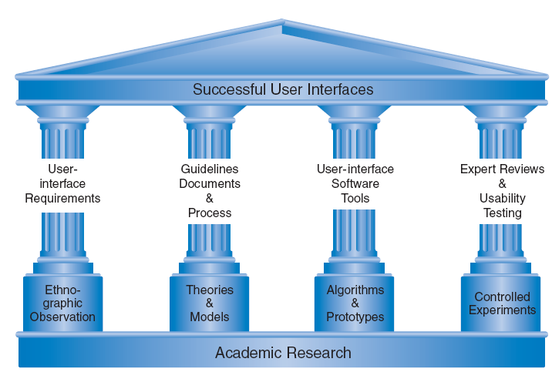

The Four Pillars of Design

User Interface Requirements

Soliciting and clearly specifying user requirements is a major key to success in any development activity

Laying out the user-interface requirements is part of the overall requirements development and management process

User interface requirements describe system behavior

Ethnographic Observation

Identifying and observing the user community in action

Guidelines documents and processes

Each project has different needs, but guidelines should be considered for:

Words, icons, and graphics

Terminology (objects and actions), abbreviations, and capitalization

Character set, fonts, font sizes, and styles (bold, italic, underline)

Icons, graphics, line thickness, and

Use of color, backgrounds, highlighting, and blinking

Screen-layout issues

Menu selection, form fill-in, and dialog-box formats

Wording of prompts, feedback, and error messages

Justification, white space, and margins

Data entry and display formats for items and lists

Use and contents of headers and footers

Input and output devices

Keyboard, display, cursor control, and pointing devices

Audible sounds, voice feedback, touch input, and other special devices

Response time for a variety of tasks

Action sequences

Direct-manipulation clicking, dragging, dropping, and gestures

Command syntax, semantics, and sequences

Programmed function keys

Error handling and recovery procedures

Training

Online help and tutorials

Training and reference materials

Command syntax, semantics, and sequences

Developmental Methodologies
IBM’s Ease of Use development methodology specifies activities by roles and phases.
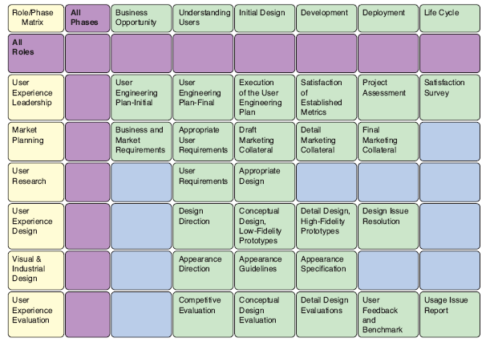

Rapid Contextual Design
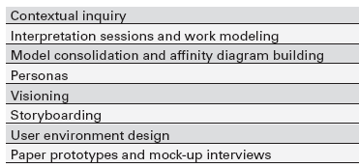

Ethnographic Observation

Preparation

Understand organization policies and work culture.

Familiarize yourself with the system and its history.

Set initial goals and prepare questions.

Gain access and permission to observe/interview.

Field Study

Establish rapport with managers and users.

Observe/interview users in their workplace and collect subjective/objective quantitative/qualitative data.

Follow any leads that emerge from the visits.

Analysis

Compile the collected data in numerical, textual, and multimedia databases.

Quantify data and compile statistics.

Reduce and interpret the data.

Refine the goals and the process used.

Reporting

Consider multiple audiences and goals.

Prepare a report and present the findings.

Participatory Design

Controversial

More user involvement brings:

More accurate information about tasks

More opportunity for users to influence design decisions

A sense of participation that builds users' ego investment in successful implementation

Potential for increased user acceptance of final system

On the negative side, extensive user involvement may:

Be more costly

Lengthen the implementation period

Build antagonism with people not involved or whose suggestions rejected

Force designers to compromise their design to satisfy incompetent participants

Build opposition to implementation

Exacerbate personality conflicts between design-team members and users

Show that organizational politics and preferences of certain individuals are more important than technical issues

Participatory Design
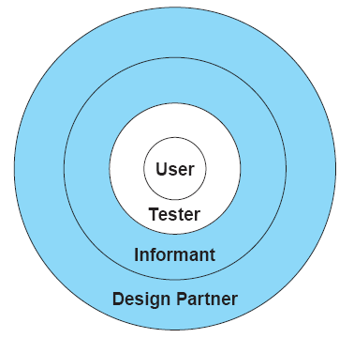

Scenario Development

Day-in-the-life scenarios:

Characterize what happens when users perform typical tasks

Can be acted out as a form of walkthrough

May be used as basis for videotape

Useful tools

Table of user communities across top, tasks listed down the side

Table of task sequences

Flowchart or transition diagram

Social Impact Statement for Early Design Review

Describe the new system and its benefits

Convey the high level goals of the new system.

Identify the stakeholders.

Identify specific benefits

Address concerns and potential barriers

Anticipate changes in job functions and potential layoffs.

Address security and privacy issues.

Discuss accountability and responsibility for system misuse and failure.

Avoid potential biases.

Weigh individual rights vs. societal benefits.

Assess trade-offs between centralization and decentralization.

Preserve democratic principles.

Ensure diverse access.

Promote simplicity and preserve what works.

Outline the development process

Present and estimated project schedule

Propose process for making decisions.

Discuss expectations of how stakeholders will be involved.

Recognize needs for more staff, training, and hardware.

Propose plan for backups of data and equipment.

Outline plan for migrating to the new system.

Legal Issues

Potential Controversies

What material is eligible for copyright?

Are copyrights or patents more appropriate for user interfaces?

What constitutes copyright infringement?

Should user interfaces be copyrighted?

Evolving public policies related to: Privacy, Liability related to system safety/reliability, Freedom of speech

29.2 User Interface Design (Evaluating Interface Designs)

Evaluation Introduction

Designers can become so entranced with their creations that they may fail to evaluate them adequately.

Experienced designers have attained the wisdom and humility to know that extensive testing is a necessity.

The determinants of the evaluation plan include:

Stage of design (early, middle, late)

Novelty of project (well defined vs. Exploratory)

Number of expected users

Criticality of the interface (life-critical medical system vs. Museum exhibit support)

Costs of product and finances allocated for testing

Time available

Experience of the design and evaluation team

Usability evaluators must broaden their methods and be open to non-empirical methods, such as user sketches, consideration of design alternatives, and ethnographic studies.

Recommendations needs to be based on observational findings

The design team needs to be involved with research on the current system design drawbacks

Tools and techniques are evolving

The range of evaluation plans might be anywhere from an ambitious two-year test with multiple phases for a new national air-traffic–control system to a three-day test with six users for a small internal web site

The range of costs might be from 20% of a project down to 5%.

Usability testing has become an established and accepted part of the design process

Expert Reviews

While informal demos to colleagues or customers can provide some useful feedback, more formal expert reviews have proven to be effective

Expert reviews entail one-half day to one week effort, although a lengthy training period may sometimes be required to explain the task domain or operational procedures

There are a variety of expert review methods to chose from:

Heuristic evaluation

Guidelines review

Consistency inspection

Cognitive walkthrough

Metaphors of human thinking

Formal usability inspection

Expert reviews can be scheduled at several points in the development process when experts are available and when the design team is ready for feedback.

Different experts tend to find different problems in an interface, so 3-5 expert reviewers can be highly productive, as can complementary usability testing.

The dangers with expert reviews are that the experts may not have an adequate understanding of the task domain or user communities.

Even experienced expert reviewers have great difficulty knowing how typical users, especially first-time users will really behave.

Step-by-Step Usability Guide from http://usability.gov/
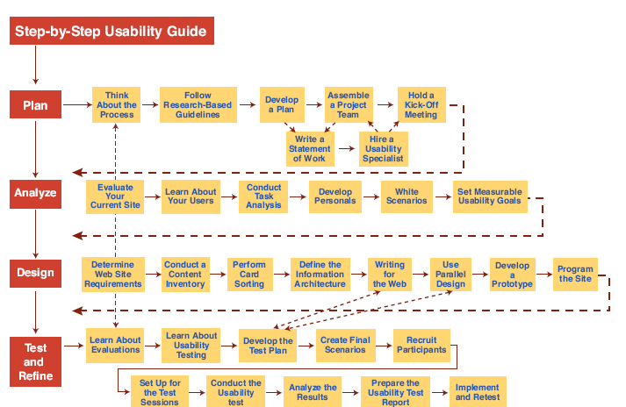

Usability Testing and Laboratories

The emergence of usability testing and laboratories since the early 1980s

Usability testing not only sped up many projects but that it produced dramatic cost savings.

The movement towards usability testing stimulated the construction of usability laboratories.

A typical modest usability lab would have two 10 by 10 foot areas, one for the participants to do their work and another, separated by a half-silvered mirror, for the testers and observers

Participants should be chosen to represent the intended user communities, with attention to

Background in computing, experience with the task, motivation, education, and ability with the natural language used in the interface

Participation should always be voluntary, and informed consent should be obtained.

Professional practice is to ask all subjects to read and sign a statement like this one:

I have freely volunteered to participate in this experiment.

I have been informed in advance what my task(s) will be and what procedures will be followed.

I have been given the opportunity to ask questions, and have had my questions answered to my satisfaction.

I am aware that I have the right to withdraw consent and to discontinue participation at any time, without prejudice to my future treatment.

My signature below may be taken as affirmation of all the above statements; it was given prior to my participation in this study.

Institutional Review Boards (IRB) often governs human subject test process

Videotaping participants performing tasks is often valuable for later review and for showing designers or managers the problems that users encounter.

Use caution in order to not interfere with participants

Invite users to think aloud (sometimes referred to as concurrent think aloud) about what they are doing as they are performing the task.

Many variant forms of usability testing have been tried:

Paper mockups

Discount usability testing

Competitive usability testing

Universal usability testing

Field test and portable labs

Remote usability testing

Can-you-break-this tests

Survey Instruments

Written user surveys are a familiar, inexpensive and generally acceptable companion for usability tests and expert reviews.

Keys to successful surveys

Clear goals in advance

Developments of focused items that help attain the goals.

Survey goals can be tied to the components of the Objects and Action Interface model of interface design.

Users could be asked for their subjective impressions about specific aspects of the interface such as the representation of:

Task domain objects and actions

Syntax of inputs and design of displays

Other goals would be to ascertain

Users background (age, gender, origins, education, income)

Experience with computers (specific applications or software packages, length of time, depth of knowledge)

Job responsibilities (decision-making influence, managerial roles, motivation)

Personality style (introvert vs. Extrovert, risk taking vs. Risk aversive, early vs. late adopter, systematic vs. Opportunistic)

Reasons for not using an interface (inadequate services, too complex, too slow)

Familiarity with features (printing, macros, shortcuts, tutorials)

Their feeling state after using an interface (confused vs. Clear, frustrated vs. In-control, bored vs. Excited).

Online surveys avoid the cost of printing and the extra effort needed for distribution and collection of paper forms.

Many people prefer to answer a brief survey displayed on a screen, instead of filling in and returning a printed form,

Although there is a potential bias in the sample

A survey example is the Questionnaire for User Interaction Satisfaction (QUIS).

http://lap.umd.edu/quis/

Acceptance Test

For large implementation projects, the customer or manager usually sets objective and measurable goals for hardware and software performance.

If the completed product fails to meet these acceptance criteria, the system must be reworked until success is demonstrated.

Rather than the vague and misleading criterion of "user friendly," measurable criteria for the user interface can be established for the following:

Time to learn specific functions

Speed of task performance

Rate of errors by users

Human retention of commands over time

Subjective user satisfaction

In a large system, there may be eight or 10 such tests to carry out on different components of the interface and with different user communities.

Once acceptance testing has been successful, there may be a period of field testing before national or international distribution.

Evaluation during Active Use

Successful active use requires constant attention from dedicated managers, user-services personnel, and maintenance staff.

Perfection is not attainable, but percentage improvements are possible.

Interviews and focus group discussions

Interviews with individual users can be productive because the interviewer can pursue specific issues of concern.

Group discussions are valuable to ascertain the universality of comments.

Continuous user-performance data logging

The software architecture should make it easy for system managers to collect data about

The patterns of system usage

Speed of user performance

Rate of errors

Frequency of request for online assistance

A major benefit is guidance to system maintainers in optimizing performance and reducing costs for all participants.

Online or telephone consultants, e-mail, and online suggestion boxes

Many users feel reassured if they know there is a human assistance available

On some network systems, the consultants can monitor the user's computer and see the same displays that the user sees

Online suggestion box or e-mail trouble reporting

Electronic mail to the maintainers or designers

For some users, writing a letter may be seen as requiring too much effort.

Discussion groups, wiki’s and newsgroups

Permit postings of open messages and questions

Some are independent, e.g. America Online and Yahoo!

Topic list

Sometimes moderators

Social systems

Comments and suggestions should be encouraged.

Controlled Psychologically-oriented Experiments

Scientific and engineering progress is often stimulated by improved techniques for precise measurement.

Rapid progress in the designs of interfaces will be stimulated as researchers and practitioners evolve suitable human-performance measures and techniques.

The outline of the scientific method as applied to human-computer interaction might comprise these tasks:

Deal with a practical problem and consider the theoretical framework

State a lucid and testable hypothesis

Identify a small number of independent variables that are to be manipulated

Carefully choose the dependent variables that will be measured

Judiciously select subjects and carefully or randomly assign subjects to groups

Control for biasing factors (non-representative sample of subjects or selection of tasks, inconsistent testing procedures)

Apply statistical methods to data analysis

Resolve the practical problem, refine the theory, and give advice to future researchers

Controlled experiments can help fine tuning the human-computer interface of actively used systems.

Performance could be compared with the control group.

Dependent measures could include performance times, user-subjective satisfaction, error rates, and user retention over time.
29.3 User Interface Design (Direct manipulation and virtual environment)

Introduction

Positive feelings associated with good user interfaces:

Mastery of the interface

Competence in performing tasks

Ease in learning the system originally and in assimilating advanced features

Confidence in the capacity to retain mastery over time

Enjoyment in using the system

Eagerness to show the system off to novices

Desire to explore more powerful aspects of the system

Examples of Direct-Manipulation Systems

Command line vs. display editors and word processors

Training times with display editors are much less than line editors

Display editors are generally more flexible and powerful

The advances of WYSIWYG word processors:

Display a full page of text

Display of the document in the form that it will appear when the final printing is done

Show cursor action

Control cursor motion through physically obvious and intuitively natural means

Use of labeled icon for actions

Display of the results of an action immediately

Provide rapid response and display

Offer easily reversible actions

Examples of Direct-Manipulation Systems: WYSIWYG word processing
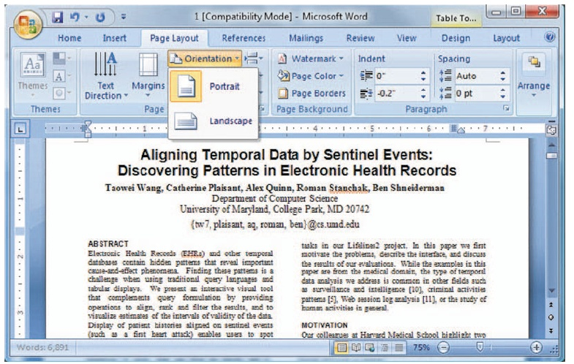

Technologies that derive from the word processor:

Integration

Desktop publication software

Slide-presentation software

Hypermedia environments

Improved macro facilities

Spell checker and thesaurus

Grammar checkers

The VisiCalc spreadsheet and its descendants

VisiCalc users delighted in watching the program propagate changes across the screen.

In some cases, spatial representations provide a better model of reality

Successful spatial data-management systems depend on choosing appropriate:

Icons

Graphical representations

Natural and comprehensible data layouts

Examples of Direct-Manipulation Systems (Video games)

Nintendo Wii, Sony PlayStation, and Microsoft Xbox

Field of action is visual and compelling

Commands are physical actions whose results are immediately shown on the screen

No syntax to remember

Most games continuously display a score

Direct manipulation in SimSity

Second Life virtual world

Spore

Myst well received

DOOM and Quake controversial

Computer-aided design

Computer-aided design (CAD) use direct manipulation

Manipulate the object of interest

Generate alternatives easily

Explain the impact

Problem solving by analogy to the real-world

Office automation

Xerox Star was a pioneer with sophisticated formatting

Apple Lisa System

Rapid and continuous graphical interaction

Microsoft Windows is a descendant

Continuing evolution of Direct-Manipulation Systems

Direct-Manipulation interfaces are being used in a wide range of applications, e.g. management dashboard for a retail store
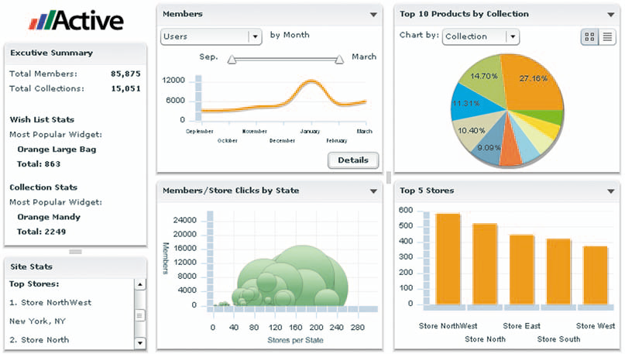

Discussion of Direct Manipulation

Problems with direct manipulation

Spatial or visual representations can be too spread out

High-level flowcharts and database-schema can become confusing

Designs may force valuable information off of the screen

Users must learn the graphical representations

The visual representation may be misleading

Typing commands with the keyboard may be faster

Principles of Direct Manipulation

Continuous representations of the objects and actions of interest with meaningful visual metaphors

Physical actions or presses of labeled buttons, instead of complex syntax

Rapid, incremental, reversible actions whose effects on the objects of interest are visible immediately

Interface-Building Tools

Visual Thinking and Icons

An icon is an image, picture, or symbol representing a concept

Icon-specific guidelines

Represent the object or action in a familiar manner

Limit the number of different icons

Make icons stand out from the background

Consider three-dimensional icons

Ensure a selected icon is visible from unselected icons

Design the movement animation

Add detailed information

Explore combinations of icons to create new objects or actions

3D Interfaces

“Pure” 3D interfaces have strong utility in some contexts, e.g., medical, product design. In other situations, more constrained interaction may actually be preferable to simplify interactions.

“Enhanced” interfaces, better than reality, can help reduce the limitations of the real-world, e.g., providing simultaneous views.

Avatars in multiplayer 3-D worlds

First person games

Features for effective 3D

Use occlusion, shadows, perspective, and other 3D techniques carefully.

Minimize the number of navigation steps for users to accomplish their tasks.

Keep text readable.

Avoid unnecessary visual clutter, distraction, contrast shifts, and reflections.

Simplify user movement.

Prevent errors.

Simplify object movement

Organize groups of items in aligned structures to allow rapid visual search.

Enable users to construct visual groups to support spatial recall.

Guidelines for inclusion of enhanced 3D features:

Provide overviews so users can see the big picture

Allow teleoperation

Offer X-ray vision so users can see into or beyond objects.

Provide history keeping

Permit rich user actions on objects

Enable remote collaboration

Give users control over explanatory text and let users select for details on demand.

Offer tools to select, mark, and measure.

Implement dynamic queries to rapidly filter out unneeded items.

Support semantic zooming and movement

Enable landmarks to show themselves even at a distance

Allow multiple coordinated views

Develop novel 3D icons to represent concepts that are more recognizable and memorable.
Summary
- User Interface Design
- The Four Pillars of Design
- Developmental Methodologies
- Ethnographic Observation
- Participatory Design
- Evaluation
- Expert Reviews
- Usability Testing
- Acceptance Test
- 3D Interfaces

Lecture No. 30

User Interface Design Guidelines and Principles

30.1 User Interface Design Guidelines and Principles
- Guidelines

Shared language

Best practices

Critics

Too specific, incomplete, hard to apply, and sometimes wrong

Proponents

Encapsulate experience
- Navigating the interface

Sample of the National Cancer Institute’s guidelines:

Standardize task sequences

Ensure that embedded links are descriptive

Use unique and descriptive headings

Use check boxes for binary choices

Develop pages that will print properly

Use thumbnail images to preview larger images
- Accessibility guidelines

Provide a text equivalent for every nontext element

For any time-based multimedia presentation synchronize equivalent alternatives

Information conveyed with color should also be conveyed without it

Title each frame to facilitate identification and navigation
- Organizing the display

Smith and Mosier (1986) offer five high-level goals

Consistency of data display

Efficient information assimilation by the user

Minimal memory load on the user

Compatibility of data display with data entry

Flexibility for user control of data display
- Getting the user’s attention

Intensity

Marking

Size

Choice of fonts

Inverse video

Blinking

Color

Audio
- Principles

More fundamental, widely applicable, and enduring than guidelines

Need more clarification

Fundamental principles

Determine user’s skill levels

Identify the tasks

Five primary interaction styles

Eight golden rules of interface design

Prevent errors

Automation and human control
- Determine user’s skill levels

“Know the user” Age, gender, physical and cognitive abilities, education, cultural or ethnic background, training, motivation, goals and personality

Design goals based on skill level

Novice or first-time users

Knowledgeable intermittent users

Expert frequent users

Multi-layer designs
- Identify the tasks

Task Analysis usually involve long hours observing and interviewing users

Decomposition of high level tasks

Relative task frequencies
- Choose an interaction style

Direct Manipulation

Menu selection

Form fill-in

Command language

Natural language
- The 8 golden rules of interface design

Strive for consistency

Cater to universal usability

Offer informative feedback

Design dialogs to yield closure

Prevent errors

Permit easy reversal of actions

Support internal locus of control

Reduce short term memory load
- Prevent errors

Make error messages specific, positive in tone, and constructive

Mistakes and slips (Norman, 1983)

Correct actions

Gray out inappropriate actions

Selection rather than freestyle typing

Automatic completion

Complete sequences

Single abstract commands

Macros and subroutines
- Automation and human control
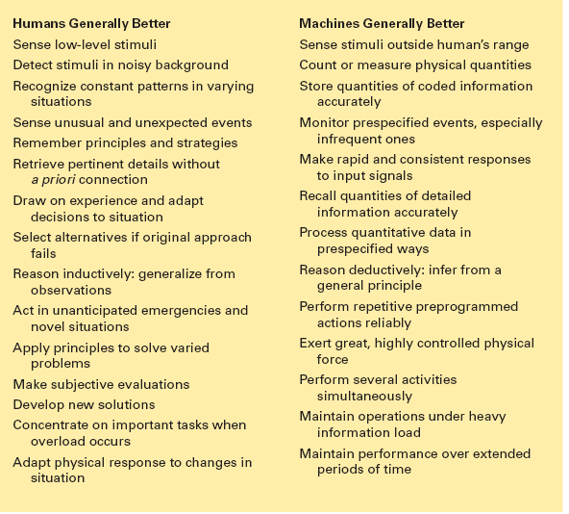

Successful integration:

Users can avoid: Routine, tedious, and error prone tasks

Users can concentrate on: Making critical decisions, coping with unexpected situations, and planning future actions

Supervisory control needed to deal with real world open systems

E.g. air-traffic controllers with low frequency, but high consequences of failure

FAA: design should place the user in control and automate only to improve system performance, without reducing human involvement

Goals for autonomous agents

Knows user's likes and dislikes

Makes proper inferences

Responds to novel situations

Performs competently with little guidance

Tool like interfaces versus autonomous agents

Aviators representing human users, not computers, more successful

User modeling for adaptive interfaces

Keeps track of user performance

Adapts behavior to suit user's needs

Allows for automatically adapting system

Response time, length of messages, density of feedback, content of menus, order of menu items, type of feedback, content of help screens

Can be problematic

System may make surprising changes

User must pause to see what has happened

User may not be able to

Predict next change

Interpret what has happened

Restore system to previous state

Alternative to agents:

User control, responsibility, accomplishment

Expand use of control panels

Style sheets for word processors

Specification boxes of query facilities

Information-visualization tools

Summary
- User Interface Design
- Guidelines
- Principles
- The 8 golden rules of interface design
- Automation and human control
- managing design process
- evaluating interface designs

Lecture No. 31

User Interface Design Patterns

31.1 User Interface (UI) Patterns Introduction

There is an "Oh, right, I know what that is" reaction to most of these patterns. However, a few of them might be new to you, and some of the familiar ones may not be part of your usual design repertoire.

Different UI Pattern Experiences

If you don't have years of design experience already, a set of patterns may serve as a learning tool.

If you talk to users, engineers, or managers about UI design, or write specifications, then you could use the pattern names as a way of communicating and discussing ideas.

Each pattern description tries to capture the reasons why the pattern works to make a UI easier to use.

The Floor Plan Analogy

The User Interface Pattern concept is inspired by the finding of design solutions in the architecture.

Just as houses have various floor plans, a good user interface does as well.

A house generally has a kitchen, living area, bedroom and bathrooms.

A user interface uses similar structures, arranged so they fit the needs of their users or inhabitants.

UI Patterns

Kept application independent

Adjusted in the design phase for application requirements

Define the individual components that will solve individual requirements.

(I.e. Do we need a bedroom or a hallway here?)

Define how the components will be combined to create the application.

(What will the layout of the house look like when we are done?)

User Interface Pattern Questions

Which User Interface Patterns are needed to be able to accomplish certain tasks?

Which work objects need to be processed?

How should user interface screen elements such as fields be grouped together?

How should the individual elements of a User Interface Pattern be arranged on the user interface?

Which are the most important elements of a given User Interface Pattern, and which other, less important ones, are also required?

User Interface Patterns

Patterns are more general, while techniques are more specific.

Together the two form a foundation for solving common problems, and there is no need to re-architect every problem.

Consider how they would be used to design a new interface or redesign an existing one.

Table Sorter

Problem: Users need to search or scan a complex table for values that interest them

Use when: Users are viewing data in a table where they must search for interesting values. There are several meaningful possibilities for sorting the table and users may be more effective if they can dynamically select the column to be sorted.

Solution: Allow users to change the column that is used for sorting the table. As users click on the column header, the table is sorted by that column’s data. Another click reverses the order, which can be visualized using an up- or down-wards pointing arrow. Make sure it is visible which columns can be clicked on and which one is active.

Tabs

Problem:

Users need to select an element out of a set (Navigation), or a large number of parameters must be displayed.

Use When:

Navigation – If a large number of destinations which a user can select can be broken down into groups, preferably less than ten, tabs can be used.

The destination is either known already or the user may have an idea about the kind of item they are after.

Large amounts of data are usually not unrelated and can be divided into categories that match the user's conceptual view

Parameter Display – When there are a large number of parameters, the most important, or ones without a sufficient default value, are often displayed on the first tab

Subsequent tabs hold parameters that have been categorized and labeled via the tab headers

Solution:

Divide the data into sections and present one section at a time. Show all sections and let users switch directly between sections.

Show the section labels horizontally and place the items for the current section underneath it. The currently selected category is generally highlighted.

This effect can be enforced by showing the tabular sheets visually, i.e. connecting the items-area with the current selection.

Tabs – Further Benefits

Further Benefits: Tabbing instantly shows the users which sections are available and makes them reachable in one click.

An important limitation comes from the fact that the categories are usually placed horizontally.

Consequently, the number of categories that "fit" is usually smaller than 10, unless an alphabetical index is used.

Paging

Problem: The user needs to browse through a large list of items

Use When:

Users need to go through a large list of items.

This pattern is applicable when the items are too large to fit on one page. (But > 10)

The items are typically ordered and the users are likely to find their desired result close to the beginning.

Paging - Solution

Present the results grouped in pages with a fixed number of items.

Provide a direct link to a particular page and links to the next/previous page that allow Stepping through the pages.

Show around 5 to 10 items at a time.

Also show the total number of items and use a title to say what kind of items they are.

Paging - Example

The navigation bar should tell the users the most important information about the list; how many items there are, how many they see now and how to get to the rest.

Tree Table

Problem: Related items which have a parent-child or temporal relationship need to be displayed in a related way.

Use When

The UI displays multivariate information, so a table works well to show the data (or allow them to be sorted, as in Table Sorter).

The items are primarily organized as a hierarchy, so you also want a tree, or outline, to display them.

Tree Table - Solution

Combining the two data-viewing approaches into one gives you the best of both worlds

The cost is some visual and programming complexity.

You can show the hierarchy of items, plus a matrix of additional data or item attributes, in one unified structure.

Additional Notes: This technique is popular in email clients and news readers, where threads of discussion form treelike structures.

Tree Table - Example

Courtesy Outlook Express's news reader

List Selector

Problem: Users need to configure an object consisting of several parts.

List Selector – Use When

A complex selection needs to be created by users from a large but defined list of items.

Items must be independent of each other so that they can be removed or added without consequences.

At some point users may change their minds and remove selected parts. Users need to know which parts are selected and which are available.

The number of available parts may change during usage of the application.

List Selector - Solution

Show all the parts and allow the user to add or remove a part from the selection list.

Show the list of parts, in categories if applicable, on one side and the list of selected parts on the other side.

Place add and remove functionality in between the left and right side.

The user can add parts by selecting them and then adding them to the parts list.

Consider speed-ups such as double-clicking or dragging to add or remove an item.

List Selector – Other Thoughts

Showing both the available and selected parts gives the user a complete and instant overview.

The visual organization creates a logical task flow from left to right.

Because item lists are used the design can easily accommodate new items or categories.

NOTE: This pattern may have to be altered if the left to right reading pattern isn’t followed in the language your users speak.

List Sorting

It is worth noting that the List Selector is very similar to a pattern where users can sort the display of their selection.

This is useful if users want to see certain data first.

It is useful to constrain the user within their selection and not provide confusion or ways to mis-configure.

List Sorting - Solution

Solution: Present the list together with up and down buttons.

By selecting an item and pressing the up or down button, the item can be moved.

Effectively it swaps its place with the item above or below it when it is moved.

By selecting several items, users can move a small set of items to a new place.

List Sorting – Example

List Sorting (Courtesy, Yahoo!)
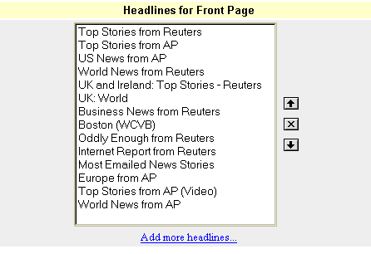

Wizards - Problem

The user wants to achieve a single goal but several decisions need to be made before the goal can be achieved.

Wizards – Use When

A non-expert user needs to perform an infrequent complex task consisting of several subtasks where decisions need to be made.

The number of subtasks must be small.

The tasks can be ordered but are not always independent of each other.

To reach the goal several steps need to be taken but the exact steps required may vary because of decisions made in previous steps.

Wizards - Solution

Take the user through the entire task one step at the time.

When the complex task is started, the user is informed about the goal that will be achieved and the fact that several decisions are needed.

The user can move between tasks using a navigation system provided by the interface, generally back, next and finish buttons.

If the user cannot start the next task before completing the current one, feedback is provided indicating the user cannot proceed before completion.

The user is also able to revise a decision by navigating back to a previous task.

Additional Notes:

The navigation buttons suggest the users that they are navigating a path with steps.

The inexperienced user may be able to learn a task or avoid invalid configurations, but an experienced user may take longer to perform the operation.

Wizards - Example

Wizard (Courtesy Microsoft XP)
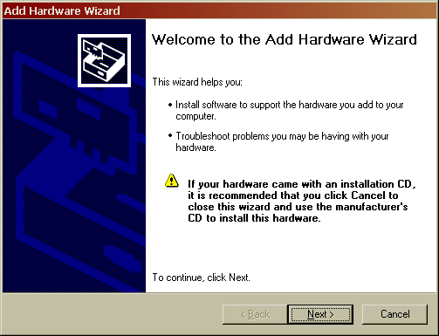

Progress Bar - Problem

Users are often impatient and need feedback during operations which take a long time to complete.

Even changing the mouse pointer to an hourglass may not be enough feedback.

Progress Bar

Use When: A time-consuming operation will take longer than two seconds or so to complete.

Solution:

It's been shown experimentally that if users see an indication that something is going on, they're much more patient, even if they have to wait longer.

Maybe it's because they know that "the system is thinking," and it isn't just hung or waiting for them to do something.

Progress Bar

Additional Notes: Show an animated indicator of how much progress has been made.

What's currently going on,

What proportion of the operation is done so far,

How much time remains, and

How to stop it

If the UI doesn’t know how long the task will take to complete, show something animated which is noncommittal about percentages

Progress Bar – NOTE!

NOTE: The GUI application shouldn’t be “frozen” (i.e. unable to repaint itself, unable to perform other operations) during the time that the longer operation is taking place. Putting the operation on a separate thread, or Swing Worker Thread in Java is desirable.

Progress Bar – Example

Animated Progress Bar (Courtesy Microsoft XP)
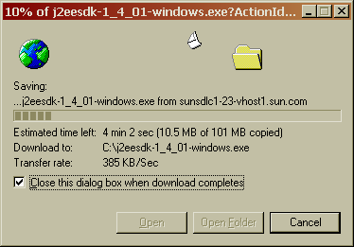

Be Creative, Have Fun!

Use existing patterns and techniques as a base to work from.

It takes a lot of work to make an easy to use GUI, but it is well worth it in the long run!

Don’t get too bizarre, and be prepared to collect feedback on the usability of new items before deployment to customers.

Examples: Table for binary logging string, various validation items, etc.
Summary
- User Interface Design Patterns
- UI Patterns Introduction
- The Floor Plan Analogy
- Table Sorter
- Tabs
- Paging
- Tree Table
- List Selector
- List Sorting

Lecture No. 32

Oracle User Experience Design Patterns

32.1 Oracle User Experience Design Patterns

Who is the user experience team at Oracle?
- Ethnographers, cognitive psychologists, and behavioral research scientists
- Human-computer interaction experts
- Product designers, graphic artists
- Software developers

What is the User Experience Design Process?

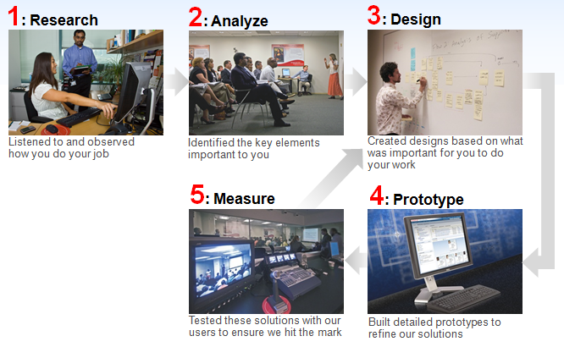
*Key Message:

Part of Oracle’s approach to building the Fusion User Experience is ensuring a variety of ways for customers to participate through our worldwide Fusion Usability Labs. Whether it is through eye-tracking research on dashboard designs, or a focus group on new collaboration technologies, or lab-based testing to measure user performance, Oracle has continued to grow its investment in cutting-edge methodologies to improve the <end user > experience.

How do we improve the post sales user experience?
- Enterprise software has a life cycle beyond release that impacts the ultimate end users experience.
- This includes setup, configuration and customization.
- How can we help our customers maintain or improve the user experience during this process?

3 Steps we are taking to address post sales experience.
- Research: Understand how our customers extend and customize our apps now.
- Externalize: UI design patterns, guidelines and standards (aka FusionGPS).
- Improve the user experience of our customization and development tools.

Why build Fusion user interface design patterns?
- UI Consistency – many flows built across many organizations used by same user.
- Buildability – design patterns supported correct use of components.
- Innovation – using patterns allows more time to focus on innovation.

How do you know if the patterns are good?

Each pattern went through multiple independent reviews to ensure:
- Usability, consistency, productivity
- Complete buildability with Oracle Fusion Middleware
- Ability to connect and interact with other patterns

Patterns were usability tested with customers before coding.

Patterns were enhanced during Oracle Fusion development to improve user experience and buildability.

How we benefited from UX patterns?
- Buildability – Starting with a realistic, proven interface design for our code made all the ADF parts fall together much easier.
- Usability – Patterns have been usability tested as Fusion has been developed. Our developers got baked in usability for free.
- Consistency – Using the same pattern across development created consistency across our Fusion Applications
- Innovation – Used patterns for the 80% of our flows needed to be consistent and predictable. This left development time for the 20% of our flows that required a unique user interface.

*Key Note:

80% of the controls, displays etc on a Prius are the same as any other car. 20% is unique.

80% of a Hyatt hotel is the same. 20% (usually the lobbies) are unique.

80% iPads interaction is similar to an iPhone. 20% unique.

Most of these 80% can be seen as “user experience patterns”
32.1 Report Design Concepts

Basic Report Design Process
The basic report design process is based on two parts. These are:

Deciding on the content of the report

Developing a prototype on paper

Contents of the Report

Stating the purpose

Determining the layout of the report

Finding the data

Manipulating the data

Determining printing area characteristics

Stating the purpose

What is the overall purpose of the report?

The purpose of this report is to show sales activity for each item in inventory, and to suggest reorder quantities based on that activity.

The purpose of this report is to calculate bowling averages and handicaps for each member of the bowling league.

Who is going to read the report?

A sales representative will use the report to evaluate individual sales performance and compare this performance to that of other representatives in the region.

The regional sales manager will use the report to evaluate regional representatives and compare the region’s performance to that of other regions.

Determining the layout of the report

What is the report title going to be?

What identifying information is needed in the header and footer?

Finding the data

What data do you want to use in the report?

Do you know the type of database you are reporting from? If you do not know, ask the database administrator in your organization for help in setting up the database type and location of the data.

What specific data should appear in the body of the report?

The body should contain all the data needed to fulfill the statement of purpose you wrote for the report.

It should also contain all of the data needed by the various users that you have identified.

Much of the data in a typical report is taken directly from data fields. Which data fields will be used, and where are they located?

Other data will be calculated based on data fields. Which data fields will be used in the calculations?

Still other data will be placed directly into the report using text objects (headings, notes, labels, and so on).

Does the data exist or does it need to be calculated?

Some report information can be drawn directly from data fields (sales information, for example); other information will have to be calculated based on data field values (for example, sales commission, based on the relationship of sales to quota).

What types of fields contain data?

You should take the time to get to know the data type for data fields that will be used in your calculations.

Manipulating the data

Do you want the data organized into groups?

How? By customer? By date? By hierarchy? Or by other criteria?

Do you want the data sorted based on record or group values?

Do you want the report to contain only specific records or groups?

Do you want to summarize the data?

Do you want to total, average, count, or determine the maximum or minimum value included in all the values in any column on the report?

What information should be flagged on the report?

You may want to call attention to some data by flagging it on the report.

You might want to flag each item that has shown no activity during the last month, during the last three months, or during some other defined period

How do you want information flagged?

You may want to flag items with an asterisk or some other symbol, or you may want a word to appear as a flag

Determining printing area characteristics

In what order will the areas print on the report?

How often do report objects print?

This will help you decide where to place charts, Cross-Tabs, and formulas to get specific results.

Report Header: Objects placed in the Report Header area print once, at the beginning of the report.

Page Header: Objects placed in the Page Header area print at the beginning of each new page.

Group Header: Objects placed in the Group Header area print at the beginning of each new group.

Body area: Objects placed in the Body area print with each new record.

Group Footer: Objects placed in the Group Footer area print at the end of each group.

Report Footer: Objects placed in the Report Footer area print once at the end of the report.

Page Footer: Objects placed in the Page Footer area print at the bottom of each page.

Developing a prototype on paper

Get the same size paper you will be using for the finished report.

Position the title and other descriptive header information, using boxes or lines to represent report elements.

Position the footer information.

Review the page layout for balance.

Look at the information you intend to include in the body of the report:

Count the number of fields being used and estimate the appropriate spacing between fields.

Use rectangles to pencil in the fields within the estimated spacing.

Change the spacing if you need to.

Decide on a logical sequence for presenting the data in the body of the report.

Label the fields to indicate that sequence.

Use small boxes to indicate group values and totals.

Place random flags in the column where you want flags to appear.

Darken any elements you want highlighted to make them stand out from the rest of the prototype.

Review the finished product for layout and balance, and make changes as needed.

Summary
- Oracle User Experience Design Patterns
- Fusion user interface design patterns
- Pattern Usage
- Report Design Concepts
- Stating the purpose
- Finding the data
- Manipulating the data
- Developing a prototype

Course Recap

Enterprise Systems Intro

SDLC

RE

SA

Quality

CBSE

SOA

DB

HCI

Report Design Concepts

Banking Case Study

References
- Motiwalla and Thompson, Enterprise Systems for Management, Second edition, Prentice hall Publications, 2012
- http://www-03.ibm.com/systems/enterprise-systems/index.html
- Gerald Kotonya and Ian Sommerville, REQUIREMENTS Engineering PROCESSES AND TECHNIQUES by Wiley Publishers
- Designing Concurrent, Distributed, and Real-Time Applications with UML’ by H. Gomaa, Addison-Wesley, 2000
- Bass, L., Clements, P. and Kazman, R., Software Architecture in Practice, Second Edition (2006), Addison-Wesley.
- Clements, P., Bachmann, F., Bass, L., Garlan, D., Ivers, j., Little, R., Nord, R. and Stafford, J., Documenting Software Architectures: Views and Beyond, 2002, Addison-Wesley. Documenting Software Architectures
- CMMi–Overview -- presentation on Carnegie Mellon Software Engineering Institute site
- Kim Caputo’s book on CMM Implementation Guide
- Ian Sommerville book : Software Engineering 7/e
- SE, Servic Orientation, Hans van Vliet
- Silberschatz, Database System Concepts-5th edition
- Ben Shneiderman & Catherine Plaisant, Designing the User Interface: Strategies for Effective Human-Computer Interaction, Fifth Edition.
- Jenifer Tidwell
  - http://www.mit.edu/~jtidwell/ui_patterns_essay.html
  - http://time-tripper.com/uipatterns
- SAP Design Guild
  - http://sapdesignguild.org/community/readers/print_reader_crm_latzina.asp
- http://www.welie.com/patterns
- George Hackman, Oracle User Experience Design Patterns, Oracle Corporation
- Report Design Concepts from IBM
  - http://publib.boulder.ibm.com/infocenter/rsahelp/v7r0m0/index.jsp?topic=/com.businessobjects.integration.eclipse.designer.doc/designer/Design_Concepts.html

