

Lecture Handouts

CSC 444

Visual Programming

Muhammad Bilal Zafar

VCOMSATS
Learning Management System

This course introduces the programming in which more than one dimensions is used to convey semantics. These dimensions include diagrams, icons or demonstration of actions performed by graphical objects. Visual Programming is the methodology in which development allows grab and use of ingredients like menus, buttons, controls and other graphic elements from a palette and built on screen for program.

Course Description:
- It opens up audience to the key skills of problem solving and visual computer programming, including the elementary programming concepts.
- Covers the fundamentals of visual programming language, iconic and symbolic representations, parsing techniques, semantics and pragmatics of visual languages.

Course Objectives:
- On completion of this course students will have the ability to:

  - Comprehend the concepts of OOP, Visual C++, ASP.net and C# languages.
  - Comprehend a programming problem and design a solution.
  - Finally Code a solution to a problem for both desktop and web based programs using visual tools.

Course Contents:

- Programming languages
- Elementary programming concepts and structures
- Object Oriented Programming
- Microsoft Visual Studio
- .Net Architecture
- C++
- Native Programming
- Visual C++
- Managed Programming
- Visual Web Programming
- ASP.NET & C#

Lesson 01
Visual Programming, Programming Languages, Elementary programming concepts & Object Oriented Programming
Visual Programming is the programming in which more than one dimensions is used to convey semantics such as diagrams, icons or demonstration of actions performed by graphical objects. A methodology in which development allows programmers to grab and use of ingredients like menus, buttons, controls and other graphic elements from a tool box.
VPLs may be further classified, according to the type and extent of visual expression used, into icon-based languages, form-based languages, and diagram languages. Visual programming environments provide graphical or iconic elements which can be manipulated by users in an interactive way according to some specific spatial grammar for program construction.
Programming language is an artificial language designed to communicate instructions to a machine, particularly a computer. It can be used to create instruction sets (programs) that can control the behavior of a machine.
The description of a programming language is usually split into the two components of syntax (form) and semantics (meaning). Some languages are defined by a specification document (for example, the C programming language is specified by an ISO Standard), while other languages, such as Perl 5 and earlier, have a dominant implementation that is used as a reference.
The syntax of a language describes the possible combinations of symbols that form a syntactically correct program. The meaning given to a combination of symbols is handled by semantics (either formal or hard-coded in a reference implementation). Since most languages are textual, this article discusses textual syntax.
Semantics is the field concerned with the rigorous mathematical study of the meaning of programming languages. It does so by evaluating the meaning of syntactically legal strings defined by a specific programming language. Semantics describes the processes a computer follows when executing a program in programming language.
Generally we can divide the programming languages into two main categories.
High Level Languages
- A language that supports system development at a high level of Abstraction thereby freeing the developer from keeping lots of details that are irrelevant to the problem at hand.

Low Level Languages
- Low-level languages are designed to operate and handle the entire hardware and instructions set architecture of a computer directly. A programming language that provides little or no abstraction from a computer's instruction set architecture. Generally this refers to either Assembly language or Machine language.
Assembly Language
- An assembly language is a low-level programming language, in which there is a very strong correspondence between the language and the architecture’s machine code instructions. Each assembly language is specific to a particular computer architecture
- Use Symbolic operation code
MOVE 3000,4000 // Copy contents of location 3000 to location 4000
Machine Language
- It is the fundamental language of the computer processor. All programs are converted into machine language before they executed. It consists of combination of 1’s and 0’s that represent high and low electrical voltage
Programming can be done in different ways but in high level languages there are two major approaches. Structured and Object Oriented Programming (OOP)
Structured Programming
Structured programming is also known as Modular Programming It is a subset of procedural programming that enforces a logical structure on the program being written to make it more efficient and easier to understand and modify. It is a technique that follows a top down design approach with block oriented structures.
Object Oriented Programming
Object-oriented programming was developed because limitations were discovered in earlier approaches to programming. To appreciate what OOP does, we need to understand what these limitations are and how they arose from traditional programming languages.

The fundamental idea behind object-oriented languages is to combine into a single unit both data and the functions that operate on that data. Such a unit is called an object. An object’s functions, called member functions in C++, typically provide the only way to access its data. If you want to read a data item in an object, you call a member function in the object. It will access the data and return the value to you. You can’t access the data directly. The data is hidden, so it is safe from accidental alteration. Data and its functions are said to be encapsulated into a single entity. Data encapsulation and data hiding are key terms in the description of object-oriented languages. If you want to modify the data in an object, you know exactly what functions interact with it. the member functions in the object. No other functions can access the data. This simplifies writing, debugging, and maintaining the program.

A C++ program typically consists of a number of objects, which communicate with each other by calling one another’s member functions.

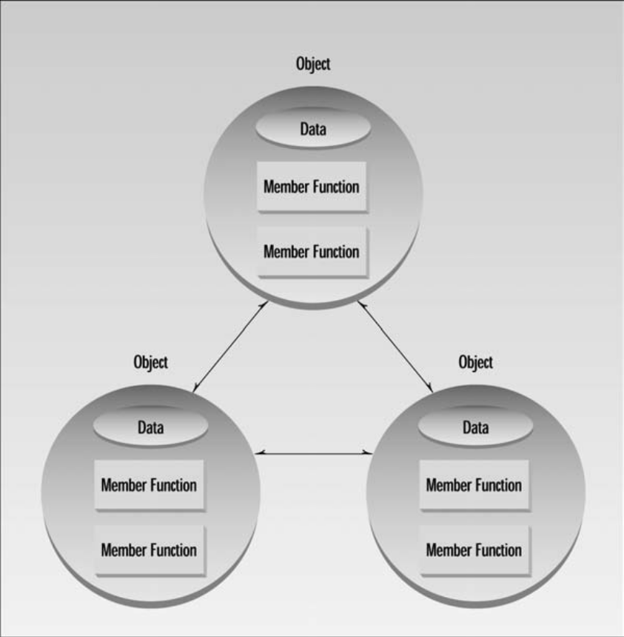

Lesson 02
IDE, .Net Architecture, CLR, FCL & Application Designs
An IDE or interactive development environment is a software application that provides comprehensive facilities to computer programmers for software development. IDE normally consists of a source code editor, build automation tools and a debugger. Several modern IDEs integrate with intelli-ense coding features. Visual IDEs allow users to create new applications by moving Programming building blocks, code nodes to create flowcharts or structure diagrams that are then compiled.
Microsoft Visual Studio is an integrated development environment (IDE) from Microsoft Corporation. It is used to develop Console and Graphical Applications, Windows Forms, Websites in both native code along together with managed code for all platforms supported by Microsoft Windows, Win Mobile & .NET Framework.
Visual Studio supports different programming languages by means of language services, which allow the code editor and debugger to support nearly any programming language, provided a language-specific service exists. Built-in languages include C/C++, VB.NET, C#, and F#. Support for other languages such as M, Python, and Ruby among others is available via language services installed separately.
It also supports XML/XSLT, HTML/XHTML, JavaScript and CSS. Individual language-specific versions of Visual Studio also exist which provide more limited language services to the user: Microsoft Visual Basic, Visual J#, Visual C#, and Visual C++.
The .NET Framework is a software framework developed by Microsoft that runs primarily on Microsoft Windows. It includes a large library and provides language interoperability (each language can use code written in other languages) across several programming languages. Programs written for the .NET Framework execute in a software environment, known as the Common Language Runtime (CLR), an application virtual machine that provides services such as security, memory management, and exception handling. The class library and the CLR together constitute the .NET Framework.
CLR defines a common programming model and a standard type system for cross-platform, multi-language development. CLR runs the code and provides services that make the development process easier.
The Base Class Library (BCL) includes a small subset of the entire class library and is the core set of classes that serve as the basic API of the Common Language Runtime. The classes in mscorlib.dll and some of the classes in System.dll and System.core.dll are considered to be a part of the BCL. The BCL classes are available in both .NET Framework as well as its alternative implementations including .NET Compact Framework, Microsoft Silverlight.
The Framework Class Library (FCL) is a superset of the BCL classes and refers to the entire class library that ship with .NET Framework. It includes an expanded set of libraries, including Window Forms, ADO.NET, ASP.NET, Language Integrated Query, Windows Presentation Foundation, Windows Communication Foundation among others. The FCL is much larger in scope than standard libraries for languages like C++, and comparable in scope to the standard libraries of Java.
Two kinds of application designs mostly used. In monolithic applications all source code is compiled into one executable file. In component based applications combination of exe file and dynamic link library file(s). It is standard practice in windows applications.
Assemblies are the building blocks of .NET Framework applications; they form the fundamental unit of deployment, version control, reuse, activation scoping, and security permissions. An assembly is a collection of types and resources that are built to work together and form a logical unit of functionality. An assembly provides the common language runtime with the information it needs to be aware of type implementations. To the runtime, a type does not exist outside the context of an assembly.
Lesson 03
C++ Basic elements, Data Types, Example Program & Preprocessor Directives
C++ language standard is defined by the document ISO/IEC 14882:1998, published by the International Organization for Standardization (ISO). This is the well - established version of C++ that has been around since 1998 and is supported by compilers on the majority of computer hardware platforms and operating systems.

A example program in C++

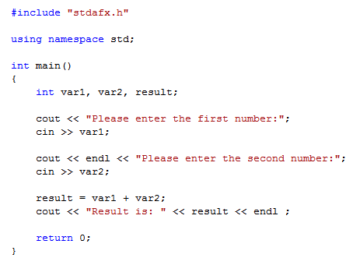

Some common elements in programming languages are Key Words, Programmer-Defined Identifiers, Operators, Punctuation and Syntax.

Keywords

Also known as reserved words and have a special meaning in C++. It cannot be used for any other purpose.

Some keywords from the example program

main
using
namespace
int
return
cout
cin

Identifiers

An identifier is a sequence of characters used to denote one of the following:

- Object or variable name
- Class, structure, or union name
- Enumerated type name
- Member of a class, structure, union, or enumeration
- Function or class-member function
- typedef name
- Label name
- Macro name
- Macro parameter

The following characters are legal as the first character of an identifier, or any subsequent character:

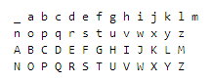

After the first character you may use alphabetic characters, numbers, or underscore characters. Upper- and lowercase characters are distinct.

Operators
Used to perform arithmetic, logical etc operations on data.
There are many types of operators, few are presented as example
  - Arithmetic + - * / %
  - Logical || & !
  - Assignment =
  - Conditional ?
  - Increment ++
  - Decrement --
Operators used in the example program + = << >>
Punctuation Marks
Characters that mark the end of the program and that separate items in the list.
Types of punctuation marks
- Logical ,
- Assignment ;
Punctuation used in the example program , ;
Variables
A variable is the name for a place in the computer's memory where you store some data. In order to use a variable in C++, we must first declare it specifying which data type we want it to be. The syntax to declare a new variable is to write the specifier of the desired data type (like int, bool, float...) followed by a valid variable identifier.
For example: int a; float mynumber;

These are two valid declarations of variables. The first one declares a variable of type int with the identifier a. The second one declares a variable of type float with the identifier mynumber. Once declared, the variables a and mynumber can be used within the rest of their scope in the program. If you are going to declare more than one variable of the same type, you can declare all of them in a single statement by separating their identifiers with commas. For example:
Int a, b, c;

This declares three variables (a, b and c), all of them of type int, and has exactly the same meaning as:

Int a;
Int b;
Int c;
When programming, we store the variables in our computer's memory, but the computer has to know what kind of data we want to store in them, since it is not going to occupy the same amount of memory to store a simple number than to store a single letter or a large number, and they are not going to be interpreted the same way.
The memory in our computers is organized in bytes. A byte is the minimum amount of memory that we can manage in C++. A byte can store a relatively small amount of data: one single character or a small integer (generally an integer between 0 and 255). In addition, the computer can manipulate more complex data types that come from grouping several bytes, such as long numbers or non-integer numbers.

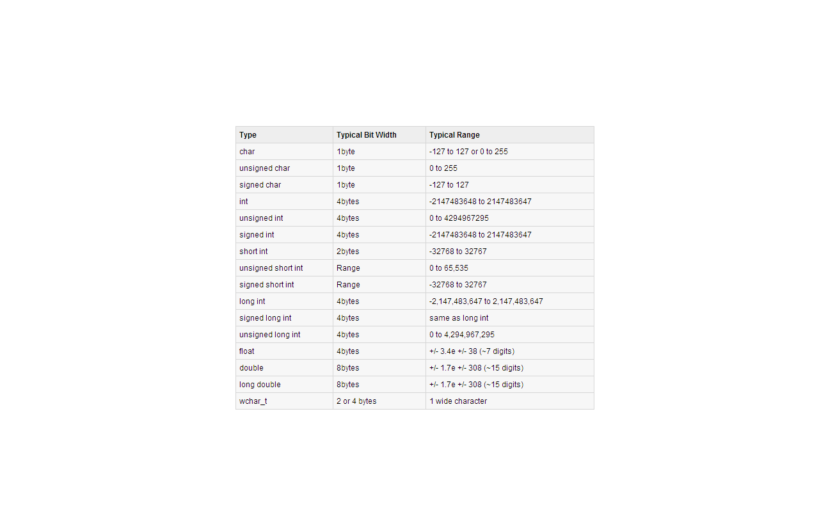
Preprocessor Directives

The first line of the program #include "stdafx.h" might look like a program statement, but it’s not. It isn’t part of a function body and doesn’t end with a semicolon, as program statements must. Instead, it starts with a number sign (#). It’s called a preprocessor directive. Recall that program statements are instructions to the computer to do something, such as adding two numbers or printing a sentence.

A preprocessor directive, on the other hand, is an instruction to the compiler. A part of the compiler called the preprocessor deals with these directives before it begins the real compilation process. The preprocessor directive #include tells the compiler to insert another file into your source file. In effect, the #include directive is replaced by the contents of the file indicated. Using an #include directive to insert another file into your source file is similar to pasting a block of text into a document with your word processor.

#include is only one of many preprocessor directives, all of which can be identified by the initial # sign. The use of preprocessor directives is not as common in C++ as it is in C, but we’ll look at a few additional examples as we go along. The type file usually included by #include is called a header file.

Lesson 04
Cout / Cin Objects, Using Directive, Escape Sequences, Looping & Decision Structures
C++ uses a convenient abstraction called streams to perform input and output operations in sequential media such as the screen or the keyboard. A stream is an object where a program can either insert or extract characters to/from it. We do not really need to care about many specifications about the physical media associated with the stream - we only need to know it will accept or provide characters sequentially.

The standard C++ library includes the header file iostream, where the standard input and output stream objects are declared. All the objects declared in this header share a peculiar property you can assume they are constructed before any static objects you define, in a translation unit that includes <iostream>. Equally, you can assume that these objects are not destroyed before the destructors for any such static objects you define. (The output streams are, however, flushed during program termination.) Therefore, you can safely read from or write to the standard streams before program startup and after program termination.

By default, the standard output of a program is the screen, and the C++ stream object defined to access it is cout. cout is used in conjunction with the insertion operator, which is written as << (two "less than" signs).

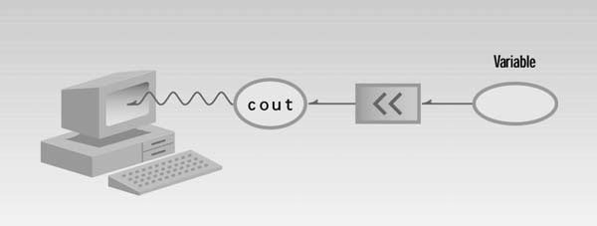

Examples
cout << "Output sentence"; // prints Output sentence on screen
cout << 120; // prints number 120 on screen
cout << x; // prints the content of x on screen

The << operator inserts the data that follows it into the stream preceding it. In the examples above it inserted the constant string Output sentence, the numerical constant 120 and variable x into the standard output stream cout. Notice that the sentence in the first instruction is enclosed between double quotes (") because it is a constant string of characters. Whenever we want to use constant strings of characters we must enclose them between double quotes (") so that they can be clearly distinguished from variable names.
The identifier cin (pronounced “C in”) is actually an object. It is predefined in C++ to correspond to the standard input stream in IOSTREAM File. This stream represents data coming from the keyboard unless it is redirected. The operator must be followed by the variable that will store the data that is going to be extracted from the stream.
Examples int age; cin >> age;
The first statement declares a variable of type int called age, and the second one waits for an input from cin (the keyboard) in order to store it in this integer variable.
cin can only process the input from the keyboard once the RETURN key has been pressed. Therefore, even if you request a single character, the extraction from cin will not process the input until the user presses RETURN after the character has been introduced.
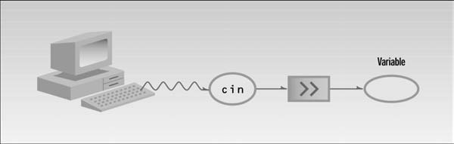
The using directive allows the names in a namespace to be used without the namespace-name as an explicit qualifier. Of course, the complete, qualified name can still be used to improve readability.
Various program components such as cout are declared within this namespace. If we didn’t use the using directive, we would need to add the std name to each program element belongs to that namespace.
For example, in our example program we’d need to say
std::cout << “Hello World”;
Character combinations consisting of a backslash (\) followed by a letter or by a combination of digits are called "escape sequences." To represent a newline character, single quotation mark, or certain other characters in a character constant, you must use escape sequences. An escape sequence is regarded as a single character and is therefore valid as a character constant.

Escape sequences are typically used to specify actions such as carriage returns and tab movements on terminals and printers. They are also used to provide literal representations of nonprinting characters and characters that usually have special meanings, such as the double quotation mark ("). The following table lists the ANSI escape sequences and what they represent.

Escape Sequence | Represents
\a | Bell (alert)
\b | Backspace
\f | Formfeed
\n | New line
\r | Carriage return
\t | Horizontal tab
\v | Vertical tab
\' | Single quotation mark
\ " | Double quotation mark
\\ | Backslash
\? | Literal question mark
\ ooo | ASCII character in octal notation
\x hh | ASCII character in hexadecimal notation
\x hhhh | Unicode character in hexadecimal notation if this escape sequence is used in a wide-character constant or a Unicode string literal.  For example, WCHAR f = L'\x4e00' or WCHAR b[] = L"The Chinese character for one is \x4e00".

Many activities in C++ are carried out by library functions. These functions perform file access, mathematical computations, and data conversion, among other things. Relationship between header and library files are bit confusing. To use a library function, like sqrt() which calculates and returns the square root of given integer, that particular library file must be linked that contains it to your program. The appropriate functions from the library file are then connected to program by the linker.
The C++ Standard Library can be categorized into two parts:
The Standard Function Library:

This library consists of general-purpose, stand-alone functions that are not part of any class. The function library is inherited from C.

The Object Oriented Class Library:

This is a collection of classes and associated functions.
Standard C++ Libarary incorporates all the Standard C libraries also, with small additions and changes to support type safety.
Loops causes a section of our program to be repeated a certain number of times. The repetition continues while a condition is true. When the condition becomes false, the loop ends and control passes to the statements following the loop.

The For Loop

The for loop is (for many people, anyway) the easiest C++ loop to understand. All
elements are gathered in one place, while in the other loop constructions they are scattered about the program, which can make it harder to unravel how these loops work. The for loop executes a section of code a fixed number of times. It’s usually used when you know, before entering the loop, how many times you want to execute the code.

Example that displays the squares of the numbers from 0 to 9

#include <iostream>
using namespace std;
int main()
{
int j; //define a loop variable
for(j=0; j<10; j++) //loop from 0 to 9
cout << j * j << “ “; //displaying the square of j
cout << endl;
return 0;
}

Here’s the output: 0 1 4 9 16 25 36 49 64 81 100 121 144 169 196

The for statement controls the loop. It consists of the keyword for, followed by parentheses that contain three expressions separated by semicolons:

for(j=0; j<15; j++)

These three expressions are the initialization expression, the test expression, and the increment expression.

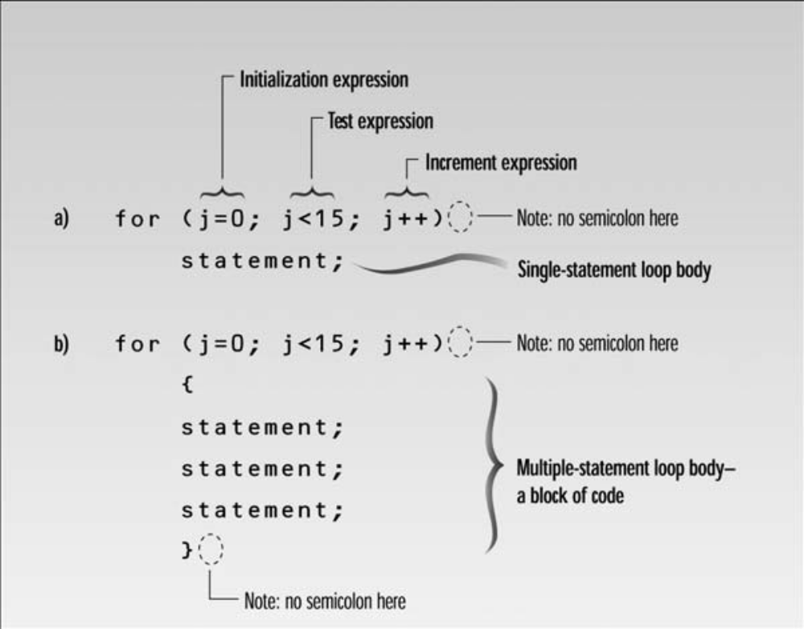

The While Loop

The for loop does something a fixed number of times. What happens if you don’t know how many times you want to do something before you start the loop? In this case a different kind of loop may be used: the while loop.

This Example asks the user to enter a series of numbers. When the number entered is 0, the loop terminates.

#include <iostream>
using namespace std;
int main()
{
int n = 99; // make sure n isn’t initialized to 0
while( n != 0 ) // loop until n is 0
cin >> n; // read a number into n
cout << endl;
return 0;
}

Here’s some sample output. The user enters numbers, and the loop continues until 0 is entered, at which point the loop and the program terminate.

1 27 33 144 9 0

Syntax of the while loop is as follows

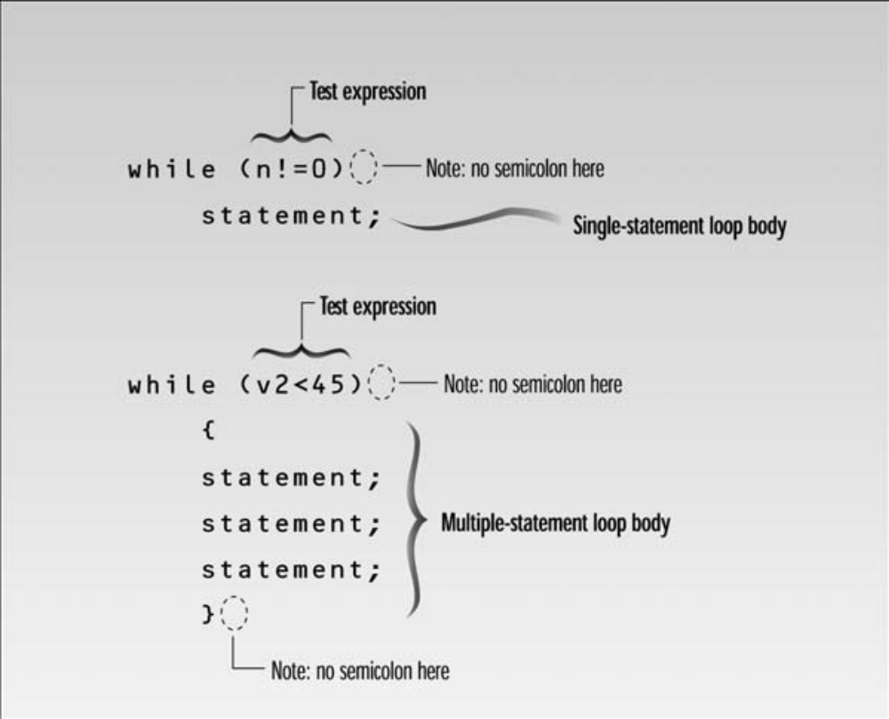

The Do While Loop

In a while loop, the test expression is evaluated at the beginning of the loop. If the test expression is false when the loop is entered, the loop body won’t be executed at all. In some situations this is what you want. But sometimes you want to guarantee that the loop body is executed at least once, no matter what the initial state of the test expression. When this is the case you should use the do loop, which places the test expression at the end of the loop.

Following example invites the user to enter two numbers: a dividend (the top number in a division) and a divisor (the bottom number). It then calculates the quotient (the answer) and the remainder, using the / and % operators, and prints out the result.

#include <iostream>
using namespace std;
int main()
{
long dividend, divisor;
char ch;
do //start of do loop
{ //do some processing
cout << “Enter dividend: “; cin >> dividend;
cout << “Enter divisor: “; cin >> divisor;
cout << “Quotient is “ << dividend / divisor;
cout << “, remainder is “ << dividend % divisor;
cout << “\nDo another? (y/n): “; //do it again?
cin >> ch;
}

while( ch != ‘n’ ); //loop condition
return 0;
}

When to Use Which Loop

We’ve made some general statements about how loops are used. The for loop is appropriate when you know in advance how many times the loop will be executed. The while and do loops are used when you don’t know in advance when the loop will terminate.

Decision Structures
Decision making structures require that the programmer specify one or more conditions to be evaluated or tested by the program, along with a statement or statements to be executed if the condition is determined to be true, and optionally, other statements to be executed if the condition is determined to be false.
Following is the general from of a typical decision making structure found in most of the programming languages:
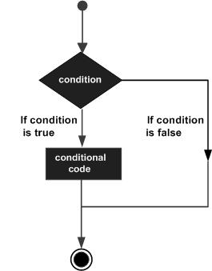

The if statement allows do something if a condition is true. If it isn’t true, nothing happens and controls transfer to the rest of next line of the looping structure. But suppose we want to do one thing if a condition is true, and do something else if it’s false.

That’s where the if...else statement comes in. It consists of an if statement, followed by a statement or block of statements, followed by the keyword else, followed by another statement or block of statements.
The structure of the If else is as follows

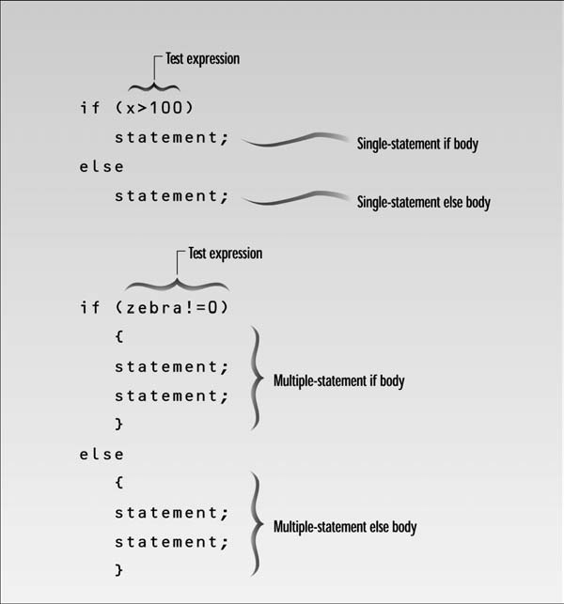

If we have a large decision tree, and all the decisions depend on the value of the same variable, we will probably want to consider a switch statement instead of a ladder of if...else or else if constructions.

The structure of the switch is as follows

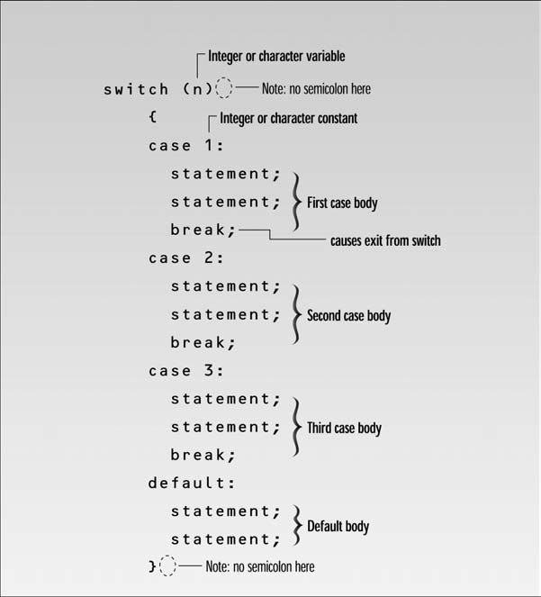

Lesson 05
Operator Precedence, Type Conversion & Casting, Bitwise Operators, L values & R values, Variable Scopes & Namespaces
Operator precedence orders the operators in a priority sequence. In any expression, operators with the highest precedence are always executed first, followed by operators with the next highest precedence, and so on, down to those with the lowest precedence of all.
The following table lists the precedence and associativity of C++ operators. Operators are listed top to bottom, in descending precedence.

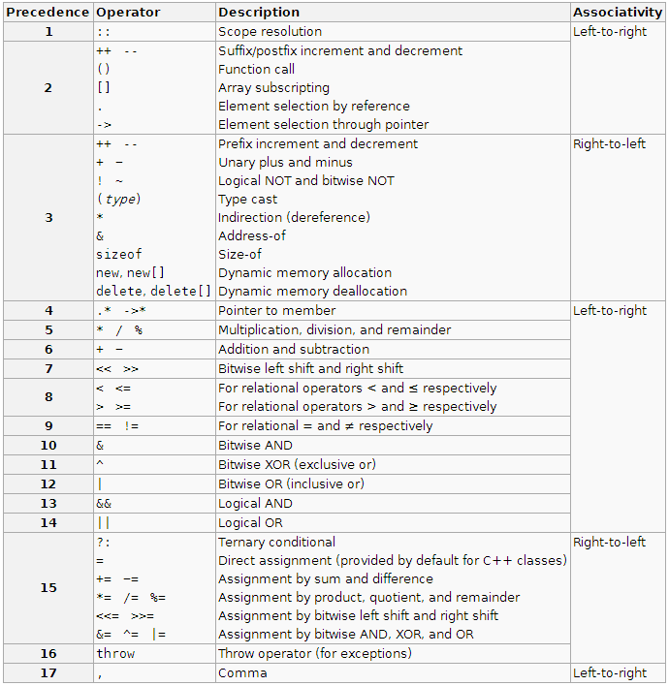

Calculations in C++ can be carried out only between values of the same type. When you write an expression involving variables or constants of different types, for each operation to be performed, the compiler has to arrange to convert the type of one of the operands to match that of the other.

This process is called implicit type conversion. For example, if you want to add a double value to a value of an integer type, the integer value is first converted to double, after which the addition is carried out. Of course, the variable that contains the value to be converted is, itself, not changed. The compiler will store the converted value in a temporary memory location, which will be discarded when the calculation is finished.

There are rules that govern the selection of the operand to be converted in any operation. Any expression to be calculated breaks down into a series of operations between two operands. For example, the expression 2*3 - 4+5 amounts to the series 2*3 resulting in 6 , 6 - 4 resulting in 2 , and finally 2+5 resulting in 7 .

Thus, the rules for converting the type of operands where necessary need to be defined only in terms of decisions about pairs of operands. So, for any pair of operands of different types, the compiler decides which operand to convert to the other considering types to be in the following rank from high to low:

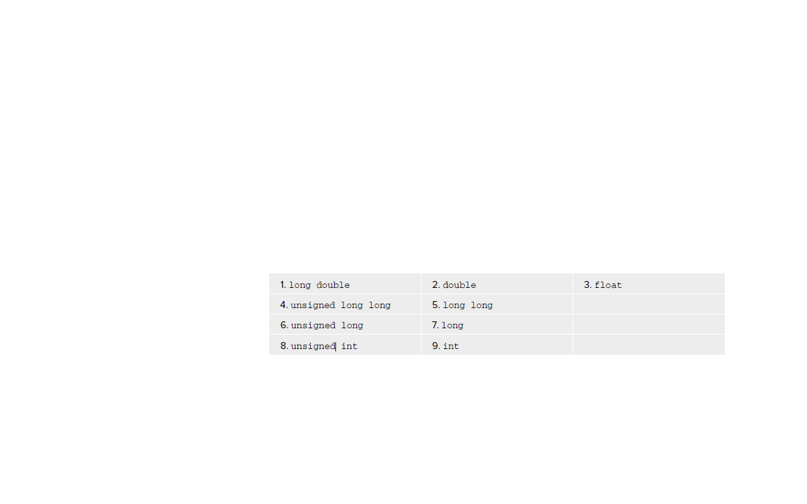
With mixed expressions involving the basic types, your compiler automatically arranges casting where necessary, but you can also force a conversion from one type to another by using an explicit type conversion, which is also referred to as a cast. To cast the value of an expression to a given type, you write the cast in the form: static_cast < the_type_to_convert_to > ( expression )

The keyword static_cast refl ects the fact that the cast is checked statically — that is, when your program is compiled. No further checks are made when you execute the program to see if this cast is safe to apply. Later, when you get to deal with classes, you will meet dynamic_cast , where the conversion is checked dynamically — that is, when the program is executing.

There are also two other kinds of cast — const_cast for removing the const-ness of an expression, and reinterpret_cast , which is an unconditional cast. The effect of the static_cast operation is to convert the value that results from evaluating expression to the type that you specify between the angled brackets. The expression can be anything from a single variable to a complex expression involving lots of nested parentheses.

Here ’ s a specific example of the use of static_cast < > ()

double value1 = 10.5;
double value2 = 15.5;
int whole_number = static_cast < int > (value1) + static_cast < int > (value2);

The initializing value for the variable whole_number is the sum of the integral parts of value1 and value2 , so they are each explicitly cast to type int . The variable whole_number will therefore have the initial value 25. The casts do not affect the values stored in value1 and value2 , which will remain as 10.5 and 15.5, respectively. The values 10 and 15 produced by the casts are just stored
temporarily for use in the calculation and then discarded. Although both casts cause a loss of information in the calculation, the compiler will always assume that you know what you are doing when you specify a cast explicitly.

Auto keyword can be used as the type of a variable in a definition statement and have its type deduced from the initial value you supply.
Here are some examples:

auto n = 16; // Type is int
auto pi = 3.14159; // Type is double
auto x = 3.5f; // Type is float
auto found = false; // Type is bool

In each case, the type assigned to the variable is the same as that of the literal used as the initializer. When you use the auto keyword in this way, you must supply an initial value for the variable.

Variables defined using the auto keyword can also be specified as constants:

const auto e = 2.71828L; // Type is const long double

You can also use functional notation:

const auto dozen(12); // Type is const int

The initial value for a variable you define using the auto keyword can also be an expression:

auto factor(n*pi*pi); // Type is double

In this case, the definitions for the variables n and pi that are used in the initializing expression must precede this statement.

The Bitwise Operators

The bitwise operators treat their operands as a series of individual bits rather than a numerical value. They work only with integer variables or integer constants as operands, so only data types short , int , long , long long , signed char , and char , as well as the unsigned variants of these, can be used.

The bitwise operators are useful in programming hardware devices, where the status of a device is often represented as a series of individual flags (that is, each bit of a byte may signify the status of a different aspect of the device), or for any situation where you might want to pack a set of on - off flags into a single variable.

There are six bitwise operators:

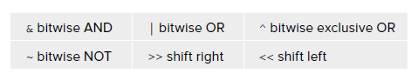

Every expression in C++ results in either an lvalue or an rvalue (sometimes written l - value and r - value and pronounced like that).

An lvalue refers to an address in memory in which something is stored on an ongoing basis. An rvalue, on the other hand, is the result of an expression that is stored transiently. An lvalue is so called because any expression that results in an l value can appear on the left of the equals sign in an assignment statement. If the result of an expression is not an lvalue, it is an rvalue.

Consider the following statements:

int a(0), b(1), c(2);
a = b + c;
b = ++a;
c = a++;

The first statement declares the variables a , b , and c to be of type int and initializes them to 0, 1, and 2, respectively.

In the second statement, the expression b+c is evaluated and the result is stored in the variable a. The result of evaluating the expression b+c is stored temporarily in a memory location and the value is copied from this location to a. Once execution of the statement is complete, the memory location holding the result of evaluating b+c is discarded. Thus, the result of evaluating the expression b+c is an rvalue.

In the third statement, the expression ++a is an lvalue because its result is a after its value is incremented. The expression a++ in the third statement is an rvalue because it stores the value of a temporarily as the result of the expression and then increments a.

An expression that consists of a single named variable is always an lvalue.

All variables have a finite lifetime when your program executes. They come into existence from the point at which you declare them and then, at some point, they disappear at the latest, when your program terminates. How long a particular variable lasts is determined by a property called its storage duration .

There are three different kinds of storage duration that a variable can have:

- Automatic storage duration
- Static storage duration
- Dynamic storage duration

Which of these a variable will have depends on how you create it. Another property that variables have is scope. The scope of a variable is simply that part of your program over which the variable name is valid. Within a variable’s scope, you can legally refer to it, either to set its value or to use it in an expression. Outside of the scope of a variable, you cannot refer to its name — any attempt to do so will cause a compiler error. Note that a variable may still exist outside of its scope, even though you cannot refer to it by name.

Namespaces allow to group entities like classes, objects and functions under a name. This way the global scope can be divided in "sub-scopes", each one with its own name. It provides a way to separate the names used in one part of a program from those used in another. This thing seems to valuable with large projects involving several teams of programmers working on different parts of the program. Each team can have its own namespace name, and worries about two teams accidentally using the same name for different functions disappear.

The format of namespaces is:
namespace identifier
{
entities
}
Where identifier is any valid identifier and entities is the set of classes, objects and functions that are included within the namespace. For example:
namespace myNamespace
{
int a, b;
}
In this case, the variables a and b are normal variables declared within a
namespace called myNamespace. In order to access these variables from
outside the myNamespace namespace we have to use the scope operator ::.

For example, to access the previous variables from outside myNamespace we
can write:
myNamespace::a
myNamespace::b

Lesson 06
Structures, Enumerations & Functions
A structure is a collection of simple variables. The variables in a structure can be of different types: Some can be int, some can be float, and so on.

The data items in a structure are called the members of the structure. Structures are one of the two important building blocks in the understanding of objects and classes. In fact, the syntax of a structure is almost identical to that of a class. A structure (as typically used) is a collection of data, while a class is a collection of both data and functions.

Structures are declared in C++ using the following syntax
struct structurename
{
member_type1 member_name1;
member_type2 member_name2;
member_type3 member_name3;
} object_name;

where structure_name is a name for the structure type, object_name can be a set of valid identifiers for objects that have the type of this structure. Within braces { } there is a list with the data members, each one is specified with a type and a valid identifier as its name. The above structure declaration is also called Structure Specifier.
Declaring structures does not mean that memory is allocated. Structure declaration gives a skeleton or template for the structure.
It is important to clearly differentiate between what is the structure type name, and what is an object (variable) that has this structure type. We can instantiate many objects (i.e. variables, like Engine, Handle and Excel) from a single structure type (part).
Example structure program

#include <iostream>
using namespace std;

struct part //declare a structure
{
int modelnumber; //ID number of widget
int partnumber; //ID number of widget part
float cost; //cost of part
};

int main()
{
part part1; //define a structure variable
part1.modelnumber = 6244; //give values to structure members
part1.partnumber = 373;
part1.cost = 217.55F;
//display structure members
cout << “Model “ << part1.modelnumber;
cout << “, part “ << part1.partnumber;
cout << “, costs $” << part1.cost << endl;
return 0;
}

The program’s output looks like this:
Model 6244, part 373, costs $217.55

The keyword struct introduces the structure definition. Next comes the structure name or tag, which is part. The declarations of the structure members model number, part number, and cost are enclosed in braces. A semicolon follows the closing brace, terminating the entire structure. Note that this use of the semicolon for structures is unlike the usage for a block of code. As we’ve seen, blocks of code, which are used in loops, decisions, and functions, are also delimited by braces. However, they don’t use a semicolon following the final brace.

Following figure shows the syntax of the structure declaration.

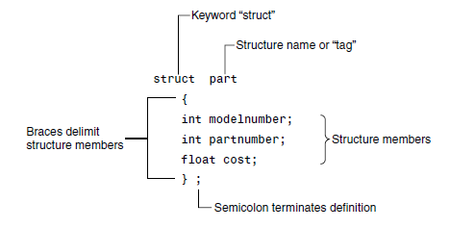
The first statement in main()

part part1;

defines a variable, called part1, of type structure part. This definition reserves space in memory for part1. How much space? In this case there will be 4 bytes for each of the two ints (assuming a 32-bit system), and 4 bytes for the float.

Once a structure variable has been defined, its members can be accessed using something called the dot operator.

Here’s how the first member is given a value:

part1.modelnumber = 6244;

Structure members are treated just like other variables. In the statement part1.modelnumber = 6244;, the member is given the value 6244 using a normal assignment operator. The program also shows members used in cout statements such as

cout << “\nModel “ << part1.modelnumber;

These statements output the values of the structure members.

Enumerations

As we’ve seen, structures can be looked at as a way to provide user-defined data types. A different approach to defining your own data type is the enumeration. This feature of C++ is less crucial than structures. You can write perfectly good object-oriented programs in C++ without knowing anything about enumerations. However, they are very much in the spirit of C++, in that, by allowing you to define your own data types, they can simplify and clarify your programming.

Here’s an example program, DAYENUM, that uses an enumeration for the days of the week:

#include <iostream>
using namespace std;

//specify enum type

enum days_of_week { Sun, Mon, Tue, Wed, Thu, Fri, Sat };

int main()
{
days_of_week day1, day2; //define variables of type days_of_week
day1 = Mon; //give values to
day2 = Thu; //variables
int diff = day2 - day1; //can do integer arithmetic
cout << “Days between = “ << diff << endl;
if(day1 < day2) //can do comparisons
cout << “day1 comes before day2\n”;
return 0;
}

An enum declaration defines the set of all names that will be permissible values of the type. These permissible values are called enumerators. The enum type days_of_week has seven enumerators: Sun, Mon, Tue, and so on, up to Sat.

Following figure shows the syntax of an enum declaration.

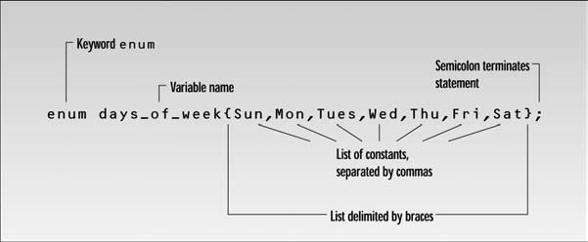

Functions

A function groups a number of program statements into a unit and gives it a name. This unit can then be invoked from other parts of the program. The most important reason to use functions is to aid in the conceptual organization of a program.

Any sequence of instructions that appears in a program more than once is a candidate for being made into a function. The function’s code is stored in only one place in memory, even though the function is executed many times in the course of the program. Functions in C++ (and C) are similar to subroutines and procedures in various other languages.

Following figure shows how a function is invoked from different sections of a program.

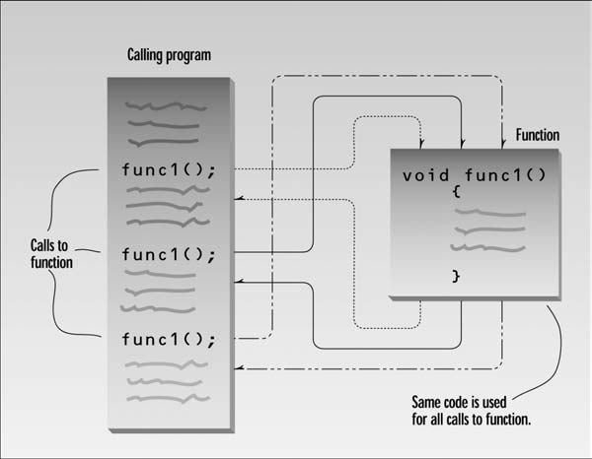

Our first example demonstrates a simple function whose purpose is to print a line of 45 asterisks.

#include <iostream>
using namespace std;

void starline(); //function declaration

// (prototype)

int main()
{
starline(); //call to function
cout << “Data type Range” << endl;
starline(); //call to function
cout << “char -128 to 127” << endl
<< “short -32,768 to 32,767” << endl
<< “int System dependent” << endl
<< “long -2,147,483,648 to 2,147,483,647” << endl;
starline(); //call to function
return 0;
}

// starline()
// function definition

void starline() //function declarator
{
for(int j=0; j<45; j++) //function body
cout << ‘*’;
cout << endl;
}

The output from the program looks like this:

*********************************************
Data type Range
*********************************************
char -128 to 127
short -32,768 to 32,767
int System dependent
long -2,147,483,648 to 2,147,483,647
*********************************************

When the function is called, control is transferred to the first statement in the function body. The other statements in the function body are then executed, and when the closing brace is encountered, control returns to the calling program.

Lesson 07
Passing Arguments to Functions, Function Overloading, Recursion & Inline Functions
Passing arguments to functions
An argument is a piece of data (an int value, for example) passed from a program to the function. Arguments allow a function to operate with different values, or even to do different things, depending on the requirements of the program calling it.

Passing constants

#include <iostream>
using namespace std;

void repchar(char, int); //function declaration

int main()
{
repchar(‘-’, 43); //call to function
cout << “Data type Range” << endl;
repchar(‘=’, 23); //call to function
cout << “char -128 to 127” << endl
<< “short -32,768 to 32,767” << endl
<< “int System dependent” << endl
<< “double -2,147,483,648 to 2,147,483,647” << endl;
repchar(‘-’, 43); //call to function
return 0;
}
//--------------------------------------------------------------
// repchar() function definition

void repchar(char ch, int n) //function declarator
{
for(int j=0; j<n; j++) //function body
cout << ch;
cout << endl;
}

The new function is called repchar(). Its declaration looks like this:

void repchar(char, int); // declaration specifies data types

The items in the parentheses are the data types of the arguments that will be sent to repchar(): char and int. In a function call, specific values—constants in this case—are inserted in the appropriate place in the parentheses:

repchar(‘-’, 43); // function call specifies actual values

This statement instructs repchar() to print a line of 43 dashes. The values supplied in the call must be of the types specified in the declaration: the first argument, the - character, must be of type char; and the second argument, the number 43, must be of type int. The types in the declaration and the definition must also agree.

Passing Variables

Let’s look at an example where variables, instead of constants, are passed as arguments. Following program incorporates the same repchar() function but lets the user specify the character and the number of times it should be repeated.

// It demonstrates variable arguments
#include <iostream>
using namespace std;
void repchar(char, int); //function declaration
int main()
{
char chin;
int nin;
cout << “Enter a character: “;
cin >> chin;
cout << “Enter number of times to repeat it: “;
cin >> nin;
repchar(chin, nin);
return 0;
}

// repchar()
// function definition

void repchar(char ch, int n) //function declarator
{
for(int j=0; j<n; j++) //function body
cout << ch;
cout << endl;
}

Here’s some sample interaction with VARARG:

Enter a character: +
Enter number of times to repeat it: 20
++++++++++++++++++++

Here chin and nin in main() are used as arguments to repchar():

repchar(chin, nin); // function call

The data types of variables used as arguments must match those specified in the function declaration and definition, just as they must for constants. That is, chin must be a char, and nin must be an int.

When a function completes its execution, it can return a single value to the calling program. Usually this return value consists of an answer to the problem the function has solved.

Passing by Reference

A reference provides an alias a different name for a variable. One of the most important uses for references is in passing arguments to functions. We’ve seen examples of function arguments passed by value. When arguments are passed by value, the called function creates a new variable of the same type as the argument and copies the argument’s value into it. As we noted, the function cannot access the original variable in the calling program, only the copy it created. Passing arguments by value is useful when the function does not need to modify the original variable in the calling program.

In fact, it offers insurance that the function cannot harm the original variable. Passing arguments by reference uses a different mechanism. Instead of a value being passed to the function, a reference to the original variable, in the calling program, is passed.

An important advantage of passing by reference is that the function can access the actual variables in the calling program. Among other benefits, this provides a mechanism for passing more than one value from the function back to the calling program.

Function overloading

Function overloading allows using same function name for defining several functions as long as they each have different parameter lists. When the function is called, the compiler chooses the correct version for the job based on the list of arguments you supply. The compiler must always be able to decide unequivocally which function should be selected in any particular instance of a function call, so the parameter list for each function in a set of overloaded functions must be unique.

Const Function Arguments

Arguments passing by reference can be used to allow a function to modify a variable in the calling program. Main reason why passing by reference used is efficiency, but you don’t want the function to modify it. Here const modifier is used with the variable in the function declaration, to guarantee such thing.

void aFunc(int& a, const int& b); //declaration
{
a = 107; // its OK
b = 111; //error: can’t modify constant argument
}

Recursion

The existence of functions makes possible a programming technique called recursion. Recursion involves a function calling itself. This sounds rather improbable, and indeed a function calling itself is often a bug. However, when used correctly this technique can be surprisingly powerful.

//calculates factorials using recursion

#include <iostream>
using namespace std;

unsigned long factfunc(unsigned long); //declaration

int main()
{
int n; //number entered by user
unsigned long fact; //factorial
cout << “Enter an integer: “;
cin >> n;
fact = factfunc(n);
cout << “Factorial of “ << n << “ is “ << fact << endl;
return 0;
}
// factfunc()
// calls itself to calculate factorials

unsigned long factfunc(unsigned long n)
{
if(n > 1)
return n * factfunc(n-1); //self call
else
return 1;
}

Every recursive function must be provided with a way to end the recursion. Otherwise it will call itself forever and crash the program. The if statement in factfunc() plays this role, terminating the recursion when n is 1.

Inline Functions

Generally functions save memory space because all the calls to the function cause the same code to be executed; the function body need not be duplicated in memory. When the compiler sees a function call, it normally generates a jump to the function. At the end of the function it jumps back to the instruction following the call. While this sequence of events may save memory space, it takes some extra time. There must be an instruction for the jump to the function, instructions for saving registers, instructions for pushing arguments onto the stack in the calling program and removing them from the stack in the function (if there are arguments), instructions for restoring registers, and an instruction to return to the
calling program. The return value (if any) must also be dealt with. All these instructions slow down the program.

To save execution time in short functions, you may elect to put the code in the function body directly inline with the code in the calling program. That is, each time there’s a function call in the source file, the actual code from the function is inserted, instead of a jump to the function.

Long sections of repeated code are generally better off as normal functions: The savings in memory space is worth the comparatively small sacrifice in execution speed. But making a short section of code into an ordinary function may result in little savings in memory space, while imposing just as much time penalty as a larger function. In fact, if a function is very short, the instructions necessary to call it may take up as much space as the instructions within the function body, so that there is not only a time penalty but a space penalty as well.

In such cases you could simply repeat the necessary code in your program, inserting the same group of statements wherever it was needed. The trouble with repeatedly inserting the same code is that you lose the benefits of program organization and clarity that come with using functions. The program may run faster and take less space, but the listing is longer and more complex.

The solution to this quandary is the inline function. This kind of function is written like a normal function in the source file but compiles into inline code instead of into a function. The source file remains well organized and easy to read, since the function is shown as a separate entity. However, when the program is compiled, the function body is actually inserted into the program wherever a function call occurs. It’s easy to make a function inline: All you need is the keyword inline in the function definition:

For Example inline float lbstokg(float pounds)

Lesson 08
Arrays, C-Strings & Buffer Overflow in Strings
Arrays are like structures in that they both group a number of items into a larger unit. But while a structure usually groups items of different types, an array groups items of the same type. More importantly, the items in a structure are accessed by name, while those in an array are accessed by an index number. Using an index number to specify an item allows easy access to a large number of items.
Arrays exist in almost every computer language. Arrays in C++ are similar to those in other languages, and identical to those in C.

The items in an array are called elements (in contrast to the items in a structure, which are called members).

Array Example Program

#include <iostream>
using namespace std;
int main()
{ int age[4]; //array ‘age’ of 4 ints
for(int j=0; j<4; j++) //get 4 ages
{
cout << “Enter an age: “;
cin >> age[j]; //access array element
}
for(int j=0; j<4; j++) //display 4 ages
cout << “You entered “ << age[j] << endl;
return 0;
}

- Here’s a sample interaction with the program:

Enter an age: 44
Enter an age: 16
Enter an age: 23
Enter an age: 68

You entered 44
You entered 16
You entered 23
You entered 68

Following figure shows the syntax or array age.

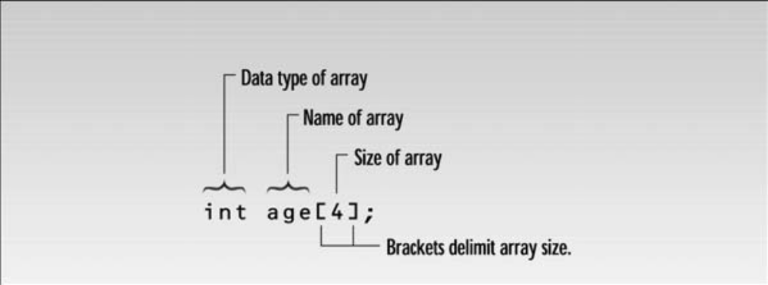

Following figure shows the elements of the array age.

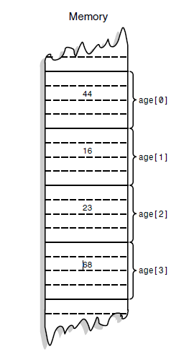

In the example we access each array element twice. The first time, we insert a value into the array, with the line

cin >> age[j];

The second time, we read it out with the line

cout << “\nYou entered “ << age[j];

In both cases the expression for the array element is age[j]

This consists of the name of the array, followed by brackets delimiting a variable j. Which of the four array elements is specified by this expression depends on the value of j; age[0] refers to the first element, age[1] to the second, age[2] to the third, and age[3] to the fourth. The variable (or constant) in the brackets is called the array index. Since j is the loop variable in both for loops, it starts at 0 and is incremented until it reaches 3, thereby accessing each of the array elements in turn.

So far we’ve looked at arrays of one dimension: A single variable specifies each array element. But arrays can have higher dimensions. Here’s a program that uses a two-dimensional array to store sales figures for several districts and several months

// displays sales chart using 2-d array
#include <iostream>
#include <iomanip> //for setprecision, etc.
using namespace std;
const int DISTRICTS = 4; //array dimensions
const int MONTHS = 3;

int main()
{
int d, m;
double sales[DISTRICTS][MONTHS]; //two-dimensional array
cout << endl;
for(d=0; d<DISTRICTS; d++) //get array values
for(m=0; m<MONTHS; m++)
{
cout << “Enter sales for district “ << d+1;
cout << “, month “ << m+1 << “: “;
cin >> sales[d][m]; //put number in array
}

cout << “\n\n”; cout << “ Month\n”; cout << “ 1 2 3”;
for(d=0; d<DISTRICTS; d++)
{
cout <<”\nDistrict “ << d+1;
for(m=0; m<MONTHS; m++) //display array values
cout << setiosflags(ios::fixed)
<< setiosflags(ios::showpoint) //always use point
<< setprecision(2) //digits to right
<< setw(10) //field width
<< sales[d][m]; //get number from array
} //end for(d)
cout << endl;
return 0;
} //end main

Graphical representation of two dimensional array.

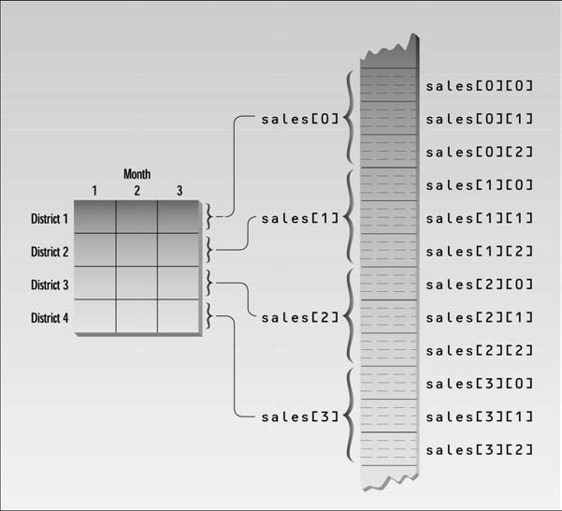

Arrays can be used as arguments to functions.

C-Strings are arrays of type char. Like other data types strings can be variable or constant.

An example program

#include <iostream>
using namespace std;
int main()
{
const int MAX = 80; //max characters in string
char str[MAX]; //string variable str
cout << “Enter a string: “;
cin >> str; //put string in str
cout << “You entered: “ << str << endl; //display string from str
return 0;
}

The definition of the string variable str looks like (and is) the definition of an array of type char:

char str[MAX];

We use the extraction operator >> to read a string from the keyboard and place it in the string variable str. This operator knows how to deal with strings; it understands that they are arrays of characters.

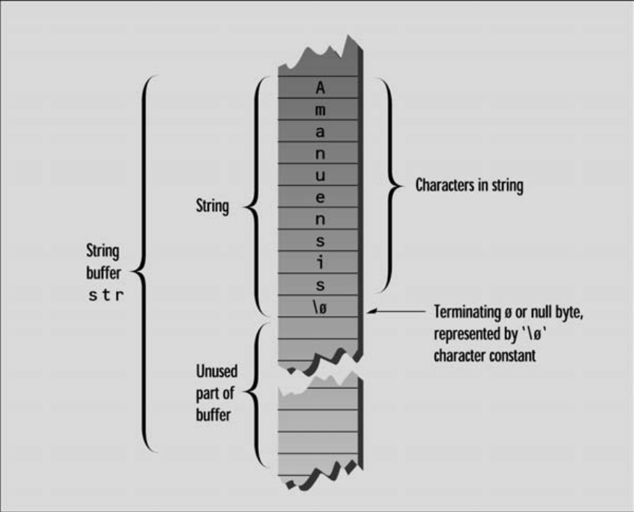

Each character occupies 1 byte of memory. An important aspect of C-strings is that they must terminate with a byte containing 0. This is often represented by the character constant ‘\0’, which is a character with an ASCII value of 0. This terminating zero is called the null character. When the << operator displays the string, it displays characters until it encounters the null character.

The above program invites the user to type in a string. What happens if the user enters a string that is longer than the array used to hold it? There is no built-in mechanism in C++ to keep a program from inserting array elements outside an array. So an overly enthusiastic typist could end up crashing the system.
However, it is possible to tell the >> operator to limit the number of characters it places in an array.

The following program demonstrates this approach.

// safetyin.cpp avoids buffer overflow with cin.width
#include <iostream>
#include <iomanip> //for setw
using namespace std;
int main()
{
const int MAX = 20; //max characters in string
char str[MAX]; //string variable str
cout << “\nEnter a string: “;
cin >> setw(MAX) >> str; //put string in str,
// no more than MAX chars
cout << “You entered: “ << str << endl;
return 0;
}

This program uses the setw manipulator to specify the maximum number of characters the input buffer can accept. The user may type more characters, but the >> operator won’t insert them into the array. Actually, one character fewer than the number specified is inserted, so there is room in the buffer for the terminating null character. Thus, in this program a maximum of 19 characters are inserted.

A string can be initialized with a constant value when it is defined.

char str[ ] = “Farewell! thou art too dear for my possessing.”;

A string can also be copied using strcpy() function. If there are arrays of arrays, of course there can be arrays of strings. This is actually quite a useful construction.

Lesson 09
Pointers, Classes & C++/CLI Programming
Pointers

Each memory location to store a data value has an address. A pointer is a variable that stores the address of another variable of a particular type. A pointer has a variable name just like any other variable and also has a type that designates what kind of variables its contents refer to. The type of a pointer variable includes the fact that it’s a pointer.

The declaration for a pointer is similar to that of an ordinary variable, except that the pointer name has an asterisk in front of it to indicating that it’s a variable, that is a pointer.
For example, to declare a pointer pnum of type long:
long* pnum;
It can also be written as, Compiler will not mind ;)
long *pnum; //convention in C++
Declarations of ordinary variables and pointers can be mixed in the similar statement.
long* pnumber, number (99);
We can find the address occupied by a variable by using the address-of operator &. Lets see an example program.
#include <iostream>
using namespace std;
int main()
{
int var1 = 11; //define and initialize
int var2 = 22; //three variables
int var3 = 33;
cout << &var1 << endl //print the addresses
<< &var2 << endl //of these variables
<< &var3 << endl;
return 0;
}

This simple program defines three integer variables and initializes them to the values 11, 22,and 33. It then prints out the addresses of these variables. The actual addresses occupied by the variables in a program depend on many factors, such as the computer the program is running on, the size of the operating system, and whether any other programs are currently in memory. For these reasons you probably won’t get the same addresses we did when you run this program.

Here’s the output on our machine:

0x8f4ffff4 ← address of var1
0x8f4ffff2 ← address of var2
0x8f4ffff0 ← address of var3

Remember that the address of a variable is not at all the same as its contents. The contents of the three variables are 11, 22, and 33. Following figure shows the three variables in memory.

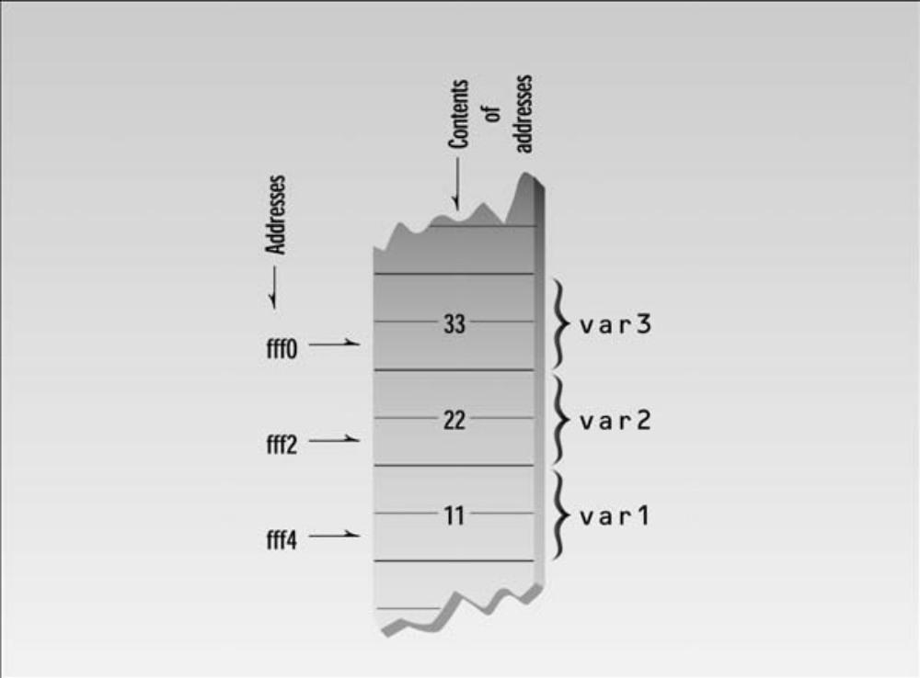

The << insertion operator interprets the addresses in hexadecimal arithmetic, as indicated by the prefix 0x before each number. This is the usual way to show memory addresses.

Taking the address of a variable and storing it in a pointer is all very well, but the really interesting aspect is how we can use it. Fundamental to using a pointer is accessing the data value in the variable to which a pointer points. This is done using the indirection operator * . The name ‘indirection operator’ stems from the fact that the data is accessed indirectly.

One aspect of this operator that can seem confusing is the fact that it has several different uses. i.e it can be used as the multiply operator, It serves as the indirection operator and it is also used in the declaration of a pointer. Each time it is used, compiler is able to distinguish its meaning by the context.

Using pointers that aren’t initialized is extremely hazardous. Random areas of memory can easily be overwritten through an uninitialized pointer.

This is the way to initialize a pointer

int number(0); // Initialized integer variable
int* pnumber( & number); // Initialized pointer

In case, you don’t want to initialize with the address of a specific variable, it can be initialized with the pointer equivalent of zero. For this, Visual C++ provides the literal nullptr, a pointer literal that does not point to anything.

int* pnumber(nullptr); // Pointer not pointing to anything

Classes

A class is a specification of a data type. It can contain data elements that can either be variables of the basic types in C++, or of other user - defined types. The data elements of a class may be single data elements, arrays, pointers, arrays of pointers, or objects of other classes. A class also can contain functions that operate on objects of the class by accessing the data elements that they include.
A class combines both the definition of the elementary data that makes up an object and the means of manipulating the data that belongs to individual objects of the class (functions).

The data and functions within a class are called members of the class. The member functions of a class are also sometimes referred to as methods

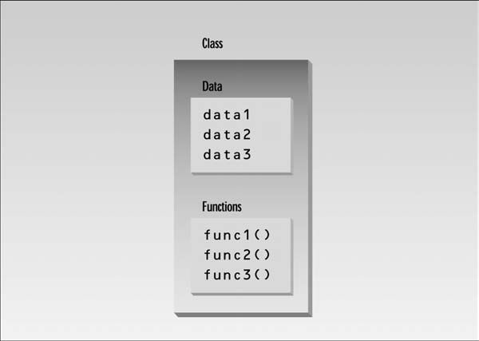

When you define a class, you define a blueprint for a data type. This doesn’t actually define any data, but it does define what the class name means, that is, what an object of the class will consist of and what operations can be performed on such an object. It’s much the same as if you wrote a description of the basic type double. This wouldn’t be an actual variable of type double, but a definition of how it’s made up and how it operates. To create a variable of a basic data type, you need to use a declaration statement.

class CBox
{
public:
double m_Length; // Length of a box in inches
double m_Width; // Width of a box in inches
double m_Height; // Height of a box in inches

// Function to calculate the volume of a box
double Volume()
{ return m_Length*m_Width*m_Height; }

};
The public keyword determines the access attributes of the members of the class that follow it. Specifying the data members as public means that these members of an object of the class can be accessed anywhere within the scope of the class object to which they belong.
You can also specify the members of a class as private or protected. Default attribute is private. Only difference between a class and a struct is that Default access specifier for a struct is public

CLR Programming
We wrote native C++ programs in the version of C++ defined by the ISO/IEC (International Standards Organization / International Electrotechnical Commision) language standard.
Now we will write applications to run under the control of the CLR in an extended version of C++ called C++/CLI. The Common Language Runtime (CLR) is the Microsoft implementation of the Common Language Infrastructure (CLI) standard. These programs will be referred as CLR programs or C++/CLI programs.
The CLI is a specification for a virtual machine environment that enables applications written in diverse high - level programming languages to be executed in different system environments without the original source code’s being changed or replicated. The CLI specifies a standard intermediate language for the virtual machine to which the high - level language source code is compiled.

Lesson 10
Classes, Friend’s Functions, The pointer this, Destructor & C++/CLI Programming
Classes..
A class constructor is a special function in a class that is responsible for creating new objects when required. A constructor, therefore, provides the opportunity to initialize objects as they are created and to ensure that data members only contain valid values. A class may have several constructors, enabling you to create objects in various ways.

You have no leeway in naming the constructors in a class they always have the same name as the class in which they are defined. The function CBox(), for example, is a constructor for our class CBox. It also has no return type. It’s wrong to specify a return type for a constructor; you must not even write it as void. The primary purpose of a class constructor is to assign initial values to the data elements of the class, and no return type for a constructor is necessary or permitted. If you inadvertently specify a return type for a constructor, the compiler will report it as an error with error number C2380.

Implementation of a constructor

// Using a constructor
#include <iostream>
Using namespace std;
class CBox // Class definition at global scope
{
public:
double m_Length;
double m_Width;
double m_Height;
// Constructor definition
CBox(double lv, double bv, double hv)
{
cout << endl << “Constructor called.”;
m_Length = lv; // Set values of data members
m_Width = bv;
m_Height = hv;
}
// Function to calculate the volume of a box
double Volume()
{ return m_Length* m_Width* m_Height; }
};

int main()
{
CBox box1(78.0,24.0,18.0); // Declare and initialize box1
CBox cigarBox(8.0,5.0,1.0); // Declare and initialize cigarBox
double boxVolume(0.0); // Stores the volume of a box
boxVolume = box1.Volume(); // Calculate volume of box1
cout << endl << “Volume of box1 = “ << boxVolume;
cout << endl << “Volume of cigarBox = “<< cigarBox.Volume();
cout << endl;
return 0;
}

A default constructor is one that does not require any arguments to be supplied, or one whose arguments are all optional.

CBox() // Default constructor
{ } // Totally devoid of statements

A no-argument constructor can initialize data members to constant values & a multi-argument constructor can initialize data members to values passed as arguments. It can be initialized with another object of the same type. It’s called the default copy constructor. It’s a one argument constructor whose argument is an object of the same class as the constructor.

CBox box2(box1); CBox box2 = box1;

A constructor that sets the values of the data members of a class object, but still admits the possibility of any part of a program being able to mess with what are essentially the guts of an object, is almost a contradiction in terms. Protection is needed for class data members.

Private Keyword: Class members that are private can, in general, be accessed only by member functions of a class. A normal function has no direct means of accessing the private members of a class.

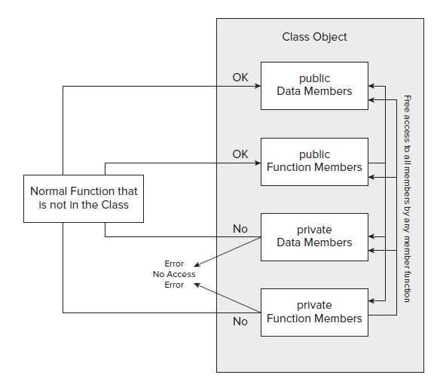

There may be circumstances when, for one reason or another, you want certain selected functions that are not members of a class to, nonetheless, be able to access all the members of a class — a sort of elite group with special privileges. Such functions are called friend functions of a class and are defined using the keyword friend. You can either include the prototype of a friend function in the class definition, or you can include the whole function definition. Functions that are friends of a class and are defined within the class definition are also, by default, inline.

Friend functions are not members of the class, and therefore, the access attributes do not apply to them. They are just ordinary global functions with special privileges.

A function can be declared friend function as follows. Either includes the prototype of a friend function in the class definition, or you can include the whole function definition.

friend double BoxSurface(Cbox aBox);

In the CBox class, you wrote the Volume() function in terms of the class member names in the definition of the class. Of course, every object of type CBox that you create contains these members, so there has to be a mechanism for the function to refer to the members of the particular object for which the function is called. When any member function executes, it automatically contains a hidden pointer with the name this, which points to the object used with the function call. Therefore, when the member m_Length is accessed in the Volume() function during execution, it ’ s actually referring to this - > m_Length , which is the fully specifi ed reference to the object member that is being used. The compiler takes care of adding the necessary pointer name this to the member names in the function.
If you need to, you can use the pointer this explicitly within a member function. You might, for example, want to return a pointer to the current object.

As constructor is called automatically when a object is created, similarly there is another function, which is called automatically when an object is destroyed. It is known as Destructor. A destructor has the same name as the constructor (which is the same as the class name) but is preceded by a tilde:

~Cbox () { }

CLR Programming Fundamental Data Types
You can and should use the ISO/IEC C++ fundamental data type names in your C++/CLI programs, and with arithmetic operations, they work exactly as you have seen in native C++. Although all the operations with fundamental types you have seen work in the same way in C++/CLI, the fundamental type names in a C++/CLI program have a different meaning and introduce additional capabilities in certain situations. A fundamental type in a C++/CLI program is a value class type and can behave either as an ordinary value or as an object if the circumstances require it.

Within the C++/CLI language, each ISO/IEC fundamental type name maps to a value class type that is defined in the System namespace. Thus, in a C++/CLI program, the ISO/IEC fundamental type names are shorthand for the associated value class type. This enables the value of a fundamental type to be treated simply as a value or be automatically converted to an object of its associated value class type when necessary.

Because the ISO/IEC C++ fundamental type names are aliases for the value class type names in a C++/CLI program, in principle, you can use either in your C++/CLI code.

Ex ISO/IEC C++
int count = 10;
double value = 2.5;

But in C++ / CLI, it is like this:

System::Int32 count = 10;
System::Double value = 2.5;
Example Program

#include "stdafx.h"
using namespace System;
int main(array < System::String ^ > ^args)
{
int apples, oranges; // Declare two integer variables
int fruit; // ...then another one
apples = 5; oranges = 6; // Set initial values
fruit = apples + oranges; // Get the total fruit
Console::WriteLine(L"\nOranges are not the only fruit...");
Console::Write(L"- and we have ");
Console::Write(fruit);
Console::Write(L" fruits in all.\n");
return 0;
}

The Write() and WriteLine() function is a C++/CLI function is defined in the Console class in the System namespace. Both the Console::Write() and Console::WriteLine() functions have a facility for you to control the format of the output, and the mechanism works in exactly the same way with both.

First, look at how you can get the output that was produced by the three output statements in the previous section with a single statement:

int packageCount = 25;
Console::WriteLine(L"There are {0} packages.", packageCount);

The second statement here will output the same output as you saw in the previous section. The first argument to the Console::WriteLine() function here is the string L “ There are {0} packages. ” , and the bit that determines that the value of the second argument should be placed in the string is “ {0}. ” The braces enclose a format string that applies to the second argument to the function, although in this instance, the format string is about as simple as it could get, being just a zero.

The arguments that follow the first argument to the Console::WriteLine() function are numbered in sequence starting with zero, like this:

referenced by: 0 1 2 etc.
Console::WriteLine("Format string", arg2, arg3, arg4,... );

Thus, the zero between the braces in the previous code fragment indicates that the value of the packageCount argument should replace the {0} in the string that is to be written to the command line.

If you want to output the weight as well as the number of packages, you could write this:

int packageCount = 25;
double packageWeight = 7.5;
Console::WriteLine(L"There are {0} packages weighing {1} pounds.",
packageCount, packageWeight);

The output statement now has three arguments, and the second and third arguments are referenced by 0 and 1, respectively, between the braces. So, this will produce the output:

There are 25 packages weighing 7.5 pounds.

You could also write the statement with the last two arguments in reverse sequence, like this:

Console::WriteLine(L"There are {1} packages weighing {0} pounds.",
packageWeight, packageCount);

The packageWeight variable is now referenced by 0 and packageCount by 1 in the format string, and the output will be the same as previously.

Lesson 11
Constant Objects, Arrays of Objects, Static Data / Function Members, Unions, CLI - Formatting the output & Using safe_cast
When an object is declared as const, it can’t be modified. It follows that only const member functions with it, because they’re the only ones that guarantee not to modify it. To create class objects that are fixed from time to time, just like values such as pi or inchesPerFoot that might declare as const double.

A constant object can be defined as
.
const CBox standard(3.0, 5.0, 8.0);

A const member function guarantees that it will never modify any of its class’s member data. An object is declared as const will always have a this pointer that is const, so the compiler will not allow any member function to be called that does not assume the this pointer that is passed to it is const .

To make this pointer in a member function const, declare the function as const within the class definition.

double Volume() const
bool Compare(const CBox & xBox) const

You can create an array of objects in exactly the same way as you created an ordinary array where the elements were one of the built - in types. Each element of an array of class objects causes the default constructor to be called.

Both data members and function members of a class can be declared as static. Because the context is a class definition, there’s a little more to it than the effect of the static keyword outside of a class.

Static Data Members

When you declare data members of a class to be static, the effect is that the static data members are defined only once and are shared between all objects of the class. Each object gets its own copies of each of the ordinary data members of a class, but only one instance of each static data member exists, regardless of how many class objects have been defined.

One use for a static data member is to count how many objects actually exist. You could add a static data member to the public section of the CBox class by adding the following statement to the previous class definition:

static int objectCount; // Count of objects in existence

You now have a problem. How do you initialize the static data member?

You can’t initialize the static data member in the class definition that’s simply a blueprint for an object, and initializing values are not allowed. You don’t want to initialize it in a constructor, because you want to increment it every time the constructor is called so the count of the number of objects created is accumulated. You can’t initialize it in another member function because a member function is associated with an object, and you want it initialized before any object is created. The answer is to write the initialization of the static data member outside of the class definition with this statement:

int CBox::objectCount(0); // Initialize static member of class CBox

Static Function Members

By declaring a function member as static, you make it independent of any particular object of the class. Referencing members of the class from within a static function must be done using qualified names. The static member function has the advantage that it exists, and can be called, even if no objects of the class exist. In this case, only static data members can be used because they are the only ones that exist. Thus, you can call a static function member of a class to examine static data members, even when you do not know for certain that any objects of the class exist. You could, therefore, use a static member function to determine whether some objects of the class have been created or, indeed, how many have been created.

Of course, after the objects have been defined, a static member function can access private as well as public members of class objects. A static function might have this prototype:

static void Afunction(int n);

A static function can be called in relation to a particular object by a statement such as the following:
aBox.Afunction(10);

where aBox is an object of the class. The same function could also be called without reference to an object. In this case, the statement would take the following form,

CBox::Afunction(10);

where CBox is the class name. Using the class name and the scope resolution operator serves to tell the compiler to which class the function Afunction() belongs.

Pointer to Objects

Class objects can involve considerable amounts of data, so using the pass - by - value mechanism by specifying parameters to a function to be objects can be very time - consuming and inefficient because each argument object will be copied. A pointer to a class object is declared in the same way that as declare other pointers.

For example, a pointer to objects of type CBox is declared in this statement:

CBox* pBox(nullptr); // Declare a pointer to CBox

#include "stdafx.h"
#include "iostream"

using std::cout;
using std::endl;

class CBox // Class definition at global scope
{
public:
// Constructor definition
explicit CBox(double lv = 1.0, double bv = 1.0, double hv = 1.0)
{
cout << endl << "Constructor called.";
m_Length = lv; // Set values of
m_Width = bv; // data members
m_Height = hv;
}
// Function to calculate the volume of a box
double Volume() const
{
return m_Length*m_Width*m_Height;
}
// Function to compare two boxes which returns true
// if the first is greater than the second, and false otherwise
bool Compare(CBox* pBox) const
{
if(!pBox)
return 0;
return this->Volume() > pBox->Volume();
}
private:
double m_Length; // Length of a box in inches
double m_Width; // Width of a box in inches
double m_Height; // Height of a box in inches
};
int main()
{
CBox boxes[5]; // Array of CBox objects declared
CBox match(2.2, 1.1, 0.5); // Declare match box
CBox cigar(8.0, 5.0, 1.0); // Declare cigar Box
CBox* pB1(&cigar); // Initialize pointer to cigar object address
CBox* pB2(0); // Pointer to CBox initialized to null

cout << endl <<"Address of cigar is "<< pB1 // Display address
<< endl << "Volume of cigar is " << pB1->Volume(); // Volume of object pointed to

pB2 = &match;

if(pB2->Compare(pB1)) // Compare via pointers
cout << endl<< "match is greater than cigar";
else
cout << endl << "match is less than or equal to cigar";
pB1 = boxes; // Set to address of array
boxes[2] = match; // Set 3rd element to match
cout << endl // Now access thru pointer
<< "Volume of boxes[2] is " << (pB1 + 2)->Volume();
cout << endl;

getchar();
return 0;
}

If you run the example, the output looks something like that shown here:

Constructor called.
Constructor called.
Constructor called.
Constructor called.
Constructor called.
Constructor called.
Constructor called.

Address of cigar is 0012FE20

Volume of cigar is 40 match is less than or equal to cigar

Volume of boxes is 1.21
References really come into their own when they are used with classes. As with pointers, there is virtually no difference between the way you declare and use references to class objects and the way in which references to variables of basic types are declared and used.

A reference to the object cigar can be declared as

CBox &rcigar(cigar); // Define reference to object cigar

To use a reference to calculate the volume of the object cigar, just use the reference name where the object name would otherwise appear:

cout << rcigar.Volume(); // Output volume of cigar thru a reference

Unions

A facility of sharing the same memory by more than one variable is called a union and there are four basic ways in which you can use one:

You can use it so that a variable A occupies a block of memory at one point in a program, which is later occupied by another variable B of a different type, because A is no longer required.

A situation in a program where a large array of data is required, but you don’t know in advance of execution what the data type will be.

A third possible use for a union is when you want to interpret the same data in two or more different ways.

This could happen when you have a variable that is of type long and you want to treat it as two values of type short.

You can use a union as a means of passing an object or a data value around where you don’t know in advance what its type is going to be.
The union can provide for storing any one of the possible range of types that you might have.

CLR Programming

The keyboard input capabilities with a .NET Framework console program are limited.

Console::ReadLine()

Reads complete line of input as a string using the function.

String^ line = Console::ReadLine();

The variable line is of type String^ and stores a reference to the string that results from executing the Console::ReadLine() function; the little hat character, ^ , following the type name, String , indicates that this is a handle that references an object of type String .

Console::Read()

This function can read a single character.

char ch = Console::Read();

With the Read() function, you could read input data character by character, and then, analyze the characters read and convert the input to a corresponding numeric value.

Console::ReadKey()

This function returns the key that was pressed as an object of type ConsoleKeyInfo , which is a value class type defined in the System namespace.

ConsoleKeyInfo keyPress = Console::ReadKey(true);

The argument true to the ReadKey() function results in the key press not being displayed on the command line. An argument value of false (or omitting the argument) will cause the character corresponding to the key pressed being displayed. The result of executing the function will be stored in keyPress .

To identify the character corresponding to the key (or keys) pressed, use the expression keyPress.KeyChar .

Console::WriteLine(L"The key press corresponds to the character: {0}", keyPress.KeyChar);

The other value classes that correspond to native C++ fundamental types also define a Parse() function, so, for example, when you want to read a floating - point value from the keyboard, you can pass the string that Console::ReadLine() returns to the Double::Parse() function. The result will be a value of type double.

Using safe_cast

The safe_cast operation is for explicit casts in the CLR environment. In most instances, you can use static_cast to cast from one type to another in a C++/CLI program without problems, but because there are exceptions that will result in an error message, it is better to use safe_cast . You use safe_cast in exactly the same way as static_cast .

For example:

double value1 = 10.5;
double value2 = 15.5;
int whole_number = safe_cast <int> (value1) + safe_cast <int> (value2);
The last statement casts each of the values of type double to type int before adding them together and storing the result in whole_number .

Lesson 12

Operator Overloading, Class templates & CLR Programming

Operator Overloading
It is a very important capability because it enables you to make standard C++ operators, such as + , - , * , and so on, work with objects of your own data types. It allows to write a function that redefines a particular operator so that it performs a particular action when You can only initialize the first member of the union when you declare an instance.

it’s used with objects of a class. For example, you could redefine the operator > so that, when it was used with objects of the class CBox that you saw earlier, it would return true if the first CBox argument had a greater volume than the second.

Class Templates
A class template is not, in itself, a class, but a sort of recipe for a class that will be used by the compiler to generate the code for a class. In following figure it is graphically illustrated.

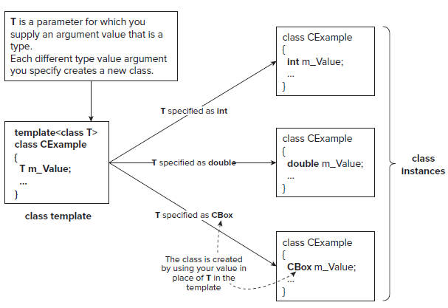
An appropriate class definition is generated when you instantiate an object of a template class for a particular type, so you can generate any number of different classes from one class template.

CLR Programming

C++/Cli Enumerations

Enumerations in a C++/CLI program are signifi cantly different from those in an ISO/IEC C++ program. For a start, you defi ne an enumeration in C++/CLI like this:

enum class Suit{Clubs, Diamonds, Hearts, Spades};

This defines an enumeration type, Suit , and variables of type Suit can be assigned only one of the values defined by the enumeration Hearts , Clubs , Diamonds , or Spades . When you refer to the constants in a C++/CLI enumeration, you must always qualify the constant you are using with the enumeration type name.
For example:

Suit suit = Suit::Clubs;

This statement assigns the value Clubs from the Suit enumeration to the variable with the name suit. The :: operator that separates the type name, Suit , from the name of the enumeration constant, Clubs , is the scope resolution operator that you have seen before, and it indicates that Clubs exists within the scope of the Suit enumeration. Note the use of the word class in the definition of the enumeration, following the enum keyword. This does not appear in the definition of an ISO/IEC C++ enumeration as you saw earlier, and it identifies the enumeration as C++/CLI. In fact, the two words combined, enum class, are a keyword in C++/CLI that is different from the two keywords, enum and class . The use of the enum class keyword gives a clue to another difference from an ISO/IEC C++ enumeration; the constants here that are defined within the enumeration — Hearts , Clubs , and so on — are objects , not simply values of a fundamental type as in the ISO/IEC C++ version.

In fact, by default, they are objects of type Int32 , so they each encapsulate a 32 - bit integer value; however, you must cast a constant to the fundamental type int before attempting to use it as such. Because a C++/CLI enumeration is a class type, you cannot define it locally, within a function, for example, so if you want to define such an enumeration for use in main() , for example, you would define it at global scope.

Lesson 13
Using Classes, Defining a Problem, & CLR Programming
In this part we will look that how a class might be used to solve a problem. The problem has to be simple in order to keep us on track, so we’ll consider problems in which we can use an extended version of the CBox class.

The principal function of a box is to contain objects of one kind or another, so, in a word, the problem is packaging. We’ll attempt to provide a class that eases packaging problems in general and then see how it might be used. We will assume that we ’ ll always be working on packing CBox objects into other CBox objects since, if you want to pack candy in a box, you can always represent each
of the pieces of candy as an idealized CBox object. The basic operations that you might want to provide in the CBox class include:

Calculate the volume of a CBox. This is a fundamental characteristic of a CBox object, and you have an implementation of this already.

Compare the volumes of two CBox objects to determine which is the larger. You probably should support a complete set of comparison operators for CBox objects. You already have a version of the > operator.

Compare the volume of a CBox object with a specified value, and vice versa. You also have an implementation of this for the > operator, but you will also need to implement functions supporting the other comparison operators.

Add two CBox objects to produce a new CBox object that will contain both the original objects. Thus, the result will be at least the sum of the volumes, but may be larger. You have a version of this already that overloads the + operator.

Multiply a CBox object by an integer (and vice versa) to provide a new CBox object that will contain a specified number of the original objects. This is effectively designing a carton.

Determine how many CBox objects of a given size can be packed in another CBox object of a given size. This is effectively division, so you could implement this by overloading the / operator.

Determine the volume of space remaining in a CBox object after packing it with the maximum number of CBox objects of a given size.

So this lecture covers all these implementation of programs which was practically discussed in the lecture video.

CLR Programming

For each loop

All the loop statements apply equally well to C++/CLI programs, and the C++/CLI language provides with the luxury of an additional kind of loop called the for each loop. This loop also works with native C++ code in Visual C++ 2010, although formally the for each loop is not part of the ISO/IEC standard C++ language. The for each loop is specifically for iterating through all the objects in a particular kind of set of objects.

// Analyzing a string using a for each loop
#include "stdafx.h"
using namespace System;
int main(array < System::String ^ > ^args)
{
int vowels(0), consonants(0);
String^ proverb(L"A nod is as good as a wink to a blind horse.");
for each(wchar_t ch in proverb)
{
if(Char::IsLetter(ch))
{
ch = Char::ToLower(ch); // Convert to lowercase
switch(ch)
{
case 'a': case 'e': case 'i': case 'o': case 'u':
++vowels;
break;
default:
++consonants;
break;
}
}
}
Console::WriteLine(proverb);
Console::WriteLine(L"The proverb contains {0} vowels and {1} consonants.",
vowels, consonants);
return 0;
}

This example produces the following output:

A nod is as good as a wink to a blind horse.
The proverb contains 14 vowels and 18 consonants.

Tracking Handles

A tracking handle has similarities to a native C++ pointer, but there are also some significant differences.

A tracking handle does store an address, which is automatically updated by the garbage collector if the object it references is moved during compaction of the heap.

Garbage Collector:

In C and C++, many objects require the programmer to allocate their resources once declared, before the objects can be safely used.

Releasing these resources back to the free memory pool once the object has been used is the responsibility of the programmer.

If resources are not released, the code is said to leak memory, as more and more resources are consumed needlessly.

On the other hand, if resources are released prematurely, loss of data, the corruption of other memory areas, and null pointer exceptions can occur.

The CLR garbage collector periodically checks the memory heap for any unreferenced objects, and releases the resources held by these objects.

However, you cannot perform address arithmetic with a tracking handle as you can with a native pointer, and casting a tracking handle is not permitted. For instance, the String class type is a reference class type, so variables that reference String objects must be tracking handles.

Lesson 14
A Multi-file Project, Organizing Program Code, Naming Program Files & CLR Programming
At this stage of the course we started a first multi file project. You will learn how to create a project with multiple files and where to place the files. In our project we distributed the code among several files for the first time. It is not a common practice with C++ applications generally, but with Windows programming, it is essential. The sheer volume of code involved in even the simplest program necessitates dividing it into workable chunks.

There are basically two kinds of source code files in a

Header Files
Source Files

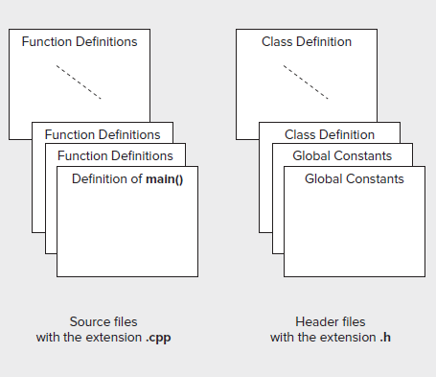

First, there’s the executable code that corresponds to the definitions of the functions that make up the program. Second, there are definitions of various kinds that are necessary for the executable code to compile correctly. These are global constants and variables; data types that include classes, structures, and unions; and function prototypes. The executable source code is stored in files with the extension .cpp, and the definitions are stored in files with the extension .h. From time to time, you might want to use code from existing files in a new project. In this case, you only have to add the .cpp files to the project, which you can do by using the Project ->Add -> Existing Item. . . menu option, or by right - clicking either Source Files or Header Files in the Solution Explorer tab and selecting Add -> Existing Item. . . from the context menu to add the file to your project. You don’t need to add .h files to your project, although you can if you want them to be shown in the Solution Explorer pane immediately. The code from .h files will be added at the beginning of the .cpp files that require them as a result of the #include directives that you specify.

You need #include directives for header files containing standard library functions and other standard definitions, as well as for your own header fi les. Visual C++ 2010 automatically keeps track of all these fi les, and enables you to view them in the Solution Explorer tab.

Naming

For classes of any complexity, it’s usual to store the class definition in a .h file with a file name based on the class name. Store the implementation of the function members of the class that are defined outside the class definition in a .cpp file with the same name.

On this basis, the definition of our CBox class appeared in a file with the name Box.h. Similarly, the class implementation was stored in the file Box.cpp. With programs of any size it would be a good idea to get into the habit of creating .h and .cpp files to hold your program code from now on. Segmenting a C++ program into .h and .cpp files is a very convenient approach, as it makes it easy to find the definition or implementation of any class. As long as you know the class name, you can go directly to the file you want. However you can choose to structure your files, the Class View still displays all the individual classes, as well as all the members of each class

CLR Programming

CLR arrays are different from the native C++ arrays. Memory for a CLR array is allocated on the garbage - collected heap.

The general form for specifying the type of variable to reference a one - dimensional array is

array < element_type > ^

CLR array is created on the heap so an array variable is always have a tracking handle.
array < int > ^ data;
The array variable, data can store a reference to any one - dimensional array of elements of type int . CLR array can be created using the gcnew operator at the same time that you declare the array variable:

array < int > ^ data = gcnew array < int > (100);

Functional notation can also be used to initialize the variable data :

array < int > ^ data(gcnew array < int > (100));

Elements in a CLR array are objects; here storing objects are of type Int32 in the array. An array variable can store the address of any array of the same rank (the rank being the number of dimensions, which in the case of the data array is 1) and element type.

data = gcnew array < int > (45);

This statement creates a new one - dimensional array of 45 elements of type int and stores its address in data. The original array referenced by the handle, data, is discarded. static Clear() function of the Array class can be used to set any sequence of numeric elements in an array to zero. You call a static function using the class name.

Array::Clear(samples, 0, samples- > Length);

The first argument to Clear() is the array that is to be cleared. The second argument is the index for the first element to be cleared. The third argument is the number of elements to be cleared. Thus, this example sets all the elements of the samples array to 0.0. If Clear() function is applied to an array of tracking handles such as String^ , the elements are set to nullptr. Apply it to an array of bool elements they are set to false

Lesson 15
Library Class for Strings & CLR Programming
The string standard header defines the string and wstring classes that represent character strings. Both are defined in the string header as template classes that are instances of the basic_string < T > class template. The string class is defined as basic_string < char >, and wstring is defined as basic_string < wchar_t >, so the string class represents strings of characters of type char, and wstring represents strings of characters of type wchar_t.

These string types are much easier to use than null - terminated strings and bring with them a whole range of powerful functions. Because string and wstring are both instances of the same template, basic_string < T > , they provide the same functionality, so I ’ ll only discuss the features and use in the context of the string type. The wstring type will work just the same, except that the strings contain Unicode character codes and you must use the L prefi x for string literals in your code.

There is much functionality that we can perform with the Library class of strings like creating, concatenating, joining, comparing and searching with in strings.

For example a string object can be created and initialized as

string sentence = "This sentence is false.";

The sentence object will be initialized with the string literal that appears to the right of the assignment operator. A string object has no terminating null character, so the string length is the number of characters in the string, 23 in this instance.

You can discover the length of the string encapsulated by a string object at any time by calling its length() member function.

For example:

cout < < "The string is of length " < < sentence.length() < < endl;

Executing the statement produces the output: The string is of length 23

CLR Programming

The Array class provides functions that search the elements of a one - dimensional array. BinarySearch() function use a binary search algorithm to find the index position of a given element in the entire array, or in a given range of elements.

The binary search algorithm requires that the elements are ordered.

array < int > ^ values = { 23, 45, 68, 94, 123, 127, 150, 203, 299};
int toBeFound(127);
int position = Array::BinarySearch(values, toBeFound);
if(position < 0)
Console::WriteLine(L"{0} was not found.", toBeFound);
else
Console::WriteLine(L"{0} was found at index position {1}.", toBeFound, position);

To search a given range of elements in an array you use a version of the BinarySearch() function that accepts four arguments.

array < int > ^ values = { 23, 45, 68, 94, 123, 127, 150, 203, 299};
int toBeFound(127);
int position = Array::BinarySearch(values, 3, 6, toBeFound);

First argument is the handle of the array to be searched. 2nd argument is the index position of the element where the search should start. Third argument is the number of elements to be searched 4th argument is what you are looking for.

In CLR programming we can create arrays that have two or more dimensions. But maximum number of dimensions an array can have is 32. Specify the number of dimensions that your array has between the angled brackets immediately following the element type, and separated from it by a comma. The dimension of an array is 1 by default.

array < int, 2 >^ values = gcnew array < int, 2 > (4, 5);

This statement creates a two - dimensional array with four rows and five columns for a total of 20 elements.

Array of Arrays

Array elements can be of any type, so you can create arrays where the elements are tracking handles that reference arrays. This gives you the possibility of creating so - called jagged arrays , because each handle referencing an array can have a different number of elements. Suppose you want to store the names of children in a class grouped by the grade they scored, where there are five classifications corresponding to grades A, B, C, D, and E.

You could first create an array of five elements where each element stores an array of names.

array < array < String^ > ^ > ^ grades(gcnew array < array < String^ > ^ > 5));

The array variable, grades, is a handle of type array <type>^

Each element in the array is also a handle to an array, so the type of the array elements is of the same form, array < type > ^ , this has to go between the angled brackets in the original array type specification, which results in array <array<type>^>^ . The elements stored in the array are also handles to String objects, so you must replace type in the last expression with String^

Lesson 16 & 17
Object - Oriented Programming Basics, Inheritance, Polymorphism & CLR Programming

Classes in OOP also define the objects to which your program relates. You program the solution to a problem in terms of the objects that are specific to the problem, using operations that work directly with those objects. You can define a class to represent something abstract, such as a complex number, which is a mathematical concept, or a truck which is decidedly physical (especially if you run into one on the highway). So, as well as being a data type, a class can also be a definition of a set of real - world objects of a particular kind, at least to the degree necessary to solve a given problem.

You can think of a class as defining the characteristics of a particular group of things that are specified by a common set of parameters and share a common set of operations that may be performed on them. The operations that you can apply to objects of a given class type are defined by the class interface, which corresponds to the functions contained in the public section of the class definition. The CBox class that you used in the previous chapter is a good example — it defined a box in terms of its dimensions plus a set of public functions that you could apply to CBox objects to solve a problem.

Of course, there are many different kinds of boxes in the real world: there are cartons, coffins, candy boxes, and cereal boxes, to name but a few, and you will certainly be able to come up with many others. You can differentiate boxes by the kinds of things they hold, the materials from which they are made, and in a multitude of other ways, but even though there are many different kinds of boxes, they share some common characteristics — the essence of boxiness , perhaps.

Therefore, you can still visualize all kinds of boxes as actually being related to one another, even though they have many differentiating features. You could define a particular kind of box as having the generic characteristics of all boxes perhaps just a length, a width, and a height. You could then add some additional characteristics to the basic box type to differentiate a particular kind of box from the rest. You may also find that there are new things you can do with your specific kind of box that you cant do with other boxes. It’s also possible that some objects may be the result of combining a particular kind of box with some other type of object: a box of candy or a crate of beer, for example. To accommodate this, you could define one kind of box as a generic box with basic “boxiness” characteristics and then specify another sort of box as a further specialization of that.

Following figure illustrates an example of the kinds of relationships you might define between different sorts of boxes.

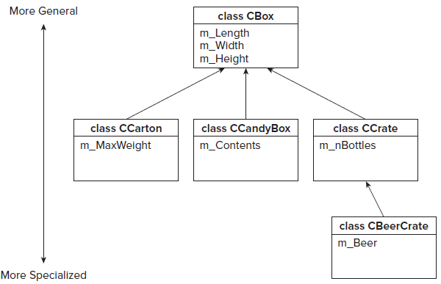

Inheritance

Inheritance is the process of creating new classes, called derived classes, from existing or base classes. The derived class inherits all the capabilities of the base class but can add embellishments and refinements of its own. The base class is unchanged by this process. The only members of a base class that are not inherited by a derived class are the destructor, the constructors, and any member functions overloading the assignment operator.

Inheritance is depicted in following figure

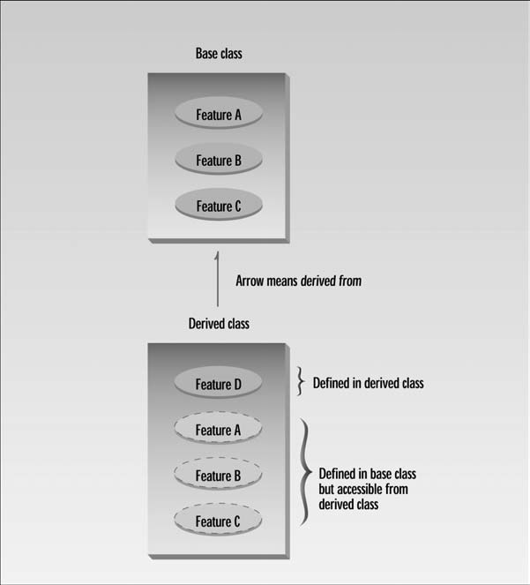

Main advantages of inheritance are

- Reusability -- facility to use public methods of base class without rewriting the same

- Extensibility -- extending the base class logic as per business logic of the derived class

- Data hiding -- base class can decide to keep some data private so that it cannot be altered by the derived class

- Overriding-- With inheritance, we will be able to override the methods of the base class so that meaningful implementation of the base class method can be designed in the derived class.

Virtual Functions and Polymorphism

This lesson covers a rather loosely related collection of such subjects: virtual functions. Virtual functions in particular are essential for polymorphism, one of the cornerstones of object-oriented programming.

Virtual means existing in appearance but not in reality. When virtual functions are used, a program that appears to be calling a function of one class may in reality be calling a function of a different class.

Why are virtual functions needed?

Suppose you have a number of objects of different classes but you want to put them all in an array and perform a particular operation on them using the same function call. For example, suppose a graphics program includes several different shapes: a triangle, a ball, a square, and so on. Each of these classes has a member function draw() that causes the object to be drawn on the screen. Now suppose you plan to make a picture by grouping a number of these elements together and you want to draw the picture in a convenient way.

One approach is to create an array that holds pointers to all the different objects in the picture.

The array might be defined like this:

shape* ptrarr[100]; // array of 100 pointers to shapes

If you insert pointers to all the shapes into this array, you can then draw an entire picture using a simple loop:

for(int j=0; j<N; j++)
ptrarr[j]->draw();

This is an amazing capability: Completely different functions are executed by the same function call. If the pointer in ptrarr points to a ball, the function that draws a ball is called; if it points to a triangle, the triangle-drawing function is called. This is called polymorphism, which means different forms. The functions have the same appearance, the draw() expression, but different actual functions are called, depending on the contents of ptrarr[j].

Polymorphism is one of the key features of object-oriented programming, after classes and inheritance.

CLR Programming

For the most part, functions in a C++/CLI program work in exactly the same way as in a native program. As we deal in handles and tracking references when programming for the CLR, not native pointers & references, so that introduces some differences. Function parameters and return values in a CLR program can be value class types, tracking handles, tracking references, and interior pointers.

When a parameter is an array, there is no need to have a separate parameter for the size of the array because C++/CLI arrays have the size built into the Length property. We cannot do address arithmetic with array parameters in a C++/CLI program as in native C++ program, so we use array indexing for this. Returning a handle to memory we have allocated on the CLR heap is not a problem because the garbage collector takes care of releasing the memory when it is no longer in use. The mechanism for accepting a variable number of arguments in C++/CLI is different from the native C++ mechanism. Accessing command line arguments in main() in a C++/CLI program is also different from the native C++ mechanism.

Lesson 18, 19, 20 & 21
Debugging & CLR Programming
Debugging
Bugs are errors in your program, and debugging is the process of finding and eliminating them. You are undoubtedly aware by now that debugging is an integral part of the programming process it goes with the territory, as they say.

The facts about bugs in your programs are rather depressing.

Every program you write that is more than trivial will contain bugs that you need to try to expose, find, and eliminate if your program is to be reliable and effective. Note the three phases here — a program bug is not necessarily apparent; even when it is apparent you may not know where it is in your source code; and even when you know roughly where it is, it may not be easy to determine what exactly is causing the problem, and thus eliminate it.

Many programs that you write will contain bugs even after you think you have fully tested them.

Program bugs can remain hidden in a program that is apparently operating correctly sometimes for years. They generally become apparent at the most inconvenient moments.

Programs beyond a certain size and complexity always contain bugs, no matter how much time and effort you expend testing them.

Many potential bugs are eliminated during the compile and link phases, but there are still quite a few left even after you manage to produce an executable module for your program. Unfortunately, despite the fact that program bugs are as inevitable as death and taxes, debugging is not an exact science; however, you can still adopt a structured approach to eliminating bugs.

There are four broad strategies you can adopt to make debugging as painless as possible:

Don’t re - invent the wheel. Understand and use the library facilities provided as part of Visual C++ 2008 / 2010 (or other commercial software components you have access to) so that your program uses as much pre - tested code as possible. Note that while this will reduce the likelihood of bugs in your code, libraries, operating systems, and commercial software, components will still contain bugs in general, so your code can share those bugs.

Develop and test your code incrementally. By testing each significant class and function individually, and gradually assembling separate code components after testing them, you can make the development process much easier, with fewer obscure bugs occurring along the way.

Code defensively which means writing code to guard against potential errors. For example, declare member functions of native C++ classes that don’t modify an object as const. Use const parameters where appropriate.

Define const objects with the required values. Include debugging code that checks and validates data and conditions in your program from the outset.

Broadly, there are two kinds of errors you can make in your code that result in program bugs:

Syntactic errors These are errors that result from statements that are not of the correct form; for example, if you miss a semicolon from the end of a statement or use a colon where you should put a comma. The compiler recognizes all syntactic errors, and you generally get a fairly good indication of what the error is so it’s easy to fix.

Semantic errors These are errors where the code is syntactically correct, but it does not do what you intended. The compiler cannot know what you intended to achieve with your program, so it cannot detect semantic errors; however, you will often get an indication that something is wrong because the program terminates abnormally.

Debugger

- It is a program that controls the execution of program code in such a way that we can step through the source code one line at a time, or run to a particular point in the program.

- At each point in the code where the debugger stops, we can inspect or even change the values of variables before continuing. During debugging we can change the source code, recompile, and then restart the program from the beginning.

A breakpoint is a point in our program where the debugger automatically suspends execution when in debugging mode.

A trace-point is a special kind of breakpoint that has a custom action associated with it.

Debugging can be started by pressing F5. It simply executes a program up to the first breakpoint (if any) where execution will halt. When programmer examined all he/she needs to at a breakpoint, selecting the same menu item or toolbar button again will continue execution up to the next breakpoint and so on. If there are no breakpoints, the entire program is executed without stopping.

Defining a variable that you want to inspect is referred to as setting a watch for the variable.

Local tab

- The Locals tab shows the values of the variables local to the current function.
- In general, new variables come into scope as you trace through a program and then go out of scope as you exit the block in which they are defined.

Modules tab

- Lists details of the code modules currently executing.
- If application crashes, we can determine in which module the crash happened.

Watch1 Tab

- Variables can be added to the Watch1 tab that we want to watch.
- We can also watch the value of a expression.

We can change the values of the variables that we are watching in the Watch windows, Autos window and Locals windows.

Using preprocessor directives, you can add any code you like to your program so that it is only compiled and executed in the debug version. Your debug code is omitted completely from the release version, so it does not affect the efficiency of the tested program at all. You could use the absence of the NDEBUG symbol as the control mechanism for the inclusion of debugging code; that’s the symbol used to control the assert() function operation in the standard library, as discussed in the last section.

Alternatively, for a better and more positive control mechanism, you can use another preprocessor symbol, DEBUG, that is always defined automatically in Visual C++ in the debug version of a program, but is not defined in the release version. You simply enclose code that you only want compiled and executed when you are debugging between a preprocessor #ifdef / #endif pair of directives, with the test applied to the DEBUG symbol, as follows:

#ifdef _DEBUG
// Code for debugging purposes...
#endif // _DEBUG

The code between the #ifdef and the #endif is compiled only if the symbol DEBUG is defined. This means that once your code is fully tested, you can produce the release version completely free of any overhead from your debugging code. The debug code can do anything that is helpful to you in the debugging process, from simply outputting a message to trace the sequence of execution to providing additional calculations to verify and validate data, or calling functions providing debug output.

The call stack stores information about functions that have been called and are still executing because they have not returned yet. Call stack window shows the sequence of function calls outstanding at the current point in the program.

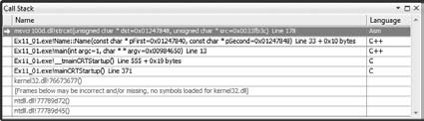

CLR Programming

Function properties for native C++ applies equally well to C++/CLI language.
The only exceptions are that Parameter types and return types will be of fundamental types. The throw and catch mechanism for exceptions works much the same in CLR programs as it does in native C++ programs, but there are some differences. In CLI exceptions are always thrown using tracking handles.

try
{
throw L"Catch me if you can.";
}

catch(String^ ex) // The exception will not be caught by this
{
Console::WriteLine(L"String^: {0}",ex);
}

The catch block cannot catch the object. Because the throw statement throws an exception of type const wchar_t* , not of type String^ . To catch the exception as thrown, the catch block needs to be:
try
{
throw L"Catch me if you can.";
}
catch(const wchar_t* ex) // The exception thrown is of this type
{
String^ exc = gcnew String(ex);
Console::WriteLine(L"wchar_t:{0}", exc);
}

This catch block catches the exception because it now has the correct type.

Generic Functions

Although generic functions appear to do the same thing as function templates and, therefore, at first sight, seem superfluous, generic functions work rather differently from template functions, and the differences make them a valuable additional capability in CLR programs. When you use a function template, the compiler generates the source code for each function that you require from the template; this generated code is then compiled along with the rest of your program code. In some cases, this can result in many functions being generated, and the size of the execution module may be increased substantially. On the other hand, a generic function specification is itself compiled, and when you call a function that matches the generic function specification, actual types are substituted for the type parameters at execution time.

A generic function can be defined by using type parameters that are replaced by actual types when the function is called.

Example

generic < typename T > where T:IComparable
T MaxElement(array < T > ^ x)
{
T max(x[0]);
for(int i = 1; i < x- > Length; i++)
if(max- > CompareTo(x[i]) < 0)
max = x[i];
return max;
}

This generic function does the same job as the native C++ function. The generic keyword in the first line identifies what follows as a generic specification, and the first line defines the type parameter for the function as T ; the typename keyword between the angled brackets indicates that the T that follows is the name of a type parameter in the generic function, and that this type parameter is replaced by an actual type when the generic function is used.

For a generic function with multiple type parameters, the parameter names go between the angled brackets, each preceded by the typename keyword and separated by commas. The where keyword that follows the closing angled bracket introduces a constraint on the actual type that may be substituted for T when you use the generic function. This particular constraint says that any type that is to replace T in the generic function must implement the IComparable interface.

The second line specifies the generic function name MaxElement , its return type T , and its parameter list. This looks rather like an ordinary function header, except that it involves the generic type parameter T. The return type for the generic function and the array element type that is part of the parameter type specification are both of type T, so both these types are determined when the generic function is used.

Struct and Class Types

The C++/CLI programming language has its own struct and class types. In fact, C++/CLI allows the definition of two different struct and class types that have different characteristics; value struct types and value class types, and ref struct types and ref class types. Each of the two word combinations, value struct , ref struct , value class , and ref class , is a keyword and distinct from the keywords struct and class ; value and ref are not, by themselves, keywords.

As in native C++, the only difference between a struct and a class in C++/CLI is that members of a struct are public by default, whereas members of a class are private by default. One essential difference between value classes (or value structs) and reference classes (or ref structs) is that variables of value class types contain their own data, whereas variables to access reference class types must be handles, and therefore contain an address.

Member functions of C++/CLI classes cannot be declared as const . Another difference from native C++ is that the this pointer in a non - static function member of a value class type T is an interior pointer of type interior_ptr < T > , whereas the this pointer in a ref class type T is a handle of type T^ . You need to keep this in mind when returning the this pointer from a C++/CLI function or storing it in a local variable.

There are three other restrictions that apply to both value classes and reference classes:

- A value class or ref class cannot contain fi elds that are native C++ arrays or native C++ class types.

- Friend functions are not allowed.

- A value class or ref class cannot have members that are bit - fields.

The fundamental type names such as type int and type double are shorthand for value class types in a CLR program. When you declare a data item of a value class type, memory for it will be allocated on the stack, but you can create value class objects on the heap using the gcnew operator, in which case, the variable that you use to access the value class object must be a handle.

For example:

double pi(3.142); // pi is stored on the stack
int^ lucky(gcnew int(7)); // lucky is a handle and 7 is stored on the heap
double^ two(2.0); // two is a handle, and 2.0 is stored on the heap

You can use any of these variables in an arithmetic expression but you must use the * operator to dereference the handle to access the value.

For example:

Console::WriteLine(L"2pi = {0}", *two*pi);

You could write the product as pi**two and get the right result, but it is better to use parentheses in such instances and write pi*(*two) , as this makes the code clearer.

Every C++/CLI class that you define has a ToString() function. The compiler arranges for the ToString() function for an object to be called whenever it recognizes that a string representation of an object is required, and you can call it
explicitly, if necessary. For example

double pi(3.142);
Console::WriteLine(pi.ToString());

This outputs the value of pi as a string, and it is the ToString() function that is defined in the System::Double class that provides the string. Of course, you would get the same output without explicitly calling the ToString() function. The default version of the ToString() function that you get in the Height class just outputs the class name, because there is no way to know ahead of time what value should be returned as a string for an object of your class type. To get an appropriate value output by the Console::WriteLine() function in the previous example, you must add a ToString() function to the Height class that presents the value of an object in the form that you want.

Lesson 22
Debugging Dynamic Memory, Free Store & Memory Leaks
Allocating memory dynamically is a potent source of bugs, and perhaps the most common bugs in this context are memory leaks. A memory leak arises when you use the new operator to allocate memory, but you never use the delete operator to free it again when you are done with it. Apart from just forgetting to delete memory that you have allocated, you should particularly be aware that non - virtual destructors in a class hierarchy can also cause the problem because they can cause the wrong destructor to be called when an object is destroyed, as you have seen.

Of course, when your program ends, all the memory is freed; however, while it is running, it remains allocated to your program. Memory leaks present no obvious symptoms much of the time, maybe never in some cases, but memory leaks are detrimental to the performance of your machine because memory is being occupied to no good purpose. Sometimes, it can result in a catastrophic failure of the program when all available memory has been allocated.

The functions declared in crtdbg.h check the free store using a record of its status
stored in a structure of type CrtMemState . This structure is relatively simple, and is defined as:

typedef struct _CrtMemState
{
struct _CrtMemBlockHeader* pBlockHeader; // Ptr to most recently allocated block
unsigned long lCounts[_MAX_BLOCKS]; // Counter for each type of block
unsigned long lSizes[_MAX_BLOCKS];// Total bytes allocated in each block type
unsigned long lHighWaterCount; // The most bytes allocated at a time up to now
unsigned long lTotalCount; // The total bytes allocated at present
} _CrtMemState;

You won’t be concerned directly with the details of the state of the free store because you are using functions that present the information in a more readable form. There are quite a few functions involved in tracking free store operations, but you will only look at the 05 most interesting ones. These provide you with the following capabilities:

- To record the state of the free store at any point
- To determine the difference between two states of the free store
- To output state information
- To output information about objects in the free store
- To detect memory leaks

We can control free store debug operations by setting a flag, crtDbgFlag , which is of type int. This flag incorporates five separate control bits, including one to enable automatic memory leak checking.
For memory leak we need to check the example illustrated in the lecture video.

Lesson 23
Debugging in C++ / CLI Programming
Life is simpler with C++/CLI programming. None of the complications of corrupted pointers or memory leaks arise in programs written for the CLR, so this reduces the debugging problem substantially, compared to native C++, at a stroke. You set breakpoints and trace points in a CLR program exactly the same way that you do for a native C++ code. You have a specific option that applies to C++/CLI code for preventing the debugger from stepping through library code.

The Debug and Trace classes in the System::Diagnostics namespace are for tracing execution of a program for debugging purposes. The capabilities provided by the Debug and Trace classes are identical; the difference between them is that Trace functions are compiled into release builds, whereas Debug functions are not.

Assertions

The Debug and Trace classes have static Assert() functions that provide a similar capability to the native C++ assert() function. The Assert() function in the Debug class only works in debug builds. The Assert() function in the Trace class works in release builds. The first argument to the Debug::Assert() function is a bool value or expression that causes the program to assert when the argument is false.

The static Assert() function in the Debug and Trace classes provides an
assertion capability in CLR programs. There are three courses of action after an assertion.

- Abort
Clicking the Abort button ends the program immediately.
- Ignore
Clicking the Ignore button allows the program to continue.
- Retry
Clicking the Retry button gives the option of executing the program in debug mode.

Debugging is a big topic, and Visual C++ 2010 provides many debugging facilities beyond what I have discussed here. You should have little trouble expanding your knowledge of the debug capabilities through the Visual C++ 2010 documentation.

Lesson 24 & 25
Windows Programming Concepts & Windows Messages
In these lessons we will take a look at the basic ideas that are involved in every Windows program in C++. We’ll first develop a very simple example that uses the Windows operating system API directly. This will enable us to understand how a Windows application works behinds the scenes, which will be useful to you when you are developing applications using the more sophisticated facilities provided by Visual C++ 2010.

Visual C++ provides us with 3 basic ways of creating an interactive Windows application

Using the Windows API

- This is the fundamental interface that the Windows operating system provides for communications between itself and the applications that are executing under its control.

Using the Microsoft Foundation Classes

- A set of C++ classes that encapsulate the Windows API.

Using Windows Forms

- Form - based development mechanism for creating applications that execute with the CLR.

- Using Windows Forms is by far the fastest and easiest mechanism for generating an application because the amount of code that you have to write is greatly reduced compared with the other two possibilities.

In a way, these three approaches form a progression from the most programming-intensive to the least programming-intensive. With the Windows API, you are writing code throughout all the elements that make up the GUI for your application must be created programmatically. With MFC applications there’s some help with GUI build in that you can assemble controls on a dialog form graphically and just program the interactions with the user; however, you still are involved in a lot of coding. With a Windows Forms application, you can build the complete GUI, including the primary application window, by assembling the controls that the user interacts with graphically. You just place the controls wherever you want them in a form window, and the code to create them is generated automatically. Using Windows Forms is by far the fastest and easiest mechanism for generating an application because the amount of code that you have to write is greatly reduced compared with the other two possibilities. The code for a Windows Forms application also gains all the benefi ts of executing with the CLR.

Using the MFC involves more programming effort than Windows Forms, but you have more control over how the GUI is created and you end up with a program that will execute natively on your PC. Because using the Windows API directly is the most laborious method for developing an application.

Elements of a Window

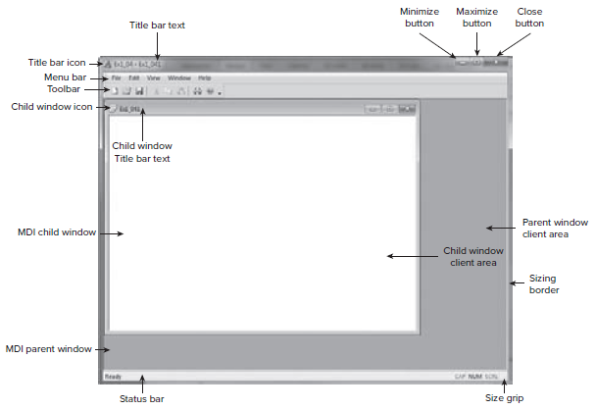

Windows Programs & OS

Your program is subservient to the operating system and Windows is in control. Your program must not deal directly with the hardware, and all communications with the outside world must pass through Windows. When you use a Windows
Program, you are interacting primarily with Windows, which then communicates with the application program on your behalf. Your Windows program is the tail, Windows is the dog, and your program wags only when Windows tells it to.

There are a number of reasons why this is so. First and foremost, because your program is potentially always sharing the computer with other programs that may be executing at the same time, Windows has to have primary control to manage the sharing of machine resources. If one application were allowed to have primary control in a Windows environment, this would inevitably make programming more complicated because of the need to provide for the possibility of other programs, and information intended for other applications could be lost.

A second reason for Windows being in control is that Windows embodies a standard user interface and needs to be in charge to enforce that standard. You can only display information on the screen using the tools that Windows provides, and then only when authorized.

A Windows program is mostly event - driven, so it essentially waits around for something to happen. A significant part of the code of a Windows application is dedicated to processing events that are caused by external actions of the user.

Windows Message

It is simply a record of the data relating to an event. Message queue for an application is just a sequence of such messages waiting to be processed by the application. By sending a message, Windows can tell our program that some action needs to be taken or an event such as a mouse click has occurred.

A Windows program must contain a function specifically for handling these messages.

- WindowProc() is the function we can use to sending the messages to our applications. Windows accesses the function through a pointer to a function.

- DefWindowProc() is used to pass a message back to Windows. Provides default message processing.

Windows API

All of the communications between any Windows application and Windows itself use the Windows application programming interface (API). There are 100 of API’s which covers all aspects of the communications between Windows and our application.

Visual C++ 2010 packages the Windows API in a way that structures the API functions in an object - oriented manner, and provides an easier way to use the interface in C++ with more default functionality. This takes the form of the
Microsoft Foundation Classes, MFC. Also, for applications targeting the CLR, you have a facility called Windows Forms where the code necessary to create a GUI is all created automatically. All you have to do is supply the code necessary to handle the events in the way that your application requires.

Windows Data Types

Windows defines a significant number of data types that are used to specify function parameter types and return types in the Windows API. These Windows - specific types also propagate through to functions that are defined in MFC. Each of these Windows types will map to some C++ type, but because the mapping between Windows types and C++ types can change, you should always use the
Windows type where this applies. For example, in the past the Windows type WORD has been defined in one version of Windows as type unsigned short and in another Windows version as type unsigned int. On 16 - bit machines these types are equivalent, but on 32 - bit machines they are decidedly different so anyone using the C++ type rather than the Windows type could run into problems. You can find the complete list of Windows data types in the documentation.

Structure of a Windows Program

For a minimal Windows program that just uses the Windows API, you will write two functions. These are a WinMain() function, where execution of the program begins and basic program initialization is carried out, and a WindowProc() function that is called by Windows to process messages for the application.

The WindowProc() part of a Windows program is usually the larger portion because this is where most of the application - specific code is, responding to messages caused by user input of one kind or another. Although these two functions make up a complete program, they are not directly connected. WinMain() does not call WindowProc() , Windows does. In fact, Windows also calls WinMain() .

This is illustrated in the following figure.

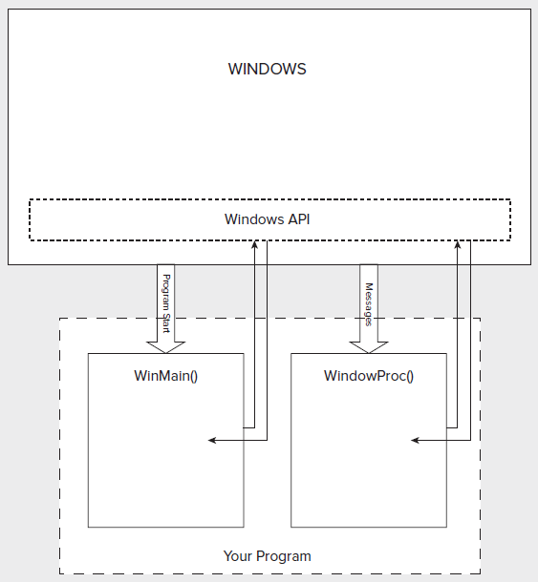

The function WinMain() communicates with Windows by calling some of the Windows API functions. The same applies to WindowProc(). The integrating factor in your Windows program is Windows itself, which links to both WinMain() and WindowProc().

In this section you will also learn in lectures video that how to create a simple program window and how to deal with windows messages. That simple program illustrate the two essential components of a Windows program: the WinMain() function that provides initialization and setup, and the WindowProc() function that services Windows messages.

The relationship between these is illustrated in following figure.

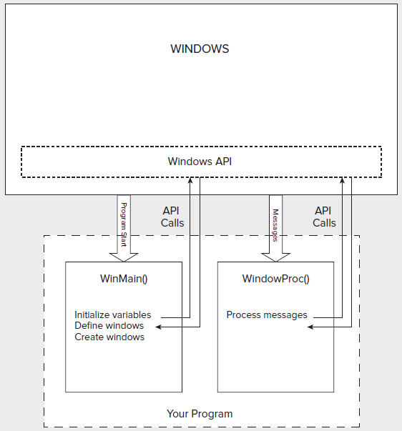

Lesson 26, 27 & 28
MFC, Windows Forms, Documents, Views, SDI & MDI Applications
The Microsoft Foundation Classes (MFC) are a set of predefined classes upon which Windows programming with Visual C++ is built. These classes represent an object - oriented approach to Windows programming that encapsulates the Windows API. MFC does not adhere strictly to the object - oriented principles of encapsulation and data hiding, principally because much of the MFC code was written before such principles were well established.

The process of writing a Windows program involves creating and using MFC objects or objects of classes derived from MFC. The objects of these MFC based class types incorporate member functions for communicating with Windows, for processing Windows messages, and for sending messages to each other. These derived classes, of course, inherit all of the members of their base classes. These inherited functions do practically all of the general grunt work necessary for a Windows application to work. All you need to do is to add data and function members to customize the classes to provide the application specific functionality that you need in your program.

Try a MFC program as per directed in lesson video.

A Windows form is an entity that represents a window of some kind. By a window, I mean window in its most general sense, being an area on the screen that can be a button, a dialog, a regular window, or any other kind of visible GUI component. A Windows form is encapsulated by a subclass of the System::Windows::Forms::Form class, but you don’t need to worry about this much initially, because all the code to create a form is created automatically. To see just how easy it’s going to be, create a basic window using Windows Forms that has a standard menu as per directed in the lesson video.

The structure of an MFC program incorporates two application-oriented entities.

- A document
- A view

A document is the name given to the collection of data in your application with which the user interacts. Although the word document seems to imply something of a textual nature, a document isn’t limited to text. It could be the data for a game, a geometric model, a text file, a collection of data on the distribution of orange trees in California, or, indeed, anything you want. The term document is just a convenient label for the application data in your program, treated as a unit.

A document in is defined as an object of a document class. Your document class is derived from the CDocument class in the MFC library, and you’ll add your own data members to store items that your application requires, and member functions to support processing of that data. Your application is not limited to a single document type, you can define multiple document classes when there are several different kinds of documents involved in your application.

Handling application data in this way enables standard mechanisms to be provided within MFC for managing a collection of application data as a unit and for storing and retrieving data contained in document objects to and from disk. These mechanisms are inherited by your document class from the base class defined in the MFC library, so you get a broad range of functionality built into your application automatically, without having to write any code.

Document Interfaces

You have a choice as to whether your program deals with just one document at a time, or with several. The Single Document Interface, abbreviated as SDI, is supported by the MFC library for programs that require only one document to be open at a time. A program using this interface is referred to as an SDI application.

For programs needing several documents to be open at one time, you can use the Multiple Document Interface, which is usually referred to as MDI. With the MDI, as well as being able to open multiple documents of one type, your program can also be organized to handle documents of different types simultaneously with each document displayed in its own window.

You need to supply the code to deal with processing whatever different kinds of documents you intend to support. With an MDI application, each document is displayed in a child window of the application window. You have an additional application variant called the multiple top - level document architecture where each document window is a child of the desktop.

A view is an object that provides a mechanism for displaying some or all of the data stored in a document. It defines how the data is to be displayed in a window, How the user can interact with it. Application view class be derived from the MFC class Cview. The window in which a view appears is called a frame window. A view is always relates to a particular document object.

A view is actually displayed in its own window that exactly fills the client area of a frame window. Following figure illustrates how the data in a document might be displayed in two views.

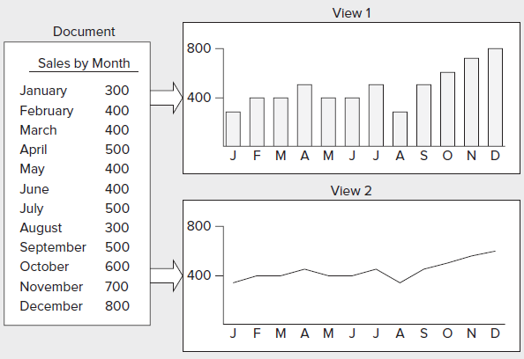

MFC incorporates a mechanism for integrating a document with its views & each frame window with a currently active view. A document object automatically maintains a list of pointers to its associated views. A view object has a data member holding a pointer to the document that relates to it. Each frame window stores a pointer to the currently active view object. The coordination among a document, a view, and a frame window is established by another MFC class of objects called document templates.

A document template manages the document objects in your program, as well as the windows and views associated with each of them. There is one document template for each type of document that you have in your application. If you have two or more documents of the same type, you need only one document template to manage them. To be more specifi c about the role of a document template, a document template object creates document objects and frame window objects, and views of a document are created by a frame window object. The application object that is fundamental to every MFC application creates the document template object itself.

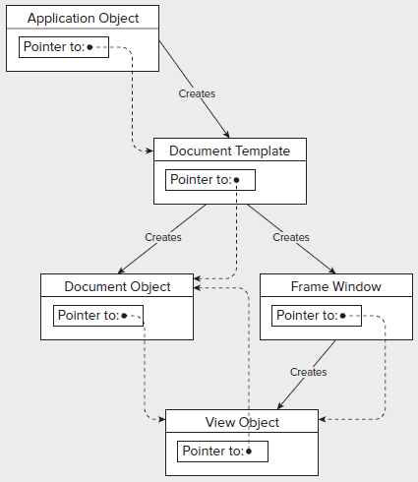

MFC has two classes for defining document templates.
For SDI applications
  - CSingleDocTemplate Has only one document and usually just one view.
For MDI applications
  - CMultiDocTemplate Have multiple documents active at one time, so many views.
Examples of all these applications explained in the videos are needed to be practiced.
Lesson 29
ASP - Active Server Pages, ASP.NET, Life Cycle, Page Life Cycle Events
ASP.NET is a web application framework developed by Microsoft to allow programmers to build dynamic web sites. ASP.NET allows using a full featured programming language such as C# or VB.NET to build web applications easily.

ASP.Net works on top of the HTTP protocol and uses the HTTP commands and policies to set a browser-to-server two-way communication and cooperation. ASP.Net is a part of Microsoft .Net platform. ASP.Net applications are complied codes, written using the extensible and reusable components or objects present in .Net framework. These codes can use the entire hierarchy of classes in .Net framework.

The ASP.Net component model provides various building blocks of ASP.Net pages. Basically it is an object model, which describes:

Server side counterparts of almost all HTML elements or tags, like <form> and <input>.

Server controls, which help in developing complex user-interface for example the Calendar control or the Gridview control.

ASP.Net is a technology, which works on the .Net framework that contains all web-related functionalities. The .Net framework is made of an object-oriented hierarchy. An ASP.Net web application is made of pages. When a user requests an ASP.Net page, the IIS delegates the processing of the page to the ASP.Net runtime system.

The ASP.Net runtime transforms the .aspx page into an instance of a class, which inherits from the base class Page of the .Net framework. Therefore, each ASP.Net page is an object and all its components i.e., the server-side controls are also objects.

ASP.Net provides an abstraction layer on top of HTTP on which the web applications are built. It provides high-level entities like classes and components within an object-oriented paradigm.

The key development tool for building ASP.Net applications and front ends is Visual Studio. It provides a complete set of development tools for building ASP.Net web applications, web services, desktop applications and mobile applications.
Life Cycle
ASP.Net life cycle specifies, how ASP.Net processes pages to produce dynamic output. The application and its pages are instantiated and processed ASP.Net compiles the pages dynamically

The ASP.Net life cycle could be divided into two groups:
- Application Life Cycle
The application life cycle has the following stages:

User makes a request for accessing application resource, a page. Browser sends this request to the web server.

A unified pipeline receives the first request and the following events take place:

  - An object of the Application Manager class is created.
  - An object of the Hosting Environment class is created to provide information regarding the resources.
  - Top level items in the application are compiled.

Response objects are created . the application objects: HttpContext, HttpRequest and HttpResponse are created and initialized.

An instance of the HttpApplication object is created and assigned to the request. The request is processed by the HttpApplication class. Different events are raised by this class for processing the request.
- Page Life Cycle
When a page is requested, it is loaded into the server memory, processed and sent to the browser. Then it is unloaded from the memory. At each of this steps, methods and events are available, which could be overridden according to the need of the application. In other words, you can write your own code to override the default code.

The Page class creates a hierarchical tree of all the controls on the page. All the components on the page, except the directives are part of this control tree.

The page life cycle phases are:

- Initialization
- Instantiation of the controls on the page
- Restoration and maintenance of the state
- Execution of the event handler codes
- Page rendering

Understanding the page cycle helps in writing codes for making some specific thing happen at any stage of the page life cycle. It also helps in writing custom controls and initializing them at right time, populate their properties with view-state data and run control behavior code.
Page Life Cycle Events
At each stage of the page life cycle, the page raises some events, which could be coded. An event handler is basically a function or subroutine, bound to the event, using declarative attributes like Onclick or handle.

Following are the page life cycle events:

- PreInit is the first event in page life cycle. It checks the IsPostBack property and determines whether the page is a postback. It sets the themes and master pages, creates dynamic controls and gets and sets profile property values. This event can be handled by overloading the OnPreInit method or creating a Page_PreInit handler.

- Init event initializes the control property and the control tree is built. This event can be handled by overloading the OnInit method or creating a Page_Init handler.

- InitComplete event allows tracking of view state. All the controls turn on view-state tracking.

- LoadViewState event allows loading view state information into the controls.

- LoadPostData during this phase, the contents of all the input fields defined with the <form> tag are processed.

- PreLoad occurs before the post back data is loaded in the controls. This event can be handled by overloading the OnPreLoad method or creating a Page_PreLoad handler.

- Load event is raised for the page first and then recursively for all child controls. The controls in the control tree are created. This event can be handled by overloading the OnLoad method or creating a Page_Load handler.

- LoadComplete the loading process is completed, control event handlers are run and page validation takes place. This event can be handled by overloading the OnLoadComplete method or creating a Page_LoadComplete handler.

- PreRender event occurs just before the output is rendered. By handling this event, pages and controls can perform any updates before the output is rendered.

- PreRenderComplete as the PreRender event is recursively fired for all child controls, this event ensures the completion of the pre-rendering phase.

- SaveStateComplete state of control on the page is saved. Personalization, control state and view state information is saved. The HTML markup is generated. This stage can be handled by overriding the Render method or creating a Page_Render handler.

- UnLoad the UnLoad phase is the last phase of the page life cycle. It raises the UnLoad event for all controls recursively and lastly for the page itself. Final cleanup is done and all resources and references, such as database connections, are freed. This event can be handled by modifying the OnUnLoad method or creating a Page_UnLoad handler.

An ASP.Net page is made of number of server controls along with the HTML controls, text and images. Sensitive data from the page and the states of different controls on the page are stored in hidden fields and forms the context of that page request.
An ASP.Net page is also a server side file saved with the .aspx extension. It is modular in nature and can be divided into the following core sections:
- Page directives
- Code Section
- Page Layout
Lesson 30
Event Handling, Application & Session Events, Page & Control Events, Server Object, Request Object & Response Object
Event is an action or occurrence like mouse click, key press, mouse movements, or any system generated notification. The processes communicate through events. For example, Interrupts are system generated events. When events occur the application should be able to respond to it.

In ASP.Net an event is raised on the client, and handled in the server. For example, a user clicks a button displayed in the browser. A Click event is raised. The browser handles this client-side event by posting it to the server.

The server has a subroutine describing what to do when the event is raised; it is called the event-handler. Therefore, when the event message is transmitted to the server, it checks whether the Click event has an associated event handler, and if it has, the event handler is executed.

ASP.Net event handlers generally take two parameters and return void. The first parameter represents the object raising the event and the second parameter is called the event argument.

The general syntax of an event is:

private void EventName (object sender, EventArgs e);

Application and Session Events

The most important application events are

- Application_Start . it is raised when the application/website is started
- Application_End . it is raised when the application/website is stopped

Similarly, the most used Session events are:

  - Session_Start . it is raised when a user first requests a page from the application
  - Session_End . it is raised when the session ends

Page and Control Events

Common page and control events are

- DataBinding raised when a control bind to a data source
- Disposed when the page or the control is released
- Error it is an page event, occurs when an unhandled exception is thrown
- Init raised when the page or the control is initialized
- Load raised when the page or a control is loaded
- PreRender raised when the page or the control is to be rendered
- Unload raised when the page or control is unloaded from memory

The page itself is instantiated as a control object. All web forms are basically instances of the ASP.Net Page class.

The page class has the following extremely useful properties that correspond to intrinsic objects like:

- Session.
- Application
- Cache
- Request
- Response
- Server
- User
- Trace

The Server Object:

The Server object in Asp.Net is an instance of the System.Web.HttpServerUtility class. The HttpServerUtility class provides numerous properties and methods to perform various jobs.

The methods and properties of the HttpServerUtility class are exposed through the intrinsic Server object provided by ASP.NET.

The following table provides a list of the properties:

Property | Description
MachineName | Name of server's computer
ScriptTimeOut | Gets and sets the request time-out value in seconds.

The following table provides a list of some important methods:

Method | Description
CreateObject(String) | Creates an instance of the COM object identified by its ProgID (Programmatic ID)
CreateObject(Type) | Creates an instance of the COM object identified by its Type
Equals(Object) | Determines whether the specified Object is equal to the current Object
Execute(String) | Executes the handler for the specified virtual path in the context of the current request.
Execute(String, Boolean) | Executes the handler for the specified virtual path in the context of the current request and specifies whether to clear the QueryString and Form collections
GetLastError | Returns the previous exception.
GetType | Gets the Type of the current instance.
HtmlEncode | Changes an ordinary string into a string with legal HTML characters.
HtmlDecode | Converts an Html string into an ordinary string
ToString | Returns a String that represents the current Object
Transfer(String) | For the current request, terminates execution of the current page and starts execution of a new page by using the specified URL path of the page.
UrlDecode | Converts an URL string into an ordinary string
UrlEncodeToken | Works same as UrlEncode, but on a byte array that contains Base64-encoded data
UrlDecodeToken | Works same as UrlDecode, but on a byte array that contains Base64-encoded data
MapPath | Return the physical path that corresponds to a specified virtual file path on the server
Transfer | Transfers execution to another web page in the current application

The Request Object:

The request object is an instance of the System.Web.HttpRequest class. It represents the values and properties of the HTTP request that makes the page loading into the browser.

The information presented by this object is wrapped up by the higher level abstractions (the web control model), however, this object helps in checking some information like the client browser and cookies.

The following table provides some noteworthy properties of the Request object:

Property | Description
AcceptTypes | Gets a string array of client-supported MIME accept types.
ApplicationPath | Gets the ASP.NET application's virtual application root path on the server.
Browser | Gets or sets information about the requesting client's browser capabilities.
ContentEncoding | Gets or sets the character set of the entity-body.
ContentLength | Specifies the length, in bytes, of content sent by the client.
ContentType | Gets or sets the MIME content type of the incoming request.
Cookies | Gets a collection of cookies sent by the client.
FilePath | Gets the virtual path of the current request.
Files | Gets the collection of files uploaded by the client, in multipart MIME format.
Form | Gets a collection of form variables.
Headers | Gets a collection of HTTP headers.
HttpMethod | Gets the HTTP data transfer method (such as GET, POST, or HEAD) used by the client.
InputStream | Gets the contents of the incoming HTTP entity body.
IsSecureConnection | Gets a value indicating whether the HTTP connection uses secure sockets (that is, HTTPS).
Url | Gets information about the URL of the current request.
UrlReferrer | Gets information about the URL of the client's previous request that linked to the current URL.
UserAgent | Gets the raw user agent string of the client browser.
UserHostAddress | Gets the IP host address of the remote client.
UserHostName | Gets the DNS name of the remote client.
UserLanguages | Gets a sorted string array of client language preferences.

The following table provides a list of some important methods:

Method | Description
BinaryRead | Performs a binary read of a specified number of bytes from the current input stream.
Equals(Object) | Determines whether the specified Object is equal to the current Object. (Inherited from Object.)
GetType | Gets the Type of the current instance.
MapImageCoordinates | Maps an incoming image-field form parameter to appropriate x-coordinate and y-coordinate values.
MapPath(String) | Maps the specified virtual path to a physical path.
SaveAs | Saves an HTTP request to disk.
ToString | Returns a String that represents the current Object
ValidateInput | Causes validation to occur for the collections accessed through the Cookies, Form, and QueryString properties.

The Response Object:

The Response object represents the server's response to the client request. It is an instance of the System.Web.HttpResponse class.
In ASP.Net, the Response object does not play a vital role in sending HTML text to the client, because the server-side controls have nested, object oriented methods for rendering themselves.

However, the HttpResponse object still provides some important functionalities, like the cookie feature and the Redirect() method. The Response.Redirect() method allows transferring the user to another page, inside as well as outside the application. It requires a round trip.

The following table provides some properties of the Response object:

Property | Description
Buffer | Gets or sets a value indicating whether to buffer output and send it after the complete response is finished processing.
BufferOutput | Gets or sets a value indicating whether to buffer output and send it after the complete page is finished processing.
Charset | Gets or sets the HTTP character set of the output stream.
ContentEncoding | Gets or sets the HTTP character set of the output stream.
ContentType | Gets or sets the HTTP MIME type of the output stream.
Cookies | Gets the response cookie collection.
Expires | Gets or sets the number of minutes before a page cached on a browser expires.
ExpiresAbsolute | Gets or sets the absolute date and time at which to remove cached information from the cache
HeaderEncoding | Gets or sets an Encoding object that represents the encoding for the current header output stream.
Headers | Gets the collection of response headers.
IsClientConnected | Gets a value indicating whether the client is still connected to the server.
Output | Enables output of text to the outgoing HTTP response stream.
OutputStream | Enables binary output to the outgoing HTTP content body.
RedirectLocation | Gets or sets the value of the Http Location header.
Status | Sets the Status line that is returned to the client.
StatusCode | Gets or sets the HTTP status code of the output returned to the client.
StatusDescription | Gets or sets the HTTP status string of the output returned to the client.
SubStatusCode | Gets or sets a value qualifying the status code of the response.
SuppressContent | Gets or sets a value indicating whether to send HTTP content to the client.

The following table provides a list of some important methods:

Method | Description
AddHeader | Adds an HTTP header to the output stream. AddHeader is provided for compatibility with earlier versions of ASP.
AppendCookie | Infrastructure. Adds an HTTP cookie to the intrinsic cookie collection.
AppendHeader | Adds an HTTP header to the output stream.
AppendToLog | Adds custom log information to the Internet Information Services (IIS) log file.
BinaryWrite | Writes a string of binary characters to the HTTP output stream.
ClearContent | Clears all content output from the buffer stream.
Close | Closes the socket connection to a client.
End | Sends all currently buffered output to the client, stops execution of the page, and raises the EndRequest event.
Equals(Object) | Determines whether the specified Object is equal to the current Object
Flush | Sends all currently buffered output to the client.
GetType | Gets the Type of the current instance.
ToString | Returns a String that represents the current Object.
TransmitFile(String) | Writes the specified file directly to an HTTP response output stream, without buffering it in memory.
Write(Char) | Writes a character to an HTTP response output stream.
Write(Object) | Writes an Object to an HTTP response stream.
Write(String) | Writes a string to an HTTP response output stream.
WriteFile(String) | Writes the contents of the specified file directly to an HTTP response output stream as a file block.
WriteFile(String, Boolean) | Writes the contents of the specified file directly to an HTTP response output stream as a memory block.

The following simple example has a text box control where the user can enter name, a button to send the information to the server and a label control to display the URL of the client computer.

The content file:

<%@ Page Language="C#" AutoEventWireup="true"
CodeBehind="Default.aspx.cs"
Inherits="server_side._Default" %>

<!DOCTYPE html PUBLIC "-//W3C//DTD XHTML 1.0 Transitional//EN"
"http://www.w3.org/TR/xhtml1/DTD/xhtml1-transitional.dtd">

<html xmlns="http://www.w3.org/1999/xhtml" >
<head runat="server">
<title>Untitled Page</title>
</head>
<body>
<form id="form1" runat="server">
<div>
Enter your name:<br />
<asp:TextBox ID="TextBox1" runat="server"></asp:TextBox>
<asp:Button ID="Button1" runat="server"
OnClick="Button1_Click" Text="Submit" />
<br />
<asp:Label ID="Label1" runat="server"/>

</div>
</form>
</body>
</html>

The code behind for Button1_Click:

protected void Button1_Click(object sender, EventArgs e)
{
if (!String.IsNullOrEmpty(TextBox1.Text))
{
// Access the HttpServerUtility methods through
// the intrinsic Server object.
Label1.Text = "Welcome, " +
Server.HtmlEncode(TextBox1.Text) +
".<br/> The url is " +
Server.UrlEncode(Request.Url.ToString());
}

}

Run the page to see the following result
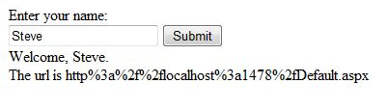
Lesson 31
ASP.NET - Server Controls, ASP.NET - HTML Server Controls, ASP.NET - HTML Client Side & ASP.NET - Basic Controls
Server Controls

Controls are small building blocks of the graphical user interface, which includes text boxes, buttons, check boxes, list boxes, labels and numerous other tools, using which users can enter data, make selections and indicate their preferences.
Controls are also used for structural jobs, like validation, data access, security, creating master pages, data manipulation.

ASP.Net uses five types of web controls, which are:

- HTML controls
- HTML Server controls
- ASP.Net Server controls
- ASP.Net Ajax Server controls
- User controls and custom controls

ASP.Net server controls are the primary controls used in ASP.Net. These controls again could be grouped into the following categories:

- Validation controls - these are used to validate user input and work by running client-side script
- Data source controls - these controls provides data binding to different data sources
- Data view controls - these are various lists and tables, which can bind to data from data sources for display
- Personalization controls - these are used for personalization of a page according to the user's preference, based on user information
- Login and security controls - these controls provide user authentication
- Master pages - these provides consistent layout and interface throughout the application
- Navigation controls - these helps in navigation, for example, the menus, tree view etc.
- Rich controls - these implements special features, for example, AdRotator control, FileUpload control, Calendar control etc.

The basic syntax for using server controls is:

<asp:controlType ID ="ControlID" runat="server" Property1=value1 [Property2=value2] />

The ASP.Net server controls with a visual aspect are derived from the WebControl class and inherit all the properties, events and methods of this class.

The WebControl class itself and some other server controls that are not visually rendered, e.g., the PlaceHolder control or XML control etc., are derived from the System.Web.UI.Control class.

ASP.Net server controls inherit all properties, events and methods of the WebControl and System.Web.UI.Control class.

HTML Server Controls

The HTML server controls are basically the original HTML controls but enhanced to enable server side processing. The HTML controls like the header tags, anchor tags and input elements are not processed by the server but sent to the browser for display.

They are specifically converted to a server control by adding the attribute runat="server" and adding an id attribute to make them available for server-side processing.

For example, consider the HTML input control:

<input type="text" size="40">

It could be converted to a server control, by adding the runat and id attribute:

<input type="text" id="testtext" size="40" runat="server">

HTML Client Side

ASP.Net client side coding has two aspects:

Client side scripts: that would run on the browser and in turn would speed up the execution of page. For example, client side data validation which can catch invalid data and warn the user accordingly without making a round trip to the server.

Client side source code: that the ASP.NET pages generate. For example, the HTML source code of an ASP.NET page contains a number of hidden fields and automatically injected blocks of JavaScript code, which keeps information like view state or does other jobs to make the page work.

Client Side Scripts:

All ASP.Net server controls allow calling client side code written using JavaScript or VBScript. Some ASP.Net server controls use client side scripting to provide responses to the users without posting back to the server, for example, the validation controls.

Apart from these scripts the Button control has a property OnClientClick, which allows executing client-side script, when the button is clicked.

Client Side Source Code

We have already discussed that, ASP.NET pages are generally written in two files:

The content file or the markup file ( .aspx)
The code-behind file

The content file contains the HTML or ASP.Net controls tags and literals to form the structure of the page and the code behind file contains the class definition. At run time, the content file is parsed and transformed into a page class.

This class along with the class definition in the code file and some other system generated code make the executable code (assembly) that processes all posted data and generates the response and sends it back to the client.

HTML Basic Controls

Now we will discuss the basic html controls available in ASP.NET

Button Controls:

ASP .Net provides three types of button controls: buttons, link buttons and image buttons.

When a user clicks a button control, two events are raised Click and Command.
Basic syntax for button controls:

<asp:Button ID="Button1" runat="server"
onclick="Button1_Click" Text="Click" />

Common Properties of the Button control:

Property | Description
Text | The text displayed by the button. This is for button and link button controls only.
ImageUrl | For image button control only. The image to be displayed for the button.
AlternateText | For image button control only. The text to be displayed if the browser can't display the image.
CausesValidation | Determines whether page validation occurs when a user clicks the button. The default is true.
PostBackUrl | The URL of the page that should be requested when the user clicks the button.

Text Boxes and Labels:

Text box controls are typically used to accept input from the user. A text box control can accept one or more lines to text depending upon the setting of the TextMode attribute.

Label controls provide an easy way to display text which can be changed from one execution of a page to the next. If you want to display a text that does not change, you use the literal text.

Basic syntax for text controls:

<asp:TextBox ID="txtstate" runat="server" ></asp:TextBox

Common Properties of the Text Box and Labels:

Property | Description
TextMode | Specifies the type of text box. SingleLine creates a standard text box, MultiLIne creates a text box that accepts more than one line of text and the Password causes the characters that are entered to be masked. The default is SingleLine.
Text | The text content of the text box
MaxLength | The maximum number of characters that can be entered into the text box.
Wrap | It determines whether or not text wraps automatically for multi-line text box; default is true.
ReadOnly | Determines whether the user can change the text in the box; default is false, i.e., the user can change the text.
Columns | The width of the text box in characters. The actual width is determined based on the font that's used for the text entry
Rows | The height of a multi-line text box in lines. The default value is 0, means a single line text box.

Check Boxes and Radio Buttons:

A check box displays a single option that the user can either check or uncheck and radio buttons present a group of options from which the user can select just one option.

Basic syntax for check box:

<asp:CheckBox ID= "chkoption" runat= "Server"> </asp:CheckBox>

Basic syntax for radio button:

<asp:RadioButton ID= "rdboption" runat= "Server">
</asp: RadioButton>

Common Properties of the Check Boxes and Radio Buttons:

Property | Description
Text | The text displayed next to the check box or radio button.
Checked | Specifies whether it is selected or not, default is false.
GroupName | Name of the group the control belongs to.

List Controls:

ASP.Net provides the controls: drop-down list, list box, radio button list, check box list and bulleted list. These control let a user choose from one or more items from the list.

List boxes and drop-down list contain one or more list items. These lists could be loaded either by code or by the ListItem Collection Editor.

Basic syntax for list box control:

<asp:ListBox ID="ListBox1" runat="server"
AutoPostBack="True"
OnSelectedIndexChanged="ListBox1_SelectedIndexChanged">
</asp:ListBox>

Basic syntax for a drop-down list control:

<asp:DropDownList ID="DropDownList1" runat="server"
AutoPostBack="True" OnSelectedIndexChanged="DropDownList1_SelectedIndexChanged">
</asp:DropDownList>

Common Properties of List box and Drop-down Lists:

Property | Description
Items | The collection of ListItem objects that represents the items in the control. This property returns an object of type ListItemCollection.
Rows | Specifies the number of items displayed in the box. If actual list contains more rows than displayed then a scroll bar is added.
SelectedIndex | The index of the currently selected item. If more than one item is selected, then the index of the first selected item. If no item is selected, the value of this property is -1.
SelectedValue | The value of the currently selected item. If more than one item is selected, then the value of the first selected item. If no item is selected, the value of this property is an empty string("").
SelectionMode | Indicates whether a list box allows single selections or multiple selections.

Common Properties of each list item objects:

Property | Description
Text | The text displayed for the item
Selected | Indicates whether the item is selected.
Value | A string value associated with the item.

The List Item Collections:

The ListItemCollection object is a collection of ListItem objects. Each ListItem object represents one item in the list. Items in a ListItemCollection are numbered from 0.

When the items into a list box are loaded using strings like:

lstcolor.Items.Add("Blue")

then both the Text and Value properties of the list item are set to the string value you specify. To set it differently you must create a list item object and then add that item to the collection.

The ListItem Collection Editor is used to add item to a drop-down list or list box. This is used to create a static list of items. To display the Collection Editor select Edit item from the smart tag menu, or select the control and then click the ellipsis button from the Item property in the Properties window.

Common Properties of List Item Collection:

Property | Description
Item(integer) | A ListItem object that represents the item at the specified index.
Count | The number of items in the collection.

Common methods of List Item Collection:

Methods | Description
Add(string) | Adds a new item to the end of the collection and assigns the string parameter to the Text property of the item.
Add(ListItem) | Adds a new item to the end of the collection.
Insert(integer, string) | Inserts an item at the specified index location in the collection, and assigns the string parameter to the Text property of the item.
Insert(integer, ListItem) | Inserts the item at the specified index location in the collection.
Remove(string) | Removes the item with the Text value same as the string.
Remove(ListItem) | Removes the specified item.
RemoveAt(integer) | Removes the item at the specified index as the integer.
Clear | Removes all the items of the collection.
FindByValue(string) | Returns the item whose Value is same as the string.
FindByValue(Text) | Returns the item whose Text is same as the string.

Radio Button list and Check Box list

A radio button list presents a list of mutually exclusive options. A check box list presents a list of independent options. These controls contain a collection of ListItem objects that could be referred to through the Items property of the control.

Basic syntax for radio button list:

<asp:RadioButtonList ID="RadioButtonList1" runat="server"
AutoPostBack="True" OnSelectedIndexChanged="RadioButtonList1_SelectedIndexChanged">
</asp:RadioButtonList>

Basic syntax for check box list:

<asp:CheckBoxList ID="CheckBoxList1" runat="server"
AutoPostBack="True"
OnSelectedIndexChanged="CheckBoxList1_SelectedIndexChanged">
</asp:CheckBoxList>

Common Properties of Check Box and Radio Button Lists:

Property | Description
RepeatLayout | This attribute specifies whether the table tags or the normal html flow to use while formatting the list when it is rendered. The default is Table
RepeatDirection | It specifies the direction in which the controls to be repeated. The values available are Horizontal and Vertical. Default is Vertical
RepeatColumns | It specifies the number of columns to use when repeating the controls; default is 0.

Bulleted lists and Numbered lists:

The bulleted list control creates bulleted lists or numbered lists. These controls contain a collection of ListItem objects that could be referred to through the Items property of the control.

Basic syntax of a bulleted list:

<asp:BulletedList ID="BulletedList1" runat="server">
</asp:BulletedList>

Common Properties of the Bulleted List:

Property | Description
BulletStyle | This property specifies the style and looks of the bullets, or numbers.
RepeatDirection | It specifies the direction in which the controls to be repeated. The values available are Horizontal and Vertical. Default is Vertical
RepeatColumns | It specifies the number of columns to use when repeating the controls; default is 0.

HyperLink Control:

The HyperLink control is like the HTML <a> element.

Basic syntax for a hyperlink control:

<asp:HyperLink ID="HyperLink1" runat="server">
HyperLink
</asp:HyperLink>

It has the following important properties:

Property | Description
ImageUrl | Path of the image to be displayed by the control
NavigateUrl | Target link URL
Text | The text to be displayed as the link
Target | The window or frame which will load the linked page.

Image Control:

The image control is used for displaying images on the web page, or some alternative text, if the image is not available.

Basic syntax for an image control:

<asp:Image ID="Image1" runat="server">

It has the following important properties:

Property | Description
AlternateText | Alternate text to be displayed
ImageAlign | Alignment options for the control
ImageUrl | Path of the image to be displayed by the control

Lesson 32
ASP.NET – Directives, ASP.NET - State Management & Validation Controls
ASP.Net directives are instructions to specify optional settings, such as registering a custom control and page language. These settings describe how the web forms (.aspx) or user controls (.ascx) pages are processed by the .Net framework.

The syntax for declaring a directive is:

<%@ directive_name attribute=value [attribute=value] %>

The Application Directive

The Application directive defines application-specific attributes. It is provided at the top of the global.aspx file.

The basic syntax for a sample Application directive is

<%@ Application Language="C#" %>

The Assembly Directive

The Assembly directive links an assembly to the page or the application at parse time. This could appear either in the global.asax file for application-wide linking or in the page file or a user control file for linking to a page or user control.

The basic syntax for a sample Assembly directive is

<%@ Assembly Name ="myassembly" %>

The Control Directive

The Control directive is used with the user controls and appears in the user control (.ascx) files.

The basic syntax for a sample Control directive is:

<%@ Control Language="C#" EnableViewState="false" %>

The Implements Directive

The Implement directive indicates that the web page, master page or user control page must implement the specified .Net framework interface.

The basic syntax for an Implements directive is

<%@ Implements Interface="interface_name" %>

The Import Directive

The Import directive imports a namespace into a web page, user control pate of application. If the Import directive is specified in the global.asax, then it will apply to the entire application. If it is in a page of user control page, then it would apply to that page or control.

The basic syntax for an Import directive is:

<%@ namespace="System.Drawing" %>

The Master Directive

The Master directive specifies a page file as being the mater page.

The basic syntax for a sample MasterPage directive is:

<%@ MasterPage Language="C#" AutoEventWireup="true"
CodeFile="SiteMater.master.cs" Inherits="SiteMaster" %>

The MasterType Directive

The MasterType directive assigns a class name to the Master property of a page, to make it strongly typed.

The basic syntax for a MasterType directive is

<%@ MasterType attribute="value"[attribute="value" ...] %>

The OutputCache Directive

The OutputCache directive controls the output caching policies of a web page or a user control. We will discuss this directive in details, in data caching.

The basic syntax for a OutputCache directive is

<%@ OutputCache Duration="15" VaryByParam="None" %>

The Page Directive

The Page directive defines the attributes specific to the page file for the page parser and the compiler.

The basic syntax for a Page directive is

<%@ Page Language="C#" AutoEventWireup="true"
CodeFile="Default.aspx.cs" Inherits="_Default" Trace="true" %>

The PreviousPageType Directive

The PreviousPageType directive assigns a class to a page, so that the page is strongly typed.

The basic syntax for a sample PreviousPagetype directive is

<%@ PreviousPageType attribute="value"[attribute="value" ...] %>

The Reference Directive

The Reference directive indicates that another page or user control should be compiled and linked to the current page.

The basic syntax for a sample Reference directive is

<%@ Reference Page ="somepage.aspx" %>

The Register Directive

The Register derivative is used for registering the custom server controls and user controls.

The basic syntax for a sample Register directive is

<%@ Register Src="~/footer.ascx" TagName="footer"
TagPrefix="Tfooter" %>

State Management
HTTP (Hyper Text Transfer Protocol) is a stateless protocol. When the client disconnects from the server, the ASP.Net engine discards the page objects. This way each web application can scale up to serve numerous requests simultaneously without running out of server memory.

However, there need to be some technique to store the information between requests and to retrieve it when required. This information i.e., the current value of all the controls and variables for the current user in the current session is called the State.

View State:

The View State is the state of the page and all its controls. It is automatically maintained across posts by the ASP.Net framework. When a page is sent back to the client, the changes in the properties of the page and its controls are determined and stored in the value of a hidden input field named _VIEWSTATE. When the page is again post back the _VIEWSTATE field is sent to the server with the HTTP request.

The view state could be enabled or disabled for:
The entire application - by setting the EnableViewState property in the <pages> section of web.config file

A page - by setting the EnableViewState attribute of the Page directive, as <%@ Page Language="C#" EnableViewState="false" %>

A control - by setting the Control.EnableViewState property.

It is implemented using a view state object defined by the StateBag class which defines a collection of view state items. The state bag is a data structure containing attribute/value pairs, stored as strings associated with objects.

Session State

When a user connects to an ASP.Net website, a new session object is created. When session state is turned on, a new session state object is created for each new request. This session state object becomes part of the context and it is available through the page.

Session state is generally used for storing application data like inventory or supplier list, or a customer record or shopping cart. It can also keep information about the user and his preference and keep track of pending operations.
Sessions are identified and tracked with a 120-bit SessionID, which is passed from client to server and back as cookie or a modified URL. The SessionID is globally unique and random.

The session state object is created from the HttpSessionState class, which defines a collection of session state items.

Application State

An ASP.Net application is the collection of all web pages, code and other files within a single virtual directory on a web server. When information is stored in application state, it is available to all the users.

To provide for the use of application state, ASP.Net creates an application state object for each application from the HTTPApplicationState class and stores this object in server memory. This object is represented by class file global.asax.

Application State is mostly used to store hit counters and other statistical data, global application data like tax rate, discount rate etc and to keep track of users visiting the site.

Validation Controls
ASP.Net validation controls validate the user input data to ensure that useless, unauthenticated or contradictory data don.t get stored.

ASP.Net provides the following validation controls:

- RequiredFieldValidator
- RangeValidator
- CompareValidator
- RegularExpressionValidator
- CustomValidator
- ValidationSummary

******************

