

Handouts

CSC 441

Compiler Construction

Muhammad Bilal Zafar

VCOMSATS
Learning Management System

The purpose of the course is to become familiar with the functionality of the different phases in the construction of a compiler front end and to gain insight of how these phases are related to each other.

Course Outline:
- Introduction to Compiler
- Structure of Compiler
- Syntax Directed Translator
- Lexical Analysis
- Syntax Analysis
- Semantic Analysis
- Syntax Directed Translation
- Intermediate Code Generation

Lesson 01, 02 & 03
Language Processors, Interpreters, Compiler Vs Interpreters, Language Processing System, The Structure of a Compiler, Compiler Construction Tools, Evolution of Programming Languages, 1st - 5th Generation Languages, Impacts on Compilers, Modeling in Compiler Design, Code Optimization, Programming Language Basics
Compiler is a piece of software that translates a program in one (artificial) language, Lang1, to a program in another (artificial) language, Lang2. Our primarily focus is the case where Lang1 is a programming language that humans like to program in, and Lang2is (or is “closer to”) a machine language, that a computer “understands” and can execute. The compiler should say something even if the input is not a valid program of Lang1. Namely, it should give an error message explaining why the input is not a valid program.

Simply stated, a compiler is a program that can read a program in one language - the source language - and translate it into an equivalent program in another language - the target language. An important role of the compiler is to report any errors in the source program that it detects during the translation process.

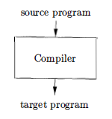

An interpreter is another common kind of language processor. Instead of producing a target program as a translation, an interpreter appears to directly execute the operations specified in the source program on inputs supplied by the user.

The machine-language target program produced by a compiler is usually much faster than an interpreter at mapping inputs to outputs. An interpreter, however, can usually give better error diagnostics than a compiler, because it executes the source program statement by statement.

Java language processors combine compilation and interpretation, as shown in following figure. A Java source program may first be compiled into an intermediate form called bytecodes. The bytecodes are then interpreted by a virtual machine. A benefit of this arrangement is that bytecodes compiled on one machine can be interpreted on another machine, perhaps across a network. In order to achieve faster processing of inputs to outputs, some Java compilers, called just-in-time compilers, translate the bytecodes into machine language immediately before they run the intermediate program to process the input.

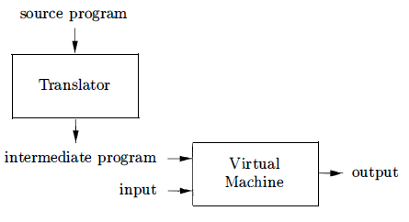

In addition to a compiler, several other programs may be required to create
an executable target program, as shown.

A source program may be divided into modules stored in separate files. The task of collecting the source program is sometimes entrusted to a separate program, called a preprocessor. The preprocessor may also expand shorthands, called macros, into source language statements. The modified source program is then fed to a compiler. The compiler may produce an assembly-language program as its output, because assembly language is easier to produce as output and is easier to debug. The assembly language is then processed by a program called an assembler that produces relocatable machine code as its output.

Large programs are often compiled in pieces, so the relocatable machine code may have to be linked together with other relocatable object files and library files into the code that actually runs on the machine. The linker resolves external memory addresses, where the code in one file may refer to a location in another file. The loader then puts together the entire executable object files into memory for execution.

Up to this point we have treated a compiler as a single box that maps a source program into a semantically equivalent target program. If we open up this box a little, we see that there are two parts to this mapping: analysis and synthesis.

The analysis part breaks up the source program into constituent pieces and imposes a grammatical structure on them. It then uses this structure to create an intermediate representation of the source program. If the analysis part detects that the source program is either syntactically ill formed or semantically unsound, then it must provide informative messages, so the user can take corrective action. The analysis part also collects information about the source program and stores it in a data structure called a symbol table, which is passed along with the intermediate representation to the synthesis part.

The synthesis part constructs the desired target program from the intermediate representation and the information in the symbol table. The analysis part is often called the front end of the compiler; the synthesis part is the back end. If we examine the compilation process in more detail, we see that it operates as a sequence of phases, each of which transforms one representation of the source program to another.

A typical decomposition of a compiler into phases is shown below:

In practice, several phases may be grouped together, and the intermediate representations between the grouped phases need not be constructed explicitly. The symbol table, which stores information about the entire source program, is used by all phases of the compiler. Some compilers have a machine-independent optimization phase between the front end and the back end. The purpose of this optimization phase is to perform transformations on the intermediate representation, so that the back end can produce a better target program than it would have otherwise produced from an unoptimized intermediate representation.

The compiler writer, like any software developer, can profitably use modern software development environments containing tools such as language editors, debuggers, version managers, profilers, test harnesses, and so on. In addition to these general software-development tools, other more specialized tools have been created to help implement various phases of a compiler. These tools use specialized languages for specifying and implementing specific components, and many use quite sophisticated algorithms. The most successful tools are those that hide the details of the generation algorithm and produce components that can be easily integrated into the remainder of the compiler.

Some commonly used compiler-construction tools include:

- Parser generators that automatically produce syntax analyzers from a grammatical description of a programming language.

- Scanner generators that produce lexical analyzers from a regular-expression description of the tokens of a language.

- Syntax-directed translation engines that produce collections of routines for walking a parse tree and generating intermediate code.

- Code-generator generators that produce a code generator from a collection of rules for translating each operation of the intermediate language into the machine language for a target machine.

- Data-flow analysis engines that facilitate the gathering of information about how values are transmitted from one part of a program to each other part. Data-flow analysis is a key part of code optimization.

- Compiler- construction toolkits that provide an integrated set of routines for constructing various phases of a compiler.

Evolution of programming languages: The first electronic computers appeared in the 1940's and were programmed in machine language by sequences of O's and 1's that explicitly told the computer what operations to execute and in what order. The operations themselves were very low level: move data from one location to another add the contents of two registers, compare two values, and so on. Needless to say, this kind of programming was slow, tedious, and error prone. And once written the programs were hard to understand and modify.

The first step towards more people-friendly programming languages was the development of mnemonic assembly languages in the early 1950's. Initially, the instructions in an assembly language were just mnemonic representations of machine instructions. Later, macro instructions were added to assembly languages so that a programmer could define parameterized shorthands for frequently used sequences of machine instructions. A major step towards higher-level languages was made in the latter half of the 1950's with the development of Fortran for scientific computation, Cobol for business data processing, and Lisp for symbolic computation. The philosophy behind these languages was to create higher-level notations with which programmers could more easily write numerical computations, business applications, and symbolic programs. These languages were so successful that they are still in use today.

In the following decades, many more languages were created with innovative features to help make programming easier, more natural, and more robust. Today, there are thousands of programming languages. They can be classified in a variety of ways.

One classification is by generation. First-generation languages are the machine languages, second-generation the assembly languages, and third-generation the higher-level languages like Fortran, Cobol, Lisp, C, C++, C#, and Java. Fourth-generation languages are languages designed for specific applications like NOMAD for report generation, SQL for database queries, and Postscript for text formatting. The term fifth-generation language has been applied to logic- and constraint-based languages like Prolog and OPS5.

Another classification of languages uses the term imperative for languages in which a program specifies how a computation is to be done and declarative for languages in which a program specifies what computation is to be done. Languages such as C, C++, C#, and Java are imperative languages. In imperative languages there is a notion of program state and statements that change the state. Functional languages such as ML and Haskell and constraint logic languages such as Prolog are often considered to be declarative languages. The term von Neumann language is applied to programming languages whose computational model is based on the von Neumann computer architecture. Many of today's languages, such as Fortran and C are von Neumann languages. An object-oriented language is one that supports object-oriented programming, a programming style in which a program consists of a collection of objects that interact with one another. Simula 67 and Smalltalk are the earliest major object-oriented languages. Languages such as C++, C#, Java, and Ruby are more recent object-oriented languages. Scripting languages are interpreted languages with high-level operators designed for "gluing together" computations. These computations were originally called "scripts." Awk, JavaScript, Perl, PHP, Python, Ruby, and Tel are popular examples of scripting languages. Programs written in scripting languages are often much shorter than equivalent programs written in languages like C.

Since the design of programming languages and compilers are intimately related, the advances in programming languages placed new demands on compiler writers. They had to devise algorithms and representations to translate and support the new language features. Since the 1940's, computer architecture has evolved as well. Not only did the compiler writers have to track new language features, they also had to devise translation algorithms that would take maximal advantage of the new hardware capabilities.

Compilers can help promote the use of high-level languages by minimizing the execution overhead of the programs written in these languages. Compilers are also critical in making high-performance computer architectures effective on users' applications. In fact, the performance of a computer system is so dependent on compiler technology that compilers are used as a tool in evaluating architectural concepts before a computer is built. Compiler writing is challenging. A compiler by itself is a large program. Moreover, many modern language-processing systems handle several source languages and target machines within the same framework; that is, they serve as collections of compilers, possibly consisting of millions of lines of code. Consequently, good software-engineering techniques are essential for creating and evolving modern language processors.

A compiler must translate correctly the potentially infinite set of programs that could be written in the source language. The problem of generating the optimal target code from a source program is undecidable in general, thus, compiler writers must evaluate tradeoffs about what problems to tackle and what heuristics to use to approach the problem of generating efficient code.

The study of compilers is mainly a study of how we design the right mathematical models and choose the right algorithms, while balancing the need for generality and power against simplicity and efficiency. Some of most fundamental models are finite-state machines and regular expressions. These models are useful for describing the lexical units of programs (keywords, identifiers) and for describing the algorithms used by the compiler to recognize those units. Also among the most fundamental models are context-free grammars, used to describe the syntactic structure of programming languages such as the nesting of parentheses or control constructs. Similarly, trees are an important model for representing the structure of programs and their translation into object code.

The term "optimization" in compiler design refers to the attempts that a compiler makes to produce code that is more efficient than the obvious code. "Optimization" is thus a misnomer, since there is no way that the code produced by a compiler can be guaranteed to be as fast or faster than any other code that performs the same task.

In modern times, the optimization of code that a compiler performs has become both more important and more complex. It is more complex because processor architectures have become more complex, yielding more opportunities to improve the way code executes. It is more important because massively parallel computers require substantial optimization, or their performance suffers by orders of magnitude. With the likely prevalence of multi core machines (computers with chips that have large numbers of processors on them), all compilers will have to face the problem of taking advantage of multiprocessor machines.

Compiler optimizations must meet the following design objectives:

- The optimization must be correct, that is, preserve the meaning of the compiled program.

- The optimization must improve the performance of many programs.

- The compilation time must be kept reasonable, and

- The engineering effort required must be manageable.

It is impossible to overemphasize the importance of correctness. It is trivial to write a compiler that generates fast code if the generated code need not be correct! Optimizing compilers are so difficult to get right that we dare say that no optimizing compiler is completely error-free! Thus, the most important objective in writing a compiler is that it is correct. The second goal is that the compiler must be effective in improving the performance of many input programs. Normally, performance means the speed of the program execution. Especially in embedded applications, we may also wish to minimize the size of the generated code. And in the case of mobile devices, it is also desirable that the code minimizes power consumption.

Typically, the same optimizations that speed up execution time also conserve power. Besides performance, usability aspects such as error reporting and debugging are also important. Third, we need to keep the compilation time short to support a rapid development and debugging cycle. Finally, a compiler is a complex system; we must keep the system simple to assure that the engineering and maintenance costs of the compiler are manageable.

Lesson 04
Syntax Director Translator, Syntax Definition, CFG, Derivations, Parse Trees, Ambiguity, Associativity & Precedence
This section illustrates the compiling techniques by developing a program that translates representative programming language statements into three-address code, an intermediate representation.

The analysis phase of a compiler breaks up a source program into constituent pieces and produces an internal representation for it, called intermediate code. The synthesis phase translates the intermediate code into the target program. Analysis is organized around the "syntax" of the language to be compiled. The syntax of a programming language describes the proper form of its programs, while the semantics of the language defines what its programs mean, that is, what each program does when it executes. For specifying syntax, we present a widely used notation, called context-free grammars or BNF (for Backus-NaurForm).

Besides specifying the syntax of a language, a context-free grammar can be used to help guide the translation of programs. For simplicity, we consider the syntax-directed translation of infix expressions to postfix form, a notation in which operators appear after their operands. For example, the postfix form of the expression 9 - 5 + 2 is 95 - 2+. Translation into postfix form is rich enough to illustrate syntax analysis. The simple translator handles expressions like 9 - 5 + 2, consisting of digits separated by plus and minus signs. One reason for starting with such simple expressions is that the syntax analyzer can work directly with the individual characters for operators and operands.

Lexical analyzer allows a translator to handle multicharacter constructs like identifiers, which are written as sequences of characters, but are treated as units called tokens during syntax analysis, for example, in the expression count + 1, the identifier count is treated as a unit. The lexical analyzer allows numbers, identifiers, and "white space" (blanks, tabs, and newlines) to appear within expressions.
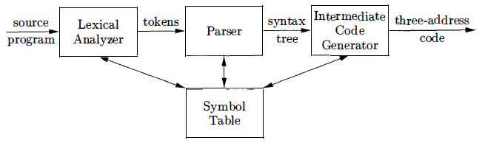
In this model, the parser produces a syntax tree that is further translated into three-address code. Some compilers combine parsing and intermediate-code generation into one component.

Context Free Grammar is used to specify the syntax of the language. Shortly we can say it “Grammar”. A grammar describes the hierarchical structure of most programming language constructs.

Ex. if ( expression ) statement else statement

That is, an if-else statement is the concatenation of the keyword if, an opening parenthesis, an expression, a closing parenthesis, a statement, the keyword else, and another statement. Using the variable expr to denote an expression and the variable stmt to denote a statement, this structuring rule can be expressed as stmt -> if ( expr ) stmt else stmt in which the arrow may be read as "can have the form." Such a rule is called a production. In a production, lexical elements like the keyword if and the parentheses are called terminals. Variables like expr and stmt represent sequences of terminals and are called nonterminals.

A context-free grammar has four components:

- A set of terminal symbols, sometimes referred to as "tokens." The terminals are the elementary symbols of the language defined by the grammar.

- A set of nonterminals, sometimes called "syntactic variables." Each nonterminal represents a set of strings of terminals, in a manner we shall describe.

- A set of productions, where each production consists of a nonterminal, called the head or left side of the production, an arrow, and a sequence of terminals and/or nonterminals , called the body or right side of the production .

- A designation of one of the nonterminals as the start symbol.

Example Expressions … 9 – 5 + 2 , 5 – 4 , 8 …

Since a plus or minus sign must appear between two digits, we refer to such expressions as lists of digits separated by plus or minus signs. The productions are
List → list + digit
List → list – digit
List → digit
Digit → 0 1 1 1 2 1 3 1 4 1 5 1 6 1 7 1 8 1 9

A grammar derives strings by beginning with the start symbol and repeatedly replacing a nonterminal by the body of a production for that nonterminal. The terminal strings that can be derived from the start symbol form the language defined by the grammar.

Parsing is the problem of taking a string of terminals and figuring out how to derive it from the start symbol of the grammar. If it cannot be derived from the start symbol of the grammar, then reporting syntax errors within the string.

Given a context-free grammar, a parse tree according to the grammar is a tree with the following properties:

- The root is labeled by the start symbol.
- Each leaf is labeled by a terminal or by ɛ.
- Each interior node is labeled by a nonterminal.
- If A → X1 X2 … Xn is a production, then node A has immediate children X1, X2, …, Xn where Xi is a (non)terminal or ε.

A grammar can have more than one parse tree generating a given string of terminals. Such a grammar is said to be ambiguous. To show that a grammar is ambiguous, all we need to do is find a terminal string that is the yield of more than one parse tree. Since a string with more than one parse tree usually has more than one meaning, we need to design unambiguous grammars for compiling applications, or to use ambiguous grammars with additional rules to resolve the ambiguities.

Consider the Grammar G = [ {string}, {+,-,0,1,2,3,4,5,6,7,8,9}, P, string ]

Its productions are string → string + string | string - string | 0 | 1 | … | 9
This grammar is ambiguous, because more than one parse tree
represents the string 9-5+2

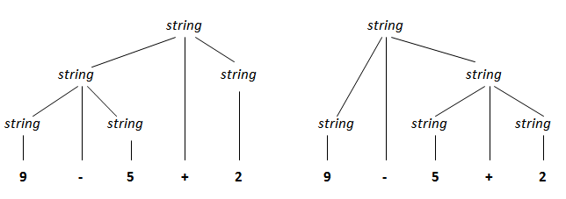
By convention,
9+5+2 is equivalent to (9+5) +2 &
9-5-2 is equivalent to (9-5) -2
When an operand like 5 has operators to its left and right, conventions are needed for deciding which operator applies to that operand. We say that the operator + associates to the left, because an operand with plus signs on both sides of it belongs to the operator to its left. In most programming languages the four arithmetic operators, addition, subtraction, multiplication and division are left-associative.

Consider the expression 9+5*2. There are two possible interpretations of this expression: (9+5 ) *2 or 9+ ( 5*2) . The associativity rules for + and * apply to occurrences of the same operator, so they do not resolve this ambiguity.

An Associativity and precedence table is shown below:
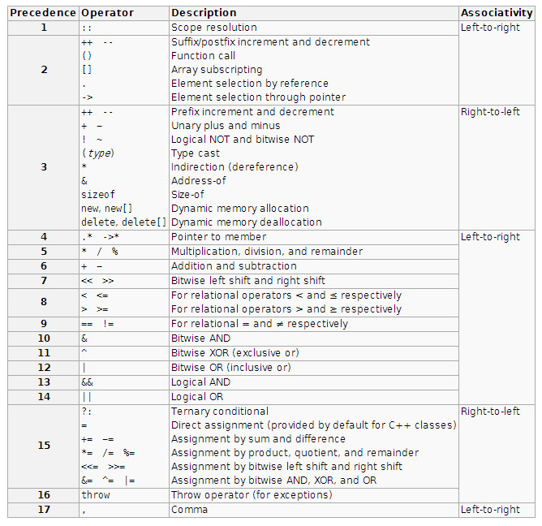

Lesson 05
Attributes, Translation Schemes, Postfix Notation, Synthesized Attributes, Tree Traversals, Translation Schemes, Preorder and Post order Traversals
Syntax-directed translation is done by attaching rules or program fragments to productions in a grammar. For example, consider an expression expr generated
by the production expr → expr1 + term

Here, expr is the sum of the two sub expressions expr₁ and term. We can translate expr by exploiting its structure, as in the following pseudo-code:
translate expr₁;
translate term;
handle +;
An attribute is any quantity associated with a programming construct. Examples of attributes are data types of expressions, the number of instructions in the generated code, or the location of the first instruction in the generated code for a construct, among many other possibilities.

A translation scheme is a notation for attaching program fragments to the productions of a grammar. The program fragments are executed when the production is used during syntax analysis. The combined result of all these fragment executions, in the order induced by the syntax analy sis, produces the translation of the program to which this analysis/synthesis process is applied.

The postfix notation for an expression E can be defined inductively as follows:

- If E is a variable or constant, then the postfix notation for E is E itself.
- If E is an expression of the form E₁ op E₂ , where op is any binary operator, then the postfix notation for E is E'₁ E'₂ op, where E'₁ and E'₂ are the postfix notations for El and E2 , respectively.
- If E is a parenthesized expression of the form (E₁), then the postfix notation for E is the same as the postfix notation for E₁.

The postfix notation for (9-5)+2 is 95-2+. That is, the translations of 9, 5, and 2 are the constants themselves, by rule (1). Then, the translation of 9-5 is 95- by rule (2) . The translation of (9-5) is the same by rule (3). Having translated the parenthesized subexpression, we may apply rule (2) to the entire expression, with (9-5) in the role of El and 2 in the role of E2 , to get the result 95-2+.

No parentheses are needed in postfix notation, because the position and arity (number of arguments) of the operators permits only one decoding of a postfix expression. The "trick" is to repeatedly scan the postfix string from the left, until you find an operator. Then, look to the left for the proper number of operands, and group this operator with its operands. Evaluate the operator on the operands, and replace them by the result. Then repeat the process, continuing to the right and searching for another operator.

A syntax-directed definition associates

- With each grammar symbol, a set of attributes, and
- With each production, a set of semantic rules for computing the values of the attributes associated with the symbols appearing in the production.

An attribute is said to be synthesized if its value at a parse-tree node N is determined from attribute values at the children of N and at N itself. Synthesized attributes have the desirable property that they can be evaluated during a single bottom-up traversal of a parse tree.

Tree traversals will be used for describing attribute evaluation and for specifying the execution of code fragments in a translation scheme. A traversal of a tree starts at the root and visits each node of the tree in some order.

A depth-first traversal starts at the root and recursively visits the children of each node in any order, not necessarily from left to right. It is called "depthfirst" because it visits an unvisited child of a node whenever it can, so it visits nodes as far away from the root (as "deep" ) as quickly as it can.

The following procedure visit(N) is a depth first traversal that visits the children of a node in left-to-right order, shown below as well.

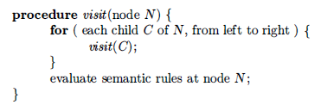
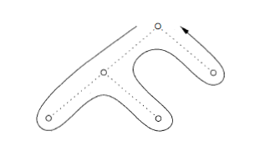
In this traversal, we have included the action of evaluating translations at each node, just before we finish with the node (that is, after translations at the children have surely been computed). In general, the actions associated with a traversal can be whatever we choose, or nothing at all. A syntax-directed definition does not impose any specific order for the evaluation of attributes on a parse tree; any evaluation order that computes an attribute a after all the other attributes that a depends on is acceptable. Synthesized attributes can be evaluated during any bottom-up traversal, that is, a traversal that evaluates attributes at a node after having evaluated attributes at its children.

A syntax-directed translation scheme is a notation for specifying a translation by attaching program fragments to productions in a grammar. A translation scheme is like a syntax-directed definition, except that the order of evaluation of the semantic rules is explicitly specified. Program fragments embedded within production bodies are called semantic actions. The position at which an action is to be executed is shown by enclosing it between curly braces and writing it within the production body, as in

rest -> + term { print('+') } rest₁

We shall see such rules when we consider an alternative form of grammar for expressions, where the nonterminal rest represents "everything but the first term of an expression." Again, the subscript in rest₁ distinguishes this instance of nonterminal rest in the production body from the instance of rest at the head of the production. When drawing a parse tree for a translation scheme, we indicate an action by constructing an extra child for it, connected by a dashed line to the node that Corresponds to the head of the production. An extra leaf is constructed for the semantic action.

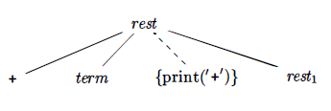
Actions translating 9-5+2 into 95-2+
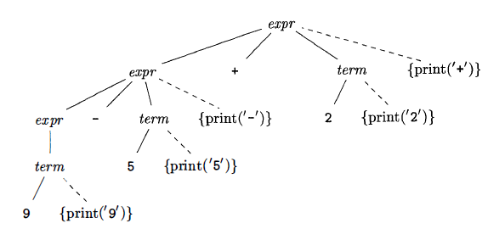

Following are the actions for translating into postfix notation
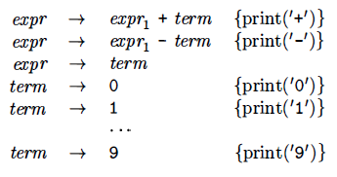

The implementation of a translation scheme must ensure that semantic actions are performed in the order they would appear during a postorder traversal of a parse tree. The implementation need not actually construct a parse tree (often it does not), as long as it ensures that the semantic actions are performed as if we constructed a parse tree and then executed the actions during a postorder traversal.

In preorder traversal action is done when we first visit a node. If the action is done just before we leave a node for the last time, then we say it is a postorder traversal of the tree.

Preorder and postorder traversals define corresponding orderings on nodes, based on when the action at a node would be performed.

Lesson 06
Parsing, Top Down Parsing, Predictive Parsing, Designing a Predictive Parser, Left Recursion
Parsing is the process of determining how a string of terminals can be generated by a grammar. In discussing this problem, it is helpful to think of a parse tree being constructed, even though a compiler may not construct one, in practice. However, a parser must be capable of constructing the tree in principle, or else the translation cannot be guaranteed correct.

For any context-free grammar there is a parser that takes at most O(n³) time to parse a string of n terminals. But cubic time is generally too expensive. Fortunately, for real programming languages, we can generally design a grammar that can be parsed quickly. Linear-time algorithms suffice to parse essentially all languages that arise in practice. Programming-language parsers almost always make a single left-to-right scan over the input, looking ahead one terminal at a time, and constructing pieces of the parse tree as they go.

Most parsing methods fall into one of two classes, called the top-down and bottom-up methods. These terms refer to the order in which nodes in the parse tree are constructed. In top-down parsers, construction starts at the root and proceeds towards the leaves, while in bottom-up parsers, construction starts at the leaves and proceeds towards the root. The popularity of top-down parsers is due to the fact that efficient parsers can be constructed more easily by hand using top-down methods. Bottom-up parsing, however, can handle a larger class of grammars and translation schemes, so software tools for generating parsers directly from grammars often use bottom-up methods.

The top-down construction of a parse tree as shown below for the given grammar is done by starting with the root, labeled with the starting nonterminal stmt, and repeatedly performing the following two steps.

- At node N, labeled with nonterminal A, select one of the productions for A and construct children at N for the symbols in the production body.
- Find the next node at which a subtree is to be constructed, typically the leftmost unexpanded nonterminal of the tree.
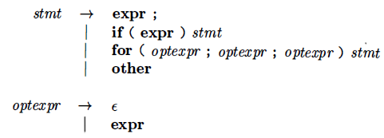
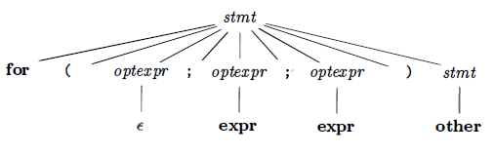

For some grammars, the above steps can be implemented during a single left-to-right scan of the input string. The current terminal being scanned in the input is frequently referred to as the lookahead symbol. Initially, the lookahead symbol is the first , i.e., leftmost , terminal of the input string.

Following are the step wise illustration for the parse tree we constructed above.
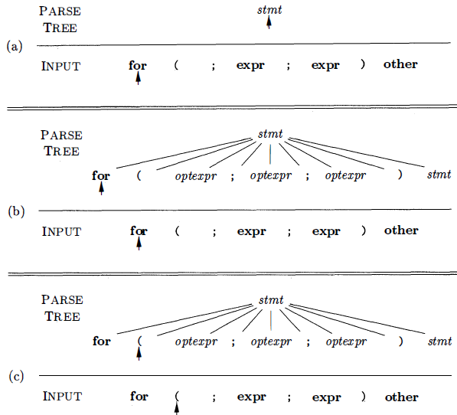

Recursive-descent parsing is a top-down method of syntax analysis in which a set of recursive procedures is used to process the input. One procedure is associated with each nonterminal of a grammar. Here, we consider a simple form of recursive-descent parsing, called predictive parsing, in which the lookahead symbol unambiguously determines the flow of control through the procedure body for each nonterminal. The sequence of procedure calls during the analysis of an input string implicitly defines a parse tree for the input, and can be used to build an explicit parse tree, if desired.

The predictive parser consists of procedures for the nonterminals stmt and optexpr of the grammar we saw earlier and an additional procedure match, used to simplify the code for stmt and optexpr. Procedure match(t) compares its argument t with the lookahead symbol and advances to the next input terminal if they match. Thus match changes the value of variable lookahead, a global variable that holds the currently scanned input terminal.

We can also say that one of the most straightforward forms of parsing is recursive descent parsing. A basic operation necessary for this involves reading characters from the input stream and matching then with terminals from the grammar that describes the syntax of the input. Our recursive descent parsers will look ahead one character and advance the input stream reading pointer when proper matches occur. The routine presented in following figure accomplishes this matching and reading process.
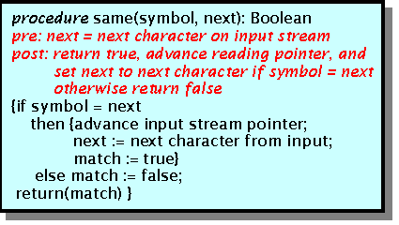
Note that the variable called 'next' looks ahead and always provides the next character that will be read from the input stream. This feature is essential if we wish our parsers to be able to predict what is due to arrive as input. Note also that an error indicator is returned.
What a recursive descent parser actually does is to perform a depth-first search of the derivation tree for the string being parsed. This provides the 'descent' portion of the name. The 'recursive' portion comes from the parser's form, a collection of recursive procedures.
As our first example, consider the simple grammar
E → x+T
T → (E)
T → x
and the derivation tree is shown following for the expression x+(x+x)
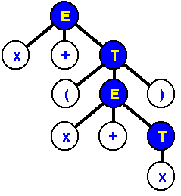
A recursive descent parser traverses the tree by first calling a procedure to recognize an E. This procedure reads an 'x' and a '+' and then calls a procedure to recognize a T. This would look like the following routine.
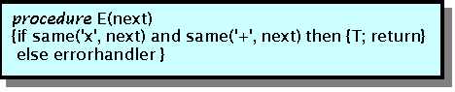
Note that 'errorhandler' is a procedure that notifies the user that a syntax error has been made and then possibly terminates execution.
In order to recognize a T, the parser must figure out which of the productions to execute. This is not difficult and is done in the procedure that appears below.
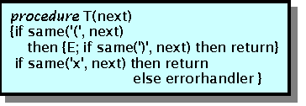
In the above routine, the parser determines whether T had the form (E) or x. If not then the error routine was called, otherwise the appropriate terminals and nonterminals were recognized. So, all one needs to write a recursive descent parser is a nice grammar. But, what exactly is a 'nice' grammar? The remainder of this essay will be devoted to answering this question.

First of all a grammar must be deterministic. Examine the grammar for conditional statements presented below. (S is the nonterminal that generates statements and B is one that generates Boolean expressions.)
S → if B then S;
S → if B then S else S;
Both of these productions begin the same way, so it is not clear from the first symbols exactly which production is to be used in recognizing a conditional statement. The solution to this problem is called factoring. We will see factoring in later sections
It is possible for a recursive-descent parser to loop forever. A problem arises with "left-recursive" productions like
expr → expr + term
where the leftmost symbol of the body is the same as the nonterminal at the head of the production. Suppose the procedure for expr decides to apply this production. The body begins with expr so the procedure for expr is called recursively. Since the lookahead symbol changes only when a terminal in the body is matched, no change to the input took place between recursive calls of expr.

As a result, the second call to expr does exactly what the first call did, which means a third call to expr, and so on, forever. A left-recursive production can be eliminated by rewriting the offending production.

Consider a nonterminal A with two productions A → A α | β
where α and β are sequences of terminals and nonterminals that do not start with A.
For example, in expr → expr + term | term
nonterminal A = expr, string α = + term, and string β = term.
The nonterminal A and its production are said to be left recursive, because the production A → Aα has A itself as the leftmost symbol on the right side.

A left-recursive production can be eliminated by systematically
rewriting the grammar using right recursive productions
A → β R
R → α R | ɛ
Lesson 07 & 08
Translator for Simple Expressions, Abstract and Concrete Syntax, Adapting the Translation Scheme, Lexical Analysis, Symbol Tables, Intermediate Code Generator, Syntax Directed Translator Flow, Role of the Lexical Analyzer, Input Buffering
Using the techniques of the recent sections, we now construct a syntax directed translator that translates arithmetic expressions into postfix form. To keep the initial program manageably small, we start with expressions consisting of digits separated by binary plus and minus signs. A syntax-directed translation scheme often serves as the specification for a translator. The following scheme defines the actions for translating into postfix notation.

Often, the underlying grammar of a given scheme has to be modified before it can be parsed with a predictive parser. In particular, the grammar underlying the scheme is left recursive, and as we saw in the last section, a predictive parser cannot handle a left-recursive grammar.

We appear to have a conflict: on the one hand we need a grammar that facilitates translation on the other hand we need a significantly different grammar that facilitates parsing. The solution is to begin with the grammar for easy translation and carefully transform it to facilitate parsing. By eliminating the left recursion, we can obtain a grammar suitable for use in a predictive recursive-descent translator.

A useful starting point for designing a translator is a data structure called an abstract syntax tree. In an abstract syntax tree for an expression, each interior node represents an operator; the children of the node represent the operands of the operator. In following abstract syntax tree for 9-5+2 the root represents the operator +.
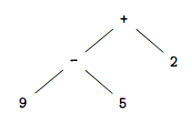
The subtrees of the root represent the sub expressions 9-5 and 2. The grouping of 9-5 as an operand reflects the left-to-right evaluation of operators at the same precedence level. Since - and + have the same precedence, 9-5+2 is equivalent to (9-5) +2.

Abstract syntax trees, or simply syntax trees, resemble parse trees to an extent. However, in the syntax tree, interior nodes represent programming constructs while in the parse tree, the interior nodes represent nonterminals. Many nonterminals of a grammar represent programming constructs, but others are "helpers" of one sort of another, such as those representing terms, factors, or other variations of expressions. In the syntax tree, these helpers typically are not needed and are hence dropped. To emphasize the contrast, a parse tree is sometimes called a concrete syntax tree, and the underlying grammar is called a concrete syntax for the language.

The left-recursion-elimination technique can also be applied to productions containing semantic actions. First, the technique extends to multiple productions for A. In our example, A is expr, and there are two leftrecursive productions for expr and one that is not left recursive. The technique transforms the productions A → Aα | Aβ | γ into
A → γR
R → αR | βR | ɛ
Second, we need to transform productions that have embedded actions, not just terminals and nonterminals. Semantic actions embedded in the productions are simply carried along in the transformation, as if they were terminals.

A lexical analyzer reads characters from the input and groups them into "token objects." Along with a terminal symbol that is used for parsing decisions, a token object carries additional information in the form of attribute values. So far, there has been no need to distinguish between the terms "token" and "terminal," since the parser ignores the attribute values that are carried by a token. In this section, a token is a terminal along with additional information. A sequence of input characters that comprises a single token is called a lexeme. Thus, we can say that the lexical analyzer insulates a parser from the lexeme representation of tokens.

Typical tasks performed by lexical analyzer:
- Remove white space and comments
- Encode constants as tokens
- Recognize keywords
- Recognize identifiers and store identifier names in a global symbol table

The extended translation actions for translating into postfix notations to allow numbers and identifiers, also including multiply and division will be:

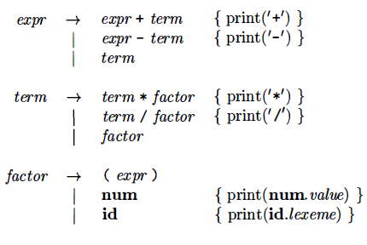

Terminal num is assumed to have an attribute num.value, which gives the integer value corresponding to this occurrence of num. Terminal id has a string-valued attribute written as id.lexeme; we assume this string is the actual lexeme comprising this instance of the token id.

Most languages allow arbitrary amounts of white space to appear between tokens. Comments are likewise ignored during parsing, so they may also be treated as white space. If white space is eliminated by the lexical analyzer, the parser will never have to consider it. Following code skips white space by reading input characters as long as it sees a blank, a tab, or a newline.
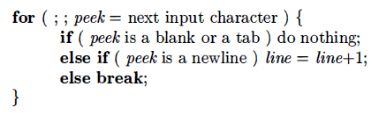
A lexical analyzer may need to read ahead some characters before it can decide on the token to be returned to the parser. For example, a lexical analyzer for C or Java must read ahead after it sees the character >. If the next character is =, then > is part of the character sequence >=, the lexeme for the token for the "greater than or equal to" operator. Otherwise > itself forms the "greater than" operator, and the lexical analyzer has read one character too many.

A general approach to reading ahead on the input, is to maintain an input buffer from which the lexical analyzer can read and push back characters. Input buffers can be justified on efficiency grounds alone, since fetching a block of characters is usually more efficient than fetching one character at a time. A pointer keeps track of the portion of the input that has been analyzed; pushing back a character is implemented by moving back the pointer.

For a single digit, appears in a grammar for expressions, it is replaced with an arbitrary integer constant . Integer constants can be allowed either by creating a terminal symbol, say num, for such constants or by incorporating the syntax of integer constants into the grammar. For example input 16+28+50 will be transformed into (num, 31) (+) (num, 28) (+) (num, 59)
Here, the terminal symbol + has no attributes, so its tuple is simply (+)

Symbol tables are data structures that are used by compilers to hold information about source-program constructs. The information is collected incrementally by the analysis phases of a compiler and used by the synthesis phases to generate the target code. Entries in the symbol table contain information about an identifier such as its character string (or lexeme) , its type, its position in storage, and any other relevant information. Symbol tables typically need to support multiple declarations of the same identifier within a program.

Symbol Table per scope: The term "scope of identifier x' really refers to the scope of a particular declaration of x. The term scope by itself refers to a portion of a program that is the scope of one or more declarations. Scopes are important, because the same identifier can be declared for different purposes in different parts of a program. Common names like i and x often have multiple uses. As another example, subclasses can redeclare a method name to override a method in a superclass. If blocks can be nested, several declarations of the same identifier can appear within a single block. The following syntax results in nested blocks when stmts can generate a block:
block → '{' decl stmts '}'

The front end of a compiler constructs an intermediate representation of the source program from which the back end generates the target program. Two most important intermediate representations are:

  - Trees, including parse trees and (abstract) syntax trees.
  - Linear representations, especially "three-address code."

During parsing, syntax-tree nodes are created to represent significant programming constructs. As analysis proceeds, information is added to the nodes in the form of attributes associated with the nodes. The choice of attributes depends on the translation to be performed. Three-address code, on the other hand, is a sequence of elementary program steps, such as the addition of two values. Unlike the tree, there is no hierarchical structure. We need this representation if we are to do any significant optimization of code. In that case, we break the long sequence of three-address statements that form a program into "basic blocks," which are sequences of statements that are always executed one-after-the-other, with no branching. In addition to creating an intermediate representation, a compiler front end checks that the source program follows the syntactic and semantic rules of the source language. This checking is called static checking, in general "static" means "done by the compiler." Static checking assures that certain kinds of programming errors, including type mismatches, are detected and reported during compilation.

Static checks are consistency checks that are done during compilation. Not only do they assure that a program can be compiled successfully, but they also have the potential for catching programming errors early, before a program is run. Static checking includes:
- Syntactic Checking. There is more to syntax than grammars. For example, constraints such as an identifier being declared at most once in a scope, or that a break statement must have an enclosing loop or switch statement, are syntactic, although they are not encoded in, or enforced by, a grammar used for parsing.
- Type Checking. The type rules of a language assure that an operator or function is applied to the right number and type of operands. If conversion between types is necessary, e.g. , when an integer is added to a float, then the type-checker can insert an operator into the syntax tree to represent that conversion.

Three-address code is a sequence of instructions of the form x = y op Z where x, y, and z are names, constants, or compiler-generated temporaries & op stands for an operator.

Arrays will be handled by using the following two variants of instructions:
x[y] = z x = y[z]

The first puts the value of z in the location x[y] , and the second puts the value of y [z] in the location x.

Three-address instructions are executed in numerical sequence unless forced to do otherwise by a conditional or unconditional jump. We choose the following instructions for control flow:

if False x goto L if x is false, next execute the instruction labeled L
if True x goto L if x is true, next execute the instruction labeled L
goto L next execute the instruction labeled L

A label L can be attached to any instruction by prep ending a prefix L. An instruction can have more than one label. Finally, we need instructions that copy a value. The following three-address instruction copies the value of y into x: x = y

Syntax Directed Translator Flow: The starting point for a syntax-directed translator is a grammar for the source language. A grammar describes the hierarchical structure of programs. It is defined in terms of elementary symbols called terminals and variable symbols called nonterminals. These symbols represent language constructs. The productions of a grammar consist of a non terminal called the left side of a production and a sequence of terminals and non terminals called the right side of the production. One non terminal is designated as the start symbol. A lexical analyzer reads the input one character at a time and produces as output a stream of tokens. A token consists of a terminal symbol along with additional information in the form of attribute values.
Parsing is the problem of figuring out how a string of terminals can be derived from the start symbol of the grammar by repeatedly replacing a non terminal by the body of one of its productions. Efficient parsers can be built, using a top-down method called predictive parsing. A syntax-directed definition attaches rules to productions, the rules compute attribute vales.
Sometimes, lexical analyzers are divided into a cascade of two processes:
- Scanning consists of the simple processes that do not require tokenization of the input, such as deletion of comments and compaction of consecutive whitespace characters into one.
- Lexical analysis is the more complex portion, where the scanner produces the sequence of tokens as output.
There are a number of reasons why the analysis portion is normally separated into lexical analysis and parsing.
- The separation of lexical and syntactic analysis often allows us to simplify at least one of these tasks.
- Compiler efficiency is improved. A separate lexical analyzer allows to apply specialized techniques that serve only the lexical task, not the job of parsing.
- Compiler portability is enhanced. Input-device-specific peculiarities can be restricted to the lexical analyzer.
A token is a pair consisting of a token name and an optional attribute value. The token name is an abstract symbol representing a kind of lexical unit, e.g., a particular keyword, or sequence of input characters denoting an identifier. A pattern is a description of the form that the lexemes of a token may take. In the case of a keyword as a token, the pattern is just the sequence of characters that form the keyword. A lexeme is a sequence of characters in the source program that matches the pattern for a token and is identified by the lexical analyzer as an instance of that token.
Lesson 09 & 10
Specification of Tokens, Regular Expressions, Regular Definitions, Recognition of Tokens, Transition Diagrams, Finite Automata, NFA, Transition Tables
In this section first we need to know about finite vs infinite sets and also uses the notion of a countable set. A countable set is either a finite set or one whose elements can be counted. The set of rational numbers, i.e., fractions in lowest terms, is countable. The set of real numbers is uncountable, because it is strictly bigger, i.e., it cannot be counted.
A regular expression is a sequence of characters that forms a search pattern, mainly for use in pattern matching with strings. The idea is that the regular expressions over an alphabet consist of the alphabet, and expressions using union, concatenation, and *, but it takes more words to say it right. Each regular expression r denotes a language L(r), which is also defined recursively from the languages denoted by r's subexpressions.
Rules that define the regular expressions over some alphabet Σ and the languages that those expressions denote are:
BASIS: There are two rules that form the basis:
- ε is a regular expression, and L(ε) is {ε} , that is, the language whose sole member is the empty string.
- If a is a symbol in Σ, then a is a regular expression, and L(a) = {a}, that is, the language with one string, of length one, with a in its 1st position.
INDUCTION: There are four parts to the induction whereby larger regular expressions are built from smaller ones.
Suppose r and s are regular expressions denoting languages L(r) and L(s), respectively.
- (r) | (s) is a regular expression denoting the language L(r) U L(s)
- (r) (s) is a regular expression denoting the language L(r)L(s)
- (r)* is a regular expression denoting (L (r)) *
- (r) is a regular expression denoting L(r)
Regular expressions often contain unnecessary pairs of parentheses. We may drop certain pairs of parentheses if we adopt the conventions that:
- The unary operator * has highest precedence and is left associative.
- Concatenation has second highest precedence and is left associative.
- | has lowest precedence and is left associative.

For example regular definition for the language of C identifiers is
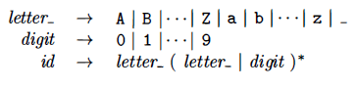
A language that can be defined by a regular expression is called a regular set. If two regular expressions r and s denote the same regular set , we say they are equivalent and write r = s.
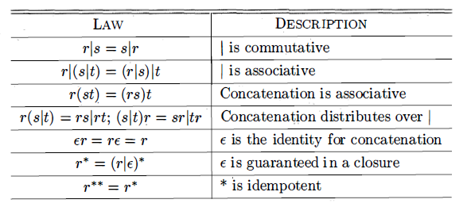
There are many extensions of the basic regular expressions given above.
The following three will be occasionally used in this course as they are useful for lexical analyzers.
- One or more instances. This is the positive closure operator + mentioned above.
- Zero or one instance. The unary postfix operator ? defined by
r? = r | ε for any RE r.
- Character classes. If a₁, a₂, ..., a_{n} are symbols in the alphabet, then
[a₁a₂...a_{n}] = a₁ | a₂ | ... | a_{n}. In the special case where all the a's are consecutive, we can simplify the notation further to just [a₁-a_{n}].
As an intermediate step in the construction of a lexical analyzer, we first convert patterns into stylized flowcharts, called "transition diagrams”.
Transition diagrams have a collection of nodes or circles, called states Each state represents a condition that could occur during the process of scanning the input looking for a lexeme that matches one of several patterns.
Edges are directed from one state of the transition diagram to another. Each edge is labeled by a symbol or set of symbols. Some important conventions:
- The double circles represent accepting or final states at which point a lexeme has been found. There is often an action to be done (e.g., returning the token), which is written to the right of the double circle.
- If we have moved one (or more) characters too far in finding the token, one (or more) stars are drawn.
- An imaginary start state exists and has an arrow coming from it to indicate where to begin the process.
Following transition diagram is used for recognizing the lexemes matching the token relop.
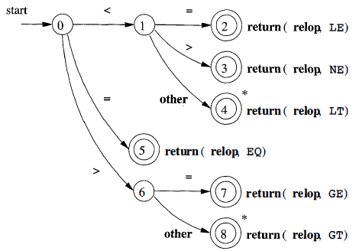

Recognizing keywords and identifiers presents a problem. Usually, keywords like if or then are reserved (as they are in our running example), so they are not identifiers even though they look like identifiers.
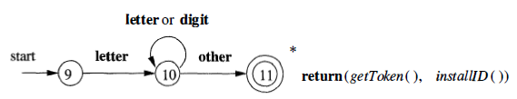
Finite automata are like the graphs in transition diagrams but they simply decide if an input string is in the language (generated by our regular expression). Finite automata are recognizers, they simply say "yes" or "no" about each possible input string. There are two types of Finite automata:
- Nondeterministic finite automata (NFA) have no restrictions on the labels of their edges. A symbol can label several edges out of the same state, and ε, the empty string, is a possible label.
- Deterministic finite automata (DFA) have exactly one edge, for each state, and for each symbol of its input alphabet with that symbol leaving that state. So if you know the next symbol and the current state, the next state is determined. That is, the execution is deterministic, hence the name.
Both deterministic and nondeterministic finite automata are capable of recognizing the same languages.
An NFA is basically a flow chart like the transition diagrams we have already seen. Indeed an NFA can be represented by a transition graph whose nodes are states and whose edges are labeled with elements of Σ ∪ ε. The differences between a transition graph and previous transition diagrams are:
- Possibly multiple edges with the same label leaving a single state.
- An edge may be labeled with ε.
For example the transition graph shown below is for an NFA recognizing the language of regular expression (a | b) * abb This ex, describes all strings of a's and b's ending in the particular string abb.
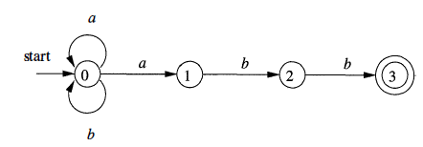
Transition Table is an equivalent way to represent an NFA, in which, for each state s and input symbol x (and ε), the set of successor states x leads to from s. The empty set φ is used when there is no edge labeled x emanating from s. Transition Table for (a | b) * abb

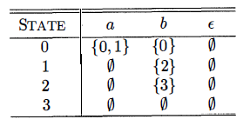
Lesson 11 & 12
Acceptance of Input Strings by Automata, Deterministic Finite Automata, Simulating a DFA, Regular Expressions to Automata, Conversion of an NFA to a DFA, Simulation of an NFA, Construction of RE to NFA
An NFA accepts a string if the symbols of the string specify a path from the start to an accepting state.
- These symbols may specify several paths, some of which lead to accepting states and some that don't.
- In such a case the NFA does accept the string, one successful path is enough.
- If an edge is labeled ε, then it can be taken for free.
A deterministic finite automaton (DFA) is a special case of an NFA where:
- There are no moves on input ε, and
- For each state S and input symbol a, there is exactly one edge out of s labeled a.
If we are using a transition table to represent a DFA, then each entry is a single state. We may therefore represent this state without the curly braces that we use to form sets. While the NFA is an abstract representation of an algorithm to recognize the strings of a certain language, the DFA is a simple, concrete algorithm for recognizing strings. It is fortunate indeed that every regular expression and every NFA can be converted to a DFA accepting the same language, because it is the DFA that we really implement or simulate when building lexical analyzers.
The following algorithm shows how to apply a DFA to a string.

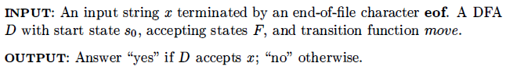
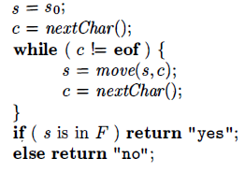
The function move(s, c) gives the state to which there is an edge from state s on input c.
The function next Char returns the next character of the input string x.
For example Transition graph of a DFA accepting the language (a|b)*abb, same as that accepted by the NFA previously.
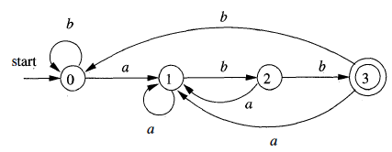
The regular expression is the notation of choice for describing lexical analyzers and other pattern-processing software. Implementation of that software requires the simulation of a DFA, or perhaps simulation of an NFA. NFA often has a choice of move on an input symbol or on ε, or even a choice of making a transition ε on or on a real input symbol. Its simulation is less straightforward than for a DFA. So it is important to convert an NFA to a DFA that accepts the same language. "The subset construction," is used to give a useful algorithm for simulating NFA's directly, in situations (other than lexical analysis) where the NFA-to-DFA conversion takes more time than the direct simulation. The general idea behind the subset construction is that each state of the constructed DFA corresponds to a set of NFA states.
INPUT: An NFA N
OUTPUT: A DFA D accepting the same language as N.
METHOD: Construct a transition table Dtran for D.
Each state of D is a set of NFA states, and construct Dtran so D will simulate "in parallel" all possible moves N can make on a given input string.
First issue is to deal with ɛ-transitions of N properly. Definitions of several functions that describe basic computations on the states of N that are needed in the algorithm are described below:
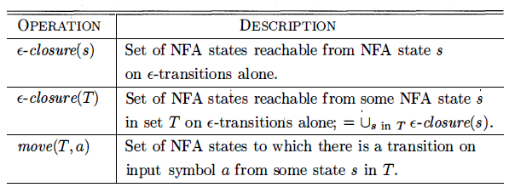
Here s is a single state of N, while T is a set of states of N. For the demonstration of this, see example 3.21 of Dragon book¹.
A strategy that has been used in a number of text-editing programs is to construct an NFA from a regular expression and then simulate the NFA.
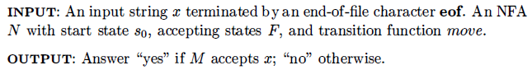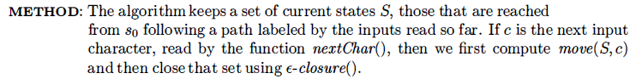
- Compilers Principle, Techniques & Tools 2nd Ed by Aho, Lam, Sethi, Ullman
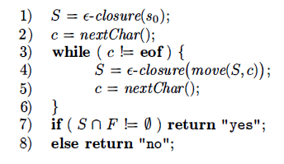
If carefully implemented, this algorithm can be quite efficient. As the ideas involved are useful in a number of similar algorithms involving search of graphs. The data structures we need are:
- Two stacks, each of which holds a set of NFA states. One of these stacks, oldStates, holds the "current" set of states, i.e., the value of S on the right side of line (4). The second, newStates, holds the "next" set of states - S on the left side of line (4). Unseen is a step where, as we go around the loop of lines (3) through (6), newStates is transferred to oldStates.
- A boolean array already On, indexed by the NFA states, to indicate which states are in newStates. While the array and stack hold the same information, it is much faster to interrogate alreadyOn[s] than to search for state s on the stack newStates. It is for this efficiency that we maintain both representations.
- A two-dimensional array move[s,a] holding the transition table of the NFA. The entries in this table, which are sets of states, are represented by linked lists.
Now we see an algorithm for converting any RE to NFA. The algorithm is syntax-directed, it works recursively up the parse tree for the regular expression. For each subexpression the algorithm constructs an NFA with a single accepting state.
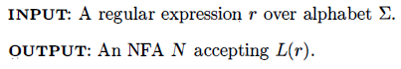
Method:
- Begin by parsing r into its constituent subexpressions.
- The rules for constructing an NFA consist of basis rules for handling subexpressions with no operators.
- Inductive rules for constructing larger NFA's from the NFA's for the immediate sub expressions of a given expression.
Basis Step:
For expression ɛ construct the NFA 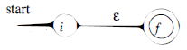
Here, i is a new state, the start state of this NFA, and f is another new state, the accepting state for the NFA.
Now for any sub-expression a in Σ construct the NFA 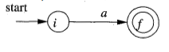
Here again, i is a new state, the start state of this NFA, and f is another new state, the accepting state for the NFA.
In both of the basis constructions, we construct a distinct NFA, with new states, for every occurrence of ε or some a as a sub expression of r.
Induction Step:
Suppose N(s) and N(t) are NFA's for regular expressions s and t, respectively.
- If r = s|t. Then N(r) , the NFA for r, should be constructed as
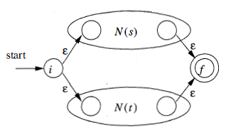
N(r) accepts L(s) U L(t) , which is the same as L(r) .

- Now Suppose r = st , Then N(r) , the NFA for r, should be constructed as
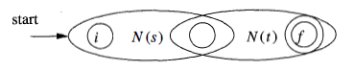
N(r) accepts L(s)L(t) , which is the same as L(r) .
- Now Suppose r = s* , Then N(r) , the NFA for r, should be constructed as
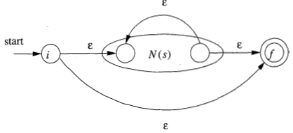
N(r) accept all the strings in L(s)¹ , L(s)² , and so on , so the entire set of strings accepted by N(r) is L(s*).
- Finally suppose r = (s) , Then L(r) = L(s) and we can use the NFA N(s) as N(r).
See example 3.24 of dragon book for detail demonstration of this algorithm.
Lesson 13 & 14
Design of a Lexical-Analyzer Generator, Structure of the Generated Analyzer, Pattern Matching Based on NFA 's, DFA's for Lexical Analyzers, Optimization of DFA-Based Pattern Matchers, Important States of an NFA, Functions Computed from the Syntax Tree, Computing nullable, firstpos, and lastpos & follow-ups, Converting a RE Directly to DFA
In this lecture we will see the designing technique in generating a lexical-analyzer. We will discuss two approaches, based on NFA's and DFA's. The program that serves as the lexical analyzer includes a fixed program that simulates an automaton. The rest of the lexical analyzer consists of components that are created from the Lex program.
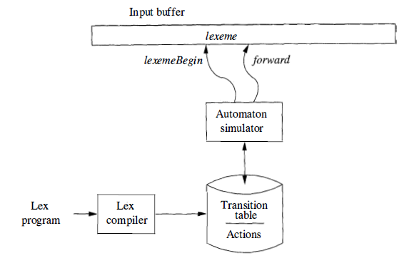
Its components are:
- A transition table for the automaton.
- Functions that are passed directly through Lex to the output.
- The actions from the input program, which appear as fragments of code to be invoked by the automaton simulator.
For pattern based matching the simulator starts reading characters and calculates the set of states. At some point the input character does not lead to any state or we have reached the eof. Since we wish to find the longest lexeme matching the pattern we proceed backwards from the current point (where there was no state) until we reach an accepting state (i.e., the set of NFA states, N-states, contains an accepting N-state). Each accepting N-state corresponds to a matched pattern. The lex rule is that if a lexeme matches multiple patterns we choose the pattern listed first in the lex-program.
For example consider three patterns and their associated actions and consider processing the input aaba We start by constructing the three NFAs.
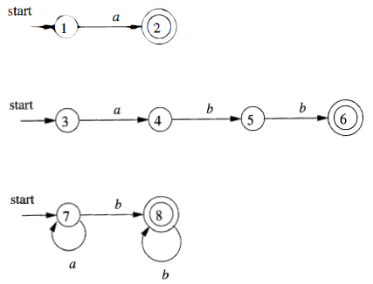
We introduce a new start state and ε-transitions
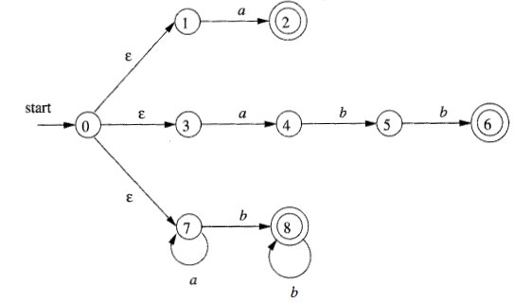
We start at the ε-closure of the start state, which is {0,1,3,7}. The first a (remember the input is aaba) takes us to {2,4,7}. This includes an accepting state and indeed we have matched the first pattern. However, we do not stop since we may find a longer match. The next a takes us to {7} and next b takes us to {8}. The next a fails since there are no a-transitions out of state 8. We are back in {8} and ask if one of these N-states is an accepting state. Indeed state 8 is accepting for third pattern. Action would now be performed.
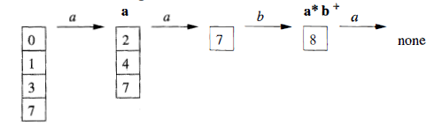

Another architecture, resembling the output of Lex , is to convert the NFA for all the patterns into an equivalent DFA, using the subset construction method. Within each DFA state, if there are one or more accepting NFA states, determine the first pattern whose accepting state is represented, and make that pattern the output of the DFA state.
A transition graph for the DFA handling the patterns a, abb and a*b⁺ that is constructed by the subset construction from the NFA.
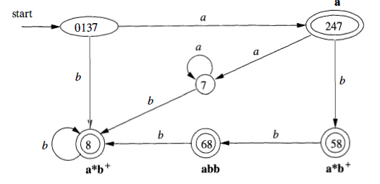
In the diagram, when there is no NFA state possible, we do not show the edge. Technically we should show these edges, all of which lead to the same D-state, called the dead state, and corresponds to the empty subset of N-states.
Prior to begin our discussion of how to go directly from a regular expression to a DFA, we must first dissect the NFA construction and consider the roles played by various states. We call a state of an NFA important if it has a non-ɛ out-transition. The subset construction uses only the important states in a set T when it computes ɛ- closure (move(T, a)), the set of states reachable from T on input a.
During the subset construction, two sets of NFA states can be identified if they:
- Have the same important states, and
- Either both have accepting states or neither does.
The important states are those introduced as initial states in the basis part for a particular symbol position in the regular expression. The constructed NFA has only one accepting state, but this state, having no out-transitions, is not an important state. By concatenating unique right endmarker # to a regular expression r, we give the accepting state for r a transition on #, making it an important state of the NFA for (r) #. The important states of the NFA correspond directly to the positions in the regular expression that hold symbols of the alphabet.It is useful to present the regular expression by its syntax tree, where the leaves correspond to operands and the interior nodes correspond to operators.
An interior node is called a cat-node, or-node, or star-node if it is labeled by the concatenation operator (dot) , union operator | , or star operator *, respectively.
To construct a DFA directly from a regular expression, we construct its syntax tree and then compute four functions: nullable, firstpos, lastpos, and followpos, defined as follows. Each definition refers to the syntax tree for particular augmented regular expression (r) #.
- nullable(n) is true for a syntax-tree node n if and only if the subexpression represented by n has E in its language. That is, the subexpressiort can be "made null" or the empty string, even though there may be other strings it can represent as well.

- firstpos(n) is the set of positions in the subtree rooted at n that correspond to the first symbol of at least one string in the language of the subexpression rooted at n.

- lastpos(n) is the set of positions in the subtree rooted at n that correspond to the last symbol of at least one string in the language of the sub expression rooted at n.

- followpos(p) for a position p, is the set of positions q in the entire syntax tree such that there is some string x = a₁ a₂ . . . an in L ((r)#) such that for some i, there is a way to explain the membership of x in L((r)#) by matching a_{i} to position p of the syntax tree and a_{i}+1 to position q.
nullable, firstpos, and lastpos can be computed by a straight forward recursion on the height of the tree.
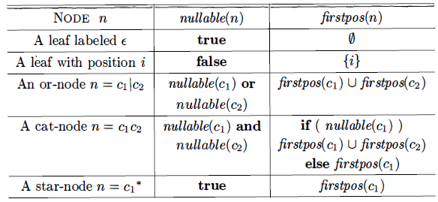
This is the algorithm to convert a RE directly to a DFA
INPUT: A regular expression r
OUTPUT: A DFA D that recognizes L(r)
METHOD: Construct a syntax tree T from the augmented regular expression (r) #. Compute nullable, firstpos, lastpos, and followpos for T. Construct Dstates, the set of states of DFA D, and Dtran, the transition function for D (Procedure). The states of D are sets of positions in T. Initially, each state is "unmarked," and a state becomes "marked" just before we consider its out-transitions. The start state of D is firstpos(n₀), where node n₀ is the root of T.
The accepting states are those containing the position for the endmarker symbol #.
An example DFA for the regular expression r = (a|b)*abb. Augmented Syntax Tree r = (a|b)*abb#
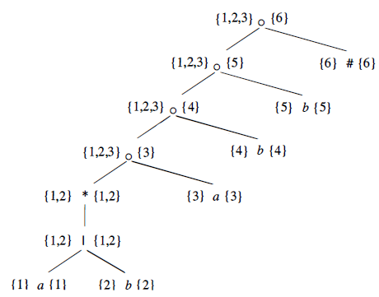
Nullable is true for only star node firstpos & lastpos are showed in tree. followpos are:
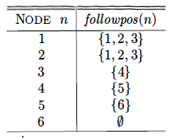
Start state of D = A = firstpos(rootnode) = {1,2,3}. Now we have to compute Dtran[A, a] & Dtran[A, b] Among the positions of A, 1 and 3 corresponds to a, while 2 corresponds to b.
- Dtran[A, a] = followpos(1) U followpos(3) = { l , 2, 3, 4}
- Dtran[A, b] = followpos(2) = {1, 2, 3}
- State A is similar, and does not have to be added to Dstates.
- B = {I, 2, 3, 4 } , is new, so we add it to Dstates.
Proceeding in this way to compute its transitions and we got
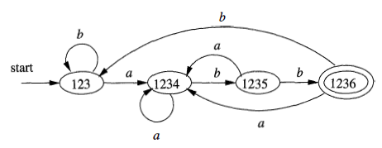
Lesson 15
Minimizing the Number of States of DFA, Two dimensional Table
Minimizing the number of states is discussed in detail during lecture, see section 3.9.6 of dragon book for example.
The simplest and fastest way to represent the transition function of a DFA is a two-dimensional table indexed by states and characters. Given a state and next input character, we access the array to find the next state and any special action we must take, e.g. returning a token to the parser. Since a typical lexical analyzer has several hundred states in its DFA and involves the ASCII alphabet of 128 input characters, the array consumes less than a megabyte.
A more subtle data structure that allows us to combine the speed of array access with the compression of lists with defaults. A structure of four arrays:
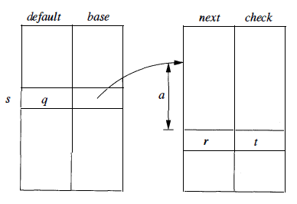
The base array is used to determine the base location of the entries for state s, which are located in the next and check arrays. The default array is used to determine an alternative base location if the check array tells us the one given by base[s] is invalid. To compute nextState(s,a) the transition for state s on input a, we examine the next and check entries in location l = base[s] +a
- Character a is treated as an integer and range is 0 to 127.

Lesson 16 & 17
Syntax Analysis, The Role of the Parser, Syntax Error Handling, Error-Recovery Strategies, CFG, Parse Trees and Derivations, Ambiguity, Verifying the Language Generated by a Grammar, CFG Vs Res, Lexical Vs Syntactic Analysis, Eliminating Ambiguity
In this section parsing methods are discussed that are typically used in compilers. Programs may contain syntactic errors, so we will see extensions of the parsing methods for recovery from common errors. The syntax of programming language constructs can be specified by CFG (Backus-Naur Form) notation. Grammars offer significant benefits for both language designers and compiler writers. A grammar gives a precise syntactic specification of a programming language. From certain classes of grammars, we can construct automatically an efficient parser that determines the syntactic structure of a source program. The structure imparted to a language by a properly designed grammar is useful for translating source programs into correct object code and for detecting errors.
In our compiler model, the parser obtains a string of tokens from the lexical analyzer, as shown below and verifies that the string of token names can be generated by the grammar for the source language.

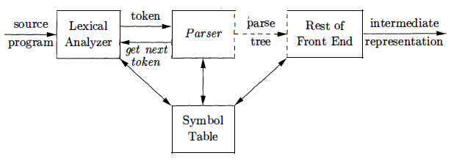

We expect the parser to report any syntax errors in an intelligible fashion and to recover from commonly occurring errors to continue processing the remainder of the program. Conceptually, for well-formed programs, the parser constructs a parse tree and passes it to the rest of the compiler for further processing. In fact, the parse tree need not be constructed explicitly, since checking and translation actions can be interspersed with parsing, as we shall see. Thus, the parser and the rest of the front end could well be implemented by a single module.

There are 03 general types of parsers for grammars: universal, top-down, and bottom-up. Universal parsing methods such as the Cocke-Younger-Kasami algorithm and Earley's algorithm can parse any grammar. These general methods are, however, too inefficient to use in production compilers. The methods commonly used in compilers are either top-down or bottom-up. Top-down methods build parse trees from the top (root) to the bottom (leaves), while bottom-up methods start from the leaves and work their way up to the root.

If a compiler had to process only correct programs, its design and implementation would be simplified greatly. However, a compiler is expected to assist the programmer in locating and tracking down errors that inevitably creep into programs, despite the programmer's best efforts. Strikingly, few languages have been designed with error handling in mind, even though errors are so commonplace. Our civilization would be radically different if spoken languages had the same requirements for syntactic accuracy as computer languages. Most programming language specifications do not describe how a compiler should respond to errors; error handling is left to the compiler designer.

Planning the error handling right from the start can both simplify the structure of a compiler and improve its handling of errors. Common programming errors can occur at many different levels.

- Lexical errors include misspellings of identifiers, keywords, or operators - e.g., the use of an identifier elipseSize instead of ellipseSize – and missing quotes around text intended as a string.

- Semantic errors include type mismatches between operators and operands. An example is a return statement in a Java method with result type void.

- Syntactic errors include misplaced semicolons or extra or missing braces, that is, "{" or "}" As another example, in C or Java, the appearance of a case statement without an enclosing switch is a syntactic error.

- Logical errors can be anything from incorrect reasoning on the part of the programmer to the use in a C program of the assignment operator = instead of the comparison operator ==.

The error handler in a parser has goals that are simple to state but challenging to realize. These goals included reporting the presence of errors clearly and accurately, recovering from each error quickly enough to detect subsequent errors. Add minimal overhead to the processing of correct programs.
Once an error is detected, how should the parser recover? Although no strategy has proven itself universally acceptable, a few methods have broad applicability. The simplest approach is for the parser to quit with an informative error message when it detects the first error. Additional errors are often uncovered if the parser can restore itself to a state where processing of the input can continue with reasonable hopes that the further processing will provide meaningful diagnostic information. If errors pile up, it is better for the compiler to give up after exceeding some error limit than to produce an annoying avalanche of "spurious" errors.

- Trivial Approach: No Recovery
Print an error message when parsing cannot continue and then terminate parsing.

- Panic-Mode Recovery
The parser discards input until it encounters a synchronizing token. These tokens are chosen so that the parser can make a fresh beginning. Good examples are ; and }.

- Phrase-Level Recovery
Locally replace some prefix of the remaining input by some string. Simple cases are exchanging ; with , and = with ==. Difficulties occur when the real error occurred long before an error was detected.

- Error Productions
By anticipating common errors that might be encountered, we can augment the grammar for the language at hand with productions that generate the erroneous constructs. A parser constructed from a grammar augmented by these error productions detects the anticipated errors when an error production is used during parsing. The parser can then generate appropriate error diagnostics about the erroneous construct that has been recognized in the input.

- Global Correction
Ideally, we would like a compiler to make as few changes as possible in processing an incorrect input string. There are algorithms for choosing a minimal sequence of changes to obtain a globally least-cost correction. Given an incorrect input string x and grammar G, these algorithms will find a parse tree for a related string y, such that the number of insertions, deletions, and changes of tokens required to transform x into y is as small as possible. Unfortunately, these methods are in general too costly to implement in terms of time and space, so these techniques are currently only of theoretical interest.

Grammars used to systematically describe the syntax of programming language constructs like expressions and statements.

stmt → if ( expr ) stmt else stmt

A syntactic variable stmt is used to denote statements and variable expr to denote expressions. Other productions then define precisely what an expr is and what else a stmt can be. A language generated by a (context-free) grammar is called a context free language.

Context-free grammar (grammar) consists of terminals, non-terminals, a start symbol, and productions.

Terminals:
- The basic components found by the lexer.
- They are sometimes called token names, i.e., the first component of the token as produced by the lexer.
- Non-terminals:
- Syntactic variables that denote sets of strings.
- The sets of strings denoted by non-terminals help define the language generated by the grammar

Start Symbol:
- A non-terminal that forms the root of the parse tree.
- Conventionally, the productions for the start symbol are listed first.

Productions:
- The productions of a grammar specify the manner in which the terminals and non-terminals can be combined to form strings.

A parse tree is a graphical representation of a derivation that filters out the order in which productions are applied to replace non-terminals. Each interior node of a parse tree represents the application of a production. The interior node is labeled with the non-terminal A in the head of the production. The children of the node are labeled, from left to right, by the symbols in the body of the production by which this A was replaced during the derivation.
Parse tree for –(id + id)
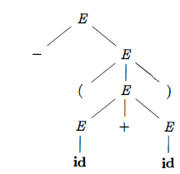
A derivation starting with a single non-terminal, A ⇒ α₁ ⇒ α₂ ... ⇒ α_{n}
It is easy to write a parse tree with A as the root and α_{n} as the leaves. The LHS of each production is a non-terminal in the frontier of the current tree so replace it with the RHS to get the next tree. There can be many derivations that wind up with the same final tree but for any parse tree there is a unique leftmost derivation the produces that tree. Similarly, there is a unique rightmost derivation that produces the tree.
A grammar that produces more than one parse tree for some sentence is said to be ambiguous. Alternatively, an ambiguous grammar is one that produces more than one leftmost derivation or more than one rightmost derivation for the same sentence.
Ex Grammar E → E + E | E * E | ( E ) | id
It is ambiguous because we have seen two parse trees for id + id * id
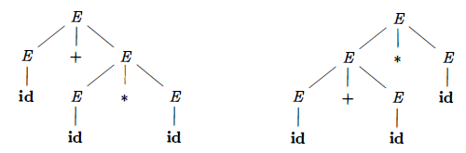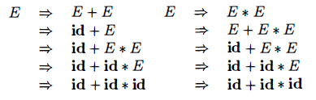
Although compiler designers rarely do so for a complete programming-language grammar, it is useful to be able to reason that a given set of productions generates a particular language. Troublesome constructs can be studied by writing a concise, abstract grammar and studying the language that it generates. A proof that a grammar G generates a language L has two parts: show that every string generated by G is in L, and conversely that every string in L can indeed be generated by G.
Every construct that can be described by a regular expression can be described by a grammar, but not vice-versa. Alternatively, every regular language is a context-free language, but not vice-versa.
Consider RE (a|b)* abb & the grammar
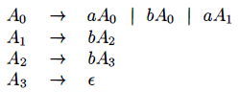
We can construct mechanically a grammar to recognize the same language as a nondeterministic finite automaton (NFA).
The defined grammar above was constructed from the NFA using the following construction methods:
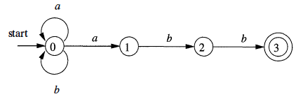
- For each state i of the NFA, create a non-terminal A_{i} .
- If state i has a transition to state j on input a add the production
A_{i} → a Aj If state i goes to state j on input ɛ add the production
A_{i} → Aj
- If i is an accepting state, add A_{i} → ɛ
- If i is the start state, make A_{i} be the start symbol of the grammar.
An ambiguous grammar can be rewritten to eliminate the ambiguity. For example eliminating the ambiguity from the following dangling-else grammar:
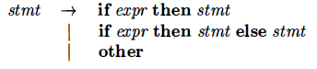
We take following compound conditional statement as example
if E₁ then S₁ else if E₂ then S₂ else S₃
This Grammar is ambiguous since the following string has the two parse trees:
if E₁ then if E₂ then S₁ else S₂
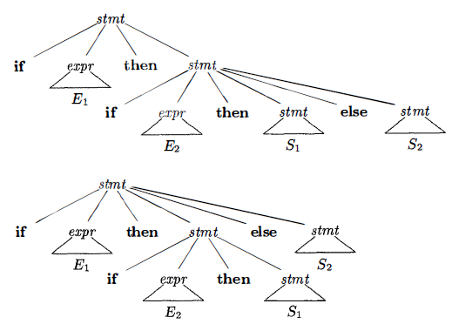
We can rewrite the dangling-else grammar with this idea. A statement appearing between a then and an else must be matched that is, the interior statement must not end with an unmatched or open then. A matched statement is either an if-then-else statement containing no open statements or it is any other kind of unconditional statement.
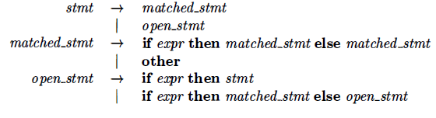
Lesson 18 & 19
Elimination of Left Recursion, Left Factoring, Non-Context-Free Language Constructs, Top Down Parsing, Recursive Decent Parsing, FIRST & FOLLOW, LL(1) Grammars
A grammar is left recursive if it has a non-terminal A such that there is a derivation A ⇒⁺ Aα for some string α .Top-down parsing methods cannot handle left-recursive grammars, so a transformation is needed to eliminate left recursion.
Immediate left recursion can be eliminated by the following technique, which works for any number of A-productions.
A → Aα₁ | Aα₂ | … | Aα_{m} | β₁ | β₂ | … | β_{n}
Then the equivalent non-recursive grammar is
A → β₁A’ | β₂A’ | … | β_{n}A’
A’ → α₁A’ | α₂A’ | … | α_{m}A’ | ɛ
The non-terminal A generates the same strings as before but is no longer left recursive. This procedure eliminates all left recursion from the A and A' productions (provided no α_{i} is ɛ), but it does not eliminate left recursion involving derivations of two or more steps. Now we will discuss an algorithm that systematically eliminates left recursion from a grammar. It is guaranteed to work if the grammar has no cycles or ɛ-productions. The resulting non-left-recursive grammar may have ɛ-productions.
INPUT: Grammar G with no cycles or ɛ-productions.
OUTPUT: An equivalent grammar with no left recursion.
METHOD: 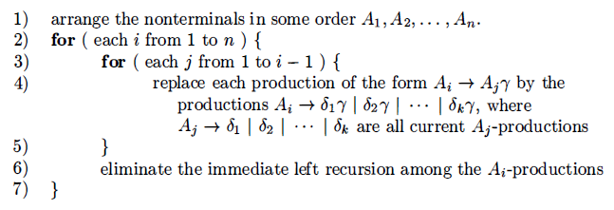
For algorithm implementation see example 4.20 of dragon book.
Left factoring is a grammar transformation that is useful for producing a grammar suitable for predictive, or top-down, parsing. If two productions with the same LHS have their RHS beginning with the same symbol (terminal or non-terminal), then the FIRST sets will not be disjoint so predictive parsing will be impossible. Top down parsing will be more difficult as a longer lookahead will be needed to decide which production to use.
When the choice between two alternative A-productions is not clear, we may be able to rewrite the productions to defer the decision until enough of the input has been seen that we can make the right choice. For example, if we have the two productions
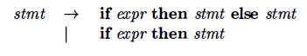
on seeing the input if we cannot immediately tell which production to choose
to expand stmt. An algorithm that deals with left factoring.
INPUT: Grammar G.
OUTPUT: An equivalent left-factored grammar.
METHOD:
- For each non-terminal A, find the longest prefix α common to two or more of its alternatives.
- If α ≠ ɛ i.e., there is a nontrivial common prefix.
  - Replace all of the A-productions A → αβ₁ | αβ_{2 …} | αβ_{n} | γ by
A → α A’ | γ
A' → β₁| β₂| …. | β_{n}
  - γ represents all alternatives that do not begin with α
Top-down parsing can be viewed as the problem of constructing a parse tree for the input string, starting from the root and creating the nodes of the parse tree in preorder (DFT). For example below mentioned is our grammar then the steps involved in construction of a parse tree are
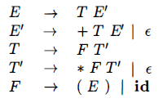
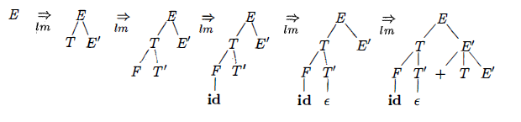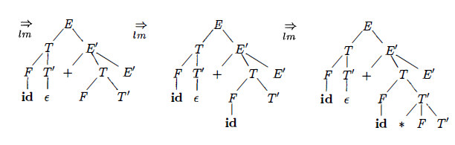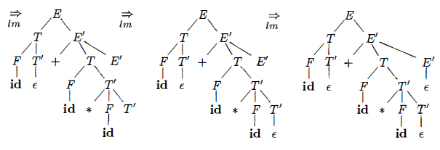
The class of grammars for which we can construct predictive parsers looking k symbols ahead in the input is sometimes called the LL(k) class. LL parser is a top-down parser for a subset of the context-free grammars. It parses the input from Left to right, and constructs a Leftmost derivation of the sentence and LR parser constructs a rightmost derivation. Recursive decent parsing is discussed earlier.
The grammar which has the aforementioned properties can be categorized as nice. A grammar must be deterministic. Left recursion should be eliminated and it must be left factored. The construction of both top-down and bottom-up parsers is aided by two functions, FIRST and FOLLOW associated with a grammar G.
During top-down parsing, FIRST and FOLLOW allows us to choose which production to apply, based on the next input symbol. During panic-mode error recovery sets of tokens produced by FOLLOW can be used as synchronizing tokens. The basic idea is that FIRST(α) tells you what the first terminal can be when you fully expand the string α and FOLLOW(A) tells what terminals can immediately follow the non-terminal A.
FIRST(A → α) is the set of all terminal symbols x such that some string of the form xβ can be derived from α
The follow set for the non-terminal A is the set of all terminals x for which some string αAxβ can be derived from the starting symbol S
Predictive parsers that is recursive-descent parsers needing no backtracking, can be constructed for a class of grammars called LL(1).
- The first "L" in LL(1) stands for scanning the input from left to right.
- The second "L" for producing a leftmost derivation.
- “1" for using one input symbol of look ahead at each step to make parsing action decisions.
The class of LL(1) grammars is rich enough to cover most programming constructs.
- No left-recursive or ambiguous grammar can be LL(1)
- A grammar G is LL(1) iff A → α | β are two distinct productions of G and hold following conditions:
- For no terminal a do both α and β derive strings beginning with a
- At most one of α and β can derive the empty string.
- If β ⇒* ɛ then α does not derive any string beginning with a terminal in FOLLOW(A)
- Likewise, if α ⇒* ɛ then β does not derive any string beginning with a terminal in FOLLOW(A)
For computation of Predictive Parsing table see Algorithm 4.31 and Example 4.32 and 4.33 of dragon book.

Lesson 20
Non-recursive Predictive Parsing, Error Recovery in Predictive Parsing, Bottom Up Parsing, Reductions, Handle Pruning, Shift-Reduce Parsing
A non recursive predictive parser can be built by maintaining a stack explicitly, rather than implicitly via recursive calls. If w is the input that has been matched so far, then the stack holds a sequence of grammar symbols α such that A table-driven parser has an input buffer a stack containing a sequence of grammar symbols, a parsing table and an output stream.
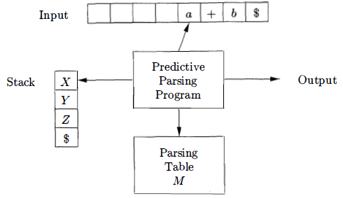
The input buffer contains the string to be parsed, followed by the end marker $. The parser is controlled by a program that considers X, the symbol on top of the stack, and a, the current input symbol. The parser is controlled by a program that considers X the symbol on top of the stack and a the current input symbol. If X is a non-terminal, the parser chooses an X-production by consulting entry M[X,a] of the parsing table M. Otherwise, it checks for a match between the terminal X and current input symbol a. The behavior of the parser can be described in terms of its configurations which give the stack contents and the remaining input.
See Algorithm 4.34 and Example 4.35 of dragon book for table driven predictive parsing.
An error is detected during predictive parsing when the terminal on top of the stack does not match the next input symbol or when non-terminal A is on top of the stack, a is the next input symbol, and M [A, a] is error (i.e. , the parsing-table entry is empty).
Panic Mode Recovery
Panic-mode error recovery is based on the idea of skipping symbols on the input until a token in a selected set of synchronizing tokens appears. Its effectiveness depends on the choice of synchronizing set. The sets should be chosen so that the parser recovers quickly from errors that are likely to occur in practice.
Phrase-level Recovery
Phrase-level error recovery is implemented by filling in the blank entries in the predictive parsing table with pointers to error routines. These routines may change, insert, or delete symbols on the input and issue appropriate error messages. They may also pop from the stack. Alteration of stack symbols or the pushing of new symbols onto the stack is questionable for several reasons. First, the steps carried out by the parser might then not correspond to the derivation of any word in the language at all. Second, we must ensure that there is no possibility of an infinite loop.
A bottom-up parse corresponds to the construction of a parse tree for an input string beginning at the leaves (the bottom) and working up towards the root (the top). A bottom-up parse for id * id
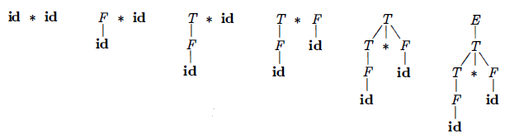
This section introduces a general style of bottom-up parsing known as shift-reduce parsing. The largest class of grammars for which shift-reduce parsers can be built, the LR grammars. Although it is too much work to build an LR parser by hand, tools called automatic parser generators make it easy to construct efficient LR parsers from suitable grammars. The concepts in this section are helpful for writing suitable grammars to make effective use of an LR parser generator.
Bottom-up parsing is the process of "reducing" a string w to the start symbol of the grammar. At each reduction step, a specific substring matching the body of a production is replaced by the non-terminal at the head of that production. The key decisions during bottom-up parsing are about when to reduce and about what production to apply, as the parse proceeds. By definition, a reduction is the reverse of a step in a derivation. The goal of bottom-up parsing is to construct a derivation in reverse.
Bottom-up parsing during a left-to-right scan of the input constructs a rightmost derivation in reverse. Informally, a "handle" is a substring that matches the body of a production, and whose reduction represents one step along the reverse of a rightmost derivation. The strings that are reduced during the reverse of a rightmost derivation are called the handles.

Formally if S ⇒* αAw then production A → β in the position following α is a handle of αAw
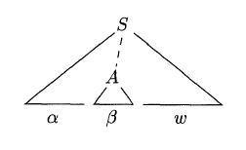
The string w to the right of the handle must contain only terminal symbols. Shift-reduce parsing is a form of bottom-up parsing in which a stack holds grammar symbols and an input buffer holds the rest of the string to be parsed. Handle will always appears at the top of the stack just before it is identified as the handle. We use $ to mark the bottom of the stack and also the right end of the input. Initially, the stack is empty and the string w is on the input.
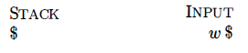
During a left-to-right scan of the input string, the parser shifts zero or more input symbols onto the stack, until it is ready to reduce a string β of grammar symbols on top of the stack. It then reduces β to the head of the appropriate production. The parser repeats this cycle until it has detected an error or until the stack contains the start symbol and the input is empty.
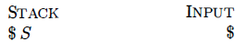
Upon entering this configuration, the parser halts and announces successful completion of parsing. The primary operations are shift and reduce.

But there are actually four possible actions a shift-reduce parser can make: shift, reduce, accept, and error.

- Shift the next input symbol onto the top of the stack.
- Reduce The right end of the string to be reduced must be at the top of the stack. Locate the left end of the string within the stack and decide with what non-terminal to replace the string.
- Accept Announce successful completion of parsing.
- Error Discover a syntax error and call an error recovery routine.

There are context-free grammars for which shift-reduce parsing cannot be used. Every shift-reduce parser for such a grammar can reach a configuration in which the parser, knowing the entire stack contents and the next input symbol, cannot decide whether to shift or to reduce ( a shift/reduce conflict), or cannot decide which of several reductions to make (a reduce/reduce conflict).

Lesson 21 & 22 & 23
LR Parsing, Items and the LR(0) Automaton, Constructing SLR-Parsing Tables, Viable Prefixes, Powerful LR Parsers, Canonical LR(1) Items, Constructing LR(1) Sets of Items, Canonical LR(1) Parsing Tables
LR(k) parsing
- L is for left-to-right scanning of the input.
- R is for constructing a rightmost derivation in reverse.
- (k) represents the number of input symbols of look-ahead that are used in making parsing decisions.
- When (k) is omitted, k is assumed to be 1
Most commercial compilers use hand-written top-down parsers of the recursive-descent (LL not LR) variety. Since the grammars for these languages are not LL(1), the straightforward application of the techniques we have seen will not work. Instead the parsers actually look ahead further than one token, but only at those few places where the grammar is in fact not LL(1).
LR parsing is attractive for a variety of reasons:

- LR parsers can be constructed to recognize virtually all programming language constructs for which context-free grammars can be written. Non LR context-free grammars exist, but these can generally be avoided for typical programming-language constructs.

- The LR-parsing method is the most general nonbacktracking shift-reduce parsing method known, yet it can be implemented as efficiently as other, more primitive shift-reduce methods (see the bibliographic notes).

- An LR parser can detect a syntactic error as soon as it is possible to do so on a left-to-right scan of the input. The class of grammars that can be parsed using LR methods is a proper superset of the class of grammars that can be parsed with predictive or LL methods.

The principal drawback of the LR method is that it is too much work to construct an LR parser by hand for a typical programming-language grammar. A specialized tool, an LR parser generator, is needed. Fortunately, many such generators are available, and we shall discuss one of the most commonly used ones, Yacc. Such a generator takes a context-free grammar and automatically produces a parser for that grammar. If the grammar contains ambiguities or other constructs that are difficult to parse in a left-to-right scan of the input, then the parser generator locates these constructs and provides detailed diagnostic messages.

An LR parser makes shift-reduce decisions by maintaining states to keep track of where we are in a parse tree states represent sets of "items." An LR(0) item of a grammar G is a production of G with a dot at some position of the body. Thus, production A → XYZ yields the four items
A → ·XYZ
A → X ·YZ
A → XY· Z
A → XYZ·
One collection of sets of LR(0) items, called the canonical LR(0) collection provides the basis for constructing a deterministic finite automaton that is used to make parsing decisions known as LR(0) automaton. The automaton for the expression grammar is shown in next slide and will serve as the running example for discussing the canonical LR( 0) collection for a grammar.

E → E + T | T
T → T * F | F
F → ( E ) | id

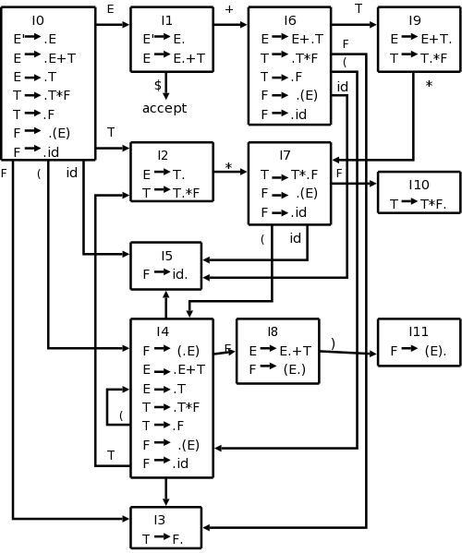

To construct the canonical LR(0) collection for a grammar, we define an augmented grammar and two functions, CLOSURE and GOTO

If G is a grammar with start symbol S, then G', the augmented grammar for G, is G with a new start symbol S' and production S' → S

The purpose of this new starting production is to indicate to the parser when it should stop parsing and announce acceptance of the input. That is, acceptance occurs when the parser is about to reduce by S' → S

Closure of Item Sets
- If I is a set of items for a grammar G, then CLOSURE(I) is the set of items constructed from I by the two rules:

- Initially, add every item in I to CLOSURE(I)

- If A → α·Bβ is in CLOSURE(I) and B → γ is a production, then add the item B → .γ to CLOSURE(I) if it is not already there. Apply this rule until no more new items can be added to CLOSURE(I)

For example if we have following Augmented Grammar
E‘ → E
E → E + T | T
T → T * F | F
F → ( E ) | id
If I is the set of one item { [E ' → ∙E] } , then CLOSURE(I) contains the set of items I₀
E‘ → ∙E
E → ∙E + T | ∙T
T → ∙T * F | ∙F
F → ∙(E) | ∙id
It is pertinent to mention that if one B-production is added to the closure of I with the dot at the left end, then all B-productions will be similarly added to the closure.
We divide all the sets of items of interest into two classes:
- Kernel items: The initial item, S‘ → ∙S and all items whose dots are not at the left end.
- Non-kernel items: All items with their dots at the left end, except for S‘ → ∙S
The Function GOTO
The second useful function is GOTO(I,X) where I is a set of items & X is a grammar symbol.
- GOTO(I,X) is defined to be the closure of the set of all items
[A → αX∙β] such that [A → α∙Xβ] is in I
- Intuitively, the GOTO function is used to define the transitions in the LR(0) automaton for a grammar. The states of the automaton correspond to sets of items, & GOTO(I,X) specifies the transition from the state for I under input X
Considering the same augmented grammar, If I is the set of two item
{ [E ' → ∙E], [E → E∙ + T] } , then GOTO(I,+) contains the items
E → E + ∙T
T → ∙T * F | ∙F
F → ∙(E) | ∙id
For the details of LR Parsing algorithm see section 4.6.3 of dragon's book. On input id * id + id the sequence of stack and input contents are:
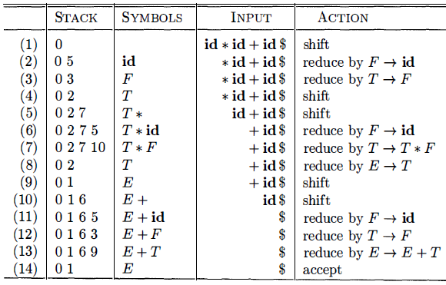
The SLR method for constructing parsing tables is a good starting point for studying LR parsing. We shall refer to the parsing table constructed by this method as an SLR table, and to an LR parser using an SLR-parsing table as an SLR parser. The other two methods augment the SLR method with lookahead information. The SLR method begins with LR(O) items and LR(O) automata. That is, given a grammar, G, we augment G to produce G', with a new start symbol S' . From G', we construct C, the canonical collection of sets of items for G' together with the GOTO function. See Algorithm 4.46 in dragon book for more details.
The prefixes of right sentential forms that can appear on the stack of a shift-reduce parser are called viable prefixes. The LR(0) automaton for a grammar characterizes the strings of grammar symbols that can appear on the stack of a shift-reduce parser for the grammar. The stack contents must be a prefix of a right-sentential form. If the stack holds α and the rest of the input is x then a sequence of reductions will take S ⇒*_{rm} αx . A viable prefix is a prefix of a right-sentential form that does not continue past the right end of the rightmost handle of that sentential form. By this definition, it is always possible to add terminal symbols to the end of a viable prefix to obtain a right-sentential form. SLR parsing is based on the fact that LR(0) automata recognize viable prefixes.

Now we shall extend the previous LR parsing techniques to use one symbol of look-ahead on the input. Two different methods:

- The "canonical-LR" or just "LR" method, which makes full use of the look-ahead symbol(s) . This method uses a large set of items, called the LR(1) items.

- The "look-ahead-LR" or "LALR" method, which is based on the LR(0) sets of items, and has many fewer states than typical parsers based on the LR(1) items.

SLR used the LR(0) items that is the items used were productions with an embedded dot, but contained no other (look-ahead) information. The LR(1) items contain the same productions with embedded dots, but add a second component, which is a terminal (or $). This second component becomes important only when the dot is at the extreme right (indicating that a reduction can be made if the input symbol is in the appropriate FOLLOW set).

For LR(1) we do that reduction only if the input symbol is exactly the second component of the item. This finer control of when to perform reductions, enables the parsing of a larger class of languages.

Formally, we say LR(1) item [A → α∙β , α] is valid for a viable prefix ϒ if there is a derivation S ⇒*_{rm} δAw ⇒_{rm} δαβw where
  - ϒ = δα
  - Either a is the first symbol of w, or w is ɛ and a is $

Consult section 4.7.1 and 4.7.2 of dragon book for examples and algorithms.

Lesson 24 & 25
Constructing LALR Parsing Tables, Efficient Construction of LALR Parsing Tables, Compaction of LR Parsing Tables, Ambiguous Grammars, Precedence and Associativity to Resolve Conflicts, Dangling-Else Ambiguity, Error Recovery in LR Parsing, Syntax-Directed Translation, Syntax-Directed Definitions, Inherited & Synthesized Attributes
LALR is our last parser construction method. This method is often used in practice, because the tables obtained by it are considerably smaller than the canonical LR tables. The same is almost true for SLR grammars, but there are a few constructs that cannot be conveniently handled by SLR techniques For a comparison of parser size, the SLR and LALR tables for a grammar always have the same number of states. This number is typically several hundred states for a language like C. The canonical LR table would typically have several thousand states for the same-size language. For LALR we merge various LR(1) item sets together obtaining nearly the LR(0) item sets we used in SLR. LR(1) items have two components, the first, called the core, is a production with a dot; the second a terminal. For LALR we merge all the item sets that have the same cores by combining the 2nd components (thus permitting reductions when any of these terminals is the next input symbol). So, we obtain the same number of states (item sets) as in SLR since only the cores distinguish item sets.
Unlike SLR, we limit reductions to occurring only for certain specified input symbols. LR(1) gives finer control, it is possible for the LALR merger to have reduce-reduce conflicts when the LR(1) items on which it is based is conflict free. These conflicts are possible but they are rare and the size reduction from LR(1) to LALR is quite large. LALR is the current method of choice for bottom-up, shift-reduce parsing.
To understand it better, let us consider our previous grammar and its sets of LR(1) items.

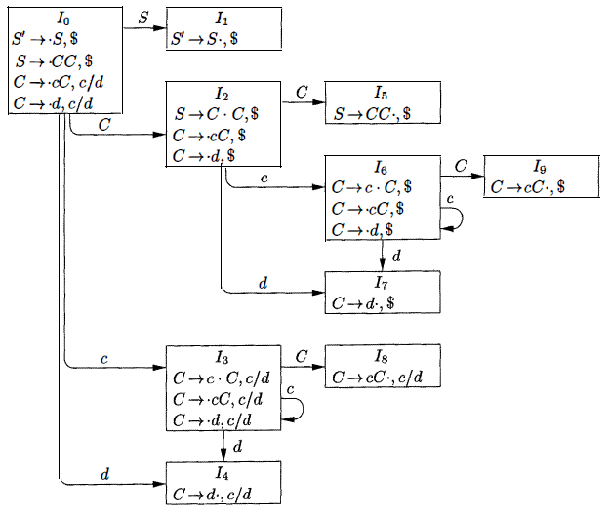
Take a pair of similar looking states, such as 1₄ and I₇. Each of these states has only items with first component C → d∙
Lookaheads are I₄ = c or d, I₇ = $
Now we can replace I₄ and I₇ by I₄₇ the union of I₄ and I₇ consisting of the set of three items represented by [C → d∙ , c/d/$]
- The goto's on d to I₄ or I₇ from I₀ , I₂ , I₃ & I₆ now enter I₄₇
- The action of state 47 is to reduce on any input.
So now we look for sets of LR(1) items having the same core, that is, set of first components, and we may merge these sets with common cores into one set of items.

Core of GOTO(I, X) depends only on the core of I, the goto's of merged sets can themselves be merged.
- Thus, there is no problem revising the goto function as we merge sets of items.
- The action functions are modified to reflect the non-error actions of all sets of items in the merger.
An easy but space-consuming LALR table construction algorithm is discussed here presented in section Algorithm 4.29 of dragon book. That algorithm is discussed in the lecture videos. Consult the book for algorithm and example.
There are several modifications we can make to LALR table construction Algorithm to avoid constructing the full collection of sets of LR(1) items in the process of creating an LALR(1) parsing table.
First, we can represent any set of LR(0) or LR(1) items I by its kernel, that is, by those items that are either the initial item - [S’ → ∙S] or
[S’ → ∙S, $] - or that have the dot somewhere other than at the beginning of the production body. We can construct the LALR(1) -item kernels from the LR(0)-item kernels by a process of propagation and spontaneous generation of look-aheads. If we have the LALR(1) kernels, we can generate the LALR(1) parsing table by closing each kernel, using the function CLOSURE. Then computing table entries by Construction of canonical-LR parsing table Algorithm, as if t he LALR(1) sets of items were canonical LR(1) sets of items. If we have the LALR(1) kernels, we can generate the LALR(1) parsing table by closing each kernel, using the function CLOSURE. Then computing table entries by Construction of canonical-LR parsing table Algorithm, as if t he LALR(1) sets of items were canonical LR(1) sets of items.
A typical programming language grammar with 50 to 100 terminals and 100 productions may have an LALR parsing table with several hundred states. The action function may easily have 20,000 entries, each requiring at least 8 bits to encode. On small devices, a more efficient encoding than a two-dimensional array may be important. One useful technique for compacting the action field is to recognize that usually many rows of the action table are identical.

To access information from this array, we assign each terminal a number from zero to one less than the number of terminals and we use this integer as an offset from the pointer value for each state. In a given state, the parsing action for the ith terminal will be found i locations past the pointer value for that state. Further space efficiency can be achieved at the expense of a somewhat slower parser by creating a list for the actions of each state. The list consists of (terminal-symbol, action) pairs. The most frequent action for a state can be placed at the end of the list, and in place of a terminal we may use the notation "any," meaning that if the current input symbol has not been found so far on the list, we should do that action no matter what the input is. Moreover, error entries can safely be replaced by reduce actions, for further uniformity along a row.
Consult example 4.66 of dragon book.
We can also encode the GOTO table by a list, but here it appears more efficient to make a list of pairs for each non-terminal A. Each pair on the list for A is of the form (currentState, nextState) indicating GOTo[currentState, A] = next State.
This technique is useful because there tend to be rather few states in any one column of the GOTO table. The reason is that the GOTO on non-terminal A can only be a state derivable from a set of items in which some items have A immediately to the left of a dot. No set has items with X and Y immediately to the left of a dot if X ≠ Y. Thus, each state appears in at most one GOTO column.
It is a fact that every ambiguous grammar fails to be LR and thus is not in any of the classes of grammars discussed in the previous two sections. However, certain types of ambiguous grammars are quite useful in the specification and implementation of languages. For language constructs like expressions, an ambiguous grammar provides a shorter, more natural specification than any equivalent unambiguous grammar. Another use of ambiguous grammars is in isolating commonly occurring syntactic constructs for special-case optimization. With an ambiguous grammar, we can specify the special-case constructs by carefully adding new productions to the grammar. Although the grammars we use are ambiguous, in all cases we specify disambiguating rules that allow only one parse tree for each sentence. In this way, the overall language specification becomes unambiguous, and sometimes it becomes possible to design an LR parser that follows the same ambiguity-resolving choices. We stress that ambiguous constructs should be used sparingly and in a strictly controlled fashion; otherwise, there can be no guarantee as to what language is recognized by a parser.

Consider the ambiguous grammar for expressions with operators + and * :
E → E + T | E * T | (E) | id
This grammar is ambiguous because it does not specify the associativity or precedence of the operators + and * The unambiguous grammar, generates the same language, but gives + lower precedence than * and makes both operators left associative.
E → E + T
T → T * F

There are two reasons why we might prefer to use the ambiguous grammar. First, we can easily change the associativity and precedence of the operators + and * without disturbing the productions or the number of states in the resulting parser. Second, the parser for the unambiguous grammar will spend a substantial fraction of its time reducing by the productions
E → E + T & T → T * F
Whose sole function is to enforce associativity and precedence. Dangling else ambiguity is fully explained in section 4.8.2 of dragon book.

An LR parser will detect an error when it consults the parsing action table and finds an error entry. Errors are never detected by consulting the goto table. An LR parser will announce an error as soon as there is no valid continuation for the portion of the input thus far scanned. A canonical LR parser will not make even a single reduction before announcing an error. SLR and LALR parsers may make several reductions before announcing an error, but they will never shift an erroneous input symbol onto the stack.

In LR parsing, panic-mode error recovery can be implemented. Scan down the stack until a state s with a goto on a particular non-terminal A is found. Zero or more input symbols are then discarded until a symbol a is found that can legitimately follow A. The parser then stacks the state GOTO(s, A) and resumes normal parsing. There might be more than one choice for the non-terminal A.

Normally these would be non-terminals representing major program pieces, such as an expression, statement, or block. For example, if A is the non-terminal stmt, a might be semicolon or } , which marks the end of a statement sequence. Phrase-level recovery is implemented by examining each error entry in the LR parsing table and deciding on the basis of language usage. Most likely programmer error that would give rise this kind of error.

An appropriate recovery procedure can then be constructed. Presumably the top of the stack and/or first input symbols would be modified in a way deemed appropriate for each error entry. In designing specific error-handling routines for an LR parser, fill each blank entry in the action field with a pointer to an error routine that will take the appropriate action selected by the compiler designer.

In syntax-directed translation we construct a parse tree or a syntax tree, and then to compute the values of attributes at the nodes of the tree by visiting the nodes of the tree. In many cases, translation can be done during parsing, without building an explicit tree. Syntax-directed translations called L-attributed translations which encompass virtually all translations that can be performed during parsing. S-attributed translations can be performed in connection with a bottom-up parse. A syntax-directed definition (SDD) is a context-free grammar together with attributes and rules.
Attributes are associated with grammar symbols and rules are associated with productions.

- If X is a symbol and a is one of its attributes, then we write X.a to denote the value of a at a particular parse-tree node labeled X.

- If we implement the nodes of the parse tree by records or objects, then the attributes of X can be implemented by data fields in the records that represent the nodes for X.

A synthesized attribute for a non-terminal A at a parse-tree node N is defined by a semantic rule associated with the production at N. The production must have A as its head. A synthesized attribute at node N is defined only in terms of attribute values at the children of N and at N itself. A parse tree for an S-attributed definition can always be annotated by evaluating the semantic rules for the attributes at each node bottom up, from the leaves to the root.

An inherited attribute for a non-terminal B at a parse-tree node N is defined by a semantic rule associated with the production at the parent of N. The production must have B as a symbol in its body. An inherited attribute at node N is defined only in terms of attribute values at N's parent, N itself, and N's siblings. Inherited attributes are convenient for expressing the dependence of a programming language construct on the context in which it appears.

Lesson 26
Evaluating an SDD at the Nodes of a Parse Tree, Dependency Graphs, Ordering the Evaluation of Attributes, S-Attributed Definitions, L-Attributed Definitions, Semantic Rules with Controlled Side Effects
Inherited attributes are useful when the structure of a parse tree does not match the abstract syntax of the source code. Now we see an example which shows how inherited attributes can be used to overcome such a mismatch due to a grammar designed for parsing rather than translation.
It computes terms like 3 * 5 and 3 * 5 * 7.
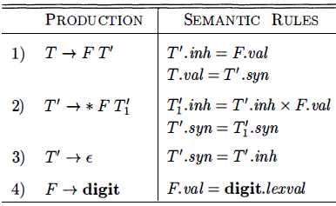
- The top-down parse of input 3 * 5 begins with the production T → FT’
- F generates the digit 3, but the operator * is generated by T'.
- Thus, the left operand 3 appears in a different sub tree of the parse tree from *
- An inherited attribute will therefore be used to pass the operand to the operator.
Each of the non-terminals T and F has a synthesized attribute val; the terminal digit has a synthesized attribute lexval. The non-terminal T' has two attributes:
  - An inherited attribute inh & A synthesized attribute syn
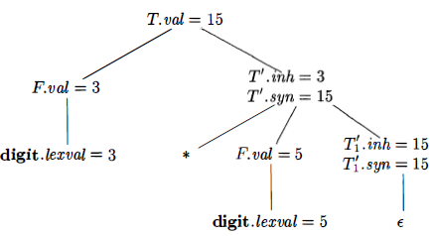
The semantic rules are based on the idea that the left operand of the
operator * is inherited. A dependency graph depicts the flow of information among the attribute instances in a particular parse tree. An edge from one attribute instance to another means that the value of the first is needed to compute the second. Edges express constraints implied by the semantic rules.
The dependency graph characterizes the possible orders in which we can evaluate the attributes at the various nodes of a parse tree. If the dependency graph has an edge from node M to node N then the attribute corresponding to M must be evaluated before the attribute of N. The only allowable orders of evaluation are those sequences of nodes N₁, N₂, … ,N_{k} such that if there is an edge of the dependency graph from N_{i} to N_{j} then i < j Such an ordering embeds a directed graph into a linear order, and is called a topological sort of the graph.
The rule is that the needed ordering can be found if and only if there are no (directed) cycles. The algorithm is simple 1st choose a node having no incoming edges then delete the node and all incident edges and repeat the same. If the algorithm terminates with nodes remaining, there is a directed cycle within these remaining nodes and hence no suitable evaluation order. If the algorithm succeeds in deleting all the nodes, then the deletion order is a suitable evaluation order and there were no directed cycles. The topological sort algorithm is nondeterministic (Choose a node) and hence there can be many topological sort orders.
Given an SDD and a parse tree, it is easy to tell (by doing a topological sort) whether a suitable evaluation exists or not. A difficult problem is, given an SDD, are there any parse trees with cycles in their dependency graphs, i.e., are there suitable evaluation orders for all parse trees.
There are classes of SDDs for which a suitable evaluation order is guaranteed. First can be defined: An SDD is S-attributed if every attribute is synthesized. For these SDDs all attributes are calculated from attribute values at the children since the other possibility, the tail attribute is at the same node, is impossible since the tail attribute must be inherited for such arrows. Thus no cycles are possible and the attributes can be evaluated by a post-order traversal of the parse tree. Since post-order corresponds to the actions of an LR parser when reducing the body of a production to its head, it is often convenient to evaluate synthesized attributes during an LR parse.
The second class of SDD's is called L-attributed definitions. The idea behind this class is that dependency-graph edges can go from left to right but not from right to left between the attributes associated with a production body. Each attribute must be either Synthesized OR Inherited but with limited rules.
Translation schemes involve side effects:
- A desk calculator might print a result
- A code generator might enter the type of an identifier into a symbol table
With SDD's, we strike a balance between attribute grammars and translation schemes. Attribute grammars have no side effects and allow any evaluation order consistent with the dependency graph. Translation schemes impose left-to-right evaluation and allow semantic actions to contain any program fragment.
Side effects in SDD's can be controlled by one of the following ways:
- Permit incidental side effects that do not constrain attribute evaluation.
In other words, permit side effects when attribute evaluation based on any topological sort of the dependency graph produces a "correct" translation, where "correct" depends on the application.
- Constrain the allowable evaluation orders, so that the same translation is produced for any allowable order. The constraints can be thought of as implicit edges added to the dependency graph.
Application includes the construction of syntax trees. Some compilers use syntax trees as an intermediate representation, a common form of SDD turns its input string into a tree. To complete the translation to intermediate code, the compiler may then walk the syntax tree, using another set of rules that are in effect an SDD on the syntax tree rather than the parse tree.
Lesson 27, 28, 29 & 30
SDT Schemes, Postfix Translation Schemes, Parser-Stack Implementation of Postfix SDT's, Eliminating Left Recursion from SDT's, SDT's for L-Attributed Definitions, Intermediate-Code Generation, Variants of Syntax Trees, DAG for Expressions, Three-Address Code, Addresses & Instructions, Quadruples, Triples, Static Single-Assignment Form, Types and Declarations, Type Expressions & Equivalence, Declarations, Sequences of Declarations, Translation of Expressions, Operations within Expressions, Incremental Translation, Type Checking, Rules for Type Checking, Type Conversions, Overloading of Functions and Operators, Type Inference and Polymorphic Functions
Syntax-directed translation schemes are a complementary notation to syntax directed definitions. A syntax-directed translation scheme (SDT) is a context free grammar with program fragments embedded within production bodies. The program fragments are called semantic actions and can appear at any position within a production body. By convention, we place curly braces around actions; if braces are needed as grammar symbols, then we quote them. Any SDT can be implemented by first building a parse tree and then performing the actions in a left-to-right depth-first order; that is, during a preorder traversal.
SDT is used to implement two important classes of SDD's:
- The underlying grammar is LR-parsable, and the SDD is S-attributed
- The underlying grammar is LL-parsable, and the SDD is L-attributed
SDT's that can be implemented during parsing can be characterized by introducing distinct marker non-terminals in place of each embedded action. Each marker M has only one production, M → ɛ If the grammar with marker non-terminals can be parsed by a given method, then the SDT can be implemented during parsing. The simplest SDD implementation occurs when we can parse the grammar bottom-up and the SDD is S-attributed. For this, we can construct an SDT in which each action is placed at the end of the production and is executed along with the reduction of the body to the head of that production. SDT's with all actions at the right ends of the production bodies are called postfix SDT's.
Postfix SDT's can be implemented during LR parsing by executing the actions when reductions occur. The attribute(s) of each grammar symbol can be put on the stack in a place where they can be found during the reduction. The best plan is to place the attributes along with the grammar symbols (or the LR states that represent these symbols) in records on the stack itself.
The parser stack contains records with a field for a grammar symbol & a field for an attribute.
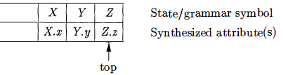
If the attributes are all synthesized, and the actions occur at the ends of the productions, then we can compute the attributes for the head when we reduce the body to the head. If we reduce by a production such as A → X Y Z, then we have all the attributes of X, Y, and Z available, at known positions on the stack. After the action, A and its attributes are at the top of the stack, in the position of the record for X
Actions for implementing the desk calculator on a bottom-up parsing stack. The stack is kept in an array of records called stack, with top a cursor to
the top of the stack.
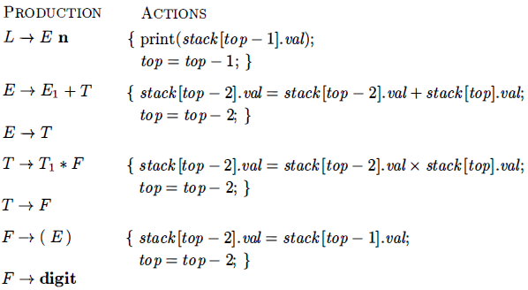
stack[top] refers to the top record on the stack,
stack[top - 1] to the record below that, and so on. Each record has a field called val which holds the attribute of whatever grammar symbol is represented in that record.
An action may be placed at any position within the body of a production. It is performed immediately after all symbols to its left are processed. So, For a production B → X {a} Y the action a is done after we have recognized X (if X is a terminal) or all the terminals derived from X (if X is a non-terminal). Ex: Turn desk-calculator into an SDT that prints the prefix form of an expression, rather than evaluating the expression, see example 5.16 from dragon book for details.
Any SDT can be implemented as follows:
- Ignoring the actions, parse the input and produce a parse tree as a result.
- Then, examine each interior node N, say one for production B → α Add additional children to N for the actions in α so the children of N from left to right have exactly the symbols and actions of α
- Perform a preorder traversal of the tree, and as soon as a node labeled by an action is visited, perform that action.
Following parse tree for expression 3 * 5 + 4 with actions inserted. Visiting the nodes in preorder, we get the prefix form of the expression: + * 3 5 4.
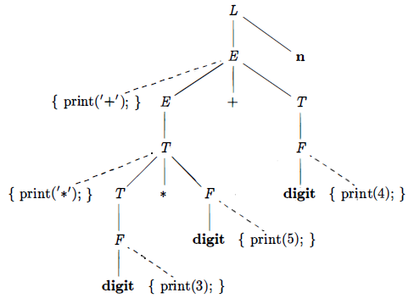
No grammar with left recursion can be parsed deterministically top-down. When the grammar is part of an SDT, actions associated with them would also be take cared. The first thing which we should take care is the order in which the actions in an SDT are performed. When transforming the grammar, treat the actions as if they were terminal symbols. This principle is based on the idea that the grammar transformation preserves the order of the terminals in the generated string.
The actions are executed in the same order in any left-to-right parse, top-down or bottom-up. The "trick" for eliminating left recursion is to take two productions A → A α | β
It generate strings consisting of a β and any number of α‘s & replace them by productions that generate the same strings using a new non-terminal R of the first production: A → β R R → α β | ɛ
- If β does not begin with A, then A no longer has a left-recursive production.
- In regular-definition, with both sets of productions, A is defined by β(α)*
Consult example 5.17 of similar book.
Rules for turning an L-attributed SDD into an SDT:
Embed the action that computes the inherited attributes for a non-terminal A immediately before that occurrence of A in the body of the production.
If several inherited attributes for A depend on one another in an acyclic fashion, order the evaluation of attributes so that those needed first are computed first. Place the actions that compute a synthesized attribute for the head of a production at the end of the body of that production. See example 5.19 for its implementation.
In the analysis-synthesis model of a compiler, the front end analyzes a source program and creates an intermediate representation, from which the back end generates target code. Ideally, details of the source language are confined to the front end, and details of the target machine to the back end. With a suitably defined intermediate representation, a compiler for language i and machine j can then be built by combining the front end for language i with the back end for machine j . This approach to creating suite of compilers can save a considerable amount of effort: m x n compilers can be built by writing just m front ends and n back ends.
Simply stated In the analysis-synthesis model of a compiler, the front end analyzes a source program and creates an intermediate representation, from which the back end generates target code.

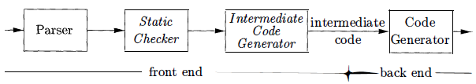

A directed acyclic graph (DAG) for an expression identifies the common sub-expressions of the expression. It has leaves corresponding to atomic operands and interior codes corresponding to operators. A node N in a DAG has more than one parent if N represents a common Sub-expression.
In a syntax tree, the tree for the common sub expression would be replicated as many times as the sub expression appears in the original expression. Ex. a + a * (b - c) + (b - c) * d
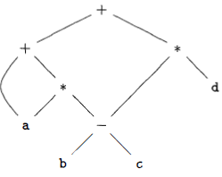
The leaf for a has two parents, because a appears twice in the expression. It is recommended to see example 6.2.
Value-Number Method for Constructing DAG's
The nodes of a syntax tree or DAG are stored in an array of records.
DAG for i = + 10 allocated in an array
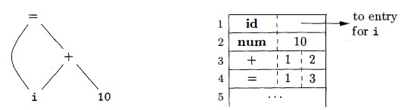
Each row of the array represents one record, and therefore one node. In each record, the first field is an operation code, indicating the label of the node. In array, leaves have one additional field, which holds the lexical value and interior nodes have two additional fields indicating the left and right children.
In three-address code, there is at most one operator on the right side of an instruction. A source-language expression like x+y*z might be translated into the sequence of three-address instructions.
t₁ = y * z t₂ = x + t₁
- t₁ and t₂ are compiler-generated temporary names.
Three-address code is a linearized representation of a syntax tree or a DAG in which explicit names correspond to the interior nodes of the graph.
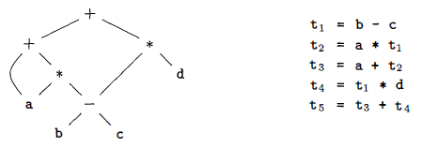
Three-address code is built from two concepts: addresses and instructions.
- In object-oriented terms, these concepts correspond to classes, and the various kinds of addresses and instructions correspond to appropriate subclasses.
- Alternatively, three-address code can be implemented using records with fields for the addresses. These records are called quadruples and triples.
An address can be one of the following:
- Name For convenience, we allow source-program names to appear as addresses in three-address code. In an implementation, a source name is replaced by a pointer to its symbol-table entry, where all information about the name is kept.
- Constant In practice, a compiler must deal with many different types of constants and variables.
- Compiler-generated temporary. It is useful, especially in optimizing compilers, to create a distinct name each time a temporary is needed.
A list of the common three-address instruction forms:
- Assignment instructions of the form x = y op Z, where op is a binary arithmetic or logical operation, and x, y, and z are addresses.
- Assignments of the form x = op y where op is a unary operation.
- Copy instructions of the form x = y, where x is assigned the value of y.
- An unconditional jump goto L. The three-address instruction with label L is the next to be executed.

A quadruple has four fields, known as op, arg₁, arg₂ & result. The op field contains an internal code for the operator. For instance, the three-address instruction x = y + Z is represented by placing + in op y in arg₁ z in arg₂ and x in result Some exceptions to this rule:
- Instructions with unary operators like x = minus y or x = y do not use arg₂
- Operators like param use neither arg₂ nor result.
- Conditional and unconditional jumps put the target label in result.
Ex: Three-address code for the assignment a = b* - c + b* - c ;
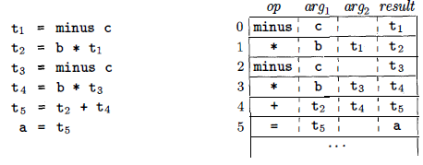
A triple has only three fields, which we call op, arg1 , and arg2. DAG and triple representations of expressions are equivalent. The result of an operation is referred to by its position. A benefit of quadruples over triples can be seen in an optimizing compiler, where instructions are often moved around. With quadruples, if we move an instruction that computes a temporary t, then the instructions that use t require no change. With triples, the result of an operation is referred to by its position, so moving an instruction may require us to change all references to that result.
Static single-assignment form (SSA) is an intermediate representation that facilitates certain code optimizations. All assignments in SSA are to variables with distinct names, hence the term static single-assignment. A program in three-address code and in static single assignment form.
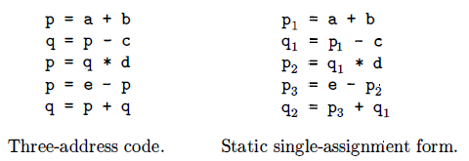
The applications of types can be grouped under checking and translation. Type checking uses logical rules to reason about the behavior of a program at run time. Specifically, it ensures that the types of the operands match the type expected by an operator. For example the && operator in Java expects its two operands to be booleans, the result is also of type boolean.
Translation Applications
- From the type of a name, a compiler can determine the storage that will be needed for that name at run time.
- Type information is also needed to calculate the address denoted by an array reference, to insert explicit type conversions, and to choose the right version of an arithmetic operator, among other things.
- The actual storage for a procedure call or an object is allocated at run time, when the procedure is called or the object is created.
- Types have structure, which is represented using type expressions.
A type expression is either a basic type or is formed by applying an operator called a type constructor to a type expression. The sets of basic types and constructors depend on the language to be checked. A basic type is a type expression. Typical basic types for a language include boolean, char, integer, float and void the latter denotes "the absence of a value."
Many type-checking rules have the form if two type expressions are equal then return a certain type else error. Potential ambiguities arise when names are given to type expressions and the names are then used in subsequent type expressions. The key issue is whether a name in a type expression stands for itself or whether it is an abbreviation for another type expression.
When type expressions are represented by graphs, two types are structurally equivalent if and only if one of the following conditions is true:
- They are the same basic type.
- They are formed by applying the same constructor to structurally equivalent types.
- One is a type name that denotes the other.
Amount of storage that will be needed for the name at run time can be determined from the type of a name. At compile time, we can use these amounts to assign each name a relative address. The type and relative address are saved in the symbol-table entry for the name. Data of varying length, such as strings, or data whose size cannot be determined until run time, such as dynamic arrays, is handled by reserving a known fixed amount of storage for a pointer to the data.
Type Checking includes several aspects.
- The language comes with a type system, i.e., a set of rules saying what types can appear where.
- The compiler assigns a type expression to parts of the source program.
- The compiler checks that the type usage in the program conforms to the type system for the language.
All type checking could be done at run time. The compiler generates code to do the checks. Some languages have very weak typing; for example, variables can change their type during execution. Often these languages need run-time checks. Ex include lisp. A sound type system guarantees that all checks can be performed prior to execution. This does not mean that a given compiler will make all the necessary checks.
There are two forms of type checking.
- Type synthesis where the types of parts are used to infer the type of the whole. Ex, integer + real = real.
- Type inference is very slick. The type of a construct is determined from usage. This permits languages like ML to check types even though names need not be declared.
Checking statements is very similar. View the statement as a function having its components as arguments and returning void. A very strict type system would do no automatic conversion. Instead it would offer functions for the programmer to explicitly convert between selected types. Then either the program has compatible types or is in error. A more liberal approach in which the language permits certain implicit conversions that the compiler is to supply. This is called type coercion. Explicit conversions supplied by the programmer are called casts.
Type conversion rules vary from language to language. The rules for Java distinguish between widening conversions which are intended to preserve information, and narrowing conversions which can lose information.
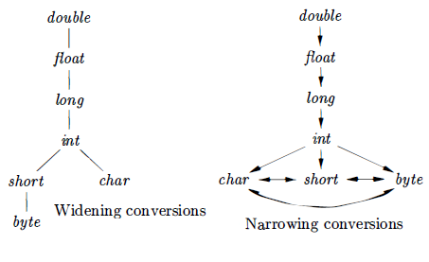
An overloaded symbol has different meanings depending on its context. Overloading is resolved when a unique meaning is determined for each occurrence of a name. In a DAG representing a type expression, we assign an integer index called a value number, to each node then we construct a signature for a node consisting of its label and the value numbers of its children, in order from left to right. The signature for a function consists of the function name and the types of its arguments. The assumption that we can resolve overloading based on the types of arguments is equivalent to saying that we can resolve overloading based on signatures. It is not always possible to resolve overloading by looking only at the arguments of a function. In Ada, instead of a single type, a sub expression standing alone may have a set of possible types for which the context must provide sufficient information to narrow the choice down to a single type.
Type inference ensures that names are used consistently. Type inference is useful for a language like ML, which is strongly typed, but does not require names to be declared before they are used. The term "polymorphic" refers to any code fragment that can be executed with arguments of different types. In parametric polymorphism, the polymorphism is characterized by parameters or type variables.
Lesson 31 & 32
Revision
******************

