Management Information Systems

Course code:

CSC 373

Credits: 3(3, 0)

Lecturer’s Profile

Ayisha Qureshi

Lecturer, Computer Science

CIIT, Islamabad

Masters in Information Systems

HEC, University of Lausanne

Switzerland

LECTURE 1
Introduction to the Course

What is Management Information Systems?
- (As a field) An organized approach to the study of the information needs of an organization's management at every level in making operational, tactical, and strategic decisions. Its objective is to design and implement procedures, processes, and routines that provide suitably detailed reports in an accurate, consistent, and timely manner.
- (Technical) In a management information system, modern, computerized systems continuously gather relevant data, both from inside and outside an organization. This data is then processed, integrated, and stored in a centralized database (or data warehouse) where it is constantly updated and made available to all who have the authority to access it, in a form that suits their purpose. (Business dictionary)

Why do business students need to study MIS?

Since Information and Communication Technologies dominate the business world nowadays, we utilize these technologies in not only businesses but daily lives as well. For example, use ATMs for money transferring, cash withdrawal etc. Behind the simple process is a full ‘process’ that is working which involves connecting with the bank central computers, verifying the card, checking the account for money, transferring the amount. Also we have the Internet, with which we connect with friends and family, search for information, using it for both entertainment and educational purposes and using cell phones for communicating. We send e-cards on SMS for wishing Eid instead of sending paper cards.

So having said that, basically our life styles are changing because of the technologies we use. Similarly business dynamics are changing in the face of emerging technologies and new software, thus increasing the competition in businesses. That’s why businesses students need to have an idea for the new technologies so as to enable students to access the problems and opportunities when using Information Technology in business. Also understand transformational changes within and outside the industry.
Introducing MIS now, is to make the students able to better understand the other course work. E.g. studying ‘Change Management’. Doing MIS now, you would know better why you need to do the change management. What challenges come with using and installing or converting to a new IS.

Careers in MIS
- Offered as Computer Science subject to business students
- Completing Master’s degree in MIS has benefits
- Companies: Insurance, telecommunications, financial services, education, medical, non profit organizations
- Rise in demand for IS personnel
- Profile: data communication analysts, system analyst, consultants, quality assurance managers, database administrators, system security analyst, IS auditor
- Skills: technical skills, written verbal communication, understanding of organizations, ability to work with people/ in groups
- CISA, CISSP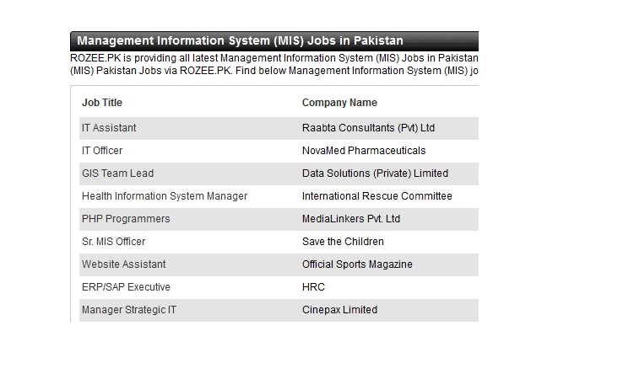
MIS Learning Outcome
- Have understanding of the Information Systems and its associated concepts
- Able to recognize the importance and use of various Information and Communication Technologies (ICTs)
- Able to analyse decision making process
- Have understanding of the various types of Information Systems
- Have knowledge of the system development
- Appreciate the social and ethical considerations of MIS within organizations

Course Contents

Module 1: Overview of Information Systems in Organizations
- Chapter 1: Introduction to Information Systems
- Chapter 2: How Businesses use Information Systems

Module 2: Information Technology Infrastructure
- Chapter 3: Hardware and Software
- Chapter 4: IT and Emerging Technologies
- Chapter 5: Databases and Information Management
- Chapter 6: Telecommunications, Internet and Wireless technology
- Chapter 7: Information System Security

Module 3: Business Information Systems
- Chapter 8: Electronic and Mobile Commerce
- Chapter 9: Enterprise Systems
- Chapter 10: Information and Decision Support Systems
- Chapter 11: Knowledge Management

Module 4: Systems Development
- Chapter 12: Managing Projects
- Chapter 13: Investigation and Analysis
- Chapter 14: Design and Implementation

Module 5: IS in Business and Society
- Chapter 15: Social and Ethical Issues in IS

Assignments
- 4 assignments per semester
- 10% of total marks
- Content:
- Detailed questions
- Internet Search

Quiz
- 4 quizzes per semester
- 10% of total marks
- Multiple choice
- Content:
- Lectures
- Case Studies

Graded Discussion Points
- Based on Case Studies
- Required to read and understand the case study
- Discuss on the discussion board
- Come up with possible answers to the case-study questions
- Based on Lectures
- Any topic will be given to discuss further
- Queries
- Ask related question for further understanding
- 5% of total marks

Sessional and Final Exams
- Sessional: 25%
- Final: 50%
- All course included
- Selected case studies

Books
- Principles of Information Systems (A Managerial Approach) by Ralph Stair, George Reynolds
- Management Information Systems (Managing the Digital Firm, Twelfth Edition) by Kennecth C. Laudon, Jane P. Laudon

Module 1: Overview of the Information System in Organizations

Chapter 1: Introduction to Information Systems

LECTURE 2

Learning Objectives
- Discuss why is it important to study and understand information systems
- Distinguish between data, information and importance of valuable information
- Discuss why organizations use Information Systems
- Identify the dimensions of Information Systems

Information Concepts
- Data: raw facts, such as employee number, number of hours worked in a week, inventory part numbers etc.

This includes alphanumeric data, image data, audio data, video data
Information: collection of facts organized so that they have additional value beyond the value of facts themselves

However, certain rules and regulations can be set up to organize data into useful and valuable information
- Process: set of logically related tasks performed to achieve a defined outcome, or simply turning data into information
- Knowledge: Process of defining relationships among data to create useful information requires knowledge. In other words knowledge is the awareness and understanding of a set of information and the ways that information can be made useful to support a specific task or reach a decision
For example, we want to calculate the salaries of the employees, which depend on the number of hours worked in a week .
Data would be the Employee No. and No. of hours worked by that employee.
Rule would be to calculate salary at the rate of 100 Rs. per hour.
Information would be the total no. of hours and then that total multiplied by 100.
Knowledge would be to apply that formula/rule on the total number of hours to create useful information.
- To be valuable to managers and decision makers, information should have the following characteristics:

Accessible Information should be easily accessible by authorized users so that they can obtain it in the right format and at the right time to meet their needs.

Accurate Error free. Inaccurate information may be generated because inaccurate data is fed into the transformation process (called GIGO).

Complete Information contains all the important facts. For example an investment report that does not contain all important costs is not complete.

Economical Information should be economical to produce. Decision makers must always balance the value of information with the cost of producing it.

Flexible Information that can be used for a variety of purposes.

Relevant Relevant information is important to the decision maker, i.e. users can make sense out of it and in accordance with their work.

Reliable Information that can be depended upon. In many cases, reliability of information depends on the reliability of data collection method.

Secure Information should be secure from access by unauthorized users.

Simple Information should be simple, not very complex. In fact, too much information can cause information overload.

Timely Information is delivered when it is needed.

Verifiable This means you can check it to make sure it is correct, perhaps by checking many sources for the same information.

The value of information is directly linked to how it helps decision makers achieve their organization’s goals

System Concepts

System: is a set of elements or components that interact to accomplish goals

The relationships among the elements determine how the system works. As shown in the figure, system has inputs, processing mechanisms, outputs and feedback.
Example: Automatic Car Wash
Feedback mechanism (assessment of how clean the car is)

Why is Information System important?

We interact with IS personally and professionally

Transforming businesses43

Globalization and Opportunities

IS effects all areas of the businesses which includes manufacturing, accounting human resources, marketing as well as the top management.

Information System

Information System is a set of interrelated components that collect, process, store, and distribute information (By computers and software as a tool)

The Information Systems support decision making, coordination, control, problem analysis and create new product. They also provide solutions to changes/challenges in business environment

Another definition

IT is an integrated Human-Machine system that combines hardware, software, databases and telecommunications networks. It collects data and processes it into information used for decision making at all levels of the organization.

Functions of an Information System

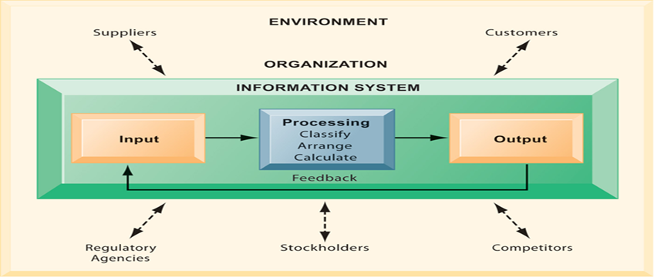

Why Firms Use IS

To achieve 6 strategic business objectives

- Operational Excellence

Achieving higher levels of efficiency and productivity in business operations, plus changes in management behaviour

Example: Wal-Mart’s Retail Link system links suppliers to stores for in-time replacements
- New Products/ Services/ Business Model

Business model: describes how company produces, delivers, and sells product or service to create wealth

Information systems and technology a major enabling tool for new products, services, business models

E.g. Apple’s iPod, iTunes online music business

- Customer and Supplier Intimacy

Serving customers well leads to customers returning, which raises revenues and profits

Intimacy with suppliers allows them to provide vital inputs, which lowers costs

E.g. JCPenney’s information system which links sales records to contract manufacturer

- Improved decision making

Managers need right information at right time

IS provide real-time data for making decisions

E.g. Verizon’s Web-based digital dashboard to provide managers with real-time data on customer complaints, network performance, line outages, etc.

Results in restoration and repairing fast and effective

- Competitive Advantage

Achieve higher sales and profit through using IS by:

Doing things better

Charging less for superior products

real time responding

Using the internet is competitive advantage
- Survival

Information technologies are necessity of doing business

Industry-level changes, e.g. Citibank’s introduction of ATMs

Dimensions of Information System (IS)

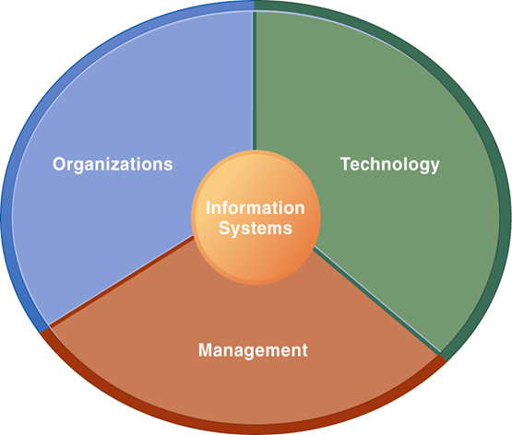
Using IS effectively depends on the understanding of organization, technology and management. Only computer literacy is not important, rather broader IS literacy is important to implement a productive IS and this field of MIS is to achieve it. Information System Literacy means to know how and why technology is applied in business.

- Organization
- Key elements : People, Structure, Business Processes, Politics, Culture
- Organizational structure has different levels and specialities

- Management
- Make decisions, formulate action plan and solve organizational problem
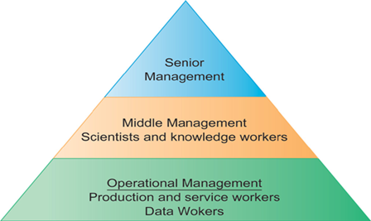
- Managers set organizational strategy for responding to business challenges
- In addition, managers must act creatively:
- Creation of new products and services
- Occasionally re-creating the organization

- Technology
- Hardware: physical component
- Software: instruction control Hardware
- Data management technology
- Network and telecommunications technology
- Network: Hardware + Software link computers
- Internet: Network to provide services
- IT infrastructure: platform to build the IS

Summary
- IS instrument for creating value to firms
- The value of information is directly linked to how it helps decision makers achieve the organization’s goals
- Information systems must be applied thoughtfully and carefully so that society and industry can reap maximum benefits

LECTURE 3

Learning Objectives
- Discuss why is it important to study and understand information systems
- Distinguish between data, information and importance of valuable information
- Discuss why organizations use Information Systems
- Identify the dimensions of Information Systems

Dimensions of Information System (IS)
Earlier we talked about Organization and Management as the dimension of IS. Similarly Technology is an important dimension and a major enabler of Information Systems.
- Technology
Technology consists of the following components
- Hardware is the physical equipment used for input, output, processing and storage. For example mouse, monitor, hard disk etc. are the hardware devices. Some hardware devices are special purpose devices such as Event Data Readers (EDR) which are used in vehicles and planes. These devices are helpful especially in knowing the cause of accidents that either the brakes were pressed or there was some engine problem. It’s also called the ‘black box’ used in planes.
- Software are computer programs that control and coordinate the hardware so that they can work properly. These include System Software and Application software. Some software are also special purpose software e.g. Fab Lab – controls automatic cutter, milling machines on an industrial site.
- Data management technology deals with software that are used to organize data on physical storage media. Data and information management is an important technologically component of IS.
- Network and telecommunications technology contains both hardware and software that are used to link various computer devices placed in different locations. Networks link computers to not only share data but also resources e.g. printer. Also telecommunications allows people to communicate via various devices and mediums. E.g. investment firms use telecomm to connect with brokers and traders. Internet is the world’s largest Network
- World Wide Web is a service provided by the internet that defines a format to display, retrieve and store web pages over the internet.
- All these components mentioned above constitute the IT infrastructure, which is the platform to build the IS. This IT infrastructure will be explained in detail from Chapter 3 to Chapter 7.

Case Study: UPS Competes Globally With Information Technology

(Laudon2012, Chapter 1, page: 22, 23)
The following are the important points marked from the case study for helping you to understand better. This case study stresses on the technological aspect of the business, how technology makes a difference.
- Company: United Parcel Service (UPS)
- Package delivery
- Started in 1907, now has 408,000 employees and 96000 vehicles
- Process: automated package tracking system
- Scannable label attached to package
- Info from “smart” tag goes to central computer
- At centre traffic route made for drivers
- Delivery Information Acquisition Device (DIAD) access info through wireless n/w
- Through bar code info at various points goes to central computer
- Info available on UPS website

Questions and Answers of the UPS Case Study.

Question 1: Inputs, Processing, Output of UPS PTS
- Input: Info about sender, destination and time of arrival, progress data
- Processing: Info transmitted central computer to distribution centre, route calculation
- Output: Tracking status, printed label, driver’s route

Question 2: Technologies used and why
- Handheld computers, bar code scanners, wireless communications, desktop commuters, UPS data storage technology, UPS tracking software, Internet (Web site)
- Reason: high level service in low price

Question 3: Strategic Business Objectives Achieved
- Operational Excellence
- Customers can download and print labels
- Drivers traffic route given to drivers
- Customer Intimacy
- Inform customers about estimated time
- Package status report updated and can be checked online
- New Service
- Point Sales Order Management System (OMS)
- Competitive Advantage
- Achieved by above mentioned implementations

Global Challenges
Challenges occur whenever technology is used or when organizations do international trade. Globalization is any change in the society occurring as a result of cultural exchange or international trade. So Globalization has impact on organizations and its IS. Thomas Friedman wrote a book called “The World is Flat”, and explained three versions of Globalization. In the 3rd version of globalization individuals from all over the world compete with other individuals, companies and countries through Internet. Earlier versions were about companies setting up offices, plants in other parts of the world where labour or other costs are cheap, whereas now globalization is about giving individual the opportunity whoever is capable enough to compete with anybody over the Internet.
However, where there are international opportunities, as mentioned above, there are challenges and obstacles as well, which are as follows:
- Cultural and language challenges
- Time and distance challenges
- Infrastructure challenges
- Currency challenges
- Technology transfer issue
- Product and Services challenges

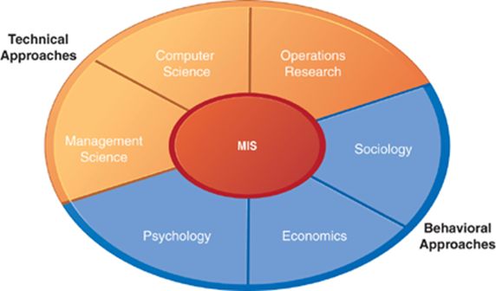

Contemporary Approaches to IS

A new approach to understanding Information System states that it is a multidisciplinary field. As mentioned in the figure below, that we need to look at IS from two sides, that is the technical as well as behavioural. In other words the study of information systems deals with the issues and insights contributed from the technical and behavioural disciplines. So information systems is not only about the machines and devices that make up any system but also the people, how they perceive the technology and how they react to a certain technology.

- Technical approach emphasizes mathematically based models
  - Computer science theories of commutation ,data storage
  - management science: models of DM and practices
  - operations research: optimizing selected parameters of org.
- Behavioural approach deal with behavioural issues like strategic business integration, design implementation, management
  - Psychology: how decision makers use formal information
  - Economics: how IS change the control and cost structures
  - Sociology: how system affect individuals and groups

The sociotechnical systems

So the result of contemporary approach is to understand the IS, or to study the MIS in sociotechnical terms, because it involves the use of computer-based information systems in business firms. MIS combines work of CS, management, and operating research for developing system solutions to real word problems and managing information technology resources. It is also concerned with behavioural issues of development, use and impact of IS.

The main actors of these systems are:
- Suppliers of hardware and software (the technologists)
- Business firms seeking to obtain value from technology
- Managers and employees seeking to achieve business value
- Firm’s environment (the contemporary legal, social, cultural context)

So to develop such a system there are 2 key points to be considered. One: Technology must be changed or designed in such a way to meet the organizational needs or individual needs. Two: organization and individuals must be changed through training, learning and planned organizational change to allow the technology to operate and prosper. So, optimal organizational performance is achieved by jointly optimizing both the social and technical issues.

Summary
- Technology usage, how it helps the business
- Globalization and it’s challenges
- Sociotechnical systems

Module 1: Overview of Information System in Organizations

Chapter 2: How Organizations use IS

LECTURE 4

Topics
- Organization and IS
- Organization structure
- Organization culture and change
- Business Process
- How IS changes business processes
- Reengineering and continuous improvement
- User satisfaction and technology acceptance
- Business Information Systems
- E-business
- Management Level
- Enterprise
- Collaboration

Organizations and IS

Organization is a formal collection of people and other resources established to accomplish a set of goals. An organization is a system, which means that it has inputs (money, people, materials, machines, data, information and decisions), processing mechanisms, outputs (goods or services) and feedback. The inputs are transformed into outputs of increased value. These outputs provide value to stakeholders: customer, supplier, manager, shareholder or employee. E.g. in the automatic car wash, consumers pay for skill, knowledge, time and energy required to accomplish the transformation.

Organizational Structure refers to the subunits and the way they relate to the overall organization. An organizational structure depends on goals and approach to management and can affect how it views and uses IS. The typical structure includes traditional, project, team and virtual structures.
- Traditional Organization Structure
It is also called hierarchical structure, is like a managerial pyramid (as shown in the figure below) where the top management or the strategic level has the highest authority and decision making power. This also means they have more impact on the corporate goals and more uniqueness of problems to solve.

- Flat organizational structure

It reduces no. of management levels. This kind of structure empowers employees at lower level to make decisions and solve problems without needing permission from midlevel managers. Empowerment means giving employees more responsibility and authority therefore IS at this level are important because they provide information to employees to make decisions.
- Project and Team Organizational Structures

Project organizational structure is centred on major product and services. Project teams are temporary. E.g. baby products company, where each line is produced by a separate unit.

Team organizational structure is centred on work teams or groups, which may be small or large, headed by a team lead. E.g. a healthcare company might have teams to organize its administration, physicians and others to work with patients.
- Virtual Organizational Structures

A virtual organization structure allows employees to accomplish work when separated in terms of location and time. These people might be in different countries, operating in different time zones. Members in a virtual organization can collaborate on any aspect of a project, such as supplying raw materials, producing goods and services. Information technology plays a major role in connecting such organizations. Information Systems are used to manage the activities of the virtual structure, requiring specialized software to coordinate the joint work.

Organizational Culture and Change

Organizational Culture:

It is a set of major understandings and assumptions shared by a group for a business, corporation or other organization. These understandings include common beliefs, values, approaches to decision making, which are not often stated or documented. New IS may at times conflict with an informal rule that is part of the organizational culture. Organizational culture affects development and operation of IS

Organizational Change:

Organizational change deals with how for-profit and non-profit organizations plan for, implement and handle change. There are two types of change: sustaining change and disruptive change. Resistance to change also affects the working of IS therefore overcoming resistance to change is important, especially disruptive change.

Organizational Learning is closely related to organizational change. It involves adapting to new conditions or altering the practices over time. In other words adjustments based on experience and ideas of the various managers and executives.
Consider Kodak, the film company. When digital photography became the norm for professional and personal photographers, some thought that the company that made its money by developing films would go down. Kodak surprised many by redefining itself as a digital photography company rather than a film company. Kodak invested heavily in its Web presence and now provides its customers with valuable digital photography services rather than film developing. Kodak has done considerably more than just survive. Kodak continues to profit from selling digital cameras, prints, and other photography services.

Business Processes and IS

Business Process is a collection of activities required to produce a product or service which is supported by flows of materials and information/knowledge. It refers to the unique ways in which organizations coordinate work, information and knowledge and the ways in which management chooses to coordinate work.

Performance of businesses depends on the business processes. There are two types of business processes:
- Functional business processes

These are tied to a specific functional area. E.g. Sales and marketing business process includes: identifying customers, product marketing and selling products
- Cross functional business processes

These cross different functional areas and require coordination across different departments

For example: Order fulfilment Process

- Sales: Generate order >> Submit Order


- Accounting: Check credit >> Approve credit >> Generate invoice


- Manufacturing & Production: Assemble product >> Ship product

How does IT improve business processes?
- New technology can actually change the flow of information, making it possible for many more people to access and share information.
- Also they can replace sequential work with tasks that can be performed simultaneously
- Thus by doing so, they can eliminating delays in decision making

However it’s important to analyse business processes before trying to improve them using the IT for better efficiency and effectiveness.

Reengineering and Continuous Improvement

Competitive organizations make fundamental changes in how they do business. In other words they change the processes which they use to achieve their goals. Business Process Reengineering involves the radical redesign of business processes, organizational structure, IS and values of the organization to achieve breakthrough performance. The benefits of reengineering are reduced delivery time, increased product and service quality, enhanced customer satisfaction and profitability. Basically it challenges fundamental assumptions and rules, especially old rules that are blocking the business process changes. Some of these rules are mentioned in the table below.

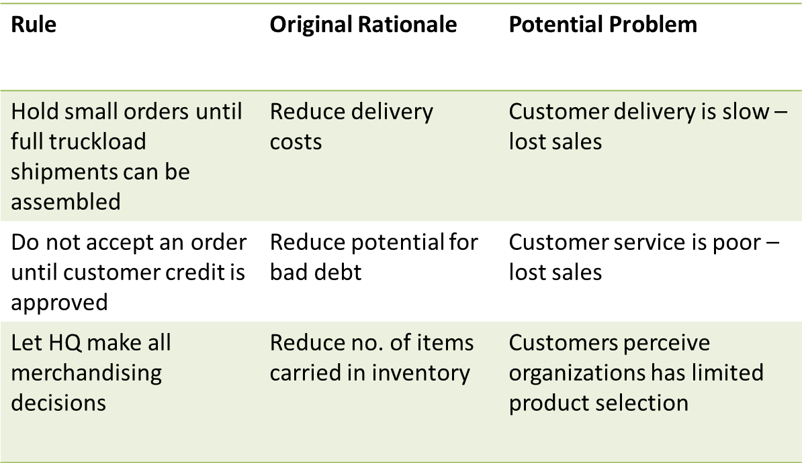

Continuous improvement on the other hand constantly seeks ways to improve business processes and add value to product and services. It is a continual change that also targets customer satisfaction and loyalty plus long-term profitability. For example manufacturing companies make continuous changes in the product design. A comparison between reengineering and improvement is listed in the table below.

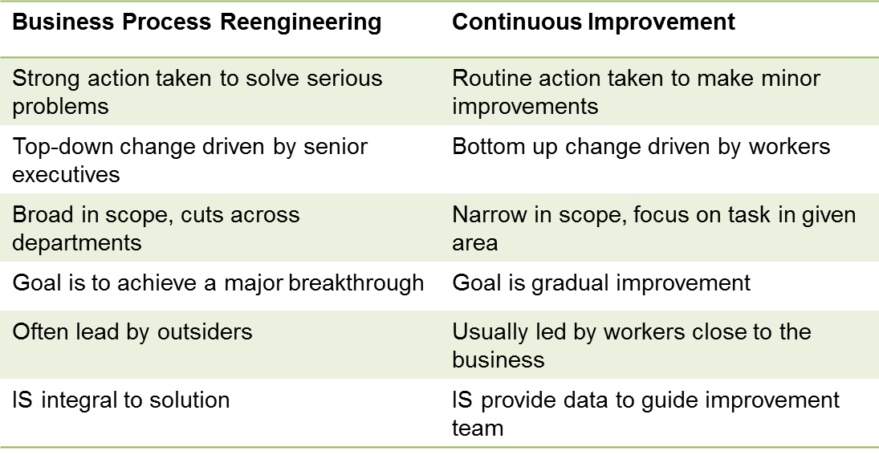

User Satisfaction and Technology Acceptance

This concept relates to the IS attitudes and usage that the new technology is accepted and used throughout the organization. User satisfaction with the computer system and the information it generates depends on quality of system and information. The quality information as mentioned in the last chapter is flexible, efficient, timely, accessible, accurate etc.

Technology acceptance model (TAM) specifies the factors that lead to better attitudes about the IS along with higher acceptance and usage of the system in an organization. It consists of two terms
- Technology diffusion: how widely technology is spread throughout an organization
- Technology infusion: extent to which technology infuses in an area or department

Companies hope that high level of diffusion, infusion, satisfaction and acceptance will lead to greater performance and profitability

LECTURE 5

Topics
- Organization and IS
- Organization structure
- Organization culture and change
- Business Process
- How IS changes business processes
- Reengineering and continuous improvement
- User satisfaction and technology acceptance
- Business Information Systems
- E-business
- Management Level
- Enterprise
- Collaboration

Business Information Systems

The purpose of BIS in organizations is to help employees in organizations accomplish routine and special tasks that include recording sales, processing payrolls to more complex decision making. There are different types of IS that support different interests, specialities and levels in the organizations
- e-commerce, m-commerce
- Management Level Systems
- Enterprise Systems
- Collaborative Systems

Electronic and Mobile Commerce

These two terms belong to a wider term, E-business which refers to use of digital technology and Internet to execute the major business related tasks which includes accounting, finance, manufacturing, HR activities. It also includes working loosely with customers and suppliers. Compared to traditional business strategy, E-business strategy is flexible and adaptable.

E-commerce is any business transaction (buying and selling) executed electronically. Its types include B2B, B2C, C2C. E-commerce also offers opportunities for small businesses since they can become a part of the international market through the Internet.

M-commerce: transactions happening anywhere, anytime (using wireless communications)

Management Level Systems
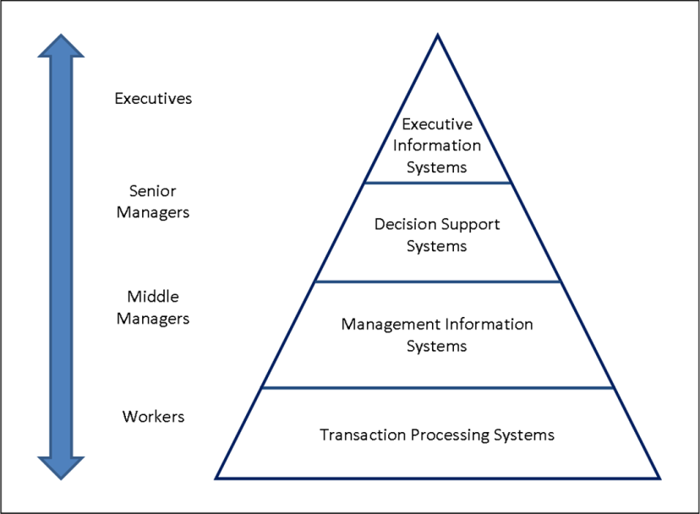

Transaction Processing System (TPS)

It is an organized collection of people, procedures, software, devices and databases used to record and complete business transactions. Transaction is any business related exchange, like sales to customers, receipts, generating payroll, paying suppliers. This was the first computer application developed by the organizations for the purpose of recording and completing transactions. The purpose of TPS is to answer routine questions and track flow of transactions e.g. how many parts are in inventory? What happened to a certain employee’s pay check? TPS should produce information that is accessible, current and accurate because it deals with tasks that are predefined and highly structured. Managers need TPS to monitor the status of internal operations.

Management Information Systems (MIS)

It is an organized collection of people, procedures, software, databases and devices that provide routine information to managers and decision makers. These systems are basically used for operational efficiency, by generating reports (daily/weekly etc). There are functional MIS for different departments such as Marketing, finance, production. MIS generate reports by summarizing and comparing data and information supplied by TPS, e.g. a report that describes inventory should be ordered. Managers use them to monitor and control the business and predict future performances.

Decision Support Systems (DSS)

DSS is an organized collection of people, procedures, software, databases and devices that support problem-specific decision making. Its purpose is to make efficient decisions, solving unique problems where solutions may not be fully predefined. Where MIS is about ‘doing things right’, DSS is about ‘doing the right things’. It uses information from TPS and MIS, plus external sources. DSS support managers in decision making process by analysing data and suggesting alternatives and assisting in final decision making. E.g. Auto manufacturers might use DSS to evaluate best location to build a new manufacturing plant.

Executive Support Systems (ESS)

ESS are used by senior management or top level managers to support them in judgement, evaluation, insight. This kind of IS provide help in strategic planning and control as well as crisis management. Information is presented through portal in the form of digital dashboards, which display graphics/charts of different Key performance indicators. E.g. ESS can provide minute to minute view of firms’ financial performance, measured by cash flow, inventory, accounts payable etc.

Case Study: Domino’s Pizza Tracker

(Laudon2012, Chapter 2, page: 52,53)
- Company: Domino’s Pizza
- Problem: Customers not happy with home delivery and pizza
- Competitive Advantage needed
- Good Pizza
- Excellent customer service
- Point of sale system – Pulse
- Captures purchase and payment data using computers, automated cash registers , scanners etc.
- Improved customer service, reduced mistakes, shorter training time
- Pulse Evolution
- Think client model to thin client model
- Networked stations with little processing power collect data
- Info goes to one machine for processing
- Benefit: easier to update and secure
- Ordering system: Pizza Tracker
- Simulated photographic version of pizza shown while ordering
- View progress of pizza ordered online
- Improved customer relationship

Case Study Questions and Answers
- Systems
- Point of sale system
- Online ordering system
- Business Processes
- Purchase and payments at physical locations
- Managing online orders for pizza
- Business performance
- Help in maintaining consistent and efficient management functions
- Taking and customizing orders, maintaining sales figures, compiling customer info
- Online Pizza tracker
- Showing photographic version of the pizza and giving view of the progress of the pizza order

Enterprise Systems

Now, you might think, how do the organizations manage all these above mentioned systems together and how these systems share information. It is difficult to manage different types of IS in an organization. The challenge is to get them all work together as one corporate system (information integration). So the solution is enterprise applications (systems) that span functional areas and not only that they execute and coordinate business processes across the firm thus integrating different processes closely.

Enterprise Resource Planning (ERP)

It is a set of integrated programs that manages the vital business operations of an entire organization. It replaces many applications with one system. Its scope varies but usually integrates marketing/sales, finance, manufacturing business processes. Take the example of Order processing Process. With an ERP, the system triggers the warehouse to pick shipment and accounts are automatically notified to send invoice. Benefit of ERP are easy adoption of improved work processes and increased access of timely data, however ERP systems can have disadvantages. This you can view in detail in Chapter 9.

Supply Chain Management Systems (SCM)
These are used to manage relationships with suppliers and link the suppliers, purchasing firms, distributers and logistic companies, so that they can share information and supply the right amount of products in less time.

Customer Relationship Management Systems (CRM)
These are used to manage relationships with customers by coordinating business processes that deal with customer sales/marketing as well as services. This in turn results in increased customer satisfaction and retention.

Knowledge Management Systems (KMS)
Since some firms have more knowledge about creating, producing and delivering products/services, they need to retain in for future. This knowledge that belongs to a firm is unique and cannot be imitated. These systems manage processes for capturing, storing and applying knowledge in organizations.

Collaboration Systems

Collaboration is about working with others to achieve shared and explicit goals. E.g. members in a team collaborate to complete a task. Investments in collaborative technologies have brought immense improvements in businesses. There are various tools utilized for collaboration, called Collaborative Software Tools which are constituted in the following categories:
- E-mail and instant messaging
- Collaborative Writing
- Event Scheduling
- Audio Conferencing
- Video Conferencing
- White boarding
- Document sharing (wikis)
- E-mail and Instant Messaging
- Major communication and collaboration tool
- IM allows real time conversation with multiple people
- Social Networking
- Corporate tool for sharing ideas and collaborating
- LinkedIn.com provides networking services to business professionals
- Wikis
- Major wiki: Wikipedia
- Contribute and edit text content and graphics
- Major repository for unstructured corporate knowledge
- Virtual Meeting Systems
- Reason: to reduce travel costs by business professionals
- Briefing, training courses, management consulting, inspirational chats
- Telepresence: integrated audio-video technology that allows the person to give the appearance of being present at the location of meeting

Module 2: Information Technology Infrastructure

Chapter 1: Hardware and Software

LECTURE 6

Learning Objectives
- Identify the IT infrastructure and its components
- Describe how to select Hardware for IS
- Describe characteristics of memory, processor, storage, input and output devices

Information Technology Infrastructure

The IT infrastructure includes investments in hardware, software services (consulting, education, and training). It not only consists of physical devices and software applications required to operate the functions of the enterprise, but also services associated with them, such as
- Computing platforms: computing services to connect employees e.g. PC, mainframes, servers etc.
- Telecomm services: required for data voice and video connectivity.
- Data management services: for storing and managing corporate data.
- Application software services: Such as ERP, SCM, CRM, KM.
- Physical facility management: physical installation of computing devices.
- IT management services: plan and develop infrastructure like project management.
- IT standards services: defining policies for using IT.
- IT training: training the employees.
- IT research: such as research on potential future IT projects.

It is important to know this ‘service platform’ because value of technology would be apparent when you are clear about how it will be used and who will use it.

The IT infrastructures have evolved from bulky costly technology to smaller finer technology infrastructures and this is because of the developments in computer processing/memory chips, storage devices, telecommunication devices and hardware/software designs. This in turn have reduced costs and increased computing power exponentially. All this is to make technology practical and yield business benefits. To make informed acquisition decisions especially for IS it is important to know the current and future business requirements. We will divide IT infrastructure into seven components: hardware, system software, application software (enterprise), data management/storage, telecommunication and networks, Internet, consulting and system integration.

Hardware Components

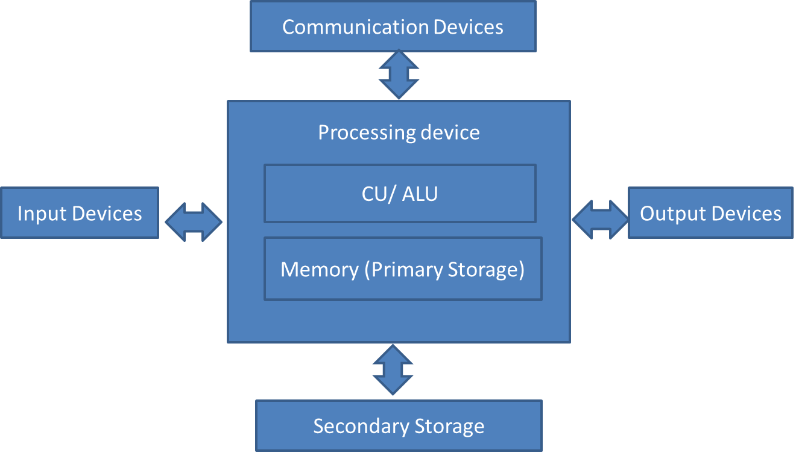

The basic hardware components include the Processing device, which includes Central Processing Unit (CPU) along with the Primary memory (RAM – main memory). The CPU consists of the Control Unit and Arithmetic Logic Unit. The ALU performs mathematical calculations and makes logical comparisons. The CU sequentially accesses program instructions, decodes them and coordinated the flow of data in and out of the ALU, primary storage and even secondary storage and output devices. Executing the machine instructions by the CPU is called the Machine Cycle, which consist of the phase Fetch, Decode, Execute and Store. The time in which the machine cycle occurs is measured in nanoseconds and picoseconds. MIPS (millions of instructions per second) is another measure of speed of computer.

Memory
Memory is the hardware component of the computer that rapidly provides data and instructions to the CPU. It is a silicon chip , where data is stored in the form of on (1) and off (0) circuit states, represented by bits. The storage capacity of memory is measured in byte (collection of eight bits).
There are two types of memory: Volatile and non-volatile.
Volatile: RAM – Random Access Memory (SDRAM, DRAM, EDO)
Non-volatile: ROM – Read Only Memory (PROM, EPROM). Computer start-up instructions are saved on ROM. A form of EPROM is used to store information on RFID chips.

Cache Memory is a type of high speed memory that a processor can access more rapidly than main memory. It stores frequently used data by the CPU. With this the CPU can access data faster, improving the overall performance of the computer system. There are three levels of cache, L1, L2 and L3.

Costs for memory capacity continues to decline, however it is still expensive than most forms of secondary storage. Effectiveness of a CBIS depends on memory capacity too, for example, complex processing problems, computer assisted product design require more memory than simpler tasks such as work processing.

Multiprocessing and Parallel Computing

Multiprocessing involves simultaneous execution of two or more instructions at the same time
- Multicore microprocessor (dual core): combines two or more independent processors into a single computer so that they cans hare the workload and boost processing capacity. Dual-core also allows doing multiple tasks like playing a game, and word processing at the same time. Multicore is used in computer for example that do a medical CAT scan.
- AMD and Intel
- Core Duo technology: defines computer power as performance per watt.

Parallel Computing is simultaneous execution of same task on multiple processors
- Massively Parallel computing systems: systems with thousands of multiple processors.
- Single instruction/ Multiple data (SIMD): parallel processors all execute same instructions on many data values simultaneously.
- Multiple Instruction/ Multiple data (MIMD): parallel processors all execute different instructions.

Grid Computing is the use of collection of computers to work in a coordinated manner. They are used to solve extremely large processing problems. This structure consists of a central server acting as Grid leader, monitoring the processing and traffic monitor. Through the World Community Grid (through Rosetta Software) more than 100,000 people donate unused time from their computers. This massive computational power is used for medical and scientific purposes.

Business uses of these technologies include: Modeling, simulating, analysing large amounts of data. They are especially used in marketing programs or boosting sales and customer relationships

Secondary Storage

Now, since the organizations need to store large amounts of data and also this need is increasing every year at the rate of 100%, they require storage devices with larger capacity. Secondary storage is non-volatile, has greater capacity and greater economy. IS needs determine the access methods, storage capacity and portability required of secondary storage media. If the storage device has faster access, it will be expensive than slower media. Along with this, security issue needs to be addressed as well.

Types of secondary storage are:
- Magnetic Disks - Hard Disk: have higher storage capacity and quicker access times. Now also portable HD are available in pocket sizes.
- Optical Discs – CD-ROM, CD-RW, DVD, DVD-R: DVD has faster access rate than CD. Most commonly used for backing up data.
- Memory Cards – used in digicams, video cams, photo printers, handheld games, smart phones
- Flash Memory - EEPROM: it is non-volatile. Consists of a electronic chip with blocks of memory cells reprogrammed in a ‘flash’.

RAID (redundant array of independent disks)

Fault tolerance of the devices is the requirement of organizations, so that they can continue with little or no loss of performance if one or more key components fail. RAID is a method of storing data based on the technology to rebuild lost data. In this approach data is split and stored on different physical drives. This technology is used to improve system performance and reliability. RAID can be implemented in different manners. A simpler way is duplicating data on drives, called disk mirroring.

Enterprise Storage

It consists of products and services designed to assist organizations in storing and retrieving digital information throughout the organization. It has three forms:
- Attached Storage

It consists of devices attached to a simple PC, but do not allow systems to share storage and are difficult to back up.

However to improve these drawbacks, there are two other forms, NAS and SAN for enterprise data storage. These have the benefits like improved Storage efficiency, Cost effectiveness and reduced risk of downtime.
- Network Attached Storage (NAS)
It consists of storage devices attached to a network. NAS also includes software to manage storage access and file management. These are servers specialized for storing files so act like file servers.
- Storage Area Network (SAN)
It is a high-speed network of shared storage devices, where users are connected through LAN or WAN, accessing these devices. IT integrates different types of storage devices like RAID, magnetic tapes etc. In SAN, the storage locations appears in the client computer as a disk drive.

LECTURE 7

Learning Objectives
- Identify the IT infrastructure and its components
- Describe how to select Hardware or IS
- Describe characteristics of memory, processor, storage, input and output devices

Output Devices

Output is generated to allow decision makers at all levels to solve problems in the form of visual, audio or textual output. But whichever the form is output should be the right information at right time to the right person in the right format.

- Display Devices
- CRT Monitors: use the Cathode Ray Tube to display images on the screens. Coloured dot on the screen is called Pixel (which represents on/off state on the screen). Resolution quality of the screen depends on pixels. More pixels mean high resolution (measured in pixels per inch (ppi)). Dot pitch is the distance between pixels in millimetres (usually .25 to .33 mm). Lesser dot pitch also creates finer image.
- LCD monitors and screens: these are flat panel displays that use liquid crystals to display images on screen. These occupy less space, are costlier and have less power consumption. These screen produce flicker free images. Another technology called Thin Film Transistors (TFT) uses transistors to control each pixels.
- OLED screens: organic light emitting diodes that are organic molecules that directly emit light thus produce images brighter and sharper than LCD, used in flexible displays and are less expensive. These screens are in cell phones, car radios and digital cameras.

- Printers and Plotters

Printer and plotters produce text/ graphics on physical medium (hard copy). There are two basic types:
- Non-Impact Printers (inkjet, Laser, Mobile). These printers have different speeds, which is measured in pages per minute (ppm). Resolution quality is measured in dots per inch (dpi). Also different printer have different capabilities.
- Impact printer are those in which the printer pin strikes against the page. Example is Dot Matrix printer, which allows continuous form of paper to be fed into it. It’s speed is calculated in characters per second (cps). It can be used for receipt generating in retail stores.
- Plotters: Plotters are type of hard copy device used for general design work e.g. print blueprints, schematics, drawing of buildings, maps and circuit diagrams. Standard plot width is up to 60 inches.

- Audio Output

It consists of speakers, head phones and ear phones used with the computer systems. These convert digital audio data into analog audio outputs.
- Data Projectors

This hardware device projects text and images on larger screens. There are different kinds of projectors, some can be fixed to the ceiling for projection and some can be portable.

Computer Systems Types and Upgrading
Following are the different types of computer systems:
- Handheld/Mobile Devices

These are single- user computers as small as a credit card or pocket size and because of the size provide ease of portability. They usually contain no disk, and data is stored on special memory. Some devices even have a built-in GPS receiver with software that can integrate the location data into the application. Examples are: handheld computer, PDA, smartphones.
- Portable Computers

These are thin, lightweight, powerful machines; with processing power like the desk top PC, which can be shifted from one place to another easily. Examples are: Laptops, notebooks, tablet PCs. Laptops have evolved immensely over time.
- Thin Client

These are low-cost, centrally managed computer, with no extra drives and limited capabilities. These do not have the storage capacity or processing power like the usual desktop. These can be used as point of sales computers. These were mentioned in the Domino’s Pizza case study as well. Data was being stored in the central computer. Benefits are that there is less risk of viruses and limited maintenance costs.
- Desktop and Workstation

These machines are slightly inexpensive than laptops, again single user systems. Workstation is relatively expensive and more powerful than desktops. They can be used for mathematical computing, Computer Aided Design and in creating special effects for motion pictures.

- Servers

These machines are used by many people to perform specific tasks such as running network or Internet applications. These also provide access to hardware and software, resources over the network. There are different types of servers depending on their use, for example: a Web server handles Internet traffic and communications. Servers offer great scalability, the ability to increase processing capability of a computer system so that it can handle more data, more users or more transactions in a given period. Adding more powerful processors means Scaling up and adding equal powered processors means scaling out. Popular serves called Blade servers are thinner than box-based servers, with many circuit boards which have processors, memory and network connections. Secondary storage maybe added to them.
- Mainframes

Mainframes are large, powerful machine, which can accommodate thousands of computers connected to them. These computers can handle millions of instructions daily associated with airline, automobile and hotel/motel reservation systems. They are used for information processing and data storage that are too large for other computers. Also they store backup of files and databases created elsewhere.
- Supercomputers

Supercomputers are the most powerful computer systems that constantly exceed limits of speed and performance. These are special purpose machines designed for applications that require complex and sophisticated mathematical calculations and rapid computational capabilities. They are used for weather forecasting for example.

Case Study: Mainframes or Distributed Systems

(PIS, Chapter 3, page: 141,142)

Some of the salient points from the case study are as follows:

Company: Bank of NewYork

Traditionally information services are provided by z-series mainframes

Competition from server based distributed systems which include midrange servers, blade servers

Distributed systems are system dividing business processes among network servers.

Expensive to shift from mainframe to distributed system. IS professionals need to take advantage of both the technologies

Question 1: Strengths and weaknesses of distributed systems and mainframes.
Distributed servers strengths:
- Open and agile
- Deployment of applications easy
- Scalability
- Inexpensive servers

Distributed servers weakness:
Not as powerful as mainframes.

Mainframes strengths:
- Ease of management
- More secure and stable
- Useful means o consolidation
- Very large complex problem solving
Mainframes weaknesses:
Not scalable and difficult to shift from mainframes to distributed systems.
Question 2: Easier and less expensive to base systems on distributed computers…
The basic reason is scalability: the new company can have the inexpensive servers, whose processing power can be increased, increase the memory or storage capacity so as to make them as powerful as mainframes. The company can scale up or scale out as required. Also they can deploy different applications easily while providing the same utilities as mainframes.

Case Study: New to the Touch

(Laudon2012, Chapter 5, page: 178,179)

Salient points from the case study are as follows:

Company: Apple iPhone

Multitouch features are:
- Versatile
- Detect fingers and gestures (easier to remember)
- Move objects, scrolling

- Panel underneath the glass senses the touch using electric fields
- Synaptics, Microsoft (windows 7)
- Microsoft’s Surface computer
- Android smartphones

LECTURE 8

Learning Objectives
- Identify and briefly describe the functions of two basic types of software
- Outline the role of operating systems
- Discuss how application software support personal, workgroup and enterprise business objectives

Software Component
Software used is critical for the working of any hardware and also critical for an organization to achieve its goals. This includes both the kind of software, system and application because these software not only control the hardware but also allow users to use the hardware for their purposes.

System software is a set of programmes that coordinate activities and functions of computer hardware & other programs.

Application Software are programs to help the users perform tasks on the computers.

Sphere of Influence is the scope of problem/opportunities addressed by organizations. Organizations use certain software that is the requirement of the certain sphere of influence, which are divided in the following 3 categories:
- Personal: Includes software for a single person or personal use.
- Workgroup: Includes software that supports a group of people working together through Internet or doing collaborative work.
- Enterprise: Includes software that supports the firm in the interactions with environment which include the suppliers, customers, competitors, government agencies etc.

System Software
- Operating System

Operating System (OS) plays a central role in the functioning of complete computer system. After boot up through BIOS instructions, the kernel which contains the main system files of the OS, is loaded in RAM and from there the OS starts functioning. Some of the common functions performed by the OS are:
- Common Hardware Function: The OS acts as intermediary between hardware and application programs and notifies for any abnormality in hardware.
- User Interfacing: It is the interface through which users interact with the system and its programs. There are two types namely command based interface and Graphical User Interface (GUI).
- Memory Management: OS also control access of memory & maximizes the usage and storage of the main memory. When application programs run, they are loaded in the main memory, in other words memory is assigned to those programs. If there is not enough space in the memory the OS assigns some part of the hard disk as memory to the requesting program, thus increasing the functional capability of the main memory. This concept of addition is called virtual memory.
- Processing tasks: OS allows various processing tasks. Task management manages all processing activities by allocating computer resources to various applications. It also allows multitasking (running more than one application at a time) and allows several users to use the same computer at the same time (time sharing).
- Networking capabilities: The OS provides features and capabilities to aid users in connecting to computer network. For example Apple computers have a built in network access and Microsoft Windows OSs lets users link to other devices and the Internet.
- File Management: The OS manages files to ensure that files are available when needed, protected from access by unauthorized users. OS keeps tracks of each file stored and who can access them. It also includes searching for files, viewing images, track when they were created and who created them and also scanning and defragmenting disks.
- Security: OS provide security which is provided by logon feature and identification code.
Hardware Implementation means that OS has the functionality to allow the system to work with any kind of peripheral hardware, for example either it is a wired mouse or an optical wireless mouse. It does it with the help of device drivers, which are small programs that tell the OS how to communicate with a certain device. With earlier systems, device drivers had to be manually installed; now with plug and play technology these are automatically installed.

Popular Operating Systems
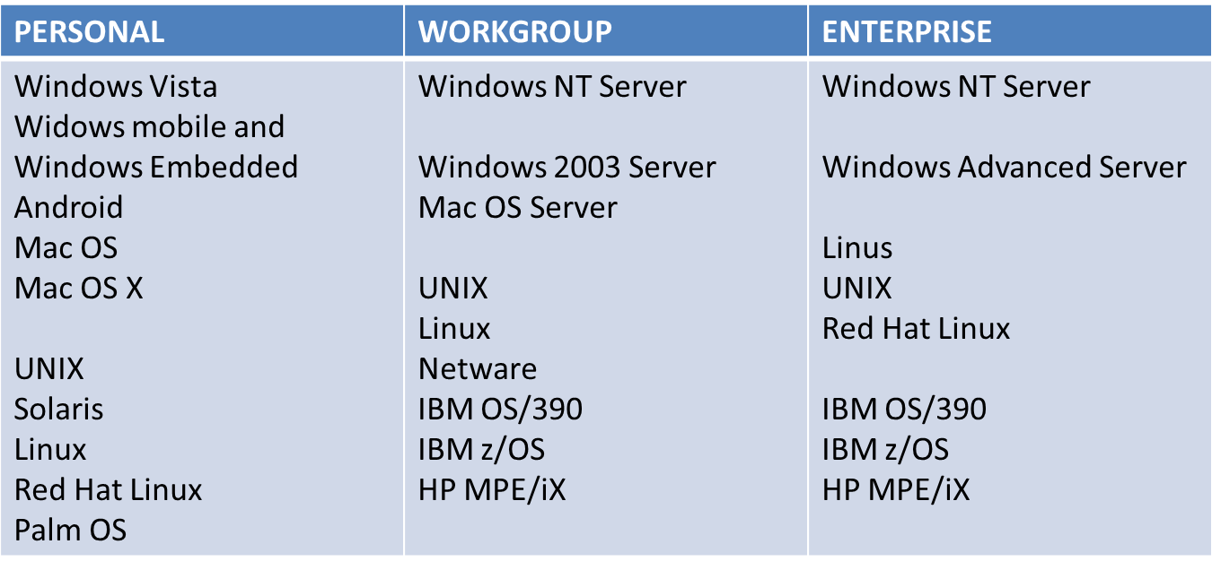
Since user demands are increasing, so is the technology being improved, so that’s why there are special purpose OS in a workgroup environment. These OS are used to run networks and perform critical business tasks. Some of the OS used on servers are mentioned in the chart. There is Windows Advanced as well, which is a 64 bit version of Windows Server family, competing with the rival Linux. It runs on Itanium processors. UNIX is used with many computer types and platforms. It also makes it easier to connect mainframe and PCs to share resources. Netware has the specific feature that any user can log in on any computer on the Network and access their familiar desktop. Red Hat is efficient at serving Web pages. Mac OS is a modern OS, which has UNIX like process management. It has the feature of pre-emptive multitasking, that is deciding how long to allocate processor to any one task, so each task gets right amount of CPU time for optimal efficiency.
At the enterprise level, almost the same kinds of OS are being used as in the Workgroup level. With the addition of specialized OS like IBM z/OS, which are IBM’s z-series Operating System( ‘z’ meaning zero downtime. These OS have the functionality to provide the mainframes with improved workload management and advanced e-commerce security. They can also allow the mainframe to be divided into smaller servers, so separate applications can be run on them. There is MPE/iX, which is an Internet enabled OS for the HP e3000 series, used for handling variety of business tasks. HP-UX is also used at the enterprise level, again used for internet applications, databases, business applications and it is available in 4 versions. So, in short, OS for mainframes have added functionality for handling business related tasks and applications.
- Embedded Operating Systems

Certain OS are embedded into the devices. Some OS are developed for special purpose devices e.g. computers on the space shuttle. A few of the examples are as follows
- Windows CE: Also called Windows Embedded. It is a scaled down version of Windows OS embedded in small computer devices such as POS terminals, computerised sewing machine, controller devices in industry etc.
- Windows Mobile: It is used in PDAs and smartphones and allows functionality of e-mail and browsing. It also includes the Personal Information Manager functions.
- BlackBerry
- Symbian OS: It is an open source multi-tasking OS that uses Bluetooth technology.
- Google Android
- iPhone OS

- Utility Programs

Utility Programs are there to help users to perform maintenance with a computer system. Some utility programs are part of the OS and some are stand alone programs that’s are separately installed.
- Hardware Utilities: Disk Scanner, Disk defragmenter, Diagnostic Utility
- Virus Detection and Recovery Utilities
- File compression Utilities
- Pop up blocker utilities

Work group Utilities enhance the performance of the servers and mainframes. Some of the prominent utilities are:
- Software to provide reports of workgroup activities
- Managing uninterrupted power supply to do controlled shut down
- Reporting unsuccessful user logon attempts
Enterprise level utilities include:
- Archiving contents of database
- Comparing contents of one file with another
- Reporting status of computer jobs

Application Software

Most of the jobs and activities in an organization can be handled by application software. Software can be categorized on the basis of how you get them. There are two types
- Proprietary software: one of a kind program for specific application in an organization, built either in house or outsourced. This software is exclusively owned by that organization and not public domain.
- Off the shelf software: acquiring an existing software program from common vendors or downloading from Internet.
There are certain advantages and disadvantages associated with both these types. Proprietary software takes a lot of time and money to be built and should be only be used when the organization wants to achieve competitive advantage. These are also discussed in Chapter 13. However there can be certain software that can be bought but modified to suit the organizational goals. These are discussed later in the chapter.
Again, these software are also divided into the three spheres of influence:
- Personal Application Software: made for single person use, e.g. word processing software, spread sheet software, graphical software etc.
- Workgroup Application Software: these include collaborative software like Google docs, Yahoo groups etc.
- Enterprise Application Software: these include applications used to share data throughout the organization, e.g. SAP’s ERP application.
- Mobile Application Software: these include special applications developed for smart phone uses. E.g. App stores provide them for iPhones.

Types of Application Software
- Open Source
- Freeware
- Shareware
- Public Domain

Summary
- System and application software are critical in achieving organizational goals
- Developing proprietary application software is effective only if it meets an organizational need and provide competitive advantage
- Software industry continues to undergo constant change, so users need to be aware of trends and issues

Module 2: Information Technology Infrastructure

Chapter 4: Emerging Technologies

LECTURE 9

Learning Objectives
- Discuss the current trends in computer hardware platforms
- Discuss the current trends in computer software platforms
- Identify the challenges of managing IT infrastructure and providing management solutions

Contemporary Hardware Platform
At the exponential rate that the hardware is improving as well as networking technology, this is all changing the way how businesses organize their computing resources. Here, we will be discussing 6 of the contemporary hardware trends.
- Emerging Mobile Digital Platform

Business computing will gradually move towards mobile digital platforms, which will be used as alternative to regular computing. This is because smartphones are evolving to become handheld computers including the functions such as transmission of data, surfing Web, e-mail and IM and displaying digital content. Talking about this platform not only includes blackberry and iPhone but also low-cost light weight subnotebooks called netbooks, which are used for wireless communication and Internet access; Tablet computers and Digital e-book readers. These will become primary means of business computing
Sales representatives of a medical device maker company uses smartphones to access the online CRM applications and sales data before meeting customers.
- Grid Computing

In grid computing, geographically remote computers are connected to form a single network to create a virtual supercomputer. That’s how the computational power of all computers in the grid are combined. The reason that allows bringing together these computers is the fact that most computer use CPU only 25% of the time for a certain work, so processing resources are left idle. So grid computing utilizes the idle time and resources. There are special software programs control and allocate resources in the grid (as mentioned before). Benefit is that instead of buying new hardware, the available resources can be combined for complex computing which result in: cost savings, speeds computing, agility and reduced power consumption.
- Virtualization

It is the process of presenting computing resources to the users that are accessed without restriction of geographic location or physical configuration, where the resources could be processing power, storage space, memory etc. There are two methods of achieving this: Single physical resource appears to users are actually multiple logical resources ( server or mainframes configured to run many instances of an OS) and multiple physical resources appear as a single logical resource ( as with storage area networks or grid computing). Benefits of virtualization are that:
- Computing processing and storage is handled using computer resources at remote locations
- Increase equipment utilization
- Conserving data centre space
- Conserving energy usage
- Run legacy systems on old OS on the same server
- Centralization of hardware administration

- Cloud Computing

Computer processing, storage, software and other services are obtained as a pool of virtualized resources over networks, primarily the Internet. Main characteristics of cloud computing are:
- On-demand self –service: people can obtain computing capabilities as per their need.
- Ubiquitous network access: individuals can use the standard network and internet devices to access the cloud resources.
- Location independent resource pooling: resources are pooled to serve multiple users.
- Rapid elasticity: resources can be increased or decreased according to the need.
- Measured service: charges are based on the amount of resources actually used.

Cloud computing is available as three services:

Cloud infrastructure: customers use processing, storage, networking, and other computing resources from cloud service providers to run their information systems.

Cloud platform: customers use infrastructure and programming tools hosted by the service provider to develop their own applications.

Cloud software: customers use software hosted by the vendor on the vendor’s hardware and delivered over a network. E.g. Google Apps.

The cloud can be public cloud and private cloud.

- Green Computing

Green Computing refers to practises and technologies for designing, manufacturing, and using devices to minimize impact on environment. One of the methods of doing is by reducing computer power consumption. The metrics of green computing are:
- Power Usage Effectiveness
- Data Centre Infrastructure efficiency
- Average Data Efficiency
- Autonomic Computing

The more computer systems become complex, the more difficult it becomes to manage them. Efforts are to develop systems that can configure themselves, optimize and heal themselves, also protect themselves from intruders. E.g. firewalls and virus protection that automatically detect viruses and take action against them.

Contemporary Software Platform
- Linux and Open Source Software
- Open Source Software: software produced by a community of several hundred thousands of programmers around the world. It is free, modifiable, and free to be redistributed. In fact it is produced by a huge community of programmers around the work to produce commercially acceptable high-quality software.
- Linux: operating systems based on UNIX. Linux applications are embedded in smart phones, netbooks, and consumer electronics. IBM, HP, Dell, Oracle produce Linux-compatible version of their products. They are also used in Web servers, high performance computing.
- Service Oriented Architecture

Web Service is a set of loosely coupled software components that exchange information with each other using standard web communications standards and languages. It can be used to build open-standard web-based applications for linking systems either outside the organization or inside the organization. It is based on XML language which is more powerful than HTML. It has following features:
- Perform presentation, communication and storage of data
- Provides standard format for data exchange from one process to another
- Service Oriented Architecture: set of self-contained services those communicate with one another to create a working software application. Business tasks happen by executing a series of these services. E.g. Dollar computers talks to other companies information systems using this architecture and there is no need to write new software code.
- IBM’s Websphere e-business software platform
- Microsoft's .Net platform
- How Dollar rent a Car uses Web services
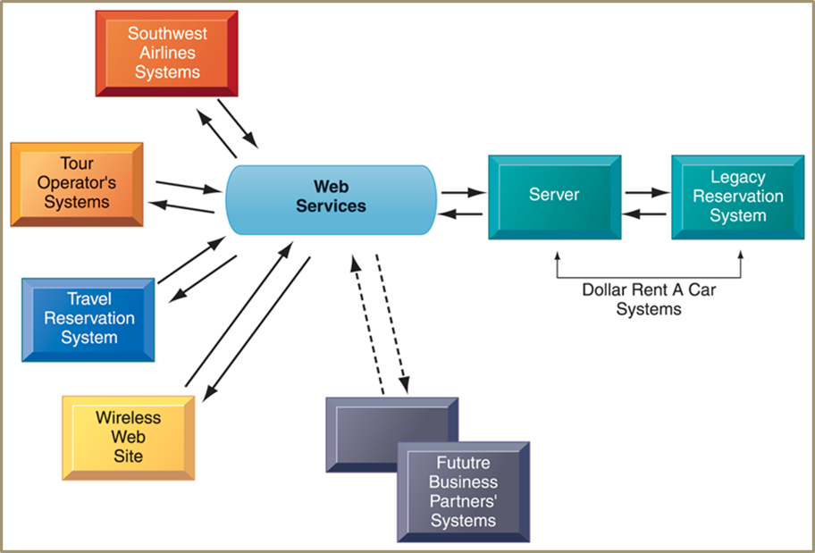
- Software Outsourcing and Cloud Services
- Software package: prewritten, commercially available, e.g. SAP
- Outsourcing: enables firms to contract custom software development to outside firms, usually off shore
- Low-level maintenance, data entry, call centre, and now new program development
- Cloud-based: software and data hosted on powerful servers and accessed through Internet and Web browser
- MS Word, Adobe Illustrator
- Enterprise software, other business function also available as a service
- Software as a Service (SaaS)
- Subscription or per transaction

Management Issues of IT infrastructure
- Platform and Infrastructure issues
- Scalability: ability of a computer, product, or system to expand to serve large number of users
- New policies, procedures or legal contracts required if changing kind of infrastructure
- Response time and availability of mission critical systems
- Management and Governance
- Who controls the IT infrastructure?
- How will infrastructure costs be allocated among business units?
- Making Wise Investments
- How much should be spent?
- Cloud computing low-cost and flexible but issue of security and work flow

Competitive Forces Model

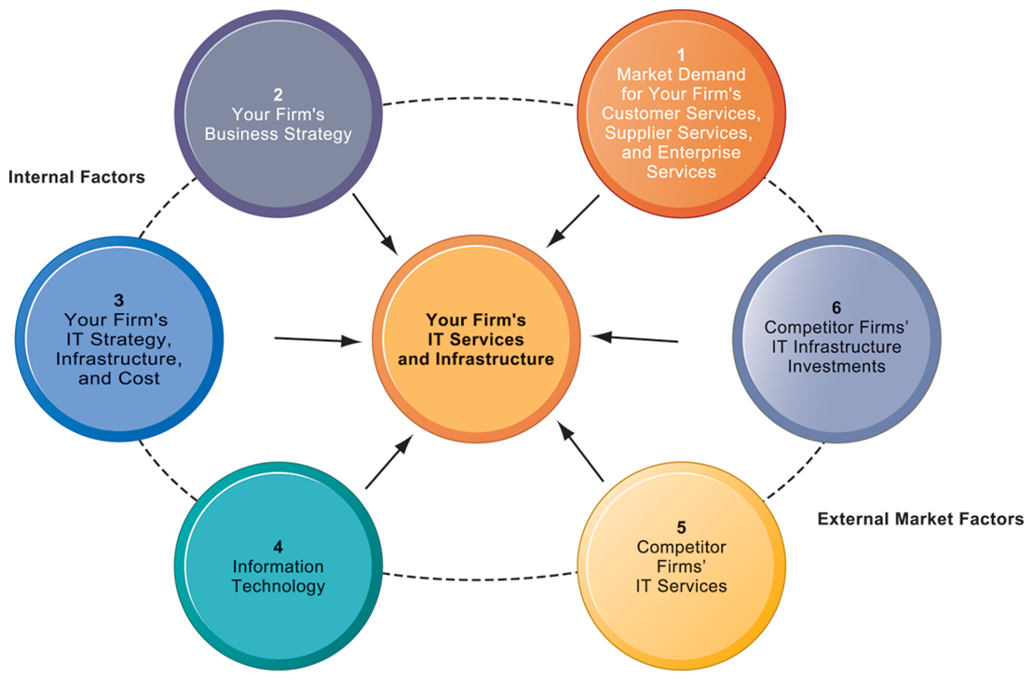

IT infrastructure is an important investment for the organizations. However, how much should be invested on IT infrastructure and whether it should be rented or purchased is not an easy decision. Total Cost of Ownership (TCO) can be used to analyse the costs. Along with that Competitive Forces Model (CFM) can be used to address the question of how much needs to be spent. CFM consists of the following 6 phases:
Phase 1: Are the current services meeting the customer demands? Make inventory of what services are being provided to customers, suppliers and employees and not down the complains if any.
Phase 2: Analyze the organizations five year business strategy to assess what new services will be provided.
Phase 3: Analyze IT plans for five years and assess alignment with the business strategy. Determine the total IT cost doing the TCO analysis.
Phase 4: Assess if the organization is ahead or behind in the current IT trends. It is suggested to spend on the technology that is not very new and has standards developed.
Phase 5: analyse what are the competitors offering in technology, compare with your organization and look for ways to excel.
Phase 6: Benchmarking the IT infrastructure expenditures since many companies are public about their expenditures in IT.

Case Study: SalesForce.com: Cloud Services Go Mainstream

(Laudon2012, Chapter 5, page: 203,204,205)
Salient points from the case study are as follows.
- Company: SalesForce.com
- Provides CRM and other application software solutions as ‘software as a service’
- On-demand model
- Eliminates need for hardware/software investments
- Very low subscription rate
- No OS, database servers, application servers to install
- No expensive licensing and maintenance fees
- Challenges
- Increased competition
- Security and reliability
- Need to expand business model
- Constant availability
- Company providing additional functionality
- Partnership with Google App
- Partnership with Apple
- Integration with Facebook
- Service improvement
- SaaS to Platform as a Service
- Intensified efforts
- Sales Cloud, Service Cloud, Custom Cloud
- Force.com application development platform
- Customise CRM application or built new one and run them in the cloud
- AppExchange: for small businesses

Questions of the case study.

Question 1: Using Cloud Computing
- SaaS on-demand model

Question 2: Challenges and meeting challenges
- Partnerships and integration
- Providing broader cloud computing ‘platform’
- Providing tools to assure customers about system reliability
- Offer PC applications so that users can work offline as well

Question 3: Factors to use SalesForce.com
- Availability
- Reliability
- Security
- Long term costs and subscription costs
- Customization

Summary
- Current trends in Computer Hardware platforms
- Current Trends in Computer software platforms
- Challenges of managing IT infrastructure and management solutions

Module 2: Information Technology Infrastructure

Chapter 5: Databases and Information Management

LECTURE 10

Why Learn About Database Systems, Data Centres and Business Intelligence?
To understand the importance of databases in businesses we need to understand where does day go and how is it used? How can it help in the job? For example, for a marketing manager, he can access the huge amount of data easily about potential customers, from surveys, web habits and past purchases and then sell products to the potential customers.
Like other components of IS, databases also help organizations achieve goals. Managers need accurate, timely and relevant information, and in most cases, they don’t get such information. That’s why databases are used to provide accurate (without errors), timely and relevant (the right information to right people), so this means they are essential for information management and decision making. Throughout this chapter we’re going to look at the two following points:
- What role do databases play in overall effectiveness of Information Systems?
- What techniques do businesses use to maximize the value of the information provided from database?

Learning Objectives
- Define general data management concepts and terms
- Identify the advantages of database approach and describe relational database model
- Identify the role and functions of DBMS
- Identify current database applications
- Identify the role of Business Intelligence

Data Management

Hierarchy of data

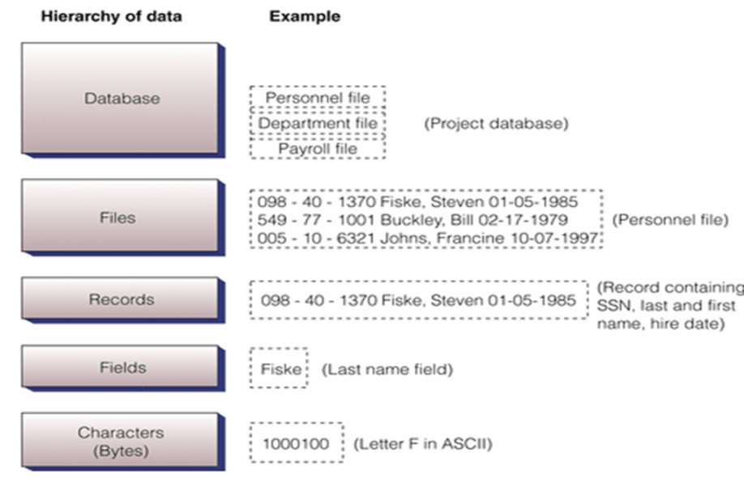

Building blocks of hierarchy are as follows:
- bit (the smallest unit of data) has only two values - 1 or 0
- bytes - 8 bits make up one byte, which represents one character like the letter A
- field (or in a database attribute), represents a combination of bytes that make up one aspect of a business object (i.e. last name, invoice number, age)
- record - a collection of related data fields (i.e. name/address/phone information for one student)
- file (or in a database an entity) - a collection of related records (all students in MIS213)
- database - a group of similar items (all students and faculty in Cameron School of Business)

TRADITIONAL (File Based ) approach to data management
Usually in file based systems, organizations tend to encourage each functional department to have its own applications programs. These in turn require own set of files and data to work on. E.g. HR dept. can have its own set of files, as known in the diagram below. These result in various problems.

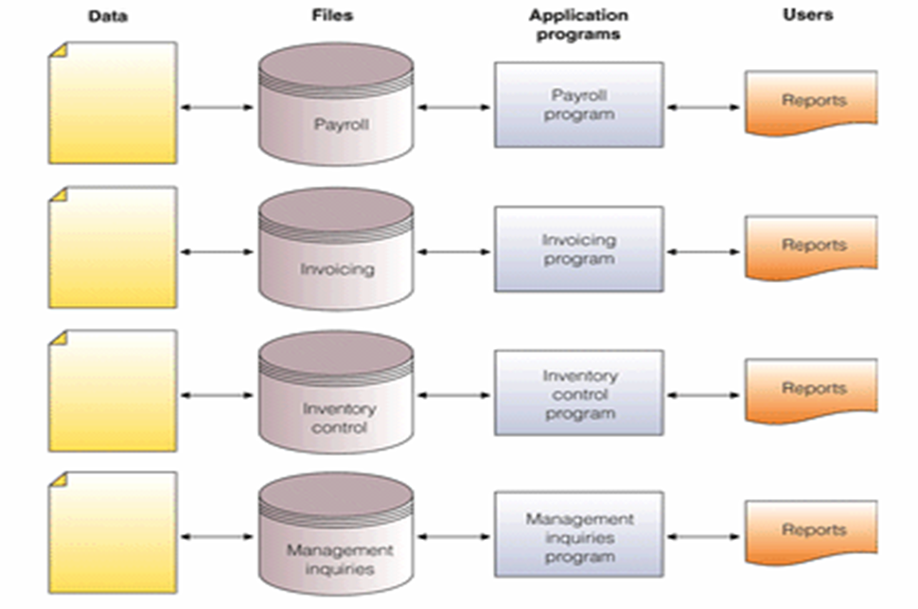

PROBLEMS
- Data Redundancy
- Duplication of data, same data is stored in multiple locations
- Data inconsistency, same attributed have different names or values
- Updating problems
- Program Data Dependence
- Changes in program require changes in data
- Lack of Flexibility
- Difficult and expensive process to retrieve ad-hoc reports
- Lack of Sharing
- Because data is located in different files and different departments, difficult to be shared and accessed in timely manner

DATABASE Approach
With database approach, data integrity maintained. Data integrity mean should be accurate, complete and consistent, so data remains intact. This is also maintained through error checking methods and validation procedures. So basically, databases solve the problems of file-based systems. They do so with the help of a database management system, which manages a combined database of files related to different departments.

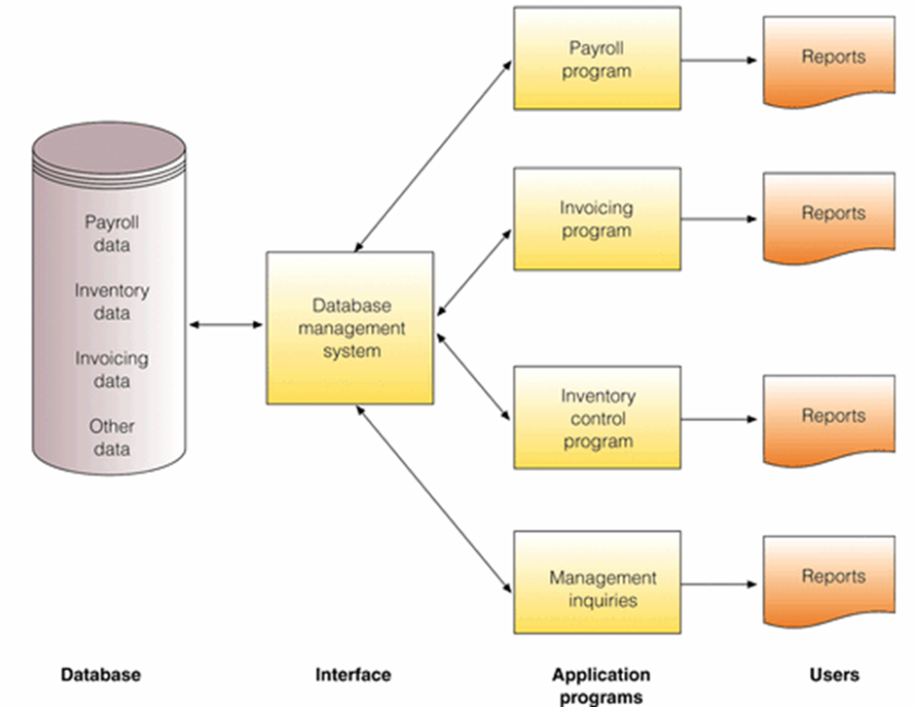

- Database
- Organized collection of data, or a collection of related files containing records
- Entity
- Generalized class of people, places or things (objects) for which data is collected, stored and maintained
- E.g. SUPPLIER, PRODUCT
- Attribute
- Specific characteristics of each entity
- E.g. SUPPLIER: Name, address
- PRODUCT: Product ID, Product Price
- Database Management System (DBMS)

Advantages of Database Approach

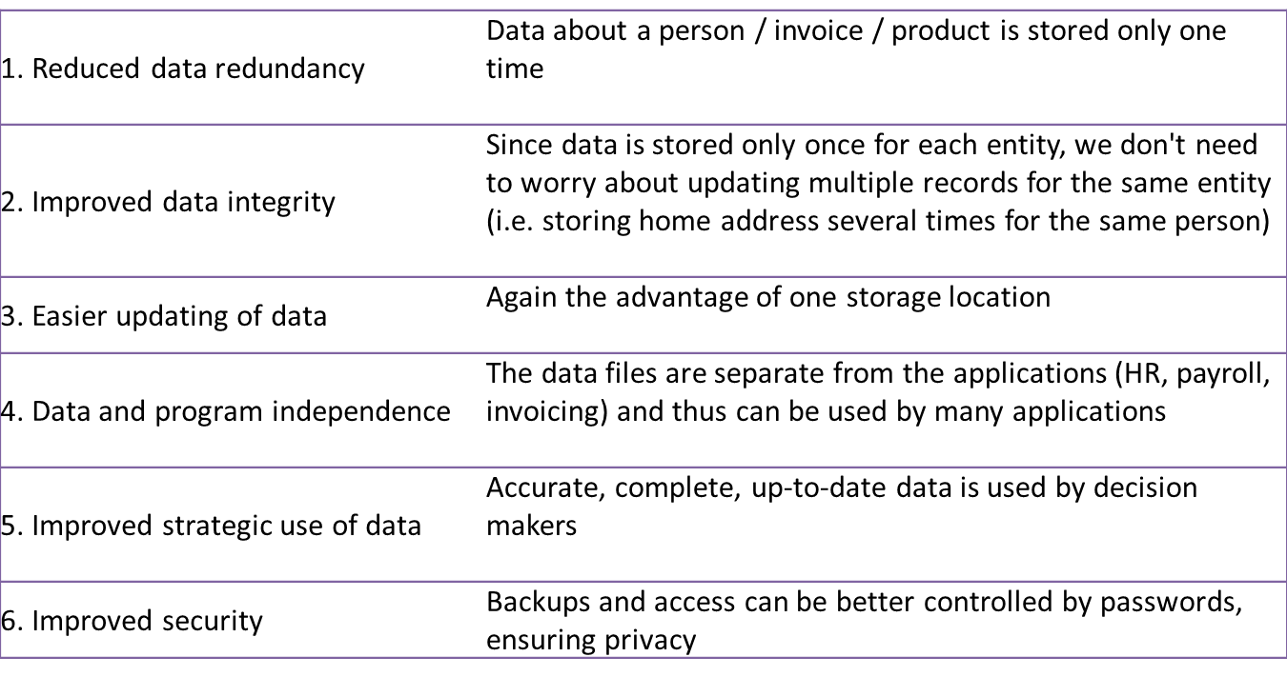
- Some more advantages of Database Approach
- Standardization of data access
- Shared data and information resources
- Disadvantages
- More complex: DBMS could be difficult to set up and operate
- More expensive: More expensive to purchase, additional personnel and additional hardware required
- Difficult to recover from failure: Failure in DBMS shuts down entire database

Data Modeling

When building a database, following must be considered:
- Content: What data should be collected and at what cost?
- Access: What data should be provided to which users and when?
- Logical Structure: How should data be arranged?
- Physical Organization: Where should data be physically located?
- Logical Design

It is the abstract model of how data should be structured and arranged. For his you use a technique called Data Model which is a diagram of entities and their relationships
- Physical Design

It is used to fine tunes logical design for performance and cost (improved response time, reduce storage space).
- Entity Relationship Diagram

In ER diagram, we use basic graphical symbols to show the organization and relation between the data, that what are the entities and what is their relationship with one another.
- One to one
- One to many
- Many to many

As in the figure below shows a one to many relationship between a Supplier and Product. That is Supplier may provide many products, but a certain product is supplied by one supplier.


Relational Database Model

The Relational Database

It is the kind of database in which data is organized into two-dimensional tables (relations) distinguished as columns and rows. One table corresponds to one entity or object. Fields (columns) store data representing an attribute and rows store data for separate records.
- Key field: identifies a record
- Primary Key: A field that uniquely identifies a set of records, cannot be duplicated and distinguishes records
- Domain is the allowable values for these attributes. E.g. attribute for pay does not include negative numbers
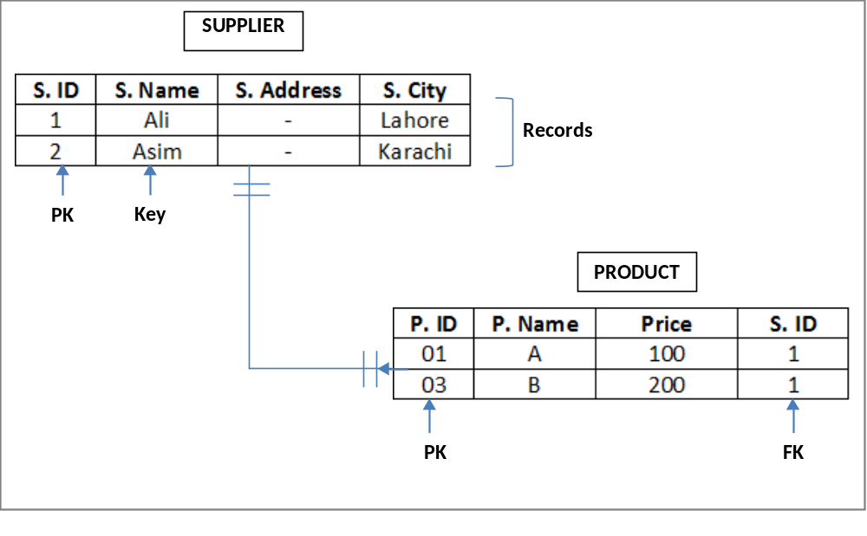
We will follow the same example of SUPPLIER and PRODUCT here, to explain the relational database of these two entities. In the SUPPLIER table, we have the attributes as: Supplier name, supplier address, supplier city and supplier ID as S.ID. Where this S.ID is the primary key for the SUPPLIER. Supplier Name might just be the ‘key’ field, as it could identify the supplier but it can be duplicated. We have added two ‘records’ in that table. Then we define the PRODUCT table, which has the fields Product ID as P.ID, Product Name and Price. Again P.ID is the primary key in this table as it uniquely identifies each record in the PRODUCT table.
Now we come to defining a relationship between tables. So, SUPPLIER and PRODUCT have a one-to-many relationship. To represent this relationship in tables, or link them, we add another field on the PRODUCT side, which is a ‘foreign key’. So, S.ID becomes the foreign key for the PRODUCT . It can be duplicated because one supplier could provide many products.
- The Relational Database Model

The relational database model allows the Manipulating Data for the purpose of inquiries and analyzing data, i.e. how is the data going to be used in this relational database.. There are following three techniques for doing so:
- Selecting: eliminating rows according to certain criteria

e.g. in the PROJECT table, suppose the president of the company wants to find the department no. for the project 226. So, with selection he can eliminate the unwanted rows and show that the project 226 belongs to dept. no. 003.
- Projecting: eliminating columns in a table. E.g. from the DEPARTMENT table, suppose the manager wants to information about the Dept. No. and SSN only, so the query can be made in such a way that only project those columns and eliminates the Dept. Name column.
- Joining; combining two or more tables. E.g. PROJECT and DEPARTMENT table can be combined to create another table with Project No., Description, Dept. No., Dept. Name and SSN.

As long as tables share at least one common attribute, tables in a relational database can be linked to provide useful information and reports. Suppose the president wants to find out the name of the manager of project 226 and his hire date. Now since these tables have a one to many relationships, and they are linked with foreign keys, the DBMS, first looks are PROJECT table, looks at the Dept. No., corresponding to project 226. Then searches DEPARTMENT to look at the SSN corresponding to the Dept. No. Then it looks in the MANAGER table and brings out the Name and Hire date corresponding to the SSN of manager.

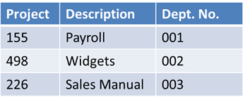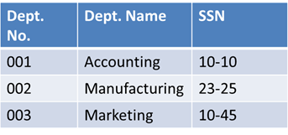

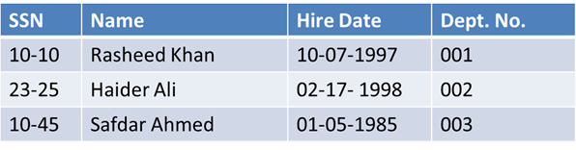

Another feature of this type of database is Data Cleanup is to develop data with the characteristics so that it can produce valuable information. As mentioned before valuable information is: accurate, complete, reliable, economical, flexible, relevant, simple, timely, verifiable, accessible and secure. For example, consider the following information added into the table for a fitness centre. It is creating problems in identifying the phone numbers of two Thomas, S. The problem can be solved by Data Cleansing, which is dividing the table, creating primary keys, and linking tables through foreign key.

LECTURE 11

Database Management Systems (DBMS)

DBMS is a group of programs used as an interface between a database and application programs/users, used to create, implement, use and update a database. It makes the physical database available for different logical views required by users. There can be different types of databases:

Single User DBMS

These are databases for personal computer and that are meant for single users. Examples: MS Access, FileMaker Pro, Microsoft InfoPath (inbuilt form making functionality)

Multiuser DBMS

These are used by large mainframe computers. These are powerful, expensive; allow hundreds of people to access. Examples: Oracle, Sybase, DB2 by IBM, Teradata database

.

Capabilities of Database Management Systems (DBMS)

DBMS corresponds to the kind of database being used. Object oriented database will have an Object oriented DBMS. All kinds DBMS have capabilities and tools for organizing, managing and accessing the data in the database.
- Data Definition language (DDL)

It is a collection of instructions and commands used to define and describe data and relations in a specific database, so it will define the data and relation between objects. So, basically used to define schema (description). It describes logical access paths and logical records in the database. For example when we use Structured Query Language (SQL), the commands would be CREATE, DROP, and ALTER for creating, deleting and modifying the table. As shown in the figure below, the command creates a table with certain fields and data types.

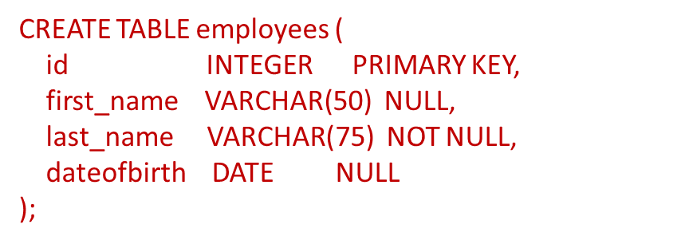

- Data Dictionary

A data dictionary is a detailed description of all data used in the database. It stores not only the name of data item , but also the range of values used, type of data, amount of storage needed, notation of person who updated it, users who can access it, list of reports that use data item.

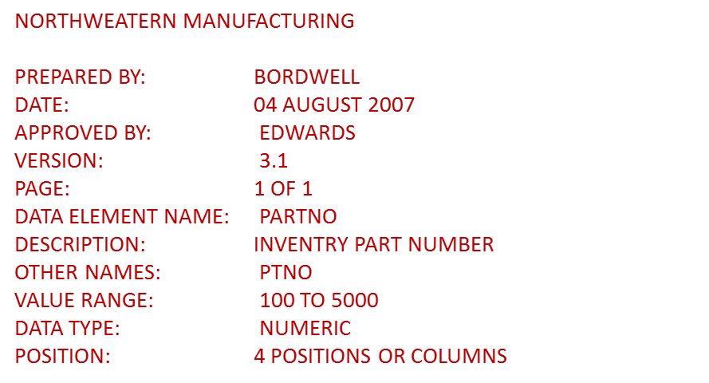

- Data Manipulation Language

Next functionality if the Data Manipulation Language (DML) that specific language used to access, modify, and make queries (request for specific data) from the database. For example: Storing, Retrieving, Manipulating data and generating reports. The querying can be done in two ways:

Query By Example (QBE)
- Visual approach to developing database queries
- GUI to retrieve data
- MS Access

Structured Query Language (SQL)
- Integral part of relational databases
- Consists of special keywords and rules
- Also includes built-in functions such as: AVG, MAX, MIN

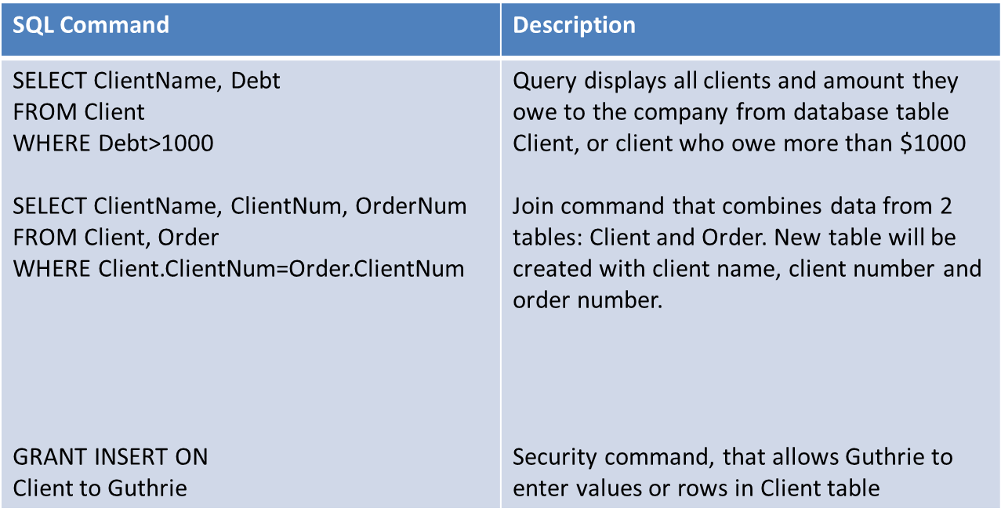

(Demonstration of MS access is shown in the recording of the lecture)

Database Administration

Database systems require a skilled Database Administrator (DBA). A DBA is expected to have clear understanding of the fundamental business of organizations, be proficient in the use of selected DBMS and stay ahead of emerging technologies and new design approaches. The role of the DBA is to plan, design, create, operate, secure, monitor, and maintain databases. He works with users and programmers to decide the content of the database and build applications respectively. He is also responsible for defining and implementing consistent principles for a variety of data issues.

Database Applications

Today’s Database Applications manipulate content of a database to produce useful information. Common manipulations include searching, filtering, synthesizing, and assimilating the data contained in a database using a number of database applications.

Businesses use databases, not only for keeping track of employee and customer records, but also to make better decisions and run operations effectively. Also for strategic business intelligence and online processing. Some of these Applications care:
- Data warehouse
- Data mining
- Business intelligence
- Web mining and text mining

- Data Warehouse

A Data Warehouse is a database that stores current and historical data of potential interest to decision makers throughout the company. The data is gathered from various operational transaction system, including website transactions and then later consolidates the information from different locations and makes them available for analysis and decisions. A Data Warehouse provides range of standardized query tools, analytical tools and graphical reporting facilities. This means that these are very large databases containing millions of data records, which are updated constantly as well. The primary advantage of a data warehouse is the ability to relate data in innovative ways. However, it can be extremely difficult to establish, with expensive costs.

- Data Mart

Data Mart on the other hand, is a subset of data warehouse. Data Mart contains summarized or highly focused portion of data about a specific functional area e.g. fiancé, inventory or personnel or marketing/sales data to deal with customer information only. In fact, specific area in the data mart might contain more detailed data than a data ware house might provide. Therefore Data marts are useful for smaller groups who want to access detailed data. That means they put targeted business information into the hands of more decision makers. Another advantage is that they can be constructed more rapidly and requires less powerful hardware as well as lower cost.

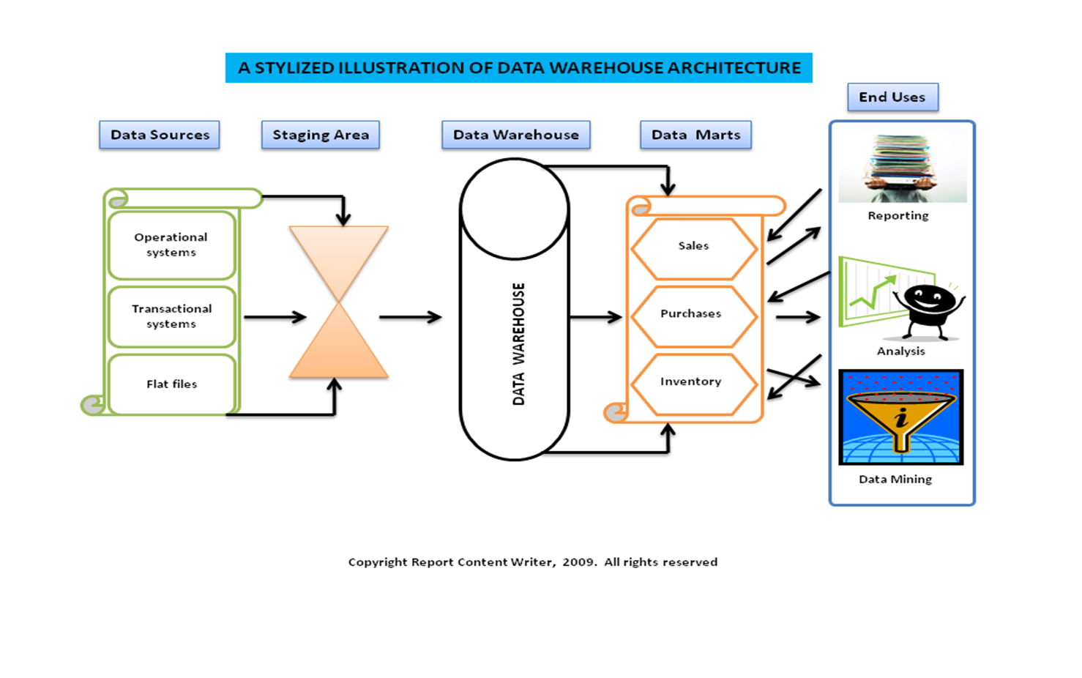

LECTURE 12

Learning Objectives
- Define general data management concepts and terms
- Identify the advantages of database approach and describe relational database model
- Identify the role and functions of DBMS
- Identify current database applications
- Identify the role of Business Intelligence

Database Applications

- Business Intelligence

Business Intelligence involves gathering enough of the right information in a timely manner and usable form and analyzing it so that it can have a positive effect on business strategy, tactics or operations.

Competitive intelligence is one aspect of business intelligence and it is limited to information about competitors and the ways that knowledge effects strategy, tactics and operations. It is beneficial for responding to changing marketplace.

Tools for Business Intelligence include:
- Software for database querying and reporting
- Multidimensional data analysis (OLAP)
- Tools for data mining

Data Mining

It provides insight into corporate data that cannot be obtained with OLAP . This method is used to find hidden patterns and relationships in large databases by inferring rule. Type of information retrieved is: association, sequences, classifications, clusters, forecasts. It has an extensive use in marketing to improve customer retention and cross-selling opportunities, campaign management as well as one-to-one marketing. Predictive Analysis: combines historic data with assumptions about future conditions to predict outcome of events such as future product sales or such probabilities. Used to find new market segments that could be profitable. Vendors like Oracle, Sybase etc. incorporate data mining functionality into their DBMS.

Online Analytical Processing (OLAP)

OLAP systems are used to answer question such as: how many washers sold in each of your sales regions and compare actual results with projected sales? It supports multidimensional data analysis, so users can use same data in different ways/dimensions (product, pricing, region, time period) for better analysis That’s why they are used with data warehouses for storing and delivering warehouse information efficiently. It also enables users to obtain online answers to ad-hoc questions.

Some of the differences between OLAP and Data mining are given in the table below.
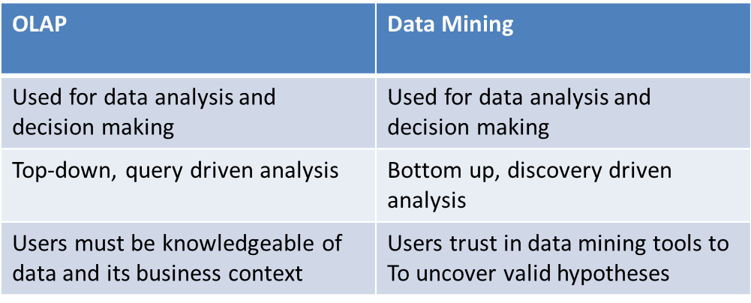

Text Mining and Web Mining

Even though BI tools deal with structured data since that is important, but unstructured data accounts for 80% of firm’s useful information. This kind of data includes: E-mails, memos, survey responses, legal cases, service reports are also valuable. Methods of analysing unstructured data are: Text mining and web mining.

Text Mining tools help businesses analyze this data
- Extract key elements from unstructured data set
- Discover patterns and relationships
- Summarize the information

Web Mining tools help in discovery and analysis of useful patterns and info from WWW
- Understanding customer behaviour
- Evaluating effectiveness of customer website
- Quantify success of marketing campaign
- There are three types: Content Mining (deals with content on the web page), Structure Mining (deals with the links on the web page), Usage Mining ( deals with how users interact on that web page)

Database and the Web

Firms use the web to make information from their internal databases available to customers and partners. Middleware and other software make this possible.
- Web server
- Application server or CGI
- Database Server

Advantages
- Web browser software easier to use than query tools
- Web interfaces require few or no change to internal databases
- Less costly

For example instead on sending paper catalogues to customers or clients, a supplier can provide the product information online.

Managing Data Resources

Establishing Information Policy
- Organizations rules for sharing, disseminating, acquiring, standardizing, classifying and inventorying information
- Which units share info, where info can be distributed, who can maintain and update it
- Data administration in large organizations is responsible for defining policies and procedures for managing organizational resources
- Database administration: design and management group performs the following functions:
- Establishing physical database
- Logical relations among elements
- Access rules and security procedures

Ensuring Data Quality
- Poor data quality is major obstacle to successful customer relationship management
- Data Quality problems
- Redundant and inconsistent data produced by multiple systems
- Data input errors
- Data Quality Audit: structured survey of accuracy and completeness of data
- Data cleansing: detects and corrects incorrect, incomplete, improperly formatted and redundant data

Case Study: What can businesses learn from Text Mining?

(Laudon2012, Chapter 6, page: 227, 228)
- Text Mining
- Discovery of patterns and relationships from large sets of unstructured data
- Mobile digital platform has amplified the explosion in digital info
- Consumer collaboration and sharing offers insights into customer behaviour and attitudes
- Problem with JetBlue
- Receiving large volume of e-mails, no simple way to read everything
- Used text analysis tools to identify facts, opinions, requests from text of survey responses, e-mails, blog entries, news article etc.
- Used it with another tool: classifying customers into groups
- Clarabridge text analytics solution
- Delivered as software service
- Challenges of unstructured data
- Lots of digital information generated that has no distinct form
- Difficult to analyze if there are loads of e-mails (with customer sentiments, preferences, requests etc.)
- Analyzing customer surveys takes weeks
- Use slow manual approaches
- Improving decision making
- Spot and address problems quickly
- Identify facts, opinions, trends etc. to act quickly on customer demands
- Categorizing comments to reveal less obvious insights
- Also used to make building improvements
- Kind of Businesses
- Airlines
- Hotel chains
- Restaurants
- Also used by location managers

Summary

- Data Management and Data Modeling are key aspects of organizing data and information
- Relational model reduce my problems of data inconsistency, easier to control, more flexible
- DBMS produce wide variety of documents, reports, useful for orgs
- Data quality is important to be maintained
- Business Intelligence tools have positive effects on business strategy

Module 2: Information Technology Infrastructure

Chapter 6: Telecommunications, Internet and Wireless Technology

LECTURE 13

Learning Objectives
- Identify the telecommunication media and hardware required for transmission
- Identify the network types and key networking technologies (including protocols)
- Discuss the principle technologies and standards for wireless networking
- Describe several telecommunication applications that orgs benefit from today
- Discuss how Internet works and its support for communications and e-business

Intro to Telecommunications

Telecommunication

Refers to the electronic transmission of signals for communication

The general model of telecommunication consists of
- The sending device
- The medium
- The communication device
- The receiving unit

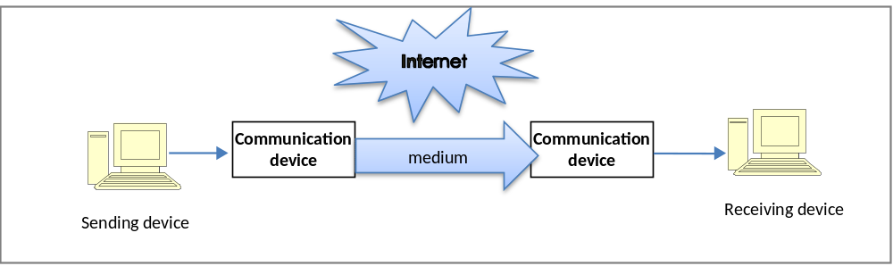

Transmission medium

Any material substance that carries an electronic signal to support communications between sending and receiving devices
- Divided into one or more communication channels
- Classified as simplex, half duplex, full duplex
- Characteristics:
- Bandwidth: rate at which data is exchanged (bps)
- Higher bandwidth, more channel transmits
- Broadband
- Latency: time it takes a signal to travel from one location to another
- Best combo: high bandwidth, low latency

- Physical transmission medium

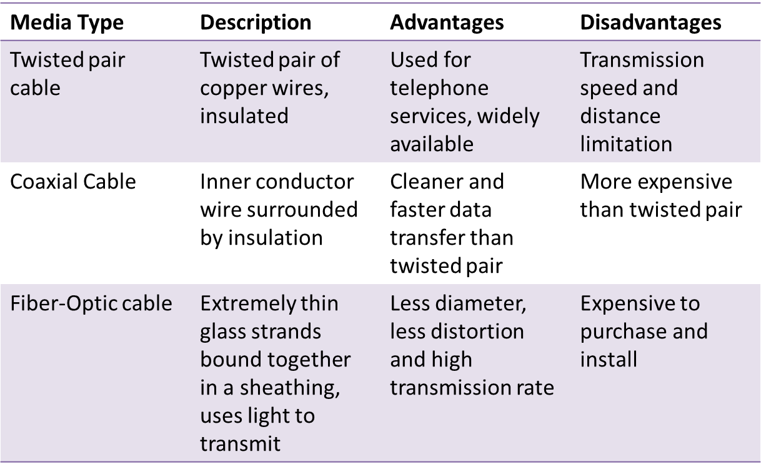
- Wireless transmission medium
- Microwave
- High frequency, high speed signal(300MHz to 300 Ghz)
- Line of sight transmission between earth based receivers
- Satellite also operates on microwave frequency
- Amplifies a signal and broadcasts it at different frequencies
- Geostationary, LEO, VSAT
- Radio
- send/receive wirelessly (30Hz to 300 Mhz)
- Infrared
- Infrared light waves
- Line of sight
- IrDA port

- Telecommunication Hardware
- Modem
- Special device that converts digital signals to analog signals (modulation) and vice versa (demodulation)
- PC modem, cable modem, DSL modem
- Hub
- Device that connect network components, sending a packet of data to all other connected devices
- Switch
- Smarter than hub, forward data to specific destination
- Network Interface Card
- Network interface device, connection medium for linking network components

- Router
- Connects multiple computers
- Transmitting packets to destination
- May have built in firewall
- WAP
- Allows transferring data wirelessly or to a wired network
- High speed antennas

Computer Network
- A network consists of two or more connected computers
- A simple network contains:
- Client computer
- Dedicated server
- Network interfaces
- Connection medium
- Network operating system
- Hub/switch

Computer Network
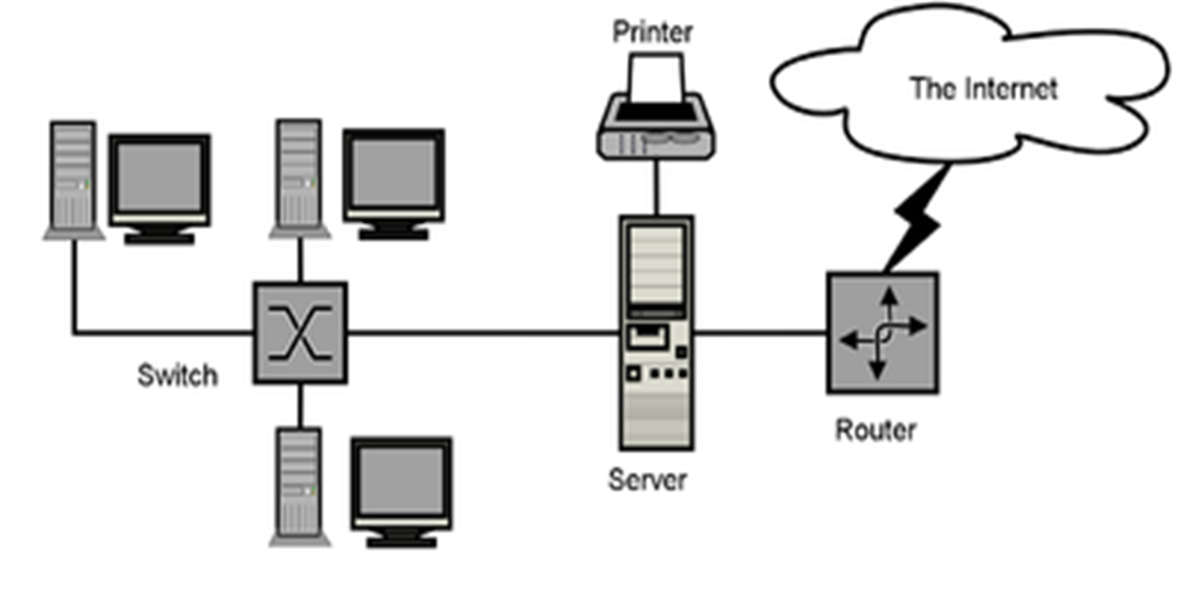

Wired Network with Hub/Switch
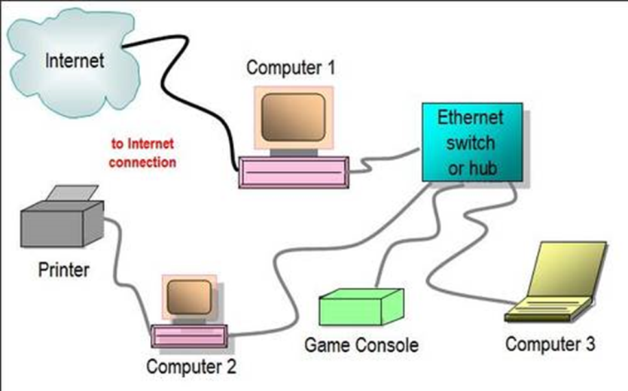

Two router Network
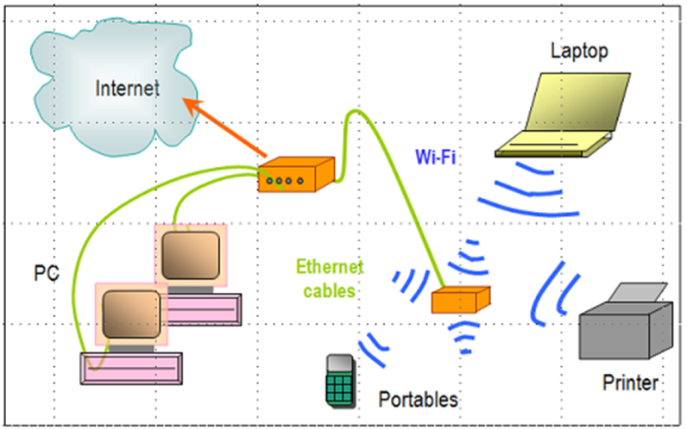

Hybrid Network
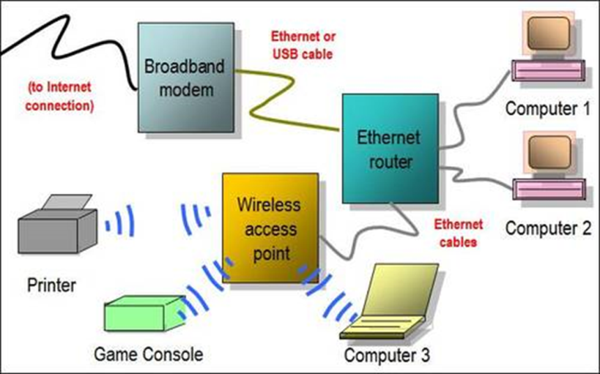

Types of Computer Networks
- Local Area Networks (LAN): connects computer systems and devices within a small area, typically they are wired into office buildings
- Computers must be equipped with the correct interface
- Client/Server architecture: One computer is dedicated network file server, providing access to resources
- Ethernet: LAN standard for physical medium (10 Mbps)
- Fast Ethernet (100Mps), Gigabit Ethernet (1 Gbps)
- Peer-to-peer architecture: used in very small networks, different computers can exchange data by direct access and also peripheral devices. Useful for small businesses
- Metropolitan Area Networks (MAN): connects computers systems within a campus or a city
- Range of 30-90 miles
- Wide Area Networks (WAN):International Networks: connects large geographical regions
- Internet – world’s largest WAN
- Mesh Networking: way to route communications among network nodes by allowing for continuous connections and reconfiguration around blocked paths
- Robust, if one node fails, others can still communicate
- Can be used to provide Internet access, secure connections to corporate networks and VoIP calls

Key Digital Networking Technologies

Client/Server computing

Distributed computing model, some processing power on client computers

Linked to network to server computers, sets rules for communication, provides every client with an address.

Packet Switching

Slicing digital messages into packets, sending them over communication paths, reassembling at destination.

Transmitted through router

TCP/IP Connectivity

Protocol: set of rules and procedures concerning transmission of information between 2 points in a network.

Now only worldwide standard Transmission Control Protocol/Internet Protocol (TCP/IP) is used with any kind of hardware for networking
- TCP: handles movement of data between computers, sequencing packets and acknowledging sending
- IP: delivery of packets and reassembling during transmission

LECTURE 14

Learning Objectives
- Identify the telecommunication media and hardware required for transmission
- Identify the network types and key networking technologies (including protocols)
- Discuss the principle technologies and standards for wireless networking
- Describe several telecommunication applications that orgs benefit from today
- Discuss how Internet works and its support for communications and e-business

Wireless Communication

Advantages:
- Helps businesses stay in touch with customers, suppliers, partners
- Provides flexible arrangements for organizing work
- Help create new products, services, sales channels
- Provide easier access to remote corporate areas

Wireless Communication Standards
- Bluetooth
- Wireless N/W standard, creates PAN
- Range: 10m, 722Kbps (2.4Ghz)
- Useful for battery powered devices (printers, Keyboard)
- FedEx: signals transmitted from handheld devices through bluetooth
- Wi-Fi (802.11)
- Standard for wireless LAN and wireless Internet access
- Range: 30-5-m, 11Mbps-54Mbps (2.4Ghz)
- Use: creating ‘hotspots’
- 802.11 n is the fastest ( 100Mbps) based on the MIMO( multiple input/multiple output)
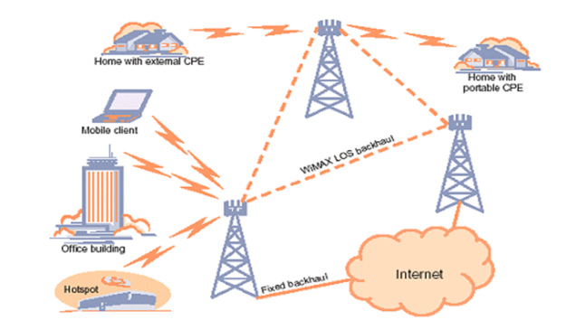
- WiMAX
- Worldwide Interoperability for Microwave Access)
- Range: 31 miles, 75Mbps
- Use: areas where difficult to install broadband or Wi-Fi
- Connectivity provided by WiMAX towers

- RFID
- Standard for radio signals to communicate with a tag
- Use: tracking movement of goods through supply chain

- RFID Tag
- embedded microchip and antenna
- Active: battery powered, send data automatically, expensive
- Passive: powered by the signals from reader, lighter, less expensive
- RFID Reader
- Reads tag, capturing the data, decodes it and send it over the network to the computer
- Reads data in its range
- Businesses need to update H/W and S/W to accommodate large data from RFID
- SAP, Oracle offer RFID-ready versions for SCM applications

Cellular Network

ITU developed standard for cellular networks to standardize and allow global roaming through cell phones.

Mobile Communication standard
- Global System for Mobile Communication (GSM) and CDMA
- GPRS (General Packet Radio Service), EDGE, EVDO (Evolution Data Optimized)
- Earlier for voice and small data
- 3G 144 Kbps to 2.4 Mbps
- Video, VoIP, graphics, rich media
- Next: 4G 100Mbps

Telecommunication and Network Applications

Important Business applications include:
- Linking Pcs to Mainframes/Servers
- Voice Mail: Send/receive store verbal messages
- Small Business Networks: Create small networks with few devices easily. Either WAP with modem or a combo device (router, firewall, hub). These also have functionality of Filtering and encryption
- Electronic Document Distribution: Send/receive digital documents which saves paper wastage and allows access faster.
- Call Centres
- Telecommuting/Virtual Workers
- Videoconferencing
- Electronic Data Interchange (EDI)
- Electronic Funds Transfer (EFT)
- Distance Learning
- Team Collaboration

Case Study: Delivering People More Efficiently Through Telecommunications

(PIS, Chapter 6, page: 285,286)

Company: Crew Transportation Industry
- Shuttling crew members to train locations where they are needed
- Problem:
- Slow to adopt telecomm technologies
- Van drivers could not communicate with dispatcher while in route
- Railway company not happy
- RailCrewXpress
- Serving railways through technology platform
- Wireless telecommunication system that connects drivers with dispatchers and company IS
- Tracks drivers, dynamic routing change, maintains history of routes and driver times
- Data is analysed to optimize the efficiency of dispatches & routing

Challenges
- Economical networking technologies
- Automatically switch between satellite and GPRS data transmission
- Intelligently decide how much info to send and when

Next milestone
- RFID scanners to be installed in vans for tracking location

Case Study: Delivering People More Efficiently Through Telecommunications
- Advantages
- Faster and efficient communication between drivers and dispatchers
- Happier railway companies, because they get accurate ETAs
- Flexibility to accept new trip orders and reroute quickly

- Real Time Monitoring
- Providing time-relevant info for quick decision-making
- View minute by minute info
- Respond quickly to changing conditions
- Analyse data for operational efficiency

LECTURE 15

Learning Objectives

- Identify the telecommunication media and hardware required for transmission
- Identify the network types and key networking technologies (including protocols)
- Discuss the principle technologies and standards for wireless networking
- Describe several telecommunication applications that orgs benefit from today
- Discuss how Internet works and its support for communications and e-business

The Internet

Extensive, public communication system

worldwide collection of networks that links billions of diverse users

World’s largest implementation of Client/Server computing

Started as ARPANET, project of DoD, U.S in 1970s
- Initial Goal: Allow scientists at different physical locations to share information and work together on military and scientific projects
- Originally 4 main computers (host)
- Now: Grown into a public , cooperative, independent network, more than 1 billion host nodes
- W3C researches and sets standards and guidelines
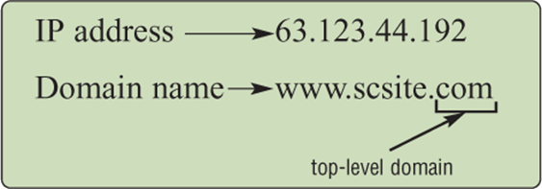

How the Internet Works
- Based on the TCP/IP networking protocol
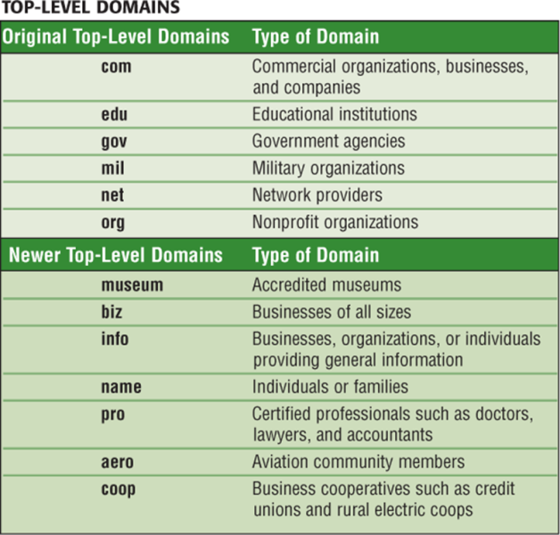
- Every computer has an Internet Address, which is a 32 bit number representing by four strings of numbers, E.g. 207.46.250.119. Domain Name is the English name that corresponds to the 32 bit number, as shown in the figure. DNS server holds the list of IP addresses mapped to their domain names. International web sites outside USA, use a two letter country code, like ‘pk’ for Pakistan.

ISPs and Internet Architecture
Internet Service Provider (ISP) is any company that provides people and organizations access to the Internet. It usually provides services over broadband internet access through DSLs, cable or satellite transmission. Some universities and businesses use the very fast T1 and T3 lines to connect to Internet

Wireless Internet Service Providers (WISP) is a company that provides wireless Internet access to computers and mobile devices

On the internet, your computer is the client that can access data, information and services from a variety of servers. Internet data traffic is carried over transcontinental high-speed Internet backbone (45Mbps to 2.5 Gbps). This backbone is usually made of Fiber optics

In addition to backbone, the internet encompasses an intricate collection of regional and local communication links (telephone lines, cable television lines etc). These lease access to ISPs and other major companies for internet connectivity.

The World Wide Web
- Developed at CERN
- Most popular Internet Service
- Consists of a worldwide collection of electronic documents, each document called a Web page
- Collection of web pages and items associated with it constitute Web site
- Web server is a computer that delivers requested Web pages to your computer
- Hypertext Transfer Language (HTML): language for formatting documents and web pages and incorporating dynamic link to other documents and pictures stored on same or remote computer

- Web Address
- a unique address of the Web page, also called a URL (Uniform Resource Locator)
- a Web browser retrieves a web page using its Web address
- Many addresses begin with HTTP – Hypertext Transfer Protocol
- HTTP is a set of rules that defines how pages transfer over the internet
- http://www.us-parks.com/grand_canyon/scenic_vistas.html

where ‘http’ is the protocol, ‘www.usparks.com’ is the domain, ‘/grand_canyon/’ is the path and ‘scenic_vistas.html’ is the web page name.

- Search Engine
- It is a program that finds Web sites, Web pages, images, videos, news and other information
- The word or phrase entered for defining your search is called a Search text or Keyword
- The results of the search are known as hits.
- bring HTML files, Microsoft Office files, PDF files, videos, images
- Search Engine Marketing
- Sponsored links for which advertisers have paid to be listed
- Fastest growing Internet advertising
- Companies optimize their sites for search engine recognition
- Search Engine Optimization (SEO): process of improving the quality & volume of web traffic to a website

Web 2.0
- Enables people to collaborate, share information, and create new services and content online
- Four features: interactivity, real-time user control, social participation and user generated content
- Mashups and Widgets
- Software services that enable users and system developers to mix and match content or software components to create something new
- Blogs
- Weblog is a personal Website that contains a series of chronological entries by the author
- Popular publishing tools, also have business uses

- RSS (Really Simple Syndication)
- Syndicates web site content so that it can be used in another setting
- Pulls specific content from Web sites and feeds it to user’s computer for later viewing
- News feeds, event listing, new stories, headlines, project updates, distributing corporate information etc.
- Wiki
- Collaborative Web sites where visitors can add, delete or modify the site, including previous author’s work
- Motorola sales reps using Wiki for sharing sales info
- Social Networking
- Build communities of friends and professional colleagues

Internet and Web Applications
- Internet Services
- E-mail: Electronic mail is service that allows transfer of messages and files via a computer network
- Chat
- Instant Messaging
- VoIP
- Voice transmission over the Internet, instead of telephone network
- Voice travels in digital form using packet switching
- Lower long distance call costs
- Newsgroups
- worldwide discussion groups posted on Internet electronic bulletin boards on which people share views on a certain topic. Groups are either moderated or unmoderated, discussion through e-mail

- Telnet and FTP
- Protocol that enables you to log on to other computers
- Accessing public files
- File Transfer Protocol, transferring files between host and remote computer
- Also uploading, downloading content to/from a web site
- Content Streaming
- Multimedia, radio broadcasts
- Watching streamed videos
- Web shopping
- Web Auctions
- Matching buyers and sellers, e.g. eBay

Summary
- Telecommunication technology lets more people send and receive all forms of data over greater distances
- EDD, EDI and EFT are useful telecomm applications that have changed the way orgs do businesses
- The internet provides a wide range of services, some practical for business use today
- However, management issues, speed and service affect all networks

Module 2: Information Technology Infrastructure

Chapter 7: Information Systems Security

LECTURE 16

Learning Objectives
- Identify the reasons for Information Systems’ vulnerabilities
- Discuss the reasons for security for business
- Discuss the different types of threats
- Identify the components of an organizational framework for security and control
- Discuss the various tools and technologies for safeguarding IS

Security and Control

Security refers to the policies, procedures, and technical measures used to prevent unauthorized access, alteration, theft or physical damage to Information Systems

Control are methods, policies, and organizational procedures that ensure that safety of the organizational assets; the accuracy and reliability or records; and operational adherence to management standards

Why Systems are Vulnerable?
- Data stored in electronic form is vulnerable
- In communication network, breach can occur at any access point
- Steal data, alter messages
- Intruders with DoS attacks disrupts Web sites operations
- Hardware breakdowns
- Bad configuring, improper installation, or unauthorized changes
- Offshore partnering also adds to system vulnerability
- Portability makes cell phones, smart phones, tablets to be easily stolen
- Apps for mobile phones can be used to malicious purposes

Internet and Wireless Security Challenges
- Internet more vulnerable than internal networks
- Widespread impact of attack
- Always-on connection have fixed address becomes fixed target
- Also most VoIP transmission is not encrypted, so susceptible to interception
- Vulnerability also increases because of e-mails, IMs and peer-to-peer(P2P) file sharing
- Wireless communication is vulnerable because radio frequency bands are easier to scan (eavesdropping)
- Hackers use wireless cards, external antenna and hacking software to intrude into WLANs
- Sniffer programs
- OS have the ability to identify the SSID of the network, and configures the NIC accordingly
- Wired Equivalent Privacy (WEP)
- Security standard
- Allows access point users to share a 40-bit encrypted password
- Stronger encryption: WPA2

Malicious Software (Malware)
- Virus
- Malicious software program that attaches itself to another program or file to be executed
- Mostly they deliver a ‘payload’, (just a message or destroys data)
- Spread from computer to computer, triggered by human actions
- Worm
- Copy themselves from computer to computer through network
- Destroy data and halt operations of computer network
- Usually come through downloaded programs, e-mail attachments
- Malware target mobile devices too, thus being a serious threat to enterprise computing
- Trojan Horse
- Looks like a legitimate program
- Does not replicate itself, but creates way for virus and other malicious code
- Based on the Greek Trojan war
- SQL injection attacks
- Malware that takes advantage of vulnerabilities in poorly coded web application software
- Enter data into online form to check for vulnerability to a SQL injection
- Spyware
- Small programs that temporarily install themselves on the computer to monitor web surfing for advertising, but they also act as malware, affecting the computer performance

Hacking and Computer Crime
- Hacking
- Accessing a computer system unauthorized
- Usually “cracker” is an individual with criminal intent
- Find weaknesses in the security features of web sites or computer systems
- CyberVandalism
- Intentional disruption, defacement of web site or corporate information
- Spoofing
- Hackers hide themselves behind fake ids
- Also involves redirecting a Web link to a fake ones that looks like the original site
- Sniffing
- Eavesdropping program that monitors information traveling over a network
- They have a legitimate use as well, but otherwise can be very lethal
- DoS Attack
- Hackers flood a network server or web server will many requests for services to crash the network
- For e-commerce sites, these attacks can be costly
- Computer Crime
- “Any violations of criminal law that involve a knowledge of computer technology for their perpetration, investigation or prosecution”
- Identity Theft
- Crime in which an imposter obtains key pieces of key personal information to impersonate someone else, eg. Credit card theft
- Phishing
- Setting up fake web sites or sending fake e-mails that look legitimate to ask users for personal data
- Pharming
- Redirects users to fake web page even when they have entered the correct web address
- Happens when ISP companies have flawed software
- Cyberterrorism
- Cyber attacks that target software that run electric power grids, air traffic control, or bank networks (on large scale)

Business Value of Security and Control
- Usually businesses don’t put much effort in security
- However, security and control is critical to businesses
- They lose 2.1% of market value if security breach happens
- Valuable and confidential info needs protection
- Inadequacy can lead to
- Legal liability
- Data exposure
- Implementation Advantages
- High return on investment
- Employee productivity
- Lower operational costs

Electronic Evidence and Computer Forensics
- Nowadays, legal cases rely on digital data stored on storage media along with e-mail and e-commerce transactions
- Effective electronic document policy
- Records organized, discarded not too soon
- Computer Forensics
- scientific collection, examination, authentication, preservation and analysis of data retrieved from storage media
- Used for court evidence
- Also includes ambient data
- Firm’s contingency planning process should have awareness of this

Case Study: When Antivirus software cripples your computers

(Laudon2012, Chapter 8, page: 304, 305)

- Company: McAfee – prominent antivirus software
- Product: AntiVirus Plus
- Problem: released an update that caused the computers to crash and failed to reboot
- Lost network capability
- Couldn’t detect USB drives
- Usually Windows XP service pack 3, McAfee VirusScan version 8.7
- Conducted investigation to figure out ‘why’ was the mistake made and ‘who’ got affected
- Result
- Users did not receive a warning that svchost.exe was going to be quarantined
- Quality assurance failed to detect the critical error
- Testing was not conducted on the mentioned operating system
- Created a “SuperDAT Remediation tool” to fix the problem

Questions: Case Study: When Antivirus software cripples your computers
- Management factors
- Did not apply proper quality assurance procedures
- Organizational factors
- Had recently changed their QA environment
- Technology factors
- The users did not receive a warning that a critical file will be quarantined
- Business Impact
- Damage an antivirus company’s reputation because people blindly trust such companies
- Customer’s businesses became non-functional and had to shut down until computers were fixed
LECTURE 17

Learning Objectives
- Identify the reasons for Information Systems’ vulnerabilities
- Discuss the reasons for security for business
- Discuss the different types of threats
- Identify the components of an organizational framework for security and control
- Discuss the various tools and technologies for safeguarding IS

Establishing Framework for Security and Control
- Information System Controls

- General Controls: govern the design, security and use of computer programs, security of data files
- Software controls, physical hardware controls, computer operations controls, data security controls, control over implementation of business processes, and administrative controls

- Application Controls: specific controls unique to each computerized application that check for data accuracy and completeness
- Input Controls: while entering data in systems
- Processing Controls: during updating
- Output Controls: results of computer processing
- Risk Assessment
- Helps to determine most cost effective set of controls
- Determines the level of risk to the firm if a specific activity or process is not properly controlled
- Value of information assets
- Points of vulnerability
- Frequency of problem
- Potential of damage
- Controls should focus on ways to minimize the risk of a certain problem if the probability of its damage is relatively greater or highest
- Power failure
- User errors
- Security Policy
- consists of statements ranking information risks, identifying acceptable security goals, and identifying the mechanisms for achieving these goals
- Disaster Recovery Planning
- Plans for restoration of computing and communication services after they have been disrupted, especially technical issues
- Business Continuity Planning
- Focuses on how the company can restore business operations after a disaster strikes
- Identifies critical business processes
- Determines plans to handle such processes
- MIS Auditing
- How does management know that IS security and controls are effective?
- Examines the firms overall security environment as well as controls governing individual IS
- Review technologies, procedures, documentation, training and personnel
- Also simulate attacks

Tools And Technologies for protecting IS
- Identity Management and Authentication
- Automating the process of keeping track of all these users and their system privileges
- Authentication is the ability to know that a person is who he/she claims to be
- Using passwords: log on to computers
- Tokens: device designed to prove identity, display passcodes that frequently change
- Smart card: size of a credit card
- Biometric authentication: systems that read and interpret individual human traits that are unique e.g. fingerprints, facial features, retinal image against stored profile.
- Firewall
- Prevents unauthorized users from accessing private networks. A firewall is a combination of hardware & software that controls the flow of incoming and outgoing network traffic
- Checks names, IP addresses, applications
- Placed in between private networks and external network
- Intrusion Detection Systems
- Provides security against suspicious network traffic and unauthorized access attempts
- Feature full-time monitoring tools placed at most vulnerable points to detect and deter intruders
- Antivirus and Antispyware software
- Designed to check computer systems and drives for computer viruses
- Effective only against viruses already known, so updating antivirus software is necessary
- Available for PCs, mobile devices, servers
- Securing Wireless Networks
- WEP
- Assign unique name to networks SSID and instruct router not to broadcast it
- WPA2
- stronger security standards, longer keys that continually change
- Encryption
- Process of transforming plain text or data into ciper text that cannot be read by anyone other than the sender and the intended receiver
- Uses secret numeric code called encryption key
- Two protocols SSL and S-HTTP
- Public key encryption: uses two set of keys, one public and one private
- Public Key Infrastructure (PKI) now widely used in e-commerce
- Ensuring System Availability
- companies rely on digital networks
- Especially when working with online transaction processing
- Fault Tolerant computer systems contain redundant hardware, software, and power supply components, providing continuous, uninterrupted service
- Used to minimize downtime
- Security Outsourcing
- Outsourcing many security functions to managed security service providers (MSSPs) that monitor network activity and perform vulnerability testing
- Security in the Cloud
- Accountability and responsibility for protection of sensitive data still reside with the company
- Cloud providers store and secure data according to corporate requirements
- Companies ask for proof of encryption from cloud providers
- Also ask if cloud providers submit to external audits and security certifications
- Securing Mobile Platforms
- Make sure company security policy includes mobile devices and their protection
- Develop guidelines with approved mobile platform and applications
- Ensure smartphone are up to date with latest security patches and antivirus

Case Study: When Antivirus software cripples your computers
- Company: McAfee – prominent antivirus software
- Product: AntiVirus Plus
- Problem: released an update that caused the computers to crash and failed to reboot
- Lost network capability
- Couldn’t detect USB drives
- Usually Windows XP service pack 3, McAfee VirusScan version 8.7
- Conducted investigation to figure out ‘why’ was the mistake made and ‘who’ got affected

Case Study: When Antivirus software cripples your computers
- Result
- Users did not receive a warning that svchost.exe was going to be quarantined
- Quality assurance failed to detect the critical error
- Testing was not conducted on the mentioned operating system
- Created a “SuperDAT Remediation tool” to fix the problem

Questions: Case Study: When Antivirus software cripples your computers
- Management factors
- Did not apply proper quality assurance procedures
- Organizational factors
- Had recently changed their QA environment
- Technology factors
- The users did not receive a warning that a critical file will be quarantined
- Business Impact
- Damage an antivirus company’s reputation because people blindly trust such companies
- Customer’s businesses became non-functional and had to shut down until computers were fixed

Summary
- Digital data are vulnerable to destruction, misuse, error and fraud, also hardware and software failures
- Situation is aggravated when systems are connected to Internet or wireless mediums
- Lack of sound security and control can cause firms relying on computer systems lose sales and productivity
- Companies need to have good general and application controls including security policy
- Different tools and technologies available to provide security to systems

Module 3: Business Information Systems

Chapter 8: Electronic and Mobile Commerce

LECTURE 18

Learning Objectives
- Discuss what makes e-commerce popular and unique
- Discuss the types of e-commerce
- Identify the different e-commerce business models
- Identify the e-commerce revenue models
- Discuss m-commerce and its use
- Discuss web site creation as the tool for effective e-commerce

E-commerce and its Features
- Use of the Internet and the Web to transact business
- Distribution, buying, selling, marketing, services

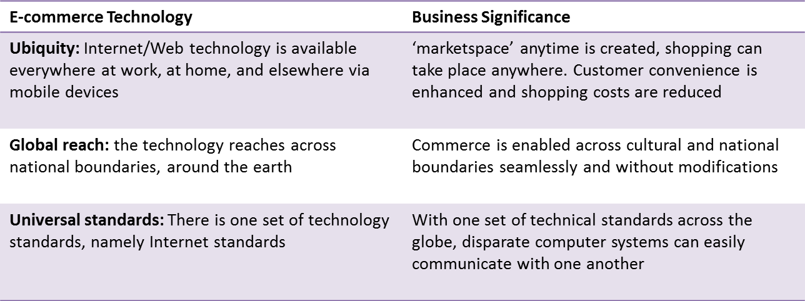
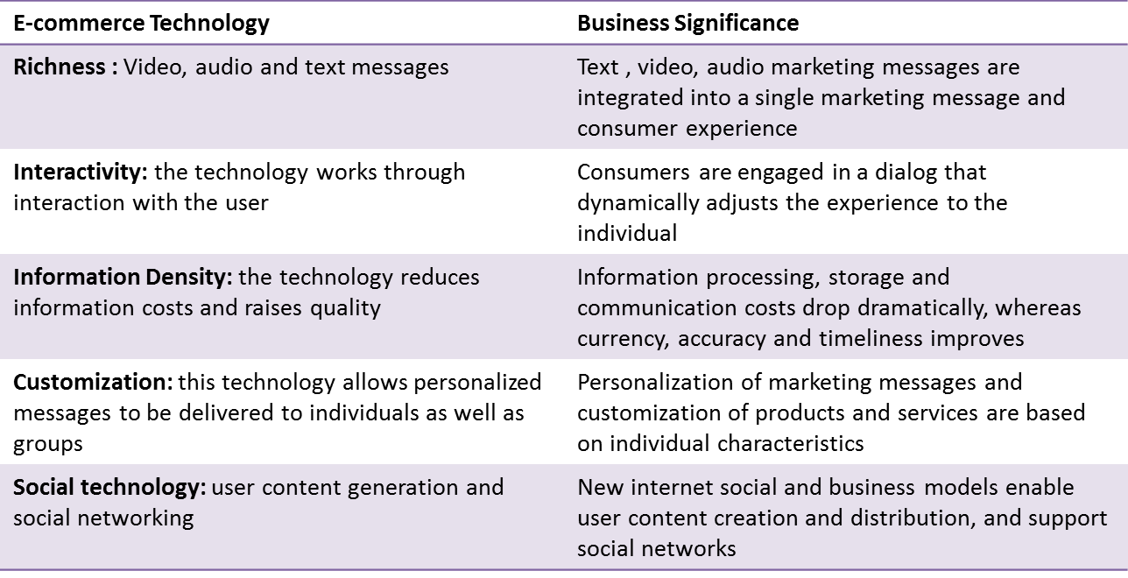

Types of e-commerce
- Business to Consumer(B2C)
- Directly selling to consumers, producers or providers of consumer products
- Good and services cheaper when purchased from the Web
- Amazon, Dell
- Business to Business(B2B)
- Useful tool for connecting business partners in a virtual supply chain
- Many companies adopt online procurement
- Automate exchange of info between two companies
- Consumer to Consumer
- Consumers directly selling to consumers by auctioning
- Most popular web site, eBay

E-commerce Business Models
- Portal
- Google, Bing, Yahoo, MSN
- Provide integrated package of content and service
- Web searching, news reading, entertainment and advertising
- Generate revenues by charging advertisers, website referrals
- E-tailer
- Online retail stores (Amazon)
- Value proposition: convenient and cost effective shopping
- Some represent a physical retailer and some are completely virtual

- Content Provider
- Includes Intellectual property, that is all forms of human expression that can be put into any tangible medium
- Text, CD, DVD, Web
- Revenue generated by selling the content inexpensively to be played or viewed on computers/mobile devices
- Service Provider
- Offering services online
- Photo sharing, online sites for backup and data storage
- Software as a Service

E-commerce Revenue Models
- Advertising Revenue Model
- Revenue generated from the advertisers who pay to expose to customers to ads on major websites and portals
- Sales Revenue Model
- Revenue generated by selling goods, information or services to customers, e.g. Amazon, iTunes
- Subscription Revenue Model
- Offering content or services while charging subscription on an ongoing basis, e.g. music magazines sites
- Free Revenue Model
- Offer services or content for free, but charge a premium for advanced or special features, e.g. photo sharing, radio, games etc.

M-commerce
- Business transactions with the help of mobile devices
- M-commerce fastest growing form of e-commerce
- In 2010, represented less than 10% of all e-commerce
- M-commerce applications are time-critical, for people on move, and accomplish a certain task more efficiently
- Banking and financial services
- Wireless advertising and retailing
- Games and entertainment

Strategies of successful E-commerce

- Building an effective Web site
- Define a team to build and maintain the site
- Site design, technologies used, hardware and software, what customers need
- Business Objectives and Web site Functionality
- What tasks should the web site accomplish?
- Develop technology and information requirements based on business objectives
- Digital catalog, product database, customer tracking, shopping cart etc.
- Establishing the Web site
- Building in house or outsourcing
- Hosting on company servers or web host provider
- Building Traffic to the Web site
- Register a domain name that defines your business
- Maki the site search engine friendly by adhering to SEO techniques
- Also deploy Web site traffic data analysis tools to monitor the traffic

- Maintaining and Improving
- Updating software and hardware with time to keep pace with technology and increasing traffic
- Be aware of new trends and developments in areas of e-commerce
- Personalization is effective in keeping customers

Summary
- E-commerce is unique and popular because of its distinguishing features, because of the Internet
- There are different business models and revenue models concerning e-commerce
- M-commerce is effective with time-critical and ‘on the move’ applications
- Building an effective web site is the key to doing effective e-commerce

Module 3: Business Information Systems

Chapter 9: Enterprise Systems

LECTURE 19

Learning Objectives
- Discuss the advantages and disadvantages of enterprise systems
- Discuss Customer relationship management and its benefits
- Identify the different functionalities of CRM software
- Discuss the Supply Chain and its importance
- Identify the different functionalities of SCM software

Enterprise Systems

Enterprise systems are central to an organization and ensure information can be shared across all business functions at all levels of management. SO, inconsistent information is reduced. The basic goal of these systems is to satisfy customers, achieve competitive advantage by reducing costs and improving operational excellency.

Enterprise resource planning (ERP) Systems is suite of integrated software modules and a common central database. These systems collect data from different departments and large number of key business processes thent his data is made available for different application in the organization. ERP systems include manufacturing & production, finance & accounting, sales & marketing, HR and integrates the information from these functional areas.

For example: in the order processing systems, when the sakes rep. places order, the customer credit si checked by the accounts, the shipment is schedules by the production and items are reserved in the inventory. All this is handled by the ERP system because it integrates the order, manufacturing and delivery data. Thus manufacturing is better informed about producing only what is required. ERPs are based on thousands of predefined business processes e.g. software SAP, Oracle, Microsoft.

Advantages of ERP Systems
- Improved access to data for operational decision making

Instead of gathering data from different business functions & coordinating the information manually, data can be easily accessed because it’s central. This results in good operational decision making. Especially it benefits the retail business which requires that right products are in store shelves at right time.
- Elimination of costly, inflexible legacy systems

Eliminate hundreds of separate systems that are difficult to fix when broken and adapting them takes very long. Legacy systems are hard to fix.
- Improvement of work processes

Since ERP systems are designed gathering requirements from leading companies, they are based on the best practices in businesses, which are geared towards doing effective customer oriented business.
- Upgrade of technology Infrastructure

Company decides on one technology platform from one vendor, so this upgrades and simplifies the IT infrastructure. It also reduces on-going and maintenance and support/training costs. By choosing one vendor and software, technology is standardized.

Disadvantages of ERP Systems
- Expense and time in implementation

It is expensive to implement ERP systems. It takes approximately 3-5 years and millions of dollars to implement ERP and sometimes without proper planning time and money exceeds the limit set.
- Difficulty implementing change

Companies have to radically change their business process to comply with the systems since they are based on the best practices. Also employees need to adjust to their new roles.
- Difficulty integrating with other systems

Companies have other systems that need to be integrated with the ERP systems so that process also takes time.
- Risks in using one vendor

It is costly to switch vendors and companies become dependent on one vendor only. The vendor might have problems updating or going out of business.
- Risk of implementation failure

Proper implementations of ERP systems require resources and lots of management support. Many companies implemented systems without proper preparation or failed to synchronize properly still have pending utilization of the system.
- Organization-wide definitions of data

To switch to ERP systems companies need to understand how business use data and how will it be organized throughout the organization, thus it requires data cleansing.

Customer Relationship Management Systems

There are phrases like ‘customer is always right’ and ‘customer comes first’. These things are very important today because competitive advantage is based on products is short lived. However, long lasting advantage is in ‘owning’ the customer. Now the question is how to build this relationship with customers. Big business obviously have diverse customers, therefore plenty of information needs to be integrated. Therefore Customer Relationship Management ia ll about managing all aspects of customer encounters, including marketing advertising, sales and customer service. That is to retain loyal customers.

CRM Systems refers to capturing and integrating customer data from all over organization, consolidate the data, analysing the data and then distributing results to various systems and customer ‘touch points’ across the enterprise. Touch points are called contact points. They provide a single enterprise view of customers. The figure below shows that CRM systems examine customers from multi-dimensions.
- Benefits-
- Improved customer satisfaction
- Increased customer retention
- Reduced operating costs
- Ability to meet customer demands

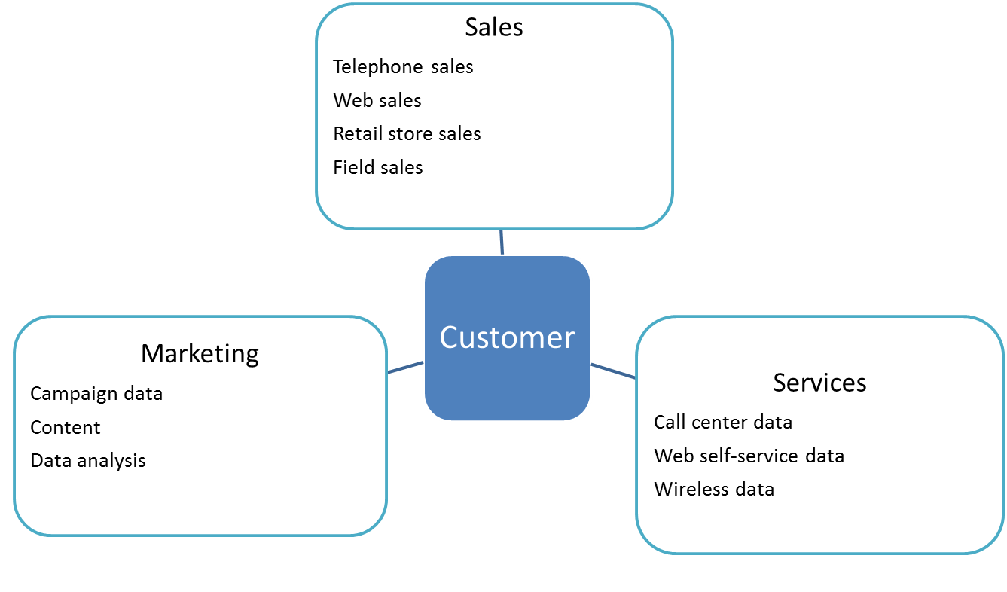

CRM software Functionality

CRM software automates and integrates the functions of sales, marketing, and service such that information can be accessed to:
- Match customer needs to product plans and offerings
- Remind them of service requirements
- Know what other products they have purchased

It consists of tools that perform functions such as:
- Personalizing websites for specific customers
- Capture interactions with customers
- Analysing with sophisticated reporting tools
- Link to other enterprise systems

CRM software are business-process driven and conform to best practices as well.
- Sales Force Automation

Help sales staff increase productivity. IT focuses to provide contact info, product info, product configuration capabilities, sales quote generation capabilities, thus maintain profitable customers. With past purchasing data, new recommendations are given. Thus it reduces cost of acquiring new customers and retaining old. It can be useful for sales forecasting and territory management.
- Customer Services

Consists of information and tools to increase efficiency of call centres, help desk and support staff. It is used for assigning and managing customer service requests. It allows to handle more call per day thus providing higher quality of service in lower cost. It also allows Web-based self service capabilities for the customers.
- Marketing

Supports direct-marketing campaign by providing product and service info for targeted marketing. This also identifies the profitable/unprofitable customers. It also supports scheduling and tracking direct-marketing mailing & email. It also identifies opportunities of cross-selling - marketing of complementary products to customers, execute marketing campaign and also determine rate of success.

Types of Customer Relationship Management Systems
- Operational CRM refers to customer –facing applications, which includes Tools for SFA, call center, marketing automation.
- Analytical CRM refers to applications that analyze customer data generated by operational CRM, so as to improve business process.

Business Value of CRM Systems
- More effective marketing
- Lower cost customer acquisition and retention
- Info from CRM increases sales revenue
- Profitable customers
- Segments for focused marketing and cross selling
- Reduces churn

LECTURE 20

Learning Objectives
- Discuss the advantages and disadvantages of enterprise systems
- Discuss Customer relationship management and its benefits
- Identify the different functionalities of CRM software
- Discuss the Supply Chain and its importance
- Identify the different functionalities of SCM software

Supply Chain Management Systems

To manage supply chain complexity and scale SCM systems are used. Supply Chain is a network of organizations and business processes for procuring raw materials into intermediate and finished products and distributing them to customers.

Suppliers <-> manufacturing plants <-> distribution centers <-> retail outlets <-> customers

E.g. Nike’s supply chain. Nike designs, markets and sells sneakers , socks , sports wear. It has a huge supply chain where contract manufacturers have their own suppliers. The Upstream of the chain consists of companies suppliers and their suppliers further. The Down stream of the chain consists of organization and processes for distributing and delivering products. (as shown in the figure)

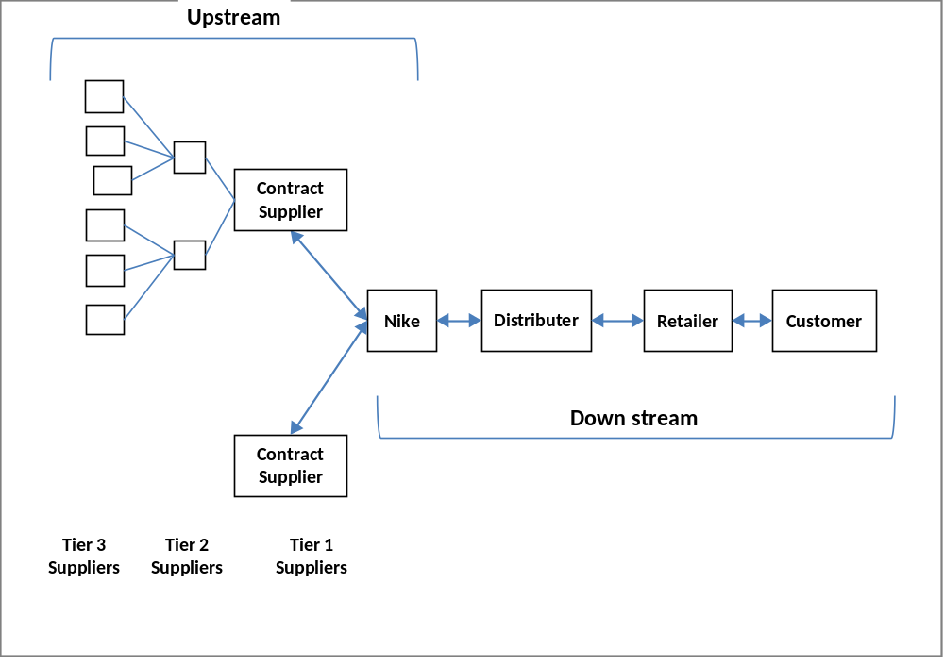

Information Systems Supply Chain Management
- Problems in supply chain management

Supply chain management falls under certain management issues
- In accurate or untimely information causes various problems
- Parts shortage, underutilized plants, high transportation costs. These inefficiencies have impact on operating costs.
- Cannot at times apply ‘just-in-time strategy’ that is components arriving when needed
- Some events cannot be foreseen so uncertainties also arise, such as uncertain product demand
- Bullwhip effect: information about the demand gets distorted as it passes from one entity to another across the supply chain. E.g. Slight rise in demand at the retailer end, piles up inventory at different levels throughout the supply chain. However, all these problems are reduced when all members in the supply chain have accurate and up to date information, so they can adjust sourcing, manufacturing and distribution plans.
- Information Systems help supply chain management by:
- Deciding when and what to produce, store and move
- Rapidly communicate orders
- Track the status of orders
- Check inventory availability and monitor inventory levels
- Reduce inventory, transportation and warehousing costs
- Track shipments
- Plan production based on customer demand
- Rapidly communicate changes in product design

Supply Chain Management Software

SCM software is classified into two categories:
- Supply Chain Planning Systems

Help companies make better decisions about:
- How much of a specific product to develop
- Establishing inventory levels of raw materials, parts and finished goods
- Determining where to store finished goods
- Identifying the transportation for product delivery

Demand planning: important and complex supply chain planning function. It determines how much product a business needs for satisfy all customers
- Vendors include: i2 technologies
- Also enterprise software vendors have the supply chain module
- Supply Chain Execution Systems

These systems manage the flow of products from distribution centres to retailers in efficient manner. They track the physical status of goods, management of materials, warehouses, and transportation operations while also managing financial info regarding all parties of the supply chain. E.g. Haworth’s Warehouse Management System (WMS) does the following:
- Tracks flow of goods
- Acts on shipping plans
- Directs movements of goods

Case Study: Southwest Airlines takes off with better Supply Chain Management

(Laudon2012, Chapter 9, page: 345, 346)
- Company: Southwest Airlines
- Low fare, high frequency, point-to point airline
- Founded in 1971, now 500 aircrafts
- Plus point: best customer service, with low cost fares
- Problem:
- Company expanded, and thus legacy IS outdated
- Lack of information visibility
- Response time for mechanical problems and parts fulfilment was slow
- However, repairing aircraft was crucial for getting passengers from one location to another
- Grounding airplanes is costly
- Inventory management solution
- I2 demand planner
- Forecasts and better visibility
- I2 service parts planner
- Right parts in the right location at the right time
- I2 service budget optimizer
- Analyses historical data of parts usage to forecast future usage
- Benefits
- Clear and unobstructed view of all data up and down the supply chain
- Ensure maintenance teams can quickly repair the aircrafts
- Increased speed and intelligence of decision making
- Increased service levels

Questions: Case Study: Southwest Airlines takes off with better Supply Chain Management
- Why parts inventory important
- Goal: providing best customer service and transporting passengers from one place to another with minimal delay
- Grounded aircrafts and repairing delays because of parts problems would effect that goal
- Technology factor
- Legacy systems lacked information visibility
- Information about parts was difficult to acquire
- I2software
- With its 3 modules: demand planner, service parts planner and service budget optimizer

Summary
- Enterprise systems help organizations achieve operational Excellency by centralization, enforcing uniform standards, and unified technology platforms
- However, implementation requires time and planning
- CRM systems help firms achieve customer intimacy because they integrate and automate customer facing processes in sales, marketing and customer services providing enterprise wide view of customers
- SCM systems coordinate planning, manufacturing and distribution with suppliers by automating information floe through all members of the supply chain

Module 3: Business Information Systems

Chapter 10: Information and Decision Support Systems

LECTURE 21

Learning Objectives
- Identify basic activities and business objectives common to all TPS
- Explain the uses of MIS and describe their inputs and outputs
- Describe Information Systems in the functional Areas of business
- Define the stages of decision making
- Discuss the importance of DSS and describe basic components of DSS
- Identify the fundamental uses of ESS

Transaction Processing Systems

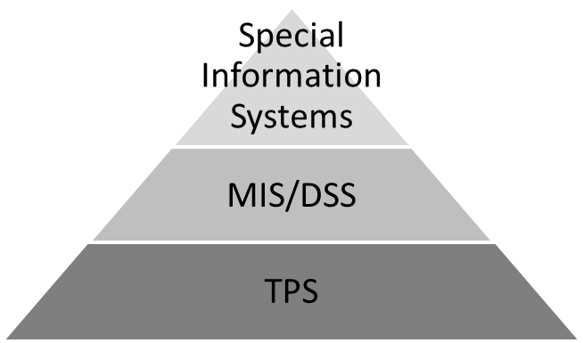
Organizations have many TPS working at operational level. They are used to capture and process the detailed data necessary to update records about fundamental business operations in the organization. These include: Order entry, inventory control, payroll, accounts payable, accounts receivable. It also serves as the foundation of all other special purpose systems e.g. MIS/DSS. In the organizational hierarchy, TPS are concerned with more routine work, less decision support, less complex analysis but deal with large amounts of input/output data ( as shown in the figure below).

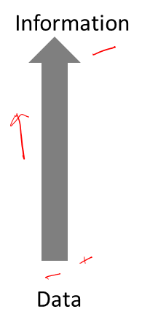
Processing Activities of TPS include:
- Data collection
- Data editing
- Data correction
- Data manipulation
- Data storage
- Document production

Transaction Processing Methods and Objectives
- Batch Processing

With batch processing business transactions are accumulated over a period of time, and then accumulated as a single batch. This might be daily, weekly or biweekly for example. Its main characteristics is that it causes some delay between an event and the eventual processing of the related transaction to update the organizational records.
- Online Transaction Processing (OLTP)

With OLTP each transaction is processed immediately, without delay. This kind of processing is essential for businesses that require current, up-to date data like airlines, ticket agencies and investment firms. This results in faster, more efficient service. Many companies use Internet to capture & process transaction data such as customer orders and shipping info from e-commerce application.

It depends on the kind of business which requires batch processing or OLTP. Because of the importance of transaction processing, organizations expect their TPSs to accomplish a number of specific objectives:
- Process data by and about transactions: capture and data process data and update databases that support routine activities.
- Maintain a high degree of accuracy and integrity: ensuring data is processed accurately and completely is very critical.
- Avoid processing fraudulent transactions: to avoid any fraud or money laundering, systems needs monitoring.
- Produce timely user responses and reports: business transactions need to happen quickly on time.
- Increase labour efficiency: employee monitoring systems help to measure and ensure performance.
- Help improve customer service
- Help built and maintain customer loyalty
- Achieve competitive advantage

Transaction Processing Activities
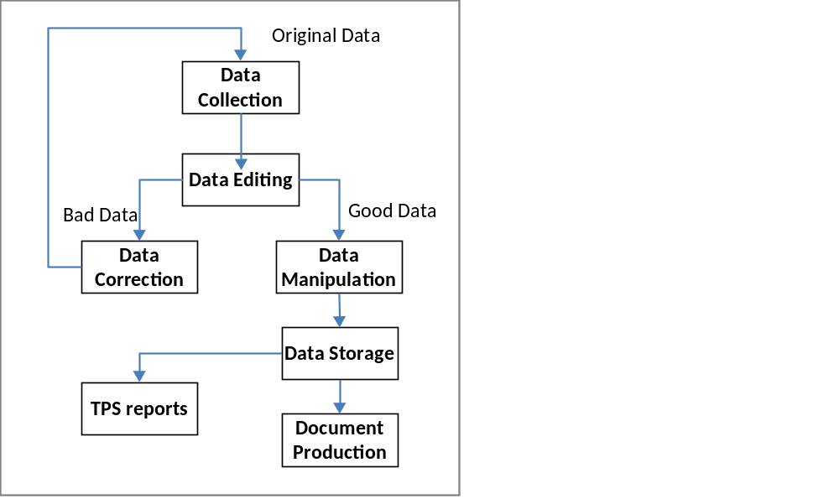
- Data Collection

Sometimes done manually, collecting handwritten sales data/ inventory changes

At times automated trough devices such as scanners /terminals, POS

Source data automation: data captured at source, in digital form in timely manner
- Through UPC codes or RFID tags
- Product ID automatically determined, price retrieved from database
- Inventory database updated and reports generated for the store manager to recorder the supply
- Data Editing
- Checking the data for validity and completeness
- Codes are checked against already stored codes
- Data Correction
- Re-entering data that was not scanned or typed properly
- Error messages are generated to specify problem so proper corrections can be made
- Some companies have Data Quality centers, to improve and maintain data
- Data Manipulation
- Process of performing calculations and other data transformations
- Classifying data, storing data in categories, calculations, summarizing results, storing data
- Data Storage
- Updating one or more databases with new transactions
- Afterwards data is available for processing and further manipulations
- also available for reporting and decision making
- Document Production
- Generating output records, documents, reports
- Hard copy (pay check) or soft copy (balance report)
- Also provide useful management information and decision support
- In addition, provide reports needed by local, state or government agencies

Transaction Processing Applications

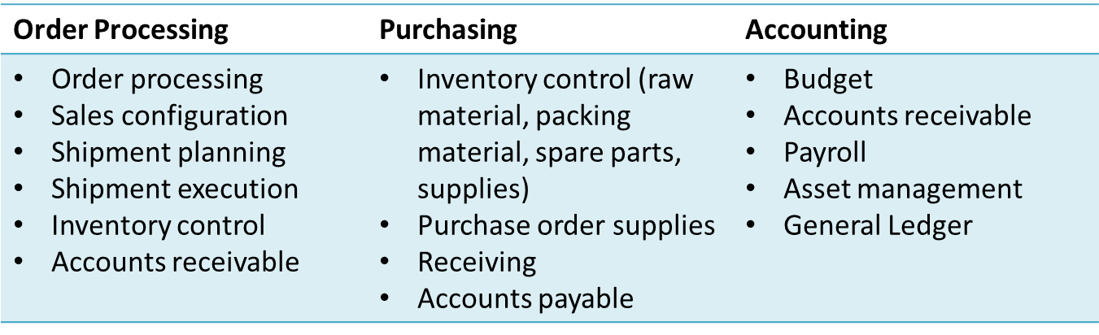

LECTURE 22

Overview of Management Information Systems

It is an integrated collection of people, procedures, databases and devices that provides managers and decision makers to help achieve organizational goals. In other words, it means giving right information to the right people, in the right format at the right time. It provides managers with insight into regular operations which is to control, organize and plan. E.g: summarizing profit and losses, generating sales activity reports either by region or product and doing comparisons. These reports thus help in the decision making regarding regular operations of the organization.

Inputs to a MIS
- Internal:
- TPS and ERP systems
- Company’s supply chain
- Data warehouses/ data marts
- Specific functional areas
- External:
- Customers, suppliers, stakeholders
- Through Internet or extranet link

Outputs of MIS
- Scheduled Reports
- Periodic. E.g. report once per day to monitor production of new item
- Key-indicator reports
- Summarizes pervious day critical activities
- Demand reports
- E.g. executive wants to know status of a certain item, so request database
- Exception Reports
- Generated when situation unusual or requires management action
- Drill Down Reports
- Get detailed data about a certain situation

Characteristics of MIS
- Providing reports with fixed and standard formats
- Produce hard copy and soft copy reports
- Use internal data stored in the computer systems
- Allow users to develop their own custom reports
- Require user request for reports developed by systems personnel

Functional Aspects of MIS
- Financial MIS

It provides financial information not only for executives but also for a broader set of people who need to make better decisions on daily basis. Functions of Financial MIS include:
- Integrating financial and operational information
- Providing easy access to financial data & information
- Make financial data immediately available
- Allows multidimensional analysis of financial data (time, plant, product etc)
- Analyzing historical and current financial activity

Subsystems of financial MIS are:
- Profit/loss and cost systems: these systems are used to compute the revenues, profits and costs from: Profit centres (investment division), Revenue centres (marketing or sales) and Cost centres (manufacturing and research).
- Auditing: these systems are used in all aspects of internal and external auditing, also checking whether financial statements and reports produced by financial MIS are accurate
- Uses and management of funds: these systems help in using the funds internally, such as purchasing inventory, updating equipment, hiring employees etc. and externally such as investments in other revenue generators

- Manufacturing MIS

Manufacturing has dramatically improved because of IS. MIS subsystems and outputs monitor and control the flow of materials, products and services throughout the organization. MIS monitors the whole process of transforming raw materials to finished goods. E.g. auto manufacturers use the manufacturing IS.

Manufacturing MIS subsystems include:
- Design and Engineering
- Use computer-aided design with new or existing products
- Blue print created and constantly revised
- Results in reduction of manufacturing costs
- Master Production scheduling and inventory control
- Provides detailed plans for both short-term and long range of scheduling manufacturing facilities
- Economic order quantity (EOQ), Materials requirement Planning (MRP),
- Just-in Time Inventory
- Process Control
- Managers use technologies to control and streamline manufacturing process
- Computer assisted manufacturing (CAM)
- Computer Integrated manufacturing (CIM)
- Quality control and Testing
- A process that ensures that the finished product meets the customer’s needs
- IS are used to monitor quality and take corrective steps to eliminate quality issues

- Marketing MIS

It supports managerial activities in product development, distribution, pricing decisions, promotional effectiveness and sales forecasting. Different subsystems in the MIS help the managers increase sales, reduce marketing expenses and develop plans for future product & services. These subsystems are:
- Market research: conducting formal study of marketing and customer preferences, which carried out through surveys, questionnaires, interviews etc. Computer systems are then used to analyse the results of research.
- Product Development: It is concerned with turning raw material to finished product. Factors that affect are plant capacity, labour skills, and engineering factors. Computers help to analyze and select the appropriate mix of factors involved.
- Promotion and advertising: Marketing depends a lot on good promo and advertisements. So Internet is used to promotions and advertising.
- Product pricing: It is an important marketing function. Companies have pricing policies that maximize revenues. Computers used to analyze pricing and revenues.
- Sales analysis: Several reports are generated to make managers good decision e.g. showing sales report for months from different dimensions, sales by product, sales by customers, sales by sales rep. Computers can be used to give sales analysis from different dimensions.
- Human Resource MIS

HRMIS is concerned with previous, current, future employees. It helps in workforce analysis, planning, hiring, training, job assignment. Nowadays HRMIS are about improving worker productivity, improving adaptability and facilitating organizational change. Thus, this keeps the workforce costs to minimum.
- HR planning: means right no. and kind of employee in right jobs when needed. It also helps in planning workforce needs and supplies.
- Selection and recruiting: Internet is utilized for creating resume templates and scheduling recruiting.
- Training and skills: Computers are used to help in evaluating and testing employees their mastery of skill.
- Salary administration
- Scheduling and Job placement

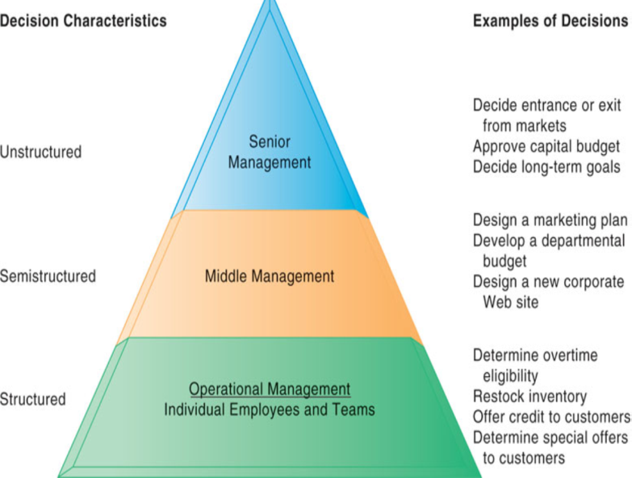
Decision Making and Problem Solving

Every organization needs effective decision making. In most cases, strategic goals and the overall goals of the organization set the course for decision making, helping employees achieve their goals. There are basically 3 types of decisions, as given below and explained in the figure:
- Structured decisions
- Repetitive and routine
- Definite procedures for handling problems
- Question: is some employee entitled to overtime pay?
- Unstructured decisions
- Decision maker must provide judgement, evaluation and insight
- Decisions are novel, important and non-routine
- Question: should we enter a new market?
- Semi-structured decisions
- Have elements of both types of decisions
- Part of the problem has a clear cut answer
- Question: Why is the reported order fulfilment report showing a decline over a past six months?

Decision Making Process

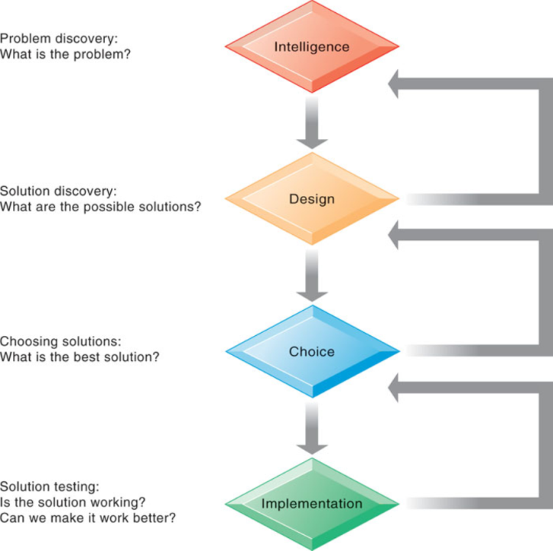

- Intelligence
- Discovering, identifying and understanding the problem
- Why, what, where
- Design
- Identifying and exploring various solutions to the problem
- Choice
- Choosing among the different alternatives
- Implementation
- Making the chosen alternative work
- Monitoring
- Evaluate the implementation, whether anticipated results are achieved

Decision making systems make use of the following problem solving techniques:
- Optimization finds the best solution, helping the organizations meet the goals. For example, given certain conditions and constraints, optimal no. of products that the organization can produce to get profit.
- Satisficing finds a good, but not necessarily the best solution. Sometimes it’s not feasible to find an optimal solutions, it might be complex or costly. Does look at all possible solutions. E.g. selecting a new location of a manufacturing plant.
- Heuristics means following the rules of thumb. These are a set of accepted guidelines and procedures to find a good solution. E.g. sorting the spam in the e-mails.

LECTURE 23

Decision Support Systems

An organized collection of people procedures, software, databases and devices used to help make decisions that solve problems are the decision support system (DSS). They deal with decision making effectiveness for unstructured and semi-structured business problems.

Benefits of DSS include:
- Generate higher profits
- Lower costs
- Better products and services

Sometimes these systems are used by all kinds of managers in government and non profit orgs as well.

Characteristics of Decision Support System
- Provide rapid access to information: information is received on the dashboard and the performance of the company can be seen in real-time. The dashboard show graphical and textual information.
- Handle large amounts of data from different sources: retrieve data from other databases over the network.
- Provide report and presentation flexibility: get the information in the format that suits the decision-maker.
- Textual and graphical representation: show text, tables, pie charts, trend lines or any preferred orientation.
- Support drill-down analysis: getting detailed information about a situation, e.g. cost of each phase, then activity, then task.
- Perform complex, sophisticated analysis and comparison:
- Support optimization, satisficing and heuristic approaches

Capabilities of Decision Support System
- Support for problem solving phases: The problem solving phases include intelligence, design, choice and implementation. It gives decision maker flexibility in getting computer support for any one or a few phases.
- Support for different decision frequencies: Decisions can range from being the continuous once to something happening once in a while. Ad-hoc DSS handles ‘one of a kind’ decisions while institutional DSS handles repetitive decisions. E.g. computer related problems occur multiple times, a DSS can monitor the system and take action to prevent problem.
- Support for different problem structures: DSS supports decision from highly structured problems to semi structured and unstructured problems.
- Support for various decision making levels: Provide help to managers at different levels, which is operational, tactical and strategic decision making.

Components of Decision Support System

At the core of DSS are a database and a model base, along with the user interface for accessing the system. The figure below shows a conceptual model of a DSS.
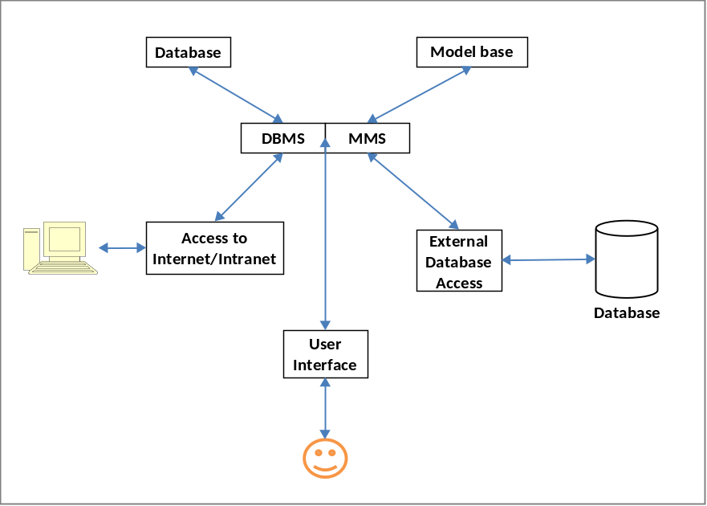

- The Database

DBMS allows managers and decision makers to perform qualitative analysis on the variety of data in the organization. So, a Data-driven DSS uses the company’s databases, retrieving info on inventory, sales, personnel, production, accounts. The techniques used are : data mining and business intelligence. E.g. Data-driven medical DSS allow doctors to have access to complete patient record. A DBMS can also connect to external database to give managers more information. These include the Internet, intranet and government databases.
- The Model Base

A model base allows managers and decision makers to perform quantitative analysis. Model-driven DSS performs mathematical analysis by giving decision makers access to variety of models so that different scenarios can be explored. These mathematical models and algorithms are constantly revised. Model Management Software (MMS) is often used to coordinate use of models in DSS, including financial, statistical analysis, graphical and project management models.
- The User Interface

The user interface allows users to interact with the background DSS. It is also called dialogue manager or dashboard.

Decision Support Systems and Business Intelligence
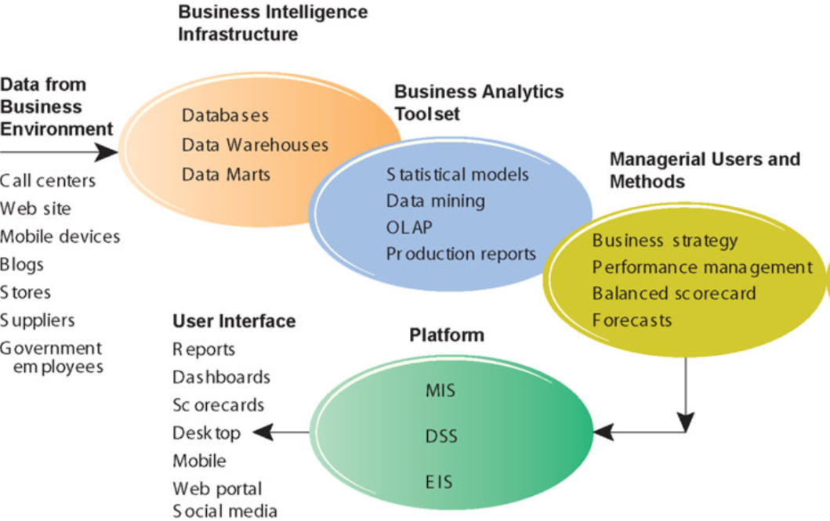

Business Intelligence

It is a term coined by vendors and IT consultants for defining tools and techniques to create business value. It is an infrastructure for warehousing, integrating, reporting and analyzing data from business environment. According to IBM, Business intelligence is an umbrella term that combines architectures, tools, databases, analytical tools, applications and methodologies for achieving competitive advantage in business. The figure above shows the Business Intelligence environment.

Group Support Systems
- GSS or GDSS

DSS is good for decision making by individuals but it is not suitable for group work. Some strategic level managers are involved in decisions in a group setting. This approach brings in the GDSS which has elements of DSS by also group level support. GDSS characteristics include:
- Special design: Procedures foster creative thinking, effective communications & good decision making techniques
- Ease of use
- Flexibility: Along with supporting different decision making styles but also integrates different perspectives
- Decision-making support: Supports different techniques like brainstorming, group consensus, nominal group technique
- Parallel communication: Comments and discussion displayed immediately
- Automated Recordkeeping: Discussions automatically stored for future reviews and analysis
- Software include: Autodesk, LotusNotes, Office Communicator/ Net Meeting. Some software are incorporated in TPS & ERPs

Executive Support Systems
- Specialized DSS, that includes all hardware, software, data, procedures and people used to assist senior level executives in the organization
- Means of tracking critical success factors
- Allow executives to ask the right questions
- Apart from the drill down ability and ease of use, ESS also
- Support the need for external data
- Help with situations that have high degree of uncertainty
- Have a future orientation
- Are linked with value added business processes

Capabilities of Executive Support Systems
- Support for defining overall vision
- Org’s major product lines, types of business to support in future
- Support for strategic planning
- Determining long term objectives by analysing the strengths and weaknesses of the organization, predicting future trends
- Support for strategic organizing and staffing
- Creation of depts., downsizing labour and analyses changes related to staffing
- Support for strategic control
- Monitoring and managing overall operations of the org
- Support for crisis management
- Handling emergencies caused by disasters
- Helps in contingency planning

Summary
- The MIS must provide the right information to the right person at the right time, in the right format
- Understanding decision making process is the key to developing effective DSS
- DSS are usually used in situations with unstructured or semi structured decisions
- DDSS help in achieving Decision making with collaboration
- ESS perform sophisticated data analysis and high degree of specialization

Module 3: Business Information Systems

Chapter 11: Knowledge Management

LECUTRE 24

Learning Objectives
- Discuss Knowledge and identify different dimensions of knowledge in an organization
- Identify the different techniques of Knowledge Management
- Discuss the steps of knowledge management
- Discuss the different types of Knowledge Management Systems
- Discuss various Intelligent techniques used in specialised IS, specifically Expert Systems

Dimensions of Knowledge

We line in an information economy, in which major source of wealth is production and distribution of knowledge. That is why knowledge management is important for various businesses. A company’s value is added by its ability to create and manage knowledge and experience. Knowledge Management and other specialized IS are used in many businesses today. E.g. robots that intelligently paint and attaches windshields or computer simulation used for training soldiers for combat (in military). Knowledge is the essence behind all these systems.

Knowledge is derived from Data and Information where:

Data is flow of transactions (raw facts) captured by the system. Information is the collection of facts organized so that they have value beyond the value of facts themselves. Or when organizations put in resources to organize data into categories, e.g. monthly regional sales report.

Knowledge is the awareness and understanding of a set of information and the ways that information can be made useful to support a specific task or reach a decision.

For example:

Data: There are 20 PCs in stock at the retail outlet.

Information: The store will run out of inventory in a week.

Knowledge: Call 800-555-2222 to order more inventory.

For some organizations people are an asset, because of the knowledge they have and knowledge they create. That’s why knowledge can be categorized as:
- Tacit: knowledge residing in minds of employees that is not documented
- Explicit: knowledge that has been documented (structured /unstructured)

The Important Dimensions on knowledge are:
- Knowledge is a Firm asset: Intangible asset
- Knowledge has different forms: Tacit, explicit, know-how, craft, skill, following procedures, knowing ‘why’
- Knowledge has a location: Cognitive event, individual attribute and collective attribute, ‘sticky’
- Knowledge is situational: know when to apply some procedure (conditional) and works in certain situations (contextual)

Knowing how to do things efficiently is a primary source of profit and competitive advantage

Overview of Knowledge Management Systems

Knowledge Management refers to set of business processes developed in an organization to create, store, transfer and apply knowledge

Knowledge Management System is an organized collection of people, procedures, software, databases and devices used to create, store, share and use the organization's knowledge and experience. These also help organizations achieve their goals. Personnel involved in KMS are knowledge workers and data workers. Knowledge workers create, use and disseminate knowledge who are usually professionals in science, engineering, business. Chief Knowledge Officer is a top-level executive who overlooks work related to KMS. He is responsible for the organization’s KMS.

Organizations create and gather knowledge using a variety of organizational learning mechanisms. When organizations gain experience, they adjust their behaviour to reflect that learning by creating new business processes and changing patterns of decision making. This process is called Organizational Learning.

Communities of Practice (COP) are informal social networks of professionals and employees within and outside the firm who have similar work-related activities and interests. E.g. a team of medical researchers looking for new ways to treat cancer. Some organizations create, store, share knowledge through COPs. They allow easier reuse of knowledge, by pointing community members to useful documents and knowledge resources.

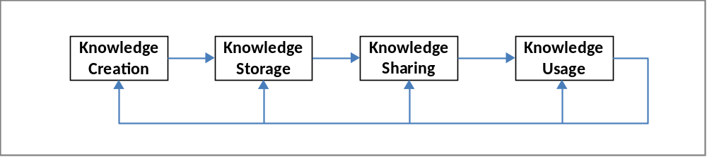

- Knowledge Acquisition/Creation

Organizations acquire knowledge in a number of ways. Initially, KMS were used to corporate repositories of documents, reports, presentations and best practices. Then they started to include unstructured documents (e-mails). In other cases, organizations acquire knowledge by developing online expert networks , allowing employees to find their required expert. Organizations also create knowledge by discovering patterns in corporate data, or retrieve from the TPS, or external sources.
- Knowledge Storage

Once these documents, patterns and expert rules are created or acquired , they are stored usually in database. Document management systems help to store documents and Expert systems help to preserve knowledge. However, organizations need planned management storage systems, and reward employees for taking time to update and store information in the systems.
- Knowledge Dissemination

Contemporary technologies like e-mails, portals have helped in the dissemination of knowledge. But in this vast sea of knowledge, knowledge need to know what is important. Training programs, informal networks, and shared management experience helps them to retrieve the important knowledge and information.
- Knowledge Usage/Application

Organizational knowledge must become a systematic part of management decision making as well as DSS, as well organization’s business processes and key applications. Also utilized in enterprise applications for managing key business processes and relationship with customers/suppliers. OS that it can be ultimately used for creating new processes, products and services.

Types of Knowledge Management Systems

- Enterprise Wide Knowledge Management Systems

These are general purpose enterprise-wide efforts collect, store, distribute and apply digital content and knowledge. Knowledge, as we explained before is either structured or semi structured or tacit knowledge. This type of KMS deals with all these kinds of knowledge. These systems include the following types:

Content Management Systems (CMS): stores both structured as well as unstructured knowledge. Around 80% of organizations’ business content is unstructured or semi structured like e-mails, memos, messages etc. . CMS also includes computer repositories of documents, presentations, best practices. For easy retrieval, information is organized into meaningful categories and then each object is classified so that it can be easily accessed. Each knowledge object is then classified or tagged according to the classification. This reduces time to search for relevant docs. Some CMS also allow storing and managing unstructured digital content such as graphics, audios, videos especially for advertising, entertainment related fields.

Knowledge Network Systems: used when knowledge is not in the form of digital documents but resides in the memory of expert individuals in the company. These systems provide online directory of corporate experts in well-defined knowledge domains and use communication technologies to get linked to experts. Some of these capabilities are present in collaboration software suites.

Learning Management Systems (LMS) provides tools for management, delivery, tracking, assessment of various types of learning and training. It also automates selection & administration of courses, group learning in online forums (supports multiple forms and mixed media content).

Collaboration tools consist of blogs and wikis also used for collaboration along with other vendor given collaboration software. These tools help capture, consolidate & centralize knowledge for the firm.
- Knowledge Work Systems

Specialized systems built for engineers, scientists & other knowledge workers charged with discovering & creating new knowledge for the company. So basically knowledge work systems are developed for the knowledge workers. These systems require sufficient computing power to handle complex graphics and calculations. Some examples are:

CAD and 3D: automates creation and revision of designs using computers & sophisticated graphics software. Design is easily tested and changed on computer. The abilities of CAD software provide design specifications for the tooling and manufacturing processes, which saves a lot of time and money.

Virtual Reality Systems have visualization, rendering, and simulation capabilities. They use interactive graphic software to create computer generated simulations close to reality. E.g. these systems can be used for training of the Boeing in which workers learn to fix problems.
- Augmented Reality: enhances visualization by augmenting real physical-world environment.

LECTURE 25

Learning Objectives
- Discuss Knowledge and identify different dimensions of knowledge in an organization
- Identify the different techniques of Knowledge Management
- Discuss the steps of knowledge management
- Discuss the different types of Knowledge Management Systems
- Discuss various Intelligent techniques used in specialised IS, specifically Expert Systems

Artificial intelligence (AI) is a field which deals with computers with the ability to mimic or duplicate the functions of the human brain. It allows the computers to imitate how the brain works for problem solving. AI Systems include the people, procedures, hardware, software, data, and knowledge needed to develop computer systems and machines that demonstrate characteristics of intelligence. Computer systems that use the notion of AI, can do the following types of taks:
- Help to make medical diagnoses
- Explore for natural resources
- Determine what is wrong with mechanical devices
- Assist in designing and developing other computer systems

When we talk about intelligence, then the intelligent behavior means:
- Learning from experience and applying the knowledge acquired from experience.
- Handle complex situations that the top managers face.
- Solve problems when important is missing since some decisions are made with little or incomplete/inaccurate information.
- Determine what is important from a huge amount of data.
- Process and manipulate symbols
- Use heuristics i.e. using approximation instead of optimal solution.

Branches of Artificial Intelligence
- Robotics: It is the use of robots. It refers to developing mechanical/computer devices that can paint cars, make precision welding and do other tasks that require high degree of precision. AI is important component in controlling software for the robots. They are used in automated manufacturing and military systems as well as hazardous working environments.
- Intelligent Agent (bot)

It consists of programs and knowledge base to perform a specific task for a person or another program. These agents have the ability to shift through large amount of data. It can be used to search the Internet to find relevant information about a certain topic, price and schedule, so they can be used in travelling agencies. It is also used in training for tracking a student’s performance. It is also used in US Army to route security clearance information for soldiers to the correct departments and people.

Neural Networks

A neural network is a computer system that can act like or simulate the functioning of a human brain. They are used for solving complex, poorly understood problems, for which large amounts of data have been collected. They find patterns and relationships in massive amounts of data that would be too complicated and difficult for a human being to analyze. Neural networks ‘learn’ patterns from large quantities of data and have ability to re-learn.

Neural network has applications in medicine, science, business address problems in pattern classification, prediction, financial analysis and control and optimization.

Expert Systems

Experts systems behave similarly to a human expert in a particular field. So, they not only store, but also use knowledge. They are developed to diagnose problems, predict future events, solve energy problems etc. These systems use heuristics to arrive to conclusions or make suggestions. For example, an agricultural company can use expert systems to find the best fertilizer mix to use on certain soils to improve crops while minimizing costs.

Expert systems are difficult and expensive to build, so these are used in situations where it is worth to spend that much time and money. So, it is worth to develop the systems only when they can be used to:
- Provide expertise expensive or rare
- Develop solutions faster than human experts
- Develop system more consistent than human experts
- Capture and preserve irreplaceable human expertise
- Expertise required at same time or in hostile environments

Components of Expert Systems

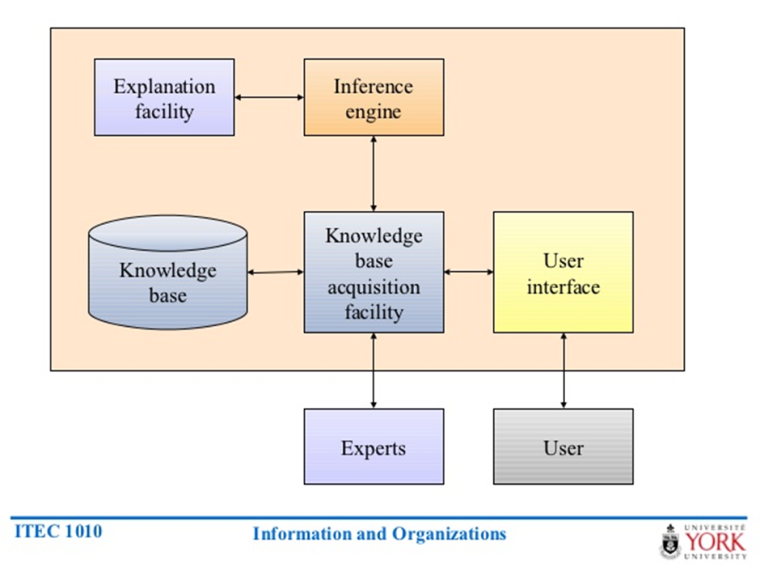

An expert system consists of a collection of integrated and related components, including a knowledge base, an inference engine, an explanation facility, a knowledge base acquisition facility and a user interface as seen in the figure above.
- Knowledge Base

It stores all relevant information, data, rules, cases, and relationships that expert systems use. As shown in the figure below, it is a natural extension to a database and DSS.A knowledge base must be developed for each unique application e.g. a medical expert systems contains facts about diseases and symptoms. Following are tools to create knowledge base:
- Assembling human experts, i.e. assembling the knowledge of various human experts e.g. doctors.
- Using fuzzy logic: capturing knowledge and relationships that are not precise or exact. Its rules help computers evaluate the imperfect or imprecise conditions they encounter and make educated guesses based on probability of correctness of the decision.
- Using rules: A rule is a conditional statement that links conditions to actions on outcomes. These rules are stored as IF-THEN-statements. These can be programmed in any language.
- Using cases: An expert system can use cases in developing a solution to a current problem or situation. (explained later)

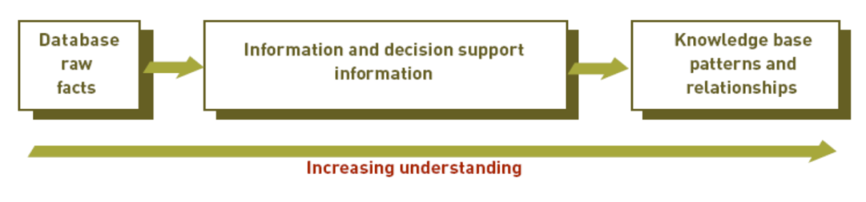
- The Inference Engine

Its basic purpose is to seek information and relationships from knowledge base and provides answers, predictions, and suggestions, like a human expert. This is the component that delivers the expert advice. It uses two methods: Backward chaining: Process starts with conclusions and works backward to supporting facts. Forward chaining: process starts with facts and works forward to conclusions. It uses the IF THEN rules to find the relationships. For example: forecasting future sales.

- The Explanation Facility

It allows a user or decision maker to understand how the expert system arrived at certain conclusions or results. Example: a doctor can find out the logic or rationale of diagnosis made by a medical expert system

- The Knowledge Acquisition Facility

The most difficult task of an expert system is creating and updating a knowledge base. So the purpose of this facility is to provide convenient and efficient means of capturing and storing all components of knowledge base. Knowledge acquisition software can be used which has easy-to-use menus. It can be a manual process or a mixture of manual and automated procedures.

- The User Interface

Specialized user interface software is employed for designing, creating, updating, and using expert systems. Its purpose is to make development and use of an expert system easier for users and decision makers. Today, the user interface permits the decision maker to develop and use their expert systems.

Participants in Developing and Using Expert Systems

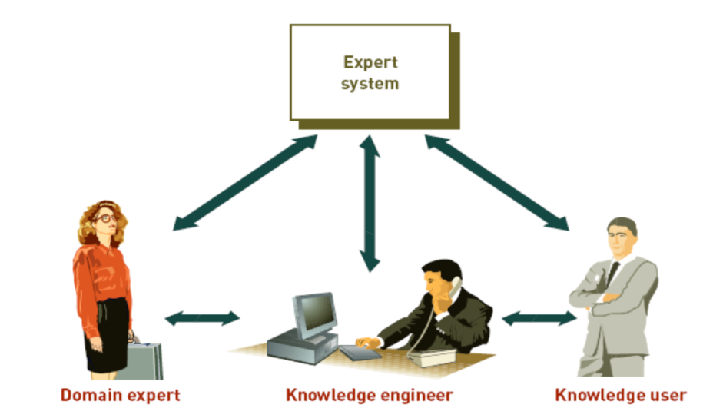
- Domain Expert

Individual or group that have expertise in a certain domain

Recognize problems, formulate theories, solve problems, learn from experience, explain situations and solutions to problems to others
- Knowledge Engineer

Who has training or experience in the design, development, implementation and maintenance of an expert system
- Knowledge User

Person or group who uses and benefits from the expert system

Case-Based Reasoning

Organizations on the whole also have collective knowledge and expertise. This organizational knowledge can be captured and stored using case-based reasoning (CBR). It is the descriptions of past experiences of human specialists, represented as cases are stored in the database. The system searches for stored cases with problem characteristics similar to the new one and apply the closest fit. The expert system can modify the solution based on the saved cases.

Uses: medicine, customer support. E.g. using this expert system can determine the best location for a new service facility.

Applications of Expert Systems and Artificial Intelligence
- Credit granting and loan analysis
- Budgeting
- Games
- Information Management & Retrieval
- Plant layout and manufacturing
- Catching cheats and terrorists
- Hospitals and medical facilities
- Virus Detection

Case Study: SFPUC Preserves expertise with better knowledge management

(Laudon2012, Chapter 11, page: 448-450)
Following are the important points highlighted from the case study. The questions will be part of the assignment.
- Company: San Francisco Public Utilities Commission (SFPUC)
- Provides water, wastewater, municipal power services
- 4 division: Regional Water, Local Water, Power and Waste Water
- Over 2000 employees
- Mission:
- provide customers with reliable, high quality, affordable water and wastewater treatment while efficiently managing human, physical and natural resources
- Problem: employees retiring from technical positions
- Training new employees
- Maintaining knowledge of retiring workers
- Organizational Need
- Rearranging operations so that generational swap doesn’t affect their operational capability
- A way to capture knowledge and communicate it further
- Challenges
- Capturing knowledge in an efficient manner of the retiring workers
- transferring this knowledge to new comers
- Maintain reliability and accountability
- Implemented Business Process Management (BPM) and workflow solution
- Enterprise Process Center (EPC)
- Managing knowledge retention, establishing ways of sharing information, defining roles and responsibilities
- Showed flow charts of business processes
- Share business process information and knowledge required to execute these processes
- Identified obsolete processes and applied automation or eliminating outdated tasks
- Find expertise: break down of large-scale process knowledge into more manageable pieces, thus allowed more users to contribute
- Final Product: centralized electronic knowledge base
- Graphical display and video

Module 4: Systems Development

Chapter 12: (IS) Project Management

Lecture 26

Learning Objectives
- Discuss the importance of project management by learning different reasons of project failures
- Discuss the various ways of selecting projects and concepts related with the selection
- Discuss the risks, specifically change management and what should be considered in designing for the organization

Importance of Project Management

Basic purpose or challenge of information systems is that they deliver genuine business benefits. Many Information Systems projects don’t succeed because organizations incorrectly assess their business value or because the organizations fail to manage change associated with the IS projects. There is a high failure rate among IS projects, since sometimes these projects take more time and money to implement than originally anticipated. Therefore, development of such a system must be carefully planned.

Inadequate project management might have the following consequences:
- Costs that vastly exceed budgets
- Unexpected time slippage
- Technical performance that is less than expected
- Failure to obtain anticipated benefits

Therefore, it is important to have knowledge about managing IS projects and causes of failure associated with them.

When these projects fail, then the systems are not used to their full potential or not used at all, or develop parallel manual systems to make them run. The erroneous systems produced might have the following types of problems:
- Doesn’t fulfil business requirements
- Not in easily understandable format
- Designed with poor user interface
- Outputs difficult to comprehend
- Data is inconsistent or incomplete
- Web pages are cluttered poorly arranged

IS Project is defined as a planned series of related activities for achieving a specific business objective. These activities are either for development of a new IS, enhancement of IS or upgrading the IT infrastructure. To manage projects Project Management is a concept that refers to application of knowledge, skills, tools, and techniques to achieve specific targets within specified budget and time constraints, which consists of the following tasks:
- Planning the work
- Assessing risk
- Estimating resources
- Organizing the work
- Acquiring human and material resources
- Assigning tasks
- Project execution
- Reporting progress
- Analyzing results
- Variables of project management
- Scope: it defines what tasks the project encompasses. It is important to define the scope initially, that is the work needed to finish the project successfully.
- Time: It is the amount of time required to complete the project. Time line is set for different project components and tasks within as well.
- Cost: The cost depends on time required multiplied and cost of human resources, plus h/w, s/w & work space costs.
- Quality: It indicates how well the project has satisfied the management. It also ensures accuracy and timeliness of the information produced.
- Risk: this refers to the potential problems that would threaten the success of a project.

Project Management Concepts

Linking Systems projects to Business Plan

In order to identify the IS projects that will deliver the most business value, organizations need to develop information systems plan that supports overall business plan. So, this plan acts as a guide or a roadmap to define the direction of systems development, the rationale, the current systems/ situations, new development to consider, the management strategy and budget. Emphasis is on corporate goals and mapping IT with those goals. Therefore the plan also indicates the key management decisions for
- Acquiring IT infrastructure
- Centralization/decentralization
- Organizational change

So, IS projects need to clearly specify the improvements that they will bring, either as information (MIS) or with decisions (DSS). For decision making systems, managers should identify what decision improvements are required to be achieved.

Critical Success Factors (CSF)

To develop and effective IS plan, both long term and short term information requirements needs to be explicitly defined. This approach suggests that these requirements are determined by a set of CSF. Goals attained results in success assured. Therefore Information Systems need to be built to provide information that helps the firm meet these goals. E.g. CSF for automobile company would be styling, quality and costs and IS is built accordingly to achieve these goals. The approach is especially suitable for creating DSS and ESS because it is targeted towards top-level management.

Portfolio Analysis

Once CSF have determined the overall direction of the systems development, portfolio analysis is used to evaluate alternative system projects. This approach lists all organization's IS projects and IT assets associated with it. It is believed that each project has its own risks and benefits so projects are profiled for risks and benefits to the firm. Even though there is no ideal profile, most desirable profile for information-intensive project has high benefits, high risk and for non-information-intensive, it has high project, low risk. Doing this kind of analysis allows better organization wide coordination of IT investments and better alignment with business objectives.

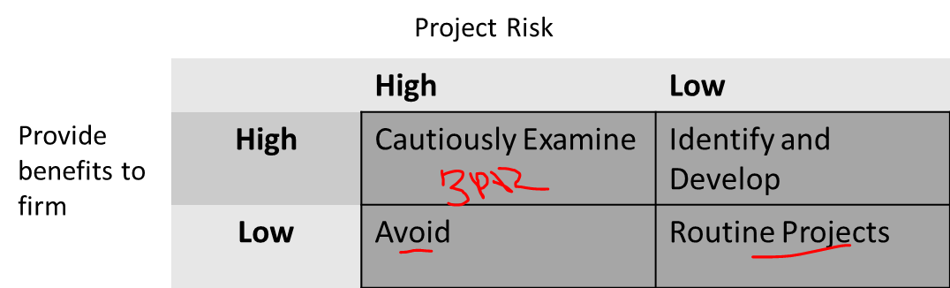

Scoring Models

This approach for useful for selecting projects where many criteria must be considered. It assigns weights to different features and then calculates weighted totals. The criteria are selected by the decision makers after group discussions. E.g. for selecting ERP systems high weights can be assigned to certain aspects of order processing, inventory management and warehousing. Even though it’s calculations, but qualitative judgments are also involved by experts who understand the issues and the technology. This approach is mostly used to rationalize and support decisions.

Change Management and Concept of Implementation

Systems differ in terms of their size, scope, level of complexity and organisational and technical components. That’s why some systems projects are at a much higher risk than others. The very prominent risk involved in the success of the systems is change management associated with it. Changes in the way information is defined, accessed and used to manage organization’s resources, often leads to new distributions of authority and power. Information Systems, whether new or updated, have a huge behavioural & organizational impact. Successful system development is dependent on change management.
- The concept of implementation

To manage change, one important approach is to examine the process of implementation. Implementation refers to all organizational activities working towards adoption, management and routinization of the new IS. This approach puts the System analyst at the centre of everything by calling him/her the Change Agent, who is responsible for:
- Redefines configuration, interactions, job activities and power relationships of various organizational groups
- Ensures all parties accept changes created by the new system.
- The Role of End User

There are various positive reasons of user involvement in the design and operation of Information Systems. Firstly, users have more opportunities to mould the system according to their priorities and business requirements. Secondly, they are more likely to react positively to the completed system. Incorporating user knowledge and expertise leads to better solutions. However, there is a user-designer communication gap, that can be a cause of high risk failure of the project. This is because both parties concerned with different ways to solve a problem. The developers think in terms of technical effectiveness while users are concerned with usage effectiveness. That’s why sometimes users are driven out of implementation process.
- Change management challenges for BPR, Enterprise Applications, Mergers

Given the challenges of innovation and implementation that are associated with projects that are geared towards enterprise applications or business process reengineering typically required intensive organizational change. Replacing old techniques and legacy systems becomes a lengthy process. Dealing with fear and anxiety, overcoming resistance by key managers, changing jobs etc. poses more difficulty

Projects related to mergers and acquisitions also have a high failure rate only because the change is undermined. It requires combining IS of two different companies, because without systems integration, benefits anticipated from mergers cannot be realized. That’s why considerable organizational change is necessary.

Designing for the Organization

Because the purpose of the new system is to improve he organizational performance IS projects must explicitly address ways in which the organization will change, when the new system in installed. This includes transformation in job functions, organizational structure, power relationships, work environment, which need to be carefully planned. Ergonomics which is interaction of people and machines in the work environment need to be considered when designing user interfaces. This also includes health issues. Designing phase should include Organizational Impact Analysis that explains how proposed system will affect various aspects of organization. And as mentioned earlier the contemporary approach to creating an IS is incorporating Sociotechnical Design in these projects. In this approach technical solutions are compared with social solutions and solution that best meets both social and technical objectives is selected for the final design.

Summary
- IS projects have a high failure rate because of improper project management
- IS projects need linking to the business plans, IT goals need to be mapped to corporate goals
- Selecting of projects is based on CSF, portfolio analysis or scoring models
- Change management is crucial for the success of any project
- IS projects need to be developed keeping the organizational and management needs in mind

Module 4: Systems Development

Chapter 13: Investigation and Analysis

Lecture 27

Learning Objectives
- Identify key participants in Systems Development
- Define the term Information Systems Planning
- Discuss various types of SDLC and their differences
- State purpose of Systems Investigation and the activities involved
- State the purpose of Systems Analysis and identify the tools and techniques used in it

The previous chapters were about different kinds of Information Systems and how different kinds of businesses can utilize the IS. Also what the benefits of using technology and IS in businesses. In these two chapters of systems development module, we are going to discuss that when an organization needs to accomplish a new task, how does it do it? It is about creating or modifying the existing systems. It can include purchasing an ERP package to developing any custom built application.

Participants of Systems Development
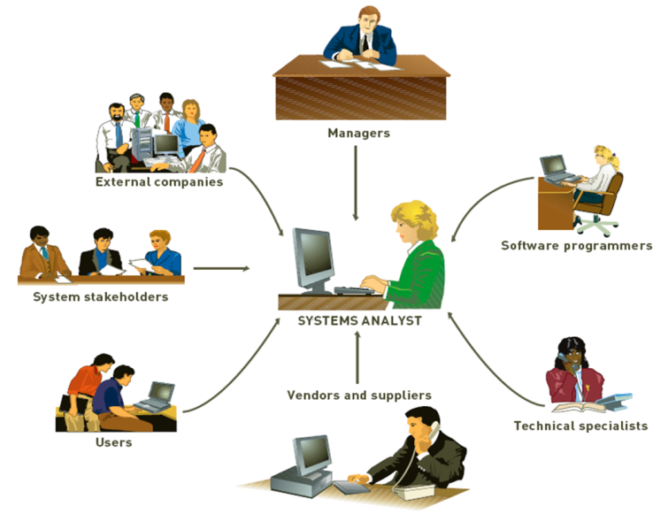
Effective system requires team effort. The Development team determines objectives of the information system and delivers system that meets objectives. It is headed by the project manager. Project is a planned collection of activities that achieves a goal. Project Manager is responsible for coordinating all people and resources needed to complete a project on time. Stakeholders are people who ultimately benefit from project. Users are people who will interact with the system regularly (employees, managers, suppliers). Systems development specialists are systems analysts: professionals who specialize in analysing and designing business systems. They are at the centre of the team as shown in the figure. Programmers are responsible for modifying or developing programs to satisfy user requirements.

Initiating Systems Development

Typical Reasons to Initiate Systems Development

Systems development initiatives can arise from all levels of an organization. These initiatives can be planned or unplanned. There are number of reasons for initiating systems development projects which include mergers, acquisitions, federal regulations, etc.
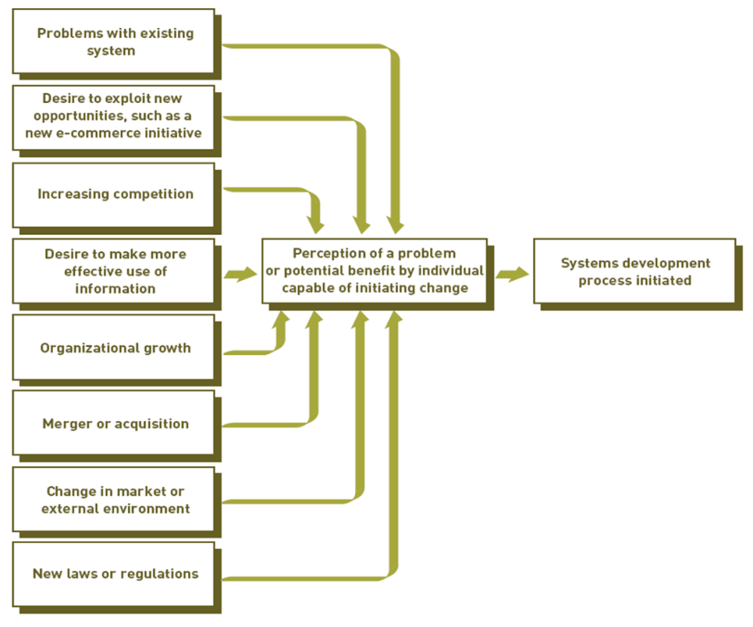

Information Systems planning and Aligning Corporate & IS goals

Information systems planning means translating strategic and organizational goals into systems development initiatives. Aligning organizational goals and IS goals are also critical for successful systems development effort. This gives a long-range view of IS used in the organization. This also allows better use of IS resources (funds, personnel and time).

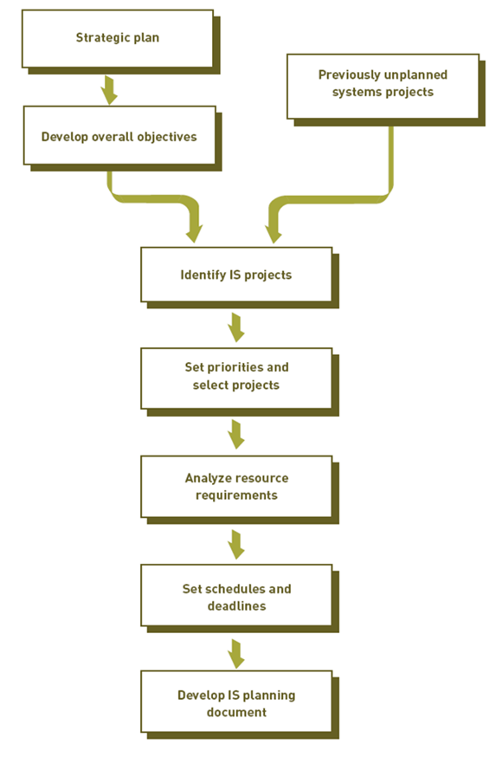

In today’s business environment, companies go for systems development projects that can provide Competitive Advantage. This requires, thinking out of the box, innovatively and critically. This can be achieved doing the following two analysis techniques:
- Creative Analysis is investigating new approaches to existing problems. The solutions are inspired by people and events not directly related to the problem.
- Critical Analysis is unbiased and careful questioning to see if system elements are related in the most effective ways. This is accomplished by:
- Questioning statements and the assumptions prevailing the organization .e.g. sometimes users assume their need can be met in only one way.
- Identifying and resolving objectives and orientations that conflict, since different departments have different priorities, which might clash as requirements.

Establishing Objectives for Systems Development
When goals are defined for systems, some set of objectives are also defined. These could be performance related objectives or cost related.
- Performance objectives: this is the measurement of the extent to which a system can perform.
- The quality or usefulness of the output
- Accuracy of the output
- The speed at which output is generated
- The scalability of the resulting system
- The risk of the system
- Cost Objectives: performance goals can be balanced with all costs:
- Development cost: cost to get the system running.
- Cost related to the uniqueness of the system application
- Fixed investments in hardware and related equipment
- Ongoing operating costs of the system include: people, software, supplies, resources.

Systems Development Lifecycles

Common systems development life cycles
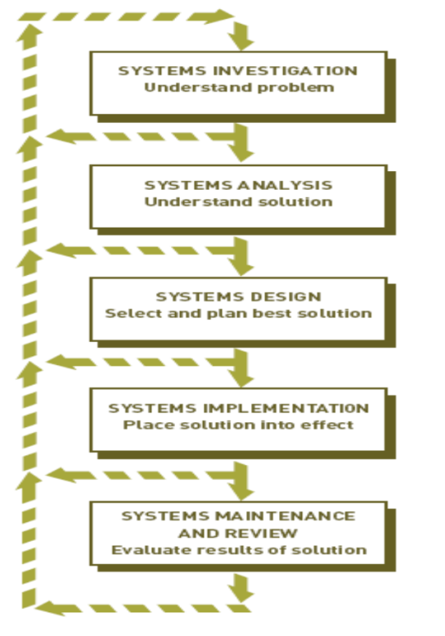
- Traditional
- Prototyping
- Rapid application development (RAD)
- End-user development

Traditional Systems Development Lifecycle
- Systems investigation: Identifies problems and opportunities and considers them in light of business goals
- Systems analysis: Studies existing systems and work processes to identify strengths, weaknesses, and opportunities for improvement
- Systems design: Defines how the information system will do what it must do to obtain the problem’s solution
- Systems implementation: Creates or acquires various system components detailed in systems design, assembles them, and places new or modified system into operation
- Systems maintenance and review: Ensures the system operates as intended and modifies the system so that it continues to meet changing business needs

Prototyping

It is an iterative approach. In first iteration, preliminary model of the major system is developed and given for feedback. It is then refined and then developed again. Then the second iteration is given. With this type of SDLC, design and implementation benefit the most. There are two types of prototypes:
- Operational prototype

It is a prototype that works and accesses real data files, edits input data, makes necessary computations and comparisons, and produces real output.
- Nonoperational prototype

It is a program mock-up, or model which includes output and input specifications and formats.
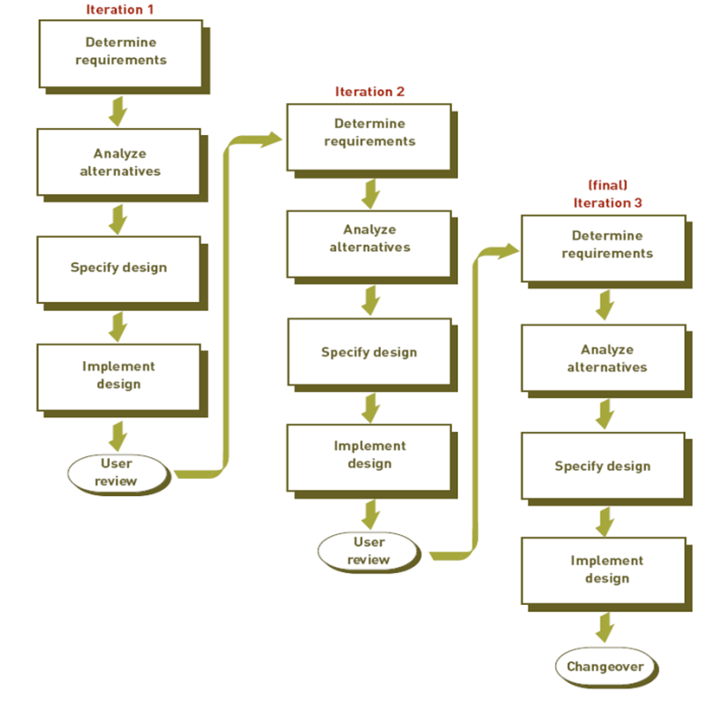

Lecture 28

Rapid Development Cycle, Joint Development Cycle

Rapid application development (RAD)

RAD employs tools, techniques, and methodologies designed to speed application development. E.g. a RAD tool called Rational Rapid Developer to make developing large Java programs and applications easier and faster. Benefits of RAD are that: it reduces paper based documentations and adapting to changing requirements easier. Other approaches to rapid development are Agile development and Extreme programming (XP), which allows the systems to change as the system is being developed. Agile development is constant interaction with system developers and users. XP uses pair of programmers who code and test parts of the systems they develop.

RAD makes extensive use of the joint application development (JAD), which is a process of data collection and requirement analysis in a group. It is most suited for developing MIS and DSS.

End-Use Systems Development Cycle

End-user systems development describes any systems development project in which business managers and users assume the primary effort. These systems developed can be small or very large. They can be developed by proper guidance from the IS professional but it has disadvantages. Some end users do not have the training to effectively develop and test a system and some of these systems have updating issues.

Out sourcing and On-demand Computing
Many companies hire an outside company that specializes in systems development to t.ake over most of the development of operational activities of the system. Any aspect of information system can be outsourced. There are many companies that offer these services, such as Accenture and Electronic Data Systems (EDS). Reasons Companies use outsourcing is:
- Reduces costs
- Obtains state-of-the-art technology
- Eliminates staffing and personnel problems
- Increases technological flexibility

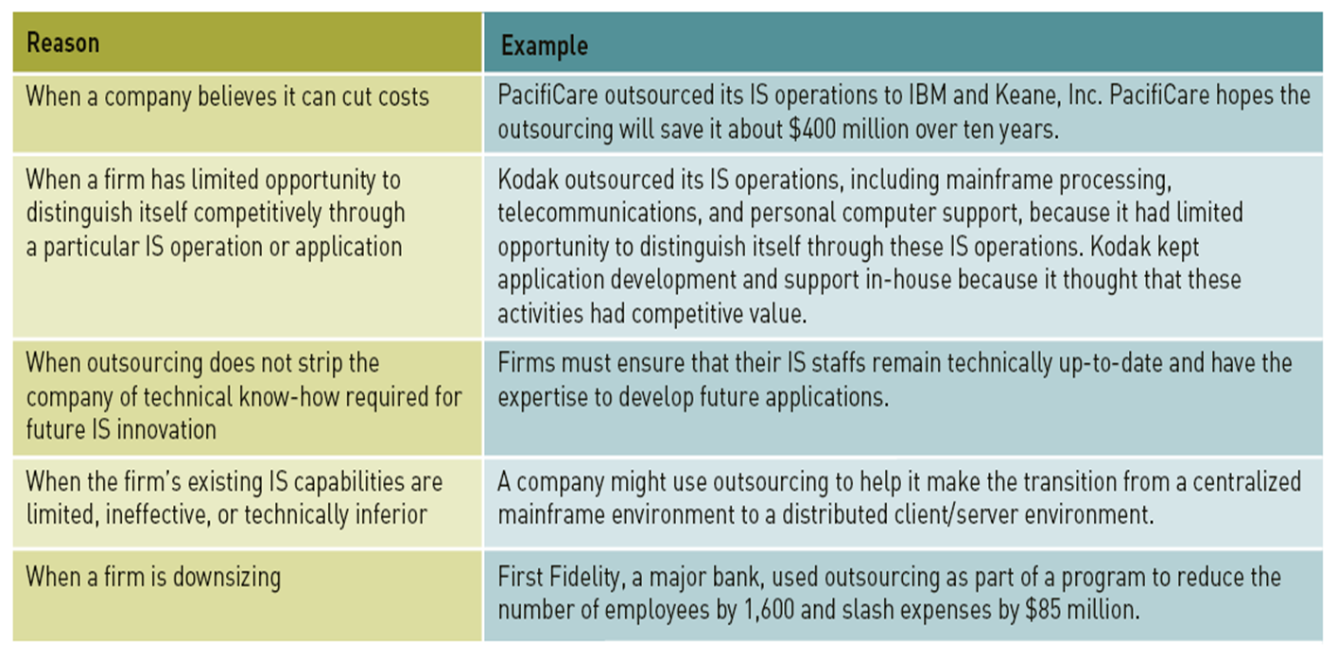

Factors Affecting Systems Development Success
- Degree of Change
- Continuous Improvement versus Reengineering
- Managing Change
- Quality and Standards
- Use of Project Management Tools
- Use of CASE tools
- Object Oriented Systems Development

Systems Investigation

The purpose of systems development is to identify potential problems and opportunities and consider themin the light of goals of the company. It uncovers the following questions:
- What primary problems might a new or enhanced system solve?
- What opportunities might a new or enhanced system provide?
- What new hardware, software, databases, telecommunications, personnel, or procedures will improve an existing system or are required in a new system?
- What are the potential costs (variable and fixed)?
- What are the associated risks?

- Initiating Systems Investigation

Systems Request Form is submitted by someone who wants IS department to initiate systems investigation, or improve some aspect of the IS. It is a formal procedure. The information included in the form consists of:
- Problems in or opportunities for system
- Objectives of systems investigation
- Overview of proposed system
- Expected costs and benefits of proposed system
- Participants in Investigation
First step after initiating the systems development is determine the development team, which consists of:
- Upper and middle level managers
- Project manager
- IS personnel
- Users, stakeholders
- Feasibility Analysis

This is the most important step of Investigation. This step assesses the feasibility of the following dimensions:
- Technical feasibility: concerned whether the hardware, software can be acquired or developed to solve the problem.
- Economic feasibility: assess if the benefits of the system are greater than the cost and time for development. Net present value is used to rant the competing projects.
- Legal feasibility: see whether there are certain laws or regulations preventing the systems development.
- Operational feasibility: whether project can be put into action or operation. This also includes if people will accept it.
- Schedule feasibility: determines whether project can be completed in a reasonable amount of time.

- The Systems Investigation Report

The primary outcome of systems investigation is the Investigation Report or Feasibility Report. It summarizes results of systems investigation and also recommends course of action: continue, modify or drop. The report reviewed by steering committee for further action.

Systems Analysis

After the project has been selected for further study, the next question is: What must the IS do to solve the problem? So, the general Considerations of this phase are:
- Clarify goals of the organization
- Assembling the participants of systems analysis
- Collecting appropriate data and requirements
- Analyzing the data and requirements
- Preparing report on existing system, new system requirements, project priorities
- Participants

The participants consist of the original development team. The team develops: List of objectives and activities, Deadlines, Statement of resources required and major milestones.

The analysis phase is divided into two important steps. Data Collection and Data Analysis.

Data Collection
Its purpose is to seek additional information about problem or the needs identifies in the Investigation Report. First part is to identify sources of data, including both internal and external sources. Next is Collecting Data, which requires a number of tools and techniques. These are:
- Structured interview
- Unstructured interview
- Direct Observation
- Questionnaires
- Statistical sampling

Data Analysis

It refers to manipulating the collected data so that it can be used. Relationships, and data flows are created for better understanding the systems. Tools and techniques for data analysis are as follows:
- Data Modeling is an approach to modeling organizational objects and associations that employees both text and graphics. It is represented by the ER diagram – which consists of objects and their relationships, where entities (objects) have certain attributes.
- Application Flowcharts show relationships among applications or systems. Different aspects of the system are represented by different shapes as shown in the diagram below.
- E.g. clear relationships among order processing functions
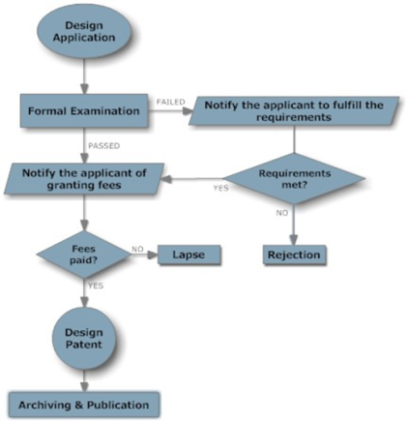
- Grid Chart is a table that shows relationships among various aspects of system development.
- E.g. a chart between showing various applications using different databases as shown in the figure below.

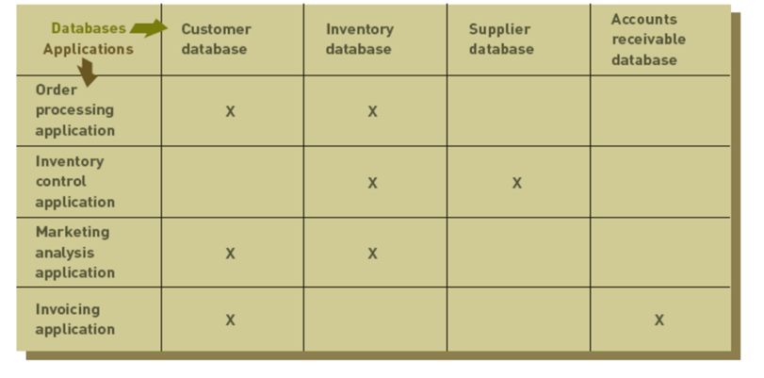
- Activity Modeling is done through the use of Data-flow diagrams (DFD). It models objects, associations and activities by describing how data can flow between and around objects. DFD describes activities that accomplish a business task
- Consists of four primary symbols
- Data flow
- Process symbol
- Entity symbol
- Data store
- Requirements Analysis

Purpose: determine user, stakeholder, and organizational needs. It captures requests of various people in detail. Some of the techniques of determining the needs are:
- Asking directly
- Works best for stable systems in which users understand system functions
- Using CSF
- Managers make list of factors that are critical to success of their field
- The IS Plan
- Translates strategic and organizational goals into systems development initiatives

- OO systems Analysis
- Object oriented approach is used to identify problems and show relationships by showing objects as classes
- Systems Analysis Report consists of:
- Strengths and weaknesses of existing system from a stakeholder’s perspective
- User/stakeholder requirements for new system
- Organizational requirements for new system
- Description of what new information system should do to solve the problem

Summary
- Effective systems development requires team effort as well as careful planning of the IS
- Systems development often uses tools to select and analyse project requirements
- Outsourcing is an option for cutting costs
- Investigation concerns the feasibility at different levels
- Analysis is concerned with collecting and analyzing data and requirements

Module 4: Systems Development

Chapter 14: Design and Implementation

Lecture 29

Learning Objectives
- Discuss System design and differences between logical and physical design
- Describe the considerations in interface design and system security design
- Describe techniques for system selection evaluation
- State the purpose of system implementation and discuss the activities associated with it
- List the advantages and disadvantages of purchasing versus developing software

This chapter is about how systems are designed and implemented and also how to avoid errors & recover from disasters.

Systems Design

Purpose: Answer HOW will the information system solve a problem?

Primary result is a technical design which is the details of system outputs, inputs, user interfaces, hardware, software, databases and telecommunications as well as their relation. Basically IS are designed for following purposes i.e. to overcome shortcomings of existing system and achieving organizational goals.

Systems design consists of two types of designs:

Logical Design describes functional requirements of a system, i.e. what the system will do? This involves planning the purpose of each system element, independent of hardware or software used. It specifies output, input, process, file, database, telecomm, procedures, security, personnel, and job requirements.

Physical Design specifies the characteristics of the system components necessary to put the logical design into action. It explains how tasks are accomplished. Physical design is based on technology as mentioned in module 2.

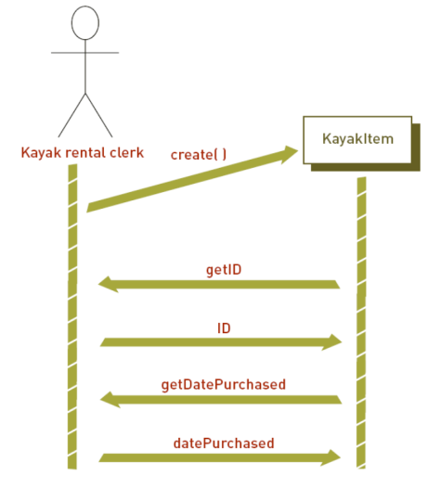
Now this logical and physical designs can be accomplished using either traditional approach or OO Design. Most organizations go for Object Oriented design due to increased flexibility. In this approach key objects and classes of objects are designed while considering the problem domain, the operating environment, and the user interface. It also considers the sequence of events that must happen for the system to function correctly. This is called a scenarios represented by a sequence diagram (figure below).

Interface design considerations

Some special system characteristics need to be considered in both logical and physical design. The interface design is about how users access & interact with system.

Sign-In procedure consists of identification, verification & authorization by use of passwords and ID, usually for gaining access to computer resources.

Interactive procedures define how people can directly interact with processing components of the system, which include:
- Menu-driven system
- Help facility
- Lookup table
- Restart procedure

Good interactive design/dialogue: has series of messages and prompts communicated between the system and user. The features include clarity, consistency, format, jargon and respect.

System Security design considerations
In additions to considering the user interface, designers should design system security and control for all aspects of system and various IT components. These considerations include:
- Preventing, Detecting, Correcting errors: Good system design should prevent errors before they occur – which means designing in such a way to prevent errors as well developing to detect and correct errors.
- Disaster Recovery and Planning: Disaster Planning is a process for anticipating and providing for disasters. Is focus is on maintaining integrity of corporate information and keeping IS running. Disaster Recovery is implementing the disaster plan. Tools related to recovery mostly concentrate on IT backup. Techniques include Hot site and Cold site. Also database backups are crucial and many techniques are provided by various DBMS for backing up and recreating database.
- Systems Controls: security lapses, fraud and privacy problems and prevention & detection is also part of the design. These controls help prevent computer misuse, crime and fraud by users. Some IS departments are either closed shops or open shops. Deterrence control is preventing problems before they occur, thus making computers more secure.

Generating Systems Design Alternatives

When the systems require a system that is to perform additional functions that existing system cannot support, then new H/W S/W needs to be purchased according to systems requirements, either from single vendor or multiple vendors.

Vendor is chosen according to the following criteria:
- Vendor’s reliability
- Service after sales
- Types of good/services it has
- Willingness to demonstrate
- Ability to modify software
- Offers training
- Evaluation by other clients

- Request for proposal (RFP)

It is a document that specifies required resources such as hardware and software in detail.

Different software are available for creation of professional RFP. The vendor selects the products that meet specifications and then quotes process. For inexpensive hardware, RFP are not necessary.
- Acquisition options
- Purchasing
- Leasing
- Renting

Renting is short term while leasing is a long term contract. There is no risk of obsolesce and no initial investment involved. On the other hand purchasing has its benefits of total control on the equipment and it is low cost if owned for longer period of time.

Evaluation and its Techniques

Evaluating and selecting a systems design, consists of two phases:

Preliminary evaluation: Dismiss unwanted proposals after investigating and comparing with criteria. Ask for formal presentation and to supply list of customers.

Final evaluation: Final demonstration (close to reality) with test data included. Also check other factors meet organizational objectives including cost comparisons, hardware performance, delivery dates, price flexibility etc.

Techniques used for doing the evaluation are:
- Apart from POI, TCO, customer satisfaction
- Group consensus: used for evaluating various reports and screen layouts
- Cost/benefit analysis: used for evaluating costs and benefits of systems or vendors
- Benchmark tests: measure the performance of a hardware or software with huge amounts of data
- Point evaluation: evaluating by assigning weights based on importance

Final Documents
- The Contract
- Between organization and Vendor
- List details of deal
- Also includes RFP
- The Design Report
- Systems Specifications

Lecture 30

Learning Objectives
- Discuss System design and differences between logical and physical design
- Describe the considerations in interface design and system security design
- Describe techniques for system selection evaluation
- State the purpose of system implementation and discuss the activities associated with it
- List the advantages and disadvantages of purchasing versus developing software

Systems Implementation

After design, no. of tasks need to be done before system is ready to be used. This includes hardware acquisition, programming and software acquisition or development, user preparation, hiring and training of personnel, site and data preparation, installation, testing and user acceptance.
- Acquiring Hardware

Organizations purchase, lease or rent hardware from IS vendor, which could be of different types such as: General or small computer manufacturers, Peripheral equipment manufacturers, Computer dealers and distributors. This also includes companies that provide computing services. Such as processing power, storage devices, network facilities.
- Acquiring Software

Software can be acquired in two ways, either making proprietary software or buying off the shelf software. Make or buy decision to be made by the company. In most cases it is a blend: e.g. OS are purchased or modify other off- the- shelf software. Or it is a blend between external and internal software development. The following table shows the comparison between off-the-shelf and developed software.

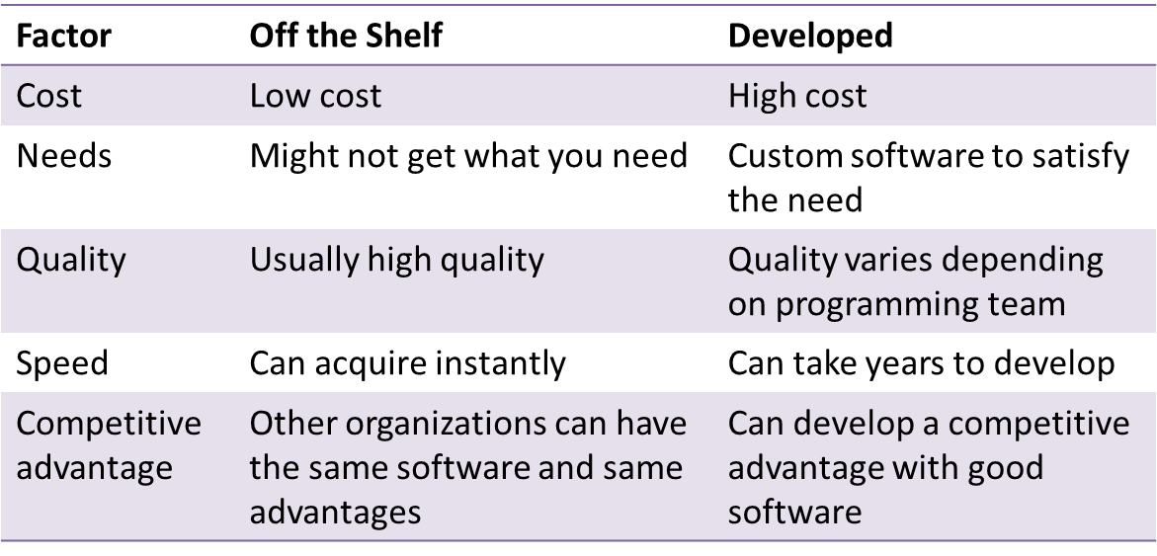
- Externally Acquired Software
When the software is acquired from vendors for development, it falls under two categories:
- Software as a Service (SaaS): (as mentioned in the chapter of emerging technologies)
- Commercial off-the-shelf (COTS): involves the use of commonly available products from the software vendors. Different software are bought from various vendors and combined into one finished product. They can be less expensive but have the challenge of integrating them into one software package.
- In-House Developed Software
When the software is developed in-house or internally, IS personnel are responsible for all aspect s of software development. It has a set of tools and techniques that are used.
- Chief programmer teams: skilled is personnel and programmers design and implement the programs.
- Structured programming: structured approach can be utilized for program development which includes sequence structure, decision structures and loop structures.
- CASE and object-oriented approach: OO approach can be utilized which involves CASE tools and .NET framework
- Cross-platform development: programs can be developed that run on multiple computer systems or operating systems. These include .NET by Microsoft.
- Integrated development environment (IDEs): IDEs combine tools needed for programming & programming languages in one integrated package. E.g. Visual Studio.
- Documentation: this is very important inn program development. Technical documentation contains purpose of each computer code and explanation. User documentation is to tell the users how the program can be used and its benefits.
- Acquiring Databases and telecommunication systems

There are acquired when there is a need of increased storage or new DBMS or to create networks and communication methods for business. Same hardware and software acquiring procedures are applied here as well.
- User Preparation

This involves readying managers, decision makers, employees, other users, and stakeholders for new systems. It is an important, but often ignored area of systems implementation. Employees should be trained and acquainted with the system’s qualities and limitations so that they become ready to use it.
- IS personnel: Hiring and Training

Training programs should be conducted for the IS personnel who will be using the computer system. These are more detailed than user training in the technical aspects of the systems.
- Site Preparation

This involves preparation of the location of a new system where it will be physically installed. Larger systems may require special equipment or rooms. Developing IS sites that are energy efficient is important.
- Data Preparation

It is also called data conversion. It ensuring all files and databases are ready to be used with new computer software and systems. E.g. the format of the payroll data needs to be converted.
- Installation

It is the process of physically placing computer equipment on the site and making it operational. Normally, manufacturer is responsible for installing computer equipment. However, someone from the organization (usually IS manager) should oversee the process.
- Testing
Good testing procedures take place to make sure system is working as expected. These testing include: Unit testing (testing each program), system testing (testing entire systems of program),volume testing (testing application with large amounts of data), integration testing (testing all related systems together), acceptance testing (testing that ensures performance objectives are satisfied). Other testing include:
- Alpha testing: testing incomplete early version
- Beta testing: testing full-version by end-users
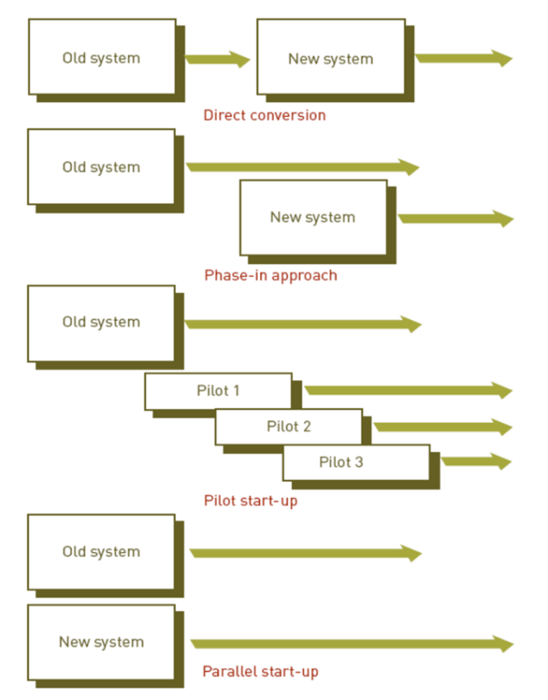
- Start Up (Cut over)

This happens after final testing. It is a process of making the final tested information system fully operational. Proper start up is very crucial. There are various methods of doing start- up, which include: Direct Conversion means stopping old systems and starting new systems at the same time on the same date. This might pose user and technical problems. Phase-in approach can be utilized when new components of the system are slowly phased in and old components are phased out. The process takes months and is repeated for each application. Pilot start-up is about running the system in one department or one group of users first, e.g. in one retail outlet. Parallel start-up involves running both the old and new systems simultaneously and switching over only when users are confident.

Systems Operation and Maintenance
- Systems operation:

Use of a new or modified system to see whether it has the performance and benefits as perceived
- Systems maintenance:

Checking, changing, and enhancing the system to make it more useful in achieving user and organizational goals
- Reasons for Maintenance
- Changes in business processes
- New requests from stakeholders, users, and managers
- Bugs or errors in program
- Technical and hardware problems
- Corporate mergers and acquisitions
- Government regulations
- Types of maintenance: Slipstream upgrade, Patch, Release, Version
- Performing Maintenance is constituted of the maintenance team that is responsible for modifying, fixing, and updating existing software Today maintenance function is becoming more automated.

Systems Review

Final step of systems development cycle. It analyzes systems to make sure that they are operating as intended. This process often compares the performance and benefits of the system as it was designed with the actual performance and benefits of the system in operation.

Types of Review procedures: Event-driven review is triggered by a problem or opportunity. Time-driven review is performed after a specified amount of time. E.g. many application programs are reviewed after six months. Or certain other application is reviewed after one year and from this review phase, the new systems development cycle might start again.

Systems Performance Measurement
Review often involves Systems performance measurement which is Monitoring the system for number of errors encountered, amount of memory required, amount of processing or CPU time needed etc. System performance products are software that measures all components of the computer-based information system and assist in assessing system performance.

CASE STUDY: Port of Brisbane Develops System to Tighten Security

(PIS, Chapter 13, page: 606, 607)

Salient points are highlighted in the lecture recording, however questions to be given as assignment.

Module 5: IS in Business and Society

Chapter 15: Social and Ethical Issues in IS

LECTURE 31

Learning Objectives
- Identify what social, ethical and political issues are raised by information systems
- Understand the five moral dimension of information systems
- Understand the social and ethical side effects of using technology in business

Ethics
- Principles of right and wrong that individuals use to make choices
- IS raise new ethical questions
- Create opportunities for intense social change
- Threaten existing distributions of power, money, rights and obligations
- Issues increase because of Internet and e-commerce
- These technologies make assembling, integrating and distributing information more easily

Ethical, Social and Political Issues

Ethical Dilemma has social and political effects

In traditional social setting people have developed rules of behaviour

Supported by laws

Information Systems might act as disturbing force – causing ripples

Takes years to develop etiquettes, expectations, social responsibilities, politically correct attitudes and approved rules

Technology Trends That Raise Ethical Issues
- Computer Power
- Rely on IT for core processes
- Data storage techniques
- Increasing databases on people
- Data analysis techniques
- Profiling
- Nonobvious Relationship Awareness (NORA)
- Networking developments
- Mining large pools of data remotely

Basic Concepts
- Responsibility
- Accepting potential costs, duties and obligations for the decisions made
- Accountability
- Mechanism in place to determine who took responsible action and who is responsible
- Liability
- Feature of political systems in which a body of law is in place that permits individuals to recover the damages done to them by other actors, systems or organizations

- Using information technology in a socially responsible manner means that you can and will be held accountable for the consequences of your actions

Moral Dimensions of Information Systems
- Information Rights: Privacy and Freedom in the Internet Age

Concept of Privacy and related laws

Challenges to privacy: Cookies, web beacons, spy ware

Technical solution: P3P (Platform for Privacy Preferences)
- Property Rights: Intellectual Property

Intellectual Property protected by three legal traditions

Trade secrets, copyright, patents

Challenges to intellectual property rights: internet, contemporary technologies, copying and distributing

Digital Media: Ease of transmission, ease of replication, ease of alteration and compactness

1998- Digital Millennium Copyright Act (DMCA)
- Accountability, Reliability and Control

Challenges existing liability laws and social practices that hold individuals/institutions responsible

Offensive material – who is responsible?

Internet is just a carrier, but content on web sites can be regulated
- System Quality: Data Quality and System Errors

What is technologically feasible level of system quality?

Sometimes correcting errors is not feasible economically

Problems caused by data entry errors
- Quality of Life: Access and Boundaries

Negative social consequences of IS

Balancing power – central versus distributed structure of power

Rapidity of change – reduced response time to global competition can effect companies

Maintaining boundaries – ‘do anything anywhere’ computing environment weakens traditional boundaries of life

Dependence and vulnerability – too much dependence on IS while standard and regulations missing

Computer crime and Abuse – acts that are either illegal or unethical

Equity and access – class differences and cultural gaps still prevail

Health risks – repetitive stress injury (RSI), computer vision syndrome (CVS), technostress

Regulations in Pakistan
- Regulatory Authorities
- Pakistan Telecommunications Authority
- Rules, regulations, policies, Act
- Block offensive content
- FIA’s National Response Center for Cyber Crimes (NR3C)
- Electronic Transactions Ordinance 2002
- E.g. Spamming defined with fine stated as of Rs. 50,000

Various Examples from Case Studies
- Identity Theft at Marriot International 2005 (PIS, Chapter 3, page: 112, 113)
- Sharing workstations of hospital’s health system (PIS, Chapter 6, page: 259, 260)
- Disaster Recovery Problems (PIS, Chapter 9, page:383, 384)
- Books and Music e-commerce site aligns security strategy with corporate goals (PIS, Chapter 14, page: 653, 654)

Summary
- Ethical Social and political issues regarding IS are all related
- It is important for companies to device Information security policies and use IT accordingly
- Moral dimension of IS need to be kept into considerations when designing Information Systems

Management Information Systems

Revision

Module 1: Overview of Information Systems in Organization

Module 1: Overview of Information Systems in Organization
- Value of Information is directly linked with how it helps decision makers achieve organizational goals
- Information Systems (IS) are used in organizations to achieve the business goals
- Sociotechnical system is an approach to develop IS where key point is learning, training, planned change

Module 1: Overview of Information Systems in Organization
- Kind of IS deployed has affects on organizational structure, culture, change and business processes
- Technology Acceptance Model (TAM) is believed to lead to higher acceptance of IS

Module 2: Information Technology Infrastructure
- IT infrastructure consists of a ‘service platform’ that encompasses hardware and software and other related services
- The kind of hardware used needs to be in accordance with input, out, processing and storage requirements
- System and Application software are critical is achieving organizational goals
- Propriety software is effective only when it meets organizational need or achieve competitive advantage

Module 2: Information Technology Infrastructure
- Technologies continue to grow so businesses need to be aware of emerging technologies and trends which include grid computing and cloud computing

Module 2: Information Technology Infrastructure
- Competitive forces Model (CFM) could be used to solve the management issues of IT infrastructure

Module 2: Information Technology Infrastructure
- Databases play a very important role in the overall effectiveness of IS
- Businesses use various techniques to maximize the value of information provided from databases (which are used to make decision and run operations)
- Data warehousing , business intelligence (data mining and OLAP), web and text mining
- Maintaining data quality is the biggest challenge and data integrity should never be compromised

Module 2: Information Technology Infrastructure
- For any kind of business networking and telecommunications support holds importance
- There could be many applications e.g. creating small business networks, EDI, EFT, videoconferencing, distance learning
- Number of applications of the Internet and Web in businesses e.g. VoIP, internet services, content streaming, FTP, web auctioning

Module 2: Information Technology Infrastructure
- IS security: understanding the vulnerability of systems e.g. security breaches, hardware breakdowns, offshoring, portability of smart phones and it’s apps
- Vulnerabilities increase with the use of internet and wireless communications
- Malicious software, hacking techniques and computer crime greatly sabotage the systems
- Business need to develop frameworks for security and control and deploy tools and techniques to enforce security policies

Module 3: Business Information Systems
- Businesses should know the uniqueness and advantages of e-commerce while knowing the different ways to do e-commerce (business models) and how to generate revenue (revenue models)
- Effective e-commerce is dependent on a successful website
- Setting objectives, building, bringing traffic and maintaining
- Enterprise Systems ensure information is shared across all business functions at all levels of the organization

Module 3: Business Information Systems
- CRM used in businesses to provide customer satisfaction, customer acquisition and retention and meeting customer demands on time

Module 3: Business Information Systems
- SCM systems used in businesses if the supply chain is large and complex so IS help the supply chain management in various aspects
- Tracking shipment, status of orders, rapid communication)
- TPS is used in performing the fundamental business operations, where work is routine based, less complex and handle large amount of data
- MIS provides managers with insight (control, plan, organize) in regular operations
- Report based output
- Businesses use MIS in various functional areas

Module 3: Business Information Systems
- Decision making is cognitive process
- DSS are built in a way to provide support for various problem solving phases, decision frequencies, different structure
- Business intelligence concepts are used in DSS
- Special purpose DSS – ESS – used by executives to help them with strategic planning, defining vision, strategic control and crisis management
- Knowing how to do things efficiently is a primary source of profit and competitive advantage

Module 3: Business Information Systems
- KMS: the knowledge companies gather needs to be retained in knowledge management systems (create, store, share, use)
- Artificial Intelligence systems form a diverse set of systems that can replicate human decision making for certain types of well-defined problems
- Expert systems can be used to medical diagnosis, crisis management, plant layout, credit granting and loan analysis

Module 4: Systems Development
- Considering IS development as a project and managing the project is important
- High rate of failure among IS projects in due to the inadequate project management there fore important to have knowledge about managing IS project and causes of failure
- Linking systems project plans with business plans in stressed
- Also successful systems development is dependent on change management
- Behavioural and organizational impact
- Sociotechnical design

Module 4: Systems Development
- Effective systems development also requires team effort and careful planning
- Long range IT use
- IS resource use
- Competitive advantage

Module 4: Systems Development
- Identify the problem
- What the system should do to solve the problem
- How should the system solve the problem
- Implement the solution
- Evaluate the working of the new solution

Module 4: Systems Development
- Systems Request Form
- Feasibility Analysis Report (Systems Investigation Report)
- Systems Analysis Report
- Systems Specifications (+ Contract)
- Documentation (user and technical)

Module 5: IS in Business and Society
- IS has ethical, social and political impacts
- Moral dimensions of IS need to be considered when deploying in the organization
- Computer crime is a serious and rapidly growing are of concern requiring management attention and government regulations

