
COMSATS Institute of Information Technology (Virtual Campus)

Block F, NISTE Building, H-8/1 Islamabad Pakistan

Wireless and Mobile Computing CSC-344
Handouts

Introduction
- Wireless Comes of Age
- The Cellular Revolution
- The Global Cellular Network
- Broadband
- Future Trends
- The Trouble With Wireless

- WIRELESS COMES OF AGE
Guglielmo Marconi invented the wireless telegraph in 1896. In 1901, he sent telegraphic signals across the Atlantic Ocean from Cornwall to St. John’s Newfoundland; a distance of about 3200 km. His invention allowed two parties to communicate by sending each other alphanumeric characters encoded in an analog signal. Over the last century, advances in wireless technologies have led to the radio, the television, the mobile telephone, and communications satellites. All types of information can now be sent to almost every corner of the world. Recently, a great deal of attention has been focused on satellite communications, wireless networking, and cellular technology.
Communications satellites were first launched in the 1960s. Those first satellites could only handle 240 voice circuits. Today, satellites carry about one-third of the voice traffic and all of the television signals between countries [EVAN98]. Modern satellites typically introduce a quarter-second propagation delay to the signals they handle. Newer satellites in lower orbits, with less inherent signal delay, have been deployed to provide data services such as Internet access.
Wireless networking is allowing businesses to develop WANs, MANs, and LANs without a cable plant. The IEEE has developed 802.11 as a standard for wireless LANs. The Bluetooth industry consortium is also working to provide a seamless wireless networking technology.
The cellular or mobile telephone is the modern equivalent of Marconi’s wireless telegraph, offering two-party, two-way communication. The first-generation wireless phones used analog technology. These devices were heavy and coverage was patchy, but they successfully demonstrated the inherent convenience of mobile communications. The current generation of wireless devices is built using digital technology. Digital networks carry much more traffic and provide better reception and security than analog networks. In addition, digital technology has made possible value-added services such as caller identification. Newer wireless devices connect to the Internet using frequency ranges that support higher information rates.
The impact of wireless communications has been and will continue to be profound. Very few inventions have been able to “shrink” the world in such a manner. The standards that define how wireless communication devices interact are quickly

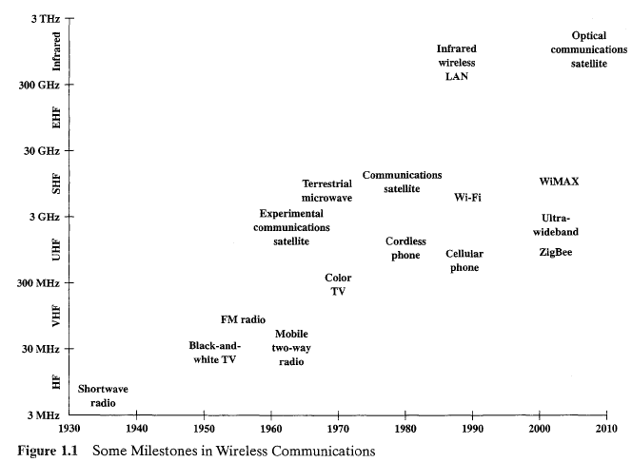

converging and soon will allow the creation of a global wireless network that will deliver a wide variety of services. Figure 1.1 highlights some of the key milestones in the development of wireless communications. Wireless technologies have gradually migrated to higher frequencies.
As will be seen in later chapters, higher frequencies enable the support of greater data rates and throughput.

1.2 THE CELLULAR REVOLUTION

The cellular revolution is apparent in the growth of the mobile phone market alone. In 1990, the number of users was approximately 11 million [ECON99]. Today, that number is in the billions. According to the ITU (International Telecommunications Union),³ the number of mobile phones worldwide outnumbered fixed-line phones for the first time in 2002. The newer generation devices, with access to the Internet and built-in digital cameras, add to this momentum. There are a number of reasons

for the increasing dominance of mobile phones. Mobile phones are convenient; they move with people. In addition, by their nature, they are location aware. A mobile phone communicates with regional base stations that are at fixed locations.
Technical innovations have contributed to the success of mobile phones. The handsets have become smaller and lighter, battery life has increased, and digital technology has improved reception and allowed better use of a finite spectrum. As with many types of digital equipment, the costs associated with mobile telephones have been decreasing. In areas where competition flourishes, prices have dropped dramatically since 1996.
In many geographic areas, mobile telephones are the only economical way to provide phone service to the population. Operators can erect base stations quickly and inexpensively when compared with digging up ground to lay copper in harsh terrain.
Mobile telephones are only the tip of the cellular revolution. Increasingly, new types of wireless devices are being introduced. These new devices have access to the Internet. They include personal organizers and telephones, but now they have Web access, instant messaging, e-mail, and other services available on the Internet. Wireless devices in automobiles allow users to download maps and directions on demand. Soon, the devices may be able to call for help when an accident has occurred or perhaps notify the user of the lowest-priced fuel in the immediate area. Other conveniences will be available as well. For example, refrigerators may one day be able to order groceries over the Internet to replace consumed items.
The first rush to wireless was for voice. Now, the attention is on data. A big part of this market is the “wireless” Internet. Wireless users use the Internet differently than fixed users. Wireless devices have limited displays and input capabilities compared with typical fixed devices such as the PC. Transactions and messaging will be the rule instead of lengthy browsing sessions. Because wireless devices are location aware, information can be tailored to the geographic location of the user. Information will be able to find users, instead of users searching for information.
  - THE GLOBAL CELLULAR NETWORK
Today there is no single cellular network. Devices support one or two of a myriad of technologies and generally work only within the confines of a single operator’s network. To move beyond this model, more work must be done to define and implement standards.
The ITU is working to develop a family of standards for the next-generation wireless devices. The new standards will use higher frequencies to increase capacity. The new standards will also help overcome the incompatibilities introduced as the different first- and second-generation networks were developed and deployed over the last decade.
The dominant first-generation digital wireless network in North America was the Advanced Mobile Phone System (AMPS). This network offers a data service using the Cellular Digital Packet Data (CDPD) overlay network, which provides a 19.2-kbps data rate. The CPDP uses idle periods on regular voice channels to provide the data service.
The key second-generation wireless systems are the Global System for Mobile Communications (GSM), Personal Communications Service (PCS) IS-136, and PCS IS-95. The PCS standard IS-136 uses time division multiple access (TDMA) while IS-95 uses code division multiple access (CDMA). The GSM and PCS IS-136 use dedicated channels at 9.6 kbps to deliver the data service.
The ITU is developing International Mobile Telecommunications-2000 (IMT- 2000). This family of standards is intended to provide a seamless global network. The standards are being developed around the 2-GHz frequency band. The new standards and frequency band will provide data rates up to 2 Mbps.
In addition to defining frequency usage, encoding techniques, and transmission, standards also need to define how mobile devices will interact with the Internet. Several standards bodies and industry consortiums are working to that end. The Wireless Application Protocol (WAP) Forum is developing a common protocol that allows devices with limited display and input capabilities to access the Internet. The Internet Engineering Task Force (IETF) is developing a mobile IP standard that adapts the ubiquitous IP protocol to work within a mobile environment.
  - BROADBAND
The Internet is increasingly a multimedia experience. Graphics, video, and audio abound on the pages of the World Wide Web. Business communications are following the same trend. For example, e-mail frequently includes large multimedia attachments. In order to participate fully, wireless networks require the same high data rates as their fixed counterparts. The higher data rates are obtainable with broadband wireless technology.
Broadband wireless service shares the same advantages of all wireless services: convenience and reduced cost. Operators can deploy the service faster than a fixed service and without the cost of a cable plant. The service is also mobile and can be deployed almost anywhere.
There are many initiatives developing broadband wireless standards around many different applications. The standards cover everything from the wireless LAN to the small wireless home network. Data rates vary from 2 Mbps to well over 100 Mbps. Many of these technologies are available now and many more will become available in the next several years.
Wireless LANs (WLANs) provide network services where it is difficult or too expensive to deploy a fixed infrastructure. The primary WLAN standard is IEEE 802.11, which provides for data rates as high as 54 Mbps.
A potential problem with 802.11 is compatibility with Bluetooth. Bluetooth is a wireless networking specification that defines wireless communications between devices such as laptops, PDAs, and mobile phones. Bluetooth and some versions of 802.11 use the same frequency band. The technologies would most likely interfere with each other if deployed in the same device.
  - FUTURE TRENDS
Much of the development effort in new wireless technology makes use of portions of the frequency spectrum that do not, in many countries, require licensing. In the United States, two such frequency bands are Industrial, Scientific, and Medical
(ISM) band near 2.4 GHz and the newly allocated unlicensed radio band, the Unlicensed National Information Infrastructure (UNII) band. UNII was created by the FCC (Federal Communications Commission) to allow manufacturers to develop high-speed wireless networks. In order to find enough bandwidth to satisfy needs, the band was established at 5 GHz, making it incompatible with 2.4-GHz equipment. The free, unlicensed portions of the radio spectrum enable manufacturers to avoid billions of dollars in licensing fees.
For years, these radio frequencies were neglected, the lonely domain of cordless phones and microwave ovens. In recent years however, spurred by consumer demand and active standards bodies, considerable research and development is underway. The first significant fruit of this activity is Wi-Fi (Wireless Fidelity), the very popular wireless LAN technology based on the IEEE 802.11 standards. In essence, Wi-Fi refers to 802.11-compatible products that have been certified as interoperable by the Wi-Fi Alliance, a body specifically set up for this certification process. Wi-Fi covers not only office-based LANs, but also home-based LANs and publicly available hot spots, which are areas around a central antenna in which people can wirelessly share information or connect to the Internet with a properly equipped laptop. Wi-Fi is examined in some detail in Chapter 14.
Wi-Fi is just the first major step in utilizing these bands. Four other innovative technologies are working their way through the research, development, and standardization efforts: WiMAX, Mobile-Fi, ZigBee, and Ultrawideband. We survey these technologies briefly in this section.
WiMAX is similar to Wi-Fi. Both create hot spots, but while Wi-Fi can cover several hundred meters, WiMAX has a range of 40 to 50 km. Thus, WiMAX provides a wireless alternative to cable, DSL, andTl/El for last-mile broadband access. It will also be used as complimentary technology to connect 802.11 hot spots to the Internet. Initial deployments of WiMAX are in fixed locations, but a mobile version is under development. WiMAX is an interoperability specification based on IEEE 802.16 and is discussed in more detail in Chapter 11.
Mobile-Fi is similar to the mobile version of WiMAX in terms of technology. The objective with Mobile-Fi is to provide Internet access to mobile users at data rates even higher than those available in today’s home broadband links. In this context, mobile truly means mobile, not just movable. Thus, a Mobile-Fi user could enjoy broadband Internet access while traveling in a moving car or train. Mobile-Fi is based on the IEEE 802.20 specifications.
ZigBee functions at a relatively low data rate over relatively short distances, compared to Wi-Fi. The objective is to develop products that are very low cost, with low power consumption and low data rate. ZigBee technology enables the coordination of communication among thousands of tiny sensors, which can be scattered throughout offices, farms, or factories, picking up bits of information about temperature, chemicals, water, or motion. They’re designed to use little energy because they’ll be left in place for 5 or 10 years and their batteries need to last. ZigBee devices communicate efficiently, passing data over radio waves from one to the other like a bucket brigade. At the end of the line the data can be dropped into a computer for analysis or picked up by another wireless technology like Wi-Fi or WiMAX.
Ultrawideband serves a very different purpose than the other technologies mentioned in this section. Ultrawideband enables the movement of massive files at
high data rates over short distances. For example, in the home, Ultrawideband would allow the user to transfer hours of video from a PC to a TV without any messy cords. On the road, a passenger who has a laptop in the trunk receiving data over Mobile-Fi could use Ultrawideband to pull that information up to a handheld computer in the front seat.
  - THE TROUBLE WITH WIRELESS
Wireless is convenient and often less expensive to deploy than fixed services, but wireless is not perfect. There are limitations, political and technical difficulties that may ultimately prevent wireless technologies from reaching their full potential. Two issues are incompatible standards and device limitations.
As mentioned previously, in North America there are two standards for digital cellular service. Internationally, there is at least one more. A device using PCS IS-136 will not work in an area where the deployed technology is PCS IS-95. Also mentioned previously is the inability to use Bluetooth and 802.11 in the same device. These are just two examples of problems that arise when industrywide standards do not exist. The lack of an industrywide standard holds the technologies back from delivering one of the true ideals of wireless: ubiquitous access to data.
Device limitations also restrict the free flow of data. The small display on a mobile telephone is inadequate for displaying more than a few lines of text. In addition, most mobile wireless devices cannot access the vast majority of WWW sites on the Internet. The browsers use a special language, wireless markup language (WML), instead of the de facto standard HTML.
Most likely, no one wireless device will be able to meet every need. The potential of wireless can be met but not with a single product. Wireless will succeed because it will be integrated into a variety of devices that can meet a variety of needs.

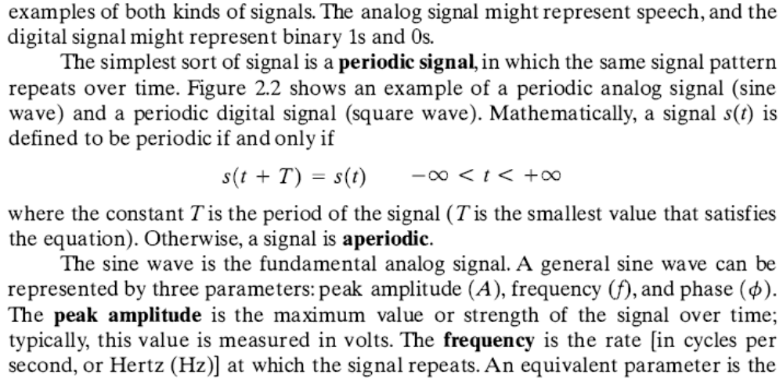

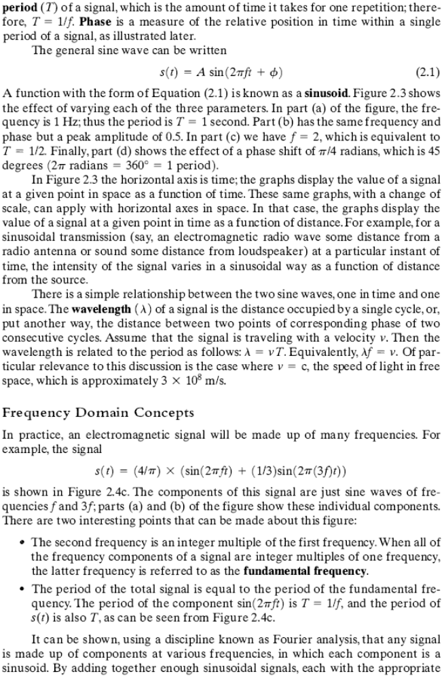
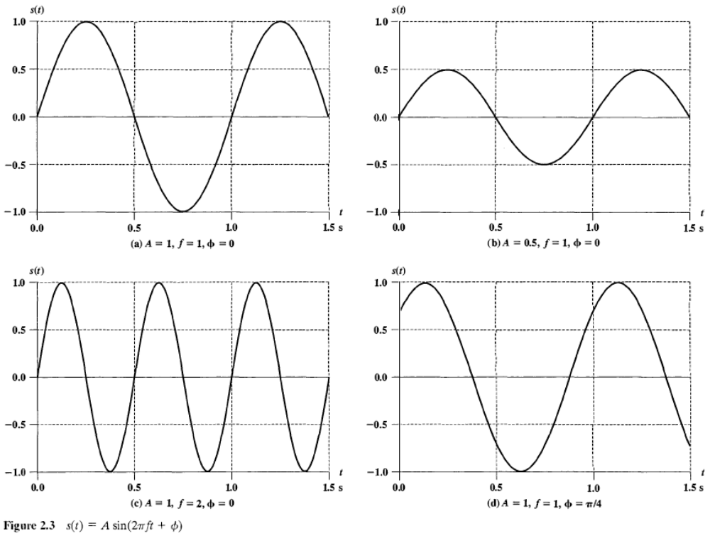

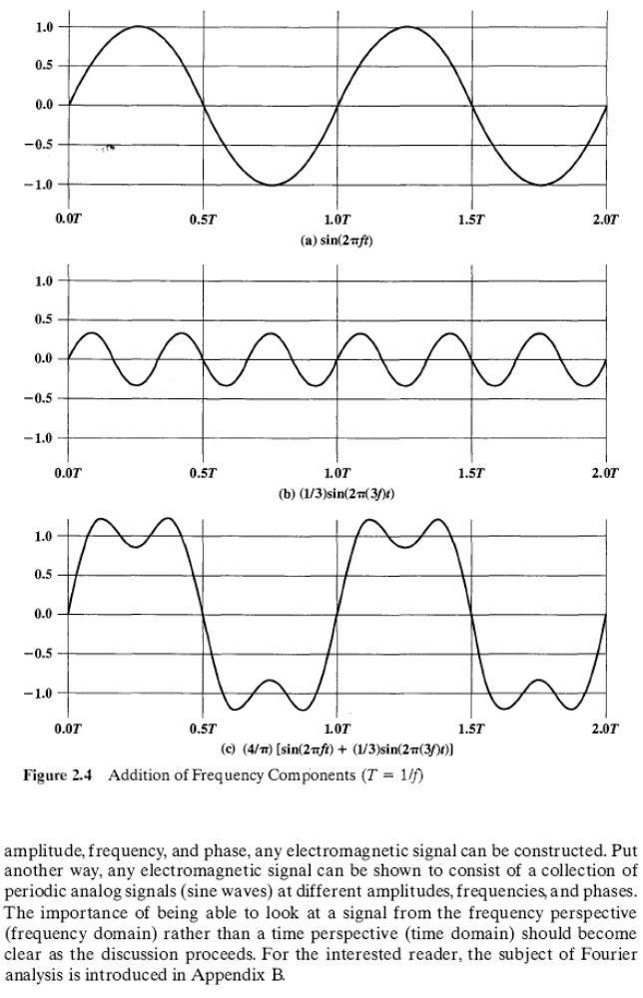
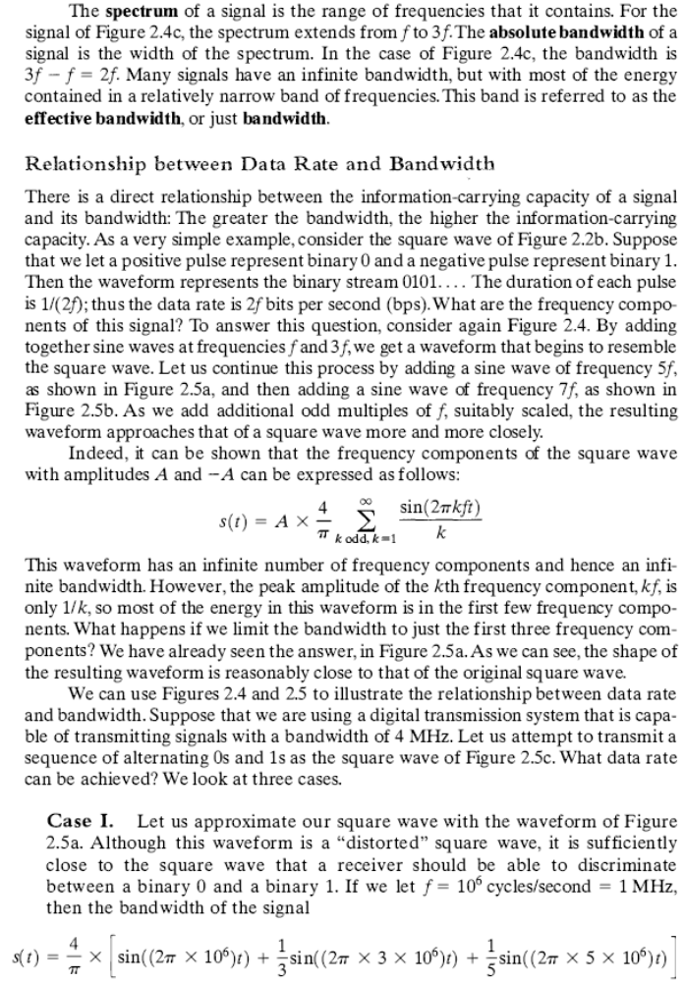
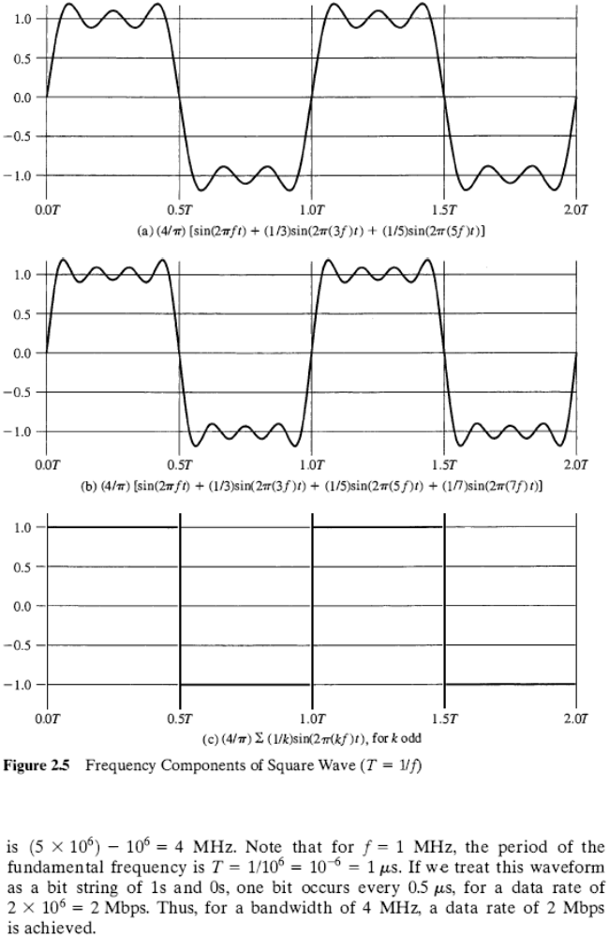
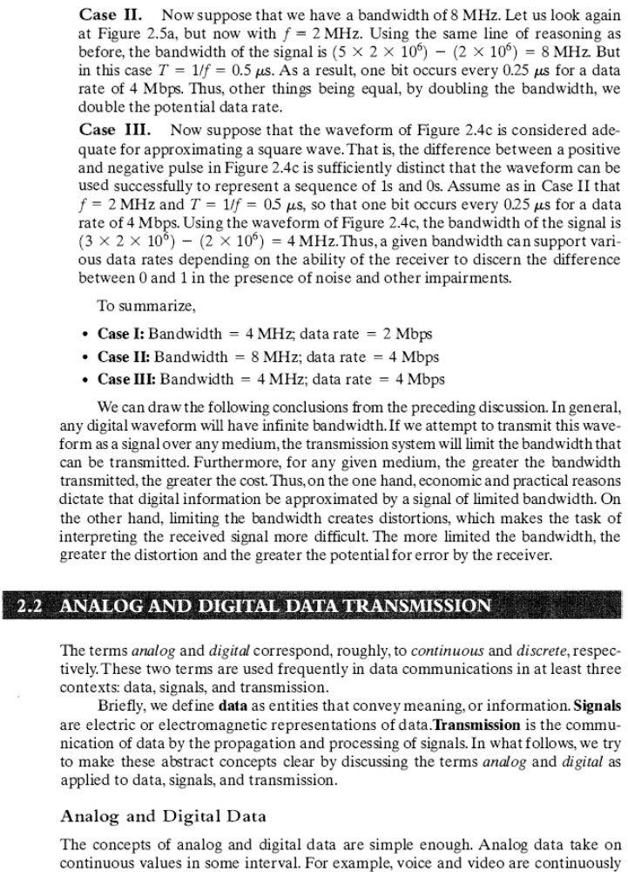
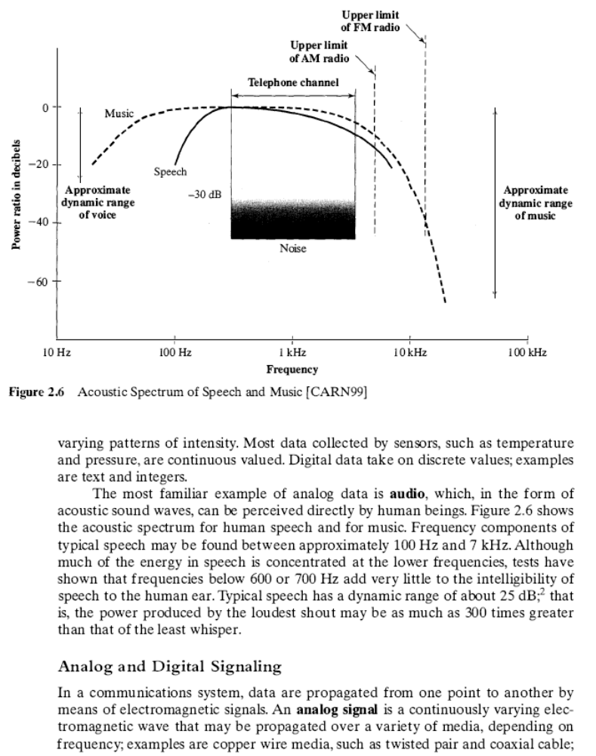

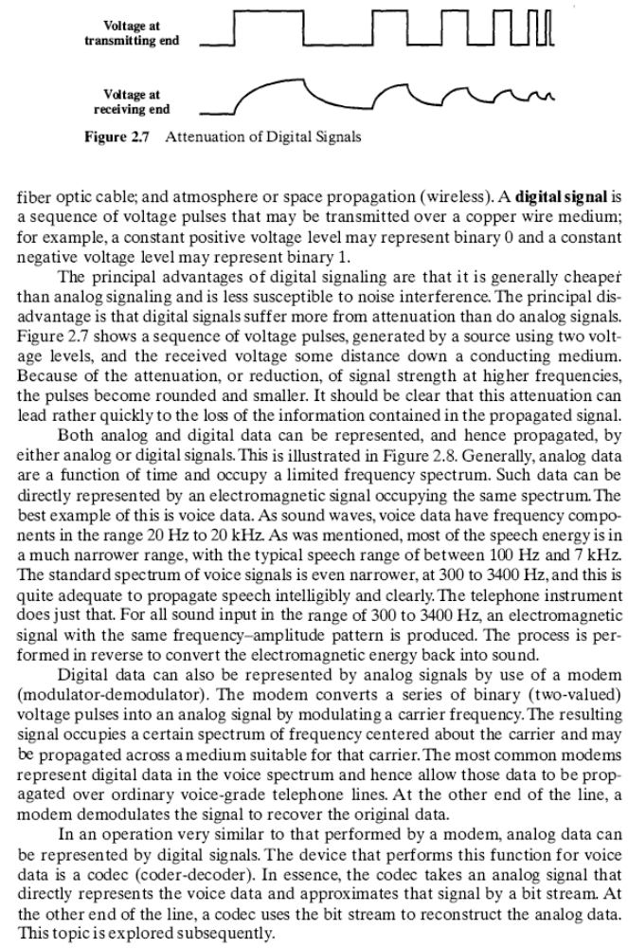
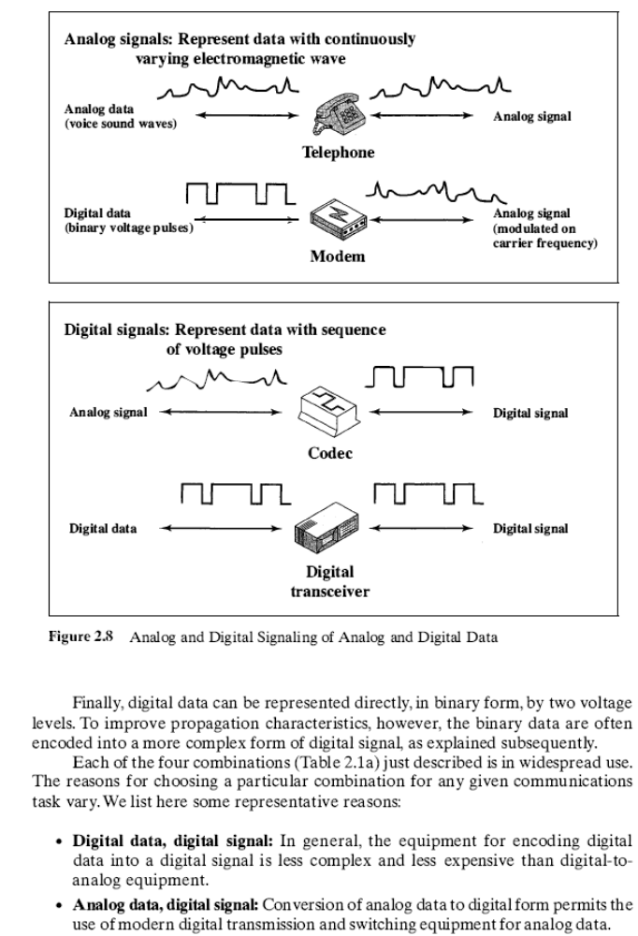
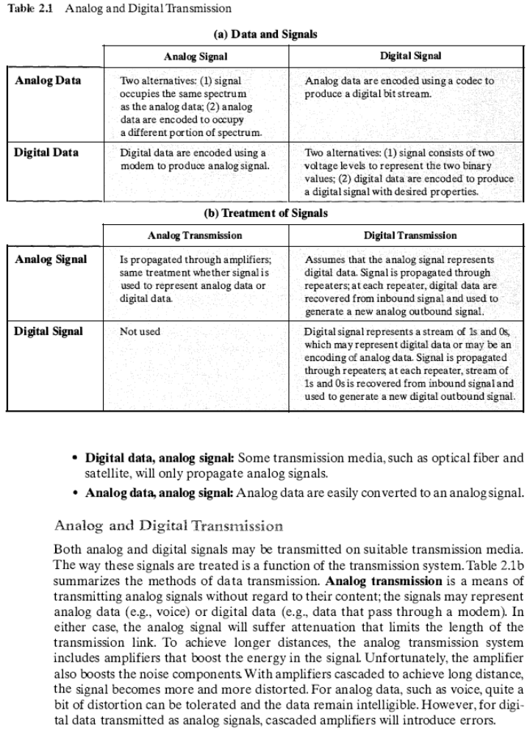
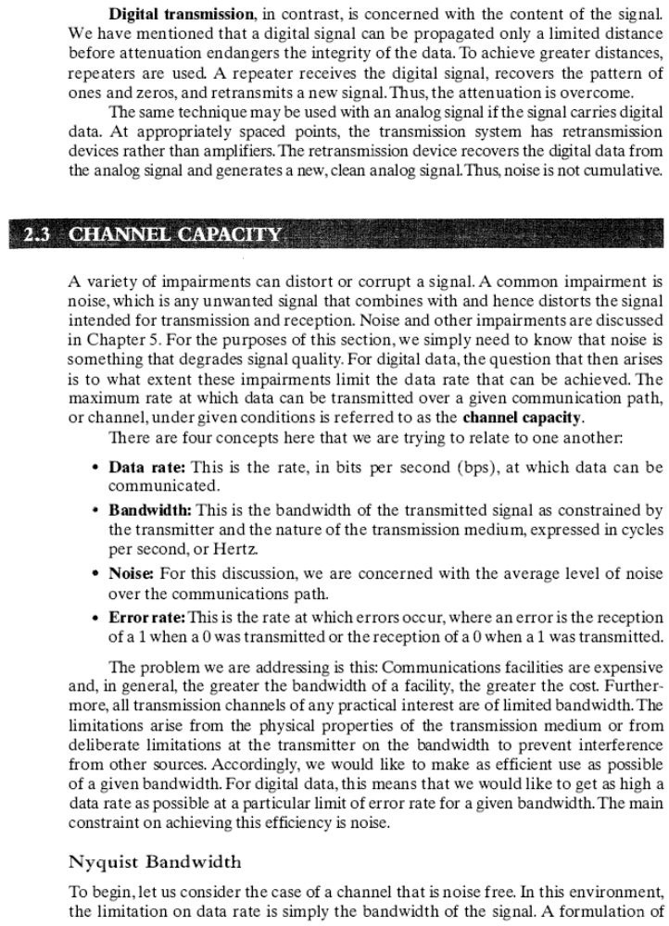
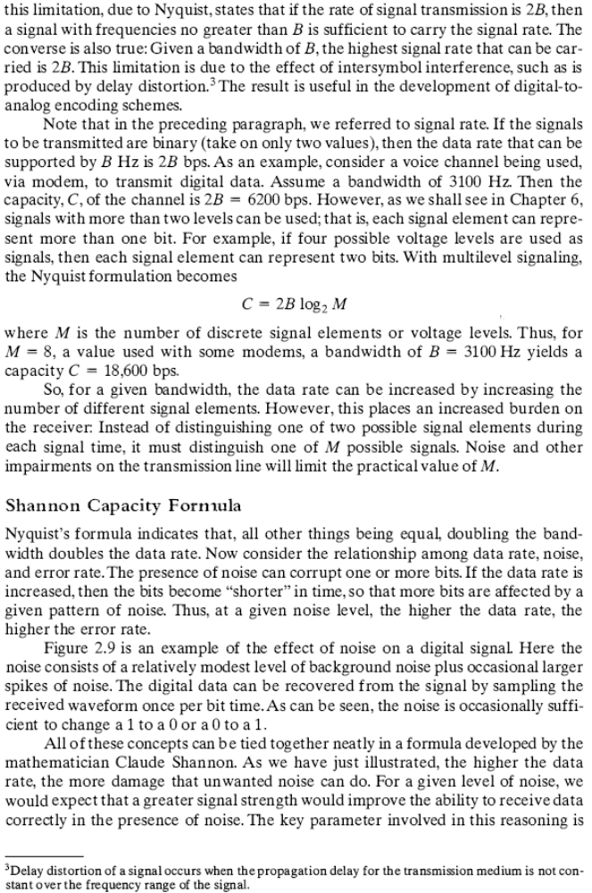
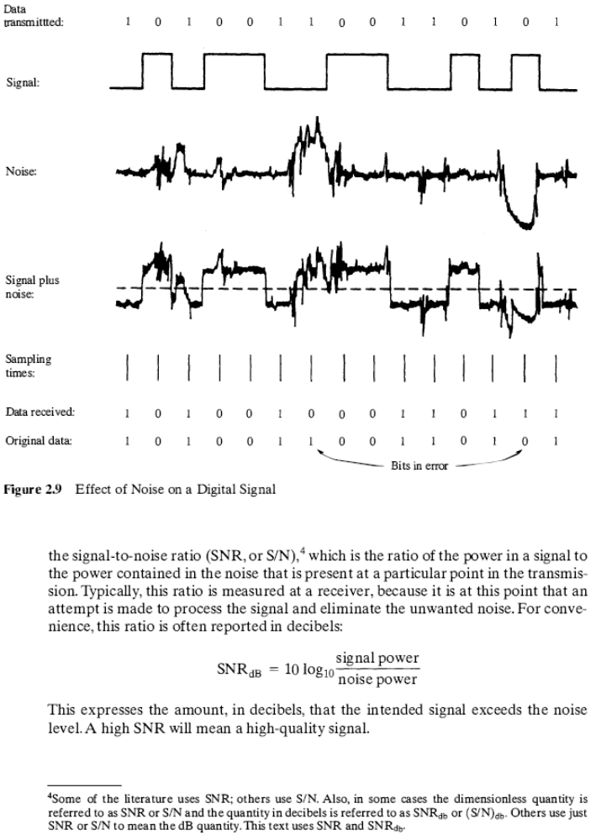
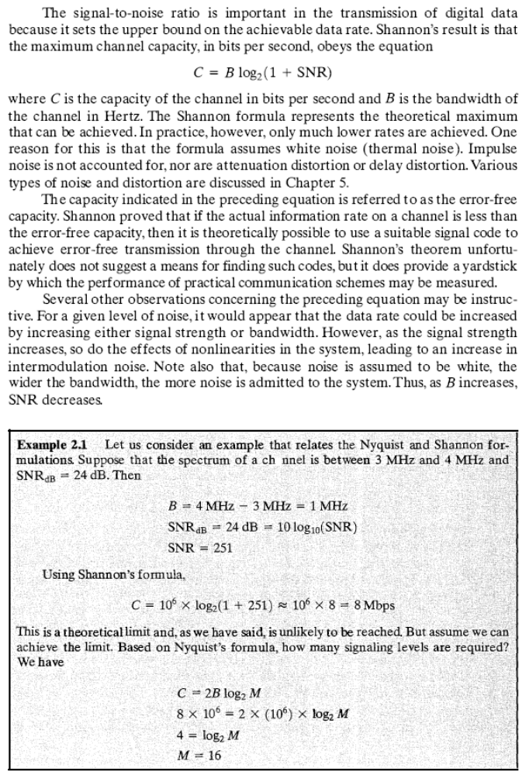
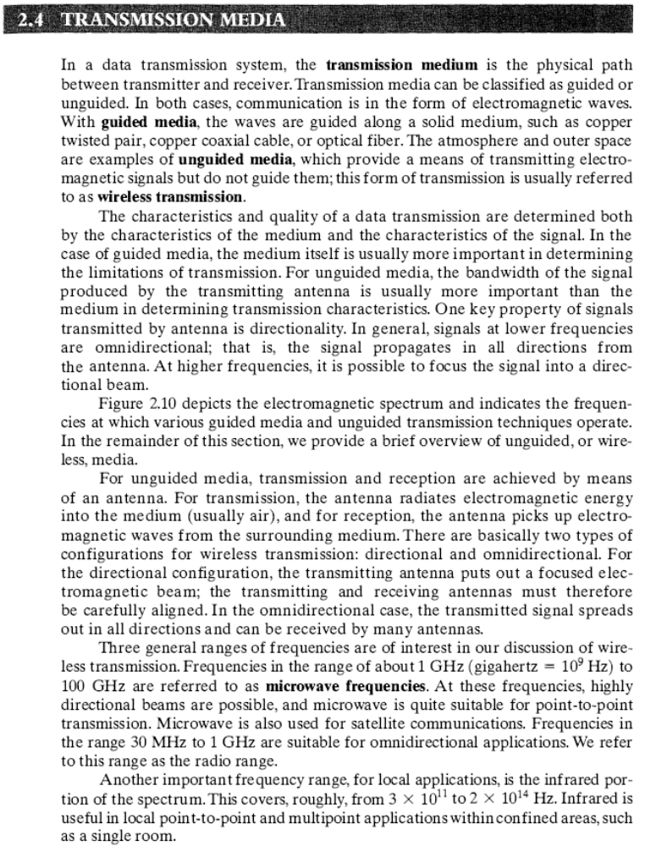

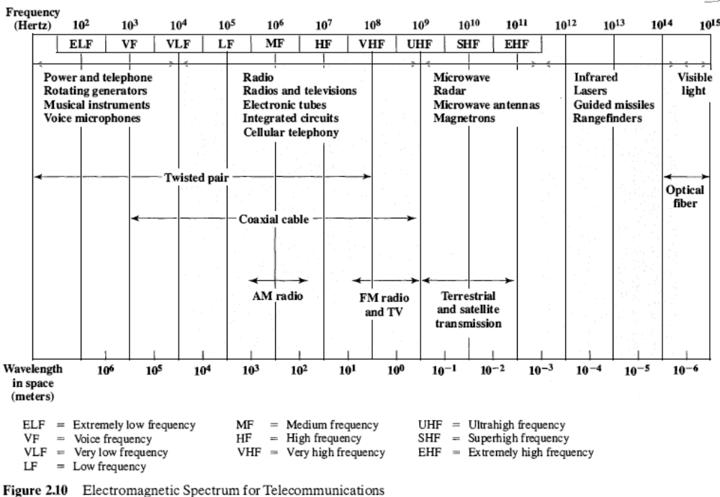

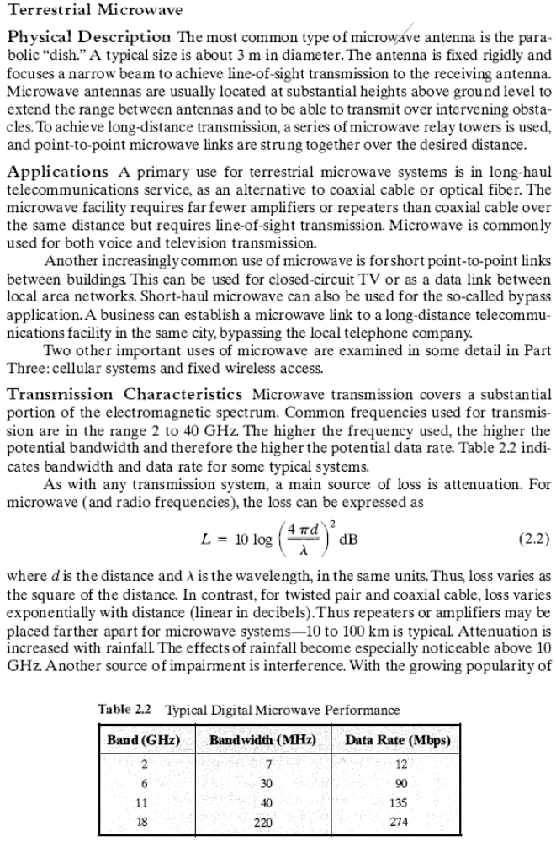
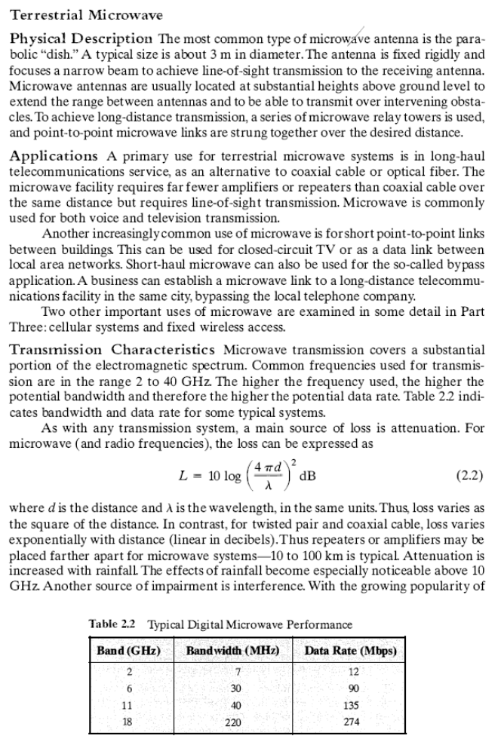
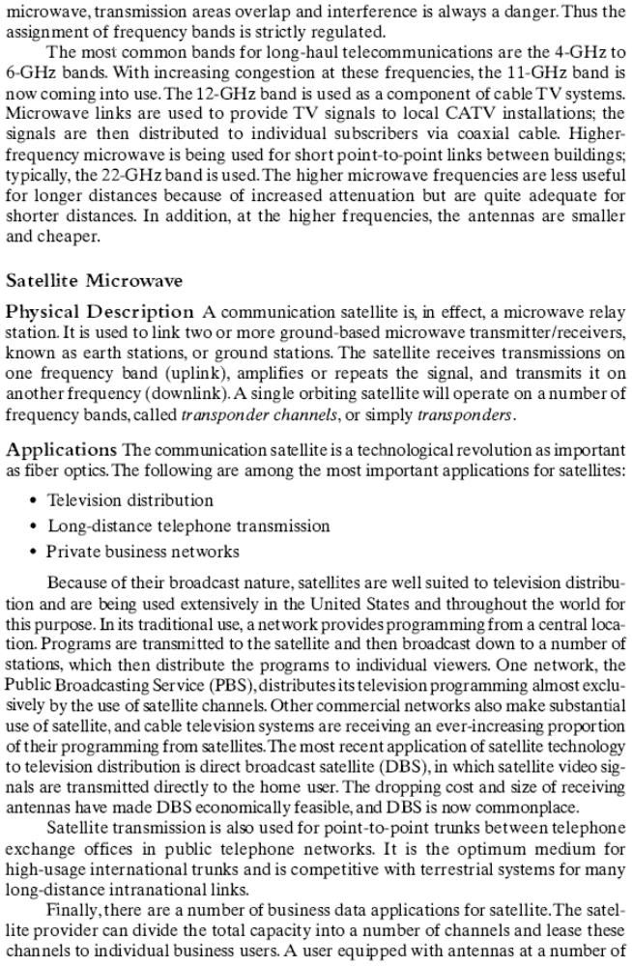
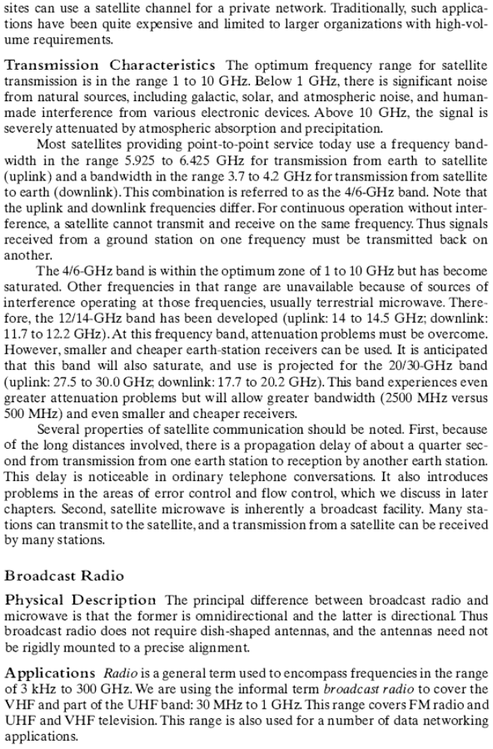
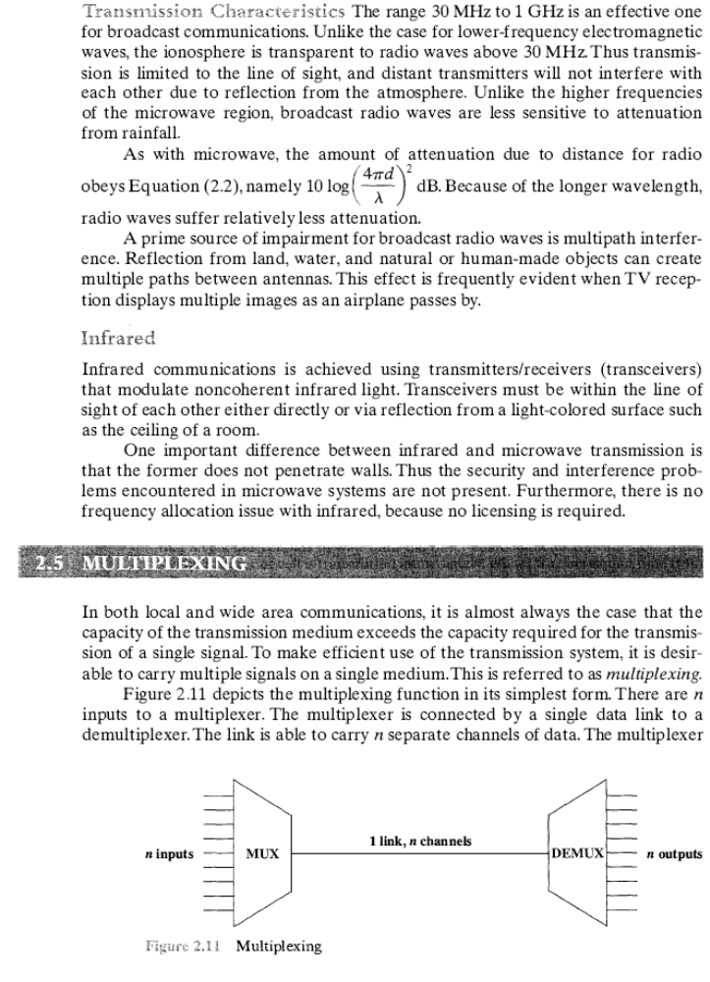
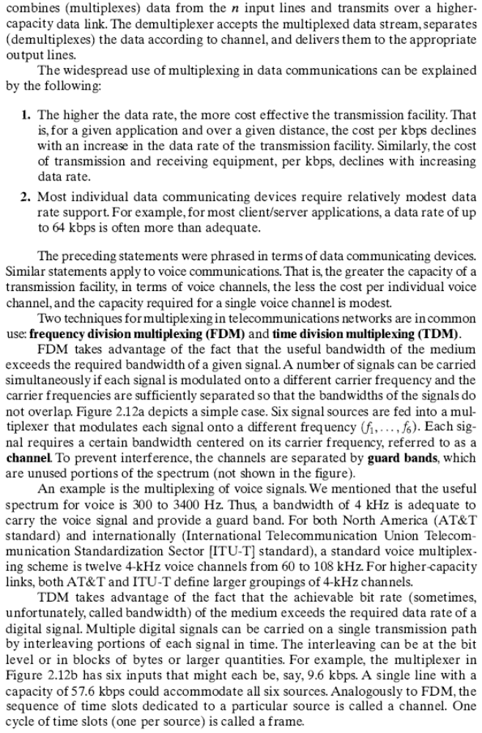
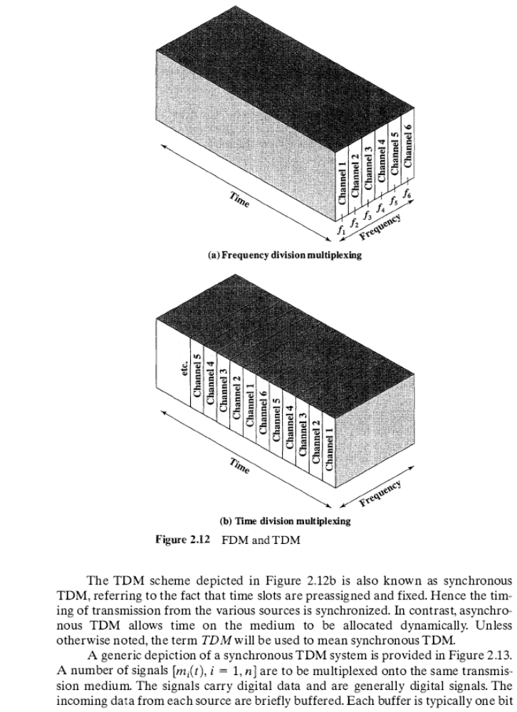
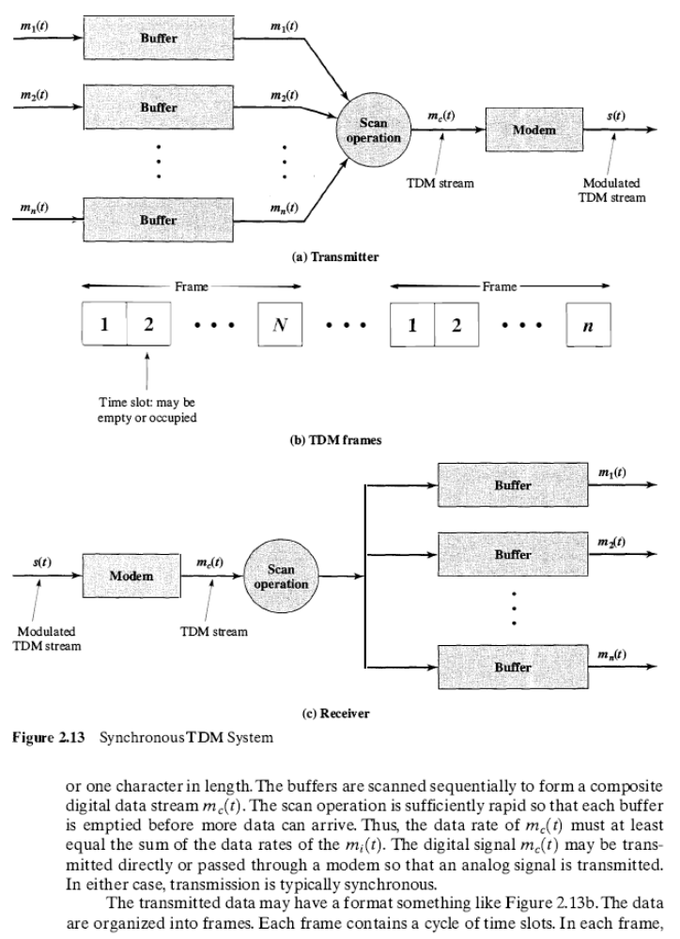
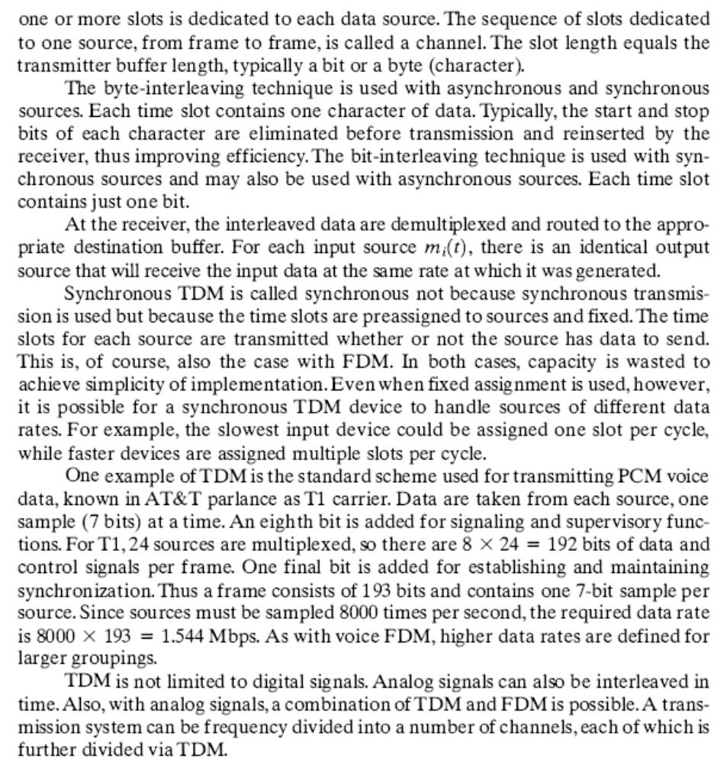

Communication Networks
- LANs, MANs, and WANs
Wide Area Networks Local Area Networks Metropolitan Area Networks
- Switching Techniques
- Circuit Switching
- Packet Switching
Basic Operation Packet Size
- Asynchronous Transfer Mode
ATM Logical Connections ATM Cells
ATM Service Categories

Communication Networks
- LANs, MANs, and WANs
Wide Area Networks Local Area Networks Metropolitan Area Networks
- Switching Techniques
- Circuit Switching
- Packet Switching
Basic Operation Packet Size
- Asynchronous Transfer Mode
ATM Logical Connections ATM Cells
ATM Service Categories

This chapter provides an overview of various approaches to communication networking. The chapter begins with a survey of different type of networks based on geographic extent. Then circuit switching, packet switching, and ATM (asynchronous transfer mode) networks are examined.
- LANs, MANS, AND WANs
Local area networks (LANs), metropolitan area networks (MANs), and wide area networks (WANs) are all examples of communications networks. Figure 3.1 illustrates these categories, plus some special cases. By way of contrast, the typical range of parameters for a multiple-processor computer is also depicted.
Wide Area Networks
WANs cover a large geographical area, may require the crossing of public right- of-ways, and may rely at least in part on circuits provided by a common carrier. Typically, a WAN consists of a number of interconnected switching nodes. A transmission from any one device is routed through these internal nodes to the specified destination device.
Traditionally, WANs have provided only relatively modest capacity to subscribers. For data attachment, either to a data network or to a telephone network by means of a modem, data rates of 64,000 bps or less have been common. Business
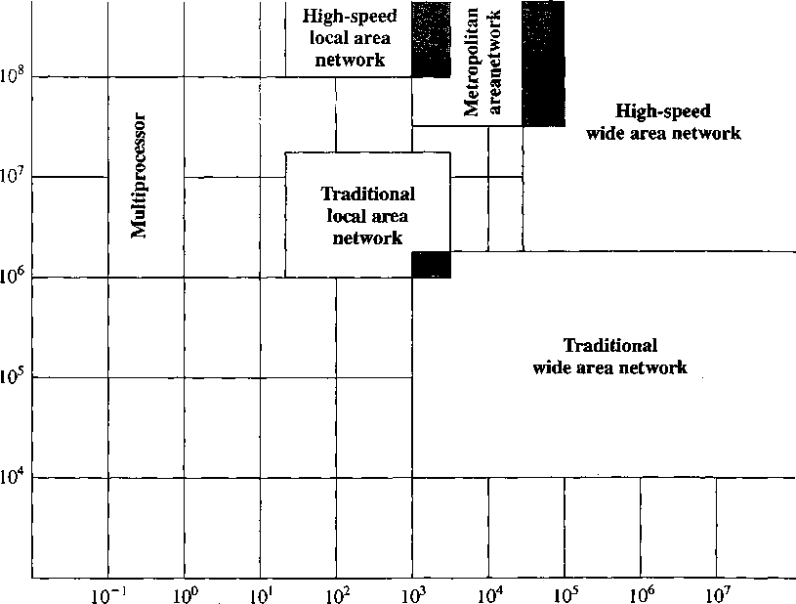
'O
S
o
o
v
S-
a
Distance (meters)
Figure 3.1 Comparison of Multiprocessor Systems, LANs, MANs, and WANs

subscribers have been able to obtain higher rates, with a service known as Tl, which operates at 1.544 Mbps, being common.
The continuing development of practical optical fiber facilities has led to the standardization of much higher data rates for WANs, and these services are becoming more widely available. These high-speed WANs provide user connections in the 10s and 100s of Mbps, using a transmission technique known asynchronous transfer mode (ATM).
Local Area Networks
As with WANs, a LAN is a communications network that interconnects a variety of devices and provides a means for information exchange among those devices. There are several key distinctions between LANs and WANs:
- The scope of the LAN is small, typically a single building or a cluster of buildings. This difference in geographic scope leads to different technical solutions.
- It is usually the case that the LAN is owned by the same organization that owns the attached devices. For WANs, this is less often the case, or at least a significant fraction of the network assets are not owned. This has two implications. First, care must be taken in the choice of LAN, since there may be a substantial capital investment (compared with dial-up or leased charges for WANs) for both purchase and maintenance. Second, the network management responsibility for a LAN falls solely on the user.
- The internal data rates of LANs are typically much greater than those of WANs.
A simple example of a LAN that highlights some of its characteristics is shown in Figure 3.2. All of the devices are attached to a shared transmission medium. A transmission from any one device can be received by all other devices attached to the same network.
Traditional LANs have provided data rates in a range from about 1 to 20 Mbps. These data rates, though substantial, have become increasingly inadequate with the proliferation of devices, the growth in multimedia applications, and the increased use of the client/server architecture. As a result, much of the effort in LAN development has been in the development of high-speed LANs, with data rates of 100 Mbps to 10 Gbps.
Server
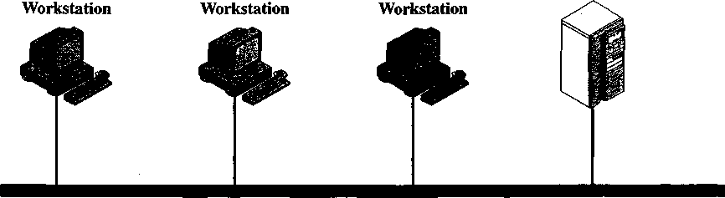
Shared transmission medium
Figure 3.2 A Simple Local Area Network

Metropolitan Area Networks
As the name suggests, a MAN occupies a middle ground between LANs and WANs. Interest in MANs has come about as a result of a recognition that the traditional point-to-point and switched network techniques used in WANs may be inadequate for the growing needs of organizations. While ATM promises to meet a wide range of high-speed needs, there is a requirement now for both private and public networks that provide high capacity at low costs over a large area. The high-speed shared-medium approach of the LAN standards provides a number of benefits that can be realized on a metropolitan scale. As Figure 3.1 indicates, MANs cover greater distances at higher data rates than LANs, although there is some overlap in geographical coverage.
The primary market for MANs is the customer that has high-capacity needs in a metropolitan area. A MAN is intended to provide the required capacity at lower cost and greater efficiency than obtaining an equivalent service from the local telephone company.
3.2 SWITCHING TECHNIQUE!
For transmission of data beyond a local area, communication is typically achieved by transmitting data from source to destination through a network of intermediate switching nodes; this switched network design is sometimes used to implement LANs and MANs as well. The switching nodes are not concerned with the content of the data; rather their purpose is to provide a switching facility that will move the data from node to node until they reach their destination. The end devices that wish to communicate may be referred to as stations. The stations may be computers, terminals, telephones, or other communicating devices. We will refer to the switching devices whose purpose is to provide communication as nodes. The nodes are connected to each other in some topology by transmission links. Each station attaches to a node, and the collection of nodes is referred to as a communication network.
Figure 3.3 illustrates a simple network. Signals entering the network from a station are routed to the destination by being switched from node to node. For example, information from station A intended for station F is sent to node 4. It may then be routed via nodes 5 and 6 or nodes 7 and 6 to the destination. Several observations are in order:
- Some nodes connect only to other nodes (e.g., 5 and 7). Their sole task is the internal (to the network) switching of information. Other nodes have one or more stations attached as well; in addition to their switching functions, such nodes accept information from and deliver information to the attached stations.
- Node-station links are generally dedicated point-to-point links. Node-node links are usually multiplexed links, using either frequency division multiplexing (FDM) or some form of time division multiplexing (TDM).
- Usually, the network is not fully connected; that is, there is not a direct link between every possible pair of nodes. However, it is always desirable to have more than one possible path through the network for each pair of stations. This enhances the reliability of the network.
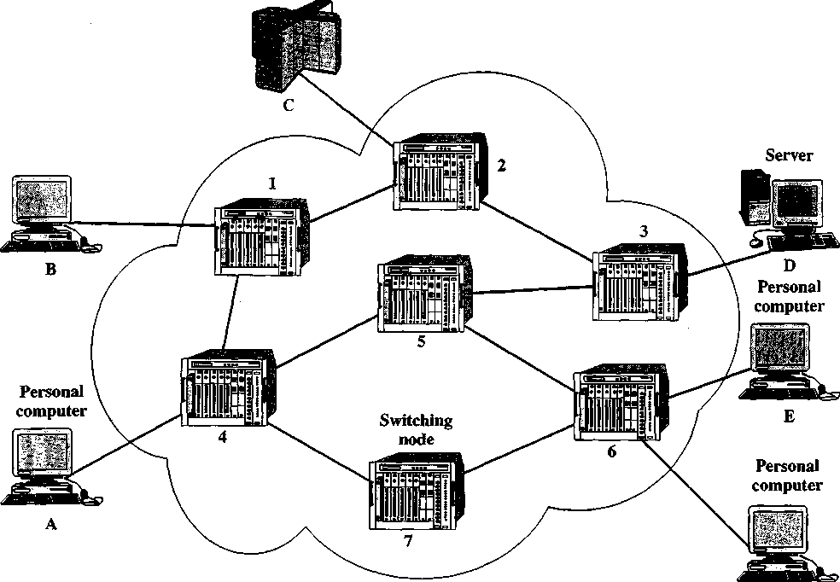
Two quite different technologies are used in wide area switched networks: circuit switching and packet switching. These two technologies differ in the way the nodes switch information from one link to another on the way from source to destination. In the remainder of this chapter, we look at the details of both of these technologies and then look at an important special case of packet switching known as cell relay, or ATM.
Mainframe
Personal
computer
Figure 3.3 Simple Switching Network

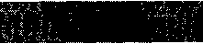
Circuit switching has been the dominant technology for both voice and data communications. Communication via circuit switching implies that there is a dedicated communication path between two stations. That path is a connected sequence of links between network nodes. On each physical link, a channel is dedicated to the connection. The most common example of circuit switching is the telephone network.
3.3 CIRCUIT SWITCHING
Communication via circuit switching involves three phases, which can be explained with reference to Figure 3.3.
- Circuit establishment. Before any signals can be transmitted, an end-to-end (station-to-station) circuit must be established. For example, station A sends a request to node 4 requesting a connection to station E. Typically, the link from A to 4 is a dedicated line, so that part of the connection already exists. Node 4 must find the next leg in a route leading to E. Based on routing information and measures of availability and perhaps cost, node 4 selects the link to node 5, allocates a free channel (using frequency division multiplexing, FDM, or time division multiplexing, TDM) on that link, and sends a message requesting connection to E. So far, a dedicated path has been established from A through 4 to 5. Because a number of stations may attach to 4, it must be able to establish internal paths from multiple stations to multiple nodes. How this is done is discussed later in this section. The remainder of the process proceeds similarly. Node 5 dedicates a channel to node 6 and internally ties that channel to the channel from node 4. Node 6 completes the connection to E. In completing the connection, a test is made to determine if E is busy or is prepared to accept the connection.
- Information transfer. Information can now be transmitted from A through the network to E. The transmission may be analog voice, digitized voice, or binary data, depending on the nature of the network. As the carriers evolve to fully integrated digital networks, the use of digital (binary) transmission for both voice and data is becoming the dominant method. The path is A-4 link, internal switching through 4,4-5 channel, internal switching through 5,5-6 channel, internal switching through 6,6-E link. Generally, the connection is full duplex, and signals may be transmitted in both directions simultaneously.
- Circuit disconnect. After some period of information transfer, the connection is terminated, usually by the action of one of the two stations. Signals must be propagated to nodes 4,5, and 6 to deallocate the dedicated resources.
Note that the connection path is established before data transmission begins. Thus, channel capacity must be reserved between each pair of nodes in the path and each node must have available internal switching capacity to handle the requested connection. The switches must have the intelligence to make these allocations and to devise a route through the network.
Circuit switching can be rather inefficient. Channel capacity is dedicated for the duration of a connection, even if no data are being transferred. For a voice connection, utilization may be rather high, but it still does not approach 100%. For a ter- minal-to-computer connection, the capacity may be idle during most of the time of the connection. In terms of performance, there is a delay prior to signal transfer for call establishment. However, once the circuit is established, the network is effectively transparent to the users. Information is transmitted at a fixed data rate with no delay other than the propagation delay through the transmission links. The delay at each node is negligible.
Circuit switching was developed to handle voice traffic but is now also used for data traffic. The best-known example of a circuit-switching network is the public telephone network (Figure 3.4). This is actually a collection of national networks interconnected to form the international service. Although originally designed and implemented to service analog telephone subscribers, it handles substantial data traffic via modem and is well on its way to being converted to a digital network.
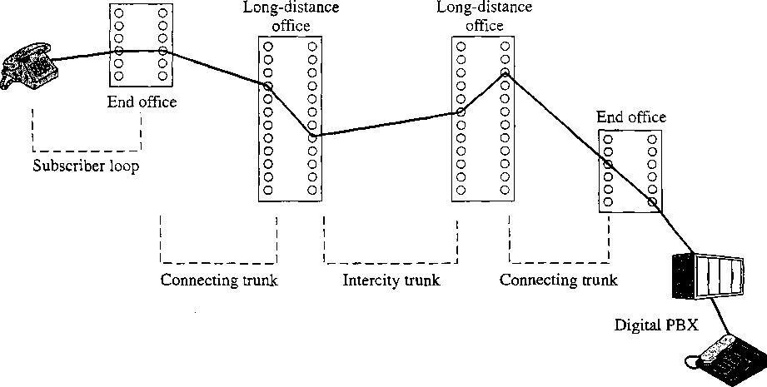
Figure 3.4 Example Connection Over a Public Circuit-Switching Network

Another well-known application of circuit switching is the private branch exchange (PBX), used to interconnect telephones within a building or office. Circuit switching is also used in private networks. Typically, such a network is set up by a corporation or other large organization to interconnect its various sites. Such a network usually consists of PBX systems at each site interconnected by dedicated, leased lines obtained from one of the carriers, such as AT&T. A final common example of the application of circuit switching is the data switch. The data switch is similar to the PBX but is designed to interconnect digital data processing devices, such as terminals and computers.
A public telecommunications network can be described using four generic architectural components:
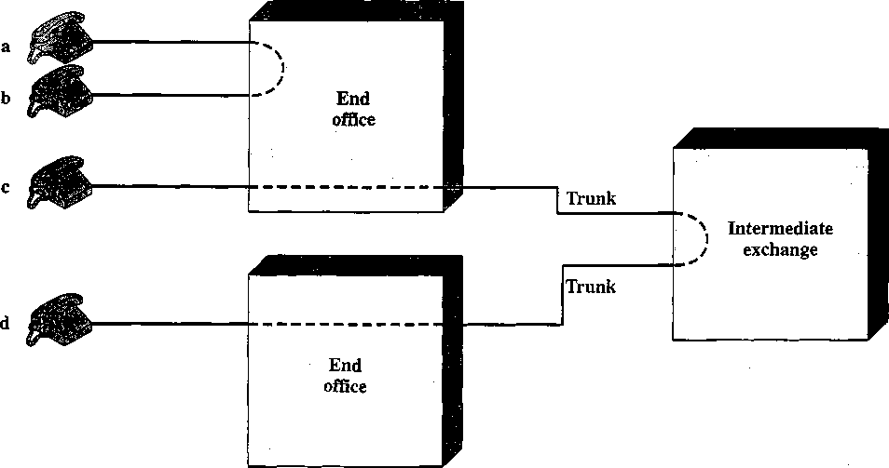
Figure 3.5 Circuit Establishment

• Trunks: The branches between exchanges. Trunks carry multiple voice-frequency circuits using either FDM or synchronous TDM. Earlier, these were referred to as carrier systems.
Subscribers connect directly to an end office, which switches traffic between subscribers and between a subscriber and other exchanges. The other exchanges are responsible for routing and switching traffic between end offices. This distinction is shown in Figure 3.5. To connect two subscribers attached to the same end office, a circuit is set up between them in the same fashion as described before. If two subscribers connect to different end offices, a circuit between them consists of a chain of circuits through one or more intermediate offices. In the figure, a connection is established between lines a and b by simply setting up the connection through the end office. The connection between c and d is more complex. In c’s end office, a connection is established between line c and one channel on a TDM trunk to the intermediate switch. In the intermediate switch, that channel is connected to a channel on a TDM trunk to d’s end office. In that end office, the channel is connected to line d.
Circuit-switching technology has been driven by its use to carry voice traffic. One of the key requirements for voice traffic is that there must be virtually no transmission delay and certainly no variation in delay. A constant signal transmission rate must be maintained, because transmission and reception occur at the same signal rate. These requirements are necessary to allow normal human conversation. Further, the quality of the received signal must be sufficiently high to provide, at a minimum, intelligibility.
Circuit switching achieved its widespread, dominant position because it is well suited to the analog transmission of voice signals. In today’s digital world, its inefficiencies are more apparent. However, despite the inefficiency, circuit switching is and will remain an attractive choice for both local area and wide area networking.
One of its key strengths is that it is transparent. Once a circuit is established, it appears like a direct connection to the two attached stations; no special networking logic is needed at the station.
- PACKET SWITCHING
Long-haul circuit-switching telecommunications networks were originally designed to handle voice traffic, and the majority of traffic on these networks continues to be voice. A key characteristic of circuit-switching networks is that resources within the network are dedicated to a particular call. For voice connections, the resulting circuit will enjoy a high percentage of utilization since, most of the time, one party or the other is talking. However, as the circuit-switching network began to be used increasingly for data connections, two shortcomings became apparent:
- In a typical terminal-to-host data connection, much of the time the line is idle. Thus, with data connections, a circuit-switching approach is inefficient.
- In a circuit-switching network, the connection provides for transmission at a constant data rate. Thus each of the two devices that are connected must transmit and receive at the same data rate as the other, which limits the utility of the network in interconnecting a variety of host computers and terminals.
To understand how packet switching addresses these problems, let us briefly summarize packet-switching operation. Data are transmitted in blocks, called packets. A typical upper bound on packet length is 1000 octets (bytes). If a source has a longer message to send, the message is broken up into a series of packets (Figure 3.6). Each packet consists of a portion of the data (or all of the data for a short message) that a station wants to transmit, plus a packet header that contains control information. The control information, at a minimum, includes the information that the network requires in order to be able to route the packet through the network and deliver it to the intended destination. At each node en route, the packet is received, stored briefly, and passed on to the next node.
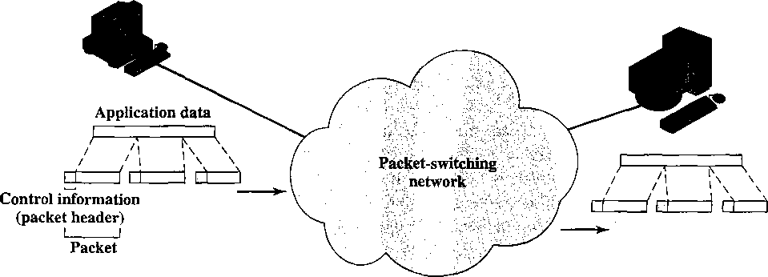
Figure 3.6 The Use of Packets

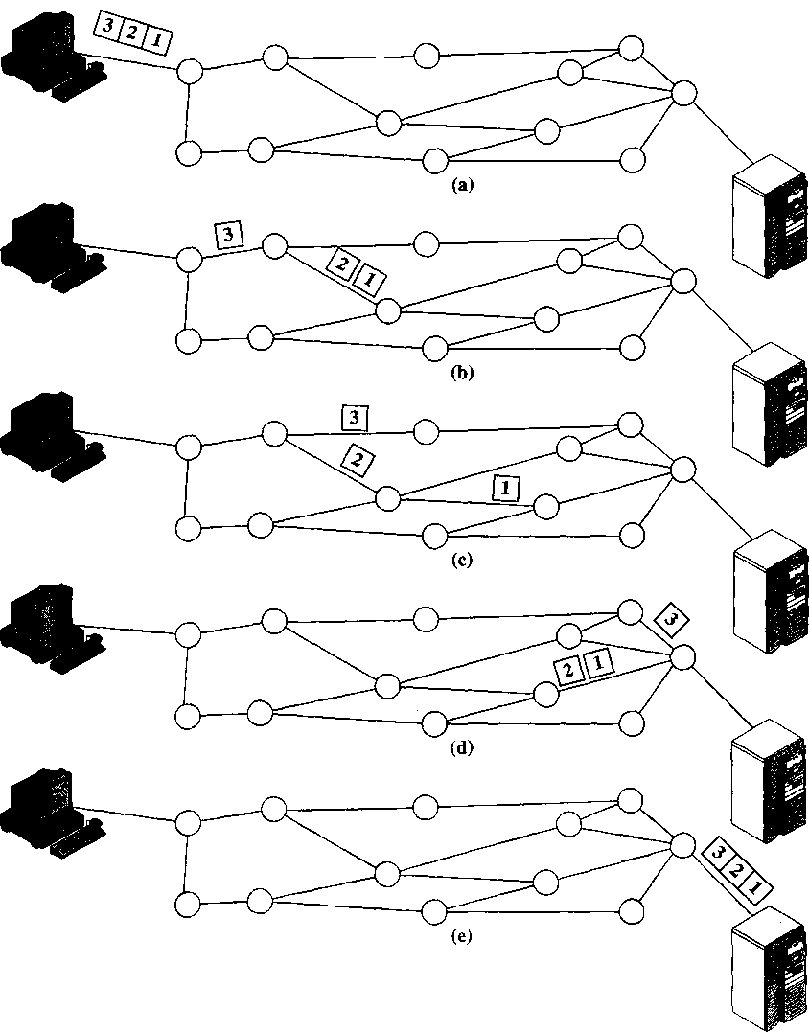
Figure 3.7 Packet Switching: Datagram Approach

Figure 3.7 illustrates the basic operation. A transmitting computer or other device sends a message as a sequence of packets (a). Each packet includes control information indicating the destination station (computer, terminal, etc.). The packets are initially sent to the node to which the sending station attaches. As each packet arrives at this node, it stores the packet briefly, determines the next leg of the route, and queues the packet to go out on that link. Each packet is transmitted to the next node (b) when the link is available. All of the packets eventually work their way through the network and are delivered to the intended destination.
The packet-switching approach has a number of advantages over circuit switching:
- Line efficiency is greater, since a single node-to-node link can be dynamically shared by many packets over time. The packets are queued up and transmitted as rapidly as possible over the link. By contrast, with circuit switching, time on a node-to-node link is preallocated using synchronous time division multiplexing. Much of the time, such a link may be idle because a portion of its time is dedicated to a connection that is idle.
- A packet-switching network can carry out data-rate conversion. Two stations of different data rates can exchange packets, since each connects to its node at its proper data rate.
- When traffic becomes heavy on a circuit-switching network, some calls are blocked; that is, the network refuses to accept additional connection requests until the load on the network decreases. On a packet-switching network, packets are still accepted, but delivery delay increases.
- Priorities can be used. Thus, if a node has a number of packets queued for transmission, it can transmit the higher-priority packets first. These packets will therefore experience less delay than lower-priority packets.
Packet switching also has disadvantages relative to circuit switching:
- Each time a packet passes through a packet-switching node it incurs a delay not present in circuit switching. At a minimum, it incurs a transmission delay equal to the length of the packet in bits divided by the incoming channel rate in bits per second; this is the time it takes to absorb the packet into an internal buffer. In addition, there may be a variable delay due to processing and queuing in the node.
- Because the packets between a given source and destination may vary in length, may take different routes, and may be subject to varying delay in the switches they encounter, the overall packet delay can vary substantially. This phenomenon, called jitter, may not be desirable for some applications (for example, in real-time applications, including telephone voice and real-time video).
- To route packets through the network, overhead information, including the address of the destination, and often sequencing information must be added to each packet, which reduces the communication capacity available for carrying user data. This is not needed in circuit switching once the circuit is set up.
- More processing is involved in the transfer of information using packet switching than in circuit switching at each node. In the case of circuit switching, there is virtually no processing at each switch once the circuit is set up.
Basic Operation
A station has a message to send through a packet-switching network that is of greater length than the maximum packet size. It therefore breaks the message into packets and sends these packets, one at a time, to the network. A question arises as to how the network will handle this stream of packets as it attempts to route them through the network and deliver them to the intended destination. Two approaches are used in contemporary networks: datagram and virtual circuit.
In the datagram approach, each packet is treated independently, with no reference to packets that have gone before. This approach is illustrated in Figure 3.7. Each node chooses the next node on a packet’s path, taking into account information received from neighboring nodes on traffic, line failures, and so on. So the packets, each with the same destination address, do not all follow the same route (c), and they may arrive out of sequence at the exit point (d). In this example, the exit node restores the packets to their original order before delivering them to the destination (e). In some datagram networks, it is up to the destination rather than the exit node to do the reordering. Also, it is possible for a packet to be destroyed in the network. For example, if a packet-switching node crashes momentarily, all of its queued packets may be lost. Again, it is up to either the exit node or the destination to detect the loss of a packet and decide how to recover it. In this technique, each packet, treated independently, is referred to as a datagram.
In the virtual circuit approach, a preplanned route is established before any packets are sent. Once the route is established, all the packets between a pair of communicating parties follow this same route through the network. This is illustrated in Figure 3.8. Because the route is fixed for the duration of the logical connection, it is somewhat similar to a circuit in a circuit-switching network and is referred to as a virtual circuit. Each packet contains a virtual circuit identifier as well as data. Each node on the preestablished route knows where to direct such packets; no routing decisions are required. At any time, each station can have more than one virtual circuit to any other station and can have virtual circuits to more than one station.
So the main characteristic of the virtual circuit technique is that a route between stations is set up prior to data transfer. Note that this does not mean that this is a dedicated path, as in circuit switching. A packet is still buffered at each node and queued for output over a line. The difference from the datagram approach is that, with virtual circuits, the node need not make a routing decision for each packet. It is made only once for all packets using that virtual circuit.
If two stations wish to exchange data over an extended period of time, there are certain advantages to virtual circuits. First, the network may provide services related to the virtual circuit, including sequencing and error control. Sequencing refers to the fact that, because all packets follow the same route, they arrive in the original order. Error control is a service that assures not only that packets arrive in proper sequence, but also that all packets arrive correctly. For example, if a packet in a sequence from node 4 to node 6 fails to arrive at node 6, or arrives with an error, node 6 can request a retransmission of that packet from node 4 (Figure 3.3). Another advantage is that packets should transit the network more rapidly with a virtual circuit; it is not necessary to make a routing decision for each packet at each node.
One advantage of the datagram approach is that the call setup phase is avoided. Thus, if a station wishes to send only one or a few packets, datagram delivery will be quicker. Another advantage of the datagram service is that, because it is more primitive, it is more flexible. For example, if congestion develops in one part of the network, incoming datagrams can be routed away from the congestion. With the use of virtual circuits, packets follow a predefined route, and thus it is more difficult for the network to adapt to congestion. A third advantage is that datagram delivery is inherently more reliable. With the use of virtual circuits, if a node fails, all virtual circuits that pass through that node are lost. With datagram delivery, if a node fails, subsequent packets may find an alternate route that bypasses that node.

Packet Size
There is a significant relationship between packet size and transmission time, as shown in Figure 3.9. In this example, it is assumed that there is a virtual circuit from station A through nodes 4 and 1 to station B (Figure 3.3). The message to be sent comprises 40 octets, and each packet contains 3 octets of control information, which is placed at the beginning of each packet and is referred to as a header. If the entire message is sent as a single packet of 43 octets (3 octets of header plus 40 octets of data), then the packet is first transmitted from station A to node 4 (Figure 3.9a).
(a) 1-packet message
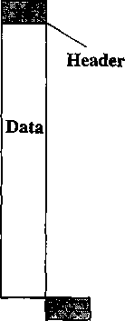
Data
(b) 2-packet message (c) 5-packet message
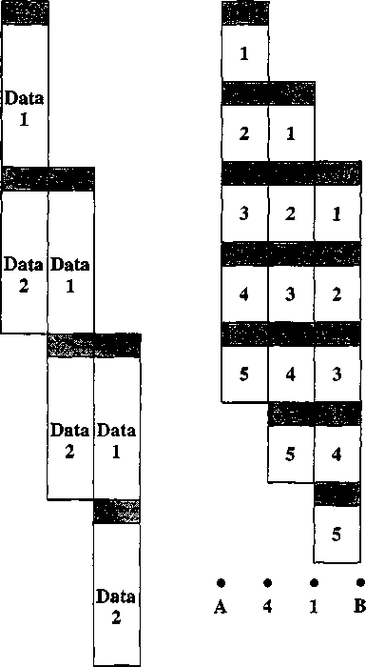
• • • •
A 4 1 B
(d) 10-packet message
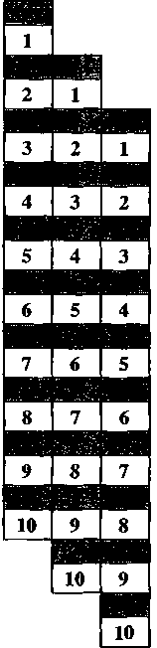
• • • •
A 4 1 B
Data
• • • •
A 4 1 B
Figure 3.9 Effect of Packet Size on Transmission Time
When the entire packet is received, it can then be transmitted from 4 to 1. When the entire packet is received at node 1, it is then transferred to station B. Ignoring switching time, total transmission time is 129 octet-times (43 octets X 3 packet transmissions).
Suppose now that we break the message up into two packets, each containing 20 octets of the message and, of course, 3 octets each of header, or control information. In this case, node 4 can begin transmitting the first packet as soon as it has arrived from A, without waiting for the second packet. Because of this overlap in

transmission, the total transmission time drops to 92 octet-times. By breaking the message up into five packets, each intermediate node can begin transmission even sooner and the savings in time is greater, with a total of 77 octet-times for transmission. However, this process of using more and smaller packets eventually results in increased, rather than reduced, delay as illustrated in Figure 3.9d. This is because each packet contains a fixed amount of header, and more packets mean more of these headers. Furthermore, the example does not show the processing and queuing delays at each node. These delays are also greater when more packets are handled for a single message. However, we shall see in the next section that an extremely small packet size (53 octets) can result in an efficient network design.
- ASYNCHRONOUS TRANSFER MODE
Asynchronous transfer mode (ATM), also known as cell relay, is in some ways similar to packet switching. Like packet switching, ATM involves the transfer of data in discrete chunks. Also, like packet switching, ATM allows multiple logical connections to be multiplexed over a single physical interface. In the case of ATM, the information flow on each logical connection is organized into fixed-size packets, called cells.
ATM is a streamlined protocol with minimal error and flow control capabilities. This reduces the overhead of processing ATM cells and reduces the number of overhead bits required with each cell, thus enabling ATM to operate at high data rates. Further, the use of fixed-size cells simplifies the processing required at each ATM node, again supporting the use of ATM at high data rates.
ATM Logical Connections
Logical connections in ATM are referred to as virtual channel connections (VCCs). A VCC is analogous to a virtual circuit in a packet-switching network; it is the basic unit of switching in an ATM network. A VCC is set up between two end users through the network, and a variable-rate, full-duplex flow of fixed-size cells is exchanged over the connection. VCCs are also used for user-network exchange (control signaling) and network-network exchange (network management and routing).
For ATM, a second sublayer of processing has been introduced that deals with the concept of virtual path (Figure 3.10). A virtual path connection (VPC) is a bundle of VCCs that have the same endpoints. Thus all of the cells flowing over all of the VCCs in a single VPC are switched together.
The virtual path concept was developed in response to a trend in high-speed networking in which the control cost of the network is becoming an increasingly higher
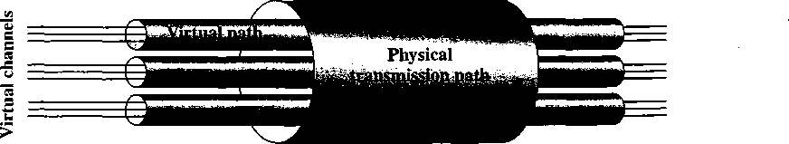
Figure 3.10 ATM Connection Relationships

proportion of the overall network cost. The virtual path technique helps contain the control cost by grouping connections sharing common paths through the network into a single unit. Network management actions can then be applied to a small number of groups of connections instead of a large number of individual connections.
ATM Cells
ATM uses fixed-size cells, consisting of a 5-octet header and a 48-octet information field. There are several advantages to the use of small, fixed-size cells. First, the use of small cells may reduce queuing delay for a high-priority cell, because it waits less if it arrives slightly behind a lower-priority cell that has gained access to a resource (e.g., the transmitter). Second, it appears that fixed-size cells can be switched more efficiently, which is important for the very high data rates of ATM. With fixed-size cells, it is easier to implement the switching mechanism in hardware.
Header Format Figure 3.11a shows the header format at the user-network interface. Figure 3.11b shows the cell header format internal to the network. Internal to the network, the Generic Flow Control field, which performs end-to-end functions, is not retained. Instead, the Virtual Path Identifier field is expanded from 8 to 12 bits.

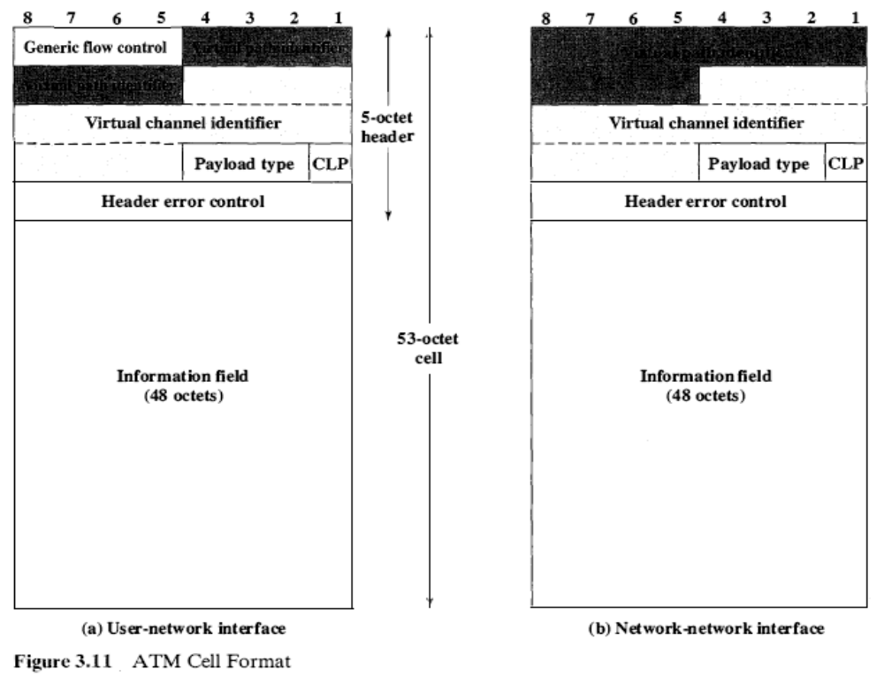
This allows support for an expanded number of VPCs internal to the network, to include those supporting subscribers and those required for network management.
The Generic Flow Control (GFC) field can be used for control of cell flow at the local user-network interface. The details of its application are for further study. The field could be used to assist the customer in controlling the flow of traffic for different qualities of service. One candidate for the use of this field is a multiple- priority level indicator to control the flow of information in a service-dependent manner. In any case, the GFC mechanism is used to alleviate short-term overload conditions in the network.
The Virtual Path Identifier (VPI) field constitutes a routing field for the network. It is 8 bits at the user-network interface and 12 bits at the network-network interface, allowing for more virtual paths to be supported within the network. The Virtual Channel Identifier (VCI) field is used for routing to and from the end user. Thus, it functions much as a service access point.
The Payload Type (PT) field indicates the type of information in the information field. Table 3.1 shows the interpretation of the PT bits. A value of 0 in the first bit indicates user information (that is, information from the next higher layer). In this case, the second bit indicates whether congestion has been experienced; the third bit, known as the service data unit (SDU) type bit, is a one-bit field that can be used to discriminate two types of ATM SDUs associated with a connection. The term SD U refers to the 48-octet payload of the cell. A value of 1 in the first bit of the payload type field indicates that this cell carries network management or maintenance information. This indication allows the insertion of network-management cells onto a user’s VCC without impacting the user’s data. Thus, the PT field can provide inband control information.
The Cell Loss Priority (CLP) field is used to provide guidance to the network in the event of congestion. A value of 0 indicates a cell of relatively higher priority, which should not be discarded unless no other alternative is available. A value of
Table 3.1 Payload Type (PT) Field Coding
PT Coding |  | Interpretation
000 | User data cell, | : congestion not experienced, | SDU-type = 0
001 | User data cell, | congestion not experienced. | SDU-type = 1
010 | User data cell, | congestion experienced. | SDU-type = 0
on | User data cell. | congestion experienced, | SDU-type = 1
100 | OAM segment associated cell
101 | OAM end-to-end associated cell
110 | Resource management cell
111 | Reserved for future function
SDU = Service Data Unit
OAM = Operations, Administration, and Maintenance

1 indicates that this cell is subject to discard within the network. The user might employ this field so that extra information may be inserted into the network, with a CLP of 1, and delivered to the destination if the network is not congested. The network may set this field to 1 for any data cell that is in violation of a agreement between the user and the network concerning traffic parameters. In this case, the switch that does the setting realizes that the cell exceeds the agreed traffic parameters but that the switch is capable of handling the cell. At a later point in the network, if congestion is encountered, this cell has been marked for discard in preference to cells that fall within agreed traffic limits.
The Header Error Control (HEC) field is an 8-bit error code that can be used to correct single-bit errors in the header and to detect double-bit errors. In the case of most existing protocols, the data that serve as input to the error code calculation are in general much longer than the size of the resulting error code. This allows for error detection. In the case of ATM, the input to the calculation is only 32 bits, compared with 8 bits for the code. The fact that the input is relatively short allows the code to be used not only for error detection but also, in some cases, for actual error correction. This is because there is sufficient redundancy in the code to recover from certain error patterns.
The error protection function provides both recovery from single-bit header errors and a low probability of the delivery of cells with errored headers under bursty error conditions. The error characteristics of fiber-based transmission systems appear to be a mix of single-bit errors and relatively large burst errors. For some transmission systems, the error correction capability, which is more time consuming, might not be invoked.
ATM Service Categories
An ATM network is designed to be able to transfer many different types of traffic simultaneously, including real-time flows such as voice, video, and bursty TCP flows. Although each such traffic flow is handled as a stream of 53-octet cells traveling through a virtual channel, the way in which each data flow is handled within the network depends on the characteristics of the traffic flow and the QoS requirements of the application. For example, real-time video traffic must be delivered within minimum variation in delay.
In this subsection, we summarize ATM service categories, which are used by an end system to identify the type of service required. The following service categories have been defined by the ATM Forum:
- Real-time service
- Constant bit rate (CBR)
- Real-time variable bit rate (rt-VBR)
- Non-real-time service
—Non-real-time variable bit rate (nrt-VBR)
—Available bit rate (ABR)
—Unspecified bit rate (UBR)
—Guaranteed frame rate (GFR)
Real-Time Services The most important distinction among applications concerns the amount of delay and the variability of delay, referred to as jitter, that the application can tolerate. Real-time applications typically involve a flow of information to a user that is intended to reproduce that flow at a source. For example, a user
expects a flow of audio or video information to be presented in a continuous, smooth fashion. A lack of continuity or excessive loss results in significant loss of quality. Applications that involve interaction between people have tight constraints on delay. Typically, any delay above a few hundred milliseconds becomes noticeable and annoying. Accordingly, the demands in the ATM network for switching and delivery of real-time data are high.
The constant bit rate (CBR) service is perhaps the simplest service to define. It is used by applications that require a fixed data rate that is continuously available during the connection lifetime and a relatively tight upper bound on transfer delay. CBR is commonly used for uncompressed audio and video information. Examples of CBR applications include
- Videoconferencing
- Interactive audio (e.g., telephony)
- Audio/video distribution (e.g., television, distance learning, pay-per-view)
- Audio/video retrieval (e.g., video-on-demand, audio library)
The real-time variable bit rate (rt-VBR) category is intended for time-sensitive applications; that is, those requiring tightly constrained delay and delay variation. The principal difference between applications appropriate for rt-VBR and those appropriate for CBR is that rt-VBR applications transmit at a rate that varies with time. Equivalently, an rt-VBR source can be characterized as somewhat bursty. For example, the standard approach to video compression results in a sequence of image frames of varying sizes. Because real-time video requires a uniform frame transmission rate, the actual data rate varies.
The rt-VBR service allows the network more flexibility than CBR. The network is able to statistically multiplex a number of connections over the same dedicated capacity and still provide the required service to each connection.
Non-Real-Time Services Non-real-time services are intended for applications that have bursty traffic characteristics and do not have tight constraints on delay and delay variation. Accordingly, the network has greater flexibility in handling such traffic flows and can make greater use of statistical multiplexing to increase network efficiency.
For some non-real-time applications, it is possible to characterize the expected traffic flow so that the network can provide substantially improved quality of service (QoS) in the areas of loss and delay. Such applications can use the non-real-time variable bit rate (nrt-VBR) service. With this service, the end system specifies a peak cell rate, a sustainable or average cell rate, and a measure of how bursty or clumped the cells may be. With this information, the network can allocate resources to provide relatively low delay and minimal cell loss.
The nrt-VBR service can be used for data transfers that have critical responsetime requirements. Examples include airline reservations, banking transactions, and process monitoring.
At any given time, a certain amount of the capacity of an ATM network is consumed in carrying CBR and the two types of VBR traffic. Additional capacity is available for one or both of the following reasons: (1) Not all of the total resources have been committed to CBR and VBR traffic, and (2) the bursty nature of VBR traffic means that at some times less than the committed capacity is being used. All of this unused capacity could be made available for the unspecified bit rate (UBR) service. This service is suitable for applications that can tolerate variable delays and some cell losses, which is typically true of TCP-based traffic. With UBR, cells are forwarded on a first-in-first-out (FIFO) basis using the capacity not consumed by other services; both delays and variable losses are possible. No initial commitment is made to a UBR source and no feedback concerning congestion is provided; this is referred to as a best-effort service. Examples of UBR applications include
- Text/data/image transfer, messaging, distribution, retrieval
- Remote terminal (e.g., telecommuting)
Bursty applications that use a reliable end-to-end protocol such as TCP can detect congestion in a network by means of increased round-trip delays and packet discarding. However, TCP has no mechanism for causing the resources within the network to be shared fairly among many TCP connections. Further, TCP does not minimize congestion as efficiently as is possible using explicit information from congested nodes within the network.
To improve the service provided to bursty sources that would otherwise use UBR, the available bit rate (ABR) service has been defined. An application using ABR specifies a peak cell rate (PCR) that it will use and a minimum cell rate (MCR) that it requires. The network allocates resources so that all ABR applications receive at least their MCR capacity. Any unused capacity is then shared in a fair and controlled fashion among all ABR sources. The ABR mechanism uses explicit feedback to sources to assure that capacity is fairly allocated. Any capacity not used by ABR sources remains available for UBR traffic.
An example of an application using ABR is LAN interconnection. In this case, the end systems attached to the ATM network are routers.
The most recent addition to the set of ATM service categories is Guaranteed Frame Rate (GFR), which is designed specifically to support IP backbone subnetworks. GFR provides better service than UBR for frame-based traffic, including IP and Ethernet. A major goal of GFR is to optimize the handling of frame-based traffic that passes from a LAN through a router onto an ATM backbone network. Such ATM networks are increasingly being used in large enterprise, carrier, and Internet service provider networks to consolidate and extend IP services over the wide area. While ABR is also an ATM service meant to provide a greater measure of guaranteed packet performance over ATM backbones, ABR is relatively difficult to implement between routers over an ATM network. With the increased emphasis on using ATM to support IP-based traffic, especially traffic that originates on Ethernet LANs, GFR may offer the most attractive alternative for providing ATM service.

Protocols and the TCP/IP Suite
- The Need for a Protocol Architecture
- The TCP/IP Protocol Architecture
The TCP/IP Layers Operation of TCP and IP TCP/IP Applications
- The OSI Model
- Internetworking
Routers
Internetworking Example

We begin this chapter by introducing the concept of a layered protocol architecture. We then examine the most important such architecture, the TCP/IP protocol suite. TCP/IP is an Internet-based concept and is the framework for developing a complete range of computer communications standards. Virtually all computer vendors now provide support for this architecture. Another well-known architecture is the Open Systems Interconnection (OSI) reference model. OSI is a standardized architecture that is often used to describe communications functions but that is now rarely implemented.
Following a discussion of protocol architectures, the important concept of internetworking is examined. Inevitably, an organization will require the use of more than one communication network. Some means of interconnecting these networks is required, and this raises issues that relate to the protocol architecture.
- THE NEED FOR A PROTOCOL ARCHITECTURE
When computers, terminals, and/or other data processing devices exchange data, the procedures involved can be quite complex. Consider, for example, the transfer of a file between two computers. There must be a data path between the two computers, either directly or via a communication network. But more is needed. Typical tasks to be performed include the following:
- The source system must either activate the direct data communication path or inform the communication network of the identity of the desired destination system.
- The source system must ascertain that the destination system is prepared to receive data.
- The file transfer application on the source system must ascertain that the file management program on the destination system is prepared to accept and store the file for this particular user.
- If the file formats used on the two systems are incompatible, one or the other system must perform a format translation function.
It is clear that there must be a high degree of cooperation between the two computer systems. Instead of implementing the logic for this as a single module, the task is broken up into subtasks, each of which is implemented separately. In a protocol architecture, the modules are arranged in a vertical stack. Each layer in the stack performs a related subset of the functions required to communicate with another system. It relies on the next lower layer to perform more primitive functions and to conceal the details of those functions. It provides services to the next higher layer. Ideally, layers should be defined so that changes in one layer do not require changes in other layers.
Of course, it takes two to communicate, so the same set of layered functions must exist in two systems. Communication is achieved by having the corresponding, or peer, layers in two systems communicate. The peer layers communicate by means of formatted blocks of data that obey a set of rules or conventions known as a protocol. The key features of a protocol are as follows:
- Syntax: Concerns the format of the data blocks
- Semantics: Includes control information for coordination and error handling
- Timing: Includes speed matching and sequencing
- THE TCP/IP PROTOCOL ARCHITECTURE
The TCP/IP protocol architecture is a result of protocol research and development conducted on the experimental packet-switched network, ARPANET, funded by the Defense Advanced Research Projects Agency (DARPA), and is generally referred to as the TCP/IP protocol suite. This protocol suite consists of a large collection of protocols that have been issued as Internet standards by the Internet Architecture Board (IAB).
The TCP/IP Layers
In general terms, communications can be said to involve three agents: applications, computers, and networks. Examples of applications include file transfer and electronic mail. The applications that we are concerned with here are distributed applications that involve the exchange of data between two computer systems. These applications, and others, execute on computers that can often support multiple simultaneous applications. Computers are connected to networks, and the data to be exchanged are transferred by the network from one computer to another. Thus, the transfer of data from one application to another involves first getting the data to the computer in which the application resides and then getting the data to the intended application within the computer.
With these concepts in mind, it appears natural to organize the communication task into five relatively independent layers:
- Physical layer
- Network access layer
- Internet layer
- Host-to-host, or transport layer
- Application layer
The physical layer covers the physical interface between a data transmission device (e.g., workstation, computer) and a transmission medium or network. This layer is concerned with specifying the characteristics of the transmission medium, the nature of the signals, the data rate, and related matters.
The network access layer is concerned with the exchange of data between an end system (server, workstation, etc.) and the network to which it is attached. The sending computer must provide the network with the address of the destination computer, so that the network may route the data to the appropriate destination. The sending computer may wish to invoke certain services, such as priority, that might be provided by the network. The specific software used at this layer depends on the type of network to be used; different standards have been developed for circuit switching, packet switching (e.g., ATM), LANs (e.g., Ethernet), and others. Thus it makes sense to separate those functions having to do with network access into a separate layer. By doing this, the remainder of the communications software, above the network access layer, need not be concerned about the specifics of the network to be used. The same higher-layer software should function properly regardless of the particular network to which the computer is attached.
The network access layer is concerned with access to and routing data across a network for two end systems attached to the same network. In those cases where two devices are attached to different networks, procedures are needed to allow data to traverse multiple interconnected networks. This is the function of the internet layer. The Internet Protocol (IP) is used at this layer to provide the routing function across multiple networks. This protocol is implemented not only in the end systems but also in routers. A router is a processor that connects two networks and whose primary function is to relay data from one network to the other on its route from the source to the destination end system.
Regardless of the nature of the applications that are exchanging data, there is usually a requirement that data be exchanged reliably. That is, we would like to be assured that all of the data arrive at the destination application and that the data arrive in the same order in which they were sent. As we shall see, the mechanisms for providing reliability are essentially independent of the nature of the applications. Thus, it makes sense to collect those mechanisms in a common layer shared by all applications; this is referred to as the host-to-host layer, or transport layer. The Transmission Control Protocol (TCP) is the most commonly used protocol to provide this functionality.
Finally, the application layer contains the logic needed to support the various user applications. For each different type of application, such as file transfer, a separate module is needed that is peculiar to that application.
Operation of TCP and IP
Figure 4.1 indicates how these protocols are configured for communications. To make clear that the total communications facility may consist of multiple networks, the constituent networks are usually referred to as subnetworks. Some sort of network access protocol, such as the Ethernet logic, is used to connect a computer to a subnetwork. This protocol enables the host to send data across the subnetwork to another host or, in the case of a host on another subnetwork, to a router. IP is implemented in all of the end systems and the routers. It acts as a relay to move a block of data from one host, through one or more routers, to another host. TCP is implemented only in the end systems; it keeps track of the blocks of data to assure that all are delivered reliably to the appropriate application.
For successful communication, every entity in the overall system must have a unique address. Actually, two levels of addressing are needed. Each host on a subnetwork must have a unique global internet address; this allows the data to be delivered to the proper host. Each process with a host must have an address that is unique within the host; this allows the host-to-host protocol (TCP) to deliver data to the proper process. These latter addresses are known as ports.
Let us trace a simple operation. Suppose that a process, associated with port 1 at host A, wishes to send a message to another process, associated with port 3 at host B.

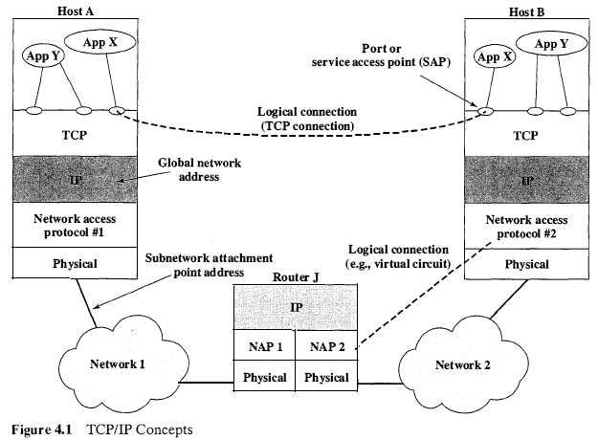

Next, TCP hands each segment over to IP, with instructions to transmit it to B. These segments must be transmitted across one or more subnetworks and relayed through one or more intermediate routers. This operation, too, requires the use of control information. Thus IP appends a header of control information to each segment to form an IP datagram. An example of an item stored in the IP header is the destination host address (in this example, B).
Finally, each IP datagram is presented to the network access layer for transmission across the first subnetwork in its journey to the destination. The network access layer appends its own header, creating a packet, or frame. The packet is transmitted across the subnetwork to router J. The packet header contains the information that the subnetwork needs to transfer the data across the subnetwork. Examples of items that may be contained in this header include
- Destination subnetwork address: The subnetwork must know to which attached device the packet is to be delivered.
- Facilities requests: The network access protocol might request the use of certain subnetwork facilities, such as priority.
At router J, the packet header is stripped off and the IP header examined. On the basis of the destination address information in the IP header, the IP module in the router directs the datagram out across subnetwork 2 to B. To do this, the datagram is again augmented with a network access header.
When the data are received at B, the reverse process occurs. At each layer, the corresponding header is removed, and the remainder is passed on to the next higher layer, until the original user data are delivered to the destination process.

As an aside, the generic name for a block of data exchanged at any protocol level is referred to as a protocol data unit (PDU). Thus, a TCP segment is a TCP PDU.
TCP/IP Applications
A number of applications have been standardized to operate on top of TCP. We mention three of the most common here.
The Simple Mail Transfer Protocol (SMTP) provides a basic electronic mail facility. It provides a mechanism for transferring messages among separate hosts. Features of SMTP include mailing lists, return receipts, and forwarding. The SMTP protocol does not specify the way in which messages are to be created; some local editing or native electronic mail facility is required. Once a message is created, SMTP accepts the message and makes use of TCP to send it to an SMTP module on another host. The target SMTP module will make use of a local electronic mail package to store the incoming message in a user’s mailbox.
The File Transfer Protocol (FTP) is used to send files from one system to another under user command. Both text and binary files are accommodated, and the protocol provides features for controlling user access. When a user wishes to engage in file transfer, FTP sets up a TCP connection to the target system for the exchange of control messages. This connection allows user ID and password to be transmitted and allows the user to specify the file and file actions desired. Once a file transfer is approved, a second TCP connection is set up for the data transfer. The file is transferred over the data connection, without the overhead of any headers or control information at the application level. When the transfer is complete, the control connection is used to signal the completion and to accept new file transfer commands.
TELNET provides a remote logon capability, which enables a user at a terminal or personal computer to logon to a remote computer and function as if directly connected to that computer. The protocol was designed to work with simple scrollmode terminals. TELNET is actually implemented in two modules: User TELNET interacts with the terminal I/O module to communicate with a local terminal. It converts the characteristics of real terminals to the network standard and vice versa. Server TELNET interacts with an application, acting as a surrogate terminal handler so that remote terminals appear as local to the application. Terminal traffic between User and Server TELNET is carried on a TCP connection.
  - THE OSI MODEL
The Open Systems Interconnection (OSI) reference model was developed by the International Organization for Standardization (ISO)¹ as a model for a computer protocol architecture and as a framework for developing protocol standards. The OSI model consists of seven layers:
- Application
- Presentation
- Session
- Transport
- Network
- Data link
- Physical
Figure 4.3 illustrates the OSI model and provides a brief definition of the functions performed at each layer. The intent of the OSI model is that protocols be developed to perform the functions of each layer.
The designers of OSI assumed that this model and the protocols developed within this model would come to dominate computer communications, eventually replacing proprietary protocol implementations and rival multivendor models such

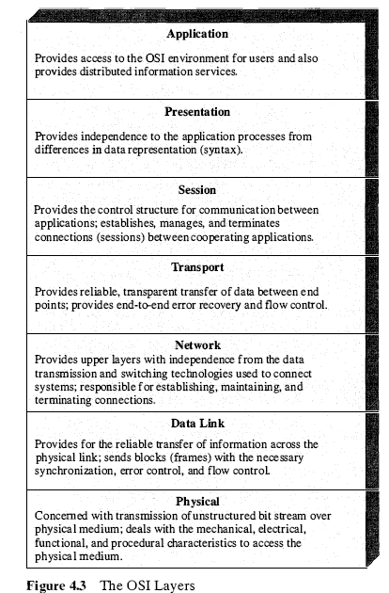

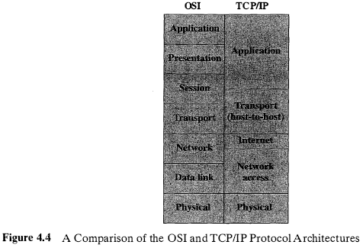

as TCP/IP. This has not happened. Although many useful protocols have been developed in the context of OSI, the overall seven-layer model has not flourished. Instead, the TCP/IP architecture has come to dominate. There are a number of reasons for this outcome. Perhaps the most important is that the key TCP/IP protocols were mature and well tested at a time when similar OSI protocols were in the development stage. When businesses began to recognize the need for interoperability across networks, only TCP/IP was available and ready to go. Another reason is that the OSI model is unnecessarily complex, with seven layers to accomplish what TCP/IP does with fewer layers.
Figure 4.4 illustrates the layers of the TCP/IP and OSI architectures, showing roughly the correspondence in functionality between the two.

  - INTERNETWORKING
In most cases, a LAN or WAN is not an isolated entity. An organization may have more than one type of LAN at a given site to satisfy a spectrum of needs. An organization may have multiple LANs of the same type at a given site to accommodate performance or security requirements. And an organization may have LANs at various sites and need them to be interconnected via WANs for central control of distributed information exchange.
Table 4.1 lists some commonly used terms relating to the interconnection of networks, or internetworking. An interconnected set of networks, from a user’s point of view, may appear simply as a larger network. However, if each of the constituent networks retains its identity, and special mechanisms are needed for communicating across multiple networks, then the entire configuration is often referred to as an internet. The most important example of an internet is referred to simply as the Internet. As the Internet has evolved from its modest beginnings as a research-oriented
packet-switching network, it has served as the basis for the development of internetworking technology and as the model for private internets within organizations. These latter are also referred to as intranets.
Table 4,1 Internetworking Terms
Communication Network
A facility that provides a data transfer service among devices attached to the network.
Internet
A collection of communication networks interconnected by bridges and/or routers.
Intranet
An internet used by a single organization that provides the key Internet applications, especially the World Wide Web. An intranet operates within the organization for internal purposes and can exist as an isolated, self-contained internet, or may have links to the Internet.
End System (ES)
A device attached to one of the networks of an internet that is used to support end-user applications or services.
Intermediate System (IS)
A device used to connect two networks and permit communication between end systems attached to different networks.
Bridge
An IS used to connect two LANs that use similar LAN protocols. The bridge acts as an address filter, picking up packets from one LAN that are intended for a destination on another LAN and passing those packets on. The bridge does not modify the contents of the packets and does not add anything to the packet. The bridge operates at layer 2 of the OSI model.
-Router
An IS used to connect two networks that may or may not be similar. The router employs an internet protocol present in each router and each end system of the network. The router operates at layer 3 of the OSI model.
Each constituent subnetwork in an internet supports communication among the devices attached to that subnetwork; these devices are referred to as end systems (ESs). In addition, subnetworks are connected by devices referred to in the ISO documents as intermediate systems (ISs). ISs provide a communications path and perform the necessary relaying and routing functions so that data can be exchanged between devices attached to different subnetworks in the internet.
Two types of ISs of particular interest are bridges and routers. The differences between them have to do with the types of protocols used for the internetworking logic. In essence, a bridge operates at layer 2 of the OSI seven-layer architecture and acts as a relay of frames between like networks. A router operates at layer 3 of the OSI architecture and routes packets between potentially different networks. Both the bridge and the router assume that the same upper-layer protocols are in use.
The roles and functions of routers were introduced in the context of IP earlier in this chapter. However, because of the importance of routers in the overall networking scheme, it is worth providing additional comment in this section.
- / INTERNETWORKING 79
Routers
Internetworking among dissimilar subnetworks is achieved by using routers to interconnect the subnetworks. Essential functions that the router must perform include the following:
- Provide a link between networks.
- Provide for the routing and delivery of data between processes on end systems attached to different networks.
- Provide these functions in such a way as not to require modifications of the networking architecture of any of the attached subnetworks.
The third point implies that the router must accommodate a number of differences among networks, such as the following:
- Addressing schemes: The networks may use different schemes for assigning addresses to devices. For example, an IEEE 802 LAN uses 48-bit binary addresses for each attached device; an ATM network typically uses 15-digit decimal addresses (encoded as 4 bits per digit for a 60-bit address). Some form of global network addressing must be provided, as well as a directory service.
- Maximum packet sizes: Packets from one network may have to be broken into smaller pieces to be transmitted on another network, a process known as segmentation or fragmentation. For example, Ethernet imposes a maximum packet size of 1500 bytes; a maximum packet size of 1000 bytes is common on X.25 packet-switching networks. A packet that is transmitted on an Ethernet system and picked up by a router for retransmission on an X.25 network may have to be fragmented into two smaller ones.
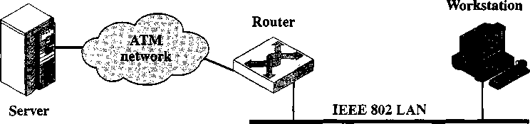

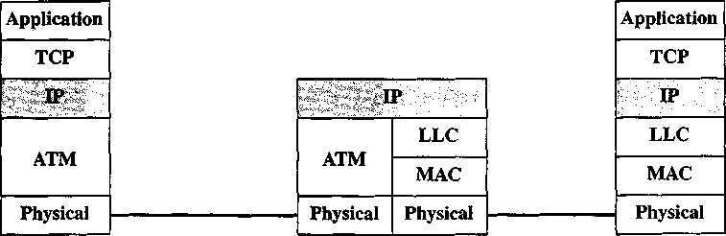
Figure 4.5 Configuration for TCP/IP Example

- Preparing the data. The
Peer-to-peer dialogue.
Before data are sent, the sending and receiving applications agree on format
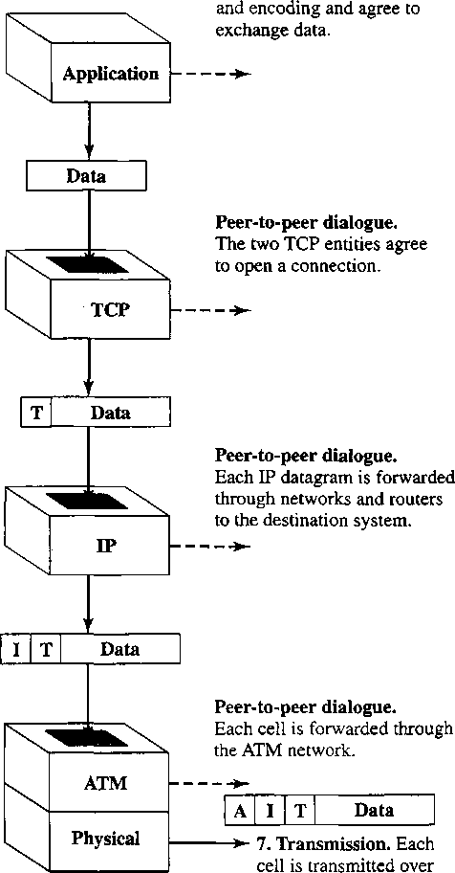
the medium as a sequence of bits.
application protocol prepares a block of data for transmission. For example, an email message (SMTP), a file (FTP), or a block of user input (TELNET).
- Using a common syntax. If necessary, the data are converted to a form expected by the destination. This may include
a different character code, the use of encryption, and/or compression.
- Segmenting the data. TCP may break the data block into a number of segments, keeping track of their sequence. Each TCP segment includes a header containing a sequence number and a frame check sequence to detect errors.
- Duplicating segments. A copy is made of each TCP segment, in case the loss
or damage of a segment necessitates retransmission. When an acknowledgment is received from the other TCP entity, a segment is erased.
- Fragmenting the segments. IP may
break a TCP segment into a number of datagrams to meet size requirements of the intervening networks. Each datagram includes a header containing a destination address, a frame check sequence, and other control information.
- Framing. An ATM header is added to each IP datagram to form an ATM cell. The header contains a connection identifier and a header error control field
Figure 4.6 Operation of TCP/IP: Action at Sender
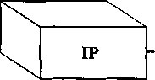
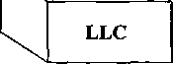
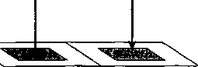
Internetworking Example
Figure 4.5 depicts a configuration that we will use to illustrate the interactions among protocols for internetworking. In this case, we focus on a server attached to an ATM WAN and a workstation attached to an IEEE 802 LAN, with a router connecting the two networks.² The router will provide a link between the server and the workstation that enables these end systems to ignore the details of the intervening networks.
Figures 4.6 through 4.8 outline typical steps in the transfer of a block of data, such as a file or a Web page, from the server, through an internet, and ultimately to an application in the workstation. In this example, the message passes through just one router. Before data can be transmitted, the application and transport layers in the server establish, with the corresponding layer in the workstation, the applicable ground rules for a communication session. These include character code to be used, error-checking method, and the like. The protocol at each layer is used for this purpose and then is used in the transmission of the message.
10. Routing the packet. IP examines the IP header and makes a routing decision. It determines which outgoing link is to be used and then passes the datagram back to the link layer for transmission on that link.
Peer-to-peer dialogue.
The router will pass this datagram onto another router or to the destination system.
I,
'^{r}
I | T | Data

i.
9. Processing the cell. The
ATM layer removes the cell header and processes it. The header error control is used for error detection. The connection number identifies the source.
¹'
L | I | T | Data

11. Forming LLC PDU. An LLC
header is added to each IP datagram to form an LLC PDU. The header contains sequence number and address information.
A | I | T | Data

8. Arriving at router. The
incoming signal is received over the transmission medium and interpreted as a cell of bits.
i
ATM | MAC
Physical | Physical

12. Framing. A MAC header and trailer is added to each LLC PDU, forming a MAC frame. The header contains address information and the trailer contains a frame check sequence.
M | L | I | T | Data | M

13. Transmission. Each frame is transmitted over the medium as a sequence of bits.
Figure 4.7 Operation of TCP/IP: Action at Router
²Section 14.1 describes the IEEE 802 protocol architecture. For now, you need to know that the architecture consists of a physical layer; a medium access control (MAC) layer concerned with addressing and error control, and a logical link control (LLC) layer, concerned with logical connections and identifying the user of LLC.

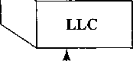
82 CHAPTER 4 / PROTOCOLS AND THE TCP/IP SUITE
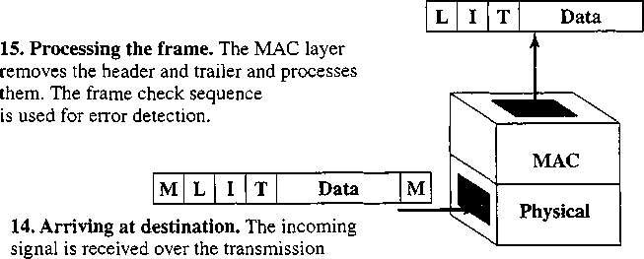
medium and interpreted as a frame of bits.
Figure 4.8 Operation of TCP/IP: Action at Receiver
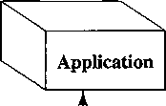
20. Delivering the data. The application performs any needed transformations, including decompression and decryption, and directs the data to the appropriate file or other destination.
19. Reassembling user data. If TCP
Data
1 V
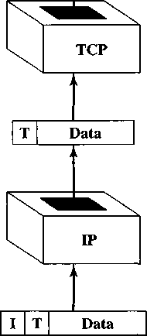
has broken the user data into multiple segments, these are reassembled and the block is passed up to the application.
18. Processing the TCP segment. TCP
removes the header. It checks the frame check sequence and acknowledges if there is a match and discards for mismatch. Flow control is also performed.
17. Processing the IP datagram. IP
removes the header. The frame check sequence and other control information are

Antennas and Propagation
- Antennas
Radiation Patterns Antenna Types Antenna Gain
- Propagation Modes
Ground Wave Propagation Sky Wave Propagation Line-of-Sight Propagation
- Line-of-Sight Transmission
Attenuation Free Space Loss Noise
The Expression E_{b}/N₀ Atmospheric Absorption Multipath Refraction
- Fading in the Mobile Environment
Multipath Propagation
Error Compensation Mechanisms

This chapter provides some fundamental background for wireless transmission. We begin with an overview of antennas and then look at signal propagation.
- ANTENNAS
An antenna can be defined as an electrical conductor or system of conductors used either for radiating electromagnetic energy or for collecting electromagnetic energy. For transmission of a signal, radio-frequency electrical energy from the transmitter is converted into electromagnetic energy by the antenna and radiated into the surrounding environment (atmosphere, space, water). For reception of a signal, electromagnetic energy impinging on the antenna is converted into radiofrequency electrical energy and fed into the receiver.
In two-way communication, the same antenna can be and often is used for both transmission and reception. This is possible because any antenna transfers energy from the surrounding environment to its input receiver terminals with the same efficiency that it transfers energy from the output transmitter terminals into the surrounding environment, assuming that the same frequency is used in both directions. Put another way, antenna characteristics are essentially the same whether an antenna is sending or receiving electromagnetic energy.
Radiation Patterns
An antenna will radiate power in all directions but, typically, does not perform equally well in all directions. A common way to characterize the performance of an antenna is the radiation pattern, which is a graphical representation of the radiation properties of an antenna as a function of space coordinates. The simplest pattern is produced by an idealized antenna known as the isotropic antenna. An isotropic antenna is a point in space that radiates power in all directions equally. The actual radiation pattern for the isotropic antenna is a sphere with the antenna at the center. However, radiation patterns are almost always depicted as a two-dimensional cross section of the three-dimensional pattern. The pattern for the isotropic antenna is shown in Figure 5.1a. The distance from the antenna to each point on the radiation pattern is proportional to the power radiated from the antenna in that direction. Figure 5.1b shows the radiation pattern of another idealized antenna. This is a directional antenna in which the preferred direction of radiation is along one axis.
The actual size of a radiation pattern is arbitrary. What is important is the relative distance from the antenna position in each direction. The relative distance determines the relative power. To determine the relative power in a given direction, a line is drawn from the antenna position at the appropriate angle, and the point of intercept with the radiation pattern is determined. Figure 5.1 shows a comparison of two transmission angles, A and B, drawn on the two radiation patterns. The isotropic antenna produces an omnidirectional radiation pattern of equal strength in all directions, so the A and B vectors are of equal length. For the antenna pattern of Figure 5.1b, the B vector is longer than the A vector, indicating that more power is radiated in the B direction than in the A direction, and the relative lengths of the two vectors are proportional to the amount of power radiated in the two directions.
The radiation pattern provides a convenient means of determining the beam width of an antenna, which is a common measure of the directivity of an antenna. The beam width, also referred to as the half-power beam width, is the angle within which the power radiated by the antenna is at least half of what it is in the most preferred direction.
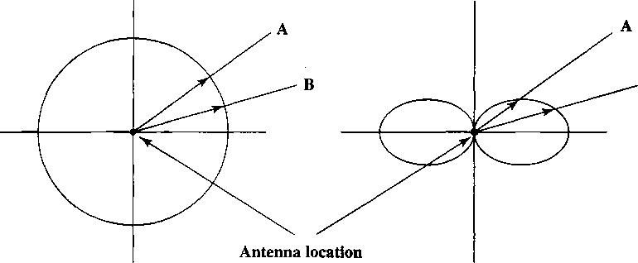
(a) Omnidirectional (b) Directional
Figure 5.1 Idealized Radiation Patterns
When an antenna is used for reception, the radiation pattern becomes a reception pattern. The longest section of the pattern indicates the best direction for reception.
Antenna Types
Dipoles Two of the simplest and most basic antennas are the half-wave dipole, or Hertz, antenna (Figure 5.2a) and the quarter-wave vertical, or Marconi, antenna (Figure 5.2b). The half-wave dipole consists of two straight collinear conductors of equal length, separated by a small gap. The length of the antenna is one-half the wavelength of the signal that can be transmitted most efficiently. A vertical quarter- wave antenna is the type commonly used for automobile radios and portable radios.
A half-wave dipole has a uniform or omnidirectional radiation pattern in one dimension and a figure eight pattern in the other two dimensions (Figure 5.3a). More complex antenna configurations can be used to produce a directional beam.
•* A/2 ►

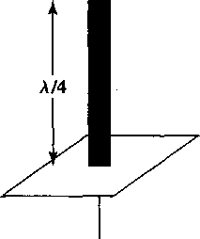
(b) Quarter-wave antenna
(a) Half-wave dipole Figure 5.2 Simple Antennas
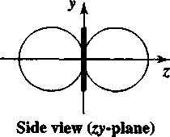
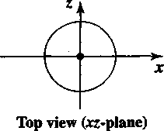
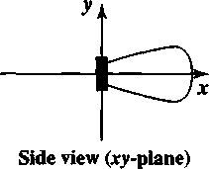
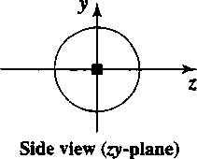
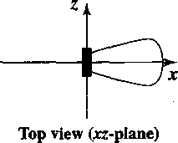
A typical directional radiation pattern is shown in Figure 5.3b. In this case the main strength of the antenna is in the x-direction.
ANTENNAS AND PROPAGATION
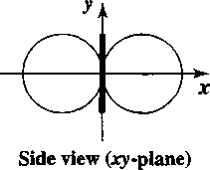
(a) Simple dipole
(b) Directed antenna
Figure 5.3 Radiation Patterns in Three Dimensions [SCHI00]
Parabolic Reflective Antenna An important type of antenna is the parabolic reflective antenna, which is used in terrestrial microwave and satellite applications. A parabola is the locus of all points equidistant from a fixed line and a fixed point not on the line. The fixed point is called the focus and the fixed line is called the directrix (Figure 5.4a). If a parabola is revolved about its axis, the surface generated is called a paraboloid. A cross section through the paraboloid parallel to its axis forms a parabola and a cross section perpendicular to the axis forms a circle. Such surfaces are used in automobile headlights, optical and radio telescopes, and microwave antennas because of the following property: If a source of electromagnetic energy (or sound) is placed at the focus of the paraboloid, and if the paraboloid is a reflecting surface, then the wave will bounce back in lines parallel to the axis of the paraboloid; Figure 5.4b shows this effect in cross section. In theory, this effect creates a parallel beam without dispersion. In practice, there will be some dispersion, because the source of energy must occupy more than one point. The converse is also true. If incoming waves are parallel to the axis of the reflecting paraboloid, the resulting signal will be concentrated at the focus.
Figure 5.4c shows a typical radiation pattern for the parabolic reflective antenna, and Table 5.1 lists beam widths for antennas of various sizes at a frequency of 12 GHz. Note that the larger the diameter of the antenna, the more tightly directional is the beam.
Antenna Gain
Antenna gain is a measure of the directionality of an antenna. Antenna gain is defined as the power output, in a particular direction, compared to that produced in any direction by a perfect omnidirectional antenna (isotropic antenna). For example,
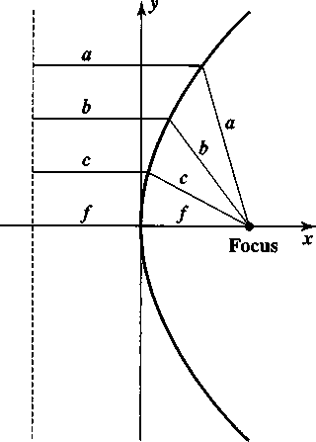
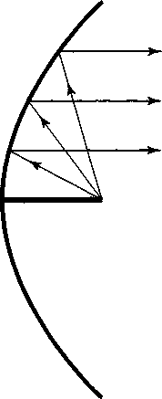
Directrix
(a) Parabola (b) Cross section of parabolic antenna
showing reflective property
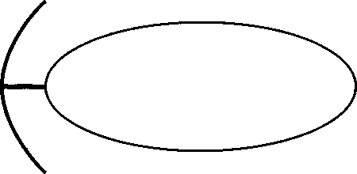
(c) Cross section of parabolic antenna showing radiation pattern
Figure 5.4 Parabolic Reflective Antenna
Table 5.1 Antenna Beamwidths for Various Diameter Parabolic Reflective Antennas at / = 12 GHz [FREE97]
Antenna Diameter (m) | Beam Width (degrees)
0.5
0.75
, 1.0
; 1.5
2.0
2.5
5.0 | 0.35

4?tA₆
A²
rf²A_{e}
where
G = antenna gain A_{e} = effective area / = carrier frequency c = speed of light (^3 X 10⁸m/s)
A = carrier wavelength
Table 5.2 shows the antenna gain and effective area of some typical antenna shapes.
Example 5.1 For a parabolic reflective antenna with a diameter of 2 m. operating at 12 GHz, what is the effective area and the antenna gain? We have an area of A = irr² = v and an effective area of A_{e} = 0.56-77. The wavelength is A = c/f = (3 X 10⁸)/(12 x 10⁹) = 0.025 m. Then
G = (7A)/A² = (7 X 7t)/(0.025)² = 35,186 G^_{b} = 45.46 dB
if an antenna has a gain of 3 dB, that antenna improves upon the isotropic antenna in that direction by 3 dB, or a factor of 2. The increased power radiated in a given direction is at the expense of other directions. In effect, increased power is radiated in one direction by reducing the power radiated in other directions. It is important to note that antenna gain does not refer to obtaining more output power than input power but rather to directionality.
A concept related to that of antenna gain is the effective area of an antenna. The effective area of an antenna is related to the physical size of the antenna and to its shape. The relationship between antenna gain and effective area is
G =
(5.1)
Table 5.2 Antenna Gains and Effective Areas [COUC01]
Type of Antenna | Effective Area A_{e} (nr) | Power Gain (relative to isotropic)
Isotropic | A²/4tt | l ." r
Infinitesimal dipole or loop' | - i.5A²/4ir ' | . 1.5 ; ■■■. .
Half-wave dipole „; | 1.64 A²/477 | 1.64
Hom_{r}mautH area A | 0 KIA | 10A/A²
Parabolic, face area A | 0 56A ' | 7A/X²
TUmstile (two crossed, perpendicular dipoles) | M5A²/4tt. | 1.15

- PROPAGATION MODES
A signal radiated from an antenna travels along one of three routes: ground wave, sky wave, or line of sight (LOS). Table 5.3 shows in which frequency range each predominates. In this book, we are almost exclusively concerned with LOS communication, but a short overview of each mode is given in this section.
Ground Wave Propagation
Ground wave propagation (Figure 5.5a) more or less follows the contour of the earth and can propagate considerable distances, well over the visual horizon. This effect is found in frequencies up to about 2 MHz. Several factors account for the tendency of electromagnetic wave in this frequency band to follow the earth’s curvature. One factor is that the electromagnetic wave induces a current in the earth’s surface, the result of which is to slow the wavefront near the earth, causing the wave- front to tilt downward and hence follow the earth’s curvature. Another factor is diffraction, which is a phenomenon having to do with the behavior of electromagnetic waves in the presence of obstacles.
Electromagnetic waves in this frequency range are scattered by the atmosphere in such a way that they do not penetrate the upper atmosphere.
The best-known example of ground wave communication is AM radio.
Sky Wave Propagation
Sky wave propagation is used for amateur radio, CB radio, and international broadcasts such as BBC and Voice of America. With sky wave propagation, a signal from an earth-based antenna is reflected from the ionized layer of the upper atmosphere (ionosphere) back down to earth. Although it appears the wave is reflected from the ionosphere as if the ionosphere were a hard reflecting surface, the effect is in fact caused by refraction. Refraction is described subsequently.
A sky wave signal can travel through a number of hops, bouncing back and forth between the ionosphere and the earth’s surface (Figure 5.5b). With this propagation mode, a signal can be picked up thousands of kilometers from the transmitter.
Line-of-Sight Propagation
Above 30 MHz, neither ground wave nor sky wave propagation modes operate, and communication must be by line of sight (Figure 5.5c). For satellite communication, a signal above 30 MHz is not reflected by the ionosphere and therefore can be transmitted between an earth station and a satellite overhead that is not beyond the horizon. For ground-based communication, the transmitting and receiving antennas must be within an effective line of sight of each other. The term effective is used because microwaves are bent or refracted by the atmosphere. The amount and even the direction of the bend depends on conditions, but generally microwaves are bent with the curvature of the earth and will therefore propagate farther than the optical line of sight.
Refraction Before proceeding, a brief discussion of refraction is warranted. Refraction occurs because the velocity of an electromagnetic wave is a function of the density
102
Table 5.3 Frequency Bands
Band | frequency Range | free-Space Wavelength Range | Propagation Characteristics | Topical Use
ELF (extremely low frequency) | 30 to 300 Hz | 10,000 to 1000 km | fpwltt | Power line frequencies; used by some home control systems.
VF (voice frequency) | 300 to 3000 Hz | 1000 to 100 km | fcfw ■ | Used by the telephone system for analog subscriber lines.
VLF (very low frequency) | 3 to 30 kHz | 100 to 10 km | GW; low attenuation day and night; high atmospheric noise level | Long-range navigation; submarine communication
LF (low frequency) | 30 to 300 kHz | 10 to 1 km | GW; slightly less reliable than VLF; absorption in daytime | Long-range navigation; marine communication radio beacons
MF (medium frequency) | 300 to 3000 kHz | 1000 to 100 m | GW and night SW; attenuation low at night, high in day; atmospheric noise | Maritime radio; direction finding; AM broadcasting.
HF (high frequency) | 3 to 30 MHz | 100 to 10 m | SW; quality varies with time of day, season, and frequency. | Amateur radio; international broadcasting, military communication; long-distance aircraft and ship communication
VHF (very high frequency) | 30 to 300 MHz | 10 to 1 m | LOS; scattering because of temperature inversion; cosmic noise | VHF television; FM broadcast and two-way radio, AM aircraft communication; aircraft navigational aids
UHF (ultra high frequency) | 300 to 3000 MHz | 100 to 10 cm | LOS; cosmic noise | UHF television; cellular telephone; radar; microwave links; personal communications systems
SHF (super high frequency) | :''::!!p3o;g^^ | 10 to 1 cm | LOS; rainfall attenuation above 10 GHz; atmospheric attenuation due to oxygen and water vapor | Satellite communication; radar; terrestrial microwave links; wireless local loop
EHF (extremely high frequency) | 30 to 300 GHz | 10 to 1 mm | LOS; atmospheric attenuation due to oxygen and water vapor | Experimental; wireless local loop
Infrared | 300 GHz to 400 THz | 1 mm to 770 nm | IflpS- ' . 'iiM jlllll' ' | Infrared LANs; consumer electronic applications
Visible light | 400 THz to 900 THz | 770 nm to 330 nm | |S|los | Optical communication

Signal
propagation
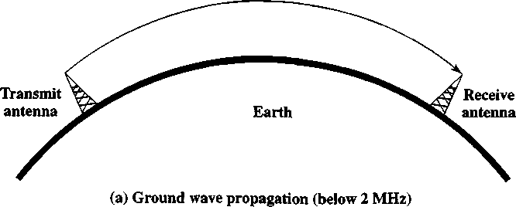

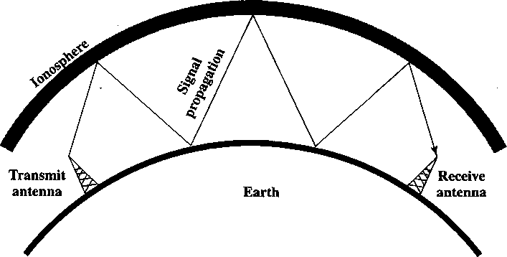
(b) Sky wave propagation (2 to 30 MHz)

Signal
propagation
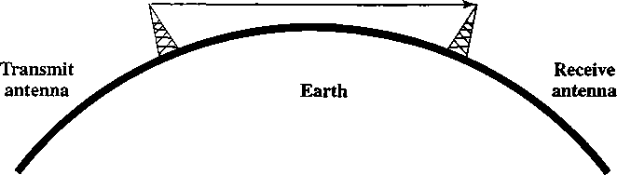
(c) Line-of-sight (LOS) propagation (above 30 MHz) Figure 5.5 Wireless Propagation Modes

of the medium through which it travels. In a vacuum, an electromagnetic wave (such as light or a radio wave) travels at approximately 3 X 10⁸ m/s. This is the constant, c, commonly referred to as the speed of light, but actually referring to the speed of light in a vacuum. In air, water, glass, and other transparent or partially transparent media, electromagnetic waves travel at speeds less than c.
When an electromagnetic wave moves from a medium of one density to a medium of another density, its speed changes. The effect is to cause a one-time
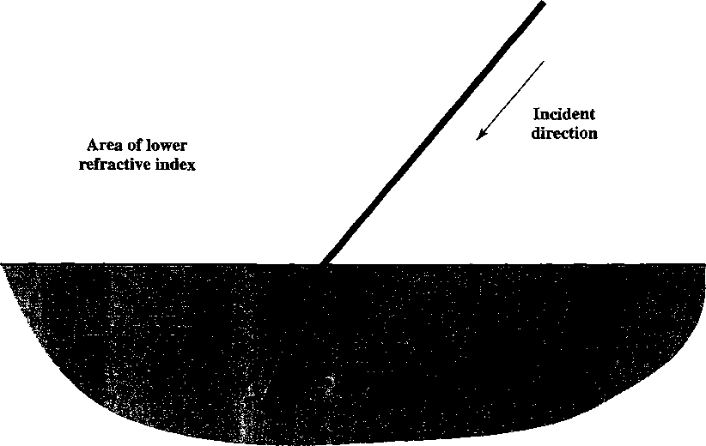
Figure 5.6 Refraction of an Electromagnetic Wave [POOL98]

bending of the direction of the wave at the boundary between the two media. This is illustrated in Figure 5.6. If moving from a less dense to a more dense medium, the wave will bend toward the more dense medium. This phenomenon is easily observed by partially immersing a stick in water. The result will look much like Figure 5.6, with the stick appearing shorter and bent.
The index of refraction of one medium relative to another is the sine of the angle of incidence divided by the sine of the angle of refraction. The index of refraction is also equal to the ratio of the respective velocities in the two media. The absolute index of refraction of a medium is calculated in comparison with that of a vacuum. Refractive index varies with wavelength, so that refractive effects differ for signals with different wavelengths.
Although Figure 5.6 shows an abrupt, one-time change in direction as a signal moves from one medium to another, a continuous, gradual bending of a signal will occur if it is moving through a medium in which the index of refraction gradually changes. Under normal propagation conditions, the refractive index of the atmosphere decreases with height so that radio waves travel more slowly near the ground than at higher altitudes. The result is a slight bending of the radio waves toward the earth.
Optical and Radio Line of Sight With no intervening obstacles, the optical line of sight can be expressed as
d = 3.51 Vh
where d is the distance between an antenna and the horizon in kilometers and h is the antenna height in meters. The effective, or radio, line of sight to the horizon is expressed as (Figure 5.7):
d = 3.57V^
where K is an adjustment factor to account for the refraction. A good rule of thumb is K = 4/3. Thus, the maximum distance between two antennas for LOS propagation is 3.57(Vk^i + VkA₂), where hi and h₂ are the heights of the two antennas.
Radio horizon
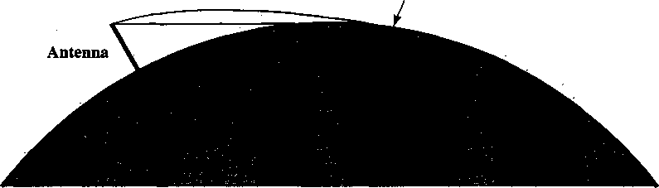
Figure 5.7 Optical and Radio Horizons
- LINE-OF-SIGHT TRANSMISSION
Example 5.2 The maximum distance between two antennas for LOS transmission if one antenna is 100 m high and the other is at giound level is.
d = 3.57 VK/i = 3.57 Vl33 = 41 km
Now suppose that ihe leceiving antenna is 10 m high.To achieve the same distance, how high must the transmitting antenna be? The result is:
VKhy = — - V133 = 7.84
This is a sav'ings of over 50 m in the height ot the transmitting antenna 'Ihis example illustrates the benefit ol raising receiving antennas above giound level to teduce the necessaiv height of the transmitter.
With any communications system, the signal that is received will differ from the signal that is transmitted, due to various transmission impairments. For analog signals, these impairments introduce various random modifications that degrade the signal quality. For digital data, bit errors are introduced: A binary 1 is transformed into a binary 0, and vice versa. In this section we examine the various impairments and comment on their effect on the information-carrying capacity of a communications link. Our concern in this book is with LOS wireless transmission, and in this context, the most significant impairments are
- Attenuation and attenuation distortion
- Free space loss
- Noise
- Atmospheric absorption
- Multipath
- Refraction
Attenuation
The strength of a signal falls off with distance over any transmission medium. For guided media, this reduction in strength, or attenuation, is generally exponential and thus is typically expressed as a constant number of decibels per unit distance. For unguided media, attenuation is a more complex function of distance and the makeup of the atmosphere. Attenuation introduces three factors for the transmission engineer.
- A received signal must have sufficient strength so that the electronic circuitry in the receiver can detect and interpret the signal.
- The signal must maintain a level sufficiently higher than noise to be received without error.
- Attenuation is greater at higher frequencies, causing distortion.
The first and second factors are dealt with by attention to signal strength and the use of amplifiers or repeaters. For a point-to-point transmission (one transmitter and one receiver), the signal strength of the transmitter must be strong enough to be received intelligibly, but not so strong as to overload the circuitry of the transmitter or receiver, which would cause distortion. Beyond a certain distance, the attenuation becomes unacceptably great, and repeaters or amplifiers are used to boost the signal at regular intervals. These problems are more complex when there are multiple receivers, where the distance from transmitter to receiver is variable.
The third factor is known as attenuation distortion. Because the attenuation varies as a function of frequency, the received signal is distorted, reducing intelligibility. Specifically, the frequency components of the received signal have different relative strengths than the frequency components of the transmitted signal. To overcome this problem, techniques are available for equalizing attenuation across a band of frequencies. One approach is to use amplifiers that amplify high frequencies more than lower frequencies.
Free Space Loss
For any type of wireless communication the signal disperses with distance. Therefore, an antenna with a fixed area will receive less signal power the farther it is from the transmitting antenna. For satellite communication this is the primary mode of signal loss. Even if no other sources of attenuation or impairment are assumed, a transmitted signal attenuates over distance because the signal is being spread over a larger and larger area. This form of attenuation is known as free space loss, which can be express in terms of the ratio of the radiated power P_{t} to the power P_{r} received by the antenna or, in decibels, by taking 10 times the log of that ratio. For the ideal isotropic antenna, free space loss is

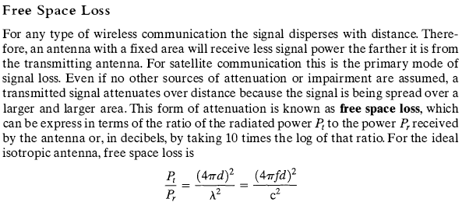

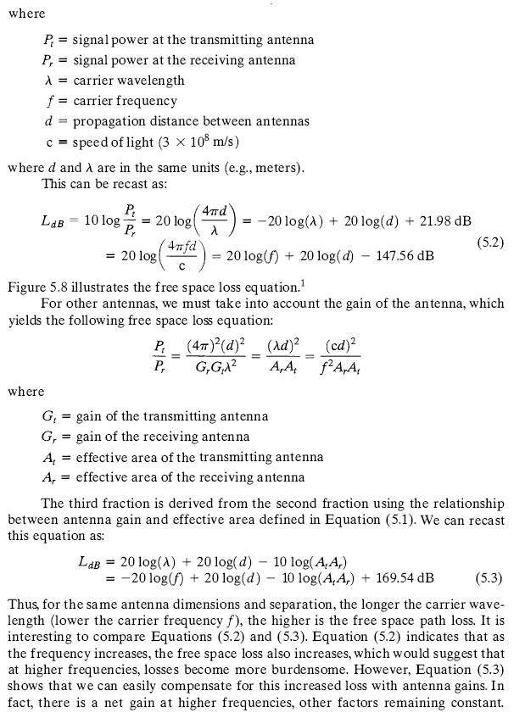

Thus, for the same antenna dimensions and separation, the longer the carrier wavelength (lower the carrier frequency /), the higher is the free space path loss. It is interesting to compare Equations (5.2) and (5.3). Equation (5.2) indicates that as the frequency increases, the free space loss also increases, which would suggest that at higher frequencies, losses become more burdensome. However, Equation (5.3) shows that we can easily compensate for this increased loss with antenna gains. In fact, there is a net gain at higher frequencies, other factors remaining constant.
Example 5.3 Determine the isotropic free space loss at 4 (ill/ for the shortest path to a synchronous satellite from earth (35,863 km). At 4 GH7. tin wavelength is (3 X 10⁸)/(4 X 10⁹) = 0.075 m-lhen,
Ljb = -20 log(0.075) + 20 log(35.853 X 10⁶) + 21.98 = 195.6 dB
Now consider the antenna gain of both the satellite- and ground-based antennas.'Ivpieal values are 44 dB and 48 dB respectively. The free space loss is:
L,jb = 195.6 - 44 - 48 = 103.6 dB
Now assume a transmit power of 250 W at the earth station. What is the power lecc-ivcd at the satellite antenna? A power of 250 W translates into 24 dBW. so the power at the receiving antenna is 24 - 103.6 = —^{7,}»6dBW.

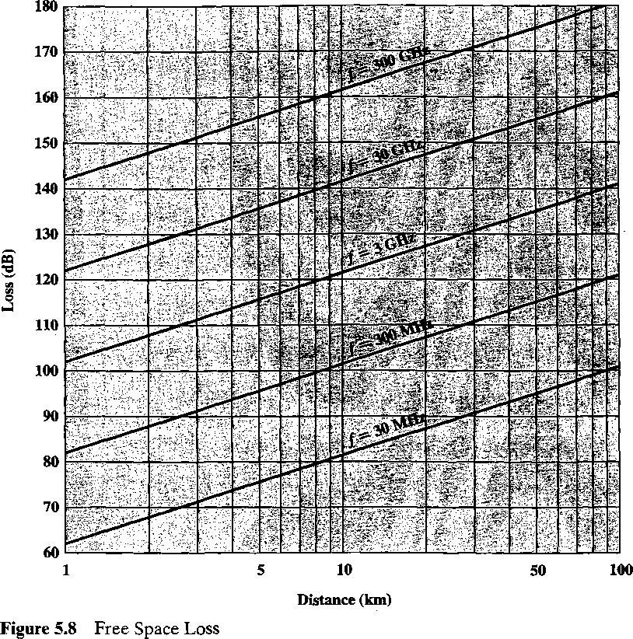
Equation (5.2) shows that at a fixed distance an increase in frequency results in an increased loss measured by 20 log (/). However, if we take into account antenna gain, and fix antenna area, then the change in loss is measured by -20 log(/); that is, there is actually a decrease in loss at higher frequencies.

Noise
For any data transmission event, the received signal will consist of the transmitted signal, modified by the various distortions imposed by the transmission system, plus additional unwanted signals that are inserted somewhere between transmission and reception. These unwanted signals are referred to as noise. Noise is the major limiting factor in communications system performance.
Noise may be divided into four categories:
- Thermal noise
- Intermodulation noise
- Crosstalk
- Impulse noise
Thermal noise is due to thermal agitation of electrons. It is present in all electronic devices and transmission media and is a function of temperature. Thermal noise is uniformly distributed across the frequency spectrum and hence is often referred to as white noise. Thermal noise cannot be eliminated and therefore places an upper bound on communications system performance. Because of the weakness of the signal received by satellite earth stations, thermal noise is particularly significant for satellite communication.
The amount of thermal noise to be found in a bandwidth of 1 Hz in any device or conductor is
where
N₀
k
T
No = kT(W/Hz)
Example 5.4 Room temperature, is usually specified as T = 17°C, or 290 K. At this temperature, the thermal noise pow er density is
Ab = (1.3803 X 10“²³) X 290 = 4 X 10“²¹ W/Hz = -204 dBW/Hz where dBW is the decibel-watt, defined in Appendix 2A.
noise power density in watts per 1 Hz of bandwidth Boltzmann’s constant = 1.38 X 1CT²³ J/K temperature, in kelvins (absolute temperature)
The noise is assumed to be independent of frequency. Thus the thermal noise in watts present in a bandwidth of B Hertz can be expressed as
N = k TB
or, in decibel-watts,
N = 10 log k + 10 log T + 10 log B = -228.6 dBW + 10 log T + 10 log B
Example 5.5 Given a receiver with an effective noise temperature of 294 K and a 10- MHz bandwidth, the thermal noise level at the receiver’s output is
N = -228.6 dBW + 10 log(294) + 10-log 10⁷ = -228.6 + 24.7 + 70 = —133.9 dBW
When signals at different frequencies share the same transmission medium, the result may be intermodulation noise. Intermodulation noise produces signals at a frequency that is the sum or difference of the two original frequencies or multiples of those frequencies. For example, the mixing of signals at frequencies fi and f₂ might produce energy at the frequency f\ + f₂. This derived signal could interfere with an intended signal at the frequency fi + f₂.
Intermodulation noise is produced when there is some nonlinearity in the transmitter, receiver, or intervening transmission system. Normally, these components behave as linear systems; that is, the output is equal to the input times a constant. In a nonlinear system, the output is a more complex function of the input. Such nonlinearity can be caused by component malfunction, the use of excessive signal strength, or just the nature of the amplifiers used. It is under these circumstances that the sum and difference frequency terms occur.
Crosstalk has been experienced by anyone who, while using the telephone, has been able to hear another conversation; it is an unwanted coupling between signal paths. It can occur by electrical coupling between nearby twisted pairs or, rarely, coax cable lines carrying multiple signals. Crosstalk can also occur when unwanted signals are picked up by microwave antennas; although highly directional antennas are used, microwave energy does spread during propagation. Typically, crosstalk is of the same order of magnitude as, or less than, thermal noise. However, in the unlicensed ISM bands, crosstalk often dominates.
All of the types of noise discussed so far have reasonably predictable and relatively constant magnitudes. Thus it is possible to engineer a transmission system to cope with them. Impulse noise, however, is noncontinuous, consisting of irregular pulses or noise spikes of short duration and of relatively high amplitude. It is generated from a variety of causes, including external electromagnetic disturbances, such as lightning, and faults and flaws in the communications system.
Impulse noise is generally only a minor annoyance for analog data. For example, voice transmission may be corrupted by short clicks and crackles with no loss of intelligibility. However, impulse noise is the primary source of error in digital data transmission. For example, a sharp spike of energy of 0.01 s duration would not destroy any voice data but would wash out about 560 bits of data being transmitted at 56 kbps.
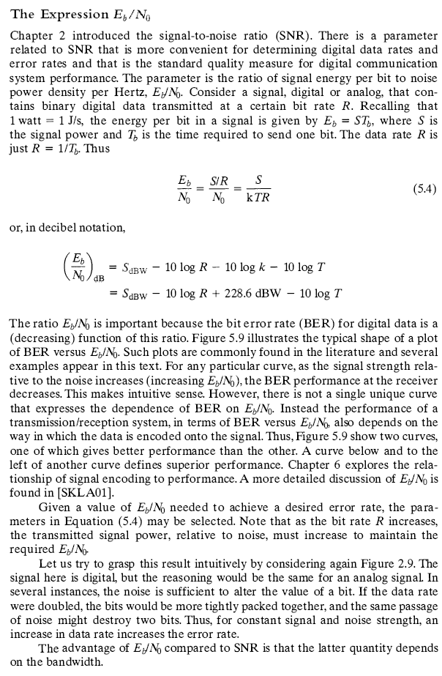

We can relate E_{b}/N₀ to SNR as follows. We have
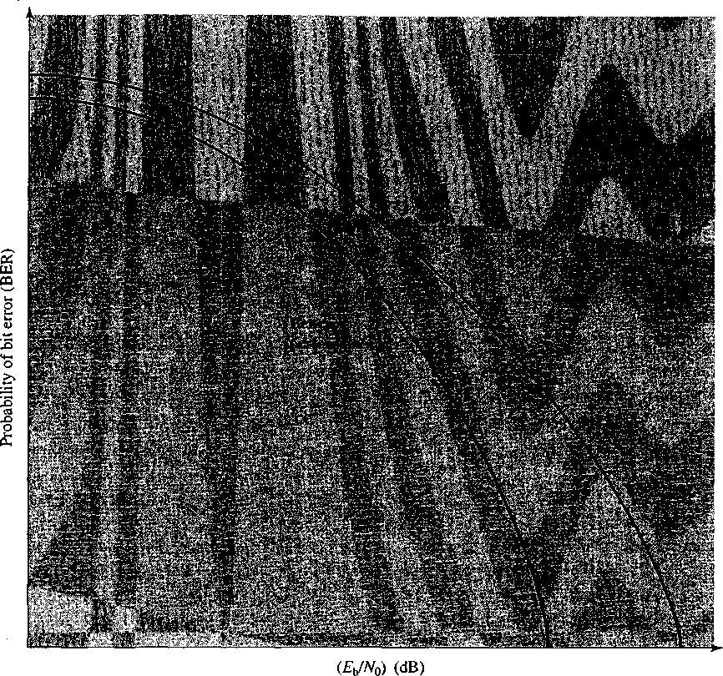
Figure 5.9 General Shape of BER Versus E_{b}/N₀ Curves
Example 5.6 Suppose a signal encoding technique requires that E_{b}/N₀ = 8.4 dB for a bit error rate of 10⁻⁴ (one bit error out of every 10,000). If the effective noise temperature is 290°K (room temperature) and the data rate is 2400 bps, what received signal level is required to overcome thermal noise?
We have
8.4 = S_{dBW} - 10 log 2400 + 228.6 dBW - 10 log 290
= S_{dBW} - (10) (3.38) + 228.6 - (10) (2.46)
S = -161.8 dBW
E_{b} S N₀ N₀R
The parameter N₀ is the noise power density in watts/hertz. Hence, the noise in a signal with bandwidth B_{T} is N = N_{Q}B_{T}. Substituting, we have

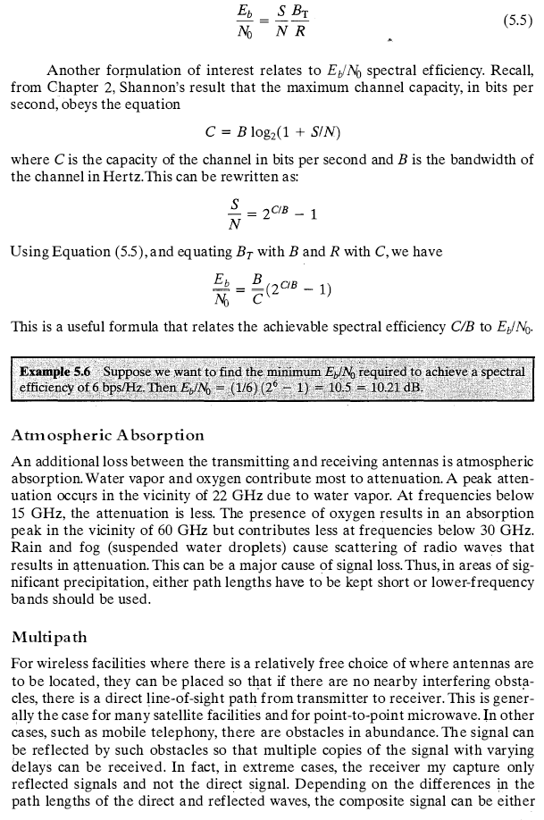

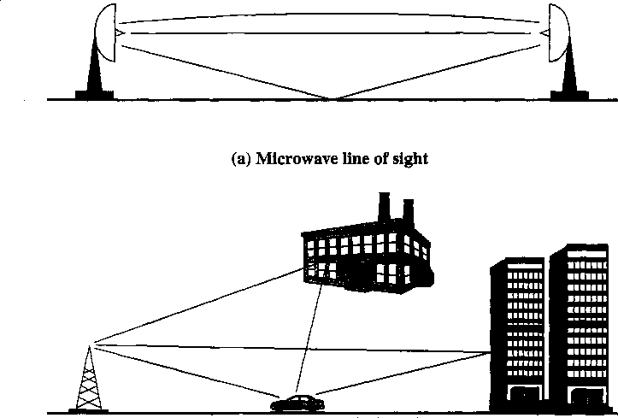
(b) Mobile radio
Figure 5.10 Examples of Multipath Interference

larger or smaller than the direct signal. Reinforcement and cancellation of the signal resulting from the signal following multiple paths can be controlled for communication between fixed, well-sited antennas, and between satellites and fixed ground stations. One exception is when the path goes across water, where the wind keeps the reflective surface of the water in motion. For mobile telephony and communication to antennas that are not well sited, multipath considerations can be paramount.
Figure 5.10 illustrates in general terms the types of multipath interference typical in terrestrial, fixed microwave and in mobile communications. For fixed microwave, in addition to the direct line of sight, the signal may follow a curved path through the atmosphere due to refraction and the signal may also reflect from the ground. For mobile communications, structures and topographic features provide reflection surfaces.
Refraction
Radio waves are refracted (or bent) when they propagate through the atmosphere. The refraction is caused by changes in the speed of the signal with altitude or by other spatial changes in the atmospheric conditions. Normally, the speed of the signal increases with altitude, causing radio waves to bend downward. However, on occasion, weather conditions may lead to variations in speed with height that differ significantly from the typical variations. This may result in a situation in which only a fraction or no part of the line-of-sight wave reaches the receiving antenna.
- FADING IN THE MOBILE ENVIRONMENT
Perhaps the most challenging technical problem facing communications systems engineers is fading in a mobile environment. The term fading refers to the time variation of received signal power caused by changes in the transmission medium or path(s). In a fixed environment, fading is affected by changes in atmospheric conditions, such as rainfall. But in a mobile environment, where one of the two antennas is moving relative to the other, the relative location of various obstacles changes over time, creating complex transmission effects.
Multipath Propagation
Three propagation mechanisms, illustrated in Figure 5.11, play a role. Reflection occurs when an electromagnetic signal encounters a surface that is large relative to the wavelength of the signal. For example, suppose a ground-reflected wave near the mobile unit is received. Because the ground-reflected wave has a 180° phase shift after reflection, the ground wave and the line-of-sight (LOS) wave may tend to cancel, resulting in high signal loss. Further, because the mobile antenna is lower than most human-made structures in the area, multipath interference occurs. These reflected waves may interfere constructively or destructively at the receiver.
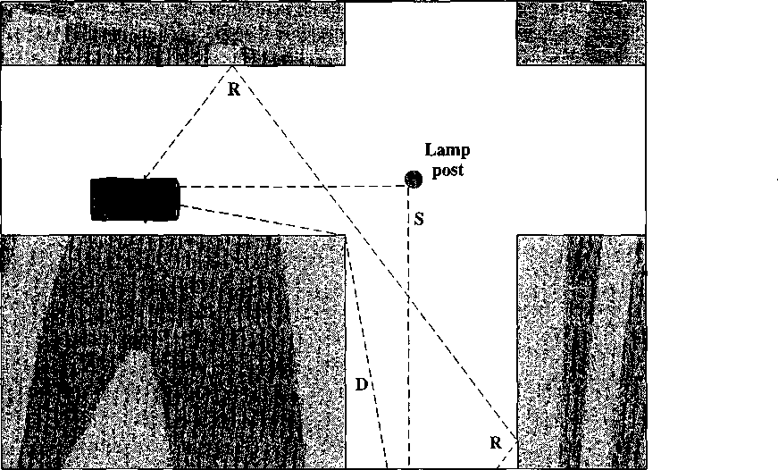
Figure 5.11 Sketch of Three Important Propagation Mechanisms:
Reflection (R), Scattering (S), Diffraction (D) [ANDE95]

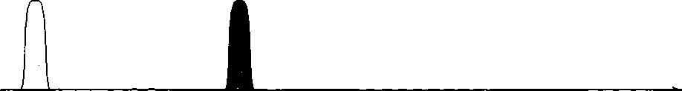

Diffraction occurs at the edge of an impenetrable body that is large compared to the wavelength of the radio wave. When a radio wave encounters such an edge, waves propagate in different directions with the edge as the source. Thus, signals can be received even when there is no unobstructed LOS from the transmitter.
If the size of an obstacle is on the order of the wavelength of the signal or less, scattering occurs. An incoming signal is scattered into several weaker outgoing signals. At typical cellular microwave frequencies, there are numerous objects, such as lamp posts and traffic signs, that can cause scattering. Thus, scattering effects are difficult to predict.
These three propagation effects influence system performance in various ways depending on local conditions and as the mobile unit moves within a cell. If a mobile unit has a clear LOS to the transmitter, then diffraction and scattering are generally minor effects, although reflection may have a significant impact. If there is no clear LOS, such as in an urban area at street level, then diffraction and scattering are the primary means of signal reception.
The Effects of Multipath Propagation As just noted, one unwanted effect of multipath propagation is that multiple copies of a signal may arrive at different phases. If these phases add destructively, the signal level relative to noise declines, making signal detection at the receiver more difficult.
A second phenomenon, of particular importance for digital transmission, is intersymbol interference (ISI). Consider that we are sending a narrow pulse at a given frequency across a link between a fixed antenna and a mobile unit. Figure 5.12 shows what the channel may deliver to the receiver if the impulse is sent at two different times. The upper line shows two pulses at the time of transmission. The lower line shows the resulting pulses at the receiver. In each case the first received pulse is the desired LOS signal. The magnitude of that pulse may change because of changes in atmospheric attenuation. Further, as the mobile unit moves farther away from the
Transmitted
pulse
Transmitted
pulse
Time
Received LOS pulse
r\
Received
multipath
pulses
Received _{Received} multipath _{LOSpulse}
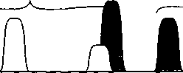
Time
Figure 5.12 Two Pulses in Time-Variant Multipath

fixed antenna, the amount of LOS attenuation increases. But in addition to this primary pulse, there may be multiple secondary pulses due to reflection, diffraction, and scattering. Now suppose that this pulse encodes one or more bits of data. In that case, one or more delayed copies of a pulse may arrive at the same time as the primary pulse for a subsequent bit. These delayed pulses act as a form of noise to the subsequent primary pulse, making recovery of the bit information more difficult.
As the mobile antenna moves, the location of various obstacles changes; hence the number, magnitude, and timing of the secondary pulses change. This makes it difficult to design signal processing techniques that will filter out multipath effects so that the intended signal is recovered with fidelity.
Types of Fading Fading effects in a mobile environment can be classified as either fast or slow. Referring to Figure 5.11, as the mobile unit moves down a street in an urban environment, rapid variations in signal strength occur over distances of about one-half a wavelength. At a frequency of 900 MHz, which is typical for mobile cellular applications, a wavelength is 0.33 m. The rapidly changing waveform in Figure 5.13 shows an example of the spatial variation of received signal amplitude at 900 MHz in an urban setting. Note that changes of amplitude can be as much as 20 or 30 dB over a short distance. This type of rapidly changing fading phenomenon, known as fast fading, affects not only mobile phones in automobiles, but even a mobile phone user walking down an urban street.
As the mobile user covers distances well in excess of a wavelength, the urban environment changes, as the user passes buildings of different heights, vacant lots, intersections, and so forth. Over these longer distances, there is a change in the average received power level about which the rapid fluctuations occur. This is indicated by the slowly changing waveform in Figure 5.13 and is referred to as slow fading.
Fading effects can also be classified as flat or selective. Flat fading, or nonse- lective fading, is that type of fading in which all frequency components of the received signal fluctuate in the same proportions simultaneously. Selective fading affects unequally the different spectral components of a radio signal. The term

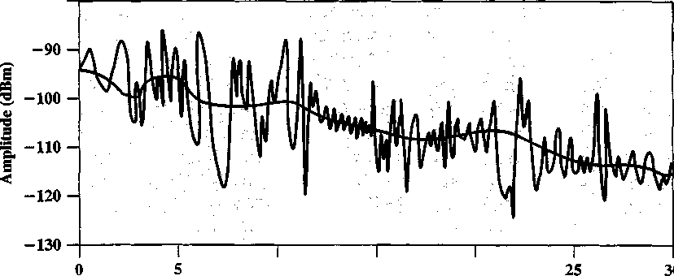
10 15 20
Position (m)
Figure 5.13 Typical Slow and Fast Fading in an Urban Mobile Environment

selective fading is usually significant only relative to the bandwidth of the overall communications channel. If attenuation occurs over a portion of the bandwidth of the signal, the fading is considered to be selective; nonselective fading implies that the signal bandwidth of interest is narrower than, and completely covered by, the spectrum affected by the fading.
The Fading Channel In designing a communications system, the communications engineer needs to estimate the effects of multipath fading and noise on the mobile channel. The simplest channel model, from the point of view of analysis, is the additive white Gaussian noise (AWGN) channel. In this channel, the desired signal is degraded by thermal noise associated with the physical channel itself as well as electronics at the transmitter and receiver (and any intermediate amplifiers or repeaters). This model is fairly accurate in some cases, such as space communications and some wire transmissions, such as coaxial cable. For terrestrial wireless transmission, particularly in the mobile situation, AWGN is not a good guide for the designer.
Rayleigh fading occurs when there are multiple indirect paths between transmitter and receiver and no distinct dominant path, such as an LOS path. This represents a worst case scenario. Fortunately, Rayleigh fading can be dealt with analytically, providing insights into performance characteristics that can be used in difficult environments, such as downtown urban settings.
Ridan fading best characterizes a situation where there is a direct LOS path in addition to a number of indirect multipath signals. The Rician model is often applicable in an indoor environment whereas the Rayleigh model characterizes outdoor settings. The Rician model also becomes more applicable in smaller cells or in more open outdoor environments. The channels can be characterized by a parameter K, defined as follows:
power in the dominant path power in the scattered paths
When K = 0 the channel is Rayleigh (i.e., numerator is zero) and when K — oo, the channel is AWGN (i.e., denominator is zero). Figure 5.14, based on [FREE98a] and [SKLA01], shows system performance in the presence of noise. Here bit error rate is plotted as a function of the ratio E_{b}/N₀. Of course, as that ratio increases, the bit error rate drops. The figure shows that with a reasonably strong signal, relative to noise, an AWGN exhibit provides fairly good performance, as do Rician channels with larger values of K, roughly corresponding to microcells or an open country environment. The performance would be adequate for a digitized voice application, but for digital data transfer efforts to compensate would be needed. The Rayleigh channel provides relatively poor performance; this is likely to be seen for flat fading and for slow fading; in these cases, error compensation mechanisms become more desirable. Finally, some environments produce fading effects worse than the so-called worst case of Rayleigh. Examples are fast fading in an urban environment and the fading within the affected band of a selective fading channel. In these cases, no level of E_{b}/N₀ will help achieve the desired performance, and compensation mechanisms are mandatory. We turn to a discussion of those mechanisms next.
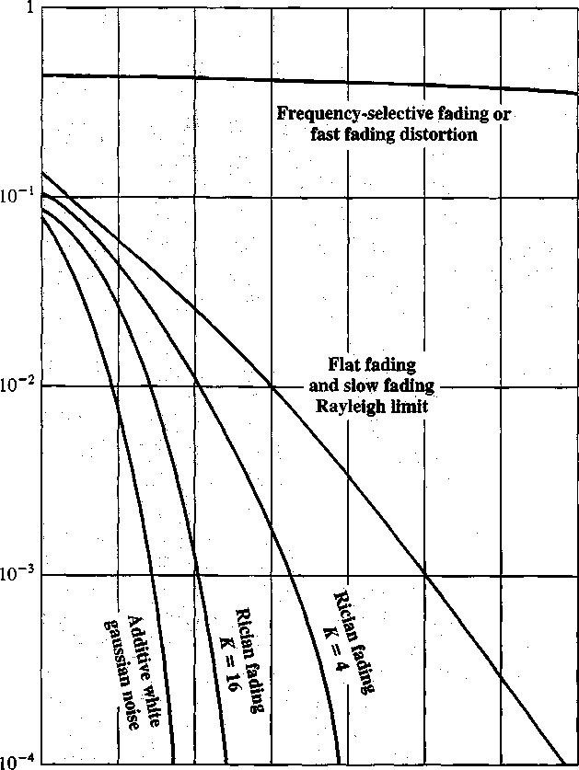
at
H
SQ
I
U
4)
©
■a
i
0 5 10 15 20 25 30 35
(E_{fc}Wo) (dB)
Figure 5.14 Theoretical Bit Error Rate for Various Fading Conditions

Error Compensation Mechanisms
The efforts to compensate for the errors and distortions introduced by multipath fading fall into three general categories: forward error correction, adaptive equalization, and diversity techniques. In the typical mobile wireless environment, techniques from all three categories are combined to combat the error rates encountered.
Forward Error Correction Forward error correction is applicable in digital transmission applications: those in which the transmitted signal carries digital data or digitized voice or video data. The term forward refers to procedures whereby a receiver, using only information contained in the incoming digital transmission, corrects bit errors in the data. This is in contrast to backward error correction, in which the receiver merely detects the presence of errors and then sends a request back to the transmitter to retransmit the data in error. Backward error correction is not practical in many wireless applications. For example, in satellite communications, the
amount of delay involved makes retransmission undesirable. In n tions, the error rates are often so high that there is a high probabili mitted block of bits will also contain errors. In these applicati correction is required. In essence, forward error correction is ach
additional, redun- m error-correcting
- Using a coding algorithm, the transmitter adds a number o dant bits to each transmitted block of data. These bits form code and are calculated as a function of the data bits.
code), the receiver ta bits. If the calcu-
- For each incoming block of bits (data plus error-correcting calculates a new error-correcting code from the incoming d lated code matches the incoming code, then the receiver assumes that no error has occurred in this block of bits.
or more bits are in that depends on the ible for the receiver
- If the incoming and calculated codes do not match, then on error. If the number of bit errors is below a threshold length of the code and the nature of the algorithm, it is pos to determine the bit positions in error and correct all errata
Typically in mobile wireless applications, the ratio of total bits sent to data bits sent is between 2 and 3.This may seem an extravagant amount ol overhead, in that the capacity of the system is cut to one-half or one-third of its pot< wireless environment is so difficult that such levels of redundan Chapter 8 examines forward error correction techniques
ntial, but the mobile :y are necessary, in detail.
Adaptive Equalization Adaptive equalization can be ap that carry analog information (e.g., analog voice or video) or di digital data, digitized voice or video) and is used to combat intf The process of equalization involves some method of gathering energy back together into its original time interval. Equaliz; techniques include the use of so-called lumped analog circu cated digital signal processing algorithms. Here we give a fla\jor of the digital signal processing approach.
Figure 5.15 illustrates a common approach using a linear equalizer circuit. In this
npled at five uniformly nples are individually re output. The circuit is
specific example, for each output symbol, the input signal is sa: spaced intervals of time, separated by a delay r. These sa weighted by the coefficients Q and then summed to produce t
referred to as adaptive because the coefficients are dynamic ally adjusted. Typically,
nown sequence of bits, s the received training s of the comparison cal- raining sequence is sent
the coefficients are set using a training sequence, which is a 1 The training sequence is transmitted. The receiver compart sequence with the expected training sequence and on the bas culates suitable values for the coefficients. Periodically, a new to account for changes in the transmission environment.
For Rayleigh channels, or worse, it may be necessary t) include a new training sequence with every single block of data. Again, this repre ents considerable overhead but is justified by the error rates encountered in a mob le wireless environment.
Diversity Techniques Diversity is based on the fact hat individual channels experience independent fading events. We can therefore compensate for error effects by providing multiple logical channels in some sense between transmitter and
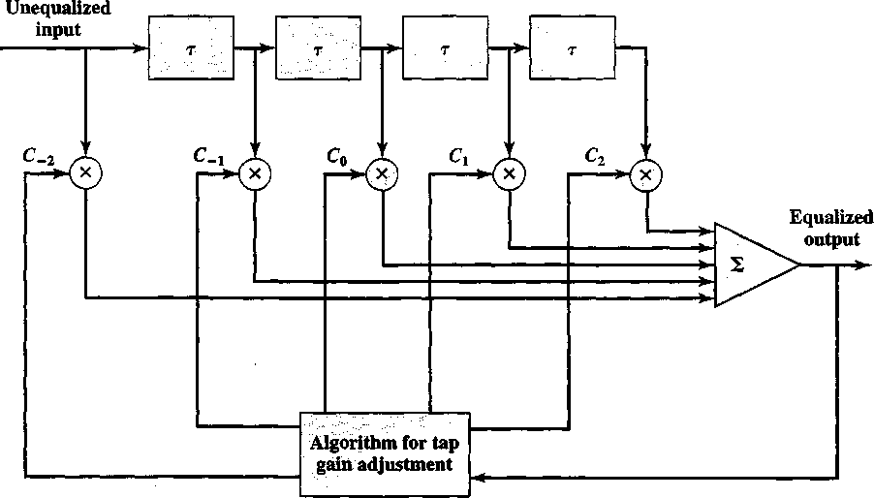
Figure 5.15 Linear Equalizer Circuit [PROAOl]

receiver and sending part of the signal over each channel. This technique does not eliminate errors but it does reduce the error rate, since we have spread the transmission out to avoid being subjected to the highest error rate that might occur. The other techniques (equalization, forward error correction) can then cope with the reduced error rate.
Some diversity techniques involve the physical transmission path and are referred to as space diversity. For example, multiple nearby antennas may be used to receive the message, with the signals combined in some fashion to reconstruct the most likely transmitted signal. Another example is the use of collocated multiple directional antennas, each oriented to a different reception angle with the incoming signals again combined to reconstitute the transmitted signal.
More commonly, the term diversity refers to frequency diversity or time diversity techniques. With frequency diversity, the signal is spread out over a larger frequency bandwidth or carried on multiple frequency carriers. The most important example of this approach is spread spectrum, which is examined in Chapter 7.
Time diversity techniques aim to spread the data out over time so that a noise burst affects fewer bits. Time diversity can be quite effective in a region of slow fading. If a mobile unit is moving slowly, it may remain in a region of a high level of fading for a relatively long interval. The result will be a long burst of errors even though the local mean signal level is much higher than the interference. Even powerful error correction codes may be unable to cope with an extended error burst. If digital data is transmitted in a time division multiplex (TDM) structure, in which multiple users share the same physical channel by the use of time slots (see Figure 2.13b), then block interleaving can be used to provide time diversity. Figure 5.16a, based on one in [JONE93], illustrates the concept. Note that the same number of bits are still affected by the noise surge, but they are spread out over a number of logical channels. If each channel is protected by forward error correction, the error-correcting
*>
Time
*-
Time
122 CHAPTER 5 / ANTENNAS AND PROPAGATION
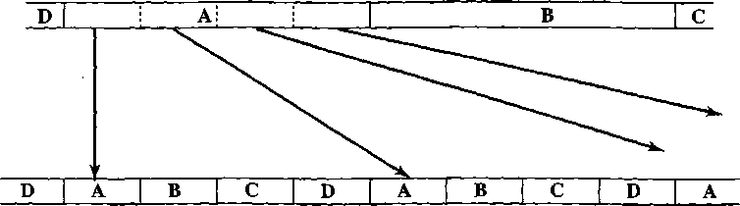

Fade giving rise to errors
(a) TDM stream
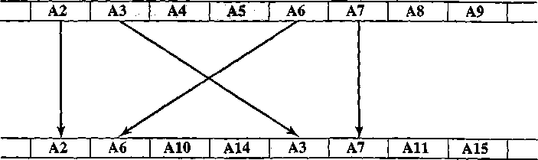
Fade giving rise to errors
(b) Interleaving without TDM Figure 5.16 Interleaving Data Blocks to Spread the Effects of Error Bursts
code may be able to cope with the fewer number of bits that are in error in a particular logical channel. If TDM is not used, time diversity can still be applied by viewing the stream of bits from the source as a sequence of blocks and then shuffling the blocks. In Figure 5.16b, blocks are shuffled in groups of four. Again, the same number of bits is in error, but the error correcting code is applied to sets of bits that are spread out in time. Even greater diversity is achieved by combining TDM interleaving with block shuffling.
The tradeoff with time diversity is delay. The greater the degree of interleaving and shuffling used, the longer the delay in reconstructing the original bit sequence at the receiver.

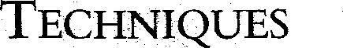
Signal Encoding
- Signal Encoding Criteria
- Digital Data, Analog Signals
Amplitude-Shift Keying Frequency-Shift Keying Phase-Shift Keying Performance Minimum-Shift Keying Quadrature Amplitude Modulation
- Analog Data, Analog Signals
Amplitude Modulation Angle Modulation
- Analog Data, Digital Signals
Pulse Code Modulation Delta Modulation (DM) Performance

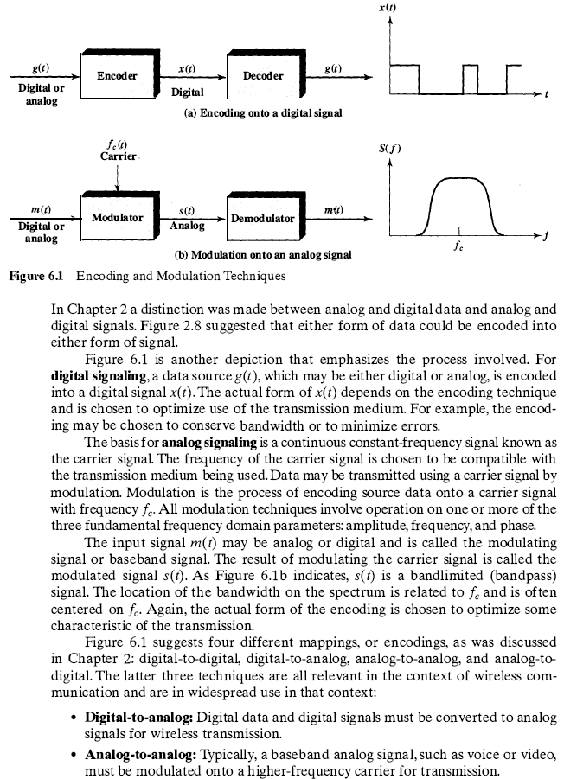

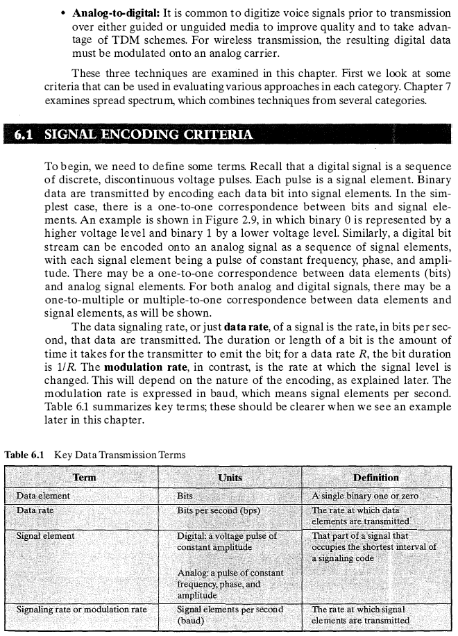

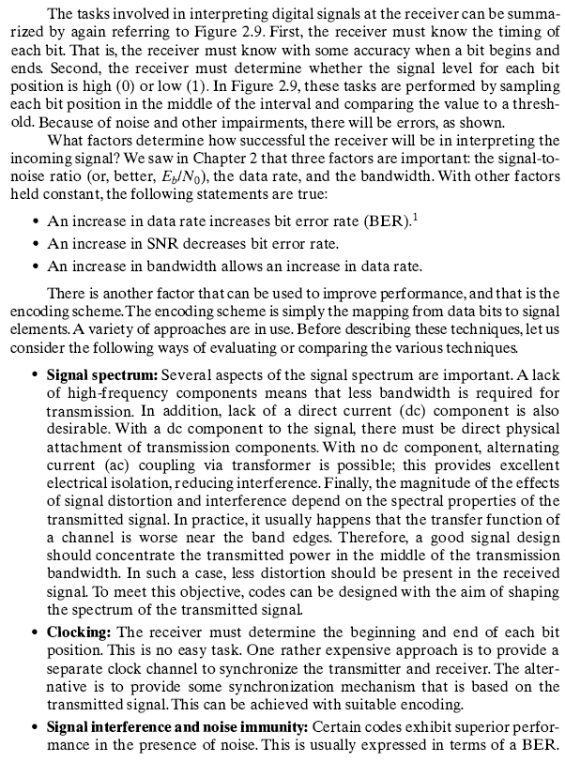

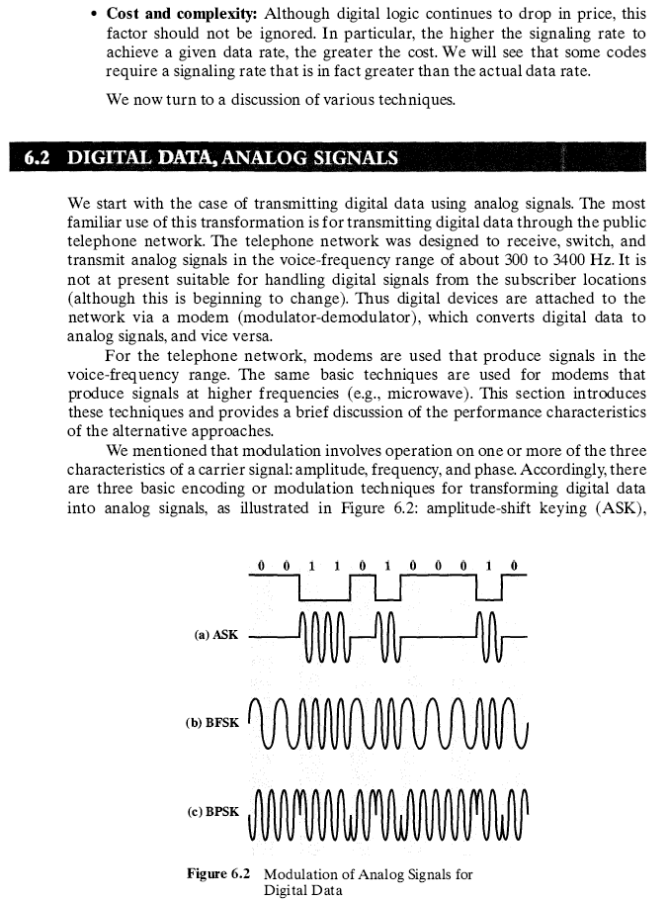

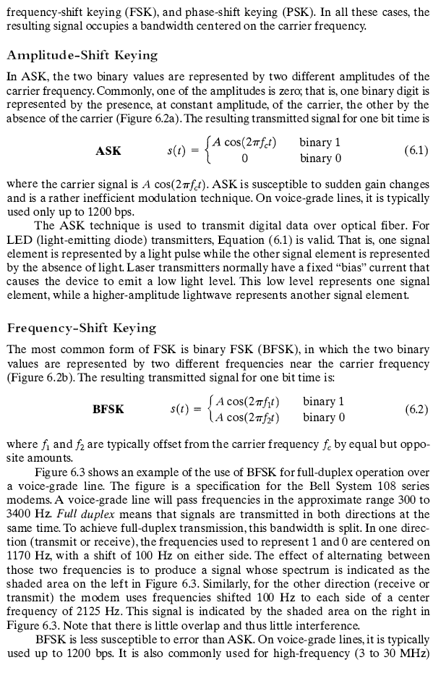

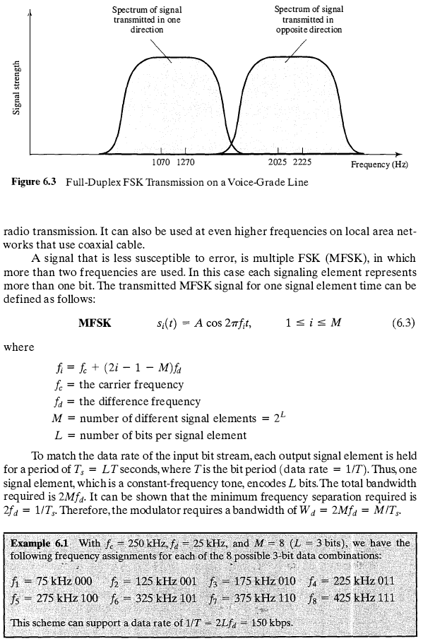

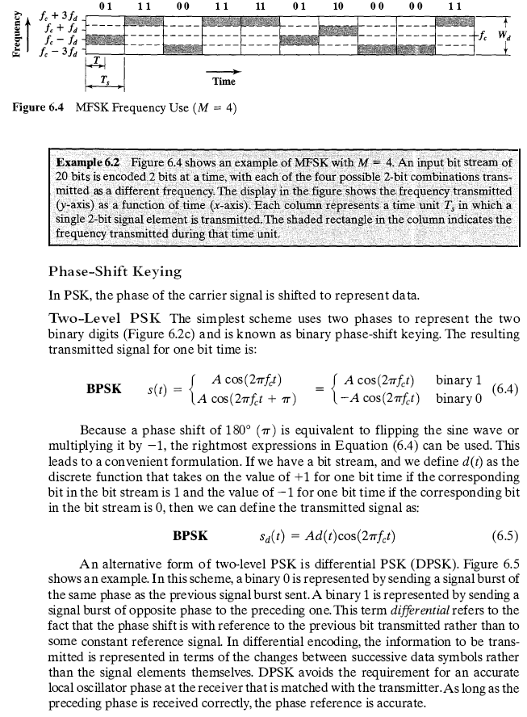

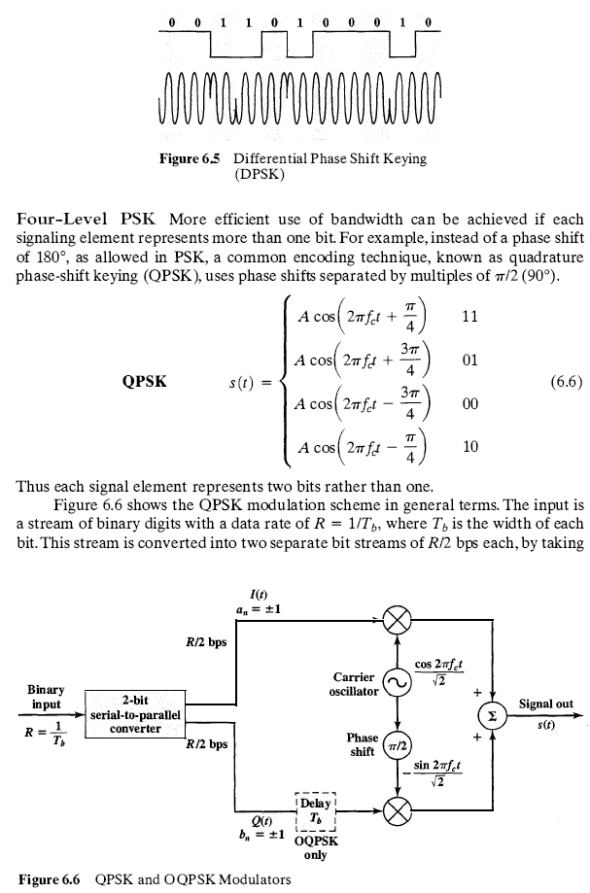

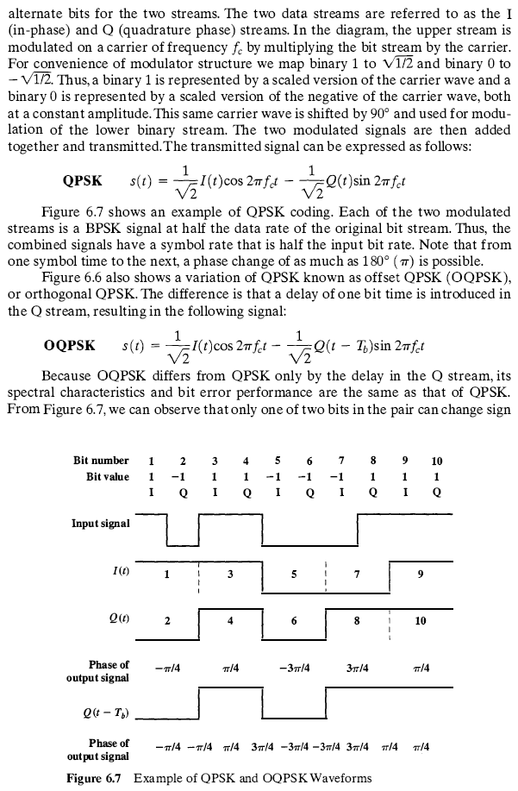

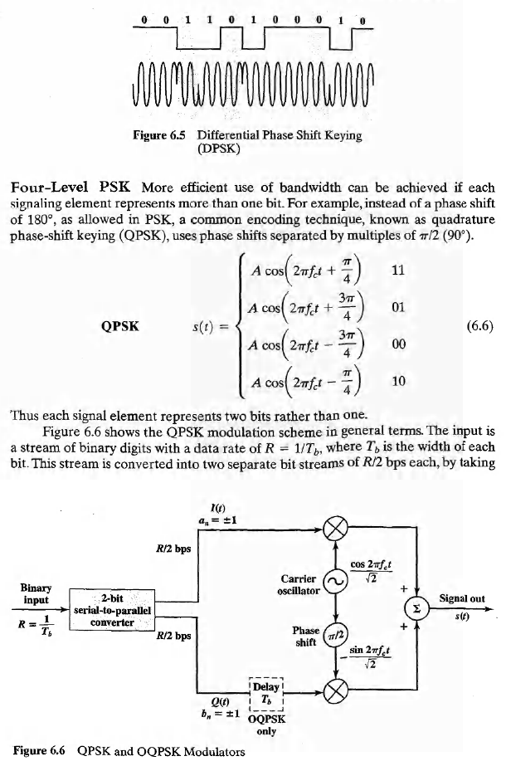

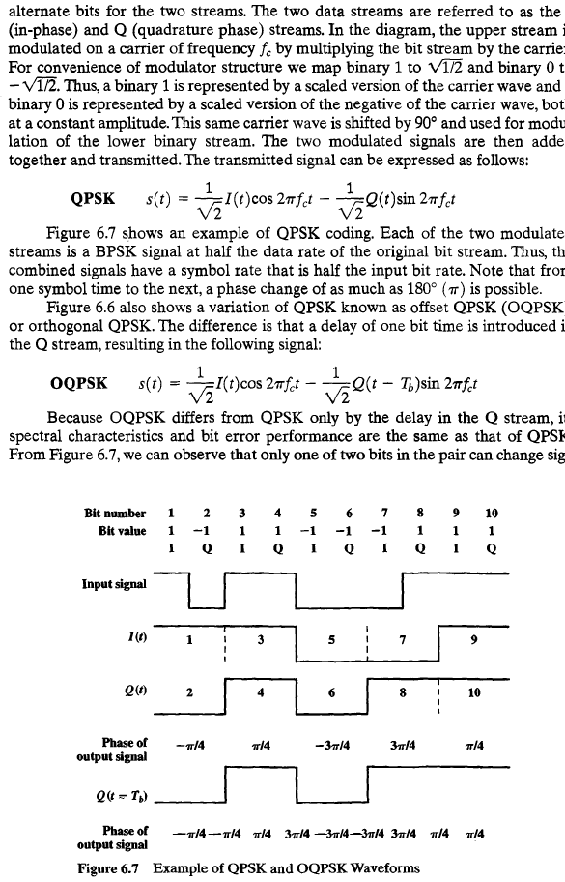

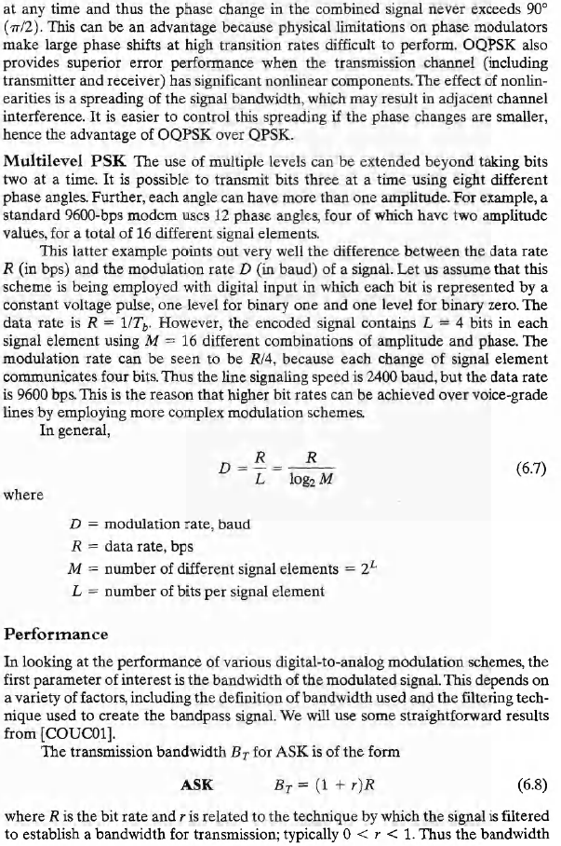

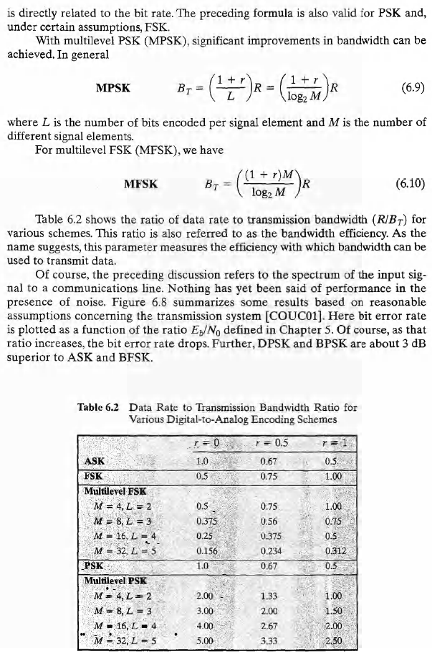

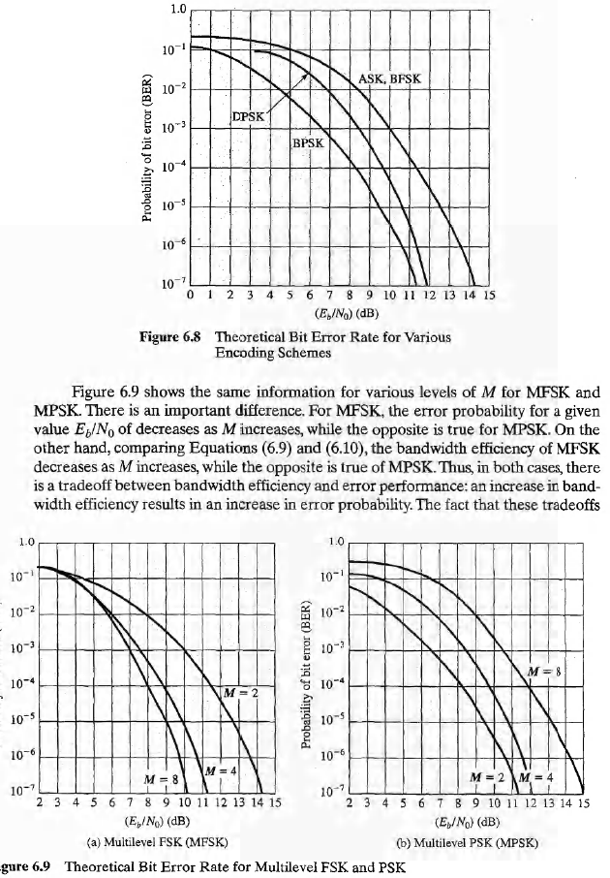

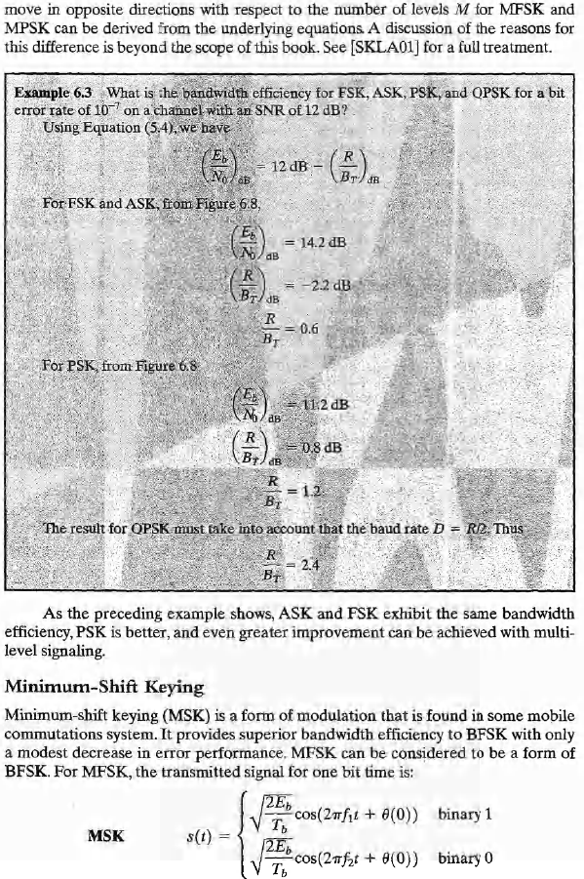

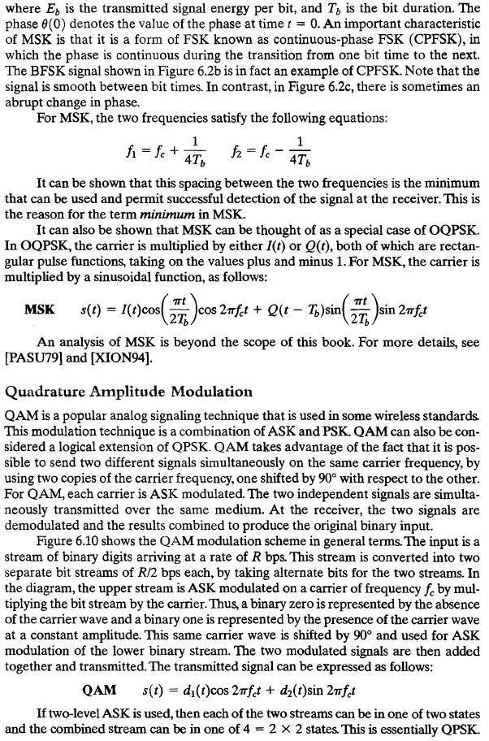

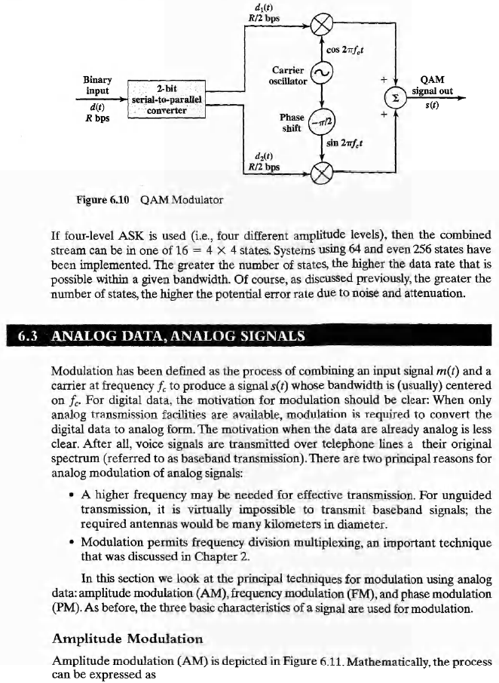

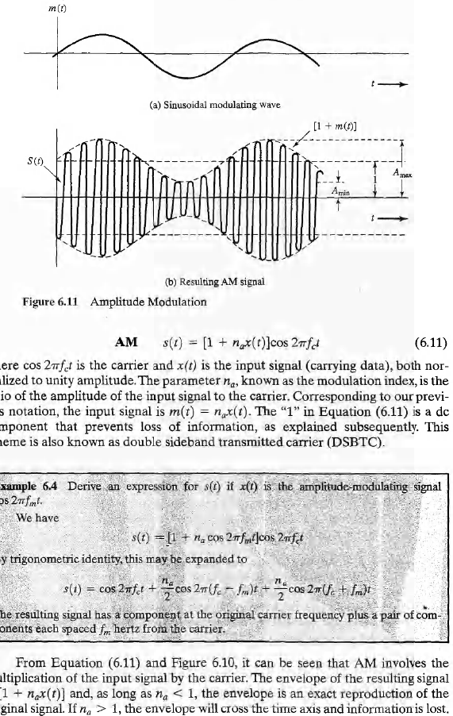

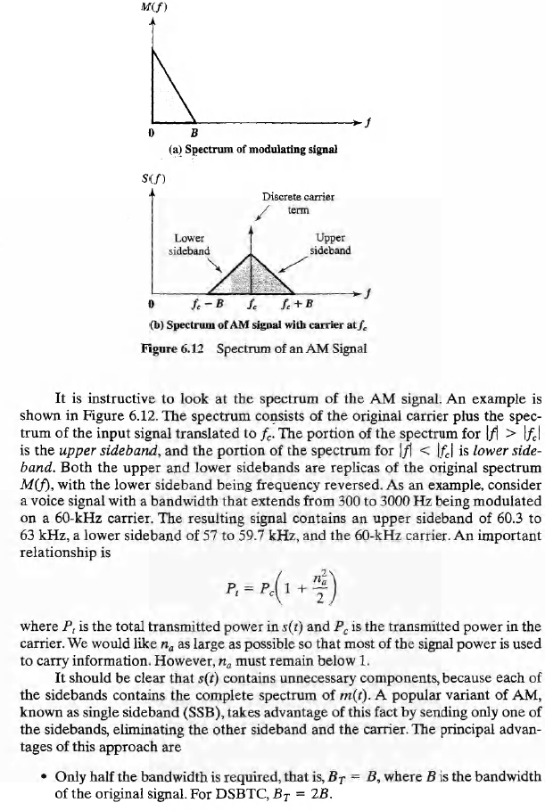

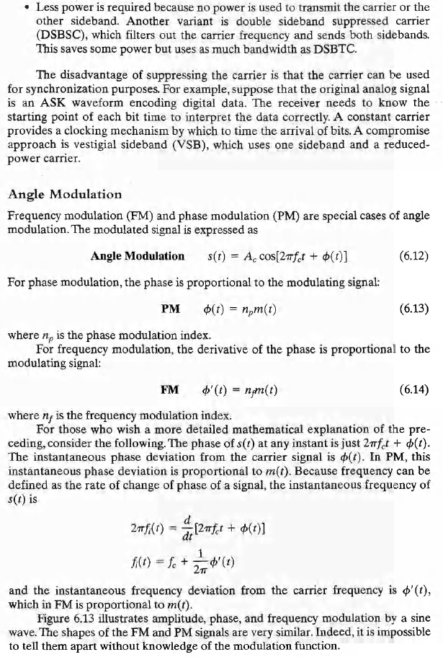

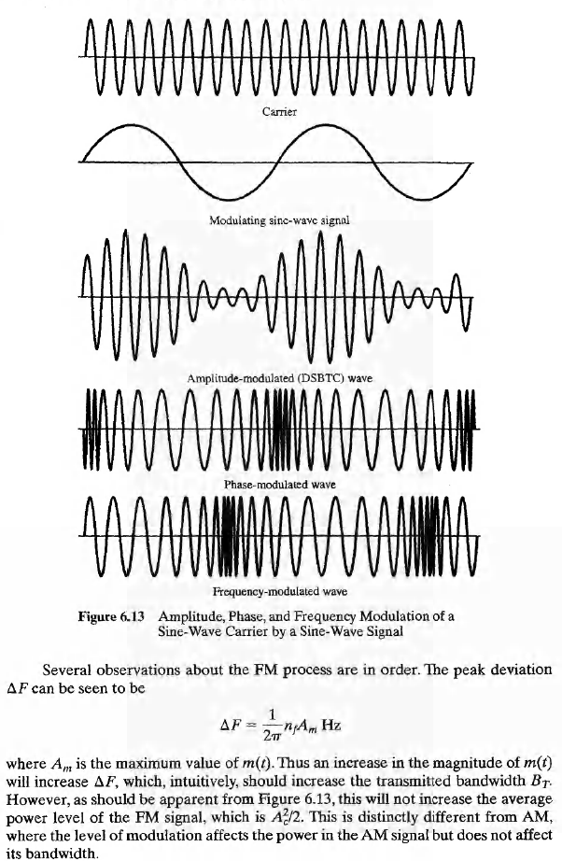

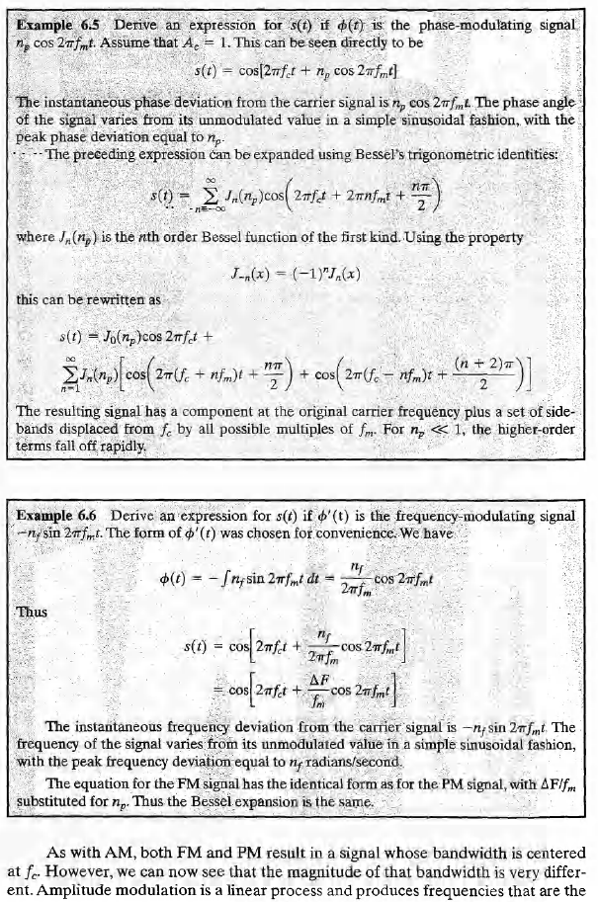

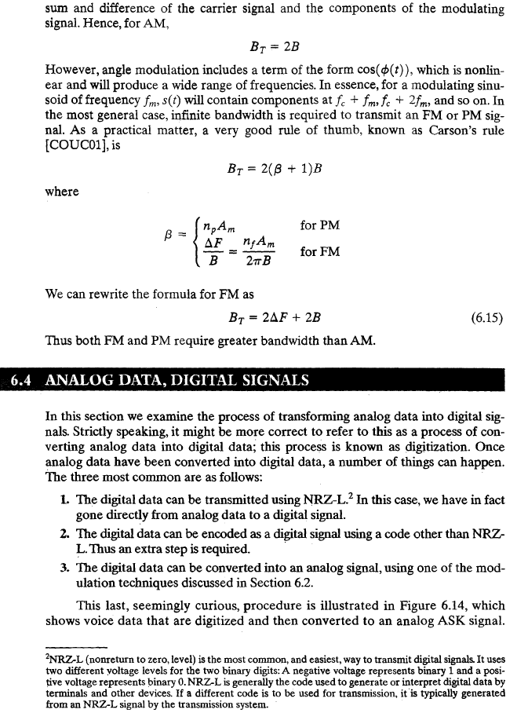

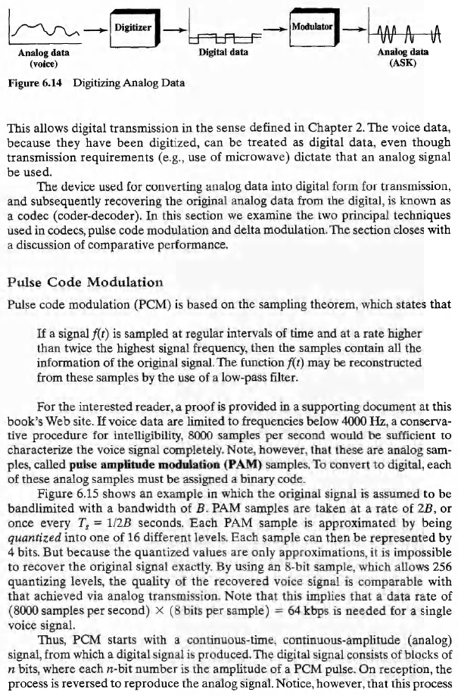

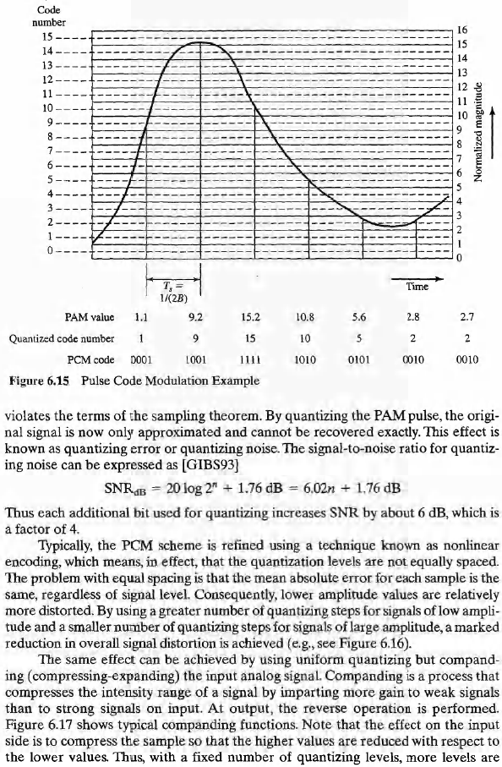

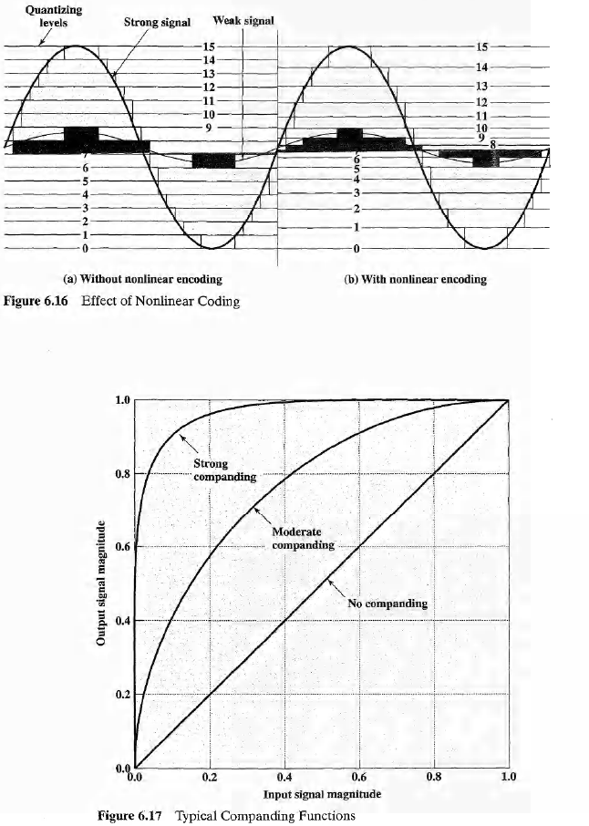

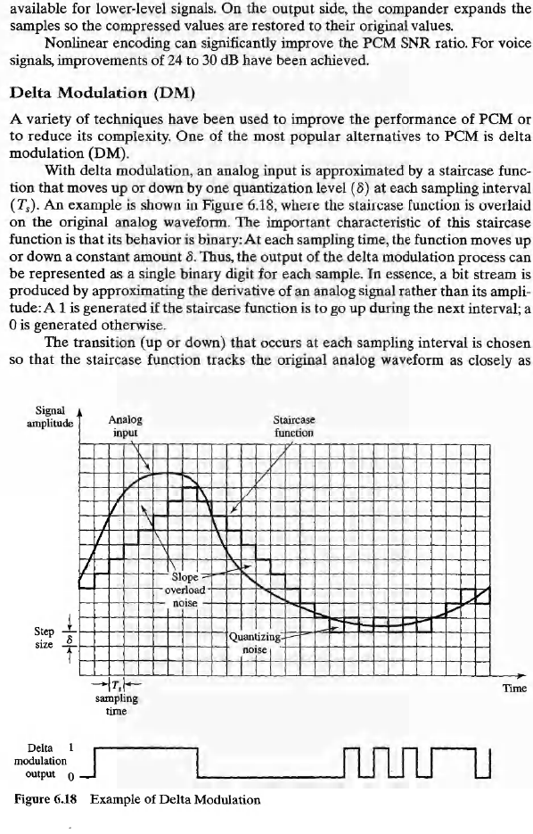

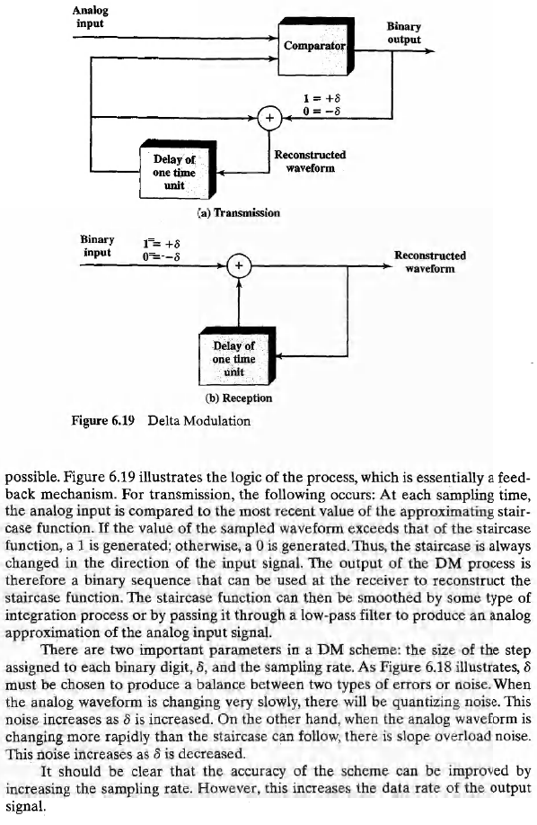

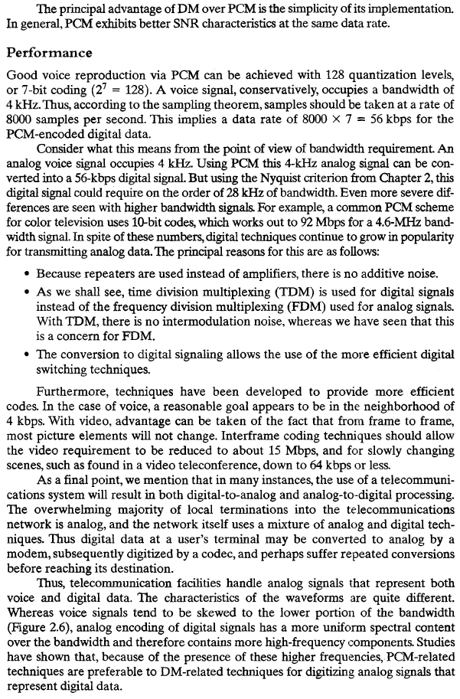

Spread Spectrum

Spread spectrum technology has blossomed from a military technology into one of the fundamental building blocks in current and next-generation wireless systems. From cellular to cordless to wireless LAN (WLAN) systems, spectrum is a vital component in the system design process.
Since spread-spectrum is such an integral ingredient, it's vital for designers to have an understanding of how this technology. In this tutorial, we'll take on that task, addressing the basic operating characteristics of a spread-spectrum system. We'll also examine the key differentiators between frequency-hop (FHSS) and direct-sequence spread spectrum (DSSS) implementations.
How It Works
Spread spectrum uses wideband, noise-like signals that are hard to detect, intercept, or demodulate. Additionally, spread-spectrum signals are harder to jam (interfere with) than narrow band signals. These low probability of intercept (LPI) and anti-jam (AJ) features are why the military has used spread spectrum for so many years. Spread-spectrum signals are intentionally made to be a much wider band than the information they are carrying to make them more noise-like.
Spread-spectrum transmitters use similar transmit power levels to narrowband transmitters. Because spread-spectrum signals are so wide, they transmit at a much lower spectral power density, measured in watts per hertz, than narrow band transmitters. This lower transmitted power density characteristic gives spread-spectrum signals a big plus. Spread-spectrum and narrowband signals can occupy the same band, with little or no interference. This capability is the main reason for all the interest in spread spectrum today.
The use of special pseudo noise (PN) codes in spread-spectrum communications makes signals appear wide band and noise-like. It is this very characteristic that makes spread-spectrum signals possess a low LPI. Spread-spectrum signals are hard to detect on narrow band equipment because the signal's energy is spread over a bandwidth of maybe 100 times the information bandwidth (Figure 1).
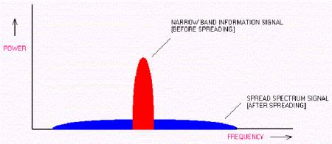

Figure 1: In a spread-spectrum system, signals are spread across a wide bandwidth, making them difficult to intercept, demodulate, and intercept.
The spread of energy over a wide band, or lower spectral power density, also makes spread-spectrum signals less likely to interfere with narrowband communications. Narrowband communications, conversely, cause little to no interference to spread spectrum systems because the correlation receiver effectively integrates over a very wide bandwidth to recover a spread spectrum signal. The correlator then "spreads" out a narrowband interferer over the receiver's total detection bandwidth.
Since the total integrated signal density or signal-to-noise ratio (SNR) at the correlator's input determines whether there will be interference or not. All spread spectrum systems have a threshold or tolerance level of interference beyond which useful communication ceases. This tolerance or threshold is related to the spread-spectrum processing gain, which is essentially the ratio of the RF bandwidth to the information bandwidth.
Direct or Hopping
Direct sequence and frequency hopping are the most commonly used methods for the spread spectrum technology. Although the basic idea is the same, these two methods have many distinctive characteristics that result in complete different radio performances.
The carrier of the direct-sequence radio stays at a fixed frequency. Narrowband information is spread out into a much larger (at least 10 times) bandwidth by using a pseudo-random chip sequence. The generation of the direct sequence spread spectrum signal (spreading) is shown in Figure 2.
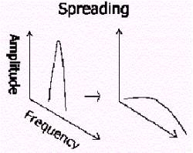

Figure 2: Comparison of the generation of a narrowband and direct-sequence spread spectrum signals.
In Figure 2, the narrowband signal and the spread-spectrum signal both use the same amount of transmit power and carry the same information. However, the power density of the spread-spectrum signal is much lower than the narrowband signal. As a result, it is more difficult to detect the presence of the spread spectrum signal. The power density is the amount of power over a certain frequency. In the case of Figure 2, the narrowband signal's power density is 10 times higher than the spread spectrum signal, assuming the spread ratio is 10.
At the receiving end of a direct-sequence system, the spread spectrum signal is de-spread to generate the original narrowband signal. Figure 3 shows the de-spreading process.
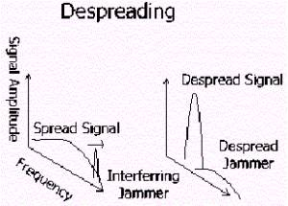

Figure 3: Diagram illustrating the despreading process in a direct-sequence system.
If there is an interference jammer in the same band, it will be spread out during the de-spreading. As a result, the jammer's impact is greatly reduced. This is the way that the direct-sequence spread-spectrum (DSSS) radio fights the interference. It spreads out the offending jammer by the spreading factor (Figure 4). Since the spreading factor is at least a factor of 10, the offending jammer's amplitude is greatly reduced by at least 90%.
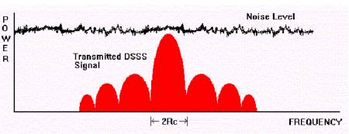

Figure 4: Direct-sequence systems combat noise problems by spreading jammers across a wideband as shown in this figure.
The Hopping Approach
Frequency-hopping systems achieve the same results provided by direct-sequence systems by using different carrier frequency at different time. The frequency-hop system's carrier will hop around within the band so that hopefully it will avoid the jammer at some frequencies.
A frequency-hopping signal is shown in Figure 5.
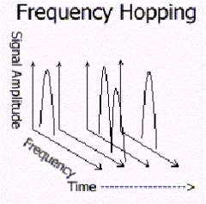

Figure 5: Diagram showing how a frequency-hop system works.
The frequency-hopping technique does not spread the signal, as a result, there is no processing gain. The processing gain is the increase in power density when the signal is de-spread and it will improve the received signal's Signal-to-noise ratio (SNR). In other words, the frequency hopper needs to put out more power in order to have the same SNR as a direct-sequence radio.
The frequency hopper, however, is more difficult to synchronize. In these architectures, the receiver and the transmitter must be synchronized in time and frequency in order to ensure proper transmission and reception of signals. In a direct-sequence radio, on the other hand, only the timing of the chips needs to be synchronized.
The frequency hopper also needs more time to search the signal and lock to it. As a result, the latency time is usually longer. While a direct-sequence radio can lock in the chip sequence in just a few bits.
To make the initial synchronization possible, the frequency hopper will typically park at a fixed frequency before hopping or communication begin. If the jammer happens to locate at the same frequency as the parking frequency, the hopper will not be able to hop at all. And once it hops, it will be very difficult, if not impossible to re-synchronize if the receiver ever lost the sync.
The frequency hopper, however, is better than the direct-sequence radio when dealing with multipath. Since the hopper does not stay at the same frequency and a null at one frequency is usually not a null at another frequency if it is not too close to the original frequency. So a hopper can usually deal with multipath fading issues better than direct-sequence radio.
The hopper itself, however, could suffer performance problems if it interferes with another radio. In these scenarios, the system that survives depends upon which can suffer more data loss. In general, a voice system can survive an error rate as high as 10⁻² while a data system must have an error rate better than 10⁻⁴. Voice system can tolerate more data loss because human brain can "guess" between the words while a dumb microprocessor can't.
Modulation and Demodulation
For direct-sequence systems the encoding signal is used to modulate a carrier, usually by phase-shift keying (PSK; for example, bi-phase or quad-phase) at the code rate. Frequency-hopping systems generate their wide band by transmitting at different frequencies, hopping from one frequency to another according to the code sequence. Typically such a system may have a few thousand frequencies to choose from, and unlike direct sequence signal, it has only one output rather than symmetrically distributed outputs.
It's important to note that for both direct-sequencing and frequency-hopping systems generate wideband signals controlled by the code sequence generator. For one the code is the direct carrier modulation (direct sequence) and the other commands the carrier frequency (frequency hopping).
There are several different modulation techniques that designers can employ when developing frequency-hop or direct-sequence systems. Information modulation can be accomplished using amplitude (AM) of frequency modulation (FM) techniques. AM is normally used because it tends to be detectable when examining the spectrum. FM is more useful because it is a constant-envelope signal, but information is still readily observed. In both AM and FM, no knowledge of the code is needed to receive the transmitted information.
Clock modulation, which is actually frequency modulation of the code clock, is another option in spread-spectrum designs. In most cases (including frequency hopping), clock modulation is not used because of the loss in correlation due to phase slippage between received and local clocks, could cause degraded performance.
Code modification is another modulation technique that designers can use when building a spread-spectrum system. Under this approach, the code is changed in such a way that the information is embedded in it, then modulated by phase transitions on a RF carrier.
In direct-sequence designs, balance modulation can be used in any suppressed carrier system used to generate the transmitted signal. Balanced modulation helps to hide the signal, as well as there are no power wasted in transmitting a carrier that would contribute to interference rejection or information transfer. When a signal has poor balance in either code or carrier, spikes are seen in its spectrum. With these spikes, or spurs, the signal is easily detectable, since these spikes are noticed above the noise and thus provide a path for detecting the hidden signal.
Once the signal is coded, modulated and then sent, the receiver must demodulate the signal. This is usually done in two steps. The first step entails removing the spectrum-spreading modulation. Then, the remaining information-bearing signal is demodulated by multiplying with a local reference identical in structure and synchronized with the received signal.
Coding Techniques
In order to transmit anything, codes used for data transmission have to be considered. However, this section will not discuss the coding of information (like error correction coding) but those that act as noise-like carriers for the information being transferred. These codes are of much greater length than those for the usual areas of data transfer, since it is intended for bandwidth spreading.
Codes in a spread-spectrum system are used for:
- Protection against interference: Coding enables a bandwidth trade for processing gain against interfering signals.
- Provision for privacy: Coding enables protection of signals from eaves dropping, so that even the code is secure.
- Noise-effect reduction: error-detection and correction codes can reduce the effects of noise and interference.
Maximal sequencing is one of the more popular coding methods in a spread-spectrum system. Maximal codes can be generated by a given shift register or a delay element of given length. In binary shift register sequence generators, the maximum length sequence is (2^n-1) chips, where n is the number of stages in the shift register.
A shift register generator consists of a shift register in conjunction with the appropriate logic, which feeds back a logical combination of the state of two or more of its stages to its input. The output, and its contents of its n stages at any clock time, is its function of the outputs of the stages fed back at the proceeding sample time. Some maximal codes can be of length 7 to [(2^36)-1] chips.
Error detection and correction codes (EDAC) must be used in frequency-hopping systems in order to overcome the high rates of error induced by partial band jamming. These codes usefulness has a threshold that must be exceeded before satisfactory performance is achieved.
In direct-sequence systems, EDACs may not be advisable because of the effect it has on the code, increasing the apparent data transmission rate, and may increase jamming threshold. Some demodulators can operate detecting errors at the approximately the same accuracy as an EDAC, so it may not be worthwhile to include a complex coding/decoding scheme in the system.
Advantages of Spread Spectrum
Spread-spectrum systems provide some clear advantages to designers. As a recap, here are nine benefits that designers can expect when using a spread-spectrum-based wireless system.
1. Reduced crosstalk interference: In spread-spectrum systems, crosstalk interference is greatly attenuated due to the processing gain of the spread spectrum system as described earlier. The effect of the suppressed crosstalk interference can be essentially removed with digital processing where noise below certain threshold results in negligible bit errors. These negligible bit errors will have little effect on voice transmissions.
2. Better voice quality/data integrity and less static noise: Due to the processing gain and digital processing nature of spread spectrum technology, a spread-spectrum-based system is more immune to interference and noise. This greatly reduces consumer electronic device-induced static noise that is commonly experienced by conventional analog wireless system users.
3. Lowered susceptibility to multipath fading: Because of its inherent frequency diversity properties (thanks to wide spectrum spread), a spread spectrum system is much less susceptible to multipath fading.
4. Inherent security: In a spread spectrum system, a PN sequence is used to either modulate the signal in the time domain (direct sequence systems) or select the carrier frequency (frequency hopping systems). Due to the pseudo-random nature of the PN sequence, the signal in the air has been "randomized". Only the receiver having the exact same pseudo-random sequence and synchronous timing can de-spread and retrieve the original signal. Consequently, a spread spectrum system provides signal security that is not available to conventional analog wireless systems.
5. Co-existence: A spread spectrum system is less susceptible to interference than other non-spread spectrum systems. In addition, with the proper designing of pseudo-random sequences, multiple spread spectrum systems can co-exist without creating severe interference to other systems. This further increases the system capacity for spread spectrum systems or devices.
6. Longer operating distances: A spread spectrum device operated in the ISM band is allowed to have higher transmit power due to its non-interfering nature. Because of the higher transmit power, the operating distance of such a device can be significantly longer than that of a traditional analog wireless communication device.
7. Hard to detect: Spread-spectrum signals are much wider than conventional narrowband transmission (of the order of 20 to 254 times the bandwidth of narrowband transmissions). Since the communication band is spread, it can be transmitted at a low power without being detrimentally by background noise. This is because when de-spreading takes place, the noise at one frequency is rejected, leaving the desired signal.
8. Hard to intercept or demodulate: The very foundation of the spreading technique is the code use to spread the signal. Without knowing the code it is impossible to decipher the transmission. Also, because the codes are so long (and quick) simply viewing the code would still be next to impossible to solve the code, hence interception is very hard.
9. Harder to jam: The most important feature of spread spectrum is its ability to reject interference. At first glance, it may be considered that spread spectrum would be most effected by interference. However, any signal is spread in the bandwidth, and after it passes through the correlator, the bandwidth signal is equal to its original bandwidth, plus the bandwidth of the local interference. An interference signal with 2 MHz bandwidth being input into a direct-sequence receiver whose signal is 10 MHz wide gives an output from the correlator of 12 MHz. The wider the interference bandwidth, the wider the output signal. Thus the wider the input signal, the less its effect on the system because the power density of the signal after processing is lower, and less power falls in the band pass filter.

Coding and Error Control

In information theory and coding theory with applications in computer science and telecommunication, error detection and correction or error control are techniques that enable reliable delivery of digital data over unreliable communication channels. Many communication channels are subject to channel noise, and thus errors may be introduced during transmission from the source to a receiver. Error detection techniques allow detecting such errors, while error correction enables reconstruction of the original data.

Definitions

The general definitions of the terms are as follows:

Error detection is the detection of errors caused by noise or other impairments during transmission from the transmitter to the receiver. Summer is another name for error detection Error correction is the detection of errors and reconstruction of the original, error-free data.

History

The most famous early systematic use of error detection was by Jewish scribes in the precise copying of the Jewish bible, beginning before Christ. An emphasis on minute details of words and spellings evolved into the idea of a perfect text in 135 CE, and with it increasingly forceful strictures that a deviation in even a single letter would make a Torah scroll invalid. The scribes used methods such as summing the number of words per line and per page (Numerical Masorah), and checking the middle paragraph, word and letter against the original. The page was thrown out if a single mistake was found, and three mistakes on a single page would result in the entire manuscript being destroyed (the equivalent of retransmission on a telecommunications channel). The effectiveness of their methods was verified by the accuracy of copying through the centuries demonstrated by discovery of the Dead Sea Scrolls in 1947–1956, dating from c.150 BCE-75 CE.

Introduction

The general idea for achieving error detection and correction is to add some redundancy (i.e., some extra data) to a message, which receivers can use to check consistency of the delivered message, and to recover data determined to be corrupted. Error-detection and correction schemes can be either systematic or non-systematic: In a systematic scheme, the transmitter sends the original data, and attaches a fixed number of check bits (or parity data), which are derived from the data bits by some deterministic algorithm. If only error detection is required, a receiver can simply apply the same algorithm to the received data bits and compare its output with the received check bits; if the values do not match, an error has occurred at some point during the transmission. In a system that uses a
non-systematic code, the original message is transformed into an encoded message that has at least as many bits as the original message.

Good error control performance requires the scheme to be selected based on the characteristics of the communication channel. Common channel models include memory-less models where errors occur randomly and with a certain probability, and dynamic models where errors occur primarily in bursts. Consequently, error-detecting and correcting codes can be generally distinguished between random- error-detecting/correcting and burst-error-detecting/correcting. Some codes can also be suitable for a mixture of random errors and burst errors.

If the channel capacity cannot be determined, or is highly variable, an error-detection scheme may be combined with a system for retransmissions of erroneous data. This is known as automatic repeat request (ARQ), and is most notably used in the Internet. An alternate approach for error control is hybrid automatic repeat request (HARQ), which is a combination of ARQ and error-correction coding.

Implementation

Error correction may generally be realized in two different ways:

Automatic repeat request (ARQ) (sometimes also referred to as backward error correction): This is an error control technique whereby an error detection scheme is combined with requests for retransmission of erroneous data. Every block of data received is checked using the error detection code used, and if the check fails, retransmission of the data is requested – this may be done repeatedly, until the data can be verified.
Forward error correction (FEC): The sender encodes the data using an error-correcting code (ECC) prior to transmission. The additional information (redundancy) added by the code is used by the receiver to recover the original data. In general, the reconstructed data is what is deemed the "most likely" original data.

ARQ and FEC may be combined, such that minor errors are corrected without retransmission, and

major errors are corrected via a request for retransmission: this is called hybrid automatic repeat- request (HARQ).

Error detection schemes

Error detection is most commonly realized using a suitable hash function (or checksum algorithm). A hash function adds a fixed-length tag to a message, which enables receivers to verify the delivered message by recomputing the tag and comparing it with the one provided.

There exists a vast variety of different hash function designs. However, some are of particularly widespread use because of either their simplicity or their suitability for detecting certain kinds of errors (e.g., the cyclic redundancy check's performance in detecting burst errors).

Random-error-correcting codes based on minimum distance coding can provide a suitable alternative to hash functions when a strict guarantee on the minimum number of errors to be detected is desired. Repetition codes, described below, are special cases of error-correcting codes: although rather inefficient, they find applications for both error correction and detection due to their simplicity.

Repetition codes

Main article: Repetition code

A repetition code is a coding scheme that repeats the bits across a channel to achieve error-free communication. Given a stream of data to be transmitted, the data is divided into blocks of bits. Each block is transmitted some predetermined number of times. For example, to send the bit pattern "1011", the four-bit block can be repeated three times, thus producing "1011 1011 1011". However, if this twelve-bit pattern was received as "1010 1011 1011" – where the first block is unlike the other two – it can be determined that an error has occurred.

Repetition codes are very inefficient, and can be susceptible to problems if the error occurs in exactly the same place for each group (e.g., "1010 1010 1010" in the previous example would be detected as correct). The advantage of repetition codes is that they are extremely simple, and are in fact used in some transmissions of numbers stations.

Parity bits

Main article: Parity bit

A parity bit is a bit that is added to a group of source bits to ensure that the number of set bits (i.e., bits with value 1) in the outcome is even or odd. It is a very simple scheme that can be used to detect single or any other odd number (i.e., three, five, etc.) of errors in the output. An even number of flipped bits will make the parity bit appear correct even though the data is erroneous.

Extensions and variations on the parity bit mechanism are horizontal redundancy checks, vertical redundancy checks, and "double," "dual," or "diagonal" parity (used in RAID-DP).

Checksums

Main article: Checksum

A checksum of a message is a modular arithmetic sum of message code words of a fixed word length
(e.g., byte values). The sum may be negated by means of a ones'-complement operation prior to

transmission to detect errors resulting in all-zero messages.

Checksum schemes include parity bits, check digits, and longitudinal redundancy checks. Some checksum schemes, such as the Damm algorithm, the Luhn algorithm, and the Verhoeff algorithm, are specifically designed to detect errors commonly introduced by humans in writing down or remembering identification numbers.

Cyclic redundancy checks (CRCs)

Main article: Cyclic redundancy check

A cyclic redundancy check (CRC) is a single-burst-error-detecting cyclic code and non-secure hash function designed to detect accidental changes to digital data in computer networks. It is not suitable for detecting maliciously introduced errors. It is characterized by specification of a so-called generator polynomial, which is used as the divisor in a polynomial long division over a finite field, taking the input data as the dividend, and where the remainder becomes the result.

Cyclic codes have favorable properties in that they are well suited for detecting burst errors. CRCs are particularly easy to implement in hardware, and are therefore commonly used in digital networks and storage devices such as hard disk drives.

Even parity is a special case of a cyclic redundancy check, where the single-bit CRC is generated by the divisor x + 1.

Cryptographic hash functions

Main article: Cryptographic hash function

The output of a cryptographic hash function, also known as a message digest, can provide strong assurances about data integrity, whether changes of the data are accidental (e.g., due to transmission errors) or maliciously introduced. Any modification to the data will likely be detected through a mismatching hash value. Furthermore, given some hash value, it is infeasible to find some input data (other than the one given) that will yield the same hash value. If an attacker can change not only the message but also the hash value, then a keyed hash or message authentication code (MAC) can be used for additional security. Without knowing the key, it is infeasible for the attacker to calculate the correct keyed hash value for a modified message.

Error-correcting codes

Main article: Forward error correction

Any error-correcting code can be used for error detection. A code with minimum Hamming distance, d, can detect up to d − 1 errors in a code word. Using minimum-distance-based error-correcting codes for error detection can be suitable if a strict limit on the minimum number of errors to be detected is desired.

Codes with minimum Hamming distance d = 2 are degenerate cases of error-correcting codes, and can be used to detect single errors. The parity bit is an example of a single-error-detecting code.

Error correction

Automatic repeat request

Main article: Automatic repeat request

Automatic Repeat reQuest (ARQ) is an error control method for data transmission that makes use of error-detection codes, acknowledgment and/or negative acknowledgment messages, and timeouts to achieve reliable data transmission. An acknowledgment is a message sent by the receiver to indicate that it has correctly received a data frame.

Usually, when the transmitter does not receive the acknowledgment before the timeout occurs (i.e., within a reasonable amount of time after sending the data frame), it retransmits the frame until it is either correctly received or the error persists beyond a predetermined number of retransmissions.
Three types of ARQ protocols are Stop-and-wait ARQ, Go-Back-N ARQ, and Selective Repeat ARQ. ARQ is appropriate if the communication channel has varying or unknown capacity, such as is the case
on the Internet. However, ARQ requires the availability of a back channel, results in possibly increased
latency due to retransmissions, and requires the maintenance of buffers and timers for retransmissions, which in the case of network congestion can put a strain on the server and overall network capacity.

Error-correcting code

An error-correcting code (ECC) or forward error correction (FEC) code is a system of adding redundant data, or parity data, to a message, such that it can be recovered by a receiver even when a number of errors (up to the capability of the code being used) were introduced, either during the process of transmission, or on storage. Since the receiver does not have to ask the sender for retransmission of the data, a back-channel is not required in forward error correction, and it is therefore suitable for simplex communication such as broadcasting. Error-correcting codes are frequently used in lower-layer communication, as well as for reliable storage in media such as CDs, DVDs, hard disks, and RAM.

Error-correcting codes are usually distinguished between convolutional codes and block codes:

Convolutional codes are processed on a bit-by-bit basis. They are particularly suitable for implementation in hardware, and the Viterbi decoder allows optimal decoding.

Block codes are processed on a block-by-block basis. Early examples of block codes are repetition codes, Hamming codes and multidimensional parity-check codes. They were followed by a number of efficient codes, Reed–Solomon codes being the most notable due to their current widespread use. Turbo codes and low-density parity-check codes (LDPC) are relatively new constructions that can provide almost optimal efficiency.

Shannon's theorem is an important theorem in forward error correction, and describes the maximum information rate at which reliable communication is possible over a channel that has a certain error probability or signal-to-noise ratio (SNR). This strict upper limit is expressed in terms of the channel capacity. More specifically, the theorem says that there exist codes such that with increasing encoding length the probability of error on a discrete memoryless channel can be made arbitrarily small, provided that the code rate is smaller than the channel capacity. The code rate is defined as the fraction k/n of k source symbols and n encoded symbols.

The actual maximum code rate allowed depends on the error-correcting code used, and may be lower. This is because Shannon's proof was only of existential nature, and did not show how to construct codes which are both optimal and have efficient encoding and decoding algorithms.

Hybrid schemes

Main article: Hybrid ARQ

Hybrid ARQ is a combination of ARQ and forward error correction. There are two basic approaches:[7]

Messages are always transmitted with FEC parity data (and error-detection redundancy). A receiver decodes a message using the parity information, and requests retransmission using ARQ only if the parity data was not sufficient for successful decoding (identified through a failed integrity check).
Messages are transmitted without parity data (only with error-detection information). If a receiver detects an error, it requests FEC information from the transmitter using ARQ, and uses it to reconstruct the original message.

The latter approach is particularly attractive on an erasure channel when using a rateless erasure code.

Applications

Applications that require low latency (such as telephone conversations) cannot use Automatic Repeat reQuest (ARQ); they must use Forward Error Correction (FEC). By the time an ARQ system discovers an error and re-transmits it, the re-sent data will arrive too late to be any good.

Applications where the transmitter immediately forgets the information as soon as it is sent (such as most television cameras) cannot use ARQ; they must use FEC because when an error occurs, the original data is no longer available. (This is also why FEC is used in data storage systems such as RAID and distributed data store).

Applications that use ARQ must have a return channel. Applications that have no return channel cannot use ARQ.

Applications that require extremely low error rates (such as digital money transfers) must use ARQ.

Internet

In a typical TCP/IP stack, error control is performed at multiple levels:

Each Ethernet frame carries a CRC-32 checksum. Frames received with incorrect checksums are discarded by the receiver hardware.
The IPv4 header contains a checksum protecting the contents of the header. Packets with mismatching checksums are dropped within the network or at the receiver.
The checksum was omitted from the IPv6 header in order to minimize processing costs in network routing and because current link layer technology is assumed to provide sufficient error detection (see also RFC 3819).
UDP has an optional checksum covering the payload and addressing information from the UDP and IP headers. Packets with incorrect checksums are discarded by the operating system network stack. The checksum is optional under IPv4, only, because the Data-Link layer checksum may already provide the desired level of error protection.
TCP provides a checksum for protecting the payload and addressing information from the TCP and IP headers. Packets with incorrect checksums are discarded within the network stack, and eventually get retransmitted using ARQ, either explicitly (such as through triple-ack) or implicitly due to a timeout.

Deep-space telecommunications

Development of error-correction codes was tightly coupled with the history of deep-space missions due to the extreme dilution of signal power over interplanetary distances, and the limited power availability aboard space probes. Whereas early missions sent their data uncoded, starting from 1968 digital error correction was implemented in the form of (sub-optimally decoded) convolutional codes and Reed–Muller codes. The Reed–Muller code was well suited to the noise the spacecraft was subject to (approximately matching a bell curve), and was implemented at the Mariner spacecraft for missions between 1969 and 1977.

The Voyager 1 and Voyager 2 missions, which started in 1977, were designed to deliver color imaging amongst scientific information of Jupiter and Saturn. This resulted in increased coding requirements, and thus the spacecraft were supported by (optimally Viterbi-decoded) convolutional codes that could be concatenated with an outer Golay (24,12,8) code.

The Voyager 2 craft additionally supported an implementation of a Reed–Solomon code: the concatenated Reed–Solomon–Viterbi (RSV) code allowed for very powerful error correction, and enabled the spacecraft's extended journey to Uranus and Neptune. Both craft use V2 RSV coding due to ECC system upgrades after 1989.

The CCSDS currently recommends usage of error correction codes with performance similar to the Voyager 2 RSV code as a minimum. Concatenated codes are increasingly falling out of favor with space missions, and are replaced by more powerful codes such as Turbo codes or LDPC codes.

The different kinds of deep space and orbital missions that are conducted suggest that trying to find a "one size fits all" error correction system will be an ongoing problem for some time to come. For missions close to earth the nature of the channel noise is different from that of a spacecraft on an interplanetary mission experiences. Additionally, as a spacecraft increases its distance from earth, the problem of correcting for noise gets larger.

Satellite broadcasting (DVB)

The demand for satellite transponder bandwidth continues to grow, fueled by the desire to deliver television (including new channels and High Definition TV) and IP data. Transponder availability and bandwidth constraints have limited this growth, because transponder capacity is determined by the selected modulation scheme and Forward error correction (FEC) rate.

Overview

QPSK coupled with traditional Reed Solomon and Viterbi codes have been used for nearly 20 years for the delivery of digital satellite TV.
Higher order modulation schemes such as 8PSK, 16QAM and 32QAM have enabled the satellite industry to increase transponder efficiency by several orders of magnitude.
This increase in the information rate in a transponder comes at the expense of an increase in the carrier power to meet the threshold requirement for existing antennas.
Tests conducted using the latest chipsets demonstrate that the performance achieved by using
Turbo Codes may be even lower than the 0.8 dB figure assumed in early designs.

Data storage

Error detection and correction codes are often used to improve the reliability of data storage media. [citation needed] A "parity track" was present on the first magnetic tape data storage in 1951. The "Optimal Rectangular Code" used in group code recording tapes not only detects but also corrects single-bit errors. Some file formats, particularly archive formats, include a checksum (most often

CRC32) to detect corruption and truncation and can employ redundancy and/or parity files to recover portions of corrupted data. Reed Solomon codes are used in compact discs to correct errors caused by scratches.

Modern hard drives use CRC codes to detect and Reed–Solomon codes to correct minor errors in sector reads, and to recover data from sectors that have "gone bad" and store that data in the spare sectors. RAID systems use a variety of error correction techniques, to correct errors when a hard drive completely fails. Filesystems such as ZFS or Btrfs, as well as some RAID implementations, support data scrubbing and resilvering, which allows bad blocks to be detected and (hopefully) recovered before they are used. The recovered data may be re-written to exactly the same physical location, to spare blocks elsewhere on the same piece of hardware, or to replacement hardware.

Error-correcting memory

DRAM memory may provide increased protection against soft errors by relying on error correcting codes. Such error-correcting memory, known as ECC or EDAC-protected memory, is particularly desirable for high fault-tolerant applications, such as servers, as well as deep-space applications due to increased radiation.

Error-correcting memory controllers traditionally use Hamming codes, although some use triple modular redundancy.

Interleaving allows distributing the effect of a single cosmic ray potentially upsetting multiple physically neighboring bits across multiple words by associating neighboring bits to different words. As long as a or threshold (e.g., a single error) in any particular word between accesses, it can be corrected (e.g., by a single-bit error correcting code), and the illusion of an error-free memory system may be maintained

Satellite Communications
Satellite communications is comparable in importance to optical fiber in the evolution of telecommunications and data communications. The first section of this chapter provides an introduction to key concerns and parameters related to the use of satellite antennas in wireless communications. The remainder of the chapter is devoted to a study of capacity allocation.
- SATELLITE PARAMETERS AND CONFIGURATIONS
The heart of a satellite communications system is a satellite-based antenna in a stable orbit above the earth. In a satellite communications system, two or more stations on or near the earth communicate via one or more satellites that serve as relay stations in space. The antenna systems on or near the earth are referred to as earth stations. A transmission from an earth station to the satellite is referred to as uplink, whereas transmissions from the satellite to the earth station are downlink. The component in the satellite that takes an uplink signal and converts it to a downlink signal is called a transponder.
There are a number of different ways of categorizing communications satellites:
- Coverage area; Global, regional, or national. The larger the area of coverage, the more satellites must be involved in a single networked system.
- Service type: Fixed service satellite (FSS), broadcast service satellite (BSS), and mobile service satellite (MSS). This chapter is concerned with FSS and BSS types.
- General usage: Commercial, military, amateur, experimental.
There are a number of differences between satellite-based and terrestrial wireless communications that affect design:
- The area of coverage of a satellite system far exceeds that of a terrestrial system. In the case of a geostationary satellite, a single antenna is visible to about one-fourth of the earth’s surface.
- Spacecraft power and allocated bandwidth are limited resources that call for careful tradeoffs in earth station/satellite design parameters.
- Conditions between communicating satellites are more time invariant than those between satellite and earth station or between two terrestrial wireless antennas. Thus, satellite-to-satellite communication links can be designed with great precision.
- Transmission cost is independent of distance, within the satellite’s area of coverage.
- Broadcast, multicast, and point-to-point applications are readily accommodated.
- Very high bandwidths or data rates are available to the user.
- Although satellite links are subject to short-term outages or degradations, the quality of transmission is normally extremely high.
- For a geostationary satellite, there is an earth-satellite-earth propagation delay of about one-fourth of a second.
- A transmitting earth station can in many cases receive its own transmission.

Satellite orbits may be classified in a number of ways:
- The orbit may be circular, with the center of the circle at the center of the earth, or elliptical, with the earth’s center at one of the two foci of the ellipse.
- A satellite may orbit around the earth in different planes. An equatorial orbit is directly above the earth’s equator. A polar orbit passes over both poles. Other orbits are referred to as inclined orbits.
- The altitude of communications satellites is classified as geostationary orbit (GEO), medium earth orbit (MEO), and low earth orbit (LEO), as explained subsequently.
Distance Figure 9.1 illustrates the geometry that dictates satellite coverage. A key factor is the elevation angle 6 of the earth station, which is the angle from the horizontal (i.e., a line tangent to the surface of the earth at the antenna’s location) to the point on the center of the main beam of the antenna when the antenna is pointed directly at the satellite. To obtain maximum satellite coverage, we would like to use an elevation angle of 0°, which would enable the satellite’s coverage to extend to the optical horizon from the satellite in all directions. However, three problems dictate
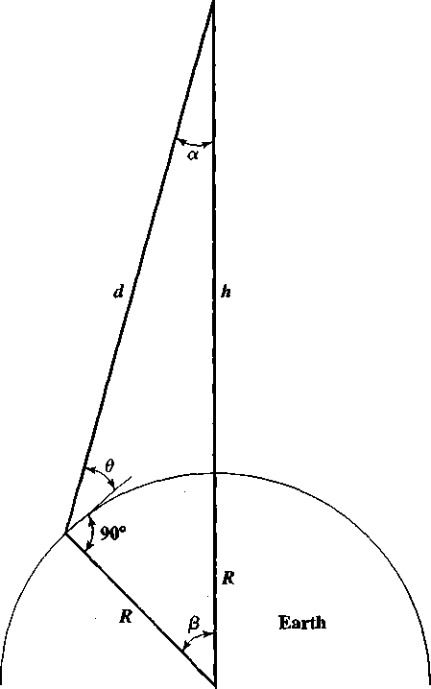
Figure 9.1 Coverage and Elevation Angles


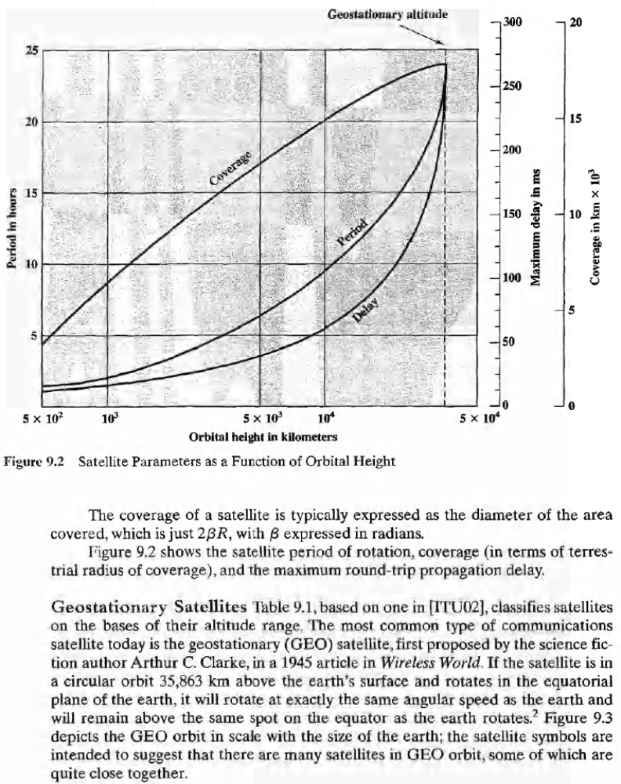

Cellular network

A cellular network or mobile network is a wireless network distributed over land areas called cells, each served by at least one fixed-location transceiver, known as a cell site or base station. In a cellular network, each cell uses a different set of frequencies from neighboring cells, to avoid interference and provide guaranteed bandwidth within each cell.
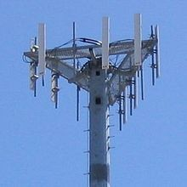

When joined together these cells provide radio coverage over a wide geographic area. This enables a large number of portable transceivers (e.g., mobile phones, pagers, etc.) to communicate with each other and with fixed transceivers and telephones anywhere in the network, via base stations, even if some of the transceivers are moving through more than one cell during transmission.

Cellular networks offer a number of desirable features:

Top of a cellular radio tower

More capacity than a single large transmitter, since the same frequency can be used for multiple links as long as they are in different cells
Mobile devices use less power than with a single transmitter or satellite since the cell towers are closer
Larger coverage area than a single terrestrial transmitter, since additional cell towers can be added indefinitely and are not limited by the horizon

Major telecommunications providers have deployed voice and data cellular networks over most of the inhabited land area of the Earth. This allows mobile phones and mobile computing devices to be connected to the public switched telephone network and public Internet. Private cellular networks can be used for research or for large organizations and fleets, such as dispatch for local public safety agencies or a taxicab company.

Concept

In a cellular radio system, a land area to be supplied with radio service is divided into regular shaped cells, which can be hexagonal, square, circular or some other regular shapes, although hexagonal cells are conventional. Each of these cells is assigned
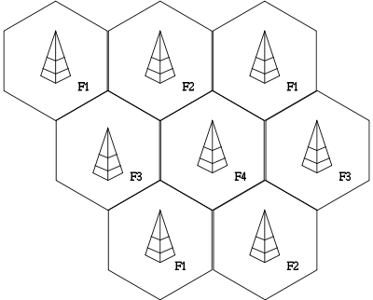

multiple frequencies (f
1
– f ) which
6

have corresponding radio base
stations. The group of frequencies can be reused in other cells, provided that the same frequencies are not reused in adjacent neighboring cells as that would cause co-channel interference.

The increased capacity in a cellular network, compared with a network with a single transmitter, comes

Example of frequency reuse factor or pattern 1/4

from the mobile communication switching system developed by Amos Joel of Bell Labs that permitted multiple callers in the same area to use the same frequency by switching calls made using the same frequency to the nearest available cellular tower having that frequency available and from the fact that the same radio frequency can be reused in a different area for a completely different transmission.
If there is a single plain transmitter, only one transmission can be used on any given frequency. Unfortunately, there is inevitably some level of interference from the signal from the other cells which use the same frequency. This means that, in a standard FDMA system, there must be at least a one cell gap between cells which reuse the same frequency.

In the simple case of the taxi company, each radio had a manually operated channel selector knob to tune to different frequencies. As the drivers moved around, they would change from channel to channel. The drivers knew which frequency covered approximately what area. When they did not receive a signal from the transmitter, they would try other channels until they found one that worked. The taxi drivers would only speak one at a time, when invited by the base station operator (this is, in a sense, time division multiple access (TDMA)).

Cell signal encoding

To distinguish signals from several different transmitters, frequency division multiple access (FDMA)
and code division multiple access (CDMA) were developed.

With FDMA, the transmitting and receiving frequencies used in each cell are different from the frequencies used in each neighbouring cell. In a simple taxi system, the taxi driver manually tuned to a frequency of a chosen cell to obtain a strong signal and to avoid interference from signals from other cells.

The principle of CDMA is more complex, but achieves the same result; the distributed transceivers can select one cell and listen to it.

Other available methods of multiplexing such as polarization division multiple access (PDMA) and time division multiple access (TDMA) cannot be used to separate signals from one cell to the next since the effects of both vary with position and this would make signal separation practically impossible. Time division multiple access, however, is used in combination with either FDMA or CDMA in a number of systems to give multiple channels within the coverage area of a single cell.

Frequency reuse

The key characteristic of a cellular network is the ability to re-use frequencies to increase both coverage and capacity. As described above, adjacent cells must use different frequencies, however there is no problem with two cells sufficiently far apart operating on the same frequency. The elements that determine frequency reuse are the reuse distance and the reuse factor.

The reuse distance, D is calculated as

where R is the cell radius and N is the number of cells per cluster. Cells may vary in radius in the ranges (1 km to 30 km). The boundaries of the cells can also overlap between adjacent cells and large cells can be divided into smaller cells.

The frequency reuse factor is the rate at which the same frequency can be used in the network. It is 1/K (or K according to some books) where K is the number of cells which cannot use the same frequencies for transmission. Common values for the frequency reuse factor are 1/3, 1/4, 1/7, 1/9 and 1/12 (or 3, 4,
7, 9 and 12 depending on notation).

In case of N sector antennas on the same base station site, each with different direction, the base station site can serve N different sectors. N is typically 3. A reuse pattern of N/K denotes a further division in frequency among N sector antennas per site. Some current and historical reuse patterns are 3/7 (North American AMPS), 6/4 (Motorola NAMPS), and 3/4 (GSM).

If the total available bandwidth is B, each cell can only use a number of frequency channels corresponding to a bandwidth of B/K, and each sector can use a bandwidth of B/NK.

Code division multiple access-based systems use a wider frequency band to achieve the same rate of transmission as FDMA, but this is compensated for by the ability to use a frequency reuse factor of 1, for example using a reuse pattern of 1/1. In other words, adjacent base station sites use the same frequencies, and the different base stations and users are separated by codes rather than frequencies. While N is shown as 1 in this example, that does not mean the CDMA cell has only one sector, but rather that the entire cell bandwidth is also available to each sector individually.

Depending on the size of the city, a taxi system may not have any frequency-reuse in its own city, but certainly in other nearby cities, the same frequency can be used. In a large city, on the other hand, frequency-reuse could certainly be in use.

Recently also orthogonal frequency-division multiple access based systems such as LTE are being deployed with a frequency reuse of 1. Since such systems do not spread the signal across the frequency band, inter-cell radio resource management is important to coordinate resource allocation between different cell sites and to limit the inter-cell interference. There are various means of Inter-Cell

Interference Coordination (ICIC) already defined in the standard. Coordinated scheduling, multi-site MIMO or multi-site beam forming are other examples for inter-cell radio resource management that might be standardized in the future.

Directional antennas

Cell towers frequently use a
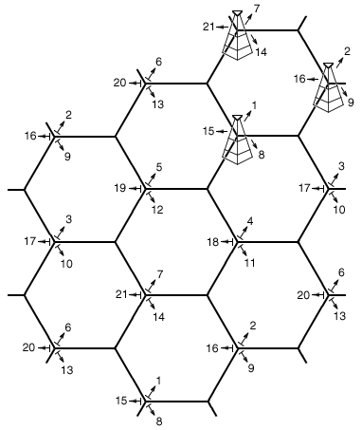

directional signal to improve reception in higher traffic areas. In the United States, the FCC limits
omni-directional cell tower signals to
100 watts of power. If the tower has directional antennas, the FCC allows the cell operator to broadcast up to 500 watts of effective radiated power (ERP).

Cell phone companies use this directional signal to improve reception along highways and inside buildings like stadiums and arenas. As a result, a cell phone user may be standing in sight of a cell tower, but still have trouble getting a good signal because the directional antennas point
a different direction.

Although the original cell towers created an even, omni-directional signal, were at the centers of the cells and were omni-directional, a cellular map can be redrawn with the cellular telephone towers located at the corners of the hexagons where three cells

Cellular telephone frequency reuse pattern. See U.S. Patent
4,144,411 (http://www.google.com/patents/US4144411)

converge. Each tower has three sets of directional antennas aimed in three different directions with
120 degrees for each cell (totaling 360 degrees) and receiving/transmitting into three different cells at different frequencies. This provides a minimum of three channels, and three towers for each cell and greatly increases the chances of receiving a usable signal from at least one direction.

The numbers in the illustration are channel numbers, which repeat every 3 cells. Large cells can be subdivided into smaller cells for high volume areas.

Broadcast messages and paging

Practically every cellular system has some kind of broadcast mechanism. This can be used directly for distributing information to multiple mobiles, commonly, for example in mobile telephony systems, the most important use of broadcast information is to set up channels for one to one communication between the mobile transceiver and the base station. This is called paging. The three different paging procedures generally adopted are sequential, parallel and selective paging.

The details of the process of paging vary somewhat from network to network, but normally we know a limited number of cells where the phone is located (this group of cells is called a Location Area in the GSM or UMTS system, or Routing Area if a data packet session is involved; in LTE, cells are grouped into Tracking Areas). Paging takes place by sending the broadcast message to all of those cells. Paging messages can be used for information transfer. This happens in pagers, in CDMA systems for sending SMS messages, and in the UMTS system where it allows for low downlink latency in packet-based connections.

Movement from cell to cell and handover

In a primitive taxi system, when the taxi moved away from a first tower and closer to a second tower, the taxi driver manually switched from one frequency to another as needed. If a communication was interrupted due to a loss of a signal, the taxi driver asked the base station operator to repeat the message on a different frequency.

In a cellular system, as the distributed mobile transceivers move from cell to cell during an ongoing continuous communication, switching from one cell frequency to a different cell frequency is done electronically without interruption and without a base station operator or manual switching. This is called the handover or handoff. Typically, a new channel is automatically selected for the mobile unit on the new base station which will serve it. The mobile unit then automatically switches from the current channel to the new channel and communication continues.

The exact details of the mobile system's move from one base station to the other varies considerably from system to system (see the example below for how a mobile phone network manages handover).

Mobile phone network

The most common example of a cellular network is a mobile phone (cell phone) network. A mobile phone is a portable telephone which receives or makes calls through a cell site (base station), or transmitting tower. Radio waves are used to
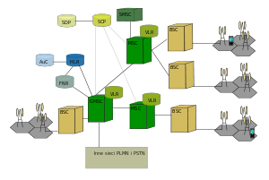

transfer signals to and from the cell phone.

Modern mobile phone networks use cells because radio frequencies are a limited, shared resource. Cell-sites and handsets change frequency under
computer control and use low power transmitters so that the usually limited number of radio frequencies can be simultaneously used by many callers with less interference.

GSM network architecture

A cellular network is used by the mobile phone operator to achieve both coverage and capacity for their subscribers. Large geographic areas are split into smaller cells to avoid line-of-sight signal loss and to support a large number of active phones in that area. All of the cell sites are connected to telephone exchanges (or switches), which in turn connect to the public telephone network.

In cities, each cell site may have a range of up to approximately ½ mile, while in rural areas, the range could be as much as 5 miles. It is possible that in clear open areas, a user may receive signals from a cell site 25 miles away.

Since almost all mobile phones use cellular technology, including GSM, CDMA, and AMPS (analog), the term "cell phone" is in some regions, notably the US, used interchangeably with "mobile phone". However, satellite phones are mobile phones that do not communicate directly with a ground-based cellular tower, but may do so indirectly by way of a satellite.

There are a number of different digital cellular technologies, including: Global System for Mobile Communications (GSM), General Packet Radio Service (GPRS), cdmaOne, CDMA2000, Evolution-Data Optimized (EV-DO), Enhanced Data Rates for GSM Evolution (EDGE), Universal Mobile Telecommunications System (UMTS), Digital Enhanced Cordless Telecommunications (DECT), Digital AMPS (IS-136/TDMA), and Integrated Digital Enhanced Network (iDEN).

Structure of the mobile phone cellular network
A simple view of the cellular mobile-radio network consists of the following: A network of radio base stations forming the base station subsystem.
The core circuit switched network for handling voice calls and text
A packet switched network for handling mobile data
The public switched telephone network to connect subscribers to the wider telephony network

This network is the foundation of the GSM system network. There are many functions that are performed by this network in order to make sure customers get the desired service including mobility management, registration, call set up, and handover.

Any phone connects to the network via an RBS (Radio Base Station) at a corner of the corresponding cell which in turn connects to the Mobile switching center (MSC). The MSC provides a connection to the public switched telephone network (PSTN). The link from a phone to the RBS is called an uplink while the other way is termed downlink.

Radio channels effectively use the transmission medium through the use of the following multiplexing
& access schemes: frequency division multiple access (FDMA), time division multiple access
(TDMA), code division multiple access (CDMA), and space division multiple access (SDMA).

Cellular handover in mobile phone networks

Main article: Handover

As the phone user moves from one cell area to another cell while a call is in progress, the mobile station will search for a new channel to attach to in order not to drop the call. Once a new channel is found, the network will command the mobile unit to switch to the new channel and at the same time switch the call onto the new channel.

With CDMA, multiple CDMA handsets share a specific radio channel. The signals are separated by using a pseudonoise code (PN code) specific to each phone. As the user moves from one cell to another, the handset sets up radio links with multiple cell sites (or sectors of the same site) simultaneously. This is known as "soft handoff" because, unlike with traditional cellular technology, there is no one defined point where the phone switches to the new cell.

In IS-95 inter-frequency handovers and older analog systems such as NMT it will typically be impossible to test the target channel directly while communicating. In this case other techniques have to be used such as pilot beacons in IS-95. This means that there is almost always a brief break in the communication while searching for the new channel followed by the risk of an unexpected return to the old channel.

If there is no ongoing communication or the communication can be interrupted, it is possible for the mobile unit to spontaneously move from one cell to another and then notify the base station with the strongest signal.

Cellular frequency choice in mobile phone networks

Main article: Cellular frequencies

The effect of frequency on cell coverage means that different frequencies serve better for different uses. Low frequencies, such as 450 MHz NMT, serve very well for countryside coverage. GSM 900
(900 MHz) is a suitable solution for light urban coverage. GSM 1800 (1.8 GHz) starts to be limited by structural walls. UMTS, at 2.1 GHz is quite similar in coverage to GSM 1800.

Higher frequencies are a disadvantage when it comes to coverage, but it is a decided advantage when it comes to capacity. Pico cells, covering e.g. one floor of a building, become possible, and the same frequency can be used for cells which are practically neighbours.

Cell service area may also vary due to interference from transmitting systems, both within and around that cell. This is true especially in CDMA based systems. The receiver requires a certain signal-to-noise ratio, and the transmitter should not send with too high transmission power in view to not cause interference with other transmitters. As the receiver moves away from the transmitter, the power received decreases, so the power control algorithm of the transmitter increases the power it transmits to restore the level of received power. As the interference (noise) rises above the received power from the transmitter, and the power of the transmitter cannot be increased any more, the signal becomes
corrupted and eventually unusable. In CDMA-based systems, the effect of interference from other mobile transmitters in the same cell on coverage area is very marked and has a special name, cell breathing.

One can see examples of cell coverage by studying some of the coverage maps provided by real operators on their web sites or by looking at independently crowdsourced maps such as OpenSignal. In certain cases they may mark the site of the transmitter, in others it can be calculated by working out the point of strongest coverage.

Coverage comparison of different frequencies

The following table shows the dependency of the coverage area of one cell on the frequency of a
CDMA2000 network:

Frequency (MHz) | Cell radius (km) | Cell area (km2) | Relative Cell Count
450 | 48.9 | 7521 | 1
950 | 26.9 | 2269 | 3.3
1800 | 14.0 | 618 | 12.2
2100 | 12.0 | 449 | 16.2

Software-Defined Radio (SDR)

Software-defined radio (SDR) is a radio communication system where components that have been typically implemented in hardware (e.g. mixers, filters, amplifiers, modulators/demodulators, detectors, etc.) are instead implemented by means of software on a personal computer or embedded system. While the concept of SDR is not new, the rapidly evolving capabilities of digital electronics render practical many processes which used to be only theoretically possible.
Overview

A basic SDR system may consist of a personal computer equipped with a sound card, or other analog- to-digital converter, preceded by some form of RF front end. Significant amounts of signal processing are handed over to the general-purpose processor, rather than being done in special-purpose hardware. Such a design produces a radio which can receive and transmit widely different radio protocols (sometimes referred to as waveforms) based solely on the software used.

Software radios have significant utility for the military and cell phone services, both of which must serve a wide variety of changing radio protocols in real time.

In the long term, software-defined radios are expected by proponents like the SDRForum (now The Wireless Innovation Forum) to become the dominant technology in radio communications. SDRs, along with software defined antennas are the enablers of the cognitive radio.

A software-defined radio can be flexible enough to avoid the "limited spectrum" assumptions of designers of previous kinds of radios, in one or more ways including:

spread spectrum and ultrawideband techniques allow several transmitters to transmit in the same place on the same frequency with very little interference, typically combined with one or more error detection and correction techniques to fix all the errors caused by that interference.
software defined antennas adaptively "lock onto" a directional signal, so that receivers can better reject interference from other directions, allowing it to detect fainter transmissions. cognitive radio techniques: each radio measures the spectrum in use and communicates that information to other cooperating radios, so that transmitters can avoid mutual interference by selecting unused frequencies.

dynamic transmitter power adjustment, based on information communicated from the receivers, lowering transmit power to the minimum necessary, reducing the near-far problem and reducing interference to others.
wireless mesh network where every added radio increases total capacity and reduces the power required at any one node. Each node only transmits loudly enough for the message to hop to the nearest node in that direction, reducing near-far problem and reducing interference to others.

Operating principles

Ideal concept
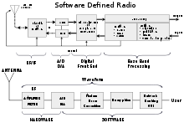

The ideal receiver scheme would be to attach an analog-
to-digital converter to an antenna. A digital signal processor would read the converter, and then its software would transform the stream of data from the converter to any other form the application requires.

An ideal transmitter would be similar. A digital signal processor would generate a stream of numbers. These would be sent to a digital-to-analog converter connected to a radio antenna.

Software Defined Radio concept

The ideal scheme is not completely realizable due to the actual limits of the technology. The main problem in both directions is the difficulty of conversion between the digital and the analog domains at a high enough rate and a high enough accuracy at the same time, and without relying upon physical processes like interference and electromagnetic resonance for assistance.

Receiver architecture

Most receivers use a variable-frequency oscillator, mixer, and filter to tune the desired signal to a common intermediate frequency or baseband, where it is then sampled by the analog-to-digital converter. However, in some applications it is not necessary to tune the signal to an intermediate frequency and the radio frequency signal is directly sampled by the analog-to-digital converter (after amplification).

Real analog-to-digital converters lack the dynamic range to pick up sub-microvolt, nanowatt-power radio signals. Therefore a low-noise amplifier must precede the conversion step and this device introduces its own problems. For example, if spurious signals are present (which is typical), these compete with the desired signals within the amplifier's dynamic range. They may introduce distortion in the desired signals, or may block them completely. The standard solution is to put band-pass filters between the antenna and the amplifier, but these reduce the radio's flexibility. Real software radios often have two or three analog channel filters with different bandwidths that are switched in and out.

History

The term "digital receiver" was coined in 1970 by a researcher at a DoD laboratory. A laboratory called the Gold Room at TRW in California created a software baseband analysis tool called Midas which of course was software defined.
The term "software radio" was coined in 1984 by a team at the Garland Texas Division of E-Systems Inc. (now Raytheon) to refer to a digital baseband receiver and published in their E-Team company newsletter. A 'Software Radio Proof-of-Concept' laboratory was developed there that popularized Software Radio within various government agencies. This 1984 Software Radio was a digital baseband receiver that provided programmable interference cancellation and demodulation for broadband signals, typically with thousands of adaptive filter taps, using multiple array processors accessing shared memory.

In 1991, Joe Mitola independently reinvented the term software radio for a plan to build a GSM base station that would combine Ferdensi's digital receiver with E-Systems Melpar's digitally controlled communications jammers for a true software-based transceiver. E-Systems Melpar sold the software radio idea to the US Air Force. Melpar built a prototype commanders' tactical terminal in 1990-91 that employed Texas Instruments TMS320C30 processors and Harris digital receiver chip sets with digitally synthesized transmission. That prototype didn't last long because when E-Systems ECI Division manufactured the first limited production units, they decided to "throw out those useless C30 boards," replacing them with conventional RF filtering on transmit and receive, reverting to a digital baseband radio instead of the SPEAKeasy like IF ADC/DACs of Mitola's prototype. The Air Force would not let Mitola publish the technical details of that prototype, nor would they let Diane Wasserman publish related software life cycle lessons learned because they regarded it as a "USAF competitive advantage." So instead, with USAF permission, in 1991 Mitola described the architecture principles without implementation details in a paper, "Software Radio: Survey, Critical Analysis and Future Directions" which became the first IEEE publication to employ the term in 1992. When Mitola presented the paper at the conference, Bob Prill of GEC Marconi began his presentation following Mitola with "Joe is absolutely right about the theory of a software radio and we are building one." Prill gave a GEC
Marconi paper on PAVE PILLAR, a SPEAKeasy precursor. SPEAKeasy, the military software radio was formulated by Wayne Bonser, then of Rome Air Development Center (RADC), now Rome Labs; by Alan Margulies of MITRE Rome, NY; and then Lt Beth Kaspar, the original DARPA SPEAKeasy PM and by others at Rome including Don Upmal. Although Mitola's IEEE publications resulted in the largest global footprint for software radio, Mitola privately credits that DoD lab of the 1970s with its leaders Carl, Dave, and John with inventing the digital receiver technology on which he based software radio once it was possible to transmit via software.

A few months after the National Telesystems Conference 1992, in an E-Systems corporate program review, a VP of E-Systems Garland Division objected to Melpar's (Mitola's) use of the term "software radio" without credit to Garland. Alan Jackson, Melpar VP of marketing at that time asked the Garland VP if their laboratory or devices included transmitters. The Garland VP said "No, of course not — ours is a software radio receiver". Al replied "Then it's a digital receiver but without a transmitter, it's not a software radio." Corporate leadership agreed with Al, so the publication stood. Many amateur radio operators and HF radio engineers had realized the value of digitizing HF at RF and of processing it with Texas Instruments TI C30 digital signal processors (DSPs) and their precursors during the 1980s and early 1990's. Radio engineers at Roke Manor in the UK and at an organization in Germany had recognized the benefits of ADC at the RF in parallel, so success has many fathers. Mitola's publication of software radio in the IEEE opened the concept to the broad community of radio engineers. His landmark May 1995 special issue of the IEEE Communications Magazine with the cover "Software Radio" was widely regarded as watershed event with thousands of academic citations. Mitola was introduced by Joao daSilva in 1997 at the First International Conference on Software Radio as "godfather" of software radio in no small part for his willingness to share such a valuable technology
"in the public interest."

Perhaps the first software-based radio transceiver was designed and implemented by Peter Hoeher and
Helmuth Lang at the German Aerospace Research Establishment (DLR, formerly DFVLR) in

Oberpfaffenhofen, Germany, in 1988. Both transmitter and receiver of an adaptive digital satellite modem were implemented according to the principles of a software radio, and a flexible hardware periphery was proposed.

The term "software defined radio" was coined in 1995 by Stephen Blust, who published a request for information from Bell South Wireless at the first meeting of the Modular Multifunction Information Transfer Systems (MMITS) forum in 1996, organized by the USAF and DARPA around the commercialization of their SPEAKeasy II program. Mitola objected to Blust's term, but finally accepted it as a pragmatic pathway towards the ideal software radio. Though the concept was first implemented with an IF ADC in the early 1990s, software-defined radios have their origins in the defense sector
since the late 1970s in both the U.S. and Europe (for example, Walter Tuttlebee described a VLF radio that used an ADC and an 8085 microprocessor). about a year after the First International Conference in Brussels. One of the first public software radio initiatives was the U.S. DARPA-Air Force military project named SpeakEasy. The primary goal of the SpeakEasy project was to use programmable processing to emulate more than 10 existing military radios, operating in frequency bands between 2 and 2000 MHz. Another SPEAKeasy design goal was to be able to easily incorporate new coding and modulation standards in the future, so that military communications can keep pace with advances
in coding and modulation techniques.

SPEAKeasy phase I

From 1990 to 1995, the goal of the SPEAKeasy program was to demonstrate a radio for the U.S. Air Force tactical ground air control party that could operate from 2 MHz to 2 GHz, and thus could interoperate with ground force radios (frequency-agile VHF, FM, and SINCGARS), Air Force radios (VHF AM), Naval Radios (VHF AM and HF SSB teleprinters) and satellites (microwave QAM). Some particular goals were to provide a new signal format in two weeks from a standing start, and demonstrate a radio into which multiple contractors could plug parts and software.

The project was demonstrated at TF-XXI Advanced Warfighting Exercise, and demonstrated all of these goals in a non-production radio. There was some discontent with failure of these early software radios to adequately filter out of band emissions, to employ more than the simplest of interoperable modes of the existing radios, and to lose connectivity or crash unexpectedly. Its cryptographic processor could not change context fast enough to keep several radio conversations on the air at once. Its software architecture, though practical enough, bore no resemblance to any other. The SPEAKeasy
architecture was refined at the MMITS Forum between 1996 and 1999 and inspired the DoD integrated process team (IPT) for programmable modular communications systems (PMCS) to proceed with what became the Joint Tactical Radio System (JTRS).

The basic arrangement of the radio receiver used an antenna feeding an amplifier and down-converter (see Frequency mixer) feeding an automatic gain control, which fed an analog to digital converter that was on a computer VMEbus with a lot of digital signal processors (Texas Instruments C40s). The transmitter had digital to analog converters on the PCI bus feeding an up converter (mixer) that led to a power amplifier and antenna. The very wide frequency range was divided into a few sub-bands with different analog radio technologies feeding the same analog to digital converters. This has since
become a standard design scheme for wide band software radios.

SPEAKeasy phase II

The goal was to get a more quickly reconfigurable architecture, i.e., several conversations at once, in an open software architecture, with cross-channel connectivity (the radio can "bridge" different radio protocols). The secondary goals were to make it smaller, cheaper, and weigh less.

The project produced a demonstration radio only fifteen months into a three-year research project. The demonstration was so successful that further development was halted, and the radio went into production with only a 4 MHz to 400 MHz range.

The software architecture identified standard interfaces for different modules of the radio: "radio frequency control" to manage the analog parts of the radio, "modem control" managed resources for modulation and demodulation schemes (FM, AM, SSB, QAM, etc.), "waveform processing" modules actually performed the modem functions, "key processing" and "cryptographic processing" managed
the cryptographic functions, a "multimedia" module did voice processing, a "human interface" provided local or remote controls, there was a "routing" module for network services, and a "control" module to keep it all straight.

The modules are said to communicate without a central operating system. Instead, they send messages over the PCI computer bus to each other with a layered protocol.

As a military project, the radio strongly distinguished "red" (unsecured secret data) and "black" (cryptographically-secured data).

The project was the first known to use FPGAs (field programmable gate arrays) for digital processing of radio data. The time to reprogram these was an issue limiting application of the radio. Today, the time to write a program for an FPGA is still significant, but the time to download a stored FPGA program is around 20 milliseconds. This means an SDR could change transmission protocols and frequencies in one fiftieth of a second, probably not an intolerable interruption for that task.

Current usage

Military

The Joint Tactical Radio System (JTRS) was a program of the US military to produce radios that provide flexible and interoperable communications. Examples of radio terminals that require support include hand-held, vehicular, airborne and dismounted radios, as well as base-stations (fixed and maritime).

This goal is achieved through the use of SDR systems based on an internationally endorsed open Software Communications Architecture (SCA). This standard uses CORBA on POSIX operating systems to coordinate various software modules.

The program is providing a flexible new approach to meet diverse soldier communications needs through software programmable radio technology. All functionality and expandability is built upon the SCA.

The SCA, despite its military origin, is under evaluation by commercial radio vendors for applicability in their domains. The adoption of general purpose SDR frameworks outside of military, intelligence, experimental and amateur uses, however, is inherently retarded by the fact that civilian users can more easily settle with a fixed architecture, optimized for a specific function, and as such more economical in mass market applications. Still, software defined radio's inherent flexibility can yield substantial
benefits in the longer run, once the fixed costs of implementing it have gone down enough to overtake the cost of iterated redesign of purpose built systems. This then explains the increasing commercial interest in the technology.

SCA-based infrastructure software and rapid development tools for SDR education and research are provided by the Open Source SCA Implementation — Embedded (OSSIE (http://ossie.wireless.vt.edu))

project. The Wireless Innovation Forum funded the SCA Reference Implementation project, an open source implementation of the SCA specification. (SCARI) can be downloaded for free.

Amateur and home use

A typical amateur software radio uses a direct conversion receiver. Unlike direct conversion receivers of the more distant past, the mixer technologies used are based on the quadrature sampling detector and the quadrature sampling exciter.
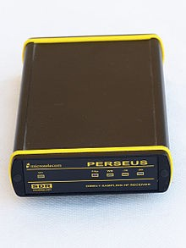

The receiver performance of this line of SDRs is directly related to the dynamic range of the analog-to-digital converters (ADCs) utilized. Radio frequency signals are down converted to the audio frequency band, which is sampled by a high performance audio frequency ADC. First generation SDRs used a PC sound card to provide ADC functionality. The newer software defined radios use embedded high performance ADCs that provide higher dynamic range and are more resistant to noise and RF interference.

A fast PC performs the digital signal processing (DSP) operations using software specific for the radio hardware. Several software radio efforts use the open source SDR library DttSP.
Microtelecom Perseus - a HF SDR
for the amateur radio market

The SDR software performs all of the demodulation, filtering (both radio frequency and audio frequency), signal enhancement (equalization and binaural presentation). Uses include every common amateur modulation: morse code, single sideband modulation, frequency modulation, amplitude modulation, and a variety of digital modes such as radioteletype, slow-scan television, and packet radio. Amateurs also experiment with new modulation methods: for instance, the DREAM
open-source project decodes the COFDM technique used by Digital Radio Mondiale.

There is a broad range of hardware solutions for radio amateurs and home use. There are professional-grade transceiver solutions, e.g. the Zeus ZS-1 or the Flex Radio, home-brew solutions,e.g. PicAStar transceiver, the SoftRock SDR kit, and starter solutions, e.g. the FiFi SDR for shortwave.

Finally, it has been discovered recently that some common DVB-T USB sticks with the Realtek RTL2832U controller and e.g. the Elonics E4000 or the Rafael Micro R820t tuner can be used as a wide-band SDR receiver. Recent experiments have proven the capability of this setup to analyze perseids shower using the graves radar signals.

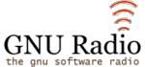

wideband operation.
More recently, the GNU Radio using primarily the Universal Software Radio Peripheral (USRP) uses a USB 2.0 interface, an FPGA, and a high-speed set of analog-to-digital and digital-to-analog converters, combined with reconfigurable free software. Its sampling and synthesis bandwidth is a thousand times that of PC sound cards, which enables

The HPSDR (High Performance Software Defined Radio) project uses a 16-bit 135 MSPS analog-

to-digital converter that provides performance over the range 0 to 55 MHz comparable to that of a conventional analogue HF radio. The receiver will also operate in the VHF and UHF range using either mixer image or alias responses. Interface to a PC is provided by a USB 2.0 interface though Ethernet could be used as well. The project is modular and comprises a backplane onto which other boards plug in. This allows experimentation with new techniques and devices without the need to replace the entire set of boards. An exciter provides 1/2 W of RF over the same range or into the VHF and UHF range using image or alias outputs.

WebSDR is a project initiated by Pieter-Tjerk de Boer providing access via browser to multiple SDR receivers worldwide covering the complete shortwave spectrum. Recently he has analyzed Chirp Transmitter signals using the coupled system of receivers.

dynamic transmitter power adjustment, based on information communicated from the receivers, lowering transmit power to the minimum necessary, reducing the near-far problem and reducing interference to others.
wireless mesh network where every added radio increases total capacity and reduces the power required at any one node. Each node only transmits loudly enough for the message to hop to the nearest node in that direction, reducing near-far problem and reducing interference to others.

Network Simulator Version 2:

NS is a publicly available tool for network simulations, built by various researches including LBL, Xerox PARC, UCB, and USC/ISI, and many other contributors as a variant of the “Real Network Simulator”, which is “a network simulator originally intended for studying the dynamic behavior of flow and congestion control schemes in packet-switched data networks” [1:Page 1].

NS is intended to simulate and research computer networks, using a discrete event simulation technique. NS is currently being developed by D.A.R.P.A. (Defense Advanced Research Projects Agency), through the SAMAN project, which aims at making network protocols and operations more susceptible to failure so that protocols and network operations would be analyzed under extreme conditions.

The following survey will attempt to cover the basics of NS without going in great details by answering the following in their stated order. What is the input topology of the simulator (to be analyzed), how is the output of the simulator validated, what protocols does the simulator support, does the public contribute to this research, and how is this contribution performed, does the simulator have any limitations, does the simulator support a parallel distributed environment, and finally what is the future of the simulator

Topology ^{[1:]}

Topology is defining an object’s location with respect to another reference point. We are interested in this report in the geography of cyberspace either of ISP’s or even complete images of the current cyberspace.

NS accept converted topologies from the following generators:
- Inet Topology generator
  - an Autonomous System (AS) level Internet topology generator
- GT-ITM(Georgia Tech Internetwork Topology Models) topology generator
  - A tool that generates graphs modeling the topological structure of internetworks
- Tiers topology generator
  - A random topology generator by Mathew Doar
- BRITE(Boston university representative internet topology generator)
  - A tool by Boston University, the project aims in creating a universal topology generator [4].
- By hand
  - Used for simple and small topologies, mostly aimed at learning the basics of NS, rather than studying specific systems.
Conversion of the previously mentioned topologies is done through separate scripts that are not incorporated in the simulator.
Validation

“Ns is not a polished and finished product, but the result of an on-going effort of research and development. In particular, bugs in the software are still being discovered and corrected. Users of NS are responsible for verifying for themselves that their simulations are not invalidated by bugs” [1:]
The program mainly tests TCP congestion control algorithms; it is also worth mentioning that the current version of the simple validation tools is backward compatible with ns-1.
Other validation methods include:

- THE SACK TCP TESTS
- Comparisons of Tahoe, Reno, and SACK TCP
- NS Simulator Tests for Random Early Detection (RED) Gateways
Since NS is a public project, it relays on an extensive bug report forum for verification and modification purposes. It also supports an extensive database of demos to illustrate the correct usage of each supported protocol.

Supported protocols

Almost all variants of TCP are supported by NS, several forms of multicast, wired networking, several ad hoc routing protocols and propagation models (but not cellular phones), data diffusion, satellite, etc. following is a list presented as it is found on the Ns web site, The list features the layer, protocol, and test library supporting the protocol for verification purposes, if found.
- Application-level:
  - HTTP, web caching and invalidation, TcpApp (test-suite-webcache.tcl)
  - telnet and ftp sources (test-suite-simple.tcl)
  - Constant-Bit-Rate (CBR) sources (test-suite-cbq.tcl)
  - On/Off sources (test-suite-intserv.tcl)
- Transport protocols (UDP, TCP, RTP, SRM):
  - basic TCP behavior (test-suite-simple.tcl, test-suite-v1{,a}.tcl)
  - Tahoe, Reno, New-Reno, and SACK TCP under different losses (test-suite-tcpVariants.tcl)
  - FACK TCP (limited validation in test-suite-tcpVariants.tcl)
  - TCP vegas (test-suite-vegas-v1.tcl)
  - New-Reno TCP (test-suite-newreno.tcl)
  - SACK TCP (test-suite-sack{,-v1,v1a})
  - full TCP (test-suite-full.tcl), partial validation only.
  - TCP initial window behavior (test-suite-tcp.tcl)
  - rate-based pacing TCP (test-suite-rbp.tcl)
  - RFC-2001 (Reno) TCP behavior (test-suite-rfc2001.tcl)
  - RTP (in test-suite-friendly.tcl, not yet added to "validate")
  - SRM (in test-suite-srm.tcl)
- Routing:
  - algorithmic routing (test-suite-algo-routing)
  - hierarchical routing (test-suite-hier-routing.tcl)
  - lan routing and broadcast (test-suite-lan.tcl)
  - manual routing (test-suite-manual-routing.tcl)
  - centralized multicast, DM multicast, not detailedDM, not multicast over LAN (test-suite-mcast.tcl)
  - routing dynamics (test-suite-routed.tcl)
  - detailed simulation using virtual classifier (test-suite-vc.tcl)
  - mixed-mode session-levels simulation (test-suite-mixmode.tcl)
  - session-level simulation (test-suite-session.tcl)
- Router Mechanisms (scheduling, queue management, admissions control, etc.):
  - FQ (Fair Queueing), SFQ (Stochastic Fair Queuing), DRR (Deficit Round Robin), FIFO (with drop-tail and RED queue management) (test-suite-schedule.tcl)
  - CBQ (both in v1 and v2 mode) (test-stuite-cbq{,-v1,-v1a})
  - RED queue management (test-suite-red{,-v1,-v1a})
  - ECN behavior (and TCP interactions) (test-suite-ecn.tcl)
  - admission control algorithms: MS, HB, ACTP, ACTO, parameter-based (in test-suite-intserv.tcl)
- Link-layer mechanisms:
  - LANs, with CSMA/CD MAC protocols (in test-suite-lan.tcl)
  - snoop
- Other:
  - Error Modules (e.g., in test-suite-ecn.tcl, test-suite-tcp-init-win.tcl, test-suite-session.tcl, and test-suite-srm.tcl)

- Invalidated protocols:
  - Fack and Asym TCP
  - RTCP
  - RTP
  - LANs with CSMA/CA MAC protocols (tcl/ex/mac-test.tcl), with MultihopMac (mac-multihop.cc)and with 802.11 (mac-802_11.cc)
  - RLM (Receiver Layered Multicast) (tcl/ex/test-rlm.tcl)
  - token bucket filters (tcl/ex/test-tbf.tcl)
  - trace-generated sources (tcl/ex/tg.tcl)
  - delay-adaptive receivers (tcl/ex/test-rcvr.tcl)
  - delay modules (delaymodel.cc)
  - IVS (ivs.cc)
- emulation mode

Contributions

The network simulator have been around for quite a while, and have been established as an industry standard on the same level as other software (Opnet, and Omnet, etc).

Contributions (in the form of code and add-ons to the simulator) to the project are made by various researchers to serve their own research need, and in effect that of the development of the NS project. Most Contributions however are not tested or validated by the VINT group, and are left to their respected developers to maintain and support.

All contributions made to the project can be found at:
http://www.isi.edu/nsnam/ns/ns-contributed.html however since we are not actually using NS, but rather surveying its abilities and functionality, a study of the contributed code will not be included in this survey, as it would be out of scope.

Limitations

Since a model is a simplified representation of a real system created with the intention of experimentations, Boundaries, rules and even deficiencies arise. A certain and most annoying deficiency faced by the developers is the enormous processing power and memory capacity required as the network size increases. This particular limitation is almost present in all network simulators present today. Other than the simulation size limitation, certain technical limitations are described to be
- TCP one-way
  - the lack of a dynamic window advertisement
  - segments and ACK calculations are in packets
  - No SYN/FIN connection establishment/teardown.
    - TCP one-way, ECN (Explicit Congestion Notification)
      - Sender doesn’t check if receiver is ECN compliant
- TCP two-way(full TCP)
  - no dynamic window advertisement,
  - no 2MSL-wait or persist states
  - no urgent data or RESET segments

Since this survey is done without actually using the tool, but rather through studying its documentation and supporting materials, it’s predictable that the actual use of NS would shed the light on more limitations related to the design of the software itself. Another limitation is the lack of a GUI built in the package, several open source scripts attempt to draft a GUI over the tool, and however this only result in decreased functionality as the tool wasn’t designed with such an option. It is although worth mentioning the presence of external tools used for viewing networks and threads (NAM: Network Animator).

Parallel distributed NS

As mentioned earlier when discussing the limitations faced by NS, design of large networks using NS proved to be very hard and almost impossible. The reasons for that as stated by the simulator developers are extensive CPU usage and large memory requirements.

These limitations lead to the development of a parallel distributed version of the network simulator. The research is lead by Dr.George Riley and Alfred Park faculty members of the Georgia Institute of Technology, College of Computing. The objective of the PDNS(parallel distributed NS) is to provide means of simulating a network topology on a distributed system of about 8~16 workstations.

The workstations are connected through a “Myrinet” network(packet-communication and switching technology used to interconnect clusters of computers), or a standard Ethernet network using the TCP/IP protocol stack.

Appraoch

Keeping and using the current NS tools was important to make use of future developments in the NS project, therefore a federated simulation approach was used, where separate installations of the NS software are running separatly on different workstations, each simulating a portion or a subnetwork of the system under consideration, with a conservative(blocking based) approach of synchronization. The NS federate approach is assumed not to need a state saving method added to the currently avaialble NS code. The software is developed with the PADS (Parralel and Distributed Simmulation) research group at the georgia institute of technology to provide support for the following Parallel and distributed modes of operation:
  - global virtual time management
  - group data communications
  - message buffer management.
communication interconnects being used are
- shared memory
  - Myrinet networks
  - TCP/IP networks
Although modification to the NS tool was higly undesirable, however it was necessary to change and later on standarize those changes for future development of the NS tool. Changes to the tool are grouped in the following categories
  - Modifications to the ns event processing infrastructure
  - Extensions to the NS TCL script syntax for describing simulations

Status and future development of NS

PDNS has been succesfully tested on a total of 128 processors, and a sum of 500,000 nodes network topology. A set of different projects are currently being developed, one is a scenario generator. The function of such a tool would be to translate the output of a topology generator into NS format and will come with a scenario library ,that will have different scenarios to thourougly test the network at hand. Last but not least a facility to inject live trafic from NS and to emulate(i.e: translate live traffic into NS) a network is available, it is usually considered a different project, therefore it was not covered in this survay of NS.

In conclusion NS has been in development in the georgia institue of technology for many years. It has been used as a reliable simulaiton and validation tool by many agencies and organizations, proving its high standars. Although the lack of a built in GUI, the fact that the project is open to the public, made it possible for other researches to contribute to it, adding more functionallity to the simulator. The future of NS is clear to be in the path of parallel and distributed simulations, as the parallel formalism aids in solving large scale networks, which are more and more becoming the normal tybe of networks in an ever developing and changing industry.

General Structure and Architecture of NS

NS (version 2) is an object-oriented, discrete event driven network simulator developed at UC Berkeley written in C++ and OTcl. NS is primarily useful for simulating local and wide area networks.
NS is an event driven network simulator developed at UC Berkeley that simulates variety of IP networks. It implements network protocols such as TCP and UPD, traffic source behavior such as FTP, Telnet, Web, CBR and router queue management mechanism such as Drop Tail, RED, routing algorithms such as Dijkstra, and more. NS also implements multicasting and some of the MAC layer protocols for LAN simulations. The NS project is now a part of the VINT project that develops tools for simulation results display, analysis and converters that convert network topologies generated by well-known generators to NS formats. Currently, NS (version 2) written in C++ and OTcl (Tcl script language with Object-oriented extensions developed at MIT) is available.

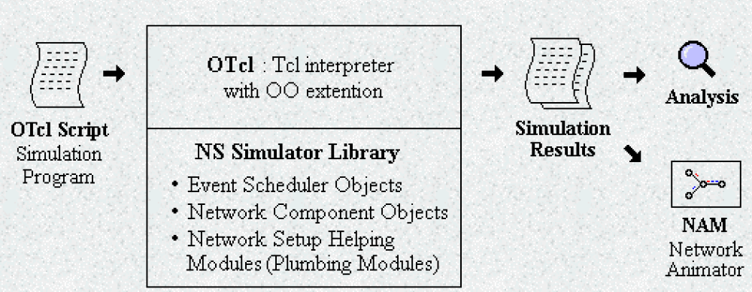
Figure B.1: Simplified User's View of NS

NS is Object-oriented Tcl (OTcl) script interpreter that has a simulation event scheduler and network component object libraries, and network setup (plumbing) module libraries (actually, plumbing modules are implemented as member functions of the base simulator object). In other words, to use NS, we program in OTcl script language. To setup and run a simulation network, a user should write an OTcl script that initiates an event scheduler, sets up the network topology using the network objects and the plumbing functions in the library, and tells traffic sources when to start and stop transmitting packets through the event scheduler. The term plumbing is used for a network setup, because setting up a network is plumbing possible data paths among network objects by setting the neighbor pointer of an object to the address of an appropriate object. When a user wants to make a new network object, he or she can easily make an object either by writing a new object or by making a compound object from the object library, and plumb the data path through the object. This may sound like complicated job, but the plumbing OTcl modules actually make the job very easy.
The power of NS comes from this plumbing. Another major component of NS beside network objects is the event scheduler. An event in NS is a packet ID that is unique for a packet with scheduled time and the pointer to an object that handles the event. In NS, an event scheduler keeps track of simulation time and fires all the events in the event queue scheduled for the current time by invoking appropriate network components, which usually are the ones who issued the events, and let them do the appropriate action associated with packet pointed by the event. Network components communicate with one another passing packets; however this does not consume actual simulation time. All the network components that need to spend some simulation time handling a packet (i.e. need a delay) use the event scheduler by issuing an event for the packet and waiting for the event to be fired to itself before doing further action handling the packet. For example, a network switch component that simulates a switch with 20 microseconds of switching delay issues an event for a packet to be switched to the scheduler as an event 20 microsecond later. The scheduler after 20 microseconds dequeues the event and fires it to the switch component, which then passes the packet to an appropriate output link component. Another use of an event scheduler is timer. For example, TCP needs a timer to keep track of a packet transmission time out for retransmission (transmission of a packet with the same TCP packet number but different NS packet ID). Timers use event schedulers in a similar manner that delay does. The only difference is that timer measures a time value associated with a packet and does an appropriate action related to that packet after a certain time goes by, and does not simulate a delay.
NS is written not only in OTcl but in C++ also. For efficiency reason, NS separates the data path implementation from control path implementations. In order to reduce packet and event processing time (not simulation time), the event scheduler and the basic network component objects in the data path are written and compiled using C++. These compiled objects are made available to the OTcl interpreter through an OTcl linkage that creates a matching OTcl object for each of the C++ objects and makes the control functions and the configurable variables specified by the C++ object act as member functions and member variables of the corresponding OTcl object. In this way, the controls of the C++ objects are given to OTcl. It is also possible to add member functions and variables to a C++ linked OTcl object.
The objects in C++ that do not need to be controlled in a simulation or internally used by another object do not need to be linked to OTcl. Likewise, an object (not in the data path) can be entirely implemented in OTcl. Figure 2 shows an object hierarchy example in C++ and OTcl. One thing to note in the figure is that for C++ objects that have an OTcl linkage forming a hierarchy, there is a matching OTcl object hierarchy very similar to that of C++.
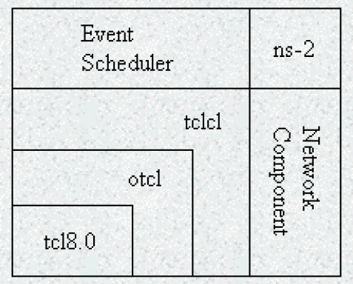
Figure B.2: Architectural View of NS
In the figure above, a general user (not an NS developer) can be thought of standing at the left bottom corner, designing and running simulations in Tcl using the simulator objects in the OTcl library. The event schedulers and most of the network components are implemented in C++ and available to OTcl through an OTcl linkage that is implemented using tclcl. The whole thing together makes NS, which is an object oriented extended Tcl interpreter with network simulator libraries.
At this point it’s important to know how to obtain NS simulation results. When a simulation is finished, NS produces one or more text-based output files that contain detailed simulation data, if specified to do so in the input Tcl (or more specifically, OTcl) script. The data can be used for simulation analysis (two simulation result analysis examples are presented in later sections) or as an input to a graphical simulation display tool called Network Animator (NAM) that is developed as a part of VINT project. NAM has a nice graphical user interface similar to that of a CD player (play, fast forward, rewind, pause and so on), and also has a display speed controller. Furthermore, it can graphically present information such as throughput and number of packet drops at each link, although the graphical information cannot be used for accurate simulation analysis.

Downloading/Installing ns & nam on LINUX
1. Download ns-allinone-2.31.tar.gz from http://www.isi.edu/nsnam
2. Put the file in /usr/src by typing, cd /usr/src
3. Unpack file by typing, tar -xvzf nsallinone-2.31.tar.gz
4. cd ns-allinone -2..31
5. type, ls -lr to check if we are in correct directory (a dot means correct directory)
6. type, ./install
7. type, ./validate to validate
To Run NS
1. Place the following bash file in user work directory, /home/usr then, ns-abc.sh
******************** Script File Start ********************
#!/bin/sh
p1=/usr/src/ns-allinone-2.31/bin
p2=/usr/src/ns-allinone-2.31/otcl-1.0a8
p3=/usr/src/ns-allinone-2.31/lib
p4=/usr/src/ns-allinone-2.31/lib/tcl8.3
p5=/usr/src/ns-allinone-2.31/lib/tk8.3
PATH=$PATH:$p1:$p2:$p3:$p4:$p5
export PATH
$PATH
LD_LIBRARY_PATH=$p3:$p4:$p5
export LD_LIBRARY_PATH=$LD_LIBRARY_PATH
$LD_LIBRARY_PATH
ns $1
******************** Script File End ********************
2. Now, ./ns-abc.sh simple.tcl
Use a file browser and select the properties button to set attributes.
Ns$1 invokes the simulator and passes in the file name as a parameter.
We can also create a script to start Network Animator , only change to be done is ns$1 to nam$1 and save as run-nam.sh by gedit abc.sh
3. To run, ./run-nam.sh
*****************************************************
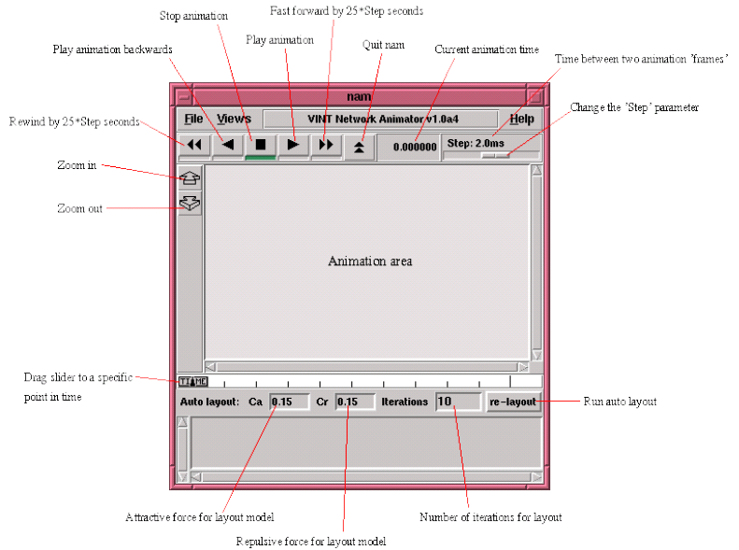
Figure B.3: nam window

Starting ns
NS starts with the command 'ns <tclscript>' (assuming that we are in the directory with the ns executable, or that were path points to that directory), where '<tclscript>' is the name of a Tcl script file which defines the simulation scenario (i.e. the topology and the events). We could also just start ns without any arguments and enter the Tcl commands in the Tcl shell, but that is definitely less comfortable. Everything else depends on the Tcl script. The script might create some output, it might write a trace file or it might start nam to visualize the simulation.

Starting nam
We can either start nam with the command 'nam <nam-file>' where '<nam-file>' is the name of a nam trace file that was generated by ns, or we can execute it directly out of the Tcl simulation script for the simulation which we want to visualize. Below we can see a screenshot of a nam window where the most important functions are being explained.

How to start Tcl Scripts
We can write wer Tcl scripts in any text editor like joe or emacs. First of all, we need to create a simulator object. This is done with the command
set ns [new Simulator]
Now we open a file for writing that is going to be used for the nam trace data.
set nf [open out.nam w]
$ns namtrace-all $nf
The first line opens the file 'out.nam' for writing and gives it the file handle 'nf'. In the second line we tell the simulator object that we created above to write all simulation data that is going to be relevant for nam into this file. The next step is to add a 'finish' procedure that closes the trace file and starts nam.
proc finish {} {
global ns nf
$ns flush-trace
close $nf
exec nam out.nam &
exit 0
}
The next line tells the simulator object to execute the 'finish' procedure after 5.0 seconds of simulation time.
$ns at 5.0 finish
We can understand what this line does just by looking at it. ns provides we with a very simple way to schedule events with the 'at' command. The last line finally starts the simulation.
$ns run

Network Components
The root of the hierarchy is the TclObject class that is the superclass of all OTcl library objects (scheduler, network components, timers and the other objects including NAM related ones). As an ancestor class of TclObject, NsObject class is the superclass of all basic network component objects that handle packets, which may compose compound network objects such as nodes and links. The basic network components are further divided into two subclasses, Connector and Classifier, based on the number of the possible output data paths. The basic network objects that have only one output data path are under the Connector class, and switching objects that have possible multiple output data paths are under the Classifier class.

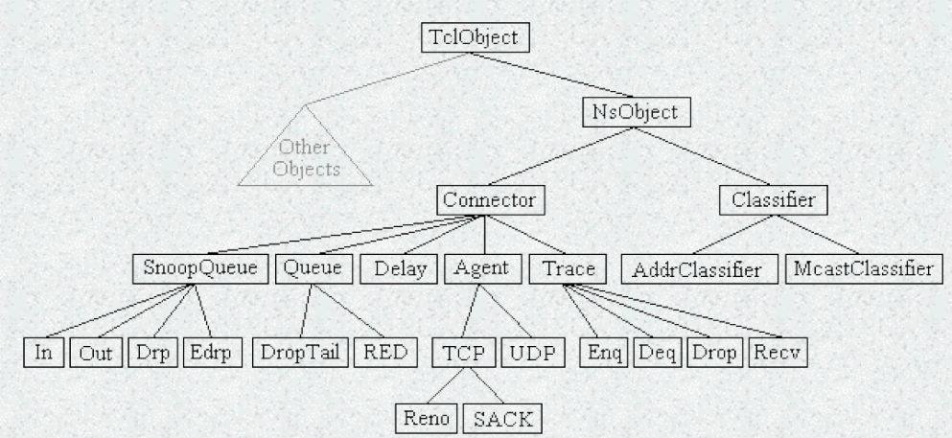
Figure B.4: class hierarchy (partial)

Node and Routing
There are two types of nodes in NS.
A unicast node has an address classifier that does unicast routing and a port classifier.
$ns rtproto type
type: Static, Session, DB, cost, multi-path
A multicast node, in addition, has a classifier that classify multicast packets from unicast packets and a multicast classifier that performs multicast routing.
$ns multicast (right after set $ns [new Scheduler])
$ns mrtproto type
type: CtrMcast, DM, ST, BST

In NS, Unicast nodes are the default nodes. To create Multicast nodes the user must explicitly notify in the input OTcl script, right after creating a scheduler object, that all the nodes that will be created are multicast nodes. After specifying the node type, the user can also select a specific routing protocol other than using a default one.

Link
A link is another major compound object in NS. When a user creates a link using a duplex-link member function of a Simulator object, two simplex links in both directions are created. One thing to note is that an output queue of a node is actually implemented as a part of simplex link object. Packets dequeued from a queue are passed to the Delay object that simulates the link delay, and packets dropped at a queue are sent to a Null Agent and are freed there. Finally, the TTL object calculates Time To Live parameters for each packet received and updates the TTL field of the packet.

Tracing
In NS, network activities are traced around simplex links. If the simulator is directed to trace network activities (specified using $ns trace-all file or $ns namtrace-all file), the links created after the command will have the following trace objects inserted. Users can also specifically create a trace object of type type between the given src and dst nodes using the create-trace {type file src dst} command. When each inserted trace object (i.e. EnqT, DeqT, DrpT and RecvT) receives a packet, it writes to the specified trace file without consuming any simulation time, and passes the packet to the next network object.

Queue Monitor
Basically, tracing objects are designed to record packet arrival time at which they are located. Although a user gets enough information from the trace, he might be interested in what is going on inside a specific output queue. For example, a user interested in RED queue behavior may want to measure the dynamics of average queue size and current queue size of a specific RED queue (i.e. need for queue monitoring). Queue monitoring can be achieved using queue monitor objects and snoop queue objects. When a packet arrives, a snoop queue object notifies the queue monitor object of this event. The queue monitor using this information monitors the queue.

Packet
A NS packet is composed of a stack of headers, and an optional data space. A packet header format is initialized when a Simulator object is created, where a stack of all registered (or possibly useable) headers, such as the common header that is commonly used by any objects as needed, IP header, TCP header, RTP header (UDP uses RTP header) and trace header, is defined, and the offset of each header in the stack is recorded. What this means is that whether or not a specific header is used, a stack composed of all registered headers is created when a packet is allocated by an agent, and a network object can access any header in the stack of a packet it processes using the corresponding offset value.

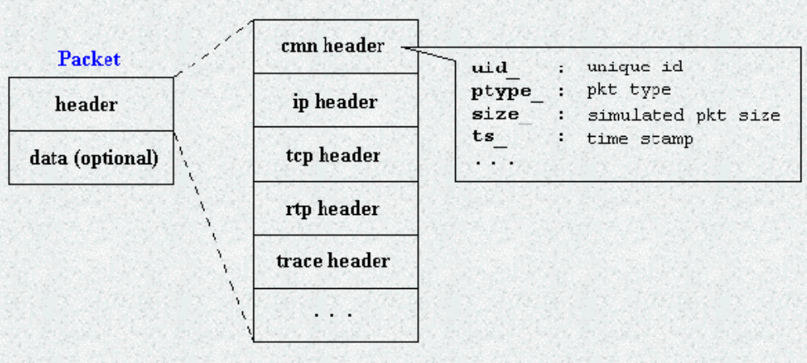
Figure B.5: NS Packet Format

Usually, a packet only has the header stack (and a data space pointer that is null). Although a packet can carry actual data (from an application) by allocating a data space, very few application and agent implementations support this. This is because it is meaningless to carry data around in a non-real-time simulation. However, if we want to implement an application that talks to another application cross the network, we might want to use this feature with a little modification in the underlying agent implementation. Another possible approach would be creating a new header for the application and modifying the underlying agent to write data received from the application to the new header.

Subscribers: The devices that attach to the network. It is still the case that most subscriber devices to public telecommunications networks are telephones, but the percentage of data traffic increases year by year. - Subscriber line: The link between the subscriber and the network, also referred to as the local loop. Almost all subscriber line connections use twisted pair wire. The length of a subscriber line is typically in a range from a few kilometers to a few tens of kilometers. The subscriber line is also known as a subscriber loop, or a local loop. - Exchanges: The switching centers in the network. A switching center that directly supports subscribers is known as an end office. Typically, an end office will support many thousands of subscribers in a localized area. There are over 19,000 end offices in the United States, so it is clearly impractical for each end office to have a direct link to each of the other end offices; this would require on the order of 2 X 10⁸ links. Rather, intermediate switching nodes are used.
This is the term used in ATM Forum documents. In ITU-T documents, this bit is referred to as the ATM- user-to-ATM-user (AAU) indication bit. The meaning is the same.
Interfaces: The hardware and software interfaces to various networks differ. The concept of a router must be independent of these differences. - Reliability: Various network services may provide anything from a reliable end-to-end virtual circuit to an unreliable service. The operation of the routers should not depend on an assumption of network reliability. The preceding requirements are best satisfied by an internetworking protocol, such as IP, that is implemented in all end systems and routers.
A Joule (J) is the International System (SI) unit of electrical, mechanical, and thermal energy. A watt is the SI unit of power, equal to one joule per second. The kelvin (K) is the SI unit of thermodynamic temperature. For a temperature in degrees kelvin of T, the corresponding temperature in degrees Celsius is equal to T — 273.15.
On the other hand, the reflected signal has a longer path, which creates a phase shift due to delay relative to the unreflected signal. When this delay is equivalent to half a wavelength, the two signals are back in phase.

