Network Security
Lecture 4
Summary of the previous lecture
Prevention, Detection and Reaction, How much security, Security trade-offs (productivity, functionality), Penetration testing tool, No free lunch
Outlines
Security through obscurity, Aspects of Security, OSI Security architecture, Active and Passive attacks, Protection and access rights
There is never a free lunch
Means don’t go for free software, free wallpapers etc. No one is going to give you anything free
Security through obscurity … ?
Obscurity means the state of being unknown, inconspicuous, or unimportant.
Security through obscurity – hiding design or implementation details to gain security:
Keeping secret not the key, but the encryption algorithm, hiding a DB server under a name different from “db”, etc.
The idea doesn’t work. It’s difficult to keep secrets (e.g. source code gets stolen). If security of a system depends on one secret, then, once it’s no longer a secret, the whole system is compromised secret algorithms, protocols etc. will not get reviewed flaws won’t be spotted and fixed less security
Systems should be secure by design, not by obfuscation
Security AND obscurity
Aspects of Security
Security attack
Any action that compromises the security of information owned by an organization.
Security mechanism
A process that is designed to detect, prevent or recover from a security attack.
Security service
Services that enhances the security of the data processing systems and the information transfers of an organization. These services are intended to counter security attacks, and they make use of one or more security mechanisms to provide the service.
OSI Security Architecture
International Telecommunication Union (ITU-T) recommends X.800, the security architecture for OSI. Defines a systematic way of defining and providing security requirements.
Security Attacks Classification
Any action that compromises the security of information owned by an organization. Information security is about how to prevent attacks, or failing that, to detect attacks
Classification according to X.800
Passive attack: The data or messages are only read/analyzed. Data/contents are not changed
Active attack: The data/contents are modified
Passive attack: Obtaining message content, Traffic analysis
Active attack: Masquerade, Replay previous messages, Modify messages in transit
Security Service
Enhance security of data processing systems and information transfers of an organization. Intended to counter security attacks. Using one or more security mechanisms. X.800 defines a security service as “ A service provided by a protocol layer of communicating open systems, which ensures adequate security of the systems or of data transfers”
Protection
In one protection model, computer consists of a collection of objects, hardware or software. Each object has a unique name and can be accessed through a well-defined set of operations.
Protection problem - ensure that each object is accessed correctly and only by those processes that are allowed to do so.
Principles of Protection
Guiding principle – principle of least privilege. Programs, users and systems should be given just enough privileges to perform their tasks. It limits damage if entity has a bug, gets abused. Can be static (during life of system, during life of process) or dynamic (changed by process as needed) – domain switching, privilege escalation. “Need to know” a similar concept regarding access to data. Must consider “grain” aspect.
Rough-grained privilege management easier, simpler, but least privilege now done in large chunks. Fine-grained management more complex, more overhead, but more protective, e.g., File ACL lists, Role Based Access Control (RBAC).
Domain can be user, process, procedure.
Domain Structure
Access-right = <object-name, rights-set>
where rights-set is a subset of all valid operations that can be performed on the object
Domain = set of access-rights
Access control
prevention of the unauthorized use of a resource, that is this service controls
- who can have access to a resource
- under what condition access can occur
- what those accessing are allowed to do
Access Matrix
View protection as a matrix (access matrix) where Rows represent domains and Columns represent objects. Access(i, j) is the set of operations that a process executing in Domain_{i} can invoke on Object_{j}
Use of Access Matrix
If a process in Domain D_{i} tries to do “op” on object O_{j}, then “op” must be in the access matrix. User who creates object can define access column for that object. Can be expanded to dynamic protection. Operations to add, delete access rights.
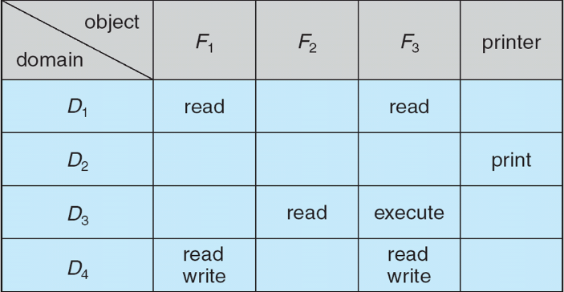
Special access rights:
owner of O_{i}
copy op from O_{i} to O_{j} (denoted by “*”)
control – D_{i} can modify D_{j} access rights
transfer – switch from domain D_{i} to D_{j}
Copy and Owner applicable to an object
Control applicable to domain object
Access matrix design separates mechanism from policy Mechanism . Operating system provides access-matrix + rules. If ensures that the matrix is only manipulated by authorized agents and that rules are strictly enforced.
Policy
User dictates policy. Who can access what object and in what mode. But doesn’t solve the general confinement problem. Each column = Access-control list for one object
Defines who can perform what operation
Domain 1 = Read, Write
Domain 2 = Read
Domain 3 = Read
Each Row = Capability List (like a key)
For each domain, what operations allowed on what objects
Summary of today’s lecture
In today’s lecture, we talked about security through obscurity. We also learnt about different types of attacks such as Active and Passive attacks. We have developed an understanding about access rights and how to use access metrix.
Next lecture topics
We will discuss different types of security attacks such as virus, worms, Trojan horse etc. DoS attacks, DDoS attacks and its different types.
The End

