Network Security
Lecture 27
Presented by: Dr. Munam Ali Shah
SET Participants
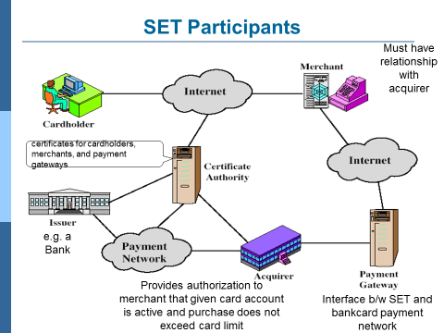
SET Requirements
Provide confidentiality; Ensure the integrity; Provides authentication that card holder is a legitimate user of a card and account: Ensure the best security practices
SET Key features
Confidentiality of information; Integrity of data; Card holder account authentication; Merchant authentication; Facilitate interoperability among software and hardware providers
SET Transaction
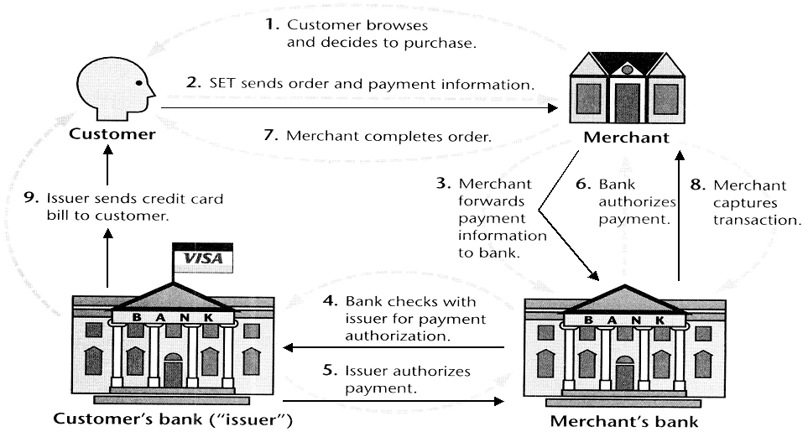
Payment Processing
- Purchase request
- Payment authorization
- Payment capture
A. SET Purchase Request
SET purchase request exchange consists of four messages
  - Initiate Request – includes brand of card, ID by customer and a nonce_A sent to merchant, get certificates of merchant and payment gateway
  - Initiate Response – merchant signed response, includes nonce_A, nonce_B, transaction ID, certificate of merchant and payment gateway
  - Purchase Request – creates OI & PI
  - Purchase Response
Purchase related information: will be forwarded to the payment gateway by the merchant (includes PI, DS , OIMD) encrypted with key K_{S} and K_{S} is encrypted with Bank’s Public key, Order related information: needed by the merchant (includes OI, DS, PIMD), Cardholder certificate: need by the merchant and the payment gateway,
Structure of Purchase Request
Purchase Request – Verification by Merchant
- Verifies cardholder certificates using CA sigs
- Verifies dual signature using customer's public signature key to ensure order has not been tampered with in transit & that it was signed using cardholder's private signature key
- Processes order and forwards the payment information to the payment gateway for authorization (described later)
- Sends a purchase response to cardholder
Purchase Request – Merchant, Purchase response, Merchant prepares a response block that includes, acknowledge of order , transaction number , The block signed by the merchant using its private key, Merchant sent to customer, the response block , Signature on block, Merchant’s signature certificate.
B. Payment Authorization
The merchant authorized the transaction with the payment gateway. The payment gateway authorization ensures that the transaction was approved by the issuer. This will guarantees that merchant will receive the payment.
Authorization request: Purchase related information: obtained from the customer and consists of Payment block E(Ks, [PI, DS, OIMD]) and digital envelop, Authorization related information: generated by the merchant, consists of, Authorization block: transaction ID signed with merchant private key, encrypted with symmetric key generated by merchant, Digital envelop: encrypting the symmetric key with the payment gateway’s public key-exchange key .
Authorization request: Certificates: Cardholder’s signature key certificate (verify the dual sig), Merchant signature key certificate (verify merchant sig), Merchant key exchange certificate (needed in response).
Payment Gateway Authorization:
- verifies all certificates
- decrypts digital envelope of authorization block to obtain symmetric key & then decrypts authorization block
- verifies merchant's signature on authorization block
- decrypts digital envelope of payment block to obtain symmetric key & then decrypts payment block
- verifies dual signature on payment block
- verifies that transaction ID received from merchant matches that in PI received (indirectly) from customer
- requests & receives an authorization from issuer
- sends authorization response back to merchant
C. Payment Capture
Merchant sends payment gateway a payment capture request (payment amount, transaction ID, Capture token info sign and encrypted by the merchant). Gateway checks request. Then create and sent the clearing request to the issuer that causes funds to be transferred to merchants account. Notifies merchant using capture response
SET Overheads
A Simple purchase transaction: Four messages between merchant and customer. Two messages between merchant and payment gateway. 6 digital signatures. 9 RSA encryption/decryption cycles. 4 DES encryption/decryption cycles, 4 certificate verifications. Multiple servers need copies of all certificates
Summary
In today’s lecture, we talked about SET (Secure Electronic Transaction). We have seen its functionality and how different entities are involved to make a transaction secure and successful.
The End

