Network Security
Lecture 26
Presented by: Dr. Munam Ali Shah
Part – 2 (e): Incorporating security in other parts of the network
Summary of the Previous Lecture
In previous lecture we continued our discussion on Authentication Applications and more precisely we talked about Kerberos in detail. Kerberos versions, threats and vulnerabilities were explored. We also talked about X.509 which makes use of certificates Issued by a Certification Authority (CA), containing: version, serial number, signature algorithm identifier, issuer X.500 name (CA), name of the CA that created and singed this certificate and period of validity etc. We also talked about one way, two way and three way authentication in X.509
Secure Electronic Transactions (SET)
Open encryption & security specification, To protect Internet credit card transactions, Developed in 1996 by Mastercard, Visa, Not a payment system, Rather a set of security protocols & formats, secure communications amongst parties, Provides trust by the use of X.509v3 , certificates, Privacy by restricted info to those who need it.
SET Participants
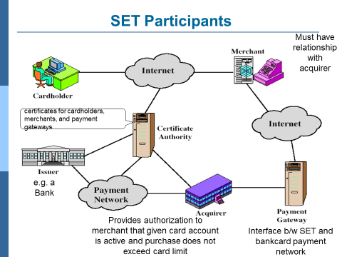
SET Requirements
Provide confidentiality of payment and ordering data. (SET uses encryption to provide confidentiality). Ensure the integrity of all transmitted data: (DS are used to provide integrity). Provides authentication that card holder is a legitimate user of a card and account: (A mechanism that links the card holder to a specific account no. reduces the incident of fraud. Uses DS and certificate for verification). Facilitate and encourage interoperability among software and hardware providers. Provides authentication that a merchant can accept credit card transactions through its relationship with a financial institution: cardholders should be able to identify merchant. DS and certificates can be used. Ensure the best security practices and system design techniques to protect all legitimate parties. Create a protocol that neither depends upon the transport security mechanism nor prevents their uses
SET Key features
Confidentiality of information, Integrity of data, Card holder account authentication, Merchant authentication.
SET Transaction
- Customer opens account such as MasterCard or Visa
- Customer receives a certificate
  - After verification receive an X.509v3 certificate sign by bank
  - Establish relation between the customer's key pair and his or her credit card
- Merchants have their own certificates
  - Two certificates, for signing message and for key exchange
  - Also has the payment gateway's public-key certificate
- Customer places an order
  - Browsing Merchant's Web site to select items and determine price
  - customer then sends a list of the items to be purchased to the merchant
  - Merchant returns an order form containing the list of items, their price, a total price, and an order number
- Merchant is verified (by customer)
a) With Order form, merchant sends a copy of its certificate
b) Customer can verify that he/she is dealing with a valid store through that certificate
- Order and payment are sent (with customer’s certificate)
  - Customer sends both order and payment information to the merchant with the customer's certificate
  - Order confirms the purchase of the items in the order form and payment contains credit card details.
  - The payment information is encrypted, cannot be read by the merchant.
  - Customer's certificate enables merchant to verify customer.
- Merchant requests payment authorization
a) Merchant sends the payment information to the payment gateway requesting for authorization.
- Merchant confirms order
  - Merchant sends confirmation of the order to the customer
- Merchant provides goods or service
- Merchant requests payment
Dual Signature
Customer creates dual messages, order information (OI) for merchant, payment information (PI) for bank, Neither party needs details of other, But must know they are linked. Use a dual signature for this signed concatenated hashes of OI & PI
DS=E(PR_{c}, [H(H(PI)||H(OI))])
Why dual signature
Suppose that the customers send the merchant two messages, a signed OI and a signed PI, The merchant passes the PI on to the bank. If the merchant can capture another OI’ from this customer, the merchant could claim that this OI’ goes with the PI rather than the original OI. The linkage in dual signature prevents this

Construction of Dual Signature
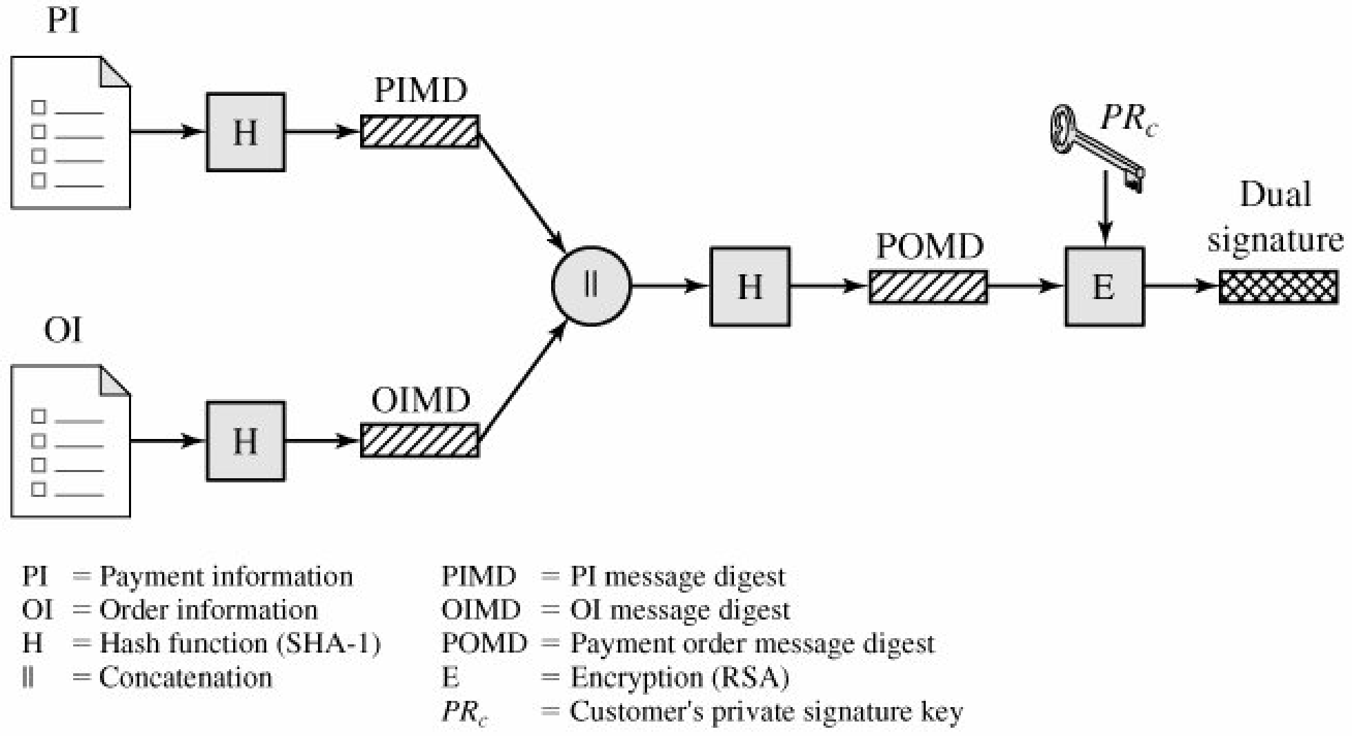
Signature verification
Merchant possess DS, OI, message digest of PI (PIMD) and public key of customer, can compare the following two quantities
H(PIMS||H[OI]) and D(PUc, DS)
If both are equal merchant has verified the signature
Bank possess DS, PI, message digest of OI (OIMD) and customer public key, can compute
H(H[OI]||OIMD) and D(PUc, DS)
Summary
In today’s lecture, we talked about SET (Secure Electronic Transaction). We have seen its functionality and how different entities are involved to make a transaction secure and successful.
The End

