CSC241: Object Oriented Programming
Lecture No 05
Lecture topics
• Reference variable
• this pointer
– Cascading function calls
• Dynamic memory allocation

C++ Reference variable
• C++ references allow you to create a second name for a memory location that you can
use to read or modify the original data stored in that location
• Syntax
– int& foo = ....;
– reference to an int
• When a reference is created, you must tell it which variable it will become an alias for
Cont.
– int x;
50
x
– int& y = x;

– y = 50;
– cout<<x;
– cout<<y;
••
Reference variable – functions
• Functions can take reference parameters
•
Implicitly and Explicitly Use this Pointer
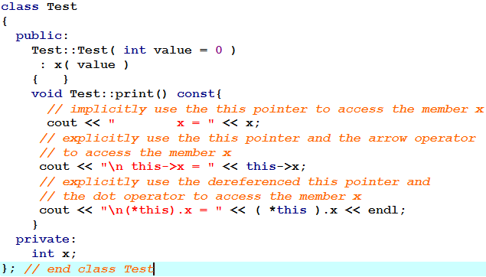

* , -> and dot operator with structure
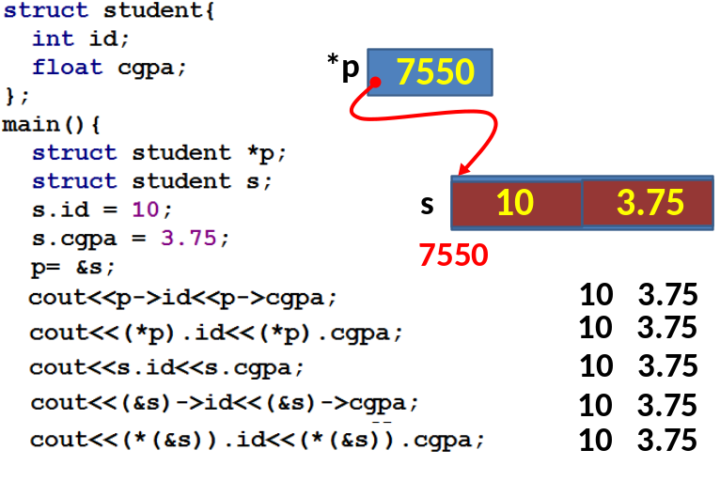
Cascading function calls using this pointer
• In cascaded member-function calls invoked multiple functions in the same statement
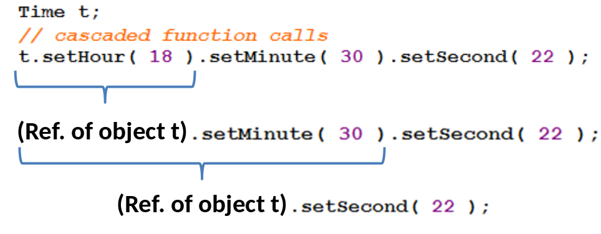

Example – Time class
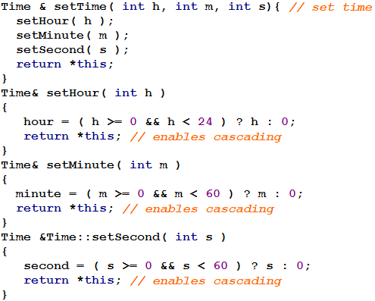
Cont.
• Why does the technique of returning *this as a reference work?
• The dot operator (.) associates from left to right
• so line 14 first evaluates t.setHour( 18 ) then returns a reference to object t
• The remaining expression is then interpreted as
– t.setMinute( 30 ).setSecond( 22 );
• t.setMinute( 30 ) call executes and returns a reference to the object t.
– t.setSecond( 22 );
Dynamic Memory Management
• C++ enables programmers to control the allocation and de-allocation of memory in a
program for any built-in or user-defined type
• Performed with operators new and delete
• E.g. in Employee class
– name char array
– It has some size e.g. 25
• Through dynamic memory we can allocate array space same as the number of character in
name
Cont.
• Dynamically allocating memory in this fashion causes an array to be created in the free
store (heap)
• Heap is a region of memory assigned to each program for storing objects created at
execution time
• Once the memory is allocated in the free store, pointer points to the first byte of that
allocated memory
• After used, memory can be return to heap by using delete operator
Dynamic memory – basic types
• C++ allows you to provide an initializer for a newly created fundamental-type variable
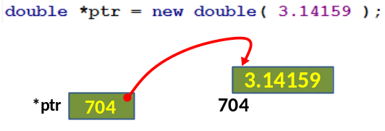

delete ptr;
Dynamic memory – array
a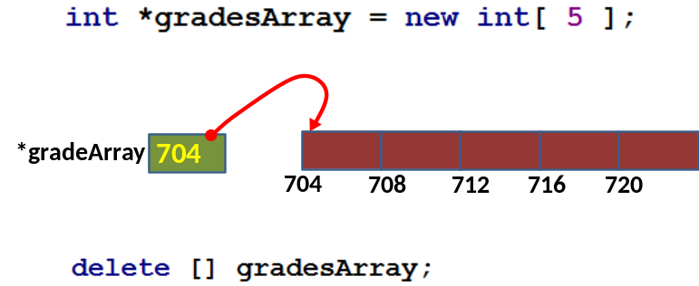
• new operator can be used to allocate arrays dynamically
Simple example
• Example 1:
– char pointer
– Allocate dynamic memory using new operator
–Write string and display it
– Delete the dynamic memory using delete operator
• Example 2:
– struct definition
– Allocate dynamic memory
– Write string and display structure contents
– Delete the dynamic memory
Dynamic memory – objects
• Consider the following declaration and statement:
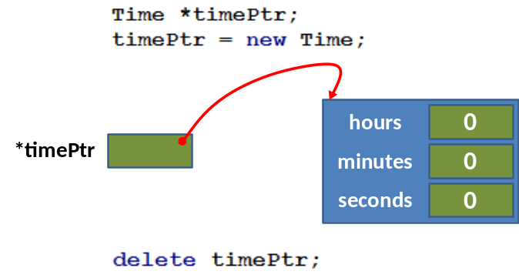
Composition – Objects as Members of Classes
• An AlarmClock object needs to know when it is supposed to sound its alarm
• So why not include a Time object as a member of the AlarmClock class
• It is refer as has-a relationship
• We will see how an object's constructor can pass arguments to member-object
constructors
Example program

static Data Members
• Each object of a class has its own copy of all the data members of the class
• In certain cases, only one copy of a variable should be shared by all objects of a class
• A static data member is used
• If a data item in a class is declared as static, only one such item is created for the entire
class, no matter how many objects are created
•
Cont.
• A member static variable is visible only within the class, but its lifetime is the entire
program
• They seems like global variables
• It continues to exist even if there are no objects of the class
• A static data item is useful when all objects of the same class must share a common item
of information
•
Uses of static data member
• Suppose an object needed to know how many other objects of its class were in the
program
• In a road-racing game, for example, a race car might want to know how many other cars
are still in the race
• In this case a static variable count could be included as a member of the class
• All the objects would have access to this variable
Example – Race class
Cont.
Static data member – access
• A public static data member can be access using any object of the class or class name
– [Object Name].[name of static variable]
• e1.count;
– [Class Name] :: [name of static variable]
• Employee ::count;
• A private static member can be access using a static member function
– [objectName].[static member function]
• e1.getCount();
– [Class name]::[static member function]
• Employee::getCount();
static member function
• A function should be static if it only access static member of class
• A call to a static function does not need an object as handler, it needs a class name
• A static function
– cannot access non static member function
– does not have a this pointer
Example – Employee class
Cont
• char *
– A pointer to a character
• const char *
– Pointer to a constant character
• char * const
– Constant pointer to a character
• const char * const
– Constant pointer to a constant character
const char * as return type
• getFirstName() and getLastName() are const function
• But return type of getFirstName() and getLastName() are const char *
•••
Return type char * is non constant pointer mean one can change the content
• const char * means content cannot be changed
Information hiding
• A class normally hides its implementation details from its clients
• For example,
– a library contains classes, compile form is given to users
– Users includes header file in cpp file contain main function and set library path
– Compile the file and use library
Abstract data type
• Consider built-in type int
• Most people associate it with an integer in mathematics
• Actually, int is an abstract representation of an integer
• ints are fixed in size (32-bits)
• if result is out of range
– “Overflow” error occurs
– "quietly" produce an incorrect result
• Mathematical integers do not have this problem
Cont.
• Built-in data types are only approximations or imperfect models of real-world concepts
• Types like int, double, char and others are all examples of abstract data types
• An abstract data types captures two concepts
– Data representation
– Operations that can be perform on that data
• For example
– int contain integers values
– Operations: add, subtract, multiply, division
ADT in C++
• In C++, the programmer uses classes to implement abstract data types and their services
• For example, to implement a array ADT
– subscript range checking
– an arbitrary range of subscripts instead of having to start with 0
– array assignment
– array comparison
– array input/output
Container classes – real world
• In real life, we use containers all the time
• For example
– pages in your book come inside a cover or binding
– you might store any number of items in containers in your garage
• Without container it is inconvenient to work with many objects
– Imagine trying to read a book that didn’t have any sort of binding
– Eat cereal that didn’t come in a box without using a bowl
•
Container classes – C++
• Container classes designed to hold collections of instance of other classes
• Arrays, stacks, queues, trees and linked lists are examples of container classes
••

