CSC241: Object Oriented Programming
Lecture No 04
Today’s Lecture
• Overloaded function
– Constructor
• const (constant)
– object
– member function
– data member
– object as function argument
• friend function
• this pointer
Objects as Function Arguments

main()
{
Distance dist1, dist3;
Distance dist2(11, 6.5);
dist1.getdist();
dist3.add_dist(dist1, dist2);
cout << “\ndist1 = “; dist1.showdist();
cout << “\ndist2 = “; dist2.showdist();
cout << “\ndist3 = “; dist3.showdist();
}
void Distance::add_dist(Distance d2, Distance d3) {
inches = d2.inches + d3.inches;
feet = 0;
if(inches >= 12.0) {
inches -= 12.0;
feet++;
}
feet += d2.feet + d3.feet;
}
class Distance { //Distance class
private:
int feet;
float inches;
public:
Distance() : feet(0), inches(0.0)
{ }
Distance(int ft, float in) : feet(ft), inches(in)
{ }
void getdist(){
cout << “\nEnter feet: “; cin >> feet;
cout << “Enter inches: “; cin >> inches;
}
void showdist(){
cout << feet << “:” << inches<<endl ;
}
void add_dist( Distance, Distance );
};

Overloaded Constructors
• It’s convenient to be able to give variables of type Distance a value when they are first
created
Distance dist2(11, 6.25);
• which defines an object, and initializes it to a value of 11 for feet and 6.25 for inches.
• Distance dist1, dist2; then No-argument constructor is called/invoked (the default
constructor)
• Since there are now two constructors with the same name, Distance(), we say the
constructor is overloaded
Member Functions Defined Outside the Class
• Such functions, needs to have a prototype/declaration within the class
• The function name, add_dist(), is preceded by the class name, Distance, and a new
symbol—the double colon (::). This symbol is called the scope resolution operator.
void Distance::add_dist(Distance d2, Distance d3)
••
It is a way of specifying what class something is associated with
• In this situation, Distance::add_dist() means “the add_dist() member function of the
Distance class”
Structures and Classes
• We used structures as a way to group data and classes as a way to group both data and
functions
• In fact, you can use structures in almost exactly the same way that you use classes
• The only formal difference between class and struct is that in a class the members are
private by default, while in a structure they are public by default.
Classes, Objects, and Memory
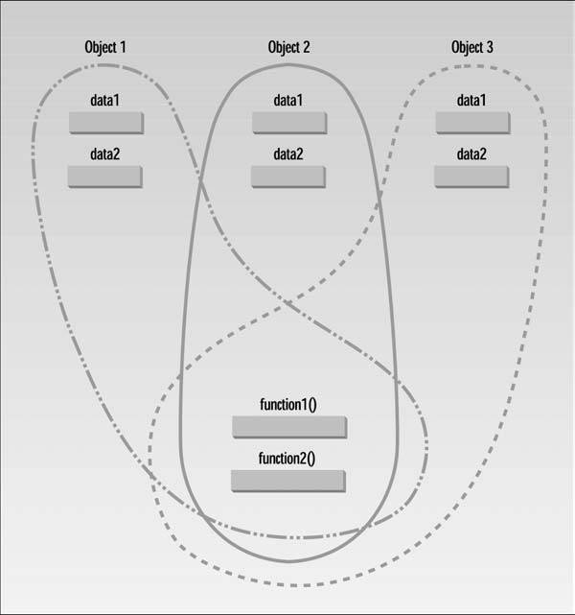
const (constant) object
• Some objects need to be modifiable and some do not
• Keyword const is used to specify that an object is not modifiable
• Any attempt to modify the object should result in a compilation error
••
declares a const object noon of class Time and initializes it to 12 noon
const (constant) member function
• Constant member function will not allow to modify private data member
•
class aClass
{
private:
int alpha;
public:
void nonFunc() //non-const member function
{ alpha = 99; } //OK
void conFunc() const //const member function
{ alpha = 99; } //ERROR: can’t modify a member
};
Example – Time class
• Data members
••• 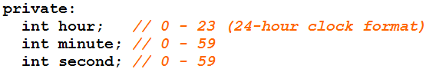
Member functions
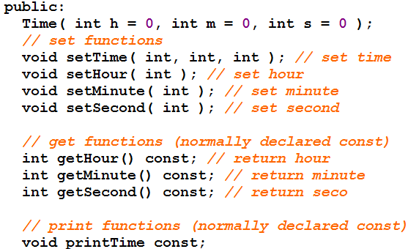

const Objects as Function Arguments
Distance Distance::add_dist(const Distance& d2) const
{
Distance temp;
inches = 0;
temp.inches = inches + d2.inches;
if(temp.inches >= 12.0) {
temp.inches -= 12.0;
temp.feet = 1;
}
temp.feet += feet + d2.feet;
return temp;
}
class Distance { //Distance class
private:
int feet;
float inches;
public:
Distance() : feet(0), inches(0.0)
{ }
Distance(int ft, float in) : feet(ft), inches(in)
{ }
void getdist(){
cout << “\nEnter feet: “; cin >> feet;
cout << “Enter inches: “; cin >> inches;
}
void showdist(){
cout << feet << “:” << inches<<endl ;
}
Distance add_dist(const Distance&) const;
};
Cont.
Initializing a const Data Member
• Constant data member must be initialized using member initializer list
private:
int count;
const int increment;
• const data member must be initialized as soon as the object is created
Example
Common errors while using const
• Following are compilation errors
– Defining as const a member function that modifies a data member of an object
– Defining as const a member function that calls a non-const member function of the class
on the same instance of the class
– Invoking a non-const member function on a const object
friend Functions
• A friend function of a class is defined outside that class's scope
• It has the right to access the non-public (and public) members of the class
• Prototypes for friend functions appear in the class definition but friends are not member
functions
• They are called just like a normal functions
Cont.
• Friend function can be declaration any where in class definition
• Place all friendship declarations first inside the class definition's body
Example – Count class
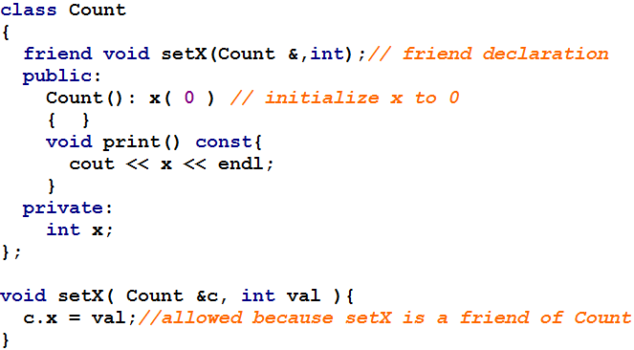
Using this pointer
• Object's member functions can manipulate the object's data
• How do member functions know which object's data members to manipulate?
• Every object has access to its own address through a pointer called this
• this pointer is passed (by the compiler) as an implicit argument to each of the object's
non-static member functions
Cont.
• An object's this pointer is not part of the object itself
• The size of the memory occupied by the this pointer is not reflected in the result of a sizeof
operation on the object
• Objects use this pointer implicitly or explicitly to reference their data members and
member functions
Type of this pointer
• The type of the this pointer depends on the type of the object
– non constant member function of class Employee, the this pointer has type Employee *
const
– constant member function of the class Employee, the this pointer has the data type
const Employee * const
Implicitly and Explicitly Use this Pointer
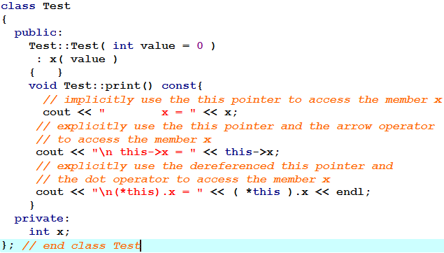
Cascading function calls using this pointer
• Multiple member functions are invoked in the same statement
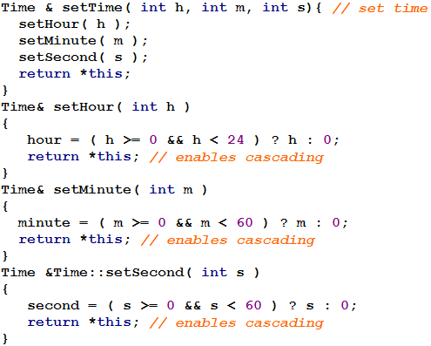
Cont.
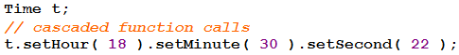
• Why does the technique of returning *this as a reference work?
• The dot operator (.) associates from left to right
• so line 14 first evaluates t.setHour( 18 ) then returns a reference to object t
• The remaining expression is then interpreted as
– t.setMinute( 30 ).setSecond( 22 );
• t.setMinute( 30 ) call executes and returns a reference to the object t.
– t.setSecond( 22 );
static Data Members
• Each object of a class has its own copy of all the data members of the class
• In certain cases, only one copy of a variable should be shared by all objects of a class
• A static data member is used
• If a data item in a class is declared as static, only one such item is created for the entire
class, no matter how many objects there are
•
Cont.
• A member static variable is visible only within the class, but its lifetime is the entire
program
• It continues to exist even if there are no objects of the class
• A static data item is useful when all objects of the same class must share a common item
of information
•
Uses of static data member
• Suppose an object needed to know how many other objects of its class were in the
program
• In a road-racing game, for example, a race car might want to know how many other cars
are still in the race
• In this case a static variable count could be included as a member of the class
• All the objects would have access to this variable
Example – Race class
Total car = 2, Car No. 10
Total car = 2, Car No. 11
Total car = 3, Car No. 12
main()
{
Race c1, c2; //create three objects
c1.setCarNo(10); c2.setCarNo(11);
c1.printData();
c2.printData();
Race c3; c3.setCarNo(12); c3.printData();
}
Total car = 3, Car No. 10
Total car = 3, Car No. 11
Total car = 3, Car No. 12
class Race
{
private:
static int count;
int carNo;
public:
Race()
{ count++; carNo=0; }
void setCarNo(int no)
{ carNo = no; }
void printData() {
cout<<“Total car = ”<< count;
cout<<“,Car No. = ”<<carNo<<endl;
}
};
int Race::count = 0;
main()
{
Race c1, c2, c3; //create three objects
c1.setCarNo(10); c2.setCarNo(11);
c3.setCarNo(12);
c1.printData();
c2.printData(); c3.printData();
}
Composition – Objects as Members of Classes
• An AlarmClock object needs to know when it is supposed to sound its alarm
• So why not include a Time object as a member of the AlarmClock class
• It is refer as has-a relationship
• We will see how an object's constructor can pass arguments to member-object
constructors
Example program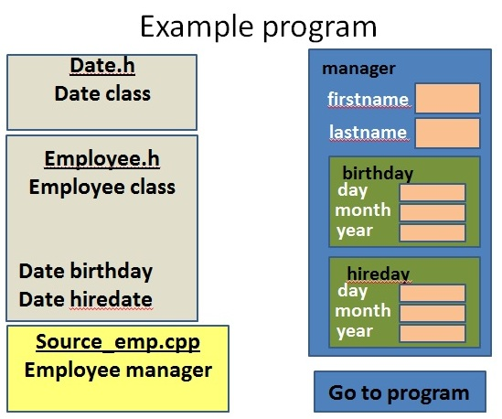
Dynamic Memory Management
• C++ enables programmers to control the allocation and deallocation of memory in a
program for any built-in or user-defined type
• Performed with operators new and delete

