CSC241: Object Oriented Programming
Lecture No 03
Today’s Lecture
• Constructor – example program
• Placing class in separate file
• Destructor – example program
• Constructor with arguments – example program
•
Example program – Distance class
• Data members
– Feet
– Inches
• Member functions
– void setdist(int ft, float in);
– void getdist();
– void initialize();
– void showdist();
Distance class – data member initialization
• Distance class shows two ways to initialize the data items in an object
– void initialize();
– void setdist(int ft, float in);
• Can an object be initialized whenever it is created, without requiring a separate call to a
member function?
• Automatic initialization is carried out using a special member function called a constructor.
• A constructor is a member function that is executed automatically whenever an object is
created.
•
Constructors
• C++ requires a construct call for each object it has created
• This ensure that object is initialized properly before it is used
• If there is no constructor, the compiler provides a default constructor that is, a constructor
with no parameters
• Name of constructor function is same as name of class
•
A counter example
• Data member
– Count
• Member function
– Constructor
– void inc_count()
– int get_count()
Automatic initialization
• An object of type Counter is first created, we want its count to be initialized to 0
• Options are
– set_count() function (call it with an argument of 0)
– zero_count() function, to set count to 0.
• Such functions would need to be executed every time we created a Counter object

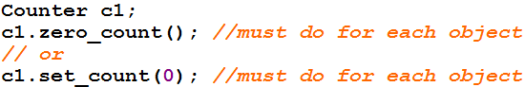
Cont.
• A programmer may forget to initialize the object after creating it
• It’s more reliable and convenient to cause each object to initialize implicitly when it is
created
• In the Counter class, the constructor Counter() is called automatically whenever a new
object of type Counter is created
• Counter c1, c2;
creates two objects. Constructor is called with each object separately
Constructor Name
• First, constructor name must be same as the name of class
– This is one way the compiler knows they are constructors
• Second, no return type is used for constructors
– Why not? Since the constructor is called automatically by the system, there’s no program
for it to return anything to; a return value wouldn’t make sense
– This is the second way the compiler knows they are constructors
Initializer List
• One of the most common tasks a constructor carries out is initializing data members
• In the Counter class the constructor must initialize the count member to 0
• The initialization takes place following the member function declarator but before the
function body.
• Initialization in constructor’s function body
Counter()
{ count = 0; }
this is not the preferred approach
Cont.
• It’s preceded by a colon. The value is placed in parentheses following the member data.
Counter() : count(0)
{ }
• If multiple members must be initialized, they’re separated by commas.
– someClass() : m1(7), m2(33), m2(4) ←initializer list { }
Placing a Class in a Separate File
• Header file (.h)
– Contain definition of class
– Not an executable file
– Included in .cpp file
• main () file (.cpp)
– Include .h file containing class definition
– Executable file
Destructors
• Destructor is a function called implicitly when an object is destroyed
• The name of the destructor for a class is the tilde character (~) followed by the class name
• No arguments and no return type for a destructor
• The most common use of destructors is to deallocate memory that was allocated for the
object by the constructor
•••
Validating Data with set Functions
• A set function should validate the value before assigning to private data member
• Set function can return a value or may display a message if invalid data is assign to object
•
Constructor with default arguments
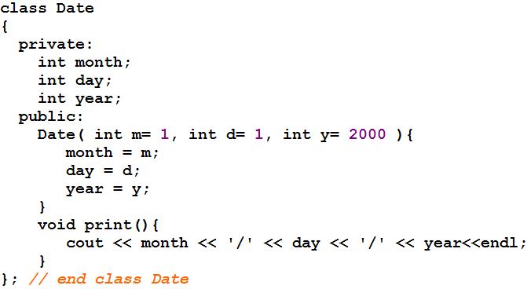
Objects as Function Arguments
void Distance::add_dist(Distance d2, Distance d3) {
inches = d2.inches + d3.inches;
feet = 0;
if(inches >= 12.0) {
inches -= 12.0;
feet++;
}
feet += d2.feet + d3.feet;
}
main()
{
Distance dist1, dist3;
Distance dist2(11, 6.5);
dist1.getdist();
dist3.add_dist(dist1, dist2);
cout << “\ndist1 = “; dist1.showdist();
cout << “\ndist2 = “; dist2.showdist();
cout << “\ndist3 = “; dist3.showdist();
}
class Distance { //Distance class
private:
int feet;
float inches;
public:
Distance() : feet(0), inches(0.0)
{ }
Distance(int ft, float in) : feet(ft), inches(in)
{ }
void getdist(){
cout << “\nEnter feet: “; cin >> feet;
cout << “Enter inches: “; cin >> inches;
}
void showdist(){
cout << feet << “:” << inches<<endl ;
}
void add_dist( Distance, Distance );
};

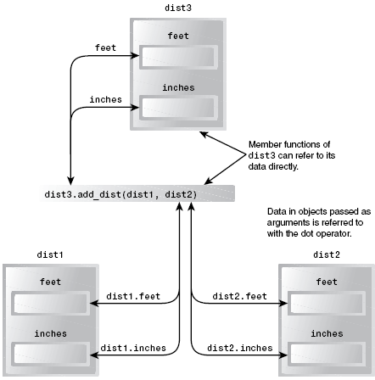
Cont.
Overloaded Constructors
• It’s convenient to be able to give variables of type Distance a value when they are first
created
Distance dist2(11, 6.25);
• which defines an object, and initializes it to a value of 11 for feet and 6.25 for inches.
• Distance dist1, dist2; then No-argument constructor is called/invoked (the default
constructor)
• Since there are now two constructors with the same name, Distance(), we say the
constructor is overloaded
Member Functions Defined Outside the Class
• Such functions, needs to have a prototype/declaration within the class
• The function name, add_dist(), is preceded by the class name, Distance, and a new
symbol—the double colon (::). This symbol is called the scope resolution operator.

void Distance::add_dist(Distance d2, Distance d3)

It is a way of specifying what class something is associated with
• In this situation, Distance::add_dist() means “the add_dist() member function of the
Distance class”
Structures and Classes
• We used structures as a way to group data and classes as a way to group both data and
functions
• In fact, you can use structures in almost exactly the same way that you use classes
• The only formal difference between class and struct is that in a class the members are
private by default, while in a structure they are public by default.
Classes, Objects, and Memory

