CSC241: Object Oriented Programming
Lecture No 02
Lecture topics
• Simple C++ program using cin and cout
• Member function with parameters
• Set functions and get functions
• Constructor
Member function with parameter
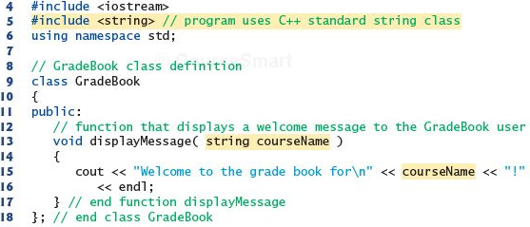

A book class
Class book {
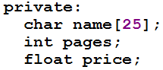
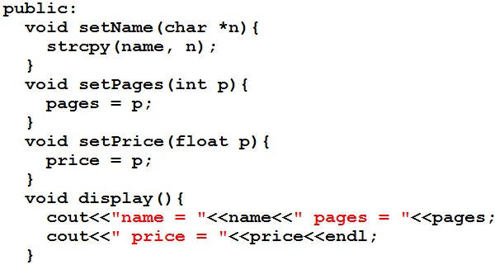
}
Class data
• The class Book contain three data items
– char name[15];
– int pages;
– float price;
• There can be any number of data members in a class just as in structure
• Data member are after the keyword private, so they can be accessed from within the class,
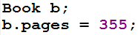
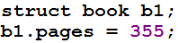
but not outside

Member function
• These functions are included in a class
• There are four member functions in class Book
– setName(char *n)
– setPages(int p)
– setPrice(float p)
– display()
• These functions are followed by a keyword public, so they can be accessed outside the
class
Class data and member function
• Access specifier label public and private
• Function are public and data is private
• Data is hidden so that it can be safe from accidental manipulation
• Functions operates on data are public so they can be accessed from outside the class
Defining Objects

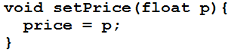
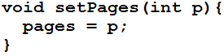
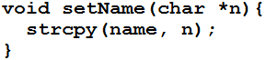
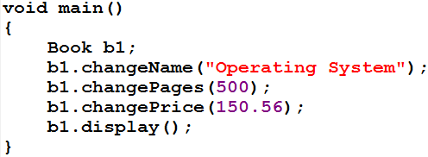

B1
Name Operating System
Pages 500
Price 150.56

Cont.
• Defining an object is similar to defining a variable of any data type: Space is set aside for it
in memory e.g. int x;
• Defining objects in this way (book b1;) means creating them
• An object is an instance (that is, a specific example) of a class. Objects are sometimes
called instance variables.
•
Calling Member Functions
• The next four statements in main() call the member function
– b1.setName("Operating System");
– b1.setPages(500);
– b1.setPrice(150.56);
– b1.display();
• don’t look like normal function calls
• This syntax is used to call a member function that is associated with a specific object
• It doesn’t make sense to say
– changeName("Operating System");
because a member function is always called to act on a specific object, not on the class in
general
Cont.
• To use a member function, the dot operator (the period) connects the object name and the
member function.
• The syntax is similar to the way we refer to structure members, but the parentheses signal
that we’re executing a member function rather than referring to a data item.
• The dot operator is also called the class member access operator.
Data members, set and get functions
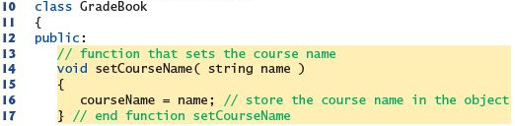

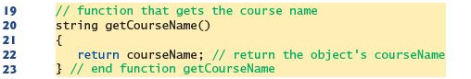

Example program – Distance class
• Data members
– Feet
– Inches
• Member functions
– void setdist(int ft, float in);
– void getdist();
– void initialize();
– void showdist();
Distance class – data member initialization
• Distance class shows two ways to initialize the data items in an object
– void initialize();
– void setdist(int ft, float in);
• Can an object be initialized whenever it is created, without requiring a separate call to a
member function?
• Automatic initialization is carried out using a special member function called a constructor.
• A constructor is a member function that is executed automatically whenever an object is
created.
•
Constructors
• C++ requires a construct call for each object it has created
• This ensure that object is initialized properly before it is used
• If there is no constructor, the compiler provides a default constructor that is, a constructor
with no parameters
• Name of constructor function is same as name of class
•
A counter example
• Data member
– Count
• Member function
– Constructor
– void inc_count()
– int get_count()
Automatic initialization
• An object of type Counter is first created, we want its count to be initialized to 0
• Options are
– set_count() function (call it with an argument of 0)
– zero_count() function, to set count to 0.
• Such functions would need to be executed every time we created a Counter object

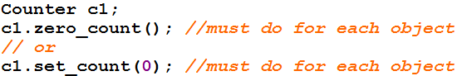

Cont.
• A programmer may forget to initialize the object after creating it
• It’s more reliable and convenient to cause each object to initialize implicitly when it is
created
• In the Counter class, the constructor Counter() is called automatically whenever a new
object of type Counter is created
• Counter c1, c2;
creates two objects. Constructor is called with each object separately
Constructor Name
• First, constructor name must be same as the name of class
– This is one way the compiler knows they are constructors
• Second, no return type is used for constructors
– Why not? Since the constructor is called automatically by the system, there’s no program
for it to return anything to; a return value wouldn’t make sense
– This is the second way the compiler knows they are constructors
Initializer List
• One of the most common tasks a constructor carries out is initializing data members
• In the Counter class the constructor must initialize the count member to 0
• The initialization takes place following the member function declarator but before the
function body.
• Initialization in constructor’s function body
Counter()
{ count = 0; }
this is not the preferred approach
Cont.
• It’s preceded by a colon. The value is placed in parentheses following the member data.
Counter() : count(0)
{ }
• If multiple members must be initialized, they’re separated by commas.
– someClass() : m1(7), m2(33), m2(4) ←initializer list { }
Placing a Class in a Separate File
• Header file (.h)
– Contain definition of class
– Not an executable file
– Included in .cpp file
• main () file (.cpp)
– Include .h file containing class definition
– Executable file
Destructors
• Destructor is a function called automatically when an object is destroyed
• The most common use of destructors is to deallocate memory that was allocated for the
object by the constructor
•••
Validating Data with set Functions
• A set function should validate the value before assigning to private data member
• Set function can return a value or may display a message if invalid data is assign to object

