CSC241: Object Oriented Programming
Lecture No 01
Aim of the course
• This course provides
– motivation of object oriented programming language
– in depth knowledge of the various concepts of object oriented programming and its
implementation in C++
Course book
• Text book
– C++ How to program by Deitel and Deitel
• Reference books
–Waite Group’s Object oriented programming in C++, Robert Lafore

Marks distribution
• Assignments: 10%
• Quizzes: 15%
• Sessional exam 01: 10%
• Sessional exam 02: 15%
• Terminal Exam: 50%
Introduction
• Five concepts in object oriented programming are:
– Object
– Classes
– Encapsulation
– Inheritance
– Polymorphism
Simple analogy
• You are driving a car
• You can pressing accelerator pedal
• Someone has design it and built it
• Engineering drawings 􀃆 car
• Drawings also includes design for accelerator pedal to make car go faster
• We can say, pedal “hides” complex mechanism that make the car go faster
•
Cont.
• Brake pedal “hides” the mechanism that slow the car
• Steering wheel “hides” the mechanism that turn the car and so on
• Simple “interfaces” like accelerator and brake pedal, steering wheel, transmission shift and
etc. allow driver to interact car’s complex internal mechanisms

Points to be noted
• You cannot drive the engineering design of a car
• Before you can drive a car, it must be built according to engineering design
• The car will not accelerator on its own, a driver must press the accelerator pedal
Object oriented programming concepts
• Function hides from user the complex task it performs
• Same as accelerator pedal hides complex mechanism of making the car go faster
• C++ makes a program unit called class that houses various functions
• Same as car engineering design houses the mechanism of accelerator pedal
Cont.
• In C++, a class can have various functions that are design to perform a class tasks
• For example, a class representing bank account might contain functions
– Deposit money
– Withdraw money
– Current balance
Car example
Real world
• Engineering drawing cannot be drive
• A car is build from that drawing
• Pressing accelerator pedal sends a message to car to perform task (go faster)
••
Cont.
• Car analogy is used to introduce
– Class
– Objects
– Member functions
• In addition to capabilities of car, it has many attributes
• Color, No. of doors, amount of gas in tank, total miles driven and etc
• Attributes are part of car engineering drawing
Cont.
• These attribute are always associated with the car
• Every car maintains its own attribute
• Example 1: each car knows how much gas in its own tank but do not know how much is in
the tanks of other cars
• Example 2: a bank account object has a balance attribute. Each bank account object knows
the balance in its account not the others
Object
• Look around right now and you'll find many examples of real-world objects:
• your dog, your desk, your television set, your bicycle.
• Real-world objects share two characteristics: They all have
–State and
–Behavior

Object example
• A dog x has state (name, color, breed, hungry) and behavior (barking, fetching, wagging
tail).
•
• Your bicycle also have state (current gear, current pedal cadence, current speed) and
behavior (changing gear, changing pedal cadence, applying brakes).
•
Cont.
• For each object that you see, ask yourself two questions:
– "What possible states can this object be in?" and
– "What possible behavior can this object perform?"
•
Real world objects
• Real-world objects vary in complexity
– your desktop lamp may have only two possible states (on and off) and two possible
behaviors (turn on, turn off),
– but your desktop radio might have additional states (on, off, current volume, current
station) and behavior (turn on, turn off, increase volume, decrease volume, seek, scan,
and tune).
Cont..
• You may also notice that some objects, in turn, will also contain other objects.
• These real-world observations all translate into the world of object-oriented programming
•
Class
• In the real world, you'll often find many individual objects all of the same kind
• There may be thousands of other bicycles in existence, all of the same make and model.
• Each bicycle was built from the same engineering design and contains the same
components.
• In object-oriented terms, we say that your bicycle is an instance of the class of objects
known as bicycles.
Software Object
• Software objects are conceptually similar to real-world objects: they too consist of state and
related behavior. An object stores its state in
–fields (variables in some programming languages)
and exposes its behavior through
–methods (functions in some programming languages). A Software Object
Cont.
• Methods operate on an object's internal state and serve as the primary mechanism for
object-to-object communication.

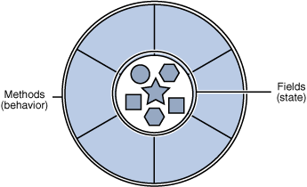
•
Class vs. Object
• Class is a blue print of an object, which is non-live entity.
• Object is instance of class, which is a live entity.
• Example:
– Employee is a class
– Fruit is a class
– I am an object
– apple is an object
Points to remember
• A class is not a living entity, it is just a engineering design that how an object of this class
look like
• Object are living entities
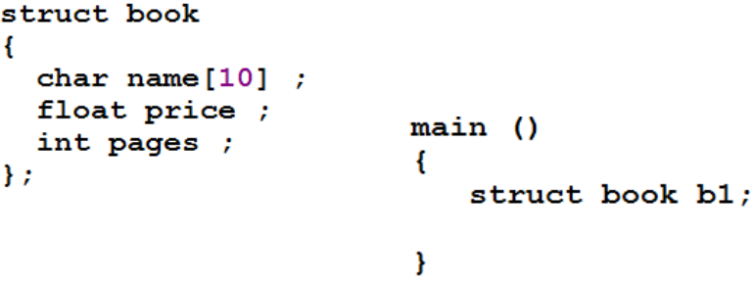

Defining a class with member function

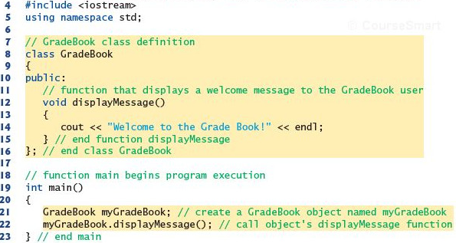
Cont.
• Class definition
• Access specifier – Public
• Class’s body is enclosed in a pair of { }
• Class definition ends at semi colon
• Member function
• Class object
• Dot operator

