Static Class Data
Having said that each object contains its own separate data, we must now amend that slightly.
If a data item in a class is declared as static, only one such item is created for the entire
class, no matter how many objects there are. A static data item is useful when all objects of the
same class must share a common item of information. A member variable defined as static
has characteristics similar to a normal static variable: It is visible only within the class, but its
lifetime is the entire program. It continues to exist even if there are no objects of the class.
(See Chapter 5 for a discussion of static variables.) However, while a normal static variable is
used to retain information between calls to a function, static class member data is used to share
information among the objects of a class.
Uses of Static Class Data
Why would you want to use static member data? As an example, suppose an object needed
to know how many other objects of its class were in the program. In a road-racing game, for
example, a race car might want to know how many other cars are still in the race. In this case a
static variable count could be included as a member of the class. All the objects would have
access to this variable. It would be the same variable for all of them; they would all see the
same count.
An Example of Static Class Data
Here’s an example, STATDATA, that demonstrates a simple static data member:
// statdata.cpp
// static class data
#include <iostream>
using namespace std;
////////////////////////////////////////////////////////////////
class foo
{
private:
static int count; //only one data item for all objects
//note: “declaration” only!
public:
foo() //increments count when object created
{ count++; }
int getcount() //returns count
{ return count; }
};
//--------------------------------------------------------------
int foo::count = 0; //*definition* of count
////////////////////////////////////////////////////////////////
int main()
{
foo f1, f2, f3; //create three objects
cout << “count is “ << f1.getcount() << endl; //each object
cout << “count is “ << f2.getcount() << endl; //sees the
cout << “count is “ << f3.getcount() << endl; //same value
return 0;
}
The class foo in this example has one data item, count, which is type static int. The
constructor for this class causes count to be incremented. In main() we define three objects of
class foo. Since the constructor is called three times, count is incremented three times. Another
member function, getcount(), returns the value in count. We call this function from all three
objects, and—as we expected—each prints the same value. Here’s the output:
count is 3 ← static data
count is 3
count is 3
If we had used an ordinary automatic variable—as opposed to a static variable—for count,
each constructor would have incremented its own private copy of count once, and the output
would have been
count is 1 ← automatic data
count is 1
count is 1
Static class variables are not used as often as ordinary non-static variables, but they are important
in many situations. Figure below shows how static variables compare with automatic variables.
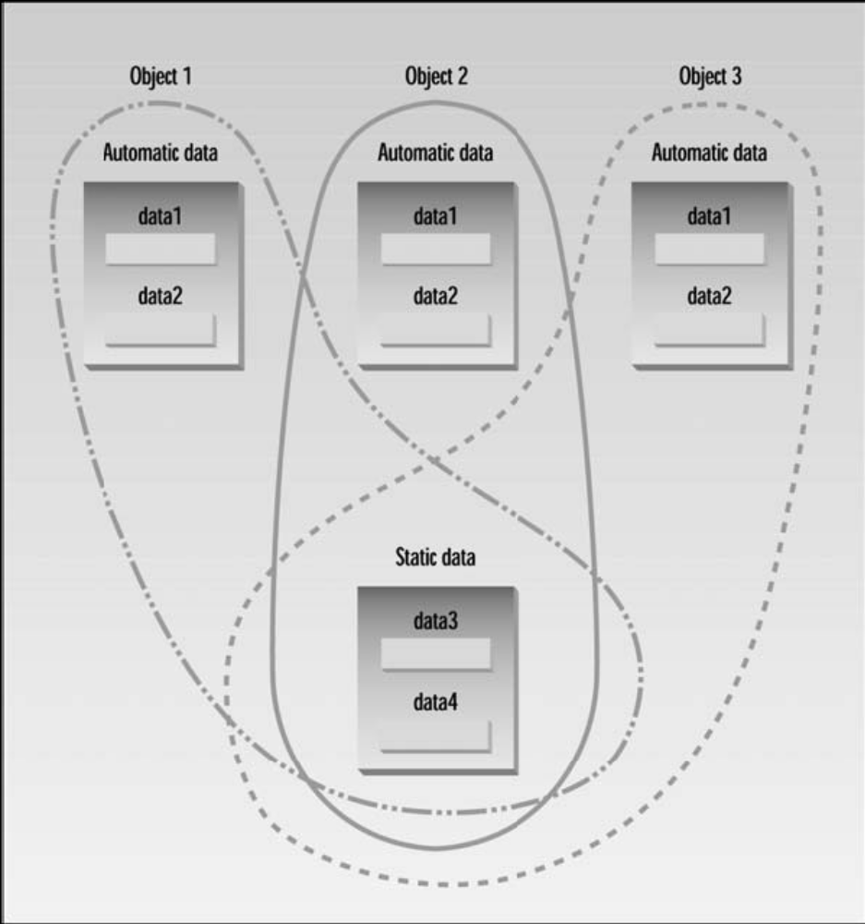

Separate Declaration and Definition
Static member data requires an unusual format. Ordinary variables are usually declared (the
compiler is told about their name and type) and defined (the compiler sets aside memory to
hold the variable) in the same statement. Static member data, on the other hand, requires two
separate statements. The variable’s declaration appears in the class definition, but the variable
is actually defined outside the class, in much the same way as a global variable.
Why is this two-part approach used? If static member data were defined inside the class (as it
actually was in early versions of C++), it would violate the idea that a class definition is only a
blueprint and does not set aside any memory. Putting the definition of static member data outside
the class also serves to emphasize that the memory space for such data is allocated only once,
before the program starts to execute, and that one static member variable is accessed by an
entire class; each object does not have its own version of the variable, as it would with
ordinary member data. In this way a static member variable is more like a global variable.
It’s easy to handle static data incorrectly, and the compiler is not helpful about such errors. If
you include the declaration of a static variable but forget its definition, there will be no warning
from the compiler. Everything looks fine until you get to the linker, which will tell you that
you’re trying to reference an undeclared global variable. This happens even if you include the
definition but forget the class name (the foo:: in the STATDATA example).

