Stream Classes
A stream is a general name given to a flow of data. In C++ a stream is represented by an object
of a particular class. So far we’ve used the cin and cout stream objects. Different streams are
used to represent different kinds of data flow. For example, the ifstream class represents data
flow from input disk files.
Advantages of Streams
C programmers may wonder what advantages there are to using the stream classes for I/O,
instead of traditional C functions such as printf() and scanf(), and—for files—fprintf(),
fscanf(), and so on.
One reason is simplicity. If you’ve ever used a %d formatting character when you should have
used a %f in printf(), you’ll appreciate this. There are no such formatting characters in
streams, since each object already knows how to display itself. This removes a major source of
errors.
Another reason is that you can overload existing operators and functions, such as the insertion
(<<) and extraction (>>) operators, to work with classes that you create. This makes your own
classes work in the same way as the built-in types, which again makes programming easier and
more error free (not to mention more aesthetically satisfying).
You may wonder whether stream I/O is important if you plan to program in an environment
with a graphical user interface such as Windows, where direct text output to the screen is not
used. Do you still need to know about C++ streams? Yes, because they are the best way to
write data to files, and also to format data in memory for later use in text input/output windows
and other GUI elements.
I/O stream classes
- It represent input and output stream
    - In input stream, the bytes flow from a device (e.g., a keyboard) to main memory
    - In output stream, bytes flow from main memory to a device (e.g., a display screen, a printer)
- We have already use stream class
  - Extraction operator >> is a member of istream class
  - Insertion operator << is a member of ostream class
  - istream and ostream are derived from ios

- cout object:
  - It representing the standard output stream which is usually monitor
  - It is a predefined object of the ostream_withassign class, which is derived from the ostream class
- cin object:
  - Represent standard input stream which is usually key board
  - It is a predefined object of istream_withassign class, which is derived from istream
Header files
- IOSTREAM
    - classes used for input and output to the video display and keyboard are declared in header file IOSTREAM
- FSTREAM
    - classes used specifically for disk file I/O are declared in the file
iostream class
- iostream class is derived from both istream and ostream by multiple inheritance
- Classes derived from it can be used with e.g. disk files, that may be opened for both input and output at the same time
ios class
- It is base class of all the stream classes
- It contains the majority of the features to operate C++ streams
- Three most important features are
  - Formatting flags,
  - Error-status flags,
  - File operation mode
Formatting Flags
- It is a set of flag in ios class
- Flags act as on/off switches that specify various aspects of input and output format and operation
- All the flags can be set using the setf() and unsetf() ios member functions
- All flag are the member of ios class so they can be access using scope resolution operator
  - ios::skipws
- Example
float x = 18.0;
cout<< x << endl; cout.setf(ios::showpoint);
cout<< x << endl; cout.setf(ios::scientific);
cout<< x << endl;
ios manipulators / functions
- Manipulators are formatting instructions inserted directly into a stream
  - endl
  - setw(int)
- Functions can use to set the formatting flags and perform other tasks
  - width(w);
The istream Class
The istream class, which is derived from ios, performs input-specific activities, or extraction.
It’s easy to confuse extraction and the related output activity, insertion. Figure 12.2 emphasizes
the difference.

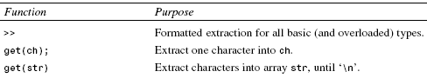

The ostream Class
The ostream class handles output or insertion activities. Table 12.7 shows the most commonly
used member functions of this class. The last four functions in this table deal specifically with
disk files.
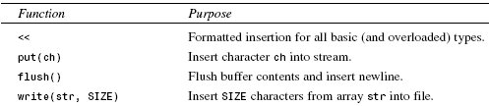
Stream Errors
So far in this book we’ve mostly used a rather straightforward approach to input and output,
using statements of the form
cout << “Good morning”;
and
cin >> var;
However, as you may have discovered, this approach assumes that nothing will go wrong during
the I/O process. This isn’t always the case, especially with input. What happens if a user
enters the string “nine” instead of the integer 9, or pushes the Enter key without entering anything?
Or what happens if there’s a hardware failure? In this section we’ll explore such problems.
Many of the techniques we’ll see here are applicable to file I/O as well.
Error-Status Bits
The stream error-status flags constitute an ios enum member that reports errors that occurred in
an input or output operation. They’re summarized in Table 12.8. Figure 12.3 shows how these
flags look. Various ios functions can be used to read (and even set) these error flags,
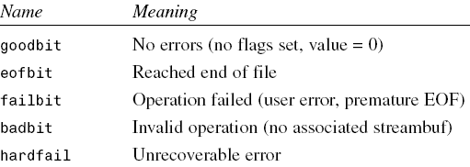
Disk File I/O with Streams
Most programs need to save data to disk files and read it back in. Working with disk files
requires another set of classes: ifstream for input, fstream for both input and output, and
ofstream for output. Objects of these classes can be associated with disk files, and we can use
their member functions to read and write to the files.
Referring back to Figure 12.1, you can see that ifstream is derived from istream, fstream is
derived from iostream, and ofstream is derived from ostream. These ancestor classes are in
turn derived from ios. Thus the file-oriented classes derive many of their member functions
from more general classes. The file-oriented classes are also derived, by multiple inheritance,
from the fstreambase class. This class contains an object of class filebuf, which is a fileoriented
buffer, and its associated member functions, derived from the more general streambuf
class. You don’t usually need to worry about these buffer classes.
The ifstream, ofstream, and fstream classes are declared in the FSTREAM file.
C programmers will note that the approach to disk I/O used in C++ is quite different from that
in C. The old C functions, such as fread() and fwrite(), will still work in C++, but they are
not so well suited to the object-oriented environment. The new C++ approach is considerably
cleaner and easier to implement. (Incidentally, be careful about mixing the old C functions
with C++ streams. They don’t always work together gracefully, although there are ways to
make them cooperate.)
Formatted File I/O
In formatted I/O, numbers are stored on disk as a series of characters. Thus 6.02, rather than
being stored as a 4-byte type float or an 8-byte type double, is stored as the characters ‘6’,
‘.’, ‘0’, and ‘2’. This can be inefficient for numbers with many digits, but it’s appropriate
in many situations and easy to implement. Characters and strings are stored more or less
normally.
Writing Data
The following program writes a character, an integer, a type double, and two string objects to
a disk file. There is no output to the screen. Here’s the listing for FORMATO:
// formato.cpp
// writes formatted output to a file, using <<
#include <fstream> //for file I/O
#include <iostream>
#include <string>
using namespace std;
int main()
{
char ch = ‘x’;
int j = 77;
double d = 6.02;
string str1 = “Kafka”; //strings without
string str2 = “Proust”; // embedded spaces
ofstream outfile(“fdata.txt”); //create ofstream object
outfile << ch //insert (write) data
<< j
<< ‘ ‘ //needs space between numbers
<< d
<< str1
<< ‘ ‘ //needs spaces between strings
<< str2;
cout << “File written\n”;
return 0;
}
Here we define an object called outfile to be a member of the ofstream class. At the same
time, we initialize it to the file FDATA.TXT. This initialization sets aside various resources for the
file, and accesses or opens the file of that name on the disk. If the file doesn’t exist, it is created.
If it does exist, it is truncated and the new data replaces the old. The outfile object acts
much as cout did in previous programs, so we can use the insertion operator (<<) to output
variables of any basic type to the file. This works because the insertion operator is appropriately
overloaded in ostream, from which ofstream is derived.
When the program terminates, the outfile object goes out of scope. This calls its destructor,
which closes the file, so we don’t need to close the file explicitly.
There are several potential formatting glitches. First, you must separate numbers (such as 77
and 6.02) with nonnumeric characters. Since numbers are stored as a sequence of characters,
rather than as a fixed-length field, this is the only way the extraction operator will know, when
the data is read back from the file, where one number stops and the next one begins. Second,
strings must be separated with whitespace for the same reason. This implies that strings cannot
contain imbedded blanks. In this example we use the space character (‘ ‘) for both kinds of
delimiters. Characters need no delimiters, since they have a fixed length.
You can verify that FORMATO has indeed written the data by examining the FDATA.TXT file with
the Windows WORDPAD accessory or the DOS command TYPE.
Reading Data
We can read the file generated by FORMATO by using an ifstream object, initialized to the
name of the file. The file is automatically opened when the object is created. We can then read
from it using the extraction (>>) operator.
Here’s the listing for the FORMATI program, which reads the data back in from the FDATA.TXT
file:
// formati.cpp
// reads formatted output from a file, using >>
#include <fstream> //for file I/O
#include <iostream>
#include <string>
using namespace std;
int main()
{
char ch;
int j;
double d;
string str1;
string str2;
ifstream infile(“fdata.txt”); //create ifstream object
//extract (read) data from it
infile >> ch >> j >> d >> str1 >> str2;
cout << ch << endl //display the data
<< j << endl
<< d << endl
<< str1 << endl
<< str2 << endl;
return 0;
}
Here the ifstream object, which we name infile, acts much the way cin did in previous programs.
Provided that we have formatted the data correctly when inserting it into the file, there’s
no trouble extracting it, storing it in the appropriate variables, and displaying its contents. The
program’s output looks like this:
x
77
6.02
Kafka
Proust
Of course the numbers are converted back to their binary representations for storage in the program.
That is, the 77 is stored in the variable j as a type int, not as two characters, and the
6.02 is stored as a double.
Strings with Embedded Blanks
The technique of our last examples won’t work with char* strings containing embedded
blanks. To handle such strings, you need to write a specific delimiter character after each
string, and use the getline()function, rather than the extraction operator, to read them in. Our
next program, OLINE, outputs some strings with blanks embedded in them.
// oline.cpp
// file output with strings
#include <fstream> //for file I/O
using namespace std;
int main()
{
ofstream outfile(“TEST.TXT”); //create file for output
//send text to file
outfile << “I fear thee, ancient Mariner!\n”;
outfile << “I fear thy skinny hand\n”;
outfile << “And thou art long, and lank, and brown,\n”;
outfile << “As is the ribbed sea sand.\n”;
return 0;
}
When you run the program, the lines of text (from Samuel Taylor Coleridge’s The Rime of the
Ancient Mariner) are written to a file. Each one is specifically terminated with a newline (‘\n’)
character. Note that these are char* strings, not objects of the string class. Many stream operations
work more easily with char* strings.
To extract the strings from the file, we create an ifstream and read from it one line at a time
using the getline() function, which is a member of istream. This function reads characters,
including whitespace, until it encounters the ‘\n’ character, and places the resulting string in
the buffer supplied as an argument. The maximum size of the buffer is given as the second
argument. The contents of the buffer are displayed after each line.
// iline.cpp
// file input with strings
#include <fstream> //for file functions
#include <iostream>
using namespace std;
int main()
{
const int MAX = 80; //size of buffer
char buffer[MAX]; //character buffer
ifstream infile(“TEST.TXT”); //create file for input
while( !infile.eof() ) //until end-of-file
{
infile.getline(buffer, MAX); //read a line of text
cout << buffer << endl; //display it
}
return 0;
}
The output of ILINE to the screen is the same as the data written to the TEST.TXT file by OLINE:
the four-line Coleridge stanza. The program has no way of knowing in advance how many
strings are in the file, so it continues to read one string at a time until it encounters an end-offile.
Incidentally, don’t use this program to read random text files. It requires all the text lines
to terminate with the ‘\n’ character, and if you encounter a file in which this is not the case,
the program will hang.
Detecting End-of-File
As we have seen, objects derived from ios contain error-status flags that can be checked to
determine the results of operations. When we read a file little by little, as we do here, we will
eventually encounter an end-of-file (EOF) condition. The EOF is a signal sent to the program
from the operating system when there is no more data to read. In ILINE we could have checked
for this in the line
while( !infile.eof() ) // until eof encountered
However, checking specifically for an eofbit means that we won’t detect the other error flags,
such as the failbit and badbit, which may also occur, although more rarely. To do this, we
can change our loop condition:
while( infile.good() ) // until any error encountered
You can also test the stream directly. Any stream object, such as infile, has a value that can
be tested for the usual error conditions, including EOF. If any such condition is true, the object
returns a zero value. If everything is going well, the object returns a nonzero value. This value
is actually a pointer, but the “address” returned has no significance except to be tested for a
zero or nonzero value. Thus we can rewrite our while loop again:
while( infile ) // until any error encountered
This is certainly simple, but it may not be quite so clear to the uninitiated what it does.
Character I/O
The put() and get() functions, which are members of ostream and istream, respectively, can
be used to output and input single characters. Here’s a program, OCHAR, that outputs a string,
one character at a time:
// ochar.cpp
// file output with characters
#include <fstream> //for file functions
#include <iostream>
#include <string>
using namespace std;
int main()
{
string str = “Time is a great teacher, but unfortunately “
“it kills all its pupils. Berlioz”;
ofstream outfile(“TEST.TXT”); //create file for output
for(int j=0; j<str.size(); j++) //for each character,
outfile.put( str[j] ); //write it to file
cout << “File written\n”;
return 0;
}
In this program an ofstream object is created as it was in OLINE. The length of the string
object str is found using the size() member function, and the characters are output using
put() in a for loop. The aphorism by Hector Berlioz (a 19th-century composer of operas and
program music) is written to the file TEST.TXT. We can read this file back in and display it using
the ICHAR program.
// ichar.cpp
// file input with characters
#include <fstream> //for file functions
#include <iostream>
using namespace std;
int main()
{
char ch; //character to read
ifstream infile(“TEST.TXT”); //create file for input
while( infile ) //read until EOF or error
{
infile.get(ch); //read character
cout << ch; //display it
}
cout << endl;
return 0;
}
This program uses the get() function and continues reading until the EOF is reached (or an
error occurs). Each character read from the file is displayed using cout, so the entire aphorism
appears on the screen.
Another approach to reading characters from a file is the rdbuf() function, a member of the
ios class. This function returns a pointer to the streambuf (or filebuf) object associated with
the stream object. This object contains a buffer that holds the characters read from the stream,
so you can use the pointer to it as a data object in its own right. Here’s the listing for ICHAR2:
// ichar2.cpp
// file input with characters
#include <fstream> //for file functions
#include <iostream>
using namespace std;
int main()
{
ifstream infile(“TEST.TXT”); //create file for input
cout << infile.rdbuf(); //send its buffer to cout
cout << endl;
return 0;
}
This program has the same effect as ICHAR. It also takes the prize for the shortest file-oriented
program. Note that rdbuf() knows that it should return when it encounters an EOF.
Binary I/O
You can write a few numbers to disk using formatted I/O, but if you’re storing a large amount
of numerical data it’s more efficient to use binary I/O, in which numbers are stored as they are
in the computer’s RAM memory, rather than as strings of characters. In binary I/O an int is
stored in 4 bytes, whereas its text version might be “12345”, requiring 5 bytes. Similarly, a
float is always stored in 4 bytes, while its formatted version might be “6.02314e13”, requiring
10 bytes.
Our next example shows how an array of integers is written to disk and then read back into
memory, using binary format. We use two new functions: write(), a member of ofstream; and
read(), a member of ifstream. These functions think about data in terms of bytes (type char).
They don’t care how the data is formatted, they simply transfer a buffer full of bytes from and
to a disk file. The parameters to write() and read() are the address of the data buffer and its
length. The address must be cast, using reinterpret_cast, to type char*, and the length is the
length in bytes (characters), not the number of data items in the buffer. Here’s the listing for
BINIO:
// binio.cpp
// binary input and output with integers
#include <fstream> //for file streams
#include <iostream>
using namespace std;
const int MAX = 100; //size of buffer
int buff[MAX]; //buffer for integers
int main()
{
for(int j=0; j<MAX; j++) //fill buffer with data
buff[j] = j; //(0, 1, 2, ...)
//create output stream
ofstream os(“edata.dat”, ios::binary);
//write to it
os.write( reinterpret_cast<char*>(buff), MAX*sizeof(int) );
os.close(); //must close it
for(j=0; j<MAX; j++) //erase buffer
buff[j] = 0;
//create input stream
ifstream is(“edata.dat”, ios::binary);
//read from it
is.read( reinterpret_cast<char*>(buff), MAX*sizeof(int) );
for(j=0; j<MAX; j++) //check data
if( buff[j] != j )
{ cerr << “Data is incorrect\n”; return 1; }
cout << “Data is correct\n”;
return 0;
}
You must use the ios::binary argument in the second parameter to write() and read() when
working with binary data. This is because the default, text mode, takes some liberties with the
data. For example, in text mode the ‘\n’ character is expanded into two bytes—a carriagereturn
and a linefeed—before being stored to disk. This makes a formatted text file more
readable by DOS-based utilities such as TYPE, but it causes confusion when it is applied to
binary data, since every byte that happens to have the ASCII value 10 is translated into 2 bytes.
The ios::binary argument is an example of a mode bit. We’ll say more about this when we
discuss the open() function later in this chapter.
The reinterpret_cast Operator
In the BINIO program (and many others to follow) we use the reinterpret_cast operator to
make it possible for a buffer of type int to look to the read() and write() functions like a
buffer of type char.
is.read( reinterpret_cast<char*>(buff), MAX*sizeof(int) );
The reinterpret_cast operator is how you tell the compiler, “I know you won’t like this, but
I want to do it anyway.” It changes the type of a section of memory without caring whether it
makes sense, so it’s up to you to use it judiciously.
You can also use reinterpret_cast to change pointer values into integers and vice versa. This
is a dangerous practice, but one which is sometimes necessary.
Closing Files
So far in our example programs there has been no need to close streams explicitly because they
are closed automatically when they go out of scope; this invokes their destructors and closes
the associated file. However, in BINIO, since both the output stream os and the input stream is
are associated with the same file, EDATA.DAT, the first stream must be closed before the second
is opened. We use the close() member function for this.
You may want to use an explicit close() every time you close a file, without relying on the
stream’s destructor. This is potentially more reliable, and certainly makes the listing more readable.
Object I/O
Since C++ is an object-oriented language, it’s reasonable to wonder how objects can be written
to and read from disk. The next examples show the process. The person class, used in several
previous examples (for example, the VIRTPERS program in Chapter 11, “Virtual Functions”),
supplies the objects.
Writing an Object to Disk
When writing an object, we generally want to use binary mode. This writes the same bit configuration
to disk that was stored in memory, and ensures that numerical data contained in
objects is handled properly. Here’s the listing for OPERS, which asks the user for information
about an object of class person, and then writes this object to the disk file PERSON.DAT:
// opers.cpp
// saves person object to disk
#include <fstream> //for file streams
#include <iostream>
using namespace std;
////////////////////////////////////////////////////////////////
class person //class of persons
{
protected:
char name[80]; //person’s name
short age; //person’s age
public:
void getData() //get person’s data
{
cout << “Enter name: “; cin >> name;
cout << “Enter age: “; cin >> age;
}
};
////////////////////////////////////////////////////////////////
int main()
{
person pers; //create a person
pers.getData(); //get data for person
//create ofstream object
ofstream outfile(“PERSON.DAT”, ios::binary);
//write to it
outfile.write(reinterpret_cast<char*>(&pers), sizeof(pers));
return 0;
}
The getData() member function of person is called to prompt the user for information, which
it places in the pers object. Here’s some sample interaction:
Enter name: Coleridge
Enter age: 62
The contents of the pers object are then written to disk, using the write() function. We use
the sizeof operator to find the length of the pers object.
Reading an Object from Disk
Reading an object back from the PERSON.DAT file requires the read() member function. Here’s
the listing for IPERS:
// ipers.cpp
// reads person object from disk
#include <fstream> //for file streams
#include <iostream>
using namespace std;
////////////////////////////////////////////////////////////////
class person //class of persons
{
protected:
char name[80]; //person’s name
short age; //person’s age
public:
void showData() //display person’s data
{
cout << “Name: “ << name << endl;
cout << “Age: “ << age << endl;
}
};
////////////////////////////////////////////////////////////////
int main()
{
person pers; //create person variable
ifstream infile(“PERSON.DAT”, ios::binary); //create stream
//read stream
infile.read( reinterpret_cast<char*>(&pers), sizeof(pers) );
pers.showData(); //display person
return 0;
}
The output from IPERS reflects whatever data the OPERS program placed in the PERSON.DAT file:
Name: Coleridge
Age: 62
I/O with Multiple Objects
The OPERS and IPERS programs wrote and read only one object at a time. Our next example
opens a file and writes as many objects as the user wants. Then it reads and displays the entire
contents of the file. Here’s the listing for DISKFUN:
// diskfun.cpp
// reads and writes several objects to disk
#include <fstream> //for file streams
#include <iostream>
using namespace std;
////////////////////////////////////////////////////////////////
class person //class of persons
{
protected:
char name[80]; //person’s name
int age; //person’s age
public:
void getData() //get person’s data
{
cout << “\n Enter name: “; cin >> name;
cout << “ Enter age: “; cin >> age;
}
void showData() //display person’s data
{
cout << “\n Name: “ << name;
cout << “\n Age: “ << age;
}
};
////////////////////////////////////////////////////////////////
int main()
{
char ch;
person pers; //create person object
fstream file; //create input/output file
//open for append
file.open(“GROUP.DAT”, ios::app | ios::out |
ios::in | ios::binary );
do //data from user to file
{
cout << “\nEnter person’s data:”;
pers.getData(); //get one person’s data
//write to file
file.write( reinterpret_cast<char*>(&pers), sizeof(pers) );
cout << “Enter another person (y/n)? “;
cin >> ch;
}
while(ch==’y’); //quit on ‘n’
file.seekg(0); //reset to start of file
//read first person
file.read( reinterpret_cast<char*>(&pers), sizeof(pers) );
while( !file.eof() ) //quit on EOF
{
cout << “\nPerson:”; //display person
pers.showData(); //read another person
file.read( reinterpret_cast<char*>(&pers), sizeof(pers) );
}
cout << endl;
return 0;
}
Here’s some sample interaction with DISKFUN. The output shown assumes that the program has
been run before and that two person objects have already been written to the file.
Enter person’s data:
Enter name: McKinley
Enter age: 22
Enter another person (y/n)? n
Person:
Name: Whitney
Age: 20
Person:
Name: Rainier
Age: 21
Person:
Name: McKinley
Age: 22
Here one additional object is added to the file, and the entire contents, consisting of three
objects, are then displayed.
The Mode Bits
We’ve seen the mode bit ios::binary before. In the open() function we include several new
mode bits. The mode bits, defined in ios, specify various aspects of how a stream object will
be opened.
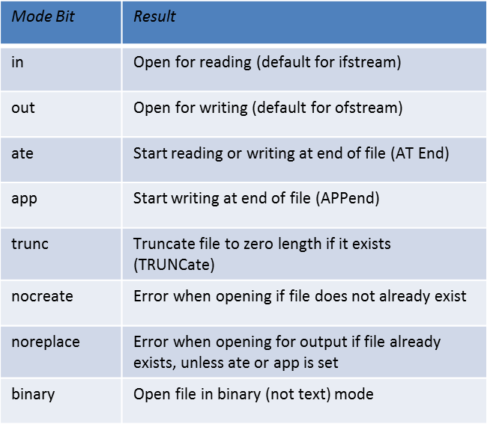
In DISKFUN we use ios::app because we want to preserve whatever was in the file before. That
is, we can write to the file, terminate the program, and start up the program again, and whatever
we write to the file will be added following the existing contents. We use ios:in and
ios:out because we want to perform both input and output on the file, and we use ios:binary
because we’re writing binary objects. The vertical bars between the flags cause the bits representing
these flags to be logically combined into a single integer, so that several flags can
apply simultaneously.
We write one person object at a time to the file, using the write() function. When we’ve finished
writing, we want to read the entire file. Before doing this we must reset the file’s current
position. We do this with the seekg() function, which we’ll examine in the next section. It
ensures we’ll start reading at the beginning of the file. Then, in a while loop, we repeatedly
read a person object from the file and display it on the screen.
This continues until we’ve read all the person objects—a state that we discover using the
eof() function, which returns the state of the ios::eofbit.
File Pointers
Each file object has associated with it two integer values called the get pointer and the put
pointer. These are also called the current get position and the current put position, or—if it’s
clear which one is meant—simply the current position. These values specify the byte number
in the file where writing or reading will take place. (The term pointer in this context should not
be confused with normal C++ pointers used as address variables.)
Often you want to start reading an existing file at the beginning and continue until the end.
When writing, you may want to start at the beginning, deleting any existing contents, or at the
end, in which case you can open the file with the ios::app mode specifier. These are the
default actions, so no manipulation of the file pointers is necessary. However, there are times
when you must take control of the file pointers yourself so that you can read from and write to
an arbitrary location in the file. The seekg() and tellg() functions allow you to set and
examine the get pointer, and the seekp() and tellp() functions perform these same actions on
the put pointer.
Specifying the Position
We saw an example of positioning the get pointer in the DISKFUN program, where the seekg()
function set it to the beginning of the file so that reading would start there. This form of
seekg() takes one argument, which represents the absolute position in the file. The start of the
file is byte 0, so that’s what we used in DISKFUN.
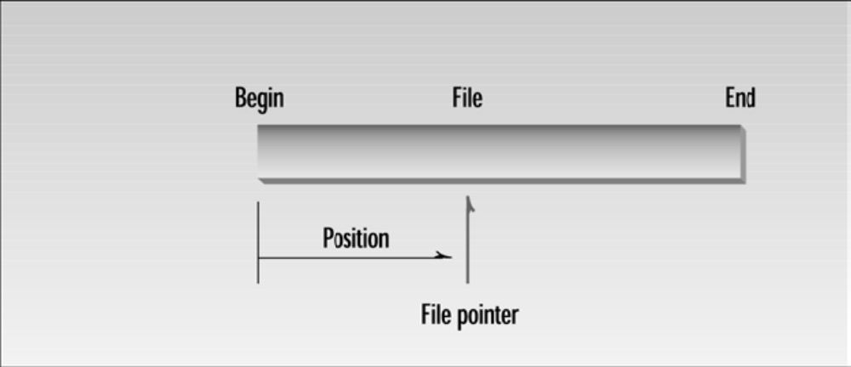
Specifying the Offset
The seekg() function can be used in two ways. We’ve seen the first, where the single argument
represents the position from the start of the file. You can also use it with two arguments,
where the first argument represents an offset from a particular location in the file, and the second
specifies the location from which the offset is measured. There are three possibilities for
the second argument: beg is the beginning of the file, cur is the current pointer position, and
end is the end of the file. The statement
seekp(-10, ios::end);
for example, will set the put pointer to 10 bytes before the end of the file.
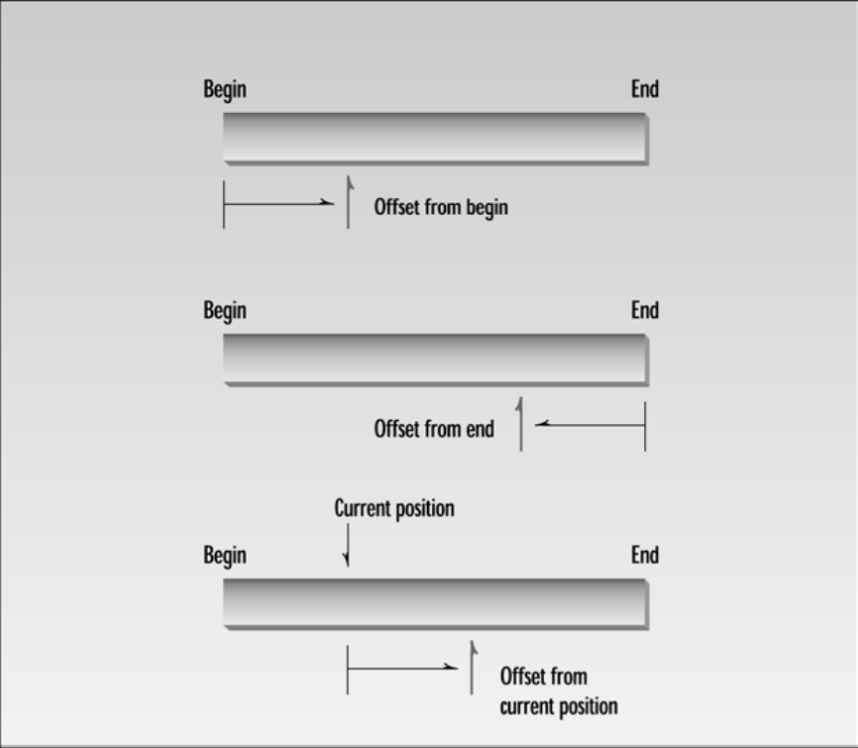
Here’s an example that uses the two-argument version of seekg() to find a particular person
object in the GROUP.DAT file, and to display the data for that particular person. Here’s the listing
for SEEKG:
// seekg.cpp
// seeks particular person in file
#include <fstream> //for file streams
#include <iostream>
using namespace std;
////////////////////////////////////////////////////////////////
class person //class of persons
{
protected:
char name[80]; //person’s name
int age; //person’s age
public:
void getData() //get person’s data
{
cout << “\n Enter name: “; cin >> name;
cout << “ Enter age: “; cin >> age;
}
void showData(void) //display person’s data
{
cout << “\n Name: “ << name;
cout << “\n Age: “ << age;
}
};
////////////////////////////////////////////////////////////////
int main()
{
person pers; //create person object
ifstream infile; //create input file
infile.open(“GROUP.DAT”, ios::in | ios::binary); //open file
infile.seekg(0, ios::end); //go to 0 bytes from end
int endposition = infile.tellg(); //find where we are
int n = endposition / sizeof(person); //number of persons
cout << “\nThere are “ << n << “ persons in file”;
cout << “\nEnter person number: “;
cin >> n;
int position = (n-1) * sizeof(person); //number times size
infile.seekg(position); //bytes from start
//read one person
infile.read( reinterpret_cast<char*>(&pers), sizeof(pers) );
pers.showData(); //display the person
cout << endl;
return 0;
}
Here’s the output from the program, assuming that the GROUP.DAT file is the same as that just
accessed in the DISKFUN example:
There are 3 persons in file
Enter person number: 2
Name: Rainier
Age: 21
For the user, we number the items starting at 1, although the program starts numbering at 0; so
person 2 is the second person of the three in the file.
File I/O with Member Functions
So far we’ve let the main() function handle the details of file I/O. When you use more sophisticated
classes it’s natural to include file I/O operations as member functions of the class. In
this section we’ll show two programs that do this. The first uses ordinary member functions in
which each object is responsible for reading and writing itself to a file. The second shows how
static member functions can read and write all the objects of a class at once.
Objects That Read and Write Themselves
Sometimes it makes sense to let each member of a class read and write itself to a file. This is a
simple approach, and works well if there aren’t many objects to be read or written at once. In
this example we add member functions—diskOut() and diskIn()—to the person class.
These functions allow a person object to write itself to disk and read itself back in.
We’ve made some simplifying assumptions. First, all objects of the class will be stored in the
same file, called PERSFILE.DAT. Second, new objects are always appended to the end of the file.
An argument to the diskIn() function allows us to read the data for any person in the file. To
prevent an attempt to read data beyond the end of the file, we include a static member function,
diskCount(), that returns the number of persons stored in the file. When inputting data to this
program, use only a last name; spaces aren’t allowed. Here’s the listing for REWOBJ:
// rewobj.cpp
// person objects do disk I/O
#include <fstream> //for file streams
#include <iostream>
using namespace std;
////////////////////////////////////////////////////////////////
class person //class of persons
{
protected:
char name[40]; //person’s name
int age; //person’s age
public:
void getData(void) //get person’s data
{
cout << “\n Enter last name: “; cin >> name;
cout << “ Enter age: “; cin >> age;
}
void showData(void) //display person’s data
{
cout << “\n Name: “ << name;
cout << “\n Age: “ << age;
}
void diskIn(int); //read from file
void diskOut(); //write to file
static int diskCount(); //return number of
// persons in file
};
//--------------------------------------------------------------
void person::diskIn(int pn) //read person number pn
{ //from file
ifstream infile; //make stream
infile.open(“PERSFILE.DAT”, ios::binary); //open it
infile.seekg( pn*sizeof(person) ); //move file ptr
infile.read( (char*)this, sizeof(*this) ); //read one person
}
//--------------------------------------------------------------
void person::diskOut() //write person to end of file
{
ofstream outfile; //make stream
//open it
outfile.open(“PERSFILE.DAT”, ios::app | ios::binary);
outfile.write( (char*)this, sizeof(*this) ); //write to it
}
//--------------------------------------------------------------
int person::diskCount() //return number of persons
{ //in file
ifstream infile;
infile.open(“PERSFILE.DAT”, ios::binary);
infile.seekg(0, ios::end); //go to 0 bytes from end
//calculate number of persons
return (int)infile.tellg() / sizeof(person);
}
////////////////////////////////////////////////////////////////
int main()
{
person p; //make an empty person
char ch;
do { //save persons to disk
cout << “Enter data for person:”;
p.getData(); //get data
p.diskOut(); //write to disk
cout << “Do another (y/n)? “;
cin >> ch;
} while(ch==’y’); //until user enters ‘n’
int n = person::diskCount(); //how many persons in file?
cout << “There are “ << n << “ persons in file\n”;
for(int j=0; j<n; j++) //for each one,
{
p.diskIn(j); //read person from disk
p.showData(); //display person
}
cout << endl;
return 0;
}
There shouldn’t be too many surprises here; you’ve seen most of the elements of this program
before. It operates in the same way as the DISKFUN program. Notice, however, that all the
details of disk operation are invisible to main(), having been hidden away in the person class.
We don’t know in advance where the data is that we’re going to read and write, since each
object is in a different place in memory. However, the this pointer always tells us where we
are when we’re in a member function. In the read() and write() stream functions, the memory
address of the object to be read or written is *this and its size is sizeof(*this).
Here’s some output, assuming there were already two persons in the file when the program was
started:
Enter data for person:
Enter name: Acheson
Enter age: 63
Enter another (y/n)? y
Enter data for person:
Enter name: Dulles
Enter age: 72
Enter another (y/n)? n
Person #1
Name: Stimson
Age: 45
Person #2
Name: Hull
Age: 58
Person #3
Name: Acheson
Age: 63
Person #4
Name: Dulles
Age: 72
If you want the user to be able to specify the filename used by the class, instead of hardwiring
it into the member functions as we do here, you could create a static member variable (say
char fileName[]) and a static function to set it. Or you might want to give each object the
name of the file it was associated with, using a nonstatic function.

