Generic programming
- There are situations where same algorithms works for different data type
  - Suppose a function that returns the maximum of two numbers
      - Same algorithm (to find the max number) works with integers and real numbers
  - Until now we have to write two separate function
      - int max (int, int);
      - float max (float, float);
  - Through generic programming we can have just one function to find max of int or float or any other type of values
- Generic programming is a style of computer programming in which algorithms are written in terms of to-be-specified-later types that are then instantiated when needed for specific types provided as parameter
- So if max() function is called with int parameter, max function with int parameter is created
- In C++ generic programming is implemented with “templates
Benefit of generic programming
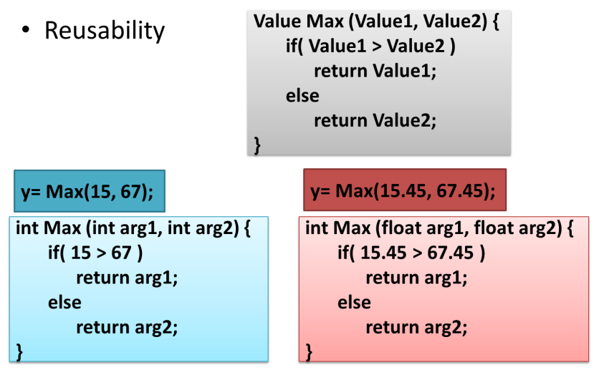
Templates
Template make it possible to use one function or class to handle many different data types. Exceptions provide a convenient, uniform way to handle errors that occur within classes. These features are combined in a single chapter largely for historical reasons: they became part of C++ at the same
time. They were not part of the original specification for C++, but were introduced as
“Experimental” topics in Ellis and Stroustrup (1990, see Appendix H, “Bibliography”).
Subsequently they were incorporated into Standard C++.
The template concept can be used in two different ways: with functions and with classes. We’ll
look at function templates first, then go on to class templates, and finally to exceptions.
Function Templates
Suppose you want to write a function that returns the absolute value of two numbers. As you
no doubt remember from high school algebra, the absolute value of a number is its value without
regard to its sign: The absolute value of 3 is 3, and the absolute value of –3 is also 3.
Ordinarily this function would be written for a particular data type:
int abs(int n) //absolute value of ints
{
return (n<0) ? -n : n; //if n is negative, return -n
}
Here the function is defined to take an argument of type int and to return a value of this same
type. But now suppose you want to find the absolute value of a type long. You will need to
write a completely new function:
long abs(long n) //absolute value of longs
{
return (n<0) ? -n : n;
}
And again, for type float:
float abs(float n) //absolute value of floats
{
return (n<0) ? -n : n;
}
The body of the function is written the same way in each case, but they are completely different
functions because they handle arguments and return values of different types. It’s true that
in C++ these functions can all be overloaded to have the same name, but you must nevertheless
write a separate definition for each one. (In the C language, which does not support overloading,
functions for different types can’t even have the same name. In the C function library this
leads to families of similarly named functions, such as abs(), fabs(), fabsl(), labs(), and
cabs().
Rewriting the same function body over and over for different types is time-consuming and
wastes space in the listing. Also, if you find you’ve made an error in one such function, you’ll
need to remember to correct it in each function body. Failing to do this correctly is a good way
to introduce inconsistencies into your program.
It would be nice if there were a way to write such a function just once, and have it work for
many different data types. This is exactly what function templates do for you.
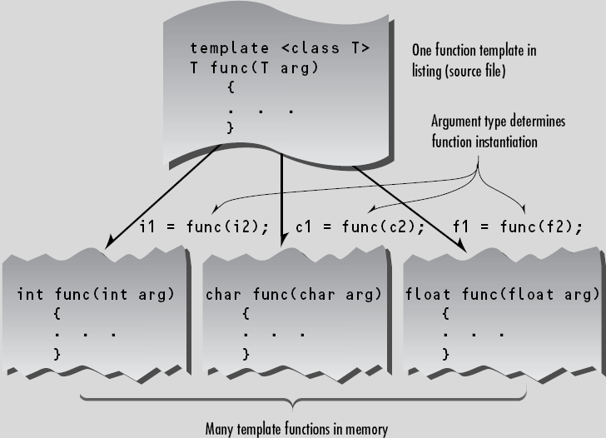
As you can see, the abs() function now works with all three of the data types (int, long, and
double) that we use as arguments. It will work on other basic numerical types as well, and it
will even work on user-defined data types, provided that the less-than operator (<) and the
unary minus operator (-) are appropriately overloaded.
Here’s how we specify the abs() function to work with multiple data types:
template <class T> //function template
T abs(T n)
{
return (n<0) ? -n : n;
}
This entire syntax, with a first line starting with the keyword template and the function definition
following, is called a function template. How does this new way of writing abs() give it
such amazing flexibility?
Function Template Syntax
The key innovation in function templates is to represent the data type used by the function not
as a specific type such as int, but by a name that can stand for any type. In the preceding
function template, this name is T. (There’s nothing magic about this name; it can be anything
you want, like Type, or anyType, or FooBar.) The template keyword signals the compiler that
we’re about to define a function template. The keyword class, within the angle brackets,
might just as well be called type. As we’ve seen, you can define your own data types using
classes, so there’s really no distinction between types and classes. The variable following the
keyword class (T in this example) is called the template argument.
Throughout the definition of the template, whenever a specific data type such as int would
ordinarily be written, we substitute the template argument, T. In the abs() template this name
appears only twice, both in the first line (the function declarator), as the argument type and
return type. In more complex functions it may appear numerous times throughout the function
body as well.
What the Compiler Does
What does the compiler do when it sees the template keyword and the function definition that
follows it? Well, nothing right away. The function template itself doesn’t cause the compiler to
generate any code. It can’t generate code because it doesn’t know yet what data type the function
will be working with. It simply remembers the template for possible future use.
Code generation doesn’t take place until the function is actually called (invoked) by a statement
within the program. In TEMPABS this happens in expressions like abs(int1) in the
statement
cout << “\nabs(“ << int << “)=” << abs(int1);
When the compiler sees such a function call, it knows that the type to use is int, because that’s
the type of the argument int1. So it generates a specific version of the abs() function for type
int, substituting int wherever it sees the name T in the function template. This is called
instantiating the function template, and each instantiated version of the function is called a
template function. (That is, a template function is a specific instance of a function template.
Isn’t English fun?)
The compiler also generates a call to the newly instantiated function, and inserts it into the
code where abs(int1) is. Similarly, the expression abs(lon1) causes the compiler to generate
a version of abs() that operates on type long and a call to this function, while the abs(dub1)
call generates a function that works on type double. Of course, the compiler is smart enough to
generate only one version of abs() for each data type. Thus, even though there are two calls to
the int version of the function, the code for this version appears only once in the executable
code.
Simplifying the Listing
Notice that the amount of RAM used by the program is the same whether we use the template
approach or actually write three separate functions. The template approaches simply saves us
from having to type three separate functions into the source file. This makes the listing shorter
and easier to understand. Also, if we want to change the way the function works, we need to
make the change in only one place in the listing instead of three places.
The Deciding Argument
The compiler decides how to compile the function based entirely on the data type used in the
function call’s argument (or arguments). The function’s return type doesn’t enter into this decision.
This is similar to the way the compiler decides which of several overloaded functions to
call.
Another Kind of Blueprint
We’ve seen that a function template isn’t really a function, since it does not actually cause program
code to be placed in memory. Instead it is a pattern, or blueprint, for making many functions.
This fits right into the philosophy of OOP. It’s similar to the way a class isn’t anything
concrete (such as program code in memory), but a blueprint for making many similar objects.
Function Templates with Multiple Arguments
Let’s look at another example of a function template. This one takes three arguments: two that
are template arguments and one of a basic type. The purpose of this function is to search an
array for a specific value. The function returns the array index for that value if it finds it, or –1
if it can’t find it. The arguments are a pointer to the array, the value to search for, and the size
of the array. In main() we define four different arrays of different types, and four values to
search for. We treat type char as a number. Then we call the template function once for each
array. Here’s the listing for TEMPFIND:
// tempfind.cpp
// template used for function that finds number in array
#include <iostream>
using namespace std;
//--------------------------------------------------------------
//function returns index number of item, or -1 if not found
template <class atype>
int find(atype* array, atype value, int size)
{
for(int j=0; j<size; j++)
if(array[j]==value)
return j;
return -1;
}
//--------------------------------------------------------------
char chrArr[] = {1, 3, 5, 9, 11, 13}; //array
char ch = 5; //value to find
int intArr[] = {1, 3, 5, 9, 11, 13};
int in = 6;
long lonArr[] = {1L, 3L, 5L, 9L, 11L, 13L};
long lo = 11L;
double dubArr[] = {1.0, 3.0, 5.0, 9.0, 11.0, 13.0};
double db = 4.0;
int main()
{
cout << “\n 5 in chrArray: index=” << find(chrArr, ch, 6);
cout << “\n 6 in intArray: index=” << find(intArr, in, 6);
cout << “\n11 in lonArray: index=” << find(lonArr, lo, 6);
cout << “\n 4 in dubArray: index=” << find(dubArr, db, 6);
cout << endl;
return 0;
}
Here we name the template argument atype. It appears in two of the function’s arguments: as
the type of a pointer to the array, and as the type of the item to be matched. The third function
argument, the array size, is always type int; it’s not a template argument. Here’s the output of
the program:
5 in chrArray: index=2
6 in intArray: index=-1
11 in lonArray: index=4
4 in dubArray: index=-1
The compiler generates four different versions of the function, one for each type used to call it.
It finds a 5 at index 2 in the character array, does not find a 6 in the integer array, and so on.
Template Arguments Must Match
When a template function is invoked, all instances of the same template argument must be of
the same type. For example, in find(), if the array name is of type int, the value to search for
must also be of type int. You can’t say
int intarray[] = {1, 3, 5, 7}; //int array
float f1 = 5.0; //float value
int value = find(intarray, f1, 4); //uh, oh
because the compiler expects all instances of atype to be the same type. It can generate a
function
find(int*, int, int);
but it can’t generate
find(int*, float, int);
because the first and second arguments must be the same type.
Syntax Variation
Some programmers put the template keyword and the function declarator on the same line:
template<class atype> int find(atype* array, atype value, int size)
{
//function body
}
Of course the compiler is happy enough with this format, but we find it more forbidding and
less clear than the multiline approach.
More Than One Template Argument
You can use more than one template argument in a function template. For example, suppose
you like the idea of the find() function template, but you aren’t sure how large an array it
might be applied to. If the array is too large then type long would be necessary for the array
size, instead of type int. On the other hand, you don’t want to use type long if you don’t need
to. You want to select the type of the array size, as well as the type of data stored, when you
call the function. To make this possible, you could make the array size into a template argument
as well. We’ll call it btype:
template <class atype, class btype>
btype find(atype* array, atype value, btype size)
{
for(btype j=0; j<size; j++) //note use of btype
if(array[j]==value)
return j;
return static_cast<btype>(-1);
}
Now you can use either type int or type long (or even a user-defined type) for the size,
whichever is appropriate. The compiler will generate different functions based not only on the
type of the array and the value to be searched for, but also on the type of the array size.
Note that multiple template arguments can lead to many functions being instantiated from a
single template. Two such arguments, if there were six basic types that could reasonably be
used for each one, would allow the creation of 36 functions. This can take up a lot of memory
if the functions are large. On the other hand, you don’t instantiate a version of the function
unless you actually call it.
Why Not Macros?
Old-time C programmers may wonder why we don’t use macros to create different versions of
a function for different data types. For example, the abs() function could be defined as
#define abs(n) ( (n<0) ? (-n) : (n) )
This has a similar effect to the class template in TEMPABS, because it performs a simple text
substitution and can thus work with any type. However, as we’ve noted before, macros aren’t
much used in C++. There are several problems with them. One is that macros don’t perform
any type checking. There may be several arguments to the macro that should be of the same
type, but the compiler won’t check whether or not they are. Also, the type of the value returned
isn’t specified, so the compiler can’t tell if you’re assigning it to an incompatible variable. In
any case, macros are confined to functions that can be expressed in a single statement. There
are also other, more subtle, problems with macros. On the whole it’s best to avoid them.
What Works?
How do you know whether you can instantiate a template function for a particular data type?
For example, could you use the find() function from TEMPFIND to find a C-string (type char*)
in an array of C-strings? To see whether this is possible, check the operators used in the function.
If they all work on the data type, you can probably use it. In find(), however, we compare
two variables using the equal-to (==) operator. You can’t use this operator with C-strings;
you must use the strcmp() library function. Thus find() won’t work on C-strings. However,
it does work on the string class because that class overloads the == operator.
Class Templates
The template concept can be extended to classes. Class templates are generally used for data
storage (container) classes. (We’ll see a major example of this in the next chapter, “The
Standard Template Library.”) Stacks and linked lists, which we encountered in previous chapters,
are examples of data-storage classes. However, the examples of these classes that we presented
could store data of only a single basic type. The Stack class in the STAKARAY program
in Chapter 7, “Arrays and Strings,” for example, could store data only of type int. Here’s a
condensed version of that class.
class Stack
{
private:
int st[MAX]; //array of ints
int top; //index number of top of stack
public:
Stack(); //constructor
void push(int var); //takes int as argument
int pop(); //returns int value
};
If we wanted to store data of type long in a stack, we would need to define a completely new
class:
class LongStack
{
private:
long st[MAX]; //array of longs
int top; //index number of top of stack
public:
LongStack(); //constructor
void push(long var); //takes long as argument
long pop(); //returns long value
};
Similarly, we would need to create a new stack class for every data type we wanted to store. It
would be nice to be able to write a single class specification that would work for variables of
all types, instead of a single basic type. As you may have guessed, class templates allow us to
do this. We’ll create a variation of STAKARAY that uses a class template. Here’s the listing for
TEMPSTAK:
// tempstak.cpp
// implements stack class as a template
#include <iostream.h>
using namespace std;
const int MAX = 100; //size of array
////////////////////////////////////////////////////////////////
template <class Type>
class Stack
{
private:
Type st[MAX]; //stack: array of any type
int top; //number of top of stack
public:
Stack() //constructor
{ top = -1; }
void push(Type var) //put number on stack
{ st[++top] = var; }
Type pop() //take number off stack
{ return st[top--]; }
};
////////////////////////////////////////////////////////////////
int main()
{
Stack<float> s1; //s1 is object of class Stack<float>
s1.push(1111.1F); //push 3 floats, pop 3 floats
s1.push(2222.2F);
s1.push(3333.3F);
cout << “1: “ << s1.pop() << endl;
cout << “2: “ << s1.pop() << endl;
cout << “3: “ << s1.pop() << endl;
Stack<long> s2; //s2 is object of class Stack<long>
s2.push(123123123L); //push 3 longs, pop 3 longs
s2.push(234234234L);
s2.push(345345345L);
cout << “1: “ << s2.pop() << endl;
cout << “2: “ << s2.pop() << endl;
cout << “3: “ << s2.pop() << endl;
return 0;
}
Here the class Stack is presented as a template class. The approach is similar to that used in
function templates. The template keyword and class Stack signal that the entire class will be
a template.
template <class Type>
class Stack
{
//data and member functions using template argument Type
};
A template argument, named Type in this example, is then used (instead of a fixed data type
such as int) everyplace in the class specification where there is a reference to the type of the
array st. There are three such places: the definition of st, the argument type of the push()
function, and the return type of the pop() function.
Class templates differ from function templates in the way they are instantiated. To create an
actual function from a function template, you call it using arguments of a specific type.
Classes, however, are instantiated by defining an object using the template argument.
Stack<float> s1;
This creates an object, s1, a stack that stores numbers of type float. The compiler provides
space in memory for this object’s data, using type float wherever the template argument Type
appears in the class specification. It also provides space for the member functions (if these
have not already been placed in memory by another object of type Stack<float>). These
member functions also operate exclusively on type float. Figure 14.2 shows how a class template
and definitions of specific objects cause these objects to be placed in memory.
Creating a Stack object that stores objects of a different type, as in
Stack<long> s2;
creates not only a different space for data, but also a new set of member functions that operate
on type long.
Note that the name of the type of s1 consists of the class name Stack plus the template argument:
Stack<float>. This distinguishes it from other classes that might be created from the
same template, such as Stack<int> or Stack<long>.
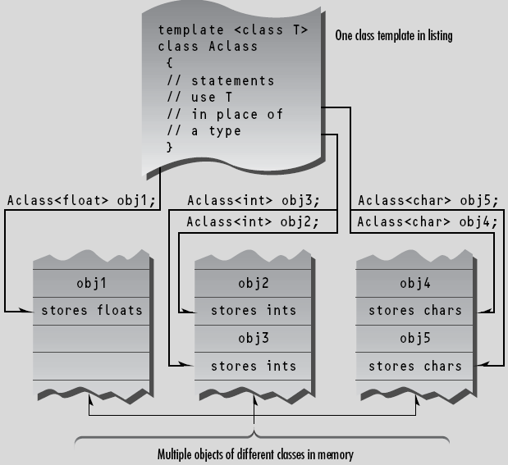
In TEMPSTAK we exercise the s1 and s2 stacks by pushing and popping three values on each
one and displaying each popped value. Here’s the output:
1: 3333.3 //float stack
2: 2222.2
3: 1111.1
1: 345345345 //long stack
2: 234234234
3: 123123123
In this example the template approach gives us two classes for the price of one, and we could
instantiate class objects for other numerical types with just a single line of code.
Class Name Depends on Context
In the TEMPSTAK example, the member functions of the class template were all defined within
the class. If the member functions are defined externally (outside of the class specification), we
need a new syntax. The next program shows how this works. Here’s the listing for TEMPSTAK2:
// temstak2.cpp
// implements stack class as a template
// member functions are defined outside the class
#include <iostream>
using namespace std;
const int MAX = 100;
////////////////////////////////////////////////////////////////
template <class Type>
class Stack
{
private:
Type st[MAX]; //stack: array of any type
int top; //number of top of stack
public:
Stack(); //constructor
void push(Type var); //put number on stack
Type pop(); //take number off stack
};
////////////////////////////////////////////////////////////////
template<class Type>
Stack<Type>::Stack() //constructor
{
top = -1;
}
//--------------------------------------------------------------
template<class Type>
void Stack<Type>::push(Type var) //put number on stack
{
st[++top] = var;
}
//--------------------------------------------------------------
template<class Type>
Type Stack<Type>::pop() //take number off stack
{
return st[top--];
}
//--------------------------------------------------------------
int main()
{
Stack<float> s1; //s1 is object of class Stack<float>
s1.push(1111.1F); //push 3 floats, pop 3 floats
s1.push(2222.2F);
s1.push(3333.3F);
cout << “1: “ << s1.pop() << endl;
cout << “2: “ << s1.pop() << endl;
cout << “3: “ << s1.pop() << endl;
Stack<long> s2; //s2 is object of class Stack<long>
s2.push(123123123L); //push 3 longs, pop 3 longs
s2.push(234234234L);
s2.push(345345345L);
cout << “1: “ << s2.pop() << endl;
cout << “2: “ << s2.pop() << endl;
cout << “3: “ << s2.pop() << endl;
return 0;
}
The expression template<class Type> must precede not only the class definition, but each
externally defined member function as well. Here’s how the push() function looks:
template<class Type>
void Stack<Type>::push(Type var)
{
st[++top] = var;
}
The name Stack<Type> is used to identify the class of which push() is a member. In a normal
non-template member function the name Stack alone would suffice:
void Stack::push(int var) //Stack() as a non-template function
{
st[++top] = var;
}
but for a function template we need the template argument as well: Stack<Type>.
Thus we see that the name of the template class is expressed differently in different contexts.
Within the class specification, it’s simply the name itself: Stack. For externally defined member
functions, it’s the class name plus the template argument name: Stack<Type>. When you
define actual objects for storing a specific data type, it’s the class name plus this specific type:
Stack<float>, for example.
class Stack //Stack class specifier
{ };
void Stack<Type>::push(Type var) //push() definition
{ }
Stack<float> s1; //object of type Stack<float>
You must exercise considerable care to use the correct name in the correct context. It’s easy to
forget to add the <Type> or <float> to the Stack. The compiler hates it when you get it wrong.
Although it’s not demonstrated in this example, you must also be careful of the syntax when a
member function returns a value of its own class. Suppose we define a class Int that provided
safety features for integers, as discussed in Exercise 4 in Chapter 8, “Operator Overloading.” If
you used an external definition for a member function xfunc() of this class that returned type
Int, you would need to use Int<Type> for the return type as well as preceding the scope resolution
operator:
Int<Type> Int<Type>::xfunc(Int arg)
{ }
The class name used as a type of a function argument, on the other hand, doesn’t need to
include the <Type> designation.

