Default Copy constructor
- Two ways to initialize objects.
  - no-argument constructor
Distance d1;
  - multi-argument constructor
Distance d2(4, 5,76);
- An object can be initialize with another object of the same type
  - Distance d1 = d2;
- A default copy constructor will be called
  - One argument constructor whose argument is an object of same class
- If no copy constructor define in class then complier adds default copy constructor
- When default copy constructor is invoked
  - When object is pass as an argument to a function
Distance d1, d2, d3;
…
d3.add_dist(d1, d2);
  - When an object is return by value
Prototype : Distance add_dist(Distance d);
Function call: d3 = d2.add_dist(d1);
Copy constructor—Function Arguments
- The copy constructor is invoked when an object is passed by value to a function.
- It creates the copy that the function operates on.
- Thus if the function
void func(alpha a);
called by the statement
func(a1);
then the copy constructor would be invoked to create a copy of the a1 object for use by func().
- Copy constructor is not invoked if the argument is pass by reference or by pointer. In these case no copy is created
Copy constructor—Function Return Values
- The copy constructor also creates a temporary object when a value (an object) is returned from a function.
- Suppose there was a function
alpha func();
and this function was called by the statement
a2 = func();
- The copy constructor would be invoked to create a copy of the value returned by func(), and
- this value would be assigned to a2
Memory management
- It is an act of managing computer memory
- It provides ways to dynamically allocate memory to programs at their request, and freeing it for reuse when no longer needed
- In c++ new and delete operator are use to dynamically allocate and deallocate memory for C++ program

A String Class Using new
class String {
private:
char* str;
public:
String(char* s) {
int length = strlen(s);
str = new char[length+1];
strcpy(str, s);
}
~String() {
cout << “Deleting str.\n”;
delete[ ] str;
}
void display() {
cout << str << endl;
Memory Map
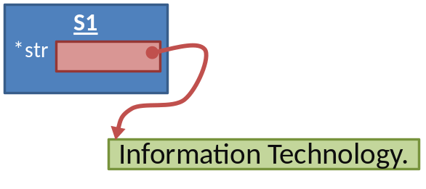
}
};
main() {
String s1 = “Information Technology.”;
cout << “s1=”; //display string
s1.display();
}
A problem with String class
- If you copy one String object to another, say with a statement like s2 = s1,
- Both objects now point to the same string in memory.
- But if you delete one string, the destructor will delete the char* string, leaving the other object with an invalid pointer
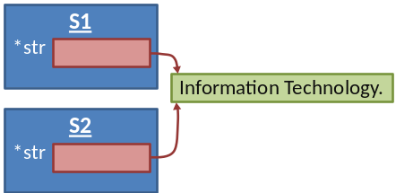

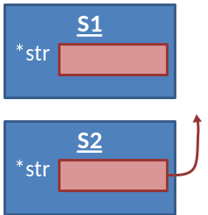

Pointers to Objects
Pointers can point to objects as well as to simple data types and arrays. We’ve seen many
examples of objects defined and given a name, in statements like
Distance dist;
where an object called dist is defined to be of the Distance class.
Sometimes, however, we don’t know, at the time that we write the program, how many objects
we want to create. When this is the case we can use new to create objects while the program is
running. As we’ve seen, new returns a pointer to an unnamed object. Let’s look at a short example
program, ENGLPTR, that compares the two approaches to creating objects.
// englptr.cpp
// accessing member functions by pointer
#include <iostream>
using namespace std;
////////////////////////////////////////////////////////////////
class Distance //English Distance class
{
private:
int feet;
float inches;
public:
void getdist() //get length from user
{
cout << “\nEnter feet: “; cin >> feet;
cout << “Enter inches: “; cin >> inches;
}
void showdist() //display distance
{ cout << feet << “\’-” << inches << ‘\”’; }
};
////////////////////////////////////////////////////////////////
int main()
{
Distance dist; //define a named Distance object
dist.getdist(); //access object members
dist.showdist(); // with dot operator
Distance* distptr; //pointer to Distance
distptr = new Distance; //points to new Distance object
distptr->getdist(); //access object members
distptr->showdist(); // with -> operator
cout << endl;
return 0;
}
This program uses a variation of the English Distance class seen in previous chapters. The
main() function defines dist, uses the Distance member function getdist() to get a distance
from the user, and then uses showdist() to display it.
Referring to Members
ENGLPTR then creates another object of type Distance using the new operator, and returns a
pointer to it called distptr.
The question is, how do we refer to the member functions in the object pointed to by distptr?
You might guess that we would use the dot (.) membership-access operator, as in
distptr.getdist(); // won’t work; distptr is not a variable
but this won’t work. The dot operator requires the identifier on its left to be a variable. Since
distptr is a pointer to a variable, we need another syntax. One approach is to dereference (get
the contents of the variable pointed to by) the pointer:
(*distptr).getdist(); // ok but inelegant
However, this is slightly cumbersome because of the parentheses. (The parentheses are necessary
because the dot operator (.) has higher precedence than the dereference operator (*). An
equivalent but more concise approach is furnished by the membership-access operator, which
consists of a hyphen and a greater-than sign:
distptr->getdist(); // better approach
As you can see in ENGLPTR, the -> operator works with pointers to objects in just the same way
that the . operator works with objects. Here’s the output of the program:
Enter feet: 10 ← this object uses the dot operator
Enter inches: 6.25
10’-6.25”
Enter feet: 6 ← this object uses the -> operator
Enter inches: 4.75
6’-4.75”
Another Approach to new
You may come across another—less common—approach to using new to obtain memory for
objects.
Since new can return a pointer to an area of memory that holds an object, we should be able to
refer to the original object by dereferencing the pointer. The ENGLREF example shows how this
is done.
// englref.cpp
// dereferencing the pointer returned by new
#include <iostream>
using namespace std;
////////////////////////////////////////////////////////////////
class Distance // English Distance class
{
private:
int feet;
float inches;
public:
void getdist() // get length from user
{
cout << “\nEnter feet: “; cin >> feet;
cout << “Enter inches: “; cin >> inches;
}
void showdist() // display distance
{ cout << feet << “\’-” << inches << ‘\”’; }
};
////////////////////////////////////////////////////////////////
int main()
{
Distance& dist = *(new Distance); // create Distance object
// alias is “dist”
dist.getdist(); // access object members
dist.showdist(); // with dot operator
cout << endl;
return 0;
}
The expression
new Distance
returns a pointer to a memory area large enough for a Distance object, so we can refer to the
original object as
*(new Distance)
This is the object pointed to by the pointer. Using a reference, we define dist to be an object
of type Distance, and we set it equal to *(new Distance). Now we can refer to members of
dist using the dot membership operator, rather than ->.
This approach is less common than using pointers to objects obtained with new, or simply
declaring an object, but it works in a similar way.
An Array of Pointers to Objects
A common programming construction is an array of pointers to objects. This arrangement
allows easy access to a group of objects, and is more flexible than placing the objects themselves
in an array. (For instance, in the PERSORT example in this chapter we’ll see how a group
of objects can be sorted by sorting an array of pointers to them, rather than sorting the objects
themselves.)
Our next example, PTROBJS, creates an array of pointers to the person class. Here’s the listing:
// ptrobjs.cpp
// array of pointers to objects
#include <iostream>
using namespace std;
////////////////////////////////////////////////////////////////
class person //class of persons
{
protected:
char name[40]; //person’s name
public:
void setName() //set the name
{
cout << “Enter name: “;
cin >> name;
}
void printName() //get the name
{
cout << “\n Name is: “ << name;
}
};
////////////////////////////////////////////////////////////////
int main()
{
person* persPtr[100]; //array of pointers to persons
int n = 0; //number of persons in array
char choice;
do //put persons in array
{
persPtr[n] = new person; //make new object
persPtr[n]->setName(); //set person’s name
n++; //count new person
cout << “Enter another (y/n)? “; //enter another
cin >> choice; //person?
}
while( choice==’y’ ); //quit on ‘n’
for(int j=0; j<n; j++) //print names of
{ //all persons
cout << “\nPerson number “ << j+1;
persPtr[j]->printName();
}
cout << endl;
return 0;
} //end main()
The class person has a single data item, name, which holds a string representing a person’s
name. Two member functions, setName() and printName(), allow the name to be set and displayed.
Program Operation
The main() function defines an array, persPtr, of 100 pointers to type person. In a do loop it
then asks the user to enter a name. With this name it creates a person object using new, and
stores a pointer to this object in the array persPtr. To demonstrate how easy it is to access the
objects using the pointers, it then prints out the name data for each person object.
Here’s a sample interaction with the program:
Enter name: Stroustrup ← user enters names
Enter another (y/n)? y
Enter name: Ritchie
Enter another (y/n)? y
Enter name: Kernighan
Enter another (y/n)? n
Person number 1 ← program displays all names stored
Name is: Stroustrup
Person number 2
Name is: Ritchie
Person number 3
Name is: Kernighan

Polymorphism
- It enables to write programs that process objects of classes (that are part of the same class hierarchy) as if they are all objects of the hierarchy's base class.
Polymorphism – Example 1
D1 class
- Program that simulates the movement of several types of animals for a biological study
  - Classes Fish, Frog and Bird
  - Each of these classes inherits from base class Animal
    - contains a function move and maintains an animal's current location
  - Each derived class implements function move
  - Program maintains an array of pointers to objects of the various derived classes (Fish, Frog and Bird )
  - To simulate the animal’s movements, the program sends each object the same message, move()
  - Each object knows how to modify its location appropriately for its specific type of movement
  - Relying on each object to know how to "do the right thing" in response to the same function call is the key concept of polymorphism
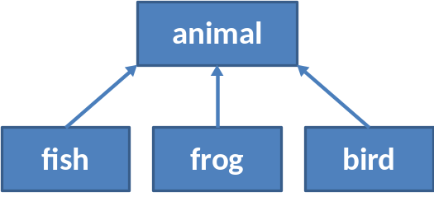
Polymorphism – Example 2
  - Suppose you have a objects of different classes
    - All are inherited from a base class
    - you want to put them all in an array
    - perform a particular operation on them using the same function call.
shape* ptrArray[4];
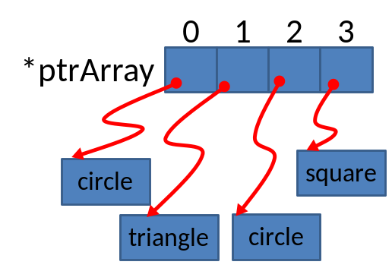
ptrArray[0] = new Circle;
ptrArray[1] = new Triangle;
ptrArray[0] = new Circle;
ptrArray[0] = new Square;
for(int j=0; j<4; j++)
ptrarr[j]->draw();

Condition for polymorphism
Following condition must be meet in order to achieve polymorphic behaviour
  - First, all the different classes of shapes, such as circle and triangles, must be inherited from a single base class
  - Second, the draw() function must be declared to be virtual in the base class.
Shape
draw()
Circle
draw()
Square
draw()
Triangle
draw()

Example programs
- Normal Member Functions Accessed with Pointers
- Virtual Member Functions Accessed with Pointers
Normal Member Functions Accessed with Pointers
Our first example shows what happens when a base class and derived classes all have functions
with the same name, and you access these functions using pointers but without using virtual
functions. Here’s the listing for NOTVIRT:
// notvirt.cpp
// normal functions accessed from pointer
#include <iostream>
using namespace std;
////////////////////////////////////////////////////////////////
class Base //base class
{
public:
void show() //normal function
{ cout << “Base\n”; }
};
////////////////////////////////////////////////////////////////
class Derv1 : public Base //derived class 1
{
public:
void show()
{ cout << “Derv1\n”; }
};
////////////////////////////////////////////////////////////////
class Derv2 : public Base //derived class 2
{
public:
void show()
{ cout << “Derv2\n”; }
};
////////////////////////////////////////////////////////////////
int main()
{
Derv1 dv1; //object of derived class 1
Derv2 dv2; //object of derived class 2
Base* ptr; //pointer to base class
ptr = &dv1; //put address of dv1 in pointer
ptr->show(); //execute show()
ptr = &dv2; //put address of dv2 in pointer
ptr->show(); //execute show()
return 0;
}
The Derv1 and Derv2 classes are derived from class Base. Each of these three classes has a
member function show(). In main() we create objects of class Derv1 and Derv2, and a pointer
to class Base. Then we put the address of a derived class object in the base class pointer in
the line
ptr = &dv1; // derived class address in base class pointer
But wait—how can we get away with this? Doesn’t the compiler complain that we’re assigning
an address of one type (Derv1) to a pointer of another (Base)? On the contrary, the compiler is
perfectly happy, because type checking has been relaxed in this situation, for reasons that will
become apparent soon. The rule is that pointers to objects of a derived class are typecompatible
with pointers to objects of the base class.
Now the question is, when you execute the line
ptr->show();
what function is called? Is it Base::show() or Derv1::show()? Again, in the last two lines of
NOTVIRT we put the address of an object of class Derv2 in the pointer, and again execute
ptr->show();
Which of the show() functions is called here? The output from the program answers these
questions:
Base
Base
As you can see, the function in the base class is always executed. The compiler ignores the
contents of the pointer ptr and chooses the member function that matches the type of the
pointer, as shown in Figure 11.1.
Sometimes this is what we want, but it doesn’t solve the problem posed at the beginning of this
section: accessing objects of different classes using the same statement.
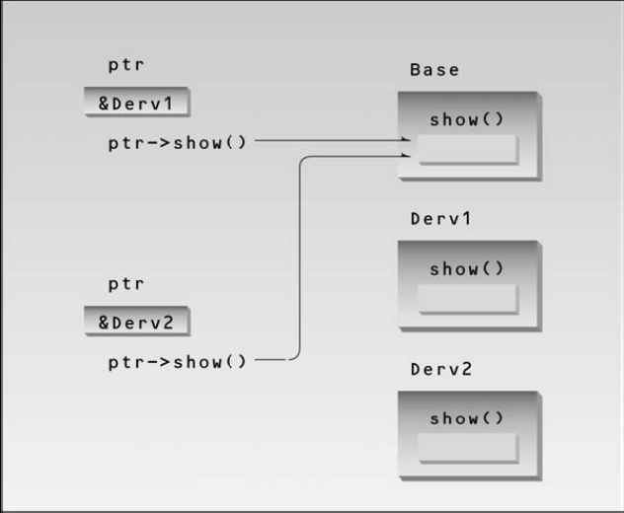
Virtual Member Functions Accessed with Pointers
Let’s make a single change in our program: We’ll place the keyword virtual in front of the
declarator for the show() function in the base class. Here’s the listing for the resulting program,
VIRT:
// virt.cpp
// virtual functions accessed from pointer
#include <iostream>
using namespace std;
////////////////////////////////////////////////////////////////
class Base //base class
{
public:
virtual void show() //virtual function
{ cout << “Base\n”; }
};
////////////////////////////////////////////////////////////////
class Derv1 : public Base //derived class 1
public:
void show()
{ cout << “Derv1\n”; }
};
////////////////////////////////////////////////////////////////
class Derv2 : public Base //derived class 2
{
public:
void show()
{ cout << “Derv2\n”; }
};
////////////////////////////////////////////////////////////////
int main()
{
Derv1 dv1; //object of derived class 1
Derv2 dv2; //object of derived class 2
Base* ptr; //pointer to base class
ptr = &dv1; //put address of dv1 in pointer
ptr->show(); //execute show()
ptr = &dv2; //put address of dv2 in pointer
ptr->show(); //execute show()
return 0;
}
The output of this program is
Derv1
Derv2
Now, as you can see, the member functions of the derived classes, not the base class, are executed.
We change the contents of ptr from the address of Derv1 to that of Derv2, and the particular
instance of show() that is executed also changes. So the same function call
ptr->show();
executes different functions, depending on the contents of ptr. The rule is that the compiler
selects the function based on the contents of the pointer ptr, not on the type of the pointer
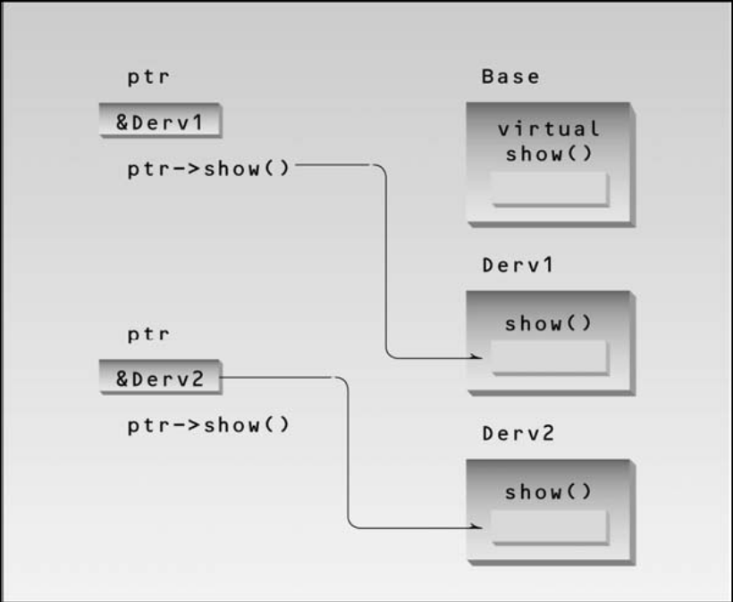
Static binding
- When a member function/virtual function is called with the object of that class
- For example
  - dist1.getdist();
  - derv1.show();
  - base1.show();
- Function invocation is resolved at compile time.
- This is called static or early binding
- This is not a polymorphic behavior
Dynamic binding (Late Binding)
- Virtual function can be invoked using base class pointer to a derive class object
  - shapePtr—>draw()
- Now the correct derived class draw function will be selected dynamically (execution time)
- This is called dynamic or late binding
- At run time, when it knows what class is pointed by shapePtr, the draw function of that class is called

The astute reader may wonder how the compiler knows what function to compile. In NOTVIRT
the compiler has no problem with the expression
ptr->show();
It always compiles a call to the show() function in the base class. But in VIRT the compiler
doesn’t know what class the contents of ptr may contain. It could be the address of an object
of the Derv1 class or of the Derv2 class. Which version of draw() does the compiler call? In
fact the compiler doesn’t know what to do, so it arranges for the decision to be deferred until
the program is running. At runtime, when it is known what class is pointed to by ptr, the
appropriate version of draw will be called. This is called late binding or dynamic binding.
(Choosing functions in the normal way, during compilation, is called early binding or
static binding.) Late binding requires some overhead but provides increased power and
flexibility.
We’ll put these ideas to use in a moment, but first let’s consider a refinement to the idea of
virtual functions.

Allowable assignments b/w base and derived class object and pointer
- Four ways to aim base and derive class pointer at base and derived class objects
  - Base class pointer to base class objects
  - Derived class pointer to derived class objects
  - Base class pointer to derive class objects
    - Derive class object is also object of base class
  - Derive class pointer to base class object.
    - Not allowed
    - “is a” relationship applies only from derive class to base class not vice versa

Abstract Classes and Pure Virtual Functions
Think of the shape class in the multshap program in Chapter 9. We’ll never make an object of
the shape class; we’ll only make specific shapes such as circles and triangles. When we will
never want to instantiate objects of a base class, we call it an abstract class. Such a class exists
only to act as a parent of derived classes that will be used to instantiate objects. It may also
provide an interface for the class hierarchy.
How can we make it clear to someone using our family of classes that we don’t want anyone to
instantiate objects of the base class? We could just say this in the documentation, and count on
the users of the class to remember it, but of course it’s much better to write our classes so that
such instantiation is impossible. How can we can do that? By placing at least one pure virtual
function in the base class. A pure virtual function is one with the expression =0 added to the
declaration. This is shown in the VIRTPURE example.
// virtpure.cpp
// pure virtual function
#include <iostream>
using namespace std;
////////////////////////////////////////////////////////////////
class Base //base class
{
public:
virtual void show() = 0; //pure virtual function
};
////////////////////////////////////////////////////////////////
class Derv1 : public Base //derived class 1
{
public:
void show()
{ cout << “Derv1\n”; }
};
////////////////////////////////////////////////////////////////
class Derv2 : public Base //derived class 2
{
public:
void show()
{ cout << “Derv2\n”; }
};
////////////////////////////////////////////////////////////////
int main()
{
// Base bad; //can’t make object from abstract class
Base* arr[2]; //array of pointers to base class
Derv1 dv1; //object of derived class 1
Derv2 dv2; //object of derived class 2
arr[0] = &dv1; //put address of dv1 in array
arr[1] = &dv2; //put address of dv2 in array
arr[0]->show(); //execute show() in both objects
arr[1]->show();
return 0;
}
Here the virtual function show() is declared as
virtual void show() = 0; // pure virtual function
The equal sign here has nothing to do with assignment; the value 0 is not assigned to anything.
The =0 syntax is simply how we tell the compiler that a virtual function will be pure. Now if in
main() you attempt to create objects of class Base, the compiler will complain that you’re trying
to instantiate an object of an abstract class. It will also tell you the name of the pure virtual
function that makes it an abstract class. Notice that, although this is only a declaration, you
never need to write a definition of the base class show(), although you can if you need to.
Once you’ve placed a pure virtual function in the base class, you must override it in all the
derived classes from which you want to instantiate objects. If a class doesn’t override the pure
virtual function, it becomes an abstract class itself, and you can’t instantiate objects from it
(although you might from classes derived from it). For consistency, you may want to make all
the virtual functions in the base class pure.
As you can see, we’ve made another, unrelated, change in VIRTPURE: The addresses of the
member functions are stored in an array of pointers and accessed using array elements. This
works in just the same way as using a single pointer. The output of VIRTPURE is the same as
VIRT:
Derv1
Derv2
Virtual Functions and the person Class
Now that we understand some of the mechanics of virtual functions, let’s look at a situation
where it makes sense to use them. Our example is an extension of the PTROBJ and PERSORT
examples from Chapter 10, “Pointers.” It uses the same person class, but adds two derived
classes, student and professor. These derived classes each contain a function called
isOutstanding(). This function makes it easy for the school administrators to create a list of
outstanding students and professors for the venerable Awards Day ceremony. Here’s the listing
for VIRTPERS:
// virtpers.cpp
// virtual functions with person class
#include <iostream>
using namespace std;
////////////////////////////////////////////////////////////////
class person //person class
{
protected:
char name[40];
public:
void getName()
{ cout << “ Enter name: “; cin >> name; }
void putName()
{ cout << “Name is: “ << name << endl; }
virtual void getData() = 0; //pure virtual func
virtual bool isOutstanding() = 0; //pure virtual func
};
////////////////////////////////////////////////////////////////
class student : public person //student class
{
private:
float gpa; //grade point average
public:
void getData() //get student data from user
{
person::getName();
cout << “ Enter student’s GPA: “; cin >> gpa;
}
bool isOutstanding()
{ return (gpa > 3.5) ? true : false; }
};
////////////////////////////////////////////////////////////////
class professor : public person //professor class
{
private:
int numPubs; //number of papers published
public:
void getData() //get professor data from user
{
person::getName();
cout << “ Enter number of professor’s publications: “;
cin >> numPubs;
}
bool isOutstanding()
{ return (numPubs > 100) ? true : false; }
};
////////////////////////////////////////////////////////////////
int main()
{
person* persPtr[100]; //array of pointers to persons
int n = 0; //number of persons on list
char choice;
do {
cout << “Enter student or professor (s/p): “;
cin >> choice;
if(choice==’s’) //put new student
persPtr[n] = new student; // in array
else //put new professor
persPtr[n] = new professor; // in array
persPtr[n++]->getData(); //get data for person
cout << “ Enter another (y/n)? “; //do another person?
cin >> choice;
} while( choice==’y’ ); //cycle until not ‘y’
for(int j=0; j<n; j++) //print names of all
{ //persons, and
persPtr[j]->putName(); //say if outstanding
if( persPtr[j]->isOutstanding() )
cout << “ This person is outstanding\n”;
}
return 0;
} //end main()
The Classes
The person class is an abstract class because it contains the pure virtual functions getData()
and isOutstanding(). No person objects can ever be created. This class exists only to be the
base class for the student and professor classes. The student and professor classes add
new data items to the base class. The student class contains a variable gpa of type float,
which represents the student’s grade point average (GPA). The professor class contains a
variable numPubs, of type int, which represents the number of scholarly publications the professor
has published. Students with a GPA of over 3.5 and professors who have published
more than 100 papers are considered outstanding. (We’ll refrain from comment on the desirability
of these criteria for judging educational excellence.)
The isOutstanding() Function
The isOutstanding() function is declared as a pure virtual function in person. In the student
class this function returns a bool true if the student’s GPA is greater than 3.5, and false otherwise.
In professor it returns true if the professor’s numPubs variable is greater than 100.
The getData() function asks the user for the GPA for a student, but for the number of publications
for a professor.
The main() Program
In main() we first let the user enter a number of student and teacher names. For students, the
program also asks for the GPA, and for professors it asks for the number of publications. When
the user is finished, the program prints out the names of all the students and professors, noting
those who are outstanding. Here’s some sample interaction:
Enter student or professor (s/p): s
Enter name: Timmy
Enter student’s GPA: 1.2
Enter another (y/n)? y
Enter student or professor (s/p): s
Enter name: Brenda
Enter student’s GPA: 3.9
Enter another (y/n)? y
Enter student or professor (s/p): s
Enter name: Sandy
Enter student’s GPA: 2.4
Enter another (y/n)? y
Enter student or professor (s/p): p
Enter name: Shipley
Enter number of professor’s publications: 714
Enter another (y/n)? y
Enter student or professor (s/p): p
Enter name: Wainright
Enter number of professor’s publications: 13
Enter another (y/n)? n
Name is: Timmy
Name is: Brenda
This person is outstanding
Name is: Sandy
Name is: Shipley
This person is outstanding
Name is: Wainright
Virtual Destructors
Base class destructors should always be virtual. Suppose you use delete with a base class
pointer to a derived class object to destroy the derived-class object. If the base-class destructor
is not virtual then delete, like a normal member function, calls the destructor for the base
class, not the destructor for the derived class. This will cause only the base part of the object to
be destroyed. The VIRTDEST program shows how this looks.
//vertdest.cpp
//tests non-virtual and virtual destructors
#include <iostream>
using namespace std;
////////////////////////////////////////////////////////////////
class Base
{
public:
~Base() //non-virtual destructor
// virtual ~Base() //virtual destructor
{ cout << “Base destroyed\n”; }
};
////////////////////////////////////////////////////////////////
class Derv : public Base
{
public:
~Derv()
{ cout << “Derv destroyed\n”; }
};
////////////////////////////////////////////////////////////////
int main()
{
Base* pBase = new Derv;
delete pBase;
return 0;
}
The output for this program as written is
Base destroyed
This shows that the destructor for the Derv part of the object isn’t called. In the listing the base
class destructor is not virtual, but you can make it so by commenting out the first definition for
the destructor and substituting the second. Now the output is
Derv destroyed
Base destroyed
Now both parts of the derived class object are destroyed properly. Of course, if none of the
destructors has anything important to do (like deleting memory obtained with new) then virtual
destructors aren’t important. But in general, to ensure that derived-class objects are destroyed
properly, you should make destructors in all base classes virtual.
Most class libraries have a base class that includes a virtual destructor, which ensures that all
derived classes have virtual destructors.
Virtual Base Classes
Before leaving the subject of virtual programming elements, we should mention virtual base
classes as they relate to multiple inheritance.
Consider the situation shown in Figure 11.3, with a base class, Parent; two derived classes,
Child1 and Child2; and a fourth class, Grandchild, derived from both Child1 and Child2.
In this arrangement a problem can arise if a member function in the Grandchild class wants to
access data or functions in the Parent class. The NORMBASE program shows what happens.
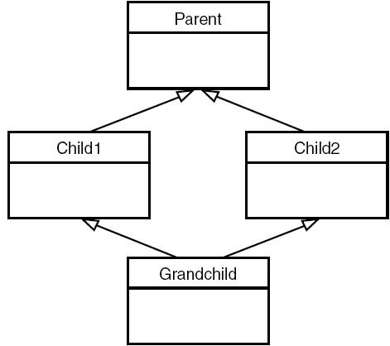
// ambiguous reference to base class
class Parent
{
protected:
int basedata;
};
class Child1 : public Parent
{ };
class Child2 : public Parent
{ };
class Grandchild : public Child1, public Child2
{
public:
int getdata()
{ return basedata; } // ERROR: ambiguous
};
A compiler error occurs when the getdata() member function in Grandchild attempts to
access basedata in Parent. Why? When the Child1 and Child2 classes are derived from
Parent, each inherits a copy of Parent; this copy is called a subobject. Each of the two subobjects
contains its own copy of Parent’s data, including basedata. Now, when Grandchild
refers to basedata, which of the two copies will it access? The situation is ambiguous, and
that’s what the compiler reports.

To eliminate the ambiguity, we make Child1 and Child2 into virtual base classes, as shown by
the example VIRTBASE.
// virtbase.cpp
// virtual base classes
class Parent
{
protected:
int basedata;
};
class Child1 : virtual public Parent // shares copy of Parent
{ };
class Child2 : virtual public Parent // shares copy of Parent
{ };
class Grandchild : public Child1, public Child2
{
public:
int getdata()
{ return basedata; } // OK: only one copy of Parent
};
The use of the keyword virtual in these two classes causes them to share a single common
subobject of their base class Parent. Since there is only one copy of basedata, there is no
ambiguity when it is referred to in Grandchild.
The need for virtual base classes may indicate a conceptual problem with your use of multiple
inheritance, so they should be used with caution.
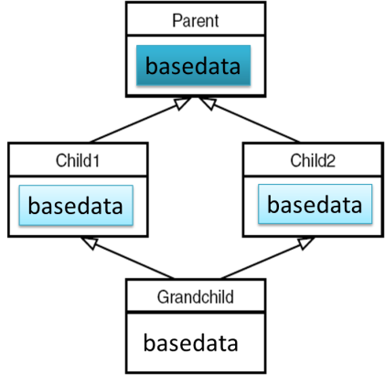
Friend Functions
The concepts of encapsulation and data hiding dictate that nonmember functions should not be
able to access an object’s private or protected data. The policy is, if you’re not a member, you
can’t get in. However, there are situations where such rigid discrimination leads to considerable
inconvenience.
Friends as Bridges
Imagine that you want a function to operate on objects of two different classes. Perhaps the
function will take objects of the two classes as arguments, and operate on their private data. In
this situation there’s nothing like a friend function. Here’s a simple example, FRIEND, that
shows how friend functions can act as a bridge between two classes:
// friend.cpp
// friend functions
#include <iostream>
using namespace std;
////////////////////////////////////////////////////////////////
class beta; //needed for frifunc declaration
class alpha
{
private:
int data;
public:
alpha() : data(3) { } //no-arg constructor
friend int frifunc(alpha, beta); //friend function
};
////////////////////////////////////////////////////////////////
class beta
{
private:
int data;
public:
beta() : data(7) { } //no-arg constructor
friend int frifunc(alpha, beta); //friend function
};
////////////////////////////////////////////////////////////////
int frifunc(alpha a, beta b) //function definition
{
return( a.data + b.data );
}
//--------------------------------------------------------------
int main()
{
alpha aa;
beta bb;
cout << frifunc(aa, bb) << endl; //call the function
return 0;
}
In this program, the two classes are alpha and beta. The constructors in these classes initialize
their single data items to fixed values (3 in alpha and 7 in beta).
We want the function frifunc() to have access to both of these private data members, so we
make it a friend function. It’s declared with the friend keyword in both classes:
friend int frifunc(alpha, beta);
This declaration can be placed anywhere in the class; it doesn’t matter whether it goes in the
public or the private section.
n object of each class is passed as an argument to the function frifunc(), and it accesses the
private data member of both classes through these arguments. The function doesn’t do much:
It adds the data items and returns the sum. The main() program calls this function and prints
the result.
A minor point: Remember that a class can’t be referred to until it has been declared. Class
beta is referred to in the declaration of the function frifunc() in class alpha, so beta must be
declared before alpha. Hence the declaration
class beta;
at the beginning of the program.
Breaching the Walls
We should note that friend functions are controversial. During the development of C++, arguments
raged over the desirability of including this feature. On the one hand, it adds flexibility
to the language; on the other, it is not in keeping with data hiding, the philosophy that only
member functions can access a class’s private data.
How serious is the breach of data integrity when friend functions are used? A friend function
must be declared as such within the class whose data it will access. Thus a programmer who
does not have access to the source code for the class cannot make a function into a friend. In
this respect, the integrity of the class is still protected. Even so, friend functions are conceptually
messy, and potentially lead to a spaghetti-code situation if numerous friends muddy the
clear boundaries between classes. For this reason friend functions should be used sparingly. If
you find yourself using many friends, you may need to rethink the design of the program.
English Distance Example
However, sometimes friend functions are too convenient to avoid. Perhaps the most common
example is when friends are used to increase the versatility of overloaded operators. The following
program shows a limitation in the use of such operators when friends are not used. This
example is a variation on the ENGLPLUS and ENGLCONV programs in Chapter 8, “Operator
Overloading.” It’s called NOFRI.
// nofri.cpp
// limitation to overloaded + operator
#include <iostream>
using namespace std;
////////////////////////////////////////////////////////////////
class Distance //English Distance class
{
private:
int feet;
float inches;
public:
Distance() : feet(0), inches(0.0) //constructor (no args)
{ } //constructor (one arg)
Distance(float fltfeet) //convert float to Distance
{ //feet is integer part
feet = static_cast<int>(fltfeet);
inches = 12*(fltfeet-feet); //inches is what’s left
}
Distance(int ft, float in) //constructor (two args)
{ feet = ft; inches = in; }
void showdist() //display distance
{ cout << feet << “\’-” << inches << ‘\”’; }
Distance operator + (Distance);
};
//--------------------------------------------------------------
//add this distance to d2
Distance Distance::operator + (Distance d2) //return the sum
{
int f = feet + d2.feet; //add the feet
float i = inches + d2.inches; //add the inches
if(i >= 12.0) //if total exceeds 12.0,
{ i -= 12.0; f++; } //less 12 inches, plus 1 foot
return Distance(f,i); //return new Distance with sum
}
////////////////////////////////////////////////////////////////
int main()
{
Distance d1 = 2.5; //constructor converts
Distance d2 = 1.25; //float feet to Distance
Distance d3;
cout << “\nd1 = “; d1.showdist();
cout << “\nd2 = “; d2.showdist();
d3 = d1 + 10.0; //distance + float: OK
cout << “\nd3 = “; d3.showdist();
// d3 = 10.0 + d1; //float + Distance: ERROR
// cout << “\nd3 = “; d3.showdist();
cout << endl;
return 0;
}
In this program, the + operator is overloaded to add two objects of type Distance. Also, there
is a one-argument constructor that converts a value of type float, representing feet and decimal
fractions of feet, into a Distance value. (That is, it converts 10.25' into 10'–3''.)
When such a constructor exists, you can make statements like this in main():
d3 = d1 + 10.0;
The overloaded + is looking for objects of type Distance both on its left and on its right, but if
the argument on the right is type float, the compiler will use the one-argument constructor to
convert this float to a Distance value, and then carry out the addition.
Here is what appears to be a subtle variation on this statement:
d3 = 10.0 + d1;
Does this work? No, because the object of which the overloaded + operator is a member must
be the variable to the left of the operator. When we place a variable of a different type there, or
a constant, then the compiler uses the + operator that adds that type (float in this case), not
the one that adds Distance objects. Unfortunately, this operator does not know how to convert
float to Distance, so it can’t handle this situation. Here’s the output from NOFRI:
d1 = 2’-6”
d2 = 1’-3”
d3 = 12’-6”
The second addition won’t compile, so these statements are commented out. We could get
around this problem by creating a new object of type Distance:
d3 = Distance(10, 0) + d1;
but this is nonintuitive and inelegant. How can we write natural-looking statements that have
nonmember data types to the left of the operator? As you may have guessed, a friend can help
you out of this dilemma. The FRENGL program shows how.
// frengl.cpp
// friend overloaded + operator
#include <iostream>
using namespace std;
////////////////////////////////////////////////////////////////
class Distance //English Distance class
{
private:
int feet;
float inches;
public:
Distance() //constructor (no args)
{ feet = 0; inches = 0.0; }
Distance( float fltfeet ) //constructor (one arg)
{ //convert float to Distance
feet = int(fltfeet); //feet is integer part
inches = 12*(fltfeet-feet); //inches is what’s left
}
Distance(int ft, float in) //constructor (two args)
{ feet = ft; inches = in; }
void showdist() //display distance
{ cout << feet << “\’-” << inches << ‘\”’; }
friend Distance operator + (Distance, Distance); //friend
};
//
Distance operator + (Distance d1, Distance d2) //add d1 to d2
{
int f = d1.feet + d2.feet; //add the feet
float i = d1.inches + d2.inches; //add the inches
if(i >= 12.0) //if inches exceeds 12.0,
{ i -= 12.0; f++; } //less 12 inches, plus 1 foot
return Distance(f,i); //return new Distance with sum
}
//--------------------------------------------------------------
int main()
{
Distance d1 = 2.5; //constructor converts
Distance d2 = 1.25; //float-feet to Distance
Distance d3;
cout << “\nd1 = “; d1.showdist();
cout << “\nd2 = “; d2.showdist();
d3 = d1 + 10.0; //distance + float: OK
cout << “\nd3 = “; d3.showdist();
d3 = 10.0 + d1; //float + Distance: OK
cout << “\nd3 = “; d3.showdist();
cout << endl;
return 0;
}
The overloaded + operator is made into a friend:
friend Distance operator + (Distance, Distance);
Notice that, while the overloaded + operator took one argument as a member function, it takes
two as a friend function. In a member function, one of the objects on which the + operates is
the object of which it was a member, and the second is an argument. In a friend, both objects
must be arguments.
The only change to the body of the overloaded + function is that the variables feet and
inches, used in NOFRI for direct access to the object’s data, have been replaced in FRENGL by
d1.feet and d1.inches, since this object is supplied as an argument.
Remember that, to make a function a friend, only the function declaration within the class is
preceded by the keyword friend. The class definition is written normally, as are calls to the
function.
friends for Functional Notation
Sometimes a friend allows a more obvious syntax for calling a function than does a member
function. For example, suppose we want a function that will square (multiply by itself) an
object of the English Distance class and return the result in square feet, as a type float. The
MISQ example shows how this might be done with a member function.
// misq.cpp
// member square() function for Distance
#include <iostream>
using namespace std;
////////////////////////////////////////////////////////////////
class Distance //English Distance class
{
private:
int feet;
float inches;
public: //constructor (no args)
Distance() : feet(0), inches(0.0)
{ } //constructor (two args)
Distance(int ft, float in) : feet(ft), inches(in)
{ }
void showdist() //display distance
{ cout << feet << “\’-” << inches << ‘\”’; }
float square(); //member function
};
//--------------------------------------------------------------
float Distance::square() //return square of
{ //this Distance
float fltfeet = feet + inches/12; //convert to float
float feetsqrd = fltfeet * fltfeet; //find the square
return feetsqrd; //return square feet
}
////////////////////////////////////////////////////////////////
int main()
{
Distance dist(3, 6.0); //two-arg constructor (3’-6”)
float sqft;
sqft = dist.square(); //return square of dist
//display distance and square
cout << “\nDistance = “; dist.showdist();
cout << “\nSquare = “ << sqft << “ square feet\n”;
return 0;
}
The main() part of the program creates a Distance value, squares it, and prints out the result.
The output shows the original distance and the square:
Distance = 3’-6”
Square = 12.25 square feet
In main() we use the statement
sqft = dist.square();
to find the square of dist and assign it to sqft. This works all right, but if we want to work
with Distance objects using the same syntax that we use with ordinary numbers, we would
probably prefer a functional notation:
sqft = square(dist);
We can achieve this effect by making square() a friend of the Distance class, as shown in
FRISQ:
// frisq.cpp
// friend square() function for Distance
#include <iostream>
using namespace std;
////////////////////////////////////////////////////////////////
class Distance //English Distance class
{
private:
int feet;
float inches;
public:
Distance() : feet(0), inches(0.0) //constructor (no args)
{ }
//constructor (two args)
Distance(int ft, float in) : feet(ft), inches(in)
{ }
void showdist() //display distance
{ cout << feet << “\’-” << inches << ‘\”’; }
friend float square(Distance); //friend function
};
//--------------------------------------------------------------
float square(Distance d) //return square of
{ //this Distance
float fltfeet = d.feet + d.inches/12; //convert to float
float feetsqrd = fltfeet * fltfeet; //find the square
return feetsqrd; //return square feet
}
////////////////////////////////////////////////////////////////
int main()
{
Distance dist(3, 6.0); //two-arg constructor (3’-6”)
float sqft;
sqft = square(dist); //return square of dist
//display distance and square
cout << “\nDistance = “; dist.showdist();
cout << “\nSquare = “ << sqft << “ square feet\n”;
return 0;
}
Whereas square() takes no arguments as a member function in MISQ, it takes one as a friend
in FRISQ. In general, the friend version of a function requires one more argument than when
the function is a member. The square() function in FRISQ is similar to that in MISQ, but it refers
to the data in the source Distance object as d.feet and d.inches, instead of as feet and
inches.
friend Classes
The member functions of a class can all be made friends at the same time when you make the
entire class a friend. The program FRICLASS shows how this looks.
// friclass.cpp
// friend classes
#include <iostream>
using namespace std;
////////////////////////////////////////////////////////////////
class alpha
{
private:
int data1;
public:
alpha() : data1(99) { } //constructor
friend class beta; //beta is a friend class
};
////////////////////////////////////////////////////////////////
class beta
{ //all member functions can
public: //access private alpha data
void func1(alpha a) { cout << “\ndata1=” << a.data1; }
void func2(alpha a) { cout << “\ndata1=” << a.data1; }
};
////////////////////////////////////////////////////////////////
int main()
{
alpha a;
beta b;
b.func1(a);
b.func2(a);
cout << endl;
return 0;
}
In class alpha the entire class beta is proclaimed a friend. Now all the member functions of
beta can access the private data of alpha (in this program, the single data item data1).
Note that in the friend declaration we specify that beta is a class using the class keyword:
friend class beta;
We could have also declared beta to be a class before the alpha class specifier, as in previous
examples
class beta;
and then, within alpha, referred to beta without the class keyword:
friend beta;
Static Functions
In the STATIC example in Chapter 6, “Objects and Classes,” we introduced static data members.
As you may recall, a static data member is not duplicated for each object; rather a single
data item is shared by all objects of a class. The STATIC example showed a class that kept track
of how many objects of itself there were. Let’s extend this concept by showing how functions
as well as data may be static. Besides showing static functions, our example will model a
class that provides an ID number for each of its objects. This allows you to query an object to
find out which object it is—a capability that is sometimes useful in debugging a program,
among other situations. The program also casts some light on the operation of destructors.
Here’s the listing for STATFUNC:
// statfunc.cpp
// static functions and ID numbers for objects
#include <iostream>
using namespace std;
////////////////////////////////////////////////////////////////
class gamma
{
private:
static int total; //total objects of this class
// (declaration only)
int id; //ID number of this object
public:
gamma() //no-argument constructor
{
total++; //add another object
id = total; //id equals current total
}
~gamma() //destructor
{
total--;
cout << “Destroying ID number “ << id << endl;
}
static void showtotal() //static function
{
cout << “Total is “ << total << endl;
}
void showid() //non-static function
{
cout << “ID number is “ << id << endl;
}
};
//--------------------------------------------------------------
int gamma::total = 0; //definition of total
////////////////////////////////////////////////////////////////
int main()
{
gamma g1;
gamma::showtotal();
gamma g2, g3;
gamma::showtotal();
g1.showid();
g2.showid();
g3.showid();
cout << “----------end of program----------\n”;
return 0;
}
Accessing static Functions
In this program there is a static data member, total, in the class gamma. This data keeps track
of how many objects of the class there are. It is incremented by the constructor and decremented
by the destructor.
Suppose we want to access total from outside the class. We construct a function,
showtotal(), that prints the total’s value. But how do we access this function?
When a data member is declared static, there is only one such data value for the entire class,
no matter how many objects of the class are created. In fact, there may be no such objects at
all, but we still want to be able to learn this fact. We could create a dummy object to use in
calling a member function, as in
gamma dummyObj; // make an object so we can call function
dummyObj.showtotal(); // call function
But this is rather inelegant. We shouldn’t need to refer to a specific object when we’re doing
something that relates to the entire class. It’s more reasonable to use the name of the class
itself with the scope-resolution operator.
gamma::showtotal(); // more reasonable
However, this won’t work if showtotal() is a normal member function; an object and the
dot member-access operator are required in such cases. To access showtotal() using only
the class name, we must declare it to be a static member function. This is what we do in
STATFUNC, in the declarator
static void showtotal()
Now the function can be accessed using only the class name. Here’s the output:
Total is 1
Total is 3
ID number is 1
ID number is 2
ID number is 3
----------end of program--------
Destroying ID number 3
Destroying ID number 2
Destroying ID number 1
We define one object, g1, and then print out the value of total, which is 1. Then we define
two more objects, g2 and g3, and again print out the total, which is now 3.
Numbering the Objects
We’ve placed another function in gamma() to print out the ID number of individual members.
This ID number is set equal to total when an object is created, so each object has a unique
number. The showid() function prints out the ID of its object. We call it three times in main(),
in the statements
g1.showid();
g2.showid();
g3.showid();
As the output shows, each object has a unique number. The g1 object is numbered 1, g2 is 2,
and g3 is 3.
Investigating Destructors
Now that we know how to number objects, we can investigate an interesting fact about destructors.
STATFUNC prints an end of program message in its last statement, but it’s not done yet, as
the output shows. The three objects created in the program must be destroyed before the program
terminates, so that memory is not left in an inaccessible state. The compiler takes care of
this by invoking the destructor.
We can see that this happens by inserting a statement in the destructor that prints a message.
Since we’ve numbered the objects, we can also find out the order in which the objects are
destroyed. As the output shows, the last object created, g3, is destroyed first. One can infer
from this last-in-first-out approach that local objects are stored on the stack.
Assignment and Copy Initialization
The C++ compiler is always busy on your behalf, doing things you can’t be bothered to do. If
you take charge, it will defer to your judgment; otherwise it will do things its own way. Two
important examples of this process are the assignment operator and the copy constructor.
You’ve used the assignment operator many times, probably without thinking too much about it.
Suppose a1 and a2 are objects. Unless you tell the compiler otherwise, the statement
a2 = a1; // set a2 to the value of a1
will cause the compiler to copy the data from a1, member by member, into a2. This is the
default action of the assignment operator, =.
You’re also familiar with initializing variables. Initializing an object with another object, as in
alpha a2(a1); // initialize a2 to the value of a1
causes a similar action. The compiler creates a new object, a2, and copies the data from a1,
member by member, into a2. This is the default action of the copy constructor.
Both of these default activities are provided, free of charge, by the compiler. If member-bymember
copying is what you want, you need take no further action. However, if you want
assignment or initialization to do something more complex, you can override the default functions.
We’ll discuss the techniques for overloading the assignment operator and the copy constructor
separately, and then put them together in an example that gives a String class a more
efficient way to manage memory. We’ll also introduce a new UML feature: the object diagram.
Overloading the Assignment Operator
Let’s look at a short example that demonstrates the technique of overloading the assignment
operator. Here’s the listing for ASSIGN:
// assign.cpp
// overloads assignment operator (=)
#include <iostream>
using namespace std;
////////////////////////////////////////////////////////////////
class alpha
{
private:
int data;
public:
alpha() //no-arg constructor
{ }
alpha(int d) //one-arg constructor
{ data = d; }
void display() //display data
{ cout << data; }
alpha operator = (alpha& a) //overloaded = operator
{
data = a.data; //not done automatically
cout << “\nAssignment operator invoked”;
return alpha(data); //return copy of this alpha
}
};
////////////////////////////////////////////////////////////////
int main()
{
alpha a1(37);
alpha a2;
a2 = a1; //invoke overloaded =
cout << “\na2=”; a2.display(); //display a2
alpha a3 = a2; //does NOT invoke =
cout << “\na3=”; a3.display(); //display a3
cout << endl;
return 0;
}
The alpha class is very simple; it contains only one data member. Constructors initialize the
data, and a member function can print out its value. The new aspect of ASSIGN is the function
operator=(), which overloads the = operator.
In main(), we define a1 and give it the value 37, and define a2 but give it no value. Then we
use the assignment operator to set a2 to the value of a1:
a2 = a1; // assignment statement
This causes our overloaded operator=() function to be invoked. Here’s the output from
ASSIGN:
Assignment operator invoked
a2=37
a3=37
Initialization Is Not Assignment
In the last two lines of ASSIGN, we initialize the object a3 to the value a2 and display it. Don’t
be confused by the syntax here. The equal sign in
alpha a3 = a2; // copy initialization, not an assignment
is not an assignment but an initialization, with the same effect as
alpha a3(a2); // alternative form of copy initialization
This is why the assignment operator is executed only once, as shown by the single invocation
of the line
Assignment operator invoked
in the output of ASSIGN.
Taking Responsibility
When you overload the = operator you assume responsibility for doing whatever the default
assignment operator did. Often this involves copying data members from one object to another.
The alpha class in ASSIGN has only one data item, data, so the operator=() function copies its
value with the statement
data = a.data;
The function also prints the Assignment operator invoked message so that we can tell when
it executes.
Passing by Reference
Notice that the argument to operator=() is passed by reference. It is not absolutely necessary
to do this, but it’s usually a good idea. Why? As you know, an argument passed by value generates
a copy of itself in the function to which it is passed. The argument passed to the
operator=() function is no exception. If such objects are large, the copies can waste a lot of
memory. Values passed by reference don’t generate copies, and thus help to conserve memory.
Also, there are certain situations in which you want to keep track of the number of objects (as
in the STATFUNC example, where we assigned numbers to the objects). If the compiler is generating
extra objects every time you use the assignment operator, you may wind up with more
objects than you expected. Passing by reference helps avoid such spurious object creation.
Returning a Value
As we’ve seen, a function can return information to the calling program by value or by reference.
When an object is returned by value, a new object is created and returned to the calling
program. In the calling program, the value of this object can be assigned to a new object or it
can be used in other ways. When an object is returned by reference, no new object is created.
A reference to the original object in the function is all that’s returned to the calling program.
The operator=() function in ASSIGN returns a value by creating a temporary alpha object and
initializing it using the one-argument constructor in the statement
return alpha(data);
The value returned is a copy of, but not the same object as, the object of which the overloaded
= operator is a member. Returning a value makes it possible to chain = operators:
a3 = a2 = a1;
However, returning by value has the same disadvantages as passing an argument by value: It
creates an extra copy that wastes memory and can cause confusion. Can we return this value
with a reference, using the declarator shown here for the overloaded = operator?
alpha& operator = (alpha& a) // bad idea in this case
Unfortunately, we can’t use reference returns on variables that are local to a function.
Remember that local (automatic) variables—that is, those created within a function (and not
designated static)—are destroyed when the function returns. A return by reference returns
only the address of the data being returned, and, for local data, this address points to data
within the function. When the function is terminated and this data is destroyed, the pointer is
left with a meaningless value. Your compiler may flag this usage with a warning. (We’ll see
one way to solve this problem in the section “The this Pointer” later in this chapter.)
Not Inherited
The assignment operator is unique among operators in that it is not inherited. If you overload
the assignment operator in a base class, you can’t use this same function in any derived classes.
The Copy Constructor
As we discussed, you can define and at the same time initialize an object to the value of
another object with two kinds of statements:
alpha a3(a2); // copy initialization
alpha a3 = a2; // copy initialization, alternate syntax
Both styles of definition invoke a copy constructor: a constructor that creates a new object and
copies its argument into it. The default copy constructor, which is provided automatically by
the compiler for every object, performs a member-by-member copy. This is similar to what the
assignment operator does; the difference is that the copy constructor also creates a new object.
Like the assignment operator, the copy constructor can be overloaded by the user. The XOFXREF
example shows how it’s done.
// xofxref.cpp
// copy constructor: X(X&)
#include <iostream>
using namespace std;
////////////////////////////////////////////////////////////////
class alpha
{
private:
int data;
public:
alpha() //no-arg constructor
{ }
alpha(int d) //one-arg constructor
{ data = d; }
alpha(alpha& a) //copy constructor
{
data = a.data;
cout << “\nCopy constructor invoked”;
}
void display() //display
{ cout << data; }
void operator = (alpha& a) //overloaded = operator
{
data = a.data;
cout << “\nAssignment operator invoked”;
}
};
int main()
{
alpha a1(37);
alpha a2;
a2 = a1; //invoke overloaded =
cout << “\na2=”; a2.display(); //display a2
alpha a3(a1); //invoke copy constructor
// alpha a3 = a1; //equivalent definition of a3
cout << “\na3=”; a3.display(); //display a3
cout << endl;
return 0;
}
This program overloads both the assignment operator and the copy constructor. The overloaded
assignment operator is similar to that in the ASSIGN example. The copy constructor takes one
argument: an object of type alpha, passed by reference. Here’s its declarator:
alpha(alpha&)
This declarator has the form X(X&) (pronounced “X of X ref”). Here’s the output of XOFXREF:
Assignment operator invoked
a2=37
Copy constructor invoked
a3=37
The statement
a2 = a1;
invokes the assignment operator, while
alpha a3(a1);
invokes the copy constructor. The equivalent statement
alpha a3 = a1;
could also be used to invoke the copy constructor.
We’ve seen that the copy constructor may be invoked when an object is defined. It is also
invoked when arguments are passed by value to functions and when values are returned from
functions. Let’s discuss these situations briefly.
Function Arguments
The copy constructor is invoked when an object is passed by value to a function. It creates the
copy that the function operates on. Thus if the function
void func(alpha);
were declared in XOFXREF, and this function were called by the statement
func(a1);
then the copy constructor would be invoked to create a copy of the a1 object for use by
func(). (Of course, the copy constructor is not invoked if the argument is passed by reference
or if a pointer to it is passed. In these cases no copy is created; the function operates on the
original variable.)
Function Return Values
The copy constructor also creates a temporary object when a value is returned from a function.
Suppose there was a function like this in XOFXREF
alpha func();
and this function was called by the statement
a2 = func();
The copy constructor would be invoked to create a copy of the value returned by func(), and
this value would be assigned (invoking the assignment operator) to a2.
Why Not an X(X) Constructor?
Do we need to use a reference in the argument to the copy constructor? Could we pass by
value instead? No, the compiler complains that it is out of memory if we try to compile
alpha(alpha a)
Why? Because when an argument is passed by value, a copy of it is constructed. What makes
the copy? The copy constructor. But this is the copy constructor, so it calls itself. In fact, it
calls itself over and over until the compiler runs out of memory. So, in the copy constructor,
the argument must be passed by reference, which creates no copies.
Watch Out for Destructors
In the sections “Passing by Reference” and “Returning a Value,” we discussed passing arguments
to a function by value and returning by value. These situations cause the destructor to be
called as well, when the temporary objects created by the function are destroyed when the
function returns. This can cause considerable consternation if you’re not expecting it. The
moral is, when working with objects that require more than member-by-member copying, pass
and return by reference—not by value—whenever possible.
Define Both Copy Constructor and Assignment Operator
When you overload the assignment operator, you almost always want to overload the copy
constructor as well (and vice versa). You don’t want your custom copying routine used in some
situations, and the default member-by-member scheme used in others. Even if you don’t think
you’ll use one or the other, you may find the compiler using them in nonobvious situations,
such as passing an argument to a function by value, and returning from a function by value.
In fact, if the constructor to a class involves the use of system resources such as memory or
disk files, you should almost always overload both the assignment operator and the copy constructor,
and make sure they do what you want.
How to Prohibit Copying
We’ve discussed how to customize the copying of objects using the assignment operator and
the copy constructor. Sometimes, however, you may want to prohibit the copying of an object
using these operations. For example, it might be essential that each member of a class be created
with a unique value for some member, which is provided as an argument to the constructor.
If an object is copied, the copy will be given the same value. To avoid copying, overload
the assignment operator and the copy constructor as private members.
class alpha
{
private:
alpha& operator = (alpha&); // private assignment operator
alpha(alpha&); // private copy constructor
};
As soon as you attempt a copying operation, such as
alpha a1, a2;
a1 = a2; // assignment
alpha a3(a1); // copy constructor
the compiler will tell you that the function is not accessible. You don’t need to define the functions,
since they will never be called.
A Memory-Efficient String Class
The ASSIGN and XOFXREF examples don’t really need to have overloaded assignment operators
and copy constructors. They use straightforward classes with only one data item, so the default
assignment operator and copy constructor would work just as well. Let’s look at an example
where it is essential for the user to overload these operators.
Defects with the String Class
We’ve seen various versions of our homemade String class in previous chapters. However,
these versions are not very sophisticated. It would be nice to overload the = operator so that we
could assign the value of one String object to another with the statement
s2 = s1;
If we overload the = operator, the question arises of how we will handle the actual string (the
array of type char), which is the principal data item in the String class.
One possibility is for each String object to have a place to store a string. If we assign one
String object to another (from s1 into s2 in the previous statement), we simply copy the string
from the source into the destination object. If you’re concerned with conserving memory, the
problem with this is that the same string now exists in two (or more) places in memory. This is
not very efficient, especially if the strings are long.
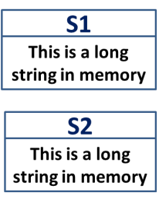
Instead of having each String object contain its own char* string, we could arrange for it to
contain only a pointer to a string. Now, if we assign one String object to another, we need
only copy the pointer from one object to another; both pointers will point to the same string.
This is efficient, since only a single copy of the string itself needs to be stored in memory.
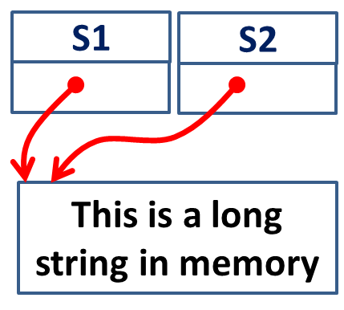
However, if we use this system we need to be careful when we destroy a String object. If a
String’s destructor uses delete to free the memory occupied by the string, and if there are
several objects with pointers pointing to the string, these other objects will be left with pointers
pointing to memory that may no longer hold the string they think it does; they become dangling
pointers.
To use pointers to strings in String objects, we need a way to keep track of how many String
objects point to a particular string, so that we can avoid using delete on the string until the
last String that points to it is itself deleted. Our next example, STRIMEM, does just this.
A String-Counter Class
Suppose we have several String objects pointing to the same string and we want to keep a
count of how many Strings point to the string. Where will we store this count?
It would be cumbersome for every String object to maintain a count of how many of its fellow
Strings were pointing to a particular string, so we don’t want to use a member variable in
String for the count. Could we use a static variable? This is a possibility; we could create a
static array and use it to store a list of string addresses and counts. However, this requires considerable
overhead. It’s more efficient to create a new class to store the count. Each object of
this class, which we call strCount, contains a count and also a pointer to the string itself. Each
String object contains a pointer to the appropriate strCount object. Figure 11.6 shows how
this looks.
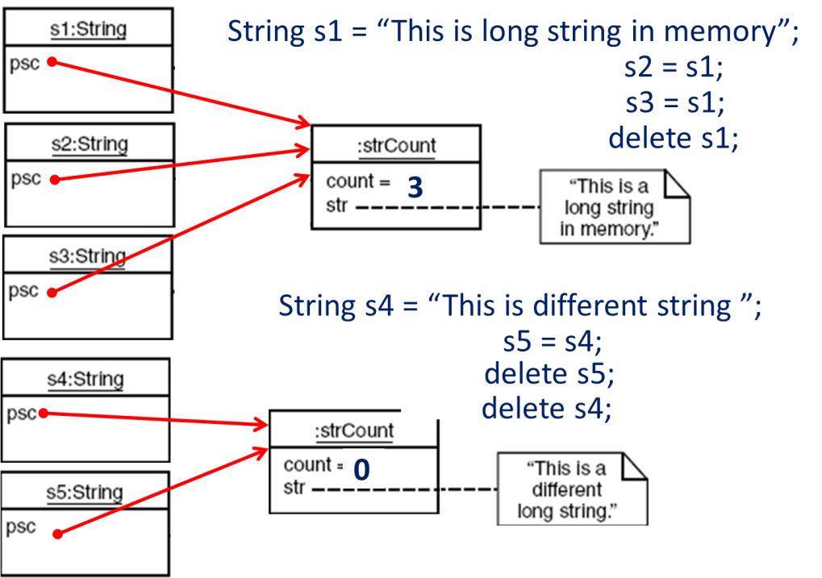
To ensure that String objects have access to strCount objects, we make String a friend of
strCount. Also, we want to ensure that the strCount class is used only by the String class.
To prevent access to any of its functions, we make all member functions of strCount private.
Because String is a friend, it can nevertheless access any part of strCount. Here’s the listing
for STRIMEM:
// strimem.cpp
// memory-saving String class
// overloaded assignment and copy constructor
#include <iostream>
#include <cstring> //for strcpy(), etc.
using namespace std;
////////////////////////////////////////////////////////////////
class strCount //keep track of number
{ //of unique strings
private:
int count; //number of instances
char* str; //pointer to string
friend class String; //make ourselves available
//member functions are private
//--------------------------------------------------------------
strCount(char* s) //one-arg constructor
{
int length = strlen(s); //length of string argument
str = new char[length+1]; //get memory for string
strcpy(str, s); //copy argument to it
count=1; //start count at 1
}
//--------------------------------------------------------------
~strCount() //destructor
{ delete[] str; } //delete the string
};
////////////////////////////////////////////////////////////////
class String //String class
{
private:
strCount* psc; //pointer to strCount
public:
String() //no-arg constructor
{ psc = new strCount(“NULL”); }
//--------------------------------------------------------------
String(char* s) //1-arg constructor
{ psc = new strCount(s); }
//--------------------------------------------------------------
String(String& S) //copy constructor
{
psc = S.psc;
(psc->count)++;
}
//--------------------------------------------------------------
~String() //destructor
{
if(psc->count==1) //if we are its last user,
delete psc; // delete our strCount
else // otherwise,
(psc->count)--; // decrement its count
}
//--------------------------------------------------------------
void display() //display the String
{
cout << psc->str; //print string
cout << “ (addr=” << psc << “)”; //print address
}
//--------------------------------------------------------------
void operator = (String& S) //assign the string
{
if(psc->count==1) //if we are its last user,
delete psc; // delete our strCount
else // otherwise,
(psc->count)--; // decrement its count
psc = S.psc; //use argument’s strCount
(psc->count)++; //increment its count
}
};
////////////////////////////////////////////////////////////////
int main()
{
String s3 = “When the fox preaches, look to your geese.”;
cout << “\ns3=”; s3.display(); //display s3
String s1; //define String
s1 = s3; //assign it another String
cout << “\ns1=”; s1.display(); //display it
String s2(s3); //initialize with String
cout << “\ns2=”; s2.display(); //display it
cout << endl;
return 0;
}
In the main() part of STRIMEM we define a String object, s3, to contain the proverb “When the
fox preaches, look to your geese.” We define another String s1 and set it equal to s3; then we
define s2 and initialize it to s3. Setting s1 equal to s3 invokes the overloaded assignment operator;
initializing s2 to s3 invokes the overloaded copy constructor. We print out all three
strings, and also the address of the strCount object pointed to by each object’s psc pointer, to
show that these objects are all the same. Here’s the output from STRIMEM:
s3=When the fox preaches, look to your geese. (addr=0x8f510e00)
s1=When the fox preaches, look to your geese. (addr=0x8f510e00)
s2=When the fox preaches, look to your geese. (addr=0x8f510e00)
The other duties of the String class are divided between the String and strCount classes.
Let’s see what they do.
The strCount Class
The strCount class contains the pointer to the actual string and the count of how many String
class objects point to this string. Its single constructor takes a pointer to a string as an argument
and creates a new memory area for the string. It copies the string into this area and sets
the count to 1, since just one String points to it when it is created. The destructor in strCount
frees the memory used by the string. (We use delete[] with brackets because a string is an
array.)
The String Class
The String class uses three constructors. If a new string is being created, as in the zeroargument
and C-string-argument constructors, a new strCount object is created to hold the
string, and the psc pointer is set to point to this object. If an existing String object is being
copied, as in the copy constructor and the overloaded assignment operator, the pointer psc is
set to point to the old strCount object, and the count in this object is incremented.
The overloaded assignment operator, as well as the destructor, must also delete the old
strCount object pointed to by psc if the count is 1. (We don’t need brackets on delete
because we’re deleting only a single strCount object.) Why must the assignment operator
worry about deletion? Remember that the String object on the left of the equal sign (call it s1)
was pointing at some strCount object (call it oldStrCnt) before the assignment. After the
assignment s1 will be pointing to the object on the right of the equal sign. If there are now no
String objects pointing to oldStrCnt, it should be deleted. If there are other objects pointing
to it, its count must be decremented.
.
Assignment operator

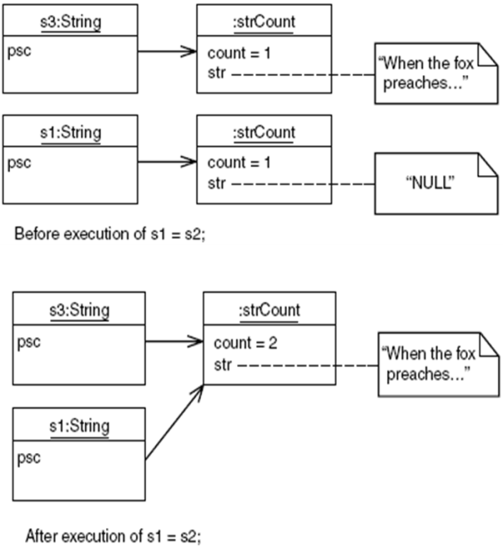

Copy constructor
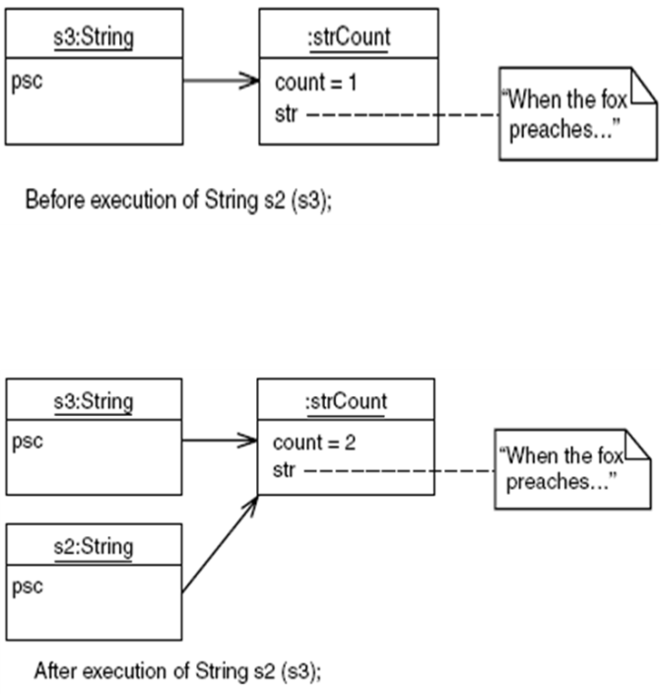
The this Pointer
The member functions of every object have access to a sort of magic pointer named this,
which points to the object itself. Thus any member function can find out the address of the
object of which it is a member. Here’s a short example, WHERE, that shows the mechanism:
// where.cpp
// the this pointer
#include <iostream>
using namespace std;
////////////////////////////////////////////////////////////////
class where
{
private:
char charray[10]; //occupies 10 bytes
public:
void reveal()
{ cout << “\nMy object’s address is “ << this; }
};
////////////////////////////////////////////////////////////////
int main()
{
where w1, w2, w3; //make three objects
w1.reveal(); //see where they are
w2.reveal();
w3.reveal();
cout << endl;
return 0;
}
The main() program in this example creates three objects of type where. It then asks each
object to print its address, using the reveal() member function. This function prints out the
value of the this pointer. Here’s the output:
My object’s address is 0x8f4effec
My object’s address is 0x8f4effe2
My object’s address is 0x8f4effd8
Since the data in each object consists of an array of 10 bytes, the objects are spaced 10 bytes
apart in memory. (EC minus E2 is 10 decimal, as is E2 minus D8.) Some compilers may place
extra bytes in objects, making them slightly larger than 10 bytes.
Accessing Member Data with this
When you call a member function, it comes into existence with the value of this set to the
address of the object for which it was called. The this pointer can be treated like any other
pointer to an object, and can thus be used to access the data in the object it points to, as shown
in the DOTHIS program:
// dothis.cpp
// the this pointer referring to data
#include <iostream>
using namespace std;
////////////////////////////////////////////////////////////////
class what
{
private:
int alpha;
public:
void tester()
{
this->alpha = 11; //same as alpha = 11;
cout << this->alpha; //same as cout << alpha;
}
};
////////////////////////////////////////////////////////////////
int main()
{
what w;
w.tester();
cout << endl;
return 0;
}
This program simply prints out the value 11. Notice that the tester() member function
accesses the variable alpha as
this->alpha
This is exactly the same as referring to alpha directly. This syntax works, but there is no reason
for it except to show that this does indeed point to the object.
Using this for Returning Values
A more practical use for this is in returning values from member functions and overloaded
operators.
Recall that in the ASSIGN program we could not return an object by reference, because the
object was local to the function returning it and thus was destroyed when the function returned.
We need a more permanent object if we’re going to return it by reference. The object of which
a function is a member is more permanent than its individual member functions. An object’s
member functions are created and destroyed every time they’re called, but the object itself
endures until it is destroyed by some outside agency (for example, when it is deleted). Thus
returning by reference the object of which a function is a member is a better bet than returning
a temporary object created in a member function. The this pointer makes this easy.
Here’s the listing for ASSIGN2, in which the operator=() function returns by reference the
object that invoked it:
//assign2.cpp
// returns contents of the this pointer
#include <iostream>
using namespace std;
////////////////////////////////////////////////////////////////
class alpha
{
private:
int data;
public:
alpha() //no-arg constructor
{ }
alpha(int d) //one-arg constructor
{ data = d; }
void display() //display data
{ cout << data; }
alpha& operator = (alpha& a) //overloaded = operator
{
data = a.data; //not done automatically
cout << “\nAssignment operator invoked”;
return *this; //return copy of this alpha
}
};
////////////////////////////////////////////////////////////////
int main()
{
alpha a1(37);
alpha a2, a3;
a3 = a2 = a1; //invoke overloaded =, twice
cout << “\na2=”; a2.display(); //display a2
cout << “\na3=”; a3.display(); //display a3
cout << endl;
return 0;
}
In this program we can use the declaration
alpha& operator = (alpha& a)
which returns by reference, instead of
alpha operator = (alpha& a)
which returns by value. The last statement in this function is
return *this;
Since this is a pointer to the object of which the function is a member, *this is that object
itself, and the statement returns it by reference. Here’s the output of ASSIGN2:
Assignment operator invoked
Assignment operator invoked
a2=37
a3=37
Each time the equal sign is encountered in
a3 = a2 = a1;
the overloaded operator=() function is called, which prints the messages. The three objects all
end up with the same value.
You usually want to return by reference from overloaded assignment operators, using *this, to
avoid the creation of extra objects.
Revised STRIMEM Program
Using the this pointer we can revise the operator=() function in STRIMEM to return a value by
reference, thus making possible multiple assignment operators for String objects, such as
s1 = s2 = s3;
At the same time, we can avoid the creation of spurious objects, such as those that are created
when objects are returned by value. Here’s the listing for STRIMEM2:
// strimem2.cpp
// memory-saving String class
// the this pointer in overloaded assignment
#include <iostream>
#include <cstring> //for strcpy(), etc
using namespace std;
////////////////////////////////////////////////////////////////
class strCount //keep track of number
{ //of unique strings
private:
int count; //number of instances
char* str; //pointer to string
friend class String; //make ourselves available
//member functions are private
strCount(char* s) //one-arg constructor
{
int length = strlen(s); //length of string argument
str = new char[length+1]; //get memory for string
strcpy(str, s); //copy argument to it
count=1; //start count at 1
}
//--------------------------------------------------------------
~strCount() //destructor
{ delete[] str; } //delete the string
};
////////////////////////////////////////////////////////////////
class String //String class
{
private:
strCount* psc; //pointer to strCount
public:
String() //no-arg constructor
{ psc = new strCount(“NULL”); }
//--------------------------------------------------------------
String(char* s) //1-arg constructor
{ psc = new strCount(s); }
//--------------------------------------------------------------
String(String& S) //copy constructor
{
cout << “\nCOPY CONSTRUCTOR”;
psc = S.psc;
(psc->count)++;
}
//--------------------------------------------------------------
~String() //destructor
{
if(psc->count==1) //if we are its last user,
delete psc; // delete our strCount
else // otherwise,
(psc->count)--; // decrement its count
}
//--------------------------------------------------------------
void display() //display the String
{
cout << psc->str; //print string
cout << “ (addr=” << psc << “)”; //print address
}
//--------------------------------------------------------------
String& operator = (String& S) //assign the string
{
cout << “\nASSIGNMENT”;
if(psc->count==1) //if we are its last user,
delete psc; //delete our strCount
else // otherwise,
(psc->count)--; // decrement its count
psc = S.psc; //use argument’s strCount
(psc->count)++; //increment count
return *this; //return this object
}
};
int main()
{
String s3 = “When the fox preaches, look to your geese.”;
cout << “\ns3=”; s3.display(); //display s3
String s1, s2; //define Strings
s1 = s2 = s3; //assign them
cout << “\ns1=”; s1.display(); //display it
cout << “\ns2=”; s2.display(); //display it
cout << endl; //wait for keypress
return 0;
}
Now the declarator for the = operator is
String& operator = (String& S) // return by reference
And, as in ASSIGN2, this function returns a pointer to this. Here’s the output:
s3=When the fox preaches, look to your geese. (addr=0x8f640d3a)
ASSIGNMENT
ASSIGNMENT
s1=When the fox preaches, look to your geese. (addr=0x8f640d3a)
s2=When the fox preaches, look to your geese. (addr=0x8f640d3a)
The output shows that, following the assignment statement, all three String objects point to
the same strCount object.
We should note that the this pointer is not available in static member functions, since they are
not associated with a particular object.
Beware of Self-Assignment
A corollary of Murphy’s Law states that whatever is possible, someone will eventually do. This
is certainly true in programming, so you can expect that if you have overloaded the = operator,
someone will use it to set an object equal to itself:
alpha = alpha;
Your overloaded assignment operator should be prepared to handle such self-assignment.
Otherwise, bad things may happen. For example, in the main() part of the STRIMEM2 program,
if you set a String object equal to itself, the program will crash (unless there are other String
objects using the same strCount object). The problem is that the code for the assignment operator
deletes the strCount object if it thinks the object that called it is the only object using the
strCount. Self-assignment will cause it to believe this, even though nothing should be deleted.
To fix this, you should check for self-assignment at the start of any overloaded assignment
operator. You can do this in most cases by comparing the address of the object for which the
operator was called with the address of its argument. If the addresses are the same, the objects
are identical and you should return immediately. (You don’t need to assign one to the other;
they’re already the same.) For example, in STRIMEM2, you can insert the lines
if(this == &S)
return *this;
at the start of operator=(). That should solve the problem.
Dynamic Type Information
It’s possible to find out information about an object’s class and even change the class of an
object at runtime. We’ll look briefly at two mechanisms: the dynamic_cast operator, and the
typeid operator. These are advanced capabilities, but you may find them useful someday.
These capabilities are usually used in situations where a variety of classes are descended
(sometimes in complicated ways) from a base class. For dynamic casts to work, the base class
must be polymorphic; that is, it must have at least one virtual function.
For both dynamic_cast and typeid to work, your compiler must enable Run-Time Type
Information (RTTI). Borland C++Builder has this capability enabled by default, but in
Microsoft Visual C++ you’ll need to turn it on overtly. See Appendix C, “Microsoft Visual
C++,” for details on how this is done. You’ll also need to include the header file TYPEINFO.
Checking the Type of a Class with dynamic_cast
Suppose some other program sends your program an object (as the operating system might do
with a callback function). It’s supposed to be a certain type of object, but you want to check it
to be sure. How can you tell if an object is a certain type? The dynamic_cast operator provides
a way, assuming that the classes whose objects you want to check are all descended from
a common ancestor. The DYNCAST1 program shows how this looks.
//dyncast1.cpp
//dynamic cast used to test type of object
//RTTI must be enabled in compiler
#include <iostream>
#include <typeinfo> //for dynamic_cast
using namespace std;
////////////////////////////////////////////////////////////////
class Base
{
virtual void vertFunc() //needed for dynamic cast
{ }
};
class Derv1 : public Base
{ };
class Derv2 : public Base
{ };
////////////////////////////////////////////////////////////////
//checks if pUnknown points to a Derv1
bool isDerv1(Base* pUnknown) //unknown subclass of Base
{
Derv1* pDerv1;
if( pDerv1 = dynamic_cast<Derv1*>(pUnknown) )
return true;
else
return false;
}
//--------------------------------------------------------------
int main()
{
Derv1* d1 = new Derv1;
Derv2* d2 = new Derv2;
if( isDerv1(d1) )
cout << “d1 is a member of the Derv1 class\n”;
else
cout << “d1 is not a member of the Derv1 class\n”;
if( isDerv1(d2) )
cout << “d2 is a member of the Derv1 class\n”;
else
cout << “d2 is not a member of the Derv1 class\n”;
return 0;
}
Here we have a base class Base and two derived classes Derv1 and Derv2. There’s also a function,
isDerv1(), which returns true if the pointer it received as an argument points to an object
of class Derv1. This argument is of class Base, so the object passed can be either Derv1 or
Derv2. The dynamic_cast operator attempts to convert this unknown pointer pUnknown to type
Derv1. If the result is not zero, pUnknown did point to a Derv1 object. If the result is zero, it
pointed to something else.
Changing Pointer Types with dynamic_cast
The dynamic_cast operator allows you to cast upward and downward in the inheritance tree.
However, it allows such casting only in limited ways. The DYNCAST2 program shows examples
of such casts.
//dyncast2.cpp
//tests dynamic casts
//RTTI must be enabled in compiler
#include <iostream>
#include <typeinfo> //for dynamic_cast
using namespace std;
////////////////////////////////////////////////////////////////
class Base
{
protected:
int ba;
public:
Base() : ba(0)
{ }
Base(int b) : ba(b)
{ }
virtual void vertFunc() //needed for dynamic_cast
{ }
void show()
{ cout << “Base: ba=” << ba << endl; }
};
////////////////////////////////////////////////////////////////
class Derv : public Base
{
private:
int da;
public:
Derv(int b, int d) : da(d)
{ ba = b; }
void show()
{ cout << “Derv: ba=” << ba << “, da=” << da << endl; }
};
////////////////////////////////////////////////////////////////
int main()
{
Base* pBase = new Base(10); //pointer to Base
Derv* pDerv = new Derv(21, 22); //pointer to Derv
//derived-to-base: upcast -- points to Base subobject of Derv
pBase = dynamic_cast<Base*>(pDerv);
pBase->show(); //”Base: ba=21”
pBase = new Derv(31, 32); //normal
//base-to-derived: downcast -- (pBase must point to a Derv)
pDerv = dynamic_cast<Derv*>(pBase);
pDerv->show(); //”Derv: ba=31, da=32”
return 0;
}
Here we have a base and a derived class. We’ve given each of these classes a data item to better
demonstrate the effects of dynamic casts.
In an upcast you attempt to change a derived-class object into a base-class object. What you
get is the base part of the derived class object. In the example we make an object of class Derv.
The base class part of this object holds member data ba, which has a value of 21, and the
derived part holds data member da, which has the value 22. After the cast, pBase points to the
base-class part of this Derv class object, so when called upon to display itself, it prints Base:
ba=21. Upcasts are fine if all you want is the base part of the object.
In a downcast we put a derived class object, which is pointed to by a base-class pointer, into a
derived-class pointer.
The typeid Operator
Sometimes you want more information about an object than simple verification that it’s of a
certain class. You can obtain information about the type of an unknown object, such as its class
name, using the typeid operator. The TYPEID program demonstrates how it works.
// typeid.cpp
// demonstrates typeid() function
// RTTI must be enabled in compiler
#include <iostream>
#include <typeinfo> //for typeid()
using namespace std;
////////////////////////////////////////////////////////////////
class Base
{
virtual void virtFunc() //needed for typeid
{ }
};
class Derv1 : public Base
{ };
class Derv2 : public Base
{ };
////////////////////////////////////////////////////////////////
void displayName(Base* pB)
{
cout << “pointer to an object of “; //display name of class
cout << typeid(*pB).name() << endl; //pointed to by pB
}
//--------------------------------------------------------------
int main()
{
Base* pBase = new Derv1;
displayName(pBase); //”pointer to an object of class Derv1”
pBase = new Derv2;
displayName(pBase); //”pointer to an object of class Derv2”
return 0;
}
In this example the displayName() function displays the name of the class of the object passed
to it. To do this, it uses the name member of the type_info class, along with the typeid operator.
In main() we pass this function two objects of class Derv1 and Derv2 respectively, and the
program’s output is
pointer to an object of class Derv1
pointer to an object of class Derv2
Besides its name, other information about a class is available using typeid. For example, you
can check for equality of classes using an overloaded == operator. We’ll show an example of
this in the EMPL_IO program in Chapter 12, “Streams and Files.” Although the examples in this
section have used pointers, dynamic_cast and typeid work equally well with references.

