Inheritance
Inheritance is probably the most powerful feature of object-oriented programming, after classes
themselves. Inheritance is the process of creating new classes, called derived classes, from
existing or base classes. The derived class inherits all the capabilities of the base class but
can add embellishments and refinements of its own. The base class is unchanged by this
process.
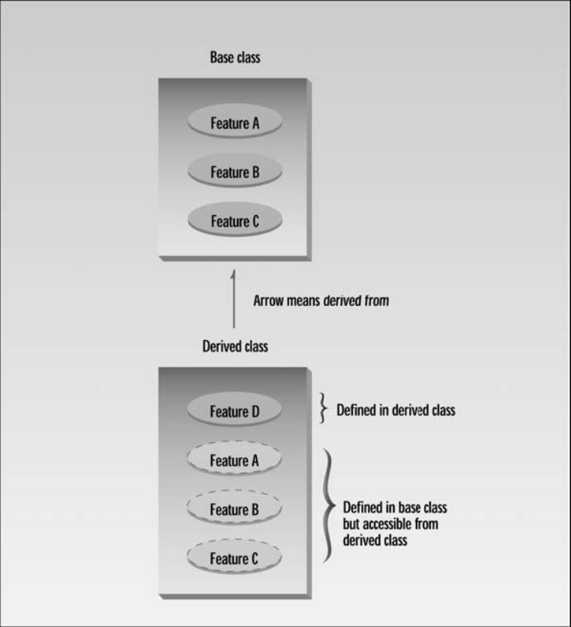
The arrow in Figure goes in the opposite direction of what you might expect. If it pointed
down we would label it inheritance. However, the more common approach is to point the
arrow up, from the derived class to the base class, and to think of it as a “derived from” arrow.
Inheritance is an essential part of OOP. Its big payoff is that it permits code reusability. Once
a base class is written and debugged, it need not be touched again, but, using inheritance, can
nevertheless be adapted to work in different situations. Reusing existing code saves time and
money and increases a program’s reliability. Inheritance can also help in the original conceptualization
of a programming problem, and in the overall design of the program.
An important result of reusability is the ease of distributing class libraries. A programmer can
use a class created by another person or company, and, without modifying it, derive other
classes from it that are suited to particular situations.
We’ll examine these features of inheritance in more detail after we’ve seen some specific
instances of inheritance at work.
Derived Class and Base Class
Remember the COUNTPP3 example from Chapter 8, “Operator Overloading”? This program
used a class Counter as a general-purpose counter variable. A count could be initialized to 0 or
to a specified number with constructors, incremented with the ++ operator, and read with the
get_count() operator.
Let’s suppose that we have worked long and hard to make the Counter class operate just the
way we want, and we’re pleased with the results, except for one thing. We really need a way to
decrement the count. Perhaps we’re counting people entering a bank, and we want to increment
the count when they come in and decrement it when they go out, so that the count represents
the number of people in the bank at any moment.
We could insert a decrement routine directly into the source code of the Counter class. However,
there are several reasons that we might not want to do this. First, the Counter class works very
well and has undergone many hours of testing and debugging. (Of course that’s an exaggeration
in this case, but it would be true in a larger and more complex class.) If we start fooling around
with the source code for Counter, the testing process will need to be carried out again, and of
course we may foul something up and spend hours debugging code that worked fine before we
modified it.
In some situations there might be another reason for not modifying the Counter class: We
might not have access to its source code, especially if it was distributed as part of a class
library. (We’ll discuss this issue further in Chapter 13, “Multifile Programs.”)
To avoid these problems we can use inheritance to create a new class based on Counter, without
modifying Counter itself. Here’s the listing for COUNTEN, which includes a new class, CountDn,
that adds a decrement operator to the Counter class:
// counten.cpp
// inheritance with Counter class
#include <iostream>
using namespace std;
////////////////////////////////////////////////////////////////
class Counter //base class
{
protected: //NOTE: not private
unsigned int count; //count
public:
Counter() : count(0) //no-arg constructor
{ }
Counter(int c) : count(c) //1-arg constructor
{ }
unsigned int get_count() const //return count
{ return count; }
Counter operator ++ () //incr count (prefix)
{ return Counter(++count); }
};
////////////////////////////////////////////////////////////////
class CountDn : public Counter //derived class
{
public:
Counter operator -- () //decr count (prefix)
{ return Counter(--count); }
};
////////////////////////////////////////////////////////////////
int main()
{
CountDn c1; //c1 of class CountDn
cout << “\nc1=” << c1.get_count(); //display c1
++c1; ++c1; ++c1; //increment c1, 3 times
cout << “\nc1=” << c1.get_count(); //display it
--c1; --c1; //decrement c1, twice
cout << “\nc1=” << c1.get_count(); //display it
cout << endl;
return 0;
}
The listing starts off with the Counter class, which (with one small exception, which we’ll
look at later) has not changed since its appearance in COUNTPP3. Notice that, for simplicity,
we haven’t modeled this program on the POSTFIX program, which incorporated the second
overloaded ++ operator to provide postfix notation.
Specifying the Derived Class
Following the Counter class in the listing is the specification for a new class, CountDn. This
class incorporates a new function, operator--(), which decrements the count. However—and
here’s the key point—the new CountDn class inherits all the features of the Counter class.
CountDn doesn’t need a constructor or the get_count() or operator++() functions, because
these already exist in Counter.
The first line of CountDn specifies that it is derived from Counter:
class CountDn : public Counter
Here we use a single colon (not the double colon used for the scope resolution operator),
followed by the keyword public and the name of the base class Counter. This sets up the
relationship between the classes. This line says that CountDn is derived from the base class
Counter. (We’ll explore the effect of the keyword public later.)
Generalization in UML Class Diagrams
In the UML, inheritance is called generalization, because the parent class is a more general form
of the child class. Or to put it another way, the child is more specific version of the parent. (We
introduced the UML in Chapter 1, “The Big Picture,” and encountered class diagrams in Chapter
8, “Operator Overloading.”) The generalization in the COUNTEN program is shown in Figure 9.2.
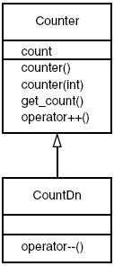
In UML class diagrams, generalization is indicated by a triangular arrowhead on the line
connecting the parent and child classes. Remember that the arrow means inherited from or
derived from or is a more specific version of. The direction of the arrow emphasizes that the
derived class refers to functions and data in the base class, while the base class has no access
to the derived class.
Notice that we’ve added attributes (member data) and operations (member functions) to the
classes in the diagram. The top area holds the class title, the middle area holds attributes, and
the bottom area is for operations.
Accessing Base Class Members
An important topic in inheritance is knowing when a member function in the base class can be
used by objects of the derived class. This is called accessibility. Let’s see how the compiler
handles the accessibility issue in the COUNTEN example.
Substituting Base Class Constructors
In the main() part of COUNTEN we create an object of class CountDn:
CountDn c1;
This causes c1 to be created as an object of class CountDn and initialized to 0. But wait—how
is this possible? There is no constructor in the CountDn class specifier, so what entity carries
out the initialization? It turns out that—at least under certain circumstances—if you don’t specify
a constructor, the derived class will use an appropriate constructor from the base class. In
COUNTEN there’s no constructor in CountDn, so the compiler uses the no-argument constructor
from Count.
This flexibility on the part of the compiler—using one function because another isn’t available—
appears regularly in inheritance situations. Generally, the substitution is what you want, but
sometimes it can be unnerving.
Substituting Base Class Member Functions
The object c1 of the CountDn class also uses the operator++() and get_count() functions
from the Counter class. The first is used to increment c1:
++c1;
The second is used to display the count in c1:
cout << “\nc1=” << c1.get_count();
Again the compiler, not finding these functions in the class of which c1 is a member, uses
member functions from the base class.
Output of COUNTEN
In main() we increment c1 three times, print out the resulting value, decrement c1 twice, and
finally print out its value again. Here’s the output:
c1=0 ← after initialization
c1=3 ← after ++c1, ++c1, ++c1
c1=1 ← after --c1, --c1
The ++ operator, the constructors, the get_count() function in the Counter class, and the --
operator in the CountDn class all work with objects of type CountDn.
The protected Access Specifier
We have increased the functionality of a class without modifying it. Well, almost without
modifying it. Let’s look at the single change we made to the Counter class.
The data in the classes we’ve looked at so far, including count in the Counter class in the earlier
COUNTPP3 program, have used the private access specifier.
In the Counter class in COUNTEN, count is given a new specifier: protected. What does this do?
Let’s first review what we know about the access specifiers private and public. A member
function of a class can always access class members, whether they are public or private. But an
object declared externally can only invoke (using the dot operator, for example) public members
of the class. It’s not allowed to use private members. For instance, suppose an object objA is an
instance of class A, and function funcA() is a member function of A. Then in main() (or any
other function that is not a member of A) the statement
objA.funcA();
will not be legal unless funcA() is public. The object objA cannot invoke private members of
class A. Private members are, well, private.
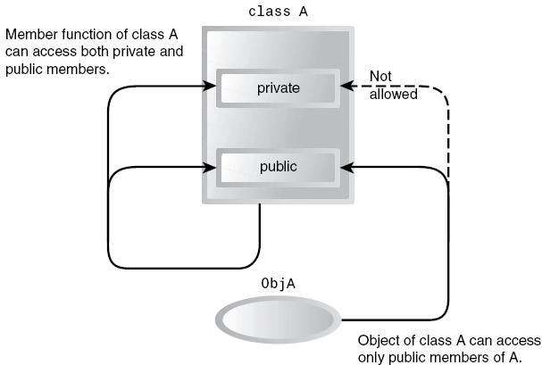

This is all we need to know if we don’t use inheritance. With inheritance, however, there is a
whole raft of additional possibilities. The question that concerns us at the moment is, can
member functions of the derived class access members of the base class? In other words, can
operator--() in CountDn access count in Counter? The answer is that member functions can
access members of the base class if the members are public, or if they are protected. They
can’t access private members.
We don’t want to make count public, since that would allow it to be accessed by any function
anywhere in the program and eliminate the advantages of data hiding. A protected member,
on the other hand, can be accessed by member functions in its own class or—and here’s the
key—in any class derived from its own class. It can’t be accessed from functions outside these
classes, such as main(). This is just what we want.

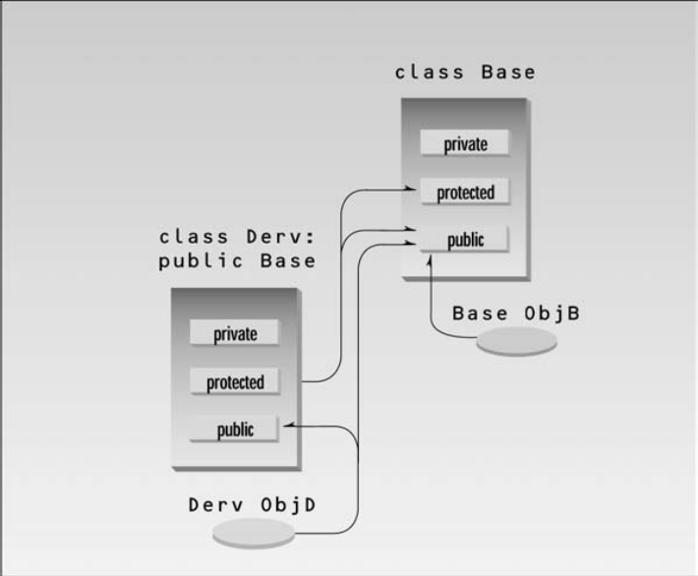
The moral is that if you are writing a class that you suspect might be used, at any point in the
future, as a base class for other classes, then any member data that the derived classes might
need to access should be made protected rather than private. This ensures that the class is
“inheritance ready.”

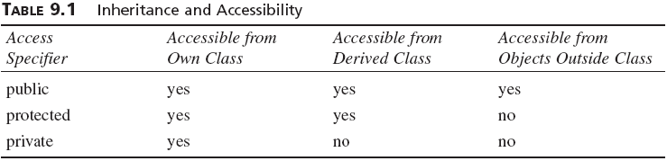

Dangers of protected
You should know that there’s a disadvantage to making class members protected. Say you’ve
written a class library, which you’re distributing to the public. Any programmer who buys this
library can access protected members of your classes simply by deriving other classes from
them. This makes protected members considerably less secure than private members. To avoid
corrupted data, it’s often safer to force derived classes to access data in the base class using
only public functions in the base class, just as ordinary main() programs must do. Using the
protected specifier leads to simpler programming, so we rely on it—perhaps a bit too much—
in the examples in this book. You’ll need to weigh the advantages of protected against its
disadvantages in your own programs.
Base Class Unchanged
Remember that, even if other classes have been derived from it, the base class remains
unchanged. In the main() part of COUNTEN, we could define objects of type Counter:
Counter c2; ← object of base class
Such objects would behave just as they would if CountDn didn’t exist.
Note also that inheritance doesn’t work in reverse. The base class and its objects don’t know
anything about any classes derived from the base class. In this example that means that objects
of class Counter, such as c2, can’t use the operator--() function in CountDn. If you want a
counter that you can decrement, it must be of class CountDn, not Counter.

Derived Class Constructors
There’s a potential glitch in the COUNTEN program. What happens if we want to initialize a
CountDn object to a value? Can the one-argument constructor in Counter be used? The answer
is no. As we saw in COUNTEN, the compiler will substitute a no-argument constructor from the base
class, but it draws the line at more complex constructors. To make such a definition work we must
write a new set of constructors for the derived class. This is shown in the COUNTEN2 program.
// counten2.cpp
// constructors in derived class
#include <iostream>
using namespace std;
////////////////////////////////////////////////////////////////
class Counter
{
protected: //NOTE: not private
unsigned int count; //count
public:
Counter() : count() //constructor, no args
{ }
Counter(int c) : count(c) //constructor, one arg
{ }
unsigned int get_count() const //return count
{ return count; }
Counter operator ++ () //incr count (prefix)
{ return Counter(++count); }
};
////////////////////////////////////////////////////////////////
class CountDn : public Counter
{
public:
CountDn() : Counter() //constructor, no args
{ }
CountDn(int c) : Counter(c) //constructor, 1 arg
{ }
CountDn operator -- () //decr count (prefix)
{ return CountDn(--count); }
};
////////////////////////////////////////////////////////////////
int main()
{
CountDn c1; //class CountDn
CountDn c2(100);
cout << “\nc1=” << c1.get_count(); //display
cout << “\nc2=” << c2.get_count(); //display
++c1; ++c1; ++c1; //increment c1
cout << “\nc1=” << c1.get_count(); //display it
--c2; --c2; //decrement c2
cout << “\nc2=” << c2.get_count(); //display it
CountDn c3 = --c2; //create c3 from c2
cout << “\nc3=” << c3.get_count(); //display c3
cout << endl;
return 0;
}
This program uses two new constructors in the CountDn class. Here is the no-argument constructor:
CountDn() : Counter()
{ }
This constructor has an unfamiliar feature: the function name following the colon. This
construction causes the CountDn() constructor to call the Counter() constructor in the base
class. In main(), when we say
CountDn c1;
the compiler will create an object of type CountDn and then call the CountDn constructor to
initialize it. This constructor will in turn call the Counter constructor, which carries out the
work. The CountDn() constructor could add additional statements of its own, but in this case
it doesn’t need to, so the function body between the braces is empty.
Calling a constructor from the initialization list may seem odd, but it makes sense. You want
to initialize any variables, whether they’re in the derived class or the base class, before any
statements in either the derived or base-class constructors are executed. By calling the baseclass
constructor before the derived-class constructor starts to execute, we accomplish this.
The statement
CountDn c2(100);
in main() uses the one-argument constructor in CountDn. This constructor also calls the
corresponding one-argument constructor in the base class:
CountDn(int c) : Counter(c) ← argument c is passed to Counter
{ }
This construction causes the argument c to be passed from CountDn() to Counter(), where it
is used to initialize the object.
In main(), after initializing the c1 and c2 objects, we increment one and decrement the other
and then print the results. The one-argument constructor is also used in an assignment statement.
CountDn c3 = --c2;
Overriding Member Functions
You can use member functions in a derived class that override—that is, have the same name
as—those in the base class. You might want to do this so that calls in your program work the
same way for objects of both base and derived classes.
Here’s an example based on the STAKARAY program from Chapter 7, “Arrays and Strings.” That
program modeled a stack, a simple data storage device. It allowed you to push integers onto
the stack and pop them off. However, STAKARAY had a potential flaw. If you tried to push too
many items onto the stack, the program might bomb, since data would be placed in memory
beyond the end of the st[] array. Or if you tried to pop too many items, the results would be
meaningless, since you would be reading data from memory locations outside the array.
To cure these defects we’ve created a new class, Stack2, derived from Stack. Objects of
Stack2 behave in exactly the same way as those of Stack, except that you will be warned if
you attempt to push too many items on the stack or if you try to pop an item from an empty
stack. Here’s the listing for STAKEN:
// staken.cpp
// overloading functions in base and derived classes
#include <iostream>
using namespace std;
#include <process.h> //for exit()
////////////////////////////////////////////////////////////////
class Stack
{
protected: //NOTE: can’t be private
enum { MAX = 3 }; //size of stack array
int st[MAX]; //stack: array of integers
int top; //index to top of stack
public:
Stack() //constructor
{ top = -1; }
void push(int var) //put number on stack
{ st[++top] = var; }
int pop() //take number off stack
{ return st[top--]; }
};
////////////////////////////////////////////////////////////////
class Stack2 : public Stack
{
public:
void push(int var) //put number on stack
{
if(top >= MAX-1) //error if stack full
{ cout << “\nError: stack is full”; exit(1); }
Stack::push(var); //call push() in Stack class
}
int pop() //take number off stack
{
if(top < 0) //error if stack empty
{ cout << “\nError: stack is empty\n”; exit(1); }
return Stack::pop(); //call pop() in Stack class
}
};
////////////////////////////////////////////////////////////////
int main()
{
Stack2 s1;
s1.push(11); //push some values onto stack
s1.push(22);
s1.push(33);
cout << endl << s1.pop(); //pop some values from stack
cout << endl << s1.pop();
cout << endl << s1.pop();
cout << endl << s1.pop(); //oops, popped one too many...
cout << endl;
return 0;
}
In this program the Stack class is just the same as it was in the STAKARAY program, except that
the data members have been made protected.
Which Function Is Used?
The Stack2 class contains two functions, push() and pop(). These functions have the same
names, and the same argument and return types, as the functions in Stack. When we call these
functions from main(), in statements like
s1.push(11);
how does the compiler know which of the two push() functions to use? Here’s the rule: When
the same function exists in both the base class and the derived class, the function in the derived
class will be executed. (This is true of objects of the derived class. Objects of the base class
don’t know anything about the derived class and will always use the base class functions.) We
say that the derived class function overrides the base class function. So in the preceding statement,
since s1 is an object of class Stack2, the push() function in Stack2 will be executed,
not the one in Stack.
The push() function in Stack2 checks to see whether the stack is full. If it is, it displays an
error message and causes the program to exit. If it isn’t, it calls the push() function in Stack.
Similarly, the pop() function in Stack2 checks to see whether the stack is empty. If it is, it
prints an error message and exits; otherwise, it calls the pop() function in Stack.
In main() we push three items onto the stack, but we pop four. The last pop elicits an error
message
33
22
11
Error: stack is empty
and terminates the program.
Scope Resolution with Overridden Functions
How do push() and pop() in Stack2 access push() and pop() in Stack? They use the scope
resolution operator, ::, in the statements
Stack::push(var);
and
return Stack::pop();
These statements specify that the push() and pop() functions in Stack are to be called. Without
the scope resolution operator, the compiler would think the push() and pop() functions in
Stack2 were calling themselves, which—in this case—would lead to program failure. Using the
scope resolution operator allows you to specify exactly what class the function is a member of.
Inheritance in the English Distance Class
Here’s a somewhat more complex example of inheritance. So far in this book the various programs
that used the English Distance class assumed that the distances to be represented would
always be positive. This is usually the case in architectural drawings. However, if we were
measuring, say, the water level of the Pacific Ocean as the tides varied, we might want to be
able to represent negative feet-and-inches quantities. (Tide levels below mean-lower-low-water
are called minus tides; they prompt clam diggers to take advantage of the larger area of exposed
beach.)
Let’s derive a new class from Distance. This class will add a single data item to our feet-andinches
measurements: a sign, which can be positive or negative. When we add the sign, we’ll
also need to modify the member functions so they can work with signed distances. Here’s the
listing for ENGLEN:
// englen.cpp
// inheritance using English Distances
#include <iostream>
using namespace std;
enum posneg { pos, neg }; //for sign in DistSign
////////////////////////////////////////////////////////////////
class Distance //English Distance class
{
protected: //NOTE: can’t be private
int feet;
float inches;
public: //no-arg constructor
Distance() : feet(0), inches(0.0)
{ } //2-arg constructor)
Distance(int ft, float in) : feet(ft), inches(in)
{ }
void getdist() //get length from user
{
cout << “\nEnter feet: “; cin >> feet;
cout << “Enter inches: “; cin >> inches;
}
void showdist() const //display distance
{ cout << feet << “\’-” << inches << ‘\”’; }
};
////////////////////////////////////////////////////////////////
class DistSign : public Distance //adds sign to Distance
{
private:
posneg sign; //sign is pos or neg
public:
//no-arg constructor
DistSign() : Distance() //call base constructor
{ sign = pos; } //set the sign to +
//2- or 3-arg constructor
DistSign(int ft, float in, posneg sg=pos) :
Distance(ft, in) //call base constructor
{ sign = sg; } //set the sign
void getdist() //get length from user
{
Distance::getdist(); //call base getdist()
char ch; //get sign from user
cout << “Enter sign (+ or -): “; cin >> ch;
sign = (ch==’+’) ? pos : neg;
}
void showdist() const //display distance
{
cout << ( (sign==pos) ? “(+)” : “(-)” ); //show sign
Distance::showdist(); //ft and in
}
};
////////////////////////////////////////////////////////////////
int main()
{
DistSign alpha; //no-arg constructor
alpha.getdist(); //get alpha from user
DistSign beta(11, 6.25); //2-arg constructor
DistSign gamma(100, 5.5, neg); //3-arg constructor
//display all distances
cout << “\nalpha = “; alpha.showdist();
cout << “\nbeta = “; beta.showdist();
cout << “\ngamma = “; gamma.showdist();
cout << endl;
return 0;
}
Here the DistSign class adds the functionality to deal with signed numbers. The Distance
class in this program is just the same as in previous programs, except that the data is protected.
Actually in this case it could be private, because none of the derived-class functions accesses
it. However, it’s safer to make it protected so that a derived-class function could access it if
necessary.
Operation of ENGLEN
The main() program declares three different signed distances. It gets a value for alpha from
the user and initializes beta to (+)11'–6.25'' and gamma to (–)100'–5.5''. In the output we use
parentheses around the sign to avoid confusion with the hyphen separating feet and inches. Here’s
some sample output:
Enter feet: 6
Enter inches: 2.5
Enter sign (+ or -): -
alpha = (-)6’-2.5”
beta = (+)11’-6.25”
gamma = (-)100’-5.5”
The DistSign class is derived from Distance. It adds a single variable, sign, which is of type
posneg. The sign variable will hold the sign of the distance. The posneg type is defined in an
enum statement to have two possible values: pos and neg.
Constructors in DistSign
DistSign has two constructors, mirroring those in Distance. The first takes no arguments,
the second takes either two or three arguments. The third, optional, argument in the second
constructor is a sign, either pos or neg. Its default value is pos. These constructors allow us to
define variables (objects) of type DistSign in several ways.
Both constructors in DistSign call the corresponding constructors in Distance to set the feetand-
inches values. They then set the sign variable. The no-argument constructor always sets it
to pos. The second constructor sets it to pos if no third-argument value has been provided, or
to a value (pos or neg) if the argument is specified.
The arguments ft and in, passed from main() to the second constructor in DistSign, are simply
forwarded to the constructor in Distance.
Member Functions in DistSign
Adding a sign to Distance has consequences for both of its member functions. The getdist()
function in the DistSign class must ask the user for the sign as well as for feet-and-inches
values, and the showdist() function must display the sign along with the feet and inches. These
functions call the corresponding functions in Distance, in the lines
Distance::getdist();
and
Distance::showdist();
These calls get and display the feet and inches values. The body of getdist() and showdist()
in DistSign then go on to deal with the sign.
Class Hierarchies
In the examples so far in this chapter, inheritance has been used to add functionality to an
existing class. Now let’s look at an example where inheritance is used for a different purpose:
as part of the original design of a program.
Our example models a database of employees of a widget company. We’ve simplified the situation
so that only three kinds of employees are represented. Managers manage, scientists perform
research to develop better widgets, and laborers operate the dangerous widget-stamping presses.
The database stores a name and an employee identification number for all employees, no matter
what their category. However, for managers, it also stores their titles and golf club dues. For
scientists, it stores the number of scholarly articles they have published. Laborers need no
additional data beyond their names and numbers.
Our example program starts with a base class employee. This class handles the employee’s last
name and employee number. From this class three other classes are derived: manager, scientist,
and laborer. The manager and scientist classes contain additional information about these
categories of employee, and member functions to handle this information.

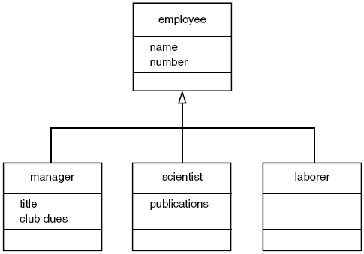

Here’s the listing for EMPLOY:
// employ.cpp
// models employee database using inheritance
#include <iostream>
using namespace std;
const int LEN = 80; //maximum length of names
////////////////////////////////////////////////////////////////
class employee //employee class
{
private:
char name[LEN]; //employee name
unsigned long number; //employee number
public:
void getdata()
{
cout << “\n Enter last name: “; cin >> name;
cout << “ Enter number: “; cin >> number;
}
void putdata() const
{
cout << “\n Name: “ << name;
cout << “\n Number: “ << number;
}
};
////////////////////////////////////////////////////////////////
class manager : public employee //management class
{
private:
char title[LEN]; //”vice-president” etc.
double dues; //golf club dues
public:
void getdata()
{
employee::getdata();
cout << “ Enter title: “; cin >> title;
cout << “ Enter golf club dues: “; cin >> dues;
}
void putdata() const
{
employee::putdata();
cout << “\n Title: “ << title;
cout << “\n Golf club dues: “ << dues;
}
};
////////////////////////////////////////////////////////////////
class scientist : public employee //scientist class
{
private:
int pubs; //number of publications
public:
void getdata()
{
employee::getdata();
cout << “ Enter number of pubs: “; cin >> pubs;
}
void putdata() const
{
employee::putdata();
cout << “\n Number of publications: “ << pubs;
}
};
////////////////////////////////////////////////////////////////
class laborer : public employee //laborer class
{
};
////////////////////////////////////////////////////////////////
int main()
{
manager m1, m2;
scientist s1;
laborer l1;
cout << endl; //get data for several employees
cout << “\nEnter data for manager 1”;
m1.getdata();
cout << “\nEnter data for manager 2”;
m2.getdata();
cout << “\nEnter data for scientist 1”;
s1.getdata();
cout << “\nEnter data for laborer 1”;
l1.getdata();
//display data for several employees
cout << “\nData on manager 1”;
m1.putdata();
cout << “\nData on manager 2”;
m2.putdata();
cout << “\nData on scientist 1”;
s1.putdata();
cout << “\nData on laborer 1”;
l1.putdata();
cout << endl;
return 0;
}
The main() part of the program declares four objects of different classes: two managers, a
scientist, and a laborer. (Of course many more employees of each type could be defined, but
the output would become rather large.) It then calls the getdata() member functions to obtain
information about each employee, and the putdata() function to display this information.
Here’s a sample interaction with EMPLOY. First the user supplies the data.
Enter data for manager 1
Enter last name: Wainsworth
Enter number: 10
Enter title: President
Enter golf club dues: 1000000
Enter data on manager 2
Enter last name: Bradley
Enter number: 124
Enter title: Vice-President
Enter golf club dues: 500000
Enter data for scientist 1
Enter last name: Hauptman-Frenglish
Enter number: 234234
Enter number of pubs: 999
Enter data for laborer 1
Enter last name: Jones
Enter number: 6546544
The program then plays it back.
Data on manager 1
Name: Wainsworth
Number: 10
Title: President
Golf club dues: 1000000
Data on manager 2
Name: Bradley
Number: 124
Title: Vice-President
Golf club dues: 500000
Data on scientist 1
Name: Hauptman-Frenglish
Number: 234234
Number of publications: 999
Data on laborer 1
Name: Jones
Number: 6546544
A more sophisticated program would use an array or some other container to arrange the data
so that a large number of employee objects could be accommodated.
“Abstract” Base Class
Notice that we don’t define any objects of the base class employee. We use this as a general
class whose sole purpose is to act as a base from which other classes are derived.
The laborer class operates identically to the employee class, since it contains no additional
data or functions. It may seem that the laborer class is unnecessary, but by making it a separate
class we emphasize that all classes are descended from the same source, employee. Also, if in
the future we decided to modify the laborer class, we would not need to change the declaration
for employee.
Classes used only for deriving other classes, as employee is in EMPLOY, are sometimes loosely
called abstract classes, meaning that no actual instances (objects) of this class are created.
However, the term abstract has a more precise definition that we’ll look at in Chapter 11,
“Virtual Functions.”
Constructors and Member Functions
There are no constructors in either the base or derived classes, so the compiler creates objects
of the various classes automatically when it encounters definitions like
manager m1, m2;
using the default constructor for manager calling the default constructor for employee.
The getdata() and putdata() functions in employee accept a name and number from the
user and display a name and number. Functions also called getdata() and putdata() in the
manager and scientist classes use the functions in employee, and also do their own work.
In manager, the getdata() function asks the user for a title and the amount of golf club dues,
and putdata() displays these values. In scientist, these functions handle the number of
publications.
Public and Private Inheritance
C++ provides a wealth of ways to fine-tune access to class members. One such access-control
mechanism is the way derived classes are declared. Our examples so far have used publicly
derived classes, with declarations like
class manager : public employee
which appeared in the EMPLOY example.
What is the effect of the public keyword in this statement, and what are the alternatives?
Listen up: The keyword public specifies that objects of the derived class are able to access
public member functions of the base class. The alternative is the keyword private. When this
keyword is used, objects of the derived class cannot access public member functions of the
base class. Since objects can never access private or protected members of a class, the result
is that no member of the base class is accessible to objects of the derived class.
Access Combinations
There are so many possibilities for access that it’s instructive to look at an example program
that shows what works and what doesn’t. Here’s the listing for PUBPRIV:
// pubpriv.cpp
// tests publicly- and privately-derived classes
#include <iostream>
using namespace std;
////////////////////////////////////////////////////////////////
class A //base class
{
private:
int privdataA; //(functions have the same access
protected: //rules as the data shown here)
int protdataA;
public:
int pubdataA;
};
////////////////////////////////////////////////////////////////
class B : public A //publicly-derived class
{
public:
void funct()
{
int a;
a = privdataA; //error: not accessible
a = protdataA; //OK
a = pubdataA; //OK
}
};
////////////////////////////////////////////////////////////////
class C : private A //privately-derived class
{
public:
void funct()
{
int a;
a = privdataA; //error: not accessible
a = protdataA; //OK
a = pubdataA; //OK
}
};
////////////////////////////////////////////////////////////////
int main()
{
int a;
B objB;
a = objB.privdataA; //error: not accessible
a = objB.protdataA; //error: not accessible
a = objB.pubdataA; //OK (A public to B)
C objC;
a = objC.privdataA; //error: not accessible
a = objC.protdataA; //error: not accessible
a = objC.pubdataA; //error: not accessible (A private to C)
return 0;
}
The program specifies a base class, A, with private, protected, and public data items. Two
classes, B and C, are derived from A. B is publicly derived and C is privately derived.
As we’ve seen before, functions in the derived classes can access protected and public data in
the base class. Objects of the derived classes cannot access private or protected members of the
base class.
What’s new is the difference between publicly derived and privately derived classes. Objects of
the publicly derived class B can access public members of the base class A, while objects of the
privately derived class C cannot; they can only access the public members of their own derived
class.

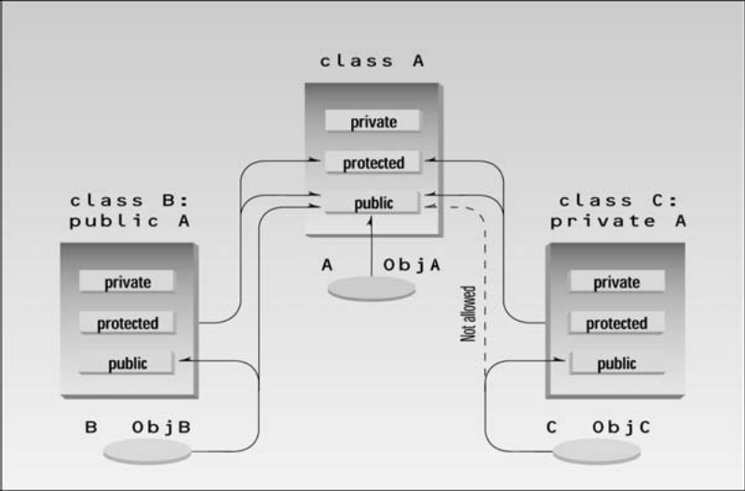
Access Specifiers: When to Use What
How do you decide when to use private as opposed to public inheritance? In most cases a
derived class exists to offer an improved—or a more specialized—version of the base class.
We’ve seen examples of such derived classes (for instance, the CountDn class that adds the
decrement operator to the Counter class and the manager class that is a more specialized version
of the employee class). In such cases it makes sense for objects of the derived class to
access the public functions of the base class if they want to perform a basic operation, and to
access functions in the derived class to perform the more specialized operations that the
derived class provides. In such cases public derivation is appropriate.
In some situations, however, the derived class is created as a way of completely modifying the
operation of the base class, hiding or disguising its original interface. For example, imagine
that you have already created a really nice Array class that acts like an array but provides
protection against out-of-bounds array indexes. Then suppose you want to use this Array class
as the basis for a Stack class, instead of using a basic array. You might derive Stack from
Array, but you wouldn’t want the users of Stack objects to treat them as if they were arrays,
using the [] operator to access data items, for example. Objects of Stack should always be
treated as if they were stacks, using push() and pop(). That is, you want to disguise the Array
class as a Stack class. In this situation, private derivation would allow you to conceal all the
Array class functions from objects of the derived Stack class.
Levels of Inheritance
Classes can be derived from classes that are themselves derived. Here’s a miniprogram that
shows the idea:
class A
{ };
class B : public A
{ };
class C : public B
{ };
Here B is derived from A, and C is derived from B. The process can be extended to an arbitrary
number of levels—D could be derived from C, and so on.
As a more concrete example, suppose that we decided to add a special kind of laborer called a
foreman to the EMPLOY program. We’ll create a new program, EMPLOY2, that incorporates
objects of class foreman.
Since a foreman is a kind of laborer, the foreman class is derived from the laborer class.

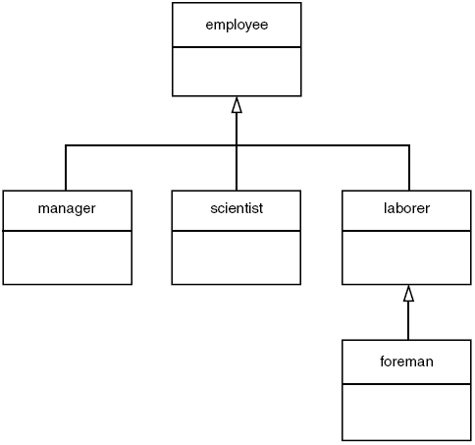
Foremen oversee the widget-stamping operation, supervising groups of laborers. They are
responsible for the widget production quota for their group. A foreman’s ability is measured by
the percentage of production quotas successfully met. The quotas data item in the foreman
class represents this percentage. Here’s the listing for EMPLOY2:
// employ2.cpp
// multiple levels of inheritance
#include <iostream>
using namespace std;
const int LEN = 80; //maximum length of names
////////////////////////////////////////////////////////////////
class employee
{
private:
char name[LEN]; //employee name
unsigned long number; //employee number
public:
void getdata()
{
cout << “\n Enter last name: “; cin >> name;
cout << “ Enter number: “; cin >> number;
}
void putdata() const
{
cout << “\n Name: “ << name;
cout << “\n Number: “ << number;
}
};
////////////////////////////////////////////////////////////////
class manager : public employee //manager class
{
private:
char title[LEN]; //”vice-president” etc.
double dues; //golf club dues
public:
void getdata()
{
employee::getdata();
cout << “ Enter title: “; cin >> title;
cout << “ Enter golf club dues: “; cin >> dues;
}
void putdata() const
{
employee::putdata();
cout << “\n Title: “ << title;
cout << “\n Golf club dues: “ << dues;
}
};
////////////////////////////////////////////////////////////////
class scientist : public employee //scientist class
{
private:
int pubs; //number of publications
public:
void getdata()
{
employee::getdata();
cout << “ Enter number of pubs: “; cin >> pubs;
}
void putdata() const
{
employee::putdata();
cout << “\n Number of publications: “ << pubs;
}
};
////////////////////////////////////////////////////////////////
class laborer : public employee //laborer class
{
};
////////////////////////////////////////////////////////////////
class foreman : public laborer //foreman class
{
private:
float quotas; //percent of quotas met successfully
public:
void getdata()
{
laborer::getdata();
cout << “ Enter quotas: “; cin >> quotas;
}
void putdata() const
{
laborer::putdata();
cout << “\n Quotas: “ << quotas;
}
};
////////////////////////////////////////////////////////////////
int main()
{
laborer l1;
foreman f1;
cout << endl;
cout << “\nEnter data for laborer 1”;
l1.getdata();
cout << “\nEnter data for foreman 1”;
f1.getdata();
cout << endl;
cout << “\nData on laborer 1”;
l1.putdata();
cout << “\nData on foreman 1”;
f1.putdata();
cout << endl;
return 0;
}
Notice that a class hierarchy is not the same as an organization chart. An organization chart
shows lines of command. A class hierarchy results from generalizing common characteristics.
The more general the class, the higher it is on the chart. Thus a laborer is more general than a
foreman, who is a specialized kind of laborer, so laborer is shown above foreman in the class
hierarchy, although a foreman is probably paid more than a laborer.
Multiple Inheritance
A class can be derived from more than one base class. This is called multiple inheritance.
Figure shows how this looks when a class C is derived from base classes A and B.
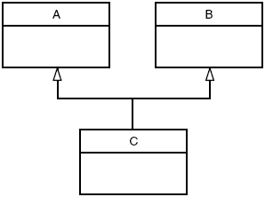
The syntax for multiple inheritance is similar to that for single inheritance. In the situation
shown in Figure 9.9, the relationship is expressed like this:
class A // base class A
{
};
class B // base class B
{
};
class C : public A, public B // C is derived from A and B
{
};
The base classes from which C is derived are listed following the colon in C’s specification;
they are separated by commas.
Member Functions in Multiple Inheritance
As an example of multiple inheritance, suppose that we need to record the educational
experience of some of the employees in the EMPLOY program. Let’s also suppose that, perhaps
in a different project, we’ve already developed a class called student that models students with
different educational backgrounds. We decide that instead of modifying the employee class to
incorporate educational data, we will add this data by multiple inheritance from the student
class.
The student class stores the name of the school or university last attended and the highest
degree received. Both these data items are stored as strings. Two member functions, getedu()
and putedu(), ask the user for this information and display it.
Educational information is not relevant to every class of employee. Let’s suppose, somewhat
undemocratically, that we don’t need to record the educational experience of laborers; it’s only
relevant for managers and scientists. We therefore modify manager and scientist so that they
inherit from both the employee and student classes,

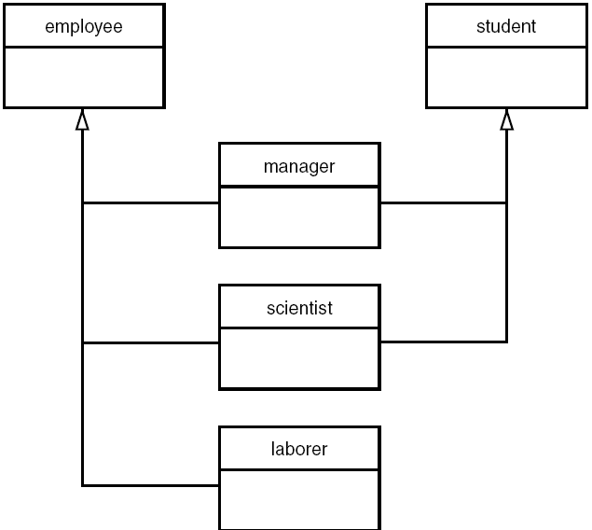
Here’s a miniprogram that shows these relationships (but leaves out everything else):
class student
{ };
class employee
{ };
class manager : private employee, private student
{ };
class scientist : private employee, private student
{ };
class laborer : public employee
{ };
And here, featuring considerably more detail, is the listing for EMPMULT:
//empmult.cpp
//multiple inheritance with employees and degrees
#include <iostream>
using namespace std;
const int LEN = 80; //maximum length of names
////////////////////////////////////////////////////////////////
class student //educational background
{
private:
char school[LEN]; //name of school or university
char degree[LEN]; //highest degree earned
public:
void getedu()
{
cout << “ Enter name of school or university: “;
cin >> school;
cout << “ Enter highest degree earned \n”;
cout << “ (Highschool, Bachelor’s, Master’s, PhD): “;
cin >> degree;
}
void putedu() const
{
cout << “\n School or university: “ << school;
cout << “\n Highest degree earned: “ << degree;
}
};
////////////////////////////////////////////////////////////////
class employee
{
private:
char name[LEN]; //employee name
unsigned long number; //employee number
public:
void getdata()
{
cout << “\n Enter last name: “; cin >> name;
cout << “ Enter number: “; cin >> number;
}
void putdata() const
{
cout << “\n Name: “ << name;
cout << “\n Number: “ << number;
}
};
////////////////////////////////////////////////////////////////
class manager : private employee, private student //management
{
private:
char title[LEN]; //”vice-president” etc.
double dues; //golf club dues
public:
void getdata()
{
employee::getdata();
cout << “ Enter title: “; cin >> title;
cout << “ Enter golf club dues: “; cin >> dues;
student::getedu();
}
void putdata() const
{
employee::putdata();
cout << “\n Title: “ << title;
cout << “\n Golf club dues: “ << dues;
student::putedu();
}
};
////////////////////////////////////////////////////////////////
class scientist : private employee, private student //scientist
{
private:
int pubs; //number of publications
public:
void getdata()
{
employee::getdata();
cout << “ Enter number of pubs: “; cin >> pubs;
student::getedu();
}
void putdata() const
{
employee::putdata();
cout << “\n Number of publications: “ << pubs;
student::putedu();
}
};
////////////////////////////////////////////////////////////////
class laborer : public employee //laborer
{
};
////////////////////////////////////////////////////////////////
int main()
{
manager m1;
scientist s1, s2;
laborer l1;
cout << endl;
cout << “\nEnter data for manager 1”; //get data for
m1.getdata(); //several employees
cout << “\nEnter data for scientist 1”;
s1.getdata();
cout << “\nEnter data for scientist 2”;
s2.getdata();
cout << “\nEnter data for laborer 1”;
l1.getdata();
cout << “\nData on manager 1”; //display data for
m1.putdata(); //several employees
cout << “\nData on scientist 1”;
s1.putdata();
cout << “\nData on scientist 2”;
s2.putdata();
cout << “\nData on laborer 1”;
l1.putdata();
cout << endl;
return 0;
}
The getdata() and putdata() functions in the manager and scientist classes incorporate
calls to functions in the student class, such as
student::getedu();
and
student::putedu();
These routines are accessible in manager and scientist because these classes are descended
from student.
Here’s some sample interaction with EMPMULT:
Enter data for manager 1
Enter last name: Bradley
Enter number: 12
Enter title: Vice-President
Enter golf club dues: 100000
Enter name of school or university: Yale
Enter highest degree earned
(Highschool, Bachelor’s, Master’s, PhD): Bachelor’s
Enter data for scientist 1
Enter last name: Twilling
Enter number: 764
Enter number of pubs: 99
Enter name of school or university: MIT
Enter highest degree earned
(Highschool, Bachelor’s, Master’s, PhD): PhD
Enter data for scientist 2
Enter last name: Yang
Enter number: 845
Enter number of pubs: 101
Enter name of school or university: Stanford
Enter highest degree earned
(Highschool, Bachelor’s, Master’s, PhD): Master’s
Enter data for laborer 1
Enter last name: Jones
Enter number: 48323
Constructors in Multiple Inheritance
EMPMULT has no constructors. Let’s look at an example that does use constructors, and see how
they’re handled in multiple inheritance.
Imagine that we’re writing a program for building contractors, and that this program models
lumber-supply items. It uses a class that represents a quantity of lumber of a certain type: 100
8-foot-long construction grade 2.4s, for example.
The class should store various kinds of data about each such lumber item. We need to know
the length (3'–6'', for example) and we need to store the number of such pieces of lumber and
their unit cost.
We also need to store a description of the lumber we’re talking about. This has two parts. The
first is the nominal dimensions of the cross-section of the lumber. This is given in inches. For
instance, lumber 2 inches by 4 inches (for you metric folks, about 5 cm by 10 cm) is called a
two-by-four. This is usually written 2.4. We also need to know the grade of lumber—rough-cut,
construction grade, surfaced-four-sides, and so on. We find it convenient to create a Type class
to hold this data. This class incorporates member data for the nominal dimensions and the grade
of the lumber, both expressed as strings, such as 2.6 and construction. Member functions get
this information from the user and display it.
We’ll use the Distance class from previous examples to store the length. Finally we create a
Lumber class that inherits both the Type and Distance classes. Here’s the listing for ENGLMULT:
// englmult.cpp
// multiple inheritance with English Distances
#include <iostream>
#include <string>
using namespace std;
////////////////////////////////////////////////////////////////
class Type //type of lumber
{
private:
string dimensions;
string grade;
public: //no-arg constructor
Type() : dimensions(“N/A”), grade(“N/A”)
{ }
//2-arg constructor
Type(string di, string gr) : dimensions(di), grade(gr)
{ }
void gettype() //get type from user
{
cout << “ Enter nominal dimensions (2x4 etc.): “;
cin >> dimensions;
cout << “ Enter grade (rough, const, etc.): “;
cin >> grade;
}
void showtype() const //display type
{
cout << “\n Dimensions: “ << dimensions;
cout << “\n Grade: “ << grade;
}
};
////////////////////////////////////////////////////////////////
class Distance //English Distance class
{
private:
int feet;
float inches;
public: //no-arg constructor
Distance() : feet(0), inches(0.0)
{ } //constructor (two args)
Distance(int ft, float in) : feet(ft), inches(in)
{ }
void getdist() //get length from user
{
cout << “ Enter feet: “; cin >> feet;
cout << “ Enter inches: “; cin >> inches;
}
void showdist() const //display distance
{ cout << feet << “\’-” << inches << ‘\”’; }
};
////////////////////////////////////////////////////////////////
class Lumber : public Type, public Distance
{
private:
int quantity; //number of pieces
double price; //price of each piece
public: //constructor (no args)
Lumber() : Type(), Distance(), quantity(0), price(0.0)
{ }
//constructor (6 args)
Lumber( string di, string gr, //args for Type
int ft, float in, //args for Distance
int qu, float prc ) : //args for our data
Type(di, gr), //call Type ctor
Distance(ft, in), //call Distance ctor
quantity(qu), price(prc) //initialize our data
{ }
void getlumber()
{
Type::gettype();
Distance::getdist();
cout << “ Enter quantity: “; cin >> quantity;
cout << “ Enter price per piece: “; cin >> price;
}
void showlumber() const
{
Type::showtype();
cout << “\n Length: “;
Distance::showdist();
cout << “\n Price for “ << quantity
<< “ pieces: $” << price * quantity;
}
};
////////////////////////////////////////////////////////////////
int main()
{
Lumber siding; //constructor (no args)
cout << “\nSiding data:\n”;
siding.getlumber(); //get siding from user
//constructor (6 args)
Lumber studs( “2x4”, “const”, 8, 0.0, 200, 4.45F );
//display lumber data
cout << “\nSiding”; siding.showlumber();
cout << “\nStuds”; studs.showlumber();
cout << endl;
return 0;
}
The major new feature in this program is the use of constructors in the derived class Lumber.
These constructors call the appropriate constructors in Type and Distance.
No-Argument Constructor
The no-argument constructor in Type looks like this:
Type()
{ strcpy(dimensions, “N/A”); strcpy(grade, “N/A”); }
This constructor fills in “N/A” (not available) for the dimensions and grade variables so the
user will be made aware if an attempt is made to display data for an uninitialized lumber object.
You’re already familiar with the no-argument constructor in the Distance class:
Distance() : feet(0), inches(0.0)
{ }
The no-argument constructor in Lumber calls both of these constructors.
Lumber() : Type(), Distance(), quantity(0), price(0.0)
{ }
The names of the base-class constructors follow the colon and are separated by commas. When
the Lumber() constructor is invoked, these base-class constructors—Type() and Distance()—
will be executed. The quantity and price attributes are also initialized.
Multi-Argument Constructors
Here is the two-argument constructor for Type:
Type(string di, string gr) : dimensions(di), grade(gr)
{ }
This constructor copies string arguments to the dimensions and grade member data items.
Here’s the constructor for Distance, which is again familiar from previous programs:
Distance(int ft, float in) : feet(ft), inches(in)
{ }
The constructor for Lumber calls both of these constructors, so it must supply values for their
arguments. In addition it has two arguments of its own: the quantity of lumber and the unit price.
Thus this constructor has six arguments. It makes two calls to the two constructors, each of
which takes two arguments, and then initializes its own two data items. Here’s what it looks like:
Lumber( string di, string gr, //args for Type
int ft, float in, //args for Distance
int qu, float prc ) : //args for our data
Type(di, gr), //call Type ctor
Distance(ft, in), //call Distance ctor
quantity(qu), price(prc) //initialize our data
{ }
Ambiguity in Multiple Inheritance
Odd sorts of problems may surface in certain situations involving multiple inheritance. Here’s
a common one. Two base classes have functions with the same name, while a class derived
from both base classes has no function with this name. How do objects of the derived class
access the correct base class function? The name of the function alone is insufficient, since
the compiler can’t figure out which of the two functions is meant.
Here’s an example, AMBIGU, that demonstrates the situation:
// ambigu.cpp
// demonstrates ambiguity in multiple inheritance
#include <iostream>
using namespace std;
////////////////////////////////////////////////////////////////
class A
{
public:
void show() { cout << “Class A\n”; }
};
class B
{
public:
void show() { cout << “Class B\n”; }
};
class C : public A, public B
{
};
////////////////////////////////////////////////////////////////
int main()
{
C objC; //object of class C
// objC.show(); //ambiguous--will not compile
objC.A::show(); //OK
objC.B::show(); //OK
return 0;
}
The problem is resolved using the scope-resolution operator to specify the class in which the
function lies. Thus
objC.A::show();
refers to the version of show() that’s in the A class, while
objC.B::show();

refers to the function in the B class. Stroustrup (see Appendix H, “Bibliography”) calls this disambiguation.
Another kind of ambiguity arises if you derive a class from two classes that are each derived
from the same class. This creates a diamond-shaped inheritance tree. The DIAMOND program
shows how this looks.
//diamond.cpp
//investigates diamond-shaped multiple inheritance
#include <iostream>
using namespace std;
////////////////////////////////////////////////////////////////
class A
{
public:
void func();
};
class B : public A
{ };
class C : public A
{ };
class D : public B, public C
{ };
////////////////////////////////////////////////////////////////
int main()
{
D objD;
objD.func(); //ambiguous: won’t compile
return 0;
}
Classes B and C are both derived from class A, and class D is derived by multiple inheritance
from both B and C. Trouble starts if you try to access a member function in class A from an object
of class D. In this example objD tries to access func(). However, both B and C contain a copy of
func(), inherited from A. The compiler can’t decide which copy to use, and signals an error.
There are various advanced ways of coping with this problem, but the fact that such ambiguities
can arise causes many experts to recommend avoiding multiple inheritance altogether. You
should certainly not use it in serious programs unless you have considerable experience.

Association

- It is a simple connection or channel between classes
- It is a relationship where all objects have their own lifecycle and there is no owner
- Example: Department and student
  - Multiple students can associate with single department
  - Single student can associate with multiple departments
  - No ownership
  - Both can create and delete independently
Aggregation

- It is a form of association where all object have their own lifecycle but there is a ownership like parent and child
- Represents as “has a” relationship
- Implementation details:
  - Use pointer variables that points to object of other class
  - Can use a reference variables that points to object of other class
  - Not responsible for creation/destruction of subclass
- Example: Employee and Company
    - A single employee cannot belong to multiple company.
    - If we delete the company, Employee object will not destroy
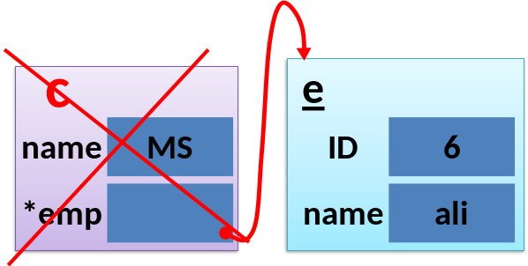

Aggregation Example program
//////// class Employee ///////
class Employee
{
private:
char *myName_p;
public:
Employee(char *name){
cout<<"Employee::ctor\n";
myName_p = new char(sizeof(strlen(name)));
myName_p = name;
}

char* disp(){
return(myName_p);
}

~Employee()
{
cout<<"Employee:dtor\n\n";
delete (myName_p);
}
};
//////// class Company ///////
class Company
{
private:
char *name;
Employee *myEmp_p;
public:
Company(char * compName, Employee* emp){
cout<<"Company::ctor\n";
name = new char(sizeof(strlen(compName)));
name = compName;
myEmp_p = emp;
};

~Company()
{
cout<<"Company:dtor\n\n";
myEmp_p = NULL;
};
};

main()
{
cout<<"\nExample of Aggregation Relationship \n";
cout<<"-----------------------------------------\n\n";

{
cout<<"Here, an Employee-David works for Company-MS \n";
Employee emp("David");

{
Company comp("MS", &emp);
} // here Company object will be deleted, whereas Employee object is still there

cout<<"At this point Company gets deleted...\n";
cout<<"\nBut Employee-"<<emp.disp();
cout<<" is still there\n";

} //here Employee object will be deleted
system("pause");
}

Composition
- It is a specialize form of aggregation.
- It is a strong composition
- Parent and child objects have coincident lifetimes
- Child object dose not have it's own lifecycle
- If parent object gets deleted, then all of it's child objects will also be deleted
- Composition gives us 'part-of‘ relationship
- It is a stronger form of aggregation
- It has all the characteristics of aggregation plus two more
  - The part may belong to only one whole
  - The life time of the part is same as life time of the whole
- For example, it make sense to say that an engine is part-of a car.
  - The lifetime of the part (Engine) is managed by the whole (Car), in other words, when Car is destroyed, Engine is destroyed along with it.
- Implementation details
  - Use normal member variables
  - Can use pointer values if composition class automatically handles allocation/deallocation
  - Responsible for creation/destruction of subclass

UML representation of Composition

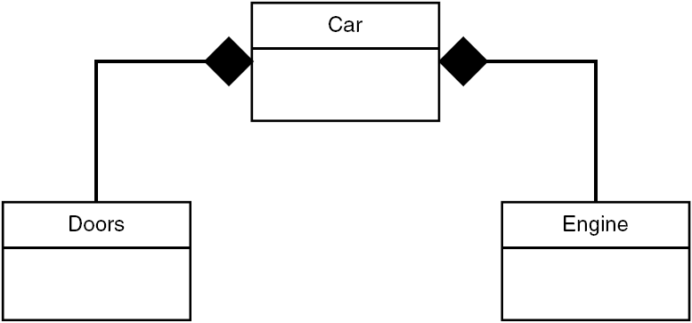

Composition example
- Relationship between houses and rooms
  - House can contains multiple room
  - There is no independent life for room and any room cannot belong to different houses.
  - If house is deleted room will also be deleted automatically
Implementation details
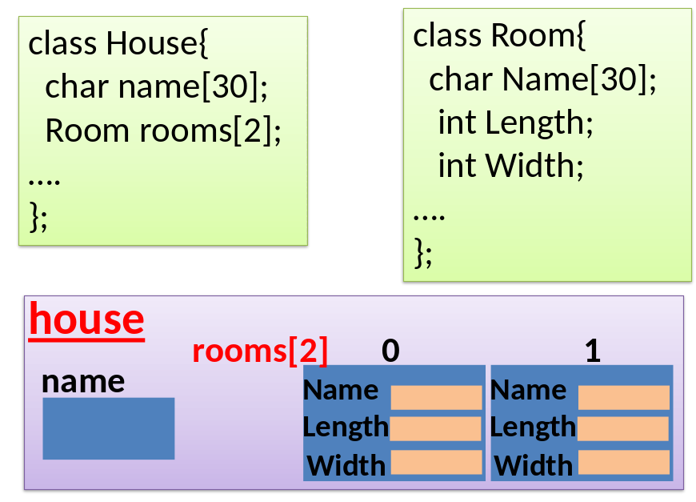fs
Example program
class House;
class Room
{
private:
char * name;
int length;
int width;
public:
Room(){

};
Room(char* rName, int len, int wid)
{
cout<<"Room::ctor\n";
name = new char(sizeof(strlen(rName)));
name = rName;
length = len;
width = wid;
}

~Room(){
cout<<"Room::dtor"<<endl;
delete [] name;
}

void disp(){
cout<< name<<" length :"<<length<<"width : "<<width<<endl;
}
};

class House
{
private:
char* name;
Room roomsList[3];
public:
House(char *myName) {
cout<<"House::ctor\n";
name = new char(sizeof(strlen(myName)));;
name = myName;
roomsList[0] = Room("kitchen", 12, 15);
roomsList[1] = Room("Bedroom", 24, 30);
roomsList[2] = Room("TV lounge", 15, 20);
}

~House(){
cout<<"House: dtor"<<endl;
delete [] name;
}

void disp(){
cout<<"\n\nName of the House :"<<name;
unsigned int i;
cout<<"\n\nRooms details...\n";
for(i=0; i<3; ++i)
(&roomsList[i])->disp();
cout<<"\n\n";
}
};

int main()
{
cout<<"\nExample of Composition Relationship\n";
cout<<"-----------------------------------------\n\n";

House hse("xyz");

cout<<"\n\nHouse details...\n";
hse.disp();

cout<<"Here House itself creates the Rooms and Deletes as well, before it gets deletd...\n";
system("pause");
}

