Algorithms and Data Structures
(CSC112)

Handout -6
Arrays & Strings

- Array
- Array Elements
- Accessing array elements
- Declaring an array
- Initializing an array
- Two-dimensional Array
- Array of Structure
- String
- Array of Strings
- Examples
Arrays
  - Contain fixed number of elements of same data type
  - Static entity- same size throughout the program
  - An array must be defined before it is used
  - An array definition specifies a variable type, a name and size
  - Size specifies how many data items the array will contain
  - An example
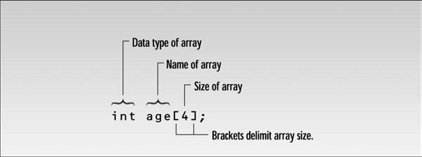

Array Elements  - The items in an array are called elements  - All the elements are of the same type  - The first array element is numbered 0  - Four elements (0-3) are stored consecutively in  the memory | 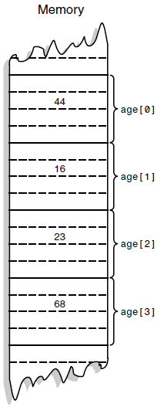
Accessing array elements
To access an element specify array name and array index number
- Syntax:
  - arrayname[ arrayindex]
- to access 3rd element of array age we use
  - age[2] age is the name of the array and 2 is the index number
Declaring an array
- when declaring an array, specify
  - type of array
  - array name
  - number of elements
    - arrayType arrayName [ numberofElements ]
  - examples
    - int results [10 ];
    - float myArray [50];
- declaring multiple arrays of same type
  - format similar to regular variables
  - example: int b[5], x[10];
Initializing an array
- when an array is defined then you can give values to each array elements
- example:
  - int n[5]={1,2,3,4,5};
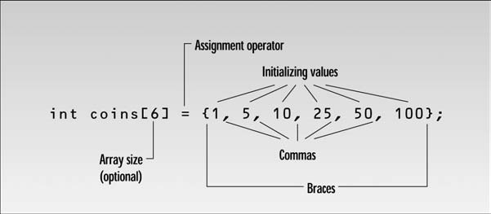
Two-dimensional Array
- one-dimensional array: a single variable specifies each array elements
- but arrays can be defined as two-dimensional
- array of arrays is called multidimensional array
- all the elements are of the same data type
- example: int anArray[3][5];
  - a two dimensional array
  - first subscript as being the row, the second as column
  - so this array contains 3 rows and 5 columns
[0][0] [0][1] [0][2] [0][3] [0][4]
[1][0] [1][1] [1][2] [1][3] [1][4]
[2][0] [2][1] [2][2] [2][3] [2][4]

Strings
- two types of strings are used in C++
- C-Strings and strings that are object of the String class
- C-Strings or C-Style String
- the definition of the string variable looks like the definition of an array of type char
char str[MAX];
- we read a string from the keyboard and place it in the string variable str
- the extraction operator >> knows how to deal with strings
- if the user enters a string “Amanuensis”, it will look like
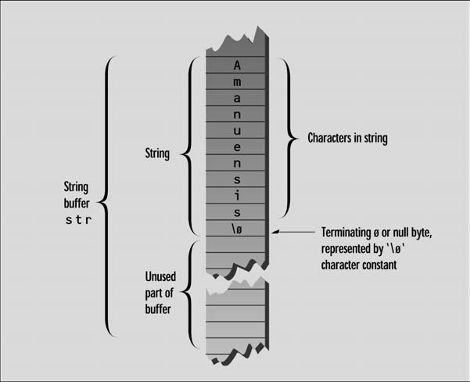
- each character occupies 1 byte of memory
- C-Strings must terminate with a byte containing 0
- it is often represented by a character constant “\0” which is character with an ASCII value of 0
- this terminating zero is called “Null character”
- when the operator << displays a string, it displays characters until it encounters the null character
-----------------------------------------------

