Algorithms and Data Structures
(CSC112)

Handout -29
Traversing a Graph

- Breadth First Search (BFS)
- Depth First Search (DFS)

Traversing a Graph
- Many application of graph requires a structured system to examine the vertices and edges of a graph G
- That is a graph traversal, which means visiting all the nodes of the graph
- There are two graph traversal methods
(a) Breadth First Search (BFS)
  - Think Queue
(b) Depth First Search (DFS)
  - Think Stack

- Goal
  - To systematically visit the nodes of a graph
- A tree is a directed, acyclic, graph (DAG)
- If the graph is a tree,
  - DFS is exhibited by preorder, postorder, and (for binary trees) inorder traversals
  - BFS is exhibited by level-order traversal

Tree searches
- A tree search starts at the root and explores nodes from there, looking for a goal node (a node that satisfies certain conditions, depending on the problem)
- For some problems, any goal node is acceptable (N or J); for other problems, you want a minimum-depth goal node, that is, a goal node nearest the root (only J)

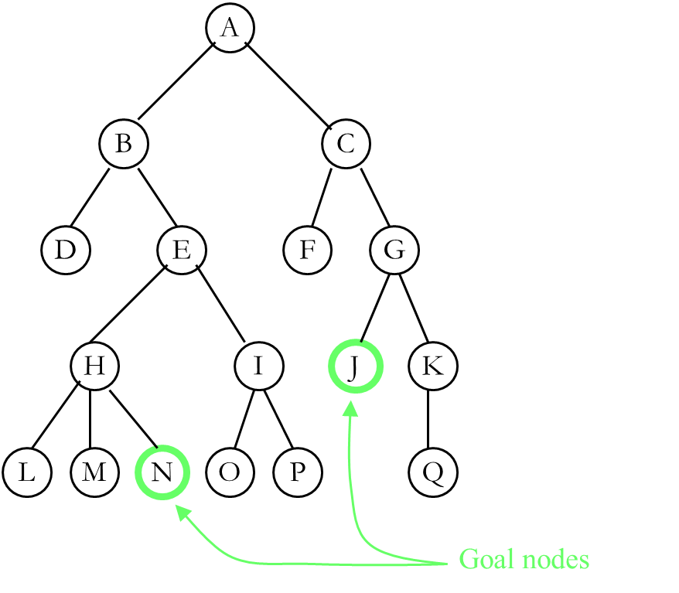
Depth-first searching
- A depth-first search (DFS) explores a path all the way to a leaf before backtracking and exploring another path
- For example, after searching A, then B, then D, the search backtracks and tries another path from B
- Node are explored in the order A B D E H L M N I O P C F G J K Q
- N will be found before J

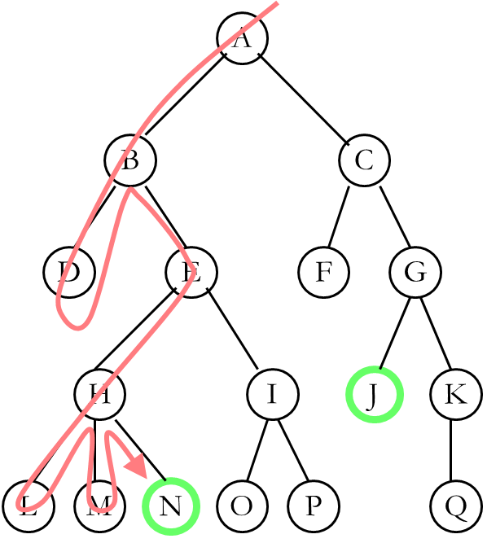

Breadth-first searching
- A breadth-first search (BFS) explores nodes nearest the root before exploring nodes further away
- For example, after searching A, then B, then C, the search proceeds with D, E, F, G
- Node are explored in the order A B C D E F G H I J K L M N O P Q
- J will be found before N
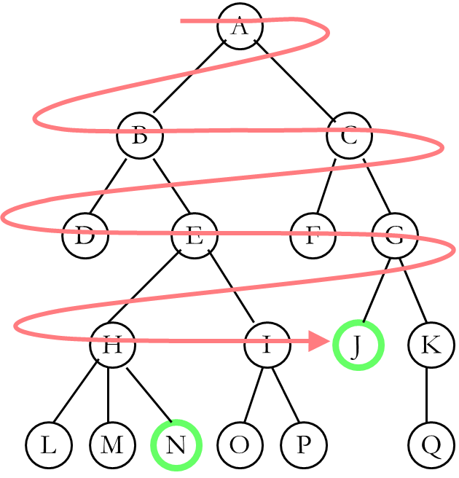
Graph Traversal
- Problem: Search for a certain node or traverse all nodes in the graph
- Depth First Search
  - Once a possible path is found, continue the search until the end of the path
- Breadth First Search
  - Start several paths at a time, and advance in each one step at a time

Depth-First Search
Exploring a Labyrinth Without Getting Lost
- A Depth-First Search (DFS) in an undirected graph G is like wandering in a labyrinth with a string and a can of red paint without getting lost.
- We start at vertex s, tying the end of our string to the point and painting s “visited”. Next we label s as our current vertex called u.
- Now we travel along an arbitrary edge (u, v).
- If edge (u, v) leads us to an already visited vertex v we return to u.
- If vertex v is unvisited, we unroll our string and move to v, paint v “visited”, set v as our current vertex, and repeat the previous steps.

Breadth-First Search
- Like DFS, a Breadth-First Search (BFS) traverses a connected component of a graph, and in doing so defines a spanning tree with several useful properties.
- The starting vertex s has level 0, and, as in DFS, defines that point as an “anchor.”
- In the first round, the string is unrolled the length of one edge, and all of the edges that are only one edge away from the anchor are visited.
- These edges are placed into level 1
- In the second round, all the new edges that can be reached by unrolling the string 2 edges are visited and placed in level 2.
- This continues until every vertex has been assigned a level.
- The label of any vertex v corresponds to the length of the shortest path from s to v.

-----------------------------------------------

