Algorithms and Data Structures
(CSC112)

Handout -28
Graphs

- Graph
- Directed Graph
- Undirected Graph
- Sub-Graph
- Spanning Sub-Graph
- Degree of a Vertex
- Weighted Graph
- Elementary and Simple Path
- Link List Representation

Graph
- A graph G consist of
1. Set of vertices V (called nodes), V = {v1, v2, v3, v4......} and
2. Set of edges E={e1, e2, e3......}
- A graph can be represented as G = (V, E), where V is a finite and non empty set of vertices and E is a set of pairs of vertices called edges
- Each edge ‘e’ in E is identified with a unique pair (a, b) of nodes in V, denoted by e = {a, b}

- Consider the following graph, G
- Then the vertex V and edge E can be represented as:
V = {v1, v2, v3, v4, v5, v6} and E = {e1, e2, e3, e4, e5, e6}
E = {(v1, v2) (v2, v3) (v1, v3) (v3, v4),(v3, v5) (v5, v6)}
- There are six edges and vertex in the graph

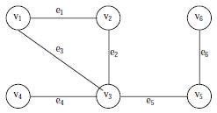
Directed Graph
- A graph can be a
  - Directed Graph
  - Undirected/Simple Graph
- A directed graph G is defined as an ordered pair (V, E) where, V is a set of vertices and the ordered pairs in E are called edges on V
- A directed graph can be represented geometrically as a set of marked points (called vertices) V with a set of arrows (called edges) E between pairs of points (or vertex or nodes) so that there is at most one arrow from one vertex to another vertex
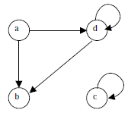
Undirected Graph
- An undirected graph G is defined abstractly as an ordered pair (V, E), where V is a set of vertices and the E is a set at edges
- An undirected graph can be represented geometrically as a set of marked points (called vertices) V with a set of lines (called edges) E between the points
- An undirected graph G is shown in the following figure

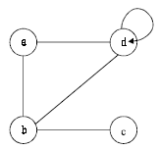
Sub-Graph
- Let G = (V, E) be a graph
- A graph G1 = (V1, E1) is said to be a sub-graph of G if E1 is a subset of E and V1 is a subset of V such that the edges in E1 are incident only with the vertices in V1
- For example, Fig.(b) is a sub-graph of Fig. (a)
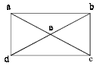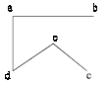
Fig (a)
Fig (a)

Degree of a Vertex
- The number of edges incident on a vertex is its degree
- The degree of vertex a, is written as degree (a)
- If the degree of vertex a is zero, then vertex a is called isolated vertex
- For example the degree of the vertex a in following figure is 3
Weighted Graph
- A graph G is said to be weighted graph if every edge and/or vertices in the graph is assigned with some weight or value
- A weighted graph can be defined as G = (V, E, We, Wv) where V is the set of vertices, E is the set of edges and We is a weight of the edges whose domain is E and Wv is a weight of the vertices whose domain is V
Complete Graph
- A graph G is said to complete (or fully connected or strongly connected) if there is a path from every vertex to every other vertex
- Let a and b are two vertices in the directed graph, then it is a complete graph if there is a path from a to b as well as a path from b to a
- Fig X illustrates the complete undirected graph
- Fig Y shows the complete directed graph

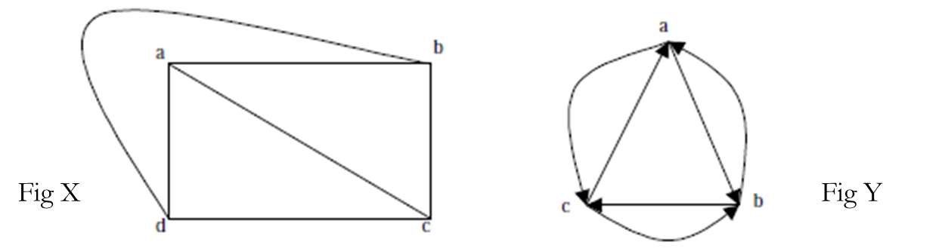

Elementary and Simple Path
- In a directed graph, a path is a sequence of edges (e1, e2, e3, ...... en) such that the edges are connected with each other
- A path is said to be elementary if it does not meet the same vertex twice
- A path is said to be simple if it does not meet the same edges twice

-----------------------------------------------

