Algorithms and Data Structures
(CSC112)

Handout -25
Types of Queue

- Queue
- Operations on Queues
- A Dequeue Operation
- An Enqueue Operation
- Array Implementation
- Link list Implementation
- Examples

- It is a linear data structure used to represent a linear list and permits deletion to be performed at one end and of the list and the insertions at the other end.
- The information in such a list is processed in the same order as it was received.
- i.e-FIRST-COME-FIRST-SERVE basis(FCFS).
- Or FIRST IN FIRST OUT(FIFO).
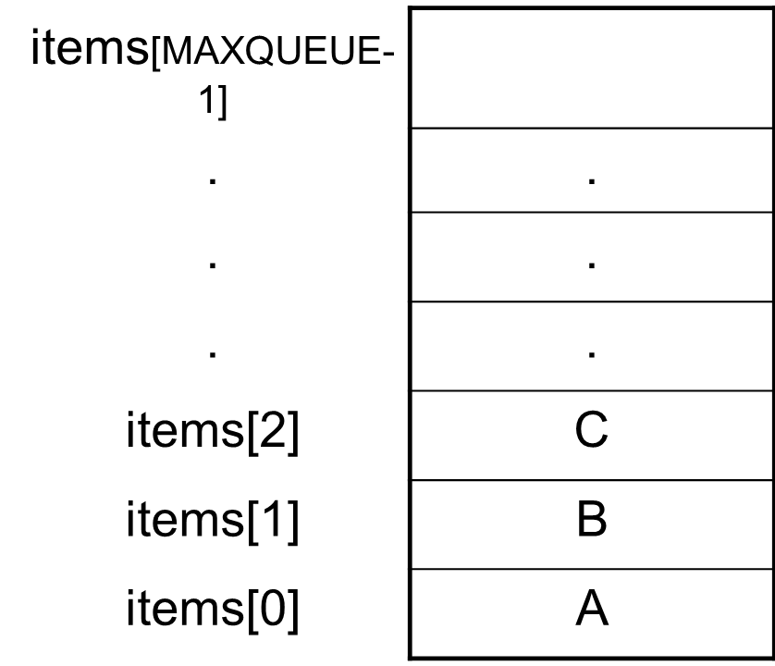

Declaration of a Queue
# define MAXQUEUE 50 /* size of the queue items*/
typedef struct {
int front;
int rear;
int items[MAXQUEUE];
}QUEUE;

Implementation of queue.
- Two common ways in which queues may be implemented are as follows:
- ARRAYS
- POINTERS(one way linear linked list)

Operations of queue
- Insertion in queue.
- Deletion in queue.
- List(display) of the queue.

Different type of queue
- Circular queue
- Double Ended Queue
- Priority queue

`Circular queue
- Let we have an array named Q, that contains n element in which Q[1] comes after Q[n] in the array.
- When this technique is used to construct a queue is called circular queue.
- In other word we can say that a queue is called circular when the last room comes just before the first room.

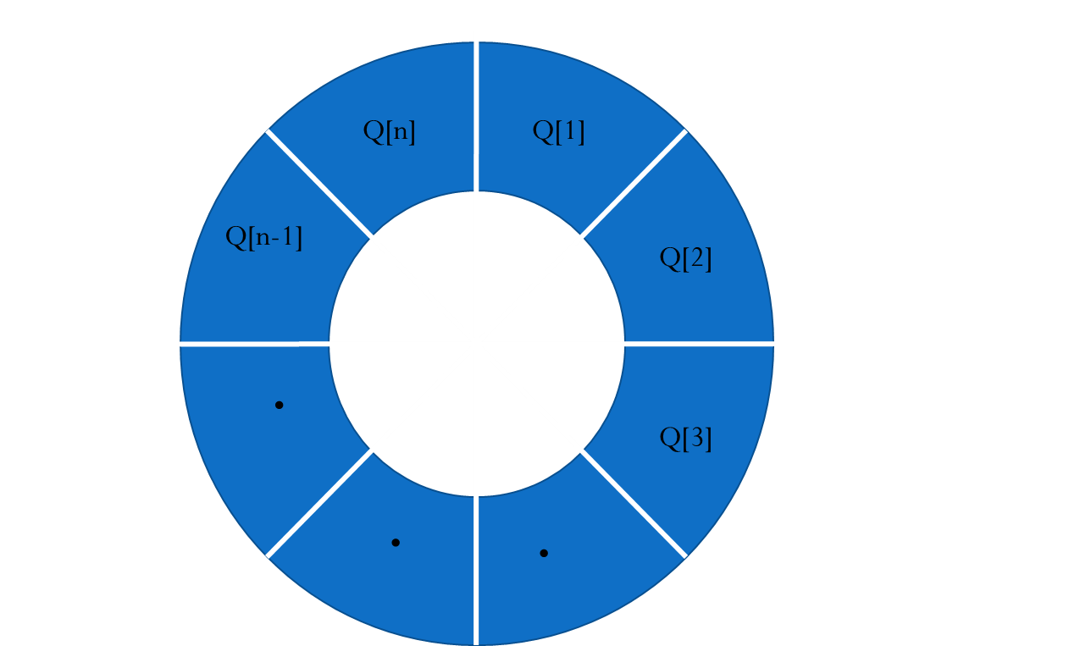
- In a circular queue when rear=n, if we insert an element then this element is assigned to q[1] instead of increasing rear to n+1.
- Suppose queue contains only one element that is front=rear!=0 and suppose that the element is removed then the front and rear pointers are now assigned ‘0’ to indicate that the queue is EMPTY.

Application of queue
- An e.g. of queue is time sharing computer system where many users share the system simultaneously.
- The procedure, which is used to design such type of system, is Round Robin Technique.
- The railway reservation counter is also an example of queue where the people collect their tickets on FIFO or FCFS based.

DEQUES
- A deque is a homogeneous list in which elements can be added or inserted and deleted or removed from both the ends.
  - We can add a new element at the rear or front end and also we can remove an element from both front and rear end.
- Hence it is called Double Ended Queue.
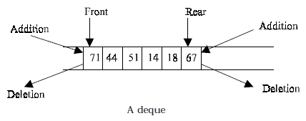
- There are two types of deque depending upon the restriction to perform insertion or deletion operations at the two ends.
1. Input restricted deque
2. Output restricted deque
- An input restricted deque
  - is a deque, which allows insertion at only 1 end, rear end,
  - but allows deletion at both ends, rear and front end of the lists.
- An output-restricted deque
  - is a deque, which allows deletion at only one end, front end,
  - but allows insertion at both ends, rear and front ends, of the lists.

The possible operation performed on deque
1. Add an element at the rear end
2. Add an element at the front end
3. Delete an element from the front end
4. Delete an element from the rear end
- Only 1st, 3rd and 4th operations are performed by input-restricted deque
- 1st, 2nd and 3rd operations are performed by output-restricted deque.

QUEUE OPERATIONS
- Initialize the queue
- Insert to the rear of the queue
- Remove (Delete) from the front of the queue
- Is the Queue Empty
- Is the Queue Full
- What is the size of the Queue

PRIORITY QUEUES
- The priority queue is a data structure in which intrinsic ordering of the elements determines the results of its basic operations.
- An ascending priority queue is a collection of items into which items can be inserted arbitrarily and from which only the smallest item can be removed. On the other hand a descending priority queue allows only the largest item to be removed.

Priority QUEUE Operations
- Insertion
  - The insertion in Priority queues is the same as in non-priority queues.
- Deletion
  - Deletion requires a search for the element of highest priority and deletes the element with highest priority. The following methods can be used for deletion/removal from a given Priority Queue:
    - An empty indicator replaces deleted elements.
    - After each deletion elements can be moved up in the array decrementing the rear.
    - The array in the queue can be maintained as an ordered circular array
Priority Queue Declaration
- Queue data type of Priority Queue is the same as the Non-priority Queue.
#define MAXQUEUE 10 /* size of the queue items*/
typedef struct {
int front, rear;
int items[MAXQUEUE];
}QUEUE;

-----------------------------------------------

