Algorithms and Data Structures
(CSC112)

Handout -22
Linked List as an ADT

- The basic operations on linked lists are:
  - Initialize the list
  - Determine whether the list is empty
  - Print the list
  - Find the length of the list
  - Destroy the list
  - Retrieve the info contained in the first node
  - Retrieve the info contained in the last node
  - Search the list for a given item
  - Insert an item in the list
  - Delete an item from the list
  - Make a copy of the linked list
- In general, there are two types of linked lists:
  - Sorted and unsorted lists
- The algorithms to implement the operations search, insert, and remove slightly differ for sorted and unsorted lists
- The abstract class linkedListType will implement the basic linked list operations
  - Derived classes: unorderedLinkedList and orderedLinkedList
- If a linked list is unordered, we can insert a new item at either the end or the beginning
  - buildListForward inserts item at the end
  - buildListBackward inserts new item at the beginning
- To accommodate both operations, we will write two functions:
  - insertFirst and insertLast
- We will use two pointers in the list:
  - first and last

Structure of Linked List Nodes
- The node has two member variables
- To simplify operations such as insert and delete, we define the class to implement the node of a linked list as a struct
- The definition of the struct nodeType is:

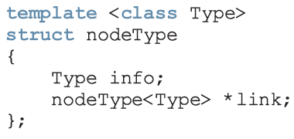
Member Variables of the class linkedListType
- We use two pointers: first and last
- We also keep a count of the number of nodes in the list
- linkedListType has three member variables:
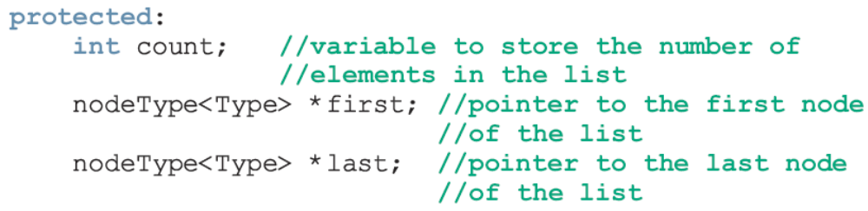
Linked List Iterators
- One of the basic operations performed on a list is to process each node of the list
  - List must be traversed, starting at first node
  - Common technique is to provide an iterator
- Iterator: object that produces each element of a container, one element at a time
  - The two most common operations are:
++ (the increment operator)
* (the dereferencing operator)
- Note that an iterator is an object
- We need to define a class (linkedListIterator) to create iterators to objects of the class linkedListType
  - Would have two member variables:
    - One to refer to (the current) node
    - One to refer to the node just before the (current) node




