Algorithms and Data Structures
(CSC112)

Handout -21
Singly Linked List

- All the nodes in a singly linked list are arranged sequentially by linking with a pointer.
- A singly linked list can grow or shrink, because it is a dynamic data structure.
- All the nodes in a singly linked list are arranged sequentially by linking with a pointer.
- A singly linked list can grow or shrink, because it is a dynamic data structure.
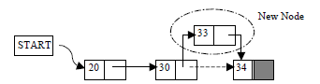

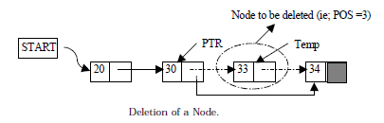

Linked Lists
- Linked list: a list of items (nodes), in which the order of the nodes is determined by the address, called the link, stored in each node
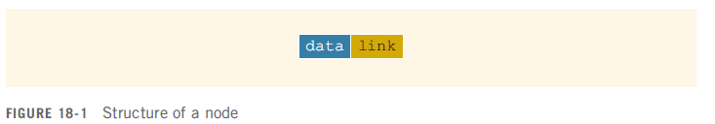

Linked Lists: Some Properties
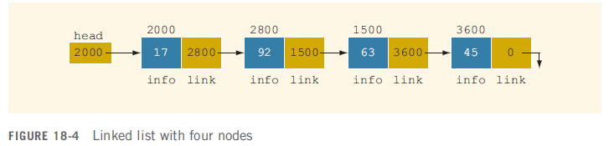

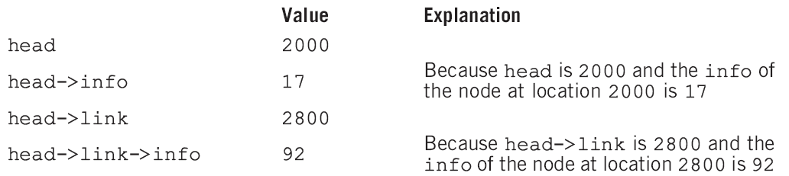

- Because each node of a linked list has two components, we need to declare each node as a class or struct
  - Data type of a node depends on the specific application
  - The link component of each node is a pointer
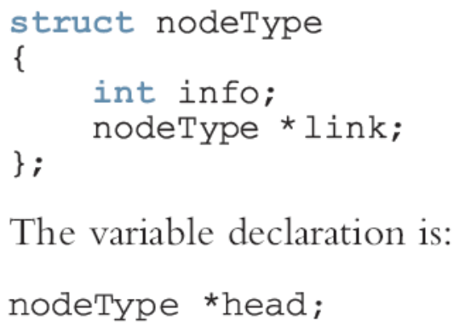

Traversing a Linked List
- The basic operations of a linked list are:
  - Search to determine if an item is in the list
  - Insert an item in the list
  - Delete an item from the list
- Traversal: given a pointer to the first node of the list, step through the nodes of the list

Building a Linked List
- If data is unsorted
  - The list will be unsorted
- Can build a linked list forward or backward
  - Forward: a new node is always inserted at the end of the linked list
  - Backward: a new node is always inserted at the beginning of the list

Building a Linked List Forward
- You need three pointers to build the list:
  - One to point to the first node in the list, which cannot be moved
  - One to point to the last node in the list
  - One to create the new node

Building a Linked List Backward
- The algorithm is:
  - Initialize first to NULL
  - For each item in the list
    - Create the new node, newNode
    - Store the item in newNode
    - Insert newNode before first
    - Update the value of the pointer first

-----------------------------------------------

