Algorithms and Data Structures
(CSC112)

Handout -19
Linked List Traversal and Insertion of Elements

- Inserting into a linked list involves two steps:
  - Find the correct location
  - Do the work to insert the new value
- We can insert into any position
  - Front
  - End
  - Somewhere in the middle
Linked List Traversal
- Traversal means “visiting” or examining each node.
- Simple linked list
  - Start at the beginning
  - Go one node at a time until the end
- Recursive procedure (or function)
  - Given a head pointer
  - Looks at just one node
  - What procedure will look at the rest?

Node Definition
node definesa record
data isoftype Num
next isoftype ptr toa node
endrecord

Adding an Element to a Linked List

Involves two steps:
- Finding the correct location
- Doing the work to add the node

Inserting to the Front
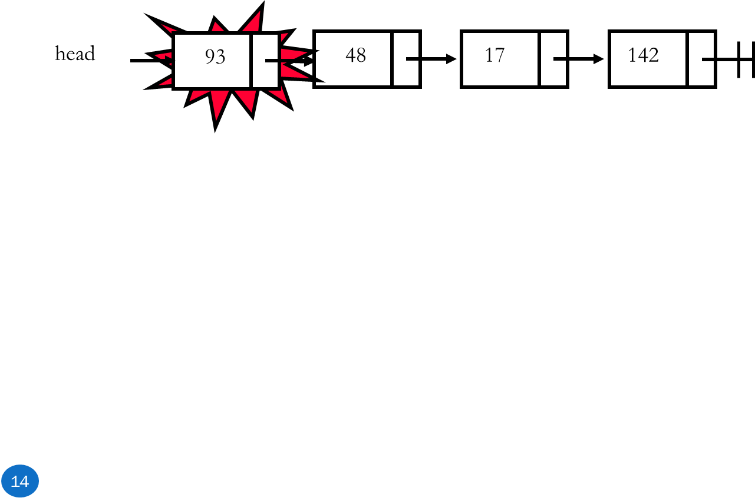
- There is no work to find the correct location
- Empty or not, head will point to the right location

Inserting to the End

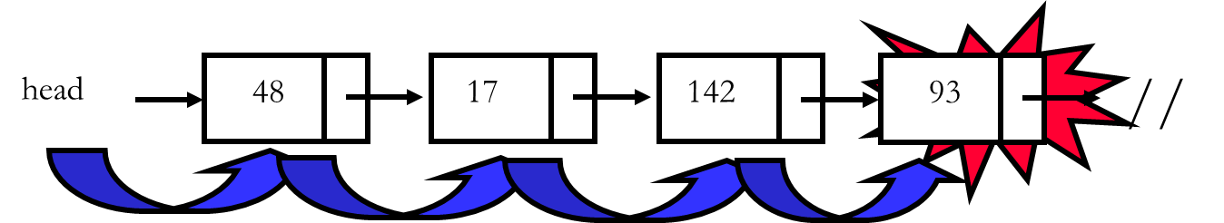
  - Find the end of the list
(when at NIL)
  - Recursion or iteration
Inserting to the Middle
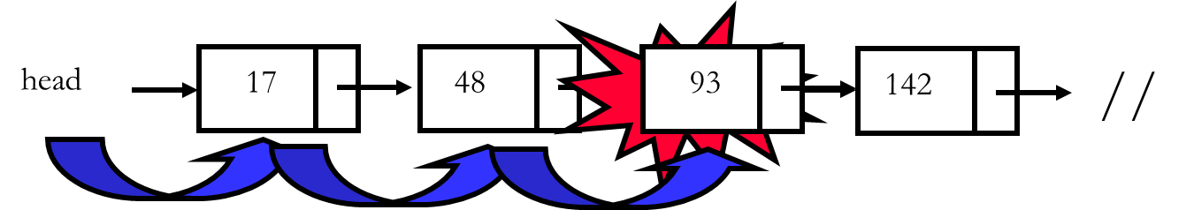

- Used when order is important
- Go to the node that should follow the one to add
  - Recursion or iteration

Three Types of Insertion
- To front
  - No recursion needed
- To end
  - Get to the end, then add node
- In order (in middle)
  - To maintain sorted property

Inserting to the Front of a Linked List
- Need an in/out pointer parameter
- Create new node
- Fill in data
- Make new node’s next pointer point to current
- Update current to point to new node
Inserting to End of a Linked List
- Recursively traverse the list until at end
- Then:
  - Create new node at current
  - Fill in data
  - Terminate the new node’s
next pointer to point to NIL

Inserting In Order into a Linked List
- Recursively traverse until you find the correct place to insert
  - Compare to see if you need to insert before current
  - If adding largest value, then insert at the end
- Perform the commands to do the insertion
  - Create new node
  - Add data
  - Update the next pointer of the new node
  - Update current to point to new node

-----------------------------------------------

