Algorithms and Data Structures
(CSC112)

Handout -1
Introduction to Algorithms and Data Structures

- Algorithms and Data Structures
- Static Data Structures
    - Searching Algorithms
    - Sorting Algorithms
    - List implementation through Array
    - ADT: Stack
    - ADT: Queue
- Dynamic Data Structures (Linear)
    - Linked List (Linear Data Structure)
- Dynamic Data Structures (Non-Linear)
    - Trees, Graphs, Hashing

3 steps in the study of data structures
- Logical or mathematical description of the structure
- Implementation of the structure on the computer
- Quantitative analysis of the structure, which includes determining the amount of memory needed to store the structure and the time required to process the structure

Lists (Array /Linked List)
Items have a position in this Collection
  - Random access or not?
Array Lists
  - internal storage container is native array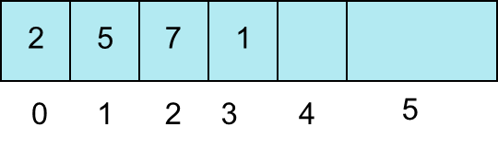
Linked Lists
public class Node
{ private Object data;
private Node next;
}

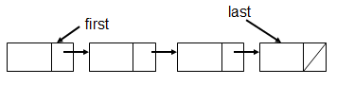

Stacks
- Collection with access only to the last element inserted
- Last in first out
- insert/push
- remove/pop
- top
- make empty

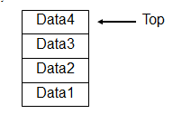
Queue

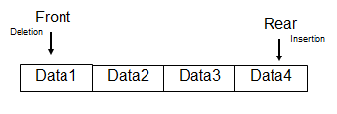

Trees
- Similar to a linked list
public class TreeNode
{ private Object data;
private TreeNode left;
private TreeNode right;
}

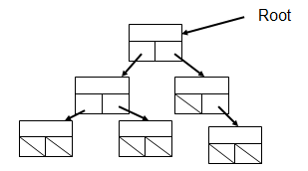

Hash Tables
- Take a key, apply function
- f(key) = hash value
- store data or object based on hash value
- Sorting O(N), access O(1) if a perfect hash function and enough memory for table
- how deal with collisions?

-----------------------------------------------

